Received 00th January 20xx,
ªDepartment of Chemistry, University of Liverpool, Crown Street, Liverpool, L69 7ZD, UK. E-mail: T.Hasell@liverpool.ac.uk
Electronic Supplementary Information (ESI) available: [details of any supplementary information available should be included here]. See DOI: 10.1039/x0xx00000x
Accepted 00th January 20xx
DOI: 10.1039/x0xx00000x
www.rsc.org/
Macroporous sulfur polymers from a sodium chloride porogen — a low cost, versatile remediation material
Samuel Petcher, Douglas Parker, Tom Hasell*
Recent research has demonstrated that it is possible to generate polymers from elemental sulfur and a variety of organic crosslinkers using the so called ‘inverse vulcanisation’ process. The polymerisation is solvent free, self-initiating and has a high atom economy (>90%). A variety of applications have been demonstrated but the most pertinent is the sequestration of heavy metals. Effective sorbents usually possess a degree of porosity, herein we demonstrate the generation of a macroporous thiopolymer matrix and we test it’s ability to remove aqueous mercury chloride from solution. It was found that the macroporous polymer possessed a capacity of 2.27 mg g⁻¹ (Langmuir) and a surface area of over 15 m² g⁻¹.
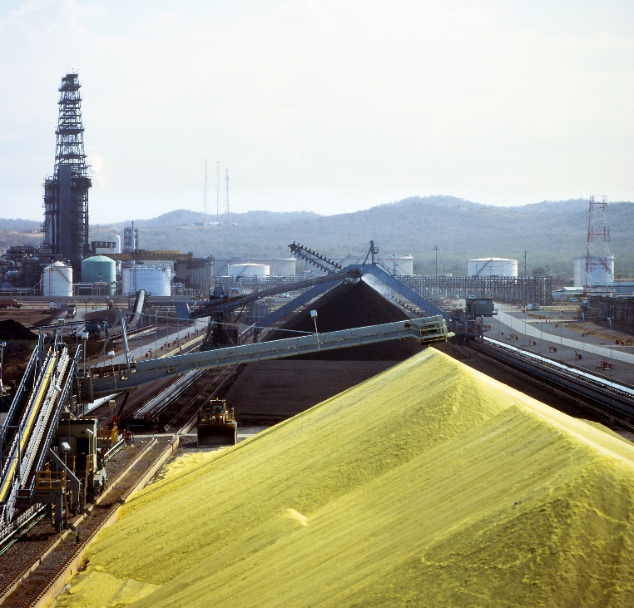
Water impact
Figure 1 - Large quantities of waste sulfur being stored in Vancouver, Canada
Merucry is a significant global health hazard, with growing research efforts focussed on its remediation from wastewater streams. The ease of application of mercury in small scale gold mining has led to prolific use and now over 25% of global mercury emissions result from this process. Other anthropogenic sources include burning of fossil fuels, waste incinaration, and chemical plants. The prevalence of the negative effects on human health are widespread and well documented. For a matererial to be effectively used for mercury filtration and capture, it therefore needs to have not only a high affinity to bind the mercury, but also to be low enough in lost to allow large scale application. Elemental sulfur is itself an unwanted by-product of the petrochemicals industry. The use of sulfur to make high-affinity, low cost, materials for Hg capture is therefore an attractive prospect, providing that porosity can be generated at the nano-micro scale.
Introduction
Heavy metal contamination exists in the waste streams of many industries, such as chemical manufacturing, mining operations, waste incineration, agriculture and fossil fuel fired power stations.^{1–5} The emitted heavy metals are extremely harmful environmental pollutants as they are widely distributed in the air, water and soil.^{6–8} Mercury is of particular concern for human health because of its relative solubility in water and tendency to bioaccumulate and cause severe toxic effects.^{1,9} Sources of mercury can be either anthropogenic or natural.¹⁰ The form in which these sources are introduced to the environment are unrelated to the final chemical state as almost all forms of mercury are harmful and accumulate in sediment, fish, and the groundwater table.¹¹ Of particular note is Minimata, Japan a place in which there are over 2000 registered casualties of demithylmercury pollution from a local chemical plant.¹² The scale of the incident pushed mercury poisoning to the public eye and as a result the ‘Minimata convention’ – a global effort to reduce anthopogenic sources of mercury has been signed by over 120 countries.^{13,14} Another anthropogenic source of environmental mercury is artisanal and small scale gold mining.¹⁵
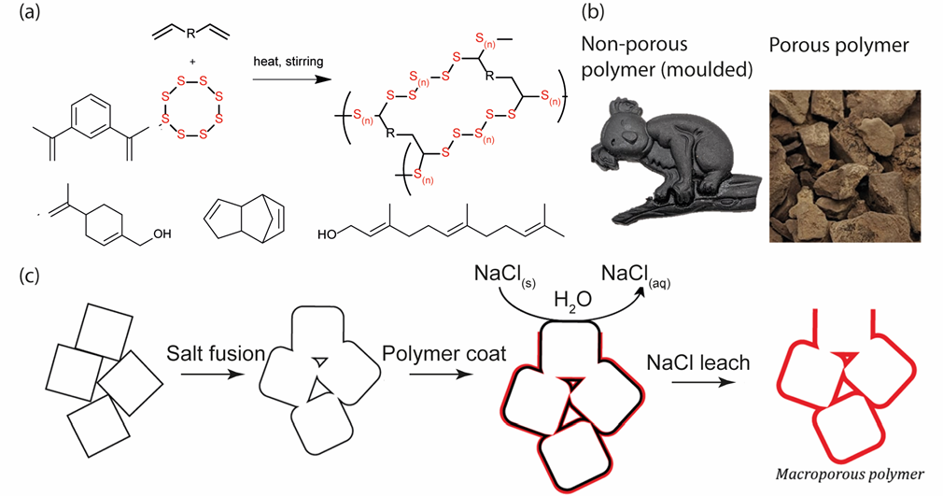
The modern petrochemical manufacturing process includes desulfurisation mechanisms.¹⁶ This is because sulfur is contained within crude oil mixtures and can cause acid rain, and other issues such as metal corrosion. The quantity of extracted sulfur results in a large volume of waste material (Figure 1). Current industrial uses of sulfur include fertilizers, sulfuric acid, and carbon disulfide manufacture, but the production of sulfur still exceeds demand. The cost of this waste product is therefore approximately the price of shipping. Hence, finding applications for this sulfur is a challenge within chemistry.
Figure 2 - (a) Generalised scheme of the inverse vulcanisation reaction and a suggested structure for the products of the reaction (b) Physical appearance of products of the pure polymer, a NaCl template and the produced porous polymer (c) Schematic illustrating the NaCl templating process and how the porous polymer is produced
Polymeric sulfur is produced via the homolysis of sulfur at elevated temperatures and is observable at 159 °C the ‘floor temperature’ of molten sulfur.^{17,18} At this temperature the S₈ ring undergoes ring opening polymerisation (ROP). It is difficult to use polymeric sulfur because it is thermodynamically unstable and degrades via a backbiting mechanism back to S₈ (ESI S1).¹⁹ Because of this, uses for polymeric sulfur have been limited.¹⁷
Inverse vulcanised polymers are a new class of polymeric materials produced from sulfur and unsaturated organic small molecules. The process was pioneered in the group of Jeffrey Pyun.^{20,21} These small molecules, usually dienes, can crosslink and stabilise chains of polymeric sulfur (Figure 2a). Through this process enhanced properties are observed such as improved ion sorption, processability and stability.^{22,23}
Up to 90 wt.% sulfur loading has been demonstrated and yields demonstrated above 90 % are regularly achieved.^{24,25} The process is also solvent free, which fulfils one of the principles of green chemistry, alongside the excellent atom economy of the process.²⁶ As a result of the recent emergence of this class of materials many properties are currently being discovered. Properties that have thus far been demonstrated are: antimicrobial surfaces,²⁷ cathode materials,²² lens materials, ²⁸ novel carbonisation precursors,²⁹ controlled release media,³⁰ metal ion sorbents,^{31,32} vitrimers³³ and insulation materials.³⁴ A recent review by Chalker et al. detailed many of the applications of inverse vulcanised polymers.³⁵
Applications such as those in insulation, controlled release and ion sorption would benefit from porosity. For example, closed cell porosity would benefit applications in insulation and open cell in controlled release and sorption.
Hasell et al. first demonstrated the use of supercritical carbon dioxide as a foaming agent, producing a material with a significant fraction of closed cell porosity.²³ However, despite the nature of the porosity the sample still outperformed non-porous samples ground to a powder, and more importantly: elemental sulfur, for mercury uptake.
Thielke et al. demonstrated that it was possible to form nanofibers of sulfur polymer mixed with poly(methyl methacrylate) using electrospinning.³⁶ The fibres were then tested as a mercury sorbent, demonstrating a significant uptake capacity of 327.7 mg g⁻¹.³⁶ In the wider area of generating macro-porosity in non-sulfur based polymers, there are examples in the literature making use of a technique first reported by Murphy et al. in which sodium chloride crystals are used as a template media.³⁷ This technique was first adapted to sulfur polymers in research by Parker et al., as shown in Figures 2b, 2c.³¹
Since the Parker et al. publication this method has been adapted by several researchers also working on sulfur polymers. Abraham et al. reported a porous sulfur divinylbenzene copolymer produced in this fashion.³⁴ The produced material was tested for gaseous mercury absorption and performed within the range of commercially activated materials. Furthermore, the material was thermally insulating at levels comparable to commercially available materials. The Chalker research group at Flinders University, Adelaide have demonstrated multiple applications for salt templated porous sulfur polymers: iron sequestration, mercury sequestration and oil-water separation.^{38,39} Furthermore, the same research group has explored sulfur polymers as potential controlled release agents for fertiliser.³⁰
Here, we investigate the salt template process and the application of antisolvent precipitation to exert greater control to the process. We explore how the ratio of solvent:antisolvent effects the produced sodium chloride particle size and how this affects the resultant pore size and interconnectivity in the final porous polymer. We explore the process as applied to several crosslinking agents, both bio-renewable and low cost industrial feedstocks.
Experimental
Materials
Sulfur (S₈, sublimed powder, reagent grade, ≥ 99.5 %, Brenntag UK & Ireland). Dicyclopentadiene (DCPD), perrilyl alcohol (PA), 1,3-diisopropenylbenzene (DIB), and farnesol (FSOL) were obtained from Merck. Sodium chloride and ethanol were obtained from Fischer-Sci.
Generation of salt template
Sodium chloride (50 g, an excess) was added to a beaker containing 100 mL of distilled water. The mixture was allowed to stir for 24 hours, until no more sodium chloride would dissolve into the resultant solution. The mixture was then filtered keeping the filtrate, a saturated solution of sodium chloride. This solution was then added to 900 mL of ethanol with vigorous stirring over the course of one minute. The resultant mixture was a cloudy white suspension.
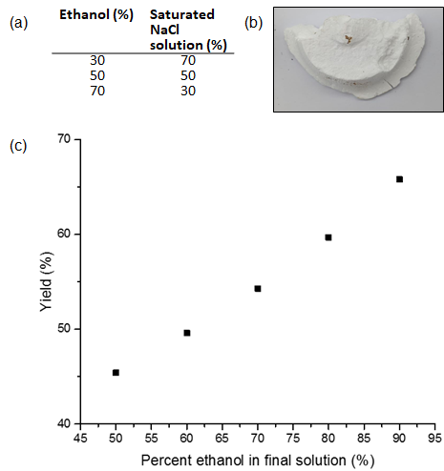
The resultant suspension was filtered under vacuum using a Whitman no. 5 filter paper. The solid residue was a fused cake of sodium chloride. The cake was dried in an oven at 120 °C, and produced a porous sodium chloride matrix.
Figure 3 - (a) The ratios of solvent:antisolvent investigated for the generation of SCP's (b) Physical appearance of generated SCP (c) The percent recovery of sodium chloride as a function of the percentage ethanol in the final mixture volume
Preparation of porous polymer
The sodium chloride porogen monolith was placed in an oven and heated to 180 °C. Sulfur (5 g) and crosslinker were charged into a 12 mL glass reaction vial. The vial was placed in a metal heating block set to 159 °C. The mixture was equipped with a magnetic stirrer bar and allowed to stir at 900 rpm until a single phase formed. The solution was then poured onto the preheated sodium chloride porogen and allowed to cure at 180 °C for two hours before the temperature was lowered to 140 °C for a further ten hours.
After curing the polymer-salt composite was placed in in a Soxhlet system and the sodium chloride was allowed to leach out of the composite over the course of 72 hours, leaving a porous polymer.
Characterisation
Scanning electron microscopy (SEM) was performed on a JEOL JSM 6610 SEM, operating at 3 keV using the upper detector. Samples were coated in gold.
Thermogravimetric Analysis (TGA) was carried out in platinum pans using a Q5000IR analyser (TA Instruments) with an automated vertical overhead thermobalance. The samples were heated at 5 °C min⁻¹ to 700 °C under air.
Powder X-ray Diffraction (PXRD): Data were measured using a PANalytical X’Pert PRO diffractometer with Cu-K radiation, operating in transmission geometry
Hg capture: Polymer samples were added to aqueous mercury chloride solutions and stirred (60 rpm) on a sample roller. After the required times, the solutions were filtered and the filtrate analysed by ICP-OES.
Results and discussions
Generation of sodium chloride porogen (SCP)
The SCPs were confirmed to be sodium chloride via the use of pXRD. (ESI S2) Initially, the effect of solvent:antisolvent ratio was explored and the effect this had on the morphology and yield of the produced SCP is shown in Figure 3.
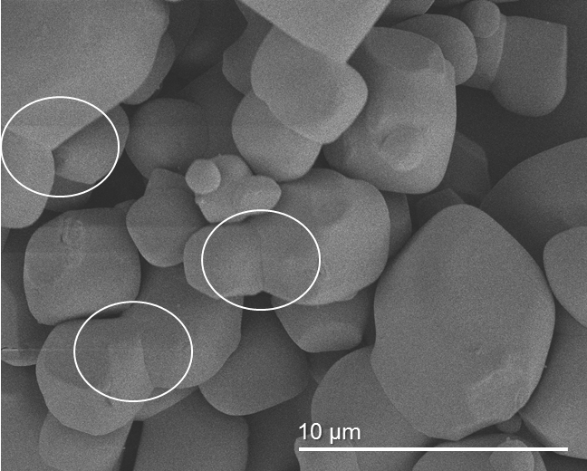
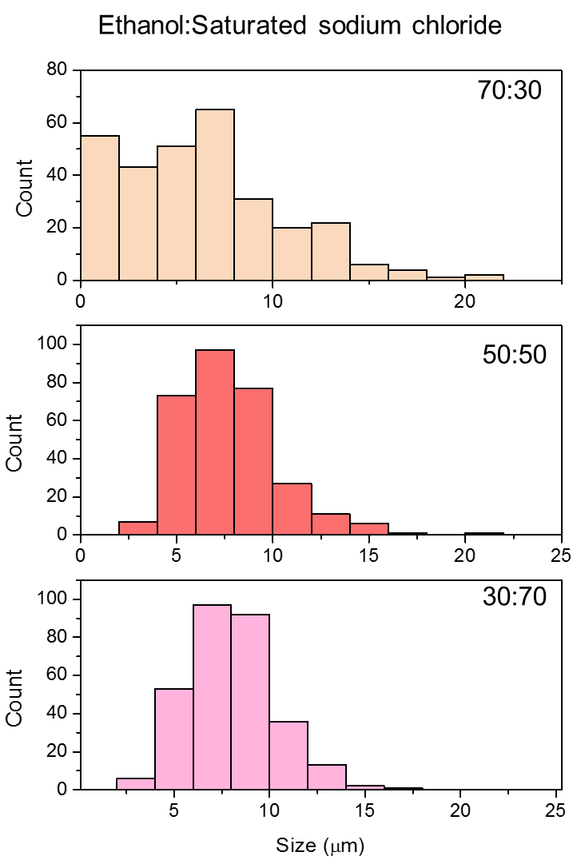
As demonstrated in Figure 3c the percentage ethanol present in the final mixture volume greatly affected the percentage recovery of the sodium chloride from solution. This percentage recovery is explainable as the final solubility of the sodium chloride in ratios of ethanol:water. As more ethanol is added to the saturated sodium chloride solution the solubility of the sodium chloride in the resultant solution drops. This causes the sodium chloride to precipitate out of solution. Figure 3b also shows the physical appearance of a SCP. It is important to note the monolithic structure of the SCP. During the filtration step attribute of the process. Previous literature has focused on the fusing of sodium chloride crystals at elevated humidity, but the hygroscopic nature of micrometre scale the makes sodium chloride crystals fuse in situ, even at low humidity levels. This fusing is evident when imaged via SEM (Figure 4).
Figure 4 – Altered micrograph of an SCP with ellipses overlaid to demonstrate areas in which the sodium chloride crystals fused
Figure 5 - Set of histograms showing the result of counting the longest exposed face of 200 sodium chloride crystals from micrographs of precipitant sodium chloride. Demonstrates that as the proportion of ethanol is increased in the final mixture the size of the crystals produced decreases
In addition to this fusing, as the percentage ethanol present in the final solution increases, it is noted that the distribution of sizes of crystals produced in the precipitation process changes. As can be seen in the histogram in Figure 5 the amount of smaller crystals increases as the proportion of ethanol also increases (ESI S5). This observation tied in with the improved percentage recovery resulted in the choice of using 90 % ethanol when exploring applications for the produced porous polymer as this also produced the smallest pore size and hence the greatest specific surface area.
Generation of porous polymer and properties
Molten pre-polymer (polymer that is partially reacted but not yet in the solid state) is poured onto the SCP and then cured to the solid state in the oven. The SCP-polymer composite is then place in water to generate a porous polymer matrix by dissolution and removal of the salt. Previous research demonstrated the potential of this process for the crosslinking agent DCPD, though with a larger pore size.³¹ To assess the generality of the technique, it was decided to also explore two renewable crosslinkers, the linear molecule farnesol and perillyl alcohol, alongside the widely studied crosslinker DIB. SEM imaging showed successful templating of all four of the polymers (Figure 6). The images reveal a fine microstructure, in which the imprints left behind by the SCP are very apparent. However, it should be noted that while DCPD, FSOL and DIB all formed monoliths PA did not. During the leaching process the monolith broke apart into a fine powder. A similar porous sulfur–polymer powder was previously been described as a ‘low density polysulfides’.⁴⁰
As demonstrated in Figure 6 the morphologies produced when using different polymers in the curing process are varied. It is possible that this difference in morphology is a result of the differing viscosities of the prepolymer solutions. A more viscous solution would be less able to penetrate fully into the SCP and would retain less of the fine microstructure that is present in the SCP. On the contrary however, it is also possible that the failure of S-PA to form a complete monolith could be also due to the mechanical strength of the polymer itself.
Mercury absorption
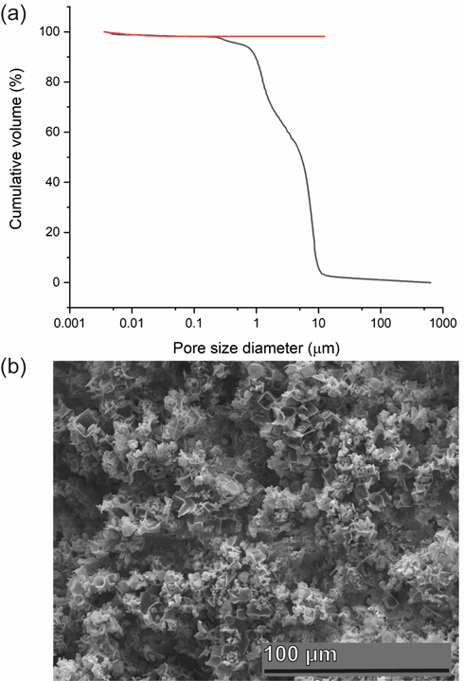
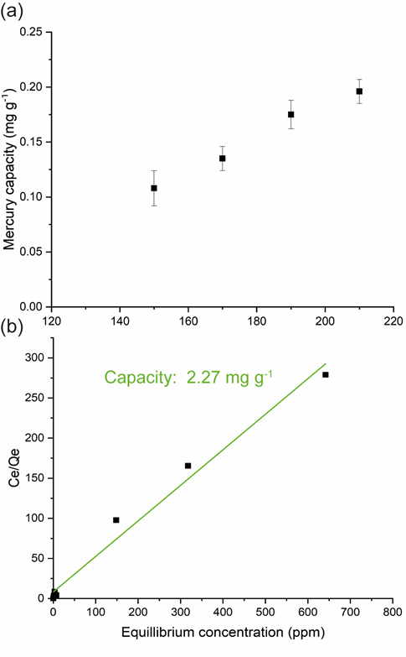
The application of porous sulfur polymers to the sorption of mercury from is a rapidly developing field.^{23,29,32,34,36,39,41,42} However, with each method developed comes a discrete set of advantages and disadvantages. While NaCl salt is attractive as a porogen in terms of low cost and good potential for scale-up, a disadvantage of the SCP method for generation of a mercury sorbent from inverse vulcanised polymers is that previously the capacity of the sorbent has been comparatively low. For example, Hg capacities of sulfur polymers have been reported in the range of 0.041 mg g⁻¹ (Parker et al.),³³ 0.0078 mg g⁻¹ (Worthington et al.),³⁹ 0.098 mg g⁻¹ (Parker et al.),³¹ and 0.151 mg g⁻¹ (Abraham et al.),³⁴ whereas sulfur polymers that have been electrospun, carbonised, or coated onto microporous supports can have capacities as high as 327.7 mg g⁻¹(Thielke et al.)³⁶, 850 mg g⁻¹ (Lee et al.)²⁹ , or 716 mg g⁻¹ (Wu et al.)⁴¹ respectively. That said, for widespread practical application as Hg sorbent, as long as uptake is adequate for use, commercial factors may be a more deciding factor. Therefore, the scope for production at scale makes salt templating an important process for investigation.
Figure 6 - (a) A graph that demonstrates the cumulative volume of the sample as a function of the pore size diameter obtained via mercury porosimetry (b) Micrograph demonstrating the morphology of the samples in which an open, porous network is demonstrated
Figure 7 - (a) Graph demonstrating the apparent linear dependence between the mercury capacity of a polymer and the temperature it was synthesised at (b) A plot of equilibrium concentration (Ce) vs the equilibrium concentration divided by the capacity at that concentration (Ce/Qe) which provides the saturation capacity of the material Q₀ which is known as the saturation capacity (2.27 mg g⁻¹) in this case
Previous reports on the salt templating of sulfur polymers by Chalker et al. and Abaraham et al. ^{34,43} both used NaCl crystals in their as supplied state, leading to pore sizes of the order of ~100 µm. By controlling the crystallisation of the NaCl from solution, the pore sizes reported here have been reduced by at least an order of magnitude, resulting in more accessible surface for adsorption. Consequently, the results obtained from this study are the highest to date in terms of mercury capacity of any salt templated sulfur polymer.
It has been previously demonstrated that different polymers have varying physical and chemical characteristics. Through the variation of reaction conditions and reagents it is possible to produce two polymers that are wildly variable in their physiochemical properties. One hypothesis is that the reaction may chain transfer via a hydrogen abstraction mechanism. This would produce terminal thiol groups, thus increasing the capacity of the sample for mercury. However, despite obtaining a graph showing a linear dependence for the temperature of synthesis vs the mercury capacity of the samples (Figure 7a) it was not possible to confirm that this is related to thiol production. It is likely that this is due to the weak FTIR S-H stretch not showing in the polymer (ESI S4).
Figure 7b demonstrates the Langmuir isotherm fitting used to obtain the saturation capacity of the porous polymer, the isotherm fitting revealed that the porous polymer has a saturation capacity of 56 mg g⁻¹. This saturation capacity exceeds that of all previously reported salt template sulfur polymers, as well as commercially available activated carbon that has a saturation capacity of 12.37 mg g⁻¹, as recently reported by Sharma et al..⁴⁴
In terms of the mechanism of absorption it is possible to make some broad conclusions. Firstly, the increased absorption in basic conditions suggests the active site is acidic. Secondly the kinetic graph (Figure S13) fits to a second order mechanism with a regression greater than 0.995, consistent with chemisorption, in agreement with an acidic ion exchange site.
Comparison to other sorbents present in the literature
When looking at potential new generation low cost sorbents it is important to make comparisons to previous attempts in the literature. It is also important to consider the characteristics (saturation capacity, absorption parameter, cost) of the sorbent in order to make a fair comparison. However, in the literature the properties of sorbents are not always fully explored, keeping this in mind however the material will be compared to various other materials produced in the literature.
Bio-sorbents and other naturally derived sorbents include clays, barks, animal products and other materials. These materials have the advantage of having almost no environmental impact given that they are responsibly sourced, but generally speaking lack the high-performance that is provided by ion-exchange resins and other synthetic materials.
Ghodbane et al. found that eucalyptus bark is capable of removing 33.11 mg g⁻¹ of mercury chloride from solution at 20 from solution at 20 degrees Celsius.⁴⁵ Bricka et al. investigated the use of cellulose as a potential bio-sorbent but found that the mercury uptake was 0.64 mg g⁻¹, even when it was functionalised with xanthanate esters.
Usually the more effective sorbents are those that are derived from the ‘cutting edge’ of chemistry – materials that possess molecular porosity such as MOFs and COFs. These materials are somewhat special in that their porosity is due to the nature of their bonds, and as such possess incredibly high specific surface areas, often exceeding 1000 m² g⁻¹, which makes them excellent sorbent media. For example, in a recent review by Wang et al. they looked in depth at the research landscape and found the best absorption capacity reported for a MOF was 836.7 mg g⁻¹ in a paper by Hu et al.^{46,47} Li et al. designed a mercury ‘nano-trap’ which in essence was a post-synthetically modified porous organic polymer that had a saturation capacity of 1014 mg g⁻¹.
Impressive as these materials are however, they have a downside in that the manufacture is often both costly or not easily implemented/requires the use of potentially dangerous chemicals.
It is also possible to generate new materials from waste products; it has been shown previously that it is possible to use fly ash as a sorbent. Fly ash is the remnant waste from the coal combustion process, and in a paper that was published by Wang et al. they demonstrated the uses of fly ash as a mercury sorbent.⁴⁸ Their material displayed uptake capacities of up to 1.85 mg g ⁻¹.
One of the key advantages in using a waste material to generate new materials is that the infrastructure is already in place. Bio-sorbents often do not have this pre-existing infrastructure and the mass production of molecularly porous materials is often difficult – barring the use of zeolites and activated carbons. Overall, we feel that despite the shortcomings of the material we have produced it is a novel and interesting material with the potential to be introduced as a low cost sorbent generated from waste products and low cost reagents.

Disposal or recycle
Recyclability of sorbents is often a concept that is tested in depth, usually making use of acidic washes, however given the cost of the material it would be prudent to dispose of the material as is. Burial underground would be appropriate as previous research (Worthington et al.) has demonstrated that the mercury eventually deposits as a mercury sulfur material that is presumable cinnabar, a naturally occurring mineral.
Conclusions
In summary, macroporous sulfur polymers with undefined surface areas were produced. Synthesis was performed with low cost, non-toxic, readily available materials. A range of crosslinking agents was explored: both those of a bio-renewable nature and industrial feedstocks.
The discovery that an increase in temperature of synthesis increased the mercury capacity of the polymer played a key role in increasing the mercury capacity of the sorbent to that which is higher than commercially available activated carbon.
While we explored the applicability of these polymers to mercury, it has been demonstrated that these porous polymers may have further applications in the recovery of aqueous gold, palladium and several other heavy metals.³²
There is great scope for the improvement of these materials, through the generation of more elastic materials that would be able to withstand deformation, or investigation into why the temperature of synthesis increases the mercury capacity of the polymers. We anticipate that these materials could be of great importance in future efforts to reduce global mercury contamination of wastewater streams.
Acknowledgements
We thank S. Moss for assistance with ICP-OES, and C. Crick for useful discussions. T. Hasell is supported by a Royal Society University Research Fellowship.
Notes and references
1 H. Gonzalez, Water Air Soil Pollut., 1991, 56, 83–93.
2 M. O. Fashola, V. M. Ngole-Jeme and O. O. Babalola, Int. J. Environ. Res. Public Health, , DOI:10.3390/ijerph13111047.
3 T. Astrup, H. Mosbæk and T. H. Christensen, Waste Manag., 2006, 26, 803–814.
4 Q. Yang, Z. Li, X. Lu, Q. Duan, L. Huang and J. Bi, Sci. Total Environ., 2018, 642, 690–700.
5 V. B. Vouk and W. T. Piver, Environ. Health Perspect., 1983, 47, 201.
6 R. A. Wuana and F. E. Okieimen, ISRN Ecol., 2011, 2011, 1–20.
7 M. A. Hassanien, Springer, Dordrecht, 2011, pp. 287–307.
8 P. B. Tchounwou, C. G. Yedjou, A. K. Patlolla and D. J. Sutton, Exp. Suppl., 2012, 101, 133–64.
9 W. Y. Shiu, K. C. Ma, D. Mackay, J. N. Seiber and R. D. Wauchope, Rev. Environ. Contam. Toxicol., 1990, 116, 15–187.
10 United Nations Environment Program, Global Mercury Assessment 2018 | UNEP, https://www.unenvironment.org/resources/publication/global-mercury-assessment-2018, (accessed 12 September 2019).
11 N. E. Selin, Annu. Rev. Environ. Resour., 2009, 34, 43–63.
12 H. Tamashiro, H. Akagi, M. Arakaki, M. Futatsuka and L. H. Roht, Int. Arch. Occup. Environ. Health, 1984, 54, 135–46.
13 United Nations, MINAMATA CONVENTION ON MERCURY, 2013.
14 O. A. Osiro, D. K. Kariuki and L. W. Gathece, Int. Dent. J., , DOI:10.1111/idj.12461.
15 L. J. Esdaile and J. M. Chalker, Chem. - A Eur. J., 2018, 24, 6905–6916.
16 C. Song, Catal. Today, 2003, 86, 211–263.
17 A. V Tobolsky, J. Polym. Sci. Part C Polym. Symp., 1966, 12, 71–78.
18 B. Meyer, Chem. Rev., 1976, 76, 367–388.
19 M. J. H. Worthington, R. L. Kucera and J. M. Chalker, Green Chem., 2017, 19, 2748–2761.
20 Y. Zhang, R. S. Glass, K. Char and J. Pyun, Polym. Chem., 2019, 10, 4078–4105.
21 J. J. Griebel, R. S. Glass, K. Char and J. Pyun, Prog. Polym. Sci., 2016, 58, 90–125.
22 W. J. Chung, J. J. Griebel, E. T. Kim, H. Yoon, A. G. Simmonds, H. J. Ji, P. T. Dirlam, R. S. Glass, J. J. Wie, N. A. Nguyen, B. W. Guralnick, J. Park, Á. Somogyi, P. Theato, M. E. Mackay, Y.-E. Sung, K. Char and J. Pyun, Nat. Chem., 2013, 5, 518.
23 T. Hasell, D. J. Parker, H. A. Jones, T. McAllister and S. M. Howdle, Chem. Commun., 2016, 52, 5383–5386.
24 J. A. Smith, X. Wu, N. G. Berry and T. Hasell, J. Polym. Sci. Part A Polym. Chem., 2018, 56, 1777–1781.
25 S. Z. Khawaja, S. Vijay Kumar, K. K. Jena and S. M. Alhassan, Mater. Lett., 2017, 203, 58–61.
26 P. T. Anastas and J. C. Warner, Green Chemistry: Theory and Practice, Oxford University Press, 1998.
27 Z. Deng, A. Hoefling, P. Théato and K. Lienkamp, Macromol. Chem. Phys., 2017, 219, 1700497.
28 J. J. Griebel, S. Namnabat, E. T. Kim, R. Himmelhuber, D. H. Moronta, W. J. Chung, A. G. Simmonds, K.-J. Kim, J. van der Laan, N. A. Nguyen, E. L. Dereniak, M. E. Mackay, K. Char, R. S. Glass, R. A. Norwood and J. Pyun, Adv. Mater., 2014, 26, 3014–3018.
29 J.-S. M. Lee, D. J. Parker, A. I. Cooper and T. Hasell, J. Mater. Chem. A, 2017, 5, 18603–18609.
30 M. Mann, J. E. Kruger, F. Andari, J. McErlean, J. R. Gascooke, J. A. Smith, M. J. H. Worthington, C. C. C. McKinley, J. A. Campbell, D. A. Lewis, T. Hasell, M. V Perkins and J. M. Chalker, Org. Biomol. Chem., , DOI:10.1039/C8OB02130A.
31 D. J. Parker, H. A. Jones, S. Petcher, L. Cervini, J. M. Griffin, R. Akhtar and T. Hasell, J. Mater. Chem. A, 2017, 5, 11682–11692.
32 M. P. Crockett, A. M. Evans, M. J. H. Worthington, I. S. Albuquerque, A. D. Slattery, C. T. Gibson, J. A. Campbell, D. A. Lewis, G. J. L. Bernardes and J. M. Chalker, Angew. Chemie Int. Ed., 2015, 55, 1714–1718.
33 D. J. Parker, S. T. Chong and T. Hasell, RSC Adv., 2018, 8, 27892–27899.
34 A. Mammoottil Abraham, V. Wadi, V. Vijayan Pillai and S. Alhassan, Sulfur Rich Porous Material for Mercury Adsorption and Thermal Insulation, 2017.
35 J. M. Chalker, M. J. H. Worthington, N. A. Lundquist and L. J. Esdaile, Springer, Cham, 2019, pp. 125–151.
36 M. Thielke, L. Bultema, D. Brauer, B. Richter, M. Fischer, P. Theato, M. W. Thielke, L. A. Bultema, D. D. Brauer, B. Richter, M. Fischer and P. Theato, Polymers (Basel)., 2016, 8, 266.
37 W. L. Murphy, R. G. Dennis, J. L. Kileny and D. J. Mooney, Tissue Eng., 2002, 8, 43–52.
38 N. A. Lundquist, M. J. H. Worthington, N. Adamson, C. T. Gibson, M. R. Johnston, A. V Ellis and J. M. Chalker, RSC Adv., 2018, 8, 1232–1236.
39 M. J. H Worthington, R. L. Kucera, I. S. Albuquerque, C. T. Gibson, A. Sibley, A. D. Slattery, J. A. Campbell, S. F. K Alboaiji, K. A. Muller, J. Young, N. Adamson, J. R. Gascooke, D. Jampaiah, Y. M. Sabri, S. K. Bhargava, S. J. Ippolito, D. A. Lewis, J. S. Quinton, A. V Ellis, A. Johs, G. J. L Bernardes, J. M. Chalker, M. J. H Worthington, R. L. Kucera, C. T. Gibson, A. Sibley, A. D. Slattery, J. A. Campbell, S. F. K Alboaiji, J. Young, N. Adamson, J. R. Gascooke, D. A. Lewis, J. S. Quinton, A. V Ellis, J. M. Chalker, S. I. Australia S Albuquerque, G. J. L Bernardes, S. D. Australia Jampaiah, Y. M. Sabri, S. K. Bhargava and S. J. Ippolito, Chem. Eur. J, 2017, 23, 1–13.
40 N. A. Lundquist, M. J. H. Worthington, N. Adamson, C. T. Gibson, M. R. Johnston, A. V. Ellis and J. M. Chalker, RSC Adv., 2018, 8, 1232–1236.
41 X. Wu, J. A. Smith, S. Petcher, B. Zhang, D. J. Parker, J. M. Griffin and T. Hasell, Nat. Commun., 2019, 10, 647.
42 D. J. Parker, S. T. Chong and T. Hasell, RSC Adv., 2018, 8, 27892–27899.
43 M. J. H. Worthington, C. J. Shearer, L. J. Esdaile, J. A. Campbell, C. T. Gibson, S. K. Legg, Y. Yin, N. A. Lundquist, J. R. Gascooke, I. S. Albuquerque, J. G. Shapter, G. G. Andersson, D. A. Lewis, G. J. L. Bernardes and J. M. Chalker, Adv. Sustain. Syst., 2018, 2, 1800024.
44 A. Sharma, A. Sharma and R. K. Arya, Sep. Sci. Technol., 2015, 50, 1310–1320.
45 I. Ghodbane and O. Hamdaoui, J. Hazard. Mater., 2008, 160, 301–309.
46 X. Wang, J. N Manikoff, X. Wang and J. N Manikoff, Gen. Chem., 2018, 4, 180003–180003.
47 Y. Wu, G. Xu, F. Wei, Q. Song, T. Tang, X. Wang and Q. Hu, Microporous Mesoporous Mater., 2016, 235, 204–210.
48 S. Wang and H. Wu, J. Hazard. Mater., 2006, 136, 482–501.

