Gene Expression, Metabolite and Lipid Profiling in Eco-indicator Daphnia magna Indicate Diverse Mechanisms of Toxicity by Legacy and Emerging Flame-retardants

Leona D. Scanlan^{1#}, Alex Loguinov¹, Quincy Teng², Philipp Antczak³, Kathleen Dailey¹, Daniel Nowinski¹, Jonah Kornbluh¹, Xin Xin Lin¹, Erica Lachenauer¹, Audrey Arai¹, Katie Douglas⁴, Francesco Falciani³, Heather M. Stapleton⁴, Chris Vulpe¹

¹University of California Berkeley, Department of Nutritional Sciences and Toxicology, Berkeley, CA 94720
² U.S. EPA, National Exposure Research Laboratory, Athens, GA 30605
³University of Liverpool Institute for Integrative Biology, Liverpool, L69 7ZB, UK
⁴ Nicholas School of the Environment, Duke University, Durham, NC 27708
* Address correspondence to vulpe@berkeley.edu
# Current address: National Institute of Standards and Technology, Biomolecular Measurement Division, Gaithersburg, MD, 20899.

ABSTRACT
The use of chemical flame-retardants (FR) in consumer products has steadily increased over the last 30 years. Toxicity data for legacy FRs such as pentabromodiphenyl ether (pentaBDE) exist, but little is known about effects of new formulations. To address this issue, the toxicity of seven FR chemicals and formulations was assessed on freshwater crustacean Daphnia magna. Acute 48-hour nominal LC₅₀ values for penta- and octabromodiphenyl ether (pentaBDE, octaBDE), Firemaster550® (FM550), Firemaster® BZ-54 (BZ54), bis (2-ethylhexyl) tetrabromophthalate (BEH-TEBP), triphenyl phosphate (TPHP), and non-brominated BEH-TEBP analog bis (2-ethylhexyl) phthalate (BEHP) ranged from 58 μg/L (pentaBDE) to 3.96 mg/L (octaBDE). Gene expression, ^{H}NMR-based metabolomic and lipidomic profiling at 1/10 LC₅₀ revealed distinct patterns of organismal response for each exposure. Brominated components of FM550 (i.e. BZ-54) accumulated in Daphnia magna over 48-hours following 1/10 LC₅₀ exposure. In dose-response analysis, FM550 elicited significant transcriptional responses at five concentrations across a range from 1/10⁶ LC₅₀ to ½ LC₅₀. Our results suggest that octaBDE, BZ54 and BEH-TEBP affect distinct signal-transduction pathways, while pentaBDE affects protein turnover and FM550 impairs nutrient utilization or uptake in Daphnia. Results cannot confirm traditionally defined narcosis as a mode of toxicity as compounds affected Daphnia through diverse molecular mechanisms.

TOC
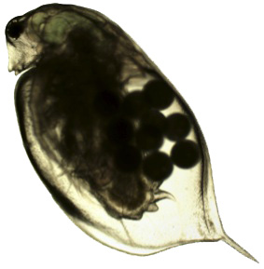

INTRODUCTION
California passed Technical Bulletin 117 in 1975, mandating all upholstered furniture sold in the state to meet an open-flame flammability standard. Manufacturers used chemical flame-retardant mixtures such as polybrominated diphenyl ethers (PBDE) to meet this requirement.¹ ² The law was amended in 2013 (TB117-2013) to include alternate flammability standards methods,³ but FR chemicals are still used and are still present in homes. Leaching of FRs from consumer products caused global contamination – PBDEs such as pentaBDE are in soil near recycling facilities,⁴ sewage sludge in South Africa,⁵ U.S. costal sediments,⁶ the atmosphere above the U.K.,⁷ and the Canadian arctic.⁸ PBDEs are detected in biota including sea turtle eggs,⁹ lake trout, Chinook salmon,¹⁰ humpback dolphins,¹¹ and wild frogs.¹²
PBDEs are also detected in human serum,¹³ ¹⁴ breast milk¹⁵ ¹⁶ and adipose tissue.¹⁷ Studies in the US found significant associations between PBDEs in human serum and PBDEs in house dust,¹⁸ and levels in the Californian population are higher than those in other US states.¹⁴ Human exposure to PBDEs can occur from dietary sources and from inadvertent ingestion of contaminated house dust particles.¹⁴ ¹⁹
Toxicity studies in mammals found that pentaBDE elicits numerous toxicological effects, including hyperactivity in rodents ²⁰ ²¹ and impaired spermatogenesis in rats.²¹ PBDEs also disrupts thyroid hormone regulation.²² In human adult males, exposure is associated with changes in thyroid hormone (T3 and T4), estradiol, sex hormone binding globulin and follicle stimulating hormone.²³ PBDEs can potentially convert photochemically to dioxin, a potent carcinogen,²⁴ ²⁵ but do not act via the aryl hydrocarbon receptor in vitro.²⁶
Studies on the lower-trophic organism Daphnia manga show that hexaBDE affects reproduction in the μg/L range.²⁷ Tetra- and triBDE can delay molting in adult daphnids.²⁸ PentaBDE changes retinoid status in zebrafish.²⁹ PBDEs induce many toxicological phenotypes, but specific molecular mechanisms of toxicity are not fully understood.³⁰
PBDEs are persistent and bio-accumulative and are prone to long-range global transport.³¹ ³² PentaBDE and octaBDE were banned from use in the European Union (EU), voluntarily phased out in the United States, and added to the Stockholm Convention as Annex A chemicals slated for elimination.³³ ³¹ ³⁴ ³⁵ As a result, levels of PBDEs are decreasing in CA homes. There is, however, a corresponding increase in one of the PentaBDE replacements, Firemaster®550 (FM550).³⁶
FM550 started replacing pentaBDE in furniture foam and fabric in 2004.² It is a mixture of four different chemicals: two brominated components, bis (2-ethylhexyl) tetrabromophthalate (BEH-TEBP, 8%) and 2-ethylhexyl-2,3,4,5-tetrabromobenzoate (EH-TBB, 30%), and two aryl phosphate ester compounds, triphenyl phosphate (TPHP, 17%) and isopropylated triaryl phosphates (ITP, 45%). ITP is a mixture of ortho-, meta-, and para-substituted isomers of mono-, di-, tri-, and tetra-ITPs.³⁷ ³⁸ ³⁹ Related mixture Firemaster BZ54 consists of BEH-TEBP (30%) and EH-TBB (70%).⁴⁰ FM550 is applied to polyurethane foam in furniture⁴¹ and some infant products.⁴² The brominated components BEH-TEBP and EH-TBB were detected in house dust in 2006, 2012 and 2014;³⁸ ⁴³ levels are increasing.³⁶ BEH-TEBP and EH-TBB were detected in marine biota including mammals in Hong Kong,¹¹ mysid shrimp in the Netherlands⁴⁴ and a bivalve and a gastropod from North Carolina.⁴⁵
Studies on FM550 show endocrine effects and obesity in rats after perinatal exposure⁴⁶ ⁴⁷ and can activate PPARγ in Chinese Hamster ovary cells.⁴⁸ Human HepG2 cells showed an increase in AhR-dependent transcription,³⁹ but rat hepatocytes did not.⁴⁹ In vitro metabolism studies found phase I metabolites in human and rat liver microsomes and from porcine carboxylesterase.⁵⁰ In studies with ecologically relevant species, EH-TBB and BEH-TEBP caused a significant increase in DNA strand breaks in fathead minnow liver cells during exposure but not after a recovery period.⁵¹ Fathead minnow and carp hepatically metabolize EH-TBB and BEH-TEBP in vitro.⁴⁰ TPHP and monoITP exposures affect zebra fish embryo heart development through AhR-independent (TPHP, monoITP) and AhR-dependent (monoITP) pathways.³⁹ The present study is the first to look at mechanistic effects of FM550 to lower-level trophic species Daphnia magna.
Triphenyl phosphate (TPHP, also called TPP) is a EU high-production volume plasticizer and flame-retardant that can enter the environment by diffusive volatilization, leaching and abrasion.⁵² It has been detected in sewage treatment plant influent and effluent,⁵³ air, water, house dust and sediment, but data on TPHP occurrence in biota and mode of toxicity are limited.⁵⁴ 96-hour LC₅₀ values for TPHP on fish species range from 300-1200 μg/L, but can be as high as 300 mg/L; LC₅₀ values for TPHP on Daphnia range from 1 to 1.35 mg/L.⁵⁵
Daphnia magna are commonly used to evaluate invertebrate response to environmental pollutants.⁵⁶ ⁵⁷ As a lower-trophic parthenogenetic filter feeder, they ingest suspended solids and associated hydrophobic chemicals. It is important to understand the effects of FRs on environmentally relevant Daphnia manga because biotic exposure to FRs may occur through disposal and leaching. PBDEs are hydrophobic and can accumulate in marine copepods,⁵⁸ ⁵⁹ and some brominated FRs biomagnify in aquatic food chains.⁶⁰

This work represents the first comprehensive analysis of the acute toxicity of seven emerging and legacy chemical FR formulations. It also investigates molecular mechanisms of toxicity of chemical FRs on an ecologically relevant invertebrate via gene expression microarray, ^{H}NMR based metabolomics, lipidomic profiling and subsequent data analyses. This work sought to determine if response to FRs was unique or nonspecific, as hydrophobic chemicals are presumed to act through a general narcotic mode of toxicity and would cause indistinguishable gene expression profiles and molecular effects.⁶¹

MATERIALS AND METHODS
Daphnia culture. Daphnia magna (Aquatic Research Organisms) were cultured asexually in a growth chamber (Conviron) at 21±1 ºC with 16 hours of light and eight hours of dark per day in COMBO⁶² media. They were fed Pseudokirchneriella subcapitata (formerly Selenastrum capricornutum) and yeast cereal-leaf and trout chow mix three times per week following renewal of media. Media was aerated overnight to increase dissolved oxygen levels. pH was maintained at 7.4-7.8. Media chemical composition is described in Table S1. All chemical exposures were done in glass beakers.

Toxicity assays. Acute toxicity assays were similar to U.S. EPA Whole Effluent Toxicity.⁶³ Five first instar (<24 hours old) daphnids were added to 35 ml COMBO media. Chemical FRs dissolved in dimethyl sulfoxide (DMSO) (EMD Chemicals, Inc) were added to make five concentrations of FR. 0.05 – 0.1% DMSO total exposure volume was used. Typically, four replicates of five daphnids were exposed to five different concentrations of FR and a DMSO control at one time. At least three sets of four replicates each were conducted per FR, with the exception of BZ54, for which a significant LC₅₀ was determined after fewer exposures. Animals were fed algae after 24 hours, and lethality was measured after 48 hours. Acute LC₅₀ values were determined using probit⁶³ or Spearman-Karber.⁶⁴ Chemicals were manufactured by: Chemtura (FM550 and BZ54), Unitex (BEH-TEBP), Aldrich (TPHP), Larodan Chemicals (pentaBDE), Bromine Compounds Ltd (octaBDE), and Aldrich (BEHP). Chemical abbreviation nomenclature is from Bergman et. al 2012.⁶⁵ Chemical structures are shown in Figure 1.

Accumulation of FM550. 100 adult daphnids were exposed in four liters COMBO media to 48.6 µg/L (1/10 LC₅₀), 48.6 ng/L or to a DMSO control. Animals were fed algae after 24 hours, removed from exposure media at 48 hours and put in chemical-free media for a 24-hour depuration with feeding before removal and freezing at -80 ºC. For microarray analysis, animals were removed from exposure media and RNA was extracted immediately with methods described below. Exposures were repeated until a total of four biological replicates of ~400 daphnids were collected per concentration. Samples were analyzed for EH-TBB and BEH-TEBP concentration using gas chromatography mass spectrometry operated in negative chemical ionization mode (GC/ECNI-MS).³⁸ Detailed methods are in the Supporting Information (SI). A one-way ANOVA test was performed in Prism (Graphpad) to determine significant differences between exposure groups. Samples with p-value <0.05 were considered significant. EH-TBB was not detected in laboratory blanks (<0.5 ng) but was detected in the control samples (83.6 ± 22.8 ng). BEH-TEBP was detected in laboratory blanks (1.2 ± 1.1 ng) and was above MDL in one control sample.

Gene expression microarrays. 15-20 adult (14 day old) daphnids were exposed to 1/10 LC₅₀ or DMSO volume control in 800 ml COMBO media. Animals were fed algae after 24 hours, and after 48 hours RNA was extracted in Trizol reagent (Invitrogen) with a handheld homogenizer (Biospec Products Inc). RNA quality was assessed with spectrometry and agarose gel electrophoresis. 200 ng RNA was then reverse-transcribed, amplified and hybridized onto a custom Agilent Oligonucleotide DNA microarray (AMADID # 023710) with the Agilent Low-Input Quick-Amp one-color array kit and protocol (Santa Clara, CA). Four exposed and four control arrays were done per chemical and for five total FM550 concentrations. One TPHP control and one FM550 control were removed due to experimental error. Arrays were scanned with a 16-bit GenePix 4000B Microarray Scanner with 5-micron resolution. Features were edited and regression analysis was performed with GenePix Pro, and the resultant data were processed as in Loguinov et al.⁶⁶ Detailed methods are available in the SI. Array data is available at http://www.ncbi.nlm.nih.gov/geo.

Quantitative reverse transcription PCR. To independently verify microarray results, expression of ten genes in eleven conditions was analyzed with qPCR. Genes were chosen based on q-value, degree of differential expression or potential mode of toxicity. 1 µg RNA (from additional biological replicates) was reverse transcribed and amplified as in Scanlan et al.⁶⁷ Actin and GAPDH were used as housekeeping genes. Primer sequences are shown in Table S2. Detailed methods are available in the SI.

Gene ontology, pathway enrichment and cluster analysis. The Daphnia magna array was annotated with a protein blast, which identified 4958 Daphnia pulex homologues with an expect (E) value less than or equal to 10⁻⁴. The list was matched with the Kyoto Encyclopedia of Genes and Genomes (KEGG) database annotation (www.genome.jp/kegg) and genes were sorted into respective pathways. Of these, 1425 mapped onto 114 Daphnia pulex KEGG pathways. Pathways representing less than five genes in the array were removed, leaving 95 pathways and 1402 genes total in an unbiased sample of the original 371 KEGG pathways. Significance was calculated using a modified Fisher Exact Probability P-value.⁶⁸ ⁶⁹
Similarity of gene expression data was analyzed with Hierarchical Ordered Partitioning And Collapsing Hybrid (HOPACH) cluster analysis using the R package hopach from bioconductor.org using the cosangle distance metric.⁷⁰ All “NA” values were replaced with zeros. HOPACH provides a measure of clustering reproducibility through boot strap resampling and assigns a probability of “cluster membership” for each chemical/gene.

Blast2GO⁷¹ (B2G) gene ontology enrichment analysis was performed on gene expression data to determine gene functions affected in each exposure. Microarray gene probes and EST sequences were annotated with B2G (default parameters) to create a reference gene set. Expression data for each chemical was compared to the reference set via Enrichment Analysis (default, two-tailed settings). Enrichment was performed with 0.01, 0.05 and 0.15 False Discovery Rates (FDR, measure of significance). Additional B2G and HOPACH analyses on FM550 dose-response are detailed in the SI.

Metabolomics of FM550 and pentaBDE-exposed Daphnia. For instrument optimization, hemolymph from 80 unexposed adult (14 day old) daphnids was collected from daphnids incubated in 800 mL COMBO media with feeding after 24 hours. After 48 hours, hemolymph was extracted by piercing the carapace with a needle and aspirating hemolymph with a small pipette.^{62, 72} For metabolomics analysis, animals were exposed to 1/10 LC₅₀ FM550 or pentaBDE or DMSO control (with equal volume chemical), fed after 24 hours and frozen on dry ice after 48 hours. Seven biological replicates of 40 animals each were collected for each condition and stored at -80 °C until analysis. Hemolymph was extracted using a dual phase extraction procedure⁷³ and ^{H}NMR spectra were acquired at 20ºC on an Agilent Inova 600 MHz NMR spectrometer with a cryogenic triple-resonance flow probe using direct-injection NMR analysis.⁷⁴ ⁷⁵ Data were further analyzed with MetaboAnalyst 2.0 (http://www.metaboanalyst.ca)⁷⁶ ⁷⁷ to determine overrepresentation of biological function groups and pathway analysis. Methods are detailed in the SI.

Lipidome of FM550 and pentaBDE-exposed Daphnia. Daphnids were exposed to 1/10 LC₅₀ FM550 or pentaBDE or DMSO control, as above. After 48 hours, animals were removed from culture, flash-frozen on dry ice, ground in 1.6 ml ultra-pure water with a handheld homogenizer (Biospec Products Inc.) and frozen at -80 ºC. Lipids were extracted and analyzed by the Kansas State University Lipidomics Research Center. Five replicates of 10-11 animals were collected for each condition. Data were log transformed and significance was determined with a standard two-sample t-test and a Wilcox rank sum test for two sample data. Additional details on extraction methods and statistical analyses are available in SI.

RESULTS
Flame-retardant Toxicity in Daphnia magna. LC₅₀ values were determined for each FR after a 48 hr exposure (Table 1 and Figure 2). LC₅₀ values are reported as milligrams FR per liter COMBO media (mg/L). PentaBDE was significantly more toxic than any other FR (LC₅₀ = 58 μg/L), determined by binary comparison of LC₅₀ values and corresponding confidence intervals.⁷⁸ OctaBDE and BEHP were the least toxic (3.96 and 3.31 mg/L). Of note, BEHP was significantly less toxic to Daphnia than its brominated homolog BEH-TEBP. No correlation was found between the log K_{ow} and the log LC₅₀ for each compound (Figure S1), although sample size precludes robust statistical confidence. Log K_{ow} values were taken from published studies and, for PBDEs, log K_{ow} values were weighted by congener abundance (Table S3).³⁹ ⁷⁹ ⁸⁰ ⁸¹ ⁸²

FM550 accumulates in Daphnia magna after a 48-hour exposure to 1/10 LC₅₀. Daphnids exposed to 1/10 LC₅₀ FM550 (48.6 μg/L) for 48 hours showed a significant increase in both BEH-TEBP and EH-TBB as compared to control (Figure 3). Exposure to 1/10,000 LC₅₀ (48.6 ng/L) was not significantly higher than control. Measured concentrations are reported in Table S4.

Each flame-retardant caused distinct patterns of differential gene expression at 1/10 LC₅₀. Gene expression microarray, qPCR and computational analyses were used to investigate and compare biological effects of FR exposure. Table S5a lists the number of differentially expressed genes in each condition. qPCR independently verified microarray results for 27 out of 32 genes tested (Table S6). HOPACH cluster analysis of differential expression grouped BEH-TEBP and BZ54 together while all other FRs clustered individually (Figure 4). KEGG pathway enrichment analysis found a total of 12 pathways overrepresented (Table 2), four in common to two conditions. No KEGG findings were significant for TPHP.

All FM550 concentrations affected gene expression. Gene expression analysis was performed with RNA from daphnids exposed to 243 μg/L (1/2 LC₅₀), 48.6 μg/L (1/10 LC₅₀), 48.6 ng/L, 243 pg/L or 48.6 pg/L FM550 (N = 4 replicates each). Exposure at 48.6 ng/L (1/10,000 LC₅₀) resulted in the largest number of differentially expressed genes as compared to untreated control. Surprisingly, all concentrations caused differential gene expression suggesting that the no-observed transcriptional effect level⁸³ ⁸⁴ was not reached. The number of differentially expressed genes is in Table S5b. Three genes (a trichohyalin-like protein, peroxidase and an unknown protein) were differentially expressed at each concentration (Table S7). When compared to other FRs, HOPACH clustered all concentrations together, with three concentrations significantly similar to each other (Figure 4). KEGG pathway enrichment analysis found significant enhancement of pathways (p-value ≤ 0.1) for three concentrations (48.6 μg/L, 48.6 ng/L and 48.6 pg/L). A total of seven pathways were affected; however each was unique to one concentration (Table S8). Analyses for linear trend⁸⁵ ⁸⁶ ⁸⁷ found three genes significantly, negatively associated to concentration (Table S9) and a large decrease in gene response at the highest concentrations (Table S10). Chemical clustering (HOPACH) showed the highest exposures were most similar, while the lowest was least (Figure S1). Clustering based on gene expression found 44 clusters (not shown). B2G⁷¹ gene ontology analysis with GOSSIP ⁸⁸ on the largest cluster indicated over-expression of functions related to oxygen binding, oxygen transporter activity and the hemoglobin complex (Table S11).

FM550 metabolite profiles are distinguishable from control, while pentaBDE profiles are not. To better understand effects at the metabolite level, ^{H}NMR was used to investigate changes in hemolymph metabolomic profiles between control and 1/10 LC₅₀-exposed Daphnia. PLS-DA scores plots (Figure S2) show considerable separation between control and FM550-exposed daphnids (validated with ANOVA, p-value = 0.04). FM550 exposure elevated or decreased levels of 14 small molecule metabolites (Table S12). Pathway analysis with MetaboAnalyst showed an increase in nitrogen metabolism, arginine and proline metabolism and aminoacyl-tRNA biosynthesis and a decrease in valine, leucine and isoleucine degradation and aminoacyl-tRNA biosynthesis (Table S13). Enrichment analysis with MetaboAnalyst showed an increase in ammonia recycling and protein biosynthesis and a decrease in protein biosynthesis and valine, leucine and isoleucine degradation (Table S14). Changes in valine, leucine and isoleucine gene expression were also seen in gene expression data from one FM550 exposure (48.6 ng/L). There was no significant difference between pentaBDE-exposed and control groups (Figure S2 and Figure 5).

Changes in lipidome were detected after exposure to FM550 or pentaBDE. FR chemicals tested in this study are hydrophobic, and FM550 caused transcriptional changes in genes related to fatty acid metabolism and the peroxisome. To complement transcriptomic and metabolomic studies, changes in the lipidome of FM550 and pentaBDE-exposed animals were analyzed. Both pentaBDE and FM550 significantly changed the level of two fats out of 352 tested (p-value ≤ 0.04, Table S15). FM550 increased a phosphatidylcholine with 42 carbons and seven double bonds (PC 42:7), while pentaBDE increased lysophosphatidylcholine (LPC 20:0), and both increased phosphatidylcholine (PC 44:9).

DISCUSSION
Flame-retardants are toxic to Daphnia magna. LC₅₀ values show that FM550 and its components are highly toxic to aquatic organisms as defined by the U.S. EPA (LC₅₀ values of 0.1 – 1 mg/L). Actual dissolved chemical concentrations are unknown as quantification in aqueous media is difficult or impossible. FRs have low aqueous solubility, and DMSO was used to increase chemical availability. PentaBDE was one to two orders of magnitude more acutely toxic than any other FR; octaBDE was one of the least toxic. The phenomenon of increased toxicity with less-brominated PBDEs has been seen in other organisms,⁸⁹ ⁹⁰ ⁹¹ but the trend is not always true in Daphnia magna.²⁸ BZ54, which contains BEH-TEBP and EH-TBB, was significantly more toxic than BEH-TEBP alone. TPHP, BEHP and BZ54 LC₅₀ values agree with those previously derived.⁹² ⁹³ ³⁹ ⁹⁴ Our work establishes for the first time LC₅₀ values for FM550 mixture, BEH-TEBP, and octaBDE.

Molecular effects are unique for each chemical and formulation. Aquatic toxicants are commonly divided into different categories based on chemical properties and presumed mechanism of action: non-polar hydrophobic chemicals causing Type I narcosis, polar hydrophobic chemicals causing Type II narcosis, unselective reactive chemicals, and chemicals with specific modes of action.⁹⁵ Hydrophobic chemicals with a log K_{ow} ≥ 2.7 are often considered “narcotics.” Toxicity attributed to narcosis is postulated to result from chemical disruption of lipid-based cellular membranes,⁹⁶ ⁹⁷ which leads to an as-of-yet unspecified cellular dysfunction. Type I molecules are believed to move three-dimensionally through membranes, while Type II molecules interact with charged phospholipid headgroups;⁹⁸ toxicity is attributed to a shared mechanism.⁹⁷ However, some hydrophobic chemicals cause greater toxicity than is predicted from K_{ow},⁹⁸ which cannot be attributed to “narcosis”.⁹⁵

We did not see a relationship between the log K_{ow} and log LC₅₀ (Figure S3). Previous work in Daphnia on two presumed narcotics (pyrene and fluoranthene) by Vandenbrouck et al, did not find clear separation between gene expression profiles of individual chemicals and binary mixtures at various concentrations, suggesting a similar mode of action that was interpreted as narcosis.⁶¹ However, in the present work, clear differences were seen at the gene expression, metabolomics and lipidomic levels. While the data set is limited, results suggest biological effects beyond those attributed to chemical hydrophobicity and narcosis.

KEGG pathway analysis further supports specific mechanisms of action for the flame-retardants in Daphnia magna. OctaBDE and BEH-TEBP increased the glycosphingolipid biosynthesis pathway, involved in growth factor signaling and morphogenesis in arthropods.⁹⁹ BZ54 affected Wnt and Hedgehog signal transduction and glycosaminoglycan degradation. Results for pentaBDE showed an increase in expression of genes related to pyrimidine (C, T and U nucleotides) metabolism, the spliceosome, the ribosome, and the proteasome suggesting an effect on transcription and translation.

FM550 accumulates in Daphnia magna and may cause nutritional dysregulation. BEH-TBPH and EH-TBB are detected in marine mammals¹¹ and accumulate in fathead minnows,⁵¹ and could bioaccumulate, although in vitro studies show rapid metabolism of EH-TBB.⁵⁰ We found that D. magna accumulated both brominated components after 48 hours, suggesting trophic transfer could be possible.

Analysis of ^{H}NMR metabolomic data (Tables S13 and S14) showed an effect on nitrogen metabolism and ammonia recycling, which is related to protein catabolism in Daphnia¹⁰⁰ and increases along with the rate of ammonia excretion when Cladocerns energy requirements are not met (e.g. starvation).¹⁰¹ ¹⁰² Ammonia itself is detrimental to Daphnia and can decrease the number of molts, time to egg laying, and size of eggs.¹⁰³ In this study, KEGG analyses showed transcriptional changes consistent with effects on the nutritional status of Daphnia, specifically fatty acid and amino acid metabolism. These results are consistent with nutritional deficiency in Daphnia exposed to FM550. Dose-response data also showed possible effects on oxygen transport. Three genes differentially expressed in all five concentrations may be useful biomarkers of exposure to FM550.

ACKNOWLEDGEMENTS
This work was supported by NSF CBET-1066358 to CV, NIEHS R01ES016099 to HMS and NERC Grant NE/1028246/2 to FF. The lipid analyses performed at Kansas Lipidomics Research Center Analytical Laboratory were supported by NSF EPS 0236913, MCB 0455318 and DBI 0521587.

TABLES
Chemical | LC₅₀ (mg/L) | Statistical Method | 95% Confidence Interval
FM550 | 0.486 | Spearman-Karber | 0.357-0.661
BEH-TEBP | 0.91 | Spearman-Karber | 0.830-0.990
BZ54 | 0.5 | Spearman-Karber | 0.400 - 0.620
TPHP | 0.53 | Spearman-Karber | 0.480 - 0.580
PentaBDE | 0.058 | probit | 0.046 - 0.070
OctaBDE | 3.96 | probit | 1.629-5.963
BEHP | 3.31 | probit | 1.928-4.930
Table 1. Acute, 48-hour LC₅₀ values of flame-retardants and related chemicals on freshwater crustacean Daphnia magna.

Biological Pathways Affected by Exposure to Different Chemical Flame-Retardants
KEGG Biological Pathway | FM550 | octaBDE | pentaBDE | BZ54 | BEH-TEBP | BEHP
Ribosome | 0.061 |  | 0.030
Glycosphingolipid biosynthesis |  | 0.086 |  |  | 0.089
Spliceosome |  |  | 0.066
Pyrimidine metabolism |  |  | 0.002
Proteasome |  |  | 0.074
Wnt signaling pathway |  |  |  | 0.089
Porphyrin and chlorophyll metabolism |  |  |  | 0.020 | 0.026
Glycosaminoglycan degradation |  |  |  | 0.052
Hedgehog signaling pathway |  |  |  | 0.052
Arginine and proline metabolism |  |  |  |  | 0.083
Tyrosine metabolism |  |  |  |  | 0.048 | 0.042
Phenylalanine metabolism |  |  |  |  | 0.044
Table 2. KEGG pathway analysis of gene expression data. Results show that exposure to flame-retardants largely affected different biological pathways. Numbers in this graph represent the p-value of each analysis. P-values of 0.1 or less are considered significant.

FIGURES

Figure 1. Molecular structures of chemical flame-retardants. A. Polybromodiphenyl ether. B. Triphenyl phosphate (TPHP). C. bis(2-ethylhexyl) tetrabromophthalate (BEH-TEBP). D. bis(2-ethylhexyl) tetrabromobenzoate (EH-TBB). E. Isopropylated triaryl phosphates (ITP). F. bis(2-ethylhexyl) phthalate (BEHP). B-E are components of Firemaster®550. C and D are components of Firemaster® BZ-54. E contains a mixture of molecules with one, two or three isopropyl-substituted phenol rings.

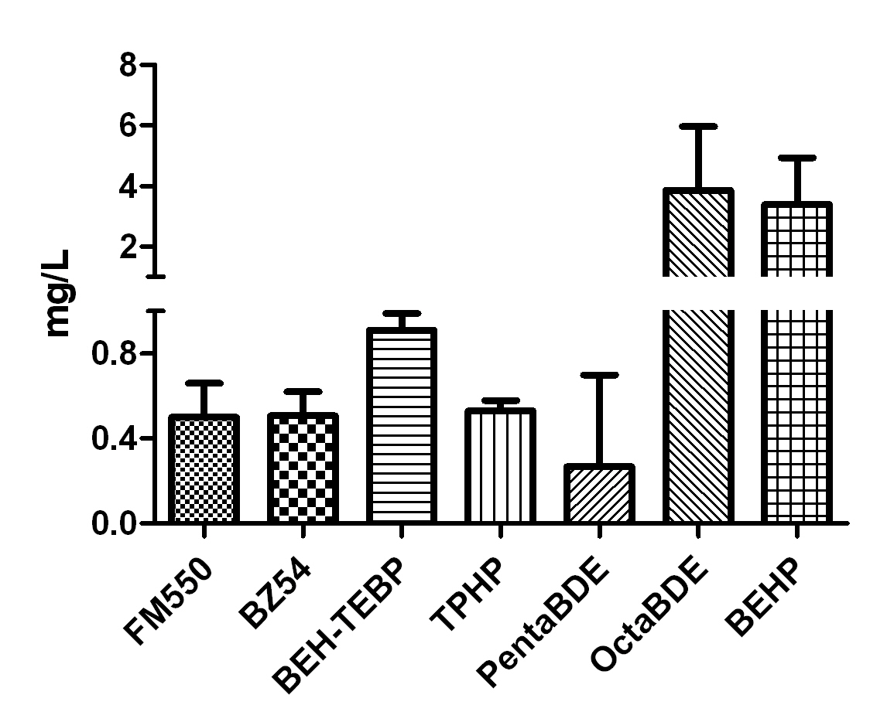
Figure 2. Acute, 48-hour LC₅₀ values for flame-retardants on Daphnia magna. LC₅₀ values were determined with probit or Spearman-Karber statistical programs. Error bars represent 95% confidence interval.

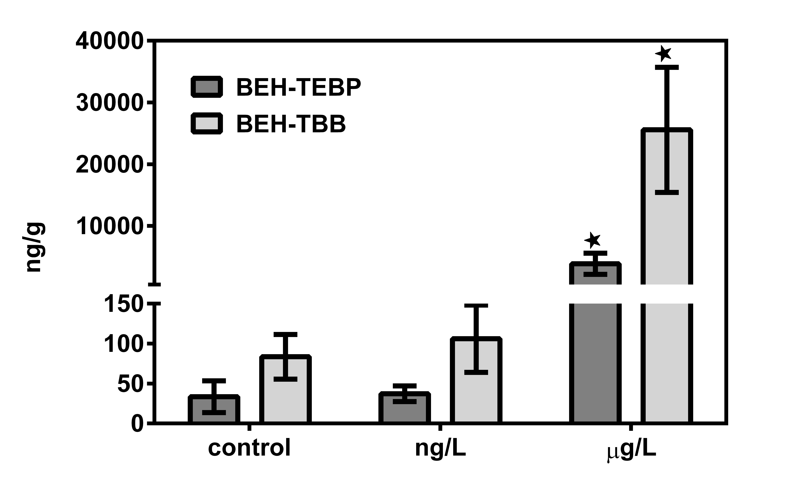
Figure 3. Accumulation of BEH-TEBP and EH-TBB was measured after 48-hour exposure to 48.6 μg/L (1/10 LC₅₀) or 48.6 ng/g FM550. Concentrations: nanograms chemical per gram daphnid, dry weight (ng/g).

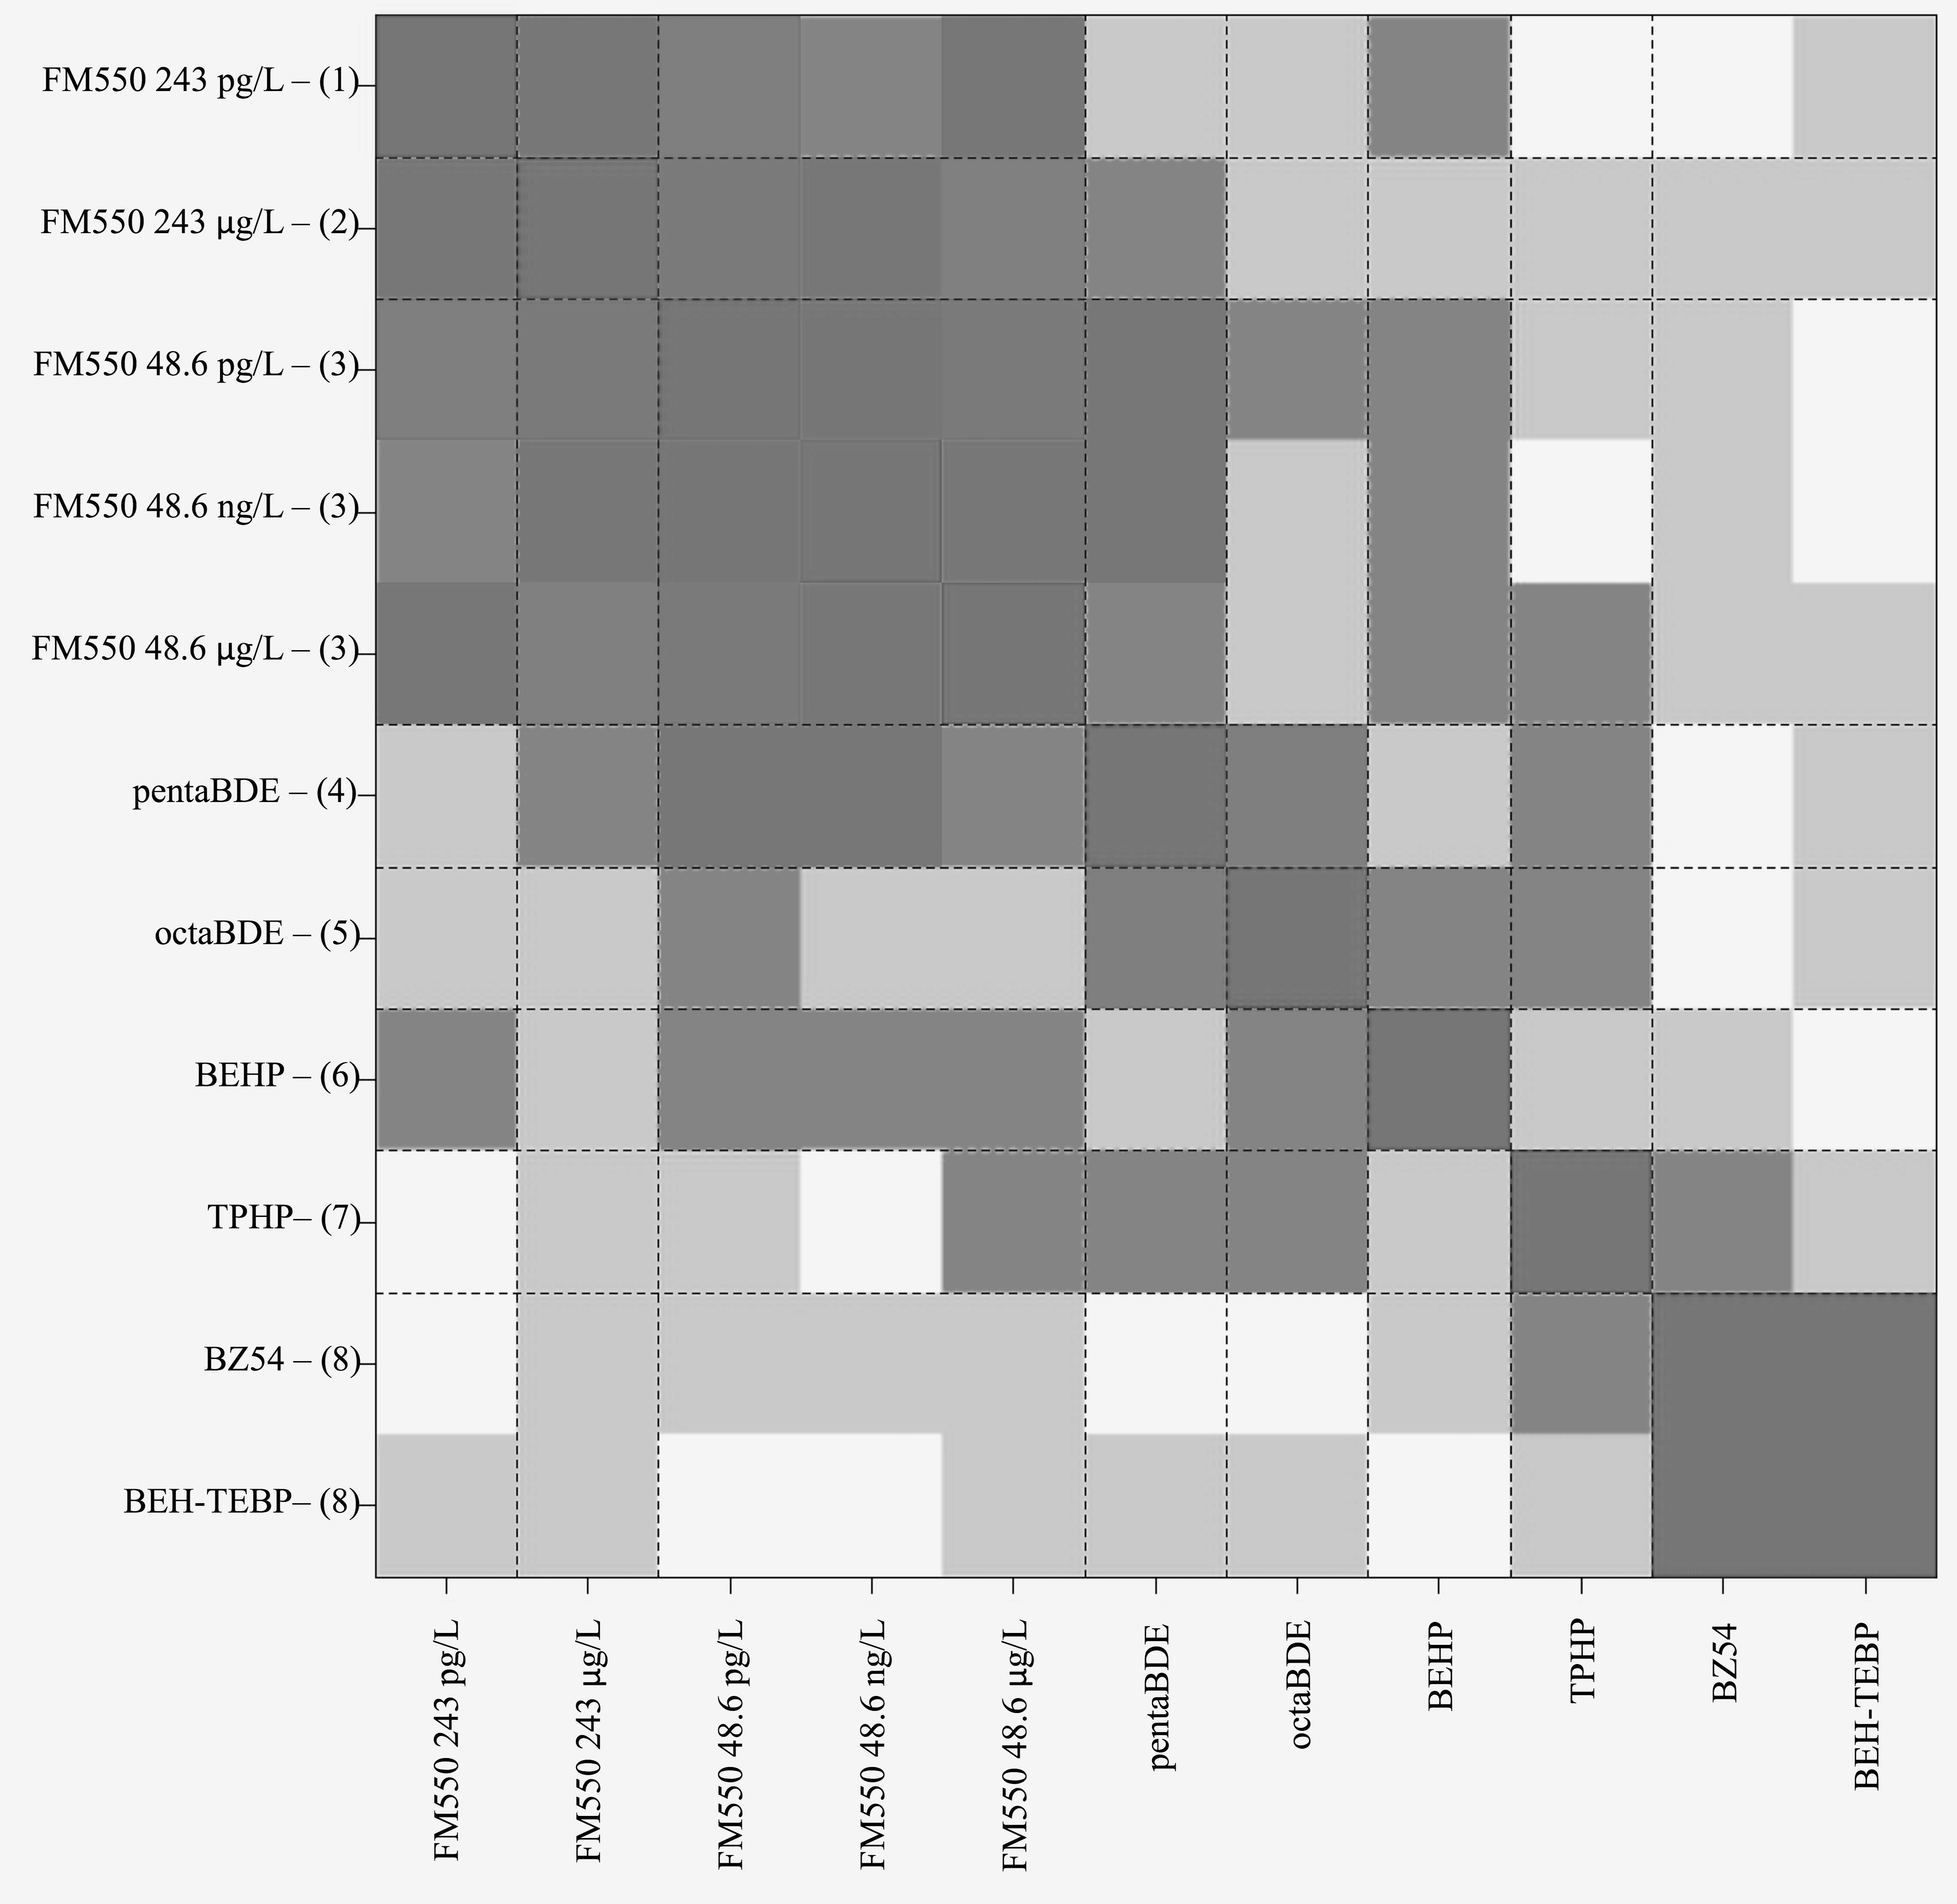
Figure 4. HOPACH cluster analysis of gene expression similarity. Darker colored squares indicate more similarity. Clusters are numbered 1-8 on the y-axis. Three FM550 concentrations clustered (3), as did BZ54 and BEH-TEBP (8).

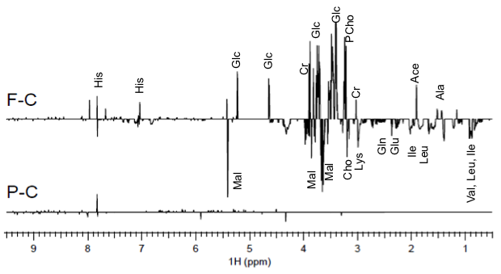
Figure 5. ^{H}NMR spectra showing metabolomics changes in FM550 (F-C) or pentaBDE (P-C) exposed Daphnia magna as compared to control. PentaBDE-induced changes were not significantly different from control.

REFERENCES

1. Shaw, S. D.; Blum, A.; Weber, R.; Kannan, K.; Rich, D.; Lucas, D.; Koshland, C. P.; Dobraca, D.; Hanson, S.; Birnbaum, L. S., Halogenated flame retardants: do the fire safety benefits justify the risks? Reviews on environmental health 2010, 25 (4), 261-305.
2. Blum, A., The fire retardant dilemma. Science 2007, 318 (5848), 194-5.
3. State of California Department of Consumer Affairs, Technical Bulletin 117-2013. Bureau of Electronic and Appliance Repair, Home Furnishings; and Thermal Insulation, Eds. California, 2013.
4. Gao, S.; Hong, J.; Yu, Z.; Wang, J.; Yang, G.; Sheng, G.; Fu, J., Polybrominated diphenyl ethers in surface soils from e-waste recycling areas and industrial areas in South China: Concentration levels, congener profile, and inventory. Environmental toxicology and chemistry / SETAC 2011, (Journal Article).
5. Daso, A. P.; Fatoki, O. S.; Odendaal, J. P.; Olujimi, O. O., Occurrence of Selected Polybrominated Diphenyl Ethers and 2,2',4,4',5,5'-Hexabromobiphenyl (BB-153) in Sewage Sludge and Effluent Samples of a Wastewater-Treatment Plant in Cape Town, South Africa. Archives of Environmental Contamination and Toxicology 2011, (Journal Article).
6. Kimbrough, K. L.; Johnson, W. E.; Lauenstein, G. G.; Christensen, J. D.; Apeti, D. A., An Assessment of Polybrominated Diphenyl Ethers (PBDEs) in Sediments and Bivalves of the U.S. Costal Zone. Memorandum, N. T., Ed. Silver Spring, MD, 2009; Vol. NOS NCCOS, p 87.
7. Birgul, A.; Katsoyiannis, A.; Gioia, R.; Crosse, J.; Earnshaw, M.; Ratola, N.; Jones, K. C.; Sweetman, A. J., Atmospheric polybrominated diphenyl ethers (PBDEs) in the United Kingdom. Environmental Pollution 2012, 169, 105-111.
8. Xiao, H.; Hung, H.; Wania, F.; Lao, R.; Sabljic, E.; Sverko, E.; Lei, Y. D.; Fellin, P.; Barresi, E., Field evaluation of a flow-through sampler for measuring pesticides and brominated flame retardants in the arctic atmosphere. Environ Sci Technol 2012, 46 (14), 7669-76.
9. Alava, J. J.; Keller, J. M.; Wyneken, J.; Crowder, L.; Scott, G.; Kucklick, J. R., Geographical variation of persistent organic pollutants in eggs of threatened loggerhead sea turtles (Caretta caretta) from southeastern United States. Environmental toxicology and chemistry / SETAC 2011, 30 (7), 1677-1688.
10. Kuo, Y. M.; Sepulveda, M. S.; Hua, I.; Ochoa-Acuna, H. G.; Sutton, T. M., Bioaccumulation and biomagnification of polybrominated diphenyl ethers in a food web of Lake Michigan. Ecotoxicology (London, England) 2010, 19 (4), 623-634.
11. Lam, J. C.; Lau, R. K.; Murphy, M. B.; Lam, P. K., Temporal trends of hexabromocyclododecanes (HBCDs) and polyrominated diphenyl ethers (PBDEs) and detection of two novel flame retardants in marine mammals from Hong Kong, South China. Environmental science & technology 2009, 43 (18), 6944-6949.
12. Liu, P. Y.; Du, G. D.; Zhao, Y. X.; Mu, Y. S.; Zhang, A. Q.; Qin, Z. F.; Zhang, X. Y.; Yan, S. S.; Li, Y.; Wei, R. G.; Qin, X. F.; Yang, Y. J., Bioaccumulation, maternal transfer and elimination of polybrominated diphenyl ethers in wild frogs. Chemosphere 2011, 84 (7), 972-978.
13. Horton, M. K.; Bousleiman, S.; Jones, R.; Sjodin, A.; Liu, X.; Whyatt, R.; Wapner, R.; Factor-Litvak, P., Predictors of serum concentrations of polybrominated flame retardants among healthy pregnant women in an urban environment: a cross-sectional study. Environmental health : a global access science source 2013, 12 (1), 23.
14. Zota, A. R.; Rudel, R. A.; Morello-Frosch, R. A.; Brody, J. G., Elevated house dust and serum concentrations of PBDEs in California: unintended consequences of furniture flammability standards? Environmental science & technology 2008, 42 (21), 8158-8164.
15. Main, K. M.; Kiviranta, H.; Virtanen, H. E.; Sundqvist, E.; Tuomisto, J. T.; Tuomisto, J.; Vartiainen, T.; Skakkebaek, N. E.; Toppari, J., Flame retardants in placenta and breast milk and cryptorchidism in newborn boys. Environmental health perspectives 2007, 115 (10), 1519-1526.
16. Jakobsson, K.; Fang, J.; Athanasiadou, M.; Rignell-Hydbom, A.; Bergman, A., Polybrominated diphenyl ethers in maternal serum, umbilical cord serum, colostrum and mature breast milk. Insights from a pilot study and the literature. Environment international 2012, 47, 121-130.
17. Malarvannan, G.; Dirinck, E.; Dirtu, A. C.; Pereira-Fernandes, A.; Neels, H.; Jorens, P. G.; Gaal, L. V.; Blust, R.; Covaci, A., Distribution of persistent organic pollutants in two different fat compartments from obese individuals. Environ Int 2013, 55, 33-42.
18. Johnson, P. I.; Stapleton, H. M.; Sjodin, A.; Meeker, J. D., Relationships between polybrominated diphenyl ether concentrations in house dust and serum. Environ Sci Technol 2010, 44 (14), 5627-32.
19. Huwe, J. K.; West, M., Polybrominated diphenyl ethers in U.S. Meat and poultry from two statistically designed surveys showing trends and levels from 2002 to 2008. Journal of Agricultural and Food Chemistry 2011, 59 (10), 5428-5434.
20. Viberg, H.; Fredriksson, A.; Eriksson, P., Investigations of strain and/or gender differences in developmental neurotoxic effects of polybrominated diphenyl ethers in mice. Toxicol Sci 2004, 81 (2), 344-53.
21. Kuriyama, S. N.; Talsness, C. E.; Grote, K.; Chahoud, I., Developmental exposure to low dose PBDE 99: effects on male fertility and neurobehavior in rat offspring. Environ Health Perspect 2005, 113 (2), 149-54.
22. Dingemans, M. M.; van den Berg, M.; Westerink, R. H., Neurotoxicity of brominated flame retardants: (in)direct effects of parent and hydroxylated polybrominated diphenyl ethers on the (developing) nervous system. Environ Health Perspect 2011, 119 (7), 900-7.
23. Johnson, P. I.; Stapleton, H. M.; Mukherjee, B.; Hauser, R.; Meeker, J. D., Associations between brominated flame retardants in house dust and hormone levels in men. Sci Total Environ 2013, 445-446, 177-84.
24. Erickson, P. R.; Grandbois, M.; Arnold, W. A.; McNeill, K., Photochemical formation of brominated dioxins and other products of concern from hydroxylated polybrominated diphenyl ethers (OH-PBDEs). Environ Sci Technol 2012, 46 (15), 8174-80.
25. Steen, P. O.; Grandbois, M.; McNeill, K.; Arnold, W. A., Photochemical formation of halogenated dioxins from hydroxylated polybrominated diphenyl ethers (OH-PBDEs) and chlorinated derivatives (OH-PBCDEs). Environ Sci Technol 2009, 43 (12), 4405-11.
26. Wahl, M.; Guenther, R.; Yang, L.; Bergman, A.; Straehle, U.; Strack, S.; Weiss, C., Polybrominated diphenyl ethers and arylhydrocarbon receptor agonists: Different toxicity and target gene expression. Toxicol Lett 2010, 198 (2), 119-26.
27. Nakari, T.; Huhtala, S., Comparison of toxicity of congener-153 of PCB, PBB, and PBDE to Daphnia magna. Ecotoxicology and environmental safety 2008, 71 (2), 514-518.
28. Davies, R.; Zou, E., Polybrominated diphenyl ethers disrupt molting in neonatal Daphnia magna. Ecotoxicology 2012, 21 (5), 1371-1380.
29. Chen, L.; Hu, C.; Huang, C.; Wang, Q.; Wang, X.; Yang, L.; Zhou, B., Alterations in retinoid status after long-term exposure to PBDEs in zebrafish (Danio rerio). Aquatic Toxicology 2012, 120, 11-18.
30. Siddiqi, M. A.; Laessig, R. H.; Reed, K. D., Polybrominated diphenyl ethers (PBDEs): new pollutants-old diseases. Clinical medicine & research 2003, 1 (4), 281-90.
31. Stockholm Convention, Decision POPRC-1/3: Pentabromodiphenyl ether. Stockholm Convention on persistent organic pollutants (POPs), Ed. 2011.
32. Wania, F.; Dugani, C. B., Assessing the long-range transport potential of polybrominated diphenyl ethers: a comparison of four multimedia models. Environ Toxicol Chem 2003, 22 (6), 1252-61.
33. The European Parliment, Directive 2002/95/EC of the European Parliment and of the Council of 27 January 2003 on the restriction of the use of certain hazardous substances in electrical and electrical equipment. 2003.
34. Stapleton, H. M.; Sharma, S.; Getzinger, G.; Ferguson, P. L.; Gabriel, M.; Webster, T. F.; Blum, A., Novel and high volume use flame retardants in US couches reflective of the 2005 PentaBDE phase out. Environ Sci Technol 2012, 46 (24), 13432-9.
35. Parliment, T. E., Directive 2003/11/EC of the European Parliment and of the Council of 6 February 2003 amending for the 24th time Council Directive 76/769/EEC relating to restrictions on the marketing and use of certain dangerous substances and preparations (pentabromodiphenyl ether, octabromodiphenyl ether). 2003.
36. Dodson, R. E.; Perovich, L. J.; Covaci, A.; Van den Eede, N.; Ionas, A. C.; Dirtu, A. C.; Brody, J. G.; Rudel, R. A., After the PBDE phase-out: a broad suite of flame retardants in repeat house dust samples from California. Environ Sci Technol 2012, 46 (24), 13056-66.
37. Klosterhaus, S.; Konstantinov, A.; Davis, E.; Klein, J.; Stapleton, H. In Characterization of the Brominated Chemicals in a PentaBDE Replacement Mixture and their Detection in Biosolids, Ottawa, Ontario, Canada, 2009; Ottawa, Ontario, Canada.
38. Stapleton, H. M.; Allen, J. G.; Kelly, S. M.; Konstantinov, A.; Klosterhaus, S.; Watkins, D.; McClean, M. D.; Webster, T. F., Alternate and new brominated flame retardants detected in U.S. house dust. Environmental science & technology 2008, 42 (18), 6910-6916.
39. McGee, S. P.; Konstantinov, A.; Stapleton, H. M.; Volz, D. C., Aryl Phosphate Esters Within a Major PentaBDE Replacement Product Induce Cardiotoxicity in Developing Zebrafish Embryos: Potential Role of the Aryl Hydrocarbon Receptor. Toxicol Sci 2013.
40. Bearr, J. S.; Mitchelmore, C. L.; Roberts, S. C.; Stapleton, H. M., Species specific differences in the in vitro metabolism of the flame retardant mixture, Firemaster((R)) BZ-54. Aquat Toxicol 2012, 124-125C, 41-47.
41. Stapleton, H. M.; Klosterhaus, S.; Eagle, S.; Fuh, J.; Meeker, J. D.; Blum, A.; Webster, T. F., Detection of Organophosphate Flame Retardants in Furniture Foam and US House Dust. Environmental science & technology 2009, 43 (19), 7490-7495.
42. Stapleton, H. M.; Klosterhaus, S.; Keller, A.; Ferguson, P. L.; van Bergen, S.; Cooper, E.; Webster, T. F.; Blum, A., Identification of flame retardants in polyurethane foam collected from baby products. Environmental science & technology 2011, 45 (12), 5323-5331.
43. Stapleton, H. M.; Misenheimer, J.; Hoffman, K.; Webster, T. F., Flame retardant associations between children's handwipes and house dust. Chemosphere 2014.
44. Verslycke, T. A.; Vethaak, A. D.; Arijs, K.; Janssen, C. R., Flame retardants, surfactants and organotins in sediment and mysid shrimp of the Scheldt estuary (The Netherlands). Environmental pollution (Barking, Essex : 1987) 2005, 136 (1), 19-31.
45. La Guardia, M. J.; Hale, R. C.; Harvey, E.; Mainor, T. M.; Ciparis, S., In situ accumulation of HBCD, PBDEs, and several alternative flame-retardants in the bivalve (Corbicula fluminea) and gastropod (Elimia proxima). Environ Sci Technol 2012, 46 (11), 5798-805.
46. Springer, C.; Dere, E.; Hall, S. J.; McDonnell, E. V.; Roberts, S. C.; Butt, C. M.; Stapleton, H. M.; Watkins, D. J.; McClean, M. D.; Webster, T. F.; Schlezinger, J. J.; Boekelheide, K., Rodent Thyroid, Liver, and Fetal Testis Toxicity of the Monoester Metabolite of Bis-(2-ethylhexyl) Tetrabromophthalate (TBPH), a Novel Brominated Flame Retardant Present in Indoor Dust. Environ Health Perspect 2012.
47. Patisaul, H. B.; Roberts, S. C.; Mabrey, N.; McCaffrey, K. A.; Gear, R. B.; Braun, J.; Belcher, S. M.; Stapleton, H. M., Accumulation and Endocrine Disrupting Effects of the Flame Retardant Mixture Firemaster((R)) 550 in Rats: An Exploratory Assessment. Journal of biochemical and molecular toxicology 2012.
48. Belcher, S. M.; Cookman, C. J.; Patisaul, H. B.; Stapleton, H. M., In vitro assessment of human nuclear hormone receptor activity and cytotoxicity of the flame retardant mixture FM 550 and its triarylphosphate and brominated components. Toxicol Lett 2014, 228 (2), 93-102.
49. Saunders, D. M.; Higley, E. B.; Hecker, M.; Mankidy, R.; Giesy, J. P., In vitro endocrine disruption and TCDD-like effects of three novel brominated flame retardants: TBPH, TBB, & TBCO. Toxicol Lett 2013, 223 (2), 252-259.
50. Roberts, S. C.; Macaulay, L. J.; Stapleton, H. M., In vitro metabolism of the brominated flame retardants 2-ethylhexyl-2,3,4,5-tetrabromobenzoate (TBB) and bis(2-ethylhexyl) 2,3,4,5-tetrabromophthalate (TBPH) in human and rat tissues. Chem Res Toxicol 2012, 25 (7), 1435-41.
51. Bearr, J. S.; Stapleton, H. M.; Mitchelmore, C. L., Accumulation and DNA damage in fathead minnows (Pimephales promelas) exposed to 2 brominated flame-retardant mixtures, Firemaster 550 and Firemaster BZ-54. Environ Toxicol Chem 2010, 29 (3), 722-9.
52. Lin, K., Joint acute toxicity of tributyl phosphate and triphenyl phosphate to Daphnia magna. Environmental Chemistry Letters 2009, 7 (4), 309-312.
53. Marklund, A.; Andersson, B.; Haglund, P., Organophosphorus flame retardants and plasticizers in Swedish sewage treatment plants. Environ Sci Technol 2005, 39 (19), 7423-9.
54. van der Veen, I.; de Boer, J., Phosphorus flame retardants: properties, production, environmental occurrence, toxicity and analysis. Chemosphere 2012, 88 (10), 1119-53.
55. United States Environmental Protection Agency, Furniture flame retardancy partnership environmental profiles of chemical Flame-Retardant Alternatives for Low-Desnisty Polyuretane Foam. Cincinnati, OH, 2005; Vol. 2.
56. Watanabe, H.; Kobayashi, K.; Kato, Y.; Oda, S.; Abe, R.; Tatarazako, N.; Iguchi, T., Transcriptome profiling in crustaceans as a tool for ecotoxicogenomics: Daphnia magna DNA microarray. Cell biology and toxicology 2008, 24 (6), 641-7.
57. Seda, J.; Petrusek, A.; Sehnal, F., Daphnia as a model organism in limnology and aquatic biology: some aspects of its reproduction and development PREFACE. J. Limnol. 2011, 70 (2), 336-336.
58. Magnusson, K.; Tiselius, P., The importance of uptake from food for the bioaccumulation of PCB and PBDE in the marine planktonic copepod Acartia clausi. Aquatic Toxicology (Amsterdam, Netherlands) 2010, 98 (4), 374-380.
59. Magnusson, K.; Magnusson, M.; Ostberg, P.; Granberg, M.; Tiselius, P., Bioaccumulation of 14C-PCB 101 and 14C-PBDE 99 in the marine planktonic copepod Calanus finmarchicus under different food regimes. Marine environmental research 2007, 63 (1), 67-81.
60. Losada, S.; Roach, A.; Roosens, L.; Santos, F. J.; Galceran, M. T.; Vetter, W.; Neels, H.; Covaci, A., Biomagnification of anthropogenic and naturally-produced organobrominated compounds in a marine food web from Sydney Harbour, Australia. Environment international 2009, 35 (8), 1142-1149.
61. Vandenbrouck, T.; Jones, O. A.; Dom, N.; Griffin, J. L.; De Coen, W., Mixtures of similarly acting compounds in Daphnia magna: from gene to metabolite and beyond. Environ Int 2010, 36 (3), 254-68.
62. Kilham, S. S.; Kreeger, D. A.; Lynn, S. G.; Goulden, C. E.; Herrera, L., COMBO: a defined freshwater culture medium for algae and zooplankton. Hydrobiologia 1998, 377, 147-159.
63. Agency, U. S. E. P. Methods for Measuring the Acute Toxicity of Effluents and Receiving Waters to Freshwater and Marine Organisms. Fifth Edition; U.S. Environmental Protection Agency, Office of Water: Washington, D.C., 2002.
64. Hamilton, M. A.; Russo, R. C.; Thurston, R. V., TRIMMED SPEARMAN-KARBER METHOD FOR ESTIMATING MEDIAN LETHAL CONCENTRATIONS IN TOXICITY BIOASSAYS. Environmental science & technology 1977, 11 (7), 714-719.
65. Bergman, A.; Ryden, A.; Law, R. J.; de Boer, J.; Covaci, A.; Alaee, M.; Birnbaum, L.; Petreas, M.; Rose, M.; Sakai, S.; Van den Eede, N.; van der Veen, I., A novel abbreviation standard for organobromine, organochlorine and organophosphorus flame retardants and some characteristics of the chemicals. Environ Int 2012, 49, 57-82.
66. Loguinov, A. V.; Mian, I. S.; Vulpe, C. D., Exploratory differential gene expression analysis in microarray experiments with no or limited replication. Genome biology 2004, 5 (3), R18.
67. Scanlan, L. D.; Reed, R. B.; Loguinov, A. V.; Antczak, P.; Tagmount, A.; Aloni, S.; Nowinski, D. T.; Luong, P.; Tran, C.; Karunaratne, N.; Pham, D.; Lin, X. X.; Falciani, F.; Higgins, C. P.; Ranville, J. F.; Vulpe, C. D.; Gilbert, B., Silver Nanowire Exposure Results in Internalization and Toxicity to Daphnia magna. ACS nano 2013, 7 (12), 10681-94.
68. Huang da, W.; Sherman, B. T.; Lempicki, R. A., Systematic and integrative analysis of large gene lists using DAVID bioinformatics resources. Nature protocols 2009, 4 (1), 44-57.
69. Huang da, W.; Sherman, B. T.; Lempicki, R. A., Bioinformatics enrichment tools: paths toward the comprehensive functional analysis of large gene lists. Nucleic acids research 2009, 37 (1), 1-13.
70. van der Laan, M. J.; Pollard, K. S., A new algorithm for hybrid hierarchical clustering with visualization and the bootstrap. Journal of Statistical Planning and Inference 2003, 117 (2), 275-303.
71. Conesa, A.; Gotz, S.; Garcia-Gomez, J. M.; Terol, J.; Talon, M.; Robles, M., Blast2GO: a universal tool for annotation, visualization and analysis in functional genomics research. Bioinformatics (Oxford, England) 2005, 21 (18), 3674-3676.
72. Mucklow, P. T.; Vizoso, D. B.; Jensen, K. H.; Refardt, D.; Ebert, D., Variation in phenoloxidase activity and its relation to parasite resistance within and between populations of Daphnia magna. Proceedings.Biological sciences / The Royal Society 2004, 271 (1544), 1175-1183.
73. Viant, M. R., Revealing the metabolome of animal tissues using 1H nuclear magnetic resonance spectroscopy. Methods in molecular biology (Clifton, N.J.) 2007, 358, 229-46.
74. Teng, Q.; Ekman, D. R.; Huang, W.; Collette, T. W., Push-through direct injection NMR: an optimized automation method applied to metabolomics. The Analyst 2012, 137 (9), 2226-32.
75. Bax, A.; Davis, D. G., MLEV-17-BASED TWO-DIMENSIONAL HOMONUCLEAR MAGNETIZATION TRANSFER SPECTROSCOPY. J. Magn. Reson. 1985, 65 (2), 355-360.
76. Xia, J.; Psychogios, N.; Young, N.; Wishart, D. S., MetaboAnalyst: a web server for metabolomic data analysis and interpretation. Nucleic Acids Res 2009, 37 (Web Server issue), W652-60.
77. Xia, J.; Mandal, R.; Sinelnikov, I. V.; Broadhurst, D.; Wishart, D. S., MetaboAnalyst 2.0--a comprehensive server for metabolomic data analysis. Nucleic Acids Res 2012, 40 (Web Server issue), W127-33.
78. Wheeler, M. W.; Park, R. M.; Bailer, A. J., Comparing median lethal concentration values using confidence interval overlap or ratio tests. Environmental toxicology and chemistry / SETAC 2006, 25 (5), 1441-1444.
79. Agency for Toxic Substances and Disease Registry (ATSDR), Toxicological profile for Di(2-ethylhexyl)phthalate (DEHP). U.S. Department of Health and Human Services, Public Health Service.: Atlanta, GA, 2002.
80. Reemtsma, T.; Quintana, J. B.; Rodil, R.; Garcia-Lopez, M.; Rodriguez, I., Organophosphorus flame retardants and plasticizers in water and air I. Occurrence and fate. Trac-Trends Anal. Chem. 2008, 27 (9), 727-737.
81. La, A. G. M. J.; Hale, R. C.; Harvey, E., Detailed polybrominated diphenyl ether (PBDE) congener composition of the widely used penta-, octa-, and deca-PBDE technical flame-retardant mixtures. Environ Sci Technol 2006, 40 (20), 6247-54.
82. Sjodin, A. Occupational and Dietary Exposure to Organohalogen Substances, with Special Emphasis on Polybrominated Diphenyl Ethers. Stockholm University, Stockholm, 2000.
83. Lobenhofer, E. K.; Cui, X.; Bennett, L.; Cable, P. L.; Merrick, B. A.; Churchill, G. A.; Afshari, C. A., Exploration of low-dose estrogen effects: identification of No Observed Transcriptional Effect Level (NOTEL). Toxicologic pathology 2004, 32 (4), 482-92.
84. Zarbl, H.; Gallo, M. A.; Glick, J.; Yeung, K. Y.; Vouros, P., The vanishing zero revisited: Thresholds in the age of genomics. Chem.-Biol. Interact. 2010, 184 (1-2), 273-278.
85. Smyth, G. K., Limma: Linear models for microarray data. Springer: New York, 2005; p 397-420.
86. Team, R. D. C. R: A language and environment for statistical computing., R Foundation for Statistical Computing: Vienna, Austria, 2008.
87. Pollard, K. S.; Dudoit, S.; van der Laan, M. J., Multiple Testing Procedures: R multtest Package and Applications to Genomics. In Bioinformatics and Computational Biology Solutions Using R and Bioconductor, Gentleman, R.; Carey, V.; Huber, W.; Irizarry, R.; Dudoit, S., Eds. Springer: 2005; pp 251-272.
88. Bluthgen, N.; Brand, K.; Cajavec, B.; Swat, M.; Herzel, H.; Beule, D., Biological profiling of gene groups utilizing Gene Ontology. Genome informatics. International Conference on Genome Informatics 2005, 16 (1), 106-15.
89. Mhadhbi, L.; Fumega, J.; Beiras, R., Toxicological Effects of Three Polybromodiphenyl Ethers (BDE-47, BDE-99 and BDE-154) on Growth of Marine Algae Isochrysis galbana. Water Air and Soil Pollution 2012, 223 (7), 4007-4016.
90. Pellacani, C.; Buschini, A.; Galati, S.; Mussi, F.; Franzoni, S.; Costa, L. G., Evaluation of DNA Damage Induced by 2 Polybrominated Diphenyl Ether Flame Retardants (BDE-47 and BDE-209) in SK-N-MC Cells. International journal of toxicology 2012, 31 (4), 372-379.
91. Usenko, C. Y.; Robinson, E. M.; Usenko, S.; Brooks, B. W.; Bruce, E. D., PBDE DEVELOPMENTAL EFFECTS ON EMBRYONIC ZEBRAFISH. Environmental Toxicology and Chemistry 2011, 30 (8), 1865-1872.
92. Waaijers, S.; Bleyenberg, T. E.; Dits, A.; Schoorl, M.; Schutt, J.; Kools, S. A.; de Voogt, P.; Admiraal, W.; Parsons, J. R.; Kraak, M., Daphnid Life Cycle Responses to New Generation Flame Retardants. Environ Sci Technol 2013.
93. Adams, W. J.; Biddinger, G. R.; Robillard, K. A.; Gorsuch, J. W., A SUMMARY OF THE ACUTE TOXICITY OF 14 PHTHALATE-ESTERS TO REPRESENTATIVE AQUATIC ORGANISMS. Environmental Toxicology and Chemistry 1995, 14 (9), 1569-1574.
94. Chemtura USA Corporation, Material Safety Data Sheet 00896: Firemaster® 550. Middlebury, Conneticut, 2006; p 8.
95. Verhaar, H. J.; Solbe, J.; Speksnijder, J.; van Leeuwen, C. J.; Hermens, J. L., Classifying environmental pollutants: Part 3. External validation of the classification system. Chemosphere 2000, 40 (8), 875-83.
96. Sanderson, H.; Thomsen, M., Ecotoxicological quantitative structure-activity relationships for pharmaceuticals. Bull Environ Contam Toxicol 2007, 79 (3), 331-5.
97. Veith, G. D.; Broderius, S. J., Rules for distinguishing toxicants that cause type I and type II narcosis syndromes. Environ Health Perspect 1990, 87, 207-11.
98. Roberts, D. W.; Costello, J. F., Mechanisms of action for general and polar narcosis: A difference in dimension. QSAR Comb. Sci. 2003, 22 (2), 226-233.
99. Tiemeyer, M.; Selleck, S.; Esko, J., Arthropoda. In Essentials of Glycobiology, 2nd Edition, Varki, A.; Cummings, R.; Esko, J.; Freeze, H.; Stanley, P.; Bertozzi, C.; Hart, G.; Etzler, M., Eds. Cold Spring Harbor Laboratory Press: Cold Spring Harbor (NY), 2009.
100. Scavia, D.; Gardner, W. S., KINETICS OF NITROGEN AND PHOSPHORUS RELEASE IN VARYING FOOD SUPPLIES BY DAPHNIA-MAGNA. Hydrobiologia 1982, 96 (2), 105-111.
101. Hessen, D. O., CARBON, NITROGEN AND PHOSPHORUS STATUS IN DAPHNIA AT VARYING FOOD CONDITIONS. J. Plankton Res. 1990, 12 (6), 1239-1249.
102. D'Abramo, L.; Conklin, D.; Akiyama, D.; Nutrition, I. W. G. o. C., Crustacean Nutrition. World Aquaculture Society: Baton Rouge, 1997; Vol. 6.
103. Yang, Z.; Lu, K.; Chen, Y.; Montagnes, D. J., The interactive effects of ammonia and microcystin on life-history traits of the cladoceran Daphnia magna: synergistic or antagonistic? PLoS ONE 2012, 7 (3), e32285.

