Controlled Synthesis of Calcium Carbonate Nanoparticles and Stimuli-Responsive Multi-Layered Nanocapsules for Oral Drug Delivery
Nancy M. Elbaz,ª Andrew Owen,^{b} Steve Rannard ª and Tom O. McDonald ^{a, *}
a. Department of Chemistry, University of Liverpool, Crown Street, Liverpool, L69 7ZD, United Kingdom.
E-mail: tomm@liv.ac.uk; Tel: +44 (0)151 795 0524
b. Department of Molecular and Clinical Pharmacology, University of Liverpool, Block H, 70 Pembroke Place, Liverpool, L69 3GF, UK
KEYWORDS. Layer-by-Layer (LbL) self-assembly, LbL nanocapsules, calcium carbonate nanoparticles, curcumin, stimuli responsive multi-layered nanocapsules.
ABSTRACT: Stimuli-responsive layer-by-layer (LbL) capsules are appealing drug carriers for oral drug delivery owing to their abilities to utilize environmental differences to trigger changes in particles properties. LbL capsules typically have micrometer diameter ranging between 1-5 µm. The opportunity to use LbL for the modification of particles in the nanorange may provide enhanced benefits and properties for drug delivery. In this work, we used multiple polyelectrolytes to prepare novel stimuli-responsive multi-layered nanocapsules with submicron diameters. A systematic study was conducted to investigate the influence of various experimental parameters on the formation of calcium carbonate nanoparticles (CaCO₃) as nanocores. The resultant nanocores were then used for the assembly of LbL nanocapsules and the variables that influenced the diameter of capsules were investigated. Finally, novel stimuli-responsive multi-layered nanocapsules made of four polyelectrolytes including Eudragit L100, chitosan, sodium alginate, and poly-L-arginine were prepared and characterized. The stimuli-responsive multi-layered nanocapsules loaded with a model drug, curcumin, were assessed for drug release under pH conditions that mimic the gastrointestinal tract. These data demonstrate the potential for nanocapsules to be designed to protect the drug in the stomach and release it in the lower gastrointestinal tract.
- Introduction.
Oral drug delivery is a preferred administration route owing to its convenience along with its ease and flexible manufacturing and inherent compatibility with self-administration. However, because many drugs have low aqueous solubility, oral drug delivery is often challenging. Oral delivery is complicated by factors such as variable pH and transit time, as well as drug metabolism enzymes and ATP-dependent transporters that limit bioavailability (Thanki et al., 2013). Stimuli-responsive nanoparticles present a promising approach to oral drug delivery due to their tailored properties enabling environmental differences to trigger conformational changes in their structure (e.g. in response to a certain stimuli such as pH) (Ensign et al., 2012). Such a structural change may result in nanoparticles collapsing or swelling, which can control the drug release, and thus increasing local drug and therapeutic effect at the targeted site (Delcea et al., 2011),(Sung et al., 2012).
Functionalization by layer-by layer (LbL) self-assembly has emerged as a promising platform for the formation of capsules or the surface modification of particles for applications in oral drug delivery (Santos et al., 2018). LbL modification allows the surface properties of particles to be controlled by modulating the layers’ composition and thickness. Additionally, the functionalities in the surface coating can be tailored to be responsive to either single or multiple stimuli to trigger a selective drug release (Delcea et al., 2011; van Dongen et al., 2009). Capsules made by LbL modification are typically spherical with micrometer diameters and consist of two distinct components: the shell and the cavity. The shell is built up via the consecutive deposition of two or more oppositely charged polyelectrolytes, while the cavity is formed upon the removal of a sacrificial core (Tong et al., 2012). For example, multilayered microcapsules made of serum albumin and tannic acid were prepared. These microcapsules were loaded with lactoferrin, showed high stability in gastric conditions, and released the lactoferrin in small intestine (Kilic et al., 2017). LbL capsules can exhibit pH-dependent swelling behavior due to the changes in charge density along with the polyelectrolytes as a function of pH, this influences the electrostatic interactions between the polyelectrolyte layers. These pH-dependent swelling changes resulted in switches in the capsule’s permeability (Delcea et al., 2011; Wohl and Engbersen, 2012). For example, Mauser et al. (2006), showed that hollow microcapsules made of polyallylamine hydrochloride and poly(methacrylic acid) displayed pH-switchable properties. By changing the pH, the capsules could reversibly switch between swelling and shrinking of the diameters between 4 and 8 μm (Tatjana Mauser et al., 2006).
An alternative approach is to use LbL as a method for coating nanocarriers rather than preparing a hollow capsule. In this role, the multilayer coating can be used to modify the colloidal behavior or drug release properties. Cuomo et al. prepared pH-responsive liposome-templated chitosan/alginate LbL nanocapsules (Cuomo et al., 2012). They showed that the outermost layer controlled the pH responsive behavior resulting in changes in swelling and colloidal stability of the capsules. When chitosan was the outer layer, the nanocapsules were protonated at acidic pH, which provided colloidal stability through electrostatic repulsion. However, at pH 8 the outer layer was deprotonated and the nanocapsules aggregated. When alginate was the outer layer, the nanocapsules were colloidally stable at both pH 4.6 and 8. Instead, the nanocapsules displayed an increase in swelling at pH 8. This occurred as the electrostatic attractive interactions between the internal layers of the polyelectrolytes was reduced upon the deprotonation of the chitosan (Cuomo et al., 2012). Santos et al. (2015) prepared a nanosuspension of ibuprofen functionalized by LbL with polyallylamine hydrochloride and poly(styrene sulfonate). They showed that increasing the thickness of the layers resulted in slower release (Santos et al., 2015). Poly(lactic-co-glycolic acid) PLGA cores coated with polymers formed by LbL have also been produced. The polymer layer was used to control drug release and biological behavior by tracking in vivo (Morton et al., 2013). A range of polymers were used including hyaluronic acid, dextran sulfate, and alginate and doxorubicin (Dox) and a near-IR dye were chosen as the payload (Ramasamy et al., 2017, 2014b, 2014a; Ruttala et al., 2017). The addition of the polymer shell reduced the release rate after 24 hours by approximately half (Morton et al., 2013). These examples show the potential benefit for using LbL to control drug release from nanocarriers.

The successful formation of multilayer surface coatings by the LbL self-assembly technique is governed by several factors including pH, ionic strength, salt concentration and template/substrate nature (Wang et al., 2008). The pH and ionic strength of polyelectrolyte solution influence the amount of polyelectrolyte adsorbed because the polyelectrolytes undergo various conformation changes in the solution; highly charged polyelectrolytes present a stretched conformation, while weakly charged polyelectrolytes adopt random coil conformations. Salt concentration also influences the polyelectrolyte conformation by screening the electrostatic repulsion within the polyelectrolyte chains (Antipov et al., 2003; Wohl and Engbersen, 2012; Zhang et al., 2011). When preparing capsules, the nature and diameter of the template for the core significantly influence the properties of the structures obtained from LbL self-assembly. A range of materials have been utilized for the sacrificial core templates including CaCO₃, (Feoktistova et al., 2016; Gao et al., 2015; Sato et al., 2014) silica, (Mihai et al., 2013) polystyrene, (D́jugnat and Sukhorukov, 2004) and liposomes (Cuomo et al., 2012). Among these cavity templates, spherical CaCO₃ particles are one of the most commonly used for biomedical applications because of their biocompatibility and biodegradability (German et al., 2018). Additionally, CaCO₃ particles can be easily removed in aqueous solution at neutral pH and thus retaining the payloads unharmed as compared to other templates (Imoto et al., 2010),(Cuomo et al., 2012).
Co-precipitation is a simple method of preparing CaCO₃ particles via mixing calcium chloride (CaCl₂) with sodium carbonate (Na₂CO₃) solutions resulting in formation of particles on the micron scale ranging from 1-5 μm (Boyjoo et al., 2014). Spherical CaCO₃ nanoparticles are employed in several biomedical applications owing to their high solubility, low toxicity, biological inertness, spherical shape and small diameter (Wang et al., 2010). However, due to the high polydispersity and limited control of diameter and shape of CaCO₃ nanoparticles, successful formation on nanoparticles depends heavily on the reaction conditions such as alkaline pH, high supersaturation, room temperature (Boyjoo et al., 2014)⁻(Trushina et al., 2016). Given that the diameter and shape of CaCO₃ particles directly determines the diameter and shape of LbL capsules, there is a need to synthesize CaCO₃ cores on the nanoscale through controlling the diameter and the morphology of the CaCO₃ cores.
The combination of nanoscale diameters and the responsive behavior offered through LbL assembly of multilayer polymer coating would be very attractive for applications in drug delivery. The nanoscale dimensions would potentially increase the drug loading while the responsive behavior would provide triggered drug release. In this work, we prepared novel, stimuli-responsive multi-layered nanocapsules made of multiple layers of four polyelectrolytes including poly-L-arginine, sodium alginate, chitosan, and Eudragit L100 (Figure 1). This combination of polyelectrolytes has been selected to provide properties well-suited to delivery to the colon: Poly-L-arginine hydrochloride is cationic cell-penetrating peptide (Reyes-Ortega, 2014). Sodium alginate is a well-established polyanion. Chitosan is a cationic polysaccharide with pK_{a} 6.5 that has mucoadhesive properties (Bravo-Osuna et al., 2007). Finally, Eudragit L100, is a commercially available excipient made of poly(methacrylic acid-co-methyl methacrylate) copolymer and is a polyanion with a pK_{a} 6. Firstly, a systematic study was conducted to formulate cores with well-defined shape and submicron diameters via studying the impact of various experimental parameters in aqueous solution and a mixture solvent of glycerol and water. Then, the prepared CaCO₃ nanoparticle cores were used for the assembly of LbL nanocapsules using poly-L-arginine and sodium alginate along with studying the influences of polyelectrolytes concentration, salt concentration, calcium carbonate diameters on the morphology and diameters of LbL nanocapsules. Finally, the stimuli-responsive multi-layered nanocapsules made of four polyelectrolytes including poly-L-arginine, sodium alginate, chitosan, and Eudragit L100 were prepared and characterized with scanning electron microscope (SEM), dynamic light scattering (DLS), energy-dispersive X-ray spectroscopy (EDX). The resultant nanocapsules were then loaded with curcumin as a model drug and the in-vitro release profile was monitored at different pH values that mimic gastrointestinal tract (GIT) conditions for 24 hours.
FIGURE 1

Material and Methods.

2.1. Materials.
Calcium chloride, sodium carbonate, sodium carboxymethyl cellulose, degree of substitution 0.7 (CMC) (average M_{w} ~250,000), poly(styrene sulfonate) (PSS) (average M_{w} 70,000), glycerol, sodium chloride (NaCl), poly-L-arginine hydrochloride M_{w} >70,000), sodium alginate (from brown algae, medium viscosity), chitosan (low molecular weight), polyvinylpyrrolidone (PVP) (average M_{w} 40,000), sodium dodecyl sulfate (SDS), Curcumin, Phosphate buffered saline (PBS) and glacial acetic acid were purchased from Sigma-Aldrich. Ethylenediaminetetraacetic acid (EDTA) was purchased from thermo-fisher scientific. Eudragit L100 was obtained as a gift from Evonik Industries, Germany. Dialysis tubes were purchased from spectrum laboratories. All chemicals were used without further purification. Distilled water was used in all experiments.

2.2. Methods.

2.2.1. Preparation of CaCO₃ nanoparticles.
The effect of a range of processing parameters on the particles’ properties such as diameter and shape were studied. Two series of experiments were carried out, the first series in aqueous solution and second one in a mixture of aqueous and organic solvent as described below.

2.2.1.1. Preparation of CaCO₃ nanoparticles in aqueous solution
CaCO₃ nanoparticles were synthesized using modified version of a previous literature method (Deng et al., 2013). Briefly, calcium carbonate (CaCO₃) cores were prepared by 615 µl of 0.33 M aqueous solution calcium chloride (CaCl₂) to 1.5 mL of 1% w/v CMC and stirring for 20 minutes. Afterwards, 615 µl of 0.33 M of sodium carbonate (Na₂CO₃) was added under vigorous stirring for 60 minutes at room temperature. The sample was centrifuged at 1470 g for 2 minutes. Then, the precipitate was separated from the supernatant and then washed twice with distilled water to remove unreacted species. To prepare CaCO₃ nanoparticles, several experimental parameters such as pH (5.5, 9, 12, and 14), salt concentrations (0.016, 0.033, and 0.33 M), volume of surfactant (0.75 and 1.5 mL), surfactant type (CMC and PSS), surfactant concentration (0.2, 0.4, and 1% w/v), and solvents were varied. The yield of the nanoparticles was assessed qualitatively by looking at the diameter of the pellet after centrifugation.

2.2.1.2. CaCO₃ nanoparticles in aqueous-organic solvent mixtures.
A mixture of glycerol and water was used to prepare CaCO₃ nanoparticles. The process was based on a previous literature method (Trushina et al., 2016). The synthesis was started by preparing 0.33 M of calcium chloride and sodium carbonate in a mixture solution of glycerol and water of volume ratio 70:30 % v/v. Then, 615 µl of 0.33 M calcium chloride was mixed with 615 µl of 0.33 M sodium carbonate and stirred. The dispersion was centrifuged at 1470 g for 2 minutes. Then, the precipitate was separated from the supernatant and then washed twice with distilled water. To synthesize uniform and spherical CaCO₃ nanoparticles, A range of experiments were carried out using 70:30 v/v of calcium chloride and sodium carbonate along with varying the volume of 1% w/v PSS and salt concentrations (0.15 and 0.33 M). The yield of the nanoparticles was assessed qualitatively by looking at the size of the pellet after centrifugation.

2.2.2. Preparation of poly-L-arginine/alginate (LbL) capsules.
The CaCO₃ nanoparticles with diameter of 500 nm were used as cores to prepare LbL nanocapsule made with poly-L-arginine and sodium alginate. LbL capsules were synthesized using a modified literature method (Trushina et al., 2016). Briefly, solutions of 1% w/v of poly-L-arginine or alginate were prepared by dissolution in 0.05 M NaCl. Then 0.25 mL of poly-L-arginine was added to the prepared cores in an Eppendorf tube and continuously shaken for 20 minutes followed by centrifugation and washed twice with 2 mL of milli-Q water. 0.25 mL of alginate solution was then added and shaken for 20 minutes, followed by centrifugation and washing twice with 2 mL of distilled water. These steps were repeated until 4-layered capsules were formed. The dispersion was centrifuged at 1470 g for 2 minutes and then washed twice with distilled water. To fine tune the diameter and uniformity of LbL nanocapsules, different parameters such as the concentrations and volumes of polyelectrolytes and NaCl were studied. To obtain a monodispersed LbL nanocapsules, various experimental parameters such as polyelectrolyte concentration (0.2, 0.6, and 0.8% w/v), and NaCl concentration (0.05, 0.1, and 0.2 ~M).

2.2.2.1. Preparation of poly-L-arginine/Alginate (LbL) capsules with different cores diameters.
LbL nanocapsules were prepared using the following conditions: 0.8% w/v for polyelectrolyte concentration, 0.25 mL for polyelectrolyte volume, 0.05 M for NaCl concentration. The impact of template diameter on the formation of LbL capsules was studied by using nanocores with different diameters: 1000, 750, and 500 nm for assembles of layered capsules.

2.2.2.2. Preparation of stimuli-responsive multi-layered nanocapsules.
Stimuli-responsive LbL nanocapsules were prepared using various polyelectrolytes such as Eudragit L100, chitosan, poly-L-arginine, and sodium alginate. These was done by using the same experimental parameters used for preparing LbL pol-L-arginine/alginate nanocapsules. The nanocores with a mean diameter of 500 nm were used to prepare two samples of LbL modified nanoparticles with differing surfaces. Both were based on 4-layers of poly-L-arginine/sodium alginate. Afterwards, both samples of modified nanocores were re-dispersed into 0.5 mL 0.05M NaCl followed by adding 0.25 mL of poly-L-arginine was added as fifth layer for one sample (NCs-A/E), while 0.25 mL of chitosan was added as a fifth layer to the second sample (NCs-C/E). Both samples were shaken for 20 minutes and then purified as previously described. Finally, both samples were re-dispersed in 0.5 mL of 0.05 M NaCl followed by adding 0.25 mL Eudragit L100 dissolved in 0.05N NaCl (pH 7) and shaken for 20 minutes. The samples were then centrifuged at 1470 g for 2 minutes and washed twice with 2 mL of distilled water.

2.3. Drug loading.
Curcumin was firstly processed using a solid dispersion method (Elbaz et al., 2016). Briefly, 50 mg of curcumin was dissolved in 10 mL ethanol containing surfactants namely PVP and SDS with ratio of 1:2:2 to enhance its aqueous solubility. Then curcumin was then loaded into CaCO₃ nanoparticles at targeted loading of 0.023 mg/mg (2.32 wt. %) with respect to the CaCO₃ using the following method: mixing 500 µl of processed-curcumin (1 mg/mL) with 615 µl of 0.15M CaCl₂ at 0.33 M and 750 µl of 1 % PSS and stirred for 20 minutes. 615 µl of 0.15 M NaCO₃ was then added and stirred for 15 minutes. The sample dispersion was centrifuged at 1470 g for 2 minutes and the supernatant was collected and used for determining the encapsulation efficiency (EE) indirectly using UV-visible spectroscopy at 430 nm using equation 1. The sample was then washed twice with distilled water. Finally, stimuli-responsive nanocapsules were prepared as mentioned previously (in the section on Preparation of CaCO₃ nanoparticles in aqueous solution).
$EE (\%)=\frac{[(initial amount of drug)-( free amount of drug in supernatant)]}{(initial amount of drug)× 100 }$ (1)

2.4. Characterization of Drug release.
In-vitro release studies were carried out in different media: 0.1 M HCl (pH 1.2) and phosphate buffer (pH 7.4) were used to simulate the pH ranges between the stomach (pH 1.2) and small intestine (pH 7.4) (Elbaz et al., 2016). The dissolution media was adjusted to maintain sink conditions, and all experiments were run in triplicate. 1 mL of stimuli-responsive nanocapsules (NCs-A/E or NCs-C/E) were dispersed in a freshly prepared release medium in a dialysis tube. The enclosed dialysis tubes were immersed in 20 ml of the release medium and placed in a shaking incubator at 37 °C under mild mixing. For each sample, 1 mL of the release medium was withdrawn at fixed time intervals and replaced by fresh medium. Different concentrations of curcumin (1.25, 2.5, 5, 6.6, and 10 µg) were prepared in a mixture of ethanol and PBS (1;1 with regards to volume), and measured using UV-vis spectroscopy (Cary UV 500, Agilent Technologies) at 430 nm to plot a calibration curve. The concentration of the released drug was measured using UV-vis spectroscopy (Cary UV 500, Agilent Technologies) according to the following equation (2):
$Cumulative drug release \left(\%\right)=\frac{Amount of drug in release medium }{Initial amount of drug loaded into nanocapsules }×100$(2)
For determining the P values for significance, unpair t-test was used to determine the significance between the means and mean ± standard deviation of both nanocapsules in two different pH values using unpaired t-test analysis, GraphPad Prism Software Version 8.

2.6. Stability Study
The z-average diameter and polydispersity index (PDI) of both nanocapsules (NCs-A/E and NCs-C/E) dispersed in water were measured over 14 days by using a Malvern Zetasizer ZS instrument.

2.5. Characterization techniques.

2.5.1. Scanning Electron Microscope (SEM).
The morphology of all samples includes nanocores, LbL capsules, and hollow capsules were characterized with HITACHI S-4800 SEM. For these samples, imaging was performed in high vacuum at 10 kV and 20 kV accelerating voltage. The SEM samples were prepared as follows: carbon tape was deposited on the aluminum stub followed by adding a glass slide. Then, a drop of the sample was added on the cover slide and subsequently dried in air. Afterwards, the samples were coated with gold.

2.5.2. Energy-dispersive X-ray spectroscopy (EDX).
The chemical composition of all samples was characterized with EDX. For EDX analysis, a drop of each sample was added to the aluminum stubs and dried in air. The analysis was carried out in the HITACHI S-4800 SEM at 20 kV accelerating voltage and 13,000 X magnification, AZtecOne Oxford Instruments encompass silicon drift detector (10 mm² area) with Ultra-thin window (UTW) using AZtecOne Oxford Instruments software.

2.5.3. Dynamic Light Spectroscopy (DLS).
The diameter and zeta potential of nanocores and LbL nanocapsules was studied using a Malven Zetasizer ZS instrument at approximately 5 mg/mL at 25°C. The diameter of nanocores and LbL nanocapsules were tested in triplets at 25 °C and the z-average and polydispersity index (PDI) results averaged. These samples were dispersed in water and each measurement was done using disposable polystyrene cuvettes. The layer deposition was monitored with DLS and Zeta potential measurement.

Results and discussion.

3.1. Preparation of CaCO₃ nanoparticles in aqueous solution.
Co-precipitation is one of the simplest methods to prepare CaCO₃ nanoparticles via mixing CaCl₂ and Na₂CO₃ often in the presence of a surfactant. The resultant particles are often monodispersed 1-5 μm in diameter (Boyjoo et al., 2014). However, to obtain nanocores, extensive optimization was required. This was performed by changing a number of the experimental conditions such as concentration of precursors, pH, solvent, and surfactant concentration. The resulting nanoparticles were analyzed by dynamic light scattering to obtain a mean diameter and polydispersity index (PDI) and imaged by SEM.
Initially the effect of varying the concentrations of the precursors on the cores diameters using carboxymethyl cellulose (CMC) as a surfactant were investigated. Decreasing the concentration of calcium and carbonate ions from 0.33 to 0.033 and 0.016 M resulted in decreasing the mean diameter of cores from 1100 to 846 and 790 nm, respectively (Table S1). According to the dynamics of crystal growth, the nucleation of calcium carbonate is directly proportional to the degree of supersaturation. Therefore, at lower concentration of salt, the supersaturation was reduced resulting in a lower nucleation rate. However, due to the presence of surfactant, which electrostatically interacted with calcium ions, the nucleation of CaCO₃ nanoparticles in supersaturation solution dominates and thus stops the growth resulting in decreasing the cores diameters to nanometers (Kirboga and Oner, n.d.; Trushina et al., 2016).
Upon decreasing the concentration of CMC from 1 % to 0.2 % w/v, the mean diameter of nanocores decreased from 790 to 610 nm (Figure 2A) along with narrowing the polydispersity index (PDI) from 0.8 to 0.12 (Table S2). The presence of CMC was crucial, it is known to bind to Ca²⁺ ions resulting in increasing nucleation rate as well as providing steric stabilization that prevents the aggregation of the nanoparticles (Declet et al., 2016). However, if the concentration of CMC is too high, an irregular shape may be produced. Conversely, when the concentration of CMC is too low, the particles diameter could not be controlled.

The influence of pH on CaCO₃ nanoparticles was also studied. This study showed that increasing the pH using 0.25 M NaOH resulted in varying the shape of CaCO₃ nanoparticles. At pH 5.5, spherical nanoparticles were formed (Figure 3A), while increasing the pH to 9 resulted in the formation of nanocubes (Figure 3B). Upon adjusting the pH of calcium chloride at 12, it resulted in the formation of CaCO₃ nanoflowers (Figure 3C). Further increase of pH to 14, the nanorods (Figure 3D) were obtained. Controlled crystal growth depends on the degree of interaction between the carboxylic group of CMC and Ca ²⁺ ions in solution. The degree of ionization of the carboxylic acid group of CMC and the CaCO₃ supersaturation are both controlled by pH. The pK_{a} of CMC is ∼4.5 and therefore at higher pH values more carboxylic group are ionized and more sites become available for binding with Ca²⁺ ions to inhibit crystal growth in all directions (Orelma et al., 2011). Additionally, as pH increases the greater supersaturation may overwhelm the carboxylate group leading to uncontrolled crystal growth and formation of irregular CaCO₃ shapes (Boyjoo et al., 2014). The combination of these factors results in the pH of the solution during precipitation controlling the morphology of the nanoparticles.
FIGURE 2
Sodium poly (styrene sulfonate) (PSS), an anionic synthetic polymer, was also assessed as an alternative surfactant to CMC. This was carried out in order to investigate the effect of different surfactants on the formation of CaCO₃ nanoparticles. The same experimental parameters including surfactant concentration, volume of surfactant and concentration of precursors were used to prepare PSS-stabilized CaCO₃ nanoparticles. Upon varying the concentrations of PSS, it was found that the z-average diameter of the nanoparticles decreased from 1199 to 783 as PSS concentration increases from 0.2 to 1 % w/v. The smallest nanocores with a narrow PDI were formed upon using PSS concentration of 1% w/v (Figure 2B). The increase in PSS concentration decreases the nanocores diameters, because the presence of highly charged sulfonate group in PSS that electronically bind to the Ca²⁺ ions resulted in increasing the nucleation rate and halting the growth process leading to the formation of smaller cores. (Backfolk et al., 2002) Unlike CMC, higher concentration of PSS were required to stabilize nanocores due to its lower molecular weight (70 Kg/mol for PSS and 250 Kg/mol for CMC) (Reisch et al., 2015). However, the main issue concerning the CaCO₃ nanoparticles formed using PSS as the surfactant was the low yield of nanoparticles (as qualitatively assessed based on the diameter of the pellet after centrifuging). Hence, a mixture of glycerol and water was used in an attempt to obtain smaller and spherical CaCO₃ nanoparticles with higher yield. Glycerol was used as a solvent along with water due to its ability to increases the viscosity, which has been shown to control the nucleation and growth process (Backfolk et al., 2002).

3.1.1 Preparation of CaCO₃ nanocores in aqueous-organic mixture solvent.
For preparing a well-controlled diameter and shape CaCO₃ nanoparticles, a mixture of glycerol and water was used. A systematic study of CaCO₃ nanoparticles formation using a mixture of glycerol and water of 70:30 % v/v along with studying the impacts of several experimental parameters such as precursors’ concentrations, mixing time, surfactants concentration and volume were carried out. By using volume ratios of glycerol: water of 70:30 % v/v the nanoparticles diameters CaCO₃ were in the micron scale (mean diameter of 2.9 μm) without surfactant, while nanoparticles were produced in the presence of the PSS surfactant had a mean diameter of 769 ± 20 nm. Finally, by reducing the precursor concentration from 0.33 to 0.15 M, the core diameters reduced from 769 to 500 ±8 nm, respectively (Figure 4A-B). In addition, varying the mixing time resulted in decreasing the diameters of CaCO₃ nanoparticles.
FIGURE 3
The successful production of the CaCO₃ nanoparticles with a mean diameter of 500 nm was due to the optimized synthesis variables; the inclusion of glycerol, the concentration of surfactants and the concentration of the precursors all played a key role. Firstly, the glycerol forms a three-dimensional network of hydrogen-bonded molecules, and thus significantly increases the solution viscosity. It is known that the viscosity of the solution predetermines the rate of diffusion of Ca²⁺ ions which regulates the speed of crystallization and thus favors the nucleation process and terminates the crystal growth (Trushina et al., 2016). Secondly, the presence of surfactant also stabilizes the CaCO₃ nuclei, increases supersaturation and suppresses the crystal growth (El-Shahate et al., 2016). Finally, it was revealed that diameters of CaCO₃ nanoparticles increases with increasing salt concentration. This trend could be ascribed to limited number of nucleation sites provided by hydroxyl group in glycerol. We hypothesize therefore, that all the sites on the surfactant molecules are occupied by crystal nuclei and it then becomes energetically favorable for the remaining ions to associate with the growing particles instead of forming new nuclei. Consequently, more ions are present in solution will favor the growth of particles due to the constant number of nuclei in the solution (Trushina et al., 2016). Taken together, adjusting experimental parameters includes the volume ratio of glycerol: water, volume of PSS, and salt concentration is the key to produce CaCO₃ nanoparticles with controlled diameter and shape.

3.2. Preparation of LbL nanocapsules.

3.2.1. Preparation of poly-L-arginine/alginate LbL nanocapsules.
CaCO₃ nanoparticles with diameters 500 nm ±8 nm and zeta potential -20 mV were prepared in the presence of 70% v/v aqueous glycerol and used as cores for preparing LbL nanocapsules made of poly-L-arginine and sodium alginate. Due to the negatively charged nature of the nanocores, the layer deposition process was started with a positively charged polyelectrolyte (poly-L-arginine). During the LbL process, zeta potential was used to monitor the layer deposition as the alternation in the zeta potential values is the sign for a successful layer deposition of the employed polyelectrolytes (J-E Park et al., 2013; Panda et al., 2017; Sun et al., 2016).
Nanocapsules with four-layers were synthesized along with varying several parameters to obtained LbL nanocapsules with defined diameters and shapes. As the concentration of polyelectrolytes is known to have a great influence in the diameter and uniformity of LbL nanocapsules, different concentrations of polyelectrolytes were used, while the remaining parameters kept constant such as NaCl, polyelectrolytes volume and pH. It was found that capsule diameter decreased from 1410 to 779 nm by increasing polyelectrolytes concentration from 0.2 to 0.8 % w/v, respectively (Figure 5A). The polydispersity index of LbL nanocapsules also decreased from 0.4 to 0.2 upon increasing the polyelectrolytes concentration from 0.2 to 0.8 % w/v (NaCl concentration maintained at 0.05 M) (Figure 5A). This fact could be ascribed to the steric stabilization offered by the increased concentration of polyelectrolytes in the solution, which prevented the aggregation of the nanocapsules. The effect of salt also investigated on the diameter and charge of each polymer layer. As shown in Figure 5B, the diameter of LbL capsules increased from 779 to 950, and 2780 nm as the salt concentration increased from 0.05 to 0.1 and 0.2 M, respectively. This increase in diameter was likely due to the increase in the thickness of deposited polyelectrolytes layer. It is known that salt ions screen the charges on the polyelectrolytes layer leading to deposition of high amount of polyelectrolytes and increasing in layer thickness and core diameter (Antipov et al., 2003; Zhang et al., 2011). Additionally, the increase in the polydispersity index (PDI) indicates that some aggregation of the particles may have occurred. This was likely due to the salt induced screening of the surface charges reducing the electrostatic repulsion between the nanoparticles.
FIGURE 5

3.2.2. Preparation of poly-L-arginine/alginate LbL nanocapsules with different cores diameters.
The CaCO₃ nanoparticles with different mean diameters of 1000 (PDI: 0.06), 750 (PDI: 0.19), and 500 (PDI: 0.15) nm were prepared in glycerol-water mixture solvent were then used for preparing LbL nanocapsules made of poly-L-arginine/alginate. After the deposition of four polyelectrolyte layers onto these three nanocores, analysis by DLS showed that LbL nanocapsules mean diameters were 1200, 827, and 750 nm, respectively. These data confirmed that by the diameter of the cores could be used to control the diameter of the resulting capsules. Analysis of the three samples by SEM showed that three LbL capsules have smaller diameter compared to the DLS data (Figure 6A-C). DLS measures the hydrodynamic diameter of the particles in the dispersed form, where the water that is associated with polymer coatings on the particles will contribute to the particle diameter. Whereas, SEM measures the particles in the dry form. The zeta potential of largest (1000 nm) and smallest (500 nm) CaCO₃ nanoparticles were also measured after each layer deposition (Figure S1 A-B). These results showed that the zeta potential was CaCO₃ was around -20 mV and the potential was reversed upon deposition of first layer of poly-L-arginine, which is positively charged polyelectrolyte. Upon the deposition of negatively charged alginate, the zeta-potential was changed from 20 mV to -24 mV. Both measurements (Figure S1 A-B) were nearly identical and showed the alternation of zeta potential values, which confirms the deposition of polyelectrolyte layers onto nanoparticles independent of the particle diameter.
To obtain hollow LbL nanocapsules the cores were removed by adding 0.2 M EDTA at pH 7 (Rivera et al., 2015). After core removal, SEM analysis showed that the hollow nanocapsules look differently depending on their diameters (Figure 6D-F). The largest coated cores (1200 nm diameter) resulted in collapsed spheres (Figure 6D), the coated nanocores with 827 nm diameter had partially collapsed (Figure 6E). The smallest coated nanocores (750 nm) resulted appeared spherical (Figure 6F) even after core removal.
FIGURE 6
Therefore, in order to verify successful core removal of the smallest nanocapsules (mean diameter 750 nm), energy-dispersive X-ray (EDX) spectroscopy was used to obtain information on the elemental composition of the sample. The EDX graph of LbL coated nanocores displayed a peak at 3.7 KeV that corresponded to the presence of calcium (Figure S3A), while no peak was appeared corresponds to calcium in the EDX graph of hollow LbL nanocapsules (Figure S3B), which confirms the complete dissolution of calcium carbonate cores.

3.2.3. Preparation of stimuli-responsive multi-layered capsules.
The smallest nanocores were then used to prepare stimuli-responsive LbL nanocapsules made of multiple layers such as Eudragit L100, chitosan, poly-L-arginine and sodium alginate. The aim of this work was to assess the potential for the system to provide triggered drug release due to the pH responsive properties of the polyelectrolytes. Two CaCO₃ nanocores with the same mean diameter of 500 ± 9 nm (as measured by DLS) were used for the assembly of four-layered nanocapsules made of poly-L-arginine and alginate followed by adding the fifth layer which was either poly-L-arginine or chitosan (Table 1). Finally, the sixth and outermost layer was Eudragit L100, a pH-responsive polymer was used for both samples (denoted as NCs-A/E and NCs-C/E when the fifth layer was either poly-L-arginine (A) or chitosan (C), respectively, and (E) represents Eudragit L100). Both samples (NCs-A/E and NCs-C/E) were characterized with SEM before (Figure 7A-B) and after core removal (Supporting Information, Figure S2). The SEM images demonstrated that the samples were spherical, mono-dispersed and with diameters of approximately 400 ± 50 nm. DLS was also used to measure the diameter of LbL nanocapsules and showed that they are nanoscale with diameters of 750 ± 5 nm with narrow polydispersity of 0.18 (Figure S4). The alternation of zeta potential values upon deposition of various layers from positive to negative confirmed the consecutive deposition of polyelectrolyte layers onto the CaCO₃ nanocores (Figure 8A-B). The final composition of the multi-layered nanocapsules is shown in Table 1. The stability of both nanocapsules was evaluated over time in water. The NCs-A/E nanocapsules were stable over two weeks, while NCs-C/E showed a slight increase in diameter after 8 days (Figure S5).
Table 1: Composition, diameter, and zeta potential of multi-layered nanocapsules composed of various polyelectrolytes.
Samples | Composition (deposition sequence) |  |  |  |  |  | Diameter as measured by SEM (nm) | Zeta-potential (mV)
 | 1st | 2nd | 3rd | 4th | 5th | 6th
NCs-A/E | ARG | ALG | ARG | ALG | ARG | EUD-L100 | 390 ± 50 | -28 ± 2.80
NCs-C/E | ARG | ALG | ARG | ALG | CS | EUD-L100 | 400 ± 50 | -43 ± 1.75

FIGURE 7
FIGURE 8
3.3. Drug loading and release.
Curcumin is an active component in the spice turmeric and has been studied for a wide range of clinical applications (Hewlings and Kalman, 2017; Preetha Anand et al., 2007). The current consensus on the therapeutic potential of curcumin is divided with ongoing discussion regarding its non-specificity in assays (Baker, 2016; Nelson et al., 2017) compared to some promising data from high quality clinical trials (Heger, 2017). Either way, it is an attractive model for poorly water-soluble drugs, it has low aqueous solubility (predicted to be 0.00575 mg/ml) and is colored which aids UV-Vis quantification. The aqueous solubility of curcumin can be greatly improved by modification with PVP and SDS with ratio (1:2:2) (Elbaz et al., 2016). Therefore, solid dispersion was used to enhance the solubility of curcumin, which allowed the successful encapsulation into the calcium carbonate nanocores, the encapsulation efficiency of the curcumin was 70 % with a loading of 0.016 mg/mg (1.63 wt. %) with respect to the CaCO₃. For drug release, a comparative study was done to investigate the impact of chitosan and poly-L-arginine along with Eudragit L100. Curcumin-loaded multi-layered capsules samples of (NCs-A/E and NCs-C/E) were prepared. The release profiles of these stimuli-responsive nanocapsules were obtained in two release media at both pH 1.2 and 7.4 (Figure 9A-B) that stimulate physiological environments in either the stomach or small intestine. At pH 1.2, a model of the pH in the stomach (Figure 9A), the drug release percentage of NCs-A/E and NCs-C/E were 26.2% and 12.4% within 2 hours. After 24 hours, 58.9% and 53.1% were released from NCs-A/E and NCs-C/E respectively. The results showed that NCs-A/E and NCs-C/E exhibited a slow drug release at pH 1.2 especially within first few hours corresponding to the stomach transit time (1-2 hours). Such slow drug release was ascribed to the presence of Eudragit L100 that is deprotonated at acidic media forming a dense film on the nanocapsules surface and maintaining the integrity of capsules structures, thus delaying the drug release. Our results agree with literature findings, Chen et al. prepared Eudragit coated Chitosan nanoparticles that showed a delay release of insulin at pH 1.2 (Chen et al., 2017).(Chen et al., 2017) Doxorubicin-loaded Eudragit-coated chitosan nanoparticles were also prepared and displayed a delay drug release at upper gastrointestinal tract (Unsoy et al., 2014).

FIGURE 9

A higher pH of 7.4 (Figure 9B) was used to model the pH in the intestine. This experiment showed a considerable difference in the drug release behavior for the different surface coatings. At 2 hours, the drug released from NCs-A/E and NCs-C/E at pH 7.4 within 2 hours were 19.9% and 8.4%, respectively. After 24 hours, the cumulative release percentage of NCs-A/E and NCs-C/E had increased to 96.5% and 46.8% respectively. This difference in the release behaviors of the penultimate layers. In the case on sample NCs-A/E, the penultimate layer polyarginine was a salt with HCl and was therefore charged independent of pH. While sample NCs-C/E had a penultimate chitosan layer which has a (pK_{a} of 6.5) and therefore is less charged at pH 7.4. This transition renders the chitosan layer insoluble and provides a barrier to curcumin release. Additionally, the pH response transition removes any electrostatic attraction between the Eudragit L100 and the coated nanocores and likely results in the dissolution Eudragit L100 for the NCs-C/E sample. This hypothesis is supported by the Zeta potential measurement of the sample at pH 7.4 that provided a value of +19 mV. While in the case of the NCs-A/E samples all the layers are ionized and therefore present a reduced barrier to curcumin release (Figure 10). For this sample, the Zeta potential value was -28 mV revealing the Eudragit L100 layer was still present as a result of the electrostatic association with the cationic polyarginine. From this release study, it was demonstrated that NCs-A/E showed a delay drug release at acidic media while a rapid drug release in neutral pH, which mimics the intestinal pH and thus rendering it a potential nanocarrier for oral drug delivery. Moreover, NCs-C/E comprising chitosan and Eudragit L100 conferred a desirable delay of drug release and provided a promising controlled and sustained release behavior at two pH values (1.2 and 7.4) over 24 hours, showing an appealing potential as a nanocarrier for colon-targeted drug delivery applications.
FIGURE 10

Conclusion
A systematic study of CaCO₃ cores and LbL capsules formation has been carried out to determine the ultimate conditions enabling nanosized cores and LbL capsules. These stimuli-responsive multi-layered nanocapsules were also formulated in order with the aim of providing protection to allow selective drug delivery in the colon. We showed that by changing the composition of the layers, it was possible to obtain different drug release behavior. This was due to switches in the ionization of the layers changing the permeability of the nanocapsules. When the fifth layer was not pH responsive (NCs-A/E) the nanocapsules demonstrated a delayed drug release at acidic pH, while a rapid drug release at the pH found in the intestine. Our system that included pH responsive behavior in both the fifth and sixth layer (NCs-C/E) showed the capacity to protect the drug in the stomach and showed restricted release in the intestine. This may be very appealing for targeted drug delivery to the colon, for diseases such as colon cancer.

ASSOCIATED CONTENT
Supporting Information
The Supporting Information contains SEM analysis of the stimuli-responsive nanocapsules after core removal. The Supporting Information is available free of charge on the ACS Publications website.

Acknowledgments
The authors would like to thank the Department of Chemistry at the University of Liverpool for supporting NME with an International Postgraduate Research Studentship, we also gratefully acknowledge financial support from the EPSRC (Grant Number EP/M01973X/1).

References
Antipov, A.A., Sukhorukov, G.B., Möhwald, H., 2003. Influence of the Ionic Strength on the Polyelectrolyte Multilayers’ Permeability. https://doi.org/10.1021/LA026101N
Backfolk, K., Lagerge, S., Rosenholm, J.B., Eklund, D., 2002. Aspects on the Interaction between Sodium Carboxymethylcellulose and Calcium Carbonate and the Relationship to Specific Site Adsorption. J. Colloid Interface Sci. 248, 5–12. https://doi.org/10.1006/jcis.2001.8195
Baker, M., 2016. Chemists warn against deceptive molecules: Spice extract curcumin dupes assays and leads some drug hunters astray. Nature 541, 144–145.
Boyjoo, Y., Pareek, V.K., Liu, J., 2014. Synthesis of micro and nano-sized calcium carbonate particles and their applications. J. Mater. Chem. A 2, 14270. https://doi.org/10.1039/C4TA02070G
Bravo-Osuna, I., Vauthier, C., Farabollini, A., Palmieri, G.F., Ponchel, G., 2007. Mucoadhesion mechanism of chitosan and thiolated chitosan-poly(isobutyl cyanoacrylate) core-shell nanoparticles. Biomaterials 28, 2233–2243. https://doi.org/10.1016/j.biomaterials.2007.01.005
Chen, S., Guo, F., Deng, T., Zhu, S., Liu, W., Zhong, H., Yu, H., Luo, R., Deng, Z., 2017. Eudragit S100-Coated Chitosan Nanoparticles Co-loading Tat for Enhanced Oral Colon Absorption of Insulin. AAPS PharmSciTech 18, 1277–1287. https://doi.org/10.1208/s12249-016-0594-z
Cuomo, F., Lopez, F., Ceglie, A., Maiuro, L., Miguel, M.G., Lindman, B., 2012. pH-responsive liposome-templated polyelectrolyte nanocapsules. Soft Matter 8, 4415. https://doi.org/10.1039/c2sm07388a
Declet, A., Reyes, E., Suárez, O.M., 2016. Calcium carbonate precipitation: A review of the carbonate crystallization process and applications in bioinspired composites. Rev. Adv. Mater. Sci.
Delcea, M., Möhwald, H., Skirtach, A.G., 2011. Stimuli-responsive LbL capsules and nanoshells for drug delivery. Adv. Drug Deliv. Rev. 63, 730–747. https://doi.org/10.1016/j.addr.2011.03.010
Deng, Z.J., Morton, S.W., Ben-Akiva, E., Dreaden, E.C., Shopsowitz, K.E., Hammond, P.T., 2013. Layer-by-layer nanoparticles for systemic codelivery of an anticancer drug and siRNA for potential triple-negative breast cancer treatment. ACS Nano. https://doi.org/10.1021/nn4047925
D́jugnat, C., Sukhorukov, G.B., 2004. pH-responsive properties of hollow polyelectrolyte microcapsules templated on various cores. Langmuir 20, 7265–7269. https://doi.org/10.1021/la049706n
El-Shahate, M., Saraya, I., Hassan, H., Latif Rokbaa, A., 2016. Preparation of Vaterite Calcium Carbonate in the Form of Spherical Nano-size Particles with the Aid of Polycarboxylate Superplasticizer as a Capping Agent &quot; Preparation of Vaterite Calcium Carbonate in the Form of Spherical Nano-size Particles with t. Am. J. Nanomater. 4, 44–51. https://doi.org/10.12691/ajn-4-2-3
Elbaz, N.M., Khalil, I.A., Abd-Rabou, A.A., El-Sherbiny, I.M., 2016. Chitosan-based nano-in-microparticle carriers for enhanced oral delivery and anticancer activity of propolis. Int. J. Biol. Macromol. 92, 254–269. https://doi.org/10.1016/j.ijbiomac.2016.07.024
Ensign, L.M., Cone, R., Hanes, J., 2012. Oral drug delivery with polymeric nanoparticles: The gastrointestinal mucus barriers. Adv. Drug Deliv. Rev. 64, 557–570. https://doi.org/10.1016/j.addr.2011.12.009
Feoktistova, N., Rose, J., Prokopović, V.Z., Vikulina, A.S., Skirtach, A., Volodkin, D., 2016. Controlling the Vaterite CaCO3Crystal Pores. Design of Tailor-Made Polymer Based Microcapsules by Hard Templating. Langmuir 32, 4229–4238. https://doi.org/10.1021/acs.langmuir.6b00717
Gao, H., Wen, D., Sukhorukov, G.B., 2015. Composite silica nanoparticle/polyelectrolyte microcapsules with reduced permeability and enhanced ultrasound sensitivity. J. Mater. Chem. B 3, 1888–1897. https://doi.org/10.1039/C4TB01717J
German, S. V., Novoselova, M. V., Bratashov, D.N., Demina, P.A., Atkin, V.S., Voronin, D. V., Khlebtsov, B.N., Parakhonskiy, B. V., Sukhorukov, G.B., Gorin, D.A., 2018. High-efficiency freezing-induced loading of inorganic nanoparticles and proteins into micron- and submicron-sized porous particles. Sci. Rep. 8, 17763. https://doi.org/10.1038/s41598-018-35846-x
Heger, M., 2017. Don’t discount all curcumin trial data. Nature 543, 40. https://doi.org/10.1038/nrc3017
Hewlings, S., Kalman, D., 2017. Curcumin: A Review of Its’ Effects on Human Health. Foods 6, 92. https://doi.org/10.3390/foods6100092
Imoto, T., Kida, T., Matsusaki, M., Akashi, M., 2010. Preparation and Unique pH-Responsive Properties of Novel Biodegradable Nanocapsules Composed of Poly(γ-glutamic acid) and Chitosan as Weak Polyelectrolytes. Macromol. Biosci. 10, 271–277. https://doi.org/10.1002/mabi.200900272
J-E Park, S., Yashchenok, A., Parakhonskiy, B., Senem Donatan, bc, Kohler, D., Skirtach ade, A., Möhwald, H., 2013. Polyelectrolyte multilayer microcapsules templated on spherical, elliptical and square calcium carbonate particles www.rsc.org/MaterialsB As featured in: Polyelectrolyte multilayer microcapsules templated on spherical, elliptical and square calcium carbon. J. Mater. Chem. B Pages J. Mater. Chem. B 1, 1201–1372.
Kilic, E., Novoselova, M. V., Lim, S.H., Pyataev, N.A., Pinyaev, S.I., Kulikov, O.A., Sindeeva, O.A., Mayorova, O.A., Murney, R., Antipina, M.N., Haigh, B., Sukhorukov, G.B., Kiryukhin, M. V., 2017. Formulation for Oral Delivery of Lactoferrin Based on Bovine Serum Albumin and Tannic Acid Multilayer Microcapsules. Sci. Rep. 7, 44159. https://doi.org/10.1038/srep44159
Kirboga, S., Oner, M., n.d. Effect of the Experimental Parameters on Calcium Carbonate Precipitation.
Mihai, M., Schwarz, S., Janke, A., Ghiorghiţǎ, C.A., Drǎgan, E.S., 2013. Silica microparticles surface coating by layer-by-layer or polyelectrolyte complex adsorption. J. Polym. Res. 20. https://doi.org/10.1007/s10965-013-0089-5
Morton, S.W., Poon, Z., Hammond, P.T., 2013. The architecture and biological performance of drug-loaded LbL nanoparticles. Biomaterials 34, 5328–5335. https://doi.org/10.1016/j.biomaterials.2013.03.059
Nelson, K.M., Dahlin, J.L., Bisson, J., Graham, J., Pauli, G.F., Walters, M.A., 2017. The Essential Medicinal Chemistry of Curcumin. J. Med. Chem. 60, 1620–1637. https://doi.org/10.1021/acs.jmedchem.6b00975
Orelma, H., Filpponen, I., Johansson, L.S., Laine, J., Rojas, O.J., 2011. Modification of cellulose films by adsorption of cmc and chitosan for controlled attachment of biomolecules. Biomacromolecules 12, 4311–4318. https://doi.org/10.1021/bm201236a
Panda, A.K., Chakraborty, D., Sarkar, I., Khan, T., Sa, G., 2017. New insights into therapeutic activity and anticancer properties of curcumin. J. Exp. Pharmacol. 9, 31–45. https://doi.org/10.2147/JEP.S70568
Preetha Anand, Kunnumakkara, A.B., Newman, R.A., Aggarwal, B.B., 2007. Bioavailability of Curcumin : Problems and Promises reviews Bioavailability of Curcumin : Problems and Promises. Mol. Pharm. 4, 807–818. https://doi.org/10.1021/mp700113r
Ramasamy, T., Haidar, Z.S., Tran, T.H., Choi, J.Y., Jeong, J.-H., Shin, B.S., Choi, H.-G., Yong, C.S., Kim, J.O., 2014a. Layer-by-layer assembly of liposomal nanoparticles with PEGylated polyelectrolytes enhances systemic delivery of multiple anticancer drugs. Acta Biomater. 10, 5116–5127. https://doi.org/10.1016/j.actbio.2014.08.021
Ramasamy, T., Ruttala, H.B., Gupta, B., Poudel, B.K., Choi, H.-G., Yong, C.S., Kim, J.O., 2017. Smart chemistry-based nanosized drug delivery systems for systemic applications: A comprehensive review. J. Control. Release 258, 226–253. https://doi.org/10.1016/j.jconrel.2017.04.043
Ramasamy, T., Tran, T.H., Choi, J.Y., Cho, H.J., Kim, J.H., Yong, C.S., Choi, H.-G., Kim, J.O., 2014b. Layer-by-layer coated lipid–polymer hybrid nanoparticles designed for use in anticancer drug delivery. Carbohydr. Polym. 102, 653–661. https://doi.org/10.1016/J.CARBPOL.2013.11.009
Reisch, A., Runser, A., Arntz, Y., Mély, Y., Klymchenko, A.S., 2015. Charge-Controlled Nanoprecipitation as a Modular Approach to Ultrasmall Polymer Nanocarriers: Making Bright and Stable Nanoparticles. ACS Nano 9, 5104–5116. https://doi.org/10.1021/acsnano.5b00214
Reyes-Ortega, F., 2014. pH-responsive polymers: properties, synthesis and applications. Smart Polym. their Appl. 45–92. https://doi.org/10.1533/9780857097026.1.45
Rivera, M.C., Pinheiro, A.C., Bourbon, A.I., Cerqueira, M.A., Vicente, A.A., 2015. Hollow chitosan/alginate nanocapsules for bioactive compound delivery. Int. J. Biol. Macromol. https://doi.org/10.1016/j.ijbiomac.2015.03.003
Ruttala, H.B., Ramasamy, T., Gupta, B., Choi, H.-G., Yong, C.S., Kim, J.O., 2017. Multiple polysaccharide–drug complex-loaded liposomes: A unique strategy in drug loading and cancer targeting. Carbohydr. Polym. 173, 57–66. https://doi.org/10.1016/j.carbpol.2017.05.062
Santos, A.C., Caldas, M., Pattekari, P., Fontes Ribeiro, C., Ribeiro, A.J., Lvov, Y., Veiga, F., 2018. Layer-by-Layer coated drug-core nanoparticles as versatile delivery platforms, in: Design and Development of New Nanocarriers. William Andrew Publishing, pp. 595–635. https://doi.org/10.1016/B978-0-12-813627-0.00016-8
Santos, A.C., Pattekari, P., Jesus, S., Veiga, F., Lvov, Y., Ribeiro, A.J., 2015. Sonication-Assisted Layer-by-Layer Assembly for Low Solubility Drug Nanoformulation. ACS Appl. Mater. Interfaces 7, 11972–11983. https://doi.org/10.1021/acsami.5b02002
Sato, K., Seno, M., Anzai, J.I., 2014. Release of insulin from calcium carbonate microspheres with: And without layer-by-layer thin coatings. Polymers (Basel). 6, 2157–2165. https://doi.org/10.3390/polym6082157
Sun, L., Xiong, X., Zou, Q., Ouyang, P., Burkhardt, C., Krastev, R., 2016. Design of intelligent chitosan/heparin hollow microcapsules for drug delivery. J. Appl. Polym. Sci 133. https://doi.org/10.1002/app.44425
Sung, H.-W., Sonaje, K., Liao, Z.-X., Hsu, L.-W., Chuang, E.-Y., 2012. pH-Responsive Nanoparticles Shelled with Chitosan for Oral Delivery of Insulin: From Mechanism to Therapeutic Applications. Acc. Chem. Res. 45, 619–629. https://doi.org/10.1021/ar200234q
Tatjana Mauser, *,†, Christophe Déjugnat, †, Helmuth Möhwald, † and, Sukhorukov‡, G.B., 2006. Microcapsules Made of Weak Polyelectrolytes: Templating and Stimuli-Responsive Properties. https://doi.org/10.1021/LA060088F
Thanki, K., Gangwal, R.P., Sangamwar, A.T., Jain, S., 2013. Oral delivery of anticancer drugs: Challenges and opportunities. J. Control. Release 170, 15–40. https://doi.org/10.1016/j.jconrel.2013.04.020
Tong, W., Song, X., Gao, C., 2012. Layer-by-layer assembly of microcapsules and their biomedical applications. Chem. Soc. Rev. 41, 6103–6124. https://doi.org/10.1039/c2cs35088b
Trushina, D.B., Bukreeva, T. V., Antipina, M.N., 2016. Size-Controlled Synthesis of Vaterite Calcium Carbonate by the Mixing Method: Aiming for Nanosized Particles. Cryst. Growth Des. 16, 1311–1319. https://doi.org/10.1021/acs.cgd.5b01422
Unsoy, G., Khodadust, R., Yalcin, S., Mutlu, P., Gunduz, U., 2014. Synthesis of Doxorubicin loaded magnetic chitosan nanoparticles for pH responsive targeted drug delivery. Eur. J. Pharm. Sci. 62, 243–250. https://doi.org/10.1016/J.EJPS.2014.05.021
van Dongen, S.F.M., de Hoog, H.-P.M., Peters, R.J.R.W., Nallani, M., Nolte, R.J.M., van Hest, J.C.M., 2009. Biohybrid Polymer Capsules. Chem. Rev. 109, 6212–6274. https://doi.org/10.1021/cr900072y
Wang, J., Chen, J.-S., Zong, J.-Y., Zhao, D., Li, F., Zhuo, R.-X., Cheng, S.-X., 2010. Calcium Carbonate/Carboxymethyl Chitosan Hybrid Microspheres and Nanospheres for Drug Delivery. J. Phys. Chem. C 114, 18940–18945. https://doi.org/10.1021/jp105906p
Wang, Y., Angelatos, A.S., Caruso, F., 2008. Template Synthesis of Nanostructured Materials via Layer-by-Layer Assembly †. Chem. Mater. 20, 848–858. https://doi.org/10.1021/cm7024813
Wohl, B.M., Engbersen, J.F.J., 2012. Responsive layer-by-layer materials for drug delivery. J. Control. Release 158, 2–14. https://doi.org/10.1016/J.JCONREL.2011.08.035
Zhang, L., Zheng, M., Liu, X., Sun, J., 2011. Layer-by-Layer Assembly of Salt-Containing Polyelectrolyte Complexes for the Fabrication of Dewetting-Induced Porous Coatings †. Langmuir 27, 1346–1352. https://doi.org/10.1021/la103953n

Graphical abstract
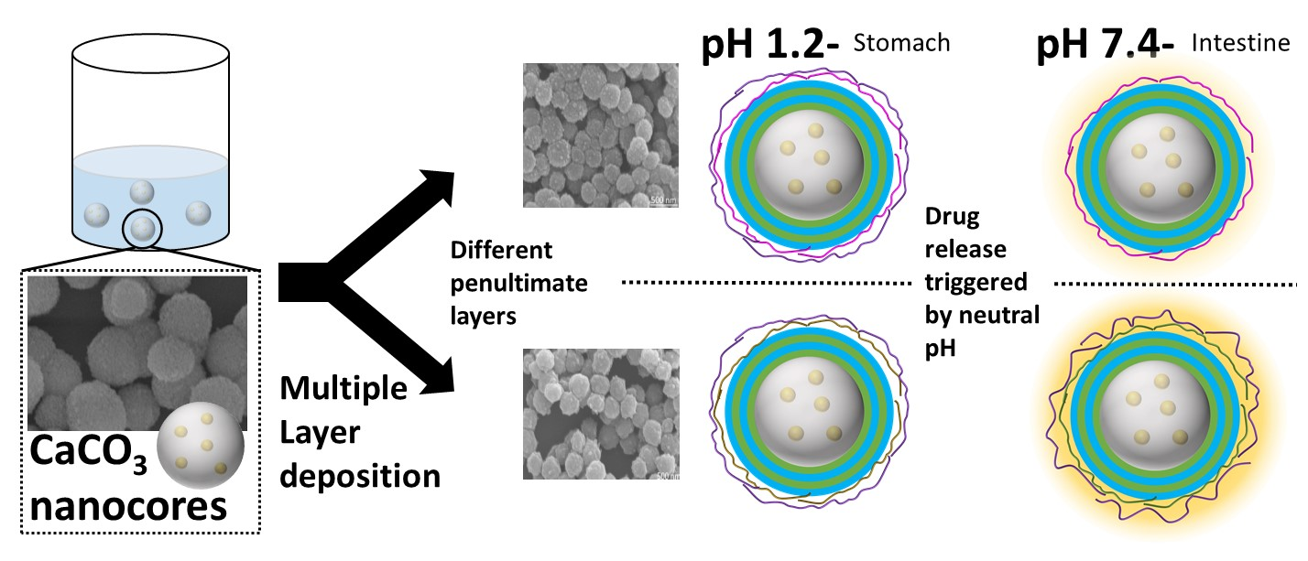
Abstract Figure: Calcium carbonate nanoparticles loaded with curcumin were modified by layer-by-layer to form stimuli responsive nanocapsules. In-vitro drug release at different pH conditions mimicking gastrointestinal transit showed that the design of the structures of the layers in the nanocapsules can be used to protect the drug in the stomach and release it in the intestine.

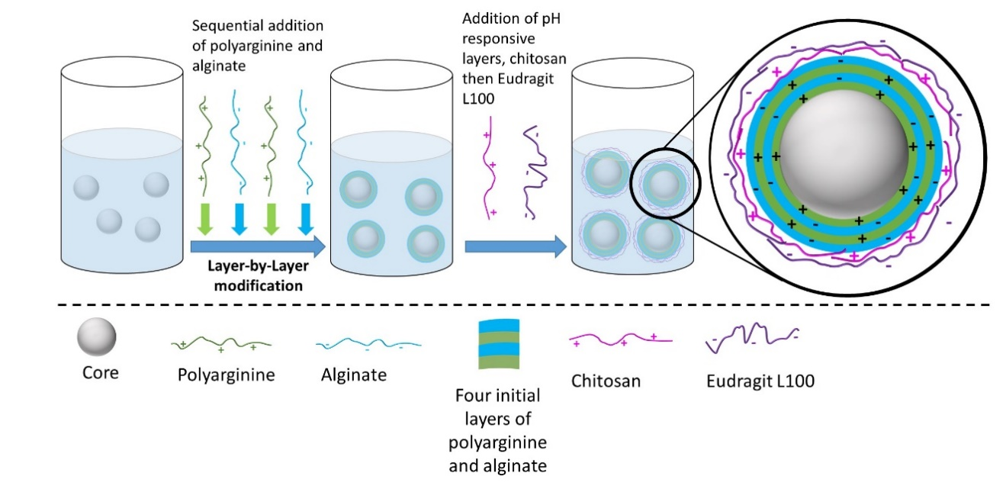
Figure 1: Schematic illustration of multi-layered nanocapsules synthesis using four polyelectrolytes including poly-L-arginine, sodium alginate, chitosan, and Eudragit L100.

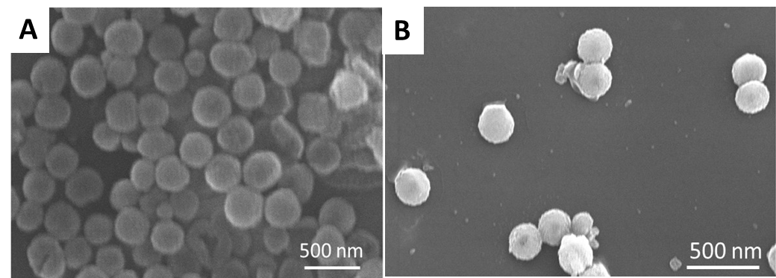
Figure 2: SEM images of optimized CaCO₃ nanoparticles in water prepared with different surfactants. (A) CMC-stabilized CaCO₃ nanoparticles in water with salt concentration of 0.016M and CMC concentration of 0.2%. (B) PSS-stabilized CaCO₃ nanoparticles in water solution with salt concentration of 0.016 M and PSS concentration of 1%.

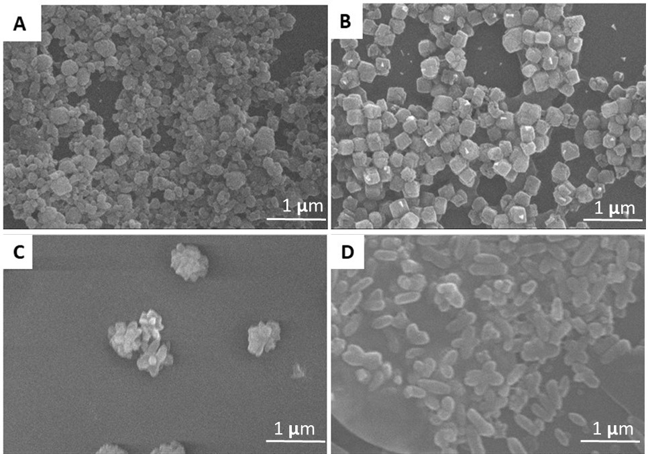
Figure 3: SEM images of various shapes of CaCO₃ nanoparticles obtained as a result of varying the pH during precipitation: (A) pH 5.5 spherical, (B) pH 9 cubes, (C) pH 12 flowers, and (D) pH 14 rods.

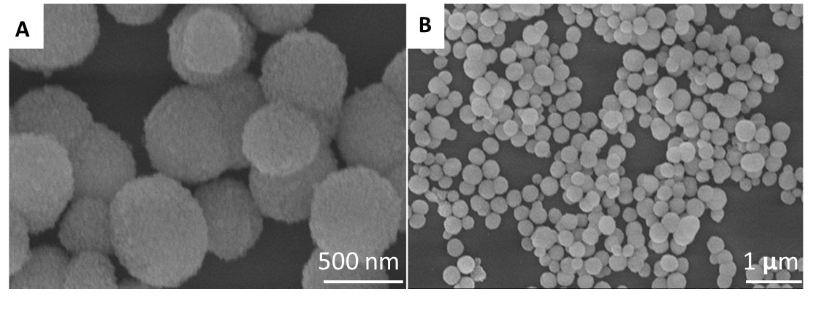
Figure 4: SEM images (A-B) at different magnification of optimized CaCO₃ nanoparticles prepared in 70:30 % v/v glycerol: water and precursor concentration 0.15 M solvent mixture at different magnifications.

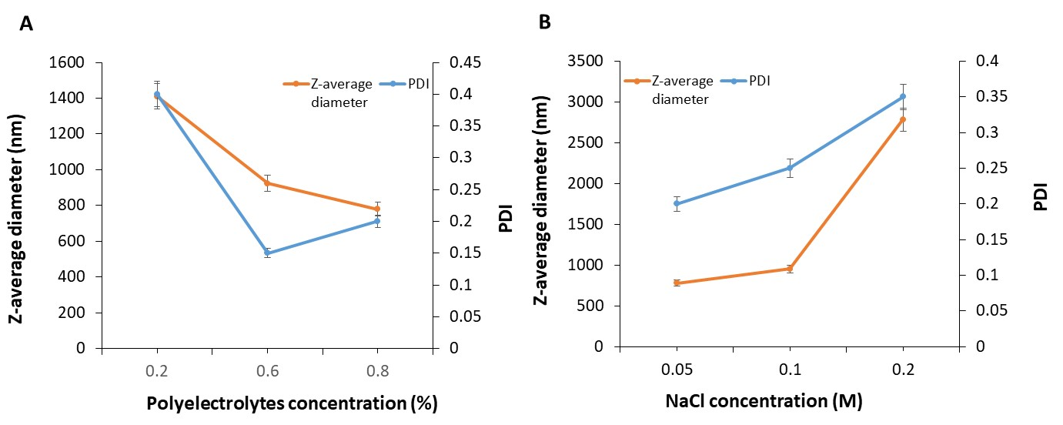
Figure 5: Optimization of the LbL coated nanocores. (A) Diameters and polydispersity index of LbL capsules as measured by DLS as a function of polyelectrolytes concentration. (B) Diameters and PDI of LbL capsules plotted as measured by DLS as a function of NaCl concentration.

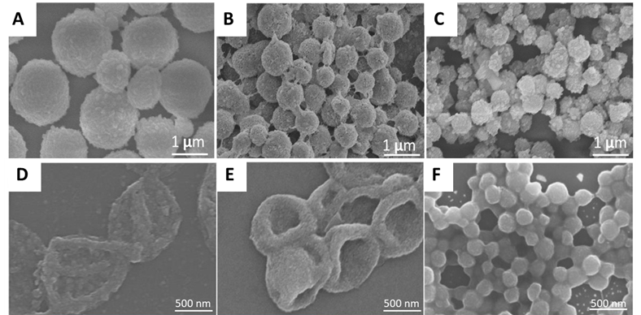

Figure 6: SEM images of poly-L-arginine/alginate LbL capsules of different diameters (A) 1200 nm, (B) 827 nm, and (C) 750 nm. SEM images (A-C) of hollow poly-L-arginine/alginate LbL nanocapsules obtained after incubated with 0.2 M EDTA for 24 hours with capsules of different diameters (A) 1200 nm, (B) 827 nm, (C) 750 nm.

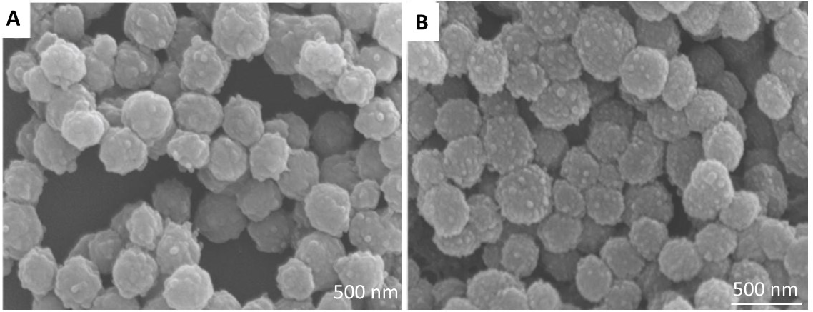
Figure 7: SEM images of stimuli-responsive nanocapsules composed of four alternating layers of poly-L-arginine and alginate with different fifth layers: (A) The fifth layer was poly-L-arginine, (NCs-A/E) and (B) The fifth layer was chitosan, (NCs-C/E). In both samples the sixth layer was Eudragit L100.

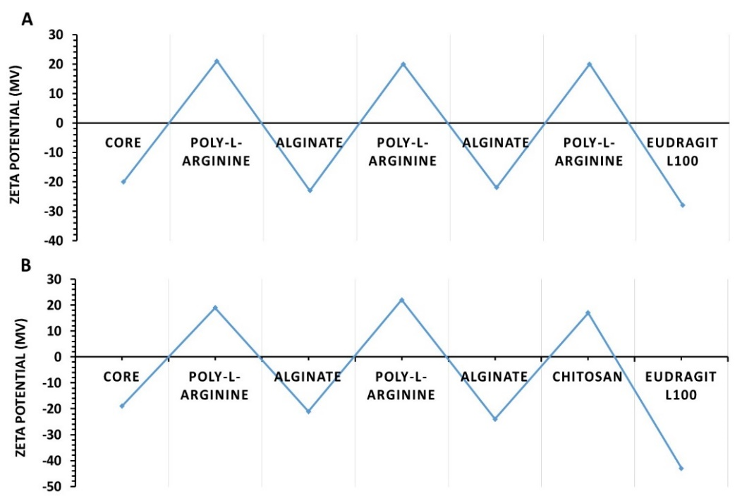
Figure 8: Zeta potential of LbL nanocapsules composed of four alternating layers of poly-L-arginine and alginate with different fifth layers and a sixth layer of Eudragit L100. Both samples showed an alternation in Zeta potential values, which confirmed layer deposition. The two different samples were: (A) The fifth layer was poly-L-arginine, (NCs-A/E) and (B) The fifth layer was chitosan, (NCs-C/E). All the measurements were done in triplicate.

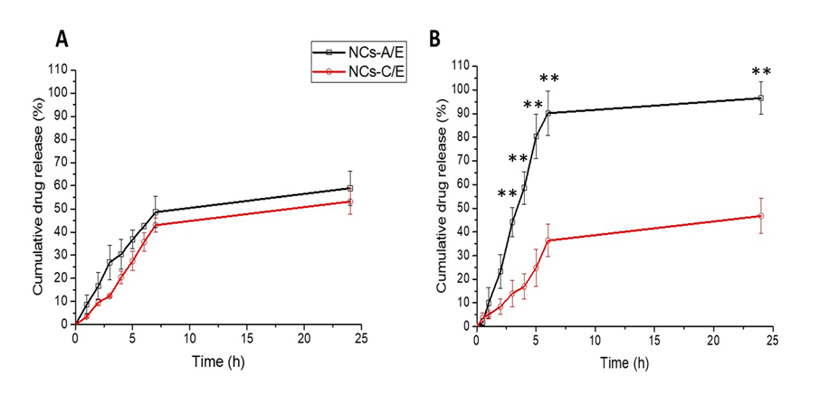

Figure 9: Cumulative curcumin release percentage from the two samples with different LbL structures at pH 1.2 (A) and pH 7.4 (B). The nanocapsules composed of four alternating layers of poly-L-arginine and alginate with different fifth layers: In NCs-A/E, the fifth layer was poly-L-arginine, and in NCs-C/E the fifth layer was chitosan. In both samples the sixth layer was Eudragit L100. Each sample was carried out in triplicate. The p-value showed that the difference in curcumin release behaviour between the two samples at pH 7.5 was significant (P < 0.01 **).

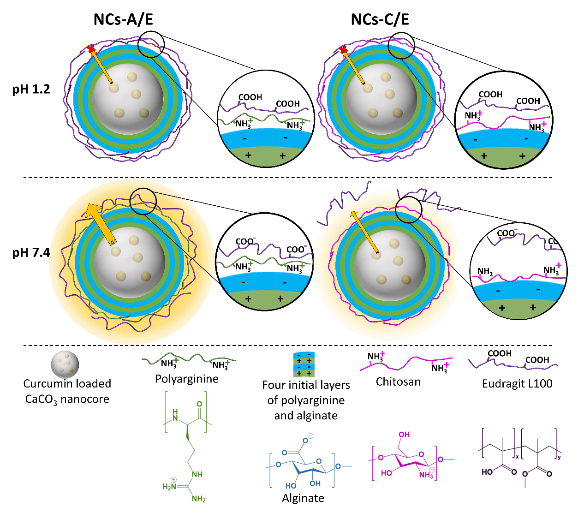
Figure 10: The pH-triggered release of curcumin from LbL coated nanoparticles. The figure illustrates the changes in the coating of the nanoparticles at pH 1.2 and pH 7.4. At pH 1.2 (mimic for conditions in the stomach) the outer coating of Eudragit L100 is protonated, insoluble in water and will provide a barrier to the release of the curcumin entrapped in the nanocores for both NCs-A/E (polyarginine and Eudragit L100 as the outer two layers) and NCs-C/E (chitosan and Eudragit L100 as the outer two layers). At pH 7.4, (mimic for conditions in the intestine) the Eudragit L100 outer layer for both samples is deprotonated and anionic. However, the different behavior of the penultimate layer (polyarginine or chitosan) results in different curcumin release behavior for NCs-A/E and NCs-C/E.

