**Phosphorescent Iridium(III) Complexes with Acyclic Diaminocarbene Ligands as Chemosensors for Mercury**

Anzhelika A. Eremina,a Mikhail A. Kinzhalov,\*,a Evgenе A. Katlenok,a Andrey S. Smirnov,a   
Elena V. Andrusenko,b Evgeny A. Pidko,b,c Vitalii V. Suslonov,a and Konstantin V. Luzyanin\*,a,d

a Saint Petersburg State University, 7/9 Universitetskaya Nab., St. Petersburg, 199034 Russian Federation

b TheoMAT Group, ITMO University, Lomonosova 9, St. Petersburg 191002, Russian Federation

c Inorganic Systems Engineering Group, Department of Chemical Engineering, Faculty of Applied Sciences, Delft University of Technology, Van der Maasweg 9, 2629 HZ Delft, The Netherlands

d Department of Chemistry, University of Liverpool, Crown Street, Liverpool L69 7ZD, United Kingdom

**Abstract**

A new application for *bis*(cyclometallated)-iridium(III) species containing ancillary acyclic diaminocarbene ligands, *viz.* for sensing of mercury(II) ions, is disclosed. A family of *bis*(cyclometallated)-iridium(III) species supported by both parent isocyanide and acyclic diaminocarbene ligands was prepared, and their electrochemical and photophysical properties were evaluated, revealing efficient blue-green phosphorescence in solution with quantum yields of up to 55%. We uncovered that photophysical properties of these complexes are dramatically altered by the presence of metal ions, and that the complex [Ir(ppy)2(CN){C(NH2)(NHС6H4-4-X)}] with ADC ligand reacts selectively with Hg2+ ions, enabling its use for sensing of mercury(II) ions in solution. The limit of detection was as low as 2.63 × 10−7 M, and additional mechanistic studies indicated the formation of an unusual dinuclear iridium(III)-cyclometallated intermediate, bridged by a mercury-(dicyano) fragment as a driving force of mercury sensing.

**Keywords**: acyclic diaminocarbene, iridium(III) complexes, phosphorescence, sensor applications, mercury.

**Introduction**

In the last decade, phosphorescent cyclometalated-iridium(III) complexes have received considerable attention owing to their applications in photophysics,[1](#_ENREF_1) analyte sensing,[2](#_ENREF_7) bioimaging,[3](#_ENREF_14) and catalysis.[4](#_ENREF_19) Valuable photophysical characteristics of those stem from the high luminescence quantum yield and comparatively faster phosphorescence lifetime, that can be additionally tuned by varying the ligand environment.[1c](#_ENREF_3) Detection of transition metals is an attractive field for phosphorescent cyclometalated-iridium(III) complexes, and discovery of Cu2+,[5](#_ENREF_25) Zn2+,[6](#_ENREF_31) Ag+,[7](#_ENREF_32) Cr3+,[8](#_ENREF_33) and Hg2+[9](#_ENREF_34) are well documented (see **Figure 1** for the example of Cu2+ and Cr3+ sensors).[2g](#_ENREF_13) Insofar as the detection of Hg2+ ions using cyclometalated-iridium(III) species is concerned, several examples have been previously described (**Figure 1** contains two representative systems;[9g](#_ENREF_40), [9h](#_ENREF_41) **Table S1** from the Supporting Information, SI, summarises all reported examples). Phosphorescent sensing of Hg2+ is based usually on one of two mechanisms: (*i*) coordination of mercury(II) to *S*- or *N*-donor atoms of the cyclometallating or ancillary ligands,[2g](#_ENREF_13) or (*ii*) the mercury-mediated irreversible dissociation of the ancillary ligands.[10](#_ENREF_55) A dramatic change of the luminescence profile or a complete quenching of the luminescent response are triggered in both approaches and are further used for quantification of Hg2+. It is notable that majority of the reported systems achieve the desired photophysical effect by variation of the customised cyclometallating ligands, whose preparation is generally nontrivial and accompanied by the low product yield.[9g](#_ENREF_40), [9h](#_ENREF_41)



**Figure 1.** Representative cyclometallated-iridium(III) sensors for metal ions.

Alteration of the photophysical properties by the change of the secondary ancillary ligands present in the coordination sphere of sensor species is less common but worth exploring. Recently, we reported on the cyclometallated-iridium(III) complexes containing ancillary acyclic diaminocarbene ligands (ADCs),[11](#_ENREF_56) that were generated via the addition of *N*-donor species to metal-activated isocyanides (for reviews see Ref. [[12](#_ENREF_57)]; for the representative synthetic works see Ref. [[13](#_ENREF_59)]). In the current study, we expanded this synthetic approach towards new iridium(III)-ADC species and evaluated their electrochemical and photophysical properties. We observed that these cyclometallated-iridium(III) complexes exhibit efficient blue-green phosphorescence in solution, that is dramatically affected by the presence of metal ions. It is noteworthy that while metal-ADC species are widely used in organometallic chemistry and catalysis,[14](#_ENREF_67) their application as metal sensors is unprecedented. Driven by these initial observations, we evaluated cyclometallated-iridium(III) complexes containing ADCs ligands as sensors for mercury(II) ions in solution, and report herein on our findings.

**Results and Discussion**

**Preparation and characterisation of complexes.** For this study, we prepared a series of iridium(III)-*bis*(C,N-phenylpyridinato) species with ancillary isocyanide (CNR) and ADC ligands (see SI, sections S2­–S3 for more details). *Mono*CNR complexes [Ir(ppy)2Cl(CNС6H4-4-X)] (X = F **3a**, Cl **3b**, Br **3c**, I **3d**, 81–86% isolated yields) were prepared from [(ppy)2Ir(*μ*-Cl)]2 (1) and the isocyanides CNС6H4-4-X (**2a**–**d**) (Scheme 1). Coupling of **3a**–**d** with an excess of gaseous NH3 at 50 °C in dichloroethane led to the *mono*ADC species [Ir(ppy)2{C(NH2)NHС6H4-4-X}Cl] [**4a**–**d**] (73–86% yields). Replacement of chloride in [**4a**–**d**] with one equiv of isocyanide led to the mixed isocyanide/diaminocarbene species [**5a**–**d**](OTf) (78–84%). *Bis*CNR complexes [Ir(ppy)2(CNС6H4-4-X)2](OTf) ([**6a**–**d**](OTf), 72–87%) were obtained from the reaction of 1 with 2 equivs of **2a**–**d** in the presence of 2 equivs of AgOTf as previously described.[11](#_ENREF_56)



**Scheme 1.** Preparation of complexes **3**–**8**.

Coupling of *bis*CNR [Ir(ppy)2(CNС6H4X)2](OTf) complexes [**6a**–**d**](OTf) with an excess of gaseous NH3 afforded the known *bis*ADC complexes [Ir(ppy)2{C(NH2)NHС6H4-4-X}2](OTf) [**7a**–**d**] and cyanide/ADC [Ir(ppy)2(CN){C(NH2)NHС6H4-4-X}](OTf) (**8a**–**d**).[11](#_ENREF_56) New complexes **3a**–**d** and **4a**–**d** were characterised by elemental analyses (C, H, N), high-resolution ESI+-MS, TG/DTA, IR, and 1H, 13C{1H} and 19F{1H} NMR spectroscopy (see SI, section S4 for more details). The structure of three species **3c**, **4a**,and [**5a**](OTf), were elucidated by a single-crystal X-ray diffraction (**Figure 2**, see also SI, section S5). The authenticity of the known species [**5**–**7**](OTf) and **8a**–**d** was confirmed upon a comparison of their 1H NMR spectra with those reported.[11](#_ENREF_56)

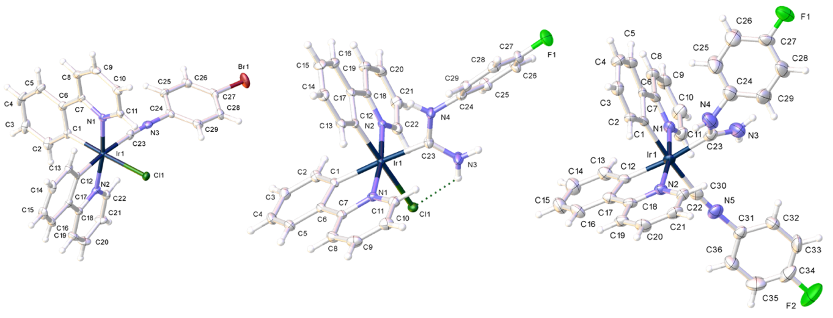

**Figure 2.** View of **3c** (left), **4a** (center), and [**5a**](OTf) (right) with the atomic numbering schemes. Thermal ellipsoids are drawn with the 50% probability. Counter anion and hydrogen labels were omitted for simplicity. Crystal data, structure refinement details, and selected bond lengths (Å) and angles (deg.) are given in the SI, section S5.

**Electrochemical studies.** Electrochemical studies were invoked to estimate the relative energy levels of the highest occupied molecular orbital (HOMO) and lowest unoccupied molecular orbital (LUMO) of ground‐state iridium(III) complexes (section S6 in SI). Oxidation potentials of cyclometalated iridium(III) complexes can be related to the HOMO energy levels, corresponding to removal of an electron from an Ir‐aryl‐centered orbital.

Cyclic voltammetry (CV) experiments for complexes **3**–**8** were carried out in MeCN solution and the data obtained are summarised in **Figure 3** and **Table S3**, while cyclic voltammograms are shown in **Figures S1**−**S6** in SI. Oxidation of complexes manifests by an irreversible wave centred at metal (0.68–1.22 V).[1a](#_ENREF_1), [15](#_ENREF_70) Substitution of chloride ligands in **3a**–**d** to isocyanide [**6a**–**d**](OTf) leads to an increase of the oxidation potential by ca. 0.2 V. Oxidation potentials for the *bis*CNR [**6a**–**d**](OTf) (ca. 1.2 V) are nearly similar to those reported previously for other *bis*CNR iridium complexes [Ir(ppy)2(CNR)2](PF6) (R = Xyl, 2,4-*i*Pr2C6H3, 1.27–1.28 V).[15e](#_ENREF_74) Conversion of one isocyanide in [**6a**–**d**](OTf) to ADC ligand in [**5a**–**d**](OTf) leads to a decrease of the oxidation potential by *ca*. 0.2 V; further transformation of the second isocyanide to ADC giving [**7a**–**d**](OTf) leads to a further decrease of the oxidation potential by *ca*. 0.2 V. These data suggest that carbene is a stronger electron-donating ligand than compared to the parent isocyanide evidenced by the destabilisation of the HOMO levels in the former.[16](#_ENREF_75) Known iridium cyclometallated complexes containing *C*,*C-*chelating *bis*-ADC ligands show similar electrochemistry trends.[17](#_ENREF_76)

**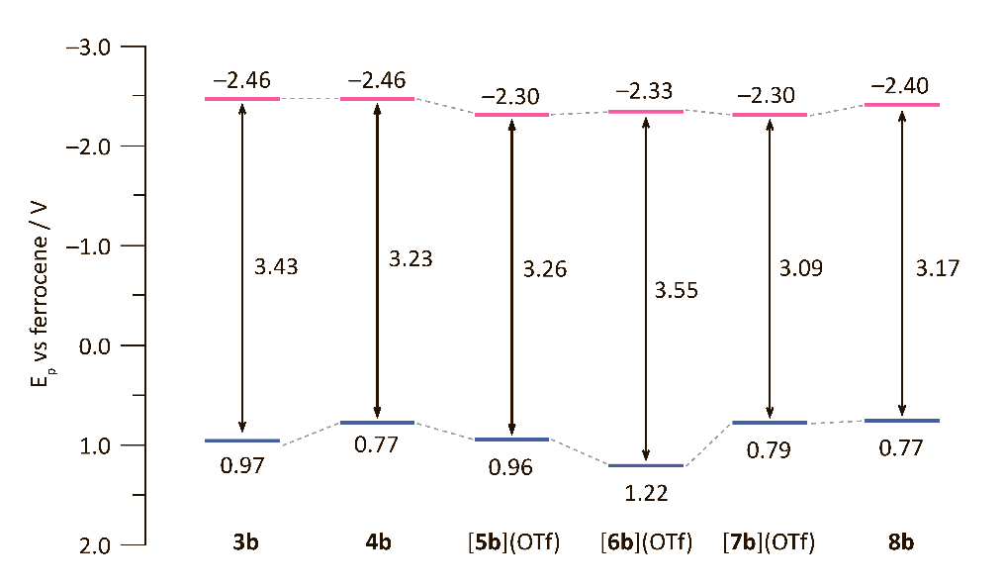**

**Figure 3.** Summary of electrochemical data for complexes **3b**–**8b**, see **Table S3** in SI for all data on **3**–**8**. Redox gap: ΔE = Epox – Epred).

Upon reduction, one-electron oxidation waves with a potential in the range –2.5 to –2.2 V that are marginally influenced by the change of the ancillary ligands, were detected. It suggests that the reduction involves population of a π\* orbital in cyclometalated ligand, that thus contains the LUMO orbital. These reduction potentials are comparable to the previously reported isocyanide iridium complexes [Ir(ppy)2(CNR)2](PF6) (R = Xyl, 2,4-*i*Pr2C6H3, –2.37 V).[15e](#_ENREF_74)

**Photophysical studies.** *UV−vis absorption properties*. UV−vis absorption spectra of the complexes **3**–**8** were measured in MeCN at ambient temperature. UV–vis data for **3**–**8** are summarised in **Table 1** and **Figures S7**–**S12** (section S7 in SI); overlay of selected spectra is given in **Figure 4**. All cationic complexes with either CNR or ADC ligands are nearly colourless ([**6a**–**d**](OTf) and [**7a**–**d**](OTf)) or yellowish ([**5b**–**d**](OTf)), while neutral complexes with CNR, ADC, Cl or CN ligands (**3a**–**d**, **4a**–**d**, and **8a**–**d**) are bright yellow.

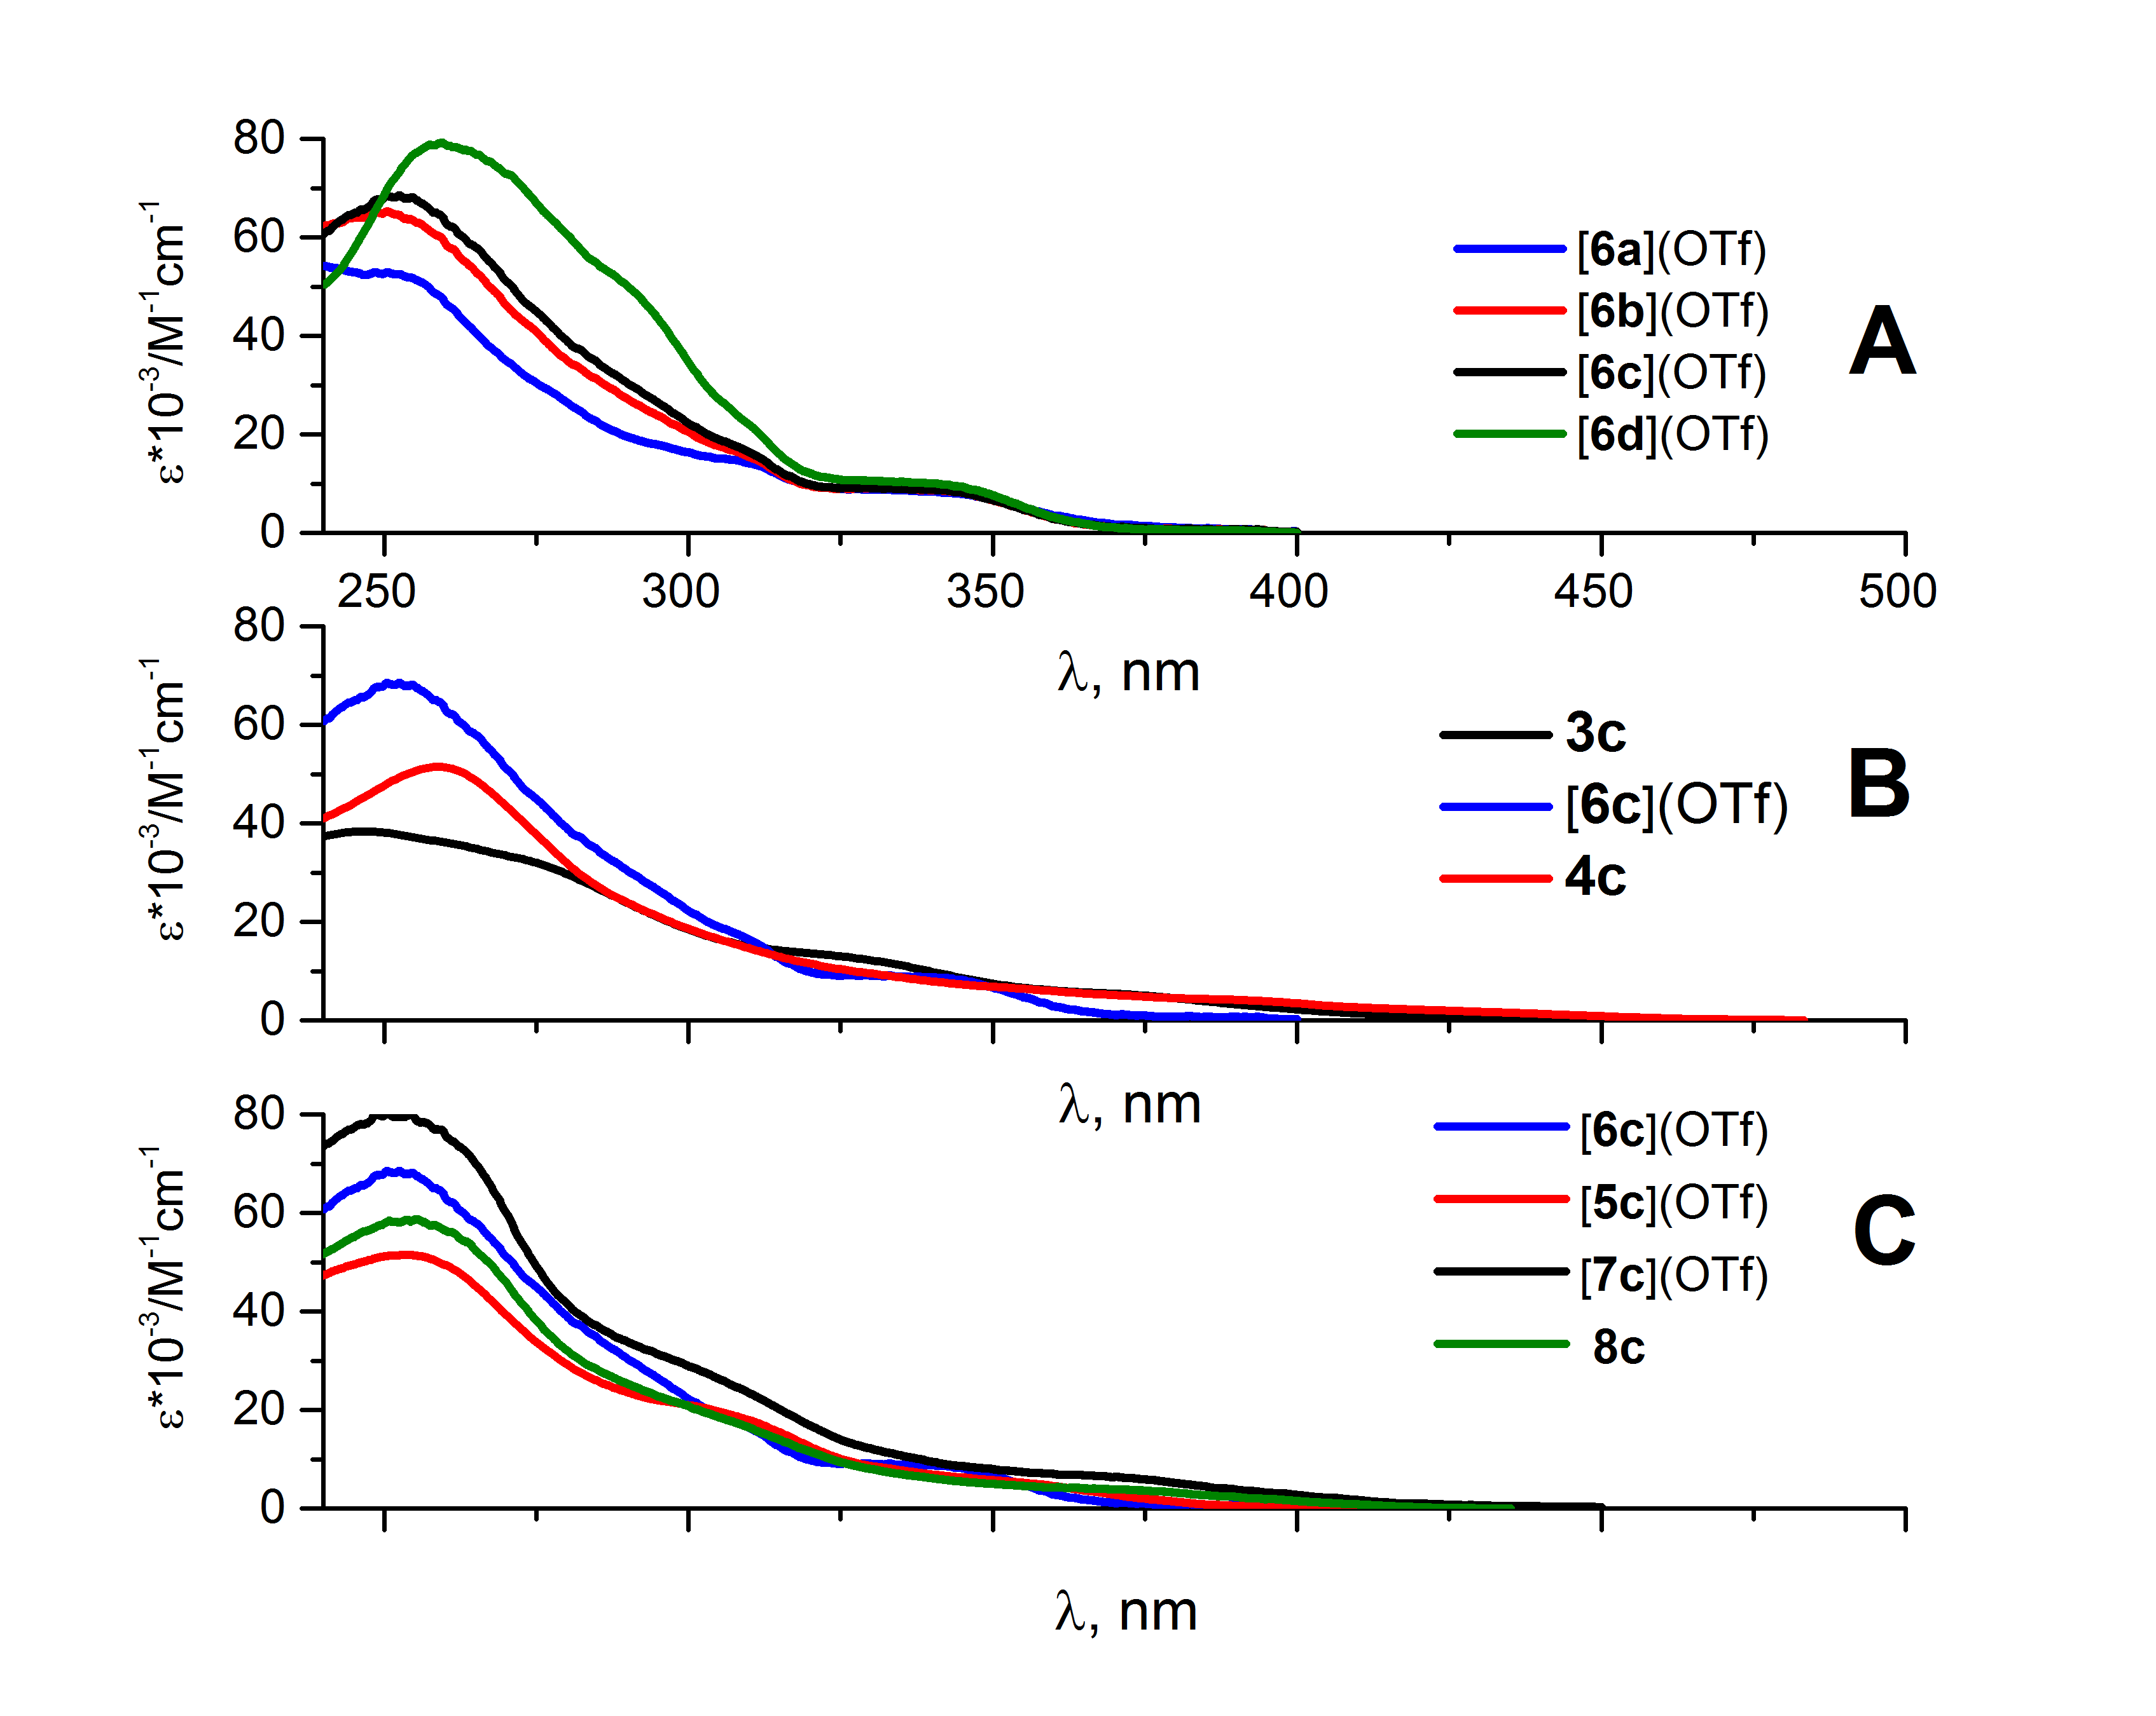

**Figure 4.** Overlay of UV-vis spectra for [**6a**–**d**](OTf) and **3c**–**8c** in MeCN at RT.

For all **3**–**8**, UV-vis spectra contain strong absorption bands below 340 nm with high molar extinction coefficients (ε = (10.3–79.6)×103 M–1cm–1), assigned to spin-allowed π–π\* ligand centred transitions (1LC).[18](#_ENREF_77) For all **3**–**8**, the less intense bands (ɛ = (0.4–9.4)×103 M–1cm–1) observed in the 340–400 nm region are attributed to spin-allowed singlet metal-to-ligand charge transfer (1MLCT) transitions; that is consistent with the previously reported experimental data and DFT calculations for NHC- and ADC-iridium(III) complexes.[17](#_ENREF_76), [19](#_ENREF_78) The energy of the 1MLCT absorption band are also affected by the change of the ancillary ligands.[20](#_ENREF_82) When both CNRs in [**6a**–**d**](OTf) are converted to ADC ligands in [**7a**–**d**](OTf), a *ca*. 30 nm (ca. 2000 cm–1) red shift of the 1MLCT bands in absorption spectra is observed (**Figure 4**, C). This could be explained by decrease of a π-acceptor and increase of σ-donating properties of carbene ligand that leads to destabilisation of HOMO.[14b](#_ENREF_68), [17](#_ENREF_76), [20](#_ENREF_82) Complexes with two ADC ligands [**7a**–**d**](OTf) show blue-shifted 1MLCT bands relative to the complexes with ADC/Cl (**4a**–**d**) or ADC/CN (**8a**–**d**) ligands as the strong σ-donation from ADC increase the HOMO–LUMO gap.[14b](#_ENREF_68) Weak bands (ɛ = ca. 400 M–1cm–1) in the region of 440–475 nm, that were observed for **4a**–**d** only, were assigned as spin-forbidden singlet to triplet metal-to-ligand charge transfer (3MLCT) transitions.[18](#_ENREF_77) Variation of the halogen substituent in aryl fragment of the CNR or the corresponding ADC ligands induces no significant change in the positions of the 1MLCT bands and only exerts minimal influence on the extinction coefficients (**Figure 4**, A, e.g. 346 nm (ɛ = 7.9×103 M–1cm–1) in [**6b**](OTf) vs 344 nm (ɛ = 8.3×103 M–1cm–1) in [**6c**](OTf)).

**Table 1.** UV–Vis absorbance data for complexes **3**–**8**.

|  |  |
| --- | --- |
| Complex | Absorption: λmax /nm (ε×10−3/M−1cm−1)*a* |
| **3a** | 251 (41.7); 262sh (40.0); 285sh (24.6); 317sh (13.8); 374 (4.5); 407br (1.5) |
| **3b** | 246 (36.4); 262sh (35.1); 329sh (10.3); 373 (4.20); 410br (1.1) |
| **3c** | 247 (38.4); 278sh (30.7); 329sh (12.4); 375sh (5.0); 453br (0.4) |
| **3d** | 259 (54.4); 274sh (44.4); 333 (13.6); 372sh (5.5); 407br (1.3) |
| **4a** | 243sh (29.2); 252sh (32.0); 261 (33.2); 274sh (26.4); 298sh (14.4); 331sh (7.4); 356sh (5.0); 374sh (4.0); 392sh (3.2); 417sh (1.9); 442sh (1.1); 475sh (0.3) |
| **4b** | 250sh (35.0); 260 (37.8); 275sh (28.7); 300sh (14.4); 332sh (7.3); 355sh (5.1); 395 (3.3); 430sh (1.7); 455sh (0.8); 474sh (0.4) |
| **4c** | 253sh (49.6); 259 (51.7); 276sh (36.5); 295sh (21.1); 332sh (9.4); 391sh (4.2); 399sh (3.6); 450sh (0.9) |
| **4d** | 259 (43.1); 276sh (32.3): 302sh (14.7); 355sh (5.3); 394sh (3.6); 436sh (1.6); 475sh (0.4) |
| [**5a**](OTf) | 238 (53.33); 252 (53.85); 300sh (20.6); 315sh (14.5); 354 (6.67); 378sh (1.88) |
| [**5b**](OTf) | 248 (53.7); 362sh (49.8); 301 (20.7); 315sh (14.9); 348sh (6.1); 368br (3.5) |
| [**5c**](OTf) | 253 (51.45); 309 (18.28); 344sh (6.4); 360sh (4.5); 376br (1.8) |
| [**5d**](OTf) | 253 (41.0); 271sh (31.6); 300sh (15.8); 380sh (4.1); 407sh (1.7) |
| [**6a**](OTf) | 257sh (50.2); 280sh (26.5); 311 (13.8); 346 (7.71); 372br (1.5) |
| [**6b**](OTf) | 250 (65.1); 275sh (40.7); 311sh (15.0); 346 (7.9) |
| [**6c**](OTf) | 252 (68.2); 269sh (52.8); 311sh (15.6); 344 (8.3) |
| [**6d**](OTf) | 259sh (79.1); 292sh (47.9); 312sh (19.7); 345 (9.4) |
| [**7a**](OTf) | 252 (47.4); 266sh (41.4); 304sh (15.7); 336sh (6.2); 372 (3.72); 404sh (1.1) |
| [**7b**](OTf) | 252 (79.6); 270sh (60.1); 307sh (25.1); 369sh (6.5); 408 (1.9) |
| [**7c**](OTf) | 255 (58.7); 270sh (46.4); 306sh (19.6); 373 (5.5); 402br (2.2) |
| [**7d**](OTf) | 254 (41.4): 268sh (35.4); 305sh (15.4); 338sh (7.2); 376 (5.1); 414sh (1.6) |
| **8a** | 254 (36.6); 268sh (30.5): 304sh (13.6); 340sh (5.9); 378 (4.1); 411sh (1.4) |
| **8b** | 254 (38.86); 268sh (32.2); 307sh (12.3); 339sh (5.6); 377 (3.98); 410sh (1.3) |
| **8c** | 251 (41.66); 262sh (40.0); 285sh (24.6); 317sh (13.8); 374 (4.48); 407br (1.5) |
| **8d** | 252 (47.4); 266sh (41.4); 304sh (15.7); 336sh (6.2); 372 (3.72); 404sh (1.1) |

a Recorded in MeCN solution (concentration = 10−5 M).

*Emission properties*. Upon photoexcitation at 350 nm (for [**6a**–**d**](OTf)), 375 (for [**5b**–**d**](OTf), [**7a**–**d**](OTf), **8a**–**d**) or 400 nm (for **3a**–**d** and **4a**–**d)** all complexes exhibit broad, blue-green phosphorescence in MeCN solution at RT and in glassy medium at 77 K (**Figure 5**). **Table 2** summarises the steady-state and time-resolved emission data, and **Figure 6** contains overlay of RT and low temperature emission spectra for the representative species (see section S8 in SI for the full data).

**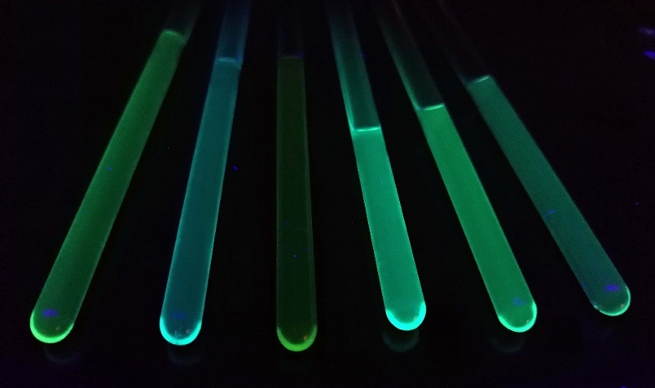**

**Figure 5.** The photograph of phosphorescent emission of representative iridium(III) species **3с**–**8с** in CH2Cl2 solution at RT (from left to right **3c**,[**6c**](OTf), **4c**, [**5c**](OTf), [**7c**](OTf)and **8c**). Excitation wavelength of 365 nm produced by a portable UV lamp.

C:\Users\chem\Dropbox\Мишины документы\sciense\ART\Еремина аммиак__2\_____REVISION\Lum All (1).tif

**Figure 6.** Overlay of RT (top) and 77 K (bottom) emission spectra of representative iridium(III) species (**A**: [**6a**–**d**](OTf); **B**: **3c**, **4c** and [**6c**](OTf); C: [**5c**](OTf), [**6c**](OTf), [**7c**](OTf)and **8c**) in MeCN solution and EtOH/2-metoxyethanol glass, respectively.

Excitation spectra (**Figures** **S13**–**S36** in SI) of **3**–**8** match well to their absorption spectra suggesting that the lowest excited state remains unchanged during the emission process.[20](#_ENREF_82) The vibronic structure with a frequency of 1400 cm–1 is visible in each spectrum (except **4a**–**d**), indicating a significant contribution from a LC state in the lowest-energy excited state.[20](#_ENREF_82) Emission spectra of complexes **4a**–**d** are non-structured at RT indicating that they may have the most pronounced MLCT character in the lowest excited state.[20](#_ENREF_82) Change of halogen substituent on the isocyanide or ADC ligands from chlorine to iodine leads to a decrease in phosphorescence quantum yields and lifetimes (eg. τ = 12 μs and Φ = 0.55 for [**6b**](OTf), τ = 8 μs and Φ = 0.50 for [**6c**](OTf), and τ = 4 μs and Φ = 0.06 for [**6d**](OTf)), presumably due to “heavy-atom effect”,[21](#_ENREF_83) although emission maxima and emission profile are retained (**Figure 6**, A).

Change of the ancillary ligands (CNR, Cl, ADC, and/or CN) induces dramatic changes in the emission properties of complexes. Hence, *mono*CNR complexes **3a**–**d** exhibit greenish-blue phosphorescence with λmax = 469 nm at RT and 460 nm at 77 K with the relatively small quantum yields up to Φ = 0.10 for **3a** (**Figure 6**, B).Substitution of chloride ligand by an CNR in *bis*CNR complexes [**6a**–**d**](OTf) leads to a blue shift of phosphorescence (λmax = 451 nm at RT and 449 nm at 77 K nm) and a significant increase in quantum yield (Φ = 0.55 for [**6b**](OTf)). The quantum yield of [**6b**](OTf) is higher than that of other *bis*CNR iridium complexes with cyclometallating ppy ligand: [Ir(ppy)2(CNR)2](PF6) (R = Xyl, 2,6-*i*Pr2C6H3) (Φ = 0.24 and 0.37, respectively)[15e](#_ENREF_74) and is comparable with quantum yields for complexes with 2,4‐difluorophenylpyridine (F2ppy) [Ir(F2ppy)2(CNR)2](PF6) (R = 2,4-(MeO)2C6H3, 2,4-(CF3)2C6H3) (Φ = 0.50 and 0.39, respectively).[17](#_ENREF_76)

*Mono*ADC **4a**–**d** exhibit broadgreenish-blue phosphorescence with λmax = 502 nm at RT and 481 nm at 77 K (Δ λmax 33 nm (1400 cm–1) at RT and 21 nm (950 cm–1) at 77K), with quantum yields being two-fold smaller that for the starting **3a**–**d** (Φ = 0.04 for **4a**). Redshift for the emission maxima upon transformation of isocyanide ligands to ADCs could be explained by a decrease of π-accepting and increase of σ-donating properties of carbene ligand[14b](#_ENREF_68) that leads to destabilisation of HOMO,[20](#_ENREF_82) confirmed by a cathode shift of the oxidation potential of *ca*. 0.3 V. This trend was previously observed for other phosphorescent iridium(III),[17](#_ENREF_76) platinum(II)[22](#_ENREF_84) and rhenium(I)[23](#_ENREF_85) complexes. Conversion of *bis*CNR [**6a**–**d**](OTf) to *mono*ADC [**5a**–**d**](OTf) induces a redshift of the emission maxima to λmax = 458 nm at RT and 455 nm at 77K; similar effect was observed in *bis*ADC complexes [**7a**–**d**](OTf) (λmax = 472 nm at RT and 469 nm at 77 K) and cyanide/ADC complexes **8a**–**d** (462 nm at 77 K). For the latter, emission maxima is *ca.* 15 nm (700 cm–1) redshifted when compared to the known iridium cyanide/CNR complex [Ir(ppy)2(CN)(CN*t*Bu)].[24](#_ENREF_86)

Both *mono*ADC **4a**–**d** (Φ = 0.04 for **4a**) and *mono*CNR complexes **3a**–**d** (Φ = 0.10 for **3a**) demonstrate relatively small quantum yields, that can be explained by the presence of chloride ligand, which have smaller ligand field splitting parameter[25](#_ENREF_87) and stabilised the non-emissive metal centred (MC) states of iridium.[24](#_ENREF_86), [26](#_ENREF_88)*Mono*ADC [**5a**–**d**](OTf), *bis*ADC [**7a**–**d**](OTf) and cyanide/ADC complexes **8a**–**d** exhibit quantum yields (Φ = 0.40 for [**5b**](OTf), 0.31 for [**7b**](OTf) and 0.45 for **8b**) somewhat lower than *bis*CNR [**6**](OTf), albeit significantly larger than those for the known *bis*ADC species [Ir(F2ppy)2((Ar)CNH–NH)C(Ar))](PF6) (Ar = 4-CF3C6H4, 3,5-(CF3)2C6H3, Φ up to 0.078).[17](#_ENREF_76)

At RT, all the complexes exhibit monoexponential decays and their lifetimes lie in the range of 4–16 μs, which are in agreement with the values reported for other iridium(III) isocyanide complexes.[15e](#_ENREF_74), [27](#_ENREF_89) To obtain a better understanding of the photophysics of **3**–**8**, we compared the emission properties at RT and 77 K. All of the complexes investigated in this study exhibit better resolved phosphorescence spectra in EtOH/2-metoxyethanol (1:1 = v/v) at 77 K compared to those recorded at RT (**Table 2**, **Figure 6**). When the medium is changed from fluid MeCN (298 K) to frozen glasses (77 K), complex [**5a**–**d**](OTf) and [**6a**–**d**](OTf) show small rigidochromic blue shifts of 2–3 nm (100–150 cm–1), similar vibronic progressions within each family of complexes and significantly longer lifetimes of (64±1) μs for [**6a**–**d**](OTf) and (21±1) μs for [**5a**–**d**](OTf). Estimate of the Huang-Rhys factor, SM ca. 1 indicating that the lowest excited state is a predominantly ppy-centered 3LC state with very minimal contributions from 1MLCT states.[20](#_ENREF_82) Red shifts of emission spectra, decrease of lifetimes and the Huang-Rhys factor with decreasing of a π-accepting properties of ancillary ligands in a row CNR ≈ CN < ADC < Cl in complexes [Ir(ppy)2(C(NH2)(NHC6H4X)L] ([**5a**–**d**](OTf), **8a**–**d,** [**7a–d**](OTf)and **4a**–**d**, respectively) indicate the increasing of mixing of 3LC and 1MLCT states. The latter is additionally confirmed by more pronounced (compared to [**4a**–**d**](OTf)) rigidochromic blue shifts of emission spectra at 77K (120 cm–1 for [**5a**–**d**](OTf), 230 cm–1 for [**7a**–**d**](OTf), 450 cm–1 for **8a**–**d**, and 930 cm–1 for **4a**–**d**).

**Table 2.** Emission data for **3–8**.

|  |  |  |  |  |  |  |  |
| --- | --- | --- | --- | --- | --- | --- | --- |
| Complex | Emission λmax, nm | | Lifetime, *μ*s | | Quantum yield (Φ)a | Δ 77K­­–RT, cm–1e | SMf |
| 298 K (MeCN) | 77 K (EtOH/2-metoxyethanol glass) | 298 K | 77K |
| **3ab** | 469; 500; 538sh; 595sh | 460; 493; 526; 566sh; 605sh | 4 | 10 | 0.10 | 420 | 1.0 |
| **3bb** | 469; 499; 536sh | 460; 493; 527; 564sh; 612sh | 4 | 10 | 0.09 | 420 | 1.0 |
| **3cb** | 469; 500; 531sh; 587sh | 460; 493; 526; 569sh; 619sh | 4 | 10 | 0.09 | 420 | 1.0 |
| **3db** | 469; 499; 542sh; 586sh | 461; 493; 526; 572sh | 4 | 10 | 0.10 | 370 | 1.0 |
| **4ab** | 502; 559sh; 630sh | 481; 513; 556sh; 596sh | 6 | 7 | 0.04 | 870 | 0.8 |
| **4bb** | 509; 553sh; 605sh | 480; 513; 548sh; 595sh | 6 | 8 | 0.02 | 1190 | 0.8 |
| **4cb** | 503; 558; 603 | 481; 495sh; 515; 552sh; 592sh | 4 | 8 | 0.03 | 910 | 0.8 |
| **4db** | 499; 525sh; 570sh | 481; 513; 554sh; 595sh | 4 | 8 | 0.02 | 750 | 0.7 |
| [**5a**](OTf)с | 457;488;521sh; 562sh; | 454; 486; 516; 528sh; 559; 600sh | 7 | 25 | 0.15 | 100 | 0.8 |
| [**5b**](OTf)с | 458; 488; 517sh; 560sh | 455; 487; 518sh; 554sh | 7 | 21 | 0.40 | 140 | 1.0 |
| [**5c**](OTf)с | 458; 488; 518sh; 561sh | 455; 471sh; 488; 513sh; 558sh | 5 | 21 | 0.14 | 140 | 1.0 |
| [**5d**](OTf)с | 457; 488; 519sh; 559sh | 455; 487; 521sh; 560sh | 3 | 22 | 0.07 | 100 | 1.0 |
| [**6a**](OTf)d | 451; 481; 511; 554sh | 449; 466sh; 481; 505sh; 518sh; 555sh; 600 | 16 | 63 | 0.38 | 100 | 0.9 |
| [**6b**](OTf)d | 451; 481; 514sh; 557sh | 448; 470sh; 481; 507; 520sh; 552sh | 12 | 65 | 0.55 | 150 | 0.9 |
| [**6c**](OTf)d | 451; 480; 508; 551sh | 449; 481; 507; 520sh; 550sh | 8 | 64 | 0.50 | 100 | 0.9 |
| [**6d**](OTf)d | 451; 482; 515; 557sh; 600sh | 448; 469sh; 507; 521sh; 553; 596sh | 4 | 63 | 0.06 | 150 | 0.9 |
| [**7a**](OTf)c | 472; 500; 582sh | 467; 498; 530sh; 574sh; | 4 | 7 | 0.06 | 230 | 0.8 |
| [**7b**](OTf)c | 472; 498; 534sh;591sh | 467; 499; 530sh; 547sh; 573sh | 5 | 10 | 0.31 | 230 | 0.7 |
| [**7c**](OTf)c | 473; 502; 534sh; 585 | 467; 499; 529; 545sh; 575sh | 5 | 10 | 0.43 | 270 | 0.7 |
| [**7d**](OTf)c | 471; 497; 537; 583 | 467; 499; 529; 545sh; 575sh | 5 | 10 | 0.42 | 180 | 0.7 |
| **8a**c | 473; 499; 545; 588sh | 463; 494; 528sh; 576sh | 5 | 7 | 0.37 | 460 | 0.8 |
| **8b**c | 473; 500; 545; 595sh | 463; 598; 494; 529sh; 572sh | 5 | 8 | 0.45 | 460 | 0.7 |
| **8c**c | 471; 497; 540sh; 588 | 462; 493; 528; 569sh | 5 | 8 | 0.37 | 410 | 0.7 |
| **8d**c**]** | 471; 497; 543sh; 593sh | 463; 494; 529sh; 572sh | 5 | 8 | 0.23 | 460 | 0.7 |

a Quantum yields (Ф) in degassed MeCN solution were measured at 298 K with [Ru(bpy)3](ClO4)2 (Ф 0.028) as a standard.[28](#_ENREF_90)

b Excitation at 400 nm.

c Excitation at 375 nm.

d Excitation at 350 nm.

e Difference between the emission maxima at 77K and RT.

f The Huang-Rhys factor, SM, was estimated from the peak heights of the first two features of the 77 K emission spectra.

**TD-DFT calculations.** To gain insight into the electronic structures and the optical properties of the obtained complexes we performed time-dependent DFT calculations on **3b**−**8b** (see section S9, SI). The optimised ground-state geometries of **3b**−**8b** (PBE0/6-311+G(d,p)&LanL2DZ(Ir)/PCM(MeCN) level of theory)[29](#_ENREF_91) cohere well with the experimental X-ray structures (**Table S4** in SI), the main bond distances and angles are close between themselves with a maximum absolute deviations of 0.023 Å and 14.4° indicating a sufficient accuracy of the selected computational protocol.[30](#_ENREF_93) The lowest-energy spin-allowed transitions for all six complexes to give S1 are HOMO → LUMO transitions (**Tables S5–S10** in SI). Calculated MO energies and HOMO–LUMO gaps (**Figure 7**) follow the trends observed in the electrochemical studies, with calculated gaps being consistently ca. 0.79–1.29 eV greater than those observed in the CV experiments.[30](#_ENREF_93)

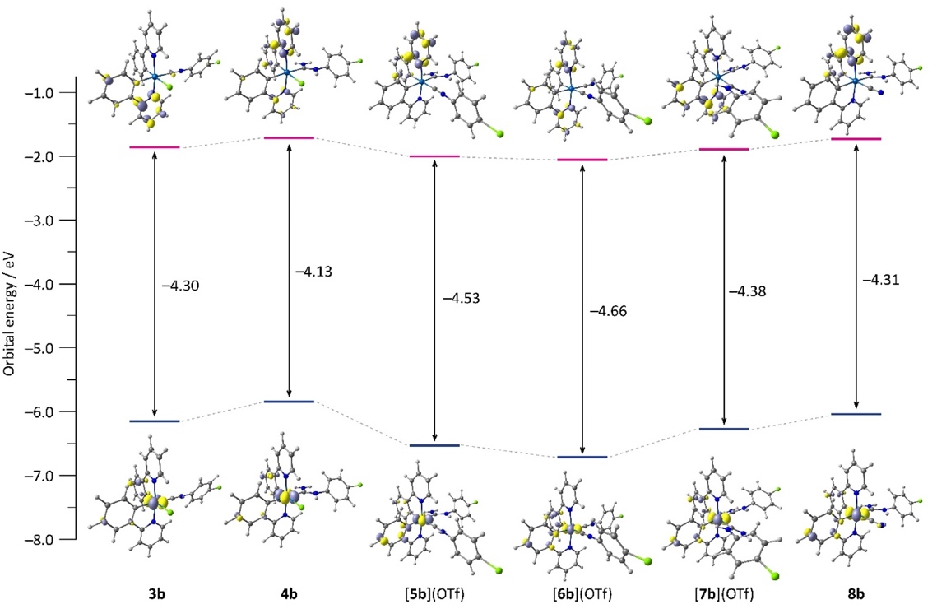

**Figure 7**. Calculated molecular orbital energy HOMO–LUMO gaps and surface plots of the HOMO and LUMO for compounds **3b**−**8b** at PBE0/6-311+G(d,p)&LanL2DZ(Ir)/PCM(MeCN) level of theory.

Trends in the calculated HOMO and LUMO energies of **3b**−**8b** are in agreement with those obtained in the course of electrochemical measurements: the lower (more negative) *E*HOMO and *E*LUMO energies correspond to the higher (more positive) *E*Ox and *E*Red potentials, respectively (**Figures 7** and **3**). At the same time, the larger calculated HOMO−LUMO energy gap corresponds to a larger electrochemical gap. The LUMOs are mostly dominated by the *π*\* molecular orbitals on the ppy ligands,[31](#_ENREF_97) explaining the observation of the minor impact of the nature of the auxiliary ligands on the computed LUMO energies (**Figure 7**). On contrary, the energy of the HOMO having large contribution from the iridium *d*-orbitals is much stronger affected by the donor-acceptor properties of the auxiliary ligands (**Table S11** in SI). An estimate of the molecular fragment contributions to frontier orbitals was carried out within the Hirshfeld population analysis using MultiWFN program package.[32](#_ENREF_98) For **3b**, **4b**, **7b**, and **8b**, the HOMO includes a ca. 31–40% contribution from the iridium d-orbitals; complexes **5b** and **6b** are the exception where the metal contribution is only 19–25%; the other dominant contribution to the HOMO is the *π*-system of the phenyl group phenylpyridine. Increased contribution from the iridium *d*-orbitals is due to the worse stabilisation of the *dπ* orbital in the presence of better donation ligands (ADC vs isocyanide), leading to decrease HOMO−LUMO energy gap in **4b**, **7b**, and **8b** in comparison to **5b** and **6b**.

TD-DFT calculations were carried out to elucidate the nature of the transitions in the absorbance profile. The simulated based on TD-DFT calculations and the experimental UV-vis spectra of all complexes have a good agreement. Calculated absorption spectra for compounds **6b**, **7b**, **8b** reasonably reproduce the experimental spectral profiles (**Figure S40** in SI). For all complexes, transitions were identified at 350–400 nm that predominantly correspond to 1MLCT. The absorbance at about 350 nm may be described as mostly 1LC with some 1MLCT. The higher energy transitions of these complexes (λabs < 300 nm) could be characterised as 1LC transitions.

(TD)DFT calculations show that the transformation of the isocyanide to ADC ligand within the cyclometallated iridium(III) complexes considered here is accompanied with the increase of the relative contribution of the iridium d orbitals to HOMO resulting in its effective destabilisation and, accordingly, decrease of the HOMO-LUMO gap. This, in turn, gives rise to the enhanced mixing of the 1MLCT and 3LC states.

**Metal sensing using iridium(III)-ADC complexes**

*Optimisation of detection conditions.* Complexes **5b**–**8b**, that show good solution phosphorescence quantum yields,were evaluated as potential chemosensors for Hg2+ ions in solution (see section S10, SI). Addition of 1 equiv of Hg2+ (MeCN solution of Hg(ClO4)2) to MeCN solution of **5b**–**7b** resulted in the drop of the phosphorescence intensity by *ca*. 5–40% for **5b**–**7b** without shift of the emission maxima (**Figures S45**–**48** in SI). Complex **8b** showed a 80% decrease in the intensity and the weak residual luminescence upon addition of Hg2+ ions, suggesting its use for Hg(II) sensing.

Changes in the photophysical properties of **8b** by varying the concentration of Hg2+ ions were investigated in more detail using UV–Vis absorption and photoluminescence (PL) spectroscopy (**Figures 8** and **9**), where stepwise changes in the spectra were observed. Hence, upon addition 0.1–0.5 equiv (mole fraction ca. 0.1–0.3) Hg2+ ions, the absorbance of the MLCT band at 340–420 nm is weakened gradually with blue shift of *ca*. 13 nm, giving first isobestic point at 366 nm. Upon addition of 1 equiv of Hg2+ ions (mole fraction 0.5), the band at 340–380 nm is red-shifted by ca. 9 nm, while the band at 370–400 nm increases gradually to the second isobestic point at 369 nm. These data indicate a two-step manner of interaction between **8b** and mercury cations. The absorption spectra were no longer affected by subsequent increase of the Hg2+ concentration above 1 equiv.



**Figure 8.** Changes in the UV–vis spectra of **8b** (70 *μ*M) in MeCN upon titration with Hg(II) (0–260 *μ*M). Inset: enlarged UV–vis spectra (330–450 nm) showing two isobestic points.



**Figure 9.** Changes in the PL spectra of **8b** (70 *μ*M) in CH3CN upon titration with Hg2+ ions (0–260 μM).

In the course of addition of Hg2+, changes in the emission spectra of **8b** (c = 7 × 10−5 M) follow the same trend (**Figure 9**). Hence, upon addition of Hg2+ (0.1–0.3 equiv) to the solution of **8b** in MeCN, the intensity of emission bands at ca. 472 nm and 500 nm gradually decreases (for up to ca. 70% for 0.5 equiv of Hg2+ added) with blue shift of the emission maxima to 462 nm (Δ λmax 10 nm). Subsequent increase of Hg2+ to up to 1 equiv (mole fraction 0.5) inflicted the gradual decrease in the emission (to ca. 15% for 1 equiv of Hg2+ added) accompanied by a red shift to 472 nm (Δλ = 10 nm). Intensity of the phosphorescence at this wavelength was used to evaluate the sensing properties of **8b**. Titration experiments indicate two equivalent points with 2:1 and 1:1 binding stoichiometry’s between **8b** and Hg2+ (**Figure S50** in SI), that was confirmed later by the Job’s plot (**Figure S51** in SI),[8](#_ENREF_33) showing the maximum absence intensity of phosphorescence when 0.5 mole equiv of Hg2+ was added. Titration experiments using **8a**–**d** showed similar stepwise changes in the emission spectra. On the basis of 2:1 stoichiometry, the linear relationship was obtained between phosphorescence intensity at 472 nm and the concentration of Hg2+ ions in the range 10−60 *μ*M and the linear correlation coefficient was 0.995, indicating the sensitivity of complex towards Hg2+. Limit of detection (LOD) calculated was 2.63 × 10−7 M, based on 3σ/k, where σ corresponds to the standard deviation of the blank measurements, and k the slope in the plot of the intensity versus the sample concentration (**Figure S52** in SI). As a result, sensor **8b** was selected for further studies on Hg2+ sensing.

*Selectivity of mercury(II) sensing.* To examine the selectivity of mercury(II) sensing using **8b**, other metal ions including alkali (Li+), alkaline earth (Mg2+), and transition metal ions (Ag+, Mg2+, Mn2+, Ni2+, Zn2+, Cu2+, Cd2+, Pb2+) were tested under the same condition as that of Hg2+ by PL spectroscopy. As shown in **Figure 10** (blue bars) and **Figure 11**, only the addition of Hg2+ to the solution of **8b** resulted in a nearly 70% luminescence quenching, whereas the addition of other individual metals cations showed little influence over PL intensity of **8b**. Titration with Ni2+ and Mn2+ ions demonstrated only a slight luminescence quenching (ca. 30%) without any shift of phosphorescence maximum (**Figure S53–57** in SI). We believe that a bimolecular quenching of the excited state, consistent with linear Stern-Volmer (SV) plots (**Figure S58** in SI, the values of SV quenching constants for Mn2+ and Ni2+ are 1.9×104 M–1 and 1.4×104 M–1, respectively), in responsible in this case. For Zn2+ and Cd2+, a similar to Hg2+ hypochromic shift of phosphorescence maximum was observed (Δλmax ca. 10 nm), but luminescence intensity remained almost unchanged (**Figure S53** in SI). To further investigate the selectivity of the probe for the detection of Hg2+, competition experiments in the simultaneous presence of other metal ions and Hg2+ were performed. In the absence and in the presence of competitive cations, obvious spectral changes were observed for **8b** only upon addition of Hg2+ ion (**Figure 10**, red bars versus blue bars). Addition of 1 equiv of acid (HClO4) to **8b** did not affect the PL spectra and of response to the addition of Hg2+,indicating no influence of pH on sensing process.



**Figure 10.** The phosphorescence response of complex **8b** (70 *μ*M) in MeCN against addition of 0.5 mole equiv of various metal cations. Bars represent the ratio of areas under the PL plots of free **8b** solutionand for **8b** solutionwith various metal cations. The blue bars represent the addition of 0.5 mole equiv of various metal cations to a 70 *μ*M solution of **8b**, while the red bars represent the subsequent addition of Hg2+ ions (0.5 eq.) to the above solutions.

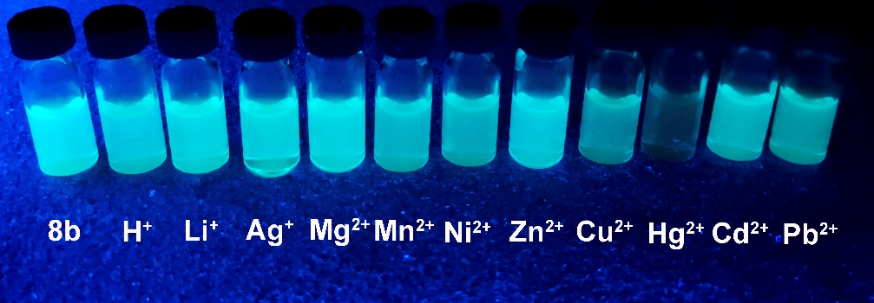

**Figure 11.** The photograph of phosphorescent emission observed from the solutions of **8b** in MeCN (500 *µ*M) in the presence of different metal cations or acid (1 equiv of H+, Li+, Ag+, Mg2+, Mn2+, Ni2+, Zn2+, Cu2+, Hg2+, Cd2+, or Pb2+). Excitation wavelength of 365 nm produced by a portable UV lamp.

*Probing the sensing mechanism.*To shed some light on mechanism of Hg2+ sensing using **8**, additional HR-ESI+-MS, 1H NMR and FT-IR measurements were undertaken. Before addition of Hg2+ ions, HR ESI+-MS exhibit signals due to protonated molecular ion [M + H]+ and the fragmentation due to loss of cyanide [M – CN]+. Addition of 0.5 equiv of Hg2+ leads to disappearance of the [M + H]+ peak, and the increase in the intensity of [M – CN]+. Subsequent addition of Hg2+ above 1 equiv results in the emergence of a signal due to [Ir(ppy)2]+ (**Figure S59** in SI) indicating decomposition of the starting iridium complex **8** with the cleavage of the Ir–C bonds with both CN and ADC ancillary ligands. 1H NMR spectra of the reaction mixtures obtained by the addition of 1 equiv Hg2+ to solution of **8** resembles the spectrum of the known [Ir(ppy)2(MeCN)2](OTf) complex (**Figure S60** in SI). UV-vis (350–500) and phosphorescence spectra for the reaction mixture match those for [Ir(ppy)2(MeCN)2](OTf) suggesting mechanism of sensing through the decomposition of **8** to [Ir(ppy)2(MeCN)2]+. Addition of 0.5 equiv of Hg2+ ions to **8** is accompanied by a significant increase of CN stretching vibration by *ca*. 28 cm–1 (**Figure S62** in SI) that is consistent with the formation of a dinuclear iridium(III) species, containing bridging mercury-dicyanide fragment (**Scheme 2**).[33](#_ENREF_99) DFT calculation evidence a substantial contribution of the *π*\*-system of the cyanide ligand in **8b** to the respective HOMO (**Figure 7**). Coordination of Hg2+ to the CN moiety in **8b** would then decrease the HOMO energy. This hypothesis is in line with the results of TD-DFT calculations (PBE0/6-311+G(d,p)&LanL2DZ(Ir)/PCM(CH3CN)) on a proposed model complex [**8b**–Hg–**8b**]2+ featuring a mercury(II)-bridged dimer of **8b** revealing a decrease in the HOMO energy and an increase the HOMO–LUMO energy gap (–4.36 eV) upon the dimerisation, which gives rise to the observed hypochromic shift of the absorption and emission spectra (**Figures S43** and **S44** in SI).



**Scheme 2.** Proposed mercury(II) sensing mechanism using **8a**–**d**.

Proposed mechanism of mercury sensing using **8a**–**d** is summarised in **Scheme 2**. To further confirm our assumption, an additional probe, *i.e.* [Ir(ppy)2(CNMe){C(NH2)NHС6H4-4-Cl}](OTf) (**9**) was prepared by the alkylation of cyanide ligand in **8b** with MeOTf. As expected, conversion of cyanide to methyl isocyanide resulted in nearly complete disappearance of sensing properties; only slight decrease in the PL emission intensities was observed after the addition of Hg2+ to solution of **9** in MeCN (**Figures S45** and **S49** in SI,6 and 10% decrease in the intensity after the addition of 0.5 and 1 equiv of Hg2+, respectively).

**Final Remarks**

In the course of our studies, a family of *bis*(cyclometallated)-iridium(III) species containing ancillary acyclic diaminocarbene ligands was prepared via the metal-mediated addition of ammonia to iridium(III)-isocyanides. All complexes were characterised with the help of a number of spectroscopic/spectrometric (IR, 1H and 13C NMR, HRESI+-MS, UV-vis, luminescence) and non-spectroscopic (CHN elemental analysis, cyclic voltammetry) techniques. We found that the electrochemical and photophysical properties of (cyclometallated)-iridium(III) species are significantly altered on going from the isocyanides to carbenes, further the concept that the electronic structure and excited-state dynamics is controlled by ancillary ligand modification. Herein, a conversion of the isocyanide to ADC leads to a change in the long wavelength 1MLCT absorption bands, oxidation potentials and the interplay between 3LC and 1MLCT excited states in these complexes in the lowest electronically excited state responsible for phosphorescence. This could be explained by decrease of a *π*-accepting and increase of strong *σ*-donating properties of carbene ligand that leads to destabilisation of HOMO, which also is confirmed by cathode shift of the oxidation potentials.

Importantly, both CNR and ADC complexes exhibit strong blue-green phosphorescence in MeCN solution, achieving quantum yields of up to 55% for the isocyanide [Ir(ppy)2(CNС6H4-4-Cl)2](OTf) and up to 45% for the ADC [Ir(ppy)2(CN){C(NH2)(NHС6H4-4-Cl)}] emitters. Complexes [Ir(ppy)2(CN){C(NH2)(NHС6H4-4-X)}] with ADC and cyano ancillary ligands react selectively with Hg2+ ions and this could be used in the efficient sensing of mercury(II) ions in solution with the limit of detection as low as 2.63 × 10−7 M. A Job’s plot and a titration isotherm plotting PL emission intensities vs Hg2+ concentration established a 1:2 binding stoichiometry, while additional mechanistic studies supported the intermediate formation of dinuclear iridium(III)-cyclometallated species linked by the bridging mercury-(dicyano) fragment as a driving force of mercury sensing. Our first results open up a new application field for the ADC-metal complexes, *viz*. ion sensing, and the future studies in this field are currently underway in our group.

**Experimental Section**

**Materials and Instrumentation.** This section is provided in the SI (section S2) and includes reagents and materials used, details of X-ray structure determinations and computation details.

**Synthetic work.** *Synthesis of* ***3a****–****d****.* Cyclometallated complex [(ppy)2Ir(*μ*-Cl)]2 (1; 60 mg, 0.056 mmol) was suspended in CH2Cl2 (10 mL), and the solution of isocyanide 2a–d (0.12 mmol) in CH2Cl2 (5 mL) was added dropwise. The reaction mixture was stirred at RT (3 h) to give a yellow solution, whereupon the solvent was evaporated under vacuum at 20–25 °C to dryness, the solid formed was washed with diethyl ether (two 5-mL portions) and dried in air at RT.

*Synthesis of* ***4a****–****d****.*Complexes **3a**–**d** (0.02 mmol) were dissolved in 1,2-dichloroethane (3 mL) at RT. The vials with the formed solution were put in a closed bottle with an aqueous solution of 14*M* ammonia and were heated to 50 °C for 1 d, whereupon the solvent was evaporated under vacuum at 20–25 °C to dryness, the solid formed was recrystallised from mixture dichloromethane/methanol (1:1) at 40 °C and dried in air at RT.

*Synthesis of [****5a****–****d****](OTf).* Complexes [**5b**–**d**](OTf) were previously prepared via a different approach.[11](#_ENREF_56) In the current method, a mixture of **4a**–**d** (0.02 mmol) and AgOTf (0.02 mmol) was suspended in MeCN (3 mL) and then stirred at RT (1 h) to give a yellow solution with the colourless precipitate of AgCl that was separated by centrifugation. A solution of **2a**–**d** (0.02 mmol) in MeCN (2 mL) was added dropwise to the obtained homogeneous reaction mixture. The reaction mixture was stirred at RT (3 h) to give a yellow solution, whereupon the solvent was evaporated under vacuum at 20–25 °C to dryness, the solid formed was washed with diethyl ether (three 2-mL portions) and dried in air at RT. Yields of [**5a**–**d**](OTf) prepared via this route were 78–84%.

*Synthesis of* ***9****.* Solution of MeOTf (4 mg, 0.024 mmol) in CH2Cl2 (1.5 mL) was added to solution of **8b** (0.020 mmol) in CH2Cl2 (1.5 mL) at −70 °C to form a yellow solution. The reaction mixture was kept at −70 °C for 30 min and then warmed to RT and left to stand for an additional 30 min, whereupon it was evaporated to dryness at RT. The solid formed was washed with Et2O (three 2 mL portions) and dried in air at RT.

**Characterisation.** Characterisation data and data of elemental analyses (C, H, N), high-resolution ESI+-MS, TG/DTA, IR, and 1H, 13C{1H} and 19F{1H} NMR spectroscopy are included in the SI (section S3).

**Mercury(II) titration and selectivity experiments.** A stock solution of complex **8b** (1 mM) was prepared in MeCN and then diluted to 70 μM with CH3CN for titration and selectivity experiments. 2.5 mM stock acetonitrile solutions of Hg(II) perchlorate and other metal ions (Cu+2, Li+, Cd2+, Pb2+, Zn2+, Ni2+, Mg2+, Mn2+, Ag+) were prepared in HPLC grade acetonitrile and water. Hg(ClO4)2, Cu(NO3)2 and perchlorate salts of the other cations were used as the cation source. Emission spectra were determined with excitation at 370 nm. The titration experiments were carried out by adding 2 mL of a solution of complex **8b** (70 μM) into a quartz cuvette of 1 cm optical path length, and then adding the Hg(II) stock solution incrementally by using a calibrated micropipette. The test samples for selectivity experiments were prepared by adding appropriate amounts of metal ion stock solutions to 2 mL of a solution of complex **8b** (70 μM). The test solutions were stirred for 3 min, and then the UV–vis absorption and photoluminescence (PL) spectra) were recorded.

The limit of detection was calculated based on photoluminescence titration. Standard deviation achieved by the fluorescence emission spectrum of probes was measured 5 times. To attain the slope, the ratio of emission intensity was plotted against the concentration of analyte Hg2+. The limit of detection was calculated using the following equation: The limit of detection = 3 × σ / s Where, σ = standard deviation of probe; s = slope value of the plot [probe] plotted against Hg2+.

**Associated content**

**Supporting Information.** The Supporting Information is available free of charge on the ACS Publications website at DOI: XXXX. Experimental details for the characterisation of the complexes, crystallographic and computational information, UV-vis absorption spectra, excitation and emission spectra and NMR spectra (PDF).

**Accession Codes.** CCDC 1538180, 1576668 and 1947707 contain the supplementary crystallographic data for this paper. These data can be obtained free of charge viawww.ccdc.cam.ac.uk/data\_request/cif, or by emailing data\_request@ccdc.cam.ac.uk, or by contacting The Cambridge Crystallographic Data Centre, 12 Union Road, Cambridge CB2 1EZ, UK; fax: +44 1223 336033.

AUTHOR INFORMATION

Corresponding Authors

\*E-mail for M.A.K.: m.kinzhalov@spbu.ru.

\*E-mail for K.V.L.: konstantin.luzyanin@liverpool.ac.uk.

ORCID

M. Kinzhalov 0000-0001-5055-1212

A. Smirnov 0000-0001-9444-2069

K. Luzyanin 0000-0001-9312-7139

**Conflicts of interest.** There are no conflicts to declare.

**Acknowledgements**

Authors are grateful to the Russian Foundation for Basic Research (project 18-33-20073, synthetic chemistry of iridium) and to the grant program of the President of the Russian Federation (project МК-4457.2018.3, photophysical measurements). DFT studies were supported by the Government of the Russian Federation (Grant 08-08) and the Ministry of Education and Science of Russian Federation (Project 11.1706.2017/4.6). E.A.P. thanks the Netherlands Organization for Scientific Research (NWO) for the access to SurfSARA supercomputer facilities. EAA and EAK acknowledge the financial support from Saint Petersburg State University (grant for internship by Event 6 (34824077) and postdoctoral fellowship, correspondingly). KVL additionally thanks the University of Liverpool for support. Physicochemical measurements were performed at Center for Magnetic Resonance, Center for XRD Studies, Center for Chemical Analysis and Materials Research, Center of Thermal Analysis and Calorimetry, Center for Optical and Laser Materials Research, and Chemistry Educational Centre (all belonging to Saint Petersburg State University).

**References**

1. a) Na, H.; Teets, T. S., Highly Luminescent Cyclometalated Iridium Complexes Generated by Nucleophilic Addition to Coordinated Isocyanides, *J. Am. Chem. Soc.* **2018,** *140*, 6353–6360; b) Chi, Y.; Chou, P.-T., Transition-metal phosphors with cyclometalating ligands: fundamentals and applications, *Chem. Soc. Rev.* **2010,** *39*, 638–655; c) Mills, I. N.; Porras, J. A.; Bernhard, S., Judicious Design of Cationic, Cyclometalated Ir(III) Complexes for Photochemical Energy Conversion and Optoelectronics, *Acc. Chem. Res.* **2018,** *51*, 352–364; d) Hu, T.; He, L.; Duan, L.; Qiu, Y., Solid-state light-emitting electrochemical cells based on ionic iridium(iii) complexes, *J. Mater. Chem.* **2012,** *22*, 4206–4215; e) Umamahesh, B.; Karthikeyan, N. S.; Sathiyanarayanan, K. I.; Malicka, J. M.; Cocchi, M., Tetrazole iridium(iii) complexes as a class of phosphorescent emitters for high-efficiency OLEDs, *J. Mat. Chem. C* **2016,** *4*, 10053–10060; f) Na, H.; Cañada, Louise M.; Wen, Z.; I-Chia Wu, J.; Teets, T. S., Mixed-carbene cyclometalated iridium complexes with saturated blue luminescence, *Chem. Sci.* **2019,** *10*, 6254-6260.

2. a) Choung, K. S.; Marroquin, K.; Teets, T. S., Cyclometalated iridium–BODIPY ratiometric O2 sensors, *Chemical Science* **2019,** *10*, 5124-5132; b) Yoshihara, T.; Hosaka, M.; Terata, M.; Ichikawa, K.; Murayama, S.; Tanaka, A.; Mori, M.; Itabashi, H.; Takeuchi, T.; Tobita, S., Intracellular and in Vivo Oxygen Sensing Using Phosphorescent Ir(III) Complexes with a Modified Acetylacetonato Ligand, *Anal. Chem.* **2015,** *87*, 2710–2717; c) Zhang, K. Y.; Gao, P.; Sun, G.; Zhang, T.; Li, X.; Liu, S.; Zhao, Q.; Lo, K. K.-W.; Huang, W., Dual-Phosphorescent Iridium(III) Complexes Extending Oxygen Sensing from Hypoxia to Hyperoxia, *J. Am. Chem. Soc.* **2018,** *140*, 7827–7834; d) Liu, C.; Yu, H.; Rao, X.; Lv, X.; Jin, Z.; Qiu, J., Bis-cyclometalated Ir(III) complexes with a diphenylamino group: design, synthesis, and application in oxygen sensing, *Dyes and Pigments* **2017,** *136*, 641–647; e) Ma, D.-L.; Lin, S.; Wang, W.; Yang, C.; Leung, C.-H., Luminescent chemosensors by using cyclometalated iridium(iii) complexes and their applications, *Chem. Sci.* **2017,** *8*, 878–889; f) Ramón‐Márquez, T.; Marín‐Suárez, M.; Fernández‐Gutiérrez, A.; Fernández‐Sánchez, J. F., Iridium Complexes in the Development of Optical Sensors. In *Iridium(III) in Optoelectronic and Photonics Applications*, Zysman‐Colman, E., Ed. John Wiley & Sons2017; pp 479–539; g) Ma, D.-L.; Wong, S.-Y.; Kang, T.-S.; Ng, H.-P.; Han, Q.-B.; Leung, C.-H., Iridium(III)-based chemosensors for the detection of metal ions, *Methods* **2019**, in press, DOI: 10.1016/j.ymeth.2019.02.013.

3. a) Zhang, Q.; Lu, X.; Wang, H.; Tian, X.; Wang, A.; Zhou, H.; Wu, J.; Tian, Y., A benzoic acid terpyridine-based cyclometalated iridium(iii) complex as a two-photon fluorescence probe for imaging nuclear histidine, *Chem. Commun.* **2018,** *54*, 3771-3774; b) Jin, C.; Guan, R.; Wu, J.; Yuan, B.; Wang, L.; Huang, J.; Wang, H.; Ji, L.; Chao, H., Rational design of NIR-emitting iridium(iii) complexes for multimodal phosphorescence imaging of mitochondria under two-photon excitation, *Chem. Commun.* **2017,** *53*, 10374–10377; c) Ye, R.-R.; Cao, J.-J.; Tan, C.-P.; Ji, L.-N.; Mao, Z.-W., Valproic Acid-Functionalized Cyclometalated Iridium(III) Complexes as Mitochondria-Targeting Anticancer Agents, *Chem. Eur. J.* **2017,** *23*, 15166–15176; d) Caporale, C.; Massi, M., Cyclometalated iridium(III) complexes for life science, *Coord. Chem. Rev.* **2018,** *363*, 71–91; e) Zamora, A.; Vigueras, G.; Rodríguez, V.; Santana, M. D.; Ruiz, J., Cyclometalated iridium(III) luminescent complexes in therapy and phototherapy, *Coord. Chem. Rev.* **2018,** *360*, 34–76.

4. a) Takizawa, S.-y.; Kano, R.; Ikuta, N.; Murata, S., An anionic iridium(iii) complex as a visible-light absorbing photosensitizer, *Dalton Trans.* **2018**, 11041–11046; b) Huang, H.; Banerjee, S.; Sadler, P. J., Recent Advances in the Design of Targeted Iridium(III) Photosensitizers for Photodynamic Therapy, *ChemBioChem* **2018,** *19*, 1574-1589; c) Huang, T.; Yu, Q.; Liu, S.; Zhang, K. Y.; Huang, W.; Zhao, Q., Rational Design of Phosphorescent Iridium(III) Complexes for Selective Glutathione Sensing and Amplified Photodynamic Therapy, *ChemBioChem* **2019,** *20*, 576-586; d) Islamova, R. M.; Dobrynin, M. V.; Vlasov, A. V.; Eremina, A. A.; Kinzhalov, M. A.; Kolesnikov, I. E.; Zolotarev, A. A.; Masloborodova, E. A.; Luzyanin, K. V., Iridium(iii)-catalysed cross-linking of polysiloxanes leading to the thermally resistant luminescent silicone rubbers, *Catal. Sci. Technol.* **2017,** *7*, 5843–5846; e) Shon, J.-H.; Teets, T. S., Molecular Photosensitizers in Energy Research and Catalysis: Design Principles and Recent Developments, *ACS Energy Lett.* **2019,** *4*, 558–566; f) Arias-Rotondo, D. M.; McCusker, J. K., The photophysics of photoredox catalysis: a roadmap for catalyst design, *Chemical Society Reviews* **2016,** *45*, 5803-5820.

5. a) You, Y.; Han, Y.; Lee, Y.-M.; Park, S. Y.; Nam, W.; Lippard, S. J., Phosphorescent Sensor for Robust Quantification of Copper(II) Ion, *J. Am. Chem. Soc.* **2011,** *133*, 11488–11491; b) Shen, W.; Yan, L.; Tian, W.; Cui, X.; Qi, Z.; Sun, Y., A novel aggregation induced emission active cyclometalated Ir(III) complex as a luminescent probe for detection of copper(II) ion in aqueous solution, *J. Luminescence* **2016,** *177*, 299–305; c) Zhao, N.; Wu, Y.-H.; Luo, J.; Shi, L.-X.; Chen, Z.-N., Aggregation-induced phosphorescence of iridium(iii) complexes with 2,2′-bipyridine-acylhydrazone and their highly selective recognition to Cu2+, *Analyst* **2013,** *138*, 894–900; d) Zhao, N.; Wu, Y.-H.; Wen, H.-M.; Zhang, X.; Chen, Z.-N., Conversion from ILCT to LLCT/MLCT Excited State by Heavy Metal Ion Binding in Iridium(III) Complexes with Functionalized 2,2′-Bipyridyl Ligands, *Organometallics* **2009,** *28*, 5603–5611; e) Lu, F.; Yamamura, M.; Nabeshima, T., Luminescent biscyclometalated iridium(III) complex for selective and switchable Cu2+ ion binding in aqueous media, *Tetrahedron Lett.* **2013,** *54*, 779–782; f) Shen, W.; Qi, Z.; Yan, L.; Tian, W.; Cui, X.; Yao, H.; Sun, Y., A novel cyclometalated Ir(iii) complex based luminescence intensity and lifetime sensor for Cu2+, *RSC Advances* **2016,** *6*, 16482-16488.

6. You, Y.; Lee, S.; Kim, T.; Ohkubo, K.; Chae, W.-S.; Fukuzumi, S.; Jhon, G.-J.; Nam, W.; Lippard, S. J., Phosphorescent Sensor for Biological Mobile Zinc, *J. Am. Chem. Soc.* **2011,** *133*, 18328–18342.

7. Schmittel, M.; Lin, H., Luminescent Iridium Phenanthroline Crown Ether Complex for the Detection of Silver(I) Ions in Aqueous Media, *Inorg. Chem.* **2007,** *46*, 9139–9145.

8. Han, Y.; You, Y.; Lee, Y.-M.; Nam, W., Double Action: Toward Phosphorescence Ratiometric Sensing of Chromium Ion, *Adv. Mat.* **2012,** *24*, 2748–2754.

9. a) Ru, J.; Chen, X.; Guan, L.; Tang, X.; Wang, C.; Meng, Y.; Zhang, G.; Liu, W., Ratiometric Iridium(III) Complex-Based Phosphorescent Chemodosimeter for Hg2+ Applicable in Time-Resolved Luminescence Assay and Live Cell Imaging, *Anal. Chem.* **2015,** *87*, 3255–3262; b) Mei, Q.; Shi, Y.; Hua, Q.; Tong, B., Phosphorescent chemosensor for Hg2+ based on an iridium(iii) complex coordinated with 4-phenylquinazoline and carbazole dithiocarbamate, *RSC Advances* **2015,** *5*, 74924–74931; c) Cao, H.-T.; Ding, L.; Shan, G.-G.; Sun, H.-Z.; Wu, Y.; Su, Z.-M., A sulfur-free iridium(iii) complex for highly selective and multi-signaling mercury(ii)-chemosensors, *Dalton Trans.* **2015,** *44*, 19997–20003; d) Liu, Y.; Li, M.; Zhao, Q.; Wu, H.; Huang, K.; Li, F., Phosphorescent Iridium(III) Complex with an N∧O Ligand as a Hg2+-Selective Chemodosimeter and Logic Gate, *Inorg. Chem.* **2011,** *50*, 5969–5977; e) Wu, Y.; Jing, H.; Dong, Z.; Zhao, Q.; Wu, H.; Li, F., Ratiometric Phosphorescence Imaging of Hg(II) in Living Cells Based on a Neutral Iridium(III) Complex, *Inorg. Chem.* **2011,** *50*, 7412–7420; f) Zeng, H.; Yu, F.; Dai, J.; Sun, H.; Lu, Z.; Li, M.; Jiang, Q.; Huang, Y., A highly selective sulfur-free iridium(iii)-complex-based phosphorescent chemidosimeter for detection of mercury(ii) ions, *Dalton Trans.* **2012,** *41*, 4878–4883; g) Mei, Q.; Hua, Q.; Tong, B.; Shi, Y.; Chen, C.; Huang, W., A reversible and highly selective phosphorescent sensor for Hg2+ based on iridium (III) complex, *Tetrahedron* **2015,** *71*, 9366–9370; h) Rhee, H.; Kim, T.; Hong, J.-I., Ir(iii) complex-based phosphorescence and electrochemiluminescence chemodosimetric probes for Hg(ii) ions with high selectivity and sensitivity, *Dalton Trans.* **2018,** *47*, 3803–3810; i) Chen, Z.; Meng, G.; Tang, H.; Ye, Y.; Sun, R.; Chen, M.; Wang, K.-M., A novel cationic iridium(iii) complex with a thiorhodamine-based auxiliary ligand: application for luminescent and colorimetric detection of Hg2+ in an aqueous solution, *New J. Chem.* **2017,** *41*, 8312–8319; j) Ponram, M.; Balijapalli, U.; Sambath, B.; Kulathu Iyer, S.; Kakaraparthi, K.; Thota, G.; Bakthavachalam, V.; Cingaram, R.; Sung-Ho, J.; Natesan Sundaramurthy, K., Inkjet-printed phosphorescent Iridium(III) complex based paper sensor for highly selective detection of Hg2+, *Dyes and Pigments* **2019,** *163*, 176–182; k) Alam, P.; Kaur, G.; Climent, C.; Pasha, S.; Casanova, D.; Alemany, P.; Roy Choudhury, A.; Laskar, I. R., New ‘aggregation induced emission (AIE)’ active cyclometalated iridium(iii) based phosphorescent sensors: high sensitivity for mercury(ii) ions, *Dalton Trans.* **2014,** *43*, 16431–16440; l) Tong, B.; Mei, Q.; Lu, M., A highly selective chemosensor for mercury(II) cations based on cyclometalated iridium(III) complex, *Inorg. Chim. Acta* **2012,** *391*, 15-19; m) Tong, B.; Zhang, Y.; Han, Z.; Chen, D.; Zhang, Q.-F., Highly sensitive colorimetric phosphorescent chemodosimeter for Hg2+ based iridium(III) complex with (Ph2PS)2N auxiliary ligand, *Inorg. Chem. Commun.* **2013,** *28*, 31–36; n) Tong, B.; Zhang, M.; Han, Z.; Mei, Q.; Zhang, Q., Novel colorimetric phosphorescent chemodosimeter for Hg2+ based iridium(III) complex with phosphonodithioate auxiliary ligand, *J. Organomet. Chem.* **2013,** *724*, 180–185; o) Tong, B.; Ma, P.; Zhang, M.; Liu, Y.; Mei, Q.; Zhang, Q.-F., Phosphorescent iridium(III) carbodithioate complex for the detection of Hg2+ and acetonitrile, *Inorg. Chem. Commun.* **2013,** *37*, 121–126; p) Chan, D. S.-H.; Fu, W.-C.; Wang, M.; Liu, L.-J.; Leung, C.-H.; Ma, D.-L., A Highly Selective and Non-Reaction Based Chemosensor for the Detection of Hg2+ Ions Using a Luminescent Iridium(III) Complex, *PLOS ONE* **2013,** *8*, e60114; q) Zhao, Q.; Cao, T.; Li, F.; Li, X.; Jing, H.; Yi, T.; Huang, C., A Highly Selective and Multisignaling Optical−Electrochemical Sensor for Hg2+ Based on a Phosphorescent Iridium(III) Complex, *Organometallics* **2007,** *26*, 2077–2081; r) Zhao, Q.; Liu, S.; Li, F.; Yi, T.; Huang, C., Multisignaling detection of Hg2+ based on a phosphorescent iridium(iii) complex, *Dalton Trans.* **2008**, 3836–3840; s) Yang, H.; Qian, J.; Li, L.; Zhou, Z.; Li, D.; Wu, H.; Yang, S., A selective phosphorescent chemodosimeter for mercury ion, *Inorg. Chim. Acta* **2010,** *363*, 1755–1759; t) Mei, Q.; Shi, Y.; Chen, C.; Hua, Q.; Tong, B., A highly selective turn-on sensor for Hg2+ based on a phosphorescent iridium (III) complex, *Inorg. Chem. Commun.* **2016,** *73*, 147–151; u) Chay, R. S.; Luzyanin, K. V., Evaluation of catalytic properties of aminocarbene species derived from the integration between 3-iminoisoindolin-1-ones and palladium-bound isonitriles in Suzuki–Miyaura cross-coupling, *Inorg. Chim. Acta* **2012,** *380*, 322–327.

10. Altaf, M.; Stoeckli-Evans, H.; Ahmad, S.; Isab, A. A.; Al-Arfaj, A. R.; Malik, M. R.; Ali, S., Crystal Structure of a Trinuclear Mercury(II) Cyanide Complex of Tetramethylthiourea, [{(Tetramethylthiourea)2Hg(CN)2}2·Hg(CN)2], *J. Chem. Cryst.* **2010,** *40*, 1175–1179.

11. Kinzhalov, M. A.; Eremina, A. A.; Smirnov, A. S.; Suslonov, V. V.; Kukushkin, V. Y.; Luzyanin, K. V., Cleavage of acyclic diaminocarbene ligands at an iridium(III) center. Recognition of a new reactivity mode for carbene ligands, *Dalton Trans.* **2019,** *48*, 7571–7582.

12. a) Kinzhalov, M. A.; Boyarskii, V. P., Structure of isocyanide palladium(II) complexes and their reactivity toward nitrogen nucleophiles, *Russ. J. Gen. Chem.* **2015,** *85*, 2313–2333; b) Boyarskiy, V. P.; Bokach, N. A.; Luzyanin, K. V.; Kukushkin, V. Y., Metal-Mediated and Metal-Catalyzed Reactions of Isocyanides, *Chem. Rev.* **2015,** *115*, 2698–2779.

13. a) Kinzhalov, M. A.; Boyarskiy, V. P.; Luzyanin, K. V.; Dolgushin, F. M.; Kukushkin, V. Y., Metal-mediated coupling of a coordinated isocyanide and indazoles, *Dalton Trans.* **2013,** *42*, 10394–10397; b) Kinzhalov, M. A.; Luzyanin, K. V.; Boyarskiy, V. P.; Haukka, M.; Kukushkin, V. Y., ADC-Based Palladium Catalysts for Aqueous Suzuki−Miyaura Cross-Coupling Exhibit Greater Activity than the Most Advantageous Catalytic Systems, *Organometallics* **2013,** *32*, 5212–5223; c) Kinzhalov, M. A.; Timofeeva, S. A.; Luzyanin, K. V.; Boyarskiy, V. P.; Yakimanskiy, A. A.; Haukka, M.; Kukushkin, V. Y., Palladium(II)-Mediated Addition of Benzenediamines to Isocyanides: Generation of Three Types of Diaminocarbene Ligands Depending on the Isomeric Structure of the Nucleophile, *Organometallics* **2016,** *35*, 218–228; d) Mikherdov, A. S.; Kinzhalov, M. A.; Novikov, A. S.; Boyarskiy, V. P.; Boyarskaya, I. A.; Dar’in, D. V.; Starova, G. L.; Kukushkin, V. Y., Difference in Energy between Two Distinct Types of Chalcogen Bonds Drives Regioisomerization of Binuclear (Diaminocarbene)PdII Complexes, *J. Am. Chem. Soc.* **2016,** *138*, 14129–14137; e) Katkova, S. A.; Kinzhalov, M. A.; Tolstoy, P. M.; Novikov, A. S.; Boyarskiy, V. P.; Ananyan, A. Y.; Gushchin, P. V.; Haukka, M.; Zolotarev, A. A.; Ivanov, A. Y.; Zlotsky, S. S.; Kukushkin, V. Y., Diversity of Isomerization Patterns and Protolytic Forms in Aminocarbene PdII and PtII Complexes Formed upon Addition of N,N′-Diphenylguanidine to Metal-Activated Isocyanides, *Organometallics* **2017,** *36*, 4145–4159; f) Mikherdov, A. S.; Kinzhalov, M. A.; Novikov, A. S.; Boyarskiy, V. P.; Boyarskaya, I. A.; Avdontceva, M. S.; Kukushkin, V. Y., Ligation-Enhanced π-Hole···π Interactions Involving Isocyanides: Effect of π-Hole···π Noncovalent Bonding on Conformational Stabilization of Acyclic Diaminocarbene Ligands, *Inorg. Chem.* **2018,** *57*, 6722-6733; g) Timofeeva, S. A.; Kinzhalov, M. A.; Valishina, E. A.; Luzyanin, K. V.; Boyarskiy, V. P.; Buslaeva, T. M.; Haukka, M.; Kukushkin, V. Y., Application of palladium complexes bearing acyclic amino(hydrazido)carbene ligands as catalysts for copper-free Sonogashira cross-coupling, *J. Catal.* **2015,** *329*, 449−456; h) Gee, J. C.; Fuller, B. A.; Lockett, H.-M.; Sedghi, G.; Robertson, C. M.; Luzyanin, K. V., Visible light accelerated hydrosilylation of alkynes using platinum–[acyclic diaminocarbene] photocatalysts, *Chem. Commun.* **2018,** *54*, 9450–9453.

14. a) Kinzhalov, M. A.; Luzyanin, K. V., Reactivity of acyclic diaminocarbene ligands, *Coord. Chem. Rev.* **2019,** *399*, 213014; b) Boyarskiy, V. P.; Luzyanin, K. V.; Kukushkin, V. Y., Acyclic diaminocarbenes (ADCs) as a promising alternative to N-heterocyclic carbenes (NHCs) in transition metal catalyzed organic transformations, *Coord. Chem. Rev.* **2012,** *256*, 2029–2056; c) Slaughter, L. M., Acyclic Aminocarbenes in Catalysis, *ACS Catal.* **2012,** *2*, 1802–1816.

15. a) Shavaleev, N. M.; Monti, F.; Costa, R. D.; Scopelliti, R.; Bolink, H. J.; Orti, E.; Accorsi, G.; Armaroli, N.; Baranoff, E.; Gratzel, M.; Nazeeruddin, M. K., Bright Blue Phosphorescence from Cationic Bis-Cyclometalated Iridium(III) Isocyanide Complexes, *Inorg. Chem.* **2012,** *51*, 2263–2271; b) Shavaleev, N. M.; Monti, F.; Scopelliti, R.; Armaroli, N.; Grätzel, M.; Nazeeruddin, M. K., Blue Phosphorescence of Trifluoromethyl- and Trifluoromethoxy-Substituted Cationic Iridium(III) Isocyanide Complexes, *Organometallics* **2012,** *31*, 6288–6296; c) Shavaleev, N. M.; Monti, F.; Scopelliti, R.; Baschieri, A.; Sambri, L.; Armaroli, N.; Gratzel, M.; Nazeeruddin, M. K., Extreme Tuning of Redox and Optical Properties of Cationic Cyclometalated Iridium(III) Isocyanide Complexes, *Organometallics* **2013,** *32*, 460-467; d) Chan, K.-C.; Chu, W.-K.; Yiu, S.-M.; Ko, C.-C., Synthesis, characterization, photophysics and electrochemical study of luminescent iridium(III) complexes with isocyanoborate ligands, *Dalton Trans.* **2015,** *44*, 15135-15144; e) Maity, A.; Le, L. Q.; Zhu, Z.; Bao, J.; Teets, T. S., Steric and Electronic Influence of Aryl Isocyanides on the Properties of Iridium(III) Cyclometalates, *Inorg. Chem.* **2016,** *55*, 2299–2308.

16. Vignolle, J.; Catton, X.; Bourissou, D., Stable noncyclic singlet carbenes, *Chem. Rev.* **2009,** *109*, 3333–3384.

17. Na, H.; Maity, A.; Morshed, R.; Teets, T. S., Bis-Cyclometalated Iridium Complexes with Chelating Dicarbene Ancillary Ligands, *Organometallics* **2017,** *36*, 2965–2972.

18. Tamayo, A. B.; Alleyne, B. D.; Djurovich, P. I.; Lamansky, S.; Tsyba, I.; Ho, N. N.; Bau, R.; Thompson, M. E., Synthesis and Characterization of Facial and Meridional Tris-cyclometalated Iridium(III) Complexes, *J. Am. Chem. Soc.* **2003,** *125*, 7377–7387.

19. a) Li, T.-Y.; Liang, X.; Zhou, L.; Wu, C.; Zhang, S.; Liu, X.; Lu, G.-Z.; Xue, L.-S.; Zheng, Y.-X.; Zuo, J.-L., N-Heterocyclic Carbenes: Versatile Second Cyclometalated Ligands for Neutral Iridium(III) Heteroleptic Complexes, *Inorg. Chem.* **2015,** *54*, 161–173; b) Monti, F.; Kessler, F.; Delgado, M.; Frey, J.; Bazzanini, F.; Accorsi, G.; Armaroli, N.; Bolink, H. J.; Ortí, E.; Scopelliti, R.; Nazeeruddin, M. K.; Baranoff, E., Charged Bis-Cyclometalated Iridium(III) Complexes with Carbene-Based Ancillary Ligands, *Inorg. Chem.* **2013,** *52*, 10292–10305; c) Adamovich, V.; Boudreault, P.-L. T.; Esteruelas, M. A.; Gómez-Bautista, D.; López, A. M.; Oñate, E.; Tsai, J.-Y., Preparation via a NHC Dimer Complex, Photophysical Properties, and Device Performance of Heteroleptic Bis(tridentate) Iridium(III) Emitters, *Organometallics* **2019,** *38*, 2738–2747; d) Adamovich, V.; Bajo, S.; Boudreault, P.-L. T.; Esteruelas, M. A.; López, A. M.; Martín, J.; Oliván, M.; Oñate, E.; Palacios, A. U.; San-Torcuato, A.; Tsai, J.-Y.; Xia, C., Preparation of Tris-Heteroleptic Iridium(III) Complexes Containing a Cyclometalated Aryl-N-Heterocyclic Carbene Ligand, *Inorg. Chem.* **2018,** *57*, 10744–10760.

20. Li, J.; Djurovich, P. I.; Alleyne, B. D.; Yousufuddin, M.; Ho, N. N.; Thomas, J. C.; Peters, J. C.; Bau, R.; Thompson, M. E., Synthetic Control of Excited-State Properties in Cyclometalated Ir(III) Complexes Using Ancillary Ligands, *Inorg. Chem.* **2005,** *44*, 1713–1727.

21. McClure, D. S., Triplet-singlet transition in organic molecules – lifetime measurements of the triplet state, *J. Chem. Phys.* **1949,** *17*, 905–913.

22. Lai, S.-W.; Chan, M. C.-W.; Cheung, K.-K.; Che, C.-M., Carbene and Isocyanide Ligation at Luminescent Cyclometalated 6-Phenyl-2,2'-bipyridyl Platinum(II) Complexes: Structural and Spectroscopic Studies, *Organometallics* **1999,** *18*, 3327–3336.

23. Ng, C.-O.; Cheng, S.-C.; Chu, W.-K.; Tang, K.-M.; Yiu, S.-M.; Ko, C.-C., Luminescent Rhenium(I) Pyridyldiaminocarbene Complexes: Photophysics, Anion-Binding, and CO2-Capturing Properties, *Inorg. Chem.* **2016,** *55*, 7969-7979.

24. Dedeian, K.; Shi, J.; Forsythe, E.; Morton, D. C.; Zavalij, P. Y., Blue phosphorescence from mixed cyano-isocyanide cyclometalated iridium(III) complexes, *Inorg. Chem.* **2007,** *46*, 1603–1611.

25. Reinen, D.; Atanasov, M.; Köhler, P.; Babel, D., Jahn–Teller coupling and the influence of strain in Tg and Eg ground and excited states – A ligand field and DFT study on halide MIIIX6 model complexes [M=TiIII–CuIII; X=F−, Cl−], *Coord. Chem. Rev.* **2010,** *254*, 2703–2754.

26. Cho, Y.-J.; Kim, S.-Y.; Choi, C. M.; Kim, N. J.; Kim, C. H.; Cho, D. W.; Son, H.-J.; Pac, C.; Kang, S. O., Photophysics and Excited-State Properties of Cyclometalated Iridium(III)–Platinum(II) and Iridium(III)–Iridium(III) Bimetallic Complexes Bridged by Dipyridylpyrazine, *Inorg. Chem.* **2017,** *56*, 5305–5315.

27. Na, H.; Maity, A.; Teets, T. S., Bis-cyclometalated iridium complexes with electronically modified aryl isocyanide ancillary ligands, *Dalton Transactions* **2017,** *46*, 5008-5016.

28. Brouwer Albert, M., Standards for photoluminescence quantum yield measurements in solution (IUPAC Technical Report). In *Pure and Applied Chemistry*2011; Vol. 83, p 2213.

29. a) Adamo, C.; Barone, V., Toward reliable density functional methods without adjustable parameters: The PBE0 model, *J. Chem. Phys.* **1999,** *110*, 6158–6170; b) Tomasi, J.; Mennucci, B.; Cammi, R., Quantum Mechanical Continuum Solvation Models, *Chem. Rev.* **2005,** *105*, 2999–3094.

30. a) Zhao, Y.; Truhlar, D. G., Benchmark Energetic Data in a Model System for Grubbs II Metathesis Catalysis and Their Use for the Development, Assessment, and Validation of Electronic Structure Methods, *J. Chem. Theory Comp.* **2009,** *5*, 324–333; b) Valero, R.; Costa, R.; Moreira, I. d. P. R.; Truhlar, D. G.; Illas, F., Performance of the M06 family of exchange-correlation functionals for predicting magnetic coupling in organic and inorganic molecules, *J. Chem. Phys.* **2008,** *128*, 114103; c) Srivastava, R.; Joshi, L. R., The effect of substituted 1,2,4-triazole moiety on the emission, phosphorescent properties of the blue emitting heteroleptic iridium(iii) complexes and the OLED performance: a theoretical study, *Physical Chemistry Chemical Physics* **2014,** *16*, 17284-17294; d) Adamo, C.; Jacquemin, D., The calculations of excited-state properties with Time-Dependent Density Functional Theory, *Chem. Soc. Rev.* **2013,** *42*, 845–856.

31. Hay, P. J., Theoretical Studies of the Ground and Excited Electronic States in Cyclometalated Phenylpyridine Ir(III) Complexes Using Density Functional Theory, *J. Phys. Chem. A* **2002,** *106*, 1634–1641.

32. Lu, T.; Chen, F. W., Multiwfn: A multifunctional wavefunction analyzer, *J. Comput. Chem.* **2012,** *33*, 580–592.

33. a) Cano, A.; Reguera, L.; Avila, M.; Velasco-Arias, D.; Reguera, E., Charge Redistribution Effects in Hexacyanometallates Evaluated from XPS Data, *European Journal of Inorganic Chemistry* **2020,** *2020*, 137-145; b) Saghatforoush, L.; Moeini, K.; Golsanamlou, V.; Amani, V.; Bakhtiari, A.; Mardani, Z., Structural, spectral and theoretical study of the coordination of 3,6-bis(2-pyridyl)tetrazine ligand with zinc(II) and mercury(II), *Inorg. Chim. Acta* **2018,** *483*, 392–401; c) Draper, N. D.; Batchelor, R. J.; Sih, B. C.; Ye, Z.-G.; Leznoff, D. B., Synthesis, Structure, and Properties of [(tmeda)Cu[Hg(CN)2]2][HgCl4]:  A Non-Centrosymmetric 2-D Layered System that Shows Strong Optical Anisotropy, *Chem. Mat.* **2003,** *15*, 1612–1616; d) Draper, N. D.; Batchelor, R. J.; Leznoff, D. B., Tuning the Structures of Mercury Cyanide-Based Coordination Polymers with Transition Metal Cations, *Cryst. Growth Des.* **2004,** *4*, 621–632; e) Vahrenkamp, H.; Gei, A.; N. Richardson, G., Cyanide-bridged oligonuclear complexes: features and attractions *Dalton Trans.* **1997**, 3643–3652; f) Leznoff, D. B.; Draper, N. D.; Batchelor, R. J., Using HgX2 units (X=Cl, CN) to increase structural and magnetic dimensionality in conjunction with (2,2′-bipyridyl)copper(II) building blocks, *Polyhedron* **2003,** *22*, 1735–1743.

**TOC Graphics and Synopsys**

*Bis*(cyclometalated)-iridium(III) species with ancillary isocyanides and acyclic diaminocarbene ligands were prepared and examined as efficient phosphorescent sensors for mercury(II) ions in solution with the limit of detection as low as 2.63 × 10−7 M.

