Magma-Sourced Geothermal Energy and Plans for Krafla Magma Testbed, Iceland
John C. Eichelberger, Charles Carrigan, Hjalti Pall Ingolfsson, Yan Lavallée, John Ludden, Sigurdur Markusson, Anette Mortensen, Paolo Papale, Freysteinn Sigmundsson, Elodie Saubin, Jefferson W. Tester, and the KMT Consortium
International Arctic Research Center, University of Alaska Fairbanks, Fairbanks, USA 99775
jceichelberger@alaska.edu
Keywords: magma, geothermal energy, volcanology, magma-hydrothermal regime

Abstract
Super-hot geothermal systems (SHGS) would be much more efficient in generating electric power than conventional systems. The heat source is expected to be magma accumulated just below the producing reservoir. These comprise a system of coupled, stacked liquid reservoirs, one of magma and one of hydrothermal fluid. Between them is hot rock, so hot that it will be ductile. The liquids in both reservoirs are expected to convect. In the hydrothermal reservoir, convection is by porous flow, where the fluid constitutes < 10 vol.% of the reservoir. For the magma reservoir, the circulating liquid+crystal suspension constitutes 100 vol.% of its container. Heat is advected upward through the magma, conducted through its ductile rock lid, and then advected upward by hydrothermal fluid where it can be extracted for power production. The rate-controlling step in transporting energy from deep crust to near surface is conduction through the magma’s lid, for which thickness is the critical factor. Heat flux from magma to hydrothermal fluid is inversely proportional to the thickness of the lid. The response time between a perturbation in one reservoir and its effect on the other is proportional to the square of the lid thickness. Most of the thermal energy in the system is contained within the magma, because magma’s energy is released not just be cooling but by latent heat of crystallization.
Direct evidence for such a model is provided by accidental encounters with silicic magma by geothermal drilling at Kilauea Volcano, Hawaii; Krafla Caldera, Iceland; and Menengai Caldera, Kenya. The most complete data comes from the Iceland Deep Drilling Project’s IDDP-1 within Landsvirkjun’s (National Power Company of Iceland) Krafla Geothermal Project. IDDP-1 produced a sustained power output estimated at >100 MWt. The magma’s lid is < 20 m with a thermal gradient of > 20ºC/m, yielding a heat flow of > 40 W/m² and a characteristic response time of about one year or less, well within the lifetime of a power plant. Thus, extracting superheated fluid from adjacent the magma body would in effect be using magma energy.
There are, however, major challenges to putting magma energy into practice, including finding alloys and cements that will make the boreholes sustainable, treating the fluids so they can be introduced to turbines, and successfully prospecting for other magmatic sources. Besides its potential for power production, understanding where magma is and how it behaves is critical for mitigating risks to communities under threat of explosive eruptions. Thus was born the concept of the Krafla Magma Testbed (KMT). KMT will provide long-term infrastructure where science and engineering teams can conduct sampling, observations, and experiments in magma and its superhot rock envelope. Example analogues from other science fields are particle accelerators and telescope arrays. Critical experiments in Phase One of KMT include: 1) core through the rock-magma transition; 2) emplace a thermocouple string to measure heat flux through magma’s conductive lid; 3) provide (under)ground truth for testing geophysical techniques for locating magma. As the project progresses, further tests of drilling materials, borehole design, extreme sensors, and energy extraction will be conducted and a time series of magma samples obtained. KMT will be the first deep laboratory in the last frontier of Earth’s crust, with the potential to revolutionize both geothermal energy and volcanology.

1. Introduction
As we enter an era where CO₂ in the atmosphere and its attendant effects are building to crisis levels, geothermal energy is emerging as a particularly attractive clean option. It is continuous (base load) and unlike the other continuous clean source, hydroelectric (although hydroelectric is not always continuous in seasonal cycles and decadal droughts), it has negligible ecological impact and a small footprint. Geothermal power plants are sited on their “fuel” source and reinject “waste” on site, therefore requiring no long-distance transport of hazardous, spillable materials. Although the resource is not uniformly distributed – no energy resource is and emerging HVDC technology can extend the economical reach of power generation – geothermal could benefit far more of humanity than the 0.3% of electricity (World Energy Council, 2016) it now produces. Major impediments to greater use of geothermal energy are its inefficiency and the time, expenditure, and assumption of financial risk necessary for development. But geothermal developments now associated with volcanic systems tap mere whiffs of steam at ~250ºC from the ~1000ºC magmatic furnace below. The low efficiency, of the order of 10%, of converting low-enthalpy hydrothermal fluid to electricity, translates to a requirement of having many supply wells and often a continuing need for drilling to make up for decline in steam pressure in the exploited reservoir.
Much could be gained by going to higher pressure and temperature and tapping superheated or supercritical fluid. This could boost energy transport to the surface by as much as ten fold and efficiency of conversion to electricity by as much as three fold (Tester et al., 2006; Scott et al., 2017). The Iceland Deep Drilling Program (IDDP; Fridleifsson et al., 2017) has successfully reached high pressure and high temperature conditions where fluids are expected to be supercritical. This important achievement may, however, encounter a limitation in common with conventional geothermal and with Enhanced Geothermal Systems (EGS) at conventional temperatures: the source of energy is hot rock and rock is poor at storing and conducting heat because of low heat capacity and low thermal conductivity. Going to a near-magma fluid source could be a game-changer for geothermal energy. However, development requires a testbed approach to concurrently improve methods of geophysical imaging of magma and to develop borehole materials and designs to withstand the extreme environment.

2. Lessons from recent drilling
None of this discussion would be useful were it not for accidental encounters with magma by geothermal drilling over the past decade at Krafla, Iceland; Puna, Hawaii; and Menengai, Kenya. Impediments to getting direct data from magma in situ were the lack of geophysical techniques for accurately locating magma together with economic and safety risks because conditions were unknown. It was also unknown how close magma was beneath exploited geothermal systems, hence it was by serendipitous discoveries that it was found that magma could be drilled and safely controlled using standard geothermal practices. Figure 1 shows visualizations of the drilling encounters that have occurred to date. By far the best documented is the Iceland Deep Drilling Project’s IDDP-1, which encountered liquidus rhyolite magma at 2102 m depth in Krafla Caldera. This was not the first well at Krafla to encounter the magma, but with the operator Landsvirkjun (Iceland National Power Company) working with the IDDP team and with funding from the International Continental Scientific Drilling Program (ICDP) and the U.S. National Science Foundation (NSF) and others, a large amount of data and its interpretation were published in an open and timely way in a special issue of Geothermics (2014). Although IDDP-1 helped to show the geothermal potential of magma (Elders et al., 2014), the goal of IDDP is to find supercritical fluids. IDDP-1 got too hot too shallow (low pressure). IDDP moved on as planned to the Reykjanes Peninsula. The door of opportunity to explore magma at Krafla Caldera was opened by IDDP-1. It still remains to go through it.
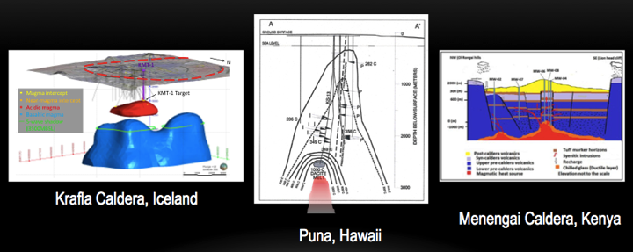
Figure 1: (L) Plausible model (JW Catley, Reykjavik University) for rhyolitic (red) and basaltic (blue) magma beneath Krafla Caldera (red circle). Geothermal wells (~40) are gray. Planned site and target of KMT-1 are also shown. Two wells penetrated magma and four others may have come close based on temperature and gases. (M) Dacite magma encountered under the lower east rift of Kilauea volcano (Teplow et al, 2009). (R) Syenite magma body centered under Menengai Caldera (Mbia, et al, 2015).
Two important points can be made. First, there are some striking commonalities that suggest that lessons learned at one place will find general applicability. In particular, there is the unexpectedly (though not if one considers lava lakes; Hardee, 1980) short transition from solid rock to molten rock. This is the conductive “magma lid” of Carrigan (1984). But the upper mush zone of partially crystallized magma seen in lava lakes and expected thermodynamically is missing. Secondly, the magma was controlled through normal geothermal engineering practice, even though in two cases it started to flow up the well. Prior to such encounters, drilling into magma might have been considered too high a safety risk. Might it start an eruption? But silicic magma is viscous even at liquidus temperatures and its viscosity is strongly temperature dependent, so it flows slowly through a small (compared to a volcanic conduit), cold borehole. Hence, it is easily quenched forming a rock plug (Fig. 2). Indeed, it could be argued that the risk of drilling into even well known oil and gas reservoirs, where the gas and fluid are both low viscosity and combustible, is considerably higher, as not infrequently demonstrated. We hear about explosive volcanic eruptions, further confused by use of the term “ash” to describe eruption products. Magma does “explode” but only in the sense of providing a firehose-like high discharge rate caused by gas expansion with melt fragmentation forming ash, rather than by combustion.
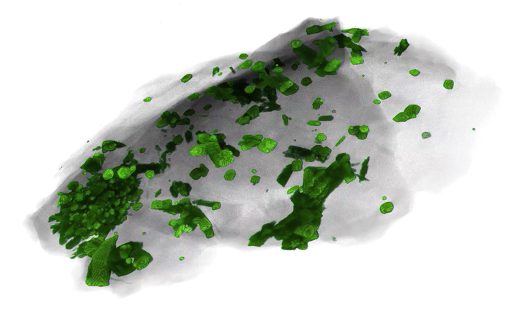
Figure 2: X-ray tomograph of rhyolite magma quenched at 2100 m depth in IDDP-1 and recovered by circulating drilling fluid. False-color green crystals, mostly plagioclase feldspar, float in transparent melt (now glass) “space”. Long dimension of chip is 3mm. Sample provided by Landsvirkjun (National Power Company of Iceland) and imaged by imaged by Fabian Wadsworth at Munich University working with Elodie Saubin, University of Canterbury and Ian Schipper, University Wellington, New Zealand.
It is interesting to note another similarity among the three sites: none of the intersected magmas had erupted in the last several thousand years – or ever as far as is known for Kilauea. Thus we find that not only is the geophysics wanting, but the volcanologist’s faith that eruption products provide a good representation of magma present beneath the surface as well. Taken together, magma drilling results are quite surprising and challenge “conventional wisdom”.

Table 1: Results from magma penetration during drilling in contrast to expectations
Observation | Common expectation | Hypothesis
I. Magma very shallow, 2.1-2.5 km depth | There are few if any cases where silicic magma has been proposed to be so shallow except as intrusions that soon crystallize. | The three magma sites are all in very hot rift structures. Shallow depth reduces cost of KMT relative to other sites, more typically proposed depths of 4-5 km, if correct, are accessible for future exploitation.
II. The top of the magma body has few crystals; substantially crystallized magma (mush) is absent | This is where the most rapid heat loss and therefore crystallization is to be expected, forming a mush zone, which is evidently missing. | Convection continually replaces roof-proximal magma with uncooled magma from deeper within the reservoir.
III. IDDP-1 showed very high permeability just above the magma. | Very hot rock is expected to be ductile and therefore not support open fractures. | Thermal fracturing caused by contraction during cooling causes high strains that open fractures within 100ºC of the solidus. (Lister, 1974; Lamur et al, 2017; Bjornsson et al, 1980; Axelsson et al, 2014).
IV. IDDP-1 showed no decline in thermal output during extended flow test. | Some reduction in pressure and temperature with time would be expected. | Sustained power output can be explained by continued thermal fracturing, as shown in lava lake drilling (Hardee, 1980) and suggested for Grimsvotn (Bodvarsson and Bodvarsson, 1980) and Krafla (Axelsson et al, 2014).
V. Magma encountered by drilling has not erupted in 10,000 (Krafla and Menengai) or ever (Kilauea). | Eruptions are generally expected to provide a representative sampling of magma at shallow depth under a volcano. | These shallow silicic magmas are apparently stable within the upper crust, requiring a massive influx of new magma to trigger their eruption, e.g., Sigurdsson and Sparks (1981) and Pallister et al (1982)

All of the above hypotheses are favorable from the standpoint of using magma as an energy source. Item V suggests that measurement of pressure and temperature in the magma could be used to forecast large eruptions.

3. Thermal properties of magma
Consider a 1 km³ silicic magma body, such as the one preserved in “fossil” form by the famous monolith El Capitan in Yosemite Valley, USA. When in a largely molten state it represented a huge concentration of thermal energy in Earth’s crust, 10¹⁸ J/km³ in latent heat of crystallization alone. Crystallization would thus produce a thermal power output of 1 GWt for about 30 years (10⁹s). This is in stark contrast to hot but solid rock, which contains no latent heat and is the heat source for conventional geothermal systems. Within the fairly short temperature range over which granitic (i.e., rhyolitic) magma crystallizes – because it is a near-eutectic composition – one can calculate an effective heat capacity that includes the heat released both by simple cooling and by crystallization (Fig. 3). It can be seen that magma is an order of magnitude more effective medium for storing thermal energy than rock. Moreover, as will be discussed later, much more of the energy in magma is accessible because heat is carried by natural convection, whereas in solid rock it must be accessed by short path-length conduction to fluid in pores or fractures, which then must have sufficient connectedness to permit rapid fluid flow.
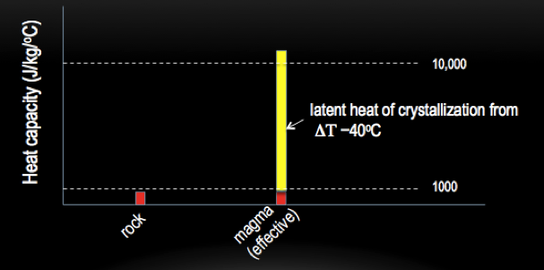
Figure 3: Comparison of the heat capacity of solid rock, the main component and storer of heat of a hydrothermal reservoir, with the effective heat capacity of rhyolitic magma within its crystallization interval.

It is useful to think in terms of energy density because this tells us from how much volume energy must be “collected” to obtain a certain result (Fig. 4). It is the collection process that is the primary challenge for any energy source.
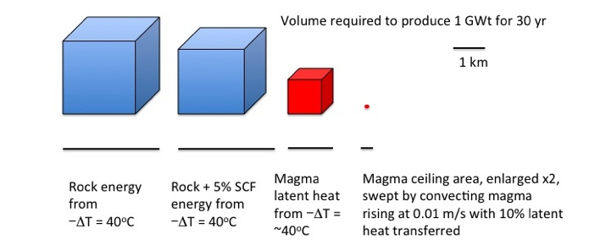
Figure 4: Comparison of reservoir volumes required to yield 10¹⁸ J (1 GWt for 30 a). Also shown is area of rising magma column that would deliver 1 GWt for conditions specified (see Fig. 6). SCF is supercritical fluid.
The simplest possible view of a magma body is one that is instantaneously emplaced in an initially cold environment and then crystallizes from the outside inward, essentially forming an insulator on itself (Fig. 5). Because this insulator is at very high temperature it is presumed to be unable to support fractures because of its ductility. An approximation for the thickness of the insulator as a function of time is:
L = (D*t)^{-1/2} (1)
where L is the thickness of the crystallized rind or insulator in meters, D is its thermal diffusivity, 10⁻⁶ m²/s, and t is time since emplacement in seconds. Vertical heat flow out, F in W/m², is:
Fz = -(ΔΤ/Δz)k (2)
where ΔΤ is the temperature drop across the insulator, k is thermal conductivity of the insulator, about 2 W/mºC, and Δz is L. Thus, F decreases in proportion to (t)^{-1/2}.
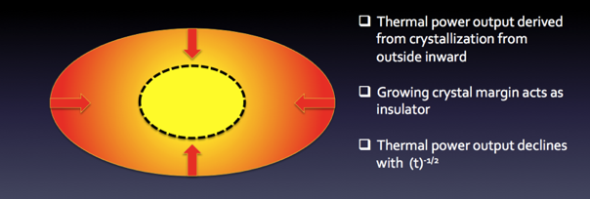
Fig. 5: Simple, conventional view of crystallizing magma body.
However, two factors appear to inhibit growth of L with time. One is thermal fracturing, which allows fluids to maintain contact with the near-magma environment. The other is convection in magma, required to explain the absence of crystallization near the roof (Fig. 6).
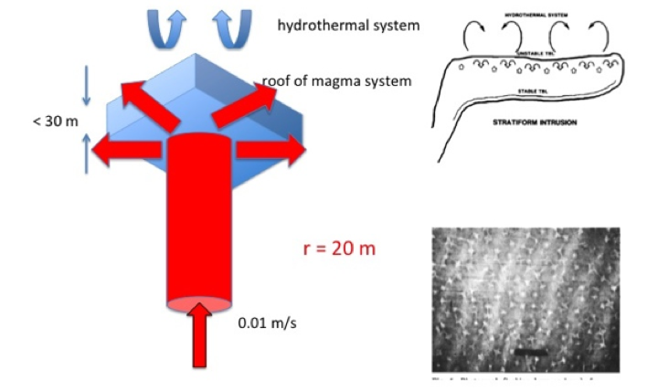
Figure 6: Size of “magma heat pipe” required to deliver 1 GWt from 10% of its latent heat to the ceiling of a magma chamber. Relative area needed is shown in Figure 4. Illustrations at right from Carrigan (1984) and Carrigan and Cygan (1986) view and laboratory simulation of multiple convection cells (high Rayleigh number) delivering heat to roof of magma chamber.
These considerations suggest quite a different picture of a magma body (Fig. 7).
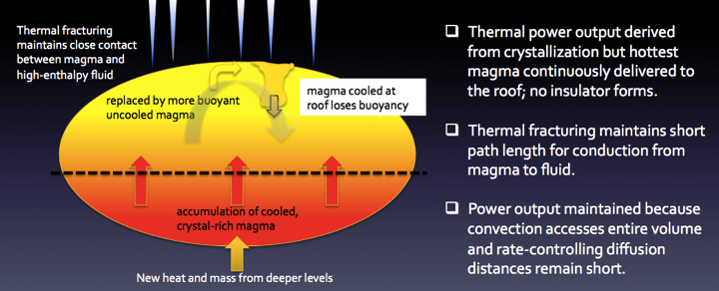
Figure 7: Hypothethical view of magma body that satisfies observations II, III, and IV in Table 1.
The parameter L, thickness of the magma lid whether crystallized magma or wallrock, is the conductive zone separating the magma reservoir from the hydrothermal reservoir, bounded by the transition from rock to magma on the lower surface and from ductile rock to thermal fracturing on the upper surface. This parameter is critical because it controls the rate-limiting step in heat transfer in the system. Using values for IDDP-1, (Mortensen et al, 2014; Axelsson et al, 2014) and substituting L in equation (2) for Δz, we have L < 20 m and ΔΤ ∼ 400ºC yielding Fz = -40 W/m² (negative because z increases downward). Extracted as latent heat of crystallization, this would form a crystal layer at a rate of 1 m/a. However, such a layer is absent and there is evidence that the magma has been there at least since a phreato-magmatic explosion in 1724. This is the argument for magma convection at Krafla. Sustaining 100 MW thermal output with that heat flow would require a surface area of 2.5 km² or most of one estimate of the area of the rhyolitic magma body. However, the value taken for L is an upper limit and so the heat flux is a lower limit.
Equation (1) can also be taken as relating the characteristic response time, τ, of one reservoir to a perturbation in the other. Rearranging, we have:
τ = L²*D (3)
and for the values explained above, τ ∼ 1 a. This means that extracting energy from the hydrothermal reservoir (cooling it) will begin to affect the magma reservoir quickly, perhaps speeding up convection. That is to say that if L is small, magma energy is being used and the supply of energy on a human timescale is virtually limitless provided the magma body is as large as commonly postulated. A relatively new and now widely accepted view is that magma systems are essentially heat pipes extending upward from Earth’s mantle (Cashman et al, 2017). Scott et al. (2017) have modeled the generation of supercritical or superheated fluid above a magmatic heat source. The stages of heat transport from source to surface are portrayed schematically in Fig. 8.
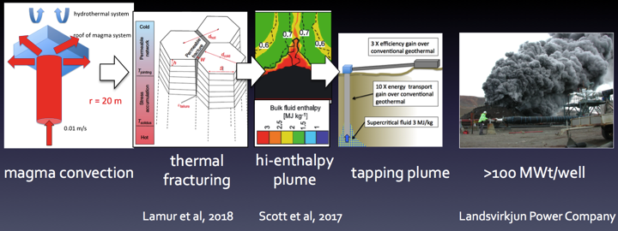
Fig. 8: Idealized scenario for magma-sourced geothermal energy.
However, if L is hundreds of meters, then the response time of the magma heat source to geothermal production will be thousands of years. Thus, on a human time scale, in such a case the advantage of being connected to a convecting magmatic heat source containing latent heat of crystallization is lost and only “old” heat is being mined.

Krafla Magma Testbed
What is outlined here is a significant paradigm shift in thought, but is also highly speculative. It relies heavily on the intriguing but sparse observations and incomplete samples (large interval with no cuttings returned due to lost circulation) from IDDP-1. The obvious first-order tests of the hypothesis are core samples through the hydrothermal to magma interval combined with temperature measurements to determine heat flow. This requires time, not the more common and economical drill-sample-measure-abandon approach to scientific drilling, both for time series data and for engineering innovation to make a sustained presence of sensors possible, i.e., a testbed approach (Ludden et al, these proceedings). The obvious place to do this is Krafla, where the position of the magma body and the drilling conditions are precisely known. Equally important is that the operator of the geothermal field, Landsvirkjun, is welcoming of science for the general good and is fully open to sharing of data and experience. Surface facilities have already been offered to KMT. Thus, the international scientific and engineering communities have a first and ideal opportunity to explore Earth’s molten crust, and with it the promise it holds for a quantum leap in clean energy production and eruption forecasting.
KMT is now in “Phase Zero” wherein all the testing, design, and modeling tasks to take us to the point of drilling the first scientific borehole to magma are being conducted. Phase 1 will be construction of that borehole, KMT-1, near the “magma discovery well”, IDDP-1. The first critical experiments will be coring through the rock-to-magma transition and emplacement of a string of thermocouples (Fig. 10). This will correlate rock changes with temperature and for the first time directly measure heat flow from a magma body. In fact, these will be the first long-term high temperature measurements to thermal equilibrium. We plan to include various innovations, such as slip joints in casing to accommodate thermal expansion and contraction and presurizing the well with N₂ to protect it from invasion of corrosive gases from the magma.
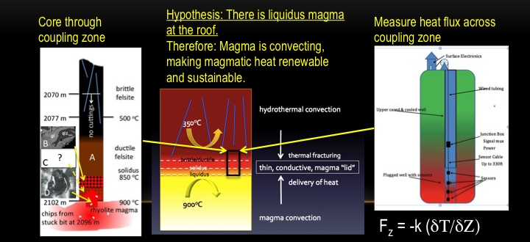
Fig. 9: Critical proof-of-concept test for proposed well KMT-1, based on the intriguing but incomplete results from IDDP-1 (Zierenberg et al, 2012). (left) The expected section should be unmelted felsite (A), partially melted felsite (B), partially crystallized magma (C), and liquidus rhyolite (D). No cuttings were returned because of lost circulation below 2070 m in IDDP-1. However, chips of B and D were recovered when the drill bit became stuck in magma at 1996 m; no C is recognized. The magma had flowed up the well after being intersected at ~2102 m. The deepest reliably known temperature, based on temporal extrapolation to local equilibrium from repeated logging, is 500ºC at 2077 m (Mortensen et al, 2014; Mortensen, oral communication, 2018). Without convection in magma, the thickness of C (releasing heat of crystallization) should be comparable to the thickness of B. The thickness of B and C (if present) can be determined by coring across the coupling zone (center). Measurement of the temperature gradient across the conductive coupling zone (right; concept of Randy Normann, Permaworks) yields heat flow from magma and predicts growth of C with time. Known constraints require >20ºC/m yielding about 1 m of crystals/year in magma. Absence of C therefore requires convection to continually replace C with A while melting B.
In subsequent phases, additional boreholes will be drilled and experiments to extract magma-sourced geothermal energy and to directly monitor the magma with extreme T, P, and chemical sensors will be conducted. Surface and borehole experiments will be conducted to test and improve geophysical techniques for locating magma bodies, an essential ability for expanding magma energy use through “magma prospecting”. Manipulation of pressure in the boreholes will be used to test and improve interpretation of signals recorded at the surface indicative of “volcano unrest” and used to forecast eruptions.
As with major infrastructure in other fields such as particle accelerators in high energy physics and telescope arrays in astronomy, once operational independent research teams will come to conduct experiments with support of surface facilities and resident scientists and engineers. Krafla volcano is already being monitored by Iceland Meteorological Office (IMO) as part of a global system of volcano monitoring. KMT will take this to a new level with subsurface sensors together with surface sensors taking volcano monitoring beyond the current state of the art (Fig. 10).
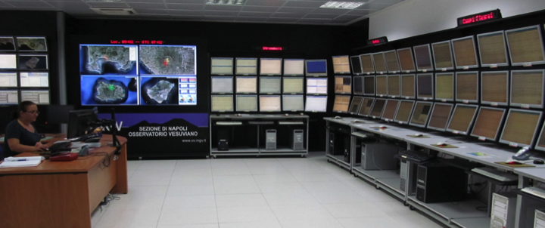
Figure 10: 24/7 operation center of INGV’s Vesuvius Observatory. Courtesy of INGV.
More information on plans for development of KMT are reported in Papale et al (this proceedings volume), and are available at www.kmt.is.

conclusions
Recent fortuitous geothermal drilling encounters with silicic magma underlying hydrothermal reservoirs reveal a remarkably short vertical distance between them, tens of meters or less. The systems can be viewed as closely coupled reservoirs, one with aqueous fluid convecting through rock pores and fractures, deriving its thermal energy by conduction through a thin solid to molten transition zone from magma. Much of the thermal energy of the magma is released by crystallization near the roof of its reservoir but crystallizing magma is continually swept away and replenished by buoyant, uncooled magma from deeper in the reservoir. Indeed, data from Krafla (Fig. 1) suggests that the silicic magma may itself overlie a basaltic magma reservoir or basaltic plexus of dikes and sills, forming a heat pipe extending from the mantle.
A critical parameter is the vertical distance between the two convecting systems because conduction of heat through this intervening zone is the rate-controlling step. It may be kept thin and therefore heat flow high by thermal fracturing on its upper surface and magma currents across its lower surface. This distance also controls the response time for a perturbation in one reservoir, for example extraction of heat for geothermal power, to affect the other. If the separation is less than a few tens of meters, then the response time will be years or less and the power that is tapped will be magma energy, essentially the latent heat of crystallization of the magma.
This possibility could produce a quantum leap in geothermal energy production and fundamental understanding of magma, including forecasting of dangerous eruptions (Eichelberger, 2019). However, crossing this frontier into molten Earth requires a sustained presence and new technological developments. General application of results will require the ability to reliably find magma elsewhere, a capacity we do not possess now. Thus a testbed approach is required (Ludden et al, these proceedings), the Krafla Magma Testbed. Among its first goals are to obtain continuous core samples across the solid rock to molten rock interface, from 400ºC to 900ºC at 50 MPa and to measure the temperature gradient and hence heat flow as well. These are goals that could not have been imagined before geothermal drillers inadvertently entered the previously speculative territory of volcanologists.

acknowledgments
We thank Landskirksun, National Power Company of Iceland, which welcomed and contributed to the development of the KMT concept, Geothermal Research Cluster (GEORG), which provided a home for KMT’s project office and supported one of their staff as our project manager (HPI), and Iceland Deep Drilling Project, which showed the path to magma. We also thank the many institutions in a dozen countries who supported the scientists and engineers in planning KMT.

References
Axelsson, G., Egilson, T., Gylfadóttir, S.S.: Modelling of Temperature Conditions Near the Bottom of Well IDDP-1 in Krafla, Northeast Iceland, Geothermics, 49, (2014) 49-57.
Björnsson, H., Björnsson, S., and Sigurgeirsson, Th.: Penetration of Water into Hot Rock Boundaries of Magma at Grímsvötn, Nature, 295, (1982) 580-581.
Carrigan, C.R.: Time and Temperature Dependent Convection Models of Cooling Reservoirs, Geophys. Res. Lett., 11, (1984) 693-696.
Carrigan, C.R., and Cygan, R.T, Implications of Magma Chamber Dynamics for Soret Related Fractionation, J. Geophys. Res, 91, (1986) 11451-11461.
Cashman, K.V., Sparks, R.S.J., and Blundy, J.D. Vertically extensive and unstable magmatic systems: A unified view of igneous processes, Science, 355, (2017).
Eichelberger, J., Planning an International Magma Observatory, Eos, 100, (2019).
Elders, W.A., Friðleifsson, G.O., Albertsson, A., Drilling Into Magma and the Implications of the Iceland Deep Drilling Project (IDDP) for High-Temperature Geothermal Systems Worldwide, Geothermics, 49, (2014) 111-118.
Fridleifsson, G.O. et al., The Iceland Deep Drilling Project 4.5 km Deep Well, IDDP-2, in the Seawater-Recharged Reykjanes Geothermal Field in SW Iceland Has Successfully Reached its Supercritical Target, Scientific Drilling 23, (2017) 1-12.
Hardee, H.C., Solidification in Kilauea Iki Lava Lake, Journal of Volcanology and Geothermal Research, 7, (1980) 211-223.
Lamur A., Lavallée Y., Iddon F., Hornby A.J., Kendrick JE., von Aulock F.W., Wadsworth F.B., 2018. Disclosing the Temperature of Columnar Jointing and Fluid Flow in Lavas. Nature Communications 9 (2018).
Lister, C.R.B. On the Penetration of Water into Hot Rock: Geophysical Journal International 39, (1974) 465 – 509.
Lowenstern, J. B., T. W. Sisson, and S. Hurwitz, Probing Magma Reservoirs to Improve Volcano Forecasts, Eos, 98, (2017).
Ludden, J.N., Stephenson, M., Curran-Taylor, H.: Energy Test-Beds Role in Providing Safe and Sustainable Energy from the Subsurface, Proceedings World Geothermal Congress 2020, Reykjavik, Iceland.
Mbia, P.K., Mortensen, A.K., Oskarsson, N., and Hardarson, B.S: Sub-Surface Geology, Petrology, and Hydrothermal Alteration, of the Menengai Geothermal Field, Kenya, Proceedings of World Geothermal Congress 2015, Melbourne, Australia.
Mortensen, A. K., Egilson, F., Gautason, B., Árnadóttir, S., and Gudmundsson, Á.: Stratigraphy, Alteration Mineralogy, Permeability and Temperature Conditions of Well IDDP-1, Krafla, NE Iceland, Geothermics, 49, (2014) 31-41.
Pallister, J.S., Hoblitt, R.P., Reyes, A.G. A Basalt Trigger for the 1991 Eruptions of Pinatubo Volcano? Nature, 356, (1992), 426-429.
Papale, P., Eichelberger, J., Ingolfsson, H.P., Lavallée, Y., Ludden, J., Markusson, S., Sigmundsson, F., and the KMT consortium: Bringing Together Volcano Science and Geothermal Industry: The KMT – Krafla Magma Testbed Breaking-Through Perspective, Proceedings World Geothermal Congress 2020, Reykjavik, Iceland.
Scott, S, Driesner, T, Weis, P, Boiling and Condensation of Saline Geothermal Fluids above Magmatic Intrusions, Geophys. Res. Lett. 44, (2017), 1696-1705.
Sigurdsson, H., Sparks, R.S.J.: Petrology of Rhyolitic and Mixed Magma Ejecta from the 1875 Eruption of Askja, Iceland, Journal of Petrology, 22, (1981), 41–84.
Teplow, W., Marsh, B., Hulen, J., Spielman, P., Kaleikini, M., Fitch, D., Rickard, W.: Dacite Melt at the Geothermal Venture Wellfield, Big Island of Hawaii, GRC Transactions, 33, (2009), 989-994.
Tester, J W, Anderson, B.J., Batchelor, A.S., Blackwell, D.D., DiPippo, R., Drake, E.M., Garnish, J., Livesay, B., Moore, M.C., Nichols, K., Petty, S., Toksoz, M.N., Veatch, R.W., Baria, R., Augustine, C., Murphy, E., Negraru, P., and Richards, M., Impact of Enhanced Geothermal Systems on US Energy Supply in the Twenty-First Century, Philosophical Transactions of the Royal Society A: Mathematical, Physical and Engineering Sciences, 365 (2007).
World Energy Council, World Energy Resources Full Report 2016.
Zierenberg, R.A., Schiffman, P., Barfod, G.H., Lesher, C.E., Marks, N.E., Lowenstern, J.B., Mortensen, A.K., Pope, E.C., Bird, D.K., Reed, M.H., Fridleifsson, G.O., Elders, W.F., Composition and Origin of Rhyolite Melt Intersected by Drilling in the Krafla Geothermal Field, Iceland, Contributions to Mineralogy and Petrology, 165, (2012), 327‐347.

