Bringing together volcano science and geothermal industry:

the KMT – Krafla Magma Testbed breaking-through perspective

Paolo Papale¹, John Eichelberger, Hjalti Pall Ingolfsson, Yan Lavallée, John Ludden, Sigurdur Markusson, Freysteinn Sigmundsson, and the KMT consortium
¹Istituto Nazionale di Geofisica e Vulcanologia, Sezione di Pisa, via Della Faggiola 32, 56126 Pisa, Italy
paolo.papale@ingv.it

Keywords: Enter your keywords here. <Normal Style>

Abstract
The ultimate source of geothermal energy is magma. This obvious consideration should be enough to establish close relationships between research in geothermal energy systems, and that connected with magmatic and volcanic systems, namely, volcanology. As a matter of fact, the two were closely linked decades ago, but then they diverged and continued to develop mostly as separate disciplines, each one having its own aims, projects, conferences, journals, and communities. Experts in geothermal system circulation, geothermal fluid flow dynamics and thermodynamics, and geothermal/volcanic fluid geochemistry, populate both communities, however, they rarely interact, and their advance in interpretation and modeling is poorly transferred to each other. That happens at a time when the demand for clean, renewable energy sources is increasingly high, and in a panorama whereby other renewable energy sources such as solar and wind have been able to expand and respond much more effectively than geothermal energy.
It is a fact that the heat flux from the Earth interior can provide enormously more energy than to-date global production levels; in fact, geothermal energy is still exploiting just the skin of an immense reservoir extending to temperatures one order of magnitude higher than those of typical productive geothermal fluids, and existing at similarly shallow depths. Those reservoirs are represented by magma itself, and by the supercritical fluids circulating in its proximity. While the search for supercritical fluids has seen increased interest during last years, recent unexpected encounters of geothermal well drills with shallow magma are opening completely new perspectives, suggesting the feasibility of close-to-magma volcano monitoring and energy exploitation systems. The scientific, technological, and logistic challenges that such a breaking-through development requires are the subject of KMT: Krafla Magma Testbed, a project which gathers scientists and industries from all over the world in an international effort towards the realization of the first magma observatory ever. That will be represented by a permanent infrastructure open into rhyolitic magma at about 2 km depth inside the Krafla caldera, Iceland, and dedicated to research and experimentation on volcano monitoring and geothermal energy production systems in the third millennium, as well as on new technologies for extreme condition environments.

1. Introduction
“Of all the hidden places we’ve not yet explored, few are as close to us and as important to us as magma” (www.kmt.is). Such a statement outlines the relevance, that will be discussed throughout this paper, of a new frontier in human exploration, represented by magma, or molten rock stored within the Earth’s crust. We have not yet explored magma in the crust, as that has been largely outside our technological capabilities. However, our history tells us that we humans are not comfortable with limits: whenever there is an opportunity, be for scientific understanding, technological advance, or industrial exploitation, we pursue it, and quite often, we achieve it.
Magma is the last unexplored frontier of the Earth’s crust because it presents the greatest technological challenge. Nevertheless, if we want to fully understand geothermal systems, volcanic eruptions, ore deposits, and the evolution of the Earth’s crust, we must go there. That appears today far less distant than in the recent past. In 2009 the government owned Icelandic company Landsvirkjun serendipitously hit rhyolite magma at ~900 °C at a depth of only 2100 m (Mortensen et al., 2014). Heat removed through water circulation was at 450 °C in a highly permeable zone at the magma-rock/fluid interface. Fragments of quenched glass and variably crystallized magma were recovered, but their contextual relationships were poorly constrained as the drilling was never set up for accurate sample recovery. However, this discovery proved that a well-designed project could penetrate this interface.
Following the discovery of magma at modest depth beneath Krafla Caldera, an international coalition of scientists and engineers has been assembled to establish a long-term natural laboratory, or ‘testbed’, to take full advantage of this important discovery — the Krafla Magma Testbed (KMT) (www.kmt.is). This paper shortly presents the aims and challenges of KMT, and its enormous potential as a break-through in scientific understanding as well as in geothermal energy production.

2. THE KMT CONCEPT
The Iceland Deep Drilling Program’s IDDP-1, drilled in 2009 at Krafla Caldera, Iceland, (e.g., Mortensen et al, 2014), encountered near liquidus rhyolite three times at 2102 m. The third time the magma flowed 9 m up the well. Other wells at Krafla have reached magma or near-magma over an area of 3.5 km² (Figure 1). The roof rock is interpreted to be partially melted felsite (Zierenberg et al, 2013), chemically similar to the magma.

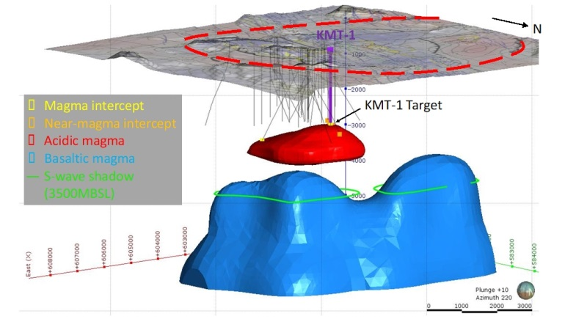
Figure 1: Plausible configuration of the magma system beneath Krafla Caldera. Red is the rhyolite magma body with intersection and near-intersection points shown. Blue is basaltic magma, based on MT and seismic data. About 40 wells drilled for geothermal development are shown in gray. Planned KMT-1 in purple closely follows IDDP-1. Caldera outline is dashed red (after Eichelberger, 2019).
At least other two documented cases exist of drill encounter with magma, at Hawaii, and at Menengai caldera, Kenya (Eichelberger, 2019). However, the Krafla case is by far the best documented. For scientific drilling into magma, there is literally no place on Earth better suited. Nowhere else has magma been encountered multiple times and controlled, and in a volcanic system about which so much is known in terms of geologic history, geophysical surveys, and monitoring, and three-dimensionally through numerous (about 40) existing boreholes. Logistical and environmental considerations are also favorable: easy access, copious water supply, an already developed geothermal field so that the project’s incremental impact will be negligible, potential benefits to the local and regional community that transcend power generation, and a welcoming geothermal partner and host country.
Resting on such a basis, KMT aims at becoming the first magma observatory on Earth: a place where scientific exploration, technological development, and industrial advance are pursued together, thanks to a permanent infrastructure consisting of a series of wells open inside and around an active magma body, complemented by a sophisticated network of surface and borehole monitoring instruments including near-magma or in-magma sensors, by lab facilities, and by a visitor center and didactic areas.

2.1 KMT pillars
KMT rests on four major pillars representing areas where developments are expected to be substantial: i) basic science, ii) volcanic hazard, iii) geothermal energy, and iv) technological development.
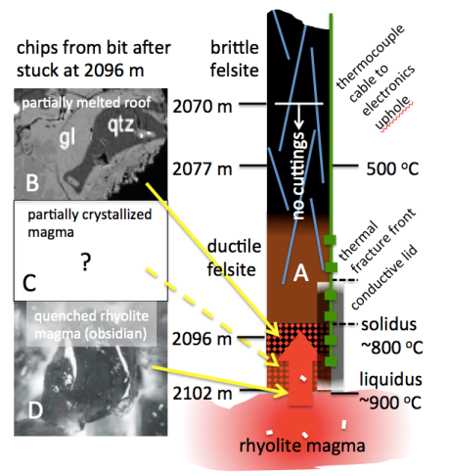
Basic science. There is an enormous amount to discover about the physical state of magma chambers. Knowledge of magma currently derives from i) interpreting activity measured at the volcano surface, ii) unraveling the geology of fossil magma chambers, iii) laboratory experiments, and iv) numerical simulations. KMT will unearth direct samples and provide direct observations that will enable competing theories to be tested. Never before has there been a long-term observation of the magmatic system, nor the ability to image it. The KMT will allow us to test and develop models about how the planet works and observe the real properties of the system. Through this, humankind will acquire, and benefit from, a hugely-improved understanding of magma dynamics, extending to some of the most relevant questions in the geosciences like the origin of the Earth’s crust, at the place on Earth where new crust is continuously forming. Particularly relevant aspects of scientific advance, also largely impacting on geothermal industry (see below), are represented by the transition between magma and surrounding rocks, and magma-geothermal fluid coupling. While there is a growing literature calling for the existence of a crystal-rich or mushy region at the transition between dominantly liquid magma and surrounding rocks (e.g., Cashman et al., 2017), none of the three aforementioned cases (Hawaii, Menengai, Krafla) has produced anything similar. In particular, magmatic samples retrieved at Krafla are either nearly aphyric obsidian (rhyolite) or nearly completely crystallized felsite with the same overall composition and geochemical fingerprint (Masotta et al., 2018), leaving an open possibility for a more abrupt transition than previously thought. Similarly, the profile of temperature emerging from drilling is surprising, showing a steep increase by several hundred degrees concentrated in the last 20-40 m above magma (Figure 2).

Figure 2. Sketch of the main observed or inferred characteristics of the rock-magma transition at IDDP-1. After Eichelberger (2019).
Volcanic hazard. Understanding the magmatic processes inside and below active volcanoes, and their relationships with quantities measured at or near the surface, is the forefront of research aimed at forecasting short-term volcanic hazards. Volcanic processes are at least as complex as atmospheric processes, with many quantities being non-linearly related, first-order governing processes occurring over wide spatial and temporal scales, extremely complex magma, rock and fluid properties, etc. However, differently from the atmosphere, we do not observe directly the magma and its surrounding environment; rather, till now we can only infer the deep conditions, e.g., from surface data inversion, from the analyses of the products of past eruptions, from numerical and lab simulations, or from a combination of the above. Directly measuring and monitoring magma chamber and surrounding rock system conditions will be a complete game changer, as for the first time we will be able to directly see and record the underground magma dynamics; like if for the first time we would be able to see and measure the atmosphere, after having experienced its effects and only imagined how it may look like. Furthermore, precise knowledge of the location and characteristics of the shallow magma reservoir, a unique situation at Krafla, allows a fundamental step forward to be achieved in the development of more robust, ground-truth, tested geophysical inversion techniques: despite substantial geophysical and geochemical investigation before drilling IDDP-1, no shallow magmatic reservoir was imaged at the 2 km depth where it was in fact found. That should ring a warning bell for many active volcanoes located in urbanized areas, e.g., Vesuvius and Campi Flegrei close to Naples, Italy, Auckland Volcanic Field in New Zealand, and many others all over the world. The existence of the KMT infrastructure will allow true real-scale experiments to be performed, by slightly perturbing the P-T conditions (e.g., through injection of fluids) under controlled conditions, then measuring in high detail the resulting “unrest”, finally establishing lab-controlled relationships between deep magmatic conditions and surface (and borehole) geophysical and geochemical records, thus revolutionizing understanding of volcanic unrests (Figure 3).
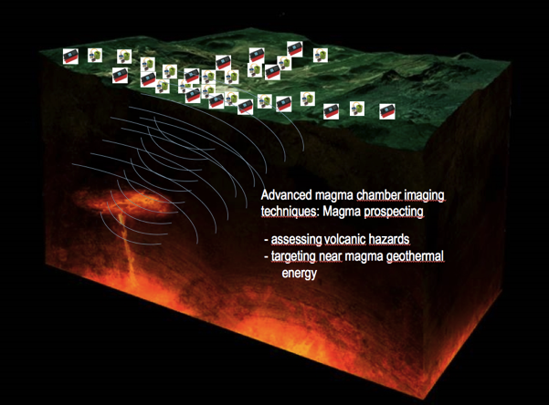
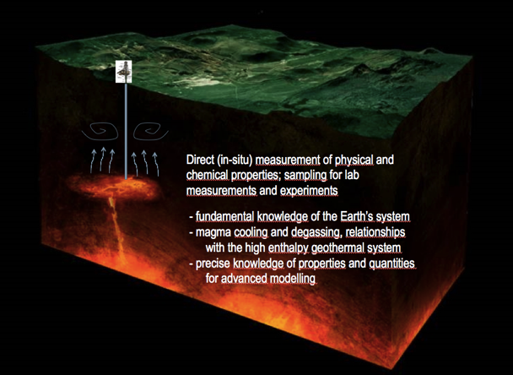
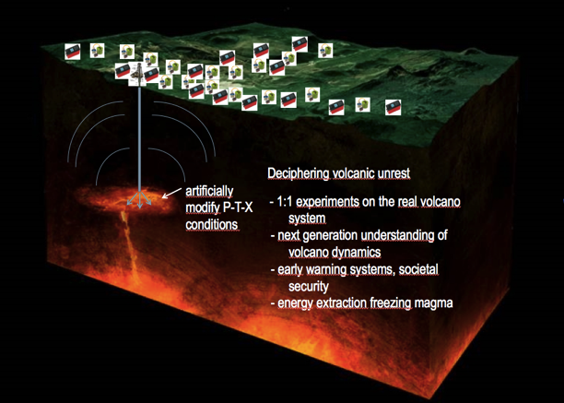
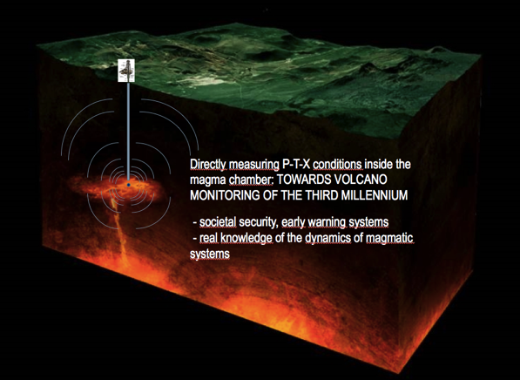

Figure 3: Visualization of the break-through advance in volcano monitoring and understanding, with some of the beneficial impacts for society.
Geothermal energy. Conventional geothermal energy production wells are limited to sub-critical conditions. The search for supercritical fluids, and their potential for exploitation, represents the current frontier in geothermal energy (e.g., see the EU-DESCRAMBLE project: http://www.descramble-h2020.eu/). More generally, geothermal energy brings about many of the characteristics that are sought after for energy production in the current global climate change era, as it is clean and renewable; however, its recent developments have not parallelized those in other similar energy production systems, like solar and wind energy, that have received far more impulse in last years. Geothermal energy is environmentally friendly, renewable energy source and independent of weather conditions. It produces reliable baseload power and heat – all the more important to balance intermittent supplies from other renewable energy sources. The establishment of KMT will tremendously benefit further research and development on extracting heat directly from magma, increasing the heat energy extractable from a geothermal field by an order of magnitude, and the efficiency of conversion to electricity by a factor of two or three.
Technological developments. KMT will provide the perfect opportunity for innovation by developing new, qualified and tested technology. It will extend drilling operations into magmatic conditions. It will develop or improve monitoring techniques for volcanology, including real-time calibrations. It will also push drilling and sensor technology to the crust’s high-temperature maximum. This venture will be working at the limits of sensor systems technology, in a dynamic environment encompassing interactions with magma at temperatures of ~900 °C and ambient temperatures at the surface. Finally, it will explore the roots of geothermal systems and the potential for direct energy extraction from magma — the ultimate geothermal resource. The requirements for new technological developments encompass the most extreme conditions existing near the Earth’s surface, superimposing to those expected for other extreme environments, e.g., the surface of Venus. New technologies and testing procedures designed for KMT will therefore impact at a much broader level, likely focusing much of the technological developments for extreme environments in the next decades.

3. KMT ROADMAP
The KMT consortium benefits of endorsement from the Icelandic government and is increasingly rising concrete interest from other countries, as well as from the academy, the geothermal and drilling industry, existing EU infrastructures in the geosciences like EPOS (www.epos-ip.org), and many other potential actors from governmental agencies to small-medium enterprises. KMT is at present in its phase zero, that will extend to the end of 2021 with the aim of ensuring readiness and feasibility to the subsequent phases described at Figure 4 and below.
Phase zero. Define governance and project implementation through a readable, clear, visionary and marketable business plan, establishing commitments for adequate funding for Phase 1 and sustainable financial plan for subsequent phases. Obtain permits and licenses for Phase 1 and answer all legal questions thereby Define the risks, perform a robust risk analysis including the analysis of the impacts of drilling into magma, formulate a risk management strategy. Define drilling and well design and engineering, including material and cement selection, and wellhead design including near-magma sensors and well monitoring. Implement a database of existing data and properties of the Krafla system, and of the monitoring network. Review and update the research plan. Further implement and manage communication with stakeholders (governments, industries, society), formulate and implement an education and outreach plan.
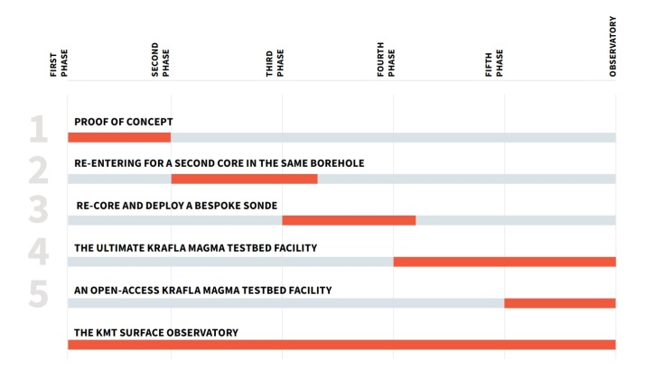
Figure 4. The different phases of KMT development.
1st Phase: Proof of concept. Drill a new dedicated research borehole with the aim of recovering a core from the boundaries of solid and molten rock, and monitoring temperature from that point onward. In the meantime, we will collaborate to develop new temperature-resilient technologies to monitor pressure. The borehole will be cased using new innovative, patented, flexible couplings allowing the steel to thermally-expand without accumulating too much stress and strain on the casing. Following successful recovery of a core, the borehole will be allowed to heat up, under constant monitoring and supervision, in order to monitor magma in situ.
2nd Phase: Re-entering for a second core in the same borehole. Following a successful proof of concept, the team intends to re-enter the first hole with a drill rig to recover another core (for second point in time series) and monitor temperature as well as pressure while the borehole heats up again. When the conditions at the bottom of the well have reached equilibrium with the surrounding environment, we may initiate flow testing of the well (involving cooling of the magma). If we deem the well and the conditions suitable without jeopardizing its future, a flow test will put the new flexible couplings and casing to the extreme test of surviving the harsh condition of high temperature and corrosive geothermal fluids. The flow-test will also provide valuable opportunity to sample the chemistry of the geothermal fluid close to magma as well as various opportunities for geothermal engineering testing and experiments.
3rd Phase: Re-core and deploy a bespoke probe. In the 3rd phase, we will re-core magma from the first well and deploy a bespoke probe to measure viscosity and density of the magma in situ. The probe will be designed so it can sense the solid base of the magmatic body, thus defining the thickness of magma underlying the geothermal system.
4th Phase: The ultimate Krafla Magma Testbed facility. In the 4th phase the intention is to drill a second research hole and recover a core in a different part of the magma reservoir, while monitoring P-T in the first hole to test the response of the magmatic system to geothermal drilling activity. This data and associated stimulation of magma in two places will enhance our ability to image the spatial distribution of the magma reservoir.
5th Phase: An open-access Krafla Magma Testbed facility. Following completion of the first delivery phases, the KMT research facility will opened to permit cutting-edge science by the research community. The facility will be open to the wider community through yearly calls for proposals, which will be considered by the KMT Executive Board.
The KMT surface observatory. At the same time the KMT will be host to numerous surface and shallow surface measurements (direct and monitored). The project board will work with the local community to develop engagement opportunities around the observatory.
Figure 5 illustrates the estimated required funding for full development of KMT in its different phases. The costs of phase zero amount to about 3.3 M$. The fundraising strategy identifies the following entities as major fund providers: i) national governments, ii) major science-supporting agencies, iii) scientific consortia and other large-scale scientific and infrastructural initiatives, iv) individual partners including industrial partners. The current phase zero includes the definition of KMT governance and legal entity to oversee and manage the project and its funding sources.
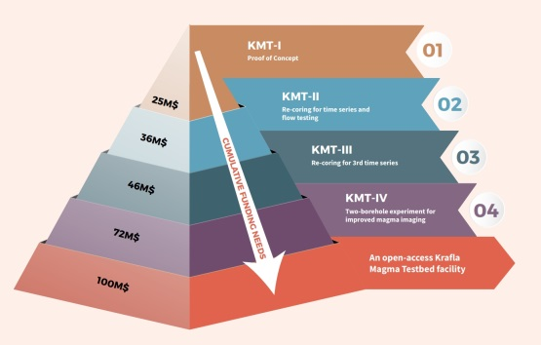
Figure 5. Funding required for the different phases of KMT.

4. CONCLUSIONS
We stand at the threshold of obtaining a new kind of knowledge about magma in Earth’s crust. The unexpected but successful encounters with rhyolite magma by geothermal drilling in Krafla Caldera, Iceland, open the door to direct exploration of hydrothermal/magma coupling and the transition from solid rock to magma itself. KMT is an unprecedented scientific research endeavor with the ambition of establishing the first ever research infrastructure able to access a magma chamber and initiate a 30-year scientific program for completely new observations and experiments concerning magma dynamics, volcanic risk, and extreme geothermal energy. KMT will become the first international magma observatory and laboratory for advanced studies of and experiments in magmatic, volcanic, and geothermal system dynamics. It is to be an open, multi-user facility, a base for investigating the highest-temperature processes in the crust of rocky planets, analogous to infrastructure for exploration of extreme environments of space, the cryosphere, seafloor, and sub-atomic particles.
KMT will use new drilling technology and sensor systems capable of working in extreme environments. It will establish the state-of-the-art technology and solutions that will allow us to harness near magma heat in regions across the planet. It will multiply by orders of magnitude the energy we can use from a sustainable system. The KMT grand challenge will teach us how to monitor magma inside the earth, providing us with the ability to predict, and potentially control, volcanic eruptions near highly-populated areas. Technological innovation within sensor systems for extreme environments will provide test cases for planetary exploration and a real-life teaching and learning environment. KMT will provide new ways of using heat and the creation of novel fuels, food production and tourism. It will help humankind to solve the energy problem, manage hazards and understand how the rocky planets have formed their crust.

References
Cashman, K.V., Sparks, R.S.J., and Blundy, J.D.: Vertically extensive and unstable magmatic systems: A unified view of igneous processes, Science, 355, (2017).
Eichelberger, J.: Towards an International Magma Observatory: Krafla Magma Testbed, Eos (in press).
Masotta, Mollo, S., Nazzari, M., Tecchiato, V., Scarlato, P., Papale, P., and Bachmann, O.: Crystallization and partial melting of rhyolite and felsite rocks at Krafla volcano: A comparative approach based on mineral and glass chemistry of natural and experimental products, Chemical Geology, 483, (2018), 603-618.
Mortensen, A. K., Egilson, F., Gautason, B., Árnadóttir, S., and Gudmundsson, Á.: Stratigraphy, alteration mineralogy, permeability and temperature conditions of well IDDP-1, Krafla, NE Iceland, Geothermics, 49, (2014), 31-41.
Zierenberg, R. A., Schiffman, P., Barfod, G. H., Lesher, C. E., Marks, N. E., Lowenstern, J. B., Mortensen, A. K., Pope, E. C., Fridleifsson, G. O., and Elders, W. A.: Composition and origin of rhyolite melt intersected by drilling in the Krafla geothermal field, Iceland, Mineralology and Petrology, 165, (2013), 327-347.

