TITLE: Clinically unnecessary and avoidable emergency health service use for epilepsy: A survey of what English services are doing to reduce it.
AUTHORS: Amy Mathieson¹, Anthony G. Marson², Mike Jackson³, Leone Ridsdale⁴, Steve Goodacre⁵, Jon M. Dickson⁶, Adam J. Noble¹.

AFFILIATIONS:
¹ Department of Health Services Research, University of Liverpool, UK.
² Department of Molecular and Clinical Pharmacology, University of Liverpool. UK.
³ North West Ambulance Service NHS Trust, Bolton, UK.
⁴ Department of Basic and Clinical Neuroscience, King’s College London, UK.
⁵ School of Health and Related Research, University of Sheffield, UK.
⁶ Academic Unit of Primary Medical Care, University of Sheffield, UK.

CORRESPONDING AUTHOR:
Amy Mathieson Ph.D MA BSocSc (Hons)

ADDRESS:
Department of Health Services Research
University of Liverpool
2nd Floor, Waterhouse Building Block B
Liverpool
L69 3GL
Amy.mathieson@liverpool.ac.uk

TITLE: Clinically unnecessary and avoidable emergency health service use for epilepsy: A survey of what English services are doing to reduce it.

ABSTRACT
Purpose: Epilepsy is associated with costly unplanned health service use. The UK’s National Audits of Seizure Management in Hospital found use was often clinically unnecessary, avoidable and typically led to little benefit for epilepsy management. We systematically identified how services have responded to reduce such use.
Methods: We invited England’s ambulance services, neuroscience and neurology centres and a random sample of Emergency Departments (EDs) to complete a survey. It asked what innovations they (or services they worked with) had made in the past 5 years or were making, the priority afforded to them, user involvement, what comprised usual practice, and barriers to change.
Results: 72/87 of invited (82.8%) services responded. EDs ascribed less priority to reducing emergency hospital use for epilepsy and convulsions, than other service types. Overall, 60% of services reported a change(s) and/or were planning one. Neurology/neuroscience sites (93.8%) were most likely to report change; EDs (15.4%) least likely. Eleven types of change were identified; 5 sought to promote proactive epilepsy care and avert the need for emergency care; 3 focused on the care received from emergency services; and 3 focused on follow-up care ED attendees received. Most were for those with established, rather than new epilepsy and targeted known limitations to current care provision.
Conclusion: Reducing emergency hospital use by PWE is a high priority for most health services in England and a number of new services have been developed. However, they have not been consistently implemented and innovation is lacking in some areas of care.

Keywords: Epilepsy, Survey, Service Evaluation, Innovations, Emergency Care

INTRODUCTION
Of chronic ambulatory care sensitive conditions (ASC), epilepsy is the UK’s second most common reason for unplanned hospital use; 20% of people with epilepsy (PWE) attend a hospital emergency department (ED) each year; half are admitted (1). This use is important as whilst expensive, much is clinically unnecessary.
The 2011 and 2013 National Audits of Seizure Management in Hospitals (NASH) (2) indicated most attendees did not require the full facilities of ED; ~61% had known, rather than new epilepsy, and most had experienced uncomplicated seizures. Others (e.g.,(3)) report similar findings.
Some visits by PWE were also associated with suboptimal ambulatory care, with indications that some patients were on outdated treatment regimens. Attending ED did not though typically instigate care improvements; most (80%) were not seen by a specialist at the time, and 60% were not referred to one. Unsurprisingly, ~60% of PWE therefore re-attend within 12 months (4). In the UK, once diagnosed and prescribed treatment by a specialist, adults with epilepsy tend to be referred back to their general practitioner. They are though, meant to be referred back to specialist services as need arises (e.g., inadequate seizure control) (5).
In view of NASH’s findings, calls for health organisations to innovate to improve care quality arose. However, it is unknown whether they have translated into action and what the nature of any change was. This information is needed to interpret any care improvements that may or may not be identified by subsequent NASH rounds and to ensure innovations are shared. The findings will be of interest to those in the UK, as well as other European countries given EuroNASH is now occurring (6).
We completed a cross-sectional survey to systematically determine what changes services made.

MATERIALS AND METHODS
Design
A piloted online survey ran from 1st April to 30th June 2019 (Table 1).
Respondents rated the priority their service assigned to reducing unplanned hospitalizations for chronic ACSs and ranked different ACSs for the priority each should be given. They reported changes their organization (or local services they worked with) had made and/or were planning to make to how PWE are cared for to reduce clinically unnecessary and/or avoidable unplanned health service use. They were asked for anticipated benefits and how service users were involved in informing the change/s.
Services not reporting or planning changes were asked why and shown three known care innovations, and asked if they comprised usual practice within their organization.
Ethical approval was not required for this service evaluation (7).
Recruitment
We sent invitations to clinical leads/directors of England’s ambulance trusts (n=11), regional neuroscience (n=25) and neurology centres (n=16), and a random sample of 25% (n=35) of its ‘Type 1’ EDs (stratified by area and size). Type 1 EDs are those which offer a consultant-led 24 hour service with full resuscitation facilities and designated accommodation for the reception of accident and emergency patients.
Analysis
The first 50% of responses were imported into QSR International's NVivo 10. A qualitative researcher (AM) identified recurrent service change types and, with wider team support, collated them into a thematic coding framework. This was applied to the full dataset and modified to ensure all types were captured.
RESULTS
Sample
Seventy-two (82.8%) services responded – 36 (85.7%) neurology and neuroscience centres, 26 (74.3%) EDs, and 10 (90.9%) ambulance services. Responding services’ characteristics were similar to those of non-participating sites (SF.1). Responding individuals were doctors (72.2%), paramedics (13.9%) and nurses (13.9%). Analyses relating to service changes are based on responses from 68 (94.4%) services without missing data.
Priority
The pooled response indicated reducing unplanned hospitalizations associated with chronic ACSs was a “high priority” (median 4; interquartile range [IQR] 3-5). In ranking the 8 ACSs, ‘epilepsy and convulsions’ was given a pooled median rank of 3 (IQR=2-4). Neurology/neuroscience centres gave it a median rank of 2 (1-3), ambulances services 3.5 (2.75-5) and EDs 4 (IQR= 3-5).

Service changes
Forty-one (60.3%) services said they or service(s) they worked with had made and/or were planning a service change(s) (SF. 2). Thirty-four (50.0%) reported a change(s) had occurred. Neurology/neuroscience sites (n=30, 93.8%) were most likely to report changes, EDs (n=4, 15.4%) least likely.
Types of change
Eleven change types were identified. Table 2 describes them. Most addressed the care of those with established, rather than new epilepsy. They fell into three categories according to the part of the patient’s care journey they focused:

Before emergency help is sought
Seventeen (25%) services reported such changes. These related to care planning; attempting to prevent a person’s condition from requiring emergency help. The most widely made change was the introduction of Rapid Access clinics, providing specialist epilepsy support to patients between routine appointments as needs arose. Less common changes included implementing education for PWE on seizure first aid, and – to enable more proactive and risk-stratified care – access by specialist services between appointments to data on a person’s seizure control and medication.

When person is being cared for by emergency services
Nineteen (27.9%) services reported these changes. The most common was the introduction or expansion of an acute neurology service, whereby an epilepsy nurse specialist (ENS) or neurologist was available to review ED attendees, either face-to-face or virtually. The aim being to facilitate discharge and identity support needs. Another change was the introduction by ambulance services of protocols to support non-conveyance to ED and alternative care arrangements for PWE with uncomplicated seizure presentations. Some included these persons having a telephone review by an epilepsy service within 1-5 days.

Follow-up care
Twenty three (33.8%) services reported these changes, with most expanding neurology services for those with established epilepsy. These sought to reduce waiting times for ED referrals (aim 1-4 weeks). Some services offered telephonic clinics, others face-to-face appointments but within primary care locations to increase accessibility. To further minimise referral times, one neurology service allowed EDs to directly book patients into their service’s appointment slots, whilst two other services had implemented processes to automatically notify them of seizure-related ED attendances.

Usual Practice
Nine (33.3%) of the 27 services that had not made and did not plan any changes, reported usual practice comprised at least one of the three presented service innovations (Table 2). Five (18.5%) said epilepsy services were automatically informed of patients attending ED, three (11.1%) used protocols to divert people presenting with an uncomplicated seizure away from ED, and 2 (7.4%) reported medical records for PWE were accessible to ambulance staff.

Service user involvement
Of the 34 services that had implemented a change, only 7 (21.2%) had consulted service users.

DISCUSSION
Our survey shows to what extent calls for change to the care of people presenting with seizures have been heard and acted on. Neurological and ambulance services appear to be making efforts to bring about change; ~90% of neurological services and 70% of ambulance services reported a made and/ or planned change.

EDs, in contrast, appear less engaged – only 15% reported a change. The number did improve when EDs’ descriptions of usual practice were considered. Most though continued to not report innovative practice in relation to convulsions and epilepsy. This might be because a change by a service they work with had not been sufficiently communicated to them. It might also reflect a lower perceived priority. Of chronic ACSs, convulsions and epilepsy is the second leading cause of unplanned hospital use. EDs though placed it fourth in terms of the priority it should receive.

With respect to the changes made by services, eleven types were reported. These varied in complexity and the part of the patient’s care journey they targeted. Most focused on established epilepsy, corresponding with its burden on ED. The changes typically targeted known limitations to current service provision from which ED use might arise – including inequality in referrals from acute to specialist epilepsy services (8); variable seizure first aid training provision (9); limited information sharing between specialist, acute and primary care services (10); and the challenge of a comparatively small specialist workforce being able to promptly learn of and respond to exacerbations in a patients conditions (1).

In describing the changes and their benefits, most respondents did not report that the service change had been evaluated. Thus, it remains to be seen whether they will deliver anticipated benefits. For some changes to have an effect, others might need to first occur. Access to medical records, for instance, might enable paramedics be able to confidently identify those suitable for non-conveyance to ED (10).
Despite being a statutory obligation, few services consulted service users on changes. It is unclear therefore whether they will be acceptable to the target population. For instance, available alternative care packages may not encapsulate the things PWE want (11).
Our survey received an excellent response rate. For services not reporting changes, we also captured the reasons (SF. 3). We asked respondents to report on changes their service or one they work with had or were planning to make. A limitation of this is that our finding on the number of services making a change might be an exaggeration since we cannot rule out ‘double-counting’.

CONCLUSION
Reducing emergency hospital use by PWE is a high priority for health services in England and a number of new services have been developed. However, they have not been consistently implemented and innovation has been lacking in some areas of care.

Conflict of interests
We declare there are no conflict of interests.

Funding
This project is funded by the National Institute for Health Research’s Health Services and Delivery Research Programme (HS&DR Programme) (project number 17/05/62). The views and opinions expressed herein are those of the authors and do not necessarily reflect those of the University of Liverpool, the HS&DR programme, the NIHR, the NHS, or the Department of Health and Social Care.

Acknowledgements
We are grateful to the sites that took part, to the International League Against Epilepsy, the Royal College of Emergency Medicine and the ambulance national leads groups that helped promote the survey. We are also grateful to Dr Pete Dixon for his assistance in producing the Supplementary File maps.

References:
1. Hart YM, Shorvon SD. The nature of epilepsy in the general population. II. Medical care. Epilepsy research. 1995;21(1):51-8.
2. Dixon PA, Kirkham JJ, Marson AG, Pearson MG. National Audit of Seizure management in Hospitals (NASH): results of the national audit of adult epilepsy in the UK. BMJ open. 2015;5(3):e007325.
3. Dickson JM, Taylor LH, Shewan J, Baldwin T, Grünewald RA, Reuber M. Cross-sectional study of the prehospital management of adult patients with a suspected seizure (EPIC1). BMJ open. 2016;6(2):e010573.
4. Noble AJ, Goldstein LH, Seed P, Glucksman E, Ridsdale L. Characteristics of people with epilepsy who attend emergency departments: prospective study of metropolitan hospital attendees. Epilepsia. 2012;53(10):1820-8.
5. National Clinical Guideline Centre. Pharmacological Update of Clinical Guideline 20. The Epilepsies: The Diagnosis and Management of the Epilepsies in Adults and Children in Primary and Secondary Care. 2012 [Available from: ncbi.nlm.nih.gov/pubmedhealth/PMH0068980.
6. EuroNASH. EuroNASH: European Audit of Seizure management in Hospitals 2019 [Available from: http://www.euronash.eu/.
7. Medical Research Council & Health Research Authority. Is my study research? 2019 [Available from: http://www.hra-decisiontools.org.uk/research/.
8. Grainger R, Pearson M, Dixon P, Devonport E, Timoney M, Bodger K, et al. Referral patterns after a seizure admission in an English region: an opportunity for effective intervention? An observational study of routine hospital data. BMJ open. 2016;6(1):e010100.
9. Noble A, Marson A, Tudur-Smith C, Morgan M, Hughes D, Goodacre S, et al. ‘Seizure First Aid Training’for people with epilepsy who attend emergency departments, and their family and friends: study protocol for intervention development and a pilot randomised controlled trial. BMJ open. 2015;5(7):e009040.
10. Noble AJ, Snape D, Goodacre S, Jackson M, Sherratt FC, Pearson M, et al. Qualitative study of paramedics' experiences of managing seizures: a national perspective from England. BMJ open. 2016;6(11):e014022.
11. Noble AJ, Mathieson A, Ridsdale L, Holmes E, Morgan M, McKinlay A, et al. Developing patient-centred, feasible alternative care for adult emergency department users with epilepsy: protocol for the mixed-methods observational ‘Collaborate’project. BMJ open. 2019;9(11).

Table 1 Survey questions
Purpose |  | Questions | Answer
Priority |  | How much of a priority would you say reducing unplanned hospitalisation for chronic ambulatory care sensitive conditions is for your service? ª | 1=Not a priority, 2=Low priority, 3=Moderate priority, 4=High priority, 5=Very high priority
 |  | Order these conditions in terms of how much priority the urgent and emergency care system should be giving each of them, so as to reduce associated emergency admissions ^{b} | (Position 1= most important; position 8= least  important)  - Iron deficiency anaemia  - Congestive heart failure  - Convulsions and epilepsy  - Asthma  - Diabetes complications  - Chronic obstructive pulmonary disease  - Hypertension  - Angina
Changes | Past | Has your service (or any local service you may work with) made changes (within the last 5 years) to how people with suspected seizures/epilepsy are cared for that could reduce clinically unnecessary and/or avoidable unplanned health service use? ^{c} | Yes/ No/ Don’t know  If Yes…  - Provide details: (Free-text response; can append any relevant documentation, such as treatment protocols, to support answers).  - Describe how it was anticipated the change(s) might reduce clinically unnecessary and/or avoidable unplanned health service use?
 | Future | Is your service (or any local service you may work with) considering or planning to implement any changes (within the next 12 months) to how people with suspected seizures/epilepsy are cared for? | Yes/ No/ Don’t know  If Yes…  - Provide details (Free-text response):  - Describe how it is anticipated that the change(s) might reduce clinically unnecessary and/or avoidable unplanned health service use? (Free-text response)
 | Service user involvement^{d} | Were service users involved in any way in informing this service change?  By "service users" we mean representatives from the target population, e.g.  patients, carers, persons from relevant user groups | Yes/ No/ Don’t know  If Yes, how:  - Survey?  - Focus group?  - Attending service redesign workshops?  - Discussions with local support group members?  - Other, please specify
Barriers ^{e} |  | If your service has not recently made, nor is planning to make, any service changes to reduce clinically unnecessary and/or avoidable visits for suspected seizures/epilepsy, why might this be? | Free-text response.
Usual practice questions^{f} |  | What some services have recently introduced to reduce clinically unnecessary and/or avoidable visits for suspected seizures/epilepsy might already be part of usual practice in your service.  Please indicate whether any of these are usual practice within your service or local area. | - Introduced a pathway or protocol that means patients with established epilepsy who present with an uncomplicated seizure are always redirected away from ED (e.g. to an Urgent Treatment Centre, taken home, left at scene)  - Specialist epilepsy services are automatically informed of patients accessing urgent and emergency care services for suspected seizures, including 'first seizures'.  - Medical records (potentially including 'care plans') for people with epilepsy have been made accessible to ambulance service staff on-scene, to help them interpret normality of presentation and care needs.

Notes: ª The following definition was provided: “Chronic ambulatory care sensitive conditions are defined as conditions for which effective management and outpatient or community care treatment could prevent admission to hospital”; ^{b} These are the 8 most common chronic ACSs see Bardsley M, Blunt I, Davies S, et al. BMJ Open 2013;e002007. In descending order they were associated with the following number of unplanned admissions in the year 2010/11: Chronic obstructive pulmonary disease 1,117,248, Convulsions and epilepsy 77,165, Asthma 61,151, Angina 61,125, Congestive heart failure 54,728, Diabetes complications 53,693, Iron deficiency anaemia 11,425, Hypertension 6,320; ^{c} The period of 5 years was considered suitable as NASH I was conducted in March-July 2011, NASH II in June-September 2013 and sites received reports on their sites performance in December 2011 and January 2014 respectively. The overall findings appeared within the peer-reviewed literature in 2015; ^{d} "Service users" were defined as representatives from the target population, e.g. patients, carers, persons from relevant user groups; ^{e}Findings relating to barriers to change are presented in Supplementary File 3; ^{f} Question asked of services not reporting any recent or planned changes. Options presented based on the team’s knowledge.

.
Table 2 Implemented and planned changes reported by the services
Change focus | Type of service change | Description of change | Services reporting the change (n, %)
 |  |  | Ambulance N=10 | ED  N=26 | Neuro  N=32 | Total  N=68
Before emergency help is sought | 1. Rapid Access clinics | To help manage changes in severity or presentation, including an ability to address concerns between any scheduled appointments with specialist (wait time aim: ~1-2 weeks). Mode of delivery included telephone hotline, email, and face-to-face appointments or combinations thereof. Personnel delivering them was typically ENS. | 0 | 0 | 10 (31.3) | 10 (14.7)
 | 2. Educating patients and carers | Introduction of programmes to educate patients and carers on seizure first aid to increase confidence and skills and ameliorate unnecessary emergency calls for uncomplicated seizures. In some instances, this included ensuring patients (or care home if patient within one) carried a seizure care plan to aid those helping them, including ambulance crews. | 0 | 0 | 6 (18.8) | 6 (8.8)
 | 3. Educating frontline staff | For paramedics it was on seizure types, alternatives to ED and red flags; to support decision-making and improve staff confidence. For ED staff, focus was on differentiating non-epileptic attack disorder and on criteria for referral to onward services. | 0 | 1 (3.8) | 4 (12.5) | 5 (7.4)
 | 4. Collaborative working | Increased working between epilepsy specialists and other services caring for persons at an increased risk of seizures/epilepsy (e.g. neuro-oncology, stroke, learning disabilities) to proactively identify patients that may need support from or referral to the epilepsy service. Changes included more straightforward referrals pathways, promoting awareness of the specialist service and participation in multidisciplinary team meetings by epilepsy specialists. | 0 | 0 | 4 (12.5) | 4 (5.9)
 | 5. Sharing of seizure and medication data | Epilepsy services described efforts to access data on their patient’s condition between scheduled appointments to identify need for review. Changes included provision of a portal where patients could upload seizure data themselves, the use of wearable seizure detection devices, and accessing data held within primary care medical records on patients’ antiepileptic prescription and collection to identify issues with non-adherence and errors. | 0 | 0 | 2 (6.3) | 2 (2.9)
 | Individual services reporting at least one of these = 17 (25.0%)
When being cared for by emergency services | 6. Acute epilepsy service | ENS and/or consultant available to review attendees face-to-face or virtually during the emergency episode admissions. Eligibility criteria varied. For some services focus was on those with intractable epilepsy and/ or those with intellectual disabilities. | 0 | 0 | 9 (28.1) | 9 (13.2)
 | 7. Protocols to redirect away from ED | Use of protocols, with flow-charts to support decision making when managing seizures, with recommendation of non-conveyance to ED of persons with certain presentations. For those not conveyed to ED, protocols recommended leaving patients at home, ‘on scene’ or in some instances urgent treatment centres. A few protocols included mechanisms by which patients could be referred on to other services. In some instances this was in the form of ambulance crews having access to a directory of local services and their contact details. In one instance, an e-referral system allowed crews to electronically notify GPs of the attendance and its details. In two areas, patients could be referred to the epilepsy service, with an ENS contacting the patient within 1-5 days by telephone. Eligibility criteria differed. In one area, it was open to anyone with established epilepsy. In another, it was only for patients already under the epilepsy service and in certain geographical locations. | 5 (50.0) | 0 | 2 (6.3) | 7 (10.3)
 | 8. Medical record accessible to front-line staff | Paramedic access to information on patients’ medical history from their medical record. The extent of coverage, comprehensives and ease of access varied. In some instances, it was in the form of access to a generic ‘Summary Care Record’ which as a standard includes demographics, current medication and allergies. In other instances, access was to a seizure care plan, that described the patient’s usual seizure presentation/s and next of kin to help the ambulance crew interpret the normality of the presentation and facilitate non-conveyance where appropriate. In some cases, paramedics had direct access to the information whilst on scene via internet enabled mobile devices. In other instances, they needed to communicate with colleagues at a ‘clinic hub’ who communicated the information to them over the phone.  ED staff access to information on patients’ medical history from their medical record. This came in the form of access to a seizure care plan, with the aim being that care decision could be expedited, and unnecessary investigations and admissions avoided. | 3 (30.0) | 0 | 2 (6.3) | 5 (7.4)
 | Individual services reporting at least one of these = 19 (27.9%)
Follow-up care | 9. Expansion of established epilepsy service | Increased capacity to allow for shorter waiting times (aim ranged 1-8 weeks) for those with established epilepsy who were referred following an ED attendance and/ or to allow more regular patient reviews. Services noted offering additional telephone appointments, several had introduced face-to-face clinics within primary care settings to increase ease of patient access. One service also allowed EDs to directly book patients into follow-up slots to reduce time associated with booking process. Several other services had implemented a process whereby the epilepsy service was automatically notified of ED attendances for seizures. In some instances they were notified of visits only by patients under their care. In other, it was all patients. These patients’ ED attendance record would be reviewed and the person contacted by the epilepsy service if needed. | 0 | 1 (3.8) | 13 (40.6) | 14 (20.6)
 | 10. ‘First seizure’ clinics | Established or expanded (be it locations and/or clinic slot spaces) first seizure clinic to which acute and community services could refer. This typically included introduction of (or clarification) of referral criteria, mechanisms and proposed management of patients to promote consistency of care and avoid unnecessary tests and earlier discharge from ED if appropriate. Expansion was seen as allowing shorter-wait times and thus facilitated discharge. Aimed wait time 2-4 weeks. | 0 | 3 (11.5) | 7 (21.9) | 10 (14.7)
 | 11. ‘NEAD’ clinic | Introduction of specialist non-epileptic attack disorder clinic which accepted referrals from ED. | 0 | 0 | 1 (3.1) | 1 (1.5)
 | Individual services reporting at least one of these =23 (33.8%)

Notes: ED, emergency department; Neuro, regional neuroscience centre or neurology centre.

Supplementary File 1
Figure S1.1 Geographical location of regional ambulance services and survey participation
status
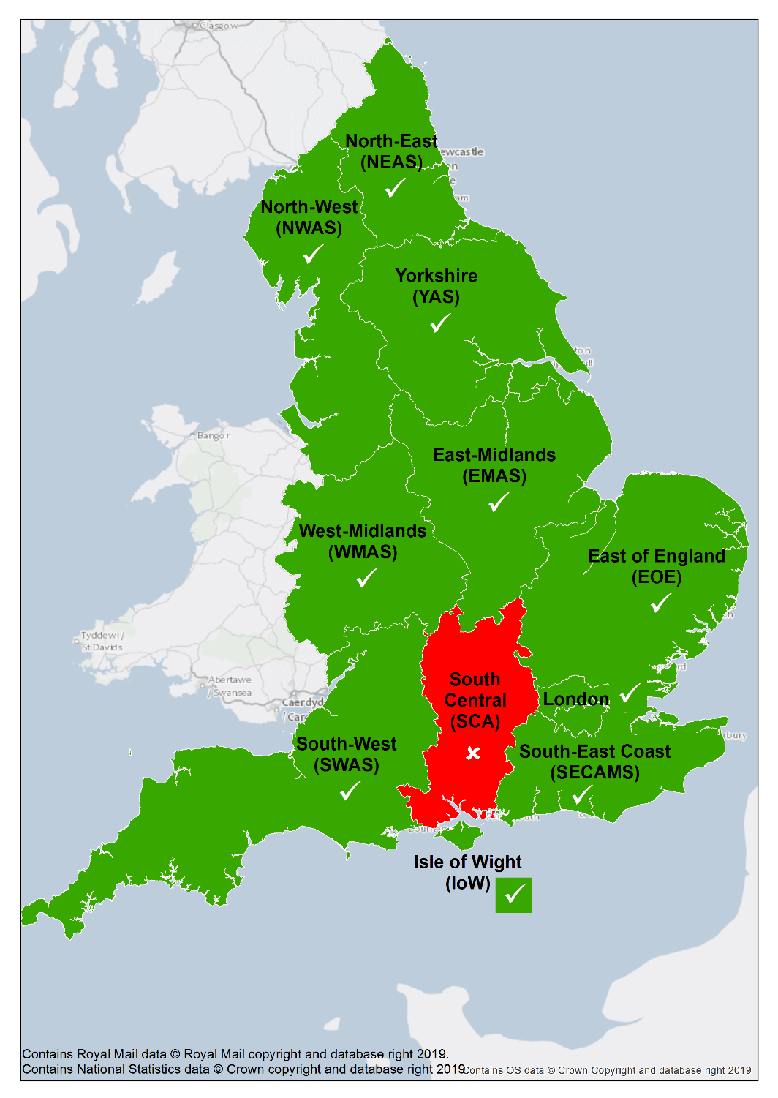
Table S1.1 Characteristics of regional ambulance services and their participation status
Service | Population covered ª | Square miles covered ª | FTE qualified ambulance staff^{b} | Calls to which an emergency response was dispatched ^{c, d} | Proportion seen, but not conveyed to ED ^{d, e}
- London Ambulance Service NHS Trust | 8.8 million | 970 | 2,597 | 1,047,357 | 34.4
- North West Ambulance Service NHS Trust | 7.3 million | 8,900 | 2,852 | 878,352 | 30.9
- East of England Ambulance Service NHS Trust | 6.1 million | 12,000 | 1,688 | 697,901 | 41.6
- West Midlands Ambulance Service NHS Foundation Trust | 5.8 million | 8,000 | 2,201 | 838,069 | 37.3
- Yorkshire Ambulance Service NHS Trust | 5.1 million | 8,800 | 1,540 | 521,331 | 31.1
- East Midlands Ambulance Service NHS Trust | 5 million | 10,000 | 1,484 | 542,325 | 33.6
- South East Coast Ambulance Service NHS Foundation Trust | 4.8 million | 5,800 | 1,592 | 656,338 | 45.3
- North East Ambulance Service NHS Foundation Trust | 2.6 million | 5,300 | 642 | 297,826 | 32.5
- South Western Ambulance Service NHS Foundation Trust | 5.5 million | 14,800 | 1,875 | 599,189 | 52.4
- Isle of Wight NHS Trust | 140,000 | 147 | 60 | 19,683 | 51.8
Acceptance rate (10/11)= 90.9%  Summary for services participating (n=10) | M= 5.3 (IQR=4.3,6.4) | M= 8,400 (IQR=4218,10500) | M= 1,640 (IQR=1273,2300) | M= 627,763  (IQR=465454, 848139) | M= 36  (IQR=31.8, 47)
Summary of services not participating (1) | 4 million | 5,800 | 1,041 | 445,798 | 42.0
Notes: ª With the exception of the Isle of Wight, this information was from Lord Carter’s (2018) report ‘Operational productivity and performance in English NHS Ambulance Trusts: Unwarranted variations’ (https://www.england.nhs.uk/wp-content/uploads/2019/09/Operational_productivity_and_performance_NHS_Ambulance_Trusts_final.pdf). Data relating to the Isle of Wight was from the Isle of Wight’s (2015) NHS Clinical Commissioning Group. Annual Report and Accounts 2014–15 (http://www.isleofwightccg.nhs.uk/Downloads/Annual%20Report/FINAL%20IOW%20CCG%20annual%20report%202014-15.v6.pdf) and the Care Quality Commission’s (2014) report ‘Isle of Wight NHS Trust. Quality Report 2014 (http://www.cqc.org.uk/sites/default/files/new_reports/AAAA1882.pdf); ^{b} Information from NHS Digital’s (2015) report ‘NHS Workforce Statistics in England, Non-medical staff - 2004-2014, As at 30 September’ (http://digital.nhs.uk/catalogue/PUB16933/nhs-staf-2014-non-med-detl-tab). Note that qualified ambulance staff here includes paramedics, technicians, advanced practitioners and ambulance service managers but does not include ambulance trainees; ^{c} From NHS England (2015) report ‘Ambulance Quality Indicators. 2015’ (https://www.england.nhs.uk/statistics/statistical-work-areas/ambulance-quality-indicators/ambulance-quality-indicators-data-2014-15/); ^{d}Includes face-to-face responses as a result of ‘111’ calls. ^{e} Includes treatment at the scene or onward referral to an alternative care pathway and those with a patient journey to a destination other than ED; M, median; FTE, full-time equivalent; IQR, interquartile range.
Figure S1.2 Geographical location of regional neuroscience centres and neurology services and survey participation status
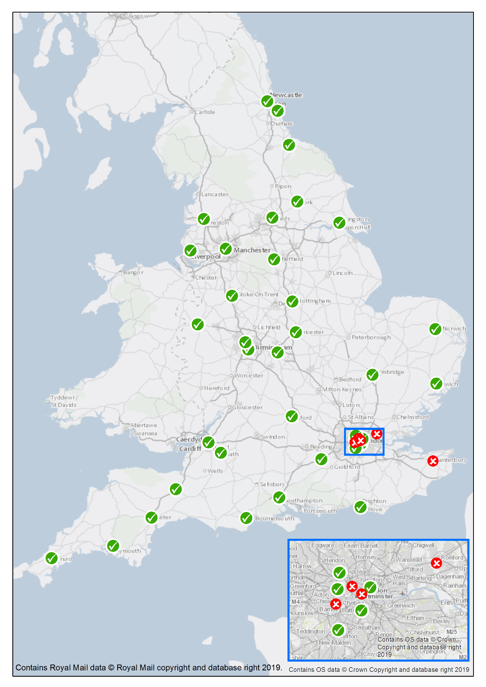

Table S1.2 Characteristics of regional neurosciences centres and neurology services and their participation status
Name of service | Region | Type | Trust’s workforce includes ª
 |  |  | ‘Adults’ neurologists | With epilepsy as a specialism | ‘Adults’ epilepsy specialist nurses
- Barts Health NHS Trust | London | Regional Neuroscience Centre | - | 3 | 1
- Imperial College Healthcare NHS Trust | London | Regional Neuroscience Centre | 44 | 4 | 1
- King's College Hospital NHS Foundation | London | Regional Neuroscience Centre | - | 5 | 2
- Royal Free London NHS Foundation Trust | London | Regional Neuroscience Centre | - | 7 | 2
- St George's University Hospitals NHS Foundation Trust | London | Regional Neuroscience Centre | 19 | 5 | 1
- Cambridge University Hospitals NHS Foundation Trust | Midlands and East | Regional Neuroscience Centre | 8 | 2 | 1
- East Suffolk and North Essex NHS Foundation Trust | Midlands and East | Neurology centre | 5 | 1 | 3
- Norfolk and Norwich University Hospitals NHS Foundation Trust | Midlands and East | Neurology centre | 10 | - | -
- Nottingham University Hospitals NHS Trust | Midlands and East | Regional Neuroscience Centre | 16 | - | -
- Sandwell and West Birmingham NHS Trust | Midlands and East | Neurology centre | 5 | 1 | -
- The Shrewsbury and Telford Hospital NHS Trust | Midlands and East | Neurology centre | 2 | 1 | 1
- University Hospitals Birmingham NHS Foundation Trust | Midlands and East | Regional Neuroscience Centre | 17 | 5 | 2
- University Hospitals of North Midlands NHS Trust | Midlands and East | Regional Neuroscience Centre | 12 | 2 | 4
- University Hospitals Coventry and Warwickshire NHS Trust | Midlands and East | Regional Neuroscience Centre | 8 | 2 | 1
- South Tyneside and Sunderland NHS Foundation Trust | North | Neurology centre | - | - | -
- Hull University Teaching Hospitals NHS Trust | North | Regional Neuroscience Centre | 7 | - | -
- Lancashire Teaching Hospitals NHS Foundation Trust | North | Regional Neuroscience Centre | 11 | 1 | 2
- The Leeds Teaching Hospitals NHS Trust | North | Regional Neuroscience Centre | 19 | 3 | 2
- Salford Royal NHS Foundation Trust | North | Regional Neuroscience Centre | 36 | 4 | 3
- Sheffield Teaching Hospitals NHS Foundation Trust | North | Regional Neuroscience Centre | 28 | 5 | 10
- South Tees Hospitals NHS Foundation Trust | North | Regional Neuroscience Centre | 9 | 2 | 1
- The Newcastle upon Tyne Hospitals NHS Foundation Trust | North | Regional Neuroscience Centre | 12 | 2 | 2
- The Walton Centre NHS Foundation Trust | North | Regional Neuroscience Centre | 36 | 10 | 3
- York Teaching Hospital NHS Foundation Trust | North | Neurology centre | 9 | - | -
- Brighton and Sussex University Hospitals NHS Trust | South East | Regional Neuroscience Centre | 2 | 3 | 0
- Oxford University Hospitals NHS Foundation Trust | South East | Regional Neuroscience Centre | 43 | 3 | 2
- University Hospital Southampton NHS Foundation Trust | South East | Regional Neuroscience Centre | 24 | 5 | 3
- North Bristol NHS Trust | South West | Regional Neuroscience Centre | 24 | 3 | 2
- Royal Cornwall Hospitals NHS Trust | South West | Neurology centre | - | 3 | 2
- Royal United Hospitals Bath NHS Foundation Trust | South West | Neurology centre | 3 | 1 | 1
- Frimley Health NHS Foundation Trust | South-East | Neurology centre | 5 | 3 | 2
- University Hospitals Plymouth NHS Trust | South-West | Regional Neuroscience Centre | 10 | 1 | 2
- Poole Hospital NHS Foundation Trust | South-West | Neurology centre | 6 | 1 | 2
- Royal Devon and Exeter NHS Foundation Trust * | South-West | Neurology centre | 7 | - | -
- Taunton and Somerset NHS Foundation Trust | South-West | Neurology centre | 4 | 1 | 1
Acceptance rate (35/41) 87.8%)  Summary for services participating (n=35) |  | Regional Neuroscience Centre=23;  Neurology centres=12 | M= 10  (IQR=6, 19) | M= 3  (IQR=1, 4.25) | M= 2  (IQR= 1, 2)
Summary for services not participating (n=6) |  | Regional Neuroscience Centre=2;  Neurology centres=4 | M= 13.5 (IQR=6.25, 22.5) | . | .
Notes: ªData from a 2017 Freedom of Information request to hospital Trust’s carried out and published by Epilepsy Action (https://www.epilepsy.org.uk/professional/epilepsy-data-visualisation/services-by-hospital-trust). If a Trust did not respond to the request or it was not possible to reconcile a Trust’s name with the results, then workforce data was sought from NHS Choices (https://www.nhs.uk/service-search). In some instances it could not be obtained, indicated by a “-“. A consultant with epilepsy as a specialism was defined as someone with demonstrable training and continuing education in epilepsy, peer review of practice and regular audit of diagnosis. Epilepsy must have been a significant part of their clinical workload (equivalent to at least one session a week). “.”=Not calculable due to data not being available; M, median; IQR, interquartile range.

Figure S1.3 Geographical location of emergency departments and their participation status
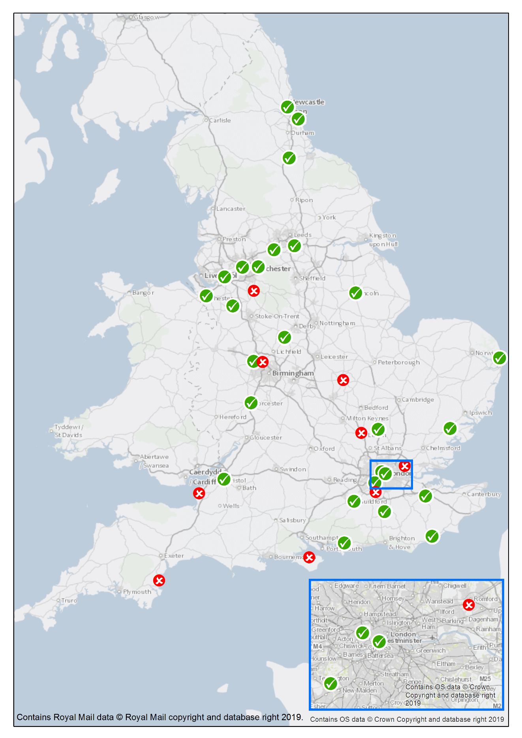

Table S1.3 Characteristics of emergency departments that did and did not participate in survey ª
Provider | Region | Number of ‘Type 1’ EDs within Trust ^{b} | Attendances 2017/18 |  |  | Consultants FTE |  | Doctors FTE ^{d} |  | Nurses FTE
 |  |  | Number |  | Quartile ^{c}
- Burton Hospitals NHS Foundation Trust | London | 2 | 128,520 |  | 3 | - |  | 12 |  | 79
- Guy's and St Thomas' NHS Foundation Trust | London | 1 | 181,325 |  | 4 | 25 |  | 74 |  | 177
- Imperial College Healthcare NHS Trust | London | 2 | 240,565 |  | 4 | 26 |  | 71 |  | 165
- Kingston Hospital NHS Foundation Trust | London | 1 | 118,080 |  | 2 | 11 |  | 22 |  | 77
- Colchester Hospital University NHS Foundation Trust | Midlands and East | 2 | 92,200 |  | 2 | 13 |  | 28 |  | 119
- East and North Hertfordshire NHS Trust | Midlands and East | 1 | 140,145 |  | 3 | 8 |  | 32 |  | 133
- James Paget University Hospitals NHS Foundation Trust | Midlands and East | 1 | 77,675 |  | 1 | 7 |  | 13 |  | 55
- The Royal Wolverhampton NHS Trust | Midlands and East | 1 | 181,775 |  | 4 | 19 |  | 35 |  | 95
- United Lincolnshire Hospitals NHS Trust | Midlands and East | 2 | 148,540 |  | 3 | 14 |  | 36 |  | 181
- Worcestershire Acute Hospitals NHS Trust | Midlands and East | 2 | 188,545 |  | 4 | 9 |  | 27 |  | 129
- Calderdale and Huddersfield NHS Foundation Trust | North | 2 | 148,445 |  | 3 | 10 |  | 23 |  | 106
- City Hospitals Sunderland NHS Foundation Trust | North | 1 | 159,420 |  | 3 | 10 |  | 26 |  | 117
- Countess of Chester Hospital NHS Foundation Trust | North | 1 | 82,785 |  | 1 | 7 |  | 23 |  | 69
- County Durham and Darlington NHS Foundation Trust | North | 2 | 210,460 |  | 4 | 11 |  | 37 |  | 108
- Mid Cheshire Hospitals NHS Foundation Trust | North | 1 | 89,300 |  | 2 | 8 |  | 13 |  | 97
- Mid Yorkshire Hospitals NHS Trust | North | 2 | 245,840 |  | 4 | 18 |  | 43 |  | 131
- Northumbria Healthcare NHS Foundation Trust | North | 1 | 194,495 |  | 4 | 24 |  | 57 |  | 84
- Salford Royal NHS Foundation Trust | North | 1 | 100,470 |  | 2 | 36 |  | 21 |  | 212
- Tameside and Glossop Integrated Care NHS Foundation Trust | North | 1 | 87,715 |  | 1 | 10 |  | 15 |  | 70
- Warrington and Halton Hospitals NHS Foundation Trust | North | 1 | 113,645 |  | 2 | 7 |  | 22 |  | 95
- East Sussex Healthcare NHS Trust | South | 2 | 119,400 |  | 3 | 8 |  | 36 |  | 94
- Maidstone and Tunbridge Wells NHS Trust | South | 2 | 174,060 |  | 4 | 13 |  | 41 |  | 135
- Royal Surrey County Hospital NHS Foundation Trust | South | 1 | 70,970 |  | 1 | 11 |  | 14 |  | 85
- Surrey and Sussex Healthcare NHS Trust | South | 1 | 98,840 |  | 2 | 9 |  | 39 |  | 82
- University Hospitals Bristol NHS Foundation Trust | South | 1 | 135,305 |  | 3 | 21 |  | 32 |  | 135
- Western Sussex Hospitals NHS Foundation Trust | South | 2 | 139,490 |  | 3 | 16 |  | 16 |  | 110
Acceptance rate (26/35) 74.3%)  Summary for services participating (n=26) |  |  |  | M= 137,398  (IQR=97180, 181438) |  |  | M= 11  (IQR=8.5, 18.5)* |  | M= 27.5 (IQR=19.75, 37.5) |  | M= 107  (IQR=83.5, 133.5)
Summary for services not-participating, including those not invited (n=111) |  |  |  | M= 115, 665  (IQR=85,585, 156,420) |  |  | M= 10  (IQR=8, 17) |  | M= 28  (IQR=18.5, 38) |  | M= 86  (IQR=61, 118.5)
Notes: ªData based on NHS Digital (2018) Hospital Accident and Emergency Activity, 2017-18 (https://digital.nhs.uk/data-and-information/publications/statistical/hospital-accident--emergency-activity/2017-18; Data was available for 25/26 of the participating sites. Staff data was current as of March 2018; Please also note that some of the provider names have since changed; ^{b} ‘Type 1’ EDs are consultant led 24 hour services with full resuscitation facilities and designated accommodation for the reception of accident and emergency patients (https://www.datadictionary.nhs.uk/data_dictionary/attributes/a/acc/accident_and_emergency_department_type_de.asp); ^{c} Lower quartile equates to fewer attendances; ^{d} Excludes consultants; M, median; IQR, interquartile range.
.
Supplementary File 2

Table S2.1 Organisations reporting of implemented or planned service changes to how people with suspected seizures/epilepsy are cared for that could reduce clinically unnecessary and/or avoidable unplanned health service use

Service type | “Has your service (or any local service you may work with) made changes…?” |  |  |  | “Is your service (or any local service you may work with) considering or planning to implement any changes…?” |  |  |  | Did the service report an implemented and/or planned change? |  |  | Did the service report that usual practice included ≥1 of the noted service changes? ^{b} |  |  | Did the service report an implemented and/or planned change or usual practice as including ≥1 of the noted service changes?
 | N | Yes  (n, %) | No  (n, %) | Don’t know  (n, %) | N | Yes  (n, %) | No  (n, %) | Don’t know  (n, %) | N | Yes  (n, %) | No ª  (n, %) | N | Yes  (n, %) | No  (n, %) |  | N | Yes  (n, %) | No ª  (n, %)
Ambulance | 10 | 7 (70.0) | 3 (30.0) | - | 10 | 1 (10.0) | 5 (50.0) | 4 (40.0) | 10 | 7 (70.0) | 3 (30.0) | 3 | 2 (66.7) | 1 (33.3) |  | 10 | 9 (90.0) | 1 (10.0)
ED | 26 | 4 (15.4) | 16 (61.5) | 6 (23.1) | 26 | - | 13 (50.0) | 13 (50.0) | 26 | 4 (15.4) | 22 (84.6) | 22 | 7 (31.8) | 15 (68.2) |  | 26 | 11 (42.3) | 15 (57.7)
Neuro | 32 | 23 (71.9) | 6 (18.8) | 3 (9.4) | 32 | 20 (62.5) | 8 (25.0) | 4 (12.5) | 32 | 30 (93.8) | 2 (6.3) | 2 | - | 2 (100) |  | 32 | 30 (93.8) | 2 (6.3)
Total | 68 | 34 (50.0) | 25 (36.8) | 9 (13.2) | 68 | 21 (30.9) | 26 (38.2) | 21 (30.9) | 68 | 41 (60.3) | 27 (39.7) | 27 | 9 (33.3) | 18 (66.7) |  | 68 | 50 (73.5) | 18 (26.5)

Service type |  |  |  |  |  |  |  |  | Did service report that their usual practice included ≥1 of the noted service changes? ^{b} |  |  | Did the service report an implemented and/or planned change or usual practice as including ≥1 of the noted service changes?
 | N | Yes  (n, %) | No  (n, %) | Don’t know  (n, %) | N | Yes  (n, %) | No  (n, %) | Don’t know  (n, %) | N | Yes  (n, %) | No  (n, %) |  | N | Yes  (n, %) | No ª  (n, %)
Ambulance | 10 | 7 (70.0) | 3 (30.0) | - | 10 | 1 (10.0) | 5 (50.0) | 4 (40.0) | 3 | 2 (66.7) | 1 (33.3) |  | 10 | 9 (90.0) | 1 (10.0)
ED | 26 | 4 (15.4) | 16 (61.5) | 6 (23.1) | 26 | - | 13 (50.0) | 13 (50.0) | 22 | 7 (31.8) | 15 (68.2) |  | 26 | 11 (42.3) | 15 (57.7)
Neuro | 32 | 23 (71.9) | 6 (18.8) | 3 (9.4) | 32 | 20 (62.5) | 8 (25.0) | 4 (12.5) | 2 | - | 2 (100) |  | 32 | 30 (93.8) | 2 (6.3)
Total | 68 | 34 (50.0) | 25 (36.8) | 9 (13.2) | 68 | 21 (30.9) | 26 (38.2) | 21 (30.9) | 27 | 9 (33.3) | 18 (66.7) |  | 68 | 50 (73.5) | 18 (26.5)

Notes: ª ”No” and “Don’t’ know” responses collapsed to form one category here; ^{b} Question presented to those services that had not implemented any relevant changes and were not planning any; ED, emergency department; Neuro, regional neuroscience centre or neurology centre.

Supplementary File 3

Barriers to change
Free text responses were thematically analysed by using the same approach used for service change types. For the 18 services that had not implemented any change, were not planning any and for who usual practice did not already include an aspect that other organisation labelled innovative, the following barriers were reported: conflicting priorities and workload demands; workforce composition; and risk.
Conflicting priorities and workload demands
The majority of the respondents (n=13; 72.2%) asserted that due to workload and demands on their service, other areas of patient care were prioritised. For some, reducing emergency health service use for PWE was not a priority as they perceived the numbers of patients with established epilepsy attending ED to be “reasonably low compared to other presentations”. As one respondent said:
“[It’s] not a major issue for me [it’s] fairly rare to see [a] totally straightforward patient with known epilepsy come in just because fitted.” – Doctor, ED
Workforce composition
A minority of respondents (n=7; 38.9%) indicated that the service innovation they envisioned as being needed required additional workforce capacity, which was lacking and perceived to not be readily obtainable. These services all described themselves as being “stretched”. High staff turnover and difficulties getting staff to attend training were noted as compounding factors.
Risk
Four respondents (22.2%) expressed that the possible risks to patients resulting from change was a barrier. Respondents were here referring to possible protocols that could divert patients with established epilepsy who have an uncomplicated seizure away from ED. It was felt that a lack of evidence on their safety meant that the case for change was not convincing. As one respondent said:
“I don't know if there is evidence that can be used to advise ambulance services that there is a safe alternative to transfer to an ED - I can't think what that alternative would be... other than... remaining with the patient for an extended period.” – Doctor, ED

