The chemistry of porous organic molecular materials

Marc A. Little* and Andrew I. Cooper*

Dr. M. A. Little,¹ Prof. A. I. Cooper^{1,2}
¹ Chemistry Department and Materials Innovation Factory, University of Liverpool, Liverpool, L7 3NY, UK.
² Leverhulme Centre for Functional Materials Discovery, University of Liverpool, Liverpool, L7 3NY, UK.
E-mail: malittle@liverpool.ac.uk, aicooper@liverpool.ac.uk

Keywords: ((porous materials, crystal engineering, porous organic cages, hydrogen-bonded organic frameworks, molecular separations, crystal structure prediction))

Abstract
Porous organic molecular materials are a sub-class of porous solids that are defined by their modular, molecular structures and the absence of extended covalent or coordination bonding in the solid state. As a result, porous molecular materials are soluble and they can be processed into different forms, such as mixed matrix membranes. The structure of the porous modules can be fine-tuned for specific applications, such as gas isotope separations, and in some cases the solid-state properties of these materials can be defined by the structure of the porous molecule as viewed in isolation. In this Review, we focus on the design of porous organic molecular materials and how their properties can be tuned for specific applications by using crystal engineering techniques. We distinguish between strategies where porosity is defined largely by the molecule itself, for example in porous organic cages, and cases where porosity is generated by the solid-state crystalline assembly. We emphasize the importance of computational techniques in the de novo design of functional, porous organic molecular materials, and how molecular modelling has been applied to understand the properties of these materials.
Biographies
Marc Little received his Ph.D. from the University of Leeds in 2012 and is currently a Research Lead in Prof. Andrew Cooper’s Group at the University of Liverpool. His current research interests include the application of crystal engineering strategies and computational methods in the design and discovery of porous organic molecular crystal with tunable structures and properties, and the use of in situ X-ray diffraction techniques in the characterization of functional materials.

Andrew Cooper FRS is the Academic Director of the Materials Innovation Factory (MIF) and Director of the Leverhulme Centre for Functional Materials Design. His research interests include organic materials, supramolecular chemistry, energy materials, and autonomous robots for materials discovery. He has been awarded the Macro Group Young Researchers Award (2002), the RSC Award in Environmentally Friendly Polymers (2005), the McBain Medal (2007), the Corday-Morgan Prize (2009), the Macro Group Award (2010), the Tilden Prize (2014), and the Hughes Medal (2019).
1. Introduction
A defining characteristic of porous organic molecular materials is that their extended structure is generally prepared by processing the molecules after synthesis—typically by post-synthesis crystallization; this distinguishes these materials from extended frameworks, such metal-organic and covalent organic frameworks, where synthesis and crystallization constitute the same step. However, classical, permanent porosity in structures without extended bonding, such as molecular crystals,^{[1–9]} is still a rare property because of the strong preference for discrete molecules to pack closely in the solid state.^{[10]} IUPAC defines a porous solid as “a solid with pores, i.e. cavities, channels or interstices, which are deeper than they are wide”, and states that these pores could be “open” or “closed”.^{[11]} By these definitions, there is no formal requirement for a porous solid to have an interconnected pore structure. For many applications, however, such as gas separation with practicable diffusion kinetics, interconnected pores may be a prerequisite. For a molecular material to be meaningfully porous after activation—that is, after any processing solvent/s are removed—it must retain a pore structure that is permeable to gases or liquids.^{[1–9]} Most molecular solids that are designated as ‘porous’ have interconnected pore structures, although there are exceptions. For example, calixarene based molecular crystals^{[12,13]} and clathrates^{[14,15]} can absorb guests through cooperative diffusion mechanisms, even though these materials do not have obvious interconnected pore structures.
Porous molecular crystals are a subclass of porous molecular materials—which includes porous amorphous solids and ‘porous liquids’—and these crystalline materials are the focus of this review article. To achieve permanent porosity in molecular crystals, materials design approaches must be developed that not only consider the chemistry of the organic components but also—and often more importantly—the techniques for processing the materials after synthesis. This presents new opportunities in materials design, since the properties of porous molecular materials can be tuned by chemically modifying the precursors, or by influencing their solid-state packing. For example, mix-and-match strategies can be developed to modulate the properties of a molecular material.^{[16–21]} Also, organic molecules can be processed post-synthesis into different structures with contrasting properties.^{[22–29]} Guest responsive materials can also be designed to respond to external stimuli,^{[22,30–33]} and organic molecules can be processed into different materials forms, such as membrane supports for separations^{[34]} or for sensing applications.^{[35,36]} While these strategies are not necessarily all unique to porous molecular crystals, we focus in this review on how the functional properties of porous organic molecular materials can be functionalized using traditional solution-based organic synthesis approaches, which generally speaking cannot be applied in the same way to extended framework materials.
Porous materials are important in chemical processes such as storage, catalysis, and molecular separations.^{[37]} Porous zeolites dominate the global market share for these applications and are produced on an industrial scale. However, zeolites suffer from some constraints; for example, they are typically hydrophilic, and adsorb water very strongly, and they are often unstable in either acids and/or bases. There has been a significant drive to discover new types of functional porous materials in recent years,^{[37]} with an focus on achieving designable pore structures, new chemical functionalities, and differentiating electronic properties.^{[1,4,6–8,38–40]} There has also been strong interest in discovering new types of porous materials with flexible and adaptive pore structures. For example, Kitagawa et al., showed that soft porous crystals of metal-organic coordination polymers can adopt their structures to accommodate and organize guest molecules in their pores,^{[41]} and the so called ‘3rd generation’ soft porous crystals^{[42]} have an array of potential applications, including hysteretic behavior for storage/release, cooperative motion to control the guest mobility and diffusivity or electronic properties, and morphological control of crystals.^{[42]} The inherently soft porous nature of many molecular materials, coupled with their unique solution processability, means that porous molecular solids should have a bright future in these areas, too.
Designing crystalline organic molecular solids to have specific structures is difficult because the crystallization of molecules does not follow simple empirical rules. Hence, it remains challenging to achieve the goal of “engineering crystals by the strategy of molecular tectonics”.^{[2]} As a result, chemical functionality in crystalline molecular solids often cannot be changed without affecting the extended crystal packing. By contrast, other examples of porous materials, including zeolites,^{[43]} metal-organic frameworks (MOFs),^{[44–47]} covalent-organic frameworks (COFs),^{[48–50]} and organic polymers^{[37,51]} are chemically bound through strongly directional covalent or coordinative bonds. This bonding dominates the lattice energy, and hence it is possible to generate families of isostructural materials with difference chemical functionality – for example, series of isoreticular MOFs.^{[46,52]} For extended frameworks, these directional bonds are formed during the framework synthesis, and this directs the inefficient packing of the building blocks to generate open, porous structures in a single step. By contrast, for molecular solids, the synthesis and subsequent crystallization constitute separate steps. Hence, the reticular chemistry concepts developed for MOFs and COFs,^{[46,48,52–55]} are not directly transferrable to organic molecular materials, and somewhat different strategies must be adopted.

1.1. Defining Porosity in Molecular Solids
1.1.1. Intrinsic Porosity
An intrinsic pore in a molecular material is defined as a guest-accessible cavity defined by covalent bonds that is prefabricated during synthesis.^{[6,8]} Discrete organic molecules that have been shown to adsorb guests in their intrinsic, guest-accessible, cavities in the solid state include calix[n]arenes,^{[12,13]} porous organic cages (POCs),^{[56]} hemicarcerands,^{[57]} cryptophanes,^{[58]} amine macrocycles,^{[59]} urea macrocycles,^{[60]} pillar[n]arenes,^{[61]} cucurbit[6]urils,^{[62]} and Noria^{[63]} (Figure 1). Intrinsically porous molecules with open, bowl- or ring-shaped cavities, such as calix[n]arenes, pillar[n]arenes and cucurbit[n]urils, often have a window, or opening, that is as wide as the intrinsic cavity. Thus, guest adsorption is dependent on the size and chemistry of the intrinsic cavity, and how these cavities are arranged in the solid state. By contrast, for intrinsically porous molecules with cage-like structures, such as POCs and cryptophanes, the windows in the molecular structure are often narrower than the intrinsic cavity size, and these windows regulate the diffusion of guest molecules into the intrinsic cavity in both liquids and in the solid-state. This is an important distinction and synthesizing intrinsically porous molecules with windows can advantageous for controlling guest diffusion. For example, intrinsically porous molecules that are soluble in solvents that are too large fit through cage windows were used to prepare liquids with permanently porous cavities; that is, ‘porous liquids’.^{[64]} Porous liquids,^{[64,65]} and other types of intrinsically porous molecules, which have interesting solution based host-guest behavior, including metal-organic polyhedra,^{[66–71]} and cryptands,^{[72]} are not discussed in this review. Instead, we focus on intrinsically porous organic molecules that have been processed into permanently porous solids.^{[6,8]}
Despite their permanent porosity, intrinsically porous molecules with well-defined cavities can crystallize as formally non-porous solids,^{[22]} highlighting the important link between extended structure and porosity in molecular materials. Solids with ‘closed porosity’, typically referred to as zero-dimensional (0-D) porous solids,^{[1]} have sometimes been shown to adsorb guest molecules through cooperative diffusion mechanisms. For example, close packed crystal structures of rigid, intrinsically porous, calix[n]arenes^{[12,13,73–78]} and cryptophanes^{[58]} can adsorb liquids and gases in the solid state, and confine the mobility of these guests, including a 0-D cryptophane that trapped Xe in its porous host structure until about 400 °C.^{[58]} Pillar[n]arene’s have been shown to adapt their non-porous crystal structures through guest-induced solid state structural rearrangements to selectively adsorb guests in the solid state.^{[79]} However, diffusion mechanisms in 0-D solids and adaptive molecular structures are difficult to predict a priori, and such materials are not discussed in detail in this review. By contrast, porosity in molecular crystals with open pore structures can be regarded as a more predictable property descriptor for material design, and this has enabled chemists to accurately predict structures and properties from first principles,^{[26,80]} although assumptions of perfect crystallinity do not always hold, and this can affect the precision to which we can design these properties.^{[17,81]} In this regard, the ability to separate synthesis from crystallization is an advantage since we can use conventional crystal growth techniques, such as slow cooling or solvent evaporation, to grow large, high-quality crystals that do have porous properties that are close to those predicted from first principles.^{[17]}
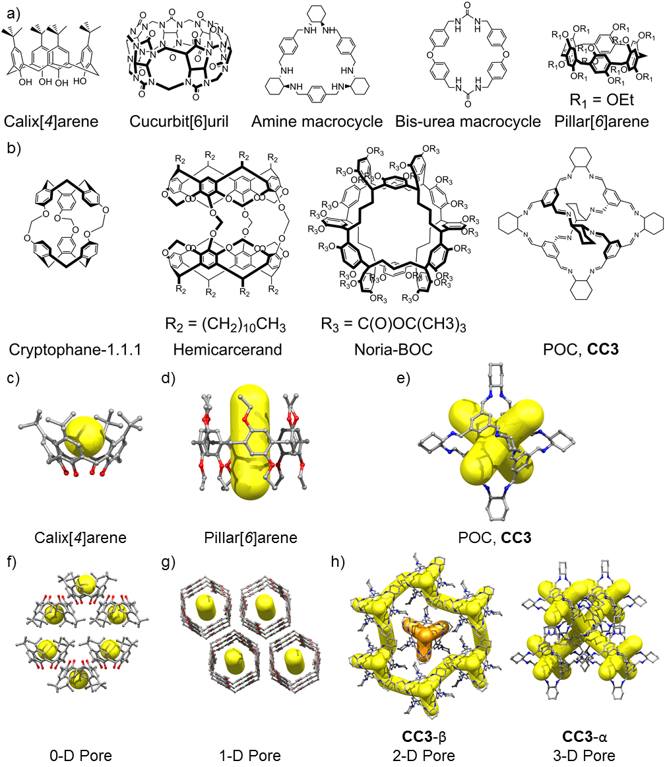

Figure 1. Molecular structures of some organic compounds with (a) open, and (b) closed intrinsic pores that have been reported to adsorb guests in their intrinsic cavities during solid-state sorption experiments.^{[12,13,56–63]} c,d,e) Different intrinsic pores in organic molecules can be used to modulate the porosity in organic crystals; including, e) 0-D pores for calix[4]arene,^{[12,13]} f) 1-D pores for pillar[6]arene,^{[82]} and g) either 2-D or 3-D pores for the POC, CC3^{[25,56]}, depending on the crystallization conditions.

1.1.2. Extrinsic Porosity
The inefficient packing of molecules in solids can create voids or channels. Molecules tend to prefer to close pack to maximize attractive intermolecular interactions,^{[10]} and hence designing molecules that pack inefficiently in solids is a challenge in materials design. Often, solvent can be used to direct frustrated packings of organic molecules, but the solvent-filled pores in these structures must be retained after crystal activation for these materials to be categorized as extrinsically porous.^{[1–4,9]} Importantly, this definition excludes solids with solvent-filled voids, sometimes referred to crystals with ‘virtual porosity’.^{[1]} Because of this, extrinsically porous solids must be characterized using sorption experiments to demonstrate actual porosity.^{[1–4,9]} By using a combination of intermolecular interactions, such as van der Waals forces and electrostatic hydrogen-bonding interactions, coupled with the design of molecules with rigid or awkward shapes, it has proved possible to direct molecules to crystallize in energetically preferred, low-density forms.^{[1–4,9,83]} However, the soft, flexible, and non-covalent nature of molecular materials means that their structures can often transform or collapse after crystal activation.^{[1–4,9]} In 1976, Barrer and Shanson^{[84]} reported that the organic molecule, Dianin’s compound, which forms organic inclusion complexes,^{[85]} behaved like an ‘organic zeolite’ after activated crystals were exposed to different gases.^{[84]} Barrer and Shanson inferred that the gas adsorption properties they observed were attributed to the porous, crystalline lattice of Dianin’s compound, and subsequent studies rationalized this hypothesis.^{[86–89]} Another archetypal extrinsically porous solid was prepared by crystallizing tris(o-phenylenedioxy)phosphonitrile trimer (TPP) from benzene to form a 1-D channel-like structure^{[90]} that was retained after activation of the pores.^{[91]} The sorption properties of TPP have been studied in detail,^{[91–93]} and the 1-D pores can even adsorb molecular motors.^{[94]} Other early examples of organic-based, extrinsically porous solids, include; 9-(3,5-dihydroxy-1-phenyl)acridine,^{[95]} dipeptide crystals,^{[96]} 4,4',4'',4'''-tetra(4,6-diamino-s-triazin-2-yl)tetraphenylmethane (HOF-1),^{[97,98]} 3,3',4,4'-tetra(trimethylsilylethynyl)biphenyl,^{[99]} phthalocyanine complexes,^{[100]} and 9,10-bis(4-((3,5-dicyano-2,6-dipyridyl)dihydropyridyl)phenylï)anthracene (SOF-1)^{[101]} (Figure 2). A characteristic of these early discoveries is that the molecular structures of the discrete units are all unique, and their crystal structures are not dominated by a single, strongly directional intermolecular interaction. Diamino triazine units were used by Wuest to construct a stable hydrogen-bonded-organic framework (HOF),^{[97]} later referred to as HOF-1 by Chen et al.,^{[98]} and this concept has been extended to a series of rigid, organic scaffolds to prepare open hydrogen bonded structures.^{[83,102–116]} However, even for these directional diamino triazine based HOF structures, it has not been possible to develop reticular chemistry concepts that are comparable to those developed in MOF and COF syntheses.^{[46,48,52–55]} This creates a fundamental materials design challenge, since it is not in general possible to functionalize a porous organic molecular material without, probably, making a significant change to the crystal packing and hence the porous properties.

Figure 2. (a) Molecular structure of compounds used to form extrinsically porous crystals, through the formation of energetically-stable, low-density crystal forms. ^{[84,91,97–99,101]}

2. Applications of Porous Organic Molecular Crystals
Intrinsic versus extrinsic porosity is merely a categorization: from an applications standpoint, it is the performance, cost, and (perhaps) processability of the material that matters.^{[37]} Porous molecular crystals have not yet reached the remarkable surface areas achieved for MOFs and COFs,^{[46,117–120]} and they are perhaps unlikely to match the largest pore apertures (9.8 nm)^{[121]} or pore volumes (5.02 cm³ g⁻¹)^{[120]} reported for such frameworks—or at least, one might expect such materials, if isolable at all, to be fantastically unstable. However, recent studies have revealed that molecular materials can achieve surface areas in excess of 3,700 m² g⁻¹,^{[122]} and have stable bulk densities as low as 0.417 g cm⁻³.^{[26]} Such high surface areas in molecular solids are remarkable, considering that their structures are held together by non-covalent interactions.^{[26,122]} As discussed below, however, high surface areas are not required for all applications and for some molecular separations, very small pores are required.^{[21]} Indeed, nitrogen adsorption is rarely the target application. More commonly, adsorption of greenhouse gases, toxic pollutants, or the molecular separation of industrial feedstocks are the relevant applications of porous solids, and hence surface areas, per se, are of only limited value in evaluating a material.^{[123]} Properties such as pore shape and dimensionality, adsorbate site chemistry and functionality, molecular flexibility, and guest responsiveness are all relevant here, and porous molecular solids could find unique advantages in this regard.
2.1 Selective Adsorbents
In 2009, our group reported a shape persistent POC, CC3 (Figure 1), that has four triangular shaped windows, packed to form a microporous solid with a 3-D pore structure.^{[56]} The CC3 molecules are packed window-to-window, and this is the preferred packing motif. The tetrahedral arrangement of the four CC3 cage windows directs the formation of a diamondoid pore network in the crystalline, CC3-α material (Figure 1h). Even though the CC3 molecules are densely packed in CC3-α, and the crystal packing in CC3-α is predicted to be the most energetically stable polymorph,^{[16]} the structure is porous because of the intrinsic porosity in the cage. Because there is no denser stable form, CC3-α has excellent stability.^{[124]}
CC3-α has two adsorption sites: the intrinsic cage cavity pore and the interstitial pore between two cage windows (Figure 3a). For adsorbed guests to reach these sites in CC3-α, they must pass through the narrowest point in the pore network, which is the triangular shaped CC3 windows (Figure 3a). These CC3 windows are somewhat dynamic in nature, which allows the CC3 windows to open and close during guest adsorption. Consequently, guests can diffuse through the CC3-α structure, even though they have dynamic radii that are larger than the size of the static CC3 window (Figure 3b). Accounting for this dynamic behavior, grand-canonical Monte Carlo (GCMC) simulations could accurately simulate gas adsorption isotherms for CC3-α (Figure 3c), and ultimately predict a strong preference for Xe and Rn adsorption over other gases, with heats of adsorption (Q_{st}) at zero-coverage for these gases calculated to be −31.3 kJ mol⁻¹ and −38.4 kJ mol⁻¹, respectively.^{[125]} The strong preference for these gases can be rationalized by Xe-loaded crystal structure of CC3-α, which showed Xe molecules located in the intrinsic and interstitial cavities, reflecting the behavior seen in snapshots from molecular dynamics simulations. By contrast, the Q_{st} value for Kr in CC3-α was −23.1 kJ mol⁻¹ and the other main constituents of air (He, H₂, H₂O, O₂, Ar, CH₄, CO₂) had Q_{st} values in the range −4.5 to −27.7 kJ mol⁻¹. Hence, CC3-α was predicted to be selectively porous to Xe and Rn over these other common gases. This was confirmed by competitive gas breakthrough experiments using an adsorption column packed with CC3-α and a gas mixture of Xe (400 ppm) and Kr (40 ppm) balanced with the common components of air (N₂, O₂, and CO₂). CC3-α also adsorbed ²²²Rn from the gas phase, and was shown to concentrate Rn in the solid state.^{[125]} This study highlights the importance of pore structure and pore chemistry on gas selectivity in molecular materials, and as well as the use of GCMC simulations and in situ diffraction techniques to gain fundamental mechanistic understanding of selective adsorption processes in porous molecular crystals.
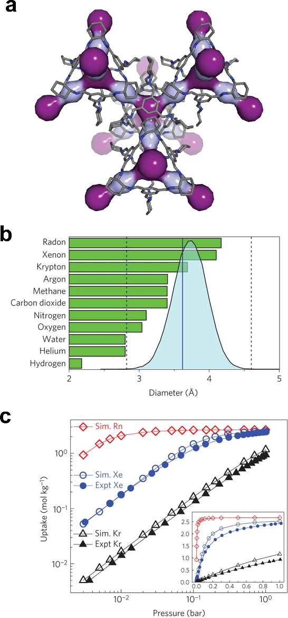
Figure 3. a) Two pore cavities exist in the 3D pore structure of CC3α: a cage cavity inside the molecule itself (dark purple) and a window cavity between adjacent cage windows (light purple). b) Molecular dynamics simulations (298 K, 1 atm) show a pore-limiting envelope (colored blue) in CC3α that encompasses the diameters of all rare gases, up to radon. The straight, vertical line corresponds to the pore-limiting diameter from the static CC3α structure. c) Predicted single-component log–log gas adsorption isotherms (Kr, Xe and Rn; open symbols) and experimental equivalents (Kr, Xe; filled symbols) at 298 K for CC3 (inset shows linear–linear plot). Simulated isotherms were obtained from grand-canonical Monte Carlo (GCMC) simulations. Reproduced with permission.^{[125]} Copyright 2014, Nature Publishing Group.

Porous molecular solids have been shown capture harmful or toxic and pollutants, and the ability to tune the molecular structure of the building blocks is useful for facilitating selective adsorption processes. Miljanić et al. reported an open porous frameworks material, that was prepared by crystallizing a fluorinated trispyrazole.^{[126]} The thermally stable structure is held together by N–H···N hydrogen bonds between pyrazole groups (Figure 4a), and π···π stacking between electron-poor tetrafluorobenzenes and electron-rich pyrazoles (Figure 4b). Interestingly, the open framework structure with fluorene-lined channels was reported to have an accessible surface area of 1,159 m² g⁻¹ and adsorbed up to 74 wt. % of harmful fluorocarbons and CFCs,^{[126]} and this materials exhibits an absorbate induced piezochromic response.^{[127]} Subsequently, this N–H···N hydrogen-bonding motif between pyrazole groups was used to prepare a series of porous HOFs, highlighting that this chemistry is a versatile route to new HOF materials.^{[128]} A series of imine-based POC materials were reported by our group to adsorb SF₆, with the CC3-α materials shown to selectively adsorb SF₆ over N₂ during competitive gas breakthrough experiments.^{[129]} Iodine adsorption was also reported, both for the imine-based POC, CC3-α^{[130]} and a per-ethylated pillar[6]arene.^{[131]} These applications highlight a wider potential for porous molecular solids to the capture harmful or useful gases and chemicals.
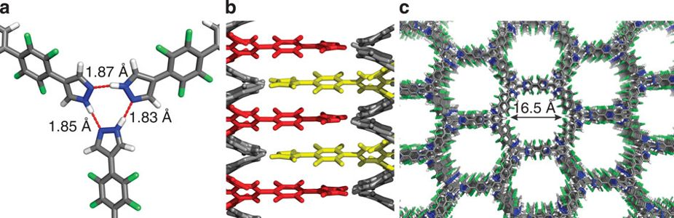
Figure 4. (a) Hydrogen bonding between pyrazoles units, and (b) π···π stacking interactions between electron-rich pyrazoles and electron-poor tetrafluorobenzene rings in the open framework structure with fluorene-lined channels reported by Miljanic et al. (c). Reproduced with permission.^{[126]} Copyright 2014, Nature Publishing Group.

2.1.1. Carbon Dioxide Capture
CO₂ is a major contributor to global warming and higher atmospheric concentration of CO₂ have been attributed to ocean acidification.^{[132]} Low energy extraction of CO₂ impurities from industrial feedstock—for example, during CH₄ sweetening—is an important industrial process, and selectively porous solids molecular solids could be used to reduce the current energy cost of this process.
In 2005, Sozanni et al. reported that TPP was selectivity porous to CO₂ over N₂, O₂, and H₂, based on single point isotherms.^{[133]} In this study, the authors attributed this to CO₂ molecules interacting more strongly with the aromatic pore walls in the TPP structure, and a series of NMR experiments was performed to quantify this.^{[133]} Indeed, related NMR experiments showed that the free rotation of molecular rotors in porous crystal structures can be regulated by adsorbing CO₂ in their pores due to interactions between the aromatic units in the pore wall and adsorbed CO₂ molecules.^{[134]}
Schröder and colleagues reported a series of permanently porous open framework materials, including SOF-1,^{[101]} SOF-7,^{[135]} SOF-9^{[136]} and SOF-10,^{[136]} which all exhibit selective gas adsorption of CO₂ over N₂ and CH₄. Of these, SOF-7 (Figure 5), was reported to have the highest uptake of CO₂ at 20 bar and 273 K, adsorbing 31.09 wt% (7.07 mmol g^{–1}).^{[135]} SOF-7 has a BET surface area = 900 m² g⁻¹, whereas SOF-10 has a surface areas over four times lower (SA_{BET} = 221 m² g⁻¹), but still adsorbed 22.49 wt% of CO₂ (5.11 mmol g–1), under the same conditions. At 1 bar and 298 K, the CO₂ uptake for SOF-7 was 1.49 mmol g⁻¹, and to determine how the CO₂ molecules interact with the porous host structure, GCMC simulations and DFT calculation were performed. These simulations revealed that the CO₂ molecules strongly interacted with the amide groups in the SOF-7, rationalizing the high CO2 uptake.^{[135]} HOF-8, that likewise has amide group in the porous host structure, was reported to have a high CO₂ uptake (2.55 mmol g⁻¹) 1 bar and 298 K,^{[137]} and dipeptide cocrystals have been reported to have high CO₂ uptakes. For example, a L-alanyl-L-valine crystal with a 1-D pore structure adsorbs 15 wt% (4.1 mmol g⁻¹) of CO₂ at 1 bar and 298 K.^{[138]} While these reports are encouraging, it is not clear that porous molecular solids have a specific benefit over MOFs for this application.^{[139]}

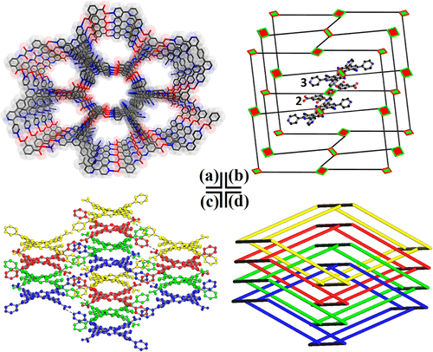
Figure 5. a) X-ray crystal structure of SOF-7. b, d) The HOF has a cds topology, and d) four of these networks are interpenetrated in the structure of this material. Reproduced under the terms of the CC-BY license.^{[135]} Copyright 2014, American Chemical Society.

A different approach to increase CO₂ adsorption in a porous molecular solid is to design a molecule with predefined intrinsic cavity that binds CO₂. Thallapally et al. reported that a porous crystalline p-tert-butylcalix[4]dihydroquinone crystal adsorbed 6.9 wt% of CO₂ at 298 K, and this study was an important development in this area.^{[140]} Atwood et al. reported a structurally related C-pentylpyrogallol[4]arene selectively adsorbed 3 wt% CO₂ at ambient temperature and pressure.^{[141]} Mastalerz et al. reported a CO₂/CH₄ selective [4+6] salicylbisimine POC,^{[142]} that was prepared by reacting triptycene-based triamine and salicylic dialdehyde.^{[143]} The porous salicylbisimine POC material has a SA_{BET} = 1375 m² g⁻¹ and was prepared by activating a crystalline DMSO solvate at 200 °C under dynamic vacuum.^{[142]} After activation, the salicylbisimine POC adsorbed 2.1 mmol g⁻¹ of CO₂ at 1 bar and 273 K. By comparison, the salicylbisimine POC only adsorbed 0.61 mmol g⁻¹ of CH₄, at 1 bar and 273 K, and selective gas adsorption of CO₂ was attributed to the presence of polar hydroxy groups in the intrinsic cage cavities.^{[142]} Other CO₂ selective POC materials have been reported, including a series of [2+3] amine functionalized organic cages reported by Zhang, which had ideal adsorption CO₂/N₂ selectivity values up to 138/1,^{[144,145]} although these Zhang cages have lower CO₂ adsorption capacities than the Mastalerz cage.^{[142]} CO₂/N₂ selectivity has been reported in a flexible propeller shaped [2+3] imine cage,^{[146]} a porphyrin based imine cage,^{[147]} a triazine-based imine cage,^{[148]} a cube-shaped POC prepared with tris-salicylaldehyde precursors,^{[149]} cryptand-like [2+3] imine cages with pyrrolic units,^{[150]} and a pyrrole-based imine cage.^{[151]} The cube shaped POC reported Mastalerz et al. adsorbed 18.2 wt% of CO₂ at 273 K and 1 bar, and this is among the highest reported CO₂ uptakes for a molecular material.^{[149]} POCs with open pore structures have also been used to develop in situ ATR-FTIR spectroscopic methods to study high pressure CO₂ adsorption;^{[152]} in combination with molecular simulations, this can give valuable insight about CO₂ absorption in organic materials. In addition to POCs, cucurbit[n]uril’s (CB[n]) have been studied for selective CO₂ adsorption. Atwood et al. showed that an amorphous solid of cucurbit[7]uril (CB[7]) exhibited a high uptake of CO₂ at 298 K and 0.1 bar (1.1 mmol g⁻¹) and 1 bar (2.3 mmol g⁻¹), with excellent ideal selectivity for CO₂ over CH₄ and N₂, under comparable conditions.^{[153]} Even though the materials was amorphous, solid-state ¹³C NMR was used to determine that the CO₂ molecules were adsorbed in the intrinsic CB[7] cavities, with selectivity attributed to oxygen atoms of CB[7] facilitating in local-dipole/quadrupole interactions with CO₂. At saturation, the amorphous CB[7] materials adsorbed 5.3 mmol g⁻¹ of CO₂, indicating that ~2 CO₂ molecules, per CB[7], were also accommodate in the amorphous structure, as only four CO₂ can fit in the intrinsic CB[7] cavity. Other CB materials have been reported for selective CO₂ adsorption capture, ^{[154,155]} including a crystalline CB[6] material, that was reported by Thallapally to adsorb 15 wt% of CO₂ at 298 K and 1 bar, and this material selectively adsorbed CO₂ over N₂ during competitive gas breakthrough experiments after being processed into pellets.^{[154]}

2.2. Hydrocarbon Separations
Porous solids are a potential energy-efficient alternative for molecular separation processes such as distillation, which is commonly used to enrich industrial feedstocks and accounts for 10–15% of the world’s energy consumption.^{[156]} New porous solids, which perform separation processes more efficiently and with lower energy consumption costs, could reduce the environmental impact of the chemical processing industry. While there are existing technologies for many separations, including pressure and temperature swing adsorption,^{[157]} and amine scrubbing for CO₂ capture,^{[158]} these existing technologies are often associated with either poor selectivity, long-term stability issues, or energy regeneration costs that are still too high. Hence, new materials that feature high selectivity and low energy penalties for regeneration are crucial for improving the efficiency and sustainability of molecular separation processes. For example, selectively porous MOF materials have been studied extensively for pressure swing adsorption,^{[159]} and highly selective porous molecular materials, that are strongly selective while only weakly binding guests in their structures, could offer great potential for future molecular separation applications.
2.2.1. Gas separations
Alkyne/olefin separations are industrially important, not least because high purity ethylene and propylene feedstocks are required for polyethylene and polypropylene synthesis. Typically, C₂H₂/C₂H₄ and C₃H₆/C₃H₈ separations are performed using high-pressure cryogenic distillations that are energetically expensive.^{[160–162]} MOFs have led the way for these molecular separations,^{[163–166]} with small pore MOF tending to perform better from a selectivity perspective.^{[166]} Organic molecular materials might struggle to compete with the isosteric heats of adsorption reported for open metal site MOFs,^{[163]} but their pore structures and cavity chemistries can be tuned to provide selective adsorption sites for hydrocarbons such as acetylene, ethene, or propene. For example, the selective adsorption of acetylene over ethylene in a MOF structure reported by Eddaoudi et al.^{[165]} was related to hydrogen-bonding interactions between acetylene and strongly basic (SiF₆)²⁻ anions, in addition to secondary van der Waals interactions with the organic framework struts. A similar observation was reported by Cadiau et al. in their MOF material that selectively adsorbed propylene over propane.^{[165]} In both studies, the chemistry of the pores was more important than their surface areas, or the presence of open metal sites.
HOFs have been shown to have applications various gas hydrocarbon gas pair separations, typically based on single gas sorption isotherms, including, C₂H₂/C₂H₄,^{[98,167]} C₂H₄/C₂H₆,^{[107]} C₂H₄/CH₄,^{[111,168]} C₂H₂/CH₄, ^{[168]} C₂H₂/CO₂,^{[105]} C₂H₆/CH_{4,}^{[168]} CO₂/CH₄,^{[111][167]} CO₂/N₂,^{[104,111,112,116,156,167]} and C₄ hydrocarbons/CH₄.^{[169]} Chen et al. reported that HOF-1 (Figure 2) adsorbed more C₂H₂ than C₂H₄ at 273 and 296 K, and the C₂H₂/C₂H₄ Henry’s law selectivities for HOF-1 at these temperatures were 19.3 and 7.9, respectively.^{[98]} The higher predicted selectivity at 273 K can be rationalized by a gate opening transition that occurred at lower pressure in the 273 K C₂H₂ isotherm. By contrast, this gate opening behavior in HOF-1 was not observed in the C₂H₄ adsorption isotherm, resulting in a significantly lower uptake of C₂H₄ under comparable condition. The adsorption enthalpies at zero coverage for C₂H₂ and C₂H₄ in HOF-1 were 58.1 and 31.9 kJ mol^{–1}, respectively, and the stronger interactions between the acidic H-atoms of acetylene and the basic amine groups of HOF-1 are likely to account for this observation.^{[98]} In a different study, Chen et al. reported that a different HOF material, HOF-3, with the same diamino triazine groups was highly selective to C₂H₂/CO₂.^{[105]} HOF-3, unlike HOF-1, has a permanently open pore structure, and GCMC simulations were performed to rationalize this selectivity. These simulations revealed that HOF-3 adsorbs C₂H₂ and CO₂ adsorb in an orderly fashion in small cavities between two hydrogen bonded diamino trazine groups. While the static gas binding energies for C₂H₂ and CO₂ in HOF-3 were 20.9 kJ mol⁻¹ and 26.3 kJ mol⁻¹, respectively, localized ordering of CO₂, in an optimized binding position, was required to achieve the higher binding energy for CO₂. By contrast, two C₂H₂ molecules could interact simultaneously with the HOF-3 structure in the same binding site, rationalizing the observed gas selectivity for C₂H₂/CO₂ during competitive gas breakthrough measurements at 296 K. Kim et al. reported that CB[6] adsorbed 11 wt% (4.2 mol/mol) of acetylene at 100 kPa and 273 K, and this material retained 6.1 wt% of acetylene (2.4 mol/mol) at STP.^{[62]} In the acetylene-loaded crystal structure of CB[6], recorded at 90 K, there were 2 acetylene molecules located in extrinsic channels, with their acidic protons hydrogen-bonded to the C=O groups of CB[6]. By contrast, the intrinsic CB[6] cavity was either occupied with residual water H₂O or disordered acetylene guest.
HOF-TCBP (where, TCBP = 3,3’,5,5’-Tetrakis-(4-carboxyphenyl)-1,1’-biphenyl) was reported to have ideal adsorbed solution theory (IAST) selectivity’s of 147, 171, 188, 231, and 241, at 295 K and 1 bar, for 1:1 molar mixtures of the gas pairs, i-C₄H₁₀/CH₄, n-C₄H₁₀/CH₄, 1-C₄H₈/CH₄, (E)-2-C₄H₈/CH₄, and (_{Z})-2-C₄H₈/CH₄, respectively, with calculated isosteric heats of adsorption at zero coverage rationalizing these values.^{[169]} HOF materials have also been used for separating hydrocarbons during competitive breakthrough adsorption experiments, including HOF-4 for C₂H₄/C₂H₆ separations,^{[107]} and HOF-BTB for C₂H₄/CH₄ and C₂H₆/CH₄ separations.^{[168]} From an applications perspective, the removal of CO₂ impurities from contaminated C₂H₂ feedstocks is an important, industrially-relevant, separation, as the direct removal of CO₂ from C₂H₂ would be more energy effective than a two-step adsorption-release process.^{[170]} In general, porous solids that effectively perform CO₂/C₂H₂ separations are rare,^{[170–173]} but molecular materials that strongly interact with CO₂ might be developed to perform this separation more effectively in the future.^{[111,174,175]}
2.2.2. Aromatic Separations
Separating the xylene isomers is a key industrial process, because the current market demand does not meet the composition of xylenes produced by catalytic reforming of crude oil, toluene disproportionation, and the distillation of pyrolysis gasoline.^{[176]} In addition, a high purity feedstock, typically >99%, of para-xylene (pX) is required to synthesize terephthalic acid, that is subsequently consumed in production of polyethylene terephthalate.^{[177]} The C₈ xylene isomers, ortho-xylene (oX, 144.5 °C), meta-xylene (mX, 139.1 °C), pX (138.2 °C), and ethylbenzene (136 °C) have similar physical properties, and the current separations processes, which include complexation and fractional crystallization,^{[178]} are energetically expensive or inefficient. An attractive, energy efficient, alternative approach to purify the C₈ isomers to use porous materials with molecular shape-selective sorption properties.^{[179]}
Ward reported a series of hydrogen-bonded guanidinium and organodisulfonates salts, that selectively formed an inclusion complexes with the pX isomer.^{[180]} A guanidinium[2,6-naphthalenedisulfonate] salt was reported to exhibit high selectivity for pX, over oX (36:1) and mX (160:1). However, this selectivity stemmed from a solid-state recrystallisation processes, which required destruction of the porous host structure to recover the pX guest from the clathrate structure, rather than a conventional guest adsorption/desorption cycle. A perethylated pillar[6]arene was reported to adapt both its crystal structure and molecular conformer to selectively adsorb pX over oX and mX in the pillar[6]arene cavity,^{[61]} highlighting the strong influence that xylene adsorption can have on the structures molecular materials. In fact, adsorption induced structural transformations of the host pillar[6]arene material directed the selective adsorption properties observed for this material. Using a more conventional porous organic molecular solid, our group reported that the imine POC, CC3-α (Figure 1), sorts other organic molecules by size and shape.^{[181]} Selectivity is an intrinsic property of the POC material, with the CC3 cage windows regulating diffusion of guest through the crystal pores. Due to faster diffusion kinetics, CC3-α performed well for xylene separations, with MD simulations showing that the pore structure in this material, along with the molecular flexibility of the CC3 host, were essential for facilitating faster diffusion of pX through porous structure (Figure 6). CC3-α was also reported to have perfect selectivity for ethylbenzene over its structural isomer, mesitylene, in the solid state, and this experimental property was observed in MD simulations.^{[181]}
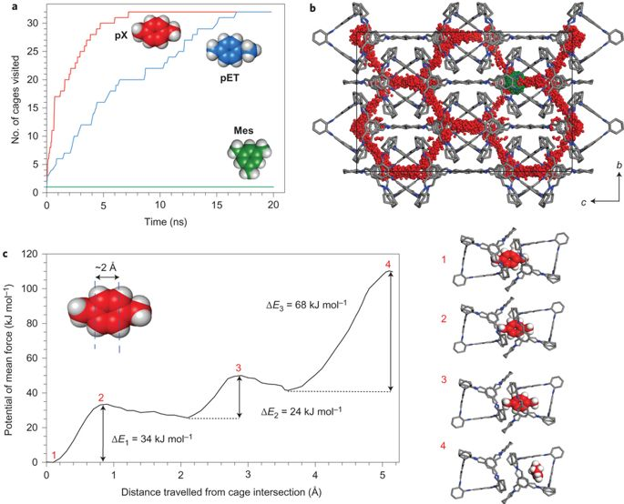
Figure 6. a) Cumulative number of cages visited over a 20 ns MD simulation for three sorbates: pX, 4-ethyltoluene and mesitylene, using a 32 CC3-α supercell. b) The centre of mass of pX (red) and mesitylene (Mes, green) positions sampled during the simulation are overlaid on the starting configuration for the guest-free CC3-α structure. c) Potential of mean force as a function of the linear distance travelled by a para-xylene through the CC3-α structure, along with representative snapshots from the MD simulation. Reproduced with permission.^{[181]} Copyright 2013, Nature Publishing Group.

3. Tuning the Properties of Porous Molecular Materials
The applications of porous molecular materials are dependent on the chemistry and molecular structure of the discrete building blocks, as well as their solid-state packing. Consequently, these two strategies can be used in concert to modify the properties of porous molecular materials. Perhaps two of the most transferrable strategies are; (i) synthesizing shape-persistent POCs with predefined intrinsic porosity^{[6,8,182,183]} in order to influence adsorption selectivity, and; (ii) using intermolecular interactions to control the assembly of different building blocks in the crystalline state, exploiting polymorphism^{[184]} and/or co-crystallization^{[185]} to tune the structure and properties of molecular crystals.
3.1. Designing Porous Organic Cages
An attractive strategy for porosity generation in molecular materials is to design and synthesize molecules with prefabricated pores, and then tunes their chemistries, shapes, and sizes. To some extent, the properties design can then be carried out at the molecular level: for example, the POC CC3 tends to have the same limiting pore size irrespective of its crystal packing, and also in the amorphous and the even liquid state.^{[64,186]} The discovery of POCs^{[56]} has allowed chemists to prefabricate porosity into organic molecules during synthesis and then express this in functional solids. Porosity in POC materials can be preserved, in some cases even if their extended crystal structures transform, collapse, or amorphize during activation. POCs with intrinsic porosity can also avoid problems arising for network interpenetration, that can otherwise result in a total loss of porosity in molecular solids.^{[187,188]} While structure interpenetration is not limited to molecular materials, and can occur in frameworks,^{[189,190]} this problem can often be addressed in MOF synthesis by using appropriate secondary-building-units,^{[52]} and in COF synthesis by using layered materials.^{[191]} The use of POCs as porous building block offers a comparable solution to this problem for molecular materials, although in some (rare) cases, self-catenation of organic cages can also occur,^{[192–194]} and this does not always destroy porosity, as demonstrated by Mastalerz and colleagues.^{[195]}
There are several possible synthetic routes to POCs; imine condensation,[16,22,24,56,144,146–148,196–206] alkyne methasis,^{[23,194,207–213]} and boronic ester condensation^{[122,195,214–216]} are the most commonly used (Figure 7a), although there is scope adopt other bond-forming chemistries.^{[217–219]} POC synthesis has been discussed in several recent reviews,^{[6,8,143,183,219–223]} and choice of bond-formation chemistry is an important for defining the bond angle between the precursors in the final POC product. Imine`-condensation reaction is perhaps, so far, the most transferable route to synthesize new, shape-persistent, POCs, and this chemistry has been developed using a large number of building blocks.^{[6,8,183,219–220]} By contrast, the use of irreversible chemical pathways to synthesize organic cages is rarer.^{[23,29,194,207–212,224–237]} However, metal-catalyst-assisted cross-coupling,^{[23,237,238]} nucleophilic aromatic substitution,^{[234]} ‘click chemistry’,^{[235]} and the Wittig reaction,^{[236]} are irreversible synthetic routes that have developed. More commonly, the design of new POCs has been focused on varying the geometry, the number of reactive groups, and the size of the organic precursor.^{[6,8,183,219–220]} For example, Mastalerz et al. demonstrated that the geometry and number of dihydroxy groups on triptycene cores could be varied to direct the synthesis of [4+6] or [8+12] cages, when these triptycene precursors were reacted with 1,4-benzenediboronic acid and 1,3,5-benzenetriboronic acid, respectively (Figure 7, where trp = triptycene).^{[122,221]} While organic cages synthesized using boronic acid condensation reactions are somewhat less common than imine cages,^{[122,195,214–216,239–244]} the 3,758 m² g⁻¹ BET surface area reported for the [8+12] boronic acid cage^{[122]} remains after 5 years the highest reported for a POC material. These POCs were designed by mapping their precursors to different platonic solids (Figure 7), where the angle between the reactive groups defined the topology of the cage product. The so-called “bite angle” is important for all cage synthesis, including metal-organic polyhedra.^{[66–71]} Fujita defined the angle dependence of ligand coordination sites on the formation of larger metal-organic polyhedral as “emergent behavior”.^{[245]} The synthesis of larger organic cages, comprising 18 or more components, can also be underpinned by the design rationale.^{[122,195,202,215,240,246–249]} Our group showed that the synthesize of imine-based POCs can be affected significantly by slight differences in precursor geometry. When the vicinal diamines (1R,2R)-1,2-diaminocyclopentane, and (1R,2R)-1,2-diaminocyclohexane, were reacted with tri(4-formylphenyl)amine, [4+6] and [8+12] imine cages, respectively, were (Figure 7),^{[16,203]} showing how a very small change to precursor geometry can elicit a large change in the cage product. Contrasting solid state properties were reported for these [4+6] and [8+12] imine cages; the [4+6] cyclopentane cage as shape persistent and crystallized to form a porous solid with an apparent SA_{BET} = 1,333 m² g⁻¹,^{[16]} whereas the [8+12] cage collapsed after the crystals were activated.^{[203]} Interestingly, when 1,2-diaminocyclopentane and 1,2-diaminocyclohexane precursors were reacted with 1,3,5-triformylbenzene, only [4+6] imine cages were isolated.^{[56,206]} Such profound differences in cage topology are difficult to predict from simply sketching of the chemical structures of the precursors. However, computational studies could predict these outcomes, both in terms of the cage geometry and the contrasting shape-persistence of the cage products.^{[16,203]}

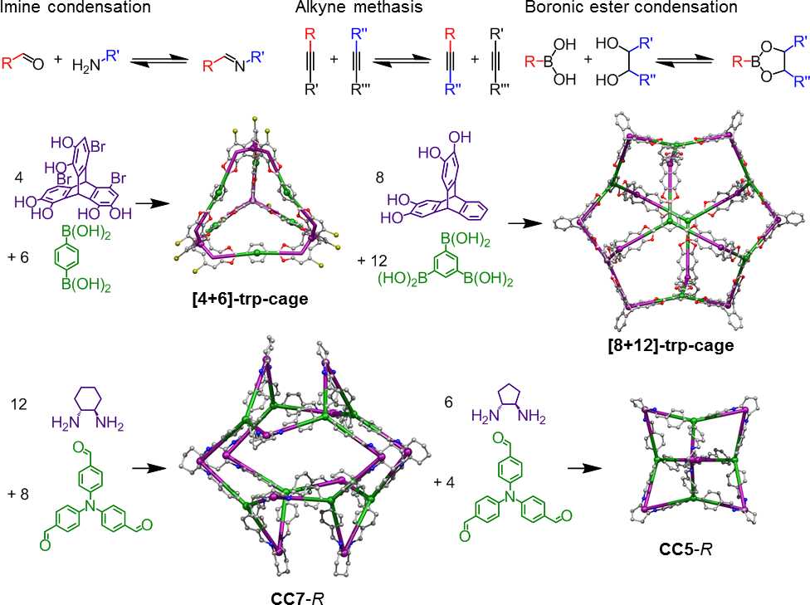
Figure 7. Chemistry and precursor geometry can be varied to direct the formation POCs into different topologies; shown for the boronic ester cages, [4+6]-typ-cage^{[221]} and [8+12]-trp-cage,^{[122]} and the imine cages, CC7,^{[203]} CC5.^{[16]}

The use of computation to predict the shape persistence of cage molecules is a powerful in silico screening technique,^{[203,250–252]} and coupling this computational approach with high throughout exploratory synthesis was shown to accelerate the discovery of a number of new organic cage compounds.^{[193]} This computational approach was be used to predict self-sorting reaction outcomes during organic cage synthesis.^{[253,254]} We envisage that such approaches will become routine in the discovery of new shape persistent cage molecules in the future, and used to design materials for specific applications: for example, by coupling these approaches with computational tools developed to predict Xe/Kr selective crystals,^{[255]} and for screening how C8 aromatics diffuse through POC-based materials.^{[181]} Indeed, the Jelfs Group has developed genetic evolutionary algorithms to identify new cage molecules (Figure 8),^{[252]} and the Simon Group has developed “eigencages” that can be used to fingerprint the 3D porosity features of POCs that control functional properties.^{[256]} These are exciting computational developments, which are now being using to discover functionalized POC based materials for specific applications.
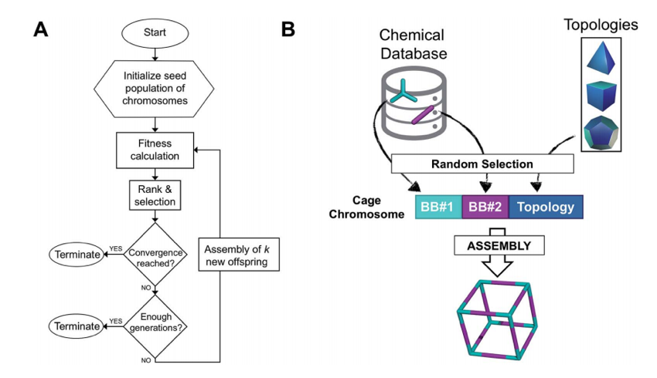
Figure 8. (a) Evolutionary algorithm workflow for predicting POC structures. (b) The POC chromosome is composed of three genes, building block (BB) #1 and #2, and cage topology. BB#1 and #2 are randomly selected from a chemical database, whereas POC topology is selected based on the topicity of the BB. Reproduced under the terms of the CC-BY license.^{[252]} Copyright 2018, The Royal Society of Chemistry.

3.2. Post-synthetic Modification of Porous Organic Cages
Porous molecular solids are, so far, less accommodating to post synthetic modification approaches than frameworks such as MOFs, at least in the solid state. Typically, pendant functional groups amenable to solid state chemical transformations, such as amines and phenols,^{[257]} are only rarely encountered as freely accessible groups in the pores of molecular solids. In fact, such groups are known to direct the crystal packing of molecules and can often be integral parts extended hydrogen-bonded networks in molecular crystal structures—they do not tend to be left ‘free floating’ in pore channels. Some exceptions exist; for example, HOF structures with freely accessible amine groups were reported.^{[104]} However, in general, there are few analogues for porous molecular crystals of the post-synthetic modification strategies developed for MOFs,^{[257]} such as retrofitting a synthetically modifiable group to an organic strut, and then using this modified strut to form the same framework materials. Instead, isomorphous substitution is more commonly encountered, and this approach is discussed in section 3.5.
A different route to post-modify porous molecular materials is to chemically alter the porous organic building blocks after they have been synthesized, prior to crystallization, using solution-phase chemistry. Mastalerz et al. reported that a shape-persistent endo-functionalized [4+6] imine POC with six free hydroxy groups in its intrinsic cage cavity can undergo a six-fold Williamson etherification to produce a chemically modified POC material (Figure 9).^{[258]} In this study, five different functional groups were investigated; methyl, propyl, allyl, benzyl, and 4-nitrobenzyl, highlighting a degree of synthetic tuneability, although the modified cages were produced in different yields (17–38%, Figure 9, Method B).^{[258]} However, even though it was the interior of the POC that was chemically modified, this transformation did subtly affect the POC shape, and hence the crystal packing of the modified and unmodified cages were different.^{[258]} In addition, the modified cages were amorphous after activation,^{[258]} whereas the unmodified cage was crystalline.^{[259]} Consequently, sorption properties for this cage series were not directly comparable, although in general, the cages that had been post-synthetically modified with larger groups had lower surface areas.^{[258]}
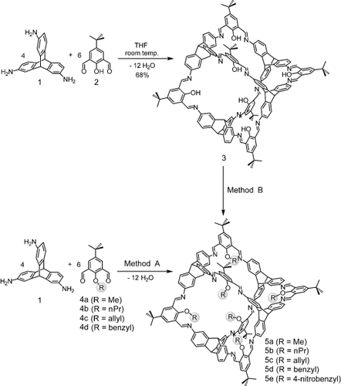
Figure 9. Synthesis of post-synthetically modified cage compounds reported by Mastalerz et al.^{[258]} Two different methods were used, with Method B: developed to post-synthetically modify an endo-functionalized cage, using six-fold Williamson ether formation. Reproduced with permission.^{[258]} Copyright 2013, Wiley-VCH.

Imine cages have also been modified post-synthetically. The imine groups can be reduced in high yields, but the resulting amine groups are more flexible, and reduced amine cages have been shown, generally speaking, to collapse during activation.^{[260]} For example, our group showed that reducing the imine group of the shape-persistent POC, CC3, afforded the flexible amine cage, RCC3, that collapsed after crystal activation to produce a formally non-porous solid.^{[260]} However, the diamine group in RCC3 has the predefined configuration to generate 5-member imidazolidine (aminal) rings when reacted with carbonyls.^{[260]} This was exploited by reacting RCC3 with one acetone molecule or six formaldehyde molecules, to produce the post-synthetically modified cages, AT-RCC3 and FT-RCC3, respectively (Figure 10, where, AT = acetone tie, and FT = formaldehyde tie).^{[260]} The modified cages, AT-RCC3 and FT-RCC3, have very slightly different POC shapes than the parent cage, CC3, but the parent cage and the post-synthetically modified cages pack isostructurally to form permanently porous solids. Interestingly, the post-synthetically modified POCs have significantly different chemical stabilities, with FT-RCC3 being chemically inert over the pH range 1.7–12.3.^{[260]} By contrast, the parent cage, CC3, chemically decomposes in acidic or basic conditions, and the aminal rings in AT-RCC3 can be hydrolyzed by H₂O. Our group showed that RCC3 reacted with six equivalents of acetaldehyde to form a methylated analogue of FT-RCC3, and that crystalline AT-RCC3 selectively reacted with 5 equivalents of formaldehyde, to cleanly form a new, dual-tied cage, 1AT-5FT-RCC3.^{[21]} By contrast, AT-RCC3 reacted with 6 equivalents of formaldehyde in solution to form FT-RCC3. Because of the different chemical stabilities of aminal rings in 1AT-5FT-RCC3, the single AT ring could be selectively hydrolyzed to generate the asymmetric molecule 5FT-RCC3, which could then be reacted with other aldehydes in solution.^{[21]} Using this protection/deprotection chemistry, we synthesized a series of post-synthetically modified POCs where molecular organic synthesis was used to fine-tune pore size. These modified POCs could be processed to form isostructural crystalline solids with fine control of the pore aperture size over the range 1.95 – 3.50 Å.^{[21]} Using a different approach, Banerjee et al. reported that POCs could be stabilized in acidic and basic conditions, after undergoing a keto–enol tautomerism;^{[261]} this not strictly speaking a post-synthetic modification, rather a chemical rearrangement, but the practical benefits are the same.
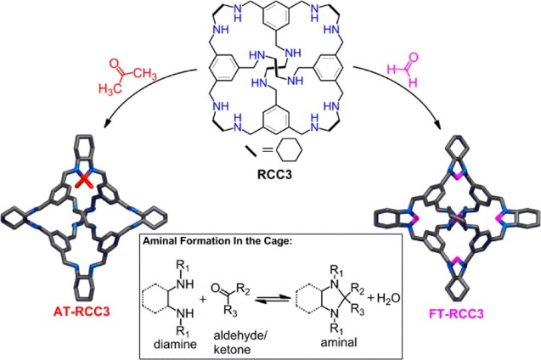
Figure 10. Post synthetic modification of amine functionalized cage, RCC3, reported by Cooper et al. Reproduced with permission.^{[260]} Copyright 2014, American Chemical Society.

Alternative synthetic routes have been developed to chemically transform POCs. For example, our group showed that a reduced amine cage could be reacted with acid chlorides to form 12-arm cage building blocks,^{[262]} and these types of cage molecules have been used as MOF linkers.^{[263]} Mastalerz et al. reported that an imine based POC could be chemically transformed into hydrocarbon cage, using a three-step method: imine reduction, nitrosylation with isoamyl nitrite, and Overberger rearrangement.^{[264]} Using different chemistry, Yamago et al. reported a carbon based nanocage, which was prepared by post-synthetically modifying a platinum nanocage, via reductive elimination of the platinum (Figure 11).^{[228]} Itami et al., and others, have reported a series of carbon based nanocages, which were prepared by post-synthetically aromatizing cyclohexane moieties under acidic conditions,^{[225,226,265]} and related reductive aromatization reactions.^{[266]} Organic synthetic modifications to metal templated assemblies have also been used to synthesize covalent organic cages. For example, Shionoya et al. reported the synthesis of covalent organic cage using a 3 nm metallocage,^{[267]} and Anderson et al. reported the synthesis of porphyrin nanospheres by coupling templated arrangements functionalized porphyrins.^{[229]} However, conventional porosity in these metal-templated, post synthetically modified cages has not yet been reported.
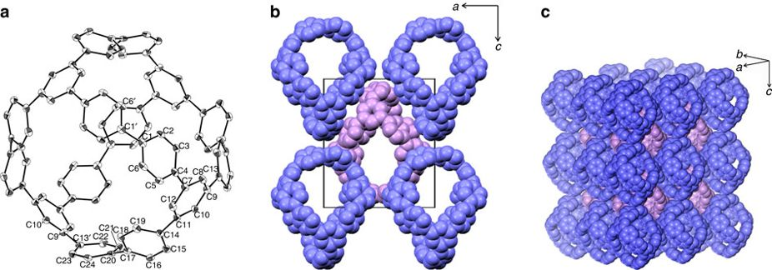

Figure 11. (a) X-ray crystal structure of the π-conjugated carbon nanocage reported by Yamago et al., and it’s solvated crystal structure (b + c). Reproduced with permission.^{[228]} Copyright 2013, Nature Publishing Group.

3.3. Tuning Crystal Porosity by Controlling Molecular Packing
A central challenge in porous molecular solid design is to develop organic building blocks that pack predictably and inefficiently. If a generic strategy existed, porous solids with rationally-designed pore dimensions and topologies could easily be targeted in the lab: as it stands, porous crystals constitute a very small fraction (e.g. 0.3% with pore volumes greater than 10⁻³ cm³ g⁻¹ were identified in a 2016 study^{[268]}) of structures in the Cambridge Structural Database. From a historical standpoint, porous materials were not initially designed; rather, they were typically discovered by experimental observation. An archetypal example is Dianin’s compound, which has an hour-glass-shaped 1-D pore,^{[89]} formed due to preferential heterochiral interactions between three -R and three S-enantiomers. This creates the porous cavities in the structure (Figure 12). It is the stacking of these hexamer units that gives rise to the unusual pore shape in Dianin’s compound. However, it is impossible to simply sketch the structure of Dianin’s compounds and determine how it would crystallize, without any prior structural knowledge, although one might could infer, for example, that the hydroxy groups are likely to hydrogen bond. While the cyclic (O–H)₆ hydrogen-bonded motif in the structure of Dianin’s compound has been used to discover several structural analogues,^{[269–273]} these cyclic (O–H)₆ hydrogen-bonded motifs are rarely directional enough to dominate crystallization outcomes. Instead, several alternative design approaches have been developed for preserving the inefficient packing of molecules in porous solids. This includes using strongly directional electrostatic interactions to direct the structures of HOFs, or using other less directional electrostatic interactions and dispersion forces to control the packing of organic molecules.
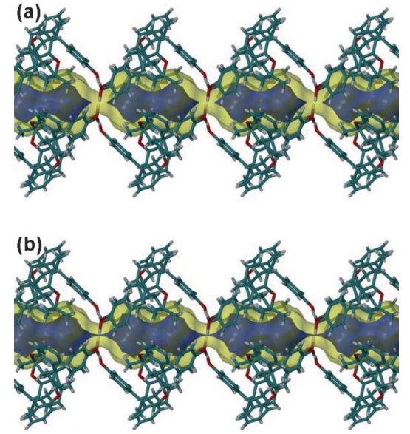
Figure 12. Dianin’s compound packs to form a porous solid with a 1-D pore structure that contains enclosed cavities. If the structure is considered static, then pore connectivity between the cavities through the cyclic (O–H)₆ hydrogen-bonded motifs (shown in blue) is disconnected using a 1.3 Å probe (a), but open using a 1.2 Å probe (b). Reproduced with permission.^{[1]} Copyright 2006, Royal Society of Chemistry.

HOF materials tend to be designed by appending functional groups that are capable of forming cooperative hydrogen-bonding motifs, such as diamino triazine or carboxylic acids, to rigid carbon-based scaffolds (Figure 13).^{[9,274,275]} However, assumptions based on likely topologies of hydrogen-bonded networks rarely consider all the possible crystallization outcomes, such as interpenetration, non-linear hydrogen-bonding motifs, or energetically competitive secondary interactions. Such effects can account for polymorphism in HOF materials.^{[9,274,275]} HOF building blocks are solution processable: as such, one possible route to tune their structures, and therefore modulate their function, is to direct the formation different solid-state forms by crystallizing from a range of solvents.
Figure 13. Complementary hydrogen-bonding motifs found in porous HOF structures, a) carboxylic acid $R_{2}^{2}$(8) motif, a) alternate interactions between diamino triazine units, c) tapes formed between benzimidazole units, and d) cyclic motifs formed between pyrazole rings. e) Carboxylic acids group have been appended to a series of carbon-based scaffolds to direct the formation of low-density HOFs.

An attractive route to screen for function in molecular crystals with hydrogen-bonded networks, and indeed for other molecular solids, is to combine computational crystal structure prediction and property prediction.^{[26,80]} Here, the stable packing arrangements available to a molecule are computationally sampled, and each structure is then ranked according to its predicted lattice energy. By plotting each predicted structure alongside a functional property descriptor, such as gas storage capacity, we can construct energy-structure-function (ESF) maps.^{[26]} ESF maps are useful in new materials discovery because they are based solely on a chemical diagram for the building block (which can be hypothetical), and yet they can identify the crystal packing arrangements available to that candidate molecule, and predict whether it is likely to have useful functional properties. Using a triptycene scaffold functionalized with benzimidazolone groups that can form cooperative, hydrogen bonded tapes, Day et al. showed how ESF maps could be used to direct experimental discovery. Here, four functional polymorphs, comprising the same organic molecule, T2,^{[276]} were discovered by experiment, including the lowest density molecular organic crystal discovered so far (T2-γ), which had an apparent SA_{BET} = 3230 m² g⁻¹, (Figure 14).^{[26]}

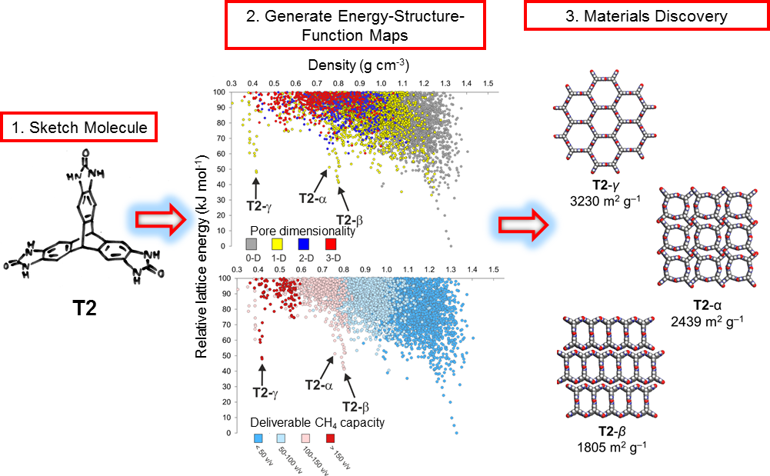
Figure 14. Materials discovery using energy-structure-function maps. For a given molecule, T2, computed crystal structures are generated, and color coded to highlight a structural (pore dimensionality) or functional (deliverable CH₄ capacity) property. Using relative lattice energy and functional properties as a fingerprint, ESF maps can be used to discover new porous polymorphs in the lab. Adapted with permission.^{[26]} Copyright 2017, Nature Publishing Group.

The T2 α-polymorph was discovered originally by Mastalerz et al., who reported that this structure had an apparent BET surface area of 2439 m² g⁻¹.^{[276]} The ESF map for T2 directed us to the discovery of three additional porous polymorphs with contrasting solid-state properties; T2-γ (SA_{BET} = 3230 m² g⁻¹), T2-β (SA_{BET} = 2439 m² g⁻¹), and T2-δ (SA_{BET} = 442 m² g⁻¹).^{[26]} Different crystallization conditions and solid-state transformations were used to access these predicted polymorphs, taking advantage of the processable and discrete nature of the building blocks (Figure 15). Interestingly, an amino-substituted bis(tetraoxacalix[2]arene[2]triazine), with the same symmetry as T2, crystallized to form the porous HOF-19, which is isostructural with T2-β.^{[108]} Also, an imidazole functionalized triptycene (H3TBI) was reported to crystallize as a distorted porous structural analogue of T2-γ.^{[277]}
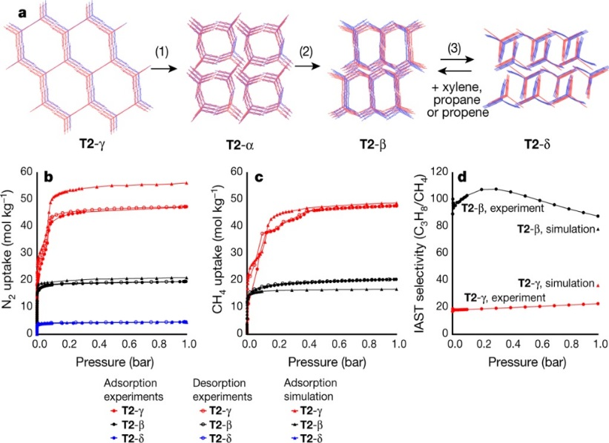
Figure 15. a, Overlays of predicted (red) and experimental (blue) solvent free structures for T2-γ, T2-α, T2-β and T2-δ, ordered by increasing predicted density. Transformation conditions: (1) loss of solvent at room temperature, heating at 340 K or mechanical grinding at room temperature; (2) heating at 358–383 K; (3) direct removal of DMSO and then acetone from DMSO/acetone solvate. T2-δ transforms back to a solvate of T2-β upon exposure to xylene, propane or propene. (b, c) Predicted and experimental gas adsorption isotherms for T2-γ (red), T2-β (black) and T2-δ (blue). b, N₂ at 77 K; c, CH₄ at 115 K; filled circles, adsorption experiments; unfilled circles, desorption experiments; filled triangles, adsorption simulations. d, Pressure-dependent IAST selectivity of propane over methane (C3H8/CH4) determined for equimolar mixtures, using experimental isotherms at 298 K. Reproduced with permission.^{[26]} Copyright 2017, Nature Publishing Group.

There are some similarities between the use of ESF maps in materials discovery and the high-throughput screening of hypothetical MOFs structures for useful functions.^{[278–281]} A key different is that ESF maps for organic materials includes information on the predicted crystal lattice energy—effectively, the likely propensity for the structure to exist—which is not generally a feature in MOF structural screens.^{[282]} The use of ESF maps in the discovery of functional organic crystals has also been used for materials such as organic semiconductors.^{[283]}
The complementary $R_{2}^{2}$(8) hydrogen bonding motif formed between two carboxylic acids (Figure 13) has been shown to direct a series of low-density hydrogen-bonded networks.^{[9,274,275]} The formation of hydrogen-bonded networks using this motif can be traced back to 1969, when Duchamp et al.^{[284]} reported the ‘α-polymorph’ of trimesic acid (TMA). The structure Duchamp reported is non-porous due to the non-planar hydrogen-bonded interactions between TMA molecules causing the hydrogen-bonded networks to interlock. However, TMA was recently revisited from a fresh perspective, after crystal structure prediction (CSP) calculations revealed an energetically stable, low-density polymorphic form, referred to as the δ−polymorph, which remained hidden, despite many groups studying the crystallization behavior of this molecule over the last 50 years.^{[285–294]} In this study, a high throughput crystallization workflow was developed to screen 280 binary solvent crystallization conditions, of which less than 2% either yielded this δ-polymorph directly, or gave a structure that transformed to this form after activation of the crystal pores.^{[295]} Unlike the non-porous α-polymorph reported by Duchamp et al., the computationally-identified δ−polymorph of TMA had a SA_{BET} 910 m² g⁻¹ at 77.3 K. CSP was also used by Hisaki et al. (Tp-apo, Figure 16) ^{[296]} to predict the structure of a carboxylic acid-based HOF material, that could not be determined directly from X-ray data alone. Instead, CSP was performed to predict possible crystal packings arrangements of the hydrogen-bonding Tp units, and one of these predicted structures was identified as the experimental structure. This structure was subsequently refined using experimental PXRD data (Figure 16). Polymorphism was not investigated in the Tp study.
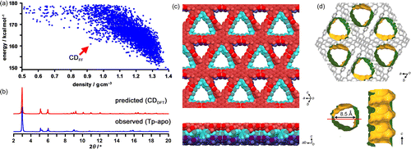
Figure 16. a) CSP energy vs density plot for the Tp-apo HOF material reported Hisaki et al. (b) Using the simulated PXRD pattern for the DFT-optimization of CD_{FF} structure, the experimental structure, with a 1-D pore structure (c,d) was discovered. Reproduced with permission.^{[296]} Copyright 2016, American Chemical Society.

The directionality of the carboxylic acid hydrogen bonding motif is appealing from a sketch-to-structure idea, but interpenetration, polymorphism, and structural stability can often thwart ideas that should work ‘on paper’. Interpenetration can also account for structural stability in HOF materials.^{[33,107,167–169]} Hence, new computational methods that predict interpenetration in molecular crystals will be important for the discovery of stable, functional solids, with desirable pore architectures. Stoddart et al., reported a series of triptycene based HOF materials, which feature interesting interpenetration and polycatenation features.^{[297,298]} For one of their materials, H6PET, interpenetration of the hydrogen-bonded framework was modulated by processing the building block from THF/toluene or Me₂CO/Et₂O, to yield two-fold (PETHOF-1) and five-fold (PETHOF-2) structures, respectively (Figure 17).^{[297]} Both structures have the same underlying acs topology of hydrogen-bonded nets, and while these materials undergo structural transformation upon desolvation, the activated materials have SA_{BET} in the region of 1100 m² g⁻¹. Our group reported that CSP could be used to determine the relative lattice energies of interpenetrated nets for the prototypical HOF building block, adamantane-1,3,5,7-tetracarboxylic acid, that was reported in 1988 by Ermer to form a 5-fold interpenetrated structure.^{[187]} CSP calculations identified additional 2-, 3-, and 4-fold interpenetrated structures for this molecule, and these structures were subsequently discovered in the lab after screening 100’s of binary crystallization conditions.^{[295]} By being able to predict interpenetration features in molecular crystals in this way, we envisage the ability to use this to design and discover interpenetrated HOF materials with favorable pore sizes and physical stability.
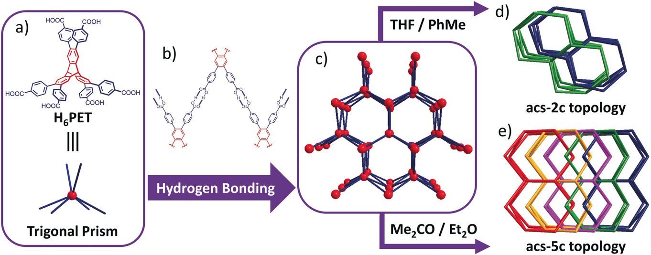
Figure 17. The trigonal prismatic HOF building block, H6PET, designed by Stoddart et al. to prepare a HOF structure with an acs topology, that can be modulated to form 2- and 5-fold interpenetrated structures. Reproduced with permission.^{[297]} Copyright 2019, Wiley-VCH.

For a materials standpoint, the stability of HOF materials remains largely untested from an application perspective, and it is likely that water will disrupt intermolecular packing in some cases. Hence, functionalization strategies are important that not only control the packing of the building blocks, but also the chemistry of the pores. One strategy to improve the hydrolytic stability of HOF materials is to make their pores hydrophobic, in order to protect the internal hydrogen-bonding networks. One example of a water-stable HOF material was prepared by crystallizing, 1,3,6,8-tetrakis(4-formylphenyl)pyrene (PFC-1),^{[299]} and in the crystal structure, hydrophobic pyrene units are π-π stacked along the 1-D pore walls (Figure 18). Interestingly, this HOF material has a high SA_{BET} > 2000 m² g⁻¹ and is one of the most hydrolytically stable HOF materials reported to date. Other HOF materials with stabilizing π-π interactions between layers of aromatic units along their pore walls have also been reported to be hydrolytically stable.^{[135,169]}

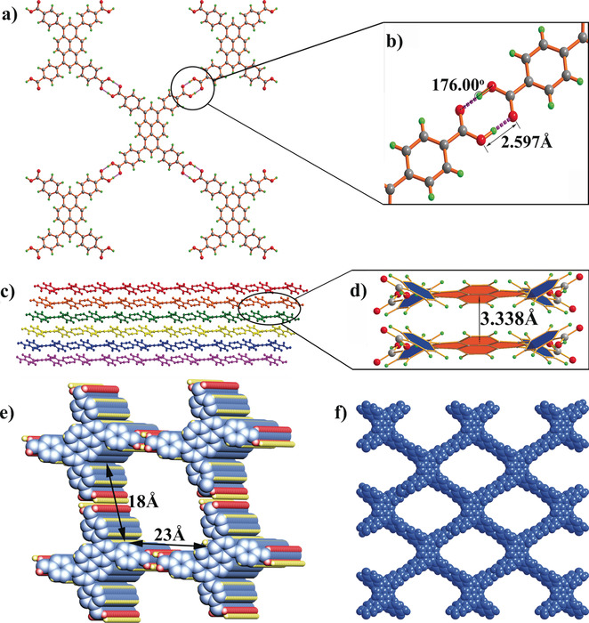
Figure 18. Crystal structure of PFC-1, that features (a, b) hydrogen-bonding between carboxylic acid units, and (c, d) face-to-face π–π stacking interactions between tetra substituted pyrene units, (e, f) to generate a porous HOF with pyrene lines pore walls. Reproduced with permission.^{[299]} Copyright 2018, Wiley-VCH.

3.4. Modulating Crystal Packing in Porous Molecular Crystals
Electrostatic hydrogen-bonding interactions in materials such as HOFs are often designed to be strongly directional and cooperative to direct crystallisation outcomes, but dispersion forces, and other less-directional electrostatic interactions, are often also important for stabilising the extended crystal packing. For example, tuning the electrostatics of aromatic rings by appending electron withdrawing fluorine atoms was used to stabilise extrinsically porous HOF structures.^{[126,128]} The energetic gain from dispersion forces, or other less directional electrostatic interactions, can also account for polymorphism in HOF materials.^{[26]} While strongly directional hydrogen-bonding units are useful in designing porous molecular solids, there are some limitations; HOF structures tend to be rigid and can suffer from structural fatigue during gas sorption cycles. Their low-density frameworks can be metastable or hydrolytically unstable, and an over-reliance on molecules having cooperative hydrogen-bonded motifs is also synthetically constraining. Intrinsically porous molecules are rarely functionalized with directional hydrogen-bonding motifs,^{[6,8,300–302]} which presents the opportunity of a hybrid strategy. More generally, though, it is useful to also develop other design strategies to create porous molecular solids without resorting to or relying on hydrogen bonding.
The helically chiral, imine-based POC, CC3, synthesised by reacting 1,3,5-triformylbenzene with vicinal -R,R or -S,S cyclohexane diamine, was reported by our group to have a strong energetic preference to form heterochiral, intermolecular, window-to-window interactions when crystallised as a racemate.^{[16,17,303]} This heterochiral pairing energetic preference was also observed in CSP calculations, which revealed there was a 32.1 kJ mol⁻¹ relative lattice energy gain to form the CC3 racemate structure.^{[16]} Interestingly, this energetic preference to form heterochiral window-to-window motifs is transferable between CC3 and POCs with the same underlying topology and cage core, including CC1 and CC4, with CC3-R directing the formation of isostructural (CC3-R, CC1-S) and (CC3-R, CC4-S) quasiracemates when these cage pairs were co-crystallised (Figure 19).^{[16,17]} By contrast, a racemic mixture of the chiral POC, CC5-R, which has a different cage structure to CC3-R, self-sorts during crystallisation to form chirally-pure solids, and this energetic preference was also accurately predicted using CSP calculations (Figure 19).^{[16]} Hence, a modular and predictable assembly of POC based materials can be achieved using CSP calculations coupled with chiral recognition.

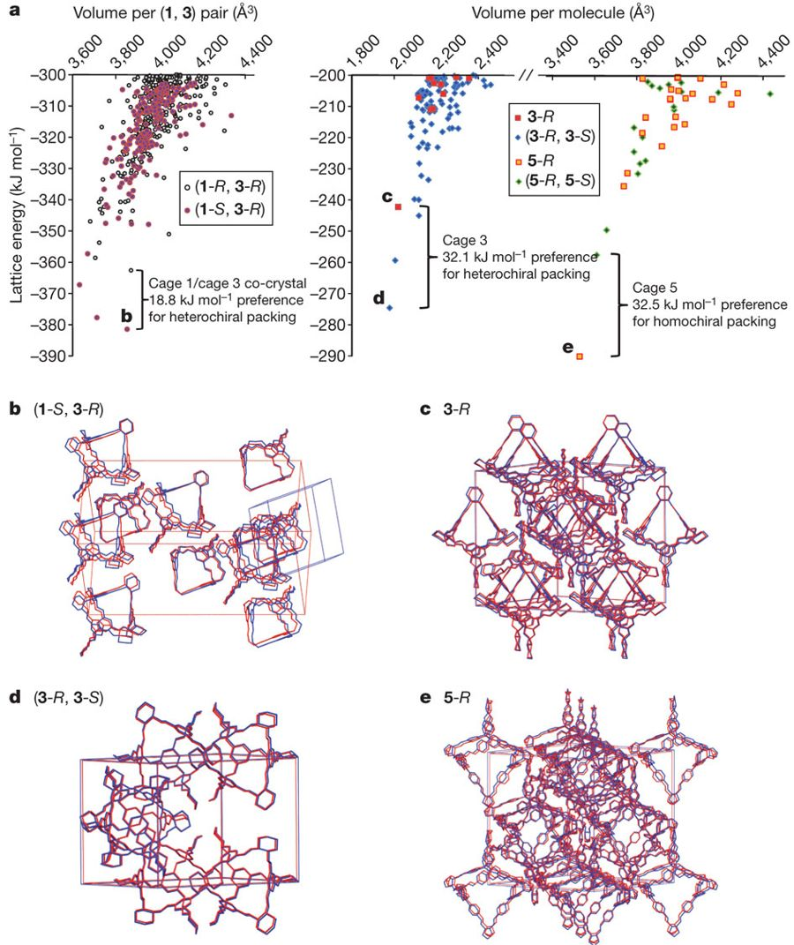
Figure 19. a) Lattice energy rankings rationalize the homochiral versus heterochiral packing preference for CC3 and CC5, and the formation of the (CC1-S, CC3-R) quasiracemate. (b, c, d, e) Packing diagrams show the excellent fit between the calculated global-minimum structures (blue) and the experimentally determined structures (red). Reproduced with permission.^{[16]} Copyright 2011, Nature Publishing Group.

Heterochiral pairing between chiral POCs is a useful and somewhat generalizable route to modulate the pore structure and material form of POC materials,^{[16,17,21,27,28,304–306]} and similar chiral recognition behavior has also been reported for imine macrocycles, prepared using chiral vicinal diamines.^{[307,308]} For POCs, our group applied this chiral recognition strategy to create crystalline solids with 1-D porous nanotube structures by co-crystallizing racemic mixtures of tubular POCs that had two linearly arranged cage windows.^{[27]} For these 1-D porous nanotube structures, CSP calculations provided a valuable in silico screening method that was used to evaluate the crystal packing preferences of the tubular POCs. By extension, co-crystallizing the tubular POCs with an opposite handed, tetrahedral cage, CC3-R, was used to assemble 3-D diamondoid pillared networks in a targeted way.^{[27]} This approach highlights that solution-processable POCs, like isoreticular MOFs and PCPs, can be assembled using a ‘mix and match’ pairing strategy.
Recently, our group used related ‘mix and match’ pairing of POCs with different pore sizes to modulate the adsorption selectivity and adsorption capacity of POC based materials for kinetic quantum sieving of D₂/H₂.^{[21]} It remains challenging to identify porous solids with the optimal pore sizes for kinetic quantum sieving applications. Typically, a porous solid with an ultrafine pore aperture (~3 Å) is needed,^{[309,310]} and this often results in materials with low pore volumes and low gas adsorption capacities. We synthesized an isostructural series of POCs with finely tuned pore sizes over the range 1.95 to 4.5 Å (Figure 20a & b),^{[21]} and determined the effect of pore aperture on kinetic quantum sieving performance across this series. We found that 6ET-RCC3, which has the smallest pore aperture (1.95 Å), had the best D₂/H₂ selectivity at 30 K (S_{D2/H2} = 3.9, Figure 20c), but this material also adsorbed the smallest amount of D₂ (0.39 mmol/g). By contrast, CC3, which has the largest pore aperture (4.5 Å), adsorbed the highest amount of D₂ at 30 K (3.67 mmol/g, Figure 20c), but had the lowest selectivity (S_{D2/H2} = 1.7), highlighting the trade-off between selectivity and adsorption capacity in kinetic quantum sieving applications. Since these POCs are modular, we were able to design a functional co-crystal, Cocystal1 (Figure 20d), that combined the POC with the best selectivity, 6ET-RCC3, with the POC with the best adsorption capacity, CC3. This created a porous cocrystal with a ‘sieving module’ that alternated with a ‘storage module’. Cocrystal1 was shown to have far better quantum sieving properties than either of the individual components (Figure 20c), illustrating both the advantages of this modular assembly strategy to achieve specific functions.
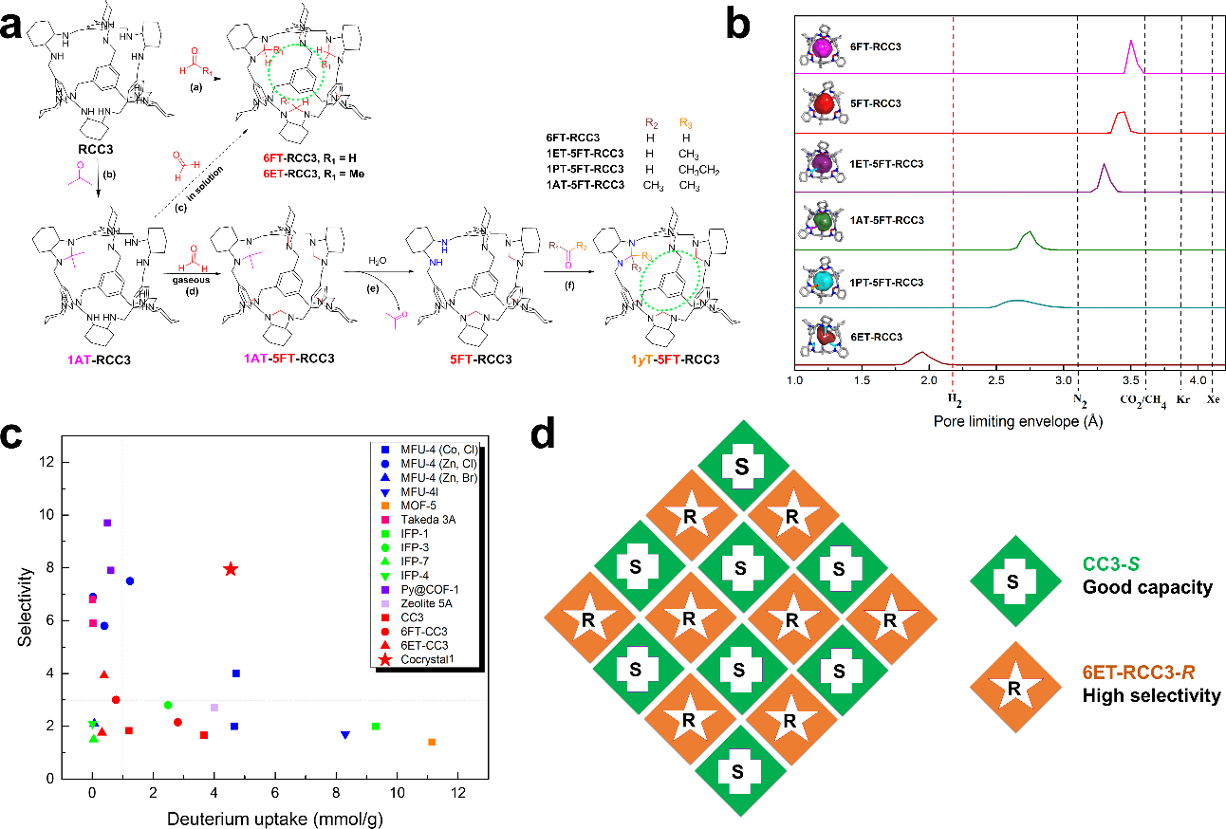
Figure 20. a) Fine-tuning pore size of POCs by molecular organic synthesis; b) The POC series pack isostructurally to form porous solids with finely-tuned pore limiting envelopes; c) Summary of hydrogen isotope kinetic quantum sieving selectivities and adsorption capacities reported for various porous materials; d) Scheme showing structure of Cocrystal1, which combines POC modules with good capacity with modules that have high selectivity to optimize the kinetic quantum sieving performance. Reproduced with permission.^{[21]} Copyright 2019, American Association for the Advancement of Science.

The influence of crystallization solvent is important for porous molecular crystals that tend to crystallize with solvent in the pore channels,^{[295,297]} but this can become more pronounced systems that lack strongly directional framework structures. Organic molecules often crystallize as solvates, or inclusion compounds, but while the channels in these structures are reminiscent of pores, they are frequently not stable to solvent removal. The formation of solvated structures is important, since different crystalline solvates can have different physical properties,^{[123,311]} but also because different porous polymorphs tend to be isolated by desolvating solvates with different crystal structures.^{[22–24,26]} Highly solvated structures can also be indicative of packing defects between the organic building blocks, that can then ultimately account for a lack of structure stability. Our group reported that the packing of the POC, CC3, can be frustrated using MeOH solvent to engineer a crystal with “virtual porosity”, which was found to collapse during crystal activation (Figure 21a). It was shown that the solvent filled extrinsic voids in the CC3 structure accounted for a lack of structure stability, but this also provided a structural blueprint to engineer a functional co-crystal. This was achieved by identifying a second cage molecule ([3+2]-cage) with the appropriate shape and dimensions to the extrinsic voids in the unstable CC3 structure, which was used to stabilize a proportion of the solvent-filled “virtual pores” (Figure 21 b and c).^{[19]} The cage modules have different functions in this “retro-engineered” co-crystal: CC3 is porous and adsorbs CO₂ during gas adsorption, while the [3+2]-cage provides structure stability and modulates the gas selectivity of the engineered co-crystal, imparting additional functionality.

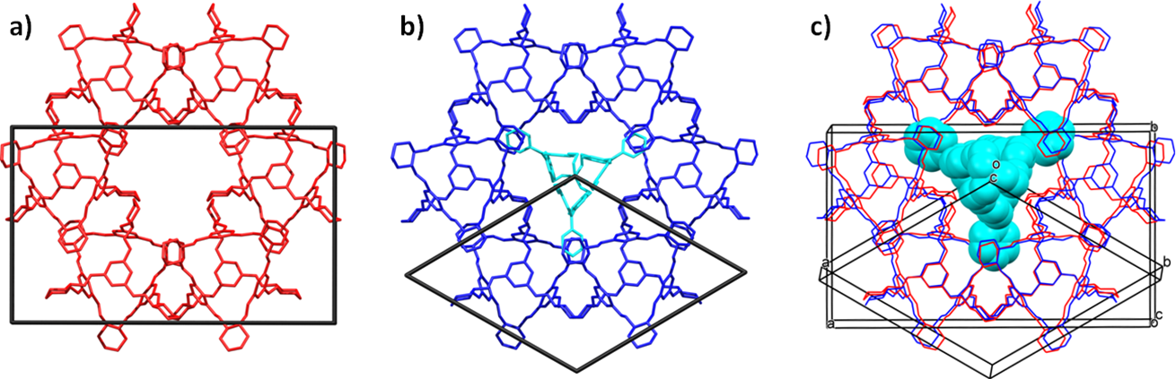
Figure 21. a) Crystal structure of CC3 solvate with “virtual pores” (red) and, b) retro-engineered co-crystal (CC3)2∙[3+2]-cage (blue). c) overlay of crystal structures shows that the 2-D pore layers are isostructural in these two materials. [3+2]-cage component shown in cyan; unit cell axes are shown. Reproduced with permission.^{[19]} Copyright 2015, Nature Publishing Group.

Even though solvents are well-known to direct crystallization outcomes, predicting solvent effects on crystallization is extremely difficult, and it is not usually clear, a priori, which solvent will stabilize a targeted porous crystal packing.^{[312]} Solvent can also influence the conformation of porous building blocks, and this can be difficult to determine and predict.^{[250]} It was reported that a series of POCs can be directed to pack in a predictable way, using the solvent 1,4-dioxane (Figure 22).^{[24]} For one of these POCs, CC13, the use of 1,4-dioxane to direct its solid state structure to a different polymorphic form more than doubled the apparent BET surface area, from 517 to 1173 m² g⁻¹. Crystallization solvents and different processing techniques can also be tuned to affect crystallization rates, as this has been shown to control the crystal packing of POCs. Doonan et al. reported that slowly crystallizing a POC, C1, from a dichloromethane/methanol solution over 24 h afforded the thermodynamic polymorph that was non porous to N₂ at 77K.^{[23]} By contrast, rapidly evaporating a benzene solution containing C1, using freeze-drying, or after rapidly adding anti-solvent, yielded a stable kinetic polymorph that was porous to N₂ (SA_{BET} = 1153 m² g⁻¹ for N2 at 77 K).^{[23]} Such approaches demonstrated that it is the processing of the POC modules that affects pore volumes in these materials, rather than attempting to synthesize a larger and often more synthetically challenging POCs that may also lack shape persistence.^{[203,301]}
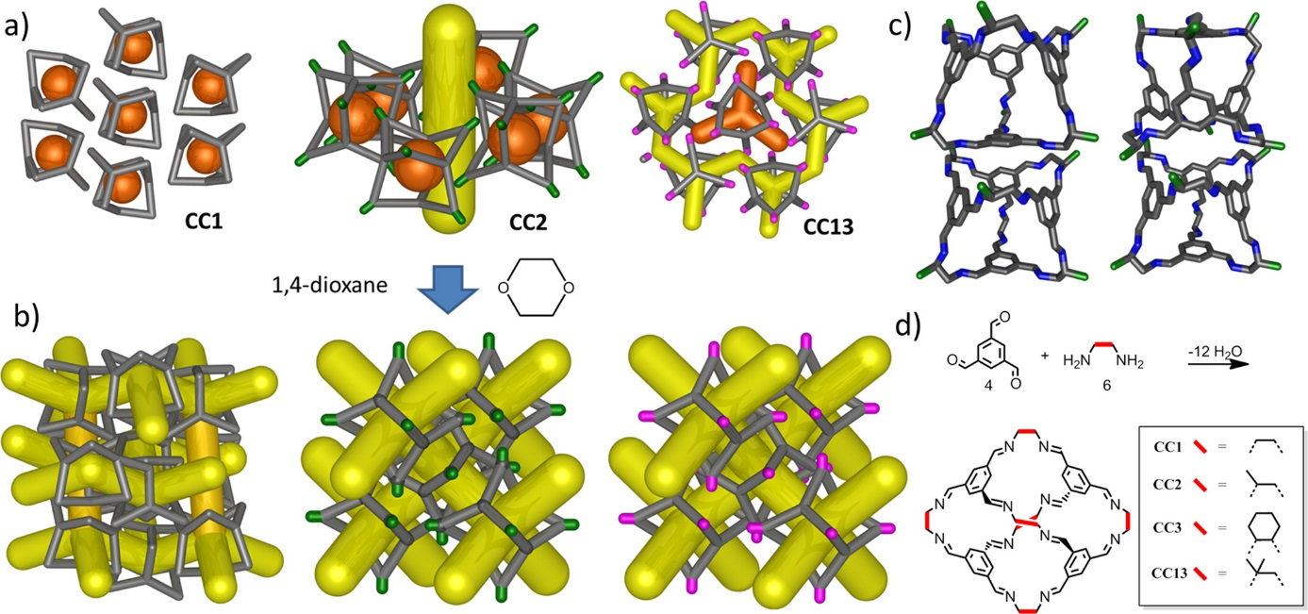
Figure 22. a) Schematic showing low-energy crystal packings, and, d) cage synthesis for CC1, CC2 (methyl vertices), and CC13 (dimethyl vertices); orange = disconnected voids; yellow = interconnected pores. (b) Crystallization in the presence of 1,4-dioxane causes pseudoisostructural window-to-window packing for all three cage modules, causing the materials to mimic the 3-dimensional diamondoid pore structure of CC3 (not shown). (c) Disconnected window-to-arene packing between the CC2 cages (left) versus interconnected window-to-window cage packing in the 1,4-dioxane-directed CC2 polymorph (right). Reproduced with permission.^{[23]} Copyright 2014, American Chemical Society.

POCs^{[22,23,25,27,28,30,206,313]}and extrinsically porous solids^{[26,31,32,295]} have been reported to exhibit polymorph-dependent physisorption properties, although extensive screening of crystallization conditions are often required to find functionally different polymorphs in the lab.^{[295]} Indeed, McCrone suggested some time ago that the discovery of different polymorphs is proportional to the amount of effort spent searching.^{[314]} The ultimate goal is to develop computational tools to predict the effect of solvent on the crystallization of porous organics. This can be done, for example, by running CSP calculations with crystallization solvent, as demonstrated for a 1:1 DMSO solvate of the anti-convulsant drug carbamazepine,^{[315]} although such approach can become computationally expensive even when assuming a 1:1 solvate stoichiometry. Porous solids, on the other hand, typically crystallize with far more solvent molecules in the channels. A different approach is to insert solvent molecules into computationally predicted structures with solvent accessible pores, and then determine the energetic solvent stabilization effect. Day et al. used this approach to study the stabilization effect lattice solvent had on the POC, CC1,^{[313]} that has a near-spherical shape and many structures with similar energies on its CSP landscape.^{[316]} In addition, CC1 has been reported to exhibit interesting solvatomorphic behavior.^{[22,24]} Day et al. developed a Monte Carlo solvent insertion procedure, to determine the energetic stabilities of different CC1 solvates, and showed that these affects could be accurately predicted. These calculations also accounted for certain CC1 solvate structures, far higher in energy than the predicted global minima CC1 structure, being isolated in the lab. While these calculations are currently far too expensive to compute for an entire crystal energy landscapes, they might in the future be used to determine solvent combinations that yield particularly functional, targeted polymorphs in the lab. To fill this gap, HT crystallization workflows, comparable to those developed for screening the crystallization of pharmaceutical compounds,^{[317,318]} have been used to accelerate the discovery of porous molecular crystals.^{[295]}
3.5. Molecular Isomorphous Substitution
Isomorphous substitution in molecular crystals is where different organic molecules are exchanged into a crystal structure without affecting the extended crystal packing. This strategy is an analogous to multivariate-MOF chemistry,^{[319]} where different ligands are used to synthesize otherwise structurally identical MOFs that have chemically different properties. Such strategies are much more difficult to achieve for molecular crystals because of the profound effect that chemically-different building blocks can have on crystal packing. Hence, isomorphous substitutions in molecular crystals are typically reliant on the substituted molecules having the same underlying shape or identical functional groups that direct isostructural extended crystal packings. Görbitz et al. reported that L-valyl-L-alanine (VA) crystallized to form 3-D hydrogen bonded structure with empty 1-D channels.^{[320]} Subsequently, Sozzani et al. reported that the four dipeptides, L-alanyl-L-valine (AV), L-valyl-L-alanine (VA), L-isoleucyl-L-valine (IV) and L-valyl-L-isoleucine (VI), could be crystallized to from isostructural solids with 1-D porous channels.^{[138]} These dipeptides are stabilized with the same underlying hydrogen-bonded network, and the dimensions of the hydrophobic pores, scale with the size of the amino acid functional groups; from 5.0 Å for AV, to 3.7 Å for VI. Of these dipeptides, VA exhibiting the highest uptake of CO₂ (4.1 mmol g⁻¹) at 195 K and 1 atm, in agreement with larger total pore volume in the VA structure.^{[138]} A series of porous dipeptides have been reported to adopt the same underlying porous structure.^{[320–322]} For example, the chemistry of these dipeptide crystals can be tuned to control topochemical polymerizations reactions in the crystal pores (Figure 23), and the volatility of adsorbed fluorinated ethers, which have application in anesthetics.^{[322]}

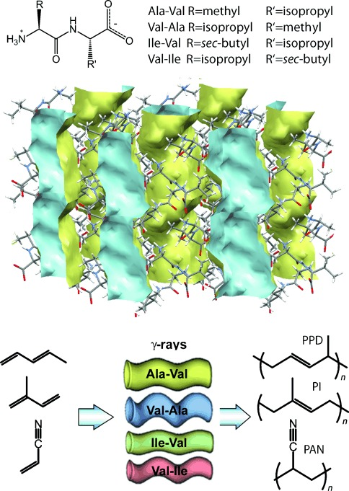
Figure 23. a) Chemical structure of the dipeptides. b) Porous crystal structure of Ala‐Val showing 1-D channel. c) Schematic representation of the monomers and dipeptide crystals used for polymerization reactions. Reproduced with permission.^{[321]} Copyright 2012, Wiley-VCH.

Davis et al. reported that a molecular scaffold assembled with steroidal urea units,^{[323]} contained 1-D channels that could be decorated with different chemical functionalities, without altering the overall packing in the structure.^{[324–326]} One of their materials, decorated with aromatic units, was shown to adsorb gases and liquids during sorption measurements.^{[325]} Our group showed that two POCs with the same underlying cage shapes, CC3-R and CC4-R, could be exchange in a porous organic ternary co-crystal, where a different cage module, CC1-S, occupied 50% of the lattice positions (Figure 24).^{[18]} The composition of this POC ‘alloy’ could be tuned to modulate the unit cell parameters and the gas adsorption uptake N₂, a property that was rationalized by using molecular simulations.^{[327]}
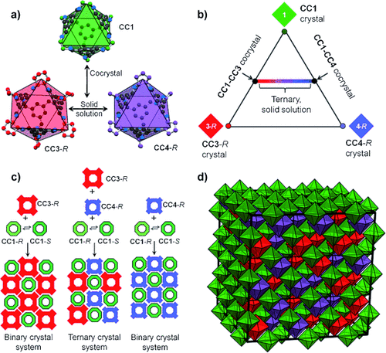
Figure 24. a, b) Structures of POCs CC1, CC3-R, and CC4-R, which form a ternary cocrystal, c) The chirality of CC1 is resolved by co-crystallization with CC3-R, CC4-R, or a mixture of both modules. d) Packing in the porous tercrystall CC1-S modules (green) occupy half of the lattice sites; CC3-R (red) and CC4-R (purple) are disordered over the remaining lattice sites. Reproduced with permission.^{[18]} Copyright 2012, Wiley-VCH.

3.6. Solid State Transformations in Porous Molecular Solids
Due to their non-covalent nature, molecular materials are held together by relatively weak non-covalent forces. They have therefore been shown to display interesting polymorph switching behaviors in the solid state. The Huang Group reported a series of non-porous adaptive crystals (NACs) with pillar[n]arene hosts,^{[61,79,82,328–332]} which undergo solid state structural rearrangements to selectively adsorb industrially-relevant feedstocks or pollutants, with high affinity and selectivity, including; pX/oX and mX,^{[61]} styrene/ethyl benzene,^{[82]} 1-pentene/trans-2-pentene,^{[333]} cis-/trans-1,4-dichloro-2-butene,^{[332]} toluene/ methylcyclohexane.^{[328]} Our group reported that the ethylenediamine-derived POC, CC1, could be interconverted between polymorphic forms in the solid state, using solvation and activation induced transformations, to create on-off, switchable porosity (Figure 25).^{[22]} Polymorph switching behavior can be computationally rationalized for CC1, taking into account its spherical shape and solvatomorphic behavior.^{[16,313]} Solvent induced, solid state, polymorph interconversion has been reported for other POC-based materials. Banerjee et al., reported that a structurally related [4+6] imine cage, TpOMe-CDA, that has more bulky cyclohexyl groups on the imine cage vertices, interconverts between three different polymorphs with contrasting sorption properties, using solvent switches with initiated with CHCl₃ and DMF.^{[30]}

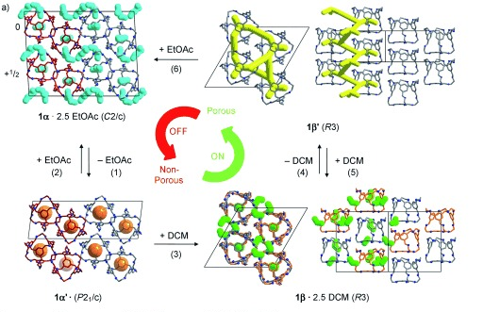
Figure 25. On-off porosity switching in a POC based molecular solids reported by Cooper et al. using solvent and activation transformation steps. Reproduced with permission.^{[22]} Copyright 2019, Wiley-VCH.

Molecules that generate extrinsically porous solids have also been reported to have interesting, polymorph-dependent sorption properties. Credi et al. reported that a molecular crystal prepared using shape-persistent azobenzene tetramers, E₄-1c, formed a porous solid that underwent E→Z photoisomerization reaction, to convert the porous crystals into a non-porous amorphous melt phase.^{[31]} Interestingly, this reversible E→Z induced transformation could be used switch optical properties, such as birefringence, or to capture of CO₂ from the gas phase. Barbour et al. reported reversible switching of the pore volume in porous halogen-bonded framework, that was induced using gas adsorption switching.^{[334]} Aida et al. reported that a C–H···N bonded porous crystalline solid, prepared using D_{3h}-symmetric molecule (Py6Mes) with a non-polar mesitylene core and 6 pendant, polar, pyridyl-rings, could be transformed between a porous open polymorph (Py^{open}) and non-porous closed polymorph (Py^{close}) in the solid state, taking advantage of the extremely labile C–H···N bonding interactions in the structures.^{[32]} For example, MeCN vapour was used to generate the Py^{open} polymorph, and a heat-induced transformation at 202°C was used to generate Py^{close} polymorph, with the in the structure. Hence, solid state polymorph switching in porous molecular solids is developing as a unique route to modulate the sorption properties of these materials.

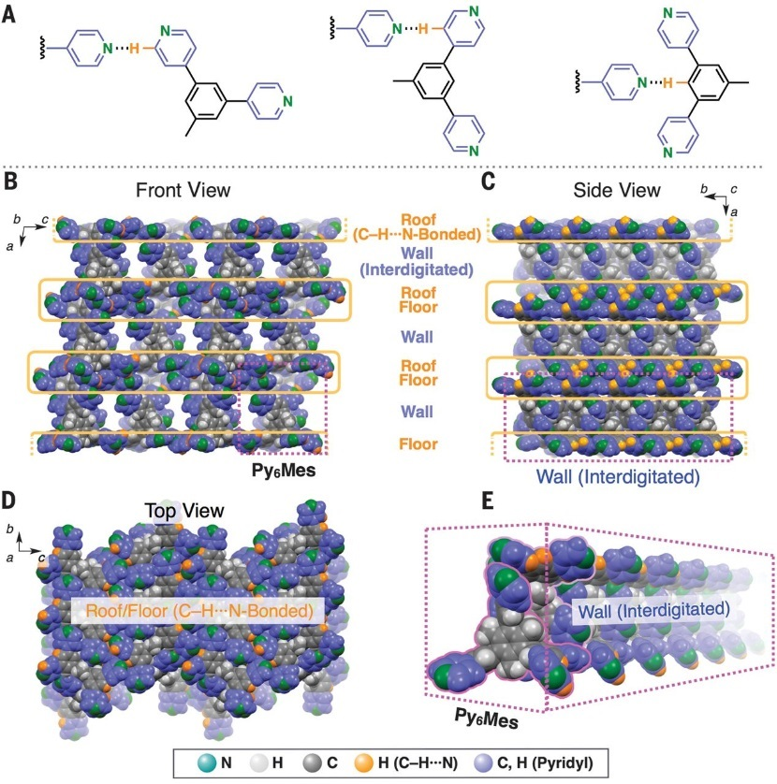
Figure 26. C–H···N bonding interaction and extended crystal packing in the porous Py^{open} polymorph report by Aida et al. Reproduced with permission.^{[32]} Copyright 2018, American Association for the Advancement of Science.

4. Outlook
The chemistry of porous organic molecular materials is dominated by the extended, non-covalent arrangement of the building blocks, and by their solution processability. As a result, processing techniques can be used both to control intermolecular packing and to modulate the physical materials properties. This means that there are many opportunities to form new functional materials by post-synthetic processing techniques, and the examples given here constitute a small selection of the possibilities that exist. For example, solution processability allows core-shell materials to be produced where it is possible to tune both surface properties and gas selectivity.^{[20]} Somewhat counterintuitively, porous molecular solids might have stability advantages: for example, the microporous imine POC CC3 is stable to boiling water without losing its crystallinity,^{[124]} and acid-stable HOFs and POCs have been reported,^{[260,261,335]} in some cases offering hydrolytic stability that is rivalled by very few crystalline porous materials. Also, structural ‘self-healing’ is possible: for example, porous molecular materials have been shown to recover crystallinity during guest absorption cycles.^{[79,82]} Hence, porous molecular materials may prove competitive with or, in specific cases, perhaps even superior to MOFs and COFs in terms of physicochemical stability.
Porous organic molecules solids may have additional relevance in applications where solution processing is required. For example, crystalline POCs have been coated onto microporous beads,^{[336]} and chiral crystalline POCs have been used as stationary phases in gas chromatography column for molecular separations.^{[337,338]} Amorphous POCs have also been coated onto microbalances for sensing application,^{[35]} and can be processed into amorphous thin films which have shown promise for molecular-sieving applications.^{[34,339]} Composites are possible, too: mixed-matrix membrane materials, prepared using in situ crystallization of POCs within a polymer of intrinsic microporosity,^{[340]} or by processing amorphous scrambled POCs^{[197]} into polymer membranes,^{[341,342]} thus improving gas permeability and selectivity. Perhaps one of the most exciting developments in porous organic molecular materials discovery is the application of computational methods to predict their structure and function.^{[343]} By using such approaches, molecules can be pre-screened for function in silico by sketching out a candidate and then computing the energy-structure-function maps.^{[26,80]} Here, the best candidates are selected in silico, rather than through trial-and-error experiments in the lab. Coupled with rapid predictions for the molecular building blocks themselves,^{[252,344]} this offers a joined up methodology for the in silico design of functional solids, not only for those functions related to porosity. We believe that the enormous success enjoyed by frameworks such as MOFs and COFs stems as much from their superior designability as their inherent physical properties, many of which can be replicated, more or less, in molecular organic crystals. As such, we see the development of new computational design methods as key to unlocking the innate potential of porous molecular solids in the future.

Acknowledgements
The authors gratefully acknowledge the Engineering and Physical Sciences Research Council (EPSRC, EP/N004884/1), the Leverhulme Research Centre for Functional Materials Design, and the University of Liverpool for funding.

Received: ((will be filled in by the editorial staff))
Revised: ((will be filled in by the editorial staff))
Published online: ((will be filled in by the editorial staff))

References
[1] L. J. Barbour, Chem. Commun. 2006, 1163.
[2] J. D. Wuest, Chem. Commun. 2005, 5830.
[3] N. B. McKeown, J. Mater. Chem. 2010, 20, 10588.
[4] J. R. Holst, A. Trewin, A. I. Cooper, Nat. Chem. 2010, 2, 915.
[5] J. Tian, P. K. Thallapally, B. P. McGrail, CrystEngComm 2012, 14, 1909.
[6] G. Zhang, M. Mastalerz, Chem. Soc. Rev. 2014, 43, 1934.
[7] K. E. Jelfs, A. I. Cooper, Curr. Opin. Solid State Mater. Sci. 2013, 17, 19.
[8] T. Hasell, A. I. Cooper, Nat. Rev. Mater. 2016, 1, 16053.
[9] R.-B. Lin, Y. He, P. Li, H. Wang, W. Zhou, B. Chen, Chem. Soc. Rev. 2019, 48, 1362.
[10] A. I. Kitaigorodskii, Acta Crystallogr. 1965, 18, 585.
[11] J. Rouquerou, D. Avnir, C. W. Fairbridge, D. H. Everett, J. H. Haynes, N. Pernicone, J. D. F. Ramsay, K. S. W. Sing, K. K. Unger, Pure Appl. Chem. 1994, 66, 1739.
[12] J. L. Atwood, L. J. Barbour, A. Jerga, Science 2002, 296, 2367.
[13] J. L. Atwood, L. J. Barbour, A. Jerga, B. L. Schottel, Science 2002, 298, 1000.
[14] S. A. Allison, R. M. Barrer, J. Chem. Soc. A Inorganic, Phys. Theor. Chem. 1969, 1717.
[15] J. L. Flippen, J. Karle, I. L. Karle, J. Am. Chem. Soc. 1970, 92, 3749.
[16] J. T. A. Jones, T. Hasell, X. Wu, J. Bacsa, K. E. Jelfs, M. Schmidtmann, S. Y. Chong, D. J. Adams, A. Trewin, F. Schiffman, F. Cora, B. Slater, A. Steiner, G. M. Day, A. I. Cooper, Nature 2011, 474, 367.
[17] T. Hasell, S. Y. Chong, K. E. Jelfs, D. J. Adams, A. I. Cooper, J. Am. Chem. Soc. 2012, 134, 588.
[18] T. Hasell, S. Y. Chong, M. Schmidtmann, D. J. Adams, A. I. Cooper, Angew. Chem., Int. Ed. 2012, 51, 7154.
[19] M. A. Little, M. E. Briggs, J. T. A. Jones, M. Schmidtmann, T. Hasell, S. Y. Chong, K. E. Jelfs, L. Chen, A. I. Cooper, Nat. Chem. 2015, 7, 153.
[20] S. Jiang, Y. Du, M. Marcello, E. W. Corcoran, D. C. Calabro, S. Y. Chong, L. Chen, R. Clowes, T. Hasell, A. I. Cooper, Angew. Chem., Int. Ed. 2018, 57, 11228.
[21] M. Liu, L. Zhang, M. A. Little, V. Kapil, M. Ceriotti, S. Yang, L. Ding, D. L. Holden, R. Balderas-Xicohténcatl, D. He, R. Clowes, S. Y. Chong, G. Schütz, L. Chen, M. Hirscher, A. I. Cooper, Science 2019, 366, 613.
[22] J. T. A. Jones, D. Holden, T. Mitra, T. Hasell, D. J. Adams, K. E. Jelfs, A. Trewin, D. J. Willock, G. M. Day, J. Bacsa, A. Steiner, A. I. Cooper, Angew. Chem., Int. Ed. 2011, 50, 749.
[23] A. Avellaneda, P. Valente, A. Burgun, J. D. Evans, A. W. Markwell-Heys, D. Rankine, D. J. Nielsen, M. R. Hill, C. J. Sumby, C. J. Doonan, Angew. Chem., Int. Ed. 2013, 52, 3746.
[24] T. Hasell, J. L. Culshaw, S. Y. Chong, M. Schmidtmann, M. A. Little, K. E. Jelfs, E. O. Pyzer-Knapp, H. Shepherd, D. J. Adams, G. M. Day, A. I. Cooper, J. Am. Chem. Soc. 2014, 136, 1438.
[25] M. A. Little, S. Y. Chong, M. Schmidtmann, T. Hasell, A. I. Cooper, Chem. Commun. 2014, 50, 9465.
[26] A. Pulido, L. Chen, T. Kaczorowski, D. Holden, M. A. Little, S. Y. Chong, B. J. Slater, D. P. McMahon, B. Bonillo, C. J. Stackhouse, A. Stephenson, C. M. Kane, R. Clowes, T. Hasell, A. I. Cooper, G. M. Day, Nature 2017, 543, 657.
[27] A. G. Slater, M. A. Little, A. Pulido, S. Y. Chong, D. Holden, L. Chen, C. Morgan, X. Wu, G. Cheng, R. Clowes, M. E. Briggs, T. Hasell, K. E. Jelfs, G. M. Day, A. I. Cooper, Nat. Chem. 2016, 9, 17.
[28] A. G. Slater, P. S. Reiss, A. Pulido, M. A. Little, D. L. Holden, L. Chen, S. Y. Chong, B. M. Alston, R. Clowes, M. Haranczyk, M. E. Briggs, T. Hasell, G. M. Day, A. I. Cooper, ACS Cent. Sci. 2017, 3, 734.
[29] A. Burgun, P. Valente, J. D. Evans, D. M. Huang, C. J. Sumby, C. J. Doonan, Chem. Commun. 2016, 52, 8850.
[30] S. Bera, K. Dey, T. K. Pal, A. Halder, S. Tothadi, S. Karak, M. Addicoat, R. Banerjee, Angew. Chem., Int. Ed. 2019, 58, 4243.
[31] M. Baroncini, S. D’Agostino, G. Bergamini, P. Ceroni, A. Comotti, P. Sozzani, I. Bassanetti, F. Grepioni, T. M. Hernandez, S. Silvi, M. Venturi, A. Credi, Nat. Chem. 2015, 7, 634.
[32] H. Yamagishi, H. Sato, A. Hori, Y. Sato, R. Matsuda, K. Kato, T. Aida, Science 2018, 361, 1242.
[33] Y.-G. Huang, Y. Shiota, M.-Y. Wu, S.-Q. Su, Z.-S. Yao, S. Kang, S. Kanegawa, G.-L. Li, S.-Q. Wu, T. Kamachi, K. Yoshizawa, K. Ariga, M.-C. Hong, O. Sato, Nat. Commun. 2016, 7, 11564.
[34] Q. Song, S. Jiang, T. Hasell, M. Liu, S. Sun, A. K. Cheetham, E. Sivaniah, A. I. Cooper, Adv. Mater. 2016, 28, 2629.
[35] M. Brutschy, M. W. Schneider, M. Mastalerz, S. R. Waldvogel, Adv. Mater. 2012, 24, 6049.
[36] K. Acharyya, P. S. Mukherjee, Chem. Commun. 2014, 50, 15788.
[37] A. G. Slater, A. I. Cooper, Science 2015, 348, aaa8075.
[38] J. W. Colson, W. R. Dichtel, Nat. Chem. 2013, 5, 453.
[39] S.-Y. Ding, W. Wang, Chem. Soc. Rev. 2013, 42, 548.
[40] H.-C. Zhou, J. R. Long, O. M. Yaghi, Chem. Rev. 2012, 112, 673.
[41] T. Uemura, D. Hiramatsu, Y. Kubota, M. Takata, S. Kitagawa, Angew. Chem., Int. Ed. 2007, 46, 4987.
[42] S. Horike, S. Shimomura, S. Kitagawa, Nat. Chem. 2009, 1, 695.
[43] C. S. Cundy, P. A. Cox, Microporous Mesoporous Mater. 2005, 82, 1.
[44] M. Kondo, T. Yoshitomi, H. Matsuzaka, S. Kitagawa, K. Seki, Angew. Chem., Int. Ed. 1997, 36, 1725.
[45] A. K. Cheetham, G. Férey, T. Loiseau, Angew. Chem., Int. Ed. 1999, 38, 3268.
[46] H. Furukawa, K. E. Cordova, M. O’Keeffe, O. M. Yaghi, Science 2013, 341, 1230444.
[47] D. Bradshaw, J. B. Claridge, E. J. Cussen, T. J. Prior, M. J. Rosseinsky, Acc. Chem. Res. 2005, 38, 273.
[48] A. P. Côté, A. I. Benin, N. W. Ockwig, M. O’Keeffe, A. J. Matzger, O. M. Yaghi, Science 2005, 310, 1166.
[49] X. Feng, X. Ding, D. Jiang, Chem. Soc. Rev. 2012, 41, 6010.
[50] M. S. Lohse, T. Bein, Adv. Funct. Mater. 2018, 28, 1705553.
[51] A. Thomas, Angew. Chem., Int. Ed. 2010, 49, 8328.
[52] O. M. Yaghi, M. O’Keeffe, N. W. Ockwig, H. K. Chae, M. Eddaoudi, J. Kim, Nature 2003, 423, 705.
[53] H. Li, M. Eddaoudi, M. O’Keeffe, O. M. Yaghi, Nature 1999, 402, 276.
[54] J. L. C. Rowsell, O. M. Yaghi, Microporous Mesoporous Mater. 2004, 73, 3.
[55] H. M. El-Kaderi, J. R. Hunt, J. L. Mendoza-Cortés, A. P. Côté, R. E. Taylor, M. O’Keeffe, O. M. Yaghi, Science 2007, 316, 268.
[56] T. Tozawa, J. T. A. Jones, S. I. Swamy, S. Jiang, D. J. Adams, S. Shakespeare, R. Clowes, D. Bradshaw, T. Hasell, S. Y. Chong, C. Tang, S. Thompson, J. Parker, A. Trewin, J. Bacsa, A. M. Z. Slawin, A. Steiner, A. I. Cooper, Nat. Mater. 2009, 8, 973.
[57] A. V Leontiev, D. M. Rudkevich, Chem. Commun. 2004, 1468.
[58] A. I. Joseph, S. H. Lapidus, C. M. Kane, K. T. Holman, Angew. Chem., Int. Ed. 2015, 54, 1471.
[59] A. Chaix, G. Mouchaham, A. Shkurenko, P. Hoang, B. Moosa, P. M. Bhatt, K. Adil, K. N. Salama, M. Eddaoudi, N. M. Khashab, J. Am. Chem. Soc. 2018, 140, 14571.
[60] M. B. Dewal, M. W. Lufaso, A. D. Hughes, S. A. Samuel, P. Pellechia, L. S. Shimizu, Chem. Mater. 2006, 18, 4855.
[61] K. Jie, M. Liu, Y. Zhou, M. A. Little, A. Pulido, S. Y. Chong, A. Stephenson, A. R. Hughes, F. Sakakibara, T. Ogoshi, F. Blanc, G. M. Day, F. Huang, A. I. Cooper, J. Am. Chem. Soc. 2018, 140, 6921.
[62] S. Lim, H. Kim, N. Selvapalam, K.-J. Kim, S. J. Cho, G. Seo, K. Kim, Angew. Chem., Int. Ed. 2008, 47, 3352.
[63] J. Tian, P. K. Thallapally, S. J. Dalgarno, P. B. McGrail, J. L. Atwood, Angew. Chem., Int. Ed. 2009, 48, 5492.
[64] N. Giri, M. G. Del Pópolo, G. Melaugh, R. L. Greenaway, K. Rätzke, T. Koschine, L. Pison, M. F. C. C. Gomes, A. I. Cooper, S. L. James, Nature 2015, 527, 216.
[65] A. Bavykina, A. Cadiau, J. Gascon, Coord. Chem. Rev. 2019, 386, 85.
[66] R. W. Saalfrank, A. Stark, K. Peters, H. G. von Schnering, Angew. Chem., Int. Ed. 1988, 27, 851.
[67] D. L. Caulder, R. E. Powers, T. N. Parac, K. N. Raymond, Angew. Chem., Int. Ed. 1998, 37, 1840.
[68] K. Harris, D. Fujita, M. Fujita, Chem. Commun. 2013, 49, 6703.
[69] M. M. J. Smulders, I. A. Riddell, C. Browne, J. R. Nitschke, Chem. Soc. Rev. 2013, 42, 1728.
[70] F. J. Rizzuto, L. K. S. von Krbek, J. R. Nitschke, Nat. Rev. Chem. 2019, 3, 204.
[71] P. Mal, B. Breiner, K. Rissanen, J. R. Nitschke, Science 2009, 324, 1697.
[72] J. M. Lehn, Acc. Chem. Res. 1978, 11, 49.
[73] C. M. Kane, A. Banisafar, T. P. Dougherty, L. J. Barbour, K. T. Holman, J. Am. Chem. Soc. 2016, 138, 4377.
[74] J. L. Atwood, L. J. Barbour, A. Jerga, Angew. Chem., Int. Ed. 2004, 43, 2948.
[75] P. K. Thallapally, B. Peter McGrail, S. J. Dalgarno, H. T. Schaef, J. Tian, J. L. Atwood, Nat. Mater. 2008, 7, 146.
[76] P. K. Thallapally, T. B. Wirsig, L. J. Barbour, J. L. Atwood, Chem. Commun. 2005, 4420.
[77] P. K. Thallapally, S. J. Dalgarno, J. L. Atwood, J. Am. Chem. Soc. 2006, 128, 15060.
[78] J. L. Atwood, L. J. Barbour, P. K. Thallapally, T. B. Wirsig, Chem. Commun. 2005, 51.
[79] K. Jie, Y. Zhou, E. Li, F. Huang, Acc. Chem. Res. 2018, 51, 2064.
[80] G. M. Day, A. I. Cooper, Adv. Mater. 2018, 30, 1704944.
[81] J. Lucero, S. K. Elsaidi, R. Anderson, T. Wu, D. A. Gómez-Gualdrón, P. K. Thallapally, M. A. Carreon, Cryst. Growth Des. 2018, 18, 921.
[82] K. Jie, M. Liu, Y. Zhou, M. A. Little, S. Bonakala, S. Y. Chong, A. Stephenson, L. Chen, F. Huang, A. I. Cooper, J. Am. Chem. Soc. 2017, 139, 2908.
[83] D. Laliberté, T. Maris, J. D. Wuest, J. Org. Chem. 2004, 69, 1776.
[84] R. M. Barrer, V. H. Shanson, J. Chem. Soc. Chem. Commun. 1976, 333.
[85] A. P. Dianin, J. Russ. Phys. Chem. Soc. 1914, 1310.
[86] F. Lee, E. Gabe, J. S. Tse, J. A. Ripmeester, J. Am. Chem. Soc. 1988, 110, 6014.
[87] G. O. Lloyd, M. W. Bredenkamp, L. J. Barbour, Chem. Commun. 2005, 4053.
[88] E. Eikeland, M. A. Spackman, B. B. Iversen, Cryst. Growth Des. 2016, 16, 6858.
[89] F. Imashiro, M. Yoshimura, T. Fujiwara, Acta Crystallogr. Sect. C Cryst. Struct. Commun. 1998, 1357.
[90] H. R. Allcock, L. A. Siegel, J. Am. Chem. Soc. 1964, 86, 5140.
[91] P. Sozzani, A. Comotti, R. Simonutti, T. Meersmann, J. W. Logan, A. Pines, Angew. Chem., Int. Ed. 2000, 39, 2695.
[92] G. Couderc, T. Hertzsch, N.-R. Behrnd, K. Krämer, J. Hulliger, Microporous Mesoporous Mater. 2006, 88, 170.
[93] T. Hertzsch, C. Gervais, J. Hulliger, B. Jaeckel, S. Guentay, H. Bruchertseifer, A. Neels, Adv. Funct. Mater. 2006, 16, 268.
[94] J. Kaleta, J. Chen, G. Bastien, M. Dračínský, M. Mašát, C. T. Rogers, B. L. Feringa, J. Michl, J. Am. Chem. Soc. 2017, 139, 10486.
[95] T. Tanaka, T. Tasaki, Y. Aoyama, J. Am. Chem. Soc. 2002, 124, 12453.
[96] D. V Soldatov, I. L. Moudrakovski, J. A. Ripmeester, Angew. Chem., Int. Ed. 2004, 43, 6308.
[97] P. Brunet, M. Simard, J. D. Wuest, J. Am. Chem. Soc. 1997, 119, 2737.
[98] Y. He, S. Xiang, B. Chen, J. Am. Chem. Soc. 2011, 133, 14570.
[99] K. J. Msayib, D. Book, P. M. Budd, N. Chaukura, K. D. M. Harris, M. Helliwell, S. Tedds, A. Walton, J. E. Warren, M. Xu, N. B. McKeown, Angew. Chem., Int. Ed. 2009, 48, 3273.
[100] C. Grazia Bezzu, M. Helliwell, J. E. Warren, D. R. Allan, N. B. McKeown, C. G. Bezzu, M. Helliwell, J. E. Warren, D. R. Allan, N. B. McKeown, Science 2010, 327, 1627.
[101] W. Yang, A. Greenaway, X. Lin, R. Matsuda, A. J. Blake, C. Wilson, W. Lewis, P. Hubberstey, S. Kitagawa, N. R. Champness, M. Schröder, J. Am. Chem. Soc. 2010, 132, 14457.
[102] H. Wang, Z. Bao, H. Wu, R.-B. Lin, W. Zhou, T.-L. Hu, B. Li, J. C.-G. Zhao, B. Chen, Chem. Commun. 2017, 53, 11150.
[103] Z. Sun, Y. Li, L. Chen, X. Jing, Z. Xie, Cryst. Growth Des. 2015, 15, 542.
[104] H. Wang, H. Wu, J. Kan, G. Chang, Z. Yao, B. Li, W. Zhou, S. Xiang, J. Cong-Gui Zhao, B. Chen, J. Mater. Chem. A 2017, 5, 8292.
[105] P. Li, Y. He, Y. Zhao, L. Weng, H. Wang, R. Krishna, H. Wu, W. Zhou, M. O’Keeffe, Y. Han, B. Chen, Angew. Chem., Int. Ed. 2015, 54, 574.
[106] S. Dahal, I. Goldberg, J. Phys. Org. Chem. 2000, 13, 382.
[107] P. Li, Y. He, H. D. Arman, R. Krishna, H. Wang, L. Weng, B. Chen, Chem. Commun. 2014, 50, 13081.
[108] B. Han, H. Wang, C. Wang, H. Wu, W. Zhou, B. Chen, J. Jiang, J. Am. Chem. Soc. 2019, 141, 8737.
[109] D. Beaudoin, J.-N. Blair-Pereira, S. Langis-Barsetti, T. Maris, J. D. Wuest, J. Org. Chem. 2017, 82, 8536.
[110] F. Helzy, T. Maris, J. D. Wuest, J. Org. Chem. 2016, 81, 3076.
[111] H. Wang, B. Li, H. Wu, T.-L. Hu, Z. Yao, W. Zhou, S. Xiang, B. Chen, J. Am. Chem. Soc. 2015, 137, 9963.
[112] W. Yang, B. Li, H. Wang, O. Alduhaish, K. Alfooty, M. A. Zayed, P. Li, H. D. Arman, B. Chen, Cryst. Growth Des. 2015, 15, 2000.
[113] J.-H. Fournier, T. Maris, J. D. Wuest, J. Org. Chem. 2004, 69, 1762.
[114] K. E. Maly, E. Gagnon, T. Maris, J. D. Wuest, J. Am. Chem. Soc. 2007, 129, 4306.
[115] P. Li, Y. He, J. Guang, L. Weng, J. C.-G. Zhao, S. Xiang, B. Chen, J. Am. Chem. Soc. 2014, 136, 547.
[116] W. Yang, F. Yang, T.-L. Hu, S. C. King, H. Wang, H. Wu, W. Zhou, J.-R. Li, H. D. Arman, B. Chen, Cryst. Growth Des. 2016, 16, 5831.
[117] G. Férey, C. Mellot-Draznieks, C. Serre, F. Millange, J. Dutour, S. Surblé, I. Margiolaki, Science 2005, 309, 2040.
[118] H. Furukawa, N. Ko, Y. B. Go, N. Aratani, S. B. Choi, E. Choi, A. Ö. Yazaydin, R. Q. Snurr, M. O’Keeffe, J. Kim, O. M. Yaghi, Science 2010, 329, 424.
[119] O. K. Farha, I. Eryazici, N. C. Jeong, B. G. Hauser, C. E. Wilmer, A. A. Sarjeant, R. Q. Snurr, S. T. Nguyen, A. Ö. Yazaydın, J. T. Hupp, J. Am. Chem. Soc. 2012, 134, 15016.
[120] I. M. Hönicke, I. Senkovska, V. Bon, I. A. Baburin, N. Bönisch, S. Raschke, J. D. Evans, S. Kaskel, Angew. Chem., Int. Ed. 2018, 57, 13780.
[121] H. Deng, S. Grunder, K. E. Cordova, C. Valente, H. Furukawa, M. Hmadeh, F. Gándara, A. C. Whalley, Z. Liu, S. Asahina, H. Kazumori, M. O’Keeffe, O. Terasaki, J. F. Stoddart, O. M. Yaghi, Science 2012, 336, 1018.
[122] G. Zhang, O. Presly, F. White, I. M. Oppel, M. Mastalerz, Angew. Chem., Int. Ed. 2014, 53, 1516.
[123] C. B. Aakeröy, N. R. Champness, C. Janiak, R. Champness, C. Janiak, C. B. Aakeröy, N. R. Champness, C. Janiak, R. Champness, C. Janiak, CrystEngComm 2010, 12, 22.
[124] T. Hasell, M. Schmidtmann, C. A. Stone, M. W. Smith, A. I. Cooper, Chem. Commun. 2012, 48, 4689.
[125] L. Chen, P. S. Reiss, S. Y. Chong, D. Holden, K. E. Jelfs, T. Hasell, M. A. Little, A. Kewley, M. E. Briggs, A. Stephenson, K. M. Thomas, J. A. Armstrong, J. Bell, J. Busto, R. Noel, J. Liu, D. M. Strachan, P. K. Thallapally, A. I. Cooper, Nat Mater 2014, 13, 954.
[126] T.-H. Chen, I. Popov, W. Kaveevivitchai, Y.-C. Chuang, Y.-S. Chen, O. Daugulis, A. J. Jacobson, O. Š. Miljanić, Nat. Commun. 2014, 5, 5131.
[127] C. H. Hendon, K. E. Wittering, T.-H. Chen, W. Kaveevivitchai, I. Popov, K. T. Butler, C. C. Wilson, D. L. Cruickshank, O. Š. Miljanić, A. Walsh, Nano Lett. 2015, 15, 2149.
[128] M. I. Hashim, H. T. M. Le, T.-H. Chen, Y.-S. Chen, O. Daugulis, C.-W. Hsu, A. J. Jacobson, W. Kaveevivitchai, X. Liang, T. Makarenko, O. Š. Miljanić, I. Popovs, H. V. Tran, X. Wang, C.-H. Wu, J. I. Wu, J. Am. Chem. Soc. 2018, 140, 6014.
[129] T. Hasell, M. Miklitz, A. Stephenson, M. A. Little, S. Y. Chong, R. Clowes, L. Chen, D. Holden, G. A. Tribello, K. E. Jelfs, A. I. Cooper, J. Am. Chem. Soc. 2016, 138, 1653.
[130] T. Hasell, M. Schmidtmann, A. I. Cooper, J. Am. Chem. Soc. 2011, 133, 14920.
[131] K. Jie, Y. Zhou, E. Li, Z. Li, R. Zhao, F. Huang, J. Am. Chem. Soc. 2017, 139, 15320.
[132] V. Masson-Delmotte, P. Zhai, H.-O. Pörtner, D. Roberts, J. Skea, P. R. Shukla, A. Pirani, W. Moufouma-Okia, C. Péan, R. Pidcock, S. Connors, J. B. R. Matthews, Y. Chen, X. Zhou, M. I. Gomis, E. Lonnoy, T. Maycock, M. Tignor, T. Waterfield, Global warming of 1.5°C An IPCC Special Report; 2018.
[133] P. Sozzani, S. Bracco, A. Comotti, L. Ferretti, R. Simonutti, Angew. Chem., Int. Ed. 2005, 44, 1816.
[134] S. Bracco, T. Miyano, M. Negroni, I. Bassanetti, L. Marchio’, P. Sozzani, N. Tohnai, A. Comotti, Chem. Commun. 2017, 53, 7776.
[135] J. Lü, C. Perez-Krap, M. Suyetin, N. H. Alsmail, Y. Yan, S. Yang, W. Lewis, E. Bichoutskaia, C. C. Tang, A. J. Blake, R. Cao, M. Schröder, J. Am. Chem. Soc. 2014, 136, 12828.
[136] J. Lü, C. Perez-Krap, F. Trousselet, Y. Yan, N. H. Alsmail, B. Karadeniz, N. M. Jacques, W. Lewis, A. J. Blake, F.-X. Coudert, R. Cao, M. Schröder, Cryst. Growth Des. 2018, 18, 2555.
[137] X.-Z. Luo, X.-J. Jia, J.-H. Deng, J.-L. Zhong, H.-J. Liu, K.-J. Wang, D.-C. Zhong, J. Am. Chem. Soc. 2013, 135, 11684.
[138] A. Comotti, S. Bracco, G. Distefano, P. Sozzani, Chem. Commun. 2009, 284.
[139] T. M. McDonald, J. A. Mason, X. Kong, E. D. Bloch, D. Gygi, A. Dani, V. Crocellà, F. Giordanino, S. O. Odoh, W. S. Drisdell, B. Vlaisavljevich, A. L. Dzubak, R. Poloni, S. K. Schnell, N. Planas, K. Lee, T. Pascal, L. F. Wan, D. Prendergast, J. B. Neaton, B. Smit, J. B. Kortright, L. Gagliardi, S. Bordiga, J. A. Reimer, J. R. Long, Nature 2015, 519, 303.
[140] P. K. Thallapally, B. P. McGrail, J. L. Atwood, C. Gaeta, C. Tedesco, P. Neri, Chem. Mater. 2007, 19, 3355.
[141] R. S. Patil, D. Banerjee, C. Zhang, P. K. Thallapally, J. L. Atwood, Angew. Chem., Int. Ed. 2016, 55, 4523.
[142] M. Mastalerz, M. W. Schneider, I. M. Oppel, O. Presly, Angew. Chem., Int. Ed. 2011, 50, 1046.
[143] M. Mastalerz, Chem. Commun. 2008, 4756.
[144] Y. Jin, B. A. Voss, A. Jin, H. Long, R. D. Noble, W. Zhang, J. Am. Chem. Soc. 2011, 133, 6650.
[145] Y. Jin, B. A. Voss, R. D. Noble, W. Zhang, Angew. Chem., Int. Ed. 2010, 49, 6348.
[146] S. Jiang, J. Bacsa, X. Wu, J. T. A. Jones, R. Dawson, A. Trewin, D. J. Adams, A. I. Cooper, Chem. Commun. 2011, 47, 8919.
[147] S. Hong, M. R. Rohman, J. Jia, Y. Kim, D. Moon, Y. Kim, Y. H. Ko, E. Lee, K. Kim, Angew. Chem., Int. Ed. 2015, 54, 13241.
[148] H. Ding, Y. Yang, B. Li, F. Pan, G. Zhu, M. Zeller, D. Yuan, C. Wang, Chem. Commun. 2015, 51, 1976.
[149] S. M. Elbert, F. Rominger, M. Mastalerz, Chem. – A Eur. J. 2014, 20, 16707.
[150] S. Pan, S. Mandal, P. K. Chattaraj, J. Phys. Chem. B 2015, 119, 10962.
[151] F. Wang, E. Sikma, Z. Duan, T. Sarma, C. Lei, Z. Zhang, S. M. Humphrey, J. L. Sessler, Chem. Commun. 2019, 55, 6185.
[152] T. Hasell, J. A. Armstrong, K. E. Jelfs, F. H. Tay, K. M. Thomas, S. G. Kazarian, A. I. Cooper, Chem. Commun. 2013, 49, 9410.
[153] J. Tian, S. Ma, P. K. Thallapally, D. Fowler, B. P. McGrail, J. L. Atwood, Chem. Commun. 2011, 47, 7626.
[154] J. Tian, J. Liu, J. Liu, P. K. Thallapally, CrystEngComm 2013, 15, 1528.
[155] P. Wang, Y. Wu, Y. Zhao, Y. Yu, M. Zhang, L. Cao, Chem. Commun. 2017, 53, 5503.
[156] D. S. Sholl, R. P. Lively, Nature 2016, 532, 435.
[157] E. S. Kikkinides, R. T. Yang, S. H. Cho, Ind. Eng. Chem. Res. 1993, 32, 2714.
[158] G. T. Rochelle, Science 2009, 325, 1652.
[159] J. A. Mason, K. Sumida, Z. R. Herm, R. Krishna, J. R. Long, Energy Environ. Sci. 2011, 4, 3030.
[160] J. A. Moulijn, M. Makkee, A. E. van Diepen, Chemical Process Technology, 2nd ed. Wiley, Delft, 2013.
[161] R. B. Eldridge, Ind. Eng. Chem. Res. 1993, 32, 2208.
[162] Z. R. Herm, E. D. Bloch, J. R. Long, Chem. Mater. 2014, 26, 323.
[163] E. D. Bloch, W. L. Queen, R. Krishna, J. M. Zadrozny, C. M. Brown, J. R. Long, Science 2012, 335, 1606.
[164] X. Cui, K. Chen, H. Xing, Q. Yang, R. Krishna, Z. Bao, H. Wu, W. Zhou, X. Dong, Y. Han, B. Li, Q. Ren, M. J. Zaworotko, B. Chen, Science 2016, 353, 141.
[165] A. Cadiau, K. Adil, P. M. Bhatt, Y. Belmabkhout, M. Eddaoudi, Science 2016, 353, 137.
[166] B. R. Barnett, M. I. Gonzalez, J. R. Long, Trends Chem. 2019, 1, 159.
[167] W. Yang, J. Wang, H. Wang, Z. Bao, J. C.-G. Zhao, B. Chen, Cryst. Growth Des. 2017, 17, 6132.
[168] T.-U. Yoon, S. Bin Baek, D. Kim, E.-J. Kim, W.-G. Lee, B. K. Singh, M. S. Lah, Y.-S. Bae, K. S. Kim, Chem. Commun. 2018, 54, 9360.
[169] F. Hu, C. Liu, M. Wu, J. Pang, F. Jiang, D. Yuan, M. Hong, Angew. Chem., Int. Ed. 2017, 56, 2101.
[170] K.-J. Chen, H. S. Scott, D. G. Madden, T. Pham, A. Kumar, A. Bajpai, M. Lusi, K. A. Forrest, B. Space, J. J. Perry, M. J. Zaworotko, Chem 2016, 1, 753.
[171] R. Eguchi, S. Uchida, N. Mizuno, Angew. Chem., Int. Ed. 2012, 51, 1635.
[172] M. L. Foo, R. Matsuda, Y. Hijikata, R. Krishna, H. Sato, S. Horike, A. Hori, J. Duan, Y. Sato, Y. Kubota, M. Takata, S. Kitagawa, J. Am. Chem. Soc. 2016, 138, 3022.
[173] W. Yang, A. J. Davies, X. Lin, M. Suyetin, R. Matsuda, A. J. Blake, C. Wilson, W. Lewis, J. E. Parker, C. C. Tang, M. W. George, P. Hubberstey, S. Kitagawa, H. Sakamoto, E. Bichoutskaia, N. R. Champness, S. Yang, M. Schröder, Chem. Sci. 2012, 3, 2993.
[174] S. Nandi, D. Chakraborty, R. Vaidhyanathan, Chem. Commun. 2016, 52, 7249.
[175] I. Bassanetti, S. Bracco, A. Comotti, M. Negroni, C. Bezuidenhout, S. Canossa, P. P. Mazzeo, L. Marchió, P. Sozzani, J. Mater. Chem. A 2018, 6, 14231.
[176] E. W. Flick, in Industrial solvent handbook, 5th ed. Noyes Data Corporation, Westwood, 1998.
[177] S. A. Treese, P. R. Pujadó, D. S. J. Jones, Handbook of petroleum processing, Springer, Dordrecht, 2008.
[178] D. M. Ruthven, Principles of Absorption and Absorption Processes, Wiley-Interscience, New York, 1984.
[179] J.-R. Li, J. Sculley, H.-C. Zhou, Chem. Rev. 2012, 112, 869.
[180] A. M. Pivovar, K. T. Holman, M. D. Ward, Chem. Mater. 2001, 13, 3018.
[181] T. Mitra, K. E. Jelfs, M. Schmidtmann, A. Ahmed, S. Y. Chong, D. J. Adams, A. I. Cooper, Nat. Chem. 2013, 5, 276.
[182] M. Mastalerz, Angew. Chem., Int. Ed. 2010, 49, 5042.
[183] J. D. Evans, C. J. Sumby, C. J. Doonan, Chem. Lett. 2015, 44, 582.
[184] J. Bernstein, Polymorphism in Molecular Crystals, Clarendon, Oxford, 2002.
[185] F. H. Herbstein, Crystalline Molecular Complexes and Compounds: Structure and Principles, Oxford University Press, New York, 2006.
[186] S. Jiang, K. E. Jelfs, D. Holden, T. Hasell, S. Y. Chong, M. Haranczyk, A. Trewin, A. I. Cooper, J. Am. Chem. Soc. 2013, 135, 17818.
[187] O. Ermer, J. Am. Chem. Soc. 1988, 110, 3747.
[188] M. J. Zaworotko, Chem. Soc. Rev. 1994, 23, 283.
[189] O. Shekhah, H. Wang, M. Paradinas, C. Ocal, B. Schüpbach, A. Terfort, D. Zacher, R. A. Fischer, C. Wöll, Nat. Mater. 2009, 8, 481.
[190] T. Ma, E. A. Kapustin, S. X. Yin, L. Liang, Z. Zhou, J. Niu, L.-H. Li, Y. Wang, J. Su, J. Li, X. Wang, W. D. Wang, W. Wang, J. Sun, O. M. Yaghi, Science 2018, 361, 48.
[191] C. S. Diercks, O. M. Yaghi, Science 2017, 355, eaal1585.
[192] T. Hasell, X. Wu, J. T. A. Jones, J. Bacsa, A. Steiner, T. Mitra, A. Trewin, D. J. Adams, A. I. Cooper, Nat. Chem. 2010, 2, 750.
[193] R. L. Greenaway, V. Santolini, M. J. Bennison, B. M. Alston, C. J. Pugh, M. A. Little, M. Miklitz, E. G. B. Eden-Rump, R. Clowes, A. Shakil, H. J. Cuthbertson, H. Armstrong, M. E. Briggs, K. E. Jelfs, A. I. Cooper, Nat. Commun. 2018, 9, 2849.
[194] Q. Wang, C. Yu, H. Long, Y. Du, Y. Jin, W. Zhang, Angew. Chem., Int. Ed. 2015, 54, 7550.
[195] G. Zhang, O. Presly, F. White, I. M. Oppel, M. Mastalerz, Angew. Chem., Int. Ed. 2014, 53, 5126.
[196] M. W. Schneider, H.-J. Siegfried Hauswald, R. Stoll, M. Mastalerz, Chem. Commun. 2012, 48, 9861.
[197] S. Jiang, J. T. A. Jones, T. Hasell, C. E. Blythe, D. J. Adams, A. Trewin, A. I. Cooper, Nat. Commun. 2011, 2, 207.
[198] X. Liu, Y. Liu, G. Li, R. Warmuth, Angew. Chem., Int. Ed. 2006, 45, 901.
[199] Y. Jin, Y. Zhu, W. Zhang, CrystEngComm 2013, 15, 1484.
[200] P. Kieryk, J. Janczak, J. Panek, M. Miklitz, J. Lisowski, Org. Lett. 2016, 18, 12.
[201] M. W. Schneider, I. M. Oppel, M. Mastalerz, Chem. – A Eur. J. 2012, 18, 4156.
[202] P. Skowronek, B. Warzajtis, U. Rychlewska, J. Gawroński, Chem. Commun. 2013, 49, 2524.
[203] K. E. Jelfs, X. Wu, M. Schmidtmann, J. T. A. Jones, J. E. Warren, D. J. Adams, A. I. Cooper, Angew. Chem., Int. Ed. 2011, 50, 10653.
[204] G. Zhu, Y. Liu, L. Flores, Z. R. Lee, C. W. Jones, D. A. Dixon, D. S. Sholl, R. P. Lively, Chem. Mater. 2018, 30, 262.
[205] M. J. Bojdys, M. E. Briggs, J. T. A. Jones, D. J. Adams, S. Y. Chong, M. Schmidtmann, A. I. Cooper, J. Am. Chem. Soc. 2011, 133, 16566.
[206] T. Mitra, X. Wu, R. Clowes, J. T. A. Jones, K. E. Jelfs, D. J. Adams, A. Trewin, J. Bacsa, A. Steiner, A. I. Cooper, Chem. – A Eur. J. 2011, 17, 10235.
[207] C. Zhang, Q. Wang, H. Long, W. Zhang, J. Am. Chem. Soc. 2011, 133, 20995.
[208] Q. Wang, C. Yu, C. Zhang, H. Long, S. Azarnoush, Y. Jin, W. Zhang, Chem. Sci. 2016, 7, 3370.
[209] T. P. Moneypenny, A. Yang, N. P. Walter, T. J. Woods, D. L. Gray, Y. Zhang, J. S. Moore, J. Am. Chem. Soc. 2018, 140, 5825.
[210] Y. Ohishi, J. Synth. Org. Chem. Japan 2018, 76, 1356.
[211] S. Lee, A. Yang, T. P. Moneypenny, J. S. Moore, J. Am. Chem. Soc. 2016, 138, 2182.
[212] T. P. Moneypenny, N. P. Walter, Z. Cai, Y.-R. Miao, D. L. Gray, J. J. Hinman, S. Lee, Y. Zhang, J. S. Moore, J. Am. Chem. Soc. 2017, 139, 3259.
[213] Q. Wang, C. Zhang, B. C. Noll, H. Long, Y. Jin, W. Zhang, Angew. Chem., Int. Ed. 2014, 53, 10663.
[214] S. D. Bull, M. G. Davidson, J. M. H. van den Elsen, J. S. Fossey, A. T. A. Jenkins, Y.-B. Jiang, Y. Kubo, F. Marken, K. Sakurai, J. Zhao, T. D. James, Acc. Chem. Res. 2013, 46, 312.
[215] S. Klotzbach, F. Beuerle, Angew. Chem., Int. Ed. 2015, 54, 10356.
[216] K. Ono, K. Johmoto, N. Yasuda, H. Uekusa, S. Fujii, M. Kiguchi, N. Iwasawa, J. Am. Chem. Soc. 2015, 137, 7015.
[217] M. A. Little, J. Donkin, J. Fisher, M. A. Halcrow, J. Loder, M. J. Hardie, Angew. Chem., Int. Ed. 2012, 51, 764.
[218] A. Dhara, F. Beuerle, Chem. – A Eur. J. 2015, 21, 17391.
[219] F. Beuerle, B. Gole, Angew. Chem., Int. Ed. 2017, 57, 4850.
[220] M. E. Briggs, A. I. Cooper, Chem. Mater. 2017, 29, 149.
[221] S. M. Elbert, N. I. Regenauer, D. Schindler, W.-S. Zhang, F. Rominger, R. R. Schröder, M. Mastalerz, Chem. – A Eur. J. 2018, 24, 11438.
[222] K. Acharyya, P. S. Mukherjee, Angew. Chem., Int. Ed. 2019, 58, 8640.
[223] M. Mastalerz, Acc. Chem. Res. 2018, 51, 2411.
[224] Y. Rubin, T. C. Parker, S. I. Khan, C. L. Holliman, S. W. McElvany, J. Am. Chem. Soc. 1996, 118, 5308.
[225] K. Matsui, Y. Segawa, T. Namikawa, K. Kamada, K. Itami, Chem. Sci. 2013, 4, 84.
[226] K. Matsui, Y. Segawa, K. Itami, J. Am. Chem. Soc. 2014, 136, 16452.
[227] Y. Tobe, N. Nakagawa, K. Naemura, T. Wakabayashi, T. Shida, Y. Achiba, J. Am. Chem. Soc. 1998, 120, 4544.
[228] E. Kayahara, T. Iwamoto, H. Takaya, T. Suzuki, M. Fujitsuka, T. Majima, N. Yasuda, N. Matsuyama, S. Seki, S. Yamago, Nat. Commun. 2013, 4, 2694.
[229] J. Cremers, R. Haver, M. Rickhaus, J. Q. Gong, L. Favereau, M. D. Peeks, T. D. W. Claridge, L. M. Herz, H. L. Anderson, J. Am. Chem. Soc. 2018, 140, 5352.
[230] H. Sato, J. A. Bender, S. T. Roberts, M. J. Krische, J. Am. Chem. Soc. 2018, 140, 2455.
[231] T. Matsushima, S. Kikkawa, I. Azumaya, S. Watanabe, ChemistryOpen 2018, 7, 278.
[232] X. Gu, T. Y. Gopalakrishna, H. Phan, Y. Ni, T. S. Herng, J. Ding, J. Wu, Angew. Chem., Int. Ed. 2017, 56, 15383.
[233] Z. Wu, J. S. Moore, Angew. Chem., Int. Ed. 1996, 35, 297.
[234] C. Zhang, Z. Wang, L. Tan, T.-L. Zhai, S. Wang, B. Tan, Y.-S. Zheng, X.-L. Yang, H.-B. Xu, Angew. Chem., Int. Ed. 2015, 54, 9244.
[235] J. Zhang, Y. Li, W. Yang, S.-W. Lai, C. Zhou, H. Liu, C.-M. Che, Y. Li, Chem. Commun. 2012, 48, 3602.
[236] H.-E. Högberg, B. Thulin, O. Wennerström, Tet. Lett. 1977, 18, 931.
[237] Z. Wu, S. Lee, J. S. Moore, J. Am. Chem. Soc. 1992, 114, 8730.
[238] C. Zhang, C.-F. Chen, J. Org. Chem. 2007, 72, 9339.
[239] N. Nishimura, K. Yoza, K. Kobayashi, J. Am. Chem. Soc. 2010, 132, 777.
[240] S. Klotzbach, T. Scherpf, F. Beuerle, Chem. Commun. 2014, 50, 12454.
[241] N. Christinat, R. Scopelliti, K. Severin, Angew. Chem., Int. Ed. 2008, 47, 1848.
[242] N. Nishimura, K. Kobayashi, Angew. Chem., Int. Ed. 2008, 47, 6255.
[243] H. Takahagi, S. Fujibe, N. Iwasawa, Chem. – A Eur. J. 2009, 15, 13327.
[244] K. Tamaki, A. Ishigami, Y. Tanaka, M. Yamanaka, K. Kobayashi, Chem. – A Eur. J. 2015, 21, 13714.
[245] Q.-F. Q.-F. Sun, J. Iwasa, D. Ogawa, Y. Ishido, S. Sato, T. Ozeki, Y. Sei, K. Yamaguchi, M. Fujita, Science 2010, 328, 1144.
[246] D. Xu, R. Warmuth, J. Am. Chem. Soc. 2008, 130, 7520.
[247] X. Liu, R. Warmuth, R. Warmuth, J. Am. Chem. Soc. 2006, 43, 14120.
[248] B. Teng, M. A. Little, T. Hasell, S. Y. Chong, K. E. Jelfs, R. Clowes, M. E. Briggs, A. I. Cooper, Cryst. Growth Des. 2019, 19, 3647.
[249] C. J. Pugh, V. Santolini, R. L. Greenaway, M. A. Little, M. E. Briggs, K. E. Jelfs, A. I. Cooper, Cryst. Growth Des. 2018, 18, 2759.
[250] V. Santolini, G. A. Tribello, K. E. Jelfs, Chem. Commun. 2015, 51, 15542.
[251] L. Turcani, E. Berardo, K. E. Jelfs, J. Comput. Chem. 2018, 39, 1931.
[252] E. Berardo, L. Turcani, M. Miklitz, K. E. Jelfs, Chem. Sci. 2018, 9, 8513.
[253] E. Berardo, R. L. Greenaway, L. Turcani, B. M. Alston, M. J. Bennison, M. Miklitz, R. Clowes, M. E. Briggs, A. I. Cooper, K. E. Jelfs, Nanoscale 2018, 10, 22381.
[254] R. L. Greenaway, V. Santolini, A. Pulido, M. A. Little, B. M. Alston, M. E. Briggs, G. M. Day, A. I. Cooper, K. Jelfs, Angew. Chem., Int. Ed. 2019, 131, 16421.
[255] M. Miklitz, S. Jiang, R. Clowes, M. E. Briggs, A. I. Cooper, K. E. Jelfs, J. Phys. Chem. C 2017, 121, 15211.
[256] A. Sturluson, M. T. Huynh, A. H. P. York, C. M. Simon, ACS Cent. Sci. 2018, 4, 1663.
[257] K. K. Tanabe, S. M. Cohen, Chem. Soc. Rev. 2011, 40, 498.
[258] M. W. Schneider, I. M. Oppel, A. Griffin, M. Mastalerz, Angew. Chem., Int. Ed. 2013, 52, 3611.
[259] M. W. Schneider, I. M. Oppel, H. Ott, L. G. Lechner, H.-J. S. Hauswald, R. Stoll, M. Mastalerz, Chem. – A Eur. J. 2012, 18, 836.
[260] M. Liu, M. A. Little, K. E. Jelfs, J. T. A. Jones, M. Schmidtmann, S. Y. Chong, T. Hasell, A. I. Cooper, J. Am. Chem. Soc. 2014, 136, 7583.
[261] S. Bera, A. Basu, S. Tothadi, B. Garai, S. Banerjee, K. Vanka, R. Banerjee, Angew. Chem., Int. Ed. 2017, 56, 2123.
[262] J. L. Culshaw, G. Cheng, M. Schmidtmann, T. Hasell, M. Liu, D. J. Adams, A. I. Cooper, J. Am. Chem. Soc. 2013, 135, 10007.
[263] S. I. Swamy, J. Bacsa, J. T. A. Jones, K. C. Stylianou, A. Steiner, L. K. Ritchie, T. Hasell, J. A. Gould, A. Laybourn, Y. Z. Khimyak, D. J. Adams, M. J. Rosseinsky, A. I. Cooper, J. Am. Chem. Soc. 2010, 132, 12773.
[264] T. H. G. Schick, J. C. Lauer, F. Rominger, M. Mastalerz, Angew. Chem., Int. Ed. 2019, 58, 1768.
[265] S. Cui, G. Zhuang, D. Lu, Q. Huang, H. Jia, Y. Wang, S. Yang, P. Du, Angew. Chem., Int. Ed. 2018, 57, 9330.
[266] N. Hayase, J. Nogami, Y. Shibata, K. Tanaka, Angew. Chem., Int. Ed. 2019, 58, 9439.
[267] S. Hiraoka, Y. Yamauchi, R. Arakane, M. Shionoya, J. Am. Chem. Soc. 2009, 131, 11646.
[268] J. D. Evans, D. M. Huang, M. Haranczyk, A. W. Thornton, C. J. Sumby, C. J. Doonan, CrystEngComm 2016, 18, 4133.
[269] M. Hyacinth, M. Chruszcz, K. S. Lee, M. Sabat, G. Gao, L. Pu, Angew. Chem., Int. Ed. 2006, 45, 5358.
[270] V. T. Nguyen, R. Bishop, I. Y. H. Chan, D. C. Craig, M. L. Scudder, CrystEngComm 2008, 10, 1810.
[271] L. H. Thomas, E. Cheung, A. O. F. Jones, A. A. Kallay, M.-H. Lemée-Cailleau, G. J. McIntyre, C. C. Wilson, Cryst. Growth Des. 2012, 12, 1746.
[272] T. Jacobs, V. J. Smith, L. H. Thomas, L. J. Barbour, Chem. Commun. 2014, 50, 85.
[273] L. Mandelcorn, Chem. Rev. 1959, 59, 827.
[274] I. Hisaki, C. Xin, K. Takahashi, T. Nakamura, Angew. Chem., Int. Ed. 2019, 58, 14794.
[275] J. Luo, J.-W. Wang, J.-H. Zhang, S. Lai, D.-C. Zhong, CrystEngComm 2018, 20, 5884.
[276] M. Mastalerz, I. M. Oppel, Angew. Chem., Int. Ed. 2012, 51, 5252.
[277] W. Yan, X. Yu, T. Yan, D. Wu, E. Ning, Y. Qi, Y.-F. Han, Q. Li, Chem. Commun. 2017, 53, 3677.
[278] C. E. Wilmer, M. Leaf, C. Y. Lee, O. K. Farha, B. G. Hauser, J. T. Hupp, R. Q. Snurr, Nat. Chem. 2011, 4, 83.
[279] Y. J. Colón, R. Q. Snurr, Chem. Soc. Rev. 2014, 43, 5735.
[280] C. M. Simon, J. Kim, D. A. Gomez-Gualdron, J. S. Camp, Y. G. Chung, R. L. Martin, R. Mercado, M. W. Deem, D. Gunter, M. Haranczyk, D. S. Sholl, R. Q. Snurr, B. Smit, Energy Environ. Sci. 2015, 8, 1190.
[281] A. Ahmed, S. Seth, J. Purewal, A. G. Wong-Foy, M. Veenstra, A. J. Matzger, D. J. Siegel, Nat. Commun. 2019, 10, 1568.
[282] M. Arhangelskis, A. D. Katsenis, N. Novendra, Z. Akimbekov, D. Gandrath, J. M. Marrett, G. Ayoub, A. J. Morris, O. K. Farha, T. Friščić, A. Navrotsky, Chem. Mater. 2019, 31, 3777.
[283] J. E. Campbell, J. Yang, G. M. Day, J. Mater. Chem. C 2017, 5, 7574.
[284] F. H. Herbstein, M. Kapon, Acta Crystallogr. Sect. B 1978, 34, 1608.
[285] F. H. Herbstein, M. Kapon, G. M. Reisner, J. Incl. Phenom. 1987, 5, 211.
[286] S. V Kolotuchin, P. A. Thiessen, E. E. Fenlon, S. R. Wilson, C. J. Loweth, S. C. Zimmerman, Chem. – A Eur. J. 1999, 5, 2537.
[287] D. J. Duchamp, R. E. Marsh, Acta Crystallogr. Sect. B 1969, 25, 5.
[288] M. Sanchez-Sala, O. Vallcorba, C. Domingo, J. A. Ayllón, Cryst. Growth Des. 2018, 18, 6621.
[289] S. H. Dale, M. R. J. Elsegood, S. J. Richards, Chem. Commun. 2004, 1278.
[290] K. G. Nath, O. Ivasenko, J. M. MacLeod, J. A. Miwa, J. D. Wuest, A. Nanci, D. F. Perepichka, F. Rosei, J. Phys. Chem. C 2007, 111, 16996.
[291] Y. Ishikawa, A. Ohira, M. Sakata, C. Hirayama, M. Kunitake, Chem. Commun. 2002, 2652.
[292] F. H. Herbstein, M. Kapon, S. Wasserman, Acta Crystallogr. Sect. B 1978, 34, 1613.
[293] R. J. Davey, M. Brychczynska, G. Sadiq, G. Dent, R. G. Pritchard, CrystEngComm 2013, 15, 856.
[294] F. H. Herbstein, M. Kapon, G. M. Reisner, Acta Crystallogr. Sect. B 1985, 41, 348.
[295] P. Cui, D. P. McMahon, P. R. Spackman, B. M. Alston, M. A. Little, G. M. Day, A. I. Cooper, Chem. Sci. 2019, 43, 9988.
[296] I. Hisaki, S. Nakagawa, N. Ikenaka, Y. Imamura, M. Katouda, M. Tashiro, H. Tsuchida, T. Ogoshi, H. Sato, N. Tohnai, M. Miyata, J. Am. Chem. Soc. 2016, 138, 6617.
[297] P. Li, P. Li, M. R. Ryder, Z. Liu, C. L. Stern, O. K. Farha, J. F. Stoddart, Angew. Chem., Int. Ed. 2019, 58, 1664.
[298] P. Li, Z. Chen, M. R. Ryder, C. L. Stern, Q.-H. Guo, X. Wang, O. K. Farha, J. F. Stoddart, J. Am. Chem. Soc. 2019, 141, 12998.
[299] Q. Yin, P. Zhao, R. J. Sa, G. C. Chen, L. Jian, T. F. Liu, R. Cao, Angew. Chem., Int. Ed. 2018, 57, 7691.
[300] Q. Ji, H. T. M. Le, X. Wang, Y.-S. Chen, T. Makarenko, A. J. Jacobson, O. Š. Miljanić, Chem. – A Eur. J. 2015, 21, 17205.
[301] P. S. Reiss, M. A. Little, V. Santolini, S. Y. Chong, T. Hasell, K. E. Jelfs, M. E. Briggs, A. I. Cooper, Chem. - A Eur. J. 2016, 22, 16547.
[302] L. Zhang, L. Xiang, C. Hang, W. Liu, W. Huang, Y. Pan, Angew. Chem., Int. Ed. 2017, 56, 7787.
[303] Y. Liu, G. Zhu, W. You, H. Tang, C. W. Jones, R. P. Lively, D. S. Sholl, J. Phys. Chem. C 2019, 123, 1720.
[304] T. Hasell, M. A. Little, S. Y. Chong, M. Schmidtmann, M. E. Briggs, V. Santolini, K. E. Jelfs, A. I. Cooper, Nanoscale 2017, 9, 6783.
[305] J. Lucero, J. M. Crawford, C. Osuna, M. A. Carreon, CrystEngComm 2019, 21, 5039.
[306] S. Tothadi, M. A. Little, T. Hasell, M. E. Briggs, S. Y. Chong, M. Liu, A. I. Cooper, CrystEngComm 2017, 19, 4933.
[307] M. Kwit, J. Grajewski, P. Skowronek, M. Zgorzelak, J. Gawroński, Chem. Rec. 2019, 19, 213.
[308] Z. Liu, J. Sun, Y. Zhou, Y. Zhang, Y. Wu, S. K. M. Nalluri, Y. Wang, A. Samanta, C. A. Mirkin, G. C. Schatz, J. F. Stoddart, J. Org. Chem. 2016, 81, 2581.
[309] K. Adil, Y. Belmabkhout, R. S. Pillai, A. Cadiau, P. M. Bhatt, A. H. Assen, G. Maurin, M. Eddaoudi, Chem. Soc. Rev. 2017, 46, 3402.
[310] J. Y. Kim, H. Oh, H. R. Moon, Adv. Mater. 2019, 31, 1805293.
[311] L. R. Nassimbeni, Acc. Chem. Res. 2003, 36, 631.
[312] A. J. Florence, A. Johnston, S. L. Price, H. Nowell, A. R. Kennedy, N. Shankland, J. Pharm. Sci. 2006, 95, 1918.
[313] D. P. McMahon, A. Stephenson, S. Y. Chong, M. A. Little, J. T. A. Jones, A. I. Cooper, G. M. Day, Faraday Discuss. 2018, 211, 383.
[314] J. Haleblian, W. McCrone, J. Pharm. Sci. 1969, 58, 911.
[315] A. J. Cruz-Cabeza, G. M. Day, W. Jones, Phys. Chem. Chem. Phys. 2011, 13, 12808.
[316] E. O. Pyzer-Knapp, H. P. G. G. Thompson, F. Schiffmann, K. E. Jelfs, S. Y. Chong, M. A. Little, A. I. Cooper, G. M. Day, Chem. Sci. 2014, 5, 2235.
[317] S. L. Morissette, S. Soukasene, D. Levinson, M. J. Cima, Ö. Almarsson, Proc. Natl. Acad. Sci. 2003, 100, 2180.
[318] S. L. Morissette, Ö. Almarsson, M. L. Peterson, J. F. Remenar, M. J. Read, A. V Lemmo, S. Ellis, M. J. Cima, C. R. Gardner, Adv. Drug Deliv. Rev. 2004, 56, 275.
[319] H. Deng, C. J. Doonan, H. Furukawa, R. B. Ferreira, J. Towne, C. B. Knobler, B. Wang, O. M. Yaghi, Science 2010, 327, 846.
[320] C. H. Görbitz, E. Gundersen, Acta Crystallogr. Sect. C 1996, 52, 1764.
[321] G. Distefano, A. Comotti, S. Bracco, M. Beretta, P. Sozzani, Angew. Chem., Int. Ed. 2012, 51, 9258.
[322] S. Bracco, D. Asnaghi, M. Negroni, P. Sozzani, A. Comotti, Chem. Commun. 2018, 54, 148.
[323] A. L. Sisson, V. del Amo Sanchez, G. Magro, A. M. E. Griffin, S. Shah, J. P. H. Charmant, A. P. Davis, Angew. Chem., Int. Ed. 2005, 44, 6878.
[324] R. Natarajan, G. Magro, L. N. Bridgland, A. Sirikulkajorn, S. Narayanan, L. E. Ryan, M. F. Haddow, A. G. Orpen, J. P. H. Charmant, A. J. Hudson, A. P. Davis, Angew. Chem., Int. Ed. 2011, 50, 11386.
[325] R. Natarajan, L. Bridgland, A. Sirikulkajorn, J.-H. Lee, M. F. Haddow, G. Magro, B. Ali, S. Narayanan, P. Strickland, J. P. H. Charmant, A. G. Orpen, N. B. McKeown, C. G. Bezzu, A. P. Davis, J. Am. Chem. Soc. 2013, 135, 16912.
[326] L. Travaglini, L. N. Bridgland, A. P. Davis, Chem. Commun. 2014, 50, 4803.
[327] R. Manurung, D. Holden, M. Miklitz, L. Chen, T. Hasell, S. Y. Chong, M. Haranczyk, A. I. Cooper, K. E. Jelfs, J. Phys. Chem. C 2015, 119, 22577.
[328] K. Jie, Y. Zhou, E. Li, R. Zhao, F. Huang, Angew. Chem., Int. Ed. 2018, 57, 12845.
[329] E. Li, Y. Zhou, R. Zhao, K. Jie, F. Huang, Angew. Chem., Int. Ed. 2019, 58, 3981.
[330] E. Li, K. Jie, Y. Zhou, R. Zhao, F. Huang, J. Am. Chem. Soc. 2018, 140, 15070.
[331] Q. Li, H. Zhu, F. Huang, J. Am. Chem. Soc. 2019, 141, 13290.
[332] Y. Zhou, K. Jie, R. Zhao, F. Huang, J. Am. Chem. Soc. 2019, 141, 11847.
[333] K. Jie, Y. Zhou, E. Li, R. Zhao, M. Liu, F. Huang, J. Am. Chem. Soc. 2018, 140, 3190.
[334] V. I. Nikolayenko, D. C. Castell, D. P. van Heerden, L. J. Barbour, Angew. Chem., Int. Ed. 2018, 57, 12086.
[335] I. Hisaki, Y. Suzuki, E. Gomez, Q. Ji, N. Tohnai, T. Nakamura, A. Douhal, J. Am. Chem. Soc. 2019, 141, 2111.
[336] T. Hasell, H. Zhang, A. I. Cooper, Adv. Mater. 2012, 24, 5732.
[337] J.-H. Zhang, S.-M. Xie, L. Chen, B.-J. Wang, P.-G. He, L.-M. Yuan, Anal. Chem. 2015, 87, 7817.
[338] A. Kewley, A. Stephenson, L. Chen, M. E. Briggs, T. Hasell, A. I. Cooper, Chem. Mater. 2015, 27, 3207.
[339] G. Zhu, D. O’Nolan, R. Lively, Chem. – A Eur. J. 2019, doi.org/10.1002/chem.201903519.
[340] A. F. Bushell, P. M. Budd, M. P. Attfield, J. T. A. Jones, T. Hasell, A. I. Cooper, P. Bernardo, F. Bazzarelli, G. Clarizia, J. C. Jansen, Angew. Chem., Int. Ed. 2013, 52, 1253.
[341] G. Zhu, F. Zhang, M. P. Rivera, X. Hu, G. Zhang, C. W. Jones, R. P. Lively, Angew. Chem., Int. Ed. 2019, 58, 2638.
[342] G. Zhu, J.-M. Y. Carrillo, A. Sujan, C. N. Okonkwo, S. Park, B. G. Sumpter, C. W. Jones, R. P. Lively, J. Mater. Chem. A 2018, 6, 22043.
[343] J. D. Evans, K. E. Jelfs, G. M. Day, C. J. Doonan, Chem. Soc. Rev. 2017, 46, 3286.
[344] V. Santolini, M. Miklitz, E. Berardo, K. E. Jelfs, Nanoscale 2017, 9, 5280.

Porous organic molecular materials are a sub-class of porous solids that are defined by their modular molecular structures and the absence of extended covalent or coordination bonding. Their solid-state structures can be tuned for specific applications by using crystal engineering and processing techniques, often using computation as a design guide.

Keyword ((porous organic crystals))

M. A. Little*, A. I. Cooper*

The chemistry of porous organic molecular materials

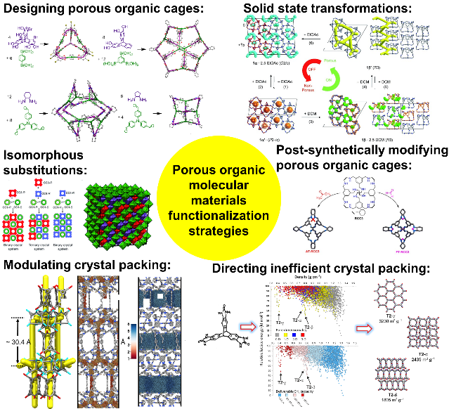

Copyright WILEY-VCH Verlag GmbH & Co. KGaA, 69469 Weinheim, Germany, 2018.

