Impact of NaF During Chloride Treatment of CdTe Solar Cells
Thomas P. Shalvey and Jonathan D. Major

Stephenson Institute for Renewable Energy, University of Liverpool, Liverpool, L69 7ZF, UK

ABSTRACT

Sodium has shown promise as a p-type dopant in CdTe solar cells but reports of increased acceptor concentrations are typically accompanied by adverse structural and morphological changes. Here we show that these changes, which occur upon chlorine activation in the presence of sodium, are dependent upon the initial grain structure. We find that small grain CdTe films deposited by sputtering undergo extensive recrystallisation following MgCl₂ treatment, whereas large grain CdTe deposited by close space sublimation (CSS) do not. This allowed the effect of NaF on device performance to be studied, which is shown to strongly enhance CdS-CdTe intermixing. This results in lower efficiencies due to inferior junction quality, without any clear change in acceptor concentration.
Keywords: cadmium compounds, sodium, photovoltaic cells, solar energy, thin films, CdTe

Introduction
Recent improvements to the device structure of CdTe solar cells have led to a record efficiency of 22.1% after a long period of stagnation [1]. There remains significant scope for further increases in efficiency by improving the V_{oc} of devices, which typically do not exceed 850 mV. Several factors contribute to the voltage deficit observed in CdTe solar cells in comparison to other technologies, such as low doping density, short carrier lifetime, a non-ohmic back contact and a complex defect structure introduced during chlorine activation [2]. In recent years there has been a substantial research effort to move away from copper doping, which limits carrier concentration below 10¹⁵ cm⁻³ and causes long term stability issues [3], towards Group V dopants such as phosphorus, arsenic [4] and antimony [5]. These have shown promising results, initially with carrier concentrations above 10¹⁶ cm⁻³ in single crystal devices with V_{oc} >1 V [6] and more recently in polycrystalline device with efficiency >20% [7]. A remaining cap to the doping level achievable though is that they also introduce AX centers meaning self-compensation remains problematic [8], [9].
Sodium has been reported as an effective p-type dopant in both CdTe single crystals and thin films [10], [11]. It has a shallow Na_{Cd} acceptor level 59 meV above the valence band in comparison to 160 meV for copper, which is more favorable for achieving high doping densities. The interstitial Na_{i} level is a similarly shallow donor level so while it is not expected to be a lifetime limiting deep defect [12], significant doping compensation may occur, hence careful control is required so as not limit the ability to dope highly p-type. Sodium is highly mobile in CdTe, especially during the activation process as evidenced in this work and consistent with other previous work (refs [11], [13]). Emziane et al [14] has studied the distribution of Na in device when included (albeit unintentionally) in the CdCl₂ treatment. Upon Cl treatment the sodium goes from an out-diffusion like profile (10¹³ cm⁻³) from the glass substrate to a homogenous distribution of Na (10¹⁶ cm⁻³) throughout the CdTe layer. Since sodium is likely to be a common impurity in CdTe solar cells, especially when deposited on soda-lime glass, it is important to understand its role in the ubiquitous chlorine activation treatment.
Incorporation of sodium into single crystal devices has proved successful, with device V_{oc} reaching 929 mV and N_{A} up to 7×10¹⁵ cm⁻³ [15]. Replicating this in polycrystalline devices has had mixed success though efforts have been limited. The incorporation of Na into thin film CdTe has centered around NaF as this is known to be an effective sodium source in CIGS [16]. Kranz [11] showed that by introducing a thin layer of NaF prior to chlorine treatment of thermally evaporated CdTe, the acceptor density could be increased by an order of magnitude to ~10¹⁵ cm⁻³. Furthermore, inclusion of sodium during the chlorine treatment was shown to significantly enhance grain growth following recrystallisation. This unfortunately also led to widening of grain boundaries creating shunting pathways, as well as a near complete consumption of the CdS layer resulting in a poor-quality junction. Similar observations of grain growth with NaF have been made by Amirkhalili on MOCVD grown CdTe films [17], and Dhere on low temperature close space sublimation (CSS) grown CdTe [18].Indeed, all prior work on NaF treatment of CdTe solar cells has focused on low temperature deposition methods. Higher temperature growth methods, such as standard CSS, result in larger grained films [19] which do not undergo significant recrystallisation or grain grown upon chlorine treatment unlike those grown by lower temperature deposition such as sputtering [20]. Additionally CdS-CdTe intermixing in CSS devices is also known to be dominated by the thermal history of the device during the CdTe growth stage rather than during CdCl₂ activation [21]. It is therefore a reasonable expectation that the manner of CdTe deposition may have as big an influence on the NaF treatment as treatment itself. By using CSS grown CdTe, it is anticipated that intermixing might occur prior to incorporation of NaF instead of during chlorine treatment, which may prevent the consumption of the CdS layer observed in previous efforts.
This work compares the effect of NaF and MgCl₂ treatment on the structural properties of both sputtered and CSS grown CdTe/CdS film stacks, and the subsequent impact on device performance.

Experimental Details
Devices were fabricated in superstrate configuration using commercially available TEC15M glass substrates (NSG Ltd), which are coated with SnO₂:F (FTO) and include a SnO₂ buffer layer. A 100 nm CdS layer was deposited onto these substrates via RF sputtering with a substrate temperature of 200 °C. CdTe deposition was carried out either by sputtering or by CSS. Sputtered CdTe films were deposited at a substrate temperature of 300 °C to a thickness 2.5μm. CSS grown CdTe was deposited with source and substrate temperatures of 610 °C and 510 °C, respectively. This was carried out in a two-step process, with the main deposition occurring under 30 Torr of N₂, and a short 30 second step under vacuum to fill voids, resulting in a film thickness of 4 - 5μm.
NaF was deposited at the back surface of the CdTe via thermal evaporation, with film thickness monitored with a calibrated quartz crystal microbalance. The film stack then underwent a MgCl₂ treatment [22] at 410 °C for 20 min before etching with a dilute nitric-phosphoric acid for 15 s. Finally, nine 0.25 cm² contacts per substrate were formed by evaporating 50 nm Au through a mask.
Devices reported in this work are comparatively low efficiency, ~8%, compared to current champion devices. This is due to the desire to evaluate the influence of NaF on a stable consistent baseline with minimal secondary influences. We have used a standard thick CdS layer, resulting in optical loss and have not included copper which will also hinder performance. This was done as it was considered the doping influence of copper inclusion would mask the influence of NaF and would further be related to the grain structure.
Film morphology was examined with using a JEOL JSM-7001F scanning electron microscope (SEM). X-ray diffraction (XRD) measurements were taken with a Rigaku SmartLab diffractometer. Current density – voltage (JV) measurements were taken with a TS Space solar simulator and Keithley 2400 SMU. External quantum efficiency (EQE) was measured with a Bentham PVE300 system calibrated with a Si reference cell. Capacitance-voltage (CV) measurements were taken in the dark with a Solartron SI1260 impedance analyzer with an AC perturbation amplitude of 30 mV and frequency of 100 kHz, and varying DC bias between -0.5 and +0.5 V in order to probe the main CdS/CdTe junction and avoid the effects of a non-ohmic back contact.

Results and Discussion
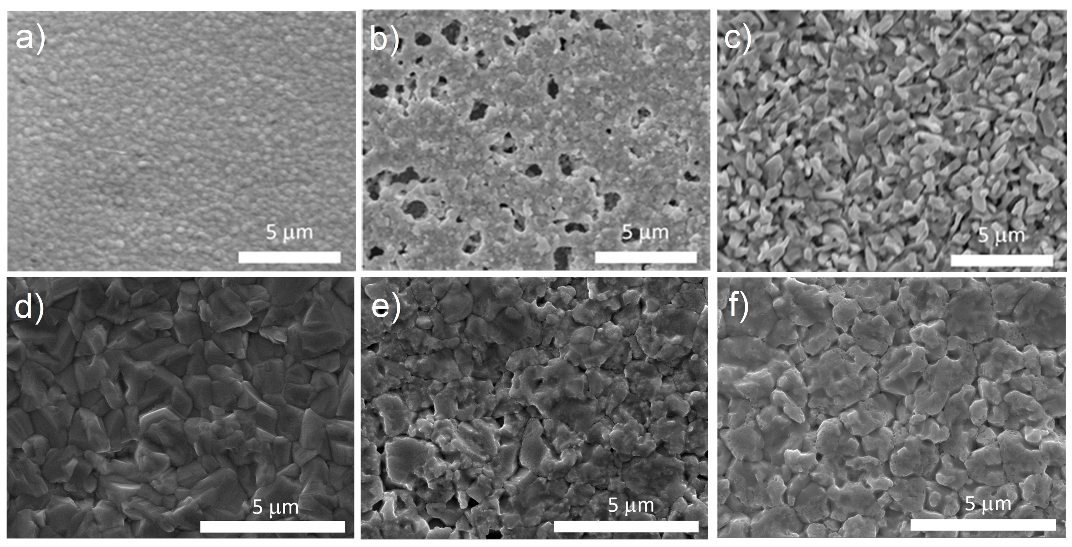
Prior to fabrication of complete device structures an initial study was carried out on CdS/CdTe film to assess the influence of a NaF and MgCl₂ treatment on CdTe film morphology and grain structure. A comparison of NaF induced recrystallisation of CdTe films grown by sputtering (substrate temperature of 300°C) and CSS (substrate temperature of 510°C) was made to assess if it is possible to obtain an increased acceptor density as demonstrated by Kranz et al [11], without the accompanying morphology changes that would prove detrimental to device performance. Figure 1 shows SEM images of sputtered and CSS grown CdTe and compares films as grown (a,d), following a standard MgCl₂ activation treatment (b,e), and a combined 5nm NaF and MgCl₂ treatment (c,f). Figure 1a shows a uniform CdTe film with small, compact grains typical for sputter deposition. Following MgCl₂ treatment (Figure 1b), there is a small increase in grain size, as well as less rounded edges to individual grains compared to the as grown state. There are also numerous pinholes in the film where the aggressive recrystallisation has left areas of the underlying substrate exposed. Following contacting this would provide shunting pathways between the interface and back contact, resulting in either reduced photovoltaic performance or complete failure. For films with 5 nm NaF deposited prior to MgCl₂ treatment (Figure 1c), the recrystallisation is strongly enhanced, with significant grain growth and faceting. Although grain growth is generally beneficial to device performance due to fewer grain boundaries, figure 2 shows a lower magnification image of the same area indicating that this grain growth is accompanied by large areas of exposed substrate (~10 μm diameter pinholes), which renders the films semi-transparent and not suitable for further device processing. This contrasts with the CSS grown films (Figure 1 d-f), where there is no grain growth apparent from the back surface upon MgCl₂ treatment without NaF. The observable changes, i.e. reduced definition of some grain boundaries, can occur due to the somewhat aggressive nature of chloride treatments on the free back surface [23]. Whilst chlorine treatment does alter the morphology of the back surface, inclusion of NaF does not appear to have much of an additional impact. For CSS films in both cases there remains a continuous layer largely free from pinholes, demonstrating the material should be less prone to NaF-related recrystallisation losses.
Figure. 1. SEM images of the back surface of CdTe films deposited via sputtering (top – a,b,c) and CSS (bottom – d,e,f) onto 100 nm CdS. The morphology of films as grown (a,d), MgCl₂ treated (b,e) and MgCl₂ treated following evaporation of 5 nm NaF (c,f) is shown.
The sputtered (2.5μm) and CSS (4 - 5μm) grown CdTe films differ as the thickness has been optimised for each deposition process. Sputtered films with small grains produce smooth, continuous films as deposited and the highly absorbing nature of CdTe means there is very little light transmission after the first micron or so of material. Owing to the large amount of recrystallisation required by the film during chloride treatment CdTe thicknesses ~2.5µm result in optimal performance with thicker devices showing buried junction like behaviour or high series resistance [24]. Hence optimized sputtered CdTe devices typically use much thinner absorber layers than devices with CSS grown CdTe, which require a much thicker film to ensure continuous coverage of the substrate due to larger grains resulting in a rougher surface [25]. Although these films are optimized for the deposition conditions rather than for thickness, recrystallization is influenced predominately by initial grain size (resulting from deposition type) instead of film thickness [21], and further tests on CSS grown samples with 20nm NaF did not indicate additional recrystallization.

Fig. 2. SEM image of the back surface of a 2.5μm thick CdTe layer deposited via sputtering onto 100nm CdS. 5nm NaF has been evaporated onto the back surface prior to MgCl₂ treatment, causing enhanced recrystallization and large areas of the underlying substrate to be exposed

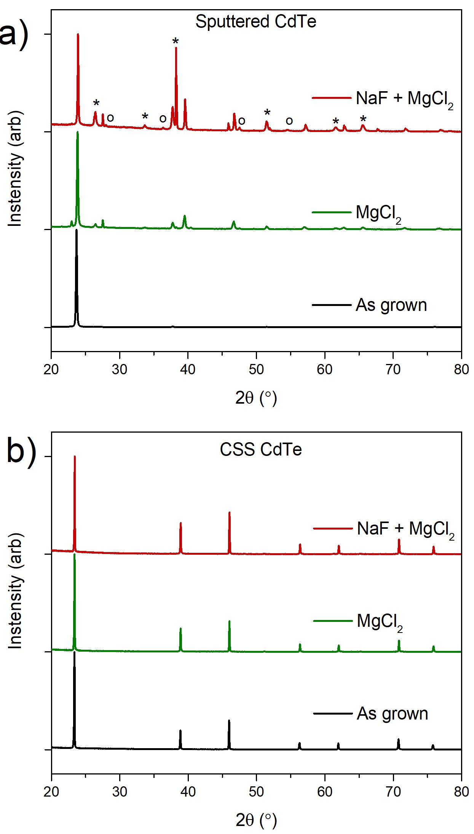
Figure. 3. XRD patterns for sputtered CdTe (a) and CSS grown CdTe (b) deposited on 100 nm CdS, normalized to the (111) CdTe peak. As grown films are compared to films with and without 5 nm NaF evaporated prior to MgCl₂ treatment at 410°C. Peaks corresponding to CdS (o) and SnO₂ (*) have been labelled.

Figure 3 compares the effect of MgCl₂ and NaF on the recrystallisation of sputtered or CSS grown CdTe via XRD analysis. Figure 3a shows that sputtered CdTe is nearly exclusively (111) oriented prior to treatment seen by the peak around 24°, as is common for low temperature growth methods [26]. MgCl₂ treatment causes recrystallisation of grains, with other CdTe peaks becoming visible in the diffraction pattern, although it retains its (111) preferential orientation. NaF and MgCl₂ treatment has a similar effect, but the recrystallisation is more pronounced resulting in a more randomized grain texture. There is also a significant signal from the CdS and SnO₂ layers underneath the CdTe, due to the exposed substrate areas shown in Figure 2. This issue is not apparent for the CSS grown film shown in Figure 3b, which shows little difference between the as grown and treated films. Whilst there is still a strong (111) preferential orientation for CSS grown CdTe, the as grown film shows a strong signal from other orientations, which is not seen for as grown sputtered CdTe. A small increase in intensity for these other peaks is observed following MgCl₂ treatment and is additionally enhanced with the addition of NaF prior to the treatment. Recrystallisation of the CSS grown CdTe is much less aggressive than for the sputtered film, indicating that a larger as deposited grain structure is more stable and may be a way to overcome the recrystallisation problems that have previously hindered the use of a combined NaF and Cl treatment in CdTe solar cells.
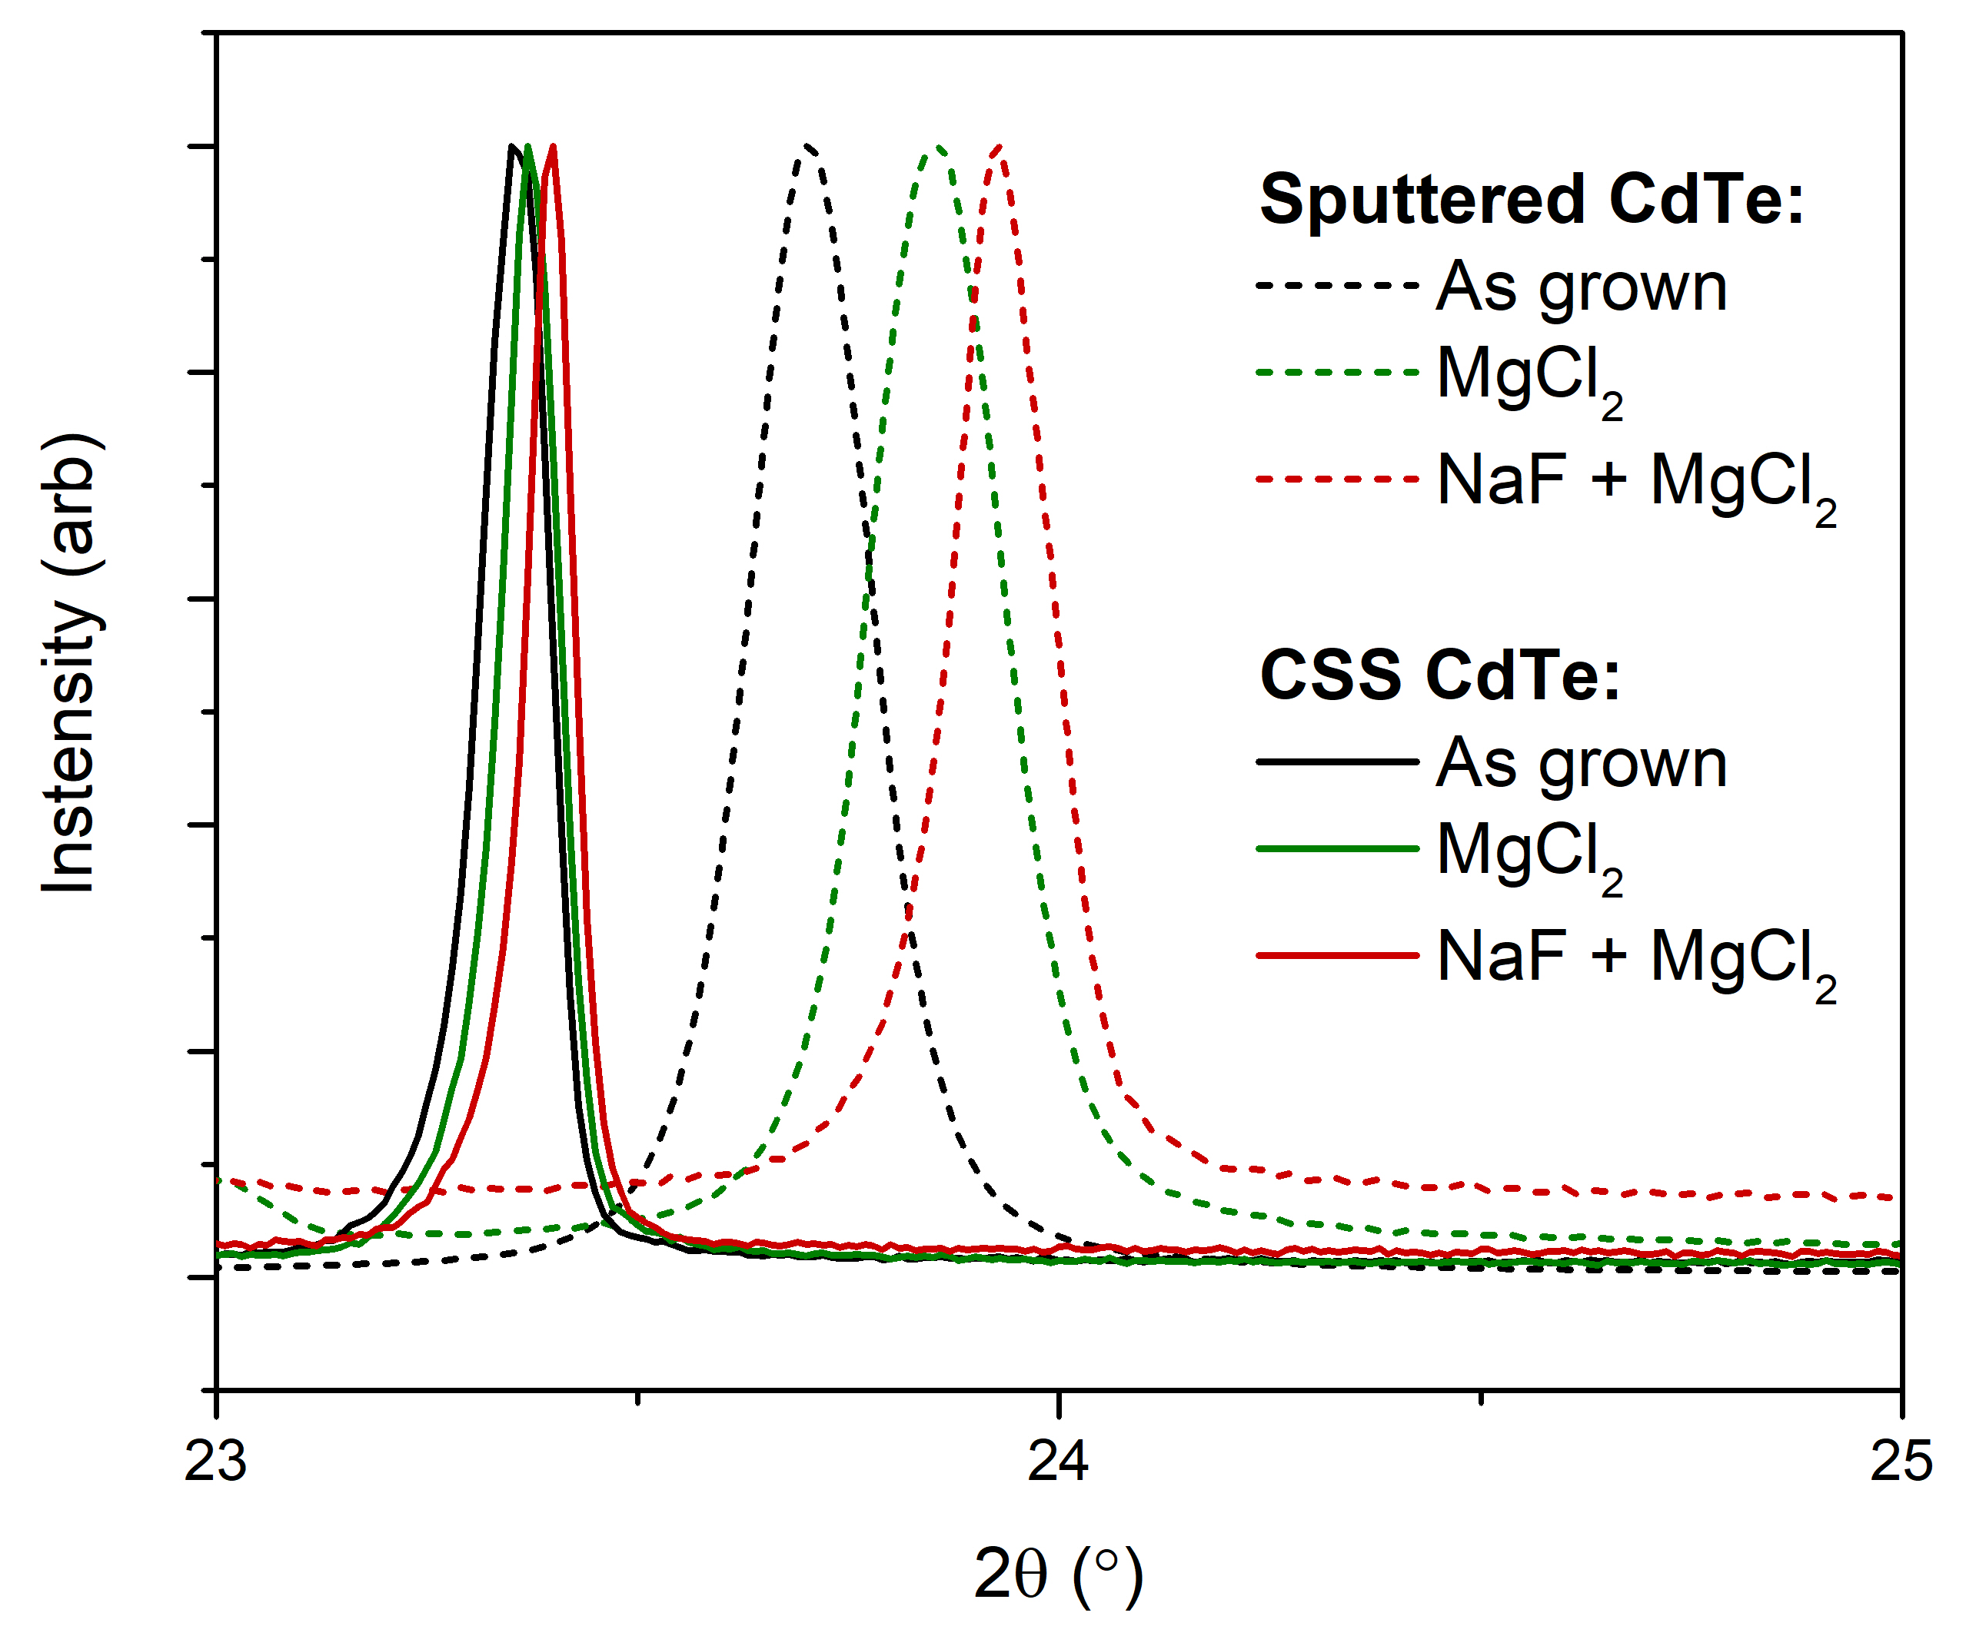
Figure 4. Normalized XRD patterns for sputtered and CSS grown CdTe films as deposited, MgCl₂ treated, and MgCl₂ treated following evaporation of 5 nm NaF between 23 - 25°, highlighting the shift of the (111) peak.

XRD data can also be used to make an assessment of the degree of intermixing between the CdS and CdTe layers. Figure 4 shows more highly resolved normalized diffraction patterns around the main (111) CdTe peak for both sputtered and CSS material. The as grown sputtered CdTe peak is centered very close to the expected position for stress-free (powdered) CdTe at 23.76°. This peak is shifted to a higher angle following MgCl₂ treatment, and even more so with a combined NaF and MgCl₂ treatment. This can be explained by considering the CdS-CdTe interdiffusion that is known to occur during chlorine treatment [27]. The substitution of sulphur onto tellurium sites decreases the average lattice spacing due to its smaller atomic radius, increasing the diffraction angle. In this way, the movement of the (111) peak is used as an indicator for the extent of CdS-CdTe intermixing. Whilst sodium and/or fluorine incorporation into the lattice might be expected to yield similar results, the low thickness of the NaF layer used here would not be sufficient to produce the observed peak shifts. Hence we can infer that for the sputtered material CdS/CdTe significant interdiffusion is occurring during MgCl₂ treatment and there is further enhancement due to the addition of NaF. We expect Na to have the dominant effect on recrystallization and intermixing, since a similar effect has been seen in other work with NaCl [11], [13]. This is supported by observations that fluorine does not readily incorporate into CdTe films, instead segregating at the back of the device, especially upon chlorine processing[14].
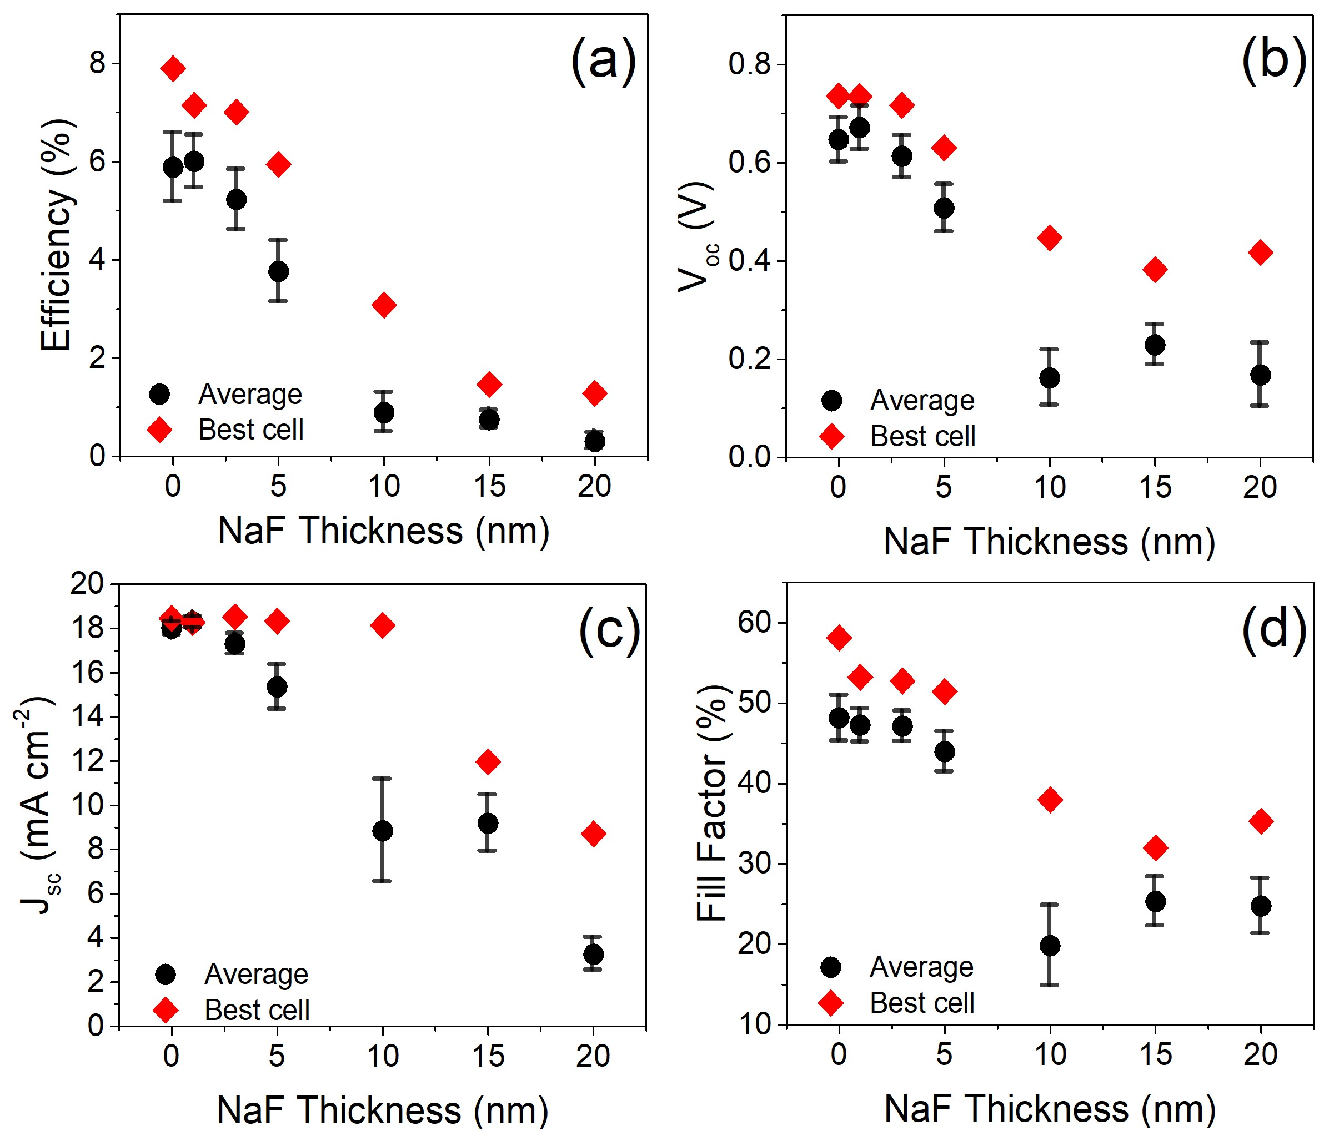
A similar trend is observed for CSS grown CdTe. The as grown peak is centered at 23.37°, which is slightly below the value expected for a CdTe powder likely due to changes in the tensile stress for the CSS grown film, increasing the average lattice spacing and therefore decreasing the diffraction angle. The shift to higher angles for the MgCl₂ treated, as well as NaF and MgCl₂ treated films, likely indicates some interdiffusion of the CdS and CdTe films is occurring during treatment. The extent of this interdiffusion appears to be significantly less pronounced than for sputtered CdTe films, indicated by the smaller changes in peak position. There could also be some influence from the thicker CSS grown CdTe film, which means there is less NaF as well as Cl per volume of CdTe and therefore less pronounced intermixing. X-rays also need to probe deeper into the sample to reach the CdS/CdTe interface compared to sputtered samples, hence the signal from this region is weaker.

Figure 5. Performance parameters for CdS/CdTe devices with between 0 – 20 nm NaF evaporated at the back surface prior to MgCl₂ treatment. The efficiency (a), open circuit voltage (b), short circuit current density (c), and fill factor (d) is given as a function of NaF thickness.
CSS based devices show stability to the recrystallisation issues observed in previous NaF and Cl treatment studies [8,11] and for sputtered layers discussed here. A series of CSS CdTe devices were fabricated with the only variable being the NaF layer thickness which was varied between 0 – 20 nm deposited via evaporation prior to the MgCl₂ treatment. Sputtered devices were not produced owing to the pronounced recrystallisation issues already discussed. Figure 5 shows both the average and peak efficiency, V_{OC}, J_{SC} and FF for devices as a function of NaF thickness extracted from JV analysis. JV and EQE curves for the highest efficiency contact from each device are given in Figure 6. The addition of NaF at the back surface results in a significant reduction in all performance parameters, with the decrease in open circuit voltage most apparent between 1-10nm NaF before leveling out around 0.4 V. The short circuit current density (J_{sc}) for the highest efficiency devices does not decrease until more than 10 nm NaF is applied, after which it begins to decrease rapidly. The fill factor gradually decreases for all NaF thicknesses used, as a result of both increased series resistance and significantly lower shunt resistance. Comparison of the JV curves (Figure 6a) shows that as the thickness of the NaF layer is increased, the V_{oc} decreases rapidly as the diode response becomes weaker due to decreasing shunt resistance. For thicknesses >10 nm, there is also a significant decrease in J_{sc}. EQE measurements were normalized to the maximum collection efficiency for each curve (Figure 6c) to allow easy comparison and can, in part, identify the source of these current losses. The clearest change is the increased collection below 500 nm for devices with thick NaF layers which is typically associated with a reduction in the thickness of the CdS layer. Although the CdS layer does contribute to parasitic absorption of high energy photons, the consumption of this layer means a poor-quality junction may be formed with the underlying SnO₂ which is not as effective in separating charges. This lowers absolute collection efficiency across all wavelengths as shown in figure 6b, despite the normalized collection increasing below 500nm in figure 6c. There are two potential causes for the reduced CdS absorption observed either a) excessive intermixing of CdS and CdTe results in consumption of the CdS layer or b) significant recrystallisation of the CdS has occurred leading to higher transparency of the CdS due to voiding. Some change in the degree of intermixing is probable given the observations from figure 3 however there some characteristics associated with increased intermixing are lacking from the EQE curves. Te interdiffusion into the CdS forms a lower bandgap CdS_{1-x}Te_{x} region which reduces EQE response in the ~520-550nm range [28]. Additionally diffusion of sulfur into the CdTe layer can reduce the bandgap via the band bowing effect, increasing the EQE cutoff to longer wavelengths in a similar manner to that currently being achieved with Se incorporation [29]. Neither of these features are strongly apparent in the EQE data. It therefore seems likely that while some additional interdiffusion is occurring, the decrease in CdS parasitic response may be due to recrystallisation of the CdS as observed by both Krantz et al [11] and Durose et al [13]. The extent of interdiffusion and agglomeration of the CdS layer might be reduced by using a less aggressive chlorine treatment, however this would likely result in a compromise between maintaining a complete CdS layer with insufficient chlorine incorporation and under-activation of the CdTe layer.
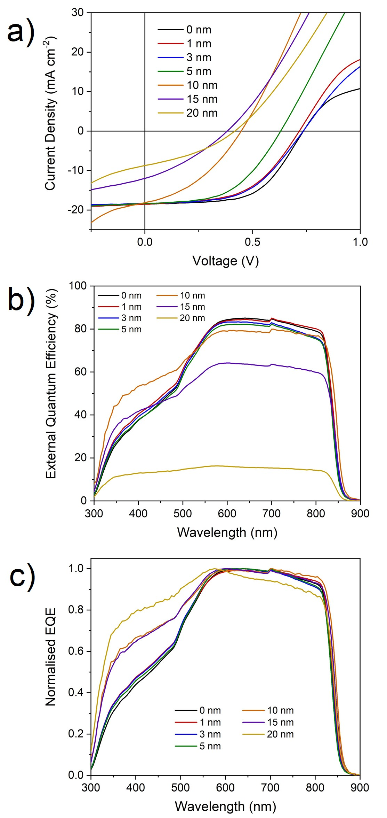
Fig. 6. (a) Current density – voltage measurements (b) external quantum efficiency measurements and (c) normalized external quantum efficiency measurements of the highest efficiency cell for CdS/CdTe devices with 0 – 20 nm NaF evaporated at the back surface prior to MgCl₂ treatment.

Figure 7 shows results from CV analysis used to determine doping density from the minimum of the carrier density profiles by making the approximation N_{A} = N_{CV}. Although at first glance figure 7a may indicate a shift in the depletion region away from the CdS/CdTe interface for increasing NaF thickness, there is no indication of a buried junction in EQE data. Considering the complexities encountered in CV measurements of CdTe solar cells, this interpretation may be too simplistic and does not account for other affects such as a rectifying back contact [30]. However, it is clear that all devices tested have a bulk doping density around 10¹⁴ cm⁻³, with no clear trend as a function of NaF thickness. This is in contrast to Kranz et al. [11] who found an increased acceptor density in evaporated CdTe/CdS devices with the addition of NaF to the chlorine treatment. The lack of change in the doping density despite significant impact upon device structure due to the presence of Na indicate strong compensation of any Na-induced acceptors by Na interstitials. Alternatively, it may indicate that the lack of recrystallisation of CSS CdTe layers means a higher annealing temperature is required to effectively incorporate the Na as a dopant. Given the deleterious impact of the current temperature used, any such increase would further compromise device performance.
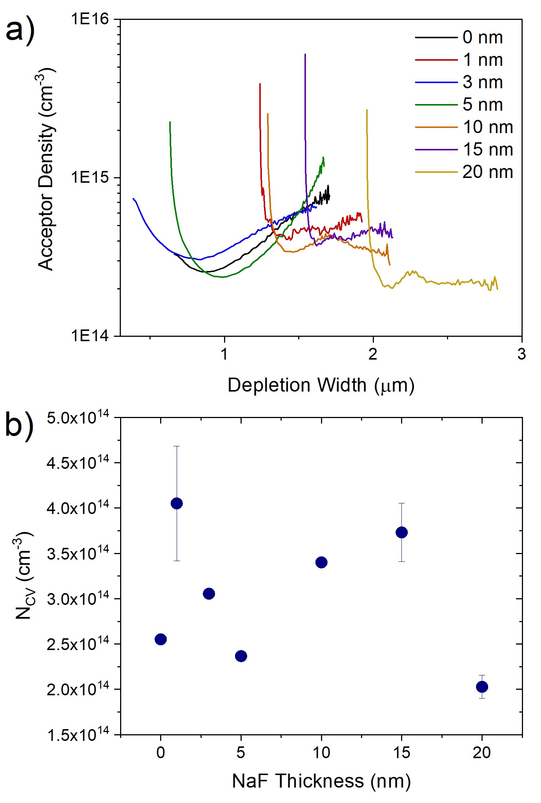
Fig. 7. (a) Acceptor density versus depletion width plots extracted from CV measurements taken between -0.5V to +0.5V for devices with between 0-20nm NaF applied at the back surface prior to MgCl2 treatment, and (b) bulk acceptor density (N_{CV} ) estimated from the minima of these curves, with errors corresponding to three datapoints either side of the minimum

Conclusion
The inclusion of NaF into CdTe/CdS solar cells during MgCl₂ treatment has been studied to determine the suitability of sodium as a p-type dopant in CdTe. It was found that although CdTe grown by CSS is not as prone to sodium induced recrystallisation as CdTe grown by lower temperature deposition methods, the impact on the CdS layer remains a problem. This is seen upon incorporation of NaF into device structures, whereby a drastic decrease in performance is observed due to consumption of the CdS layer leading to a poor-quality junction. Furthermore, no increase in acceptor concentration was observed, potentially indicating a strong self-compensation effect. The primary limit in the current device structure remains the interaction of Na with the CdS layer hence devices with and oxide partner layer such as Mg_{x}Zn_{1-x}O [31] may be amenable to more aggressive NaF treatments.

Acknowledgments
The authors gratefully acknowledge Dr Guillaume Zoppi and Prof Ken Durose for useful discussions related to the work and EPSRC for funding (EP/N01457/1 and EP/L01551X/1).

References
[1] M. A. Green, Y. Hishikawa, E. D. Dunlop, D. H. Levi, J. Hohl-Ebinger, M. Yoshita, and A. W. Y. Ho-Baillie, “Solar cell efficiency tables (Version 53),” Prog. Photovoltaics Res. Appl., vol. 27, no. 1, pp. 3–12, Jan. 2019.
[2] R. M. Geisthardt, M. Topic, and J. R. Sites, “Status and Potential of CdTe Solar-Cell Efficiency,” IEEE J. Photovoltaics, vol. 5, no. 4, pp. 1217–1221, Jul. 2015.
[3] E. Artegiani, D. Menossi, H. Shiel, V. Dhanak, J. D. Major, A. Gasparotto, K. Sun, and A. Romeo, “Analysis of a novel CuCl ₂ back contact process for improved stability in CdTe solar cells,” Prog. Photovoltaics Res. Appl., vol. 27, no. 8, p. pip.3148, May 2019.
[4] G. Kartopu, O. Oklobia, D. Turkay, D. R. Diercks, B. P. Gorman, V. Barrioz, S. Campbell, J. D. Major, M. K. Al Turkestani, S. Yerci, T. M. Barnes, N. S. Beattie, G. Zoppi, S. Jones, and S. J. C. Irvine, “Study of thin film poly-crystalline CdTe solar cells presenting high acceptor concentrations achieved by in-situ arsenic doping,” Sol. Energy Mater. Sol. Cells, vol. 194, no. February, pp. 259–267, 2019.
[5] B. E. McCandless, W. A. Buchanan, C. P. Thompson, G. Sriramagiri, R. J. Lovelett, J. Duenow, D. Albin, S. Jensen, E. Colegrove, J. Moseley, H. Moutinho, S. Harvey, M. Al-Jassim, and W. K. Metzger, “Overcoming Carrier Concentration Limits in Polycrystalline CdTe Thin Films with In Situ Doping,” Sci. Rep., vol. 8, no. 1, p. 14519, Dec. 2018.
[6] J. M. Burst, J. N. Duenow, D. S. Albin, E. Colegrove, M. O. Reese, J. A. Aguiar, C.-S. Jiang, M. K. K. Patel, M. M. Al-Jassim, D. Kuciauskas, S. Swain, T. Ablekim, K. G. Lynn, and W. K. Metzger, “CdTe solar cells with open-circuit voltage breaking the 1 V barrier,” Nat. Energy, vol. 1, no. 3, p. 16015, Feb. 2016.
[7] W. K. Metzger, S. Grover, D. Lu, E. Colegrove, J. Moseley, C. L. Perkins, X. Li, R. Mallick, W. Zhang, R. Malik, J. Kephart, C.-S. Jiang, D. Kuciauskas, D. S. Albin, M. M. Al-Jassim, G. Xiong, and M. Gloeckler, “Exceeding 20% efficiency with in situ group V doping in polycrystalline CdTe solar cells,” Nat. Energy, pp. 1–9, Aug. 2019.
[8] M. A. Flores, W. Orellana, and E. Menéndez-Proupin, “Self-compensation in phosphorus-doped CdTe,” Phys. Rev. B, vol. 96, 2017.
[9] T. Ablekim, S. K. Swain, W.-J. Yin, K. Zaunbrecher, J. Burst, T. M. Barnes, D. Kuciauskas, S.-H. Wei, and K. G. Lynn, “Self-compensation in arsenic doping of CdTe,” Sci. Rep., vol. 7, no. 1, p. 4563, Dec. 2017.
[10] B. L. Crowder and W. N. Hammer, “Shallow Acceptor States in ZnTe and CdTe,” Phys. Rev., vol. 150, no. 2, pp. 541–545, 1966.
[11] L. Kranz, J. Perrenoud, F. Pianezzi, C. Gretener, P. Rossbach, S. Buecheler, and A. N. Tiwari, “Effect of sodium on recrystallization and photovoltaic properties of CdTe solar cells,” Sol. Energy Mater. Sol. Cells, vol. 105, pp. 213–219, 2012.
[12] J.-H. Yang, W.-J. Yin, J.-S. Park, J. Ma, and S.-H. Wei, “Review on first-principles study of defect properties of CdTe as a solar cell absorber,” Semicond. Sci. Technol., vol. 31, no. 8, p. 083002, Aug. 2016.
[13] K. Durose, D. Albin, R. Ribelin, R. Dhere, D. King, H. Moutinho, R. Matson, P. Dippo, J. Hiie, and D. Levi, “The influence of NaCl on the microstructure of CdS films and CdTe solar cells,” in Microscopy of Semiconductor Materials, 1999, pp. 207–210.
[14] M. Emziane, K. Durose, D. P. Halliday, N. Romeo, and A. Bosio, “SIMS depth profiling of CdTe-based solar cells grown on sapphire substrates,” Thin Solid Films, vol. 511–512, pp. 66–70, Jul. 2006.
[15] J. N. Duenow, J. M. Burst, D. S. Albin, D. Kuciauskas, S. W. Johnston, R. C. Reedy, and W. K. Metzger, “Single-crystal CdTe solar cells with Voc greater than 900 mV,” Appl. Phys. Lett., vol. 105, no. 5, p. 053903, Aug. 2014.
[16] P. Reinhard, B. Bissig, F. Pianezzi, E. Avancini, H. Hagendorfer, D. Keller, P. Fuchs, M. Döbeli, C. Vigo, P. Crivelli, S. Nishiwaki, S. Buecheler, and A. N. Tiwari, “Features of KF and NaF Postdeposition Treatments of Cu(In,Ga)Se ₂ Absorbers for High Efficiency Thin Film Solar Cells,” Chem. Mater., vol. 27, no. 16, pp. 5755–5764, Aug. 2015.
[17] A. Amirkhalili, V. Barrioz, S. J. C. Irvine, N. S. Beattie, and G. Zoppi, “A combined Na and Cl treatment to promote grain growth in MOCVD grown CdTe thin films,” J. Alloys Compd., vol. 699, pp. 969–975, Mar. 2017.
[18] R. Dhere, K. Ramanathan, J. Keane, J. Zhou, H. Moutinho, S. Asher, and R. Noufi, “Effect of Na Incorporation on the Growth and Properties of CdTe/CdS Devices,” 2005.
[19] J. D. Major, Y. Y. Proskuryakov, K. Durose, G. Zoppi, and I. Forbes, “Control of grain size in sublimation-grown CdTe, and the improvement in performance of devices with systematically increased grain size,” Sol. Energy Mater. Sol. Cells, vol. 94, no. 6, pp. 1107–1112, 2010.
[20] J. D. Major, “Grain boundaries in CdTe thin film solar cells: a review,” Semicond. Sci. Technol., vol. 31, no. 9, p. 093001, Sep. 2016.
[21] A. A. Taylor, J. D. Major, G. Kartopu, D. Lamb, J. Duenow, R. G. Dhere, X. Maeder, S. J. C. Irvine, K. Durose, and B. G. Mendis, “A comparative study of microstructural stability and sulphur diffusion in CdS/CdTe photovoltaic devices,” Sol. Energy Mater. Sol. Cells, vol. 141, pp. 341–349, Oct. 2015.
[22] J. D. Major, R. E. Treharne, L. J. Phillips, and K. Durose, “A low-cost non-toxic post-growth activation step for CdTe solar cells,” Nature, vol. 511, no. 7509, pp. 334–337, 2014.
[23] J. D. Major, L. Bowen, R. E. Treharne, L. J. Phillips, and K. Durose, “NH 4 Cl Alternative to the CdCl 2 Treatment Step for CdTe Thin-Film Solar Cells,” IEEE J., vol. 5, no. 1, pp. 386–389, 2015.
[24] A. D. Compaan, A. Gupta, J. Drayton, S. H. Lee, and S. Wang, “14% Sputtered thin-film solar cells based on CdTe,” Phys. Status Solidi Basic Res., vol. 241, no. 3, pp. 779–782, Mar. 2004.
[25] N. R. Paudel, M. Young, P. J. Roland, R. J. Ellingson, Y. Yan, and A. D. Compaan, “Post-deposition processing options for high-efficiency sputtered CdS/CdTe solar cells,” J. Appl. Phys., vol. 115, no. 6, p. 064502, Feb. 2014.
[26] H. R. Moutinho, F. S. Hasoon, F. Abulfotuh, and L. L. Kazmerski, “Investigation of polycrystalline CdTe thin films deposited by physical vapor deposition, close‐spaced sublimation, and sputtering,” J. Vac. Sci. Technol. A Vacuum, Surfaces, Film., vol. 13, no. 6, pp. 2877–2883, Nov. 2002.
[27] R. G. Dhere, S. E. Asher, K. M. Jones, M. M. Al-Jassim, H. R. Moutinho, D. H. Rose, P. Dippo, and P. Sheldon, “Characterization of intermixing at the CdS/CdTe interface in CSS deposited CdTe,” in AIP Conference Proceedings, 2008, vol. 353, no. 1, pp. 392–399.
[28] S. H. Demtsu and J. R. Sites, “Quantification of losses in thin-film CdS/CdTe solar cells,” Conf. Rec. Thirty-First IEEE Photovolt. Spec. Conf. - 2005, pp. 347–350, 2005.
[29] T. Baines, G. Zoppi, L. Bowen, T. P. Shalvey, S. Mariotti, K. Durose, and J. D. Major, “Incorporation of CdSe layers into CdTe thin film solar cells,” Sol. Energy Mater. Sol. Cells, vol. 180, 2018.
[30] J. V. Li, A. F. Halverson, O. V. Sulima, S. Bansal, J. M. Burst, T. M. Barnes, T. A. Gessert, and D. H. Levi, “Theoretical analysis of effects of deep level, back contact, and absorber thickness on capacitance–voltage profiling of CdTe thin-film solar cells,” Sol. Energy Mater. Sol. Cells, vol. 100, pp. 126–131, May 2012.
[31] J. M. Kephart, J. W. McCamy, Z. Ma, A. Ganjoo, F. M. Alamgir, and W. S. Sampath, “Band alignment of front contact layers for high-efficiency CdTe solar cells,” Sol. Energy Mater. Sol. Cells, vol. 157, pp. 266–275, 2016.

