Comparison of the Normalized Maximum Field Strength using E‑field Probe and VNA Methods in a Reverberation Chamber

Qian Xu, *Member, IEEE*, Kai Chen, Xueqi Shen, Weihong Li, Yongjiu Zhao and Yi Huang, *Senior Member, IEEE*

*Abstract-*We report a comparative study on the maximum field strength in a reverberation chamber using a vector network analyzer (VNA) and a field probe. The measurements are performed in a reverberation chamber with a lowest usable frequency around 80 MHz. The time domain (inverse Fourier transform) and frequency domain methods are adopted in the VNA measurements. Measurement results show that these methods agree well with each other with reasonable differences. The field uniformity is also given. Discussion on different methods is finally summarized which shows that the VNA based measurements can collect more samples and reduce the overall uncertainty.



Figure 1. The definition of the radiation efficiency $η_{rad}$, where $P_{t}$ is the input power at the port of the antenna, $P_{ref}$ is the reflected power, and $P_{net}$ is the net radiated power.

Key words: Electric field, field uniformity, reverberation chamber.

1. Introduction

In electromagnetic compatibility (EMC) test and over-the-air (OTA) measurement, reverberation chambers (RCs) have been widely used in recent years [1-7]. Because of the high *Q* factor and the inherent statistical behavior, RC is a good facility to emulate complex electromagnetic environment with controllable statistical electromagnetic fields.[1]

In practice, the electric field (E-field) inside an RC has to be quantified for a required input power, i.e. the chamber transfer function needs to be known [1-10]. In the radiated susceptibility (RS) test for automobile industry [2], we focus on the maximum field strength the RC can provide and the corresponding input power has to be determined. Although only the electric field probe method is documented for the RC validation in the IEC standard [1], alternative methods can be applied.

In this letter, we compare the results obtained by using a vector network analyzer (VNA) and an electric field probe. When using a VNA, two methods are applied, the time domain (TD) method and the frequency domain (FD) method. Although these three methods have equivalencies in theory [11-13], there are differences which should be noted in practice: 1) the loss of the transmitting (Tx) antenna and the receiving (Rx) antenna (including the mismatch and the radiation efficiency); 2) the inherent statistical variation of the measured results. If the loss of the Tx and/or Rx antenna are/is not corrected, systematic errors occur and the measured E-field would be higher or lower than the real value. Another aspect is that the RC is a statistical environment, but finite samples are used in measurements, this would lead statistical variations of the measured E-field (or required input power). We give the theory first and detail the measurement results and discussion.

1. Theory

Considering the radiation efficiency and the mismatch of the Tx and Rx antenna, the chamber transfer function is defined according to the IEC standard [1]

$$T_{corr}=〈\frac{〈{\left|S_{21}\right|}^{2}〉}{\left(1-{\left|S_{11}\right|}^{2}\right)\left(1-{\left|S_{22}\right|}^{2}\right)η_{radTx}η_{radRx}}〉 (1)$$

where $S_{21}$, $S_{11}$ and $S_{22}$ are the *S*-parameters measured by the VNA for each stirrer position, $〈∙〉$ means the average over different stirrer or antenna positions, and $η_{rad*}$ represents the radiation efficiency of the Tx or Rx antenna. The definition of the radiation efficiency of the antenna is illustrated in Fig. 1. The ‘total efficiency’ includes the mismatch and radiation efficiency of the antenna, when the RC is well-stirred [14, 15] we have $S_{11FS}=〈S_{11}〉$ and $η_{tot}=\left(1-{\left|S_{11FS}\right|}^{2}\right)η_{rad}=\left(1-{\left|〈S_{11}〉\right|}^{2}\right)η_{rad}$, where $S_{11FS}$ means the reflection coefficient of an antenna measured in free space (or in a anechoic chamber). In a well-stirred RC [1-6]

$$T_{corr}=\frac{Qλ^{3}}{16π^{2}V} (2)$$

where $λ$ is the wavelength and $V$ is the RC volume. The E-field in a well-stirred RC for a received power of $P_{r}$ can be obtained as [10]

$$〈\left|E_{x}\right|〉=\frac{4π\sqrt{5π}}{λ\sqrt{η_{totRx}}}\sqrt{〈P_{r}〉} (3)$$

From (2)-(3), and applying $〈P_{r}〉=P_{netIn}T_{corr}η_{totRx}$ where $η_{totRx}$ is the total efficiency of the Rx antenna, $P_{netIn}$ is the net input power of the RC, thus the E-field can be related to $P_{netIn}$ as

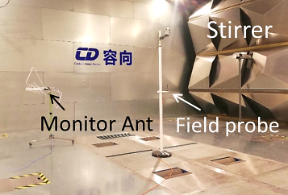 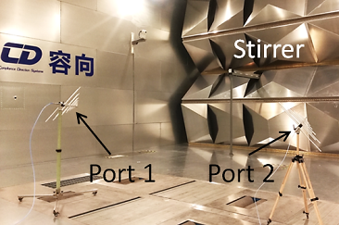

(a) (b)

Figure 2. (a) RC calibration using a Tx antenna and a field probe (field probe based method), the Tx antenna is located at the top-left corner in the RC which is not shown in the figure, (b) RC calibration using two pairs of biconical antennas, LPDAs and horn antennas (VNA based method). The dimensions of the RC are 10.8 m × 12.6 m × 6 m.

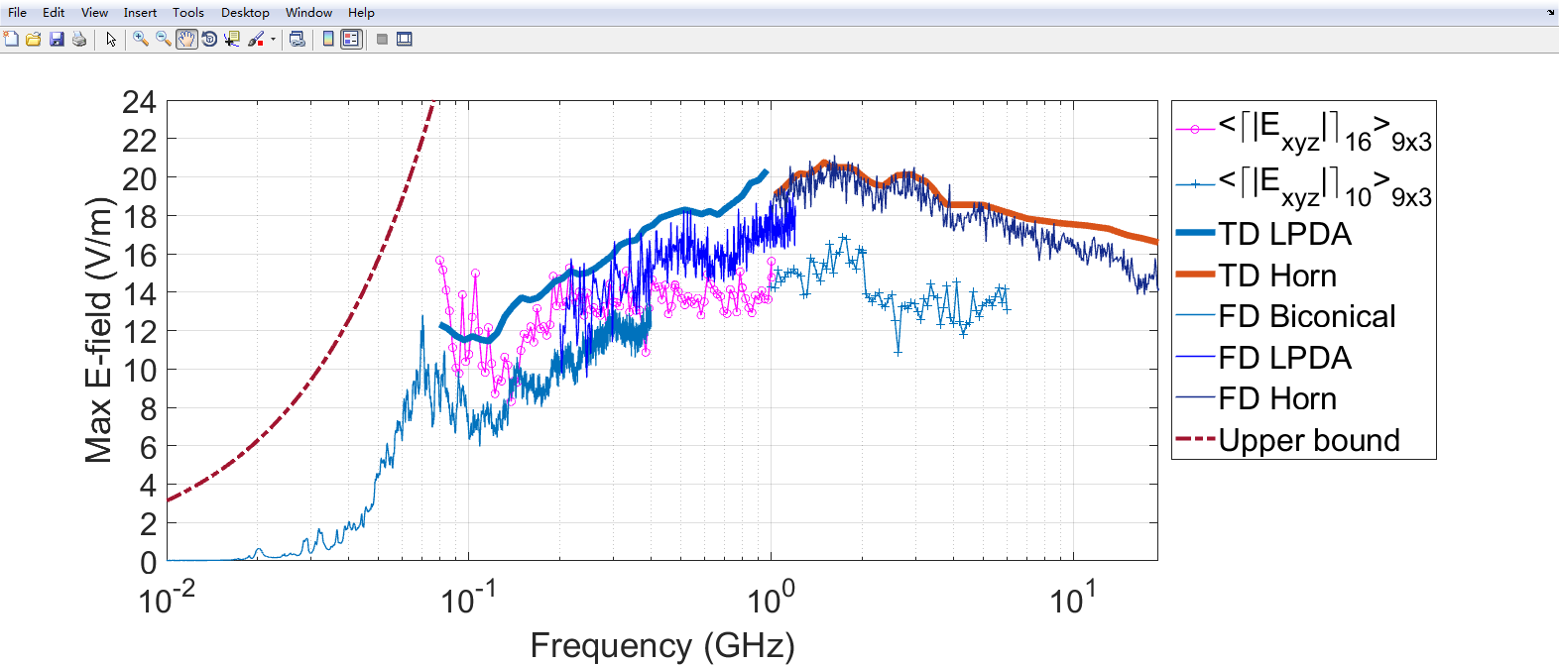

Figure 3. A comparison of the maximum E-fields obtained from the field probe, the TD method and the FD method using VNA, the upper bound is also given. The E-field magnitude is normalized to 1 W input power.

$$〈\left|E_{x}\right|〉=\sqrt{5πλQP_{netIn}/V} (4)$$

From (4), the E-field is related to the *Q* factor of a well-stirred RC, and the *Q* factor depends on the total loss in an RC. If we consider all the losses in the RC as an equivalent average absorption cross section (ACS), we have [3]

$$Q=\frac{2πV}{λ{〈ACS〉}_{all}} (5)$$

where ${〈ACS〉}_{all}$ represents the equivalent average ACS including all the losses from the cavity walls, loading objects, aperture leakage and the ACS of antennas.

From the theory we can expect:

1) If the validation is performed using a field probe, the results actually depend on the Tx antenna, because the net input power $P_{netIn}$ depends on the antenna performance. If a different antenna is used, the RC needs to be revalidated or the total efficiency of the antenna has to be quantified;

2) If the validation is performed using a VNA, the *Q* factor can be measured very accurately, the results can give theoretical values which are independent of antenna performance (when the ACS of antennas does not dominate the total loss in an RC).

1. Measurement Results

The measurement scenarios are illustrated in Fig. 2. In Fig. 2(a), the RC validation was performed using a field probe and a Tx antenna. A log-periodic dipole antenna (LPDA) was used for frequencies below 1 GHz and a horn antenna was used for frequencies above 1 GHz (not shown in Fig. 2(a)); In Fig. 2(b), the RC validation was performed using two pairs of biconical antennas, LPDA and horn antennas which cover the whole frequency band. In Fig. 2(a), a monitor antenna was also used to observe the received power [1].

For the field probe based method, considering the dynamic range of the field probe, 10 W input power was applied at the Tx antenna port. Actually this means the net input power was smaller than 10 W, since we have a fixed length cable connected to the Tx antenna located at the top-left corner of the RC (which can be included in the total efficiency of the Tx antenna). 9 probe positions were measured in the working volume, 16 and 10 stirrer positions were used in the frequency range of 80 MHz – 1 GHz and 1 GHz – 6 GHz, respectively, according to the standard [1, 2] or customer requirement. Since the electric field (E-field) is proportional to the square root of the input power $P_{t}$, we normalized the measured E-field to $\sqrt{P_{t}}$ to obtain the normalized E-field for 1 W input power. The measured results are presented in Fig. 3, where ${〈{\left\lceil \left|E_{xyz}\right|\right\rceil }_{16}〉}_{9×3}$ means the measured maximum E-fields over 16 stirrer positions were averaged over 9 probe positions with 3 polarizations ($\left|E_{x}\right|$, $\left|E_{y}\right|$, and $\left|E_{z}\right|$) for each position.

For the VNA based method, since we have measured the chamber decay time ($τ_{RC}$) in [16] using the TD technique, the *Q* factor in (4) can be obtained from $Q=ω〈τ_{RC}〉$ [3-6], where $ω=2πf$ is the angular frequency. In the RS measurement in an RC, the maximum E-fields are of interest. By applying (4) and considering the relationship between the expectation of the maximum value (of $N$ independent samples) and the mean value of the E-field (rectangular component), we have [16]

$$〈{\left\lceil \left|E_{xyz}\right|\right\rceil }_{N}〉=α(N)π\sqrt{\frac{10c_{0}〈τ_{RC}〉P_{netIn}}{V}} (6)$$

where $c_{0}=3×{10}^{8} m/s$ is the speed of light in free space and

$$α\left(N\right)=\frac{〈{\left\lceil \left|E_{x}\right|\right\rceil }_{N}〉}{\left\langle \left|E_{x}\right|\right\rangle }=\frac{\int_{0}^{∞}{Nx^{2}{\left[1-\exp\left(\frac{-x^{2}}{2}\right)\right]}^{N-1}\exp\left(\frac{-x^{2}}{2}\right)dx}}{\sqrt{π/2}}(7)$$

where the probability density function (PDF) of ${\left\lceil \left|E_{x}\right|\right\rceil }_{N}$ (the maximum E-field over $N$ independent samples) is [10]

$$PDF\left(x\right)=Nx{\left[1-\exp\left(\frac{-x^{2}}{2}\right)\right]}^{N-1}\exp\left(\frac{-x^{2}}{2}\right), x={\left\lceil \left|E_{x}\right|\right\rceil }_{N} (8)$$

We have $α\left(10\right)≈1.89$ and $α\left(16\right)≈2.04$. Since we have assessed the independent sample number [1] for the stirrer positions, 10 and 16 are good estimations. When $P_{netIn}=1 W$, the results calculated from (6) are plotted in Fig. 3 marked as ‘TD’.

As we have calibrated the reference planes of *S*-parameters to the input port of antennas, the FD results can be used directly if the radiation efficiency of Tx and Rx antennas is ignored (by setting $η_{radTx}=η_{radRx}=100\%$ in (1)). From (1) and (3), $N=10$ and $N=16$ were used for $α(N)$ in the corresponding frequency range. The estimated E-field is shown in Fig. 3 marked with ‘FD’. Because a balun was used to match the biconical antenna, the radiation efficiency of the biconical antenna is lower than the LPDA in the overlapped frequency range (200 MHz – 400 MHz).

The theoretical upper bound of the E-field is also given for $N=10$ in Fig. 3 marked with ‘Upper bound’. This value is obtained by considering only the ACS of the Tx antenna, i.e. no extra loss except the antenna ACS in an RC. The ACS of an ideal antenna (perfectly matched, 100% radiation efficiency) is ${λ^{2}}/{(8π)}$ [3], and the *Q* factor contributed from the ACS of the antenna is ${16π^{2}V}/{λ^{3}}$ which is the upper bound of the *Q* factor. From (4) and (6), we can obtain the upper bound for the maximum E-field when $N=10$

$${〈{\left\lceil \left|E_{xyz}\right|\right\rceil }_{10}〉}_{upper}=\frac{4α\left(10\right)π}{λ}\sqrt{5πP_{netIn}} (9)$$

Although the equation of the upper bound E-field is based on the well-stirred condition of an RC and the RC is not well-stirred at low frequencies, we can still use it as an estimated value but not a practical maximum value at a specific position. Similarly, the E-field measured for frequencies lower than 80 MHz in ‘FD Biconical’ can be understood in the same way.

1. Discussion

The *Q* factor measurement has been well understood in the TD and FD measurements in [11]:

$${Q_{FDcorr}}/{Q_{TD}}=η_{radTxFD}η_{radRxFD} (10)$$

where $Q_{FDcorr}$ and $Q_{TD}$ are the *Q* factor of the RC measured in the FD and TD, respectively, $Q_{FDcorr}$ means the mismatch of antennas has been corrected, $η_{radTxFD}$ and $η_{radRxFD}$ are the radiation efficiency of the Tx and Rx antenna used in the ‘FD VNA’ measurement, respectively. The *Q* factor can also be measured using the one- or two-antenna method in [17-19].

The *Q* factor measured in the TD ($Q_{TD}$) is not affected by the insertion loss of antennas and cables, which can be considered as the inherent property of the chamber itself. Although $Q_{TD}$ includes the contribution of ACS of both Tx and Rx antennas, the ACS of Rx antenna does not dominate the total loss in an RC (especially for a loaded RC), and the load effect of the Rx antenna can be ignored. Since the results are not affected by the total efficiency of the Tx antenna, the estimated E-field will be slightly higher than that obtained from the field probe (which can be observed in Fig. 3). The ratio of these differences is $\sqrt{η_{totTx}}$, where $η_{totTx}$ is the total efficiency of the Tx antenna used in E-field probe measurement:

$$E_{probe}=E_{TDVNA}\sqrt{η_{totTx}} (11)$$

The TD method does not require VNA calibration [20], and the dynamic range of $S_{21}$ can be increased by using a power amplifier, because we are only interested in the decay speed of the TD response (not the absolute value).

The field probe based method is a direct method and can be used as final results for the RC validation, but the measurement process is time consuming and the measured results depend on the efficiency of Tx antenna. If a different Tx antenna is used, the RC has to be revalidated again (or the total efficiency of Tx antenna has already been quantified). The field probe based method also suffers from statistical fluctuation because of limited independent sample numbers, especially at low frequencies in Fig. 3. To reduce this fluctuation, more independent samples are required, which means that the stirring strategy needs to be hybridized (e.g. to include the source stir technique [21]). To reduce the measurement time, many field probes can be used simultaneously [22, 23].

The principle of the FD method (FD VNA results in Fig. 3) is actually the same as the probe based method, but the results include the radiation efficiency of Rx antenna. This method also requires two-port VNA calibration which could introduce extra uncertainties at high frequencies (because of the movement of long cables in the RC). Compared with the TD VNA based method, we have

TABLE I

Pros and Cons of Different Validation Methods

(E-field@1 W input power)

|  |  |  |
| --- | --- | --- |
| Method | Pros | Cons |
| TD VNA | a) Low statistical fluctuation;  b) Fast, single Tx and Rx antenna position;  c) Independent of antenna performance;  d) VNA calibration is not necessary;  e) Dynamic range can be improved using a power amplifier. | a) Gives slightly higher values (not affected by the efficiency of the Tx antenna);  b) Not suitable for non-exponential power delay profile (PDP) decay at low frequencies (below LUF). |
| Field Probe | a) Directive and intuitive. | a) Tx antenna dependent;  b) Require many probe positions;  c) Low dynamic range. |
| FD VNA | a) Fast, single Tx and Rx antenna positions. | a) Gives slightly lower values (affected by the efficiency of the Rx antenna);  b) Tx and Rx antenna dependent;  c) VNA calibration required. |

$$E_{FDVNA}=E_{TDVNA}\sqrt{η_{radTxFD}η_{radRxFD}}$$

$$=E_{probe}\sqrt{η_{radTxFD}η_{radRxFD}}/\sqrt{η_{totTx}} (12)$$

From (11) and (12), $E_{probe}$ can be solved as

$$E_{probe}=\sqrt{\frac{E_{TDVNA}E_{FDVNA}η_{totTx}}{\sqrt{η_{radTxFD}η_{radRxFD}}}} (13)$$

where $E_{probe}$, $E_{TDVNA}$ and $E_{FDVNA}$ are the validated E-fields (normalized to 1 W input power) obtained by using the probe based method, TD VNA based method and the FD based VNA method, respectively.

We need to note that the TD VNA based method is based on a well-stirred RC, when the RC is not well-stirred, or the working frequency is below the LUF, this method cannot be used (because the PDP does not decay exponentially [24] and the extracted $τ_{RC}$ is not accurate). Table I gives typical pros and cons of these three methods. It is interesting to note that if an RC is well characterized, it can be used in a reverse way to calibrate the field probe [25, 26]. The relative uncertainties for the three methods are summarized in Table II. Note that the E-field obtained by the ‘TD VNA’ method is actually derived from theoretical equations; the uncertainty is only affected by the chamber decay constant [27] which is quite small. For the FD methods, the uncertainties are dominated by the finite samples averaged.

There are other methods sharing the same theory using an oscilloscope/spectrum analyzer [9, 28] or only one antenna [17-19, 29]. The dynamic range of an oscilloscope could be lower than the VNA, and the one-antenna method requires VNA calibration (in which $S_{11}$ has low dynamic range at high frequencies [30]). Alternative methods (including the methods in this letter) have also been proposed in *Q* factor or LUF estimation [29, 31, 32], which could also be applied in the industry.

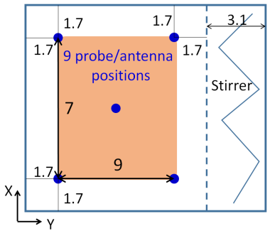

(a)

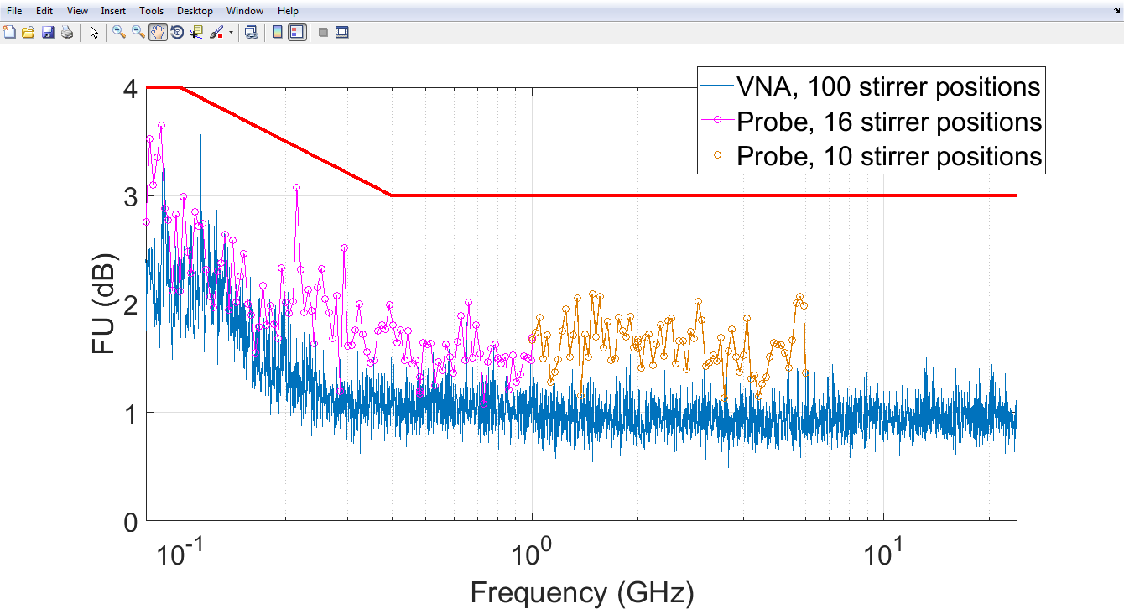

(b)

Figure 4. (a) FU measurement positions, two heights were used with 0.5 m and 2.5 m, the height of the center point was 1.5 m; (b) measured FU from the VNA and the field probe, the upper bound (thick line) is the limit in the standard IEC 61000-4-21 [1].

The field uniformity (FU) in the sense of the IEC procedure has been measured by using two methods [5], the measured results from the VNA and the field probe are given in Fig. 4. 27 maximum samples (3 polarizations, 9 probe positions) were used to calculate the FU. It can be seen in Fig. 4 that the results from the VNA method give lower FU values and smaller statistical fluctuation; this should be due to the 100 stirrer positions used but not the VNA or the field probe method.

TABLE II

Estimated Uncertainties for the Three Methods

|  |  |  |
| --- | --- | --- |
| Method | Estimated Uncertainty | Main Contribution |
| TD VNA | ~ ±1.6% for *N*=10  ~ ±1.3% for *N*=16 | Estimated from (6), dominated by the decay constant $〈τ_{RC}〉$. |
| Field Probe | ~ ±25%  For the maximum value averaged over 9 probe positionsⅹ3 polarizations. | a) Dominated by the finite sample number collected *N*=27: ~ ±19%.  b) Affected by the uncertainty of the field probe: ~ ±6% (from datasheet). |
| FD VNA | ~ ±19% | Dominated by the finite sample number collected. |

1. Conclusions

We have demonstrated an experimental comparison of reverberation chamber calibration in the sense of the IEC procedure using different methods. The results agree well with the theory; pros and cons among these methods are discussed, the measurement uncertainties are also estimated.

The TD VNA based method describes the inherent properties of the RC itself, but requires much work of data post-processing (e.g. the inverse Fourier transform), the field probe based method and the FD VNA based methods are very similar, but a calibrated E-field probe can give direct readings while FD VNA based method is affected by the radiation efficiency of the Rx antenna. The relationships among the results validated using the three methods have been given. We should keep in mind that the differences among the three methods are due to the radiation or total efficiency of Tx and/or Rx antennas, once the antenna efficiency is quantified [11-13], the system error can be corrected.

If the antenna efficiency is known, because the TD method converges faster than the FD method [19, 27] for the same sample number, the TD VNA method has the smallest uncertainty while the other two methods (FD VNA and field probe method) have similar uncertainties in theory (when frequency stirring technique is not applied). Note that in practice the uncertainty of a field probe is higher than a VNA and the VNA based methods can collect more samples efficiently and give smaller uncertainties.

References

1. IEC 61000-4-21, *Electromagnetic compatibility (EMC) – Part 4-21: Testing and measurement techniques – Reverberation chamber test methods,* IEC Standard, Ed 2.0, 2011-01.
2. SAE International, *Surface Vehicle Recommended Practice, J551-16*, Oct. 2017.
3. D. A. Hill, *Electromagnetic Fields in Cavities: Deterministic and Statistical Theories*, Wiley-IEEE Press, USA, 2009.
4. P. Besnier and B. Demoulin, *Electromagnetic Reverberation Chambers*, Wiley-ISTE, UK, 2011.
5. S. J. Boyes, Y. Huang, *Reverberation Chambers*, *Theory and Applications to EMC and Antenna Measurements*, Wiley, UK, 2016.
6. Q. Xu and Y. Huang, *Anechoic and Reverberation Chambers: Theory, Design and Measurements*, Wiley-IEEE, UK, 2019.
7. CTIA, *Test Plan for Wireless Large-Form-Factor Device Over-the-Air Performance*, ver. 1.2.1, Feb. 2019.
8. M. O. Hatfield, “A calibration procedure for reverberation chambers,” *IEEE International Symposium on Electromagnetic Compatibility. Symposium Record (Cat. No.00CH37016)*, Washington, DC, 2000, vol. 2, pp. 621-626.
9. H. G. Krauthauser and J. Nitsch, “Simplifying the measurement of total radiated power in reverberation chambers,” *International Conference on Electromagnetics in Advanced Applications*, Torino, 2007, pp. 768-771.
10. J. Ladbury, G. Koepke and D. Camell, *Evaluation of the NASA Langley Research Center Mode-Stirred Chamber Facility*, NIST Technical Note, 1508, Jan. 1999.
11. C. L. Holloway, H. A. Shah, R. J. Pirkl, W. F. Young, D. A. Hill and J. Ladbury, “Reverberation chamber techniques for determining the radiation and total efficiency of antennas,” *IEEE Transactions on Antennas and Propagation*, vol. 60, no. 4, pp. 1758-1770, April 2012.
12. A. Khaleghi, “Time-domain measurement of antenna efficiency in reverberation chamber,” *IEEE Transactions on Antennas and Propagation*, vol. 57, no. 3, pp. 817-821, March 2009.
13. Q. Xu, Y. Huang, X. Zhu, L. Xing, Z. Tian and C. Song, “A modified two-Antenna method to measure the radiation efficiency of antennas in a reverberation chamber,” *IEEE Antennas and Wireless Propagation Letters*, vol. 15, pp. 336-339, 2016.
14. X. Chen and P. Kildal, “Accuracy of antenna input reflection coefficient and mismatch factor measured in reverberation chamber,” *3rd European Conference on Antennas and Propagation*, Berlin, 2009, pp. 2678-2681.
15. P. –S. Kildal, C. Carlsson and J. Yang, “Measurement of free-space impedances of small antennas in reverberation chambers,” *Microwave and Optical Technology Letters*, vol. 32, no. 2, Jan. 2002.
16. Q. Xu, X. Shen, K. Chen, Y. Zhao and Y. Huang, “Absorption cross section measurement of a vehicle in reverberation chamber for quick estimation of field strength,” *IEEE Electromagnetic Compatibility Magazine*, accepted, 2019.
17. P. Besnier, C. Lemoine and J. Sol, “Various estimations of composite Q-factor with antennas in a reverberation chamber,” *IEEE International Symposium on Electromagnetic Compatibility (EMC)*, Dresden, Germany, 2015, pp. 1223-1227.
18. Q. Xu, Y. Huang, X. Zhu, L. Xing, Z. Tian and C. Song, “Shielding effectiveness measurement of an electrically large enclosure using one antenna,” *IEEE Transactions on Electromagnetic Compatibility*, vol. 57, no. 6, pp. 1466-1471, Dec. 2015.
19. Z. Tian, Y. Huang, Y. Shen and Q. Xu, “Efficient and accurate measurement of absorption cross section of a lossy object in reverberation chamber using two one-antenna methods,” *IEEE Transactions on Electromagnetic Compatibility*, vol. 58, no. 3, pp. 686-693, Jun. 2016.
20. Z. Tian, Y. Huang, Q. Xu, T. Loh and C. Li, “Measurement of absorption cross section of a lossy object in reverberation chamber without the need for calibration,” *Loughborough Antennas & Propagation Conference (LAPC)*, Loughborough, 2016, pp. 1-5.
21. Y. Huang and D. J. Edwards, “A novel reverberating chamber: source-stirred chamber,” *IEEE 8th International Conference on Electromagnetic Compatibility*, Edinburgh, pp. 120-124, 1992.
22. D. Mandaris, R. Vogt-Ardatjew, E. Suthau and F. Leferink, “Simultaneous multi-probe measurements for rapid evaluation of reverberation chambers,” *IEEE International Symposium on Electromagnetic Compatibility and 2018 IEEE Asia-Pacific Symposium on Electromagnetic Compatibility (EMC/APEMC)*, Singapore, 2018, pp. 590-594.
23. D. Mandaris, R. Vogt-Ardatjew, M. Zaher Mahfouz, E. Suthau and F. Leferink, “Time efficient reverberation chamber performance analysis using simultaneous multiprobe measurement technique,” *International Symposium on Electromagnetic Compatibility (EMC EUROPE)*, Amsterdam, 2018, pp. 1-5.
24. C. R. Dunlap, *Reverberation Chamber Characterization Using Enhanced Backscatter Coefficient Measurements*, PhD Thesis, Department of Electrical, Computer and Energy Engineering, University of Colorado, USA, 2013.
25. V. Mariani Primiani, F. Moglie and A. P. Pastore, “A metrology application of reverberation chambers: the current probe calibration,” *IEEE Transactions on Electromagnetic Compatibility*, vol. 49, no. 1, pp. 114-122, Feb. 2007.
26. W. Qi, S. Wang and Y. Feng, “E-field probe calibration in reverberation chamber,” *International Workshop on Electromagnetics: Applications and Student Innovation Competition*, London, 2017, pp. 38-40.
27. Z. Tian, *Efficient Measurement Techniques in Reverberation Chamber*, PhD thesis, Electrical Engineering and Electronics, University of Liverpool, 2017.
28. A. Khaleghi, “Time-domain measurement of antenna efficiency in reverberation chamber,” *IEEE Transactions on Antennas and Propagation*, vol. 57, no. 3, pp. 817-821, Mar. 2009.
29. G. Andrieu, N. Ticaud, F. Lescoat and L. Trougnou, “Fast and accurate assessment of the “well stirred condition” of a reverberation chamber from S11 measurements,” *IEEE Transactions on Electromagnetic Compatibility*, accepted, doi: 10.1109/TEMC.2018.2847727.
30. Z. Tian, Y. Huang and Q. Xu, “Enhanced backscatter coefficient measurement at high frequencies in reverberation chamber,” *International Workshop on Electromagnetics: Applications and Student Innovation Competition*, London, 2017, pp. 166-167.
31. G. Andrieu, “Calibration of reverberation chambers from S11 measurements,” *International Symposium on Electromagnetic Compatibility - EMC EUROPE*, Angers, France, 2017, pp. 1-6.
32. G. Andrieu, “Calibration of reverberation chambers from S21 measurements,” *IEEE International Symposium on Electromagnetic Compatibility & Signal/Power Integrity (EMCSI)*, Washington, DC, 2017, pp. 675-680.

1. This work was supported in part by the National Natural Science Foundation of China under Grants 61701224, and in part by Nanjing Rongce Testing Technology Ltd.

   Q. Xu, K. Chen and Y. Zhao are with College of Electronic and Information Engineering, Nanjing University of Aeronautics and Astronautics, Nanjing 211106, China (e-mail: emxu@foxmail.com).

   K. Chen, X. Shen and W. Li are with Nanjing Rongce Testing Technology Ltd, Nanjing, 211112, China (e-mail: george@emcdir.com)

   Y. Huang is with the Department of Electrical Engineering and Electronics, The University of Liverpool, Liverpool, L69 3GJ, UK. (e-mail: yi.huang@liverpool.ac.uk).