**An efficient and accurate method for transient heat conduction in a periodic structure with moving heat sources**

**Abstract:**

**Purpose –** This paper aims to propose an efficient and accurate method to analyse the transient heat conduction in a periodic structure with moving heat sources.

**Design/methodology/approach** **–** The moving heat source is modelled as a localised Gaussian distribution in space. Based on the spatial distribution, the physical feature of transient heat conduction and the periodic property of structure, a special feature of temperature responses caused by the moving heat source is illustrated. Then, combined with the superposition principle of linear system, within a small time step, computation of results corresponding to the whole structure excited by the Gaussian heat source is transformed into that of some small-scale structures. Finally, the precise integration method (PIM) is employed to solve the temperature responses of each small-scale structure efficiently and accurately.

**Findings –** Within a reasonable time step, the heat source applied on a unit cell can only cause the temperature responses of a limited number of adjacent unit cells. According to the above feature and the periodic property of structure, the contributions caused by the moving heat source for the most of time steps are repeatable, and the temperature responses of the entire periodic structure can be obtained by some small-scale structures.

**Originality/value –** A novel numerical method is proposed for analysing moving heat source problems and the numerical examples demonstrate that the proposed method is much more efficient than the traditional methods, even for larger scale problems and multiple moving heat source problems.

***Keywords:*** The Gaussian moving heat source; Periodic structure; Transient heat conduction; Precise integration method

**1. Introduction**

Moving heat sources are widely seen in practical applications in numerous manufacturing processes such as welding, laser cutting, surface heat treatment, the grinding and drilling of metals and so on. Once the temperature distribution of a structure due to a moving heat source is known, then other important quantities of interest, such as residual stresses, expansion and deflection, may also be calculated. In addition, with the rapid development of material science and technology, periodic structures with many excellent thermal qualities (low thermal conductivity and high temperature resistance) and mechanical properties (light weight and high strength) have been widely used in many modern industries, such as aerospace and nuclear engineering. Therefore, it is very important to predict the thermal behaviour of the periodic structure with moving heat sources accurately and efficiently.

Transient heat conduction with a moving heat source is an important and interesting subject that has been attracted the attention of many researchers. The studies by Rosenthal et al. (1941, 1946, 1947) on heat distribution are considered the earliest work to solve analytically the heat conduction problems of moving heat sources, where the concepts of a “quasi-stationary state” and moving coordinates were used when deriving equations for the temperature field. Although the above research work has presented the basic analytical solutions of the temperature distribution near moving heat sources that were assumed to be points, lines and surfaces, it is hard or even impossible to find analytical solutions for complicated configurations and boundary conditions. It is precisely this reason that various engineering and mathematical papers devoted to numerical methods have been developed to solve the moving heat source problem in the past few decades. And the finite element method (FEM) is recognised as the most versatile numerical method for simulating the moving heat source problem.

As the moving heat source analysis is about a transient process, after spatial discretization, ordinary differential equations need to be solved in the time domain. The direct time stepping methods (Lewis et al. 1996, Thornton 1996, Wood 1990) are the most popular and commonly used methods among existing methods, which include the forward difference, Crank-Nicolson, Galerkin and backward difference methods. When the time step is very small or the scale of model is very large, extensive computational efforts are required in the transient analysis. This is mainly because numerous equations should be solved within each time step. Thus, the FEM is usually very time-consuming for a strong and high velocity heat source (Veldman et al. 2018, Weichert and Schönert 1978). In order to improve the computational efficiency, much research work has already been done.

As known, the moving heat source analysis not only is about a transient process but also has a special characteristic that the temperature gradient near the position of the heat source is very great, while that of the remaining large area is relatively very small. Taking advantage of this characteristic, substructure methods have been introduced to enhance the performance of the FEM. Song et al. combined a rezoning technique with dynamic substructuring to greatly reduce computational time (Brown and Song 1993, Song 1990). On the basis of dynamic meshing, a substructure method was proposed by Andersen (2000) to reduce computational time in welding simulation. An iterative substructure method was proposed by Maekawa et al. (2015) to simulate the multi-pass welding efficiently. Based on the iterative substructure method, an inherent strain-based iterative substructure method (Murakawa et al. 2015) was developed to solve large-scale practical problems within reasonable computational time. Nishikawa et al. (2004a) combined the interactive substructure method and the sparse matrix iterative solver to improve the computational efficiency. Nishikawa et al. (2004b, 2007) reduced computation time with a fast iterative substructure method in which a small model with large linear zones and a large model with small nonlinear zones were developed according to the transient temperature distribution during welding.

As mentioned before, because the temperature gradient is very high around the moving heat source and falls steeply away from it, it is also natural to apply a finer mesh near the heat source and coarser mesh further away from it. As the position of the heat source changes, some adaptive meshing (Kim 2012, Na and Lee 1987, Prasad and Narayanan 1996) in response to the motion of the heat source has also been developed to reduce discretization errors and improve the computational efficiency. Combined with a graded hexahedral element, Lindgren et al. (2001, 1997) developed an automatic remeshing algorithm for three-dimensional simulations, where the computation time was reduced by 60%. Using a graded element, Runnemalm and Hyun (2000) combined error measures with a hierarchic remeshing strategy to create an automatic adaptive mesh. By means of an adaptive mesh technique and the predictor-corrector method, a non-overlapping domain-decomposed moving mesh method was developed for the simulation of multiple heat sources by Hu (2018) , which allowed heat sources to move at different speeds. A composite mesh method was developed by Goldak et al. (1999), which was easier to mesh complex structures because each mesh part was independent and a mesher was not required to maintain continuity of the mesh. On the basis of multigrid and localized refinement techniques and finite difference framework, Boffy et al. (2012) proposed a multigrid solution method which could deal with multiple moving heat sources. The adaptive meshing strategy can not only improve the accuracy of results, but also improve the computational efficiency.

Because the memory consumption and computing time increase sharply with the number of degrees of freedom in an implicit FEM, a static implicit finite element method usually takes enormous computing time and memories to analyse large-scale problems. In order to simulate a moving heat source accurately and efficiently, idealized explicit FEM is studied by some researchers. Shibahara and Ikushima (2010) proposed an idealized explicit FEM which can decrease the computing time and memory consumption of large-scale structural problems as it solves only scalar equations and not necessary to solve the global stiffness equation. On the basis of the idealized explicit FEM, an algebraic multigrid method was introduced by Ikushima et al. (2019) to form an efficient method for solving large-scale problems. On the other hand, Lindgren (2006) indicated that parallel computing made it possible to improve the computational efficiency when it was used in implicit finite elements method and had better scalability when it was used in explicit finite element methods. Graphics Processing Units (GPU) parallelization was also introduced to idealized explicit FEM (Ikushima et al. 2014), which improved the computational efficiency further. An accelerated explicit method and GPU parallel computing program of the finite element method were developed to simulate welding of large-scale finite element models (Ma 2016).

In addition, the meshless method has been recently studied to solve the transient heat conduction equation with a moving heat source by Pham (2013) and Edgar (2015). The meshless local Petrov-Galerkin method was proposed by Shibahara (2011) to analyse the transient heat conduction due to a moving heat source, which can reduce the time of mesh generation process for the large model with complex shape. A boundary element method (BEM) formulation for the moving heat source problem was developed by Lim et al.(1994). By means of a dual reciprocity boundary element method, Fahmy (2012) studied the transient heat conduction in a non-homogeneous anisotropic thermoviscoelastic thick strip placed in a constant primary magnetic field and subjected to a moving heat source. To overcome the difficulties in analysing large-area laser processing, Ahn et al. (2011) proposed a way of reducing the time and memory required for analysis by adjusting the heat input area. A line Gaussian heat source model was developed by Cai et al. (2001) to improve calculation efficiency.

Although much work has been done to reduce the computational time, it is still a tough task to simulate the transient heat conduction with moving heat sources efficiently and accurately. If the moving surface heat source has high intensity and a small diameter or multiple moving heat sources are applied on the structure, the finite element mesh must be dense enough. In addition, for the heat source at a greater speed, it is necessary to divide the time domain into a greater number of integral steps. Thus, significant computational resources in terms of CPU power and memory are still required for large-scale problems. In this present work, for improving the computational efficiency, a fast and reliable method will be developed by means of the precise integration method (PIM) (Zhong 2004, Zhong and Williams 1994, Zhong et al. 1996). The PIM is unconditionally stable and can give high-precision numerical results at the integration points, and it has been successfully applied to solve many heat conduction problems (Chen et al. 2001, Gao and Cui 2017, Gao and Cui 2018, Gu et al. 2002, Wu et al. 2013). However, to the best of the authors’ knowledge, almost all the existing research work concentrates on fixed heat loads whose positions are time-invariant. In this research, based on the distribution feature of the moving heat source, the periodic property of structure, the physical feature of transient heat conduction and the superposition principle of linear system, the PIM will be applied to solve the transient heat conduction problem with the moving surface heat source.

The remainder of this paper is outlined as follows. Next, the mathematical model and the finite element model for the transient heat conduction problem involving the Gaussian heat source in the periodic structure are presented. The physical feature of transient heat conduction will be given in Section 3. According to the above physical feature, a special feature of temperature responses caused by the moving heat source will be illustrated in Section 4. In Section 5, for each integration step, the computation of the temperature responses excited by the moving heat source corresponding to the entire periodic structure is transformed into that of the small-scale structure with a few unit cells. Based on the PIM, the detailed algorithm for computing the matrices corresponding to the moving heat load is described in Section 6, and during the procedure, the scale of the small structure and the reasonable time step are also determined. The numerical examples, which demonstrate the efficiency and accuracy of the proposed method, are presented in Section 7. Finally, the conclusions are summarized in Section 8.

**2. Mathematical model**

The considered structure, as shown in Fig. 1, is composed of  identical structural components called unit cells which are assembled end-to-end along the  and  directions to form a complete periodic structure. Let us assume that the labels of all unit cells forming the whole structure are , , , . The length of each unit cell along the  direction is  and its height along the  direction is  (see Fig. 2(a)). The heat source density in a two-dimensional Gaussian distribution is able to characterise heat surface treatment and welding and is described by only a few parameters that allow quickly parameterization (Clain et al. 2017, Goldak et al. 1984). The centre of the Gaussian heat source moves along the path of  at a constant velocity , represented by the hatched area shown in Fig. 1. As the spatial domain of heat transfer is treated as a two dimensional problem, the governing equation for the transient heat conduction in the periodic structure with the Gaussian heat source can be defined as follows in Cartesian coordinates



where ,  and  denote the mass density, heat capacity and thermal conductivity, respectively, and these parameters are periodic functions of location ;  is the temperature field;  is the time interval of interest;  represents the computational domain whose boundary is , and, where ,  and  denote the Dirichlet, Neumann and Robin boundaries, respectively ;  is the maximum heat flux in the centre of the moving heat source;  denotes the radial distance from the centre, and  is its initial location;  is the standard deviation of heat flux distribution, which is a factor reflecting the dimension of the heat source. If the circular normal distribution is described by the focus radius , then the circular zone contains about  of the heat power (Goldak and Akhlaghi 2006). Thus, in this study, it is reasonable to assume that the heat flux concentrates in a circular zone with a radius .

In addition, the initial temperature of the periodic structure, and the Dirichlet, Neumann, Robin boundary conditions are imposed as follows









where  is the initial temperature;  is the unit outward normal vector to the boundary;  and  are the given temperature and the heat flux on the boundary, respectively; the variables  and  denote the heat transfer coefficient and the temperature of surroundings, respectively. For convenience, the above variables of the boundary conditions are all time-invariant.

Because of the periodic property of the structure under study, all unit cells of the structure can be discretized using the same finite element mesh. And the following requirement should be satisfied for making full use of the periodic property: the numbers and positions of nodes on two opposite sides of a unit cell are the same but the numbers of nodes on adjacent sides may be different, as shown in Fig. 2. Let  and  denote the numbers of internal and corner nodes of a unit cell, and ,  denote the numbers of nodes located on the top (bottom) and left (right) edges, respectively, as shown in Fig. 2(b). And the nodes of any unit cell  can be numbered according to the following rules: the nodes located on the bottom edge are numbered from  to , and the nodes located on the top edge are numbered from  to , finally, the remaining nodes are numbered from  to , as shown in Fig. 2(a).



Based on the above discrete rules, if the heat capacity and conductivity matrices of a unit cell have been computed, then according to the correspondence relationship between nodes of all unit cells, the corresponding matrices of the entire periodic structure can be obtained by the accumulation of the above matrices of the unit cell.

By using the FEM (Lewis et al. 2004, Nithiarasu et al. 2016), the governing equation of transient heat conduction with moving heat sources can be expressed as



where  and  are the thermal capacity and conductivity matrices, respectively.  is the temperature vector;  is the derivative of  with respect to time ;  is the thermal force vector including the fixed heat source and heat exchange on the boundary. Since the boundary conditions considered in this paper are time-invariant,  is a constant vector. On the other hand,  is the thermal force vector corresponding to the moving heat source, which is time-variant.

Eq. can be rewritten as



where



For numerical integration, the time domain is divided into a series of time intervals whose lengths are equal to , i.e.,



Let ; then, the solution of Eq. at discrete times can be derived as



in which  is the exponential of matrix , i.e.,



The first integration of Eq. corresponding to the fixed heat source can be derived analytically. However, the second integration corresponds to the moving heat source, which cannot be derived analytically because the position of the moving heat source is time-variant and thus must be computed numerically.

Assuming that it takes  steps for the moving heat source to pass a unit cell along the moving direction, which can be met easily by choosing a reasonable time step . If the centre of the heat source moves from start point  to end point  at a constant speed  in a chosen time step  (see Fig. 3), then equivalent nodal load vectors  and  at times  and  can be obtained by numerical integration in the FEM, such as Gaussian quadrature. Assuming that at , the centre of the heat source moves to point , and an equivalent nodal load vector  at  can be computed by the linear interpolation



in which



From Eq., we can see that the motion of the heat source is simulated by heat sources of some fixed points whose values vary linearly in a time step, which can give highly accurate results with a reasonable time step.

Combining Eqs. and , Eq. can be rewritten as



where



in which  represents the identity matrix.  and  can be calculated using the proposed method in (Gao and Cui 2018) efficiently and accurately, and since the positions of boundary conditions are time-invariant,  is a constant column vector which just needs to be computed once actually.

The remaining problem is how to compute  efficiently. When the initial temperature of the periodic structure is zero and the homogenous boundary conditions are applied on boundaries of the original finite element model, then Eq. can be simplified as



The physical meaning of Eq. is that, when only the Gaussian moving heat source is applied on the structure at , then after a time step, the temperature response of the entire structure is . As the position of the Gaussian heat source is time-variant,  should be recalculated in every integration step, which is different from the computation of . Moreover, in order to obtain the temperature responses caused by the moving heat source, numerical integration should be performed to compute the equivalent nodal load vectors  and , and then both terms  and  should also be computed for each integration step. Therefore, it is very time-consuming if the proposed method by Gao and Cui (2018) is directly used for computing the temperature responses caused by the moving heat source. It is worth noting that the distribution of a moving heat source is local and time-invariant, although its central position is time-variant. Hence, it is important to reduce the memory usage and speed up the computation of  using the distribution feature of the moving heat source. In the following sections, based on the above distribution feature of the heat source, the periodic property of structure, the physical characteristic of transient heat conduction and the superposition principle of the linear system, an efficient and accurate algorithm will be established to improve the efficiency for obtaining . And that directly leads to an efficient method to solve the transient heat conduction problem in a periodic structure with a moving heat source.

**3. The physical feature of transient heat conduction**

In this section, the physical characteristics of transient heat conduction will be analysed firstly, which is one of the important bases for developing the efficient and accurate method.

For two-dimensional transient heat conduction in a homogeneous unbound medium, if a unit instantaneous external excitation is applied at point  at time , the temperature response at any point  can be expressed as (Schmitt 2019)



where  is the thermal diffusivity and  is the time interval. Eq. is called the fundamental solution of the two-dimensional transient heat conduction equation, and  at any time  follows an exponential decay with the distance between point  and the heat source point . Thus, the temperature response at a point that is much further away from the heat source point is much closer to zero. Although this characteristic occurs in a homogenous material, it is clear that the temperature response distribution is similar for a non-homogeneous material. Even if a system is discretized by the finite element mesh, the physical characteristic is also similar to the continuous system, because as the number of elements in the mesh increases, the numerical result converges to the exact solution gradually (Wilson and Nickell 1966).

According to the above physical feature of transient heat conduction, we can know that if only an initial point heat source is applied at -th node, while the initial temperatures and heat sources of other nodes are all zero, then after a time step , the non-zero temperature responses only exist at the nodes which are near the node , while the temperature responses of nodes which are far enough away from node  are zero. In the same way, the similar feature of temperature distribution can be also proved for a moving point heat source. Assuming that only a moving point heat source is applied at -th node at the initial time, and during a reasonable time step , the point heat source moves from node  to node , then according to the above physical feature of transient heat conduction, we can know that the non-zero temperature responses only exist in the area near the moving trajectory, while temperature responses of the other area that is far enough away from the moving trajectory remain zero.

Without loss of generality, in the following discussion, we can assume that moving excitations only affect  unit cells in any direction within one time step, which can be determined using the algorithm proposed in Section 6. And based on the above physical feature of transient heat conduction, a special feature of temperature responses caused by only the moving heat source in the periodic structure will be illustrated in the next section.

**4. A special feature of temperature responses due to the Gaussian moving heat source**

In this section, based on the spatial distribution of the moving heat source, the physical feature of transient heat conduction and the periodic property of structure, a special feature of temperature responses caused by the moving heat source will be illustrated in the following discussion, which directly leads to build a scheme for improving the computational efficiency. For convenience, let  denote point  of unit cell  and let  denote the temperature response of point  excited by the Gaussian heat source whose centre moves from point  to point  within a time step . Let  denote that the focus radius  is smaller than or equal to the total length of  unit cells along the moving direction, where  rounds the element  to the nearest integer greater than or equal to that element.

As we have assumed that an excitation only can affect  unit cells in any direction within one time step and the focus radius of the Gaussian heat source is , when the centre of the moving heat flux moves within the unit cell  during a time step, the non-zero temperature responses excited by the moving heat source cannot affect the left or right boundary of the periodic structure.

Based on the above fact, two cases are considered where any two different unit cells  and  can be chosen as study objects. Nevertheless, in order to illustrate easily, the value of  is fixed as  in the following discussion. Other values of  can also be used in the following similar process, and the conclusions are the same. In the first case, assuming that only the Gaussian heat source is applied on the structure and its initial central position locates at point , within one time step, its centre moves to point  at a constant speed . In the second case, assuming that the initial central position of the Gaussian heat source is at point , within one time step, it moves to point  at the same speed . As we have assumed that an excitation only can affect  unit cells in any direction within one time step, the temperature responses excited by both cases are local and not affected by the left and right boundary conditions, as shown in Fig. 4, where the left and right hatched domains represent the Gaussian heat source distributions for the first and second cases, respectively, and the left and right gradient-shaded domains represent the temperature responses excited by both cases, respectively. Note that the relative position of point   located on unit cell  are the same as that of point   located on unit cell , respectively. Moreover, because the structure is periodic, the geometric and physical properties of each unit cell and the distribution of Gaussian heat flux for both cases are all identical. Therefore, it can be easy to conclude that the temperature response of any point  excited in the first case is the same as that of point  excited in the second case, i.e.,



Thus, the temperature responses for both cases are the same by a coordinate translation. Thereby, the repeatability of temperature responses caused by the moving heat source in the periodic structure can be proved.

We have assumed that it takes  time steps for the Gaussian heat source to pass a unit cell in Section 2. Thus, if the  non-zero temperature responses excited by the moving heat source whose centre passes unit cell  have been obtained, then the  non-zero temperature responses excited by the heat source whose centre passes any unit cell  can be obtained correspondingly by the appropriate coordinate translation of those of the unit cell . On the other hand, when the Gaussian heat source moves within unit cell , the induced temperature responses for each time step can be affected by boundary conditions. Thus, the temperature responses need to be computed individually for each time step. In summary, for obtaining the temperature responses caused by the moving heat source, the remaining problem is how to efficiently compute the non-zero temperature responses corresponding to unit cell , where the set of  is composed of the value of  and the set of .

The above algorithm can not only avoid computing  for many time steps, but also eliminate much computation for forming equivalent heat loads, which can significantly improve the computational efficiency and reduce the memory cost. However, for large-scale problems, the dimensions of the matrix  and the vector  are very big, so the computational efforts for the matrix-vector multiplications are still large within a time step. Thus, the computational scale will be reduced further in the next section.

**5. Reduction of the computational scale for each integration step**

As the analysis in the last section, in order to obtain the temperature responses excited by the moving heat source passing the entire periodic structure, it only needs to compute the temperature responses excited by the moving heat source which passes a small number of unit cells. Thus, by reducing calculation times, the proposed algorithm in the last section can greatly improve the computational efficiency. In this section, based on the superposition principle in the linear system, the distribution feature of moving heat source, the physical feature of transient heat conduction and the periodic property of structure, the computational efficiency will be further improved by decreasing the computational scale for each integration step.

In a chosen time interval , the central coordinate of the moving heat source is from point  to point , which locates on the unit cell , as shown in Fig. 5(a). As the focus radius is , the heat source only exists in the following local domain whose range of coordinate is , in which



And the domain occupied by the moving heat source is composed of unit cell  , (see the Fig. 5(a), where the hatched domain represents the distribution of the Gaussian heat source), in which



where  rounds the element of  to the nearest integer toward zero.

As the distribution of the Gaussian heat source is local, and by means of the superposition principle, the equivalent heat load  corresponding to the moving heat source can be subdivided into  basic equivalent heat loads  according to the following principles: (1) the elements of basic equivalent heat load  corresponding to the nodes located on the mesh of unit cell  maybe non-zero, and the remaining elements are all zero; (2) the original heat load  are the sum of all basic equivalent heat loads, i.e.,



Substituting Eq. into Eq., the following equation can be obtained



From the above equation, the temperature response corresponding to the equivalent heat load  (as shown in Fig. 5 (a), where the gradient-shaded area represents the temperature responses excited by the Gaussian heat source ) can be obtained by adding together all temperature responses excited by every basic equivalent heat load  (as shown in Fig. 5(b)).

Next, the temperature response excited by the basic equivalent heat load  will be discussed. As we have assumed that the heat source only affects  unit cells within a time step, the non-zero temperature response caused by the basic equivalent heat load only spreads on the unit cell  which belongs to a small-scale (structure) domain consisting of  unit cells, as the gradient area shows in Fig. 5(b). Thus, the whole solution domain can be divided into two parts,  and , in which domain  is affected by the heat loads and composed of  unit cells around the unit cell , such as the unit cells enclosed by the solid line shown in Fig. 5(b), while domain  is composed of the remaining unit cells. As the non-zero temperature response just spreads in domain , and there is no heat flux exchanged between the two domains, the entire periodic structure can be decoupled into two structures with domains  and , respectively. For convenience, the homogenous boundary conditions of the original structure can be imposed on the corresponding boundaries of the small-scale structure with domain . Hence, once the non-zero temperature response of the small-scale structure is computed, the temperature response of the whole structure excited by the basic equivalent heat load  can be obtained using the correspondence relationship between the nodes. This can be done as follows. Assuming that the temperature response of the small-scale structure corresponding to the basic equivalent heat load  has been obtained as  by using the discretized rules in Section 2, and the corresponding temperature vector of the whole structure is  whose initial elements are all zero. Then, based on the node numbering rules in Section 2, we can easily obtain the node number vector of domain  (the small-scale structure) in the whole structure, denoted as . Finally, the transfer of the result of the small-scale structure corresponding to the basic equivalent heat load  to the whole structure can be expressed as



Nevertheless, when , the actual domain affected by the basic equivalent heat load  is smaller than the small-scale domain consisting of  unit cells. For example, when , the basic equivalent heat load vector is , which means that, at the initial time, only the unit cell  is subjected to non-zero heat loads. According to the physical feature of transient heat conduction, after one time step, the affected domain is only composed of unit cell (,), which is a subset of the desired small-scale domain enclosed by the solid line, as shown in Fig. 6. For consistency, the small-scale domain consisting of  unit cells is still regarded as a reasonable solution domain. Thus, the non-zero temperature responses caused by the basic equivalent heat source  can be computed in the small-scale domain. Generally, the temperature responses caused by the every basic equivalent heat load  can be computed using the small-scale structure.

In summary, firstly, by means of the superposition principle and the local distribution of the moving heat source, the computation of temperature responses caused by the whole moving heat source is transformed into that caused by  basic equivalent heat loads . Secondly, based on the physical feature of transient heat condition, the heat conduction problem corresponding to the original structure with the basic equivalent heat load  is reduced to that corresponding to some small-scale structures. Because of the periodic property of structure, the small-scale structure corresponding to every basic equivalent heat load is the same. Thus, the matrix  of the small-scale structure only needs to be computed once. When the scale of the original periodic structure is very large and parameter  is a small value, the size of matrix  is much smaller than that of the original structure. Therefore, by reducing the computational scale, the algorithm proposed in this section further improves the multiplication efficiency between the matrix and the vector for each time step. According to Eq. , matrix  can be obtained by computing matrix exponential  of the small-scale structure. And in the next section, a reasonable time step , parameter  and matrix exponential  corresponding to the small-scale structure will be determined.

**6. Determination of the time step and the matrix exponential of the small-scale structure**

In this section, using the PIM, matrix exponential  corresponding to the small-scale structure is calculated, and time step  and parameter  are also determined in the procedure.

Based on the idea of computing and storing the incremental part of the matrix exponential and an addition theorem, the PIM has been developed to calculate matrix exponential  for a given matrix  and time step .

Firstly, let



in which  is an integer. Substituting Eq. into Eq. , the following formula can be obtained



when  is a sufficiently large integer, then the norm of  is very small, so the exponential of matrix  can be obtained approximately by a Taylor series of  terms, i.e.,



Then  can be divided into the following two parts, i.e.,



And then, the addition theorem is used to calculate the incremental part (Zhong 2004), i.e.,



Finally, the matrix exponential is computed by adding the unit matrix  to , i.e.,



In the previous sections, the number of unit cells affected by the heat load is assumed to be known in advance. However, the explicit relationship between parameter  and time step  cannot be known in advance and so the following strategy is used. Firstly, we designate a desired initial time step  and a parameter  such that it is believed that the heat load of a unit cell can affect  unit cells in any direction within the time step . Once the shortest time for the heat load to affect  unit cell is found to be , then  is regarded as the final time step. The following algorithm is proposed to determine a reasonable time step.

First, according to the given parameters  and , the heat capacity and conduction matrices of the small-scale structure can be formed; then, matrix  is computed by using Eq. . Second, parameters  and  are determined using the matrix  and the initial time step  (Moler and Loan 1978, 2003, Zhang et al. 2001). Then, the matrix exponential  corresponding to time step  can be obtained by Eq. . Next, we need to determine if the heat load can spread over  unit cells within one time step . If it can, then the initial time step  is too large and the programme needs to be stopped and restarted with a smaller time step ; otherwise, looping via Eq. is performed. In each cycle of the loop, we need to judge if the heat load can spread over  unit cells within the time step . If it can, the matrix  and the time step  are stored, then the loop is broken; otherwise, the next cycle is entered.

The key step in the above procedure is to judge if the heat load spreads over  unit cells within one time step, which can be decided as follows. First, a small tolerance  is chosen, such as , and let  and  denote the nodes on interfaces  and , as shown in Fig. 7. For the -th cycle of loop , the time step is , and the corresponding matrix exponential is . If , it means that the heat load has spread over  unit cells; otherwise it has not yet spread over  unit cells.

According to the above analysis, once a specified parameter  is given, a reasonable time step  and matrix exponential  can be obtained. The choice of the parameter  is discussed as follows. If the chosen  is larger, the size of the small-scale structure and the automatically selected time step are larger. When the total time interval of the simulation is fixed, the total integration steps are fewer. However, the computational time for each step becomes larger, and the larger time step may not be suitable for simulating the motion of the Gaussian heat source accurately. Thus, to choose a smaller parameter  is more reasonable for making full use of the periodic property of structure and simulating the motion of the heat source, although the total number of integration steps becomes larger.

**7. Numerical examples**

**Example. 1** In order to demonstrate the accuracy and efficiency of the proposed method, a periodic structure composed of  unit cells is selected as an example. The unit cell consists of two different materials denoted as  and . The sizes of the unit cell are shown in Fig. 8(a). The thermal conductivity coefficients for the two materials are  and , respectively, and the volumetric heat capacities are  and , respectively. The unit cell is discretized using the FEM with three-node triangle linear elements, and the mesh is shown in Fig. 8(b). The initial condition of the periodic structure is



The heat exchanges are modelled by a Robin condition on the top side of the periodic structure with a heat transfer coefficient  and an external temperature , i.e.,



The boundary condition on the bottom side  is



An adiabatic condition is assumed on the left side , i.e.,



The temperature is imposed on the right side of the periodic structure , i.e.,



A Gaussian heat source moves from the left side of the periodic structure to its right side at a constant velocity  along the line , whose parameters are presented in Table 1.

The transient temperature responses are calculated by the proposed method and the traditional Crank-Nicholson (C-N) method. The small-scale model is composed of  unit cells for the proposed method, and the values of  and  are determined as 7 and 5, respectively, and the time step automatically selected is 0.01 s, which can simulate the motion of the Gaussian heat source accurately. The time step of 0.01 s is also used for the C-N method. Moreover, the results obtained by the C-N method with a time step of  are used as the reference solutions to demonstrate the precision of the proposed method.

When , the periodic structure composed of  unit cells is chosen to illustrate the correctness of the proposed method. Fig. 9 shows the temperature contours computed by the proposed method and the C-N method at different time *t*=1 s and 3 s. It is seen that we obtain a perfect matching on the temperature distributions between the two methods. The temperature responses computed by both methods along the line of  at three different time *t*=1 s, 2 s and 3 s are shown in Fig. 10. The red, magenta and green lines with solid circles represent the temperature responses obtained by the proposed method at *t*=1 s, 2 s and 3 s, respectively, while the blue lines with hollow circles, hollow triangles and hollow squares represent the temperature responses obtained by the C-N method at the three time, respectively. From the Fig.10, we can see that, at the different time instants, the temperature responses obtained by the proposed method are in good agreement with those computed by the C-N method, so the correctness of the proposed method is proved again.

To further illustrate the high accuracy of the proposed method, the relative errors of the results obtained from the proposed method and the C-N method with the same time step are defined as



where  denotes the temperature responses of all nodes at a given time using the proposed and the C-N methods with the time step of 0.01 s, while  denotes the results at the same time using the C-N method with the time step of . The relative errors are reported in Fig. 11, where the solid line with solid circles is for the relative error corresponding to the proposed method with the time step of 0.01 s, while the solid line with hollow circles denotes the relative error of the C-N method with the same time step of 0.01 s. Fig. 11 shows that the precision of the proposed method is higher than that of the C-N method at the initial period, and as time goes on, relative errors of both methods are all about , thus the proposed method has a high accuracy and good stability.

When  is set to 20, 40 and 60, the corresponding three periodic structures are selected to determine the efficiency of the proposed method. The direct method and the Preconditioning Conjugate Gradient (PCG) method are chosen as the solvers to compute the system of linear equations obtained by the C-N method. For the direct method, using Cholesky decomposition, the symmetric positive-definite coefficient matrix of the system of linear equations is decomposed into a lower triangular matrix, then the system of linear equations is solved using a back-substitution approach. For the PCG method, the incomplete Cholesky decomposition is applied to the symmetric positive-definite matrix of the system of linear equations, and then the system of linear equations is solved using the conjugate gradient method. Both the absolute and relative tolerances for the PCG method are set to  in this present work.

The CPU times for the proposed and C-N methods are given in Table 2. Table 2 shows that, when the direct method is used for solving the system of linear equations obtained by the C-N method, the efficiency of the proposed method is approximately 2.2, 4.4 and 8.5 times higher than that of the C-N method for the three periodic structures whose numbers of unit cells are ,  and , respectively. In addition, when the PCG solver is used to solve the system of linear equations obtained by the C-N method, the efficiency of the proposed method is about 2.1, 3.3 and 4.2 times higher than that of the C-N method for the above three periodic structures, respectively. From the above analysis, we can see that, for simulating the transient heat conduction problem of a larger scale structure with the moving heat source, the proposed method is more efficient than the C-N method. The main reason is that the proposed method does not need to compute the temperature responses caused by only the Gaussian moving heat source repeatedly, and the scale of computing the temperature responses is reduced. Thus, compared with the C-N method, the larger the periodic structure passed through by the moving heat source is, the more efficient the proposed method is.

**Example 2.** The transient heat conduction in a periodic structure with multiple moving heat sources are considered in this example. The periodic structure is composed of  unit cells, and the geometry sizes of the unit cell are shown in Fig**.** 12(a), which consists of two different material denoted as  and . The heat conduction coefficients for the two materials are  and , respectively, and the volumetric heat capacities are  and , respectively. The unit cell is discretized using the FEM with three-node linear triangular elements, and the mesh is shown inFig. 12(b). The discretized periodic structure has 1106301 nodes and 1824000 elements. The initial temperature of the periodic structure is



The heat exchanges are modelled by the Robin condition at the top and bottom boundary surfaces of the periodic structure with external temperature  and a heat transfer coefficient , i.e.,



The adiabatic condition is imposed at the left and right boundary surfaces, i.e.,



The boundary condition for each hole is kept insulated.

The following three cases are discussed. In the first case, only one Gaussian heat source is applied on the periodic structure and moves from the right side of the structure to its left side along the line  at a constant speed . In the second case, two Gaussian heat sources are applied on the periodic structure and move simultaneously from the right side to the left side along the lines  and  at the same constant speed . In the third case: three Gaussian heat sources are applied on the periodic structure and move simultaneously from the right side to the left side along the lines ,  and  at the same constant speed . The parameters for all moving heat sources are all same except that their initial central positons and moving trajectories are different. The parameters of the Gaussian heat sources are presented in Table 1.

The proposed and traditional C-N methods are chosen to compute the transient heat conduction problems in the above three cases. The small-scale structure composed of  unit cells is chosen for the proposed method, and the values of  and  are determined as 6 and 5, respectively, and the time step automatically selected by the proposed method is 1 s. And the above time step is also used for the C-N method. The results obtained by the C-N method with a time step of 0.01 s are regard as the reference solutions. Because of the computer memory limitations, the direct method cannot be used to solve the system of the linear equations in this example. Thus, the PCG method is chosen as the solver to compute the system of linear equations obtained by the C-N method, and both the absolute and relative tolerances for the PCG method are still set to .

In order to further illustrate the accuracy of the proposed method, we focus on the third case in the following discussion. Fig. 13(a)-(b) shows the temperature contours at *t*=300 s and 600 s, which are computed by the proposed method, while Fig. 13(c)-(d) shows the temperature contours at *t*=300 s and 600 s, which are computed by the C-N method. It can be seen that the results computed by both methods are almost the same, which verifies the correctness of the proposed method. The temperature responses at three points whose coordinates are ,  and  are shown in Fig. 14, in which the red, magenta and green lines with solid circles denote the results of the above three points, which are obtained by the proposed method, while the solid lines with hollow circles, hollow triangles and hollow squares are for the temperature responses at the three points, which are computed by the C-N method. Fig. 14 shows that the results given by the proposed method are almost the same as those given by the C-N method. This indicates the correctness of the proposed method again.

Furthermore, in order to prove the accuracy of the proposed method for performing multiple moving heat sources analysis, the relative errors can be calculated by Eq. . The reference solution  is the results at a given time computed by the C-N method with a time step of 0.01 s, and  represents the results at the same time computed using the proposed method and the C-N method with the same time step of 1 s. The relative errors at a different time are given in Table 3. Table 3 shows that the relative errors of the proposed method are far less than those of the C-N method at the initial period of the simulation, and then they become about 0.11% for the rest of the time for both methods, which illustrates that the precision of the proposed method is very high.

To determine the efficiency of the proposed method for performing the multiple moving heat sources analysis, the computation times for the three cases (corresponding to one, two and three Gaussian heat sources, respectively) using the proposed and C-N methods with the time step of 1 s are given in Table 4. And the efficiency of the proposed method is approximately 3.5, 4.2 and 4.5 times higher than that of the C-N method for the above three cases. The results shows that the proposed method is superior to the C-N method for solving the multiple moving heat sources problem. Compared with the C-N method, the more the moving heat sources are present, the more efficient the proposed method is.

**8. Conclusions**

An efficient and accurate method is proposed for analysing transient heat conduction in a periodic structure subjected to moving heat sources. Based on the distribution feature of the moving heat sources, the physical feature of transient heat conduction and the periodic property of the structure, a numerical scheme is put forward to improve the computational efficiency by using the special feature of temperature responses excited by the moving heat source. Moreover, according to the above physical characteristics and the superposition principle of the linear system, computation of the temperature responses of the entire periodic structure caused by the moving heat source is transformed into computation of the temperature responses of a few small-scale structures whose equivalent heat loads act on only a unit cell. The above strategy can further improve the computational efficiency by reducing the computational scale. From two numerical examples, we can conclude that, the precision of the proposed method is very high, and for a larger scale problem, the efficiency of the proposed method is approximately more than 4 times higher than the C-N (Crank-Nicholson) method. In addition, the proposed method can produce results for the multiple moving heat sources problem that are comparable to the C-N method but with a high computational efficiency.

**Acknowledgements**

The authors would like to thank the editor and three anonymous reviewers for their valuable comments and suggestions which have helped improve the overall quality of the paper. The authors are grateful for the financial support of the Natural Science Foundation of China (No. 11572076). The first author would like to acknowledge the support from the China Scholarship Council (CSC) that sponsors his visit to the University of Liverpool where much of the work in this paper is conducted.

**References**

Ahn, S. H. and Lee, C. M. (2011) "A study on large-area laser processing analysis in consideration of the moving heat source". *International Journal of Precision Engineering and Manufacturing,* Vol. 12 No. 2, pp. 285-292.

Andersen, L. F. (2000) *Residual stresses and deformations in steel structures,* Department of Naval Architecture and Offshore Engineering, Technical University of Denmark:Lyngby.

Boffy, H., Baietto, M. C., Sainsot, P. and Lubrecht, A. A. (2012) "Detailed modelling of a moving heat source using multigrid methods". *Tribology International,* Vol. 46 No. 1, pp. 279-287.

Brown, S. and Song, H. (1993) "Rezoning and dynamic substructuring techniques in FEM simulations of welding processes". *Journal of engineering for industry,* Vol. 115, pp. 415-422.

Cai, Z., Wu, S., Lu, A., Zhao, H. and Shi, Q. (2001) "Line Gauss heat source model: an efficient approach for numerical welding simulation". *Science and Technology of Welding and Joining,* Vol. 6 No. 2, pp. 84-88.

Chen, B., Gu, Y., Guan, Z. and Zhang, H. (2001) "Nonlinear transient heat conduction analysis with precise time integration method". *Numerical Heat Transfer Part B Fundamentals,* Vol. 40 No. 4, pp. 325-341.

Clain, F. M., Teixeira, P. R. d. F. and Araújo, D. B. d. (2017) "Two Heat Source Models to Simulate Welding Processes with Magnetic Deflection". *Soldagem and Inspeção,* Vol. 22 No. 1, pp. 99-113.

Fahmy, M. A. (2012) "Transient magneto-thermoviscoelastic plane waves in a non-homogeneous anisotropic thick strip subjected to a moving heat source". *Applied Mathematical Modelling,* Vol. 36 No. 10, pp. 4565-4578.

Gao, Q. and Cui, H. C. (2017) "An efficient and accurate method for transient heat conduction in 1D periodic structures". *International Journal of Heat and Mass Transfer,* Vol. 108, pp. 1535-1550.

Gao, Q. and Cui, H. C. (2018) "Efficient and accurate method for 2D periodic structures based on the physical features of the transient heat conduction". *International Journal of Thermal Sciences,* Vol. 127, pp. 213-231.

Goldak, J., Chakravarti, A. and Bibby, M. (1984) "A new finite element model for welding heat sources". *Metallurgical transactions B,* Vol. 15 No. 2, pp. 299-305.

Goldak J., M. M., Aldea V., Zhou J., Downry D. and Zypchen A. (1999) "Is real time CWM feasible? Rencent progress in CWM". In Paper Presented to the 5th International Seminar Numerical Analysis of Weldability, IIW Com. IX Graz-Seggau Austria.

Goldak, J. A. and Akhlaghi, M. (2006) *Computational welding mechanics,* Springer Science & Business Media:New York.

Gu, Y. X., Chen, B. S., Zhang, H. W. and Grandhi, R. V. (2002) "A sensitivity analysis method for linear and nonlinear transient heat conduction with precise time integration". *Structural and Multidisciplinary Optimization,* Vol. 24 No. 1, pp. 23-37.

Hu, Z. (2018) "Numerical Investigation of Heat Conduction with Multiple Moving Heat Sources". *Symmetry,* Vol. 10 No. 12, pp. 673.

Ikushima, K. and Shibahara, M. (2019) "Nonlinear Computational Welding Mechanics for Large Structures". *Journal of Offshore Mechanics and Arctic Engineering,* Vol. 141 No. 2, pp. 021603-021613.

Ikushima, K., Shibahara, M., Ikushima, K. and Shibahara, M. (2014) "Prediction of residual stresses in multi-pass welded joint using Idealized Explicit FEM accelerated by a GPU". *Computational Materials Science,* Vol. 93 No. 93, pp. 62-67.

Kim, C. (2012) "Adaptive finite element solution for the heat conduction with a moving heat source". *Journal of Mechanical Science and Technology,* Vol. 26 No. 3, pp. 967-972.

Lewis, R. W., Morgan, K., Thomas, H. and Seetharamu, K. (1996) *The Finite Element Method in Heat Transfer Analysis,* John Wiley and Sons Inc.:New York.

Lewis, R. W., Nithiarasu, P. and Seetharamu, K. N. (2004) *Fundamentals of the finite element method for heat and fluid flow,* John Wiley and Sons.

Lim, J., Chan, C. and Chandra, A. (1994) "A bem analysis for transient conduction—convection problems". *International Journal of Numerical Methods for Heat and Fluid Flow,* Vol. 4 No. 1, pp. 31-45.

Lindgren, L. E. (2001) "Finite element modeling and simulation of welding. Part 3: Efficiency and integration". *Journal of Thermal Stresses,* Vol. 24 No. 4, pp. 305-334.

Lindgren, L. E. (2006) "Numerical modelling of welding". *Computer Methods in Applied Mechanics and Engineering,* Vol. 195 No. 48, pp. 6710-6736.

Lindgren, L. E., Häggblad, H. A., Mcdill, J. M. J. and Oddy, A. S. (1997) "Automatic remeshing for three-dimensional finite element simulation of welding". *Computer Methods in Applied Mechanics and Engineering,* Vol. 147 No. 3, pp. 401-409.

Ma, N. (2016) "An accelerated explicit method with GPU parallel computing for thermal stress and welding deformation of large structure models". *The International Journal of Advanced Manufacturing Technology,* Vol. 87 No. 5-8, pp. 2195-2211.

Maekawa, A., Kawahara, A., Serizawa, H. and Murakawa, H. (2015) "Fast three-dimensional multipass welding simulation using an iterative substructure method". *Journal of Materials Processing Technology,* Vol. 215, pp. 30-41.

Moler, C. and Loan, C. V. (1978) "Nineteen dubious ways to compute the exponential of a matrix". *SIAM Review,* Vol. 20 No. 4, pp. 801-836.

Moler, C. and Loan, C. V. (2003) "Nineteen dubious ways to compute the exponential of a matrix, twenty-five years later". *SIAM Review,* Vol. 45 No. 1, pp. 1-46.

Murakawa, H., Ma, N. and Huang, H. (2015) "Iterative substructure method employing concept of inherent strain for large-scale welding problems". *Welding in the World,* Vol. 59 No. 1, pp. 53-63.

Na, S.-J. and Lee, S.-Y. (1987) "A study on the three-dimensional analysis of the transient temperature distribution in gas tungsten arc welding". *Proceedings of the Institution of Mechanical Engineers, Part B: Management and engineering manufacture,* Vol. 201 No. 3, pp. 149-156.

Nishikawa, H., Oda, I., Serizawa, H. and Murakawa, H. (2004a) "Development of High-speed and High-precision FEM for Analysis of Mechanical Problems in Welding". *Transactions of the Japan welding Research Institutetute,* Vol. 33 No. 2, pp. 161-166.

Nishikawa, H., Oda, I., Shibahara, M., Serizawa, H. and Murakawa, H. (2004b) "Three-dimensional thermal-elastic-plastic FEM analysis for predicting residual stress and deformation under multi-pass welding". In Paper Presented to the Proceedings of 14th International Offshore and Polar Engineering Conference (ISOPE'04), France.

Nishikawa, H., Serizawa, H. and Murakawa, H. (2007) "Actual application of FEM to analysis of large scale mechanical problems in welding". *Science and Technology of Welding and Joining,* Vol. 12 No. 2, pp. 147-152.

Nithiarasu, P., Lewis, R. W. and Seetharamu, K. N. (2016) *Fundamentals of the finite element method for heat and mass transfer,* John Wiley and Sons.

Pham, X.-T. (2013) "Two-dimensional rosenthal moving heat source analysis using the meshless element free galerkin method". *Numerical Heat Transfer, Part A: Applications,* Vol. 63 No. 11, pp. 807-823.

Prasad, N. S. and Narayanan, T. K. S. (1996) "Finite element analysis of temperature distribution during arc welding using adaptive grid technique". *Welding journal,* Vol. 75 No. 4, pp. S123-S128.

Reséndiz-Flores, E. O. and Saucedo-Zendejo, F. R. (2015) "Two-dimensional numerical simulation of heat transfer with moving heat source in welding using the finite pointset method". *International Journal of Heat and Mass Transfer,* Vol. 90, pp. 239-245.

Rosenthal, D. (1941) "Mathematical theory of heat distribution during welding and cutting". *Welding journal,* Vol. 20, pp. 220-234.

Rosenthal, D. (1946) "The theory of moving sources of heat and its application of metal treatments". *Transactions of the ASME,* Vol. 68, pp. 849-866.

Rosenthal, D. (1947) "Temperature distribution in cylinder heated by point source moving along its axis". *Transactions of the ASME,* Vol. 69, pp. 961-968.

Runnemalm, H. and Hyun, S. (2000) "Three-dimensional welding analysis using an adaptive mesh scheme". *Computer Methods in Applied Mechanics and Engineering,* Vol. 189 No. 2, pp. 515-523.

Schmitt, R. (2019) "Spatial and temporal temperature evolution of rotating tubes heated by a Gaussian laser beam–analytical solutions and calculations". *International Journal of Numerical Methods for Heat and Fluid Flow,* Vol. 29 No. 2, pp. 682-701.

Shibahara, M. and Atluri, S. N. (2011) "The meshless local Petrov-Galerkin method for the analysis of heat conduction due to a moving heat source, in welding". *International Journal of Thermal Sciences,* Vol. 50 No. 6, pp. 984-992.

Shibahara, M. and Ikushima, K. (2010) "Development of analytical method for welding mechanics using idealized explicit FEM". *Transactions of JWRI,* Vol. 39 No. 2, pp. 384-386.

Song, H. (1990) *Applications of finite element techniques in the simulations of structure interactions during welding*. Unpublished PhD PhD, Massachusetts Institute of Technology, Cambridge, MA, USA.

Thornton, E. A. (1996) *Thermal Structures for Aerospace Applications,* *American Institute of Aeronautics and Astronautics Journal Educational Series,* VA:Reston.

Veldman, D. W., Fey, R. H., Zwart, H., van de Wal, M., van den Boom, J. and Nijmeijer, H. (2018) "Semi-analytic approximation of the temperature field resulting from moving heat loads". *International Journal of Heat and Mass Transfer,* Vol. 122, pp. 128-137.

Weichert, R. and Schönert, K. (1978) "Temperature distribution produced by a moving heat source". *Quarterly Journal of Mechanics and Applied Mathematics,* Vol. 31 No. 3, pp. 363-379.

Wilson, E. L. and Nickell, R. E. (1966) "Application of the finite element method to heat conduction analysis". *Nuclear Engineering and Design,* Vol. 4 No. 3, pp. 276-286.

Wood, W. (1990) *Practical Time-Stepping Schemes,* Claredon Press:Oxford.

Wu, F., Gao, Q. and Zhong, W. X. (2013) "Fast precise integration method for hyperbolic heat conduction problems". *Applied Mathematics and Mechanics,* Vol. 34 No. 7, pp. 791-800.

Zhang, H. W., Chen, B. S. and Gu, Y. X. (2001) "An adaptive algorithm of precise integration for transient analysis". *Acta Mechanica Solida Sinica,* Vol. 14 No. 3, pp. 215-224.

Zhong, W. X. (2004) "On precise integration method". *Journal of computational and applied mathematics,* Vol. 163 No. 1, pp. 59-78.

Zhong, W. X. and Williams, F. W. (1994) "A precise time step integration method. Proceedings of the intistution of mechanical engineers part C". *Journal of Mechanical Engineering Science,* Vol. 208 No. 63, pp. 427-430.

Zhong, W. X., Zhu, J. N. and Zhong, X. X. (1996) "On a new time integration method for solving time dependent partial differential equations". *Computer Methods in Applied Mechanics and Engineering,* Vol. 130 No. 1-2, pp. 163-178.

**Figure and Table Captions**

**Fig. 1.** The periodic structure with a moving heat source and the unti cell numbering, where the hatched domain represents the Gaussian heat source.

**Fig. 2.** (a) Sizes of unit cell  and the node numbering; (b) the number of nodes on each edge of the unit cell.

**Fig. 3.** The schematic diagram for the motion of Gaussian heat source on a unit cell.

**Fig. 4.** The repeatability of the non-zero temperature responses caused by the moving heat source in the periodic structure.

**Fig. 5.** The superposition principle of the temperature responses due to the Gaussian heat source. (a) The temperature responses corresponding to the whole Gaussian heat source; (b) the temperature responses corresponding to the basic equivalent heat load .

**Fig. 6.** The relationship between the small-scale structure consisting of  unit cells and the actual domain affected by the basic equivalent heat load .

**Fig. 7.** The small-scale structure composed of  unit cells.

**Fig. 8.** The unit cell (a) and its mesh (b) for Example. 1.

**Fig. 9.** Comparison of the temperature contours obtained by the proposed method and the C-N method at *t*=1 s and 3 s: (a)-(b) respectively represent the temperature contours at *t*=1 s and 3 s computed by the proposed method; (c)-(d) respectively represent the temperature contours at *t*=1 s and 3 s computed by the C-N method.

**Fig. 10.** Comparison of temperature responses obtained by the proposed method (the lines with solid circles) and the C-N method (the lines with hollow markers) for *t*=1 s (the lines with red solid circles and hollow circles), 2 s (the lines with magenta solid circles and hollow triangles) and 3 s (the lines with green solid circles and hollow squares).

**Fig. 11.** The relative errors of the proposed method (the line with solid circles) and the C-N method (the line with hollow circles) with a time step of 0.01 s.

**Fig. 12.** (a) The unit cell for Example 2; (b) the FEM mesh of the unit cell.

**Fig. 13.** Comparison of the temperature contours obtained by the proposed method and the C-N method at *t*=300 s and 600 s: (a)-(b) respectively represent the temperature contours at *t*=300 s and 600 s computed by the proposed method; (c)-(d) respectively represent the temperature contours at *t*=300 s and 600 s computed by the C-N method.

**Fig. 14.** Comparison of temperature responses obtained from the proposed (the lines with solid circles) and C-N methods (the lines with hollow markers) at three different points  (the lines with red solid circles and hollow circles),  (the lines with magenta solid circles and hollow triangles ) and  (the lines with green solid circles and hollow squares).

**Table 1** Parameters of the Gaussian moving heat source for Examples 1 and 2.

**Table 2** Comparison of CPU times for the proposed method and the C-N method with direct and PCG solvers.

**Table 3** Relative error (%) at different times for the C-N and proposed methods for Example 2.

**Table 4** Comparison of CPU times for the three cases using the both methods.

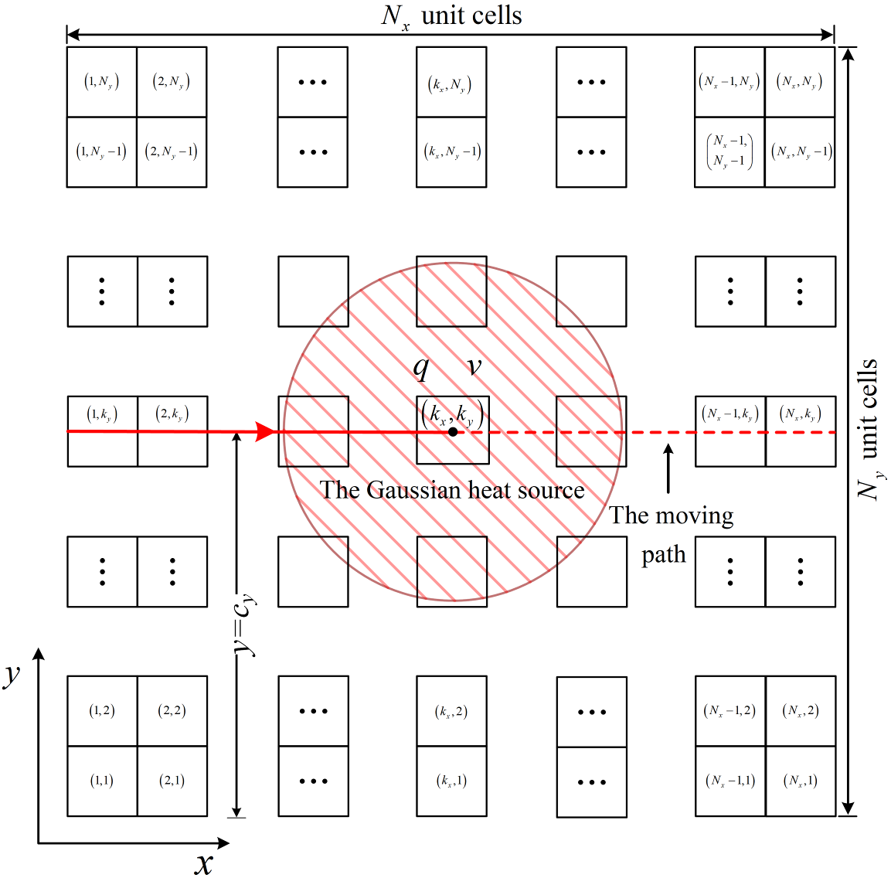

**Fig. 1.** The periodic structure with a moving heat source and the unti cell numbering, where the hatched domain represents the Gaussian heat source.

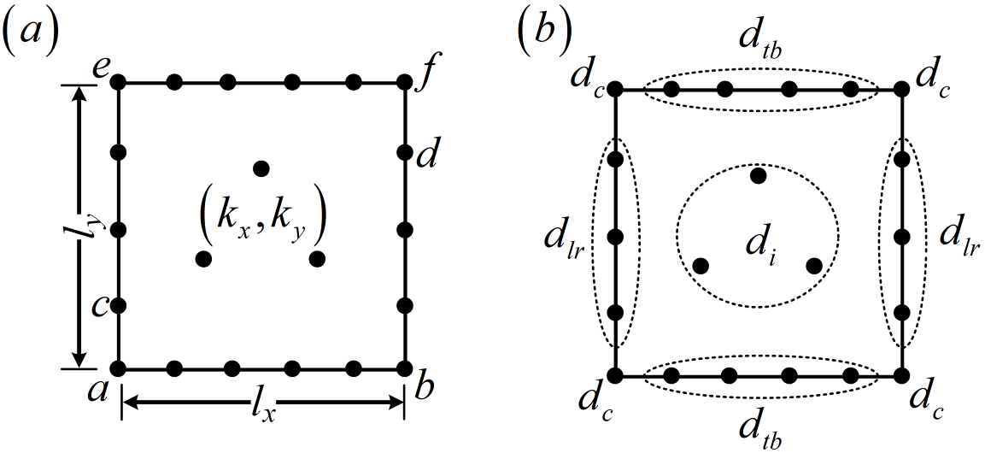

**Fig. 2.** (a) Sizes of unit cell  and the node numbering; (b) the number of nodes on each edge of the unit cell.

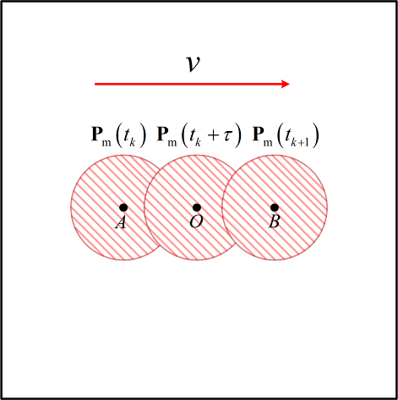

**Fig. 3.** The schematic diagram for the motion of Gaussian heat source on a unit cell.

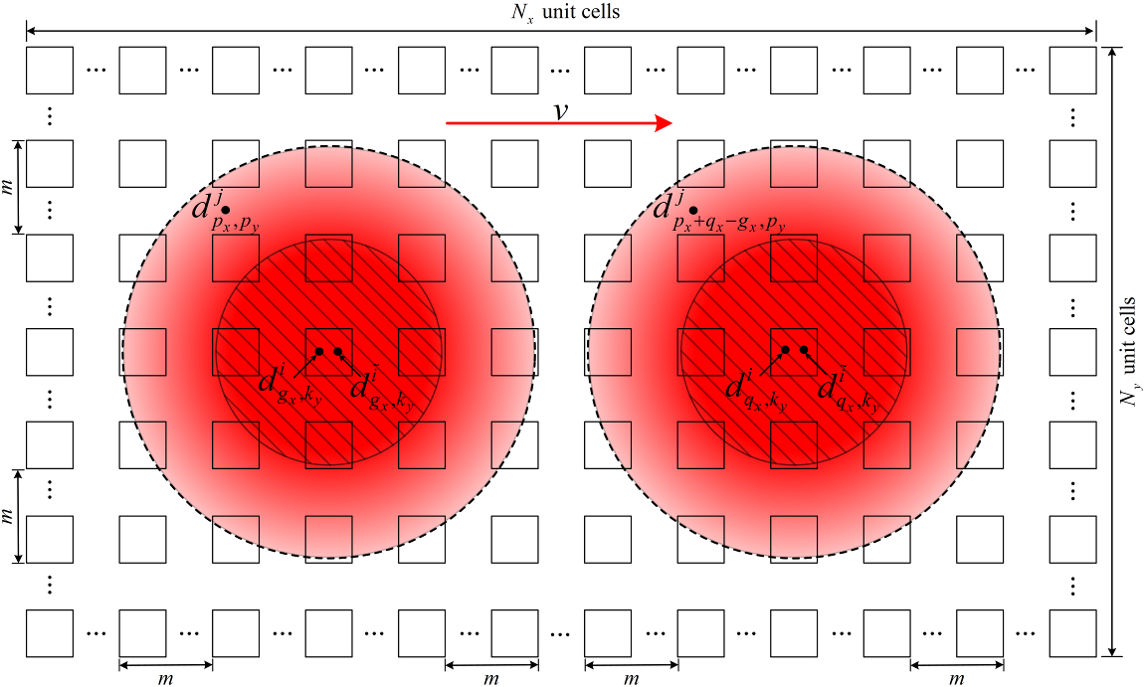

**Fig. 4.** The repeatability of the non-zero temperature responses caused by the moving heat source in the periodic structure.

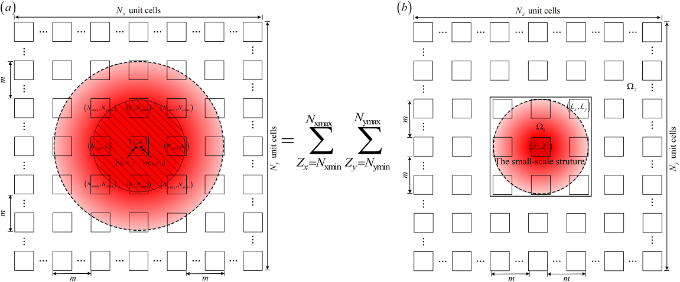

**Fig. 5.** The superposition principle of the temperature responses due to the Gaussian heat source. (a) The temperature responses corresponding to the whole Gaussian heat source; (b) the temperature responses corresponding to the basic equivalent heat load .

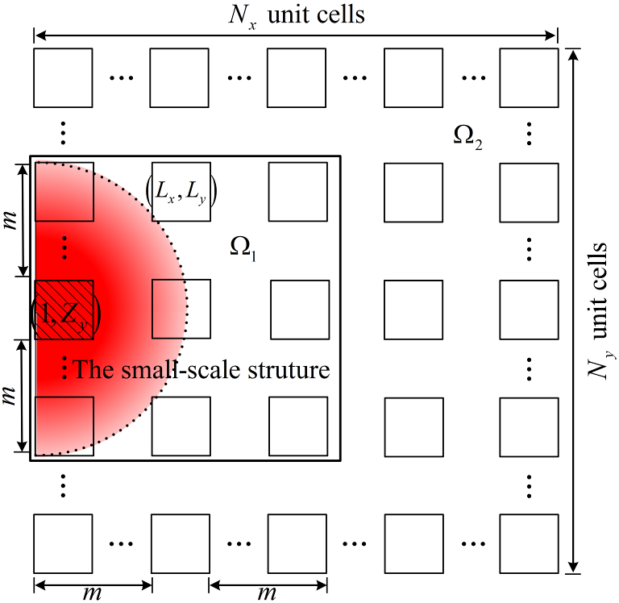

**Fig. 6.** The relationship between the small-scale structure consisting of  unit cells and the actual domain affected by the basic equivalent heat load .

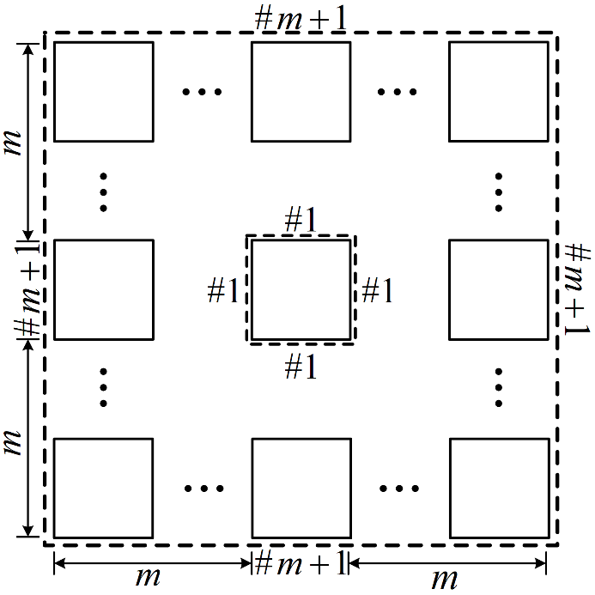

**Fig. 7.** The small-scale structure composed of  unit cells.

unit cell for example1

**Fig. 8.** The unit cell (a) and its mesh (b) for Example. 1.

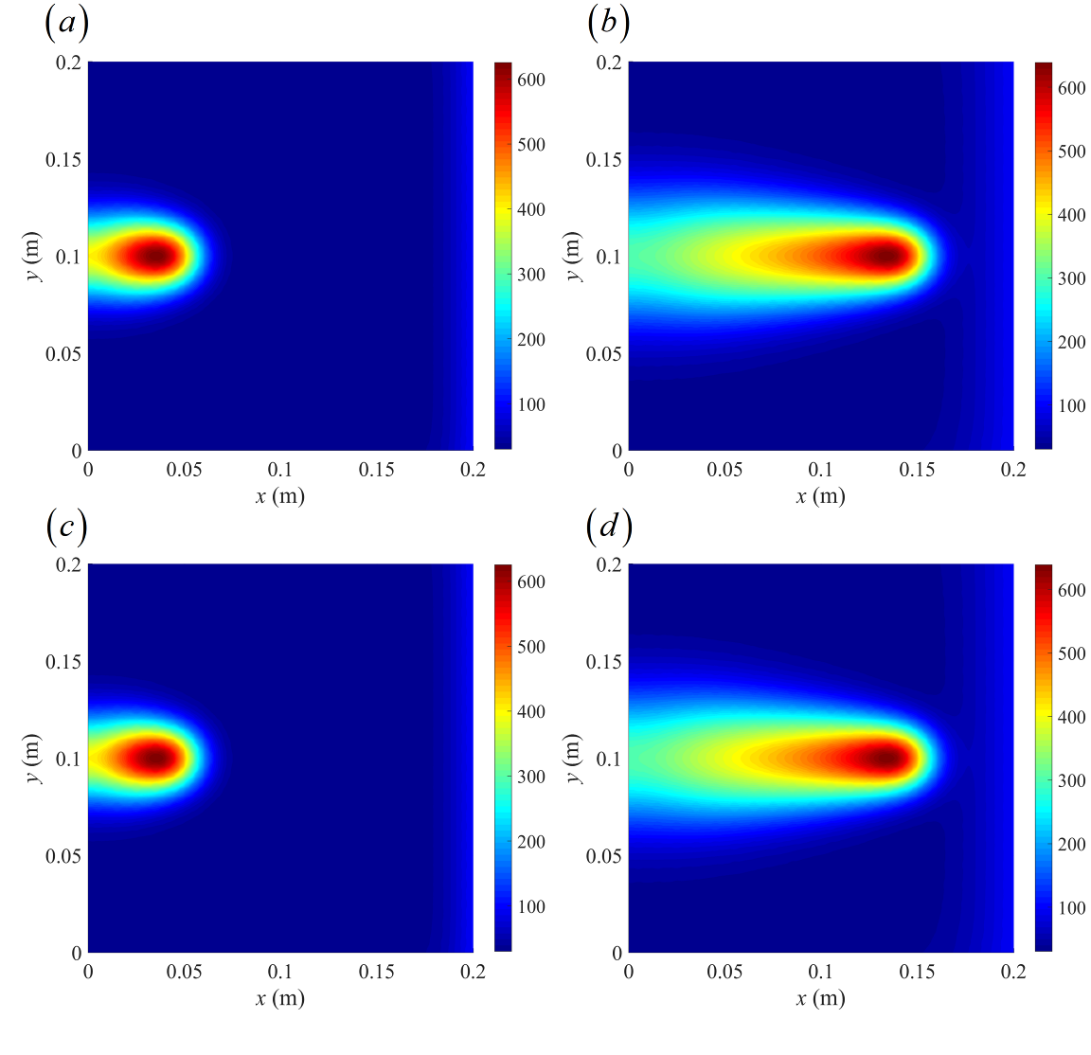

**Fig. 9.** Comparison of the temperature contours obtained by the proposed method and the C-N method at *t*=1 s and 3 s: (a)-(b) respectively represent the temperature contours at *t*=1 s and 3 s computed by the proposed method; (c)-(d) respectively represent the temperature contours at *t*=1 s and 3 s computed by the C-N method.

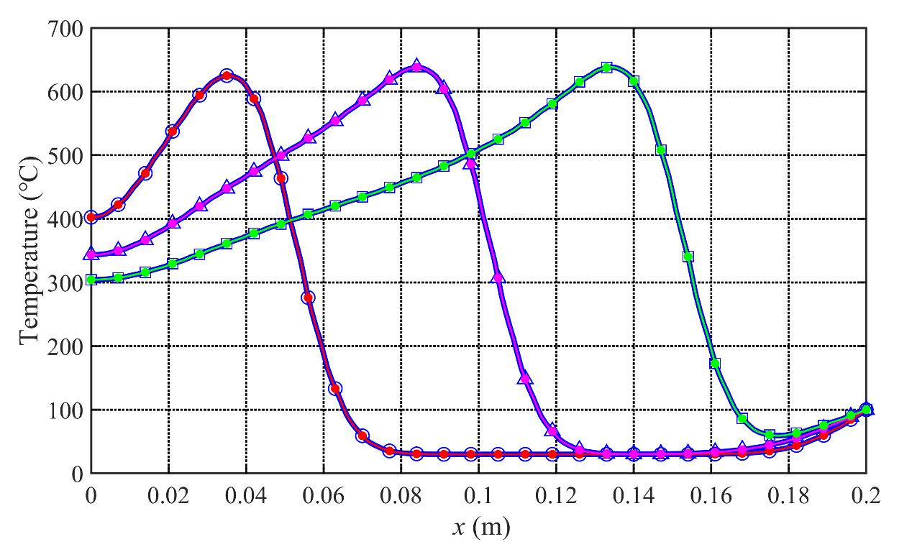

**Fig. 10.** Comparison of temperature responses obtained by the proposed method (the lines with solid circles) and the C-N method (the lines with hollow markers) for *t*=1 s (the lines with red solid circles and hollow circles), 2 s (the lines with magenta solid circles and hollow triangles) and 3 s (the lines with green solid circles and hollow squares).

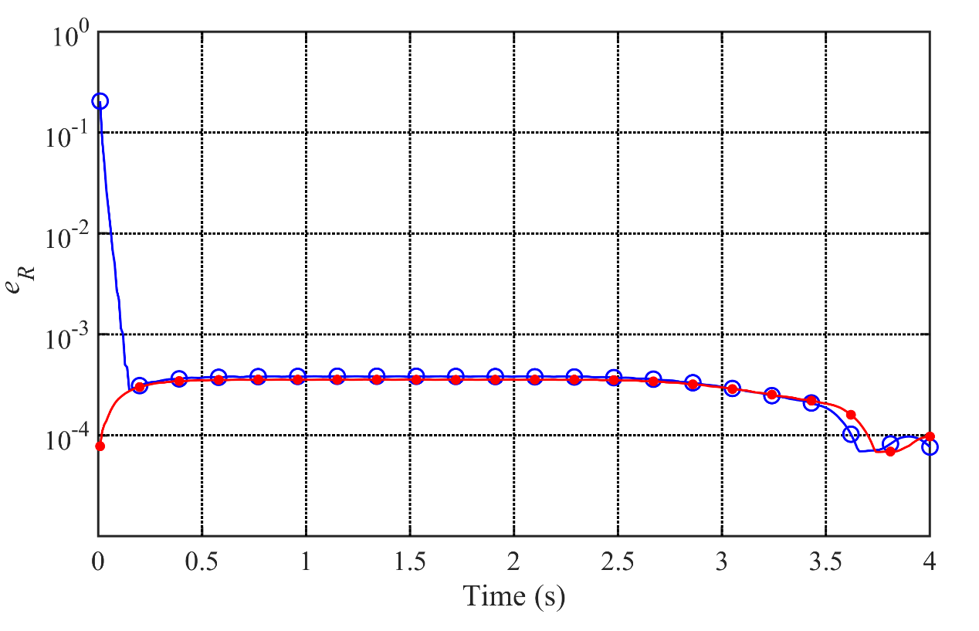

**Fig. 11.** The relative errors of the proposed method (the line with solid circles) and the C-N method (the line with hollow circles) with a time step of 0.01 s.

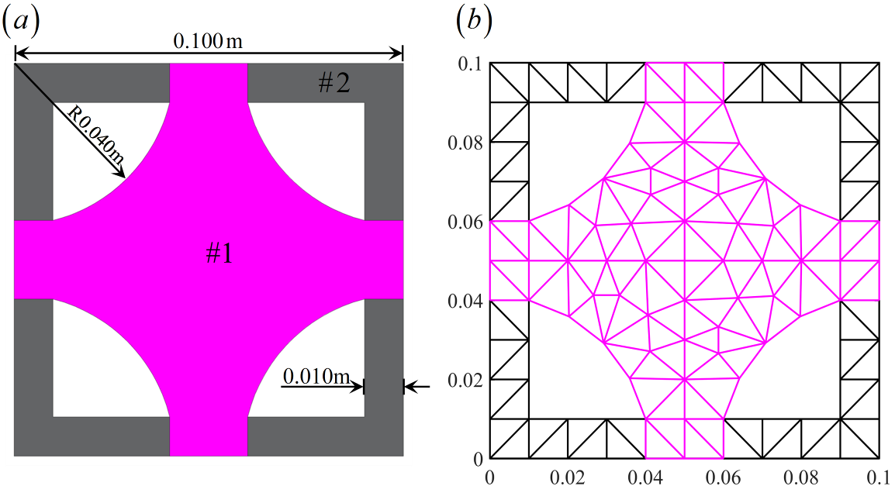

**Fig. 12.** (a) The unit cell for Example 2; (b) the FEM mesh of the unit cell.

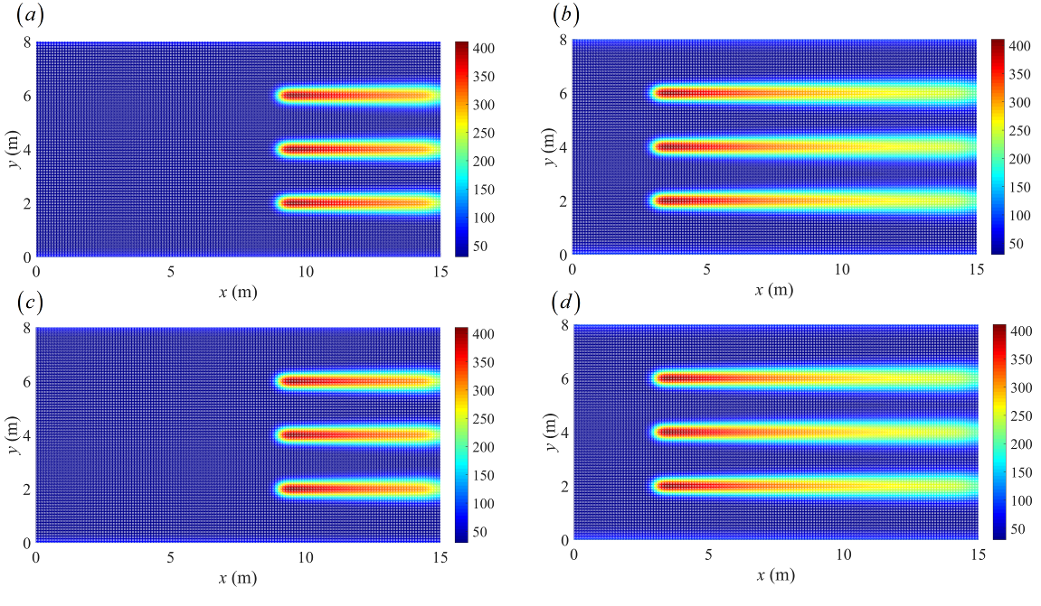

**Fig. 13.** Comparison of the temperature contours obtained by the proposed method and the C-N method at *t*=300 s and 600 s: (a)-(b) respectively represent the temperature contours at *t*=300 s and 600 s computed by the proposed method; (c)-(d) respectively represent the temperature contours at *t*=300 s and 600 s computed by the C-N method.

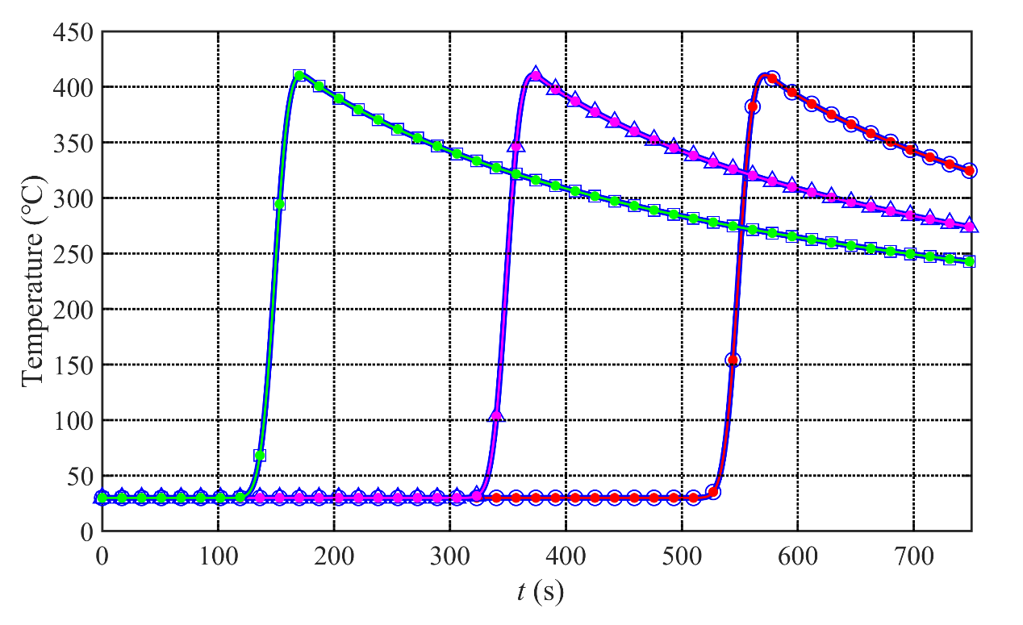

**Fig. 14.** Comparison of temperature responses obtained from the proposed (the lines with solid circles) and C-N methods (the lines with hollow markers) at three different points (4 m, 4 m) (the lines with red solid circles and hollow circles), (4 m, 8 m)(the lines with magenta solid circles and hollow triangles ) and (4 m, 12m) (the lines with green solid circles and hollow squares).**Table 1**

Parameters of the Gaussian moving heat source for Examples 1 and 2.

|  |  |  |
| --- | --- | --- |
| Parameters | Example 1 | Example 2 |
| The maximum heat source rate |  |  |
| The focus radius of the heat source |  |  |
| The velocity of the heat source |  |  |

**Table 2**

Comparison of CPU times for the proposed method and the C-N method with direct and PCG solvers.

|  |  |  |  |  |  |  |
| --- | --- | --- | --- | --- | --- | --- |
| Number of  unit cells | Number of nodes | Number of elements | Steps | CPU times for the proposed method (s) | CPU times for  the C-N method (s) | |
| The direct solver | The PCG solver |
|
| 20×20 | 71201 | 141600 | 400 | 38 | 85 | 80 |
| 40×20 | 142201 | 283200 | 800 | 61 | 270 | 204 |
| 60×20 | 213201 | 424800 | 1200 | 88 | 749 | 370 |

**Table 3**

Relative error (%) at different times for the C-N and proposed methods for Example 2.

|  |  |  |  |  |  |  |  |  |  |
| --- | --- | --- | --- | --- | --- | --- | --- | --- | --- |
| Time (s) | 1 | 4 | 16 | 64 | 256 | 500 | 600 | 700 | 750 |
| The C-N method | 1.603 | 0.332 | 0.109 | 0.114 | 0.113 | 0.111 | 0.111 | 0.111 | 0.025 |
| The proposed method | 0.034 | 0.061 | 0.109 | 0.117 | 0.114 | 0.116 | 0.116 | 0.116 | 0.024 |

**Table 4**

Comparison of CPU times for the three cases using both methods.

|  |  |  |  |
| --- | --- | --- | --- |
| Cases | Steps | The proposed method (s) | The C-N method (s) |
| Case 1 | 750 | 184 | 644 |
| Case 2 | 750 | 202 | 851 |
| Case 3 | 750 | 232 | 1050 |