Rapid quantification of the adulteration of fresh coconut water by dilution and sugars using Raman spectroscopy and chemometrics
Paul I. C. Richardson, Howbeer Muhamadali, David I. Ellis* and Royston Goodacre*
Manchester Institute of Biotechnology, School of Chemistry, Manchester, UK, M1 7DN

*Email: Roy.Goodacre@manchester.ac.uk D.Ellis@manchester.ac.uk

Keywords: fresh coconut water, food fraud, adulteration, sugars, dilution, Raman, chemometrics

Abstract
Here, for the first time, we developed Raman spectroscopy in combination with chemometrics for the quantification of adulteration of fresh coconut water by dilution, and its masking with sugars. Coconut water was extracted from young Costa Rican coconuts and heat treated to emulate pasteurization. Samples were then adulterated by dilution with water and single sugars, mixtures of sugars, and high-fructose corn syrup (HFCS). A total of 155 samples were analysed with Raman spectroscopy at 785 nm excitation and 620 spectra analysed with chemometrics. Results showed successful quantification of dilution and adulteration with single sugars between 1.9 – 2.6%, masking of dilution with mixtures of sugars at 9.8%, and masking of dilution with HFCS at 7.1%. It can be concluded that Raman spectroscopy has significant potential as rapid accurate analytical method for the detection of adulteration in this product, with the ability to discern small abnormalities in sugar ratios within coconut water.

1.Introduction
The tropical coconut palm (Cocos nucifera L.) has played an important role in the mobility of humans across different geographical regions of the globe as a source of food, water, and multiple other uses (Loiola, Azevedo, Diniz, Aragao, Azevedo, Santos, et al., 2016), said to be unparalleled in the plant kingdom (Gunn, Baudouin, & Olsen, 2011). Whilst all parts of this plant have been put to an especially wide variety of uses for millennia, it is the liquid endosperm of the coconut, commonly referred to as coconut water, which is the subject of our study here. Fresh coconut water is a refreshing and nutritious drink typically extracted from immature coconuts of 6-9 months of age (Rolle, 2007). This is due to the fact that as coconuts mature their composition and physicochemical properties alter (Tan, Cheng, Bhat, Rusul, & Easa, 2014), with the white kernel lining the inner shell becoming opaque and hardening. While the coconut water in the centre decreases in volume and sugar content (Child & Nathanael, 1950), undergoes alterations in sugar ratios, as well as increases in pH, turbidity and mineral content with a resultant loss of taste and quality (Tan, Cheng, Bhat, Rusul, & Easa, 2014). The nutrient content of coconut water has also been central to several studies (Santoso, Kubo, Ota, Tadokoro, & Maekawa, 1996; USDA, 2016a) (Table 1) as have its hydration properties.

However, it is the perceived and promoted health benefits of coconut products (DebMandal & Mandal, 2011) and packaged coconut water in particular, that could be said to be responsible for its huge increase in popularity and sales in recent years (Kaplan, 2017). These health claims are wide-ranging; from its effectiveness (Kalman, Feldman, Krieger, & Bloomer, 2012), or not (Peart, Hensby, & Shaw, 2017), as a sports energy drink, its vitamin B and C content (USDA, 2016b), potential for the treatment of hypertension (Bhagya, Prema, & Rajamohan, 2012) and high cholesterol, through to multiple claimed medical properties including hypoglycemic and antioxidant effects (Bispo, Dantas, Chaves, Pinto, da Silva, Otsuka, et al., 2017), as well as antimicrobial (Mandal, Dey, Mandal, Sarkar, Maria-Neto, & Franco, 2009), antiviral, antiparasitic, antidermatophytic, hepatoprotective and immunostimulant properties (DebMandal & Mandal, 2011). The relatively recent explosion in popularity of coconut water as a packaged drink in the last five years is well evidenced, with the global market for coconut water reaching $2.2 billion in 2016, up from $533 million in 2011(Kaplan, 2017). In the UK for example, 40 different brands are currently available, and it has increased in value as a product by 20 times since 2012 with consumption levels of 0.21 litres per capita, three times that of the USA (Glotz, 2016).
This relatively sudden and increased visibility on supermarket shelves prompted us to consider this product as vulnerable to, and a potential target of, adulteration. It is also well known that products such as these have known vulnerabilities to a variety of opportunistic behaviours and illicit practises, such as dilution with water, followed by the attempted masking of dilution with the addition of sugars, or straightforward sugar adulteration in a product whose label may state no-added sugars etc. Moreover, when the huge demand for a product only normally available from immature coconuts of a specific age range and sources (five countries worldwide (Glotz, 2017)) has the potential to outstrip supply, this can also lead to these supply networks becoming significantly more vulnerable to fraud.
Several methods have been used to analyse coconut water for various purposes, including nuclear magnetic resonance (NMR) spectroscopy with chemometrics to monitor process quality parameters, such as glucose and sucrose levels (Sucupira, Alves, Silva, de Brito, Wurlitzer, & Sousa, 2017), characterisation of the volatile profiles (aroma) from multiple varieties using headspace solid phase microextraction gas chromatography (HS-SPME-GC) (Prades, Assa, Dornier, Pain, & Boulanger, 2012), simultaneous analysis of different classes of phytohormones with high performance liquid chromatography (HPLC) and liquid chromatography mass spectrometry (Ma, Ge, Lee, Yong, Tan, & Ong, 2008). And monitoring the physicochemical degradation of coconut water (including sugars) using an electrospray ionisation (ESI) source combined with Fourier transform ion cyclotron resonance mass spectrometry (FT-ICR MS) (Costa, Souza, Soprani, Oliveira, Ogawa, Korres, et al., 2015). The common problem with all these techniques is that they are time-consuming and expensive, as well as requiring extensive sample preparation, and can not readily be employed on site. Conversely, vibrational spectroscopy (which includes near (NIR), mid-infrared (MIR) and Raman) are a group of techniques that are rapid, require minimal sample preparation, and are relatively inexpensive when compared to mass spectrometry and chromatographic approaches. Vibrational spectroscopies also have the potential for portable on-site analysis via handheld or at-line spectrometers.
Here, for the first time, Raman spectroscopy in combination with chemometrics has been used for the analysis of fresh coconut water to establish the feasibility of a vibrational spectroscopic approach in detecting intentional adulteration. Adulteration was undertaken with deionised water (dilution) as well as the addition of incremental volumes of sucrose, fructose, glucose, and mixtures of these sugars, as well as high fructose corn syrup (HFCS). These sugars could be used illicitly in order to mask dilution, or added to affect the flavour of coconut water products labelled as fresh, natural, pure, no-added sugar etc. (Glotz, 2017) , when they are nothing of the sort, an issue observed in other fruit juices previously (Rodriguez-Saona, Fry, McLaughlin, & Calvey, 2001).

- Materials and methods
  - Stock solution
Seven young coconuts (6-9 months maturity) of Costa Rican origin were purchased from a UK-based online retailer. The juice was then extracted using a specialised Cocodrill® purchased from the same retailer, centrifuged at 18,000 g, for 10 min at 4°C and pooled together to create a consistent stock solution. Our coconut water solution had a pH of 5.33 and a Brix value of 6.4°. This pooled stock solution was then stored at -80 °C in 45 mL aliquots until required. Prior to use, the coconut water from the stock solution was thawed at room temperature and divided into 1 mL aliquots, which were then heat-treated using a Techne Dri-Block DB-3A (Cole-Parmer, Stone, Staffordshire, UK) hot-plate for 150 s at 70 °C, to emulate pasteurisation, recombined and cooled in a refrigerator at 5 °C. Heat-treated aliquots were used for a maximum of three days after being thawed. D-glucose anhydrous, D-sucrose (for biochemistry 99%, RNAse and DNAse free) and D-(-)-fructose 99%≤ were purchased from Fisher Scientific (Fisher Scientific Ltd., UK), Acros Organics (Acros Organics, Belgium) and Sigma-Aldrich (Sigma-Aldrich Chemie GMBH, Germany) respectively.

2.2. Standard addition
Solutions of sucrose (5.984 g), glucose (5.990 g) and fructose (6.010 g) were each dissolved in 50 mL water (120 mgmL⁻¹). Samples were made up by spiking 250 µL aliquots of coconut water with various volumes of sugar solution ranging from 25 µL to 250 µL, increasing in 25 µL increments, and filling each sample to 500 µL with deionised water. Unadulterated coconut water was used as a negative control. A total of 31 samples were analysed using 4 machine repetitions, resulting in a total of 124 spectra for this experiment. Sample contents are shown in Table S1.

2.3. Detection of adulteration
Stock solutions matching coconut water’s total sugar concentration (USDA, 2016b) obtained from the standard addition method were made up by dissolving sucrose (3.171 g), glucose (3.150 g) and fructose (3.172 g) in 50 mL deionised water (63 mg mL⁻¹). Additionally, a mixed sugar solution, matching a coconut water’s naturally occurring concentration for each sugar, was made up by dissolving 1.347 g glucose, 1.220 g fructose and 0.582 g sucrose in 50 mL deionised water (26.94 mg mL⁻¹ glucose, 24.40 mg mL⁻¹ fructose, 11.64 mg mL⁻¹ sucrose, 62.98 mg mL⁻¹ total). Samples were made up by adulterating coconut water with deionised water, single sugar solutions, or the mixed sugar solution in increasing ratios (5-100%, 5% increments), with 3 samples of unadulterated coconut water being used as control samples. In addition, adulteration with HFCS was investigated as this is also a known and readily available alternative adulterant. A 1 mL aliquot of HFCS (Daesang America inc., Hackensack, USA) was dissolved in 10 mL water to reach a °Brix value of 6.4, matching that of coconut water. °Brix was obtained using a Signstek ATC Brix Refractometer (Signstek, London, UK). Samples were prepared and analysed in a manner identical to adulteration experiment with laboratory grade sugars. For detection of adulteration, a total of 124 samples were analysed using 4 machine replicates, resulting in a total of 496 spectra for this experiment. Adulteration ratios are presented in Table S2.

2.4. Raman spectroscopy
360 µL aliquots of each sample were transferred onto a 96 well quartz sampling plate. Raman spectra were collected using a Renishaw inVia Raman spectrometer (Renishaw Plc. Gloucestershire, UK) equipped with a laser wavelength of 785 nm and an Olympus MD Plan 10 x 10 long distance objective (KeyMed (Medical & Industrial Equipment) Ltd. Essex, UK). A 600 l/mm grating was used and the acquisition was centred at 1600 cm⁻¹, leading to a range of 408 cm⁻¹ to 2579 cm⁻¹ with 1015 bins. The optimal depth for maximum intensity was found using a depth-series acquisition, and 4 machine replicates were taken by taking a spectrum of each sample at optimal depth and 1, 2, and 3 µm closer using an automated system set up in-house. All spectra were collected as 6 accumulations and 10 s acquisition with a laser power of ~30 mW at each sample.

2.5. Data analysis
For standard addition, spectra were first subjected to manual cosmic ray removal in the WiRe Raman software used to control the instrument. These were then imported into Matlab R2017a (The MathWorks, Natick, USA) where they were subjected to baseline correction using a partial least squares algorithm (based on an algorithm by Eilers (Eilers, 2003) and created as part of an in-house analysis package) using a smoothing parameter of 10,000 and an asymmetry parameter of 0.001. These data were then imported into Microsoft Excel 2013, where the intensity of peaks unique to glucose (1123 cm⁻¹), fructose (627 cm⁻¹) and sucrose (835 cm⁻¹) were plotted against the concentration of the sugar added. A least-squares linear fitting algorithm was used to generate a line of best fit, which was then used to calculate the concentration of each sugar in coconut water using the following equation:

$$\left[S\right]=2\frac{I_{0}}{a}$$

Where S (FAO) is the concentration of sugar, I₀ is the y-intercept of the line of best fit, and a is the slope. The values were doubled to account for the 50% aqueous dilution.

For adulteration studies, spectra were subjected to manual cosmic ray removal, imported into MatLab R2017a, and baseline-corrected as described above, after which they were auto-scaled. Principal component analysis (PCA (Gromski, Muhamadali, Ellis, Xu, Correa, Turner, et al., 2015)) was used to reduce the dimensionality of these data into uncorrelated principal components (PCs) and describe relationships between samples. Additionally, partial least squares regression (PLSR (Gromski, et al., 2015)) was used to generate a linear predictive model. This was undertaken by dividing each dataset into training sets consisting of the samples with adulteration levels being increments of 10% (from 0%, 10%, 20%, 30%, 40%, 50% through to 100%) and test sets consisting of the rest of the data between these levels (at 5%, 15%, 25%, 35%, 45% for example, up to 95%). The training set was used to create several models, each with an increasing number of latent variables (LVs) used and a k-fold cross-validation (Gromski, et al., 2015) system where k=20 was used to test each model. The optimal model was chosen by aiming to minimise the root-mean-squared error on the cross-validation set (RMSECV) and the number of LVs, and the test set was fed into it.

- Results and discussion
3.1. Standard addition
As with all wholefoods, which include fruits, vegetables, and whole grains, coconuts can vary in their total water volume and nutrient content (Manivannan, Bhardwaj, Padmanabhan, Suneja, Hebbar, & Kanade, 2018). As well as slight natural individual variation within the same species, broader differences in coconut water can be a result of several factors such as differences between species (Prades, Dornier, Diop, & Pain, 2012), the country or area of origin (Loiola, et al., 2016), as well as maturity (Santoso, Kubo, Ota, Tadokoro, & Maekawa, 1996). The nature of the current study also required an accurate knowledge of the sugar content of our stock coconut water, as to mimic intentional adulteration with sugar solutions of incorrect concentrations would simply result in poor masking. The standard addition method (SAM) was therefore chosen as a method to calculate each sugar concentration. As well as serving as a proof-of-concept, in ensuring that coconut water and the changes within it can reliably be detected, it is also a simple yet effective self-validating method, removing the requirement for a second quantitative method like HPLC or GC to confirm the results.

As the spiked solution is the unknown solution, any matrix effects and variances that could be a result of using standard concentration curves are eliminated. Standard addition functions (Westley, Xu, Thilaganathan, Carnell, Turner, & Goodacre, 2017) by using the solution of unknown concentration as a base and adding known quantities of the analyte in question to create a model where concentration points are seen as x, x + n, x + 2n, x + 3n etc., where x is the concentration of the unknown sample and n is the known quantity added. These points can then be used to create a regression model which is then shifted to place the signal at a true 0 concentration. Finally, the signal at concentration x is plotted into the shifted regression model to find the true concentration.
The strongest peak of each signal was chosen as a reference to perform the standard addition calculations. As depicted in Figure S1, these can be found at 627, 835, and 1123 cm⁻¹ for fructose, sucrose, and glucose respectively. SAM assumes that the signal at 0% concentration will be 0, baseline correction was performed to minimise error. However, scaling was found to be detrimental to the model and was not performed. Using SAM the sugar concentrations were found to be 24.39, 26.95 and 11.64 mg mL⁻¹ for fructose, glucose and sucrose respectively (Figure S2). These concentrations were in agreement with the values reported in the literature, ranging from 24, 27, and 15 mg mL⁻¹ for each sugar as reported by the Food Standards Australia New Zealand nutrient database (FSANZ, 2010), to 25.5, 26.1, and 0.6 mg mL⁻¹ as reported by Santoso et al. (Santoso, Kubo, Ota, Tadokoro, & Maekawa, 1996). While the monosaccharide concentrations are fairly constant, a large variance in the sucrose concentration is observed, which is likely due to the different stages of maturity of the coconuts tested (Child & Nathanael, 1950; Tan, Cheng, Bhat, Rusul, & Easa, 2014). Child and Nathanael (Child & Nathanael, 1950) observed an increase in sucrose concentration beginning around the 7th month of growth. The experimental values can therefore be confidently stated as sufficiently accurate.

3.2. Adulteration with solutions of single sugars
Dilution with water, as well as being readily detectable with multiple analytical methods, would also result in noticeable changes in organoleptic characteristics if coconut water were watered down at higher concentrations. As the majority of the total dry weight of coconut water is sugar, keeping this concentration constant would be a simple way to not only mask this watered down taste, but also often require the use of expensive and time consuming chromatography or enzymatic methods to detect the adulteration. Moreover, in order that the taste of the final product remains consistent, producers can add sugars without dilution to normalise the sweetness of coconut water and total soluble solids content as measured by Degrees Brix (°Bx) (Nicolai, Beullens, Bobelyn, Peirs, Saeys, Theron, et al., 2007) originating from several different processing plants.
To gain an understanding of the potential of Raman spectroscopy to discriminate between sugars, coconut water was replaced with individual solutions of fructose, glucose and sucrose in various levels in 5% increments (from 0%, 5%, 10%, 15% etc. up to 100%), while keeping the total sugar concentration at a constant 63 mg mL⁻¹. This process would allow for adulterated products to remain undetected using Brix measurements. PCA was then used to reduce the dimensionality of the data (Granato, Putnik, Kovačević, Santos, Calado, Rocha, et al., 2018), and the loadings were examined for the most relevant principal components so as to understand the possible sources of the explained variance (Figure 1). Even when the total sugar concentration is kept at a constant, any alteration in the concentration of individual sugars remains clearly detectable, as displayed on the PCA scores plot of all data (Figure 1A). From the PCA plot it can be observed that each sugar extends linearly in a distinct direction from the middle (or origin) point occupied by pure unadulterated coconut water, with PC 1 separating fructose from glucose and sucrose, whilst PC 2 separates sucrose (positive side) from glucose and fructose (negative side).

Additionally, the gradual colour change in the plot from black to each sugar’s respective chosen colour indicates that each trend is concentration dependent. Only the 95% and 100% data points for fructose adulteration samples were found to be outliers. Further evaluation of the spectra for these data points led to the observation of an abnormal signal in the 400-500 cm⁻¹ range, likely due to an as yet unexplained reduction in signal-to-noise ratios in this region. Since each sugar has a distinct spectrum, clear similarities between the PCA loadings plots (Figure 1B and 1C) and the spectra for each sugar can be found. The loadings for PC 1, for example, indicated a positive weighting for the fructose reference peak at 627 cm⁻¹ along with the two peaks at 822 and 871 cm⁻¹, while indicating a negative weighting for the glucose reference peak at 1123 cm⁻¹ and the two peaks at 1331 and 1363 cm⁻¹. The loadings for PC 2 further confirm this, as they show positive influence of the reference sucrose peak at 835 cm⁻¹ and the 1132 cm⁻¹ signal, among others. From this information, it is clear that Raman spectroscopy, in combination with chemometrics, can accurately detect low levels of adulteration of coconut water with a single sugar solution, with LOD’s of 2.1%, 2.6% and 1.9% for glucose, fructose and sucrose respectively, even when the total concentration of sugar is kept constant.

3.3. Adulteration with a mixed sugar solution
The next step in exploring the discriminatory potential of Raman spectroscopy in detecting adulteration with sugars was to adulterate coconut water with a mixed sugar solution. To ensure comparable results, the experimental conditions and analytical protocols were kept identical. Additionally, the control dataset using unmasked dilution with water was included as a comparison. The PCA score plot (Figure 2) shows clear and regular trends relating to adulteration using solutions of single sugars. Additionally, an equivalent trend in the scores plots is visible for the unmasked dilution with water, demonstrating that such a practice would be easily detectable with Raman spectroscopy. It is worth noting that, although the samples adulterated with varying concentrations of single sugars (glucose and sucrose) are also on the negative side of PC1 axis (Figure 2B), similar to that of the water-diluted samples, using PC3 scores (Figure 2C) these samples display distinct clusters which allows for their discrimination from one another.
Unlike the use of individual sugars to adulterate coconut water in order to mask its dilution with water, the use of a mixed sugar solution to mask dilution while keeping individual sugar concentrations constant is significantly more difficult to detect. Compared to the PCA scores of earlier single sugar adulteration, adulteration with a mixed sugar solution shows little to no change relative to the other conditions investigated. This is predictable and even desired to an extent; given the variance for each principal component originates from changes in the concentration of each individual sugar, a lack of change indicates that these concentrations have not altered and that the masking of dilution was successful. To examine the source of variance within the mixed sugar adulteration dataset, PCA analysis was performed on the mixed sugar dataset alone (Figure 3). Immediately, there are several factors present in the scores plot (Figure 3A) which point to a far weaker detection ability. Additionally, the total explained variance (TEV) of each principal component is far smaller; where previously 3 PCs achieved a TEV of >90%, the use of 10 PCs only achieved ~44% TEV. Although the trend is weaker, it is still present; a gradual change from blue (low adulteration) to red (high adulteration) can be seen (Figure 3A).
In addition to the scores, the loadings plot was also examined to establish possible sources of variance within the dataset, and several areas of high variance were identified and highlighted. The negatively weighted peaks at 835 and 1132 cm⁻¹, indicative of sucrose, and the positively weighted peak at 627 cm⁻¹, indicative of fructose, suggest that masking of dilution was not entirely successful (Figure 3B). Based on Figure 3A showing a decrease in scores with respect to increasing adulteration, it can be inferred that sucrose was slightly in excess and that an insufficient concentration of fructose was used. Additionally, there are two peaks with positive weighting at 967 and 1417 cm⁻¹ which are not attributed to any sugar (Figure 3B). In Figure 3C, these signals can be attributed to two shoulders in the coconut water spectra, which recede with increasing adulteration. These peaks could not be readily associated with any other constituent of coconut water, though the vibrational modes associated with the peak at 967 cm⁻¹ could be attributed to either ν(C-O-C) or ν(CC chain) and 1417 cm⁻¹ to δ(CH3) or δ(CH2). Table S3 lists some of the main Raman spectral peaks observed in fresh coconut specific to sugars, as well as their tentative vibrational assignments.

3.4 High-fructose corn syrup (HFCS)

Although using laboratory grade sugars would potentially allow for greater control and better masking of dilution, the lower cost of HFCS has led it to become the industrial sweetener of choice. HFCS is an impure mixture of the mono-saccharides glucose and fructose derived from corn, generally containing 75-80% total sugar content in water. While there exist several variants with different ratios of fructose to glucose, HFCS 55, indicating a 55:45 ratio of fructose to glucose, is one of the most commonly used sweeteners in food industry.
As with previous experiments, coconut water samples were adulterated in order to keep total sugar concentration within samples constant. As this could not be achieved directly using mass measurements, HFCS was diluted to reach a Brix value of 6.4°, identical to our coconut water samples. To provide appropriate context, PCA analysis was used to compare adulteration with our mixed sugar solution and HFCS (Figure 4). From this, it is clear that detection of both adulterants is comparable and, based on the distance between the 0% and 100% adulteration samples, adulteration with HFCS is detected slightly more readily. Previous experiments have demonstrated that a major source of discriminatory power in our models is the minor discrepancy in sugar profile. It is therefore within the scope of our predictions that, while Raman spectroscopy would not be as sensitive to masking with HFCS as with solutions of a single sugar, it would provide superior detection to masking with a bespoke mimic of its sugar profile. The loadings plot (Figure S3B), also provides insight into the sources of variance with respect to increasing adulteration. Along with showing the effect of each sugar, it describes a decrease in intensity in the same shoulders at 967 and 1417 cm⁻¹ as significant. The reappearance of these shoulders further establishes their relevance in the detection of adulteration in coconut water.

3.5. Quantitative analysis
To acquire a quantitative measure of detection and predictive ability, partial least squares regression (PLSR) was employed. Example plots comparing the PLSR model for the dilution and mixed sugar adulteration samples are presented in Figure 5, and complete statistical results for each series can be found in Table 2. It should be noted that as the 95% and 100% data points in the masking of dilution with fructose series were clear outliers, as also displayed in the PCA scores plot (Figure 1A), they were excluded from the model for this dataset only.
The PLSR results of the water and single sugar solution adulteration series are largely equivalent and, most importantly, demonstrate very high concentration based discrimination abilities using Raman spectroscopy. For all four of these experiments, the R² and both the Q² values for cross-validation and test sets were above >0.999, indicative of a robust model. Additionally, the root-mean-squared error (RMSE) values for the test set, the optimal measure of each model’s predictive ability, all remain below 2%. Furthermore, the limit of detection (LOD) was calculated to be ~2-3%, providing evidence that Raman spectroscopy would detect even low levels of adulteration. The PLSR results of the mixed sugar solution adulteration dataset, despite still showing evidence of a robust model with an R² value of >0.99 and Q² values of >0.9, demonstrates a weaker predictive ability with a RMSE value on the test set of 5.2% and an LOD of 9.8%. This 4-fold increase is not surprising, as PCA demonstrated the relative weakness of the trend earlier. However, this also highlights the importance of sugar signals and their ratios in the detection of adulteration. The effect of this discrepancy in error-prediction can be visualised through the comparison of Figures 4A and 4B. The former, showing the PLSR model for the dilution series, shows very little variance with virtually no deviation from the middle blue line, indicating a very good fit between predicted and known adulteration values, with the latter showing far more variance in its cross-validation and test sets.

As we have said above coconut water has recently increased rapidly in popularity and sales. It is this sudden and exponential increase in demand for packaged coconut water during the last five years, and the short time period of only three months in which the source product is determined as being of optimum quality, that can itself lead to over demand and undersupply. These pressures then have the potential for dysfunctionality with supply chains making this product vulnerable (Spink, Ortega, Chen, & Wu, 2017) and a target for illicit practises such as mislabelling, substitution, misrepresentation, dilution, adulteration with sugars, and other forms of food fraud (David I. Ellis, Brewster, Dunn, Allwood, Golovanov, & Goodacre, 2012). In the case of coconut water, this has already been observed on multiple occasions (Glotz, 25 August 2016), from the extreme of one product being removed from shelves in the Caribbean due to it containing no coconut water at all (just chemicals and additives (Sorias, 20 May 2016)), to recent investigations in the UK by the National Food Crime Unit of the Food Standards Agency (Glotz, 2017). More pertinent to our study here, this latter UK-based investigation found added sugar in 60% of samples, sugars derived from starch, sugar cane, and maize, despite the fact that the products were labelled as being pure and free from additives. This investigation led to a total of 400 tonnes of coconut water being seized and removed from the market (Glotz, 2017). These cases readily illustrate the vulnerable nature of this type of product and the necessity for new methods to be able to detect these forms of adulteration, rapidly, and ideally on-site.

- Concluding remarks
Here, for the first time, we have demonstrated Raman spectroscopy as a potential tool for the detection of coconut water adulteration, which in combination with chemometrics successfully detected the dilution of this product, as well as its adulteration with solutions of single sugars below 3%. Using this approach, we showed that detection of dilution was still possible despite normalisation of the total sugar concentration with glucose, fructose or sucrose. Robust predictive models Q² on test set >0.99) were able to detect very low levels of single sugar adulteration, with LOD’s of 2.1%, 2.6% and 1.9% for glucose, fructose and sucrose respectively. With the masking of dilution with mixed sugar solutions to emulate coconut water’s natural sugar profile being detected at concentrations of less than 10% (Q² on test set: 0.97, LOD: 9.8%). Further investigation, this time using the more industrially relevant and common soft drink sweetener HFCS as an adulterant, showed that HFCS was detectable at even lower concentrations than our laboratory made mixed sugar solution (Q² on test set: 0.98, LOD: 7.1%).

We believe that as well as being novel, there is capacity for further development of Raman spectroscopy in combination with chemometrics for the detection of adulteration in this popular product. These could include refinement and application of a range of chemometric approaches for data analysis, or the use of laser wavelengths which are more suitable to specific types of product or adulteration, as well as closely related forms of Raman spectroscopy such as spatially offset Raman spectroscopy (SORS). SORS also has the added advantage of being able to penetrate through many types of opaque non-metallic packing, such as bottles and cartons, to retrieve detailed chemical information, and has been shown to detect a wide range of adulterants in other beverages at extremely low concentrations (D. I. Ellis, Eccles, Xu, Griffen, Muhamadali, Matousek, et al., 2017). It can be concluded that Raman spectroscopy has significant potential as rapid accurate analytical method for the detection of adulteration in this coconut water, able to discern small abnormalities in sugar ratios in coconut water. Whilst being simple to use and with the increasing commercial availability of multiple handheld instruments, the potential for portability for on-site analyses (D. I. Ellis, Muhamadali, Haughey, Elliott, & Goodacre, 2015; Hargreaves, 2014).

Acknowledgements
DIE and RG thank the UK ESRC and UK FSA for funding (Food fraud: a supply network integrated systems analysis (Grant number ES/M003183/1)).

Tables and Figures

Table 1. Typical water, macronutrient, and sugar contents of fresh coconut water harvested at 6 months from the USDA National Nutrient Database (USDA, 2016a) and Santosa et al. (Santoso, Kubo, Ota, Tadokoro, & Maekawa, 1996).

Table 2. PLSR model statistical results for each dataset measured. For each dataset, R², Q² values for the k-fold (k=20) cross-validation and test sets, along with the RMSE values for the training, cross-validation and test sets are presented. Calculated limit of detection (LOD) values are also presented. * R² and Q² values are measures of the total in the training, cross-validation and test sets explained by the model. As the 95% and 100% data for the fructose dataset were found to be outliers, they were removed.

Figure 1. PCA scores plot of the adulterated coconut water with increasing quantities of individual sugar solutions, using 2 PCs and achieving 90.1% total explained variance (TEV). A: PCA scores plot comparing PC 1 and PC 2. B: Loadings plot for PC 1 (black line), C: Loadings plot for PC 2 (black line). The reference peaks for fructose, glucose and sucrose (627, 1123 and 835 cm⁻¹ respectively) were highlighted, and their Raman spectra (red, green and blue respectively) were overlaid onto the loadings.

Figure 2. PCA scores plots of the adulteration of coconut water (black stars) with water (stars), 63 mg mL-1 solutions of fructose (circles), glucose (squares) and sucrose (triangles), and a mixed sugar solution (diamonds). The analysis was performed using 3 PCs and achieved 90.3% TEV. A: 3D scores plot, B: scores plot of PC 1 vs PC 2, C: PC 1 vs PC 3, D: PC 2 vs PC 3.

Figure 3. PCA of the adulteration of coconut water with a mixed sugar solution in 5% increments ranging from 0-100%, using 2 PCs to achieve 25.7% TEV. A) PCA scores plot comparing PC 1 and PC 2. B) Loadings plot for PC 1, indicating the variance corresponding to each wavenumber sampled. C) Overlaid Raman spectra after baseline correction and autoscaling. For each level of adulteration, the average of four machine repetitions is presented. Increasing levels of adulteration are represented by a colour change from black to purple.

Figure 4. PCA scores plot comparing the adulteration of coconut water (black stars) with a mixed sugar solution (diamonds) and a high-fructose corn syrup solution (triangles). The analysis was performed using 2 PCs and achieved 54.0% TEV.

Figure 5. A) PLSR prediction model for unmasked dilution of coconut water. Q² and the RMSE for the test set are 0.9965 and 1.67% respectively. B) PLSR prediction model for dilution masked with a mixed sugar solution. Q² and the RMSE for the test set are 0.9671 and 5.21% respectively. A complete set of statistical values can be found in Table 2.

Table 1.

Ingredient | (g/100g) (6 months) (Santoso, Kubo, Ota, Tadokoro, & Maekawa, 1996)
Water | 94.18
Total dry weight | 5.82
Protein | 0.12
Lipid | 0.07
Ash | 0.87
Dietary fiber | 1.1
Sucrose | 0.06
Glucose | 2.61
Fructose | 2.55

Table 2.
 | LVs | R² | Q² (CV) | Q² (tst) | RMSE (trn) | RMSE (CV) | RMSE (tst) | LOD (%)
Water | 4 | 0.9998 | 0.9972 | 0.9965 | 0.4286 | 1.3640 | 1.6743 | 3.3943
Fructose* | 3 | 0.9996 | 0.9967 | 0.9977 | 0.5504 | 1.3105 | 1.2323 | 2.5760
Glucose | 3 | 0.9997 | 0.9975 | 0.9984 | 0.5622 | 1.3020 | 1.1648 | 2.0874
Sucrose | 3 | 0.9997 | 0.9980 | 0.9987 | 0.5663 | 1.1551 | 1.0161 | 1.9350
Mix | 2 | 0.9957 | 0.9281 | 0.9671 | 2.0801 | 6.9218 | 5.2104 | 9.8331
HFCS | 4 | 0.9998 | 0.9727 | 0.9835 | 0.4366 | 4.2641 | 3.6900 | 7.1343

Figure 1.

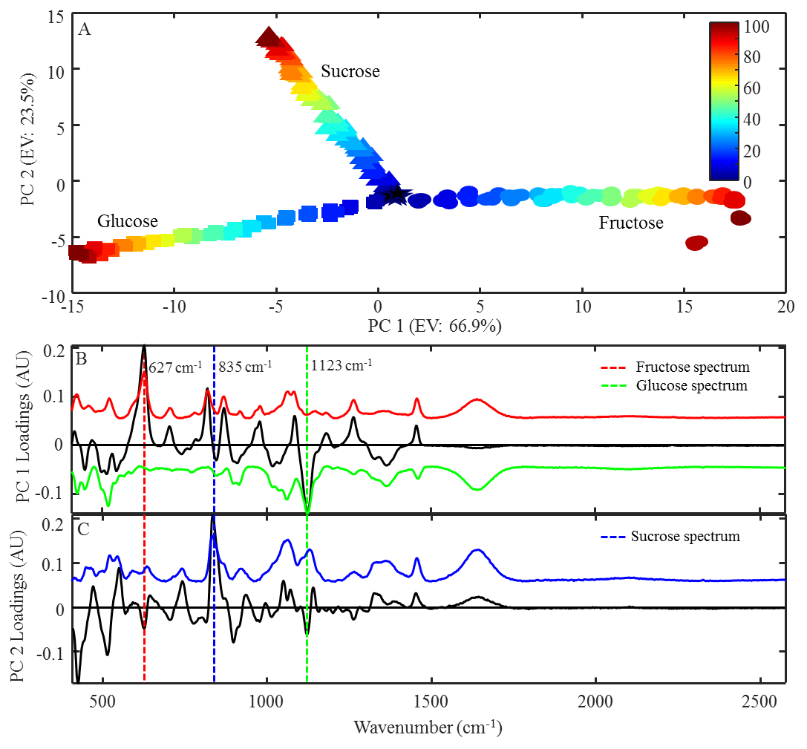

Figure 2.

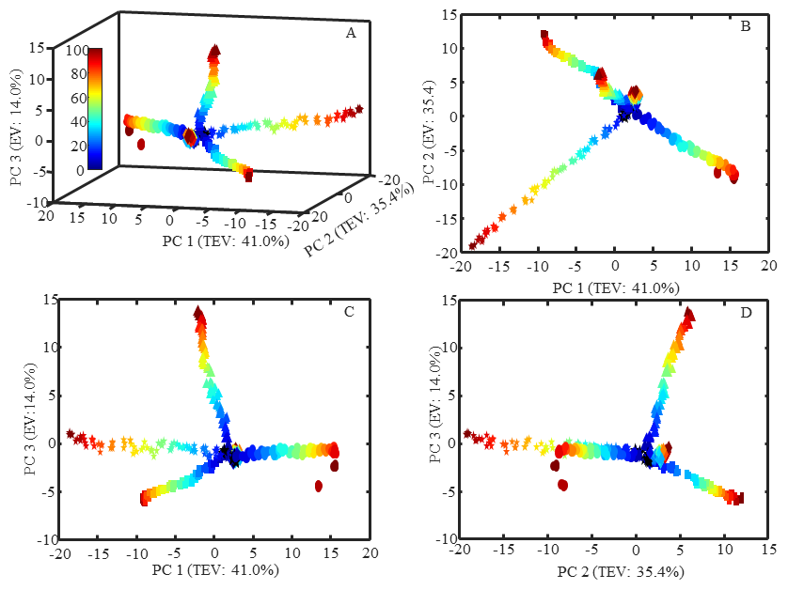

Figure 3.

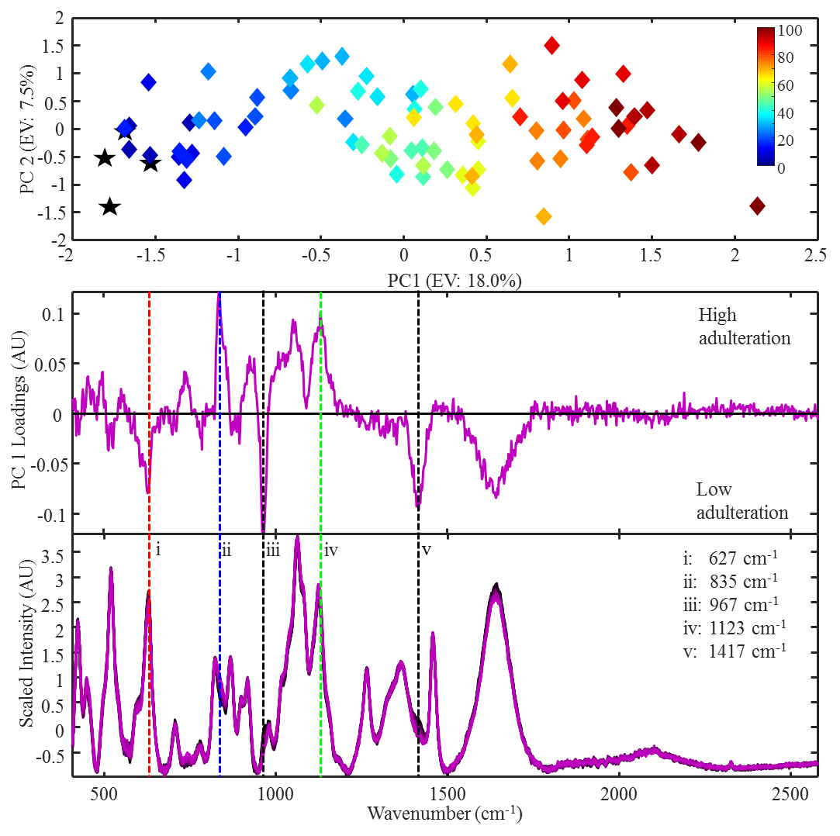

Figure 4

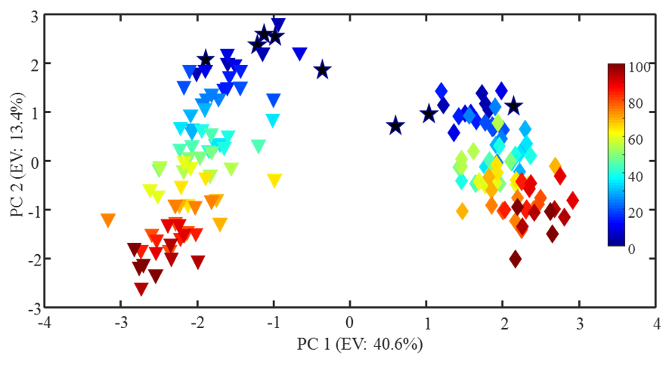

.

Figure 5.

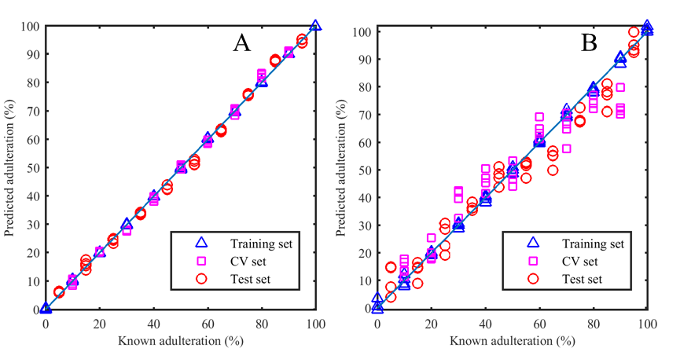
A
B

References

Bhagya, D., Prema, L., & Rajamohan, T. (2012). Therapeutic effects of tender coconut water on oxidative stress in fructose fed insulin resistant hypertensive rats. Asian Pacific Journal of Tropical Medicine, 5(4), 270-276.
Bispo, V. S., Dantas, L. S., Chaves, A. B., Pinto, I. F. D., da Silva, R. P., Otsuka, F. A. M., Santos, R. B., Santos, A. C., Trindade, D. J., & Matos, H. R. (2017). Reduction of the DNA damages, Hepatoprotective Effect and Antioxidant Potential of the Coconut Water, ascorbic and Caffeic Acids in Oxidative Stress Mediated by Ethanol. Anais Da Academia Brasileira De Ciencias, 89(2), 1095-1109.
Child, R., & Nathanael, W. R. N. (1950). Changes in the sugar composition of coconut water during maturation and germination. Journal of the Science of Food and Agriculture, 1(11), 326-329.
Costa, H. B., Souza, L. M., Soprani, L. C., Oliveira, B. G., Ogawa, E. M., Korres, A. M. N., Ventura, J. A., & Romao, W. (2015). Monitoring the physicochemical degradation of coconut water using ESI-FT-ICR MS. Food Chemistry, 174, 139-146.
DebMandal, M., & Mandal, S. (2011). Coconut (Cocos nucifera L.: Arecaceae): In health promotion and disease prevention. Asian Pacific Journal of Tropical Medicine, 4(3), 241-247.
Eilers, P. H. C. (2003). A perfect smoother. Analytical Chemistry, 75(14), 3631-3636.
Ellis, D. I., Brewster, V. L., Dunn, W. B., Allwood, J. W., Golovanov, A. P., & Goodacre, R. (2012). Fingerprinting food: current technologies for the detection of food adulteration and contamination. Chemical Society Reviews, 41(17), 5706-5727.
Ellis, D. I., Eccles, R., Xu, Y., Griffen, J., Muhamadali, H., Matousek, P., Goodall, I., & Goodacre, R. (2017). Through-container, extremely low concentration detection of multiple chemical markers of counterfeit alcohol using a handheld SORS device. Scientific Reports, 7.
Ellis, D. I., Muhamadali, H., Haughey, S. A., Elliott, C. T., & Goodacre, R. (2015). Point-and-shoot: rapid quantitative detection methods for on-site food fraud analysis - moving out of the laboratory and into the food supply chain. Analytical Methods, 7(22), 9401-9414.
FAO. (2007). Good practice for the small-scale production of bottled coconut water. In F. a. A. O. o. t. U. Nations (Ed.), Good practice for the small-scale production of bottled coconut water, (pp. 35).
FSANZ. (2010). Nutrient tables for use in Australia In).
Glotz, J. (25 August 2016). Coconut water: a fair target? In The Grocer).
Glotz, J. (2016). Infographic: The UK coconut water market at a glance. In): The Grocer.
Glotz, J. (2017). FSA probe finds widespread addition of undeclared sugar in coconut water. In). The Grocer.
Granato, D., Putnik, P., Kovačević, D., Santos, J., Calado, V., Rocha, R., Da Cruz, A., Jarvis, B., Rodionova, O., & Pomerantsev, A. (2018). Trends in chemometrics: food authentication, microbiology, and effects of processing. Comprehensive Reviews in Food Science and Food Safety, 17(663-677).
Gromski, P. S., Muhamadali, H., Ellis, D. I., Xu, Y., Correa, E., Turner, M. L., & Goodacre, R. (2015). A tutorial review: Metabolomics and partial least squares-discriminant analysis - a marriage of convenience or a shotgun wedding. Analytica Chimica Acta, 879, 10-23.
Gunn, B. F., Baudouin, L., & Olsen, K. M. (2011). Independent Origins of Cultivated Coconut (Cocos nucifera L.) in the Old World Tropics. Plos One, 6(6), 8.
Hargreaves, M. D. (2014). Handheld Raman Spectrometers and Their Applications. In Encyclopedia of Analytical Chemistry): John Wiley & Sons.
Kalman, D. S., Feldman, S., Krieger, D. R., & Bloomer, R. J. (2012). Comparison of coconut water and a carbohydrate-electrolyte sport drink on measures of hydration and physical performance in exercise-trained men. Journal of the International Society of Sports Nutrition, 9, 10.
Kaplan, J. (2017). Vita Coco to Near $1 Billion in Sales as Potential Buyers Circle. In): Bloomberg Markets.
Loiola, C. M., Azevedo, A. O. N., Diniz, L. E. C., Aragao, W. M., Azevedo, C. D. D., Santos, P., Ramos, H. C. C., Pereira, M. G., & Ramos, S. R. R. (2016). Genetic Relationships among Tall Coconut Palm (Cocos nucifera L.) Accessions of the International Coconut Genebank for Latin America and the Caribbean (ICG-LAC), Evaluated Using Microsatellite Markers (SSRs). Plos One, 11(3), 11.
Ma, Z., Ge, L., Lee, A. S. Y., Yong, J. W. H., Tan, S. N., & Ong, E. S. (2008). Simultaneous analysis of different classes of phytohormones in coconut (Cocos nucifera L.) water using high-performance liquid chromatography and liquid chromatography-tandem mass spectrometry after solid-phase extraction. Analytica Chimica Acta, 610(2), 274-281.
Mandal, S. M., Dey, S., Mandal, M., Sarkar, S., Maria-Neto, S., & Franco, O. L. (2009). Identification and structural insights of three novel antimicrobial peptides isolated from green coconut water. Peptides, 30(4), 633-637.
Manivannan, A., Bhardwaj, R., Padmanabhan, S., Suneja, P., Hebbar, K. B., & Kanade, S. R. (2018). Biochemical and nutritional characterization of coconut (Cocos nucifera L.) haustorium. Food Chemistry, 238, 153-159.
Nicolai, B. M., Beullens, K., Bobelyn, E., Peirs, A., Saeys, W., Theron, K. I., & Lammertyn, J. (2007). Nondestructive measurement of fruit and vegetable quality by means of NIR spectroscopy: A review. Postharvest Biology and Technology, 46(2), 99-118.
Peart, D. J., Hensby, A., & Shaw, M. P. (2017). Coconut Water Does Not Improve Markers of Hydration During Sub-maximal Exercise and Performance in a Subsequent Time Trial Compared with Water Alone. International Journal of Sport Nutrition and Exercise Metabolism, 27(3), 279-284.
Prades, A., Assa, R. R. A., Dornier, M., Pain, J. P., & Boulanger, R. (2012). Characterisation of the volatile profile of coconut water from five varieties using an optimised HS-SPME-GC analysis. Journal of the Science of Food and Agriculture, 92(12), 2471-2478.
Prades, A., Dornier, M., Diop, N., & Pain, J. P. (2012). Coconut water uses, composition and properties: a review. Fruits, 67(2), 87-107.
Rodriguez-Saona, L. E., Fry, F. S., McLaughlin, M. A., & Calvey, E. M. (2001). Rapid analysis of sugars in fruit juices by FT-NIR spectroscopy. Carbohydrate Research, 336(1), 63-74.
Rolle, R. (2007). Good practice for the small-scale production of coconut water. In A. a. F. E. T. Service (Ed.)). Rome: FAO.
Santoso, U., Kubo, K., Ota, T., Tadokoro, T., & Maekawa, A. (1996). Nutrient composition of kopyor coconuts (Cocos nucifera L). Food Chemistry, 57(2), 299-304.
Sorias, L. (20 May 2016). Health Ministry removes local coconut water off the market. Trinidad Express.
Spink, J., Ortega, D. L., Chen, C., & Wu, F. (2017). Food fraud prevention shifts the food risk focus to vulnerability. Trends in Food Science & Technology, 62, 215-220.
Sucupira, N. R., Alves, E. G., Silva, L. M. A., de Brito, E. S., Wurlitzer, N. J., & Sousa, P. H. M. (2017). NMR spectroscopy and chemometrics to evaluate different processing of coconut water. Food Chemistry, 216, 217-224.
Tan, T. C., Cheng, L. H., Bhat, R., Rusul, G., & Easa, A. M. (2014). Composition, physicochemical properties and thermal inactivation kinetics of polyphenol oxidase and peroxidase from coconut (Cocos nucifera) water obtained from immature, mature and overly-mature coconut. Food Chemistry, 142, 121-128.
USDA. (2016a). National Nutrient Database for Standard Reference Release 28, Basic Report 12119, Nuts, coconut water (liquid from coconuts). In).
USDA. (2016b). Nuts, coconut water (liquid from coconuts): National Nutrient Database for Standard Reference Release 28. In).
Westley, C., Xu, Y., Thilaganathan, B., Carnell, A. J., Turner, N. J., & Goodacre, R. (2017). Absolute Quantification of Uric Acid in Human Urine Using Surface Enhanced Raman Scattering with the Standard Addition Method. Analytical Chemistry, 89(4), 2472-2477.

