Quantitative detection of isotopically enriched E. coli cells by SERS

Malama Chisanga,ª Howbeer Muhamadali,ª Richard Kimber,^{b} and Royston Goodacre^{*a}
ªSchool of Chemistry, Manchester Institute of Biotechnology, University of Manchester, Manchester, UK
^{b}School of Earth and Environmental Sciences, Williamson Research Centre for Molecular Environmental Science, University of Manchester, Manchester, UK

*Corresponding authors:
Royston Goodacre, E-mail: roy.goodacre@manchester.ac.uk, Tel: 0161 306-4480

Keywords: Raman spectroscopy, Surface-enhanced Raman scattering, Isotopic labelling, FT-IR spectroscopy, Metabolic fingerprinting, Microbial differentiation

Abstract
It is clear that investigating how bacterial cells work by analysing their functional roles in microbial communities is very important in environmental, clinical and industrial microbiology. The benefits of linking genes to their respective functions include reliable identification of causative agents of various diseases, which would permit appropriate and timely treatment in healthcare systems. In industrial and municipal wastewater treatment and management, such knowledge may allow for the manipulation of microbial communities, such as bioaugmentation, in order to improve the efficiency and effectiveness of bioremediation process. Stable isotope probing coupled with identification techniques has emerged to be a potentially reliable tool for discrimination, identification and characterization of bacteria at community and single cell level; knowledge which can be utilized to link microbially mediated bioprocesses to phylogeny. The development of surface-enhanced Raman scattering (SERS) technique offers an exciting alternative to the Raman and Fourier-transform infrared spectroscopic techniques in understanding metabolic processes of microorganisms in situ. SERS employing Ag and Au nanoparticles can significantly enhance the Raman signal making it an exciting candidate for the analysis of cellular components of microorganisms. In this study, Escherichia coli cells were cultivated in minimal medium containing different ratios of ¹²C/¹³C glucose and ¹⁴N/¹⁵N ammonium chloride as the only carbon and nitrogen sources respectively, with the overall final concentrations of these substrates being constant. After growth E. coli cells were analyzed with SERS employing in situ synthesis of Ag nanoparticles. This novel investigation of SERS spectral data with multivariate chemometrics demonstrated clear clusters which could be correlated to SERS spectral shifts of biomolecules from cells grown and hence labeled with ¹³C and ¹⁵N atoms. These shifts reflect the isotopic content of the bacteria and quantification of the isotope levels could be established using chemometrics based on partial least squares regression.
Introduction
Bacteria and fungi very rarely live in isolation and are usually found in multi-species communities. In order to understand the roles of these organisms in complex environments a great deal of research has demonstrated the importance of linking specific microorganisms to their respective functional roles. These include: reliable identification of causative agents of various diseases which would permit appropriate and timely treatment in healthcare systems,¹ and within industrial and municipal wastewater treatment and management, such knowledge may allow for the manipulation of microbial communities, such as bioaugmentation, in order to improve the efficiency and effectiveness of bioremediation process.²⁻⁴ Despite being admirable, these benefits remain largely unattainable, since whilst it is relatively easy to identify microorganisms within a community, there is considerable difficulty in linking organisms to their functional roles.^{4, 5}
The emergence of stable isotope probing (SIP) coupled with the development of genomics, transcriptomics and metabolomics techniques combined with advanced identification technologies has recently started to bridge this gene (organism) to function gap.^{6, 7} Ideally, the SIP approach involves the incorporation of heavy isotopes, via metabolism of a labeled substrate, into bacterial components such as polar-lipid-derived fatty acid (PLFA), proteins, DNA, metabolites etc. allowing for direct identification of the ‘victim’ bacterium or group of bacteria that have preferentially used a labeled substrate.^{8, 9} Several studies have demonstrated the utility of SIP for linking taxonomic identity (via 16S rDNA) of bacteria to function, which mainly focused on the analysis and discrimination of isotopically enriched PLFA,¹⁰⁻¹² DNA^{8, 13, 14} and RNA.^{4, 15-17} However, the difficulties involved in resolving PLFA signatures of multi-species components as well as the limitation of isotopic enrichment due to the need to have a significant amount of labeled DNA that can be separated by isotope gradient-based centrifugation may limit the global use of PLFA and DNA-based SIP strategies.^{7, 18} Recently, Raman spectroscopy combined with SIP has attracted a lot of attention as a tool for linking gene to function.¹⁹⁻²¹ As opposed to PLFA, DNA and RNA, Raman-based SIP permits rapid, non-destructive and high throughput identification and discrimination of bacteria responsible for metabolizing labelled substrates at community and more importantly single cell levels.^{19, 22} In Raman, differentiation of labelled and unlabelled bacteria is based on respective ‘redshifts’ (vibrations that move to lower wavenumber shifts) of Raman spectral peaks arising from specific molecular vibrations of polarizable chemical bonds in labelled biomolecules such as carbohydrates, proteins, nucleic acids and lipids.²³ Therefore, Raman-based SIP may reveal vast amount of information regarding the heterogeneity, cell-cell interactions, structural properties and physiological dynamics of bacteria in their natural populations.^{20, 24} Inspite of this Raman-SIP approach being applied in medical,^{25, 26} food²⁷ and environmental²⁸ areas, Raman spectroscopy is held back by its naturally poor quantum efficiency: only ~1 in 10⁶–10⁸ incident photons undergo inelastic scattering. This limits the sensitivity of Raman techniques which may lead to long acquisition times. Consequently, this prevents Raman from being applied in routine clinical and industrial laboratories.²⁹
Surface-enhanced Raman scattering (SERS) has been developed in order to improve the sensitivity and the Raman signal (typically by 10³–10⁶ times).³⁰ Strong SERS signals originate from biomolecules in close proximity to, or adsorbed on to, carefully prepared nanometre-sized Ag or Au particles, roughened metal surfaces or thin films.³¹ Kubryk and colleagues reported the first application of SERS for single cell analysis.³² Interestingly, the same technique was employed for determining the biomolecules responsible for the major SERS spectral band around 730 cm⁻¹.³³ Nevertheless, SERS is limited by the lack of reproducibility due to a number of factors including heterogeneity of NP sizes and poor bacteria-NP interactions.³⁴ However, recent studies have demonstrated that by optimizing the nanoparticle synthesis process and careful design of experimental parameters, highly reproducible SERS spectra can be achieved.³⁵⁻³⁹
In this study, for the first time we illustrate the quantitative differentiation of bacteria labelled with varying concentrations of ¹²C/¹³C-glucose and ¹⁴N/¹⁵N-ammonium chloride using SERS involving in situ synthesis of silver nanoparticles,⁴⁰ along with multivariate chemometrics of the resultant SERS spectra.

Experimental Methods
Growth conditions
Unless otherwise stated, all chemicals were purchased from Fisher (Fisher Scientific, UK).
Escherichia coli K-12 MG1655 was grown on minimal medium supplemented with 5 g/L of varying concentrations of ¹²C-glucose and/or 99 atom % homogenously labelled ¹³C-glucose (both purchased from Sigma Aldrich, UK), and 1 g/L of varying ratios of ¹⁴N-NH₄Cl and/or 98 atom % homogenously labelled ¹⁵N-NH₄Cl (Sigma Aldrich, UK), as the single carbon and nitrogen sources respectively²². Bacterial samples were incubated as 1.5 mL aliquot replicates (n = 5) in sterile 24-well plates (Greiner Bio-one, U.K) for 15 h at 37 °C with 170 rpm shaking speed in a Multitron standard shaker incubator (INFORS-HT Bottmingen, Switzerland). To reduce potential evaporation and loss of sample during the incubation period, all plates were sealed with sterile Breathe-Easy sealing membranes (Sigma Aldrich, UK). All the cells were harvested at stationary growth phase (t = 15 h) for SERS measurements.

Sample preparation
After incubation, each sample aliquot (1.5 mL) were transferred to a sterile 2 mL microcentrifuge tube and centrifuged for 5 min at 5000 g using a bench top Eppendorf Microcentrifuge 5424R (Eppendorf Ltd, Cambridge, UK). After discarding the supernatant, the collected biomass was washed twice using 1 mL of de-ionized water to remove media components following the above centrifugation. The pellets were collected and stored at -80°C prior to SERS analysis.

In Situ Synthesis of Colloidal Silver Nanoparticles
The preparation of the sodium borohydride-reduced silver nanoparticles described in this study follows Zeiri,⁴⁰ Efrima³⁵ and the method described by Lee and Meisel⁴¹ with small modifications. Briefly, the bacterial pellets were suspended in 0.09 M sodium borohydride solution and centrifuged for 10 min at 2800 g. After removing the supernatant the pellets were resuspended in 0.04 M silver nitrate solution, at this point the silver cations were reduced by the borohydride anions to form Ag nanoparticles which were adsorbed onto the surface of the intact bacterial cells as shown by the schematic diagram in Figure 1a and in the SEM image in Figure 1c.^{35, 38}

Raman microspectroscopy analysis
Prior to Raman measurements, 5 µL of each of the bacteria-silver nanoparticles solutions were spotted on to clean and dry calcium fluoride (CaF₂) discs and air-dried for 30 min in a desiccator. SERS spectra were obtained as mapping scans using an InVia confocal Raman spectrometer (Renishaw Plc., Gloucestershire, UK) equipped with a 532 nm diode laser with laser power on the sample adjusted to 0.024 mW. The wavelength of the instrument was calibrated with a silicon wafer focused under the 50× objective and collected as a static spectrum centered at 520 cm⁻¹. The experimental parameters were maintained throughout the analysis: 25 s exposure time, 8 accumulations and 600 l/mm grating, with each spectrum collected from 500 to 3000 cm⁻¹.
SERS imaging was undertaken using the same instrument and laser wavelength as mentioned above. The spectral data were collected from 500 to 3000 cm⁻¹ using streamline mode with 60 s exposure time, 1 accumulation and 1 µm step size.

Scanning electron microscopy (SEM) analysis
After the bacteria-nanoparticle samples were washed and resuspended in deionized water, 100 µl of the sample was spotted onto a clean carbon pads supported on an aluminum stub and allowed to dry. SEM images (Figure 1c) were taken using an FEI Quanta 650 ESEM-FEG operating under high vacuum with an accelerating voltage of 10 kV.

Data analysis
All statistical analysis was carried out on MATLAB version 2015a (The MathWorks Inc., Natwick, US). All collected SERS spectra were baseline corrected using asymmetric least squares (AsLS),⁴² and scaled by applying the extended multiplicative signal correction (EMSC) method.⁴³ The unsupervised method of principal component analysis (PCA) was employed to reduce the dimensionality of the data, followed by discriminant function analysis (PC-DFA).^{44, 45} PC-DFA functions by minimising within class variance and simultaneously maximising between class variance. The first 20 PCs with a total explained variance (TEV) of 95.9% were used to generate the PC-DFA model, the class structure used were the technical repeats and so this approach is considered only semi-supervised; i.e. the algorithm is not told the amount of isotope to which the bacteria had been cultivated in.
To effect quantitative analysis partial least square regression (PLSR)⁴⁶ was employed to predict the concentrations of ¹²C/¹³C and ¹⁴N/¹⁵N using the entire SERS spectral data from 500 to 3000 cm⁻¹.
PCA was also applied to the SERS image to visualize the contrast in the image according to the PC scores. The PCA loadings were subsequently inspected to identify the significant peaks contributing to such contrast.

Results and discussion
The SERS-based SIP technique is emerging as a powerful and valuable platform for identification, differentiation, discrimination and characterization of microorganisms associated with particular vital functions in complex microbial communities.³² Nevertheless, studies reported so far are generally focused on cultivating bacteria in fully labelled substrates or partially labelled ¹³C-glucose only to reveal useful information about metabolic capabilities of microorganisms.^{32, 33} Thus, the aim of our study is to demonstrate the potential application of SERS-based SIP as a metabolic fingerprinting platform for quantitative detection and differentiation of E. coli cells grown on different ratios of isotopically enriched ¹³C-glucose and/or ¹⁵N-ammonium chloride substrates. The total concentration of these substrates was kept constant at 5 g/L glucose and 1 g/L nitrogen and it is perhaps worth noting that although in this experiment E. coli cells were exposed to different ratios of isotopically labelled carbon and nitrogen substrates, the growth profiles (Figure 2) of the cells were comparable and not affected by the varying concentrations of the heavy isotopes, which is also consistent with our previously reported findings.²² This means that all E. coli cells were phenotypically identical, and any quantitative differences which were seen in the SERS spectra of these cells would be entirely attributed to the varying isotopic content of the cells as a function of their metabolic activity.

SERS metabolic fingerprints
Figure 3a displays the average SERS spectra of E. coli cells cultivated on normal (¹²C and ¹⁴N) and isotopically labelled (¹³C and ¹⁵N) substrates for 15 h. These spectra display clear shifts of various bands to lower wavenumbers (so called ‘redshift’) due to the increase in the reduced mass which leads to a decrease in the vibrational frequencies (wavenumbers) of chemical bonds when ¹³C and ¹⁵N ‘heavy’ isotopes are incorporated.⁴⁷ Details of the affected bands and their corresponding vibrational assignments are provided in Table 1. By visual inspection, the common major spectral bands affected by ¹³C incorporation are at 2081, 1623, 1532 and 1449 cm⁻¹ which are tentatively assigned to C–N stretching, olefinic C=C stretching, C–H bending or C=C stretching and CH₂ scissoring vibrations respectively.
As one may have predicted when the cells are subjected to ¹⁵N atoms, the bands at 2081 and 1320 cm⁻¹ tentatively ascribed to the C–N stretching, C–N ring and NH₂ stretching vibrations respectively, are those that are mainly affected. The SERS bands at 1960, 1623, 1532 and 1449 cm⁻¹ do not show any significant shifts upon exposure to ¹⁵N atoms suggesting that nitrogen atom does not contribute to these vibrational modes. The unique band which emerges at 1341 cm⁻¹ upon ¹⁵N incorporation may be assigned to the isotopologues of nitrogen containing compounds such as adenine. Interestingly, when the cells are grown on both ¹³C and ¹⁵N atoms, the bands at 2081, 1588, 1320 and 1156 cm⁻¹ display further shifts (by 63, 72, 48 and 37 (Δ cm⁻¹) respectively) illustrating the joint contributions of both ¹³C and ¹⁵N atoms to the vibrational modes. These vibrations are likely to be derived from biomolecules such as proteins, DNA and amides that possess C–N chemical bonds in their molecular structures.
It is also clear that the SERS spectral bands in Figure 3a are dominated by vibrations linked to carbon atoms either linked to another carbon or to a nitrogen atom. According to previous reports, these vibrational modes are probably derived predominantly from adenine⁴⁸ and adenine derivatives such as hypoxanthine (product of purine degradation), flavin adenine dinucleotide (FAD),^{33, 40} N-acetyl glucosamine (NAG) and other components of peptidoglycan,^{31, 37, 49} and adenosine triphosphate (ATP).^{40, 50, 51} Several bands in the fingerprint region do not move no matter what the level of isotope incorporation is; for example, 1044 cm⁻¹ may be a phosphate vibrational mode from molecules such as flavin adenine dinucleotide (FAD). Since the cells were still intact after in situ synthesis of Ag nanoparticles as shown in Figure 1c, the SERS spectral features are believed to have emerged from the vibrational modes of biomolecules present in the cell wall of E. coli bacteria. Finally, the Ag nanoparticle peaks at 687 and 820 cm⁻¹ as illustrated in the spectrum of the Ag colloid only (Figure 1b) are also unaffected by any isotopic labelling. As these were consistent, they confirm that the shifts observed are due the incorporation of the heavy isotopes by the cells and not an artefact of sample to sample variation or instrument drift.
All pre-processed SERS spectral data (AsLS followed by EMSC) were subjected to PC-DFA to investigate any natural clustering patterns resulting from ¹³C and/or ¹⁵N incorporation by E. coli cells, as well as to assess the reproducibility of the spectral data. The PC-DFA scores plot of all the data (Figure 4) revealed clear separation between the spectra of E. coli cells incorporated with ¹²C/¹³C, ¹⁴N/¹⁵N and those with different combinations of both ¹³C and ¹⁵N according to the concentration and ratio of the isotopic content. As can be seen in Figure 4 the first discriminant function (DF1) reflects the increasing ratio of ¹³C in bacterial cells from left to right, which also confirms that carbon-related vibrations dominated the SERS spectral data. In addition, bacteria with increasing ¹⁵N ratio are separated from top to bottom along the DF2 axis (Figure 4, while cells containing combinations of both the heavy isotopes are also clustered where one would expect as they contain contributions from both ¹³C as well as ¹⁵N. The PC-DFA loadings plot (Figure 3b) displays the most significant vibrations contributing to the observed clustering patterns, which is also in agreement with the wavenumber shifts identified by visual inspection of the spectra (Figure 3a), and these bands have been discussed above and reported in Table 2.
The next stage of the analysis was to establish further the level of quantitative information that could be extracted from the SERS spectra from bacteria labelled with different levels of ¹³C or ¹⁵N. PLSR was employed to generate two models for each isotope (¹³C, ¹⁵N). The predictions for the PLSR models are shown in Figure 5 and it is clear that there is abundant information in the SERS spectra that allows for excellent predictions of the amount of ¹³C-glucose and of ¹⁵N-NH₄Cl that the E. coli were cultivated in. Very low root mean square error of cross validation (RMSECV from the calibration/training data) and the root mean square error of prediction (RMSEP from the test set) confirm the high prediction accuracy (Table 2). Moreover, the fact that the R² and Q² are close to one illustrates the excellent linearity of the predictions. We do note that the PLSR model of the ¹³C data displayed higher accuracy and reproducibility and this could again be due to the higher abundance of carbon related vibrations in the spectra.

Conclusions
This study demonstrates the novel application of SERS combined with isotopic labelling for the quantitative detection and differentiation of E. coli cells, even though the cells are phenotypically identical. When incorporated with varying ratios of labelled ¹³C and/or ¹⁵N isotopes, the SERS spectral bands displayed clear redshifts that were used as the basis for quantitative characterization of bacteria at the molecular level. The observed shifts in SERS spectral data were also evident in the PC-DFA loadings plots and the PLSR models clearly illustrate the highly quantitative nature of the SERS metabolic fingerprints. In addition, we have illustrated for the first time that highly reproducible SERS of bacteria cultivated on different combinations of ¹³C and ¹⁵N can be achieved using in situ synthesis of borohydride-reduced Ag nanoparticles. The findings of this study also highlight the importance of the choice of protocols (e.g. microbial sample preparation and nanoparticle synthesis) and instruments (laser wavelength) used for bacterial SERS analysis, which may consequently reveal or supress specific spectral features. For example, Kubryk and colleagues used hydroxylammonium chloride solution as the reduction agent and employed a 633 nm laser to acquire SERS spectra of isotopically labelled bacterial cells. These authors reported major shifts occurring at 733 and 1330 cm⁻¹ peaks, whilst in this study using sodium borohydride as the reduction agent and a 532 nm laser, the peak at 733 cm⁻¹ was not detected. However, by contrast in the this study, and as a consequence of using different protocols, various other peaks were detected (such as: 2081, 1960, 1623, 1588 and 1532 cm⁻¹) which displayed clear shifts upon isotopic substitution and the PC-DFA and PLS analyses showed that these contributed to the quantification process. Whilst our approach does indicate that there are more bands that are isotopically labelled compared to Kubryk and coworkers study, we do agree with these authors that stable isotopes can be highly beneficial in assigning peaks to specific vibrational modes of compounds, as illustrated in Table 1 for assigning vibrations that contain either ¹³C or ¹⁵N or both heavy isotopes. In this study we have illustrated this with ¹³C and ¹⁵N and would also expect that such an approach would work with other stable isotopes such as ¹⁸O and ³⁴S, as well as other instable isotopes (e.g. ³³P), that are from atoms that are routinely found in metabolites and proteins within bacterial and indeed eukaryotic cells.
One would expect that these SERS band shifts to be diagnostically useful as their precise initial positions (from natural isotopes) are a consequence of natural metabolite and protein differences in bacterial cell. We have shown previously that SERS of bacteria can allow for the identification of bacteria that are of clinical and industrially relevant⁵² down to sub-species levels.³¹ Thus when SERS is augmented by isotope labelling, SIP-SERS will give information on both the function of the organism as well as its identification, without recourse to PCR-based methods.
We believe that SERS-based SIP combined with multivariate chemometrics presents an exciting avenue with huge potential for application in the assignment of taxonomic identity to microbially driven bioprocesses in complex microbial communities which will aid in linking gene to function. To illustrate this Figure 6a show SERS images (with a pixel resolution of 1 μm under a built-in normal light microscope with a voxel diameter and volume of <1 µm (equivalent to the average size of E. coli cell) and ~1 pL respectively) where it is clear that bacterial cells that are labelled with heavy isotopes can be readily differentiated from bacteria grown on natural isotope containing substrates. This is also evident from the PCA scores (Figure 6b) where unlabelled, ¹³C labelled and ¹⁵N labelled E. coli cells can be clearly differentiated using PC2, PC3 and PC4 respectively. It is also worth noting that the affected peaks (1588 cm⁻¹, C-N stretching) identified using the loadings plots (Figure 6b) are in complete agreement with the corresponding SERS spectra (Figure 6a).

Acknowledgements
MC is funded by the Commonwealth Scholarship Commission, UK. HM and RG thank the European Commission’s Seventh Framework Program for funding (STREPSYNTH; Project No. 613877). RG is indebted to UK BBSRC (BB/L014823/1) for funding for Raman spectroscopy. We would like to thank Professor Jonathan Lloyd for assisting us with the ESEM instrument.

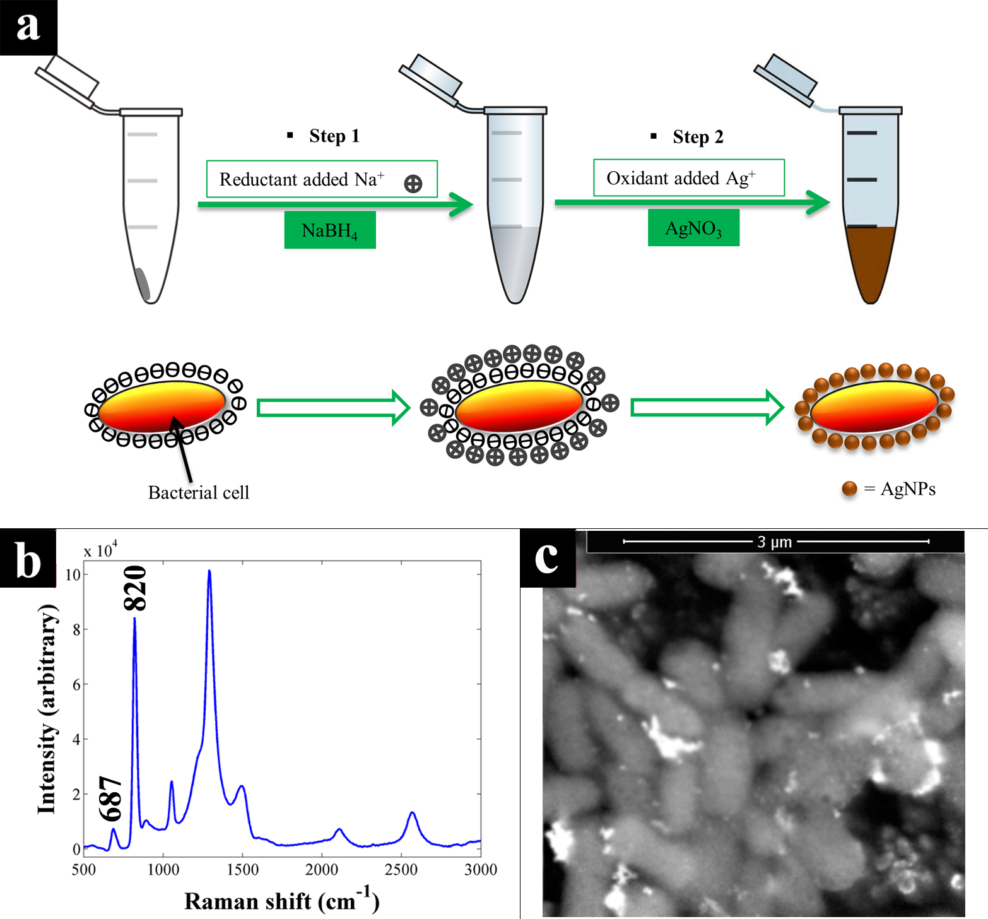
Figure 1. (a) Schematic illustration of the steps employed in this experiment leading to the formation of Ag nanoparticles. The silver cations are reduced by the borohydride reducing agent resulting in the formation of Ag nanoparticles which adsorb onto E. coli cell surfaces (b) SERS spectrum of Ag nanoparticles obtained using the same instrumental parameters as for all samples. The peaks at 687 and 820 cm⁻¹ are clearly linked with the Ag nanoparticles and not the samples (c) SEM image of a thin film of intact E. coli cells coated with sodium borohydride-reduced Ag nanoparticles

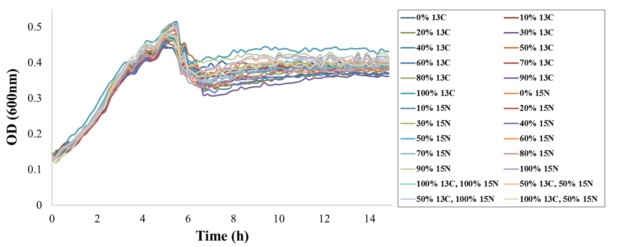
Figure 2. Growth curves of E. coli cells labelled with different ratios of ¹³C and/or ¹⁵N.

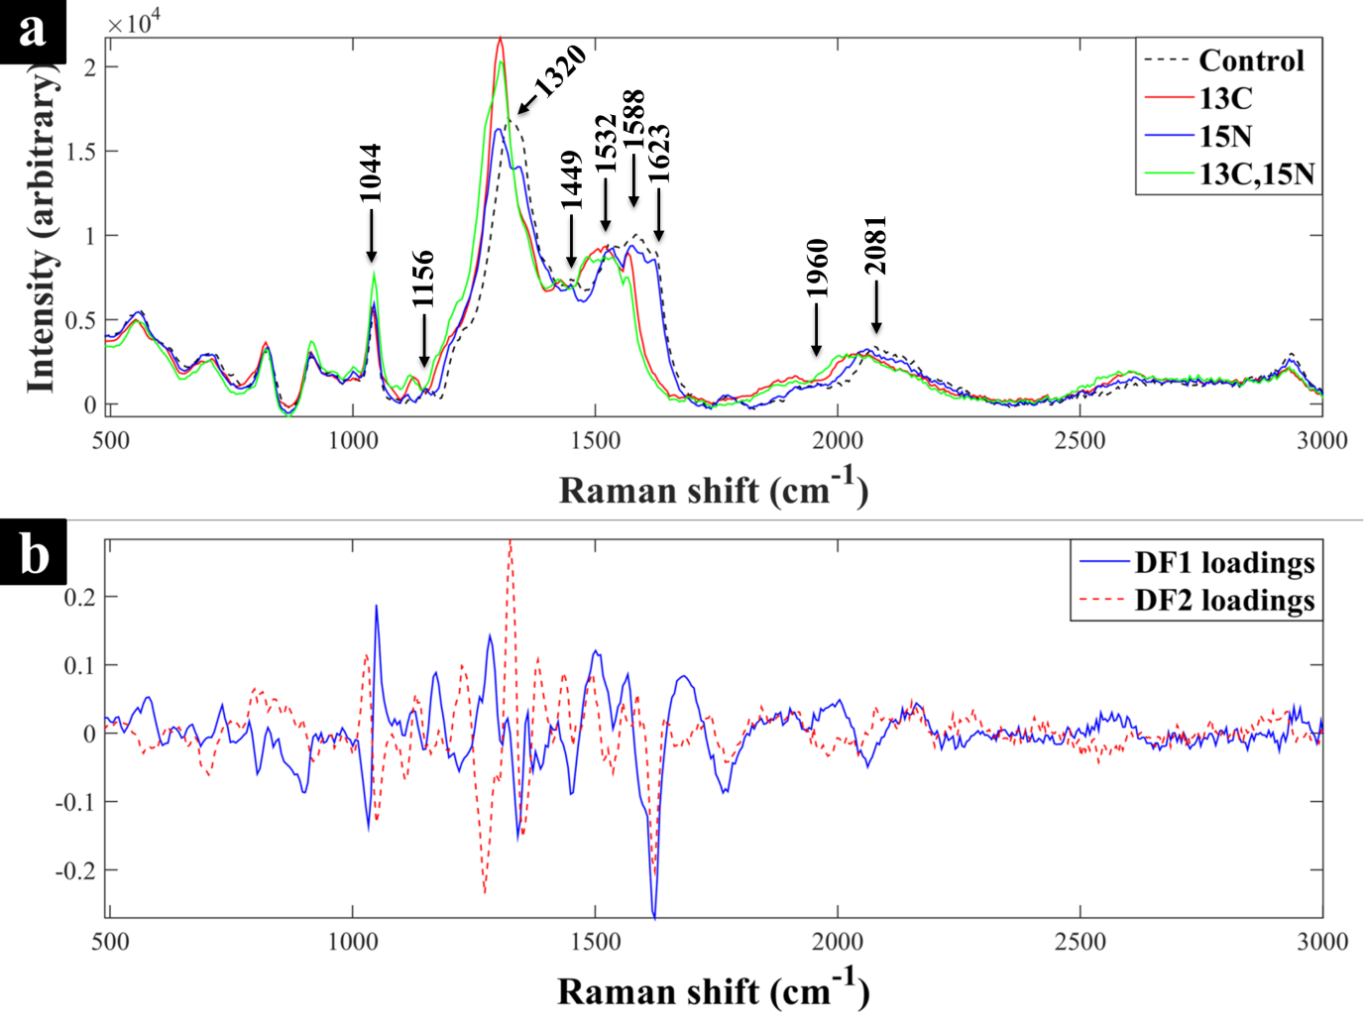
Figure 3. (a) SERS spectra of E. coli cells cultivated on unlabelled substrates (black dotted line), ¹³C labelled (red line), ¹⁵N labelled (blue line) and ¹³C and ¹⁵N labelled (green line) cells are also shown where cells were cultivated in either 0% or 100 % ¹³C-glucose and ¹⁵N-ammonium chloride as the only source of carbon and nitrogen, (b) PC-DFA loadings plot of the SERS spectral data with DF1 (blue line) and DF2 (red line) showing the major peaks affected by the labelling process.

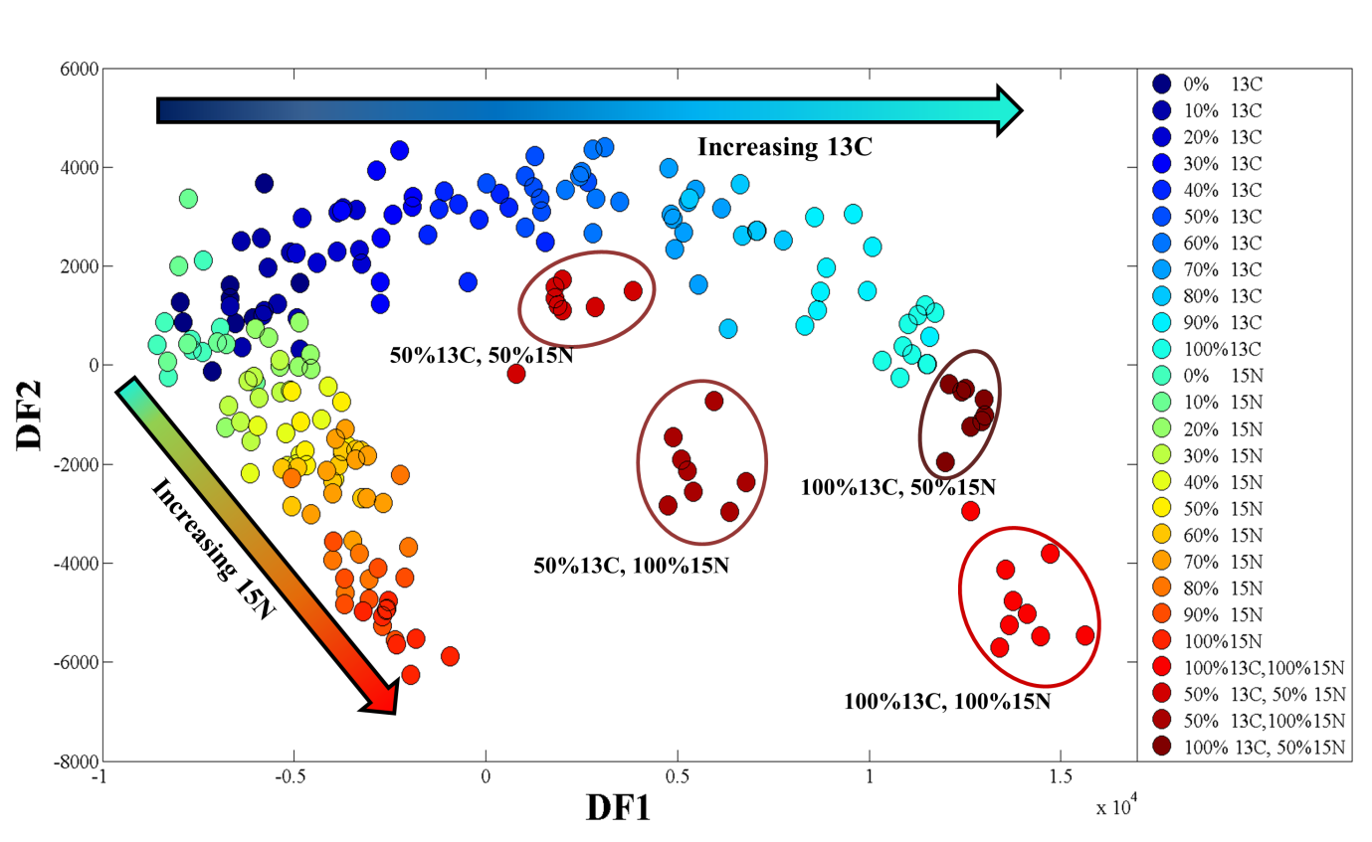
Figure 4. PC-DFA scores plot of pre-processed SERS spectral data of E. coli cells cultivated on different ratios of unlabelled (¹²C and ¹⁴N) and isotopically labelled ¹³C and/or ¹⁵N growth substrates. The arrows indicate increments in the ratios of the labelled substrates. Elipses are used to highlight cells grown on mixtures of ¹³C and ¹⁵N, and have no statistical relevance.

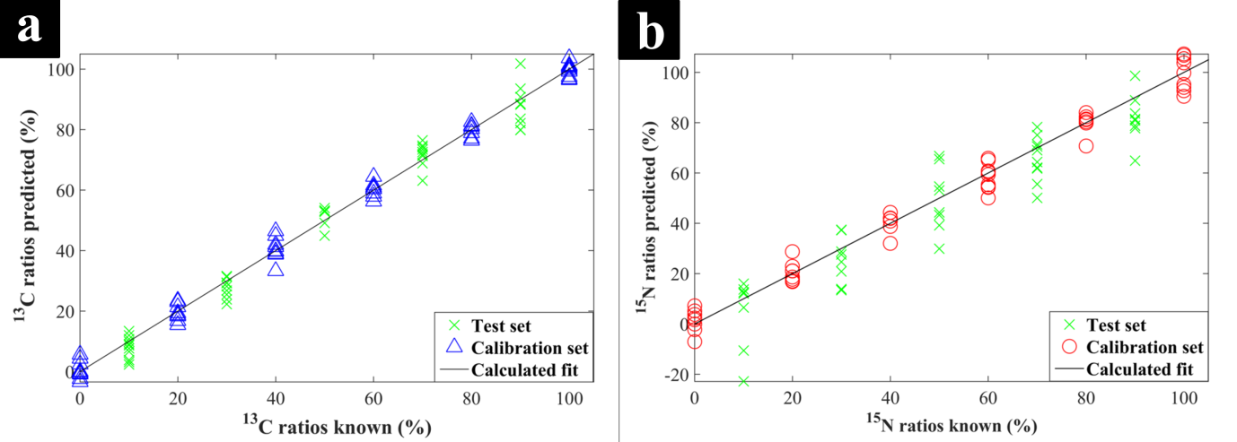
Figure 5. PLSR models of the SERS spectral generated for quantitative prediction of the ¹³C (a) and ¹⁵N (b) ratios in the test sets. The calibration and test sets are represented by green crosses and blue triangles respectively. The statistics associated with these models are presented in Table 2.

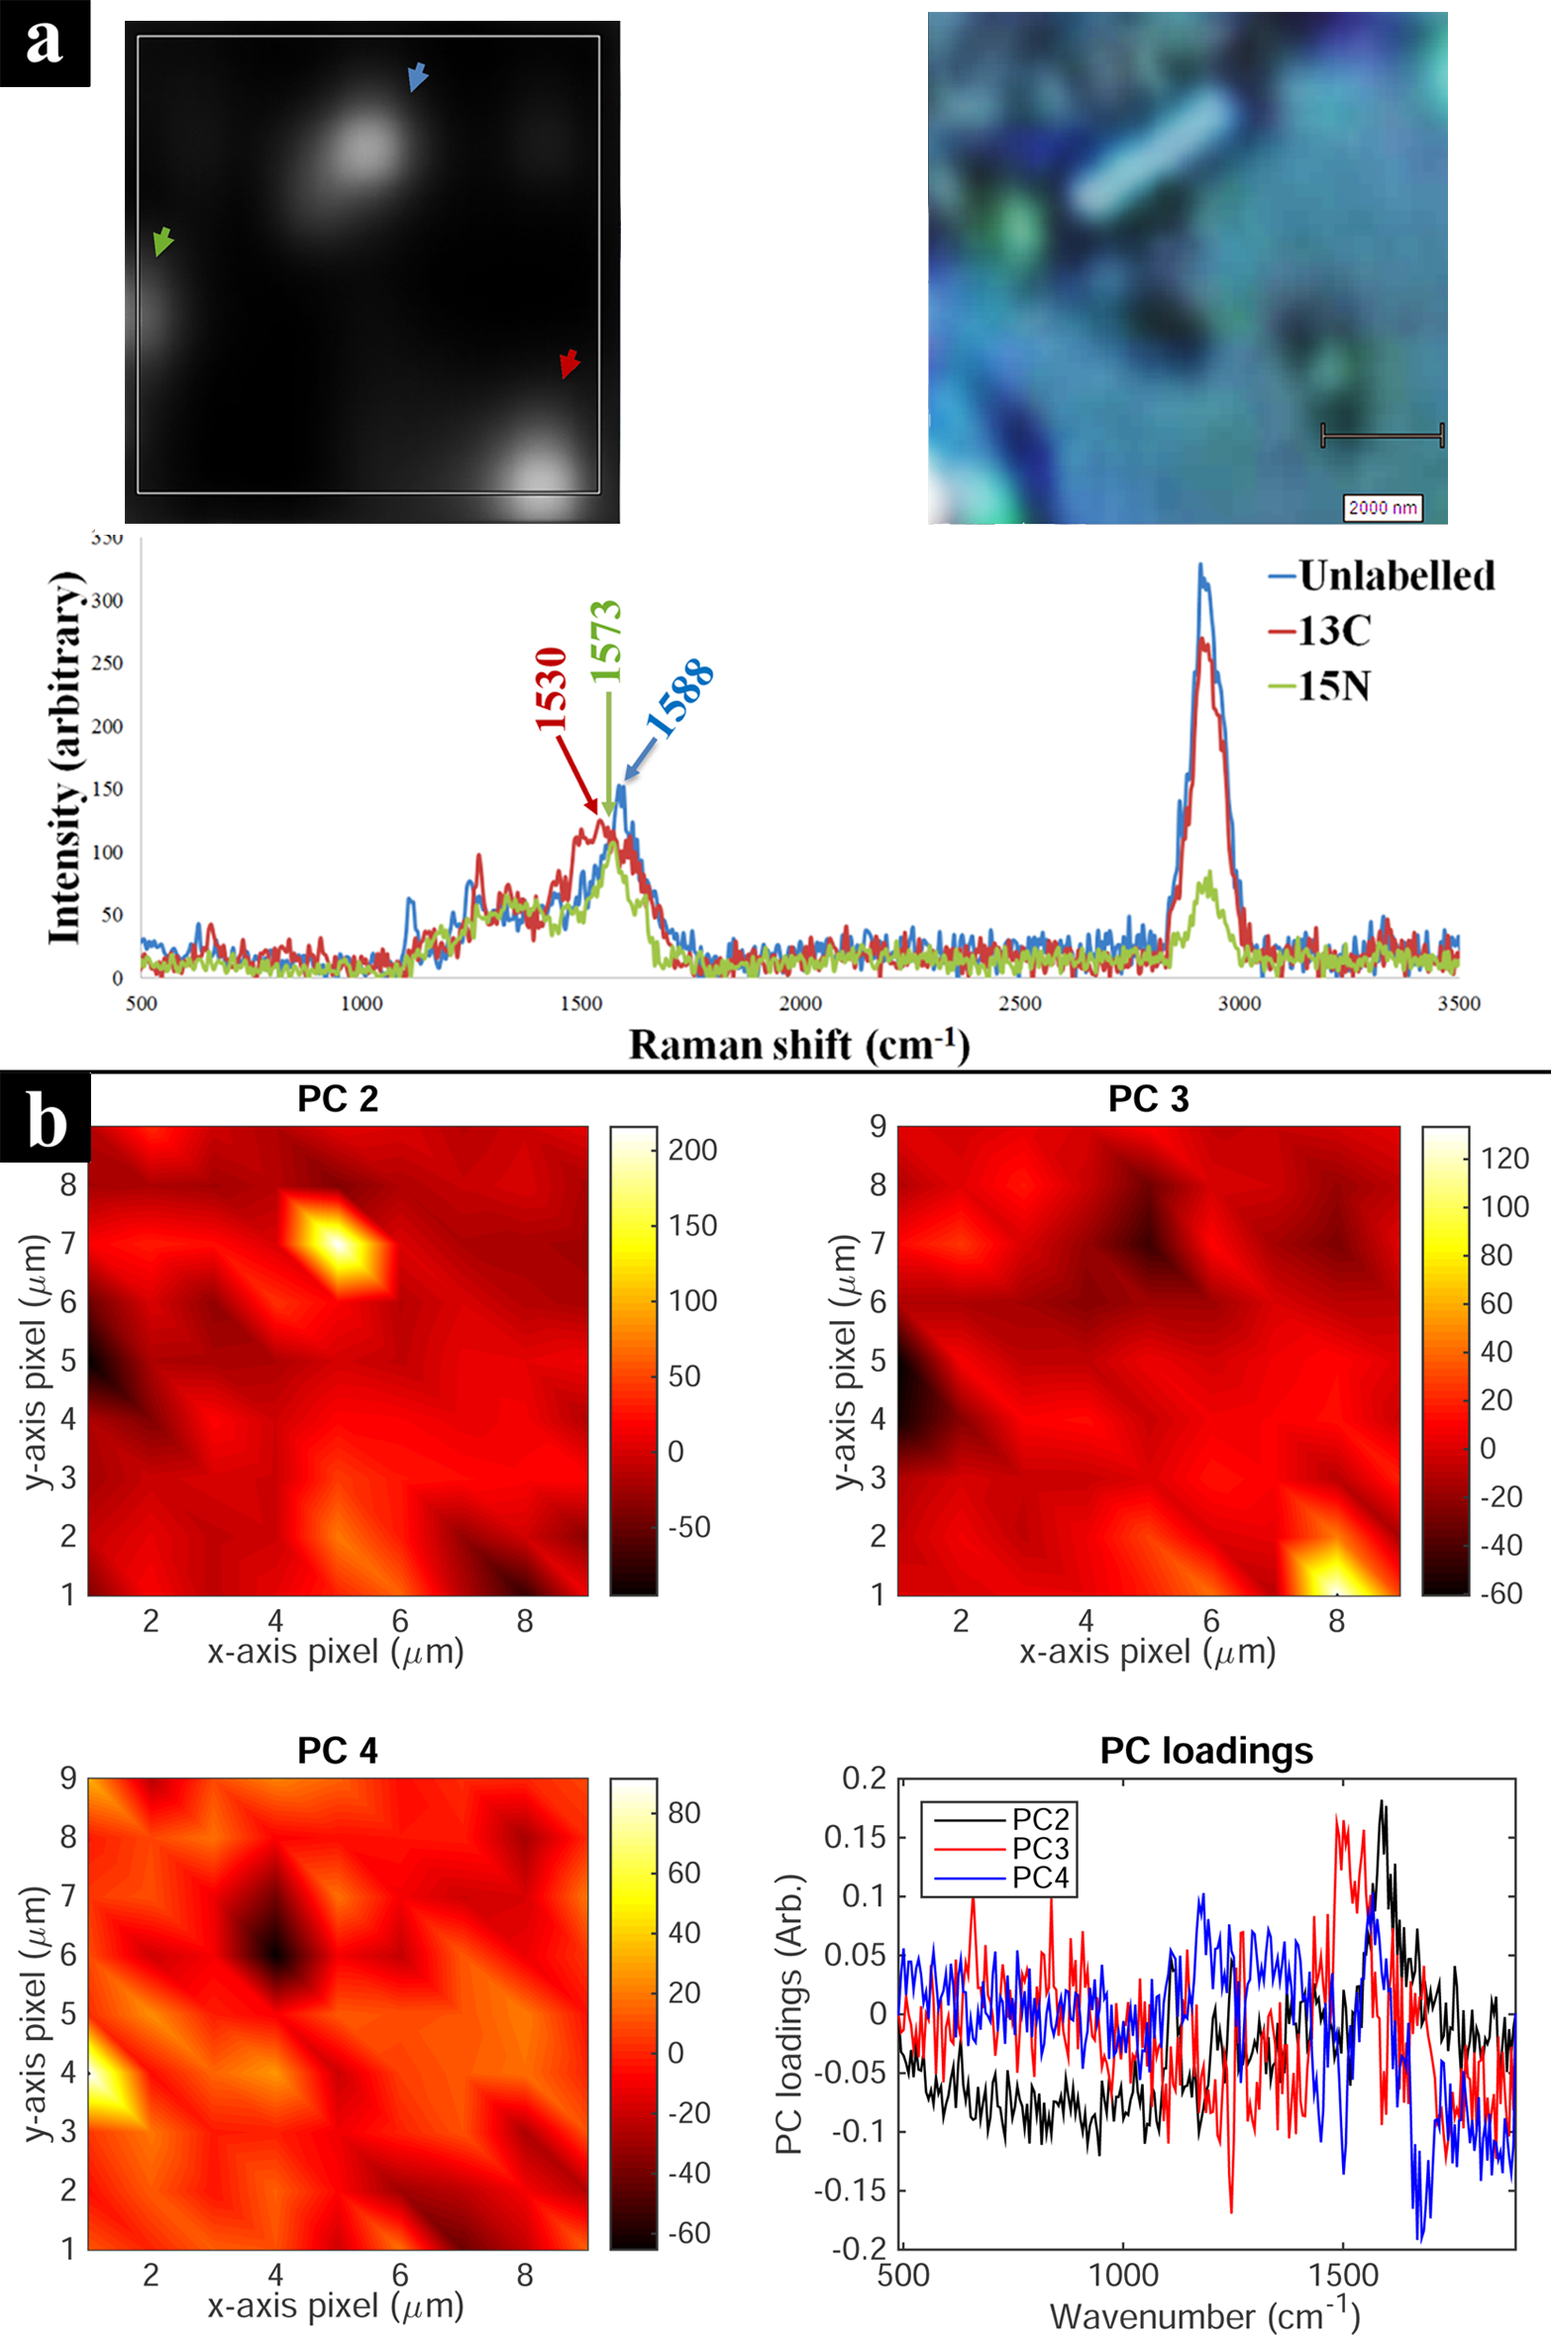
Figure 6. SERS image of isotopically labelled intact single E. coli cells. (a) SERS and corresponding white light image of three single E. coli cells, and representative spectra of each single bacterium (indicated by the arrows). The grey shading represents peak intensity at 1588 cm⁻¹. (b) PCA scores images reconstruction of the SERS spectral data collected between 500-1800 cm⁻¹, and their corresponding loadings plot; The first PC score is not shown as this only differentiates between bacterial biomass and CaF₂ background.

Table 1. Tentative band assignments for SERS spectra
Unlabelled cells (cm⁻¹) | Only ¹³C-labelled (Δ cm⁻¹) | Only ¹⁵N-labelled (Δ cm⁻¹) | Dual ¹³C, ¹⁵N-labelled (Δ cm⁻¹) | Tentative band assignment*
2081 | -39 | -24 | -63 | C–N stretch, Adenine, FAD, NAG
1960 | -49 | 0 | -49 | C=C stretch
1623 | -56 | 0 | -61 | C=C stretch, olefinic
1588 | -67 | -10 | -72 | C–N stretch, proteins, DNA, Amides
1532 | -11 | 0 | -11 | C–H bend or C=C stretch
1449 | -25 | 0 | -25 | CH₂ scissor
1320 | -16 | -27 | -48 | C–N, N–H stretch, adenine, DNA
1156 | -32 | -5 | -37 | C–N stretch, amides, DNA, adenine
1044 | 0 | 0 | 0 | O–P–O stretch in the phosphate group, FAD
*FAD, flavin adenine dinucleotide; NAG, N-acetyl glucosamine.
Table 2. Staistics on the PLSR models on the SERS data to illustrate the reproducibility and accuracy for predicting the ratios of the isotopic labels
Isotope | Factors | Q² | R² | RMSEP | RMSECV
¹³C | 5 | 0.9738 | 0.9940 | 4.7203 | 5.3380
¹⁵N | 5 | 0.8161 | 0.9814 | 11.7475 | 8.7609
Where: correlation of predictions to known isotope levels for the test set (Q²) and calibration/ training set (R²); RMSEP, root mean squared error of prediction from the test set; RMSECV, root mean squared error of cross validation from the calibration/training data.

References
1. L. N. Slater, D. F. Welch, D. Hensel and D. W. Coody, N. Engl. J. Med., 1990, 323, 1587-1593.
2. K. Watanabe, M. Teramoto, H. Futamata and S. Harayama, Appl. Environ. Microbiol., 1998, 64, 4396-4402.
3. R. Madsen, T. Lundstedt and J. Trygg, Anal. Chim. Acta, 2010, 659, 23-33.
4. M. Manefield, A. S. Whiteley, R. I. Griffiths and M. J. Bailey, Appl. Environ. Microbiol., 2002, 68, 5367-5373.
5. R. I. Amann, W. Ludwig and K. H. Schleifer, Microbiol. Rev., 1995, 59, 143-169.
6. M. G. Dumont and J. C. Murrell, Nat. Rev. Microbiol., 2005, 3, 499-504.
7. J. D. Neufeld, M. G. Dumont, J. Vohra and J. C. Murrell, Microb. Ecol., 2007, 53, 435-442.
8. S. Radajewski, P. Ineson, N. R. Parekh and J. C. Murrell, Nat., 2000, 403, 646-649.
9. S. Behrens, T. Losekann, J. Pett-Ridge, P. K. Weber, W. O. Ng, B. S. Stevenson, I. D. Hutcheon, D. A. Relman and A. M. Spormann, Appl. Environ. Microbiol., 2008, 74, 3143-3150.
10. H. T. S. Boschker, S. C. Nold, P. Wellsbury, D. Bos, W. de Graaf, R. Pel, R. J. Parkes and T. E. Cappenberg, Nat., 1998, 392, 801-805.
11. P. Roslev and N. Iversen, Appl. Environ. Microbiol., 1999, 65, 4064-4070.
12. Y. Chen, M. G. Dumont, N. P. McNamara, P. M. Chamberlain, L. Bodrossy, N. Stralis-Pavese and J. C. Murrell, Environ. Microbiol., 2008, 10, 446-459.
13. G. Webster, L. C. Watt, J. Rinna, J. C. Fry, R. P. Evershed, R. J. Parkes and A. J. Weightman, Environ. Microbiol., 2006, 8, 1575-1589.
14. M. W. Friedrich, Curr. Opin. Biotechno., 2006, 17, 59-66.
15. M. P. Ginige, P. Hugenholtz, H. Daims, M. Wagner, J. Keller and L. L. Blackall, Appl. Environ. Microbiol., 2004, 70, 588-596.
16. A. S. Whiteley, M. Manefield and T. Lueders, Curr. Opin. Biotechnol., 2006, 17, 67-71.
17. Y. Kasai, Y. Takahata, M. Manefield and K. Watanabe, Appl. Environ. Microbiol., 2006, 72, 3586-3592.
18. R. E. Drenovsky, K. P. Feris, K. M. Batten and K. Hristova, Am. Midl. Nat., 2008, 160, 140-159.
19. W. E. Huang, R. I. Griffiths, I. P. Thompson, M. J. Bailey and A. S. Whiteley, Anal. Chem., 2004, 76, 4452-4458.
20. Y. Wang, Y. T. Ji, E. S. Wharfe, R. S. Meadows, P. March, R. Goodacre, J. Xu and W. E. Huang, Anal. Chem., 2013, 85, 10697-10701.
21. Y. Wang, W. E. Huang, L. Cui and M. Wagner, Curr. Opin. Biotechnol., 2016, 41, 34-42.
22. H. Muhamadali, M. Chisanga, A. Subaihi and R. Goodacre, Anal. Chem., 2015, 87, 4578-4586.
23. W. E. Huang, M. Q. Li, R. M. Jarvis, R. Goodacre and S. A. Banwart, in Advances in Applied Microbiology, Vol 70, eds. A. I. Laskin, S. Sariaslani and G. M. Gadd, Elsevier Academic Press Inc, San Diego, 2010, vol. 70, pp. 153-186.
24. Y. Wang, Y. Z. Song, Y. F. Tao, H. Muhamadali, R. Goodacre, N. Y. Zhou, G. M. Preston, J. Xu and W. E. Huang, Anal. Chem., 2016, 88, 9443-9450.
25. K. Maquelin, C. Kirschner, L. P. Choo-Smith, N. van den Braak, H. P. Endtz, D. Naumann and G. J. Puppels, J. Microbiol. Methods, 2002, 51, 255-271.
26. R. Goodacre, E. M. Timmins, R. Burton, N. Kaderbhai, A. M. Woodward, D. B. Kell and P. J. Rooney, Microbiology-(UK), 1998, 144, 1157-1170.
27. N. Nicolaou, Y. Xu and R. Goodacre, Anal. Chem., 2011, 83, 5681-5687.
28. S. A. Eichorst, F. Strasser, T. Woyke, A. Schintlmeister, M. Wagner and D. Woebken, FEMS Microbiol. Ecol., 2015, 91.
29. L. Ashton, K. Lau, C. L. Winder and R. Goodacre, Future Microbiol., 2011, 6, 991-997.
30. M. Kahraman, M. M. Yazici, F. Sahin, O. F. Bayrak and M. Culha, Appl. Spectrosc., 2007, 61, 479-485.
31. R. M. Jarvis and R. Goodacre, Anal. Chem., 2004, 76, 40-47.
32. P. Kubryk, J. S. Kolschbach, S. Marozava, T. Lueders, R. U. Meckenstock, R. Niessner and N. P. Ivleva, Anal. Chem., 2015, 87, 6622-6630.
33. P. Kubryk, R. Niessner and N. P. Ivleva, Analyst, 2016, 141, 2874-2878.
34. H. Fisk, C. Westley, N. J. Turner and R. Goodacre, J. Raman Spectrosc., 2016, 47, 59-66.
35. S. Efrima and L. Zeiri, J. Raman Spectrosc., 2009, 40, 277-288.
36. M. Kahraman, M. M. Yazici, F. Sahin and M. Culha, J. Biomed. Opt., 2007, 12.
37. R. M. Jarvis, A. Brooker and R. Goodacre, Faraday Discuss., 2006, 132, 281-292.
38. R. M. Jarvis, A. Brooker and R. Goodacre, Anal. Chem., 2004, 76, 5198-5202.
39. M. Moskovits, J. Raman Spectrosc., 2005, 36, 485-496.
40. L. Zeiri, B. V. Bronk, Y. Shabtai, J. Czege and S. Efrima, Colloid Surf. A-Physicochem. Eng. Asp., 2002, 208, 357-362.
41. P. C. Lee and D. Meisel, J. Phys. Chem., 1982, 86, 3391-3395.
42. P. H. C. Eilers, Anal. Chem., 2004, 76, 404-411.
43. H. Martens, J. P. Nielsen and S. B. Engelsen, Anal. Chem., 2003, 75, 394-404.
44. H. J. H. Macfie, C. S. Gutteridge and J. R. Norris, J. Gen. Microbiol., 1978, 104, 67-74.
45. P. S. Gromski, H. Muhamadali, D. I. Ellis, Y. Xu, E. Correa, M. L. Turner and R. Goodacre, Anal. Chim. Acta, 2015, 879, 10-23.
46. P. Geladi and B. R. Kowalski, Anal. Chim. Acta, 1986, 185, 1-17.
47. P. J. Larkin, Infrared and Raman Spectroscopy: Principles and Spectral Interpretation, Elsevier Science Bv, Amsterdam, 2011.
48. W. R. Premasiri, Y. Gebregziabher and L. D. Ziegler, Appl. Spectrosc., 2011, 65, 493-499.
49. T. T. Liu, Y. H. Lin, C. S. Hung, T. J. Liu, Y. Chen, Y. C. Huang, T. H. Tsai, H. H. Wang, D. W. Wang, J. K. Wang, Y. L. Wang and C. H. Lin, PLoS One, 2009, 4.
50. A. Walter, A. Marz, W. Schumacher, P. Rosch and J. Popp, Lab Chip, 2011, 11, 1013-1021.
51. M. Kahraman, M. M. Yazici, F. Sahin, O. F. Bayrak, E. Topcu and M. Culha, Int. J. Environ. Anal. Chem., 2007, 87, 763-770.
52. H. Muhamadali, A. Subaihi, M. Mohammadtaheri, Y. Xu, D. I. Ellis, R. Ramanathan, V. Bansal and R. Goodacre, Analyst, 2016, 141, 5127-5136.

