Comparison of oxidation behaviour of nuclear graphite grades at very high temperatures

I-Hsuan Lo^{a,b}, Tsung-Kuang Yeh^{a,d}, Eann A Patterson^{b}, ﻿Athanasia Tzelepi^{c*}

ª Institute of Nuclear Engineering and Science, National Tsing-Hua University, Hsinchu 30013, Taiwan.
^{b} School of Engineering, University of Liverpool, Liverpool, The Quadrangle, Brownlow Hill L69 3GH, United Kingdom.
^{c} National Nuclear Laboratory (NNL), Reactor Operations Support, Central Laboratory, Sellafield CA20 1PG, United Kingdom.
^{d} Department of Engineering and System Science, National Tsing-Hua University, Hsinchu 30013, Taiwan.

*Corresponding author. Tel.：+44 (0)19467 79215.
E-mail address：nassia.tzelepi@nnl.co.uk (﻿Athanasia Tzelepi).

Abstract
In this study, the oxidation characteristics of nuclear grade graphites IG-110, IG-430, Type A(MA), Type B (MB), PGA, ATR-2E, G347A and G458A in air environments at temperatures ranging from 700 to 1600 ºC were investigated. The oxidation rates and activation energies were determined based on mass loss measurements in a series of oxidation tests. Significant increases in oxidation rates above 1200 ºC were observed at very high temperatures for all graphite grades. Isotropic graphite grades were found to have higher oxidation resistance than anisotropic graphite PGA, but the differences for fine grained graphite were small. In Regime III, pitch-based graphite has better oxidation resistance than petroleum-based graphite, and the isotropic graphite grades with larger filler particles had lower oxidation rate than the graphite grades with smaller filler particles at temperatures higher than 900 ºC. The bulk oxidation rates were found to be sensitive not only to experimental conditions but also any change in the testing system in Regime III. In order to reliably compare oxidation rates among graphite grades, all tests should be conducted in the same system and using the same test procedures.

1. Introduction
The Very High-Temperature Reactor (VHTR), known as a High Temperature Gas-Cooled Reactor (HTGR), has been selected as one of the Generation IV reactors. Graphite is designed as both the neutron moderator and a structural material for the cores of the VHTR due to its superior properties such as high thermal conductivity, specific heat capacity, isotropic thermal expansion coefficient, and small neutron-absorptive cross-section [1]. The operation temperature of the VHTR is higher than previous reactors. From the design of inherent safety, the VHTR could remove the residual heat through mechanisms such as heat conduction, heat convection and heat radiation. It is believed that the probability of damage in an accident is extremely low [2]. However, in the case of an air ingress accident, as a hot gas duct breaks, the core components will be exposed to the air. Considering the loss of coolant and the heat circulation, the core temperature would be about 1600 ºC. The graphite core component is at the risk of severe oxidation [3]. The integrity of graphite component integrity directly influences reactor safety. It is necessary to understand the oxidation behaviour of nuclear grade graphite at temperatures under conditions associated with an air ingress accident [4].
The bulk oxidation rate determined from small specimens is normally used to generalise the oxidation behaviour of the large components in reactors, and the oxidation rate obtained from the oxidation tests in this study is also bulk oxidation rate. The objective of the oxidation tests was to obtain the bulk oxidation rates for small specimens and to compare the oxidation rate of different grades of graphite. The main assumption of the bulk oxidation test is that the oxidation experimental conditions, including the specimen geometry and test environment, are similar. There is no ASTM standard for graphite oxidation at very high temperatures; although ASTM standard D7542 [16] has been widely selected as the reference in literature.
Historical works on graphite thermal oxidation in VHTRs has been mainly focused at the temperatures below 1200 ºC [1,5-9]. Notably, Lee et al. used thermogravimetric analyser (TGA) to oxidise IG-110, IG-11, NBG-17 and NBG-18 at temperatures ranging from 600 to 1600 ºC, but the oxidation test excluded the temperatures between 1200 and 1600 ºC [7]. Numerous studies have shown that the effects of an oxidation rate in the TGA, i.e., specimen size and flow rate, were different from that in a furnace at temperatures lower than 1200 ºC [4,5] and it might be worthless to compare the oxidation behaviour from different systems.
However, there was also relatively high scatter in the determination of the bulk oxidation rate and the trends in the results reported in the literature for the oxidation tests above 900 ºC are not consistent even though they were all were conducted using the same standard, ASTM D7542. Based on our previous work, a continuous increase of oxidation rate at temperatures greater than 1200 ºC was observed, and distinctly different from data reported in the literature [10]. Limited studies have been performed, particularly at temperatures higher than 1200 ºC. In order to support a VHTR design and concerns about an air ingress accident, this study has established systematic thermal oxidation tests.
This study differentiates between intrinsic and extrinsic factors associated with thermal oxidation. The main intrinsic factors are associated with the properties of the grades of graphite including the coke type, forming process, density, impurity, filler/binder microstructure, and the pore microstructure. Also, the bulk oxidation rate is highly related to the extrinsic factors, which are mainly associated with the experimental conditions, such as the supply of oxidants, specimen and system geometry.
The work presented here is intended as a comparative study of the eight nuclear grades at temperatures higher than 1200 ºC. The graphite materials selected in this study were candidate graphite grades for VHTRs in Asia, and ATR-2E and PGA were chosen because of the availability of complete property data required for reactor operation. The results of IG-110 and IG-430 have been reported previously [10]. The differences between oxidation tests proposed in the literature [4,7,8] were meticulously recorded in this study.

2. Experimental details

2.1 Materials
Nuclear grade graphites IG-110, IG-430, Type A (MA), Type B (MB), PGA, ATR-2E, G347A and G458A were selected for this study. All selected graphite grades are candidate VHTR materials except PGA and ATR-2E.
IG-430 is a pitch-based graphite and IG-110 is a petroleum-based graphite. IG-430 and IG-110 are manufactured by Toyo Tanso (Japan). They were selected because they are currently being used, or being considered, for high irradiation regions of VHTR applications [11]. In fact, IG-110 is used in all experimental gas-cooled reactors in Asia [12]. IG-430 is an advanced grade that has been developed for VHTRs with high oxidation resistance and low porosity. Preliminary measurements under VHTR operation conditions have been performed for these two graphite grades [13]. IG-110 and IG-430 are also used as the reference materials to compare with the results from the literature.
Type A (MA) and Type B (MB), manufactured by Sinosteel Ltd (China), have been developed for generation IV reactor programmes and neutron irradiation programmes. Both of these graphite grades were manufactured using the same coke, binder, baking curve, and graphitisation process. The main difference, however, is the average size of the coke particles. The particle size of MB is approximately half that of MA. A larger coke particle leads to lower density, higher specific electric resistance, higher thermal conductivity, higher open porosity, and a larger pore size [37].
G347A and G458A are fine grain graphite materials manufactured by Tokai Carbon (Japan). G347A is a pitch-based graphite and G458A a petroleum-based graphite. Both grades are formed via isostatic molding with a pitch binder. Although there is a need for the properties for both grades to be measured, the standard test, which was undertaken by Oak Ridge National Laboratory (ORNL) shows G347A and G458A to be isotropic-molded grade graphite, which means the traditional orientations of grains, ‘With Grain’ and ‘Against Grain’, are not acceptable [14]. In order to identify the two directions in these two graphite grades, ORNL used the dimension of the billet which is vertical during the molding process as the axial direction and the other two orthogonal directions as the transverse directions [14].
Although Pile Grade-A (PGA) and ATR-2E are not considered as candidate grades for VHTRs, both PGA (near-isotropic graphite) [12] and ATR-2E (isotropic graphite) were still included in the study [15]. The structures of these two graphite grades are different from VHTR candidate graphite grades. Because of the lack of oxidation rate data at very high temperature, it is still important to test these different grades as references. In addition, irradiation experiments for both PGA and ATR-2E had been completed previously and the thermal oxidation tests for them would prove useful for comparison between thermal oxidation and irradiated oxidation.

2.2 Specimen preparation
ASTM D7542-15 [16] was used for the selection of sample size, geometry and preparation method, since there is no standard for graphite oxidation tests at very high temperatures. ASTM D7542-15 [16] recommends a standard procedure for measuring oxidation rates in air of various grades of nuclear graphite, and the kinetic parameters of the oxidation reaction, mainly the activation energy, can be obtained by following the standard procedure. Specifically, the assumptions made for development of D7542 is completely within the kinetic regimes (﻿400-800 ºC) and there is an overabundance of oxygen present to preclude oxygen starvation. All the reported oxidation tests of nuclear graphite grades at temperatures above 900 ºC, which extended to Regime III, were performed following the standard.
Cylindrical specimens with a diameter of 10 mm and a length of 15 mm were prepared from the same block of graphite in a consistent manner. All graphite specimens were machined from the graphite in the same orientation, including PGA and ATR-2E. The tolerance of the machining was 0.1 mm. In order to prevent contamination during handling, the specimens were machined in lubricant-free conditions, using diamond tools, and handled with cotton gloves according to the ASTM standard D7542-15 [16].

2.3 Oxidation system setup
A dynamic oxidation system was constructed, as shown in Figure 1. A high-power 3-zone furnace with an alumina heating chamber of diameter 76 mm was used. The temperature in the heating chamber was measured using R-type thermocouples. The furnace operated with three heating zones and each zone had an independent control system, including one controller, one thermocouple and three heating rods. Prior to the oxidation tests, the furnace temperature was calibrated by an R-type thermocouple 50 cm long to ensure that the specimens were appropriately placed at locations within the desired temperature range. The temperature was constant and consistent throughout the designed location. A gas-mixing chamber, equipped with mass flow controllers and designed for achieving the required atmospheres and simulating air ingress conditions, was directly connected to the heating chamber inlet. In addition, an independent mass flow controller was connected to the chamber outlet to make ensure that the chamber was tightly sealed.

2.3.1 System maintenance
The oxidation characteristics for all of the selected graphite grades were investigated at temperatures ranging from 700 to 1600 ºC. Because the testing temperature is close to the system’s critical temperature (1700 ºC), the furnace had to be repaired several times during the research programme. In order to provide confidence in the intrinsic and extrinsic factors of the oxidation experiment, every change to the test system was recorded. Every replacement of the alumina tube in the 3-zone furnace was defined as a major repair for the test system, and the oxidation tests in this study were divided into three phases based on each replacement of the alumina tube, as depicted in Figure 2. The replaced components, including thermocouples (T), heating rods (H), and alumina tubes, were marked in red. The Roman numerals in the figure indicate the number of times the components were replaced. For example, H is the original heating rod, T(i) is the thermocouple replaced once, and Aluminum Tube (ii) is the alumina tube replaced twice.

2.3.2 Experimental Procedures
The testing temperatures in this study varied from 700 to 1600 °C, and atmospheric pressure was maintained in the heating chamber throughout each test. For each oxidation test, only one specimen, placed at the designated location inside the heating chamber, was tested at a time. Mass changes were measured using a calibrated microbalance.
The furnace chamber was first ventilated with pure argon at a flow rate of 1 L/min and then heated to the designated temperature at a rate of 3 ºC/min. An isothermal step of 10 min ensured that the system reached a state of thermal equilibrium and then the atmosphere was changed to dry air at flow rates of 1 to 6 L/min, determined by the flow velocity of a typical air ingress accident [17]. Once the oxidation test had achieved a ~10% mass loss in the graphite specimen, the atmosphere in the chamber was changed to pure argon again and the cooling stage started at a rate of 3 ºC/min. The specimens were retrieved when the furnace thermocouple reading reached ambient temperature. A schematic of the timeline for an oxidation test is shown in Figure 3.
Because the mass measurements were made at the beginning and the end of the experiment, a preliminary test at each temperature was used to estimate the time required for the different grades to attain a ~ 10% mass loss. In addition, there was a calibration test at each temperature to measure the overall mass loss of the graphite specimen during the heating and cooling stages.

2.3.3 Calibration Test
In order to provide greater confidence, after each system change, the same procedure was used to calibrate the system. Prior to the oxidation tests, the furnace temperature was calibrated by an additional R-type thermocouple of length 50 cm, in order to ensure that the temperature of the designated location was constant and consistent. In addition, an independent mass flow controller was connected to the chamber outlet to provide further confidence regarding the complete sealing of the chamber.

2.4 Determination of oxidation rate
The mass of each specimen was measured before and after every oxidation test, and the mass loss and oxidation rate were calculated based on ASTM standard D7542-15 [16], as shown below.
$Mass Loss \left(\%\right)=\frac{\left(specimen mass before oxidation-specimen mass after oxidation\right)}{specimen mass before oxidation} ×100\%$(1)
$Oxidation Rate \left(\frac{g}{m^{2}×hr}\right)=\frac{(specimen mass before oxidation-specimen mass after oxidation)}{specimen surface areaoxidation time}$ (2)
where specimen surface area is thearea of the solid cylinder. The average mass loss (g) for each set of three specimens showed a standard deviation of no more than 5% in the dry air condition. This demonstrated that the oxidation tests were well-controlled and the results were a reasonable representation of graphite oxidation for the specific graphite grade.

2.5 Determination of Arrhenius plot
In order to identify the regimes of the selected graphite grades at various temperature ranges, Arrhenius plots, based upon the experimentally-derived graphite oxidation rates and the test temperatures, were prepared [18]. The Arrhenius law (Eq 3) was adopted to calculate the respective activation energy by fitting a straight line to the various regimes, and the transition temperatures between regimes were determined based on the significant changes in the slopes of the Arrhenius plots [18–20]. The Arrhenius law, i.e.
$R_{graphite}=k_{0}exp⁡(-\frac{E_{a}}{RT})P^{n}$ (3)
where $R_{graphite}$ is oxidation rate, $T$ is temperature, $k_{o}$ is kinetic constant, $E_{a}$ is activation energy, $R$ is Regnault constant, and $P^{n}$ is partial pressure of oxygen for reaction order $n$, was adopted to calculate the respective activation energy of each graphite material [15].

3. Results and Discussion
It was important to test the thermal oxidation rates of nuclear grade graphite under VHTR conditions. However, care had to be taken because the oxidation rate is easily affected by both intrinsic and extrinsic factors [4,7]. In order to compare the oxidation rates with different graphite grades, the best method was to test all selected graphite grades using the same system without any change during the entire process. However, this proved to be impossible for high temperature experiments; in fact, the dynamic test system used in this project has been maintained and repaired several times. In order to make sure that all the intrinsic and extrinsic factors were known, every change of the test system was recorded. Also, every replacement of the alumina tube in the 3-zone furnace was defined as a major repair for the test system, and the experimental programme was separated into three phases based on each replacement of the alumina tube (Fig 2). In addition to the designated conditions for the oxidation experiments, the comparisons of the oxidation rates for different grades will be reviewed in the three phases associated to the major maintenance events (Fig 2) and the reliability of the oxidation test system is discussed in section 4.1.
The oxidation rate of all selected graphite grades in dry air at temperatures ranging from 700 to 1600 °C at 1 L/min is illustrated in Figure 3-5. The oxidation test for IG-430 at temperatures ranging from 700 to 1600 ºC was repeated after every major maintenance session as a benchmark exercise to check the oxidation rate. The oxidation rate of IG-430 at flow rates of 1 to 6 L/min is shown in Figure 7. Because of the limitations inherent in these experiments, the average value of the oxidation rates at each temperature was determined with a different number of specimens (Table 2). The data in Figures 3-5 show the mean values and the error bars to represent one standard deviation from the mean.

3.1 The effect of temperature on graphite oxidation
It was found that temperature has a distinct influence on the oxidation of graphite, especially at temperatures greater than 1200 ºC. This finding differed significantly from the results predicted in the literature [5,21].
As shown in Figure 3, the oxidation rates of IG-430 and ATR-2E were found to be lower than those of IG-110 at 700 ºC, but the rates of the former two grades were similar and they increased as the temperature rose, as had been expected for temperatures lower than 900 ºC. Within this temperature range, the major mechanism associated with the oxidation of graphite is controlled by mixed diffusion-kinetics [5]. In this Regime, oxidation is dominated primarily by air diffusing into the pores of the graphite; therefore, as expected, the difference in the oxidation rate for different grades of graphite is closely related to porosity, as shown in Table 1. The porosity of the petroleum-based IG-110 is higher than that of the pitch-based IG-430 [22]. The oxidation rate of MA, which has a higher open porosity than MB, was distinctly higher than that of MB. However, only open porosity values are available for MA and MB, so both MA and MB cannot be directly compared with the other grades with regard to porosity. However, the Tokai graphite G347A has a lower porosity than IG-430, but the oxidation rates of G347A and IG-430 were similar. By comparing G458 and C347A for example, this study has shown that, for similar porosity in Regime II, pitch-based graphite has a higher oxidation resistance than petroleum coke graphite.
At temperatures between 900 and 1200 ºC, the oxidation rates of all graphite grades continued to be higher at higher temperatures, but the rate of increase with temperature reduced. Furthermore, the oxidation rates of all graphite grades were almost the same in this temperature range except for PGA graphite. According to the literature [5], the control mechanism in this temperature range is mass transfer, and the prompt oxidation of graphite surfaces occurs as soon as they come into contact with air. Under these conditions, the dominating factors influencing the oxidation rate are the exposed surfaces of the graphite and the oxygen concentration in the test environment. The trends in the oxidation rates of IG-110 and IG-430 observed in this study were similar to those reported in the literature for temperatures below 1200ºC, at which most thermal oxidation tests of graphite were terminated in prior work [7,8,20,22–24].
However, in the data presented in this study, the oxidation rates started to increase rapidly again above 1200 ºC, which is in good agreement with our previous work [10]. This phenomenon continued up to 1500 ºC, beyond which the oxidation rates seemed to approach a constant value, but at a relatively large value of about 5000 g/m²/hr. These findings differ significantly from the results predicted in the literature [5,21], in which the oxidation rate of graphite in dry air was predicted to increase slowly in this temperature range with no evidence to support the statements. The difference in porosity is unlikely to be a factor in the oxidation rate, as the rapid increase in the oxidation rate was found in all graphite grades with that of PGA graphite being the highest. It was also observed in this study that the oxidation rate of MA with larger filler particles was lower than MB. Looking at fine grain graphites only, the oxidation rate of fine grain graphite ATR-2E with the largest filler particles was similar to the IG-series graphite and slightly higher than IG-430 at this temperature range.
All of the graphite materials reached a constant oxidation rate at temperatures between 1500 and 1600 ºC. At 1600 ºC, the oxidation rate of MA, G347A and G458A, were relatively lower than that of IG-430. The oxidation rate of petroleum-based (OC) G458A was comparable to that of the pitch-based (PC) G347A, and similar rates were found for IG-430 (PC) and IG-110 (OC). Since the petroleum-based G458A and the pitch-based G347A with similar size grains and porosity have similar oxidation rates, the coke type is not considered an influencing factor at this temperature range. Graphite grades manufactured using the same coke, MA and MB, were used to determine the effect of coke size on the oxidation above 1200 ºC. The difference in the oxidation rate between MA and MB can be explained by the smaller grains in MB. Consequently, the effect of filler size was proposed as one of the intrinsic factors for graphite oxidation above 1200 ºC.
From the tests performed in this study, the graphite materials tested have a range of material properties arising from the raw materials and the manufacturing processes. Since all materials show essentially the same trends in oxidation rate with temperatures above 900 ºC, mass transfer must control the oxidation rate rather than material properties. On the contrary, below 900 ºC, the material properties and morphology appear to play a major role since the various materials behave differently. Consequently, it is proposed that the mass transfer control may be responsible as a major control mechanism at temperatures higher than 900 ºC, but additional intrinsic factors are contributing to the differences in behaviour in temperatures ranging between 900 and 1600 ºC.

Arrhenius Plot
In order to identify the kinetic regimes at various temperature ranges, Arrhenius plots (Figure 6) were plotted based upon the oxidation rate data shown in Figures 3 to 5. The activation energy data (Table 3) in a dry air environment was calculated using the Arrhenius equation (Equation 3) by fitting a line within various temperature regimes, in order to support the proposed rate limitation for oxidation in graphite at temperatures above 1200 ºC. The activation energy directly obtained from bulk oxidation rates indicates the temperature dependence of the reaction rate and is highly influenced by the assumed starting or ending temperatures of the regime. This study only used intervals of 100 ºC; and, it is important to note that the actual transition temperature between regimes might be important at different temperature ranges. As such, the derived activation energy should only be regarded as a guideline for a rate limiting process [25].
The results derived for temperatures below 1200 ºC were in good agreement with those reported in the literature [7,22,26,27]. Earlier data in the literature showed that at temperatures beyond 1000 ºC, the forecasted activation energy for graphite oxidation would approach zero because the activation energy had already decreased at 900 ºC [5]. This behaviour for the temperature range up to 900 ºC was observed in all graphite grades in all three phases of the experimental programme. However, this study’s experimental results revealed that the activation energy for graphite oxidation actually increased again beyond 1200 ºC for all graphite grades. At temperatures higher than 1500 ºC, the activation energy decreased sharply again.
Activation energy is known to be sensitive to many factors, including oxygen content and metallic impurities within the graphite [4,5]. The graphite grade with highest impurity level was PGA based on the manufacturers specification, but the trend and value of the activation energy for PGA is in line with other grades. Other factors that need to be taken into account are the main reaction product changes from CO₂ to CO above 900 ºC [9,28] and the different activation energies between filler particles and the filler-binder matrix [29,30]. More work at very high temperature is required to further determine the influence of these factors.

3.2 The effect of flow rate on graphite oxidation
Graphite oxidation is sensitive to test environments. Since numerous studies have performed oxidation tests in different flow rates in order to define the effect of the oxygen supply on oxidation, this study examined IG-430 at different flow rates; Figure 7 shows the oxidation rate of IG-430 for each case. According to the literature, the effect of flow rate on oxidation rates shows slight changes between different grades [6,11] but only IG-430 was tested here. Each point in figure 7 represents the average value calculated from at least two tests.
In this study, experiments at higher flow rates showed increased oxidation rates; the findings regarding oxidation as a function of temperature, therefore, were in reasonably good agreement with those reported by Chi et al. [6]. There were minimal differences in oxidation rate for increased flow rate at 700 ºC but the oxidation rates change dramatically as the flow rate increases at temperatures from 800 to 1600 ºC. The flow rate of 1 L/min, determined by the flow velocity of an air ingress accident, created oxygen-starved conditions. Thus, the mass loss is more responsive to air flow in Regime III.
After the system moved from Phase 1 to Phase 2 of the experimental programme, the test at 2 L/min was repeated again to compare the flow rate effect between these two phases: for flow between 1 and2 L/min, a similar effect from flow rate on oxidation rates was observed. It was also noted that no gas leakage occurred during the tests either in Phase 1 or Phase 2 of the experimental programme.
As the flow rate was increased from 1 to 2 L/min, the gradient of oxidation rate with temperature increased with flow rate from 1000 to 1200 ºC, then it remained constant. The change between the two temperatures indicated that the control mechanism at those two temperatures was different. In addition, the flow rate effect, from 4 to 6 L/min, on the increase of oxidation rate, was much smaller than it was from 2 to 4 L/min. Since the oxidation rate above 900 ºC was boundary layer controlled, the oxidation rate was related to the available surface area of specimen and the supply of oxidant from inert gas. The result showed that the supply of oxidant was close to the available surface area of the cylinder specimen at flow rates above 4 L/min in this test.
It was noted that the oxidation rate at 1500 ºC was approximately the same as at 1600 ºC for flow rates of 4 and 6L/min. The increase in oxidation rate as the flow rate increased from 4 to 6 L/min could only be attributed to the actual flow, which means that temperatures above 1500 ºC have only a slight effect on oxidation rate. Hence, the oxidation mechanism of graphite becomes dominated by the boundary layer, which is mainly affected by the surface area in contact with inert gas and, to a lesser extent, the graphite surface structure. Further characterisation of the surface morphology would be required to confirm the assumption for the difference in oxidation rate between 1500 and 1600 ºC.

3.3 The effect of oxygen concentration on graphite oxidation
In an air ingress accident, the possibility of graphite exposure to pure air is low. According to kinetic theory, the concentration of oxygen affects the reaction order of the oxidation reaction rate (Equation 3). The increase of oxidation rate above 1200 ºC in a lower oxygen concentration in an inert-gas was tested to confirm the effect of oxygen concentration using a mixture of 10% oxygen mixed with 90% helium at a flow rate of 1 L/min, with the same experimental procedure as in previous tests. The oxidation rate for IG-430 with an oxygen concentration of 10 % is shown in Figure 7.
It was observed that the trend of the oxidation rate at temperatures lower than 1400 ºC is similar to that in air (20 % O₂), although the oxidation rate was lower. However there was a distinct difference at temperatures higher than 1400 ºC where the oxidation rate approached a constant value for 10 % concentration of O₂ , probably limited by the amount of oxygen. Similar to all the other tests in this study, an increase in oxidation rate was also observed at temperatures higher than 1200 ºC in these conditions.
The oxidation rate increased as the oxygen concentration increased from 10% to 20%. It was noted that the effect of oxygen concentration on the oxidation rate also showed a temperature dependence. The effect of oxygen concentration on the oxidation rate significantly increased with increasing temperature. The reaction order of oxygen partial pressure can be calculated using linear fitting of the Arrhenius plot of oxidation rate and oxygen partial pressure used in the oxidation test. It is confirmed that the reaction order of oxygen partial pressure increased with increasing temperature, but the value in this study calculated by only two points (10% and 20% O₂) was meaningless at each temperature. During an air ingress accident, the oxygen concentration in the inert gas will increase with the passive safety circulation and, based on these results, this would lead to a rapid increase in the oxidation rate during an accident.
The increase in oxidation rate above 1200 ºC was observed at the lower oxygen concentration. The results observed in this study are in agreement with the literature [9,28]. However, care should be taken because there are differences in the geometric ratio between the specimen and the test environment; this probably explains the reason why the oxidation rate reached a constant value at different temperatures in the studies that used the gasification method [31,32]. Furthermore, based on the theory of the chemical reactions, Ong [33] proposed that the number of carbon atoms removed from the surface will change above 1100 ºC and calculated that the oxidation rate will change when the main reactive product changes from CO₂ to CO at high temperatures. The fact that there is no significant increase in oxidation rate at low flow rates implies that this theory alone cannot explain the main mechanism of graphite oxidation above 1200 ºC.

4. General Discussion

4.1 The Reliability of the Oxidation Test
Based on the preliminary experience from oxidation tests, it was observed that the oxidation rate was sensitive to the test environment. The main challenge for a 3-zone furnace with a large diameter tube used at very high temperatures is gas leakage. The system was calibrated carefully, and this was supported by the extremely small (<5%) deviation in the oxidation rates shown in Figures 3-5.
In this project, in order to evaluate the scatter in the results of oxidation in the test, the benchmark oxidation rate for IG-430, within three phases of the experimental programme, was determined and is shown in Figure 8. The data points shown in Figure 8 were calculated from fifteen individual specimens. It was found that the margin of error for the oxidation rate of the entire benchmark exercise (IG-430) were smaller than it was in the work of Lee et al [7,24]. This proved that the experimental procedures established in this project were reliable and the system remained under good control at very high temperatures.
In the literature, nuclear graphite material at temperatures higher than 900 ºC exhibits a wide range of oxidation rate, even on specimens, prepared from the same block of graphite [7,8,26]. Chi et al. also used a 3-zone furnace along with an automated data collection system for oxidation tests [8,26]. Comparing their work published in 2008 and 2017, it is noticeable that the scatter in oxidation rate data at temperatures above 900 ºC is greater than 10% in the later tests. Most oxidation tests under VHTR conditions were conducted using thermogravimetric analysis (TGA) and the Gasification Method. The maximum temperature of the instrument used for the Gasification method is about 1200 ºC. The data published by Lee et al. (Figure 8) [7,24] were collected from a TGA system with a tube volume of 35 mL, which is much smaller than the 3-zone furnace. Hence, theoretically the level of scatter in the work of Lee et al should have been smaller than the level found in this project, because the oxidation rate at each temperature was calculated as an average over two trials. This is not the case and the margin of error in the oxidation rate in this research is much lower than that it was in the work of Lee et al. Thus, there is no doubt that the test system is reliable and generates data with small scatter.
It must be noted that an error was induced in the determination of the oxidation rate, calculated using equation 2, which related to the specimen surface area. Samples of uniform size and shape are used, and normalizing by the exposed surface area assumes an equal weight [5]. After the oxidation test, the surface area of the specimen changed as a consequence of the mass loss of approximately 10% and the oxidation focused on specimen surface in Regime III. For all calculations, the value of the surface area used to calculate the oxidation rate was the initial surface area.

It is noted that the bulk oxidation rates are sensitive to any change in the testing system. The primary assumption in conducting the bulk oxidation tests is that the bulk oxidation rate for each graphite grade can be determined as the experimental conditions are similar; therefore, the oxidation weight loss of different graphite grades can be compared and served as much needed information for predictive models. However, it was found that the bulk oxidation was highly sensitive to the test environment. In order to reliably compare oxidation rates, all tests should be conducted in the same system and using the same test procedures or the extrinsic factors related to the experimental conditions should be determined.

4.2 Intrinsic and Extrinsic Factors for Thermal Bulk Oxidation
This section summarises the intrinsic and extrinsic factors associated with the thermal bulk oxidation in Regime III based on the findings in this study and the results from the literature. There is significant uncertainty in the bulk oxidation rate reported in the literature for oxidation tests above 900 ºC and they are not consistent even though they were all conducted using same the standard, ASTM D7542.
Bulk oxidation rates are affected by a number of intrinsic and extrinsic factors. The main intrinsic factors are associated with the properties of the grades of graphite including the coke type, forming process, density, impurity, filler/binder microstructure and the pore microstructure. There is only one study that discussed the intrinsic factors of graphite oxidation at temperatures higher than 1200 ºC [7] and no extensive discussion of extrinsic factors on graphite oxidation. However, the bulk oxidation rate is strongly related to the extrinsic factors, which are mainly associated with the experimental conditions, such as the supply of oxidants, specimen and system geometry. These are discussed in the next section.

Extrinsic factors
It is postulated that the gas diffusion effects are negligible in Regime III. Nevertheless, flow rates were observed to affect oxidation rates in this study and in the literature [8,28]. The observation of errors in the determination of transition temperatures within Regime III is expected based on the literature [5,8,26,34] illustrating the shift in the transition temperatures between Regime II and III. The transition temperature between Regime II and III increased with increasing flow rates [8,28]. The effect of flow rate on transition temperature was consistent between reported studies [8,28] with the transition temperature increasing and the changes in the slope of the Arrhenius plot becoming more significant with increasing flow rates.
The oxidation tests at different flow rates were in good agreement with those reported in the literature at temperatures ranging from 900 to 1200 ºC within Regime III. The experiments at higher flow rates showed increased oxidation rates, and the effect of flow rate on the oxidation rate had a temperature dependence above 1000 ºC. Noticeably, the curvature of the Arrhenius plot was insignificant in oxidation tests with flow rates lower than 0.5 L/min [8,28].
In the bulk oxidation test, the oxidation rate is limited by the amount of oxygen. The oxidation rate increased as the oxygen concentration increased. It was noted that the effect of oxygen concentration on the oxidation rate also showed a temperature dependence: the reaction order of oxygen partial pressure increased with increasing temperature based on the Arrhenius plot produced in this study.
In addition to the supply of oxygen, the specimen size and geometry can affect the flow field [6,20,35]. In Regime III, smaller specimens should be more responsive to the oxygen-carbon reaction than larger specimens because of the larger exposed surface area (active sites) per volume unit. However, smaller specimens showed less oxygen penetration into the pore structure, especially in anisotropic graphite with large filler particles [26,36], which might explain the reason why the scatter in the oxidation rate for the PGA graphite was relatively higher than for other grades of graphite. In addition, larger specimens should exhibit greater diffusive effects. There has also been research work on the effect by different surface area to volume ratios and aspect ratios [6]. The oxidation test using the specimens with relatively high surface area to volume ratios, including this study and the literature [9,28] using the gasification method, illustrated distinct changes in Regime III. However, the geometry effect on oxidation rate could not be fully determined due to incomplete experimental data.

Intrinsic factors
The differences in oxidation rates between fine grain graphite grades were not significant at very high temperatures (Regime III).
The pore size is highly related to the filler particle type and the forming process. The performance of pore structure slightly affected the oxidation rate since the porosity of IG-110 is much higher than that of IG-430 but both grades had similar oxidation rates. Similarly, the oxidation resistance of MA graphite with higher porosity was better than that of MB graphite.
Faster oxidation of the filler-binder matrix at oxidation temperatures between 900 and 1200 ºC was deduced from an examination of the surface morphology [10]. Since there was no manufacturers’ data for the binder material used in the fine grain graphite grades, the composition difference in binder material between grades of graphite cannot be determined. Above 1200 ºC, the changes in binder oxidation cannot be determined based on the surface morhophology. Binder oxidation could be one of the factors affecting the oxidation increasing again above 1200 ºC.
In a comparison of the oxidation rate between Toyo Tanso graphite grades (IG-110 and IG-430) and Tokai graphite grades (G347A and G458A) in Regime III, it was found that pitch-based graphite has better oxidation resistance than petroleum-based graphite. The coke type could also be an intrinsic factor since the diffusion coefficient of petroleum coke is relatively high [23]. However, the effect of filler size on oxidation was more significant than the type of coke based on the difference in performance between MA and MB graphites. With the exception of the near-isotropic graphite (PGA), the graphite grades with larger filler particles had better oxidation resistance than the graphite grades with smaller filler particles at temperatures above 900 ºC.

In fact, the dominant effect in the changes in oxidation rates was still the temperature in Regime III. The picture is incomplete because the specimens used in this study are much smaller than actual graphite components.

5. Conclusions
This study has established the oxidation behaviour of eight graphite grades investigated in this study at temperatures that might be caused by an air ingress accident. Significant increases in oxidation rates above 1200 ºC were observed at very high temperatures for all graphite grades; this has only been reported in our previous work and is different from the predictions in the literature. The differences for fine grained graphites were small in Regime III. The results indicate the effect on graphite oxidation of filler particles was more distinct than porosity within fine grain graphites. At temperatures above 900 ºC, the graphite grades with larger filler particles had better oxidation resistance than the graphite grades with smaller filler particles, and pitch-based graphite has better oxidation resistance than petroleum-based graphite.
Additionally, it is noted that the bulk oxidation rates are sensitive to any change in the testing system. Bulk oxidation rates depend not only on intrinsic factors and controllable experimental parameters but also on extrinsic factors which are difficult to discover, control and reproduce. In order to reliably compare oxidation rates among graphite grades, the authors recommend that all tests should be conducted in the same system and using the same test procedures.

Acknowledgements
I-HL received funding from the National Tsing-Hua University (NTHU) and University of Liverpool (UoL) dual PhD programme and EAP was in receipt of a Royal Society Wolfson Research Merit Award. AT was funded by the National Nuclear Laboratory. The authors acknowledge invaluable discussions with Dr. Mei-Ya Wang (NTHU, Taiwan). The authors also thank Sinosteel Advanced Materials Co. Ltd. and Tokai Carbon Co. Ltd. for providing us with the graphite materials.

References
[1] E.S.Kim, H.C.No, Experimental study on the oxidation of nuclear graphite and development of an oxidation model, J. Nucl. Mater. 349 (2006) 182–194.
[2] R.N.Hill, W.M.Nutt, J.J.Laidler, Advanced reactors and associated fuel cycle facilities: Safety and environmental impacts, Health Phys. (2011) 20–31.
[3] T.Takeda, M.Hishida, Study on the passive safe technology for the prevention of air ingress during the primary-pipe rupture accident of HTGR, Nucl. Eng. Des. 200 (2000) 251–259.
[4] J.J.Kane, C.I.Contescu, R.E.Smith, G.Strydom, W.E.Windes, Understanding the reaction of nuclear graphite with molecular oxygen: Kinetics, transport, and structural evolution, J. Nucl. Mater. 493 (2017) 343–367.
[5] C.I.Contescu, S.Azad, D.Miller, M.J.Lance, F.S.Baker, T.D.Burchell, Practical aspects for characterizing air oxidation of graphite, J. Nucl. Mater. 381 (2008) 15–24.
[6] W.-H.Huang, S.-C.Tsai, I.-C.Chiu, C.-H.Chen, J.-J.Kai, The oxidation effects of nuclear graphite during air-ingress accidents in HTGR, Nucl. Eng. Des. 271 (2014) 270–274.
[7] J.J.Lee, T.K.Ghosh, S.K.Loyalka, Comparison of NBG-18 , NBG-17 , IG-110 and IG-11 oxidation kinetics in, J. Nucl. Mater. 500 (2018) 64–71.
[8] S.H.Chi, G.Chan Kim, Effects of air flow rate on the oxidation of NBG-18 and NBG-25 nuclear graphite, J. Nucl. Mater. 491 (2017) 37–42.
[9] A.Theodosiou, A.N.Jones, B.J.Marsden, Thermal oxidation of nuclear graphite: A large scale waste treatment option, PLoS One. 12 (2017)
[10] I.-H.Lo, ﻿A.Tzelepi, E.A.Patterson, T.-K.Yeh, A study of the relationship between microstructure and oxidation effects in nuclear graphite at very high temperatures, J. Nucl. Mater. 501 (2018) 361–370.
[11] T.Burchell, R.Bratton, W.Windes, NGNP Graphite Selection and Acquisition Strategy, 2007.
[12] B.J.Marsden, G.N.Hall, Graphite in gas-cooled reactors, Elsevier Inc., 2012.
[13] J.Sumita, T.Shibata, I.Fujita, E.Kunimoto, M.Yamaji, M.Eto, T.Konishi, K.Sawa, Development of evaluation method with X-ray tomography for material property of IG-430 graphite for VHTR/HTGR, Nucl. Eng. Des. 271 (2014) 314–317.
[14] A.A.Campbell, Y.Katoh, M.A.Snead, K.Takizawa, Property changes of G347A graphite due to neutron irradiation, Carbon N. Y. 109 (2016) 860–873.
[15] G.Haag, Properties of ATR-2E Graphite and Property Changes due to Fast Neutron Irradiation (Jülich-4183), Jülich-4183. 4183 (2005) 177.
[16] ASTM Standard D7542–15, Standard Test Method for Air Oxidation of Carbon and Graphite in the Kinetic Regime, ASTM International, West Conshohocken, PA, USA, 2015.
[17] JAERI, Design of high temperature engineering test reactor (HTTR), (1994).
[18] C.H.Oh, H.C.No, Experimental Validation of Stratified Flow Phenomena, Graphite Oxidation, and Mitigation Strategies of Air Ingress Accidents PI, 1400 (2004).
[19] J.Okada, T.Ikegawa, Combustion rate of artificial graphites from 700°C to 2000°C in air, J. Appl. Phys. 24 (1953) 1249–1250.
[20] C.I.Contescu, T.Guldan, P.Wang, T.D.Burchell, The effect of microstructure on air oxidation resistance of nuclear graphite, Carbon N. Y. 50 (2012) 3354–3366.
[21] P.L. Walker, F. Rusinko, L.G. Austin, Gas reactions of carbon, Adv. Catal. (1958) 133-221.
[22] W.-H.Huang, S.-C.Tsai, C.-W.Yang, J.-J.Kai, The relationship between microstructure and oxidation effects of selected IG- and NBG-grade nuclear graphites, J. Nucl. Mater. 454 (2014) 149–158.
[23] L.Xiaowei, R.Jean-Charles, Y.Suyuan, Theoretical analysis of mass transfer and reaction in a porous medium applied to the gasification of graphite by water vapor, Nucl. Eng. Des. 236 (2006) 938–947.
[24] J.J.Lee, T.K.Ghosh, S.K.Loyalka, Oxidation rate of nuclear-grade graphite IG-110 in the kinetic regime for VHTR air ingress accident scenarios, J. Nucl. Mater. 446 (2014) 38–48.
[25] M.S.El-genk, J.P.Tournier, C.I.Contescu, Chemical kinetics parameters and model validation for the gasification of PCEA nuclear graphite, J. Nucl. Mater. 444 (2014) 112–128.
[26] S.H.Chi, G.C.Kim, Comparison of the oxidation rate and degree of graphitization of selected IG and NBG nuclear graphite grades, J. Nucl. Mater. 381 (2008) 9–14.
[27] X.Luo, J.-C.Robin, S.Yu, Comparison of Oxidation Behaviors of Different Grades of Nuclear Graphite, Nucl. Sci. Eng. 151 (2005) 121–127.
[28] X.Sun, Y.Dong, Y.Zhou, Z.Li, L.Shi, Y.Sun, Z.Zhang, Effects of reaction temperature and inlet oxidizing gas flow rate on IG-110 graphite oxidation used in HTR-PM, J. Nucl. Sci. Technol. 54 (2017) 196–204.
[29] R.Moormann, H.K.Hinssen, K.Kühn, Oxidation behaviour of an HTR fuel element matrix graphite in oxygen compared to a standard nuclear graphite, Nucl. Eng. Des. 227 (2004) 281–284.
[30] P.A.Campbell, R.E.Mitchell, The impact of the distributions of surface oxides and their migration on characterization of the heterogeneous carbon-oxygen reaction, Combust. Flame. 154 (2008) 47–66.
[31] E.S.Kim, H.C.No, Experimental study on the oxidation of nuclear graphite and development of an oxidation model, J. Nucl. Mater. 349 (2006) 182–194.
[32] M.Takahashi, M.Kotaka, H.Sekimoto, Burn-off and production of CO and CO2 in the oxidation of nuclear reactor- grade graphites in a flow system, J. Nucl. Sci. Technol. 31 (1994) 1275–1286.
[33] J.J. N. ONG, On the kinetics of oxidation of graphite, Carbon N. Y. 2 (1964) 281–297.
[34] J.J.Lee, T.K.Ghosh, S.K.Loyalka, Oxidation rate of nuclear-grade graphite IG-110 in the kinetic regime for VHTR air ingress accident scenarios, J. Nucl. Mater. 446 (2014) 38–48.
[35] M.S.El-Genk, J.-M.P.Tournier, Development and validation of a model for the chemical kinetics of graphite oxidation, J. Nucl. Mater. 411 (2011) 193–207.
[36] H.K.Hinssen, K.Kühn, R.Moormann, B.Schlögl, M.Fechter, M.Mitchell, Oxidation experiments and theoretical examinations on graphite materials
[37] H.Li, H.Yang,Y.Chen, D.Huang, H.Wu, Properties and oxidation resistance of nuclear grade iso-moulded graphite manufactured with different coke particle sizes, 16th International Nuclear Graphite Specialist Meeting, Nottingham, UK, September 2015.

The List of Tables
Table 1 - Major properties and characteristic of selected graphite grades [1-4,37].
Table 2 - Number of specimens used to determine the oxidation rate for the different grades at temperature ranging from 700 to 1600 ºC.
Table 3 - Activation energies (kJ/mole) of selected graphite grades for the temperature range 973 to 1873 K.

Table 1 - Major properties and characteristic of selected graphite grades [1-4,37].
GRADE | PGA | IG-110 | IG-430 | G347A | G458A | MA | MB | ATR-2E
Manufacturer | UKAEA | Toyo Tanso |  | Tokai Carbon |  | Sinosteel AMC |  | GHT KFA GmbH
Country | UK | Japan |  | Japan |  | China
Filler | OC | OC | PC | PC | OC | - | - | PC*
Filler Grain size (μm) | Coarse, 800-1100  [1], [5] | Fine,20 (10-250) | Fine | 20 | 20 | Fine | Fine | 1000  [5]
Forming Process | Extrusion | Isostatic molding |  | CIP |  | Isostatic molding |  | Extrusion
CTE  (10⁻⁶/K⁻¹) | // 1.9 ⊥3.9  [1] | // 4.03 ⊥4.16  [6] | 4.8  [6] | // 4.18 ⊥4.48  [3]  5.5 | 3.81  [3]  4.4 | 4.8 [37] | 5.1 [37] | // 4.4 ⊥4.9  [6]
Anisotropic | 3.33 | <1.05 |  |  |  |  |  | 1.12
Density (g/cm³) | 1.74 | 1.75 | 1.88 | 1.85 | 1.86 | 1.83 | 1.85 | 1.80
Porosity (%) | 22.8 (VP) | 22.7 (VP) | 17 (VP) | 11-12 (VP) |  | 12 (OP) | 8 (OP)
OC: petroleum coke. PC: pitch coke. PC*: special pitch
OP: open porosity. VP: volume porosity.

Table 2 - Number of specimens used to determine the oxidation rate for the different grades at temperature ranging from 700 to 1600 ºC.
Grade | Flow rate (L/min) | Temperature (ºC)
 |  | 700 | 800 | 900 | 1000 | 1100 | 1200 | 1300 | 1400 | 1500 | 1600
Phase 1 of the experimental programme
IG-110 (I) | 1 | 6 | 6 | 6 | 6 | 6 | 6 | 6 | 6 | 6 | 6
IG-430 (I) | 1 | 6 | 6 | 6 | 6 | 6 | 6 | 6 | 6 | 6 | 6
ATR-2E | 1 | 3 | 3 | 3 | 3 | 3 | 3 | 3 | 3 | 3 | 3
IG-430(I) | 2 | 0 | 0 | 0 | 2 | 2 | 2 | 2 | 2 | 3 | 3
IG-430(I) | 4 | 0 | 0 | 0 | 0 | 0 | 0 | 2 | 2 | 2 | 3
IG-430(I) | 6 | 0 | 0 | 0 | 0 | 0 | 0 | 0 | 0 | 2 | 3
Phase 2 of the experimental programme
IG-110 (II) | 1 | 6 | 6 | 6 | 6 | 6 | 6 | 6 | 6 | 6 | 6
IG-430 (II) | 1 | 6 | 6 | 6 | 6 | 6 | 6 | 6 | 6 | 6 | 6
MA | 1 | 6 | 5 | 6 | 5 | 6 | 6 | 6 | 6 | 6 | 6
MB | 1 | 3 | 3 | 3 | 3 | 4 | 4 | 4 | 4 | 4 | 5
IG-430(II) | 2 | 0 | 0 | 0 | 0 | 0 | 0 | 0 | 2 | 3 | 3
IG-430(II) 10% O₂ | 1 | 0 | 2 | 2 | 2 | 2 | 2 | 2 | 2 | 2 | 2
Phase 3 of the experimental programme
IG-430 (III) | 1 | 3 | 3 | 3 | 3 | 3 | 3 | 3 | 3 | 3 | 3
PGA | 1 | 3 | 3 | 3 | 3 | 4 | 4 | 4 | 4 | 4 | 5
G347A | 1 | 2 | 2 | 2 | 3 | 3 | 3 | 3 | 3 | 3 | 3
G458A | 1 | 1 | 1 | 1 | 3 | 3 | 3 | 3 | 3 | 3 | 3
10% O₂: using 10% O₂ and 90% He as inert gas

Table 3 - Activation energies (kJ/mole) of selected graphite grades for the temperature range 973 to 1873 K.
Temperature (K) | 973-1173 | 1173-1473 | 1473-1773 | 1773-1873
Phase 1 of the experimental programme
IG-110 (I) | 40.1 | 5.8 | 26.0 | 2.5
IG-430 (I) | 70.8 | 5.5 | 22.9 | 4.5
ATR-2E | 44.6 | 5.3 | 24.6 | 2.3
Phase 2 of the experimental programme
IG-110 (II) | 53.2 | 4.9 | 15.8 | 1.8
IG-430 (II) | 81.7 | 5.5 | 14.6 | 4.7
MA | 20.9 | 5.6 | 14.7 | 6.6
MB | 43.6 | 5.7 | 16.0 | 1.8
Phase 3 of the experimental programme
IG-430 (III) | 77.0 | 8.7 | 26.6 | 9.5
PGA | 49.4 | 6.4 | 23.6 | 6.2
G347A | 22.3 | 7.8 | 23.0 | 12.1
G458A | 17.1 | 7.3 | 25.7 | 3.4

The List of Figures
Figure 1 - Schematic of the dynamic testing system for graphite oxidation experiments.
Figure 2 - Schematic of the three phases of the dynamic testing system divided due to each alumina tube replacement in the system. T(#): T is Thermocouple; H(#): Heating rod; Alumina tube(#); #: replaced times of component (i: once, ii: twice).
Figure 3 - Comparison of oxidation rate for IG-110, IG-430 and ATR-2E at temperatures ranging from 700 to 1600 ºC (Phase 1 of the experimental programme).
Figure 4 - Comparison of oxidation rate for IG-110, IG-430, Type A (MA) and Type B (MB) at temperatures ranging from 700 to 1600 ºC (Phase 2 of the experimental programme).
Figure 5 - Comparison of oxidation rate for IG-430, PGA, G347A and G458A at temperatures ranging from 700 to 1600 ºC (Phase 3 of the experimental programme).
Figure 6 - Arrhenius plots showing the temperature dependence of graphite oxidation rates at temperatures ranging from 700 to 1600 ºC: (a) Phase 1 (IG-110, IG-430, ATR-2E) (b) Phase 2 (IG-110, IG-430, MA, MB) (c) Phase 3 (IG-430, G347A, G458A). Note: The straight lines shown in the graph are indicative of the regimes.
Figure 7 - Comparison of the flow rate effect and oxygen concentration effect on the oxidation rate for IG-430 in Phase 1 and Phase 2 of the experimental programme at selected temperatures.
Figure 8 - Determination of oxidation rate for all control experiments (IG-430) within three phases of the experimental programme at temperatures ranging from 700 to 1600 ºC (each point was calculated using data from fifteen individual specimens). Comparison of the oxidation rates presented in reference [7] (each point was average of two trials).

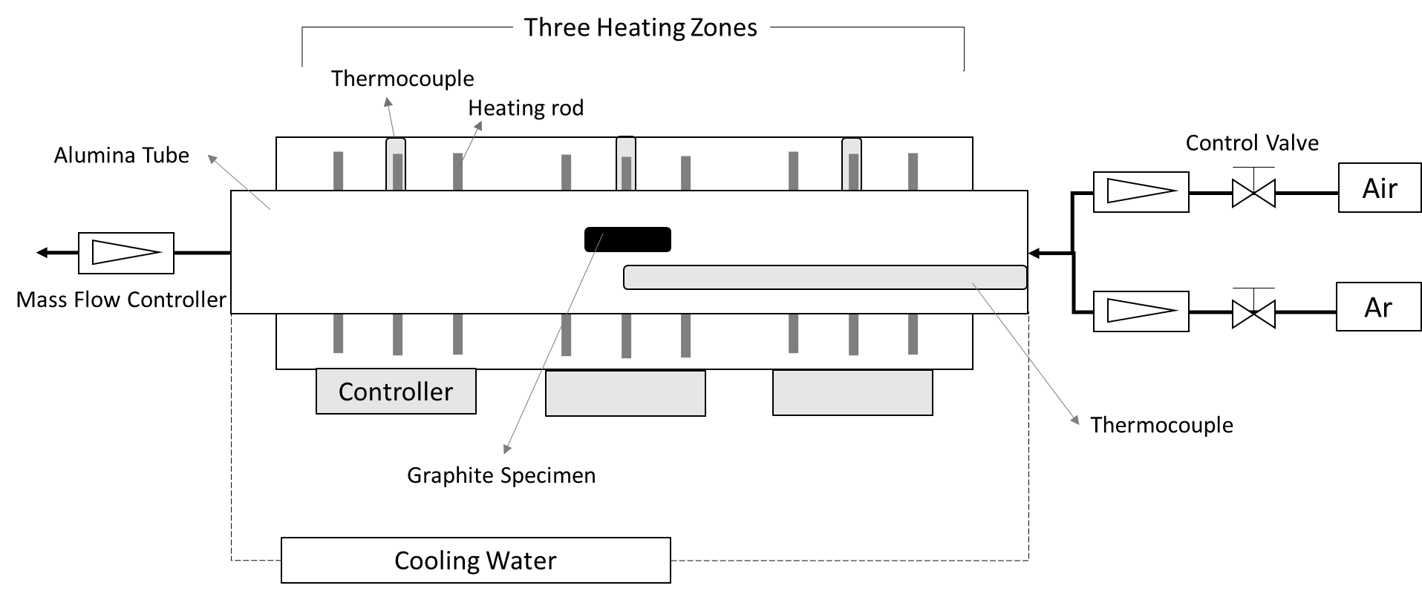
Figure 1 - Schematic of the dynamic testing system for graphite oxidation experiments.

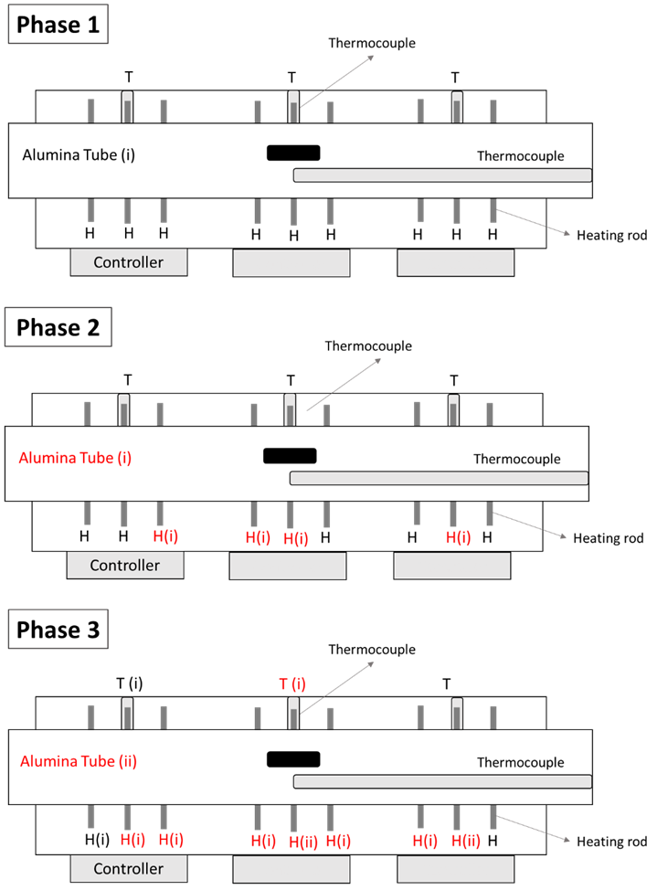
Figure 2 - Schematic of the three phases of the dynamic testing system divided due to each alumina tube replacement in the system. T(#): T is Thermocouple; H(#): Heating rod; Alumina tube(#); #: replaced times of component (i: once, ii: twice) .

Figure 3 - Comparison of oxidation rate for IG-110, IG-430 and ATR-2E at temperatures ranging from 700 to 1600 ºC (Phase 1 of the experimental programme).

Figure 4 - Comparison of oxidation rate for IG-110, IG-430, Type A (MA) and Type B (MB) at temperatures ranging from 700 to 1600 ºC (Phase 2 of the experimental programme).

Figure 5 - Comparison of oxidation rate for IG-430, PGA, G347A and G458A at temperatures ranging from 700 to 1600 ºC (Phase 3 of the experimental programme).

(a)
(b)
(c)
Figure 6 - Arrhenius plots showing the temperature dependence of graphite oxidation rates at temperatures ranging from 700 to 1600 ºC: (a) Phase 1 (IG-110, IG-430, ATR-2E) (b) Phase 2 (IG-110, IG-430, MA, MB) (c) Phase 3 (IG-430, G347A, G458A). Note: The straight lines shown in the graph are indicative of the regimes.

Figure 7 - Comparison of the flow rate effect and oxygen concentration effect on the oxidation rate for IG-430 in Phase 1 and Phase 2 of the experimental programme at selected temperatures.

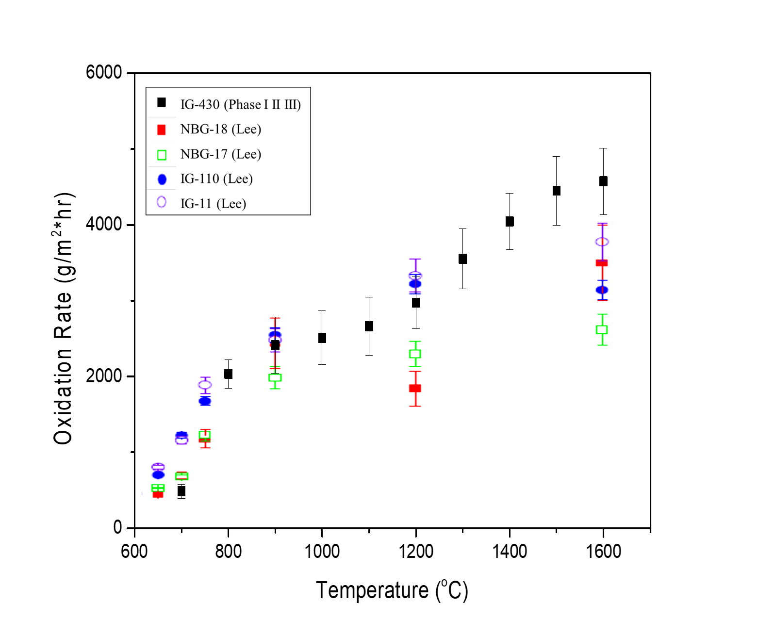

Figure 8 - Determination of oxidation rate for all control experiments (IG-430) within three phases of the experimental programme at temperatures ranging from 700 to 1600 ºC (each point was calculated using data from fifteen individual specimens). Comparison of the oxidation rates presented in reference [7] (each point was average of two trials).

