**Adsorption, surface relaxation and electrolyte structure at Pt(111) electrodes in non-aqueous and aqueous acetonitrile electrolytes**

Gary S. Harlow†a, Iain M. Aldous‡b, Paul Thompson§†, Yvonne Gründer†, Laurence J. Hardwick‡, Christopher A. Lucas†*

†Oliver Lodge Laboratory, Department of Physics, University of Liverpool, Liverpool, L69 7ZE, UK

‡Department of Chemistry, University of Liverpool, Liverpool, L69 7ZE, UK

§XMaS CRG, European Synchrotron Radiation Facility, 38043 Cedex, Grenoble, France

*Corresponding Author:[clucas@liverpool.ac.uk](mailto:clucas@liverpool.ac.uk)

**Abstract**

*In situ* electrochemical surface x-ray diffraction was employed to investigate the atomic scale structure of the electrochemical double layer and the relaxation at the Pt(111) electrode surface in non-aqueous and aqueous acetonitrile electrolytes under potential control. The x-ray measurements provide insight into the potential-dependence of the interface structure by combining potentiodynamic measurements (x-ray voltammetry) with potentiostatic measurements (crystal truncation rod data) to probe both the metal and electrolyte sides of the interface. The crystal truncation rod measurements are consistent with the potential dependent reorientation of acetonitrile in the absence of water and a parallel arrangement in the presence of water. As acetonitrile concentration increases, the electron density closest to the electrode surface also increases. Finally, Pt surface relaxation in a range of aqueous and non-aqueous solvents is discussed in general with regards to the structure of the electrochemical double layer..

**1. Introduction**

The formation of reduced oxygen species in aqueous electrolytes has been extensively studied across many biological and energy storage systems1-5. In the development of lithium battery technologies beyond those based on intercalation reactions, such as alkali metal oxygen (M-O2) systems, an understanding of non-aqueous electrolyte/metal interfaces is crucial to battery research4, 6. Non-aqueous electrolytes can have a much wider potential range of stability in comparison to their aqueous counterparts, allowing the utilisation of otherwise inaccessible or unstable redox couples, such as the formation of superoxide (O2-) from oxygen (O2). Such systems are governed by interfacial electrode processes, which are dependent on electrode surface morphology and electrolyte composition 7-14. Acetonitrile (MeCN) has been used extensively as a non-aqueous solvent to investigate superoxide formation, due to its ease of preparation as a high purity and low water content solvent (< 4 ppm H2O)3, 12, 15, 16. However, it has been reported that on roughened Pt, MeCN dissociates leaving a cyanide and methyl group17, 18. While there have been a few studies investigating the Pt(111)/MeCN electrode interface19-22, very little is known about the interfacial region at the molecular scale, especially in the absence of water. Baldelli *et al*.21 used sum frequency generation (SFG) to infer that in the absence of water the MeCN molecule undergoes a potential dependent reorientation; with the methyl-group pointed towards the electrode surface at potentials negative of the potential of zero charge (*pzc*) and the nitrile group towards the electrode at potentials positive of the *pzc*. The presence of small amounts of water was observed to enhance this effect whereas a water concentration >0.05 mole fraction (50,000 ppm) was found to disrupt any reorientation of the MeCN molecule. In the presence of excess water, MeCN is also thought to be reactively chemisorbed on Pt, where it is found to undergo, almost fully reversible, reduction and oxidation with little or no desorption19. In contrast such a process is not thought to occur in the absence of excess water, as the first step is assumed to be proton mediated22. MeCN is also found to co-adsorb with hydrogen, blocking some of the available sites for hydrogen underpotential deposition (Hupd), and even displacing pre-adsorbed hydrogen23. In general water plays a key role in electrocatalytic reactions, for example, it is known to be chemisorbed at the electrode surface and to undergo a potential dependent reorientation around the potential of zero charge24-26.

Surface X-ray diffraction (SXRD) is one of the few techniques able to simultaneously provide structural information for both the electrode and the electrolyte sides of the electrochemical interface. The few non-aqueous electrolyte systems that have been previously investigated with SXRD, however, are all ionic liquids27-30. In those experiments the sample environments were often hermetically sealed tubes that required the X-rays to pass through large volumes of liquid and, in addition, allowed only restricted angular access for the incident and scattered X-ray beams. Other SXRD experiments with ionic liquids have used a droplet cell arrangement which offers very little protection from atmospheric water31, 32. In this manuscript we describe an experimental setup that overcomes many of these limitations. *In-situ* SXRD measurements are presented that probe the Pt(111)/dry MeCN interfacial structure, both in the absence and presence of dissolved O2. Dynamic voltage-dependent measurements, so-called X-ray voltammetry (XRV), and static crystal truncation rod (CTR) data are presented. The results are used to investigate the link between surface relaxation and adsorption processes. Fits of structural models to the CTR data and XRV measurements are consistent with the idea of the MeCN molecule undergoing a potential-dependant reorientation, but also suggest that this is disrupted by the presence of O2. By comparing these results to aqueous measurements made with increasing MeCN content, and also to aqueous electrolytes with various anions we are able to link adsorption processes and surface charging to the surface relaxation of the Pt(111) electrode. Furthermore, through the modelling of extended specular reflectivity data a model of the electrochemical double layer structure at these interfaces emerges.

2. Experimental Methods

MeCN (MeCN) (≥ 99.9 %, Aldrich) was dried over freshly activated molecular sieves (4 Å) reducing water content to a value of ≤ 5 ppm water and deaerated using high purity argon (≥ 99.999%). This was determined using a coulometric Karl Fischer titrator (Mettler-Toledo). Tetrabutylammonium perchlorate (TBAClO4) (≥ 99.0 %, Aldrich) was dried under vacuum at 120 oC for 16 hours before use. The electrolyte used was MeCN + 0.1 M TBAClO4. High purity O2 (≥ 99.999%), further dried with a water trap and desiccant drying tube (P2O5), was used to oxygenate the electrolyte, this produced a final water content of < 20 ppm. Ag wire was used as quasi-reference electrode and referenced against the position of the O2-  redox couple, this was later calibrated ex-situ with an internal ferrocene standard. All potentials presented are quoted against the standard hydrogen electrode (SHE), where the ferrocene redox couple is found at +0.624 V33. Dry electrolytes and the Karl Fischer titrator were stored in an inert atmosphere glovebox with less than 0.1 ppm O2 and H2O. A Pt(111) 10 mm diameter disc electrode with a miscut < 0.1° was prepared by inductive RF heating at 1050 °C in a 3 % H2–Ar gas mixture under constant flow for 10 minutes. The electrode was subsequently cooled to room temperature in the same atmosphere, in a sealed quartz tube. The sealed tube was placed in the glovebox through an evacuated antechamber. The cell, fittings and Pt wire counter electrode were cleaned by soaking for 24 hours in a 50:50 mixture of concentrated HNO3 + H2SO4 and then rinsed and boiled in MilliQ water (18.2 MΩ). Any oxide was removed from the Ag wire quasi-reference electrode using emery paper before cleaning. The polypropylene films were rinsed and boiled in MilliQ water. The cell was then assembled in air and placed along with the separated polypropylene films and outer hood in the glovebox antechamber for 16 hours. The antechamber was evacuated and heated to 70 °C. The cell was rinsed with fresh electrolyte before use. Immediately after removal from the quartz tube the Pt(111) single crystal was covered with a drop of the electrolyte solution and transferred into the electrochemical cell at open circuit potential. Following assembly an airtight outer hood was secured over the cell and the whole ensemble was placed in a sealed glass jar and transferred to the synchrotron beamline. Immediately after removal from the jar a desiccant drying tube (P2O5) was connected between the cell and an argon (≥ 99.9%) gas line to provide a small overpressure to the outer hood. Figure 1 shows a schematic of the experimental setup that was mounted on the diffractometer. The x-ray measurements with dry MeCN were performed on the I07 beamline at the Diamond Light Source, UK, using a wavelength of 0.689 Å (18 keV). A 2+3 circle diffractometer with a PILATUS 100k (Dectris) detector was used to record the x-ray measurements. The Pt(111) surface was indexed using a hexagonal unit cell such that the surface normal lies along the (0, 0, L)hex direction and the (H, 0, 0)hex and (0, K, 0)hex vectors are subtended by 60° in the perpendicular (surface) plane. The units for H, K and L are a*=b*=4π/√3aNN and c*=2π /√6aNN, where aNN is the nearest-neighbour distance in the crystal (aNN = 2.775 Å). The detector slits were defined by selecting a region of interest (ROI) which was a multiple of the pixel height/width (172 μm). Beam defining slits were 0.5 mm x 0.5 mm and the beam size at the sample was estimated to be 200 µm x 300 µm (vertical x horizontal). Additional measurements were performed on beamline BM12-BESSRC at the APS, Argonne National Laboratory. CTR data was collected by performing L scans at fixed (H, K) values, during which a background subtraction was achieved by subtracting the x-ray signal in a pixel region adjacent to the ROI defining the scattered signal. The data was then corrected by the standard instrumental correction factors.34, 35

**3. Results and Discussion**

**3.1 Non-aqueous MeCN /Pt(111)**

The cyclic voltammetric response of Pt(111) in MeCN + 0.1 M TBAClO4 and O2-saturated MeCN + 0.1 TBAClO4 measured within the x-ray electrochemical cell is shown in Figures 2(a) and 2(b). As the electrode is fully immersed in electrolyte the voltammograms contain contributions from the polycrystalline back and sides of the crystal, the contacting Pt wire, and the (111) surface of the Pt crystal. The CV in Figure 2b shows a single redox couple of superoxide formation and oxidation that is pseudo reversible, which indicates that the cell is well sealed from atmospheric contamination; additional features in the CV that have been attributed to the presence of small amounts of water were not observed22. The CVs remained reversible throughout the experiment, with no additional features from water or air contamination becoming apparent. It was therefore possible to extend the negative potential limit by ~1 V below the potential where hydrogen evolution occurs in aqueous electrolytes. In O2-saturated electrolyte, Figure 2(b), the redox couple in the CV (at ~ -0.3 V vs. SHE) is related with the one electron reduction and oxidation of O23.

**O2 + e- ⇌ O2-  Eo =** - **0.34 V vs. SHE (1)**

The observed peaks associated with the redox couple thus confirm that the solution is saturated with O2. For the O2-saturated electrolyte the positive potential limit was restricted to 0.4 V in order to prevent the oxidation of the Pt(111) surface.

Figures 2(c) – 2(f) show the corresponding XRV data measured at the ‘anti-Bragg’ positions (0, 0, 1.52) and (0, 1, 0.52). The (0, 0, 1.52) position on the specular CTR is sensitive to any out-of-plane changes in the electron density, in both the metal and electrolyte sides of the interface. The position (0, 1, 0.52), on a non-specular CTR, is sensitive to any changes in structure and ordering of surface layers that are commensurate with the Pt(111) lattice. It is important to note that the observed changes in x-ray intensity are fully reversible, indicating that the Pt(111) surface is stable in this potential range and undergoes no irreversible roughening or restructuring. The XRV intensity measured at (0, 1, 0.52) increases with applied potential (Figures 2(c) and 2(d)), suggesting a correlation between the applied potential and the surface ordering. In contrast, XRV measurements made at the specular CTR position, (0, 0, 1.52), in Figure 2(e) show a maximum intensity at ~0 V in the positive scan direction which then decreases. Interestingly the potential of zero charge (*pzc*) for MeCN/Pt(111) is estimated to be 0.11 V using differential capacitance measurements20 and this potential is indicated by the dashed vertical lines in Figure 2. It seems likely that the change in intensity measured at (0, 0, 1.52) is due to the reorientation of the MeCN molecules adjacent to the Pt surface. This is in contradiction to SFG results where the *pzc* is placed around +547 mV based on an equal signal from positive and negative CH3 peaks, although the exact position seems strongly influenced by water content and the use of Ag/AgCl reference and its subsequent conversion21. In the O2-saturated electrolyte the response of the Pt surface, measured at (0, 1, 0.52), to the electrode potential shows a similar trend to that observed in O2-free electrolyte. The XRV measured at the specular position, Figure 2(f), now shows a shifted potential of maximum intensity and a large hysteresis on the anodic sweep. As the maximum intensity is found at the same potential as the cathodic peak in Figure 2(b), where the O2- molecule is oxidised, the measured change is therefore likely due to the adsorption/desorption of O2 species 3.

It is well established that ordered Pt(111)-(1 x 1) surfaces remain intact in aqueous solutions36-38 and SXRD measurements have shown that there is a potential-dependant relaxation of the topmost atomic layer of Pt atoms39, 40. In order to gain detailed atomic-scale information on the surface structure of the Pt(111) electrode, the specular, (0, 0, L), and a non-specular, (1, 0, L), crystal truncation rods (CTRs) were measured at 0.4 V and -1.1 V. Both the specular and non-specular CTR data were modelled simultaneously. Figures 3(a) and 3(b) show the (1, 0, L) CTR data measured in MeCN + 0.1 M TBAClO4 and O2-saturated MeCN + 0.1 M TBAClO4 respectively, with the potential held at -1.1 V and 0.4 V. Each data point has been background subtracted (using an appropriate pixel region adjacent to that defined for the detected signal) and corrected for the instrumental resolution. The solid lines are fits to the data using a structural model for the Pt(111) surface, parameterised by interlayer relaxation (ε), root-mean-squared (*rms*) roughness (σi), modelled as a static Debye-Waller factor in addition to the thermal Debye-Waller factor and coverage of the surface Pt layer (η1) as indicated in Figure 5(a). The bottom panels in Figure 3 show the ratio between the CTR data sets measured at 0.4 V and -1.1 V. Plotting the ratio between CTR data sets highlights any changes induced by the applied potential, independent of any systematic error in the data (therefore just the statistical error is shown). The solid line in the ratio data plots corresponds to the ratio of the fits to the CTR data shown in the upper panels. The systematic change that is observed as a function of potential is largely due to a change in the relaxation of the topmost Pt surface layer. The parameters that gave the best fit to the CTR data are listed in Table 1.

The CTR data shown in Figure 3 indicates that the Pt(111) surface remains well ordered across the entire potential range studied. The most significant difference in the structural models obtained by the fits to the data is in the expansion (i.e. relaxation) of the topmost Pt layer. There is also a small change in surface roughness between the two potentials which is consistent with the observed XRV at (0, 1, 0.52), shown in Figures 2(c) and 2(d). Specular CTR measurements (also known as extended x-ray reflectivity) probe the electron density profile in the direction perpendicular to the surface and are therefore sensitive to layering in the liquid side of the interface41. The atomic form factor for carbon was used to represent any adlayers in the model, as nitrogen, carbon and O2 all have similar atomic numbers. The *rms* roughness for each electrolyte adlayer was fixed slightly above that of Pt at 0.15 Å. The transition of the electron density from the interface to the bulk electrolyte is described by an error function with width 0.5 Å and a maximum electron density equal to the bulk density of MeCN. Figure 5(b) shows how the vertical electron density profile relates to the various components of this model.

As for the non-specular CTR data shown in Figure 3, Figures 4(a) and 4(b) show the specular CTR data measured in MeCN + 0.1 M TBAClO4 and O2-saturated MeCN + 0.1 M TBAClO4 respectively, with the potential held at 0.4 V and -1.1 V and the bottom panels show the ratio between the data sets measured at the two potentials. The solid lines are the best fits to the data with (solid line) and without (dashed line) the contribution from the electrolyte layering (the structural parameters to the fits are listed in Table 1). Figure 6 shows the laterally averaged surface-normal electron density profiles calculated from the best fit parameters to the CTR data in Figure 4. The electron density profiles in the electrolyte side of the interface are plotted to simulate the finite experimental resolution where the electron density is plotted as a Gaussian function with an effective vibrational amplitude corresponding to the vibrational amplitude of each atom () and a resolution-determined width added in quadrature i.e. ueff = √(ures2+ σ2), where ures = 1.1/Qmax, and Qmax is the maximum momentum transfer in the measurement, as discussed by Fenter and co-workers42. Since the profiles are laterally averaged the possibility of contributions from molecules other than MeCN and O2 exists but are expected to be minimal over the potential range investigated. The large TBA cations will have to compete with the adsorption of solvent molecules and the perchlorate anions are assumed to solvate MeCN but at more positive potentials than the measured CTRs19, 20.

Inclusion of an electrolyte layer is the only way to reproduce the measured CTR data around the first anti-Bragg position at (0, 0, 1.5). Although more complex models with additional layers in the electrolyte side of the interface gave good fits to the CTR data, we found no statistical basis to select such models over those presented here. The lack of sensitivity to the precise structure is due to the relatively weak scattering of the molecules in the electrolyte compared to the underlying Pt atoms. A more detailed discussion of the various models that were explored in fitting the CTR data is given in the supporting information (S1). Results of the fits to the data with the simple one-layer adsorbate model are represented by the curves shown in Figure 6. In O2-free solvent (Figure 6(a)) the adsorbate layer is shifted further away from the surface at 0.4 V. Since the centre of mass of an MeCN molecule lies between the two carbon atoms this shift is consistent with a 'flipping' in the orientation of MeCN, with the nitrogen atom closest to the surface at 0.4 V21. For the O2-saturated electrolyte, three main differences are apparent, (1) the adlayers are closer to the electrode surface, (2) the coverage is substantially reduced (as shown more clearly in insets 6(c) and 6(d)) and (3) the error function begins ~1 Å further away from the electrode surface, indicating an expanded double layer region, possibly due to the presence of additional layering not included in the model. The increase in adlayer coverage at the negative potential in the presence of O2 is consistent with the adsorption of superoxide as shown by experiment43 and theory44 .

3.2 The aqueous Pt(111)/MeCN electrode interface

To investigate the effect of the MeCN concentration on the interfacial structure, XRV and specular CTR data were measured as the concentration of MeCN was varied. The cyclic voltammetric response of Pt(111) at the lowest MeCN concentration (10 mM) and the highest (10 M) are shown in Figures 7(a) and 7(b) respectively. Increasing the MeCN concentration mainly leads to a flattening of the voltammetric features. Figures 7(c) and 7(d) show the XRV measured at (1 0 3.7), a position that is primarily sensitive to Pt surface relaxation. A change in the relaxation of the surface Pt atomic layer appears to be the most significant structural change at aqueous MeCN /Pt(111) interfaces. Figures 7(e) and 7(f) show XRVs measured at the specular anti-Bragg position, (0, 0, 1,5), and indicate a small intensity increase at the negative potential, most likely due to a slight decrease in surface roughness. The XRV measured at (0, 1, 0.52) was similar to that shown in figures 7(e) and 7(f) and is therefore not shown. The lack of any significant change at these anti-Bragg positions indicates that no specific adsorption/desorption processes occur. This is expected, as in aqueous electrolytes MeCN is thought to be reactively chemisorbed on Pt where an almost fully reversible reduction and oxidation occurs with little or no desorption19. The best fit to the CTR data was evaluated by inspection of both the data and the ratio between data sets, at different concentrations and different applied potentials. The model’s validity is supported by its consistency across all the concentrations of MeCN, where almost all the parameters follow a trend with concentration and the changes with potential are also found to be consistent across the different solutions. Figures 8(a) and (b) show the ratios of the CTR data measured with 0.1 M, 1.0 M and 10 M concentrations of MeCN normalized to that measured with 0.01 M MeCN at potentials of 0.0 V and 0.85 V. The solid lines show the calculated ratios from the fits to the CTR data (the CTR data, fits to the data and the corresponding structural parameters are included in the supplementary information (S2), Figures S6-7, Table S1, along with a discussion of the sensitivity of the layering models).

Changes at the metal/electrolyte interface, both as a function of potential and MeCN concentration, are dominated by the changes in Pt surface relaxation. The largest change is between the two potentials, with the surface expansion largest at 0 V. With increasing MeCN concentration the expansion of the Pt(111) surface also increases. This suggests that the presence of MeCN close to the Pt (111) surface induces an expansion of the spacing between the topmost Pt layers. Surface relaxation and expansion are discussed in more detail below The fits to the data also indicate that as the concentration of MeCN increases there is a slight increase in the out-of-plane Debye-Waller factor (roughness). Idealized vertical electron density plots, showing how the concentration of MeCN affects the vertical structure of the electrolyte close to the Pt(111) surface, are shown in Figure 9 for data measured at both potentials. MeCN is known to chemisorb at Pt (111) electrodes therefore the first adlayer in the model, which increases in coverage with the concentration of MeCN, probably corresponds to adsorbed MeCN (or at least partly). The best fits to the data also suggest that the width of the double layer region decreases with increasing MeCN concentration. Both this decrease in double layer width and the increase in coverage of MeCN with MeCN concentration are in agreement with previous voltammetric measurements45. It is also expected that adsorbed water will contribute to the electron density (and hence scattering) of the liquid layer. The coverage of the outer layer decreases with MeCN concentration. The coverage of this outer layer is greatest at 0.85 V which is when the presence of perchlorate anions is expected in the outer Helmholtz plane (OHP).

These results demonstrate the possibility of using SXRD to obtain molecular scale models of the electrochemical double layer in the vertical plane; the first adlayer being the Inner Helmholtz Plane (IHP) and the second being the OHP. Caution is however advised as individual species cannot be distinguished and the structure obtained is highly model dependent. The selection of appropriate models was however improved by being able to compare the ratios of several measurements on the same electrode where only the electrolyte concentration differed.

3.3 Comparison to studies of Pt(111) in aqueous electrolyte and the effect on Pt surface relaxation

The Pt(111) electrode has been examined in detail in both acidic (0.1 M HClO4 and 0.1 M H2SO4) and alkaline (0.1 M KOH) electrolytes by SXRD37, 40, 46. CTR data, similar to the data presented in this paper, are described in the supplementary information (S3). The quality of this CTR data precludes any analysis of the electrolyte ordering and the potential-dependent changes in the CTR data are fully reproduced by changes in the Pt surface relaxation. The surface relaxation can be driven by adsorption processes in which new Pt-adsorbate bonds alter the Pt-Pt bonding and cause outward relaxation. Simplistically, electronegative adsorbates are expected to withdraw electrons from the metal and the atoms will be less screened from each other so there is increased repulsion leading to expansion47. In contrast charge injection by electropositive adsorbates should increase screening and lead to contraction. This picture is incomplete, however, since the orbital character of electrons, anti-bonding effects, adsorbate polarity, and donor/acceptor contributions from both the metal and adsorbate need to be considered48. In fact under UHV conditions, in contrast to many metal surfaces which exhibit a surface contraction, the clean Pt(111) surface exhibits an outward relaxation of ~1% of the (111) layer spacing which is due to the d-orbital bonding and has been fully reproduced in first principles calculations49, 50.

In the absence of significant surface roughening, the intensity measured at the CTR position (1, 0, 3.7) is linearly proportional to Pt surface expansion. This allows the measured intensity to be converted to Pt surface relaxation using the fits to the CTR data as calibration. Figure 10 shows the potential dependence of the Pt surface expansion for both the aqueous electrolytes (detailed CTR data is shown in the supplementary information (S3)) and non-aqueous electrolytes (presented in this paper). Firstly, for the aqueous electrolytes it is apparent that the results for 0.1 M KOH and the different concentrations of MeCN are very similar in shape (although the expansion is of a different magnitude in each case), exhibiting a sharp reversible change in outward expansion at ~0.33 V. This is a potential that has previously been identified as the potential of zero total charge (*pztc*)51, 52 and marks the onset of hydrogen adsorption53. It is also thought that negative of the *pztc* water molecules close to the metal are oriented with the hydrogen atoms pointed towards the electrode, whereas above the *pztc* the O2 atoms point towards the electrode24, 25, 54. A similarity between the cyclic voltammograms obtained in alkaline electrolyte and in the presence of MeCN has been noted previously and attributed to the fact that the negative potential limit enables the reduction of water to H2 and increases the concentration of OH- in the double layer22. The difference in the magnitude of the surface expansion can be linked to the size of the electrochemical double layer; a more compact layer (observed as the concentration of MeCN is increased) creating a stronger counter charge dipole in the electrolyte which increases the outward relaxation55. The results obtained in 0.1 M HClO4 and 0.1 M H2SO4 are consistent with the data measured in alkaline solution at the most negative potential, when the Pt surface is fully covered by adsorbed hydrogen. However, the presence of the anions, perchlorate and sulfate, modifies both the magnitude and the observed hysteresis in the potential-dependent surface relaxation. The surface remains expanded in both H2SO4 and HClO4 until the adsorption of sulfate and perchlorate anions at around 0.42 V and 0.65 V respectively. These potentials correspond to particular features observed in the cyclic voltammograms, the butterfly peaks associated with sulphate adsorption for H2SO4 electrolytes56 and the broad reversible OH adsorption feature observed in perchlorate electrolytes57. The fact that the surface remains expanded up until an adsorption processes (of an anion or oxygenated species), even into the double layer region in the case of HClO4, demonstrates that expansion cannot be just caused by the adsorption/desorption of hydrogen alone and supports the suggestion that the relaxation of the surface is an electronic screening effect caused by the ordering and structure of the double layer.

Wieckowski has proposed that the adsorption of organic molecules at platinum electrodes can be classified into three groups58. MeCN was assumed to be in a group of molecules with delocalised π orbitals that form complexes with the Pt surface, the overlapping of the π orbitals with the Pt d-orbitals allows for the displacement of chemisorbed water which may explain the differences in minimum expansion at different MeCN concentrations. In the non-aqueous electrolytes a much larger surface expansion (~ 3.4 to 4.1 %) is observed across the entire potential range, in fact the values are similar to those observed upon the adsorption of carbon monoxide (~4 %) onto Pt(111)39, a process attributed to the back-bonding mechanism described by Blyholder59. In this mechanism there is a transfer of charge from the highest-occupied molecular orbital (HOMO) of CO to the Pt d-orbitals, with back-donation from the metal’s occupied states to the lowest unoccupied molecular orbital (LUMO) of CO. The potential-dependence of the surface relaxation implies a significant negative shift in the *pztc* compared to that observed in aqueous electrolytes. Interestingly, the presence of dissolved O2 reduces the magnitude of the Pt surface relaxation and increases the hysteresis, perhaps reflecting the larger change in the double-layer structure induced by the applied potential (Figure 6).

**4. Conclusions**

In this paper we have presented a comprehensive *in-situ* x-ray scattering study of a Pt(111) electrode both in non-aqueous solvent (acetonitrile-MeCN) and in aqueous solvents with different concentrations of MeCN. In dry MeCN + 0.1 M TBAClO4, x-ray voltammetry and extended x-ray reflectivity measurements support the idea of a potential-dependant reorientation of MeCN at the Pt(111) surface around the potential of zero total charge (*pztc)*. However, when the electrolyte is saturated with O2 the data is more consistent with an adsorption/desorption process related to the formation of O2- at negative potentials. In aqueous solutions containing MeCN at various concentrations there is no evidence of adsorption/desorption and this is consistent with the idea of MeCN being reactively chemisorbed when water is present. Extended x-ray reflectivity (specular CTR) data can be used to gain insights into the structure of the electrochemical double layer. There is a reduction in the thickness of the electrochemical double layer (between 1 to 2 Å) in the presence of water compared to the water-free MeCN solvent, consistent with the molecule lying parallel to surface. Also, as the concentration of MeCN is increased, the electron density close to the electrode surface also increases. Finally we have presented a detailed study of the potential-dependent Pt surface relaxation in both aqueous and non-aqueous solvents. This is discussed both in terms of adsorption/desorption processes and the effect of the applied electrode potential on the electrostatic interaction between the charged metal surface and the screening dipole in the electrochemical double layer.

**Acknowledgments**

Non-aqueous SXRD measurements were performed on the I07 beamline at the Diamond Light Source. We would like to thank Jonathan Rawle and Chris Nicklin for their support on beamline I07. Measurements with different MeCN concentrations were performed at 12-BM, Advanced Photon Source, for which we would like to thank Sungsik Lee and Benjamin Reinhart for their hard work in supporting the beamline. YG acknowledges the support of a Royal Society URF. Support from the EPSRC grants EP/J020265/1 and EP/K002236/1 is also gratefully acknowledged. GSH and IMA acknowledge the support of EPSRC studentships.

**Supplementary Information**. Text S1-S3, Figures S1-S12 and Tables S1-S3.

**Present Addresses**

a Gary S. Harlow is now at Division of Synchrotron Radiation Research, Lund University, Box 118, 221 00 Lund, Sweden

bIain M. Aldous is now at Centre for Materials Research, College of Science and Engineering, Physics Building, University of Leicester, Leicester, LE1 7RH, UK.

**References**

1. N. M. Marković, T. J. Schmidt, V. Stamenković and P. N. Ross, *Fuel Cells*, 2001, **1**, 105-116.

2. K. Apel and H. Hirt, *Annual Review of Plant Biology*, 2004, **55**, 373-399.

3. D. T. Sawyer, *Oxygen Chemistry*, Oxford University Press, 1991.

4. P. G. Bruce, S. A. Freunberger, L. J. Hardwick and J.-M. Tarascon, *Nat Mater*, 2012, **11**, 19-29.

5. D. Sharon, D. Hirshberg, M. Afri, A. Garsuch, A. A. Frimer and D. Aurbach, *Isr. J. Chem.*, 2015, **55**, 508-520.

6. A. C. Luntz and B. D. McCloskey, *Chem. Rev.*, 2014, **114**, 11721-11750.

7. L. Johnson, C. Li, Z. Liu, Y. Chen, S. A. Freunberger, P. C. Ashok, B. B. Praveen, K. Dholakia, J.-M. Tarascon and P. G. Bruce, *Nat Chem*, 2014, **6**, 1091-1099.

8. T. Liu, M. Leskes, W. Yu, A. J. Moore, L. Zhou, P. M. Bayley, G. Kim and C. P. Grey, *Science*, 2015, **350**, 530-533.

9. N. B. Aetukuri, B. D. McCloskey, J. M. García, L. E. Krupp, V. Viswanathan and A. C. Luntz, *Nat Chem*, 2015, **7**, 50-56.

10. C. O. Laoire, S. Mukerjee, K. M. Abraham, E. J. Plichta and M. A. Hendrickson, *J. Phys. Chem. C*, 2009, **113**, 20127-20134.

11. M. Safari, B. D. Adams and L. F. Nazar, *J. Phys. Chem. Lett.*, 2014, **5**, 3486-3491.

12. Z. Peng, S. A. Freunberger, L. J. Hardwick, Y. Chen, V. Giordani, F. Bardé, P. Novák, D. Graham, J.-M. Tarascon and P. G. Bruce, *Angew. Chem. Int. Ed.*, 2011, **50**, 6351-6355.

13. F. Endres, *ChemPhysChem*, 2002, **3**, 144-154.

14. G. H. D Gal, *Thin Solid Films*, 2000, **361**, 79-83.

15. V. S. Bryantsev, J. Uddin, V. Giordani, W. Walker, D. Addison and G. V. Chase, *J. Electrochem. Soc.*, 2013, **160**, A160-A171.

16. I. M. Aldous and L. J. Hardwick, *J. Phys. Chem. Lett.*, 2014, **5**, 3924-3930.

17. P. Cao and Y. Sun, *J. Phys. Chem. B*, 2003, **107**, 5818-5824.

18. P. Cao, Y. Sun and R. Gu, *J. Raman Spectrosc.*, 2005, **36**, 725-735.

19. S. Morin and B. E. Conway, *Journal of Electroanalytical Chemistry*, 1994, **376**, 135-150.

20. N. S. Marinković, M. Hecht, J. S. Loring and W. R. Fawcett, *Electrochimica Acta*, 1996, **41**, 641-651.

21. S. Baldelli, G. Mailhot, P. Ross, Y.-R. Shen and G. A. Somorjai, *J. Phys. Chem. B*, 2001, **105**, 654-662.

22. M. F. Suárez-Herrera, M. Costa-Figueiredo and J. M. Feliu, *Langmuir*, 2012, **28**, 5286-5294.

23. H. Angerstein-Kozlowska, B. Macdougall and B. E. Conway, *Journal of Electroanalytical Chemistry and Interfacial Electrochemistry*, 1972, **39**, 287-313.

24. T. Iwasita and X. Xia, *Journal of Electroanalytical Chemistry*, 1996, **411**, 95-102.

25. M. Osawa, M. Tsushima, H. Mogami, G. Samjeské and A. Yamakata, *J. Phys. Chem. C*, 2008, **112**, 4248-4256.

26. T. Roman and A. Groß, *Catalysis Today*, 2013, **202**, 183-190.

27. E. Sloutskin, B. M. Ocko, L. Tamam, I. Kuzmenko, T. Gog and M. Deutsch, *J. Am. Chem. Soc.*, 2005, **127**, 7796-7804.

28. M. Mezger, H. Schröder, H. Reichert, S. Schramm, J. S. Okasinski, S. Schöder, V. Honkimäki, M. Deutsch, B. M. Ocko, J. Ralston, M. Rohwerder, M. Stratmann and H. Dosch, *Science*, 2008, **322**, 424-428.

29. M. Mezger, S. Schramm, H. Schröder, H. Reichert, M. Deutsch, E. J. D. Souza, J. S. Okasinski, B. M. Ocko, V. Honkimäki and H. Dosch, *The Journal of Chemical Physics*, 2009, **131**, 094701.

30. A. Uysal, H. Zhou, G. Feng, S. S. Lee, S. Li, P. Fenter, P. T. Cummings, P. F. Fulvio, S. Dai, J. K. McDonough and Y. Gogotsi, *J. Phys. Chem. C*, 2014, **118**, 569-574.

31. K. Tamura, S.-i. Miyaguchi, K. Sakaue, Y. Nishihata and J. i. Mizuki, *Electrochemistry Communications*, 2011, **13**, 411-413.

32. K. Tamura and Y. Nishihata, *J. Phys. Chem. C*, 2016, DOI: 10.1021/acs.jpcc.5b09704.

33. V. V. Pavlishchuk and A. W. Addison, *Inorganica Chimica Acta*, 2000, **298**, 97-102.

34. C. M. Schleputz, R. Herger, P. R. Willmott, B. D. Patterson, O. Bunk, C. Bronnimann, B. Henrich, G. Hulsen and E. F. Eikenberry, *Acta Crystallographica Section A*, 2005, **61**, 418-425.

35. C. M. Schleputz, S. O. Mariager, S. A. Pauli, R. Feidenhans'l and P. R. Willmott, *J. Appl. Crystallog.*, 2011, **44**, 73-83.

36. R. M. Ishikawa and A. T. Hubbard, *Journal of Electroanalytical Chemistry and Interfacial Electrochemistry*, 1976, **69**, 317-338.

37. I. M. Tidswell, N. M. Markovic and P. N. Ross, *Journal of Electroanalytical Chemistry*, 1994, **376**, 119-126.

38. L. A. Kibler, A. Cuesta, M. Kleinert and D. M. Kolb, *Journal of Electroanalytical Chemistry*, 2000, **484**, 73-82.

39. C. A. Lucas, N. Markovic and P. N. Ross, *Surf.Sci.*, 1999, **425**, L381-L386.

40. C. A. Lucas, *Electrochimica Acta*, 2002, **47**, 3065-3074.

41. P. Fenter and N. C. Sturchio, *Progress in Surface Science*, 2004, **77**, 171-258.

42. P. Fenter, M. T. McBride, G. Srajer, N. C. Sturchio and D. Bosbach, *J. Phys. Chem. B*, 2001, **105**, 8112-8119.

43. T. A. Galloway and L. J. Hardwick, *J. Phys. Chem. Lett.*, 2016, DOI: 10.1021/acs.jpclett.6b00730.

44. G. V. Zhuang, N. M. Markovic and R. G. Ross P.N, .Power Source Modelling: Proceedings of the International Symposium., 2002.

45. I. Srejić, M. Smiljanić, Z. Rakočević and S. Štrbac, *International Journal of Electrochemical Science*, 2011, **6**, 3344-3354.

46. N. M. Marković, B. N. Grgur, C. A. Lucas and P. N. Ross, *Journal of Physical Chemistry B*, 1999, **103**, 487-495.

47. D. Jürgens, G. Held and H. Pfnür, *Surface Science*, 1994, **303**, 77-88.

48. D. Menzel, *Surf. Rev. Lett.*, 1997, **04**, 1283-1289.

49. J. L. F. Da Silva, C. Stampfl and M. Scheffler, *Surface Science*, 2006, **600**, 703-715.

50. P. J. Feibelman, J. S. Nelson and G. L. Kellogg, *Physical Review B*, 1994, **49**, 10548-10556.

51. A. Cuesta, *Surface Science*, 2004, **572**, 11-22.

52. O. A. Petrii, *Russian Journal of Electrochemistry*, 2013, **49**, 401-422.

53. J. M. Orts, R. Gómez, J. M. Feliu, A. Aldaz and J. Clavilier, *Electrochimica Acta*, 1994, **39**, 1519-1524.

54. T. Pajkossy and D. M. Kolb, *Electrochimica Acta*, 2001, **46**, 3063-3071.

55. F. Weigend, F. Evers and J. Weissmüller, *Small*, 2006, **2**, 1497-1503.

56. A. M. Funtikov, U. Stimming and R. Vogel, *Journal of Electroanalytical Chemistry*, 1997, **428**, 147-153.

57. A. Berna, V. Climent and J. Feliu, *Electrochemistry Communications*, 2007, **9**, 2789-2794.

58. A. Wiȩckowski, *Electrochimica Acta*, 1981, **26**, 1121-1124.

59. G. Blyholder, *The Journal of Physical Chemistry*, 1964, **68**, 2772-2777.

|  |  |  |  |  |  |  |
| --- | --- | --- | --- | --- | --- | --- |
|  | **Parameter** | **0.4V** | **-1.1V** | **0.4V** | **-1.1V** | |
| Metal Layers | ε34 (Å) | 0.008(1) | 0.007(1) | 0.0085(7) | | 0.0080(7) |
| ε23(Å) | 0.024(1) | 0.027(1) | 0.0232(7) | | 0.0249(8) |
| ε12(Å) | 0.079(1) | 0.094(1) | 0.065(1) | | 0.086(1) |
| σ2(Å) | 0.056(4) | 0.026(9) | 0.066(2) | | 0.047(3) |
| σ1(Å) | 0.115(2) | 0.106(3) | 0.102(2) | | 0.095(2) |
| η1 | *1* | *1* | 0.953(5) | | 0.951(5) |
| Layer 1 | θ | 1.2(1) | 1.0(1) | 0.7(1) | | 0.9(1) |
| d(Å) | 3.15(3) | 3.02(4) | 2.81(5) | | 2.74(4) |
| σ (Å) | *0.15* | *0.15* | *0.15* | | *0.15* |
| Error Function | d(Å) | 4.9(2) | 5.0(2) | 6.0(1) | | 6.3(1) |
| σ (Å) | *0.5* | *0.5* | *0.5* | | *0.5* |
| χ2red | 1.45 | 1.74 | 1.29 | | 1.41 |
| R-factor | 0.058 | 0.068 | 0.046 | | 0.048 |

**Table 1:** Structural parameters to the fits to the CTR data shown in Figures 3 and 6. The left hand side (blue background) shows the parameters giving the best fit to the data measured in MeCN + 0.1 M TBAClO4. The parameters on the right-hand side (red background) correspond to the parameters giving the best fit to the data measured in O2-saturated MeCN + 0.1 M TBAClO4. Numbers in italics correspond to parameters that were fixed during the fitting procedure. Errors are estimated from the diagonals of the covariance matrix.

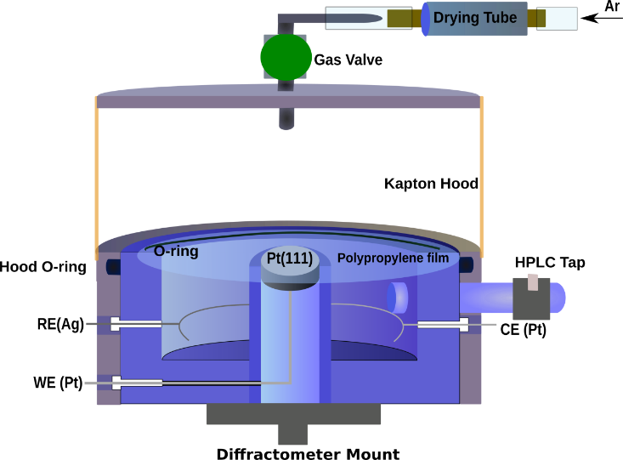

**Figure 1:** Illustration of the non-aqueous surface diffraction cell cross-section. The cell had an overpressure of dry argon.

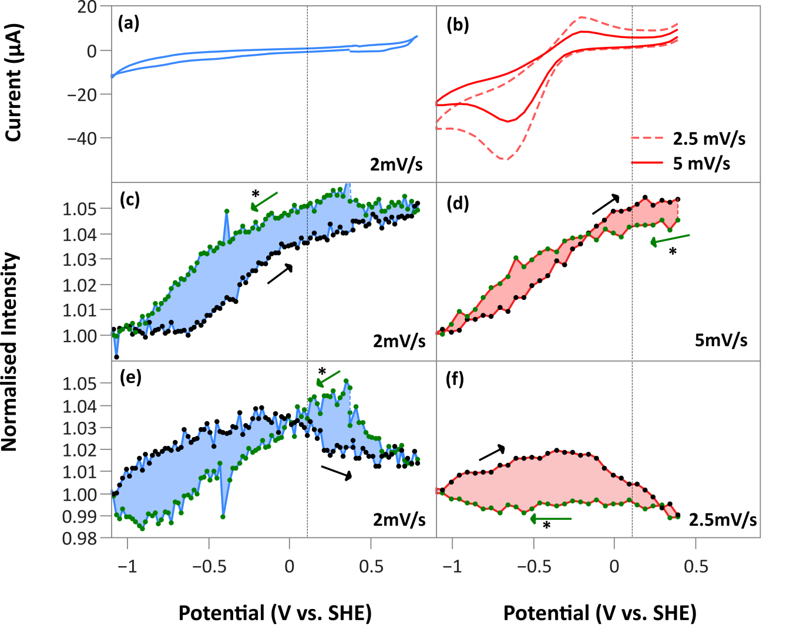

**Figure 2:** X-ray voltammetry (XRV) measurements. The left-hand side shown in blue corresponds to data measured in MeCN + 0.1 M TBAClO4 whereas the right-hand side (red) corresponds to data measured in O2-saturated MeCN + 0.1 M TBAClO4. **(a)** and **(b)** are cyclic voltammograms measured at the same time as the x-ray measurements and include some contribution from the polycrystalline back and sides of the crystal. **(c)** and **(d)** show the XRV measured at (0, 1, 0.52) as a function of potential. **(e)** and **(f)** show the XRV measured at (0, 0, 1.52), an anti-Bragg position on the specular CTR. Sweep rates are indicated.The starting direction of the scan is indicated by an asterisk.

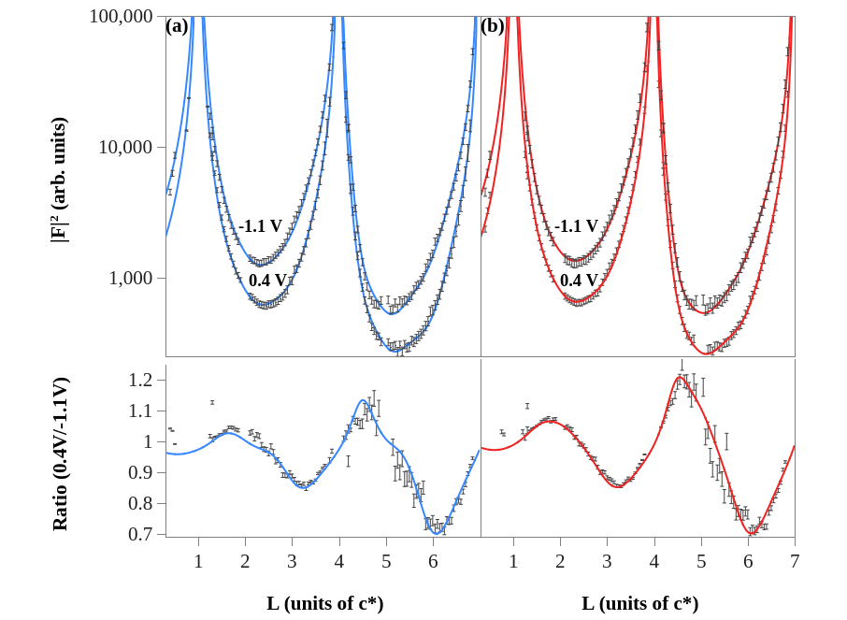

**Figure 3:** Non-specular crystal truncation rod data, (1, 0, L), measured at -1.1 V and 0.4 V, where the 0.4 V data has been shifted vertically by a factor of 0.5. The solid lines indicate the best fit to the data and the parameters are listed in Table 1. The bottom panels show the data measured at the negative potential normalised to the data measured at the positive potential. **(a)** Data measured in MeCN + 0.1 M TBAClO4. **(b)** Data measured in O2-saturated MeCN + 0.1 M TBAClO4.

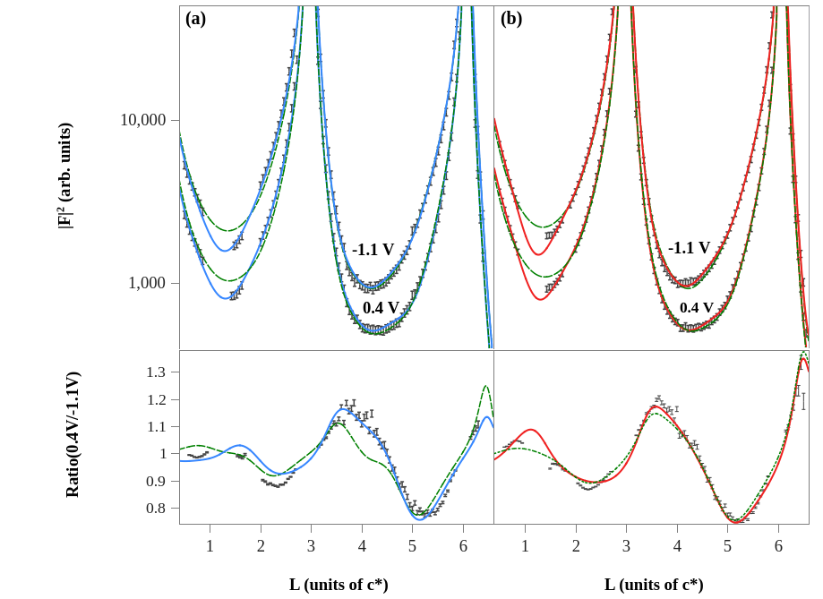

**Figure 4:** Specular crystal truncation rod data, (0, 0, L), **(a)** Measured in MeCN + 0.1 M TBAClO4. (**b)** Measured in O2-saturated MeCN + 0.1 M TBAClO4. Data at 0.4 V has been shifted by a factor of 0.5. The best fits to these data are shown by the solid lines with the structural parameters listed in Table 1. The dashed line shows a best-fit to the CTR when layering in the electrolyte is not included. The symbols in the bottom panels show the ratio obtained by dividing the data measured at 0.4 V by the data measured at -1.1 V.

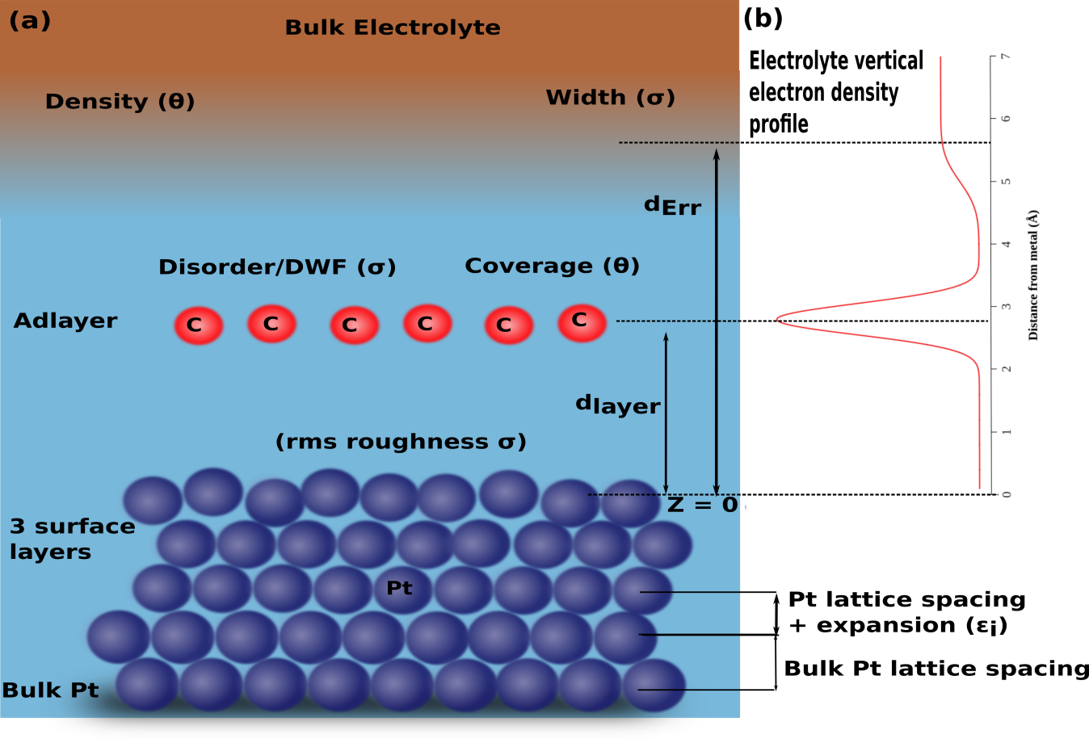

**Figure 5:** Illustration of the structural model used to fit the CTR data. **(a)** This illustration shows the metal bulk and three surface metal layers. Above the metal the model includes an adlayer, modelled with the form factor for carbon, and then an error function to account for scattering from the bulk electrolyte. **(b)** The graph shows the correspondence with a vertical electron density profile.

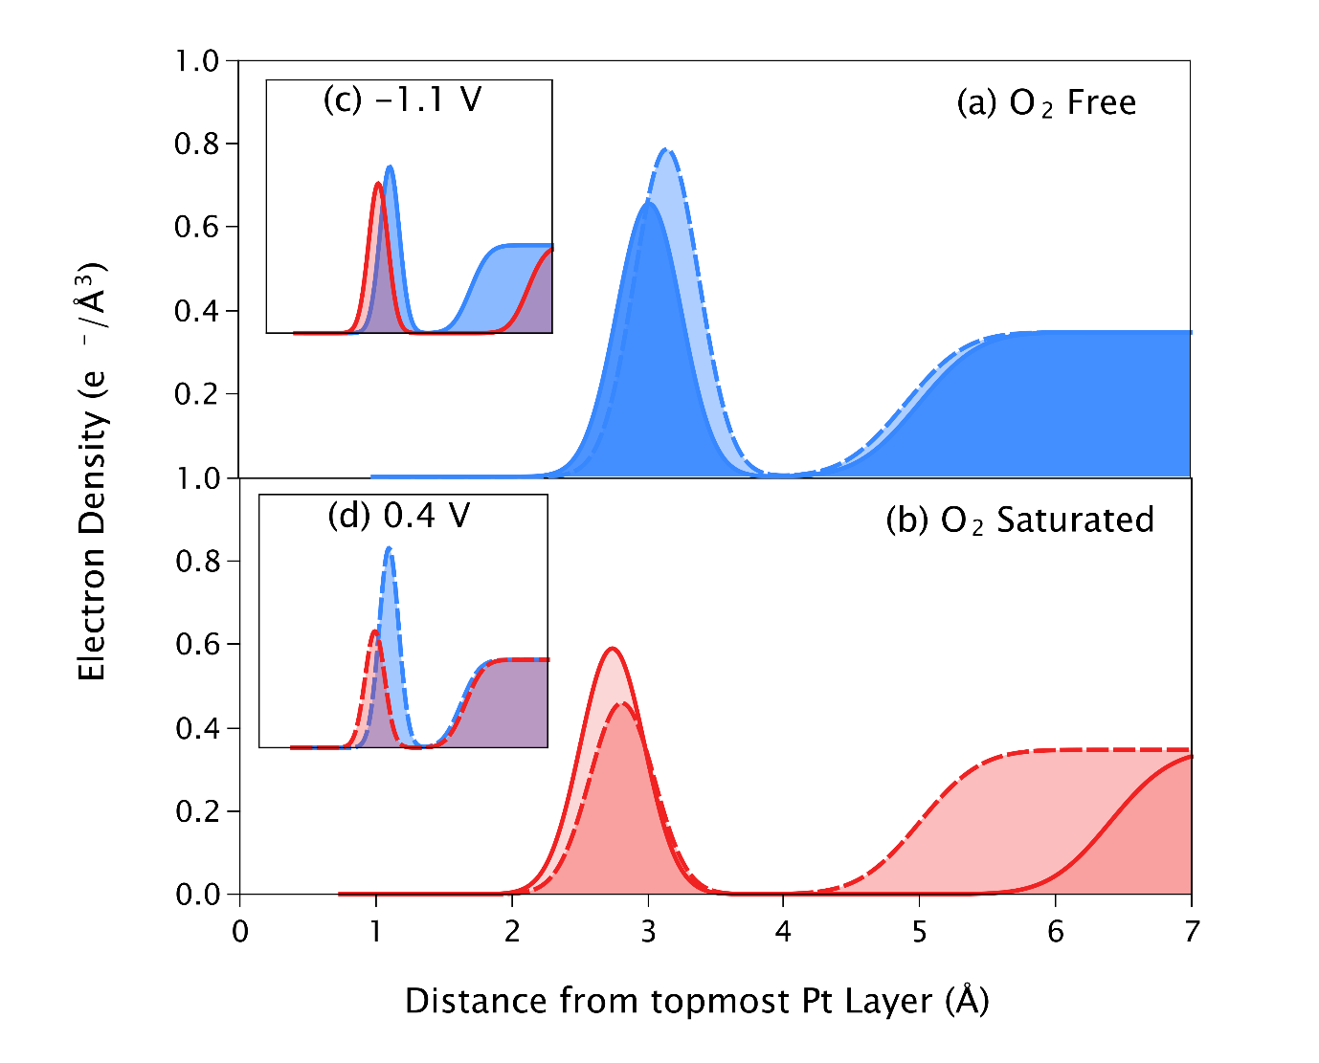

**Figure 6:** Idealised electron density profile corresponding to the fits to the CTR data according to the structural parameters listed in Table 1. The dashed lines are calculated from the best-fit to the data measured at 0.4 V whereas the solid lines correspond to the data measured at -1.1 V **(a)** for the data measured in MeCN + 0.1 M TBAClO4and **(b)** for the data measured in O2-saturated MeCN + 0.1 M TBAClO4. **(c)** and **(d)** show a comparison between the two electrolytes at -1.1 V and 0.4 V respectively.



**Figure 7:** Aqueous X-ray voltammetry (XRV) measurements. The left-hand side shown in blue corresponds to data measured in 10 mM MeCN + 0.1 M HClO4 whereas the right-hand side (red) corresponds to data measured 10 M MeCN + 0.1 M HClO4 **(a)** and **(b)** are cyclic voltammograms measured at the same time as the x-ray measurements and include some contribution from the polycrystalline back and sides of the crystal. **(c)** and **(d)** show the XRV measured at (1, 0, 3.7) as a function of potential. **(e)** and **(f)** show the XRV measured at (0, 0, 1.52), an anti-Bragg position on the specular CTR. The sweep rate was 2.5 mV/s and the scan direction is indicated by the arrows (the starting point is denoted by an asterisk).

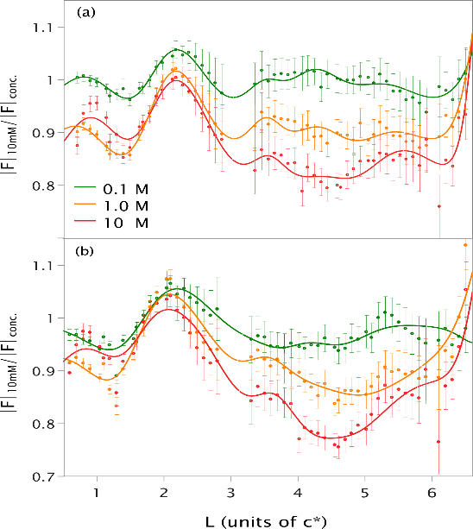

**Figure 8:** Normalised CTRs at different MeCN concentrations.CTRs were fit individually and are shown in the supporting information, all  concentrations shown are normalised to the data measured with 0.01 M MeCN at two potentials (a) 0 V (b) 0.85 V. Solid lines show the ratio of best fits to the CTRs.

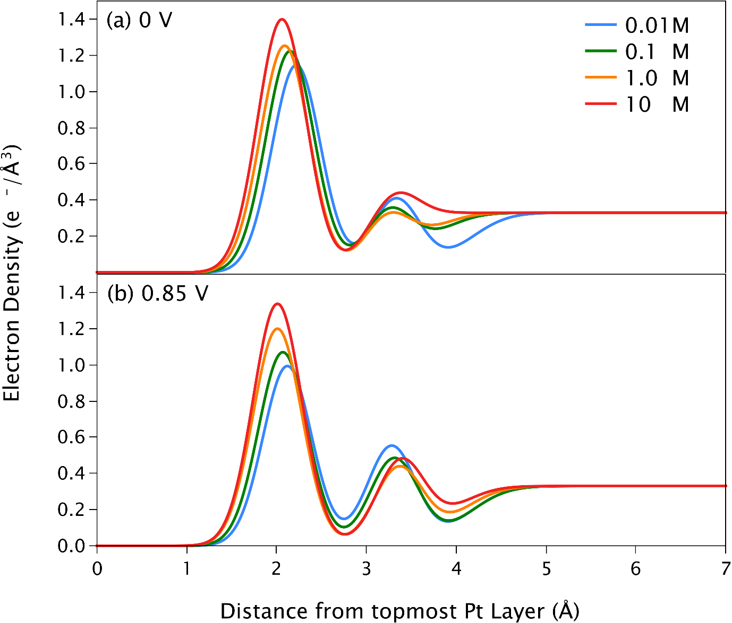

**Figure 9:** The electron density profile **c**reated using the best fit parameters to the data measured at 0 V (normalized to the bulk density of water). In this model the Pt surface is located at 0 Å.

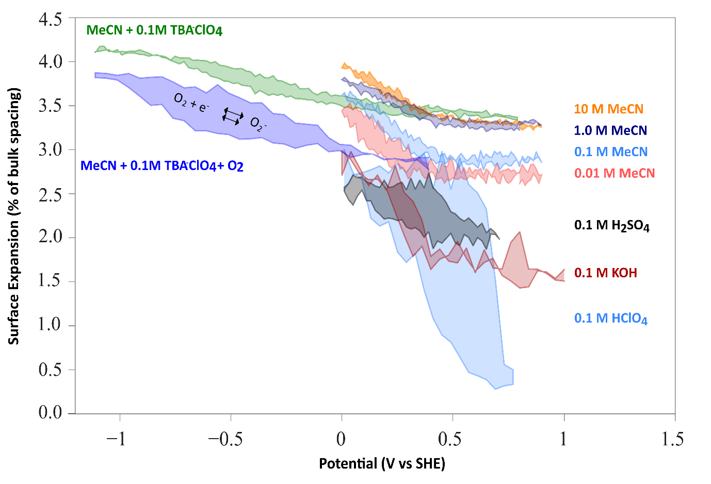

**Figure 10:** X-ray voltammetry measured at (1, 0, 3.7) for a range of electrolyte solutions as indicated. The measured intensity has been converted to surface expansion using the parameters obtained from the fits to the CTR data. Comparable sweep rates between around 2 and 2.5 mV/s were used in all cases. The shaded area indicates the amount of hysteresis.