Impact Assessment of Extreme Hydrometeorological Hazard Events on Road Networks
Juan Carlos Lam, Ph.D., A.M.ASCE¹; Jürgen Hackl, Ph.D.²; Magnus Heitzler, Ph.D.³; Bryan T. Adey, Ph.D.⁴; and Lorenz Hurni, Ph.D.⁵

Abstract: Determining the risk related to transportation networks due to the occurrence of (natural) hazard events often requires computer support. A simulation-based modeling environment can be useful when modeling a set of related events that lead up to the estimation of the probable consequences of hazard events, which affect network managers and society. Nonetheless, running such simulations can be computa- tionally expensive because each type of event requires a model of its own, and proper interfaces are needed to link events. Therefore, only a limited number of simulations can often be conducted, with the expectation that their results are representative of those that could have been obtained if all simulations had been run. This article presents a simulation reduction technique to calculate the risk related to transportation networks due to extreme hydrometeorological hazard events by conducting statistical analysis on the risk estimated when simulating the impact of nonextreme events. The technique may be of interest to network managers seeking to make decisions based on possible future climate scenarios. An example road network in Switzerland is used to illustrate the technique.
Author keywords: Extreme events; Hydrometeorological hazards; Climate scenarios; Risk; Transportation network; Uncertainty analysis.

Introduction
Managers of transportation networks can benefit from estimating the risk of (natural) hazard events to determine the best risk- reduction strategies for their transportation networks. Here, risk is defined as the probable direct consequences (i.e., costs absorbed by network managers, e.g., cost of repairs and traffic controls) and the probable indirect consequences (i.e., costs absorbed by society at large, e.g., cost of additional travel time and missed trips). In particular, transportation network managers are increasingly inter- ested in developing risk-reduction plans to address the challenges posed by climate change. For example, the Conference of European Directors of Roads (CEDR) published a report to detail possible climate mitigation and adaptation actions for the road transporta- tion sector in Europe (CEDR Task Group I4 on Climate Change

¹Research Assistant, Institute of Construction and Infrastructure Man- agement, ETH Zurich, 8093 Zurich, Switzerland; Senior Resilience Lead, Advisory Services, WSP USA, Arlington, VA 22209 (corresponding author). ORCID: https://orcid.org/0000-0003-3898-1468. Email: lam@ibi
.baug.ethz.ch; juan.lam@wsp.com
²Research Assistant, Institute of Construction and Infrastructure Management, ETH Zurich, 8093 Zurich, Switzerland; Assistant Professor, Dept. of Civil Engineering and Industrial Design, Univ. of Liverpool, Liverpool L69 3BX, United Kingdom. ORCID: https://orcid.org/0000
-0002-8849-5751. Email: hackl@ibi.baug.ethz.ch; j.hackl@liverpool.ac.uk
³Research Assistant, Institute of Cartography and Geoinformation, ETH
Zurich, 8093 Zurich, Switzerland. ORCID: https://orcid.org/0000-0002
-9021-4170. Email: hmagnus@ethz.ch
⁴Professor, Institute of Construction and Infrastructure Management, ETH Zurich, 8093 Zurich, Switzerland. Email: adey@ibi.baug.ethz.ch
⁵Professor, Institute of Cartography and Geoinformation, ETH Zurich, 8093 Zurich, Switzerland. ORCID: https://orcid.org/0000-0002-0453
-8743. Email: lhurni@ethz.ch
Mitigation and Adaptation 2016) and to acknowledge the increased frequency of climate-related effects on roads.
Efforts to tackle the challenges imposed by future climate scenarios on transportation networks require—among various activities—generating extreme hydrometeorological hazard events and assessing their impact. An extreme hazard event can be defined as an event of significant increased or decreased frequency when evaluated over an extended period (i.e., an event of a lower or higher return period), magnitude, temporal scale, and/or spatial scale. Specifying the required increase or decrease in levels associated with these attributes to distinguish extreme from nonextreme hazard events is not within the scope of this work. A review of extreme hazard event definitions across various disciplines, including those specifying levels, has been provided by McPhillips et al. (2018).
This work will focus on hydrometeorological hazard events of
increased or decreased frequency, such as rainfall events of a specific return period that lead to flood events and flood-related damages, which, in the future, in some areas, are foreseen to have a significant lower return period, leading to an increased frequency of damages (other examples include a series of rainfall events typically observed every year that facilitates the normal operation of waterways, whose individual events, in the future, are foreseen to have significant higher return periods, leading to navigational droughts).
Increasing flood-related damages are, in fact, of general concern to society because these can translate into supply chain disruption, business downtime, economic downturn, and other indirect conse- quences. In various parts of Europe, flood-related damages are expected to increase over time as a result of climate change (Feyen et al. 2012). Such effects are also expected to be observed in Switzerland given the anticipation of increasing rainfall (Vöhrinser and Schädler 2009). In 2005, Switzerland experienced the most devastating set of flood events in its history, greatly affecting many cantons, especially the cantons of Bern, Lucerne, Uri, Obwalden, and Nidwalden. According to a report released by the Federal Department of the Environment, Transport, Energy, and Commu- nications (FOEN 2008), the direct consequences of this event

amounted to CHF 3 billion. Although this event cannot confidently be attributed to climate change (Beniston 2006), the 2005 flood events along with other recent events [some of which have been recorded by Hilker et al. (2009)] serve as reminders of the level of consequences of hydrometeorological hazard events. Such events along with forecasted rainfall event estimations have driven the government to design a national strategy to address climate change (FOEN 2012).
Although national strategies are steps toward reducing the risk due to climate change, it is important to operationalize them at local levels, specifically through the development of risk-reduction plans that can address short-, medium-, and long-term challenges, the modeling of extreme hydrometeorological hazard events, and the estimation of their probable consequences. Vöhrinser and Schädler (2009) called for methods to (1) estimate the future consequences of flood events when considering climate change, and (2) overcome the challenges to generate representative future flood events and to relate flood events with damages.
In undertaking these challenges, experts have proposed several methods. Lambert et al. (2013) studied the shift of transportation asset performance due to qualitative climate scenarios, leading to the identification of the scenarios with most influence over the evaluated performance. Sadatsafavi et al. (2019) presented a method that used hierarchical clustering to identify qualitative scenarios, which could impact transportation networks in the future (e.g., cli- mate scenarios), to support the development of transportation pol- icies. Tsang et al. (2002) proposed an approach to select extreme hazard events using expert opinion and historical data to support the performance evaluation of transportation infrastructure design alter- natives, which can be extended to the selection of extreme hydro- meteorological hazards.
Suarez et al. (2005) bootstrap sampled 50 years of historical ex- treme rainfall and sea level data to create a catalogue of future rainfall and sea level events of a 100-year return period. Suarez et al. (2005) used these events to estimate the probable consequences of climate change on the road transportation network in the Boston Metropoli- tan Area. Clarke et al. (2016) used hydrometeorological hazard events of high return period (i.e., 200, 500, and 1,000 years) in the assessment of probable consequences related to a railway network in Croatia as means to consider the effects of climate change.
Moreover, climate models have been developed at regional scales (e.g., van der Linden and Mitchell 2009), and have been ap- plied to estimate the probable consequences in the transportation sector (e.g., Michaelides et al. 2014). Despite relying on fundamen- tal laws of physics, regional climate models can be computationally expensive, leading to limitations on resolution, domain size, num- ber of experiments, and duration of simulations (Bucchignani and Gutierrez 2015). Furthermore, future extreme hydrometeorological hazard events remain difficult to estimate due to their nonlinear nature (Kislov and Krenke 2009).
The variety of tools that can be used for determining the impact of (extreme and nonextreme) hydrometeorological hazard events is wide, ranging from qualitative to quantitative. An example of a qualitative tool is the Objective Ranking Tool (ORT), which was used to determine the risk related to a railway network in Croatia due to rainfall events (Clarke et al. 2016). The ORT supports the estimation and comparisons of risk outcomes using a Delphi panel, analytic hierarchy processing (AHP), and the theoretical principles of similarity judgment. Croope (2010) proposed the use of a quan- titative tool named the Critical Infrastructure Resilience Decision Support System (CIR-DSS), which integrated geographic informa- tion systems (GIS), Hazards US Multi-Hazard (HAZUS-MH), and Structural Thinking, Experiential Learning Laboratory with Animation (STELLA). CIR-DSS was used to determine the risk
related to a road network in the US state of Delaware due to a rain- fall event.
Despite the advantages of quantitative tools, their use can be computationally expensive. This is especially evident when simulation-based modeling environments are used. Such envi- ronments can require advanced computer architectures to support calculations, demand large amounts of time to obtain results, and necessitate large and well-structured data storage to retrieve results in a dynamic form.
Such environments need a series of simulation reduction tech- niques and assumptions to evaluate the results of running a small set of simulations in those environments as results that network managers can based their decisions on. Cain (2016) stated that the cost of simulations could be reduced by variance reduction methods (i.e., improving the efficiency of the simulation, e.g., input filtering, sample design, design of experiments, and importance sampling) or replacing the model (i.e., using simulation less, e.g., with a re- sponse surface) with a metamodel.
An example of a variance reduction method applied to risk assessments has been given by van Erp et al. (2016), who intro- duced the probability sort algorithm, an algorithm for the efficient sampling of damage states in a network by considering the joint probabilities of damage state scenarios. Although not replacing a simulation-based model, Stipanovic Oslakovic et al. (2013) pro- posed using a combined statistical-simulation model (i.e., regression analysis and climate model) to determine the impact of climate change on two railway tracks at a macroscopic level, with the analy- sis focused on forecasting the overall expected number of failures as opposed to the identification of failures at specific locations along the selected tracks.
This work introduces a simulation reduction technique that can be used to calculate the risk related to transportation networks due to extreme hydrometeorological hazard events. The method requires the estimation (through simulations) of the probable con- sequences of nonextreme hydrometeorological hazard events and the statistical analysis of these consequences to determine (without further simulations) the probable consequences of extreme haz- ard events. The technique reduces the computational expense of simulation-based modeling environments by cutting the number of simulations in half. More importantly, the technique supports the exploration of the uncertainty space of climate scenarios. This is important for decision makers in the context of climate change (Kunreuther et al. 2013), many of whom are managers of transpor- tation networks. Rather than attempting to accurately forecast fu- ture climate scenarios and probable consequences, the utility of the results that this work can output rests on their ability to provide a basis for decision making (Reith 2004). Michaelides et al. (2014) called for decisions makers to begin making choices concerning the resilience of transportation networks despite agreements and disagreements on climate change.
The next section presents the simulation reduction technique. That section is followed by an example road network located in the region surrounding Chur, Switzerland, that is used to illustrate the application of the technique. This article closes with a set of conclusions and recommendations for future research.

Technique Description
The technique makes the following assumptions. First, it is assumed that hydrometeorological hazard events are modeled as stochastic events that can be assigned a specific return period given the ex- pected frequency of observing an intensity measure in the region of study (whether aggregated over space or at a given point in space).

Percentile
upper median lower
a given return period
Return period (year) [log scale]
Intensity measure

Fig. 1. Illustrative representation of the uncertain relation between return periods and intensity measures.

However, such assignment is uncertain, leading to describing the relationship between a given return period and its correspond- ing intensity measure using a probability distribution (Fig. 1 pro- vides an illustration).
Finally, given the stochastic property of these events, in order to capture the uncertainty of the consequences caused by these events, the assessment of risk includes the simulation of the many different ways the events can manifest spatially and temporally—this is of importance for spatially-distributed networks.
The process of the simulation reduction technique proposed in this work is presented using business process model and notation (Fig. 2). The process consists of two stages. In the first stage, direct and indirect consequences are estimated for nonextreme hydrome- teorological hazard events. These consequences are estimated for all hazard events associated with a particular return period using the
median return period–intensity measure relationship to determine the periodicity of the hazard events—risk assessments have been traditionally restricted to the use of median relationships (or mean relationships in other cases). These consequences will vary due to the spatial and temporal variability of the hazard events. This evalu- ation is then repeated for all desired return periods, leading to an uncertain relationship between return periods and consequences (illustrated in Fig. 3, where, although similar distributions to those in Fig. 1 are used, it is acknowledged that the relationship between intensity measure and consequences is not linear).
In the second stage, these consequences are used to determine the impact of extreme hydrometeorological hazard events. The ini- tial step in this stage is to select an extreme return period–intensity measure relationship of a specific percentile. Network managers interested in the increased likelihood of a hazard event (e.g., those interested in severe climate scenarios) would select a percentile above the median. The selection of percentiles is not discussed in this work given that such decisions are specific to individual net- work managers and their complex institutional contexts and sur- rounding environment. It can be assumed, however, that managers responsible for road networks located in regions where an increas- ing frequency of flood events is a major concern would likely select percentiles that are higher than those likely selected by managers responsible for road networks located in regions where an increas- ing frequency of flood events is a minor concern. The opposite— the selection of low percentiles—can be said to occur when the network managers are concerned with an increasing frequency of drought events.
Once the percentile is selected, the next step is to determine the updated return periods for the intensity measures that were used in the simulations run during the first stage based on the new percentile relationship (Fig. 4). The updated return periods depend on the dis- tribution used to represent the relationship between return period and intensity measure. Therefore, such relationship can be said to be sensitive to the selected distribution (Eadie and Favis-Mortlock 2010).

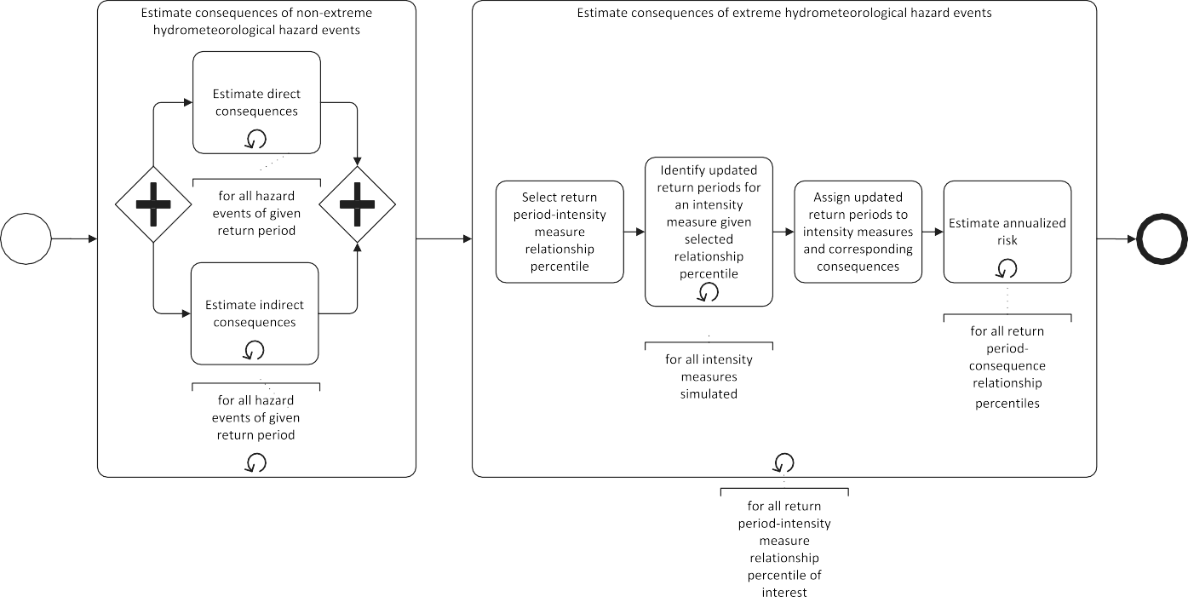
Fig. 2. Process of simulation reduction technique.

Percentile
upper median lower
return period given median return period−intensity measure relationship
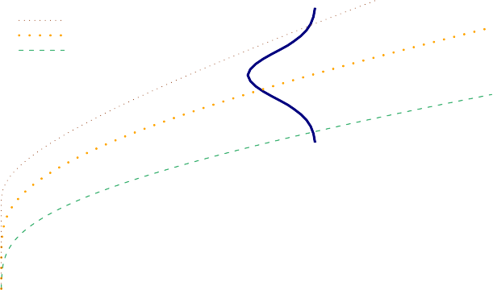
Return period (year) [log scale]
Consequence

Fig. 3. Illustrative representation of the uncertain relation between re- turn periods and consequences given a median return period–intensity measure relationship.

Percentile
upper median
a given intensity measure simulated |  |  | return period given median relationship
 | updated return period given upper percentile relationship
Return period (year) [log scale]

Fig. 4. Illustrative shift of return period given the use of an upper percentile return period–intensity measure relationship.

These updated return periods are then assigned to the simulated intensity measures, and subsequently, to the consequences pro- duced by the hydrometeorological hazard events associated with those intensity measures.
The final step involves calculating annualized risk estimates us- ing the updated return periods considering the uncertain relation- ship between return periods and consequences. Annualized risk is a monetized estimate representing the consequences a network man- ager and/or society should expect to absorb every year on average over a long period of time as a result of the occurrence of hazard events. It is then here assumed that network managers use annual- ized risk in their decision making as one of multiple factors affect- ing the design of their risk-reduction plans (i.e., other factors may not be related to risk, e.g., socioeconomic information). It is pos- sible for network managers to consider other risk metrics (e.g., the full distribution of consequences and the consequences associated with events of a particular return period). Nonetheless, as observed in the following example, given the uncertain relationship between return periods and consequences, the use of annualized risk (1) re- duces the dimensions of the risk outcome space from three to two, and (2) accounts for the effects of events of multiple return periods.
The example includes a proposed formula for annualized risk in the context of this work.

Example

Model Description
Hackl et al. (2018) presented a simulation-based modeling envi- ronment (hereafter referred to as the model) to support the estima- tion of the probable consequences of rainfall-triggered flood and mudflow events on a road network in the region surrounding Chur, Switzerland (605 km of roads, of which 51 km are high-speed roads, and 121 bridges). The process followed by the model is shown in Fig. 5 [additional details of the model physical and functional capac- ity loss activity have been given by Lam et al. (2018b)].
The model generated rainfall events of specific return periods that resulted in flood and mudflow events that affected objects in the road network, more specifically, bridges through local scour and pavement sections through mud-blocking and inundation. Losses of physical capacity (i.e., physical damages) were converted to losses of functional capacity (i.e., loss of level of service and loss of functionality) following the approach of Lam and Adey (2016). These latter type of losses helped to determine how society changed its use of the network (i.e., traffic changes).
Data size reduction techniques were applied as described by Heitzler et al. (2017b) along with a number of visualization tech- niques to support various use cases related to the management of the network (Heitzler et al. 2017a).
The model used to generate the rainfall events has been described Hackl et al. (2017). These events underwent a calibration process to generate rainfall events of a desired return period. This process re- quired first estimating the discharge resulting from a simulated rain- fall event at the location of a river gauge station of interest (in the example, the station was the Rhein-Domat/Ems station), and then comparing this discharge with the predicted discharge at that loca- tion based on historical data. The step to determine the suitability of the event is highlighted in orange. If the event was not found suit- able, the highlighted sequence flow had to be followed to generate a new (upscaled or downscaled) rainfall event.
A total of 1,200 rainfall events of various return periods were generated: 100 events for return periods of 2, 5, 10, 25, 50, 100,
250, 500, 1,000, 2,500, 5,000, and 10,000 years. The main goal of running several simulations for the same return period was to quan- tify the uncertainty of the consequences of these events.

Direct and Indirect Costs
Consequences were monetized. The direct costs were estimated to be the sum of the costs for each intervention to restore damaged objects. Therefore, the interventions to be executed depended on the damage states of the objects. Table 1 presents these costs for the damage states of interest. These costs consisted of fixed costs (e.g., costs associated with site setup) and variable costs (e.g., cost
per m⁻³ of concrete). Cost estimates were based on the work of Staubli and Hirt (2005) and complemented with data from a survey conducted by D’Ayala et al. (2015). Costs taken from the literature were adjusted to 2017 levels.
The indirect costs were composed of societal costs due to pro- longed travel time and loss of connectivity. These costs were ac- crued during the occurrence of the hazard events and throughout the restoration period for all trips through the network. The number of daily trips through the network was estimated to be 196,035.
The increased travel time per trip was estimated, and monetized at CHF 23.29 h⁻¹ (VSS 2009b). The additional costs of vehicle

Terrain
Rainfall event needs calibration
Geological Hydrological
features
Fragility functions and functional capacity loss function
network
Terrain

Spatio-temporal Geological Hydrological
precipitation fields featuresnetwork
Gauge station data
Suitable runoff- discharge event
Origin- destination matrix
Model flood
Suitable flood event
Object
Network
inventory
topology
Delay costs
Model rainfallModel runoff and
discharge
Determine suitability of rainfall-runoff- flood event
Terrain changes
Model physical and functional capacity loss
Model probable direct and indirect consequences
Rainfall event
Runoff-discharge event
Rainfall event
Model mudflow
Suitable rainfall event
Suitable mudflow event
Damage stateRestoration algorthim
probabilities and speed reductions
input parameters
Mudflow geometries
Restoration costs and times
Functional
Intensitycapacity
-durationlosses
function

Suitable discharge event
Fig. 5. Process of simulation-based modeling environment.

Table 1. Restoration costs for bridge local scour, road section inundation, and road section mud-blocking
Variable costs
Description of damage stateª | Fixed costs (CHF) | Cost measured in  CHF pier⁻¹ | Cost measured in  CHF m⁻²
Bridge local  First noticeable changes in bridge response | scour  16,000 | 24,000 | —
Significant changes in the bridge response | 30,000 | 40,000 | —
Lack of pier stability to support the bridge | 48,000 | 64,000 | —
Road section inundation  Presence of sediments and debris 3,500 |  | — | 16.50
Elements of the road section slightly damaged | 9,600 | — | 165.00
Loss of subgrade layer | 14,400 | — | 325.00
Road section mud-blocking
Encroachment limited to verge/hard strip | 3,500 | — | 16.50
Blockage of hard strip and one running lane | 9,600 | — | 165.00
Complete blockage of carriageway and/or repairable damage to surfacing | 14,400 | — | 325.00
ªData from Hackl et al. (2018).

operation were also considered, specifically additional fuel con- sumption and vehicle maintenance. The mean fuel price was ap- proximated to be CHF 1.88 L⁻¹ with a mean fuel consumption of
6.7 L per 100·veh-km, and the operating costs per vehicle without
fuel consumption was assumed to be CHF 14.39 per 100·veh-km (VSS 2009a).
The costs due to loss of connectivity were estimated based on the quantified unsatisfied demand (i.e., number of missed trips). Every hour of trip delayed was estimated to cost CHF 83.27.

Results of Nonextreme Hydrometeorological Hazard Events
The Hydrology Division of the Swiss Federal Office for the Envi- ronment published a datasheet for the station of interest (BAFU 2017), whose content was based on discharge data from 1899 to 2015. Specifically, the datasheet contained reference data points representing the 97.5-, 50-, and 2.5-percentile return period– discharge relationships that were obtained using generalized ex- treme value (GEV) distributions and the Delta Method—the latter
of which implied that the distribution of discharge values per return period was assumed to be normally distributed. Because the data- sheet excluded the parameters of the GEV distributions, maximum likelihood estimation was used to determine the parameters of those distributions (Fig. 6). The resulting distribution helped determine the discharge amounts corresponding to the return periods of inter- est (Table 2).
The costs obtained using the distribution representing the 50-percentile return period–discharge relationship are presented in Fig. 7. A spatially distributed representation of part of the cost in a subarea in the region of study for a given hazard event of 500-year return period is displayed in Fig. 8. The indirect costs are mapped to specific network objects (e.g., where delays were observed, not caused). Indirect costs due to loss of connectivity are not shown in Fig. 8 because these costs cannot be mapped to specific objects. From these results, it was observed that more simulations would need to be run in the future to eliminate the fluctuation of cost es- timates per percentile (e.g., the 97.5 percentile of the direct costs for 2-year return period events is higher than the 97.5 percentile of the direct costs for 5-year return period events), and consistent patterns

of increasing costs can be observed. The cost fluctuation was an inherent result of the model used, where each random rainfall event was modeled independently. At this point, for the purpose of this example, the set of simulations was deemed to be complete.
Annualized risk estimates were calculated for all return period– cost relationship percentiles (i.e., in increments of 1%). For this specific example, the annualized risk (AR) related to a network (X)

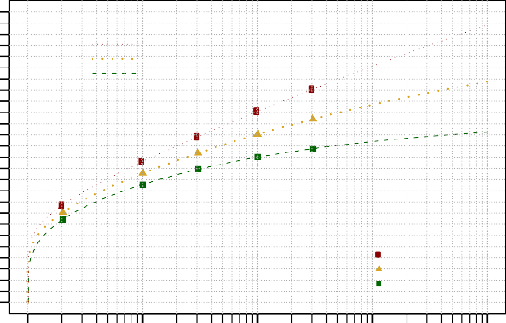
2600
Fitted Generalized Extreme Value distributions
97.5−percentile 50−percentile 2.5−percentile
Reference data points
97.5−percentile 50−percentile 2.5−percentile
2400
2200
2000
1800
Discharge (m3/s)
1600
1400
for costs associated with a specific return period–cost relationship percentile (c^{pc}) and for hydrometeorological hazard events with return periods associated with a specific return period–discharge relationship percentile (rp^{pc}) given a series of i hazard events (h) that generate n discharge amounts (d) at a point of interest is presented in Eq. (1). The annualized risk was defined as the sum product of the costs of the specified percentile (first term), and the percentile-specific likelihoods of observing those costs (second
term), for all n discharge amounts; pcf⁻¹ · was defined as the in- verse percentile function that determined the percentile selected for
ð Þ
the variable inside parenthesis. This equation assumed that (1) there was only one cost value per discharge amount, and (2) the events were arranged in increasing order of discharge, or return periodicity for that matter (e.g., 100, 250, 500 rather than 500, 100, 250).
ARpcf−1ðcpcÞ;pcf−1ðrppcÞj⋂ ⋂ hi;d^{n}

1200 X n i X
¼
i;dnþ1
i X
pc
rp
pc
i
j⋂ h
j⋂ hi;d^{n} −
rp
j⋂hX
½c
1000

800

600
400
X pc i;dn 24 1 1 35
n
i X
i X

200
0

1

10 100

1000

10000
where c^{pc} ∈ c^{pc}; rp^{pc} ∈ rp^{pc}; and
1
i
X

Return period (year) [log scale]

Fig. 6. Return period versus discharge.

Table 2. Discharge amounts for return periods of interest using return period–discharge relationships of specific percentiles
rppcj⋂ hi;dmaxðnÞþ1 ¼ 0 ð1Þ
For this example, given the fluctuation of costs described in the third paragraph of this section, minor updates to the cost had to be made. Whenever the cost value of a given return period was less than that of the previous (and hence lower) return period, the former was replaced by the latter. This is illustrated in Eq. (2)

Return period (years)
Discharge (m³=s)

2.5-percentile 50-percentile 97.5-percentile
cpc

i;dnþ1
X
j⋂h ≔ c
i

pc i;dn
X
j⋂h ↔ c
i

pc i;dnþ1
X
j⋂h < c
i

pc i;dn
X
j⋂h ð2Þ
i

2 738 800 868
5 943 1,021 1,106
10 1,053 1,153 1,258
25 1,167 1,304 1,444
50 1,237 1,407 1,577
100 1,296 1,501 1,707
250 1,361 1,615 1,872
500 1,402 1,694 1,993
1,000 1,436 1,767 2,111
2,500 1,475 1,855 2,262
5,000 1,499 1,916 2,373
10,000 1,519 1,972 2,481

Such assignment was related to the assumption that if the sto- chastic rainfall event that led that to the cost value in the lower return period, a similar event of higher return period (e.g., the same rainfall pattern but with higher rainfall intensity) would cause at least the same level of cost. The cost in the latter period could be assumed to be higher, but without additional modeling, such an estimate could not be determined.
The annualized risk results demonstrated a gradual increase in the distribution of the risk related to direct costs and a steeper increase in that corresponding to indirect costs (Fig. 9). The range in the former was not negligible, however.

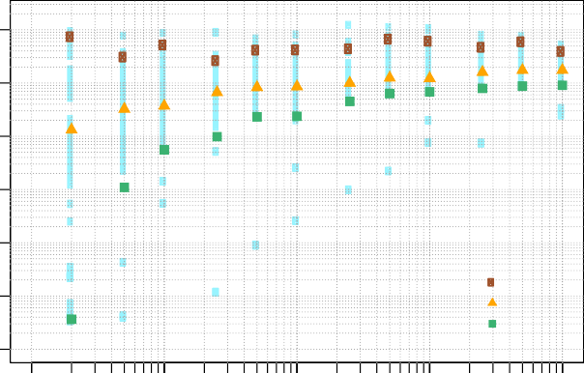
108
Direct cost (CHF) [log scale]

Percentile 97.5
50
2.5

107

106

105

104

103

102

108

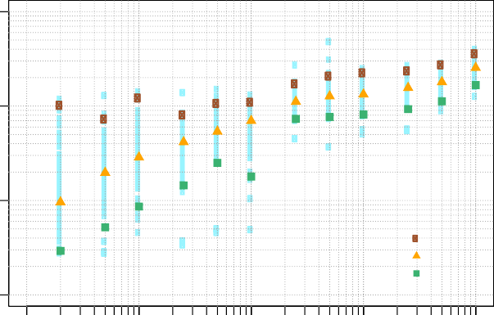
107
Indirect cost (CHF) [log scale]

Percentile 97.5
50
2.5

106

105

(a)

1 10 100 1000 10000
Return period (year) [log scale]

(b)

1 10 100 1000 10000
Return period (year) [log scale]

Fig. 7. Estimated (a) direct; and (b) indirect costs when using the 50-percentile return period–discharge relationship.

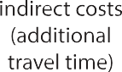

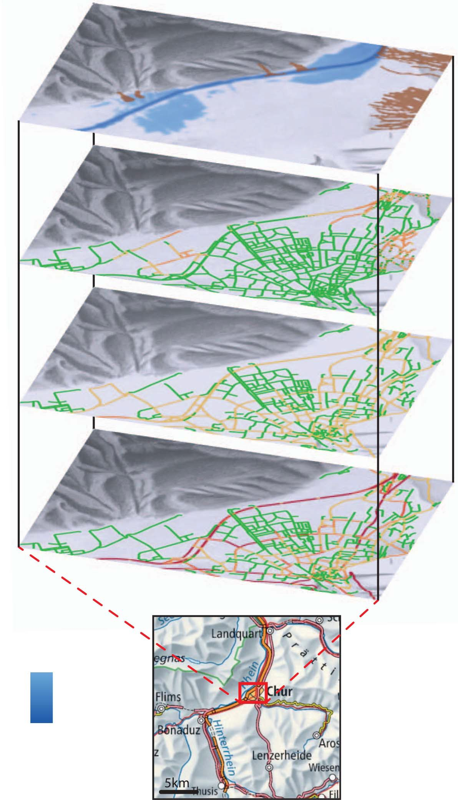
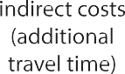
Fig. 8. A 500-year return period scenario and associated costs in a subarea within the region of study. (Base map Geodata © Swisstopo.)

Network managers can use these outputs along with annualized risk limits to determine the nonexceedance probabilities of those limits (i.e., Lam et al. 2018a). Such probabilities can provide a basis for decision making. For instance, if the annualized risk limit as- sociated with direct costs is CHF 1 million and that associated with indirect costs is CHF 3 million, then the likelihoods of observing those levels of annualized risk or higher (i.e., nonexceedance prob- ability) are approximately 0.44 and 0.91, respectively. Although the nonexceedance probability related to indirect cost may be regarded as acceptable by network managers, the nonexceedance probability associated with direct costs may be regarded as unacceptable, leading network managers to take action to reduce risk.
In this short illustration, it was assumed that both decision var- iables can be treated independently (i.e., the unacceptability of
either factor leads to the design and implementation of risk- reduction plans). However, these stated limits are presented for the purpose of exemplifying a decision-making process—some consideration was given to assign reasonable limits, however, where a limit can be qualified as reasonable if at least one network manager is foreseen to adopt such a limit. The subject of setting limits is not elaborated on in this work.

Application of Simulation Reduction Technique
The first step in applying the proposed technique required the determination of the extreme scenarios by the network manager through the selection of a set of return period–discharge relation- ship percentiles. In practice, this can be a daunting task considering

1.0
0.9
0.8
Nonexceedance probability
0.7
0.6
0.5
0.4
0.3
0.2
0.1
0.0

0

5 10

15 20 25 30

35 40

45 50
1.0
0.9
0.8
Nonexceedance probability
0.7
0.6
0.5
0.4
0.3
0.2
0.1
0.0

0.0

1.0

2.0

3.0

4.0

5.0

6.0

7.0

(a)
Annualized risk related to direct costs (million CHF)
(b)
Annualized risk related to indirect costs (million CHF)

Fig. 9. Distribution of annualized risk related to (a) direct; and (b) indirect costs when using the 50-percentile return period–discharge relationship.

the engagement of multiple stakeholders that may have different views on the climate scenarios to evaluate. One recommendation may be to explore the uncertainty space by selecting at least a hand- ful of percentiles. Another recommendation may be to specifically evaluate the impact related to the most extreme hydrometeorolog- ical event (i.e., worst scenario) as proposed by Kunreuther et al. (2013). Such an approach can be related to the stress tests described by Avdeeva and van Gelder (2014).
For this example, it was assumed that network managers would be interested in assessing the costs of extreme hydrometeorolog- ical hazard events, whose return period–discharge relationships are approximately one and two standard deviations away from the median relationship (i.e., 2.5, 16, 84, and 97.5 percentiles). Although the selection of upper relationship percentiles was ex- pected given rising concerns of future severe climate scenarios and an increasing number of flood events, estimating the risk as- sociated with a decrease in periodicity of hydrometeorological hazard events may still lead to the implementation of a risk- reduction plan. Therefore, it was decided that lower relationship percentiles would also be included in the analysis to complement the results.
The results showed large variations among the obtained returned periods (Table 3). These differences were more evident when com- paring the return periods associated with relatively large discharge amounts. In the cases of lower relationship percentiles, return peri- ods associated with the highest discharge amounts either were es- timated to be a value above a 100,000-year return period or one that was close to infinity (Inf). Neither of these values could be used in the analysis.
The next step in the process was to estimate the annualized risk given the selected return period–discharge percentiles. As expected, the results demonstrated similar trends independent of the selected percentile (Fig. 10).
Following the previous short illustration on the possible use of annualized risk limits for decision making (i.e., CHF 1 million for direct costs and CHF 3 million for indirect costs), the nonexcee- dance probabilities for each of the limits were found to be approx- imately 0.54, 0.49, 0.39, and 0.34 for the annualized risk
associated with direct costs and approximately 0.95, 0.92, 0.89, and 0.87 for the annualized risk associated with the indirect costs when using the 2.5-, 16-, 84-, and 97.5-percentile return period– discharge relationships, respectively. By using the same limits, then it was assumed that network managers did not set higher
Table 3. Derived return periods by discharge using return period– discharge relationships of specific percentiles

Return period (years)

Discharge | 2.5- | 16- | 50- | 84- | 97.5-
(m³=s) | percentile | percentile | percentile | percentile | percentile
800 | 3 | 2 | 2 | 2 | 2
1,021 | 8 | 6 | 5 | 4 | 4
1,153 | 22 | 14 | 10 | 8 | 6
1,304 | 111 | 44 | 25 | 17 | 13
1,407 | 552 | 110 | 50 | 30 | 21
1,501 | 5,438 | 299 | 100 | 52 | 34
1,615 | Inf | 1,298 | 250 | 106 | 61
1,694 | Inf | 4,604 | 500 | 176 | 93
1,767 | Inf | 19,781 | 1,000 | 287 | 139
1,855 | Inf | Inf | 2,500 | 532 | 227
1,916 | Inf | Inf | 5,000 | 828 | 320
1,972 | Inf | Inf | 10,000 | 1,265 | 443

or lower limits when assessing the impacts of extreme hydrome- teorological hazard events. In other words, the limits were inde- pendent of the return period–discharge percentile. Although this assumption may not be regarded as realistic by those arguing that network managers should be more or less tolerable to consequen- ces caused by future climates, the assumption was plausible given the context of this work. In this context, actions are needed today, and therefore, part of setting such limits involves considering the present institutional contexts and financial capacities of network managers, both of which play key roles in determining appropri- ate risk limits.
The resulting nonexceedance probabilities related to direct costs led the authors to conclude that, even under climate scenar- ios with a reducing periodicity, the costs could be large enough to immediately proceed to design and implement a risk-reduction plan for the road network in the region surrounding Chur. More- over, it could also be concluded that the probabilities related to indirect costs may no longer be acceptable as the frequency of flood events increases. For this example, in the absence of direct cost estimates, indirect cost estimates would have led to the de- velopment and execution of risk-reduction plans considering that scenarios of increasing flood-event frequency were integrated as part of the analysis.

1.0

Return period−discharge relationship
2.5−percentile 16−percentile 50−percentile 84−percentile 97.5−percentile
0.9
0.8
Nonexceedance probability
0.7
0.6
0.5
0.4
0.3
0.2
0.1
0.0
1.0
0.9

Return period−discharge relationship
2.5−percentile 16−percentile 50−percentile 84−percentile 97.5−percentile
0.8
Nonexceedance probability
0.7
0.6
0.5
0.4
0.3
0.2
0.1
0.0

(a)
0 5 10 15 20 25 30 35 40 45 50 55 60
Annualized risk related to direct costs (million CHF)

(b)
0.0 1.0 2.0 3.0 4.0 5.0 6.0 7.0 8.0 9.0
Annualized risk related to indirect costs (million CHF)

Fig. 10. Distributions of annualized risk related to (a) direct; and (b) indirect costs for return period–discharge relationships of various percentiles.

Conclusion
Simulation-based modeling environments can support the estima- tion of risk due to the occurrence of hazard events and provide trans- portation network managers with information that can lead to the generation of plans to reduce the estimated risk. Such modeling environments can be useful in particular when testing various haz- ard events, including extreme hydrometeorological hazard events. Network managers can, therefore, benefit from these tools to evalu- ate the physical and functional impact of future climates on their networks. In doing so, the entire network management community is confronted with three challenges: (1) the generation of future haz- ard scenarios, (2) the assessment of their impact in a way that the results can be used for decision making, and (3) performing these tasks with the least computational resources without compromising the ability of the modeling environment to quantify the uncertainty surrounding risk estimates.
Although the latter challenge is specifically addressed through
the proposed simulation reduction technique, the work presented here does not neglect the first two challenges. The technique eliminates the needs to rerun simulations to determine the impact of extreme hydrometeorological hazard events when risk esti- mates exist for nonextreme events, largely reducing the level of effort, and assigns available resources in generating enough haz- ard scenarios to be able to quantify the uncertain relationship between associated consequences and return periods. The effort may also shift from studying the climate effects on a small net- work to analyzing these effects on a larger (and more complex) network. Through the presented technique, network managers do not need to specify future hazard events, but use the uncertainty of the return period–intensity measure relationship to make decisions today regarding potential interventions to reduce the probable damages and lost level of service caused by such ex- treme hazard events, and hence, procure the safety of users in the future.
The technique was illustrated by an example road network in the region surrounding Chur, Switzerland, where a simulation-based modeling environment was used to run 1,200 rainfall events of up to a 10,000-year return period. It was through this example that important lessons could be drawn, specifically:
- Designated return periods are sensitive to the distribution of choice to represent the return period–intensity measure relationship.
- Estimation of probable indirect consequences (as an additional decision variable to probable direct consequences) can help
network managers reach decisions on whether to implement a risk-reduction plan or not, and if so, on the design of the plan.
- Inclusion of return period–intensity measure relationships of per- centiles below the median can still lead to a risk-reduction plan— this latter point can be useful in cases where disagreements exist regarding future climate scenarios.
Future work should focus on:
- the consideration of future nonclimate scenarios (e.g., network growth and modifications, variations in mobility habits, changes in the automobile industry, and deterioration) to be coupled with the extreme hydrometeorological hazard events because such types of stressors have been found to be relevant in the past (e.g., You et al. 2014);
- the selection of appropriate return period–intensity measure per- centiles to support decision making without affecting the valid- ity of the updated return periods or underestimating the probable consequences;
- the exploration of applications where risk metrics other than annualized risk are used (e.g., use and evaluation of three- dimensional risk surfaces to characterize risk changes based on return period–intensity measure relationships, return periods, and consequences); and
- the analysis of risk estimates disaggregated throughout space to support the design of risk-reduction plans.
With respect to the last two points, future work should continue to evaluate visualization techniques to improve the communication and analysis of probabilistic risk estimates that are time-dependent and spatially distributed.

Data Availability Statement
Some or all data, models, or code generated or used during the study are available from the corresponding author by request. Specifically, the data presented in Fig. 7 can be made available upon request. Other data and models are described in Hackl et al. (2018).

Acknowledgments
The work presented here has received funding from the European Union’s Seventh Programme for Research, Technological Devel- opment and Demonstration under Grant Agreement No. 603960,

and from Horizon 2020, the European Union’s Framework Programme for Research and Innovation under Grant Agreement No. 636285.

References
Avdeeva, Y., and P. van Gelder. 2014. Stress test methodologies (deliver- able 6.1): Novel indicators for identifying critical infrastructure at risk from natural hazards (INFRARISK). Delft, Netherlands: INFRARISK.
BAFU (Bundesamt für Umwelt). 2017. Hochwasserwahrscheinlich- keiten (Jahreshochwasser)–Rhein–Domat/Ems (EDV: 2602). Bern, Switzerland: BAFU.
Beniston, M. 2006. “August 2005 intense rainfall event in Switzerland: Not necessarily an analog for strong convective events in a greenhouse climate.” Geophys. Res. Lett. 33 (5): L05701. https://doi.org/10.1029
/2005GL025573.
Bucchignani, E., and J. M. Gutierrez. 2015. Definition of different EWIs, to support the management of European CI (deliverable 2.1): INTACT. Lecce, Italy and Santander, Spain: INTACT.
Cain, R. 2016. “Optimisation of data collection strategies for model-based evaluation and decision-making.” Ph.D. thesis, School of Computing Science, Newcastle Univ.
CEDR Task Group I4 on Climate Change Mitigation and Adaptation. 2016. “Acting on climate change.” Brussels, Belgium: Conference of European Directors of Roads.
Clarke, J., R. Corbally, and E. O’Brien. 2016. Case study results (deliver- able 8.2): Novel indicators for identifying critical infrastructure at risk from natural hazards (INFRARISK). Dublin, Ireland: INFRARISK.
Croope, S. V. 2010. “Managing critical civil infrastructure systems: Improving resilience to disasters.” Ph.D. thesis, Dept. of Civil and Environmental Engineering, Univ. of Delaware.
D’Ayala, D., et al. 2015. Fragility functions matrix (deliverable 3.2): Novel indicators for identifying critical infrastructure at risk from natural hazards (INFRARISK). London: INFRARISK.
Eadie, C., and D. Favis-Mortlock. 2010. “Estimation of drought and flood recurrence interval from historical discharge data: A case study utilising the power law distribution.” In Proc., European Geosciences Union General Assembly 2010. Vienna, Austria: European Geosciences Union.
Feyen, L., R. Dankers, K. Bo´dis, P. Salamon, and J. I. Barredo. 2012. “Fluvial flood risk in Europe in present and future climates.” Clim. Change 112 (1): 47–62. https://doi.org/10.1007/s10584-011
-0339-7.
FOEN (Federal Office for the Environment). 2008. The floods of 2005 in Switzerland: Synthesis report on the event analysis. Bern, Switzerland: FOEN.
FOEN (Federal Office for the Environment). 2012. Adaptation to climate change in Switzerland: Goals, challenges and fields of action (first part of the Federal Council’s strategy adopted on 2 March 2012). Bern, Switzerland: FOEN.
Hackl, J., M. Heitzler, J. C. Lam, B. T. Adey, and L. Hurni. 2017. “Development of flood and mudflow events for the spatio-temporal risk assessment of networks.” Eur. Water 57 (1): 179–185.
Hackl, J., J. C. Lam, M. Heitzler, B. T. Adey, and L. Hurni. 2018. “Estimating network related risks: A methodology and an application in the transport sector.” Nat. Hazards Earth Syst. Sci. 18 (8): 2273–2293. https://doi.org/10.5194/nhess-18-2273-2018.
Heitzler, M., J. C. Lam, J. Hackl, B. T. Adey, and L. Hurni. 2017a. “A simulation and visualization environment for spatiotemporal disaster risk assessments of network infrastructures.” Cartographica: Int. J. Geogr. Inf. Geovisualization 52 (4): 349–363. https://doi.org/10.3138
/cart.52.4.2017-0009.
Heitzler, M., J. C. Lam, J. Hackl, B. T. Adey, and L. Hurni. 2017b. “GPU- accelerated rendering methods to visually analyze large-scale disaster simulation data.” J. Geovisualization Spatial Anal. 1 (1–2): 3. https:// doi.org/10.1007/s41651-017-0004-4.
Hilker, N., A. Badoux, and C. Hegg. 2009. “The Swiss flood and landslide damage database 1972–2007.” Nat. Hazards Earth Syst. Sci. 9 (3): 913–925. https://doi.org/10.5194/nhess-9-913-2009.
Kislov, A. V., and A. N. Krenke. 2009. “Climate-related hazards.” In Natural disasters. Edited by V. M. Kotlyakov, 220–238. Paris: Eolss.
Kunreuther, H., G. Heal, M. Allen, O. Edenhofer, C. B. Field, and G. Yohe. 2013. “Risk management and climate change.” Nat. Clim. Change 3 (5): 447–450. https://doi.org/10.1038/nclimate1740.
Lam, J. C., and B. T. Adey. 2016. “Functional loss assessment and resto- ration analysis to quantify indirect consequences of hazards.” J. Risk Uncertainty Eng. Syst. Part A: Civ. Eng. 2 (4): 04016008. https://doi
.org/10.1061/AJRUA6.0000877.
Lam, J. C., B. T. Adey, M. Heitzler, J. Hackl, P. Gehl, N. van Erp, D. D’Ayala, P. van Gelder, and L. Hurni. 2018a. “Stress tests for a road network using fragility functions and functional capacity loss func- tions.” Reliab. Eng. Syst. Saf. 173 (May): 78–93. https://doi.org/10
.1016/j.ress.2018.01.015.
Lam, J. C., M. Heitzler, J. Hackl, B. T. Adey, and L. Hurni. 2018b. “Modelling the functional capacity losses of networks exposed to hazards.” Sustainable Resilient Infrastruct. 1–19. https://doi.org/10
.1080/23789689.2018.1469357.
Lambert, J. H., Y.-J. Wu, H. You, A. Clarens, and B. Smith. 2013. “Climate change influence on priority setting for transportation infrastructure assets.” J. Infrastruct. Syst. 19 (1): 36–46. https://doi.org/10.1061
/(ASCE)IS.1943-555X.0000094.
McPhillips, L. E., et al. 2018. “Defining extreme events: A cross- disciplinary review.” Earth’s Future 6 (3): 441–455. https://doi.org/10
.1002/2017EF000686.
Michaelides, S., P. Leviäkangas, C. Doll, and C. Heyndrickx. 2014. “Foreward: EU-funded projects on extreme and high-impact weather challenging European transport systems.” Nat. Hazard. 72 (1): 5–22. https://doi.org/10.1007/s11069-013-1007-1.
Reith, G. 2004. “Uncertain times: The notion of ‘risk’ and the development of modernity.” Time Soc. 13 (2–3): 383–402. https://doi.org/10.1177
/0961463X04045672.
Sadatsafavi, H., A. A. Kim, S. D. Anderson, and P. Bishop. 2019. “Scenario planning application in US highway transportation industry.” J. Infra- struct. Syst. 25 (2): 05019002. https://doi.org/10.1061/(ASCE)IS.1943
-555X.0000474.
Staubli, R., and T. Hirt. 2005. Leitfaden für Politiker und Praktiker: Werterhalt von Strassen. Bern, Switzerland: Schweizerischer Gemeindeverband.
Stipanovic Oslakovic, I., H. ter Maat, A. Hartmann, and G. Dewulf. 2013. “Risk assessment of climate change impacts on railway infrastructure.” In Proc., Engineering Project Organization Conf., edited by P. Carrillo and P. Chinowsky. Boulder, CO: Engineering Project Organization Society.
Suarez, P., W. Anderson, V. Mahal, and T. R. Lakshmanan. 2005. “Impacts of flooding and climate change on urban transportation: A systemwide performance assessment of the Boston Metro Area.” Transp. Res. Part D: Transp. Environ. 10 (3): 231–244. https://doi.org/10.1016/j
.trd.2005.04.007.
Tsang, J. L., J. H. Lambert, and R. C. Patev. 2002. “Extreme event scenarios for planning of infrastructure projects.” J. Infrastruct. Syst. 8 (2): 42–48. https://doi.org/10.1061/(ASCE)1076-0342(2002)
8:2(42).
van der Linden, P., and J. F. B. Mitchell. 2009. ENSEMBLES: Climate change and its impacts at seasonal, decadal and centennial timescales (summary of research and results from the ENSEMBLES project). Exeter, UK: ENSEMBLES.
van Erp, N., R. O. Linger, P. Prak, and P. van Gelder. 2016. Stress test framework for systems (deliverable 6.2): Novel indicators for identifying critical infrastructure at risk from natural hazards (INFRARISK). Delft, Netherlands: INFRARISK.
Vöhrinser, F., and B. Schädler. 2009. “Estimating the future increase in damage costs due to climate change-induced floods in Switzerland.” IOP Conf. Ser.: Earth Environ. Sci. 6 (52): 522012. https://doi.org/10
.1088/1755-1307/6/52/522012.

VSS (Schweizerischer Verband der Strassen–und Verkehrsfachleute). 2009a. Kosten-Nutzen-analysen im strassenverkehr; betriebskosten von strassenfahrzeugen (SN 641 827). Zürich, Switzerland: Schweizerischer Verband der Strassen–und Verkehrsfachleute.
VSS (Schweizerischer Verband der Strassen–und Verkehrsfachleute). 2009b. Kosten-nutzen-analysen im strassenverkehr; zeitkosten im
personenverkehr (SN 641 822a). Zürich, Switzerland: Schweizerischer Verband der Strassen–und Verkehrsfachleute.
You, H., E. B. Connelly, J. H. Lambert, and A. F. Clarens. 2014. “Climate and other scenarios disrupt priorities in several management perspec- tives.” Environ. Syst. Decisions 34 (4): 540–554. https://doi.org/10
.1007/s10669-014-9525-2.

