# Applying the Passivhaus Standard to a terraced house in a hot and humid tropical climate – evaluation of comfort and energy performance

**Roy Candra Sigalingging**

**David Chow**

**Steve Sharples**

School of Architecture, University of Liverpool, Liverpool, United Kingdom

[R.C.Sigalingging@liverpool.ac.uk](mailto:R.C.Sigalingging@liverpool.ac.uk)

## Abstract

In a hot and humid tropical climate, natural ventilation brings high levels of moisture into dwellings that, together with occupant activity, can result in very elevated internal relative humidity levels. Coupling these high relative humidities with high internal air temperatures creates occupant thermal discomfort, which is typically ameliorated in the tropics using energy-intensive air conditioning systems. This paper has investigated the potential benefits for thermal comfort and energy usage of applying the German Passivhaus standard to tropical dwellings. By creating a super insulated and air-tight envelope, the Passivhaus standard reduces fabric heat transfer, controls air infiltration and provides low energy comfort. Applying this approach to a tropical terraced house might be effective but could, potentially, have an adverse impact on mechanical cooling demand. This study took an actual terraced property in Jakarta, Indonesia and thermally modelled its performance as insulation and airtightness levels were incrementally improved up to the Passivhaus standard. Field measurements in the dwelling of air temperature and relative humidity were used to validate the thermal model of the existing house. The validated model then tested the feasibility of meeting the Passivhaus energy standard for cooling in the modified tropical house. Simulation allowed the effects of air conditioning (AC) and dehumidifiers on thermal comfort and cooling loads to be investigated. The research develop the Passivhaus building model that had the floor insulation removed to let the ground floor act as a thermal sink and potentially provide radiant cooling. Analysis revealed that the building’s predicted air temperatures were affected in a beneficial way by having the Passivhaus without floor insulation.

Practical application: Cooling in hot and humid tropical region is an energy energy-intensive approach. Design approaches that can bring comfort and save energy for the occupant are essential. The success of Passivhaus standard in mild climate might be transferable to bring comfort in tropical housing. Best practice can be developed by analyzing the Passivhaus building performance in hot and humid tropical region.

Keywords: Passivhaus, hot and humid tropical region, dehumidification, low energy building

## Introduction

Built upon the Köppen-Geiger climate classification system, Indonesia is located in the equatorial rainforest region with a fully humid zone [1]. The temperature variations throughout the year are small, with minimum average temperatures around 230C and maximum average temperature around 330C. The common level of relative humidity in Indonesia is between 69% and 90%, with the average wind velocity is between 0.2 and 0.8 m/s [2]. The high humidity and relatively warm to hot temperature become a potential problem because it is a good environment for mould to grow. The mould can be detected in the environment with relative air humidities above 65%, and temperatures between 15°C and 30 °C [3].

A demand for low-density housing in Indonesia has contributed significantly to uncontrolled urban sprawl around the edges of Indonesia’s major cities [4]. This unintentional development is characteristic of contemporary Asian Urbanization [5]. The majority of these dwellings are poorly constructed, not insulated and not well-sealed. The air conditioning (AC) that is employed to achieve thermal comfort for residents is used inefficiently and expensively. Simple passive cooling design approaches for tropical dwellings, such as glazing, shading, insulation, and natural ventilation, can reduce cooling loads by up to 43% [6]. However, due to high outdoor relative humidity levels, natural ventilation is not able to reduce internal relative humidity. Ventilation of a tropical house also needs to consider the pollution of outdoor air condition and the ingress of insects.

Indonesia’s hot and humid tropical climate, coupled with rapid urbanisation and economic growth, means the demand for cooling energy in residential buildings will increase sharply in the coming decades [7]. It is forecast that, by 2020, building energy consumption in South East Asia countries will exceed that of developed countries, with 56% of total building energy demand being used for air-conditioning [8]. Therefore, it is desirable to investigate low energy cooling systems that could help reduce the need for electric air conditioning. Any design approaches to the building that are able to bring comfort to the rooms and are energy efficient are very important. One possible solution is to apply the German Passivhaus standard [9], with its emphasis on very high levels of insulation and air tightness, to Indonesian dwellings.

This paper presents the validation and testing of a house model developed using the commercial dynamic thermal simulation software IES VE 2018 A real dwelling in Jakarta Metropolitan Region had its air temperature and relative humidity monitored, and those data were used to validate the simulationsoftware model before Passivhaus concepts were applied to the house model. The paper describes the progress of a Passivhaus standard for housing built in Indonesia that works for both thermal comfort and energy efficiency. The paper will also describe the finding of the energy advantages from cool ground temperatures and no floor insulation that were observed in the development of the house model.

### Passivhaus definition

The requirements for the German Passivhaus standard that was established as a building concept for residential buildings are shown in

Table 1 [9]. In general, the Passivhaus standard provides excellent cost-effectiveness, particularly for new build. These requirements are essentially performance-based, using passive measures, avoiding thermal bridging and creating a whole house mechanical ventilation system with vastly efficient heat recovery system [10]. Studies have recommended that Passivhaus could be a possible option in other climate types, even though the preliminary developments were made within the mild climate of Central and Northern Europe [11]. The study made by Passive-On predicted a number of issues related to Passivhaus criteria for warmer climates, including the introduction of a limit for summer cooling energy demand, a higher infiltration rate and an indoor comfort temperature that coincided with adaptive thermal comfort standards [12]. The Passivhaus standard application must also take in to consideration moisture balances and latent loads for buildings in a hot and humid climate.

Table . Passive House Criteria.

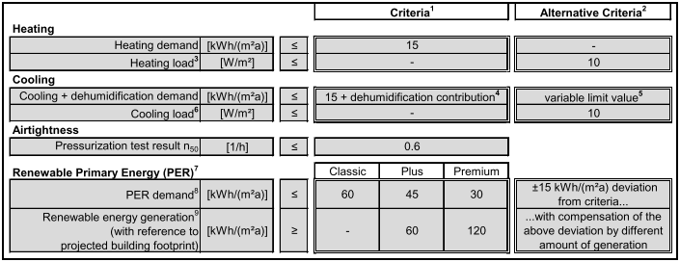

### Passivhaus cooling

One option to cool buildings is by using radiant cooling - for example, by using Concrete Core Temperature Control (CCTC), pumps cool water around pipes cast inside the floor [13]. This system was used by the Austrian embassy in Jakarta to cool the building. The primary load for the cooling supply is fulfilled by a chiller. Instead of a cold air breeze from split units, it provides gentle radiant cooling by pumping cool water into pipes cast inside the floor to create a mean temperature of 25°C. A ventilation system using a cooling recovery and dehumidification was used to deliver fresh air to all the office spaces in the building and to maintain the 60% relative humidity internally [14]. With a CCTC system for cooling, the building’s cooling energy costs are less than an ordinary office block, and it emits less carbon [15].

A cooling strategy established for a Passivhaus in a humid region in Louisiana, southern USA used a 1-ton mini-split air-conditioning system and Energy Recovery Ventilator (ERV). ERV is not a straight heat exchanger, because it also transfers water vapour to prevent the air from drying out in winter months, and removes outdoor humidity during summer months [16]. In conjunction with an air conditioning system, the ERV will keep the internal cool inside and maintain the relative humidity in the comfort level. But, in a hot and humid tropical climate, the ERV the internal high relative humidity will transfer moisture back to the building’s room. ERV systems are not dehumidifiers, and they transfer moisture from incoming humid air to the stale indoor air that is being vented to the outside. It is, therefore, necessary to create design approaches to building design that can keep indoor air humidity low while still reducing cooling energy consumption.

### Thermal Comfort

The importance of indoor thermal comfort assessment and measurement is not only related to thermal satisfaction achievement; it is also to control energy usage and enhance indoor air quality [17]. In hot climates, the effect of air movement and humidity are important as heat loss by evaporation dominates [18]. The effect of the outdoor air temperature on perceived comfort has been merged in to design standards such as ASHRAE Standard 55. The adaptive comfort standard study by ASHRAE found that there was difficulty in making generalization for areas that have mean outdoor temperatures above 23°C. The finding specified that buildings in this zone were unable to reserve thermal comfort for many hours of the day [19]. Other research found some climatic variances amongst cities in the lowland and highland areas of Indonesia, which could bring difference in people’s comfort temperature due to physical adaptation [20]. Nevertheless, the Indonesia National Standardization Agency (SNI) has issued standards whereby the comfort temperature is set at ﻿25°C ± 1 °C and comfort relative humidity at 60% ± 10% [21]. The results from a study of comfort temperatures for people in the Depok area (a Jakarta satellite town) indicated that the comfort temperature was actually higher than the SNI standard, at ﻿27.6°C [22]. The 27.6°C temperature was chosen as an upper end value of the comfort range.

## Research methodology

This study investigated the impact on thermal comfort and energy efficiency of applying the Passivhaus standard to a typical terraced dwelling in a tropical Jakarta. A census study published in Statistics Indonesia [23] found that the most prevalent floor area range for housing in the Jakarta Metropolitan Region was 50m2 to 69m2 [24]. The house in Depok, which is in Jakarta Metropolitan Region, was chosen as a case study dwelling to be monitored. This dwelling measured 6m x 10m in plan, with a total floor area of 55m2, and a floor-to-ceiling height of 2.85m. The building’s main axis orientation was northerly; it was not insulated, being constructed from a single layer of brick, and with single glazing windows (Figure 1). The windows material is clear glass with awning on the internal side which gives more privacy to the residences. The dynamic simulation software was used to develop a digital model of the house based on the actual building materials, cooling system, lights and appliances, and occupancy schedule. The simulation software designed building model’s empirical validation was determined by comparing the computer simulation results with field monitored data from the selected house. The validated model was then used to explore the effects on the indoor environment when applying the Passivhaus standard to the row house and to study the energy needed to achieve thermal comfort. The main goal of this study was to test the potential application of the Passivhaus standard to Jakarta houses with tropical conditions.

(a) 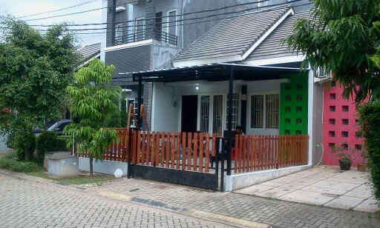(b)



Figure . The case study terraced house: (a) exterior view, (b) floor plans.

### Monitoring the house

The monitoring of the case study building was undertaken over two periods that represented two different weather conditions in Indonesia: January – February for the rainy period and September – November for the hot dry period. Loggers were used to monitor the air temperature and relative humidity of two main locations in the house (master bedroom and living room - Figure 2). Air temperature and relative humidity values were collected at 30-minute intervals using Tinytag and Rotronic data loggers placed at a height of 1.5m in the living room and master bedroom. Loggers were also used to monitor the outside air temperature and relative humidity, which were used later to validate the computer model.

### Building model validation using simulation software

The building model validation in the simulation software was done by comparing the building model air temperatures and relative humidities with measured air temperatures and relative humidities. These measurements were the only two physical parameters is was possible to record in the house. The whole house was modelled as a three-dimensional dwelling model in the simulation software based on a plan provided by the home owner (Figure 3). Predicted performance results from the model were compared monitored data for a measurement period from October, which had comparatively high weekly air temperatures, and large temperature differences between maximum and minimum temperature compared to most of the measured data. A generalization of family behaviour in the dwelling was made regarding the occupant activity used in the simulation software. The building elements used to build the base model in the simulation software are shown in Table 2. The external temperatures used in the validation were based on the monitored outdoor temperatures.

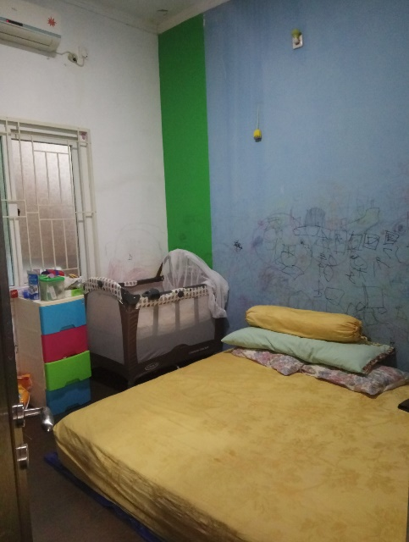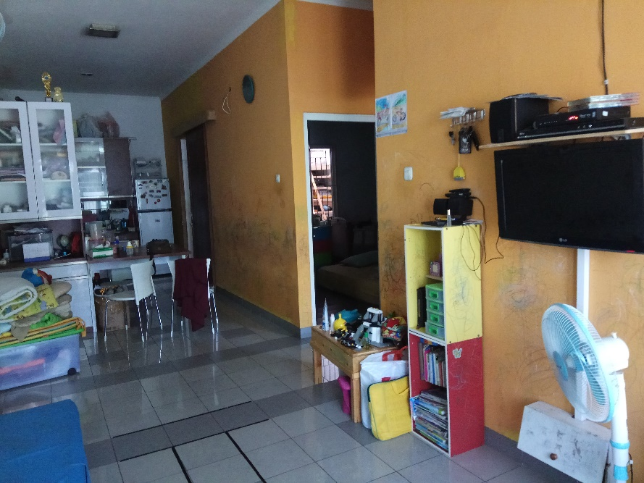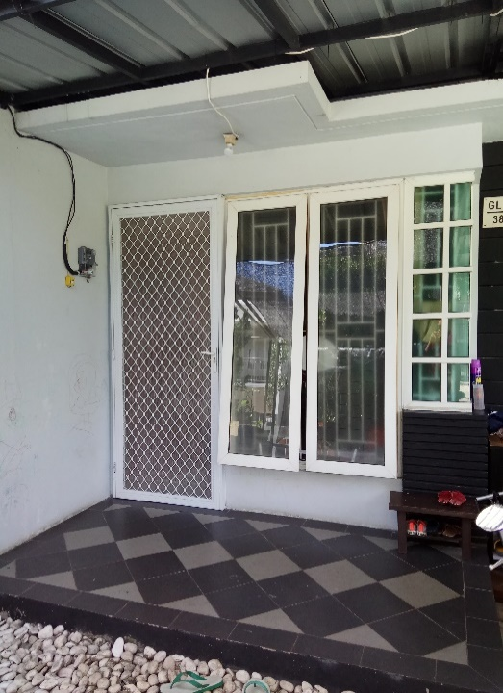

Figure . Logger location in master bedroom, outdoor area and living room.

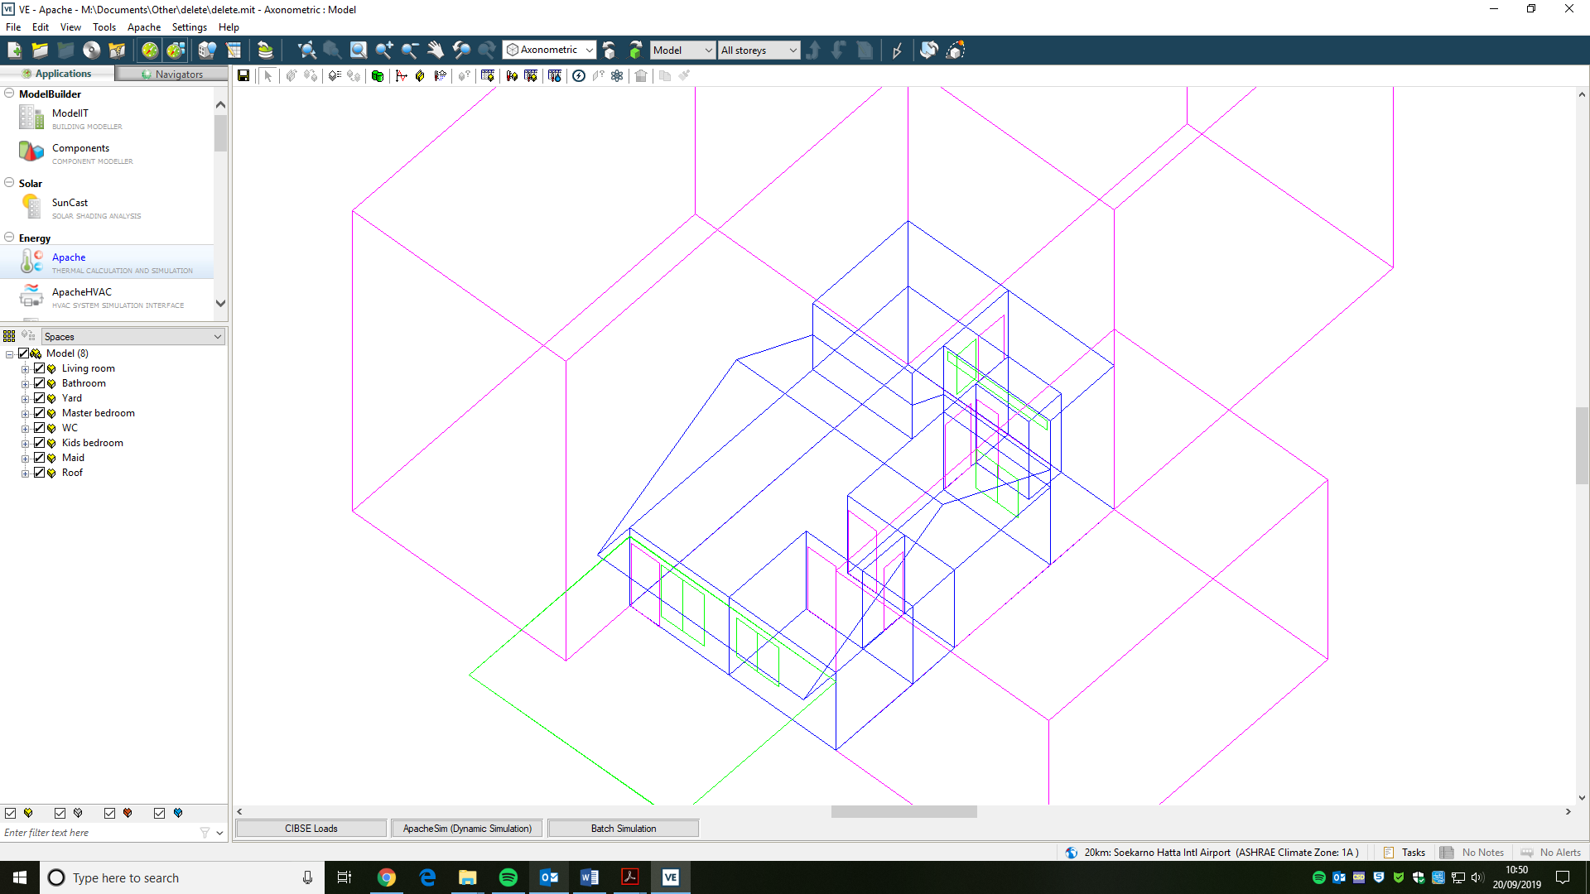

Figure . House model in simulation software.

Table . Building elements in simulation software.

|  |  |  |
| --- | --- | --- |
| Building Element | Constructional layers | U- Value  (W/m2K) |
| External and internal walls | 25 mm thick cement plaster + 100 mm thick clay brick + 25 mm thick cement plaster | 2.894 |
| Party wall | 25 mm thick cement plaster + 100 mm thick clay brick + 25 mm thick cement plaster | 2.894 |
| Floor | 8 mm thick ceramic tile + 22 mm thick cement screed + 100 mm thick concrete slab + soil layer | 3.264 |
| Window | 6 mm thick single layer glass | 4.880 |
| Ceiling | 6 mm thick gypsum board | 3.125 |
| Pitched roof | 20 mm thick roof tile + 25 mm thick timber batten | 3.377 |

The validation-simulation comparison results for the living room and master bedroom area can be seen in Figure 4 and Figure 5. The living room results in Figure 4 indicate that the simulation values showed the same trend in fluctuations as the measured data, both for air temperature and relative humidity, with small air temperature differences of 1 to 2 0C between measured and modelled results. For relative humidity, Figure 4 indicates around a 10% difference between simulated and measured values. Figure 5 shows a similar pattern of measured and modelled temperature and relative humidity variations, apart from some larger differences for relative humidity readings between 21.00 and 06.00 of the next morning, when measured values where much less than the simulated predictions. This may have been due to occupant behaviour being different from the modelled occupant profile used in the simulation. From the overall results it can be seen that there was a pattern from 1st November – 4th November, with the simulated results being closer to the measured data. This situation happened because this was a weekday period, and the activity of the occupants were relatively the same as the schedule adopted in the simulation software.

Figure . Measurement and simulation data comparison for the living living room

Figure . Measurements and simulation data comparison in master bedroom

Although the validation process indicated satisfactory agreement between modelled and field measurement data, it was important to confirm this using statistical analysis. The analysis was conducted in accordance with ASHRAE Guideline 14‐2014 [25]. The statistic MBE represents the mean ratio of relative error between two values, as shown in Equation (1), while CV/RMSE represents the average deviation between an actual value and a predicted value as shown in Equation (3). CV/RMSE values are used to assess the differences between simulated and observed hourly data, to evaluate the prediction accuracy of the simulation model. ASHRAE Guideline 14 defines the acceptable limits for calibration to hourly data as within ±10% MBE and≤30% CVRMSE(hourly) measured at a utilities level [25].

$MBE=\frac{\sum_{i=1}^{N_{S}}{(y_{i}-{\hat{y}}_{i})}}{\sum_{i=1}^{Ns}{y_{i}}}$ (1)

$\hat{Y}s=\frac{\sum_{i=1}^{N_{S}}{y_{i}}}{N_{S}}$ (2)

${CVRMSE}_{(S)}$ = $\frac{\sqrt{\sum_{i=1}^{N_{S}}{\frac{{(y_{i}-{\hat{y}}_{i})}^{2}}{N_{S}}}}}{{\hat{Y}}_{S}}$ (3)

where:

$y_{i}$: Recorded data

${\hat{y}}_{i}$: Simulated data

$N_{S}$: Sample size

${\hat{Y}}_{S}$: Sample means for recorded data

The evaluation results of the statistical error analysis data for the mean hourly error of measured data versus simulation result are listed in Table 3. The calculations were done for one-week period. From the table it can be seen that the results of the simulation comfortably meet the acceptance criteria. The living room’s relative humidity and temperature MBE percentage were very low. The relative humidity in the master bedroom was slightly above the limit, but the temperature MBE percentage was below -1% for the master bedroom. For all measured elements the CVRMSE percentage was below the acceptable limit.

Table . Statistical error data for the mean hourly error of measured data versus simulation result

|  |  |  |
| --- | --- | --- |
| **Measured element** | **MBE (%)** | **CVRMSE (%)** |
| Living room relative humidity | -5.9 | 7.5 |
| Living room Temperature | 0.3 | 3.1 |
| Master Bedroom relative humidity | -10.9 | 14.0 |
| Master Bedroom Temperature | -0.5 | 3.6 |
|  |  |  |

## Application of Passivhaus standard to the modelled house

The validated building model in the simulation software was then used to study the application of the Passivhaus standard to terraced dwelling. Through the simulation, the building model’s performance was monitored when the Passivhaus standards were applied. The effect of Passivhaus standards on the modelled house was explored by using the same building shape, layout, and occupancy schedule on the modelled house while applying one or more Passivhaus criteria. The Passivhaus standard were applied whilst trying to maintain the house’s internal environment within the thermal comfort zone.

According to the Passivhaus Institute, there are five basic principles that need to be applied for the construction of a Passivhaus building [26]. The five principles that were modelled in the simulation software were: thermal insulation, Passivhaus windows, Mechanical Ventilation Heat Recovery (MVHR), airtightness of the building, absence of thermal bridges. Table 4 shows the materials that were used in the building model to follow the Passivhaus concept. A heat recovery with air conditioning (AC) and dehumidifiers system was used to maintain the comfort inside the building rooms. The AC temperature set point in the simulation model was set at 27.60C, and the relative humidity controller at 60%. The airtightness setting in the simulation was set on 0.6 air changes per hours, which is the default design airtightness value for Passivhaus. The external temperatures used in this simulation were obtained from weather generator tool Meteonorm [27], since the monitored external temperature did not record for a one year period.

Table . Passivhaus building elements.

|  |  |  |
| --- | --- | --- |
| Building Element | Constructional layers | U- Value  (W/m2K) |
| External walls | 25 mm thick cement plaster + 100 mm thick clay brick + 100 mm XPS Extruded Polystyrene + 25 mm thick cement plaster | 0.158 |
| internal walls | 25 mm thick cement plaster + 100 mm thick clay brick + 25 mm thick cement plaster | 2.894 |
| Party wall | 25 mm thick cement plaster + 100 mm thick clay brick + 100 mm XPS Extruded Polystyrene + 25 mm thick cement plaster | 0.158 |
| Floor | 8 mm thick ceramic tile + 22 mm thick cement screed + 100 mm thick concrete slab + Urea Formaldehyde Foam + soil layer | 0.232 |
| Window | 6 mm thick double layer glass | 1.600 |
| Ceiling | 6 mm thick gypsum board | 3.125 |
| Pitched roof | 20 mm thick roof tile + 25 mm thick timber batten + 100 mm MW Glass Wool (rolls) | 0.121 |

### Operative temperature and air temperature

Operative temperature is usually considered to be a better indicator of thermal comfort as it combines both air temperature and mean radiant temperatures in a space. But operative temperature is not easy to measure in real building situations. In this study, the loggers were used to record the air temperature and relative humidity. The simulation software was used to test is there were any significant differences between predicted air temperature and operative temperatures in the house. As shown in Figure 6, there were only minor differences between predicted air temperature with operative temperature, and so it was feasible to use air temperature for the validation and the comfort analysis. This nearness of the two temperatures may be because the tropical conditions make all internal surfaces warm and the glazing area was relatively modest, leading to the air temperature being similar to the mean radiant temperature.

Figure . Comparison of air temperature and operative temperature from the simulations.

### Simulation results

Figure 7 and Figure 8 show the simulation results from the terraced house model after applying the Passivhaus standard and using air conditioning and a dehumidifier as the HVAC system. The Passivhaus building model had greatly reduced the variations in air temperatures for the whole day. However, the temperatures were still above the upper end of adaptive comfort value of 27.6 0C, making the Passivhaus building model hot and uncomfortable at all times. On the other hand, the Passivhaus model indicated low relative humidity values, with relative humidity always staying below 60% by using the AC + dehumidifier system. The opposite situation was happening for original house scenario, where the relative humidity was tracking outside relative humidity, and was most of the time above 60%.

In tropical climates, ground soil temperatures may range from around 15°C to 25°C, and so can be much cooler than the ambient air temperature [28]. Floor slabs in contact with the ground might, therefore, be effective in cooling a building by acting as heat sinks and potentially provide radiant cooling. This hypothesis was tested was removing the floor insulation from the building model that was developed for the Passivhaus building. The analysis method for ground construction setting in the simulation software is based on EN-ISO 13370 [29]. This method takes as inputs ground conductivity, floorplan characteristic dimension, wall thickness, insulation details and depth below ground level. From Figure 7 and Figure 8 the simulation results for Passivhaus building model without floor insulation show a better performance compared to others scenarios. The air temperatures comparison indicates that the Passivhaus building model without floor insulation had lower air temperature compared to the other scenarios, both in the living room and master bedroom. Passivhaus without floor insulation was able to maintain the temperature to always be below the 27.60C comfort value for this selected period. Relative humidity for the Passivhaus house without floor insulation was at a stable level, below 60%, which is in the comfort level zone for Jakarta. This finding assumes that the ground provides a suitable heatsink throughout the cooling season – this was not validated with experimental measurements and is an area that requires further investigation.

The calculated cooling energy in the simulation software also specified that the annual cooling energy used in the building was 11.41 MWh for the original building model, 10.89 MWh for the house with applied Passivhaus model, and 8.61 MWh for the Passivhaus building model without floor insulation (Figure 9).

Figure . Hourly air temperatures comparison in living room for Passivhaus approaches and original layout.

Figure . Hourly air temperatures comparison in master bedroom for Passivhaus approaches and original layout.

Figure . Yearly space cooling energy use for the original house, the Passivhaus and the Passivhaus without floor insulation.

## Conclusion

The application of the Passivhaus approach in a tropical terraced house in the tropical climate of Jakarta has been investigated. Cooling and dehumidification were key strategies in reducing relative humidity in the modelled house to achieve comfort. A digital simulation model of the house was validated against site measurements. This software was then used to study the output from the application of the Passivhaus standard on the simulated house. The simulation results showed that the building model in the simulation software for hot and humid climate was and could be used for further analysis of Passivhaus approaches. The outdoor air should be cooled and dehumidified before it is circulated in the rooms.

Based on the current analysis, after the application of Passivhaus standards to the modelled house and using an AC and dehumidifier system, room temperatures were still above the upper end comfort level of 27.6 0C for Jakarta, but the relative humidity could be kept below 60%. The predicted value from the simulation indicated that comfort levels were achieved when floor insulation was removed from the Passivhaus building model. Modelling heat flows through floors is complicated because there are many hard-to-quantify physical variables (such as soil conductivity) and there can be a major impacts from time delays, thermal storage and seasonal weather changes. While acknowledging these difficulties, this study took a snapshot of time for its modelling and used a very-well established sotware. The thermal simulation results did indicate that during the cooling season, there might be the potential for an uninsulated ground to act as heat sink in a tropical climate. However. throughout the cooling season of several months, there may be a net benefit from not having a floor insulation. This scenario also had lower energy usage compared to Passivhaus with floor insulation and the original house layout. This finding highlighted the importance of using correct ground temperatures in dynamic thermal modelling. In some software the ground temperature is assumed to be at either air temperature or a fixed value below air temperature. For countries that experience very high level of solar gain on horizontal surfaces from a high sun, such as Indonesia, it would be useful to refine ground temperature assumptions.

Finally, although potential energy and comfort benefits from Passivhaus in the tropics have been identified in this study, future work on costs, technical skills and supply chains need to be undertaken. Thermal insulation, double glazing, and creating air-tight buildings are not common construction practices in Indonesia, and the quality of construction workers needs to be improved, especially for residential construction. Capital and life cycle costs needs to be quantified to judge the economic and technical feasibility of applying Passivhaus standard to tropical buildings.

## References

[1] Kottek M, Grieser J, Beck C, et al. World Map of the Köppen-Geiger climate classification updated. *Meteorol Zeitschrift* 2006; 15: 259–263.

[2] Karyono TH. Report on thermal comfort and building energy studies in Jakarta-Indonesia. *Build Environ* 2000; 35: 77–90.

[3] Silveira VDC, Pinto MM, Westphal FS. Influence of environmental factors favorable to the development and proliferation of mold in residential buildings in tropical climates. *Build Environ* 2019; 166: 106421.

[4] Rahadi RA, Wiryono SK, Koesrindartoto DP, et al. Factors influencing the price of housing in Indonesia. *Int J Hous Mark Anal* 2015; 8: 169–188.

[5] Mookherjee D, Hoerauf E. Is It Sprawling Yet? A Density-Based Exploration of Sprawl in the Urban Agglomeration Region Around the Mega City of Delhi. Springer, Tokyo, pp. 49–60.

[6] Omer AM. Renewable building energy systems and passive human comfort solutions. *Renew Sustain Energy Rev* 2008; 12: 1562–1587.

[7] Levine M, Ürge-Vorsatz D, Blok K, et al. In: Climate Change 2007: Mitigation. Contribution of Working Group III to the Fourth Assessment Report of the Intergovernmental Panel on Climate Change. Cambridge, United Kingdom and New York, NY, USA: Cambridge University Press; 2007. p. 53-8.

[8] Katili AR, Boukhanouf R and Wilson R. Space Cooling in Buildings in Hot and Humid Climates–A Review of the Effect of Humidity on the Applicability of Existing Cooling Techniques. In: Proccedings 14th International Conference on Sustainable Energy Technologies. Cambridge University Press, Cambridge, United Kingdom and New York, USA, 2015, pp. 25–27.

[9] Passive House Institute. *Criteria for the Passive House, EnerPHit and PHI Low Energy Building Standard*. Darmstadt, Germany, www.passivehouse.com (2016, accessed 11 June 2019).

[10] Passivhaus Trust. Passivhaus : Basic Principles, http://www.passivhaus.org.uk/page.jsp?id=17 (2017, accessed 6 December 2018).

[11] Schnieders J, Hermelink A. CEPHEUS results: measurements and occupants’ satisfaction provide evidence for Passive Houses being an option for sustainable building. *Energy Policy* 2006; 34: 151–171.

[12] eERG. The Passive-On Project. *Passive-On*, http://www.eerg.it/passive-on.org/en/index.php (2018, accessed 14 November 2018).

[13] Oettl F. *Austrian Embassy Jakarta*, http://www.ecreee.org/event/regional-workshop-and-training-energy-efficiency-buildings-praia-cabo-verde (2014, accessed 23 March 2019).

[14] Austrian Embassy Jakarta. The ‘green’ Embassy Building – About the Austrian Embassy Building, https://www.bmeia.gv.at/en/austrian-embassy-jakarta/about-us/the-green-embassy-building/ (2019, accessed 4 February 2019).

[15] Financial Times. Divine insulation: passivhaus architecture - FT.com, https://www.ft.com/content/85449ed0-f729-11e5-96db-fc683b5e52db (2016, accessed 2 May 2016).

[16] MacDonald C. Just add body heat: The new Passive Houses are so energy efficient, they make heating and cooling practically irrelevant. *E - The Environmental Magazine*, 2010, pp. 22–27.

[17] Nicol JF, Humphreys MA. Adaptive thermal comfort and sustainable thermal standards for buildings. *Energy Build* 2002; 34: 563–572.

[18] Nicol F. Adaptive thermal comfort standards in the hot–humid tropics. *Energy Build* 2004; 36: 628–637.

[19] de Dear RJ, Brager GS. Thermal comfort in naturally ventilated buildings: revisions to ASHRAE Standard 55. *Energy Build* 2002; 34: 549–561.

[20] Karyono TH. Thermal Comfort in Indonesia. In: *Sustainable Houses and Living in the Hot-Humid Climates of Asia*. Singapore: Springer Singapore, pp. 115–121.

[21] SNI. *Konservasi energi sistem tata udara pada bangunan gedung*, https://anzdoc.com/konservasi-energi-sistem-tata-udara-pada-bangunan-gedung.html (2000).

[22] Santy S, Matsumoto H and Susanti L. Development of a Passive House Standard for Tropical Climates (Indonesia) - The Initial Stage. In: CLIMA 2016 – proceedings of the 12th REHVA World Congress. Aalborg: Department of Civil Engineering, Aalborg University, 2016.

[23] Badan Pusat Statistic. 2010 Population Census - Household by Region and Floor Area of Dwelling Unit - Indonesia, http://sp2010.bps.go.id/index.php/site/tabel?tid=333&wid=0 (2018, accessed 1 October 2018).

[24] Sigalingging RC, Chow D and Sharples S. Assessing Cooling Energy Load and Dehumidification in Housing Built to Passivhaus Standard in Jakarta, Indonesia. In: Design to Thrive – PLEA 2017 Volume II. Network for Comfort and Energy Use in Building, 2017, p. 2165.

[25] ASHRAE. ASHRAE Guideline 14-2002: Measurement of energy and demand savings. *ASHRAE Guide* 2002; 8400: 1–165.

[26] Feist W. The Passive House - definition. *International Passive House Association*, https://passipedia.org/basics/the_passive_house_-_definition (2016, accessed 11 June 2019).

[27] Meteotest. Meteonorm Software. *meteonorm.com*, http://www.meteonorm.com/ (2019, accessed 20 October 2019).

[28] Alam MR, Zain MFM, Kaish ABMA, et al. Underground soil and thermal conductivity materials based heat reduction for energy-efficient building in tropical environment. *Indoor Built Environ* 2015; 24: 185–200.

[29] IES-VE. Ground Contact Constructions, https://www.iesve.com/support/faq/pdf/ groundcontactconstructions_faq307.pdf (accessed 1 February 2019).

## List of figures

Figure 1. The case study terraced house: (a) exterior view, (b) floor plans. 4

Figure 2. Logger location in master bedroom, outdoor area and living room. 5

Figure 3. House model in simulation software. 6

Figure 4. Measurement and simulation data comparison for the living living room 7

Figure 5. Measurements and simulation data comparison in master bedroom 7

Figure 6. Comparison of air temperature and operative temperature from simulations. 10

Figure 7. Hourly air temperatures comparison in living room for Passivhaus approaches and original layout. 11

Figure 8. Hourly air temperatures comparison in master bedroom for Passivhaus approaches and original layout. 11

Figure 9. Yearly space cooling energy use for the original house, the Passivhaus and the Passivhaus without floor insulation. 12

## List of tables

Table 1. Passive House Criteria. 3

Table 2. Building elements in simulation software. 6

Table 3. Statistical error data for the mean hourly error of measured data versus simulation result 8

Table 4. Passivhaus building elements. 9

## Funding

We thank you to Indonesia Endowment Fund for Education (LPDP) who supported this research by provided full funding to the PhD student’s research.