Unprecedented, uncharted and unrealistic: UEFA postpones EURO 2020 by 12 months

By Dr Daniel Parnell and Dr Paul Widdop
On Tuesday 17th March UEFA announced the postponement of their flagship national team competition, EURO 2020, due to the ongoing and uncertain threat of the COVID-19 virus. The pan-European competition was scheduled for June and July in 2020 and will now be played in the corresponding months in 2021.
UEFA state: “The health of all those involved in the game is the priority”, alongside highlighting the need to “avoid placing any unnecessary pressure on national public services of those countries involved in staging matches”. This also generates more flexibility and management breathing space for European league administrators to fulfil their domestic competitions, currently on hold due the COVID-19 emergency.
This postponement is clearly a necessary precaution, given that the COVID-19 virus is a transmissible disease, meaning it can easily be spread between people being in close proximity, a point heightened given the magnitude of these mega-sport events. UEFA coin the term (and principle), purpose over profit, as such, protecting the welfare of players, backroom staff, administrators and fans is, and should always be a priority.
This postponement mirrors what is happening across other sports and entertainment industries, who have highlighted that in these uncertain times, unprecedented action is required. As such, the suspension of global sporting competitions, for example the NBA season, will have shocked sports fans around the world and will be part of a patchwork of crisis management decisions made across sport in the coming weeks and months.
Innovation, connectivity and a 60 years anniversary
The strength of EURO 2020 was its design. Expressing the cultural togetherness, cooperation and freedom of movement across the Eurozone. indeed, EURO 2020 was truly a pan-European competition spanning 12 countries, from Baku, to Bucharest, to Bilboa, and would mark the 60 years anniversary of the competition.
This collaborative approach has been lauded by economic scholars who have previously provided evidence to point towards poor returns of investment associated when hosting sport mega-events, in particularly when organised by one host nation. Yet, it is this ultimate strength that has proven Euro 2020 Achilles heel. Indeed, not only the movement of players, but also through fans, across these regions and geographies would not only add a burden to already stretched public services, but would most certainly intensify the spread of COVID-19.
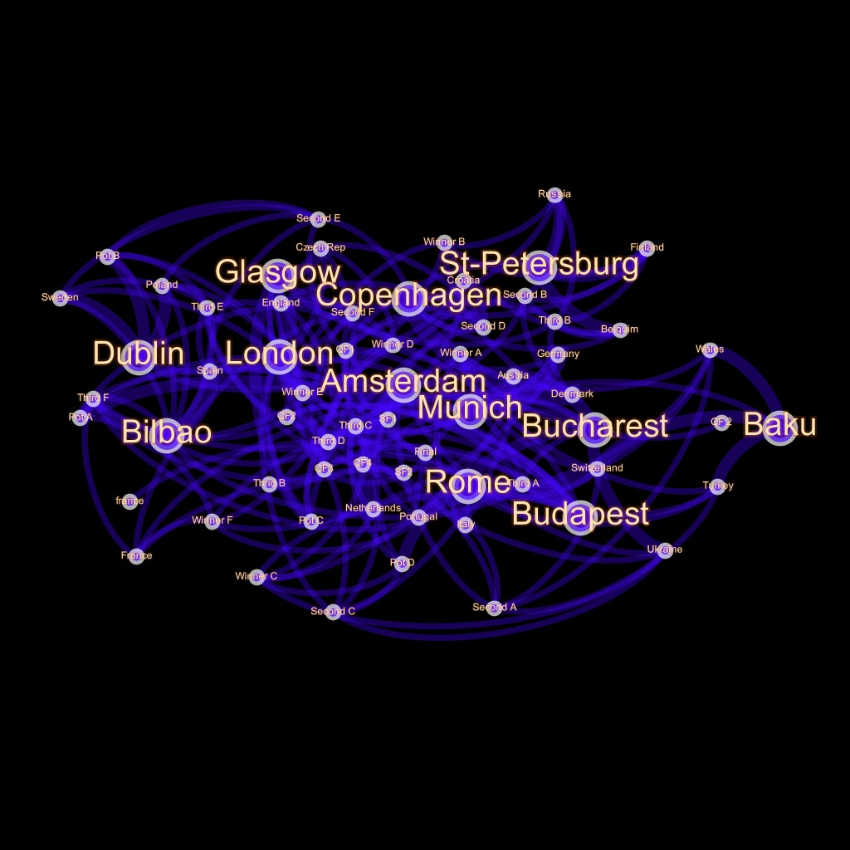
The above network map documents the movements for teams and fans across the different host cities throughout the EURO 2020 tournament. This network map illustrates a highly structured network of cities and the significant movement of people across the Eurozone (see Widdop, Bond and Parnell, 2020)
Public services: England and the United Kingdom
In the United Kingdom, in particularly, we have experienced 10 years of devastating austerity policy, which has crippled public services, including the National Health Service (NHS). These are dark days. The Secretary of State for Health and Social Care through his social media platform, sent an urgent message to his followers for manufacturers who can support ventilator production to come forward, unprecedented in peacetime Britain. Moreover, retired midwives, nurses and pharmacists (and other frontline NHS staff) are being encouraged to come back to active duty.
Therefore any competition, including EURO 2020 and the associated matches in our major cities would have been beyond irresponsible. It would have been a direct attack on the public health of the nation and indeed that of Europe. As such, we commend UEFA for their action in the face of this medical and economic crisis, whilst they may have been acted out of necessity, they have managed this crisis in keeping with custodians of the game. They have shown cooperation and collaboration across Europe and beyond. They have been clear and communicated their intentions, in these uncharted territories and more than anything, shown leadership in a time where we will undoubtedly reflect on as a dark period of genuine leadership in politics.
The stakes are high
We must also be pragmatic and realistic. In 2017/18 the domestic European leagues combined revenues from broadcasting, sponsorship and ticketing were reportedly worth €28.4bn. Moreover, it has been predicted that if the ‘Big Five’ European football leagues (England, France, Germany, Italy and Spain) do not complete their remaining clubs games for the season, they would face up to loses of almost €4bn, in match-day, broadcasting and sponsorship revenues. This announcement will trigger a real and genuine fiscal impact, yet, the full consequence will remain to be seen.
The change may open up new opportunities. In 2021, the general sports competition schedule is much lighter, with the Women’s European Championship originally taking centre stage. The EURO 2020 postponement could therefore present UEFA with an opportunity to lead something spectacular for the broader good of game, which would provide a very lucrative marketing opportunity.
Unrealistic
The ongoing challenge to these announcements is the ongoing political and economic uncertainty, ambiguity and unknowns of how a future beyond this crisis plays out. Yes, this is unchartered, and no-one will argue that this unprecedented, but no-one knows how unrealistic this is. Do we expect hundreds of thousands of people to be moving around Europe in a festival of football in the summer of 2021? Will people even want to?
What we do know, is how little we know about what the future holds. We do not know what saves we might have to make, as COVID-19 takes shots at our communities, society and also our game – the most important of our least important things.
As we move forward, we should hope that football continues to lead through its actions. Whether it’s dizzy heights of the $10 million USD contributed by FIFA to the World Health Organisation COVID-19 Solidarity Response Fund, or the more local opportunity for individual football clubs to raise awareness of strategies to tackle COVID-19 in children and young people through their football players local (and global) media reach. I am with UEFA, “Football is an uplifting and powerful force in society”, please let us make the most of it.
Dr Daniel Parnell is a senior lecturer in Sport Business at the University of Liverpool’s Management School, Chair of The Football Collective and CEO of the Association of Sporting Directors.
Dr Paul Widdop is a senior lecturer at Manchester Metropolitan University Institute of Sport.
Featured image from TRT here.

