Letter for the vet record.
9th March 2020

Possible cause of outbreak of prolific vomiting in dogs

Shirley L. Smith ¹, David A. Singleton ¹, PJ Noble ², Alan D. Radford ¹, Beth Brant ¹, Charlotte Appleton ³, Chris Jewell ³, Richard Newton ⁴, Carmen Tamayo Cuartero ⁵, Fernando Sánchez-Vizcaíno ⁵ and Gina L. Pinchbeck ¹.

¹ University of Liverpool, Institutes of Infection and Global Health and Veterinary Science, Leahurst Campus, Chester High Road, Neston, S. Wirral, CH64 7TE, UK.
² University of Liverpool, Institutes of Infection and Global Health and Veterinary Science, Leahurst Campus, Chester High Road, Neston, S. Wirral, CH64 7TE, UK.
³ CHICAS, Furness College, Lancaster University, Lancaster, LA1 4YG, UK
⁴ Animal Health Trust, Lanwades Park, Kentford, Newmarket, Suffolk, CB8 7UU
⁵ Bristol Veterinary School, University of Bristol, Churchill Building, Langford Campus, Bristol, BS40 5DU

Dear Sir.
In a letter dated 15th February 2020 we reported a potential outbreak of prolific vomiting in dogs with prolonged lethargy and inappetence, sometimes with diarrhoea. Data collected by practices participating in SAVSNET also shows a profound rise in dogs presenting for non-specific gastroenteric disease probably starting around November 2019 (figure 1). Statistical analysis has now confirmed this to be significantly outwith normal seasonal enteric disease fluctuation and therefore constituting an outbreak. Analysis of data submitted by laboratories to SAVSNET did not identify any equivalent increase in known enteric pathogen diagnoses (not presented). However, we did observe a regular winter peak in the proportion of dogs testing positive for canine enteric coronavirus (CECoV). Here we describe the results of testing samples submitted by owners and veterinarians from suspect cases of prolific vomiting and a limited number of non-affected controls for CECoV.
Samples were submitted to our laboratory and stored at –80ºC until processed. Nucleic acid was extracted using the QiaAMP Viral RNA extraction kit, reverse transcribed using random hexamers and Superscript III and tested for CECoV by PCR of the M gene (Pratelli et al 1999) (figure 2). Testing PCR positive for CECoV was significantly associated with being a case (16 of 39 cases (41%) and 0 of 16 controls (0%) tested CECoV positive, p=0.005 Fishers exact test). Samples most likely to test positive were faeces (9 of 15 samples; 60%) and vomit (and 6 of 11; 55%). Oral swabs were less frequently positive (7 of 33; 21%). When analyses were restricted to oral swabs alone, the difference between cases and controls was no longer statistically significant (P=0.09), with 7 of 33 oral swabs from cases testing positive compared to 0 of 14 from controls.
Canine enteric coronavirus is generally considered a cause of relatively mild diarrhoea or inapparent infections (Stavisky et al 2010). However, there have been sporadic reports of more profound disease associated with variants of CECoV in small numbers of usually younger dogs (Buonavoglia et al 2006). We are currently undertaking sequence analyses to identify the type of CECoVs in these samples, and continue to look for other possible causes using next generation sequencing methods. Although we cannot yet categorically confirm the role of CECoV in this outbreak, we feel it is appropriate to inform the scientific and veterinary community of these observations as they may direct further research. To avoid any doubt, it is also important to emphasise that CECoV is NOT related to known human coronaviruses including the recently emerged SARS-CoV-2, the cause of COVID19.
Although this outbreak may now be declining, we take this opportunity to remind practitioners that affected dogs usually make a full recovery with routine symptomatic veterinary therapy, and that there is no known risk to people or other species, including cats. In the absence of evidence to the contrary, it remains prudent for owners and vets to handle suspect cases carefully, and limit contact between affected and unaffected dogs.
We have established a dedicated website which is updated regularly, which also includes guidance on treatment and an owner information sheet: (https://www.liverpool.ac.uk/savsnet/dog_vomiting_potential_outbreak/). We continue to encourage practitioners to send clinical samples to us for further microbiological testing.
We would like to acknowledge the veterinary practices, including CVS, and diagnostic laboratories, whose supply of data is beginning to transform our understanding of companion animal population health. We are also extremely grateful to Dogs Trust for funding this work as part of SAVSNET-Agile (https://www.liverpool.ac.uk/savsnet/savsnet-agile/), and BBSRC for ongoing research funding.

References
Buonavoglia C, Decaro N, Martella V, Elia G, Campolo M, Desario C, Castagnaro M, Tempesta M (2006). Canine coronavirus highly pathogenic for dogs. Emerg Infect.Dis 12, 492-494.
Pratelli A, Tempesta M, Greco G, Martella V, Buonavoglia C (1999). Development of a nested PCR assay for the detection of canine coronavirus. J Virol Methods 80(1), 11-5.
Stavisky J, Pinchbeck GL, German AJ, Dawson S, Gaskell RM, Ryvar R, Radford AD (2010). Prevalence of canine enteric coronavirus in a cross-sectional survey of dogs presenting at veterinary practices. Vet Microbiol 140(1-2), 18-24.

Figure 1: Vets taking part in the SAVSNET project routinely record the main reason for presentation (MPC). The proportion of consultations about gastroenteric disease for dogs (blue) and cats (orange) is shown for the last three years, suggesting an upsurge in the proportion of GI cases (as a rate per 10,000 total recorded consultations) since Christmas this year in dogs.

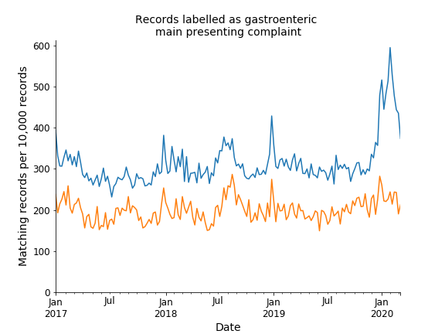

Figure 2
Results of agaraose gel electrophoresis of RT-PCR products to assess the presence of CECoV in oral swab and faeces samples submitted from seven dogs presenting with signs of prolific vomiting (cases) and four non-affected dogs (controls). Four samples (lanes 4, 6, 10 and 11) from 3 cases (B, C and G) tested positive for CECoV. All four control samples (lanes 12-15) tested negative. Lanes marked M contain molecular weight marker.
