Abstract

Title
Efficacy of dexamethasone or prednisolone for acute asthma exacerbations in children: a meta-analysis

Authors
Darshan Nitchingham - 1

Daniel B Hawcutt - 1

1. Department of Women’s and Children’s Health, University of Liverpool

Ricardo M Fernandes – 2,3

2. Department of Pediatrics, Hospital de Santa Maria, Lisbon

3. Clinical Pharmacology and Therapeutics, Faculty of Medicine, Instituto de Medicina Molecular, University of Lisbon

Berber Kapitein - 4

4. PICU, Emma Kinderziekenhuis, Amsterdam UMC, Netherlands

Andrew Lilley 5, Julie Grice 5, Helen Cibinda 5, Margaret O’Connor 5 Ian Sinha 1,5

5. Alder Hey Children’s Hospital, Liverpool, UK

Background
It is unclear which oral steroid (prednisolone or dexamethasone) is best for acute childhood asthma.

Aim
Systematically review evidence comparing efficacy of oral dexamethasone to prednisolone in children presenting to emergency departments (ED) with acute asthma. The rationale for this review is that previous meta-analyses included randomised controlled trials (RCTs) of intramuscular dexamethasone, and more recent studies have been published.

Methods
We included RCTs comparing oral dexamethasone to prednisolone in children (2-18 years) presenting to ED with acute asthma. The primary outcome was hospitalisation. Secondary outcomes included vomiting, unscheduled re-attendance, length of ED and hospital stay, and symptom resolution. Two authors independently extracted data and assessed risk of bias. Where applicable results were meta-analysed.

Results
We identified 6 RCTs (1672 children). Risk of bias was varied with 3/6 studies being open label. Treatment varied in dosage and duration across studies. There was no difference in hospitalisation risk (Risk ratio[RR]0.98, 95%CI 0.72, 1.35; Figure 1) but wide confidence intervals suggest imprecision of results. Children receiving dexamethasone were less likely to vomit (6 RCTs, RR 0.30, 95%CI 0.16, 0.55). There was no difference between groups for other secondary outcomes.

Conclusion
Oral dexamethasone is as effective as prednisolone for acute asthma in children, and is better tolerated.

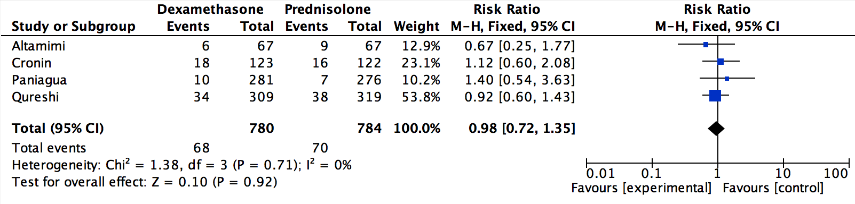
Figure 1: risk of hospitalisation

