Commentary
Considerations when choosing an appropriate bleeding risk assessment tool for patients with atrial fibrillation

Wern Yew Ding¹ MRCP
Stephanie L Harrison¹ PhD
Deirdre A Lane^{1,2} PhD
Gregory Y. H. Lip^{1,2} MD
¹Liverpool Centre for Cardiovascular Science, University of Liverpool and Liverpool Heart & Chest Hospital, Liverpool, United Kingdom; ²Aalborg Thrombosis Research Unit, Department of Clinical Medicine, Aalborg University, Aalborg, Denmark
Corresponding Author:
Prof Gregory Y H Lip gregory.lip@liverpool.ac.uk

Full mailing address University of Liverpool
William Henry Duncan Building
6 West Derby Street
Liverpool, L7 8TX
Telephone number 0151 794 9020
Word count: 1397
Keywords: atrial fibrillation, bleeding risk, stroke prevention, anticoagulation

Oral anticoagulation is integral to the management of patients with atrial fibrillation (AF) to reduce the risk of thromboembolism. Stroke risk should be assessed using the CHA₂DS₂-VASc score and men with a CHA₂DS₂-VASc score of ≥1 and women with CHA₂DS₂-VASc score ≥2 should be offered anticoagulation [1]. However, use of anticoagulation increases the risk of bleeding events and thus bleeding risk must be taken into account when initiating anticoagulation, especially since anticoagulation-related major bleeding in AF patients has been associated with a substantial increase in the risk of death, ischaemic stroke and myocardial infarction [2,3]. Intracranial haemorrhage, the most serious form of bleeding, was linked with a hazard ratio (HR) of 121.5 (95% confidence interval [CI], 91.3 - 161.8) for death and a HR of 22.0 (95% CI, 9.9 - 48.8) for stroke or myocardial infarction [2].
Several risk prediction models to determine risk of bleeding have been developed based on various clinical, biological and/or genetic markers [4–8]. The HAS-BLED score incorporates common bleeding risk factors for patients with AF [4] and is recommended by some guidelines for use in clinical practice [1,9].
However, bleeding risk scores have been used inappropriately by the ill-informed as an excuse to withhold anticoagulation. A high bleeding risk score (e.g., a HAS-BLED score of ≥3) is not a contraindication for oral anticoagulants, but instead should prompt responsible clinicians to undertake the necessary steps to reduce this risk and address modifiable risk factors such as uncontrolled hypertension, poor control of International Normalised Ratios (‘labile INRs’) if receiving a vitamin K antagonist, concomitant use of medications which increase the risk of bleeding including aspirin or non-steroidal anti-inflammatory drugs (NSAIDs) and harmful alcohol consumption [10]. Other potentially modifiable risk factors for bleeding such as anaemia, impaired renal and/or hepatic function, and reduced platelet count or function should also be considered [10]. The HAS-BLED score is then used to flag up those ‘high risk’ patients for early review and follow-up (e.g. 4 weeks, rather than 4-6 months). It is vital that patients with AF who are at high-risk of bleeding are identified as early as possible, so potentially modifiable risk factors can be addressed and the patients can be appropriately monitored. The dynamic nature of risk also necessitates that regular assessments of bleeding (and stroke risk) are performed (Figure 1) as current evidence has demonstrated that changes in risk profiles are important predictors of adverse events in patients with AF [11–13].
Bleeding risk scores vary in their complexity and simplicity to implement in clinical practice [8]. Although the inclusion of additional factors may increase the accuracy of risk models, this is often at the expense of practicality and ease of calculation. Indeed, risk prediction, especially with incorporation of various biomarkers, can improve prediction (at least statistically) but at the cost of additional complexity, cost and reduced practicality [14]. There also exists a complex relationship between thrombosis and bleeding and several risk factors are shared (e.g. age, renal dysfunction and malignancy), which complicates clinical decisions. For the vast majority of patients with AF, the net clinical benefit of oral anticoagulation to reduce risk of stroke outweighs the risk of major bleeding, including among patients identified as being at high-risk of bleeding [15].
In the current issue of the Journal of Thrombosis and Haemostasis, Chang et al. [16] report the results from a network meta-analysis of 18 studies (n=321,888 patients) comparing the sensitivity and specificity of the HAS-BLED model and other risk assessment models for predicting major bleeding events in patients with AF. Overall, Chang et al. [16] show that the European score based only on modifiable bleeding risk factors, ABC and mOBRI models had high sensitivity but low specificity, while the ORBIT, ATRIA, Shireman and GARFIELD-AF models had high specificity, but low sensitivity. The network meta-analysis clearly demonstrates that the HAS-BLED model was the most balanced in terms of sensitivity and specificity, slightly surpassing the HEMORR₂HAGES model.
These results provide an overview of the different bleeding risk models available and also quantitative evidence supporting the results of a previous systematic review which also concluded that the HAS-BLED provides the best prediction model for assessment of bleeding risk [17].
The study by Chang et al. [16] highlights some of the strengths and weaknesses of individual bleeding risk scores, particularly that those with a high sensitivity often had low specificity and vice versa. Although the HAS-BLED and HEMORR₂HAGES models were balanced, both demonstrated only modest values of sensitivity and specificity. Modest values in both attributes may cause several limitations; indeed, scores with high sensitivity, but low specificity or scores with high specificity, but low sensitivity may be more useful in certain situations [18]. For instance, the ORBIT model had high specificity and would identify patients at high-risk of bleeding. Conversely, the mOBRI model had high sensitivity and could be used to confidently identify patients at low-risk of bleeding.
When employing the various bleeding risk models as screening tools, it is important to consider the characteristics of the cohort of interest, including the tendency for patients to have a high-risk of bleeding (Bayes’ theorem) [19]. As such, Chang et al. [16] appropriately suggest that among patients at high-risk of bleeding, a model with high sensitivity is desirable, while among patients at low-risk of bleeding, a model with high specificity is desirable.
However, sensitivity and specificity may be of little practical use for clinicians when considering the probability of bleeding events in individual patients. During such situations, the predictive probabilities (positive and negative predictive values [PPV; NPV]) of the various models are more important [18]. Thus, a model with high sensitivity or specificity may have little value if it has low PPV and NPV, such that clinicians are unable to produce reliable results from their assessments. To expand on this, a model with high specificity but a low NPV may incorrectly classify a significant proportion of patients as low-risk of bleeding when they should have been identified at high-risk instead (‘false negatives’). In practice, this misclassification could result in anticoagulated patients with AF not receiving the appropriate monitoring and a lack of attention on modifiable risk factors for bleeding.
Of note, the HAS-BLED score also draws attention to several potentially reversible risk factors (uncontrolled hypertension [H]; labile International Normalised Ratio [L]; concomitant use of NSAIDs or excess alcohol [D]) when compared to other models such as mOBRI, ATRIA, ABC and GARFIELD-AF, which mostly consist of non-modifiable risk factors.
No one model for assessing bleeding risk for patients with AF has both high sensitivity and high specificity and provides a ‘best fit’ for every clinical situation. The important thing is that a formal bleeding risk assessment is undertaken in all patients initiating OAC and that bleeding risk scores, such as HAS-BLED are memorable acronyms/tools to assist in identifying and addressing modifiable risk factors and identifying which patients will require closer/more frequent follow-up to reduce risk (Figure 1).
In summary, bleeding risk scores in patients with AF should not be used as an excuse to avoid initiation of oral anticoagulation. Furthermore, anticoagulants should not be avoided solely because the patient is at an increased risk of falls. Patients with AF identified as high-risk of bleeding should be adequately monitored and appropriate strategies should be implemented to reduce the patient’s risk of bleeding when commencing anticoagulation.

Addendum:
WYD and SLH wrote the first draft and all authors provided critical revision.

Disclosures:

DAL: Investigator-initiated educational grants from Bristol Myers Squibb (BMS) and Boehringer Ingelheim; speaker for Boehringer Ingelheim, Bayer, and BMS/Pfizer and consulted for Boehringer Ingelheim, Bayer, BMS/Pfizer, and Daiichi-Sankyo.
GYHL: Consultant for Bayer/Janssen, BMS/Pfizer, Medtronic, Boehringer Ingelheim, Novartis, Verseon and Daiichi-Sankyo. Speaker for Bayer, BMS/Pfizer, Medtronic, Boehringer Ingelheim, and Daiichi-Sankyo. No fees are directly received personally.
WYD and SLH: None declared.

References
1 Lip GYH, Banerjee A, Boriani G, Chiang CE, Fargo R, Freedman B, Lane DA, Ruff CT, Turakhia M, Werring D, Patel S, Moores L. Antithrombotic Therapy for Atrial Fibrillation: CHEST Guideline and Expert Panel Report. Chest 2018; 154: 1121–201.
2 Held C, Hylek EM, Alexander JH, Hanna M, Lopes RD, Wojdyla DM, Thomas L, Al-Khalidi H, Alings M, Xavier D, Ansell J, Goto S, Ruzyllo W, Rosenqvist M, Verheugt FWA, Zhu J, Granger CB, Wallentin L. Clinical outcomes and management associated with major bleeding in patients with atrial fibrillation treated with apixaban or warfarin: insights from the ARISTOTLE trial. Eur Heart J 2015; 36: 1264–72.
3 Lip GYH, Lane DA. Bleeding risk assessment in atrial fibrillation: observations on the use and misuse of bleeding risk scores. J Thromb Haemost 2016; 14: 1711–4.
4 Pisters R, Lane DA, Nieuwlaat R, de Vos CB, Crijns HJGMGM, Lip GYH. H, Andresen D, Camm AJ, Davies W, Capucci A, Le´vy S, Olsson B, Aliot E, Breithardt G, Cobbe S, Le Heuzey JY, Santini M, Vardas P, Manini M, Bramley C, et al. A novel user-friendly score (HAS-BLED) to assess 1-year risk of major bleeding in patients with atrial fibrillation: The Euro Heart Survey. Chest 2010; 138: 1093–100.
5 Fang MC, Go AS, Chang Y, Borowsky LH, Pomernacki NK, Udaltsova N, Singer DE. A new risk scheme to predict warfarin-associated hemorrhage: The ATRIA (Anticoagulation and Risk Factors in Atrial Fibrillation) Study. J Am Coll Cardiol 2011; 58: 395–401.
6 Hijazi Z, Oldgren J, Lindback J, Alexander JH, Connolly SJ, Eikelboom JW, Ezekowitz MD, Held C, Hylek EM, Lopes RD, Siegbahn A, Yusuf S, Granger CB, Wallentin L, Lindbäck J, Alexander JH, Connolly SJ, Eikelboom JW, Ezekowitz MD, Held C, et al. The novel biomarker-based ABC (age, biomarkers, clinical history)-bleeding risk score for patients with atrial fibrillation: a derivation and validation study. Lancet 2016; 387: 2302–11.
7 Gage BF, Yan Y, Milligan PE, Waterman AD, Culverhouse R, Rich MW, Radford MJ. Clinical classification schemes for predicting hemorrhage: Results from the National Registry of Atrial Fibrillation (NRAF). Am Heart J 2006; 151: 713–9.
8 Zulkifly H, Lip GYH, Lane DA. Bleeding Risk Scores in Atrial Fibrillation and Venous Thromboembolism. Am J Cardiol 2017; 120: 1139–45.
9 National Institute for Health and Care Excellence. Guideline on atrial fibrillation: management. 2014. p. 1–45.
10 Kirchhof P, Benussi S, Kotecha D, Ahlsson A, Atar D, Casadei B, Castella M, Diener H-C, Heidbuchel H, Hendriks J, Hindricks G, Manolis AS, Oldgren J, Popescu BA, Schotten U, Van Putte B, Vardas P, Agewall S, Camm J, Baron Esquivias G, et al. 2016 ESC Guidelines for the management of atrial fibrillation developed in collaboration with EACTS. Eur Heart J 2016; 37: 2893–962.
11 Chao T-F, Lip GYH, Liu C-J, Lin Y-J, Chang S-L, Lo L-W, Hu Y-F, Tuan T-C, Liao J-N, Chung F-P, Chen T-J, Chen S-A. Relationship of Aging and Incident Comorbidities to Stroke Risk in Patients With Atrial Fibrillation. J Am Coll Cardiol 2018; 71: 122–32.
12 Chao T-F, Lip GYH, Lin Y-J, Chang S-L, Lo L-W, Hu Y-F, Tuan T-C, Liao J-N, Chung F-P, Chen T-J, Chen S-A. Incident Risk Factors and Major Bleeding in Patients with Atrial Fibrillation Treated with Oral Anticoagulants: A Comparison of Baseline, Follow-up and Delta HAS-BLED Scores with an Approach Focused on Modifiable Bleeding Risk Factors. Thromb Haemost 2018; 118: 768–77.
13 Yoon M, Yang P-S, Jang E, Yu HT, Kim T-H, Uhm J-S, Kim J-Y, Pak H-N, Lee M-H, Lip GYH, Joung B. Dynamic Changes of CHA2DS2-VASc Score and the Risk of Ischaemic Stroke in Asian Patients with Atrial Fibrillation: A Nationwide Cohort Study. Thromb Haemost 2018; 118: 1296–304.
14 Esteve-Pastor MA, Roldan V, Rivera-Caravaca JM, Ramirez-Macias I, Lip GYH, Marin F. The Use of Biomarkers in Clinical Management Guidelines: A Critical Appraisal. Thromb Haemost 2019; 119: 1901–19.
15 Friberg L, Rosenqvist M, Lip GYH. Net clinical benefit of warfarin in patients with atrial fibrillation: a report from the Swedish atrial fibrillation cohort study. Circulation 2012; 125: 2298–307.
16 Chang G, Xie Q, Ma L, Hu K, Zhang Z, Mu G, Cui Y. Accuracy of HAS-BLED and other bleeding risk assessment tools in predicting major bleeding events in atrial fibrillation: a network meta-analysis. J Thromb Haemost 2019; .
17 Borre ED, Goode A, Raitz G, Shah B, Lowenstern A, Chatterjee R, Sharan L, Allen LaPointe NM, Yapa R, Davis JK, Lallinger K, Schmidt R, Kosinski A, Al-Khatib SM, Sanders GD. Predicting Thromboembolic and Bleeding Event Risk in Patients with Non-Valvular Atrial Fibrillation: A Systematic Review. Thromb Haemost 2018; 118: 2171–87.
18 Trevethan R. Sensitivity, Specificity, and Predictive Values: Foundations, Pliabilities, and Pitfalls in Research and Practice. Front public Heal 2017; 5: 307.
19 Westbury CF. Bayes’ rule for clinicians: an introduction. Front Psychol 2010; 1: 192.

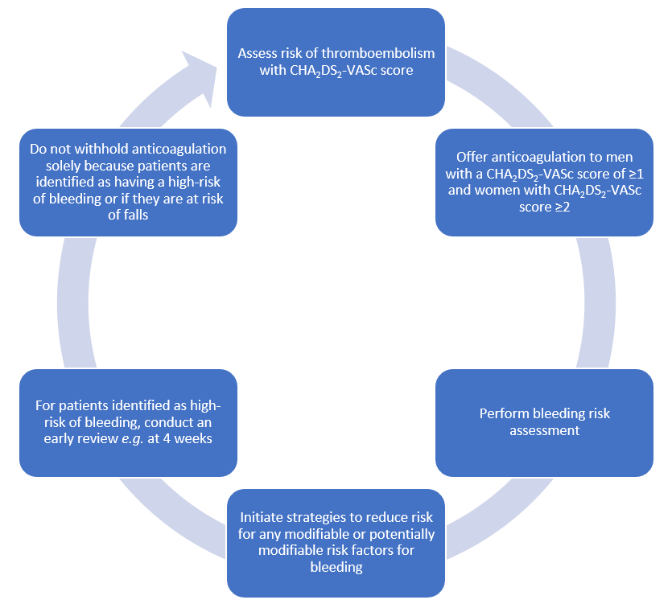
Figure 1. Stroke and bleeding risk assessment in patients with atrial fibrillation

