the Realization of Engineered Systems  
WITH CONSIDERATIONS OF Complexity

|  |  |
| --- | --- |
| Warren F. Smith  School of Engineering and IT  University of New South Wales  **Canberra, ACT, Australia** | Jelena Milisavljevic  Systems Realization Laboratory  University of Oklahoma  Norman, OK, USA |

|  |  |  |
| --- | --- | --- |
| Maryam Sabeghi  Systems Realization Laboratory  University of Oklahoma  Norman, OK, USA | Janet K. Allen  Systems Realization Laboratory  University of Oklahoma  Norman, OK, USA | Farrokh Mistree  Systems Realization Laboratory  University of Oklahoma  Norman, OK, USA |

Abstract

This paper is the product of thoughts for exploring the model-based realization of engineered systems. The question addressed is that given a relevant model, what new knowledge, understanding of emergent properties and insights can be gained by exercising the model? From the perspective that the activity of designing is a decision making process, it follows that better decisions will be made when a decision maker is better informed about the available choices and the ramification of these choices. In the context of an example of designing a small thermal plant, a description of an approach to exploring the solution space in the process of designing complex systems and uncovering emergent properties is presented. [1]

1. FRAME OF REFERENCE

Designing, in an engineering context, is an activity that seeks to deliver a description of a product to satisfy a need in response to a stated objective and/or set of requirements. In the process, it may involve invention and/or the application of science and engineering knowledge to resolve a solution. Given that multiple solutions may be proposed with differing measures of merit, it follows that the paramount role of a designer is that of a decision maker. It is further argued that understanding the inherent choices and risks within the context of a design lead to justifiable decisions. In an age where issues such as efficiency, equity, sustainability and profitability are equally valid decision drivers the motivation to develop theories and approaches to explore the design and aspiration spaces is strong. Indeed, this is what motivates the academic design community in general and the authors of this paper in particular.

Design choices can be explored through first building sufficiently detailed and valid mathematical models, and then exercising these models and seeking understanding of their behavior and the emergent properties. Such models can very quickly become very complicated. Organized complexity in the context of systems theory is said to arise from the combination of parts that form a system but the behavior of the system is not necessarily controllable or predictable from knowledge of the parts alone. Disorganized complexity in contrast is a reflection of the random and statistical variability of the parts and the subsystems and system they form. It follows that to grow complex system knowledge requires the management of aspects of both complication (complexity) and uncertainty. Managing uncertainty raises concerns such as those due to the imprecise control of process parameters, the incomplete knowledge of phenomena, the incomplete models and information aggregation, and the need to explore alternatives. Managing issues of complication include dealing with the trade-off between accuracy and computational time, the levels of interdependencies between parts, and the allocation of resources to exploring the solution and aspiration spaces. It follows that the challenge for engineers is the creation of knowledge about the system and the challenge encompasses capturing tacit knowledge, building the ability to learn from data and cases, and developing methods for guided assistance in decision making.

The authors have adopted a model based approach in pursuing these challenges recognizing that models can have different levels of fidelity, they can be incomplete and possibly inaccurate (particularly during the early stages of design).

**1.1 The Decision Support Problem**

Used is the Decision Support Problem (DSP) construct that is based on the philosophy that design is fundamentally a decision making and model-based process [1, 2]. A tailored computational environment known as DSIDES has been created to solve the DSPs.. The DSP and DSIDES are well documented in [3-7].

Reported applications of this approach include the design of ships, damage tolerant structural and mechanical systems, design of aircraft, mechanisms, thermal energy systems, composite materials and the concurrent design of multi-scale, multi-functional materials and products. A detailed set of early references to these applications is presented in [8]. Key applications more recently span specification development [9, 10], robust design [11-14], product families [15-17], the integrated realization of materials and products [18-22], and a variety of mechanical systems [23-26].

The nature of a decision and model-based approach to designing through modelling the physical world is portrayed in Figure 1. Once a model is appropriately formulated, DSIDES, with its operations research tools (traditionally an adaptive sequential linear programming algorithm delivering vertex solutions), is used to deduce “model conclusions” [5]. Where dilemmas exist this process may be iterative in nature and demand significant justification. It thus becomes imperative to be able to describe and understand the design and aspiration spaces and to be able to explore these spaces.

Key is the concept of two types of decisions (namely, selection and compromise) and that any complex design can be represented through modelling a network of compromise and selection decisions [4, 6]. Being able to work with the complexity of these decision networks is also a foundational construct as are the axioms of the approach as detailed in References [4, 6].

In reflecting on the compromise DSP, parallels with the “demands” and “wishes” of Pahl and Bietz [27] can be drawn. The demands are met by satisfaction of the DSP constraints and bounds and the wishes are represented by the goals. Collectively, the constraints and bounds define the feasible design space and the goals define the aspiration space. The feasible and aspiration spaces together then form the solution space. Note that a selection DSP can be formulated as a compromise DSP [28] where the key words “Given”, “Find”, “Satisfy” and “Minimize” are used.

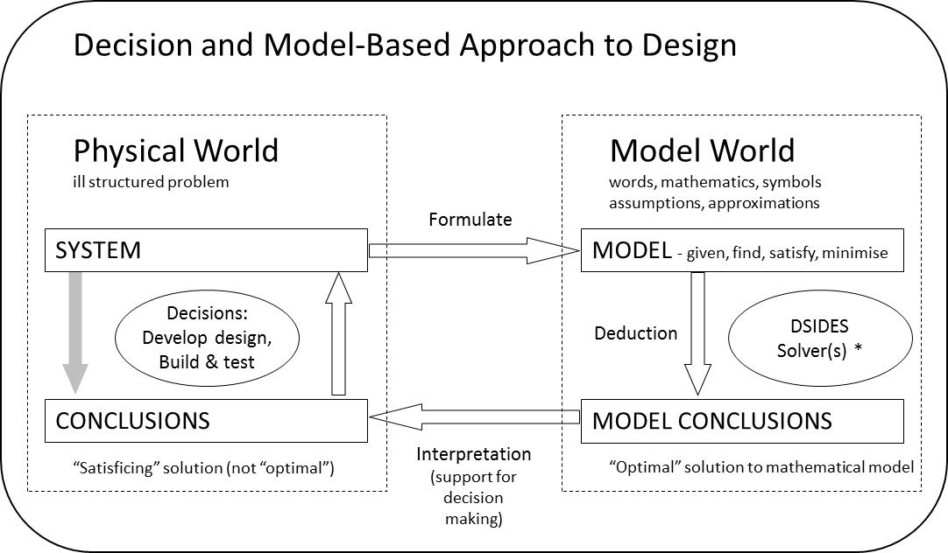

**Figure 1: Modelling the Physical World**

**1.2 Understanding the Solution Space**

A strategy for identifying a possible complex solution space and exploring it using tools within DSIDES includes:

* Firstly, discover regions where feasible designs exist based on satisfying the constraints and bounds or where they might exist by minimizing constraint violation.
* Secondly, from the neighborhood of feasible or near feasible regions frame the feasible design space extremities using a preemptive (lexicographic minimum) representation of the goals in a higher order search.
* Thirdly, having framed the space and the zones of greatest interest, move between the extremes generating deeper understanding and exploring tradeoffs using an Archimedean (weighted sum) formulation of the goals.

Our focus in this paper is on the first two steps. To discover feasible regions, zero, first and second order methods are currently available in DSIDES.

This overall process is conceptually reflected in Figure 2 where over time knowledge, confidence and utility increase while converging to a recommended decision. The decisions are made through a series of diverging, synthesizing and convergent decision making processes. As will become clearer, various tools may be used to support different decisions.

The most rudimentary approach within DSIDES is a zero order search referred to as XPLORE. Based on the algorithm of reference [29], it is used to test a range of designs within the stated system variable bounds. The best N designs are kept providing candidate starting points for higher order searches. A second method utilizing a pattern search algorithm is also available within the INITFS (Initial Feasible Solution) module. Used in series, these methods can assist greatly in delivering the Adaptive Linear Programming (ALP) algorithm a starting point from which the likelihood of achieving greater understanding of the solution space is high. In the case of a multimodal solution space a variety of starting points are employed.

Various methods may be applied to conduct post solution analysis on the data generated including visualization through the use of various plots; for one example see [30]. Given that in ALP is a linear based simplex solver, the opportunity to explore sensitivity using primal and dual information exists. Also provided in DSIDES is information about the monotonic characteristics of the model. In concert, all these elements contribute to the effective modelling, framing, exploration and dilemma resolution that is necessary when considering the design of complex systems

.

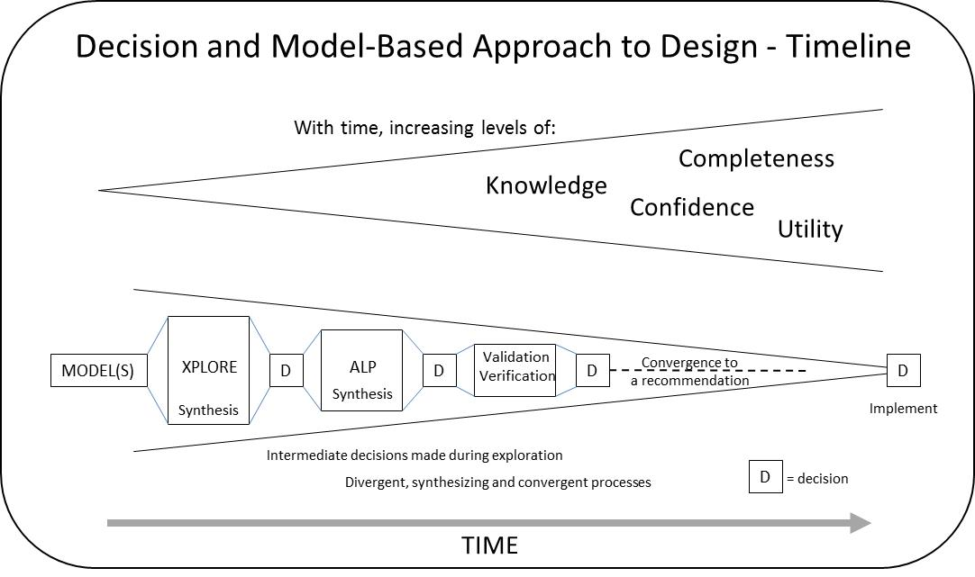

**Figure 2: Modelling and Decision Timeline**

2. SCENARIO FOR THE EXAMPLE

The study at the core of this paper is being developed to support the growing research effort within the Systems Realization Laboratory at the University of Oklahoma. Current research interests in the laboratory inter alia span complex systems, dilemma management, design space modelling and exploration, post solution analysis, and sustainability when considering economic, socio-cultural, and environmental issues. One domain allowing all these matters to be explored is thermal systems.

There are many possible applications for small scale “power” plant systems that make direct mechanical use of the power produced or that run small generators to produce electricity. Examples include provision of power to equipment in farming irrigation systems, driving reverse osmosis systems to produce fresh water for remote communities and generating electricity for general use in small collectives in both 1st and 3rd world environments.

A common approach given an available heat source is to build such a system around the Rankine cycle, a mathematical representation of a “steam” operated heat engine. A schematic representation of the Rankine cycle is shown in Figure 3 where the primary components of the system are a power producing turbine, a pump to pressurize the flow to the turbine and two heat exchangers; a condenser and a heater.

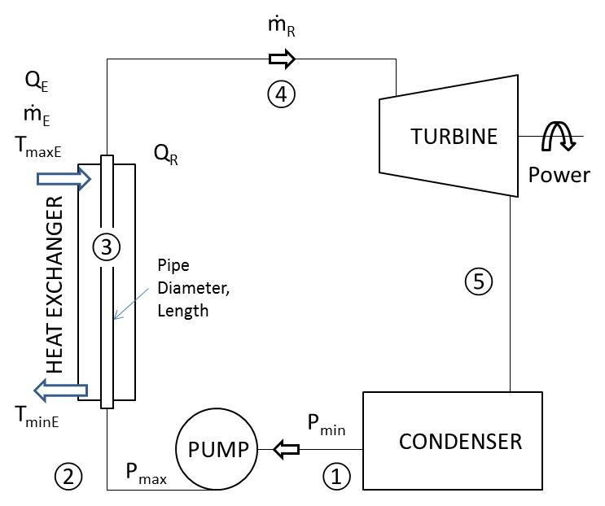

Figure 3: Stage 1 Model Schematic

In the context of building a model using a decision-based approach to design, such a thermal system affords complexity to be developed and dilemmas to be managed and resolved, both hypothetically and practically. Modelling the Rankine cycle represents Stage 1 of the model development and will be referred to herein as the foundational example model. Future expansion within the laboratory will deal with heat source issues (to the left in Figure 3) and power use issues (to the right in Figure 3) and the choice of working fluids. The common working fluid in a Rankine cycle is water. Uses of other fluids (often organic in chemistry) have given rise to the development of “organic Rankine cycles”. Of course geometric specification and design analysis of physical elements in the system also represent opportunities for model and design space exploration.

3. THE FOUNDATIONAL EXAMPLE MODEL

The foundational example model is defined by the cycle’s maximum and minimum pressures and maximum temperature (PMAX, PMIN and TMAX). Energy is transferred to the closed loop Rankine cycle through a heat exchanger. The heat exchanger is assumed to be of a counter flow design where the key characteristic is the maximum temperature of the heating flow (TMAXE).

From a decision based design approach, the determination of satisficing[2] values of these variables represents a coupled compromise-compromise DSP dealing with the Rankine cycle (PMAX, PMIN and TMAX) and the heat exchanger (TMAXE) respectively. Two additional decisions have been built into the template of the current model, namely, the selection of the fluids for both the heating and Rankine cycle loops. Therefore, in concept the current model is a compromise-compromise-selection-selection problem. Further complexity in the model will be developed in due course to reflect aspects of the mechanical design of the system components ( eg., dimensions).

The ideal Rankine cycle involves 4 processes, as shown graphically in the Temperature (T) versus Entropy (S) plot in Figure 4. There are two adiabatic isentropic processes (constant entropy) and two isobaric processes (constant pressure).

Referring to Figure 4,

①-② adiabatic pumping of the saturated liquid from PMIN to PMAX

②-④ isobaric heat addition in heat exchanger to TMAX,

④-⑤ adiabatic expansion in the turbine from PMAX to PMIN producing power with the possibility of wet steam exiting the turbine, and

⑤-① isobaric heat loss in the condenser.

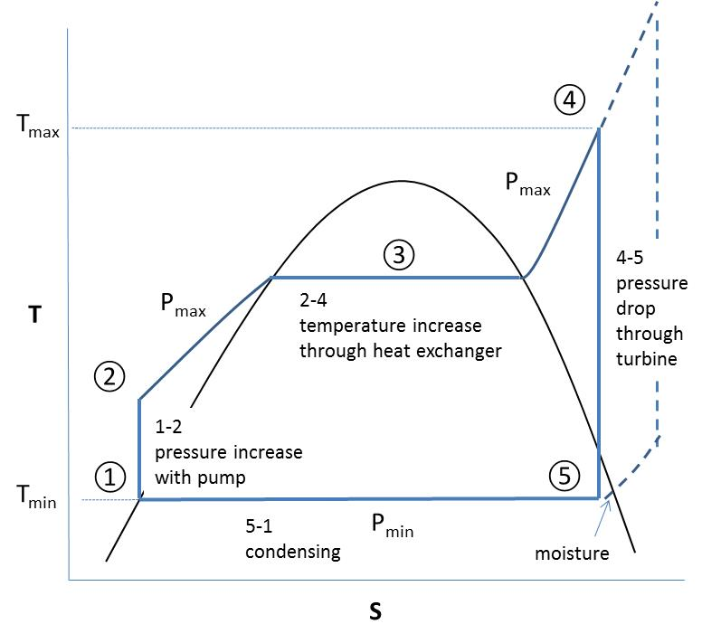

Figure 4: Rankine Cycle (Temperature v Entropy)

The isothermal segments represent moving from saturated liquid to saturated vapor in the case of ③ in the heater and the reverse in the condenser between ⑤-①. The key thermodynamic properties of the working fluid(s) are determined using REFPROP [31]. For the purposes of this paper focus has been placed on the compromise-compromise aspects and a number of system variables have been treated as parameters. One such simplification is the use of water as the working fluid in both loops.

The combined model may be summarized using the compromise key words as:

**GIVEN**

Water as the fluid in the Rankine cycle

Water as the heat transfer medium in the exchanger

The minimum pressure in the Rankine cycle

(PMIN – defined as a parameter)

Ideal Rankine cycle thermodynamics

Ideal heat transfer in the heat exchanger

Thermodynamic fluid properties

(determined using REFPROP)

**FIND**

**x, the system variables**

PMAX Maximum pressure in the Rankine cycle

TMAX Maximum temperature in the Rankine cycle

TMAXE Maximum temperature of the heating fluid

**d- and d+, the deviation variables**

**SATISFY**

**The system constraints:**

Temperature delta for maximums in exchanger

Moisture in turbine less than upper limit

Rankine cycle mas flow rate less than upper limit

Temperature at ④ ≥ temperature at ③

Quality at ④ is superheated vapor

TMAXE greater than TMINE by at least TDELE

TMINE ≥ temperature at ② by at least TDELC

Ideal Carnot cycle efficiency greater than system

efficiencies (sanity check)

Temperatures within valid ranges for REFPROP fluid

database

**The system variable bounds (xjmin ≤ xj ≤ xjmax):**

500 ≤ PMAX ≤ 5000 (kPa)

350 ≤ TMAX ≤ 850 (K)

350 ≤ TMAXE ≤ 850 (K)

**The system goals:**

Achieve zero moisture in steam leaving the turbine

(ie., steam quality of 1)

Maximize Rankine cycle efficiency

RCEFF = (Pturbine – Ppump)/Qin

Maximize temperature exchanger efficiency

TEFFEX=(TMAXE-TMINE)/(TMAXE-TEMP2)

Maximize system efficiency indicator 1

SYSEF1 = (Pturbine – Ppump)/Qout

Maximize system efficiency indicator 2

SYSEF2 = RCEFF*TEFFEX

Maximize heat transfer effectiveness in exchanger

HTEFF = f(transfer coefficient, geometry, flow etc.)

**MINIMIZE**

The deviation function (expressed in a preemptive form)

Z(**d-, d+**) = [f1(**d-, d+**), …,fk(**d-, d+**)]

The six system goals in the example have been placed at six levels of priority in the implemented preemptive model. The implication is that the first level goal function will be satisfied as far as possible and then while holding it within a tolerance; the second level goal function will be addressed. When the second has been so conditionally minimized it will be held within its tolerance and then the third goal will be worked upon; and so on in an attempt to address all the goals across all levels. Achieving satisfaction of the higher priority goals may cause the sacrifice of achievement of the lower priority goals. By prioritizing the goals differently, comparison may show competing goals driving the solution process in different directions. By grouping more than one goal at the same level, an Archimedean (weighted sum) approach can be accommodated.

4. VALIDATION OF THE MODEL

Structural validity as it applies to a computer code infers that the logic and data flows between modules are correct. This does not guarantee accuracy. Performance validity is associated with the accuracy of the results achieved as measured against reliable benchmarks and/or reasoned argument (other published work, known physical characteristics etc.).

**4.1 Structural Validity of the Model**

The compromise DSP is a hybrid multi-objective construct and this approach to designing has been validated through use [6]. The primary solver in DSIDES is an Adaptive Linear Programming algorithm, and it has also been described and validated elsewhere [5]. The current instantiation has also been shown to replicate some standard test problems. The REFPROP database is a key thermodynamic property model from NIST [31] and the NIST supplied subroutines and fluid files have been used. The total system has been integrated in a FORTRAN environment using G FORTRAN compilers on a PC platform. The functioning of the code has been successfully demonstrated to reproduce results consistent with text books and other programs providing thermodynamic properties of fluids.

Consistency and logical relationship between the constructs were checked by testing several inputs and reviewing the expected outputs, e.g., thermodynamic properties of water at different pressures and temperatures.

**4.2 Performance Validity of the Model**

Performance validity was checked through exercising the thermal model, i.e., investigation of the model by parametric study such as net power output. For instance, since the power is a function of Rankine flow rate, it is expected that higher flow rates are necessary to produce higher power. This was verified and is discussed in Section 6.

The next step for performance validity of the model was through checking the behavior of the goals. This model includes six goals, five of which estimate measures of efficiency: the Rankine cycle efficiency, the heat exchanger efficiency, two formulations of system efficiency and the heat exchanger effectiveness. By exploring different possibilities in the goal priorities for the example and by examination of the monotonicity of the goals [32] it was discovered that the prioritization of the efficiency goals in a preemptive formulation will drive the system in two directions.

If prioritization is given to the Rankine cycle efficiency and/or system efficiency formulation 1 the solutions are of high temperature and high pressure character. In discussing the results this ordering of priority will be referred to as “Order 1”. In contrast, low temperature and low pressure solutions are preferred if the heat exchanger efficiency, system efficiency formulation 2 and/or heat transfer effectiveness are prioritized (Order 2). This behavior of the model is appropriate and predictable given the model goal formulations.

5. DISCUSSION OF RESULTS

Consider that a plant producing a baseline of 25kW is required and that higher powers are sought but the maximum steam that can be produced is 0.1 kgs-1. What are the characteristic values that define the Rankine cycle and the heat exchanger?

In answering this question, a two-step process using DSIDES is used, firstly with the XPLORE grid search module and then with the ALP algorithm.

As described in Section 4, variable bounds have been defined but do they encompass feasible designs? Using XPLORE, this question is examined. Presented in Figure 5 is a plot of TMAX versus PMAX showing discrete tested combinations that lead to feasible designs for 25, 50 and 70kW cases. Feasible designs exist where the constraint violation is zero. The extent of the plot reflects the bounds of each system variable. The contraction in the number of designs and the size of the design space at least in the two dimensions shown as power increases is clearly evident. The area covered by these can be interpreted as being representative of the feasible design space(s).

**Figure. 5. Feasible designs using XPLORE  
(less than 12% moisture)**

Further use of EXPLORE can and has in this example been made to examine the regions where goals are fully satisfied or at least minimized. Being keen to ensure longevity of the plant, the operational requirement is that moisture in the steam exiting the turbine is minimized. Therefore, the Level 1 priority goal for all results presented is that of minimizing moisture. If this were the only goal specified it can be shown as in Figure 6 that there are many designs that could achieve less than 5% moisture while producing 25 kW or 50 kW. Shown in Figure 7 are those designs with zero percent moisture.

It follows that other goals need to be subsequently specified to achieve singular (local) convergence. For the 25 kW designs, using the XPLORE data, if some moisture is allowed (up to 12%) higher Rankine cycle efficiencies can be achieved with designs depicted in the region shown in top right of Figure 8 (efficiencies better than 27.5%). However, constraining the designs to have zero moisture caps the best Rankine cycle efficiency found at 25% (PMAX 2136 kPA and TMAX 759 K), significantly to the left of the Figure 8 cluster. This reflects the best “Order 1” XPLORE solution.

Considering the second system efficiency goal representation, SYSEF2, if set as priority one, values of 16% in the lower left region shown in Figure 8 are possible. If, constraining the designs to have zero moisture caps the best SYSEF2 value found is 12% (PMAX 909 kPA and TMAX 668 K), significantly higher than the Figure 8 cluster. This reflects the best “Order 2” XPLORE solution.

To summarize, higher Rankine cycle efficiencies are achieved with high temperatures and high pressures. In contrast, the higher system efficiencies result from low temperatures and low pressures. And, to achieve zero moisture in the turbine, the requirement is for high temperatures with lower pressures. Clearly, the right decision is not straightforward.

While the framing value of using the XPLORE DSIDES module has been demonstrated, what further insights can be developed using the DSIDES ALP algorithm [5] to refine understanding?

The next set of results presented are for the two groupings of the goals as discussed in Section 5, one producing high temperature and pressure results (Order 1) and the other low temperatures and pressures (Order 2). The goal deviation variable values associated with each goal (defined in Section 4) have been named with a leading “G”, for example GRCEFF referring to the Rankine Cycle Efficiency goal.

Given an upper limit on the mass flow rate in the Rankine cycle of 0.1 kgs-1, a parametric study has been undertaken to establish the power output limit for the system. Shown by the results tabulated in Table 1 (for both Order 1 and Order 2), are solutions for 25, 50 and 75 kW configurations. While not shown in Table 1 to maintain clarity, for each of the six arrangements (combinations of power output and goal priority order) different starting points were tried yet the solutions for each power output were for all intents and purposes the same, suggesting, though not guaranteeing, that the global minima (for the formulation) may have been found.

The behavior of the model can be assessed in a number of ways including convergence of the system and deviation variable. For the benchmark 25 kW cases, the convergence history for Order 1 is presented in Figures 9 and 10 and for Order 2 in Figures 11 and 12. All curves reach a stable final steady state. In the case of Order 1, zero moisture in the turbine was not achieved until iteration 9. This aspect dominated the solution process to this point. However, GRCEFF and GSYSE1 which are superimposed are seen to be generally decreasing. The reverse is true for Order 2. For Order 2, zero moisture was achieved from iteration 5 from which point reductions in GSYSE2, GEXEFF and GHTEFF are evident. Clearly an indicator of excess capacity in considering the baseline 25 kW case is that the flow rate in the turbine is well below the defined bound on this variable of 0.1. In framing and exploring a design model, the nature of the specified variable bounds needs to be understood. Some are set based on true physical constraints and some are arbitrary.

**Figure. 6: Feasible designs with moisture less than 5% using XPLORE**

**Figure. 7: Feasible designs with 0.000% moisture using XPLORE**

**Figure. 8: Trade-offs for feasible designs for 25kW using XPLORE (less than 12% moisture)**

**Table 1: Parametric Study of Power**



**Figure. 9: Order 1 system variable (25kW)  
convergence plotted against iteration**

**Figure. 10: Order 1 deviation variable (25kW)  
convergence plotted against iteration,  
(lower values preferred, GRCEFF and GSYSE1 superimposed)**

**Figure. 11: Order 2 system variable (25kW)  
convergence plotted against iteration**

**Figure: 12: Order 2 deviation variable (25kW)  
convergence plotted against iteration,  
(lower values preferred, GRCEFF and GSYSE1 superimposed)**

The parametric study of power has provided the flow rate results depicted in Figure 13. For Order 1 where Rankine cycle efficiency is favored, the flow rate is lower because of the improved efficiency. Extrapolating to where both flow rate curves would intersect the 0.1 kgs-1 upper bound, it would appear that approximately 90 kW would be available in the modelled ideal system. A companion plot of the Rankine cycle efficiency versus power is given in Figure 14 where a consistently high efficiency is achieved for Order 1. The efficiencies produced under Order 2 are forced to increase in order to produce the higher power demands. In contrast, the final plot presented, Figure 15, is used to highlight that by prioritizing the goals as per Order 2, higher values of system efficiency as measured by the second formulation can be achieved. This formulation is a product of the efficiencies of the two primary system components, exchanger and Rankine cycle. Because of the idealized efficiency of the exchanger being higher than that of the Rankine cycle, this term dominates and therefore drives the solution to the lower temperatures and pressures that suit the exchanger. The monotonically increasing curves of Figure 15 further suggest that higher overall efficiencies will come with higher power.

**Figure. 13: Rankine Cycle Mass Flow Rate, FLOWR versus Power Output (Order 1 – solid line; Order 2 – dashed line)**

**Figure 14: Rankine Cycle Efficiency versus Power Output   
(Order 1 – solid line; Order 2 – dashed line)**

**Figure 15: System Efficiency 2, GSYSE2, versus Power Output (Order 1 – solid line; Order 2 – dashed line)**

6. CONCLUDING REMARKS

Industry is faced with complexity and uncertainty and we in academia are motivated to respond to these challenges. Hence this paper is the product of thoughts for exploring the model-based realization of engineered systems when the models are incomplete and inaccurate. What new knowledge, understanding of emergent properties and insights can be gained by exercising the model? In summary, perhaps the conflict expressed in Figure 8 best reflects the discovery of emergent properties from the system. Pursuing the questions further leads to a growth in understanding and this is exemplified by the findings based on the information presented in Figures 13, 14 and 15.

While the results presented in Section 6 are for a relatively simple case and some variation has been dealt with parametrically, the model is structured to deal with significantly increased complexity through the integration of more detailed analysis. Possibilities include adding features to incorporate real as opposed to ideal characteristics of the Rankine cycle (e.g., pipe losses, pumping losses). The mechanical design and more detailed sizing of components could also be added as could higher order heat transfer models that address the time and material dependencies of conduction in the heat exchangers. Including design robustness considerations are also desirable.

The thermodynamically oriented example presented herein is anticipated to provide the foundation for a significant body of future work.

Acknowledgments

We thank the University of New South Wales, Australia, for the financial support provided to Warren Smith to spend a sabbatical at the University of Oklahoma, Norman. Jelana Milisavljevic acknowledges the financial support from NSF Eager 105268400. Maryam Sabeghi acknowledges the NSF Graduate Research Fellowship that funds her graduate studies. Janet K. Allen and Farrokh Mistree acknowledge the financial support that they received from the John and Mary Moore chair account and the LA Comp chair account, respectively.

References

1. Marston, M., J.K. Allen, and F. Mistree, *The Decision Support Problem Technique: Integrating Descriptive and Normative Approaches.* Engineering Valuation & Cost Analysis, Special Issue on Decision-Based Design: Status and Promise, 2000. **3**: p. 107-129.

2. Muster, D. and F. Mistree, *The Decision Support Problem Technique in Engineering Design.* The International Journal of Applied Engineering Education, 1988. **4**(1): p. 23-33.

3. Mistree, F., W.F. Smith, B. Bras, J.K. Allen, and D. Muster, *Decision-Based Design: A Contemporary Paradigm for Ship Design.* Transactions SNAME, 1990. **98**: p. 565-597.

4. Mistree, F., W.F. Smith, S.Z. Kamal, and B.A. Bras, *Designing Decisions: Axioms, Models and Marine Applications (Invited Lecture)*, in *Fourth International Marine Systems Design Conference (IMSDC91)*. 1991, Society of Naval Architects of Japan: Kobe, Japan. p. 1-24.

5. Mistree, F., O.F. Hughes, and B. Bras, *Compromise Decision Support Problem and the Adaptive Linear Programming Algorithm*, in *Structural Optimisation: Status and Promise*, M.P. Kamat, Editor. 1992, AIAA: Washington, DC. p. 251 - 290.

6. Mistree, F., W.F. Smith, and B.A. Bras, *A Decision-Based Approach to Concurrent Engineering, Chapter 8*, in *Handbook of Concurrent Engineering*, H.R. Paresai and W. Sullivan, Editors. 1993, Chapman-Hall: New York. p. 127-158.

7. Reddy, R., W.F. Smith, F. Mistree, B.A. Bras, W. Chen, A. Malhotra, K. Badhrinath, U. Lautenschlager, R. Pakala, S. Vadde, and P. Patel, *DSIDES User Manual*. 1992, Systems Design Laboratory, Department of Mechanical Engineering, University of Houston.

8. Mistree, F., D. Muster, S. Srinivasan, and S. Mudali, *Design of Linkages: A Conceptual Exercise in Designing for Concept.* Mechanism and Machine Theory, 1990. **25**(3): p. 273-286.

9. Chen, W., T.W. Simpson, J.K. Allen, and F. Mistree, *Satisfying Ranged Sets of Design Requirements using Design Capability Indices as Metrics.* Engineering Optimization, 1999. **31**(5): p. 615-619.

10. Lewis, K., W.F. Smith, and F. Mistree, *Ranged Set of Top-Level Specifications for Complex Engineering Systems, Chapter 10*, in *Simultaneous Engineering: Methodologies and Applications*, U. Roy, J.M. Usher, and H.R. Parsaei, Editors. 1999, Gordon and Breach Science Publishers: New York. p. 279-303.

11. Allen, J.K., C.C. Seepersad, F. Mistree, G.T. Savannah, and G. Savannah, *A Survey of Robust Design with Applications to Multidisciplinary and Multiscale Systems.* J Mech Des, 2006. **128**(4): p. 832-843.

12. Chen, W., J.K. Allen, and F. Mistree, *A Robust Concept Exploration Method for Enhancing Productivity in Concurrent Systems Design.* Concurrent Engineering, 1997. **5**(3): p. 203-217.

13. Chen, W., J.K. Allen, K.-L. Tsui, and F. Mistree, *A Procedure for Robust Design: Minimizing Variations Caused by Noise Factors and Control Factors.* Journal of Mechanical Design, 1996. **118**(4): p. 478-485.

14. Seepersad, C.C., J.K. Allen, D.L. McDowell, and F. Mistree, *Robust Design of Cellular Materials with Topological and Dimensional Imperfections.* Journal of Mechanical Design, 2006. **128**(6): p. 1285-1297.

15. Simpson, T.W., W. Chen, J.K. Allen, and F. Mistree, *Use of the Robust Concept Exploration Method to Facilitate the Design of a Family of Products.* Simultaneous engineering: Methodologies and applications, 1999. **6**: p. 247-78.

16. Simpson, T.W., J.R. Maier, and F. Mistree, *Product Platform Design: Method and Application.* Research in Engineering Design, 2001. **13**(1): p. 2-22.

17. Simpson, T.W., C.C. Seepersad, and F. Mistree, *Balancing Commonality and Performance within the Concurrent Design of Multiple Products in a Product Family.* Concurrent Engineering, 2001. **9**(3): p. 177-190.

18. Choi, H., D.L. McDowell, J.K. Allen, D. Rosen, and F. Mistree, *An Inductive Design Exploration Method for Robust Multiscale Materials Design.* Journal of Mechanical Design, 2008. **130**(3): p. 031402.

19. Choi, H.-J., D.L. Mcdowell, J.K. Allen, and F. Mistree, *An Inductive Design Exploration Method for Hierarchical Systems Design Under Uncertainty.* Engineering Optimization, 2008. **40**(4): p. 287-307.

20. McDowell, D.L., J. Panchal, H.-J. Choi, C. Seepersad, J. Allen, and F. Mistree, *Integrated Design of Multiscale, Multifunctional Materials and Products*. 2009: Butterworth-Heinemann.

21. Panchal, J.H., H.-J. Choi, J.K. Allen, D.L. McDowell, and F. Mistree, *A Systems-Based Approach for Integrated Design of Materials, Products and Design Process Chains.* Journal of Computer-Aided Materials Design, 2007. **14**(1): p. 265-293.

22. Seepersad, C.C., J.K. Allen, D.L. McDowell, and F. Mistree, *Multifunctional Topology Design of Cellular Material Structures.* Journal of Mechanical Design, 2008. **130**(3): p. 031404.

23. Chen, W., C.B. Meher-Homji, and F. Mistree, *Compromise: an Effective Approach for Condition-Based Maintenance Management of Gas Turbines.* Engineering Optimization, 1994. **22**(3): p. 185-201.

24. Hernamdez, G. and F. Mistree, *Integrating Product Design and Manufacturing: a Game Theoretic Approach.* Engineering Optimization+ A35, 2000. **32**(6): p. 749-775.

25. Koch, P., A. Barlow, J. Allen, and F. Mistree, *Facilitating Concept Exploration for Configuring Turbine Propulsion Systems.* Journal of Mechanical Design, 1998. **120**(4): p. 702-706.

26. Sinha, A., N. Bera, J.K. Allen, J.H. Panchal, and F. Mistree, *Uncertainty Management in the Design of Multiscale Systems.* Journal of Mechanical Design, 2013. **135**(1): p. 011008.

27. Pahl, G., W. Beitz, J. Feldhusen, and K.H. Grote, *Engineering design, A Systematic Approach*. Third English ed. 2007: Springer.

28. Bascaran, E., R.B. Bannerot, and F. Mistree, *Hierarchical Selection Decision Support Problems in Conceptual Design.* Engineering Optimization, 1989. **14**(3): p. 207-238.

29. Aird, T.J. and J.R. Rice, *Systematic Search in High Dimensional Sets.* SIAM Journal on Numerical Analysis, 1977. **14**(2): p. 296-312.

30. Sabeghi, M., W.F. Smith, J.K. Allen, and F. Mistree. *Solution Space Exploration in Model-Based Realization of Engineered Systems*. in *ASME Design Automation Conference*. 2015. Boston, Massachusetts: ASME.

31. Lemmon, E.W. and M.L. Huber, *Implementation of Pure Fluid and Natural Gas Standards: Reference Fluid Thermodynamic and Transport Properties Database (REFPROP)*. 2013, National Institute of Standards and Technology, NIST.

32. Smith, W.F. and F. Mistree, *Monotonicity and Goal Interaction Diagrams for the Compromise Decision Support Problem*, in *ASME DE, New York*, B.J. Gilmore, et al., Editors. 1994, ASME. p. 159-168.

1. The broad content of the paper was presented as a poster in the CSD&M Conference and the Abstract was published in the CSD&M Proceedings with a full version published in the online proceedings CEUR-CSD&M Paris 2014 - Smith, W.F., Milisavljevic, J., Sabeghi, M., Allen, J.K., Mistree, F., *Accounting for Uncertainty and Complexity in the Realization of Engineered Systems,* Proceedings of the Poster Workshop at the 2014 Complex Systems Design & Management International Conference, Paris, France, 2014.  Permission from CSD&M organizers has been received for making this paper available to a wider audience.
2. *Satisficing* is a decision-making strategy or cognitive heuristic that entails searching through the available alternatives until an acceptability threshold is met. This is contrasted with optimal decision making, an approach that specifically attempts to find the best alternative available. Wikipedia.