Received 00th January 20xx,
- Department of Chemistry and Materials Innovation Factory, University of Liverpool, Crown Street, Liverpool L69 7ZD, U.K.
- Department of Electrical Engineering and Electronics, Brownlow Hill, University of Liverpool, L69 3GJ Liverpool, U.K.
- School of Chemistry, University of Nottingham, NG7 2RD Nottingham, U.K.
†Electronic Supplementary Information (ESI) available: Experimental procedures,
¹H NMR, UV-Vis, FT-IR data, contact angle measurements, hydrogen evolution experiments, XPS data and SEM images. See DOI: 10.1039/x0xx00000x
Accepted 00th January 20xx
DOI: 10.1039/x0xx00000x
Polymer photocatalysts with plasma-enhanced activity†
Reiner Sebastian Sprick,*ª Kieran J. Cheetham,^{b} Yang Bai,ª Jesum Alves Fernandes,^{c} Michael Barnes,^{b} James W. Bradley,^{b} and Andrew I. Cooper*ª
Plasma treatment was used as a new method to enhance the photocatalytic performance of a hydrophobic polymer photocatalyst. The sacrificial hydrogen evolution rate was enhanced by a factor of more than 8 after a plasma treatment time of 20 minutes. Contact angle measurements confirmed that the plasma treatment improved the wettability of the polymer film and XPS results indicated a surface chemical modification.
Hydrogen production from water using solar energy is an active and fast-moving area of research. A range of water-dispersible inorganic photocatalysts has been developed to harvest solar energy for hydrogen evolution.^{1,2} In the last few years, organic polymer photocatalysts have also become an active area of investigation,^{3–5} with several different material classes being developed such as, carbon nitrides,^{6,7} conjugated microporous polymer networks,^{8–11} linear conjugated polymers,^{12–15} triazine-based frameworks,^{16–18} and covalent organic frameworks,^{19–21} each showing promising hydrogen production rates, at least for the sacrificial proton reduction half reaction. Most of these photocatalysts are insoluble in organic solvents, making it hard to process these materials—for example, to prepare composites. In addition, these photocatalysts are typically used in aqueous suspensions, resulting in the need for continuous agitation during photocatalysis to prevent sedimentation. Besides oligo(phenylene)s,²² which show only limited catalytic activity even under UV light, alkylated conjugated polymers were shown to be solution processible while retaining activity when cast as thin films.²³ However, the hydrophobic solubilizing alkyl-chains in these materials also results in a much reduced photocatalytic activity,^{12,23} which can be explained by a reduced wettability and poorer interaction with water.¹³
Our group and others^{11,13,24} have shown that the introduction of polar groups into apolar conjugated building blocks increases wettability and this can result in significantly enhanced photocatalytic activity.
An alternative approach to enhancing the wetability of hydrophobic polymers is plasma treatment. Even short plasma treatment times have been shown to result in a significant reduction in contact angles with water for aliphatic poly(ketones),²⁵ poly(etheretherketone)²⁶ and even for poly(tetrafluoroethylene).²⁷ When argon plasma is used, incorporation of oxygen into the material can either occur via reaction of oxygen containing species during plasma treatment (i.e., H₂O, O₂)²⁸ or by reaction of surface free radicals with atmospheric oxygen upon exposure to air after plasma treatment.²⁹ The introduction of oxygen into the material results in the formation of polar groups that enhance the interaction with water.^{25,29} Plasma treatment is inexpensive, cheap, and scalable, but there are no examples, to our knowledge, of its use to modify organic photocatalysts.
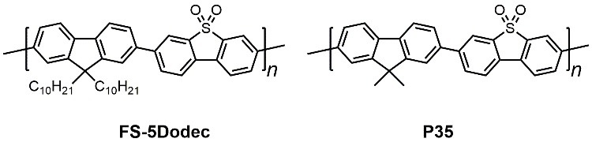
Figure 1. Structure of photocatalysts FS-5Dodec and P35.
Here we report a new approach to modifying conjugated polymer films by using plasma treatment. This enhances the wettability of conjugated polymer films bearing apolar side-chains and this enhances photocatalytic performance significantly.
For this study, we prepared a solution-procesable polymer photocatalyst, FS-5Dodec, which is a copolymer of a dibenzo[b,d]thiophene sulfone monomer and di-n-dodecyl-9H-fluorene (Figure 1). This copolymer was found previously to be photocatalytically active,³⁰ and the alkyl side chains render it highly soluble in organic solvents such as THF, dichloromethane, and chloroform. They also make the copolymer very hydrophobic. This copolymer was prepared using Pd(0)-catalysed Suzuki-Miyaura polycondensation followed by work-up and Soxhlet extraction with methanol, acetone, ethyl acetate, and chloroform. The chloroform soluble fraction was found to have a molecular weight of M_{w} = 31.9 kg mol⁻¹ (M_{n} = 18.9 kg mol⁻¹) as determined by gel permeation chromatography calibrated against polystyrene standards.
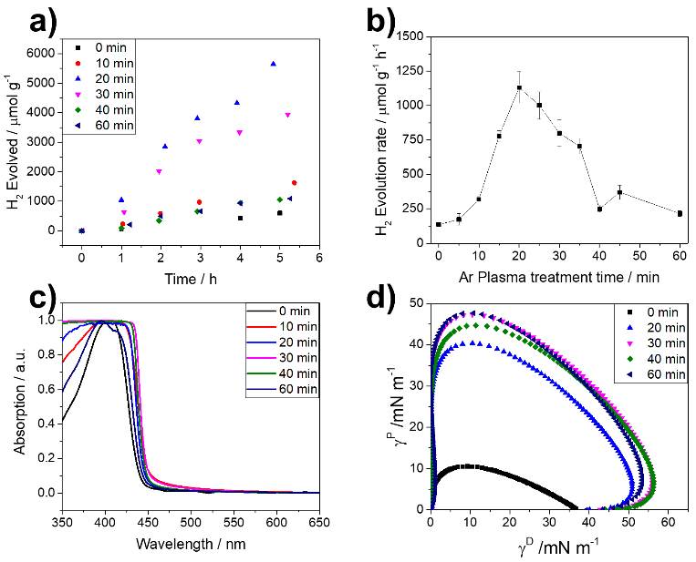
Figure 2. Plasma treated FS-5Dodec (a) Hydrogen evolution performance under visible light. Conditions: Drop-cast films on glass, 5 vol. % triethylamine in water, λ > 420 nm, 300 W Xe light-source; (b) Correlation of the plasma treatment time and the hydrogen evolution rate under visible light; (c) UV-visible absorption spectra; (d) Wetting envelopes of the polymer films.
¹H NMR spectroscopy confirmed the structure of the FS-5Dodec copolymer (Fig. S-1) and thermogravimetric analysis (TGA) showed that the polymer exhibited good thermal stability under air up to 300 °C (Fig. S-2). UV-visible spectrometry measured for a thin-film showed that the material absorbs in the visible light range (λ > 420 nm) and the band-gap was estimated to be 2.80 eV using a Tauc plot (Fig. S-3). The HOMO level energy was estimated to be -6.0 eV using photoelectron spectroscopy in air and the LUMO estimated to be -3.2 eV (Fig. S-4).
The photocatalytic activity for proton reduction for FS-5Dodec was tested in water with 5 vol. % triethylamine (TEA) acting as the hole scavenger.^{12,31} No methanol cosolvent was added. No additional metal co-catalyst was added, since residual palladium nanoparticles from the synthesis act as a co-catalyst.^{12,32} The polymer was found to have no measureable catalytic activity when tested (over 20 hours) for its performance as a spin-coated thin-film on n-octadecyltrichlorosilane (OTS) treated glass (λ > 420 nm, 300 W Xe light-source; Fig. S-5). After Ar plasma treament under reduced pressure, a low but measureable hydrogen evolution rate was determined (11 µmol g⁻¹ h⁻¹).
We went on to use drop-casted films of FS-5Dodec on frosted glass slides, which resulted in thicker and rougher films compared to the spin-coated thin-films as evident from scanning electron microscope images (4-6 µm vs 20-30 nm, Fig. S-7). When tested under otherwise identical conditions, a modest hydrogen evolution rate of 135.8 µmol g⁻¹ h⁻¹ was measured for untreated FS-5Dodec films. A significant enhancement in photocatalytic activity was observed when these films were treated with Ar plasma (Fig. 2a and b). The maximum hydrogen evolution rate of 1131.3 µmol g⁻¹ h⁻¹ was observed after 20 minutes plasma treatment time, which equates to more than an 8-fold increase in activity compared to the untreated film. Longer plasma treatments (25 to 60 minutes) led to a decrease in activity (Fig. 2b).
The plasma treatment did not change the optical properties of the films very significantly, although all films showed a small bathochromic shift compared to the untreated film (Fig. 2c). The enhanced activity seems to be due to enhanced wettability: untreated films of FS-5Dodec have a high contact angle against water in air of 109°, which is even higher than poly(p-phenylene) which has a contact angle of 88°,¹³ which impacts the photocatalytic performance.
Table 1 Ar plasma treatment time, resulting contact angle and hydrogen evolution rates for films of photocatalyst FS-5Dodec.
Treatment timeª  / min | CA (H₂O)^{b}  / ° | HER  λ > 420 nm^{c}  / µmol g⁻¹ h⁻¹
0 | 109 ± 2.7 | 135.8 ± 9.0
5 | 66 ± 5.8 | 173.2 ± 41.6
10 | 72 ± 3.2 | 318.7 ± 21.5
15 | 50 ± 7.2 | 779.3 ± 39.5
20 | 43 ± 6.7 | 1131.3 ± 113.6
25 | 42 ± 3.5 | 1001.0 ± 99.7
30 | 28 ± 2.9 | 799.1 ± 95.2
35 | 396 ± 3.1 | 704.3 ± 56.6
40 | 33 ± 2.0 | 249.3 ± 22.5
45 | 28 ± 2.0 | 370.6 ± 51.3
60 | 30 ± 1.0 | 215.4 ± 20.8
[a] Conditions: Drop-cast polymer film treated with Ar plasma (10 W, 10 mTorr); [b] Average of measurements in at least 3 location of the sample; [c] Hydrogen evolution rates (HER) determined in water/ 5 vol. % triethylamine mixtures irradiated by 300 W Xe light-source for at least 5 hours using a λ > 420 nm filter.
The contact angle was reduced to 43° after 20 minutes plasma treatment and to 30° after 60 minutes (Table 1 and Fig. S-8). However, longer treatment times of 45 and 60 minutes reduced the photocatalytic activity to 370.6 µmol g⁻¹ h⁻¹ and 215.4 µmol g⁻¹ h⁻¹, respectively. This is possibly due to damage caused to the films upon longer plasma exposure. One indication of this might be a hypsochromic shift in the absorption for the samples treated for 45 and 60 minutes relative to the sample after 20 minutes treatment. Repeat experiments show that similar rates are obtained for samples treated for the same time and a deviation of less than 20% was observed between batches (see S-9). We also considered using a plasma consisting of 80% nitrogen and 20% oxygen, rather than argon, which has been reported to result in functionalisation within the plasma.²⁹ This resulted in broadly similar hydrogen evolution rates when tested under same conditions for the same treatment times (see S-10).
Longer term-stability of an Ar plasma-treated sample (20 minutes treatment time) was evaluated by testing a sample in water/5 vol. % TEA using visible light (λ > 420 nm, 300 W Xe light-source; Fig. S-16) over 20 hours. Like the untreated polymer, the sample showed reduced activity over the course of the run, but nevertheless remained active for the duration of the experiment. We also noticed that the sample started to delaminate from the substrate, which resulted in photocatalyst moving out of the light path, accounting for at least some of the reduction in the observed activity. When water/methanol/TEA mixtures were used instead of water/5 vol. % TEA mixtures, we observed that the rates were even higher, as in previous studies.¹³ The rates for the FS-5Dodec film treated with Ar plasma for 20 minutes increased to 3861.1 µmol g⁻¹ h⁻¹ compared 692.5 µmol g⁻¹ h⁻¹ for the untreated sample under visible light illumination (λ > 420 nm, 300 W Xe-light source; Fig. S-17). Delamination was even more apparent under these conditions, possibly due to swelling of the film or formation of H₂ bubbles behind the film, effecting performance already after 4 hours. An external quantum efficiency of 0.9% at 420 nm was determined for FS-5Dodec under these conditions, when stacking three films in a row. We also studied the stability of a plasma-treated FS-5Dodec film that was stored for a month under ambient conditions in the dark. The contact angle was slightly increased after one month (54 ± 4.0° vs 43 ± 6.7°; S-13) and the hydrogen evolution rate under visible light illumination (λ > 420 nm, 300 W Xe light-source) was also found to be somewhat lower (HER = 875 ± 36.4 µmol g⁻¹ h⁻¹ vs 1131.3 ± 113.6 µmol g⁻¹ h⁻¹; S-14). This is possibly due to the oft-observed ‘hydrophilic recovery’ of plasma treated samples.³³
We assumed that the aromatic core of FS-5Dodec might be stable to O₂ and reactive oxygen species since the HOMO level is relatively deep due to the electron-withdrawing nature of the dibenzo[b,d]thiophene sulfone unit.³⁰ We therefore hypothesized that any changes to the chemical structure might occur on the alkyl side-chains, which are far more prone to oxidation. To probe this, we also plasma treated the photoatalyst P35 (Fig. 1),³⁰ which only has methyl-groups on the fluorene bridge-head, but is otherwise identical to FS-5Dodec.
As expected, we observe no changes in the UV/visible and FT-IR spectra for P35 before and after plasma treatment (Fig. S-23 and Fig. S-24). We then tested its photocatalytic performance in suspensions, rather than films, due to the insoluble nature of the material, which prohibits casting of films from solution. Unlike the case of FS-5Dodec, we observed a small drop in performance for P35 after plasma treatment from 1223 µmol g⁻¹ h⁻¹ to 979 µmol g⁻¹ h⁻¹ (visible light illumination (λ > 420 nm, 300 W Xe light-source in water/MeOH/TEA mixtures; Fig. S-25) and the contact angle remained unchanged for pellets of the material before and after treatment (Fig. S-26).
We next explored if a modification of the bridge head in the fluorene with ketones would change the wettability of the material. For this, co-polymers of dibenzo[b,d]thiophene sulfone with varied amounts of dimethyl-fluorene and fluorenone were prepared by Suzuki-Miyaura polycondensation as model polymers (P35-X%Fl, whereby X denotes the amount of fluorenone used in the polycodensation reaction; Fig. S-27). This affected the UV-vis spectra of the materials and a bathochromic shift of the absorption on-set with increased feed amount of fluorenone was observed (Fig. S-28), with P35-50%Fl being the furthest shifted, followed by P35-25%Fl, P35-5%Fl and P35. Similarly, a peak at 1716 cm⁻¹ in the FT-IR spectra was observed, which increases with increased fluorenone content (Fig. S-29). However, this does not effect the wettability, as evident by virtually unchanged contact angles with water (Fig. S-30). It also does not affect the photocatalytic activity much when tested under visible light illumination (λ > 420 nm, 300 W Xe light-source in water/MeOH/TEA mixtures), with all rates falling between 727.6 µmol g⁻¹ h⁻¹ and 981.6 µmol g⁻¹ h⁻¹ (Fig. S-31).
With all of this in mind, we investigated the effect of the plasma treatment on the soluble polymer FS-5Dodec to explore whether the effects are due to changes in the chemical structure, in this case on the alkyl side-chains, or perhaps changes in the surface roughness. FT-IR spectra before and after Ar plasma treatment were very similar (Fig. S-32) and no new band relating to chemical functionalities, such as ketones, alcohols, or carboxylates are present. This might not be surprising since the modification is expected to take place only at the surface,²⁹ and even in the case of the model polymer P35-5%Fl, the C=O stretch is not clearly visible.
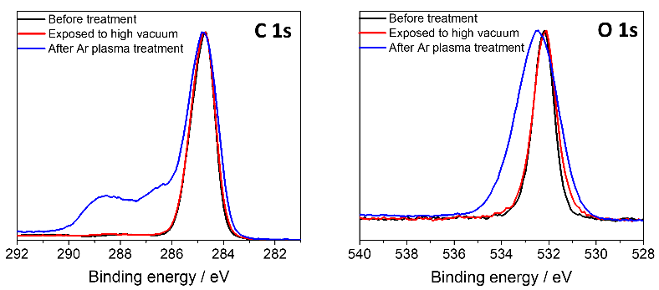
Figure 3. XPS Spectra of FS-5Dodec in the C1 region (left), O1 region (right) before and after Ar plasma treatment and after exposure to high vacuum. Treatment conditions: 20 minutes, 10 W, 10 mTorr.
We therefore used X-ray photoelectron spectroscopy (XPS) to analyse the FS-5Dode surface before and after Ar plasma treatment (Fig. 3). We found that the XPS spectra do indeed show changes to C1s and O1s regions after treatment (Figure 3; see Fig. S-33 and Fig. S-34 for peak fits). FS-5Dodec after plasma treatment showed a broader main peak to C 1s (ca. 285 eV) and O 1s region compared FS-5Dodec before plasma treatment, as well as the appearance of new species in the C 1s region. By contrast, we found that the sample that went through the vacuum treatment without plasma does not show changes to its surface chemical environment. The new features of FS-5Dodec after plasma treatment in the C1s region can be assigned to carboxylates (ca. 288.9 eV), ketones (ca. 287.7 eV), and alcohols (ca. 286.3 eV). Similar assignments have been made previously for Ar plasma treated polystyrene.²⁹ The shift in the UV/vis spectra after treatment is therefore possibly explained by the introduction of fluorenones on the bridge-head which alter the electronics,³⁴ or self-doping as previously observed for poly(fluorene) bearing carboxylates on the side-chain.³⁵
Scanning electron microscopy showed no changes to the surface morphology, ruling out that changes to the surface roughness are responsible for the enhanced wettability (Fig. S-35).²⁶ This is further evidence that chemical modification is the main cause of the observed effects on catalytic activity.
In summary, we have shown that films of a solution processible conjugated polymer photocatalyst can be modified by plasma treatment, resulting in materials with significantly increased photocatalytic activity. This can be explained by the enhanced wettability of the polymer film, which seems to have undergone chemical modification during the plasma treatment process with new polar functional groups appearing on the surface of the material. This study shows again that wettability is a key aspect for polymer photocatalysts, and we believe that plasma modification might be applicable to a wide range of other photocatalytically active materials, such as carbon nitrides.
We thank the Engineering and Physical Sciences Research Council (EPSRC) for financial support under Grant EP/N004884/1. Y.B. thanks the China Scholarship Council for a Ph.D. studentship. We thank Dr Keith Arnold for help with SEM measurements. Dr Warren Duffy and Prof. Iain McCulloch are thanked for help with PESA measurements.
Conflicts of interest
There are no conflicts to declare
Notes and references
1 A. Kudo and Y. Miseki, Chem. Soc. Rev., 2009, 38, 253–278.
2 T. Hisatomi, J. Kubota and K. Domen, Chem. Soc. Rev., 2014, 43, 7520–7535.
3 X. Wang, G. Zhang and Z.-A. Lan, Angew. Chem. Int. Ed., 2016, 55, 15712–15727.
4 J. Jayakumar and H. Chou, ChemCatChem, 2020, DOI: cctc.201901725.
5 T.-X. Wang, H.-P. Liang, D. A. Anito, X. Ding and B.-H. Han, J. Mater. Chem. A, 2020, DOI: 10.1039/D0TA00364F.
6 X. Wang, K. Maeda, A. Thomas, K. Takanabe, G. Xin, J. M. Carlsson, K. Domen and M. Antonietti, Nat. Mater., 2009, 8, 76–80.
7 D. Kong, Y. Zheng, M. Kobielusz, Y. Wang, Z. Bai, W. Macyk, X. Wang and J. Tang, Mater. Today, 2018, 21, 897–924.
8 R. S. Sprick, J. X. Jiang, B. Bonillo, S. Ren, T. Ratvijitvech, P. Guiglion, M. A. Zwijnenburg, D. J. Adams and A. I. Cooper, J. Am. Chem. Soc., 2015, 137, 3265–3270.
9 Y. S. Kochergin, D. Schwarz, A. Acharjya, A. Ichangi, R. Kulkarni, P. Eliášová, J. Vacek, J. Schmidt, A. Thomas and M. J. Bojdys, Angew. Chem. Int. Ed., 57, 2018, 14188–14192.
10 L. Li, Z. Cai, Q. Wu, W. Y. Lo, N. Zhang, L. X. Chen and L. Yu, J. Am. Chem. Soc., 2016, 138, 7681–7686.
11 K. Lin, Z. Wang, Z. Hu, P. Luo, X. Yang, X. Zhang, M. Rafiq, F. Huang and Y. Cao, J. Mater. Chem. A, 2019, 19087–19093.
12 R. S. Sprick, B. Bonillo, R. Clowes, P. Guiglion, N. J. Brownbill, B. J. Slater, F. Blanc, M. A. Zwijnenburg, D. J. Adams and A. I. Cooper, Angew. Chem. Int. Ed., 2016, 55, 1792–1796.
13 M. Sachs, R. S. Sprick, D. Pearce, S. A. J. Hillman, A. Monti, A. A. Y. Guilbert, N. J. Brownbill, S. Dimitrov, X. Shi, F. Blanc, M. A. Zwijnenburg, J. Nelson, J. R. Durrant and A. I. Cooper, Nat. Commun., 2018, 9, 4968.
14 Y. Bai, L. Wilbraham, B. J. Slater, M. A. Zwijnenburg, R. S. Sprick and A. I. Cooper, J. Am. Chem. Soc., 2019, 141, 9063–9071.
15 P.-J. J. Tseng, C.-L. L. Chang, Y.-H. H. Chan, L.-Y. Y. Ting, P.-Y. Y. Chen, C.-H. H. Liao, M.-L. L. Tsai and H.-H. H. Chou, ACS Catal., 2018, 8, 7766–7772.
16 J. Bi, W. Fang, L. Li, J. Wang, S. Liang, Y. He, M. Liu and L. Wu, Macromol. Rapid Commun., 2015, 36, 1799–1805.
17 K. Wang, L. Yang, X. Wang, L. Guo, G. Cheng, C. Zhang, S. Jin, B. Tan and A. Cooper, Angew. Chem. Int. Ed., 2017, 56, 14149-14153.
18 L. Guo, Y. Niu, S. Razzaque, B. Tan and S. Jin, ACS Catal., 2019, 9, 9438–9445.
19 T. Banerjee, F. Haase, G. Savasci, K. Gottschling, C. Ochsenfeld and B. V Lotsch, J. Am. Chem. Soc., 2017, 139, 16228–16234.
20 V. S. Vyas, F. Haase, L. Stegbauer, G. Savasci, F. Podjaski, C. Ochsenfeld and B. V Lotsch, Nat. Commun., 2015, 6, 8508.
21 P. Pachfule, A. Acharjya, J. Roeser, T. Langenhahn, M. Schwarze, R. Schomäcker, A. Thomas and J. Schmidt, J. Am. Chem. Soc., 2018, 140, 1423–1427.
22 S. Matsuoka, H. Fujii, T. Yamada, C. Pac, A. Ishida, S. Takamuku, M. Kusaba, N. Nakashima and S. Yanagida, J. Phys. Chem., 1991, 95, 5802–5808.
23 D. J. Woods, R. S. Sprick, C. L. Smith, A. J. Cowan and A. I. Cooper, Adv. Energy Mater., 2017, 7, 1700479.
24 Z. Hu, Z. Wang, X. Zhang, H. Tang, X. Liu, F. Huang and Y. Cao, iScience, 2019, 13, 33–42.
25 F. Garbassi, A. Sommazzi, L. Meda, G. Mestroni and A. Sciutto, Polymer, 1998, 39, 1503–1506.
26 C. K. Akkan, M. Hammadeh, S. Brück, H. W. Park, M. Veith, H. Abdul-Khaliq and C. Aktas, Mater. Lett., 2013, 109, 261–264.
27 M. Morra, E. Occhiello and F. Garbassi, Langmuir, 1989, 5, 872–876.
28 M. Dhayal, M. R. Alexander and J. W. Bradley, Appl. Surf. Sci., 2006, 252, 7957–7963.
29 R. M. France and R. D. Short, Langmuir, 1998, 14, 4827–4835.
30 R. S. Sprick, Y. Bai, A. A. Y. Guilbert, M. Zbiri, C. M. Aitchison, L. Wilbraham, Y. Yan, D. J. Woods, M. A. Zwijnenburg and A. I. Cooper, Chem. Mater., 2019, 31, 305–313.
31 S. Matsuoka, H. Fujii, T. Yamada, C. Pac, a Ishida, S. Takamuku, M. Kusaba, N. Nakashima, S. Yanagida, K. Hashimoto and T. Sakata, J. Phys. Chem., 1991, 95, 5802–5808.
32 J. Kosco, M. Sachs, R. Godin, M. Kirkus, L. Francas, M. Bidwell, M. Qureshi, D. Anjum, J. R. Durrant and I. McCulloch, Adv. Energy Mater., 2018, 8, 1802181.
33 R. A. Lawton, C. R. Price, A. F. Runge, W. J. Doherty and S. S. Saavedra, Colloids Surfaces A Physicochem. Eng. Asp., 2005, 253, 213–215.
34 K. Becker, J. M. Lupton, J. Feldmann, B. S. Nehls, F. Galbrecht, D. Gao and U. Scherf, Adv. Funct. Mater., 2006, 16, 364–370.
35 M. Ranger and M. Leclerc, Chem. Commun., 1997, 3, 1597–1598.

