SUPPLEMENTARY TABLES AND FIGURES

Supplementary Table 1: Search strategy conducted in PubMed
Search terms
#1 | ((heat* or hot* or humid* or high-flow or "high flow" or highflow or "higher flow")) AND (nasal adj3 (cannul* or prong*)
#2 | (((((HFT) OR HHHFNC) OR HFNC) OR fisher &paykel) OR (fisher and paykel)) OR vapotherm
#3 | (#1 or #2)
#4 | ((oxygen*) AND inhalat*) AND (therap* or deliver*)
#5 | (((low flow or low-flow)) AND nasal) AND (prong* or cannul*)
#6 | ((NCPAP) OR NCPAP) OR LFNC
#7 | ((oxygen* or high-freq*)) AND (inhalat* or ventilat* or deliver* or admin*)
#8 | (((continu*) AND positiv*) AND air*) AND press*
#9 | ((posit*) AND press*) AND (end-expirat* or respirat*)
#10 | (#4 or #5 or #6 or #7 or #8 or #9)
#11 | (infant* or child* or bab* or birth* or newborn* or neonat* or preterm* or prematur* or preterm*)
#12 | (#3 and #10 and #11)
#13 | ("2014/03/01"[Date - Entrez] : "2014/09/09"[Date - Entrez])
#14 | (#12 and #13)

Supplementary Table 2: Search strategy conducted in Ovid MEDLINE
Search terms
1 | ((heat* or hot* or humid* or high-flow or "high flow" or highflow or "higher flow") adj5 (nasal adj3 (cannul* or prong*))). mp.
2 | ((high-flow or "high flow" or highflow or "higher flow") adj4 (therap* or treat*)). mp.
3 | HFT. mp.
4 | HHHFNC. mp.
5 | HFNC. mp.
6 | Fisher &Paykel Healthcare HHHFNC. mp.
7 | Vapotherm 2000i. mp.
8 | vapotherm*. mp.
9 | "fisher and paykel". mp.
10 | "fisher&paykel". mp.
11 | or/1-10
12 | exp Oxygen Inhalation Therapy/
13 | (oxygen* adj4 inhalat* adj4 (therap* or deliver*)). mp
14 | ((low flow or low-flow) adj5 (nasal adj3 (prong* or cannul*))). mp.
15 | exp Continuous Positive Airway Pressure/
16 | exp Administration, Inhalation/
17 | NCPAP. mp.
18 | NCPAP. mp.
19 | LFNC. mp.
20 | exp High-Frequency Ventilation/
21 | exp Positive-Pressure Respiration/
22 | ((oxygen* or high-freq*) adj4 (inhalat* or ventilat* or deliver* or admin*)). mp.
23 | (continu* adj4 positiv* adj4 air* adj4 press*). mp.
24 | (posit* adj4 press* adj4 (end-expirat* or respirat*)). mp.
25 | or/12-24
26 | exp Infant, Premature/
27 | (infant* or child* or bab* or birth* or newborn* or neonat* or preterm* or prematur* or preterm*). mp.
28 | infant/ or infant, newborn/ or infant, low birth weight/
29 | infant care/ or intensive care, neonatal/
30 | Infant, Newborn, Diseases/
31 | Infant, Premature, Diseases/
32 | or/26-31
33 | 11 and 25 and 32

Supplementary Table 3: Search strategy conducted in Ovid Embase
Search terms
1 | ((heat* or hot* or humid* or high-flow or "high flow" or highflow or "higher flow") adj5 (nasal adj3 (cannul* or prong*))). mp.
2 | ((high-flow or "high flow" or highflow or "higher flow") adj4 (therap* or treat*)). mp.
3 | (HFT or HHHFNC or HFNC). mp.
4 | (Vapotherm 2000i or vapotherm*). mp.
5 | ("fisher&paykel" or "fisher and paykel"). mp.
6 | or/1-5
7 | exp oxygen therapy/
8 | (oxygen* adj4 inhalat* adj4 (therap* or deliver*)). mp.
9 | ((low flow or low-flow) adj5 (nasal adj3 (prong* or cannul*))). mp.
10 | exp positive end expiratory pressure/
11 | exp inhalational drug administration/
12 | (NCPAP or NCPAP or LFNC). mp.
13 | exp high frequency ventilation/
14 | ((oxygen* or high-freq*) adj4 (inhalat* or ventilat* or deliver* or admin*)). mp.
15 | (continu* adj4 positiv* adj4 air* adj4 press*). mp.
16 | (posit* adj4 press* adj4 (end-expirat* or respirat*)). mp.
17 | or/7-16
18 | exp prematurity/
19 | (infant* or child* or bab* or birth* or newborn* or neonat* or preterm* or prematur* or preterm*). mp.
20 | exp low birth weight/ or exp extremely low birth weight/ or exp small for date infant/ or exp very low birth weight/
21 | newborn disease/
22 | newborn intensive care/
23 | or/18-22
24 | and/6, 17, 23

Supplementary Table 4: Search strategy conducted in the Cochrane Library (CDSR/Central/DARE/HTA)
Search terms
#1 | ((heat* or hot* or humid* or high-flow or "high flow" or highflow or "higher flow") near/5 (nasal near/3 (cannul* or prong*)))
#2 | ((high-flow or "high flow" or highflow or "higher flow") near/4 (therap* or treat*))
#3 | HFT
#4 | HHHFNC
#5 | HFNC
#6 | Fisher &Paykel Healthcare HHHFNC
#7 | Vapotherm 2000i
#8 | vapotherm*
#9 | "fisher and paykel"
#10 | "fisher &paykel"
#11 | #1 or #2 or #3 or #4 or #5 or #6 or #7 or #8 or #9 or #10
#12 | MeSH descriptor: [Oxygen Inhalation Therapy] explode all trees
#13 | (oxygen* near/4 inhalat* near/4 (therap* or deliver*))
#14 | ((low flow or low-flow) near/5 (nasal near/3 (prong* or cannul*)))
#15 | MeSH descriptor: [Continuous Positive Airway Pressure] explode all trees
#16 | MeSH descriptor: [Administration, Inhalation] explode all trees
#17 | NCPAP
#18 | NCPAP
#19 | LFNC
#20 | MeSH descriptor: [High-Frequency Ventilation] explode all trees
#21 | MeSH descriptor: [Positive-Pressure Respiration] explode all trees
#22 | ((oxygen* or high-freq*) near/4 (inhalat* or ventilat* or deliver* or admin*))
#23 | (continu* near/4 positiv* near/4 air* near/4 press*)
#24 | (posit* near/4 press* near/4 (end-expirat* or respirat*))
#25 | #12 or #13 or #14 or #15 or #16 or #17 or #18 or #19 or #20 or #21 or #22 or #23 or #24
#26 | MeSH descriptor: [Infant, Premature] explode all trees
#27 | (infant* or child* or bab* or birth* or newborn* or neonat* or preterm* or prematur* or preterm*)
#28 | MeSH descriptor: [Infant] explode all trees
#29 | MeSH descriptor: [Infant, Newborn] explode all trees
#30 | MeSH descriptor: [Infant, Low Birth Weight] explode all trees
#31 | MeSH descriptor: [Infant Care] explode all trees
#32 | MeSH descriptor: [Intensive Care, Neonatal] explode all trees
#33 | MeSH descriptor: [Infant, Premature, Diseases] explode all trees
#34 | MeSH descriptor: [Infant, Newborn, Diseases] explode all trees
#35 | #26 or #27 or #28 or #29 or #30 or #31 or #32 or #33 or #34
#36 | #11 and #25 and #35

Supplementary Table 5: Risk of bias assessment (Post-extubation analysis)
Studies | Randomisation |  |  | Baseline comparability |  | Eligibility criteria specified | Co-interventions specified | Blinding |  |  | Withdrawals |  | Intention to treat
 | Truly Random | Allocation concealment | Number stated | Presented | Achieved |  |  | Assessors | Administrators | Participants | >80% in final analysis | Reasons stated
Collins et al 2013 (1) |  |  |  |  | / |  |  |  |  |  |  | NA
Manley et al 2013 (2) |  |  |  |  |  |  |  |  |  |  |  | NA
Yoder et al 2013 (3) |  |  |  | § | § |  |  |  |  |  |  | NA § | §
Collaborative group 2014 (4) |  |  |  | * | * |  |  |  |  |  | / * | N* *
Mostafa-Gharehbaghi 2014 (5) |  | NS |  |  |  |  |  |  |  |  |  | NA
Chen et al 2015 ⁽⁶⁾ | NS | NS |  |  |  |  |  |  |  |  |  | NA
Kadivar et al 2016 (7) |  | NS | / † |  |  |  |  |  |  |  | † |  | †
Kang et al 2016 (8) | NS | NS |  |  |  |  |  |  |  |  |  | NA
Elkhwad et al 2017 (9)
Sonsawad et al 2017 (10) |  |  |  |  |  |  |  |  |  |  |  | NA
= no, = yes, / = partially, NS = Not stated, NA = not applicable
§ Yoder et al 2013 (3) presented data for all study participants, a population of 432 infants who were both preterm, term and post-term and hence baseline characteristics were only presented for this mixed population. Although it is stated that the primary outcome was conducted as an intention to treat analysis for the whole trial population, data extracted from the Cochrane review by Wilkinson et al 2016 (11) for the post-extubation population show that for the following outcomes, a small number of participants were missing from the analysis: re-intubation <3 days (the primary outcome for this study), BPD and nasal trauma
* The Collaborative Group 2014 (4) presented data for all study participants, a population of 255 infants who were both preterm (n = 150) and term (n = 105), hence baseline characteristics were only presented for this mixed population; furthermore, the analysis of interest was the subgroup of preterm infants which constituted 58.8% of all participants and hence <80% in final analysis although no drop outs were reported in the study
† It is stated by Kadivar et al 2016 (7) that 108 infants were randomised in this study (54 participants in each arm), as also shown in the CONSORT flow diagram. However, baseline data and results are only reported for 54 patients (27 participants in each arm) with no explanation as to what happened to the other 54 participants

Supplementary Table 6: Risk of bias assessment (Analysis of primary respiratory support)
Studies | Randomisation |  |  | Baseline comparability |  | Eligibility criteria specified | Co-interventions specified | Blinding |  |  | Withdrawals |  | Intention to treat
 | Truly Random | Allocation concealment | Number stated | Presented | Achieved |  |  | Assessors | Administrators | Participants | >80% in final analysis | Reasons stated
Nair and Karna 2005 (12) § | NS | NS |  |  |  | / |  |  |  |  |  | NA
Iranpour et al 2011 (13) | NS | NS |  |  |  |  |  |  |  |  |  | NA
Yoder et al 2013 (3) |  |  |  | * | * |  |  |  |  |  |  | NA * | *
Klingenberg et al 2014 (14) | NS | NS |  | NA † | NA † |  |  |  |  |  |  |  | NS
Kugelman et al 2014 (15) | / |  |  |  |  |  |  |  |  |  |  | NA
Glackin et al 2016 (16) | NS |  |  |  |  |  |  |  |  |  |  | NA
Lavizzari et al 2016 (17)
Roberts et al 2016 (18)
Shin et al 2017 (19)
Murki et al 2018 (20)
= no, = yes, / = partially, NS = Not stated, NA = not applicable
§ Nair and Karna 2005 only reported their study as a conference abstract and so less information was available to assess the risk of bias than in a fully published paper
* Yoder et al 2013 (3) presented data for all study participants, a population of 432 infants who were both preterm, term and post-term and hence baseline characteristics were only presented for this mixed population. Although it is stated that the primary outcome was conducted as an intention to treat analysis for the whole trial population, data extracted from the Cochrane review by Wilkinson et al 2016 (11) for the analysis of primary respiratory support show that for BPD, a small number of participants were missing from the analysis
† The study by Klingenberg et al 2014 (14) was a crossover trial, hence baseline characteristics were presented for all participants and comparability (and whether or not it is achieved) is not applicable

Supplementary Table 7: GRADE ratings for HHHFNC versus NIPPV (Analysis of primary respiratory support: Preterm infants with no prior mechanical endotracheal ventilation)
Certainty assessment ª |  |  |  |  |  | № of patients |  | Effect |  | Certainty
Outcome | № of studies | Risk of bias | Inconsistency | Indirectness | Imprecision | HHHFNC | NIPPV | Relative  (95% CI) | Absolute  (95% CI) | Quality
Intubation/ Critical | 1 | not serious | not serious | not serious | very serious ^{b} | 11/38 (28.9%) | 13/38 (34.2%) | RR 0.85  (0.44 to 1.65) | 51 fewer per 1,000  (from 192 fewer to 222 more) | ⨁◯◯◯  Very low
BPD/ Important | 1 | not serious | not serious | not serious | very serious ^{b} | 1/38 (2.6%) | 3/38 (7.9%) | RR 0.33  (0.04 to 3.06) | 53 fewer per 1,000  (from 76 fewer to 163 more) | ⨁◯◯◯  Very low
Death/ Critical | 1 | not serious | not serious | not serious | very serious ^{b} | 0/38 (0.0%) | 0/38 (0.0%) | not estimable |  | ⨁◯◯◯  Very low
Air leak/ Important | 1 | not serious | not serious | not serious | very serious ^{b} | 2/38 (5.3%) | 0/38 (0.0%) | RR 5.00  (0.25 to 100.80) | 0 fewer per 1,000  (from 0 fewer to 0 fewer) | ⨁◯◯◯  Very low
Nasal trauma/ Important | 1 | not serious | not serious | not serious | very serious ^{b} | 0/38 (0.0%) | 0/38 (0.0%) | not estimable |  | ⨁◯◯◯  Very low
BPD = bronchopulmonary dysplasia; HHHFNC = heated humidified high-flow nasal cannula; NIPPV = nasal intermittent positive pressure ventilation
- The GRADE criteria for the certainty assessment also include an assessment of publication bias. It was not possible to test for publication bias by use of funnel plots as we only identified one study (15)
- As there is only one study with a small number of participants and very few or no events (15), imprecision is considered to be very serious as the publication of another study of HHHFNC versus NIPPV could change both the estimate and direction of effect

Supplementary Figure 1: PRISMA flow diagram

Records identified through database searching
(n = 1492)

Records excluded
(n = 741)
Records screened after duplicate removed
(n = 809)

Full-text articles assessed for eligibility
(n = 68)

Full-text articles excluded (n = 52):
- Not heated HFNC
(n = 9)
- Wrong comparator
(n = 1)
- Wrong population
(n = 2)
- Not RCT
(n = 35)
- Not efficacy / safety study
(n = 4)
- Article retracted
(n = 1)

Studies included in post-extubation analysis
(n = 10)†
Meta-analysis, n = 10

Studies included in analysis of primary respiratory support after birth
(n = 10)†
Meta-analysis, n = 8

Records / studies included
(n = 26 / n = 19)*

* 26 papers report on 19 separate studies
† One study included in both the analysis of post-extubation and primary respiratory support
HFNC = high-flow nasal cannula; RCT = randomized controlled trial

Supplementary Figure 2: Meta-analysis for efficacy outcomes: preterm infants treated following mechanical endotracheal ventilation (post-extubation analysis)
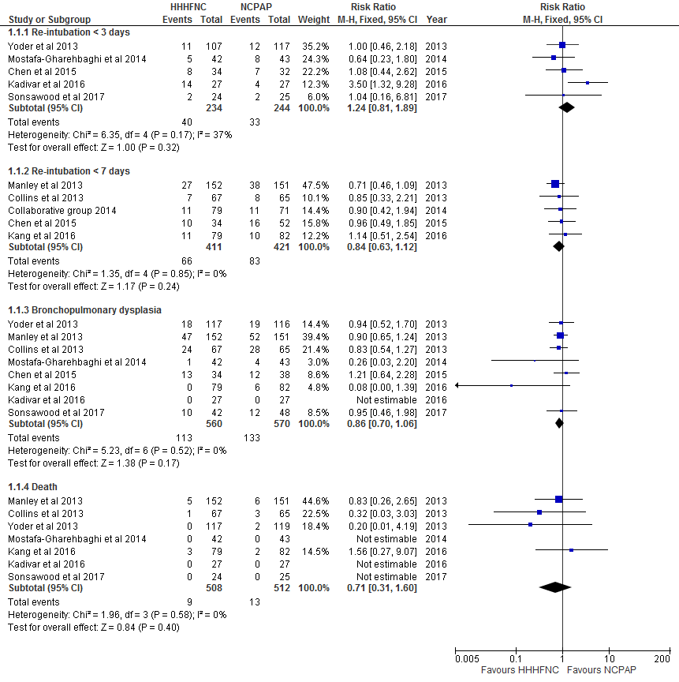

Supplementary Figure 3: Meta-analysis for safety outcomes: preterm infants treated following mechanical endotracheal ventilation (post-extubation analysis)
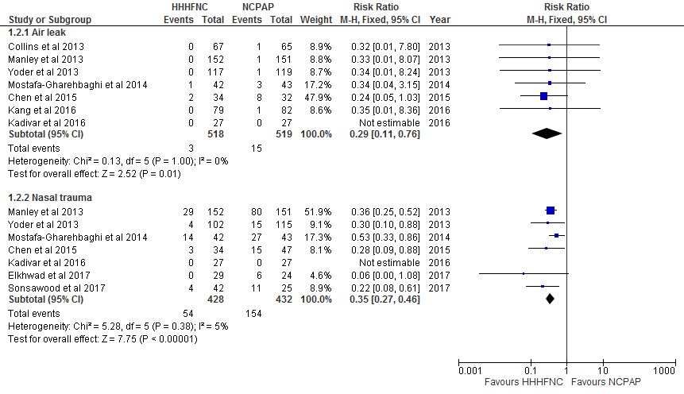

Supplementary Figure 4: Meta-analysis for efficacy outcomes: preterm infants with no prior mechanical endotracheal ventilation (primary respiratory support)
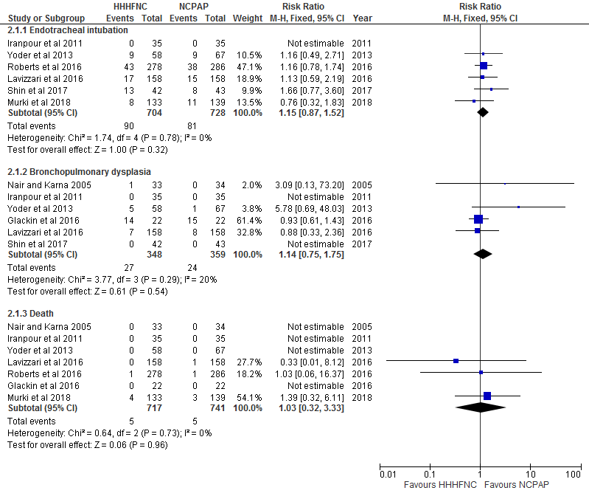

Supplementary Figure 5: Meta-analysis for safety outcomes: preterm infants with no prior mechanical endotracheal ventilation (primary respiratory support)
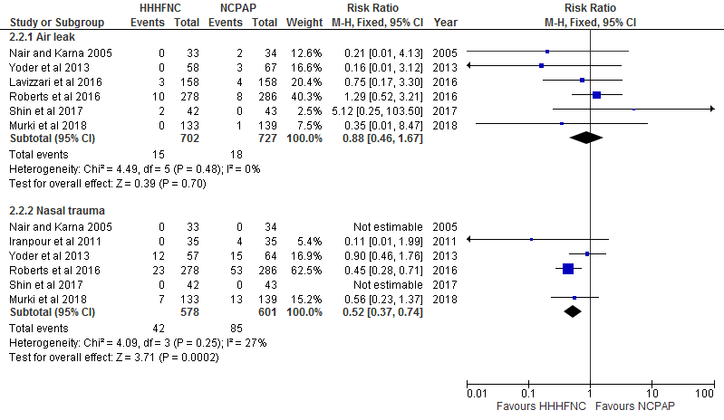

References
1. Collins CL, Holberton JR, Barfield C, Davis PG. A randomized controlled trial to compare heated humidified high-flow nasal cannulae with nasal continuous positive airway pressure postextubation in premature infants. J Pediatr. 2013;162(5):949-54.e1.
2. Manley BJ, Owen LS, Doyle LW, Andersen CC, Cartwright DW, Pritchard MA, et al. High-flow nasal cannulae in very preterm infants after extubation. N Engl J Med. 2013;369(15):1425-33.
3. Yoder BA, Stoddard RA, Li M, King J, Dirnberger DR, Abbasi S. Heated, humidified high-flow nasal cannula versus nasal CPAP for respiratory support in neonates. Pediatrics. 2013;131(5):e1482-90.
4. Collaborative Group for the Multicenter Study on Heated Humidified High-flow Nasal Cannula Ventilation. [Efficacy and safety of heated humidified high-flow nasal cannula for prevention of extubation failure in neonates]. Zhonghua Er Ke Za Zhi. 2014;52(4):271-6.
5. Mostafa-Gharehbaghi M, Mojabi H. Comparing the effectiveness of nasal continuous positive airway pressure (NCPAP) and high flow nasal cannula (HFNC) in prevention of post extubation assisted ventilation. Zahedan J Res Med Sci. 2014;17(6):e984.
6. Chen J, Gao WW, Xu F, Du LL, Zhang T, Ling X, et al. [Comparison of clinical efficacy of heated humidified high flow nasal cannula versus nasal continuous positive airway pressure in treatment of respiratory distress syndrome in very low birth weight infants]. Zhongguo Dang Dai Er Ke Za Zhi. 2015;17(8):847-51.
7. Kadivar MM, Mosayebi ZM, Razi NM, Nariman SM, Sangsari RM. High flow nasal cannulae versus nasal continuous positive airway pressure in neonates with respiratory distress syndrome managed with insure method: a randomized clinical trial. Iran J Med Sci. 2016;41(6):494-500.
8. Kang WQ, Xu BL, Liu DP, Zhang YD, Guo J, Li ZH, et al. [Efficacy of heated humidified high-flow nasal cannula in preterm infants aged less than 32 weeks after ventilator weaning]. Zhongguo Dang Dai Er Ke Za Zhi. 2016;18(6):488-91.
9. Elkhwad M, Dako J, Jennifer G, Harriet F, Anand K. Randomized control trial: heated humidity high flow nasal cannula in comparison with ncpap in the management of rds in extreme low birth infants in immediate post extubation period. J Neonat Pediatr Med. 2017;3(1).
10. Soonsawad S, Tongsawang N, Nuntnarumit P. Heated humidified high-flow nasal cannula for weaning from continuous positive airway pressure in preterm infants: a randomized controlled trial. Neonatology. 2016;110(3):204-9.
11. Wilkinson D, Andersen C, O'Donnell CP, De Paoli AG, Manley BJ. High flow nasal cannula for respiratory support in preterm infants. Cochrane Database Syst Rev. 2016;2:CD006405.
12. Nair G, Karna P. Comparison of the effects of vapotherm and nasal CPAP in respiratory distress in preterm infants. PAS. 2005;57:2054.
13. Iranpour R, Sadeghnia A, Hesaraki M. High-flow nasal cannula versus nasal continuous positive airway pressure in the management of respiratory distress syndrome. J Isfahan Med Sch. 2011;29(143):761-72.
14. Klingenberg C, Pettersen M, Hansen EA, Gustavsen LJ, Dahl IA, Leknessund A, et al. Patient comfort during treatment with heated humidified high flow nasal cannulae versus nasal continuous positive airway pressure: A randomised cross-over trial. Arch Dis Child Fetal Neonatal Ed. 2014;99(2):F134-f7.
15. Kugelman A, Riskin A, Said W, Shoris I, Mor F, Bader D. A randomized pilot study comparing heated humidified high-flow nasal cannulae with NIPPV for RDS. Pediatr Pulmonol. 2014;50(6):576-83.
16. Glackin SJ, O'Sullivan A, George S, Semberova J, Miletin J. High flow nasal cannula versus NCPAP, duration to full oral feeds in preterm infants: a randomised controlled trial. Arch Dis Child Fetal Neonatal Ed. 2016;23:23.
17. Lavizzari A, Colnaghi M, Ciuffini F, Veneroni C, Musumeci S, Cortinovis I, et al. Heated, humidified high-flow nasal cannula vs nasal continuous positive airway pressure for respiratory distress syndrome of prematurity: a randomized clinical noninferiority trial. Jama, Pediatr. 2016;08:08.
18. Roberts CT, Owen LS, Manley BJ, Froisland DH, Donath SM, Dalziel KM, et al. Nasal high-flow therapy for primary respiratory support in preterm infants. N Engl J Med. 2016;375(12):1142-51.
19. Shin J, Park K, Lee EH, Choi BM. Humidified high flow nasal cannula versus nasal continuous positive airway pressure as an initial respiratory support in preterm infants with respiratory distress: a randomized, controlled non-inferiority trial. J Korean Med Sci. 2017;32(4):650-5.
20. Murki S, Singh J, Khant C, Kumar Dash S, Oleti TP, Joy P, et al. High-Flow Nasal Cannula versus Nasal Continuous Positive Airway Pressure for Primary Respiratory Support in Preterm Infants with Respiratory Distress: A Randomized Controlled Trial. Neonatology. 2018:235-41.

