Total word count: 9180

Acorn: Developing Full-chain Industrial Carbon Capture and Storage in a Resource- and Infrastructure-Rich Hydrocarbon Province
Juan Alcalde^{1,2}, Niklas Heinemann³, Leslie Mabon⁴, Richard H. Worden⁵, Heleen de Coninck⁶, Hazel Robertson⁷, Marko Maver⁸, Saeed Ghanbari⁹, Floris Swennenhuis⁶, Indira Mann¹⁰, Tiana Walker⁷, Sam Gomersal⁷, Clare E. Bond¹, Michael J. Allen⁵, R. Stuart Haszeldine³, Alan James⁷, Eric J. Mackay⁹, Peter A. Brownsort¹⁰, Daniel R. Faulkner⁵, Steve Murphy⁷
¹Department of Geology and Petroleum Geology, University of Aberdeen, Aberdeen AB24 3FX, UK
²Institute of Earth Sciences Jaume Almera ICTJA-CSIC, C/ Lluís Solé I Sabarís s/n, 08028, Barcelona, Spain
³School of Geosciences, University of Edinburgh, Grant Institute, West Main Road, Edinburgh, EH9 3JW, UK
⁴School of Applied Social Studies, Robert Gordon University, Garthdee Road, Aberdeen AB10 7QG, UK
⁵Department of Earth, Ocean and Ecological Sciences, University of Liverpool, 4 Brownlow Street, Liverpool L69 3GP, UK
⁶Department of Environmental Science, Institute for Water and Wetland Research, Faculty of Science, Radboud University, Heyendaalseweg 135, 6525 AJ Nijmegen, The Netherlands
⁷Pale Blue Dot Energy, Bratherns Eco-Business Park, Banchory, AB 31 4BW, UK6
⁸Bellona Europa, Rue d'Egmont 15, 1000 Brussels, Belgium
⁹Institute of Petroleum Engineering, Heriot-Watt University, Riccarton, Edinburgh EH14 4AS, UK
¹⁰Scottish Carbon Capture & Storage, School of GeoSciences, University of Edinburgh, Edinburgh Centre for Carbon Innovation, High School Yards, Infirmary Street, Edinburgh EH1 1LZ, UK

Keywords
Carbon Capture and Storage; infrastructure re-use; stakeholder engagement; just transition; full-chain CCS; cost-reduction
Research highlights
- Cost reduction and stakeholder support are essential for CCS industry development
- Acorn is aimed to develop a full-chain CCS system at minimum cost by the 2020s
- Infrastructure re-use and staged investment and development enable cost reduction
- Stakeholder and local community engagement is key to promote a just transition
- The Acorn experience can be implemented in regions with similar CCS needs

Abstract
Research to date has identified cost reduction and lack of support from stakeholders as two key barriers to the development of a carbon dioxide capture and storage (CCS) industry that is capable of effectively mitigating climate change. This paper responds to these challenges through systematic evaluation of the research and development process for the Acorn CCS project, a project designed to develop a scalable, full-chain CCS project on the north-east coast of the UK. Through assessment of Acorn’s publicly-available outputs, we identify strategies which may help to enhance the viability of early-stage CCS projects. Initial capital costs can be minimised by infrastructure re-use, particularly pipelines, and by re-use of data describing the subsurface acquired during oil and gas exploration activity. Also, development of the project in separate stages of activity (e.g. different phases of infrastructure re-use and investment into new infrastructure) enables cost reduction for future build-out phases. Additionally, engagement of regional-level policy makers may help to build stakeholder support by situating CCS within regional decarbonisation narratives. We argue that these insights may be translated to general objectives for any CCS project sharing similar characteristics such as legacy infrastructure, industrial clusters and an involved stakeholder-base that is engaged with the fossil fuel industry.
- Introduction
The 2015 Paris Agreement urged the world to reduce anthropogenic CO₂ emissions to hold the global mean temperature rise less than 2°C above pre-industrial levels, and to pursue efforts to limit the temperature increase to 1.5°C (United Nations, 2015; IPCC, 2018). There is a growing body of research arguing that this goal cannot be achieved without the capture of CO₂ from fossil fuel-fired power stations and industrial sources and its subsequent storage in the subsurface (CCS) (Haszeldine et al., 2018; Alcalde et al., 2018a). CCS may have an important role in balancing power generation with climate imperatives, and it arguably represents the only pathway to balance decarbonisation for industrial applications with continued production, such as steel manufacturing, cement works and petrochemicals (Wennersten et al., 2015; IPCC, 2018). Moreover, other technologies which may be required to achieve more drastic forms of mitigation – such as geological storage of hydrogen and direct air capture – rely on components of the CCS ‘chain’ to realise (Sanz-Perez et al., 2016; Heinemann et al., 2018a; Mandova et al., 2019).
Given the urgency with which climate mitigation action is required and the risk of ‘overshooting’ the targets set under international agreements, there is hence an argument that continued CCS research and development is necessary in addition to rapid deployment of renewable energy technologies (Mabon and Shackley, 2015). Nevertheless, there are only a small number of projects in operation globally with the sole purpose of storing CO₂ in the subsurface (Bui et al., 2018; Global CCS Institute - www.globalccsinstitute.com), with others using injection of captured CO₂ as an agent for Enhanced Oil Recovery (CO₂-EOR) (Worden and Smith, 2004; Damiani et al., 2012).
Research to date has identified two key barriers to wider CCS deployment. First is the total cost of CCS projects, both capital and operational. Investments into dedicated CO₂ storage projects are economically challenging (Wennersten et al., 2015; Bui et al., 2018; IPCC, 2018), especially if upfront and operational costs cannot be mitigated with revenues from enhanced hydrocarbon production in the way they are for CO₂-EOR projects (Alvarado and Manrique, 2010). Second is the lack of support from (or at least the tolerance of) stakeholders (e.g. de Coninck et al., 2009; Stigson et al., 2012; Chaudhry et al., 2013). Especially significant here is the lack of support from political and societal opinion-shapers such as environmental NGOs, who may view CCS as being associated with (and perpetuating) the negative social and environmental effects of the fossil fuel industry (Mabon and Littlecott, 2016).
The purpose of this paper is therefore to clarify pathways to wider CCS deployment, by offering insights into how the dual challenges of cost and stakeholder support may be managed. This is achieved through evaluation of the development process for a new, real-world CCS project – the Acorn project in north-east Scotland. We identify and assess four broad areas that have helped Acorn to progress towards deployment despite a challenging global context: infrastructure re-use; storage development plan design; low-carbon build-out; and the framing of CCS within a just transition. We conclude that based on the Acorn experience, (a) an emphasis on utilisation of existing infrastructure; (b) the production of a development plan across the whole CCS chain; and (c) the leadership of national and regional government in creating a compelling financial and societal case for CCS may aid CCS expansion globally.
- Case study region and project
The North Sea region may be considered a valuable learning site for the development of a CCS industry. It has (1) coastal industrial sites that generate significant localised CO₂ emissions, with large-scale CO₂ capture potential, (2) existing infrastructure, including gas pipelines, that can be re-used for CO₂ transport, thus reducing the initial capital cost of, and timescales to, development, and (3) an abundance of geologically-characterised potential storage sites. Oil and gas reservoirs in the UK continental shelf have a proven capability to retain buoyant fluids over geological timescales, and extensive subsurface data have been acquired in the last five decades that can be used to further inform CCS projects. The broader North Sea region also has over twenty years of CCS-related history, although only one CCS project is currently in operation: Sleipner, in the Norwegian North Sea, which started injection in 1996 in response to a Norwegian carbon tax (Eiken et al., 2011). Nevertheless, the North Sea Basin hence represents a logical focus for CCS developments (e.g. Stewart et al., 2014; Bentham et al., 2014), and multiple areas of the UK North Sea have been appraised for CO₂ storage over the past decade (e.g. Heinemann et al., 2012; Spence et al., 2014; Akhurst et al., 2015).
The aim of the Acorn project is to design and implement a full-chain CCS system at minimum capital cost of capture, transport and storage by the early 2020s in the Central North Sea Basin (Figure 1). The initial stage of the Acorn project, with CO₂ capture and storage from the St Fergus Gas Terminal, north of Aberdeen (UK), has been designed around a small, industrial-scale site, but the project has been designed to have the potential to be expanded and become an import hub for incremental development of a large-scale regional CCS network. The project is centred on St Fergus, which could be developed into a larger CCS hub in subsequent investment stages. St Fergus is connected to a series of offshore hydrocarbon fields via three pipelines, and is also connected to Peterhead Harbour through which CO₂ could also be imported via tankers. Additionally, St Fergus is connected to the Grangemouth industrial complex in central Scotland, a large point source of industrial CO₂, via a redundant UK National Grid gas pipeline, thus offering a potential additional source of CO₂ for future stages (Brownsort et al., 2016). Two geological storage sites, a primary and a reserve site, have been investigated in detail to establish a full chain scenario. Both geological storage sites are located in the vicinity of three gas pipelines that connect current natural gas producing reservoirs to the mainland at St Fergus. These two geological sites are well characterised due to decades of hydrocarbon exploration and production, and offer storage capacities large enough (> 50 Mt CO₂) to provide for the planned initial operations and to provide for further build-out options proposed by Acorn.
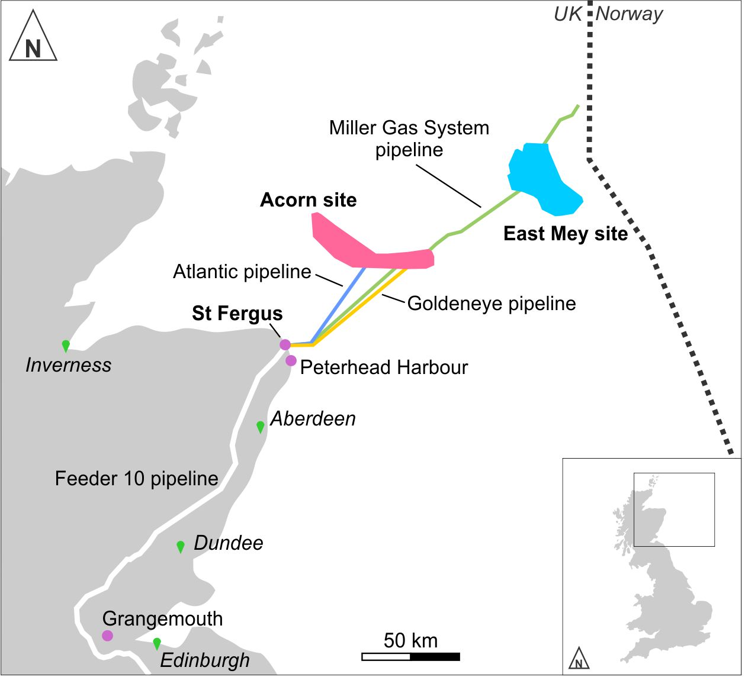
Figure 1: The Acorn project setting in the North Sea offshore Scotland. The two potential CO₂ storage sites are shown in pink (Acorn CO₂ storage site) and in light blue (East Mey storage site). The main re-usable infrastructure is also shown, including the three pipelines which could be re-used for CO₂ transport (Miller Gas System Pipeline in green; Atlantic Pipeline in blue and Goldeneye Pipeline in orange), the St Fergus gas terminal and Peterhead Harbour.
The development stages of Acorn have sought to surmount the challenges raised in Section 1 through a focus on building knowledge and capacity in a number of areas. These include (a) producing a costed technical development plan for a full-chain CCS hub based on emissions from the St Fergus Gas Terminal and storage in North Sea reservoirs; (b) identifying technical options to increase efficiency of the selected storage site through geomechanical experimentation and dynamic CO₂ flow modelling; (c) investigating available infrastructure re-use options to reduce capital expense; (d) exploring build-out options, including interconnections to the nearby Peterhead Port and to other large sources of CO₂ emissions in the UK; (e) identifying other potential locations for CCS hubs around the North Sea regions for future collaboration and/or knowledge-sharing; and (f) investigating framing and messaging to position CCS within rising awareness of the need for just transitions for workforces in carbon-intensive regions. An outline of these objectives and their interrelations is shown in Figure 2.
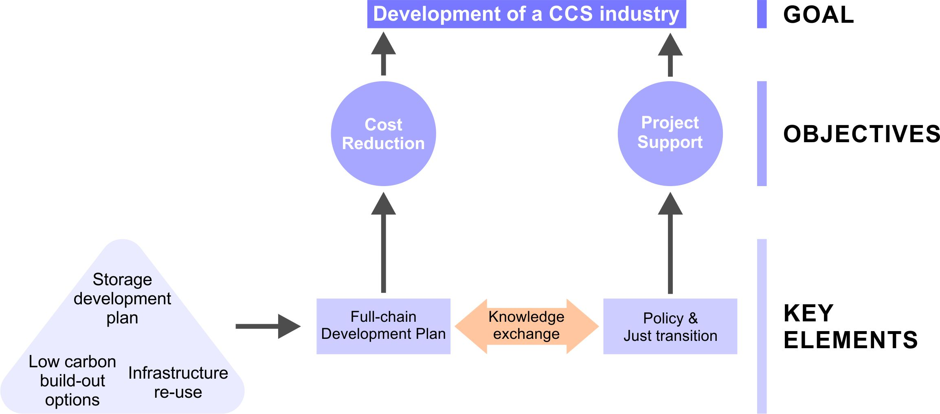
Figure 2: Key elements employed to address the objectives of cost reduction and (political, societal and stakeholder) project support, deemed critical for the development of a successful CCS project.
- Method
This paper is based on synthesis of publicly-available outputs from the first phase of the Acorn project – specifically, the phase moving the project from proof-of-concept through to design studies, funded through the European Union’s ERA-NET Accelerating CCS Technologies (ACT) programme. As a case study for the management of CCS research, development and deployment, the ACT Acorn project is valuable and significant for two reasons. Firstly, as this phase of this project is supported through public funds, the majority of underpinning research is publicly available and hence open to external scrutiny (see https://actacorn.eu/). Secondly, unlike other large research-driven CCS initiatives where outputs are publicly available (e.g. ECO2, www.eco2-project.eu; SiteChar, Neele et al., 2013 - www.sitechar-co2.eu), the underpinning studies within Acorn are done with the explicit intention of moving CCS towards commercial deployment. ACT Acorn hence represents a valuable opportunity to understand what can be learned from the research and development stages of a commercially focused CCS project.
To assess the extent to which insights from the ACT Acorn outputs may progress the state-of-the-art or carry applicability beyond the context of one specific project, evaluation of the ACT Acorn findings was supplemented with a review of current scholarly and industrial literature on CCS. The aim of this review was to understand where practices carried out within ACT Acorn may differ to those utilised elsewhere, and also to identify where actions undertaken within the research and development phase of Acorn could be improved in future deployment.
Through this synthesis and evaluation work, four broad themes of learning were identified within ACT Acorn: infrastructure re-use; storage development plan design; low-carbon build-out; and the framing of CCS within a just transition. Each of these is now evaluated in turn.

- Infrastructure re-use
The first area of learning from ACT Acorn which may have wider CCS applicability is that of infrastructure re-use. As oil and gas fields come to the end of their economic lifetimes and infrastructure is no longer required for its original use, they are planned for decommissioning and removal. However, decommissioning is expensive and developing new infrastructure for CO₂ storage projects is also capital-intensive. The idea proposed by Acorn is that existing infrastructure should be re-purposed for transport and storage of CO₂. The selective re-use of legacy assets, such as topsides (oil and gas production platforms), wells and pipelines, can offer significant cost savings and this represents an efficient approach to facilitate wider CCS deployment (ZEP, 2011; Gross, 2015; CCC, 2018). Research by the ACT Acorn project team showed that the retention and re-use of pipelines, and, to a lesser extent, other existing infrastructure such as platforms and wells, could significantly decrease the cost of CCS projects, particularly if that infrastructure is otherwise ready for decommissioning (ACT Acorn Project, 2018a). Premature decommissioning of pipeline infrastructure could increase the cost of CCS for Europe and kill-off an opportunity to kick-start an industry by increasing the project’s cost by over €600 million (Pale Blue Dot and Axis Well Technology, 2016).
There is now a risk that much of this useful infrastructure will be decommissioned (Ahinaga-Dagbui et al., 2017), precluding the lowest cost option for the development of CCS in this area, and perhaps indeed preventing any CO₂ transport and storage developments at all. Building new pipelines would increase the initial hurdle for CCS development and deployment in Europe by adding the capital cost of their replacement to the overall budget. It is therefore essential to highlight the importance of early engagement to discuss the re-usability of cost-reducing infrastructure that is already in place. We now discuss in more depth re-use opportunities and challenges across three areas: pipelines, platforms, and wells.
4.1. Pipeline re-use: If the decommissioning of pipelines is deferred, the operational costs of monitoring and maintenance are estimated to be relatively low compared to the cost of building and installing a new pipeline (DECC, 2012). However, the cost of re-use is strongly dependent on the length and physical condition of the pipeline after decades of hydrocarbon transport. The monitoring and maintenance costs depend on the length and condition of each pipeline. Re-purposing an existing pipeline generally includes various commissioning-type duties, such as drying the pipeline or running an intelligent pig (Coramik and Ege, 2017). The age, condition and pressure-rating of the pipeline are key factors in assessing the suitability of the pipeline. Older pipelines, or those that have experienced harsh production environments, may have problems with corrosion or other integrity concerns. Therefore, the potential for re-use of any pipeline depends both on technical and practical factors, such as proximity to a geological storage reservoir, estimated condition, legal- and permitting-requirements and liability arrangements.
The re-use cost profile must be assessed on a case-by-case basis. In the UK North Sea area, as in many other mature hydrocarbon areas, several suitable pipelines exist. Three of them, the Atlantic pipeline, the Goldeneye pipeline, and the Miller Gas System (MGS) pipeline, can be re-used to transport CO₂ from St Fergus to the Acorn storage site. Additionally, the MGS pipeline offers the opportunity for expansion of the CO₂ infrastructure into the Norwegian Continental Shelf. All three pipelines have been preserved in-situ under the Interim Pipeline Regime (DECC, 2018a) and are currently awaiting decommissioning. As an example of cost reduction, re-use of the Atlantic pipeline in the Acorn CCS project could have a capital cost of €38 million, whereas the cost of building a new pipeline could be over €110 million (Pale Blue Dot and Axis Well Technology, 2016; based on values from ZEP, 2011, and Benton, 2015).
4.2. Platform re-use: Offshore oil and gas production platforms can also be re-purposed for CO₂ injection, but there are significant technical, commercial and regulatory factors that need to be assessed on a case-by-case basis (Ahiaga-Dagbui et al., 2017). The main issues with re-purposing platforms and their topsides for CO₂ injection are the capital and operating costs (ACT Acorn, 2018a). Large complex oil and gas production facilities may require large-scale and costly modifications in order to be adapted to CO₂ injection operations. These modifications may include the removal of any unwanted facilities and the addition of CO₂ processing and injection facilities, such as filters, heaters, monitoring facilities etc. (e.g. Spence et al., 2014). A full refurbishment of health and safety systems such as flares and vents may also be required. Issues such as the continuing structural integrity of the jacket, on which the platform is based, or limited space on the platform, may also have implications on the economics of re-use. Additionally, there may be regulatory uncertainties, related to the granting of new permits, and on the question of liabilities from previous asset owners if ownership changes evolving from oil and gas production to CO₂ injection. For example, Jansen et al. (2011) calculated that the capital and operating costs for re-purposing a Southern North Sea gas platform, with four wells, was estimated to be €3 m/well and €2 m/well/year respectively, whereas costs for building and operating a new platform could reach €40 m/well and €1.5 m/well/year. In summary, economic issues may result in a new platform, or a subsea solution, being more cost effective than re-use of production facilities.
4.3. Well re-use: The basis for the design of an oil or gas production well is different from that of a CO₂ injection well (Bai et al., 2015). Therefore, although redundant oil and gas production wells could be repurposed for CO₂ injection, new wells are most likely to be required for CCS given the technical difficulties, risks and economic realities. Well design, in this respect, refers to the operating criteria which would make various elements of the well, such as existing wellhead, casing strings and downhole equipment, unlikely to be suitable for CO₂ injection. Those wells that may be considered suitable might carry a degree of risk and compromise, which, given the potential consequences, may not be considered acceptable. In addition, the condition of redundant wells is often uncertain and would require considerable assessment and/or remedial intervention to enable re-use, which could lead to a significant cost. The cost of re-using a well would include costs for assessment of the integrity of the wellbore, its casing and the downhole completion infrastructure, as well as some remedial and conversion work. For all these issues, well re-use is not considered suitable for the Acorn storage project, in spite of the potential cost savings of their use (ACT Acorn, 2018a).
- Storage development plan design
Similar to well-established field development plans utilised in the oil and gas industries, the storage development plan (SDP) lies at the heart of the planning process of a CCS project. The SDP contains, or is the product of, a summary of results and conclusions of all the geotechnical, engineering and scientific work required. Acorn represented one of the first times a storage development plan was developed for the UK Continental Shelf, and was designed to address the following questions:
5.1. Storage Resource and Injectivity - How much CO₂ can the site hold for a given development scenario? How easily can the CO₂ be injected?
These questions ultimately refer to the determination of the quality and suitability of the reservoir for CO₂ geological storage. To address these questions, geological characterisation followed by dynamic modelling of the site must be undertaken (Figure 3). The geological characterisation includes collation and interpretation of geological, petrophysical and geophysical data such as seismic data, wireline data and drilling information. As the foundation for all future technical work, geological characterisation is of paramount importance. The geology of the selected storage site must undergo a detailed investigation using all available subsurface data. The main tasks involve: seismic interpretation to understand the structure of the reservoir; a geomechanical analysis to determine rock strength and the stress field; a reservoir quality investigation of the reservoir formations to understand rock properties and reservoir heterogeneity; and well test and pressure data interpretation to understand reservoir conductivity and pressure response during CO₂ injection. The main outcome of these analyses is a static reservoir model of the subsurface formations which will subsequently be used to run numerical simulation of CO₂ injection and storage. In the ACT Acorn project, the geological characterisation was conducted for the two target reservoir sites, the primary Acorn storage site and the East Mey site. The Acorn storage site was already studied to a pre-FEED level in the Energy Technologies Institute’s Strategic UK CO₂ Storage Appraisal Project (Pale Blue Dot Energy and Axis Well Technology, 2016), and includes the Goldeneye depleted gas field, which was already appraised for CCS as part of the Peterhead-Goldeneye project (Tucker and Tinios, 2017). It is therefore a well known and very suitable storage site (ACT Acorn, 2018b). The East Mey site was characterised both as a reserve and an expansion option, to accommodate storage build-out opportunity (ACT Acorn, 2018c). The East Mey storage site also provides a low-cost, flexible and scalable storage option, and could be used as a potential backup of the Acorn site if required.
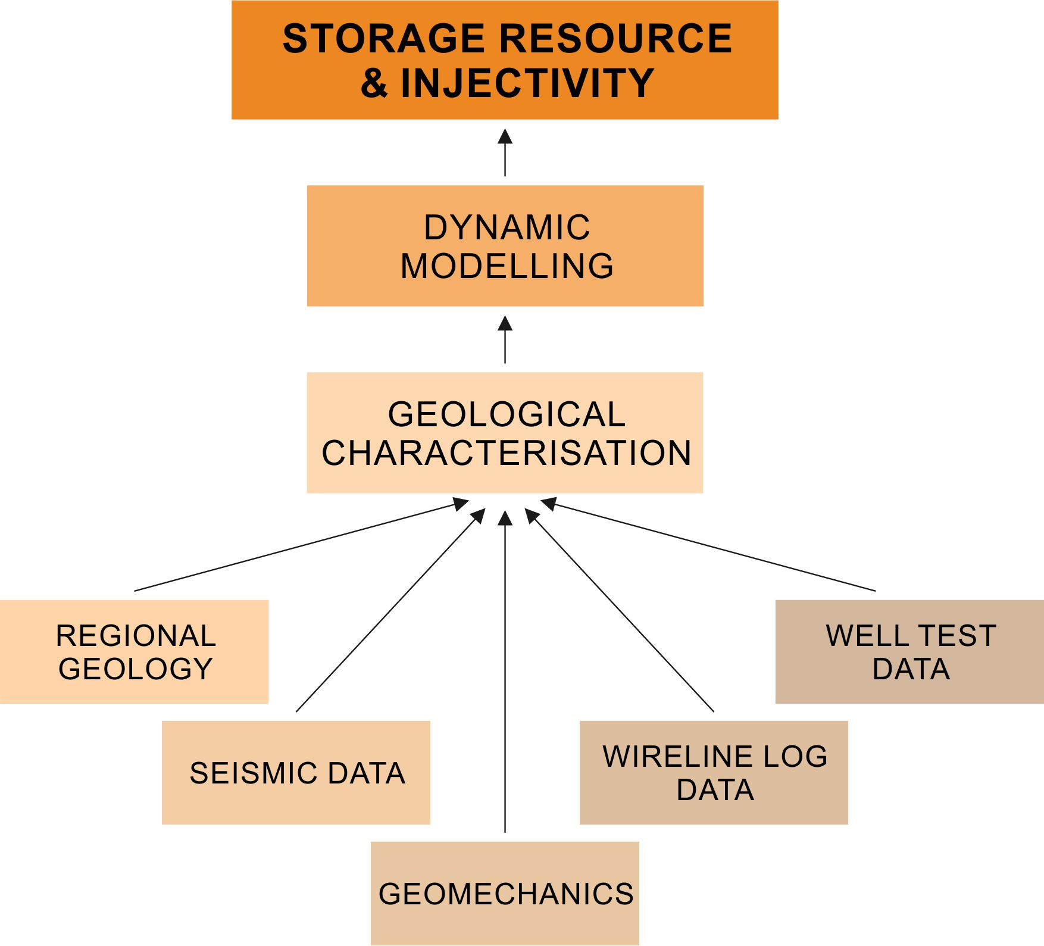
Figure 3: Workflow required for achieving the CO₂ storage resource and injectivity characterisation of the target storage site
The dynamic modelling stage follows directly from the geological characterisation and is key to an optimum understanding of the storage characteristics of the site selected. The main objective of the dynamic model is the numerical simulation of CO₂ injection and storage employing the static reservoir model developed in the previous stage. These dynamic simulations are critical to the identification of the most suitable injection locations and to forward-predict the individual injection performance for each well. This approach allows strategies to be developed to improve storage efficiency and security, and to estimate storage efficiency for individual injection strategies. The dynamic models also deliver predictions about the long-term fate of the injected CO₂ as a function of the different injection strategies considered. The injection modelling scenarios were designed to address the real-world CO₂ supply options for the Acorn storage project (ACT Acorn, 2018d).
5.2. Containment - How do we build confidence that the CO₂ will be safely contained?
This question considers the full technical risk exposure of the project and includes consideration of several scenarios where it may not be possible to inject, store or contain the planned CO₂ injection inventory. Evaluation of the leakage risk is an integral part of every SDP and includes evaluation of the technical solutions already in place and raises awareness for previously un-anticipated risks. Geological characterisation involves interpretation of the overburden in order to characterise site integrity and identify any possible leakage pathways, as well as opportunities for secondary containment, fault seal analysis of relevant faults, and provide a detailed investigation of the abandoned wells in the area. Abandoned wells are a particular source of concern, especially in mature hydrocarbon regions.
The ACT Acorn team conducted risk assessments on the two target storage sites, employing the “bow-tie” approach. This approach defines the leakage threats that may trigger leakage (e.g. the presence of a leaky abandoned well or an undetected open fault) as the top event, which can, once occurred, lead to consequences (e.g. leakage to an overlying reservoir). Several leakage scenarios were defined to account for all potential leakage threads and the impacts associated (Heinemann et al., 2018b). A notable outcome from ACT Acorn in this regard was that in a region with a long oil and gas production history like the North Sea, there are hundreds of vintage exploration and production wells, abandoned under different regulations and employing techniques and materials not necessarily suitable for CO₂ storage (Pale Blue Dot Energy and Axis Well Technology, 2016).
In such areas, leakage across geological formations or structures is generally less likely than leakage along wells. Abandoned wells are the main source of concern for leakage in mature hydrocarbon regions (Alcalde et al., 2018a), and particularly if they were abandoned under inadequate regulations. The potentially leaky wells have to be either remediated to improve their integrity, or taken into account to design an injection strategy, so that the CO₂ plume avoids these wells in its underground migration. As such, whilst CCS operations in an area with current oil and gas operations may yield infrastructure re-use benefits, ACT Acorn illustrates this must be offset against careful assessment of the status of abandoned wells, which may have penetrated the subsurface storage domain, to ensure long-term CO₂ storage security is not compromised.
The risk of leakage is defined as the combination of the probability of a leakage scenario occurring and the severity of the possible loss of CO₂. All potential scenarios which could lead to leakage, and the technical aspects which could mitigate the scenarios to occur, must be evaluated. Additionally, remediation methods, which will decrease the severity of any leakage of CO₂, need to be assessed and their impact quantified (Govindan et al., 2018). These aspects, in combination with the information obtained from the geological characterisation of the storage site, allow the design of effective programs for reliable Monitoring, Measuring and Verification (MMV) of the storage. The MMV program for the Acorn storage site can be found in ACT Acorn (2018b), but it will need to be reassessed and adapted to new information as the project develops. The MMV program for the international experiences in monitoring of CO₂ storage sites (e.g. In Salah in Algeria, Eiken et al., 2011, or Weyburn in Canada, White, 2004) are valuable sources of information for the design of MMV protocols. It is also recommended that there is a formal summary made of the lessons learned and recommendations of the risk analysis from previous CCS projects (e.g. Weyburn, In Salah, Sleipner, etc.) to update the ongoing project and to establish a knowledge transfer for the benefit of future CCS projects. Risk analyses of CCS projects should be made fully public so that regulators, and the general public, can study them, and to allow independent, external evaluation.
5.3. Development Plan and cost - How will we develop the site and how much will it cost?
The design of injection wells is important for a storage project because this type of well constitutes one of the greatest up-front investments, especially when operating offshore. A well-performance model, which takes into account the various supply and injection scenarios, will inform what tubing sizes are appropriate. The Acorn CCS project proposes a dual-completion well-design to mitigate the negative effects of CO₂ phase changes within the injection well due to the expected large range of amounts of CO₂ supply (which will affect the downhole pressure regime) at the initial stage of the project (ACT Acorn, 2018b). For the characteristics of the Acorn storage site, a subsea injection well designed to handle a range of injection rates would require lower capital cost than a platform well, and therefore it is the preferred option. Due to the degree of compaction of the reservoir and the expected pressure changes, sand screens (Ibukun et al., 2015) will be employed to reduce the risk of sand mobilisation towards the injection.
In the initial Acorn site, the capital investment required to build and condition the site (including the pipelines, umbilical, subsea infrastructure and well drilling) is estimated to be €170 million (including €47 million contingency) (ACT Acorn, 2018b). The injection operations (CO₂ transport, subsea procedures and monitoring) are estimated to amount over €4.5 million yr⁻¹ (including €1.4 contingency yr⁻¹).
6. Low-carbon build-out options and full-chain development planning
The third area of learning concerns low-carbon build-out and full-chain development planning. That is, potential for developing a larger low-carbon network on the basis of storage infrastructure established through a project such as Acorn. CO₂ transport and storage infrastructure can be shared between multiple capture projects, to maximise value, simplify investment decisions, share operating costs and so reduce development costs.
6.1. Low-carbon build-out options
For early-stage projects, the demonstration of potential build-out to enable wider decarbonisation is an important aspect of a project’s business case as it could make the project more attractive for investors and shareholders. If build-out options to expand the initial stages of the project do not exist, then further investment into the project is compromised; this may reduce the interest of potential investors. Using this phased approach, CCS can then support decarbonisation of multiple sectors including industry, heat, hydrogen and power generation.
In the ACT Acorn project, identified build-out options include: hydrogen production from natural gas, CO₂ import by ships through Peterhead Port, CO₂ transport from Central Scotland by pipeline, the potential for utilisation of CO₂, and capture of CO₂ emissions from biomass to achieve ‘negative emissions’ (ACT Acorn, 2018e). The potential to connect with hydrogen production from natural gas appears especially significant for Acorn, given that the production of hydrogen from natural gas by advanced steam methane reforming techniques (ASMR) results in pure CO₂ as a by-product. CCS can hence be applied in a cost-effective way to reduce the CO₂ emissions in the production of a clean fuel. As ~50% of energy in the UK is dedicated to heating, mainly in the domestic and service sectors (DECC, 2018b; Heinemann et al., 2018a), scale-up of this business would enable hydrogen to be stored and subsequently used as fuel in some industries; together with the necessary technical adjustments and political and social consensus, it could also be employed as a partial or full replacement of natural gas in the national gas grid (e.g. Brandon and Kurba, 2017). In the case of Acorn, there is potential to use the Acorn CCS system for the transport and storage of CO_{2,} and to link to the vast storage resource of the Central North Sea (ACT Acorn, 2018e).
Shipping of industrial waste CO₂ provides potential for decarbonisation of regions or countries that are far removed from suitable subsurface storage sites. Since the most suitable offshore storage sites in Europe are located in the North Sea, transporting the CO₂ from mainland Europe to the St Fergus hub would allow for wider regional emissions reduction. ACT Acorn showed that Peterhead’s deep-water port, only a few kilometres from St Fergus, could become a CO₂-shipping hub that collects CO₂ and, with a short new onshore connection pipeline, utilises re-used pipeline infrastructure for onward transport and storage offshore (ACT Acorn, 2018e). A visionary build-out option is the connection of technologies for ‘negative emissions’, or carbon dioxide removal (CDR) from the atmosphere, with the Acorn CCS project. Biomass with CCS, direct air capture and other CDR technologies can make an important contribution to climate change targets (IPCC, 2018), and Scotland has a great potential for their implementation (Alcalde et al., 2018b). Whilst not explicitly considered within ACT Acorn, research and development of CO₂ storage capability through initiatives such as Acorn can create the knowledge to facilitate deployment of such CDR technologies if required.
6.2. Full-chain development plan design
A full chain development plan (FCDP) for a CCS project examines all of the elements required to capture, transport and store CO₂ and sets out to document the development of different scenarios and stages of the project. To simplify investment decisions, Acorn’s FCDP has been developed as a phased project. To kick-start the project, a catalyst phase is proposed during which CO₂ will be captured at a secure and reliable source, transported and permanently stored in a geological storage site. During this phase, infrastructure that is capable of handling much greater volumes of CO₂ is secured and commissioned to support the next phase. Later on, additional infrastructure, such as additional wells or pipelines might be required. Subsequent phases could expand the sources of CO₂ and increase utilisation of the offshore infrastructure. Low-carbon build-out options, specifically designed for the project, will be accessed at this stage. Within ACT Acorn, full-chain development is realised by situating the project within the European Project of Common Interest (PCI) framework. Acorn is the first CCS Project to be awarded funding under the Connecting Europe Facility (CEF). The St Fergus site incorporates four gas-receiving terminals (Brownsort et al., 2016): SEGAL, operated by Shell (~330 kT/yr), the Scottish Area Gas Evacuation (SAGE) Terminal (operated by Ancala, ~130 kT/yr), the National Grid Plant (~60 kT/yr) and the North Sea Midstream Partners (NSMP) Terminal (operated by PX Limited, ~50 kT/yr). However, these approximately 570 kT/yr of CO₂ are raw emissions, and the capture potential is around 65% on average (Brownsort et al., 2016).
For Acorn Phase 1 (Figure 4), new facilities need to be installed to capture ~200 kT/yr from one of these terminals, assuming that the flue gas emissions come from a mixture of power turbines and heaters. Further stages of development involve the base case plus other potential buildout scenarios: Phase 2 involves CO₂ captured from hydrogen generation and transport via Peterhead Harbour (from shipping), with 64 MT of CO₂ captured, and a maximum injection of 2.7 MT yr⁻¹. Phase 3 includes a great increase in CO₂ supply up to 5MT yr-1, imported from Grangemouth via the Feeder 10 pipeline to St Fergus (Figure 1), and injection via four injection sites, with 152 MT of CO₂ stored. Through re-use of infrastructure and investments into new infrastructure, such as a newly-drilled, dual-completion, subsea injection well and a new 8 km pipeline to connect the Atlantic pipeline to the Acorn storage site, Phase 1 of the FCDP will allow the transport and injection of between 100,000 T and 2 MT of CO₂ per year (ACT Acorn, 2018d). However, the possible re-use of the redundant 78 km, 16” Atlantic gas pipeline, with a capacity to transport of up to 5-6 MT per year, will permit an upgrade of the Acorn CCS project to transmit far greater volumes of CO₂ than can be currently delivered from St Fergus industrial sites. This approach thus incorporates cost-reduction for build-out phases.
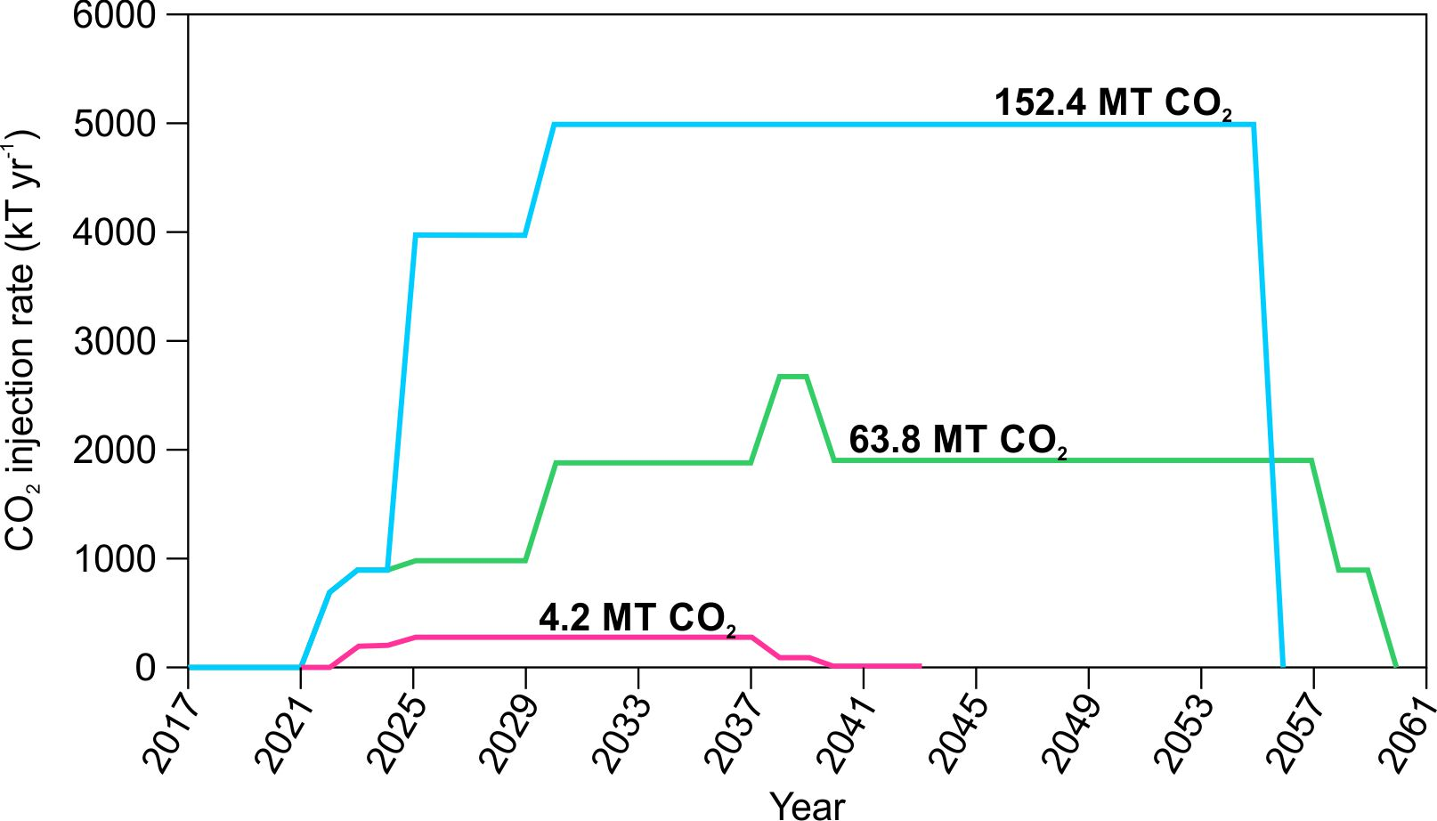
Figure 4: Three different storage phases for the Acorn project based on CO2 supply and the potential build-out options available. Phase 1 in pink, Phase 2 in green and Phase 3 in blue.
Clearly the examples illustrated in Figure 4 are specific to the Acorn CCS Project context. Nonetheless, ACT Acorn exemplifies the importance of developer competence in identifying opportunities to grow CO₂ intake, and in identifying and including build-out options in the initial project plan. Once operational, identification of build-out options could significantly simplify CCS investment decisions in adjacent regions.
- Political support and situating CCS within a just transition
The fourth and final area of assessment is the messaging that may facilitate CCS deployment. While many institutions have assigned a key role to CCS in limiting global temperature rise (e.g. BEIS, 2018), large-scale, non-EOR CCS faces several financial, political and social challenges (IEA, 2017; IPCC, 2018). The research and development work for ACT Acorn hence placed explicit attention on understanding the political context in potential deployment locations, and understanding framings and messaging to attain buy-in (ACT Acorn, 2018f).
The ACT Acorn CCS project assessed the extent to which CCS may fit with a public interest framing, particularly that of a just transition. A just transition is understood here as an imperative to ensure that carbon-intensive locations, and the workers and communities within them, are not left behind and are guided towards alternative forms of economic activity as unsustainable or carbon intensive practices are phased out nationally and globally (Baer, 2016; Evans and Phelan, 2016). Thus far, however, there has been limited consideration of how CCS may integrate with a just transition framing.
The just transition approach requires a significant role for stakeholder engagement. In this context, the focus lies on what Shackley et al (2007) refer to as ‘tier 2 stakeholders’ (those with a role in climate and energy policy wider than the specific CCS project under discussion) and ‘tier 3 stakeholders’ (the general public). The reason for this is that stakeholders in these categories are less likely to be formally engaged in project development, yet can still have significant influence on whether or not the project gains societal support through actions such as granting planning permission or influencing public opinion. Therefore, it is important to consider how stakeholders in these tiers may engage with CCS. It is recognised that stakeholder and public opinion towards CCS is informed by a much wider range of factors than merely risk or safety concerns. For instance, trust in operators and decision-makers (Terwel et al, 2012), inter-generational concerns (Gough and Boucher, 2013) and fit with personal values and world views (Mabon and Shackley, 2015) have all been identified as shaping societal opinion. Scepticism has also been raised about the perceived links between CCS and the perpetuation of a fossil fuel economy (Stephens, 2014). Therefore, attaining buy-in for CCS from stakeholders and citizens must go beyond communication of techno-scientific risks and create a compelling case for how CCS can be utilised to undertake climate change mitigation in the public interest.
A key finding of ACT Acorn’s work in this area is that if CCS is to play a role within a just transition, there needs to be greater engagement on CCS by local government (ACT Acorn, 2018g). Thus far, CCS has been discussed very much as an issue of concern by national government or international institutions; however, the ACT Acorn work indicates that it is also the responsibility of local government to set out a vision for the future, potentially including CCS. The findings of these investigations indicate that, while the just transition frame seemed to resonate in the Aberdeen area of Scotland, this was much less the case in the Netherlands (Rotterdam area) and Norway (Stavanger area). The discussions also showed that in order to develop an informed opinion on CCS, stakeholders required more information on how CCS might fit with the local context. Specific issues in this regard include: the extent to which infrastructure associated with current regional activities could be adapted or re-used for CCS, the extent to which skills present within the current workforce would be transferable to CCS, and who would be responsible for financing CCS deployment (ACT Acorn, 2018g). These aspects suggest potential for greater integration with the infrastructure re-use and low-carbon build-out actions. The outcomes from ACT Acorn hence illustrate a need to develop pathways and to engage local-level stakeholders on the outcomes of research into infrastructure, skills and financing, rather than just risk assessment, to allow stakeholders and informed citizens to reach a view on the role of CCS in a just transition. Lastly, it is worth reiterating that, for a set of technologies such as CCS which require a significant level of private-sector involvement to deliver, it is imperative to respect the need to develop a framework for CCS that positions it very much in the public interest and makes clear its value in helping carbon-intensive regions meet the climate challenge.
- Discussion
Camara et al (2013) note that as CCS technologies are still in development, there is a need for ongoing research to assess CCS as a ‘clean’ technology. As a project at the advanced research and development stage, learnings from the ACT Acorn project fill this gap in three ways. First, ACT Acorn illustrates that utilisation of existing infrastructure can provide a pathway to CCS deployment for early-stage projects where costs may be high. Wennersten et al (2015) argue that the main obstacles to CCS deployment are economic and social rather than technical, with Zhang and Huisingh (2017) likewise identifying high cost as a barrier. ACT Acorn demonstrates that in a region such as north-east Scotland with a history of subsurface activity, development (and therefore learning opportunities for society) can be aided by reuse of pipelines, platforms and wells. Second, ACT Acorn demonstrates the importance of a development plan across the whole CCS chain. Extant research suggests smaller-scale industrial applications such as steel and cement works may benefit from CCS as much as power sector applications, but that sharing of infrastructure such as pipelines may be needed to make this economically viable (Mandova et al., 2019). Perhaps different to previous large-scale CCS proposals focused on a single power sector or industrial application (e.g. Boundary Dam in Canada), ACT Acorn has paid explicit attention to low-carbon build-out options at the planning stage. The ACT Acorn approach indicates that a gradual development and build-out process may provide a more viable pathway to CCS deployment than aiming for a single large project. Third and final, a lack of stakeholder support for CCS has been identified across previous work (Chaudhry et al., 2013). What ACT Acorn adds in this regard is the importance of engagement of policy-makers at the regional level, who citizens and stakeholders may look to (as opposed to the national government) for understanding of the role of CCS in a low-carbon transition.

- Conclusions
Investments into dedicated CO₂ storage projects globally have been limited so far, mainly because they have lacked a viable revenue model, with high upfront costs and uncertain future revenues. We have here assessed Acorn as a CCS project that has the potential to overcome these hindrances by focussing on seven key elements identified during the development of the project described in this paper (infrastructure re-use, storage development plan, low-carbon build-out options, full-chain development plan, policy-support, just transition and public engagement, knowledge exchange). The successful development of these elements will make the project more likely as well as more sustainable, and hence will make it more attractive for investors.
The key learnings points that emerged from the ACT Acorn experience, which may be transferable to other projects globally aimed at initiating CCS activity, are:
- Based on nearly 50 years of geological and petroleum engineering work by the oil and gas industry in the North Sea region, the permanent sequestration of CO₂ in the subsurface has been shown to be technically feasible and geologically safe in the Acorn project. CCS developments in other contexts may hence be assisted if there is technical expertise and knowledge of subsurface characteristics gleaned from previous hydrocarbon activity in the same region;
- Preserving existing or "to-be-decommissioned" offshore infrastructure, particularly pipelines, can offer the lowest cost opportunity for a CCS project by significantly lowering the initial capital expenditure. In Acorn, the three existing pipelines provide specific potential re-use options in the CO₂ value chain. As above, there may hence be value in targeting wider CCS deployment towards more mature oil and gas-producing regions, where discussions over the future of infrastructure are ongoing and where there may be more immediate interest in re-appropriating infrastructure as opposed to decommissioning;
- Acorn indicates the value of an incremental approach to full-chain development planning, planning for gradual development rather than commencing with maximum-scale infrastructure. A catalyst phase allows a fast and low-risk implementation of a small- to medium-scale full chain CCS project. This phase will act as a seed for the subsequent build-out by adding further sources of CO₂, which represent the fully commercial side of the model. The existence of build-out options provides the incentive to invest in the initial phase of the project. Later phases can be delivered at lower unit costs as the CO₂ throughput volume increases. To achieve this, however, requires significant vision and competence on the part of the project developer to be able to identify linkages to other CO₂ sources and projects – including to industries such as hydrogen which have thus far not been considered in-depth in mainstream CCS discussions.
- Nonetheless, the ACT Acorn experience also illustrates that CCS requires governmental policy support to deal with: the current lack of a market, infrastructure requirements, and ownership and liability issues. State-owned and state-backed organisations can act as vessels for financial support and can organise infrastructure and liability as well as increase the trust of civil society. A strong role for the state (or for local and regional government) in CCS may also help to overcome concerns among environmental groups about the role for fossil fuel industry operators in a low-carbon transition;
- Stakeholders that are unlikely to be formally engaged in the project can still have significant influence on the societal support of the project through actions such as granting planning permission or influencing public opinion. ACT Acorn illustrates that those responsible for CCS deployment – especially local and regional government who may be viewed as leading on a local low-carbon transition - must create a compelling case for how CCS can undertake climate change mitigation in the public interest. This is particularly significant in carbon-intensive regions, where CCS could be framed as facilitating a just transition for workers in high-emitting industries.
Acknowledgements
The authors want to thank the entire ACT Acorn team for their support. The ACT Acorn project was funded by Accelerating CCS Technologies under Horizon 2020. Alcalde is currently funded by EIT Raw Materials – SIT4ME project (17024).

References
ACT Acorn, 2018a. Infrastructure Re-use. ACT Acorn Consortium. Available at: www.actacorn.eu
ACT Acorn, 2018b. Acorn CO₂ Storage Site Development Plan. ACT Acorn Consortium. Available at: www.actacorn.eu
ACT Acorn, 2018c. East Mey CO₂ Storage Site Development Plan. ACT Acorn Consortium. Available at: www.actacorn.eu
ACT Acorn, 2018d. Full Chain Development Plan and Budget. ACT Acorn Consortium. Available at: www.actacorn.eu
ACT Acorn, 2018e. Expansion Options. ACT Acorn Consortium. Available at: www.actacorn.eu
ACT Acorn, 2018f. Policy Options. ACT Acorn Consortium. Available at: www.actacorn.eu
ACT Acorn, 2018g. Societal Acceptance. ACT Acorn Consortium. Available at: www.actacorn.eu
Ahiaga-Dagbui, D.D., Love, P.E., Whyte, A. and Boateng, P., 2017. Costing and technological challenges of offshore oil and gas decommissioning in the UK North Sea. Journal of Construction Engineering and Management, 143, 05017008.
Akhurst, M., Hannis, S.D., Quinn, M.F., Shi, J.Q., Koenen, M., Delprat-Jannaud, F., Lecomte, J.C., Bossie-Codreanu, D., Nagy, S., Klimkowski, Ł. and Gei, D., 2015. Risk assessment-led characterisation of the SiteChar UK North Sea site for the geological storage of CO2. Oil & Gas Science and Technology–Revue d’IFP Energies nouvelles, 70pp.567-586.
Alcalde, J., Flude, S., Wilkinson, M., Johnson, G., Edlmann, K., Bond, C.E., Scott, V., Gilfillan, S.M., Ogaya, X. and Haszeldine, R.S., 2018a. Estimating geological CO₂ storage security to deliver on climate mitigation. Nature Communications, 9, 2201.
Alcalde, J., Smith, P., Haszeldine, R.S. and Bond, C.E., 2018b. The potential for implementation of Negative Emission Technologies in Scotland. International journal of greenhouse gas control, 76, 85-91.
Alvarado, V. and Manrique, E., 2010. Enhanced oil recovery: an update review. Energies, 3, 1529-1575.
Baer, H.A., 2016. The nexus of the coal industry and the state in Australia: Historical dimensions and contemporary challenges. Energy Policy 99, 194-202.
Bai, M., Sun, J., Song, K., Li, L. and Qiao, Z., 2015. Well completion and integrity evaluation for CO2 injection wells. Renewable and Sustainable Energy Reviews, 45, 556-564.
Bentham, M., Mallows, T., Lowndes, J. and Green, A., 2014. CO2 STORage Evaluation Database (CO2 Stored): the UK's online storage atlas. Energy Procedia, 63, 5103-5113.
Benton, D., 2015. Circular Economy Scotland. Green Alliance.
BEIS, 2018. The UK carbon capture, usage and storage (CCUS) deployment pathway: an action plan. Department of Business, Energy and Industrial Strategy (28th November 2018).
Brandon NP, Kurban Z. 2017. Clean energy and the hydrogen economy. Phil. Trans. R. Soc. A 375: 20160400. http://dx.doi.org/10.1098/rsta.2016.0400
Brownsort, P.A., Scott, V. and Haszeldine, R.S., 2016. Reducing costs of carbon capture and storage by shared reuse of existing pipeline—Case study of a CO2 capture cluster for industry and power in Scotland. International Journal of Greenhouse Gas Control, 52, 130-138.
Bui, M., Adjiman, C.S., Bardow, A., Anthony, E.J., Boston, A., Brown, S., Fennell, P.S., Fuss, S., Galindo, A., Hackett, L.A. and Hallett, J.P., 2018. Carbon capture and storage (CCS): the way forward. Energy & Environmental Science, 11, 1062-1176.
Camara, G., Andrade, C., Silva Junior, A., and Rocha, P. 2013. Storage of carbon dioxide in geological reservoirs: is it a cleaner technology? Journal of Cleaner Production 47: 52-60.
CCC 2018. Delivering Clean Growth: CCUS Cost Challenge Taskforce Report. July 2018. Available at: https://www.gov.uk/government/uploads/system/uploads/attachment_data/file/727040/CCUS_Cost_Challenge_Taskforce_Report.pdf. Last accessed: 19/11/18.
Chaudhry, R., Fischlein, M., Larson, J., Hall, D., Peterson, T.R., Wilson, E., and Stephens, J., 2013. Policy Stakeholders' Perceptions of Carbon Capture and Storage: A Comparison of Four U.S. States. Journal of Cleaner Production 52: 21-32.
Coramik, M. and Ege, Y., 2017. Discontinuity inspection in pipelines: A comparison review. Measurement, 111, 359-373.
Damiani, D., Litynski, J.T., McIlvried, H.G., Vikara, D.M. and Srivastava, R.D., 2012. The US department of Energy's R&D program to reduce greenhouse gas emissions through beneficial uses of carbon dioxide. Greenhouse Gases: Science and Technology, 2, 9-16.
DECC, 2012. Potential cost reductions in CCS in the power sector. Department for Business, Energy and Industrial Strategy. 94 pages
DECC, 2018a. Oil and gas: decommissioning of offshore installations and pipelines. Department for Business, Energy & Industrial Strategy. Available at: https://www.gov.uk/guidance/oil-and-gas-decommissioning-of-offshore-installations-and-pipelines. Last accessed: 19/11/2018.
DECC, 2018b. Energy Consumption in the UK. Department for Business, Energy and Industrial Strategy. 39 pages.
De Coninck, H., Flach, T., Curnow, P., Richardson, P., Anderson, J., Shackley, S., Sigurthorsson, G. and Reiner, D., 2009. The acceptability of CO2 capture and storage (CCS) in Europe: An assessment of the key determining factors: Part 1. Scientific, technical and economic dimensions. International Journal of Greenhouse Gas Control, 3, 333-343.
Eiken, O., Ringrose, P., Hermanrud, C., Nazarian, B., Torp, T.A., Hoeier, L., 2011. Lessons learned from 14 years of CCS operations: Sleipner, In Salah and Snøhvit. Energy Procedia 4, 5541-5548.
Evans, G., Phelan, L., 2016. Transition to a post-carbon society: linking environmental justice and just transition discourses. Energy Policy 99, 329-339
Jansen, F., Steinz, R. and van Gelder, B., 2011. Potential for CO2 storage in depleted fields on the Dutch Continental Shelf–Cost estimate for offshore facilities. Energy Procedia, 4, 3079-3086.
Gough, C., Boucher, P., 2013. Ethical attitudes to underground CO₂ storage: Points of convergence and potential faultlines. International Journal of Greenhouse Gas Control 13, 156-167.
Govindan, R., Nie, Z., Korre, A., Durucan, S., Shi, J., Hadi Mosleh, M., Neele, F., Wilkinson, M., Heinemann, N., 2018. A Methodology for CO2 Storage Leakage Remediation Techniques Performance Assessment and Portfolio Optimisation. 14th Greenhouse Gas Control Technologies Conference Melbourne 21-26 October 2018 (GHGT-14). Available at SSRN: https://ssrn.com/abstract=3366046
Gross, R., 2015. Approaches to cost reduction in carbon capture and storage and offshore wind. Committee on Climate Change. Available at: https://www.theccc.org.uk/wp-content/uploads/2015/06/Gross-2015-Approaches-to-cost-reduction-in-carbon-capture-and-storage-and-offshore-wind.pdf. Last accessed: 19/11/18.
Haszeldine, R.S., Flude, S., Johnson, G., and Scott, V., 2018. Negative emissions technologies and carbon capture and storage to achieve the Paris Agreement commitments. Phil. Trans. R. Soc. A 2018 376 20160447; DOI: 10.1098/rsta.2016.0447. Published 2 April 2018
Heinemann, N., Wilkinson, M., Pickup, G.E. Haszeldine, R.S., Cutler, N.A., 2012. CO₂ storage in the offshore UK Bunter Sandstone Formation. International Journal of Greenhouse Gas Control 6, 210-219.
Heinemann, N., Booth, M.G., Haszeldine, R.S., Wilkinson, M., Scafidi, J., Edlmann, K., 2018. Hydrogen storage in porous geological formations – onshore play opportunities in the Midland Valley (Scotland, UK), International Journal of Hydrogen Energy, 43/45, 20861-20874.
Heinemann, N., Robertson, H., Alcalde, J., James, A., Ghanbari, S., Bond, C., Faulkner, D., Allen, M., Mackay, E., Haszeldine, S., 2018. Applied Risk and Consequence Analysis for CO2 Storage Projects – the Captain X Storage Site, Offshore UK (Acorn). 14th Greenhouse Gas Control Technologies Conference Melbourne 21-26 October 2018 (GHGT-14). Available at SSRN: https://ssrn.com/abstract=3365976IEA, 2017. Energy Technology Perspectives 2017: Catalysing Energy Technology Transformations. OECD. 443 pp.
Ibukun, O., Tovar, J., Heinemann, N., Chalmers, F., Mokdad, B., Katoozi, K., 2015. Reservoir permeability evolution in sand producing wells. SPE Nigeria Annual International Conference and Exhibition. SPE-178357-MS.
IPCC, 2018. Special Report on Global Warming of 1.5ºC.IEA. (2016). 20 Years of Carbon Capture and Storage.
Mabon, L., and Shackley, S., 2015. More than meeting the targets? The ethical dimensions of carbon dioxide capture and storage. Environmental Values 24, 465-482.
Mabon, L and Littlecott, C (2016) ‘Stakeholder and public perceptions of CO2-EOR in the context of CCS – results from UK focus groups and implications for policy‘. International Journal of Greenhouse Gas Control 49: 128-137
Mandova, H., Patrizio, P., Leduc, S., Kjarstad, J., Wang, C., Wetterlund, E., Kranxner, F., and Gale, W., 2019. Achieving carbon-neutral iron and steelmaking in Europe through the deployment of bioenergy with carbon capture and storage. Journal of Cleaner Production 218: 118-129.
Neele, F., Delprat-Jannaud, F., Vincké, O., Volpi, V., Nepveu, M., Hofstee, C., Wollenweber, J., Lothe, A., Brunsting, S., Pearce, J. and Battani, A., 2013. The SiteChar approach to efficient and focused CO2 storage site characterisation. Energy Procedia, 37, pp.4997-5005.
Pale Blue Dot Energy & Axis Well Technology, 2016. Strategic UK Storage Appraisal Project. Energy Technologies Institute.
Sanz-Perez, E.S., Murdock, C.R., Didas, S.A. and Jones, C.W., 2016. Direct capture of CO2 from ambient air. Chemical reviews, 116(19), pp.11840-11876.
Shackley, S., Waterman, H., Godfroij, P., Reiner, D., Anderson, J., Draxlbauer, K., Flach, T., 2007. Stakeholder perceptions of CO₂ capture and storage in Europe: results from a survey. Energy Policy 35/10, 5091–5108.
Spence, B., Horan, D. and Tucker, O., 2014. The Peterhead-Goldeneye gas post-combustion CCS project. Energy Procedia, 63, 6258-6266.
Stephens, J.C., 2014. Time to Stop CCS Investments and End Government Subsidies of Fossil Fuels. Wiley Interdisciplinary Reviews: Climate Change. Volume 5, 169-173.
Stewart, R.J., Scott, V., Haszeldine, R.S., Ainger, D. and Argent, S., 2014. The feasibility of a European‐wide integrated CO2 transport network. Greenhouse Gases: Science and Technology, 4, 481-494.
Stigson, P., Hansson, A. and Lind, M., 2012. Obstacles for CCS deployment: an analysis of discrepancies of perceptions. Mitigation and adaptation strategies for global change, 17, 601-619.
Terwel B.W., ter Mors, E., Daamen, D.D.L., 2012. It's not only about safety: Beliefs and attitudes of 811 local residents regarding a CCS project in Barendrecht. International Journal of Greenhouse Gas Control 9, 41-51.
United Nations, 2015. The Paris Agreement. Framework Convention on Climate Change: http://unfccc.int/paris_agreement/items/9485.php388
The Global CCS Institute website: https://www.globalccsinstitute.com/projects/large-scale-ccs-projects
Tucker, O., and Tinios, L. 2017. Experience in developing the Goldeneye Storage Permit Application. Energy Procedia 114, 7466-7479. Doi: 10.1016/j.egypro.2017.03.1880
White, D., 2009. Monitoring CO2 storage during EOR at the Weyburn-Midale Field. The Leading Edge, 28, 838-842.
Wennersten, R., Sun, Q. and Li, H., 2015. The future potential for Carbon Capture and Storage in climate change mitigation–an overview from perspectives of technology, economy and risk. Journal of Cleaner Production, 103, pp.724-736. DOI: 10.1016/j.jclepro.2014.09.023
Worden, R.H. and Smith, L.K., 2004. Geological sequestration of CO2 in the subsurface: lessons from CO2 injection enhanced oil recovery projects in oilfields. In: S.J. Baines and R.H. Worden (Editors), Geological storage of carbon dioxide. Special Publication. Geological Society, London, 233, 211-224.
ZEP, 2011. The costs of CO2 capture, transport and storage. Post-demonstration CCS in the EU. European Technology Platform for Zero Emission Fossil Fuel Power Plants. Zero Emissions Platform.
Zhang, Z., and Huisingh, D., 2017. Carbon dioxide storage schemes: Technology, assessment and deployment. Journal of Cleaner Production 142: 1055-1064.

All cost figures in 2018 euros.

