Radiation tolerance in Pseudanabaena catenata, a cyanobacterium adapted to high pH nuclear storage ponds

Lynn Foster¹, Howbeer Muhamadali², Christopher Boothman¹, David Sigee¹, Jon K Pittman¹, Royston Goodacre², Katherine Morris¹, and Jonathan R Lloyd^{1*}

¹ Research Centre for Radwaste Disposal and Williamson Research Centre for Molecular Environmental Science, School of Earth and Environmental Sciences, The University of Manchester, Oxford Road, Manchester M13 9PL, U.K.
² Department of Biochemistry, Institute of Integrative Biology, University of Liverpool, Biosciences Building, Crown Street, Liverpool L69 7ZB, U.K.
Keywords: Cyanobacteria, FT-IR spectroscopy, metabolic fingerprint, radiation, polysaccharide, spent nuclear fuel pond

Abstract

The metabolic response to irradiation by the cyanobacterium Pseudanabaena catenata, a photosynthetic microorganism found in a high pH radioactive spent nuclear fuel pond, was studied to identify potential survival strategies in extreme radioactive environments. Whilst an X-ray dose of 95 Gy delivered over 5 days did not significantly affect cell proliferation, multivariate statistical analysis of infrared spectra from the cells revealed metabolic adaptations within the polysaccharide and amide (protein) spectral regions. Increases in polysaccharides were confirmed by complementary analytical methods including total carbohydrate assays and calcofluor white staining. Increased production of polysaccharides is of importance, having an impact on the fate of the radionuclide inventory in the pond via biosorption of cationic radionuclides, and may also impact on downstream processes through biofilm formation and biofouling. This work will therefore help inform microbial bloom control strategies in nuclear facilities, but also suggests untapped bioremediation potential for highly radioactive waters contaminated with radionuclides.

Introduction

Microorganisms are ubiquitous and inhabit a wide range of environments including those with extremes of pH, temperature, pressure, availability of water, salinity and radiation ^{1–4}. The presence of microorganisms in radioactive environments has been widely reported, for example in Spent Nuclear Fuel Ponds (SNFPs) ^{5–15} and in contaminated land surrounding the Chernobyl nuclear reactor ¹⁶. The ability of microorganisms to inhabit highly radioactive environments has been linked previously with their ability to survive other extreme environmental conditions such as desiccation ^{1,17,18}.
Studies investigating the presence of microorganisms in SNFPs across several sites, including in Spain, USA, France, India and the UK, have shown that each site exhibits a unique microbial community profile^{5–15}. The majority of sites are dominated by Proteobacteria, although eukaryotic microalgae have also been identified as being dominant at some sites¹¹. The presence of microorganisms in SNFPs is problematic since high levels of biomass can result in reduced visibility (hampering pond management), may lead to microbiologically induced corrosion (MIC) and may lead to the formation of organic-rich radioactive waste. Bruhn et al.²² highlighted the potential for the formation of biofilms and MIC in the presence of high levels of radiation, which signals the possibility of MIC on waste storage containers and fuel cladding. Indeed, several studies investigating biofilm forming organisms in ponds at the Confrentes site (Valencia, Spain) have shown the occurrence of MIC on steel coupons ^{5,6,13–15}. The potential for MIC on waste storage containers and fuel cladding could have implications for the longevity of spent fuel storage. Microorganisms have also been shown to accumulate fission products as shown with the free-living eukaryotic microalga Coccomyxa actinabiotis, isolated from a SNFP in research reactor in France, which has been shown to accumulate large quantities of ¹³⁷Cs ²⁴.
The early gas cooled reactors form part of the UK’s legacy nuclear fleet, and the fuel rods used in these reactors were clad in a magnesium non oxide (Magnox) alloy ^{25–28}. Spent fuel rods containing this cladding have been stored in open air legacy storage ponds, including the First Generation Magnox Storage Pond (FGMSP) situated on the Sellafield site (Cumbria, UK), since the late 1950s ²⁷. Within the FGMSP, fuel storage times have been longer than anticipated and the spent fuel has been subject to extensive corrosion due to the Magnox cladding and metallic fuel having low chemical stability in water. This corrosion has led to the formation of a hazardous radioactive environment with radioactive corroded spent nuclear fuel, radioactive pond effluent²⁹ and radioactive sludge²⁵⁻²⁷. In order to provide thermal cooling and minimise further corrosion of the fuel rods and the growth of microorganisms, the pond is continuously purged with alkaline dosed demineralised water (pH ~11.4) ^{25–27}. However, there is clear visible evidence for the presence of microorganisms in the pond, including events described as algal blooms ^{25,26}.
The microbial community of this open-air legacy SNFP has recently been investigated over a three year period, including during a microbial bloom period in August 2016 ³⁰. Over the course of the investigation, highly pigmented organisms with photosynthetic or hydrogen-metabolising capabilities were identified. Such organisms are likely to be pioneer species that facilitate the colonisation of the pond by heterotrophs. Background water samples indicated that Proteobacteria were the dominant microorganisms in the pond, whilst a single cyanobacterial species, Pseudanabaena catenata, was dominant during a significant bloom event³⁰. Pseudanabaena spp. are filamentous cyanobacteria, displaying a simple morphology, and lack the ability to form branches or differentiate ^{31,32}. Reports of Pseudanabaena spp. in the scientific literature are sporadic, with little known about their physiology or capabilities, and although they are associated with bloom events in a range of environments, they are often overlooked ^{31–35}.
The occurrence of cyanobacterial blooms in the legacy SNFP has the potential to disrupt waste retrieval operations and downstream processes. Although the microbial community structure of the legacy SNFP has been determined, nothing is known about how the microorganisms are able to colonise this radioactive and highly alkaline environment. The purpose of this study is to determine the adaptive response of a P. catenata culture to ionizing radiation, to help understand the potential impacts of microbial colonisation on pond biogeochemistry and ultimately to help inform control strategies employed onsite. To determine the physiological and metabolic response of a P. catenate-containing culture representative of the legacy SNFP to irradiation, Fourier transform infrared (FT-IR) spectroscopy and classical microbiological techniques were utilised. FT-IR spectroscopy is a metabolic fingerprinting technique that can be used to determine the phenotype in a given microbial sample, while shifts in these fingerprints can be correlated with metabolic consequences when the environment of the microbe is changed ³⁶. Here, we demonstrate that a culture containing P. catenata as the sole cyanobacterial species is capable of surviving a significant dose of X-irradiation over a period of 5 days. When grown photosynthetically, the culture did not display any physiological differences to untreated cultures, whilst receiving the irradiation treatment, increases in polysaccharides and a reduction in chlorophyll-a became more pronounced during the post-irradiation period. This study provides insight into the radiation resistance mechanisms employed by microorganisms representative of those colonising a high pH legacy SNFP. Understanding the behaviour of the microorganisms in response to radiation (and other stress responses) will help to provide fundamental information on adaptation mechanisms in extremophiles, and underpin more effective control strategies to minimize microbial growth and bloom formation.

Results

The effect of X-irradiation on the growth and chlorophyll concentration of the P. catenata culture

In order to determine the effect of ionising radiation on the growth and photosynthetic pigment characteristics of the P. catenata culture, the optical density at 600 nm (OD_{600nm}), cell counts and Chl-a concentration were monitored during and after the cultures were subjected to 95 Gy (1 Gy min⁻¹) of X-irradiation over a five day period (Fig 1). The absorbance of P. catenata cultures was measured at 600 nm over a period of 16 days (Fig 1a). There was a steady increase in the optical density recorded over time for both the irradiated culture and the control. The control culture started at an OD_{600nm} of 0.16 and reached 2.92 by day 16 whilst the irradiated culture started at a slightly lower OD_{600nm} of 0.13 and reached 2.79 by day 16. The overall absorbance measurements at 600 nm showed very similar trends indicating that the amount of biomass in the cultures was not significantly different. Since the cultures contained other microorganisms in addition to P. catenata, direct cell counts were carried out using a light microscope to ensure the trends seen in the turbidity measurements reflected the proliferation of the cyanobacterium, with its characteristic chain morphology (see Fig 7 for representative morphology, and Fig 1c for cell counts). Observation of both irradiated and control cultures showed P. catenata dominated the field of view, which supports the sequencing data that shows it to be the most abundant organism in the culture. Additionally, the 16S rRNA gene sequencing showed no changes in the community following the irradiation treatment (Supplementary Fig 1). Both the irradiated and control cultures started with around 8x10⁶ cells mL⁻¹ and showed an increase in cell numbers over time. By day 16 the average cell counts for the irradiated cultures were 31 % higher than those for the control at 2.8x10⁸ cells mL⁻¹ and 2.2x10⁸ cells mL⁻¹, respectively. Interestingly the filament lengths were comparable between the irradiated and control cultures, and by day 16 the irradiated cells were more variable in their length compared to the controls. Both the turbidity measurements and the cell counts show the same overall trends in growth, with no significant difference between the two sets of cultures with either measurement. The concentration of Chl-a, (Fig 1b), did not follow the same trend as seen with the OD_{600nm} values and the cell counts. The initial Chl-a concentrations were 0.4 mg L⁻¹ and 0.5 mg L⁻¹ for the control and irradiated cultures, respectively. The cultures showed similar increases in the Chl-a concentration at day 4 and up to day 8, which was whilst the irradiation treatment was still being administered and the first 3 days post irradiation. The control cultures showed a continued increase in the Chl-a concentrations recorded, with 7.8 mg L⁻¹ measured on day 16. The Chl-a levels in the irradiated cultures were lower, at day 16 a concentration of 2.6 mg L⁻¹ was recorded, which is ~66 % less than the control value. Normalisation of the Chl-a concentration to cell number showed that by day 4, the concentration of Chl-a per cell increased in both treatments and reached the maximum of 1.1 x10⁻⁴ μg L⁻¹ cell⁻¹ and 1.0 x10⁻⁴ μg L⁻¹ cell⁻¹ for the control and irradiated cultures, respectively (Supplementary Fig 2). Both sets of cultures showed a decline in the average Chl-a concentration per cell from day 8, which plateaued towards the end of the experiment, with the irradiated culture consistently showed significantly reduced concentrations of Chl-a per cell compared to the control. At day 16 the values were 9.4 x10⁻⁶ μg L⁻¹ cell⁻¹ compared to 3.7 x10⁻⁵ μg L⁻¹ cell⁻¹, for the irradiated and control cultures respectively. The pH of the unbuffered cultures was monitored over the course of sampling period, both cultures started off at a pH of 7.3 which increased to pH> 10 by day 4. The pH of the irradiated culture (Fig 1d) started to decline after day 4 reaching pH 9.2 at day 16. The pH of the control sample increased to 10.8 at day 8 and then gradually reduced to 9.8 at day 16. The pH of the irradiated culture is significantly lower than seen in the control culture.
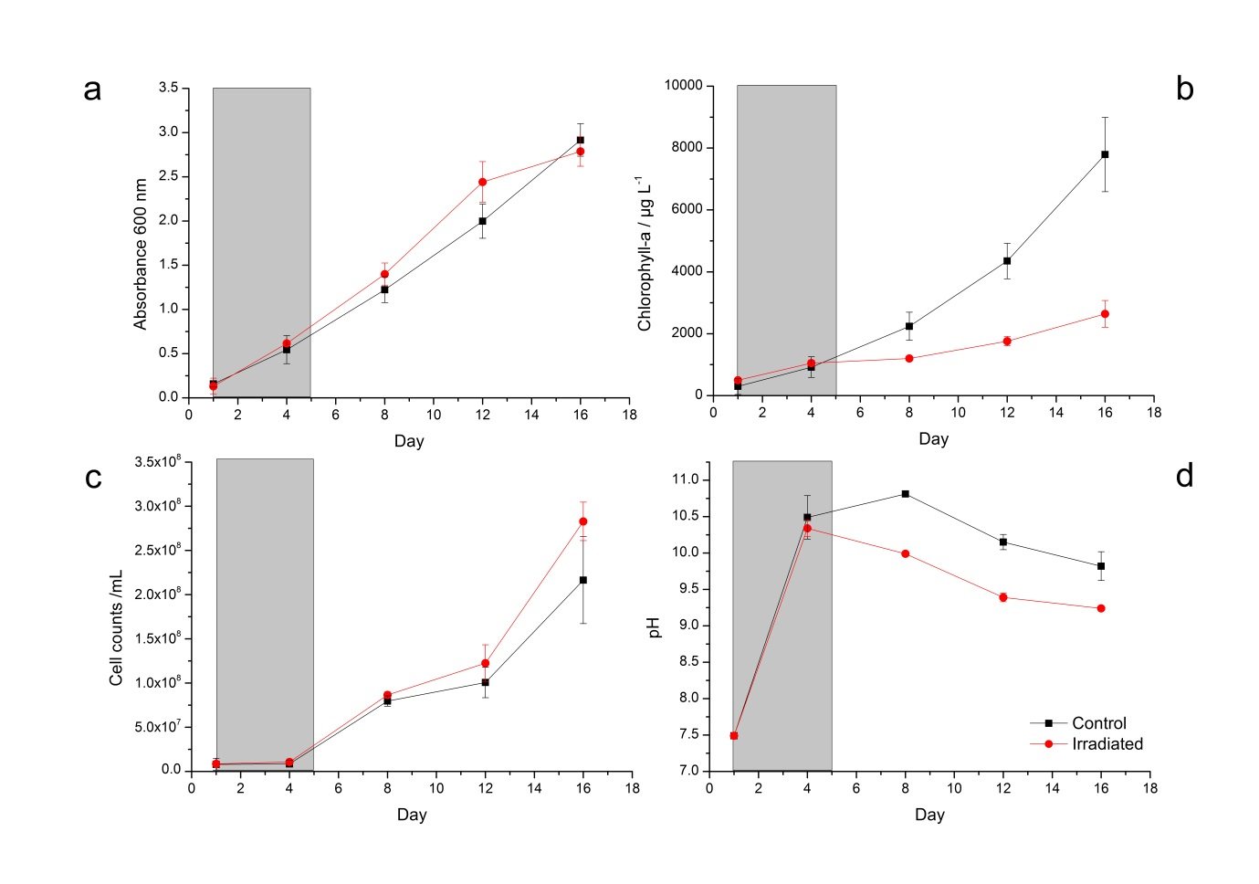
Figure 1: Growth of the P. catenata culture with and without radiation treatment: a) absorbance at 600 nm; b) chlorophyll concentration (μg L⁻¹); c) mean cell counts of P. catenata; d) pH. The grey panel indicated the period in which the irradiation treatment was being administered. Red lines are irradiated samples; black lines are control samples. Error bars are the standard deviation of three replicates.

Metabolic response of the P. catenata culture to X-irradiation determined by FT-IR spectroscopy

FT-IR spectroscopy was utilised to obtain a metabolic footprint of the cultures, and to determine if there were physiological changes associated with irradiation. A PCA scores plot of the data (Fig 2) displayed clear separation of the samples according to PC1, which accounted for 88.6 % of the total explained variance (TEV). At day 4 both sets of samples clustered together, indicating that although these cells were receiving the treatment there was no significant difference between the cultures; by contrast, by day 8 there was clear separation of the samples according to the PC2 axis. The control samples from day 8 to 16 form a tight cluster (in top left part of the PCA scores plot) which was distinct from the cluster at day 4. Interestingly the irradiated samples showed continued separation over time according to PC1 (from left to right) with each time point clustering closely.
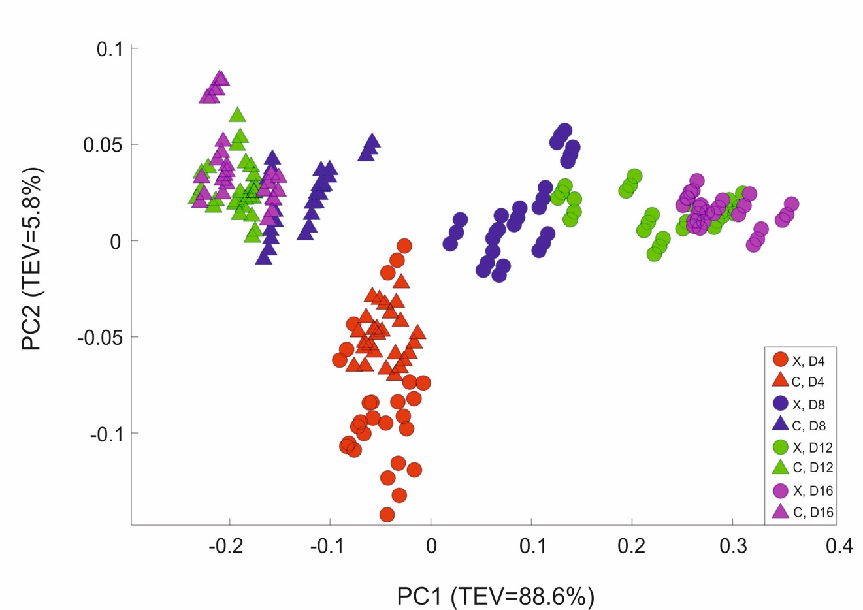
Figure 2: a) Principal component analysis scores plot of all the FT-IR spectroscopy data. Circles represent the irradiated (X) samples; triangles are control (C) samples. Colour code: Red- day 4; Blue- day 8; Green- day 12; and Purple day 16. TEV = Total Explained Variance

According to the PC1 loadings plot (Fig 3) the main vibrational regions that contribute toward the separation of the samples included: 1655 cm⁻¹ (amide I, C=O of proteins and peptides) ⁵⁵; 1545 cm⁻¹ (amide II, combination of in-plane N-H bending (60%) and C-N stretching (40%) of proteins, secondary structure of protein) (Lu et al., 2010); 1153 cm⁻¹ (stretching vibrations of hydrogen bonded C-O groups; carbohydrates) ^{56,57}; 1080 cm⁻¹ (carbonyl groups in cell wall, glycopeptides); P=O stretching, P-O-C (P-O-P) of phospholipids and esters) ⁵⁸; 1024 cm⁻¹ (C-O bending and stretching typical of glycogen) ⁵⁹. The FT-IR spectra confirmed the PCA findings, with clear variance in the baseline corrected spectra apparent, which became more pronounced in the irradiated samples taken at the later time points (Supplementary Fig 3). Over the course of the experiment the irradiated samples showed increased spectral intensities from 1200-900 cm⁻¹, which is indicative of an increase in total
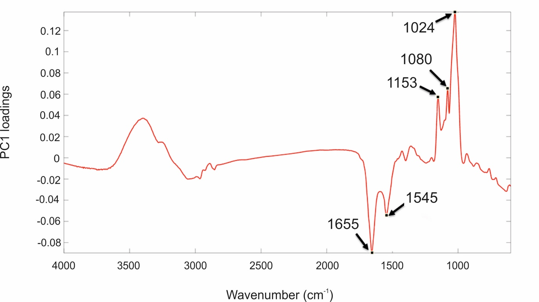
Figure 3: PC1 loading plot including the wavenumbers contributing to the shifts seen across PC1
polysaccharides ^{60,61}. Conversely, reduced spectral intensities were apparent in the amide I and II regions from 1750-1500 cm⁻¹ which indicates that there was a reduction in the total peptide content as the irradiated cultures age ^{60,61}. The total carbohydrate band heights at 1160, 1086, 1050, and 1036 cm⁻¹ were quantified and normalised by expressing them as a ratio to the lipid band at 1740 cm⁻¹, since there was no significant differences observed in this region. At day 4, the ratio value at 1160 cm⁻¹ (Fig 4) for the irradiated sample was 1.35 (s.d. 0.11) compared to 1.43 (s.d. 0.08) in the equivalent control sample, showing that there was very little difference in the polysaccharide levels during the irradiation treatment. The ratio value of the control samples did not vary much over the course of the sampling period, reducing slightly to 1.26 (s.d. 0.07) at day 16 (a 12 % reduction). The irradiated samples showed continued increases in the ratio value reaching 2.49 at day 16, which is a 1.85 fold increase from day 4. At day 16 there was a 1.97 fold increase in the polysaccharide content of the irradiated samples compared the control. The carbohydrate bands at 1086, 1050, and 1036 cm⁻¹ all showed the same trend. The largest fold change between the day 16 samples was observed at the 1036 cm⁻¹ band, which had a 2.69 fold increase in the irradiated samples.

Figure 4: Ratio plot of carbohydrate absorbance peaks: a) 1036 cm⁻¹; b) 1050 cm⁻¹; c) 1086 cm⁻¹; and d) 1160 cm⁻¹ normalised to the lipid peak at 1740 cm⁻¹ taken from FT-IR data, grey boxes indicates samples taken whilst irradiation treatment was being administered, bars are the means from 3 FT-IR spectra and error bars denote standard deviations

Total carbohydrate concentrations

To investigate the FT-IR spectroscopy findings further, the total carbohydrate concentrations in the day 4 and day 16 samples (OD_{600nm} normalised to 15) were determined (Fig 5). At day 4, the concentrations were 0.13 and 0.10 μg mL⁻¹ for the control and irradiated samples, respectively. By day 16 the control sample had shown a slight reduction in carbohydrate levels to 0.09 μg mL⁻¹, which is in agreement with the ratio plots taken from the FT-IR spectroscopy data. The irradiated samples showed an increase to 0.26 μg mL⁻¹ at day 16 (2.69 fold increase), which is also in agreement with the FT-IR ratio plots. A comparison of the carbohydrate concentrations at day 16 showed a 2.96 fold increase in the concentration of the irradiated samples compared to the control.
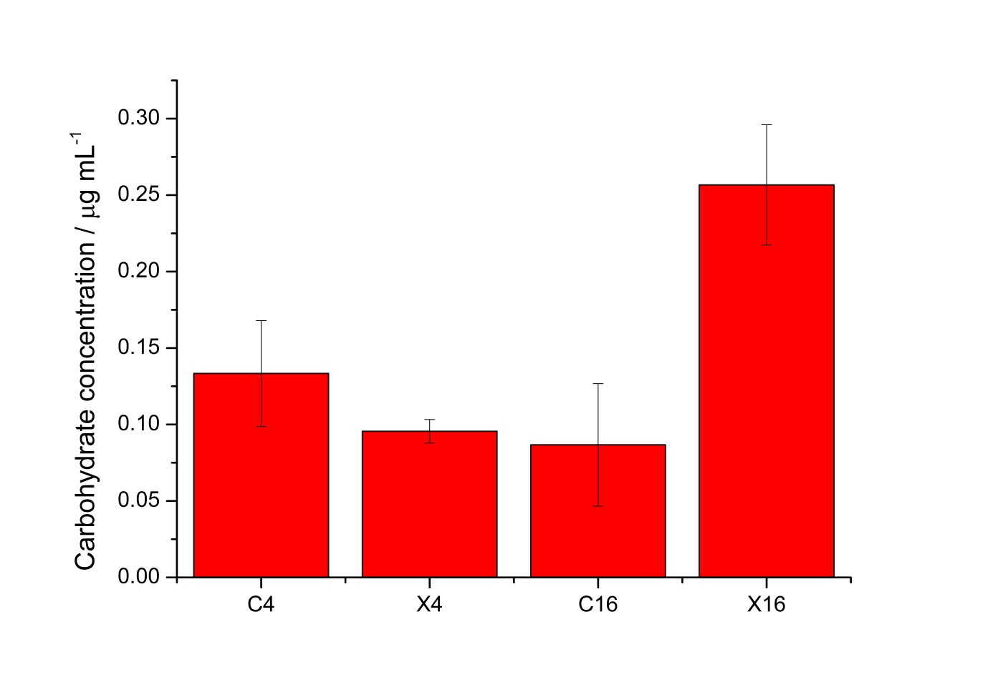
Figure 5: Total cell carbohydrate concentrations measured using Sigma-aldrich kit, samples include controls (C), and irradiated (X) at day 4 and 16, bars are mean from 3 measurements and error bars denote standard deviations

Fluorescent light microscopy determination of cell morphology and polysaccharide staining

Calcofluor white stain was used to label β-linked polysaccharides associated with cells in the culture, to determine if the changes seen in the FT-IR spectra and carbohydrate analyses were due to upregulation of polysaccharides associated with cells of P. catenata. The auto-fluorescence of P. catenata was also noted throughout the experiment, which gave a qualitative assessment of the levels of photosynthetic pigments in the cells/filaments. There was little difference in both the auto-fluorescence and the binding of the calcofluor white stain to the P. catenata filaments in either the control or the irradiated cultures whilst they were still receiving the treatment (day 4) (Supplementary Fig 4 a & c). However, by day 16 the auto-fluorescence seen across all of the P. catenata filaments in both treatments was more variable, with some cells lacking fluorescence altogether (Fig 6 a & c). Interestingly, the cells that had been exposed to the irradiation treatment showed a greater degree of variability in the auto-fluorescence levels, with a higher proportion of the irradiated cells showing reduced fluorescence compared to the non-treated filaments. At day 4 the level of fluorescence with the calcofluor polysaccharide stain was comparable between the treated and non-treated cultures (Supplementary Fig 3 b & d). The non-irradiated controls showed the same level of fluorescence with the calcofluor white stain at day 4 and day 16, indicating that the levels of β-polysaccharides remained largely similar over time. The irradiated samples, however, showed increased levels of fluorescence of the calcofluor white stain at day 16 compared to the control cultures, providing evidence that P. catenata had higher levels of β-polysaccharides associated with the cell walls or extracellular mucilage (Fig 6 b & d). Unwashed samples were also inspected using the calcofluor white stain, and the non-irradiated cells showed low levels of binding and fluorescence (Fig 6e). The stain was concentrated at the poles of the unwashed non-irradiated cells where they were connected within the filament. The unwashed irradiated cells showed the same elevated levels of fluorescence with the calcofluor stain as the washed samples. The calcofluor stain was also bound to extracellular material apparently associated with the unwashed irradiated P. catenata filaments, localised at the points where the cells in the filaments were connected (Fig 6f). This suggests that the cells were potentially releasing materials into the supernatant that contain β-polysaccharides, which was removed upon washing.
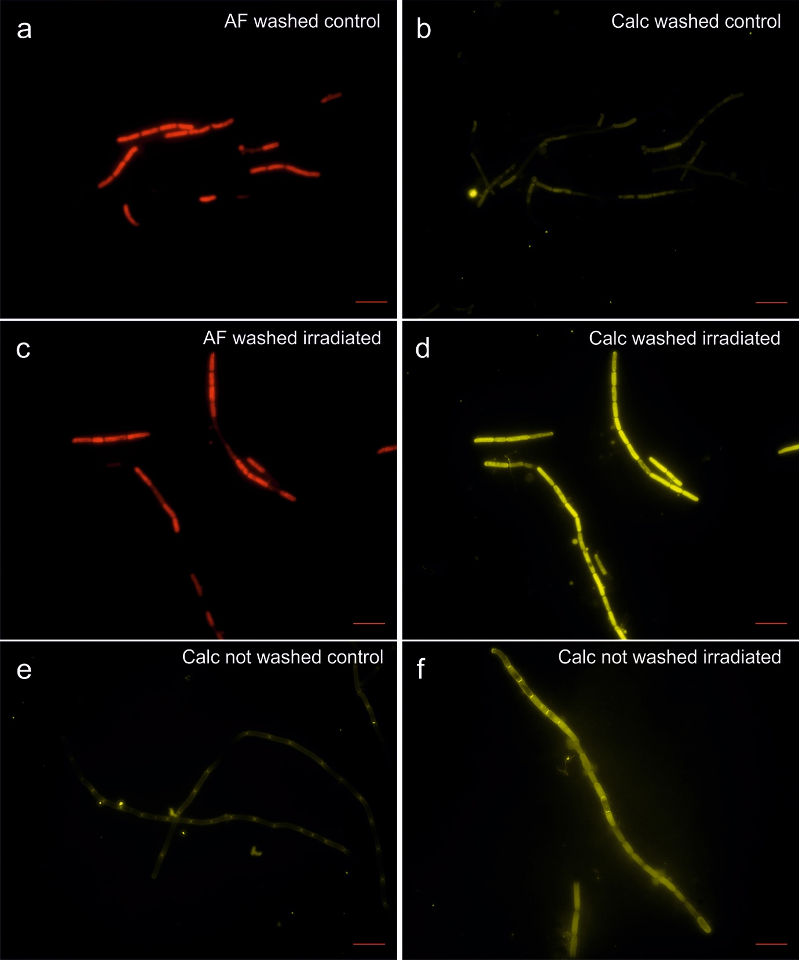
Figure 6: Light microscopy of P. catenata filaments at day 16: a-d were washed twice with normal saline [0.9 g L⁻¹ NaCl] a) auto-fluorescence of control culture; b) calcofluor white stained control culture; c) auto-fluorescence of irradiated culture; d) calcofluor white stained irradiated culture; e) calcofluor white stained unwashed control culture; and f) calcofluor white stained unwashed irradiated culture. Scale bar denotes 10 μm.

Discussion

The FGMSP spent nuclear fuel pond located on the Sellafield site is colonised by microorganisms that are diverse in their metabolic capabilities, including the potential to drive primary colonisation by photosynthesis. During a microbial bloom in August 2016, a cyanobacterium belonging to the genus Pseudanabaena was seen to dominate the community ³⁰. This study investigated the effect of X-ray irradiation on the growth and metabolism of a non-axenic culture of P. catenata. 16S rRNA gene sequencing revealed the presence of five OTUs within the P. catenata culture, which were consistent with genera identified in the SNFP, making this culture an ideal representation of the pond community for use in laboratory studies. The levels of radiation associated with the legacy SNFP are significant; Jackson et al.²⁷ reported doses of 5.65 Gy h⁻¹ associated with sludge and 0.15 mGy h⁻¹ with the pond liquor, but the activity is also dynamic, with the consistent purging of water and in pond activities changing the radiation flux that the microorganisms are likely to be in contact with. This is the first study to our knowledge assessing the effect of radiation on a microbial culture representative of the microorganism community found in a high pH and significantly radioactive legacy SNFP; here delivered at representative doses, over consecutive days.
Collectively the results of our experiments show that while the irradiation treatment was being administered to the culture there were no visible phenotypic differences observed compared to the control cultures. This suggests that the entire culture, including all microorganisms present, was able to tolerate the radiation dose administered. Differences between the two treatments only became apparent during the post-irradiation recovery period, and became more pronounced over time. The estimation of total biomass by the OD_{600nm} and cell counts were the only measurements that remained comparable between the two treatments. Perhaps surprisingly, although the cell counts of P. catenata increased over time, the recorded Chl-a concentrations did not increase in line with cell numbers. Inspection of the auto-fluorescence at day 16 when the differences were greatest showed varied levels of fluorescence across filaments. This suggests that within a filament of P. catenata, cells were showing different levels of photosynthetic potential/activity. The differences between the chlorophyll concentrations, the cell numbers and absorbance readings suggest that the proportion of photosynthetically active P. catenata cells was much lower than those contributing to the total biomass measured. A study by Sigee et al. ⁶² highlighted that estimations of total abundance of cyanobacterial populations might be misleading as some organisms are at different stages of growth and may be in a senescent state. Thus, the increase in cell numbers predicted by the optical density measurements may not match the number of viable and actively dividing cells.
Previous studies investigating the effect of ionizing radiation on axenic cultures of cyanobacteria have reported similar drops in chlorophyll concentrations, but after much higher doses from a ⁶⁰Co-gamma radiation source. El-Fatah Abomohra et al.⁶³ reported up to a 25 % reduction in the chlorophyll concentrations of Arthrospira platensis 15 days after exposure to 2.5 kGy of radiation. This coincided with a reduction in total biomass production by 34%. At lower doses of 1 and 1.5 kGy, no recorded drop in biomass was reported, however chlorophyll concentrations were reduced by 8 and 12 % respectively. The effects of irradiation treatments on chlorophyll production is varied, however, as Badri et al.⁶⁴ reported no significant impacts on chlorophyll when exposing Arthrospira cultures to similar doses used by El-Fatah Abomohra et al.⁶³. The authors reported a reduction in the antenna pigments allophycocynanin and phycocynanin in addition to an increasing lag phase in growth as the dose of radiation increased. Anabaena cultures exposed to gamma irradiation showed bleaching of their pigments immediately after exposure to 6 kGy, with a 42.5 % reduction in chlorophyll-a concentration. However, all cultures were able to recover following irradiation, although longer lag phases were observed at higher doses⁶⁵. Several studies have reported that low doses of ionizing radiation can stimulate the growth of cyanobacteria, for example Wang et al. ⁶⁶ demonstrated this with an Arthrospira spp. at 500 kGy, whilst several studies report the enhanced growth of a Synechococcus spp. at dose rates of 20 mGy y⁻¹ ^{67,68}. The stimulatory effect of lower chronic doses of ionizing radiation could offer a plausible explanation for the continued increase in cell numbers despite the drop in chlorophyll concentration and auto-fluorescence in P. catenata. These studies show that the effect of radiation can be varied and that photosynthetic pigments are affected but the dose at which this is observed differs between species.
The collected FT-IR spectral data, ratio plots of vibrational features, total cell carbohydrate concentrations and calcofluor white staining all show an overall increase in carbohydrate production over time in the irradiated cultures. From the FT-IR spectra it is not possible to determine which organisms are responsible for the differences observed, as the interrogation beam has a diameter of ~1 mm and so measures the whole microbial community. The wavenumbers observed in the PCA loadings plots, contributing to the shifts seen in the PCA scores plots, indicate that there are potentially changes associated with intracellular and extracellular polysaccharides. The wavenumber 1024 cm⁻¹ is indicative of glycogen which is a common storage molecule in cyanobacteria and some bacteria. Nutrient stress has been shown to result in increased storage of glycogen in Synechococcus species, however this coincides with a reduction of growth ⁶⁹, which is not observed in the current study. Calcofluor white stain is commonly used to identify the presence of chitin, a β-polysaccharide found in fungal cell walls, but it is also used to stain a variety of β-polysaccharides ^{70,71}. In our study, the calcofluor white stain was associated with the outer surface of the P. catenata cells, suggesting that there is an increase in β-polysaccharides associated with extracellular polymeric substances⁶⁵. It should be noted that low doses of gamma irradiation (0.5-1.5 kGy) have been shown to result in the increased production of carbohydrates in Arthrospira spp. in other studies ⁶³. It is thought that the polymeric substances provide an array of functions including increasing cell buoyancy, binding metals, accumulating nutrients, aggregation of cells to one another, the formation of biofilms on surfaces and a barrier to protect against environmental stress ^{72–74}. It is not known whether the microorganisms in the legacy SNFP produce such polymeric substances; however the similarities between the community profile in the pond and the culture used in this study suggest that this is feasible and warrants further investigation. The increased production of polysaccharide/ polymeric substances by organisms in the pond could provide a mechanism to protect microorganisms from the damaging effects of reactive oxygen species ⁷².
The presence of polysaccharides or polymeric substances associated with the microorganisms would also have implications for the fate of radionuclides in the pond and downstream processes. Cationic metals are able to adsorb to negatively charged functional groups on the surfaces of the microorganisms and polysaccharide containing mucilage of some cyanobacteria ^{75–78}. Extracellular polymeric substances also have the ability to trap organic and inorganic colloids and nanoparticles, which are thought to be present in the pond ^{75,79,80}. The same experimental set-up described in this study was used recently to investigate the interaction of ⁹⁰Sr with the cell free medium from irradiated and control cultures ⁸¹. All of the ⁹⁰Sr remained in solution when it was added to the cell free medium from the control cultures, whilst the irradiated samples resulted in the removal of approximately 10% of ⁹⁰Sr from solution. Analyses of the supernatants showed higher total carbon levels in the control cultures (324 mg L⁻¹) compared to the medium from the irradiated cultures (162 mg L⁻¹). The lower levels of TOC in the irradiated medium is surprising, particularly as the calcofluor staining presented in this study indicates the presence of extracellular material in unwashed samples which are not present following centrifugation and washing. The reduced TOC in the medium from the irradiated cultures suggests that irradiated medium either has modified functional groups which better facilitate interactions with ⁹⁰Sr or that the irradiation treatment has resulted in the secretion of additional metabolites not present in the control samples. As noted by Ashworth et al.⁸² the level of interaction although being low is worth exploring further, as is the interaction of strontium in the presence of the microorganisms in the culture.
This study provides an insight into broad scale changes in the metabolism of a microbial community dominated by P. catenata in response to doses of irradiation. The metabolic responses revealed by FTIR spectroscopy are representative of a culture-wide response, and it is therefore difficult to attribute to an individual organism. However, P. catenata specific responses were observed with the decline in photosynthetic pigments, whilst the calcofluor staining showed some of the changes observed in the polysaccharide levels are most likely attributed to this organism. Furthermore, the data presented here show that FT-IR spectroscopy would be a very powerful tool to investigate broad scale changes in the metabolic state of the pond community in situ.
The legacy SNFP on the Sellafield site is currently being decommissioned, which involves amongst other things the removal of waste stored in the pond. In order to safely and efficiently carry out routine pond operations, visibility within the pond must be maintained. The presence of microorganisms in the pond has the potential to reduce visibility and cause delays in the on-site operations, particularly during microbial bloom events. Whilst the microbial community has been described recently³⁰, little was known about the survival mechanisms the organisms used to colonise the pond. The results presented in this study provide clear insight into the adaptive response of a P. catenata dominated culture to doses of X-irradiation. As noted above, the identification of increased cell polysaccharide levels is of importance since elevated polysaccharide levels could affect the behaviour and fate of key radionuclides present in the pond⁷⁶. High levels of polysaccharide containing material could also play a role in supporting the growth of the heterotrophic microbial community whilst providing the microorganisms with a protective barrier against the environment⁸³. Analysis of microbial communities inhabiting SNFPs so far, indicate that the communities are specific to individual ponds. Recently the dominant algal species causing microbial blooms in a near neutral pH SNFP on the Sellafield Ltd. site, was shown to synthesize large quantities of the carotenoid astaxanthin, which is known to have antioxidant properties⁹. The research carried out in this study and McGraw et al.⁹ indicate that the adaptive response of the microbial communities is unique to the specific microorganism and the SNFP that they have colonised. A greater understanding of the microbial responses to the radiation they encounter in the legacy pond will help to optimise control strategies used on site to control the microbial load in the pond and prevent blooms occurring during the planned decommissioning of the FGMSP over the next 20+ years. This study also provides further information about the response of microorganisms to doses of ionizing radiation that have not previously been studied, but which are relevant to critical engineered environments, including a wider range of nuclear facilities worldwide. In this context, understanding how microorganisms able to tolerate high radiation doses interact with key radionuclides, could also be key to developing innovative biotechnological approaches for treating pond waters and nuclear effluents, and is therefore an area of intense interest worldwide.

Methods

Culturing and irradiation of P. catenata

It was not possible to culture organisms directly from water taken from the SNFP due to radiological safety limitations. A culture of the closest known relative to the Pseudanabaena species detected in the pond, P. catenata was obtained from the NIVA Culture Collection of Algae (NIVA-CYA 152), Norway. The P. catenata was inoculated in unbuffered BG11 media (Culture Collection of Algae and Protozoa) and incubated at 25 ± 1 °C, and shaken at 100 rpm in a light incubator with a photon flux density of 150 μmol m⁻² s⁻¹, and a 16:8 h light–dark cycle (supplied by cool fluorescent daylight lamps). Biological triplicates were prepared by inoculating 20 mL BG11 medium with P. catenata to a starting optical density 0.2 (OD_{600nm}). The cultures were exposed to daily doses of ionising radiation using a Faxitron CP-160 Cabinet X-radiator (160 kV; 6 mA; tungsten target). A dose of 1 Gy min⁻¹ for 19 min per day was administered to the cultures over five consecutive days to give a total dose of 95 Gy. A further triplicate set of “no dose” controls were placed inside the irradiator, shielded by an appropriate thickness of lead, to mimic the environmental (e.g., any heating due to radiation). All cultures were incubated following the treatment as previously described.

DNA extraction and 16S rRNA gene sequencing of the P. catenata culture
It was not possible to source an axenic culture of P. catenata from any culture collection for this study, therefore a non-axenic P. catenata culture was used for this work. The culture was characterised using 16S rRNA gene sequencing to monitor the relative abundance of all the prokaryotic microorganisms, and quantify any differences in the cultures at the end of the experiment. Samples (1 mL) of irradiated and control cultures at day 16 were passed through a sterile 0.2 μm filter using a vacuum filtration technique. DNA was then extracted using the MoBio PowerWater DNA isolation kit (MoBio Laboratories, Inc., Carlsbad, CA, USA). The 16S rRNA gene was sequenced from PCR amplicons on the Illumina MiSeq platform (Illumina, San Diego, CA, USA) targeting the V4 hyper variable region (forward primer, 515F, 5′-GTGYCAGCMGCCGCGGTAA-3′; reverse primer, 806R, 5′-GGACTACHVGGGTWTCTAAT-3′) for 2 × 250-bp paired-end sequencing (Illumina) ^{37,38}. The Roche FastStart High Fidelity PCR System (Roche Diagnostics Ltd, Burgess Hill, UK) was used to perform the PCR amplifications (50 μL reactions) under the following conditions; initial denaturation at 95°C for 2 min, followed by 36 cycles of 95 °C for 30 s, 55 °C for 30 s, 72 °C for 1 min, and a final extension step of 5 min at 72 °C. The SequalPrep Normalization Kit (Fisher Scientific, Loughborough, UK) was used to purify and normalise the PCR products to ~20 ng each. The PCR amplicons from all samples were pooled in equimolar ratios. The run was performed using a 4 pM sample library spiked with 4 pM PhiX to a final concentration of 10 % following the method of Schloss and Kozich ³⁹.
A sequencing pipeline was used to divide the raw sequences into samples by barcodes (up to one mismatch was permitted). Cutadapt ⁴⁰, FastQC¹, and Sickle ⁴¹ were used to perform quality control and trimming, whilst SPADes ⁴² was used to carry out MiSeq error corrections. Forward and reverse reads were incorporated into full-length sequences with Pandaseq ⁴³. ChimeraSlayer ⁴⁴ was utilised to remove chimeras, and OTUs were generated UPARSE ⁴⁵ generated OUTs, that were classified by Usearch ⁴⁶ at the 97 % similarity level, and singletons were removed. Rarefaction analysis was conducted using the original detected OTUs in Qiime ⁴⁷. The RDP classifier, version 2.2 ⁴⁸ was used to perform the taxonomic assignment.

Growth, chlorophyll-a (Chl-a) concentration and pH measurements

To quantify the total biomass in cultures by turbidity, absorbance values at 600 nm (OD_{600nm}) were recorded for 1 mL aliquots of the P. catenata cultures using a Jenway 6700 UV/Vis spectrophotometer (Bibby Scientific Limited, Staffordshire).
The concentration of Chl-a was determined as follows: 1 mL samples were centrifuged at 14,000 g for 10 min to pellet the cells. The supernatant was then discarded and the cells re-suspended in 1 mL of 70 % ethanol and incubated at room temperature for 2 h. The samples were then centrifuged at 14,000 g for 10 min, the supernatant was then removed and analysed using the Jenway 6700 UV/Vis spectrophotometer (Bibby Scientific Limited, Staffordshire). The absorbance was measured at 665 nm (Chl-a) and at 750 nm to correct for turbidity ⁴⁹. The concentration of Chl-a was then calculated using the formula of Jespersen and Christoffersen⁵⁰.
The pH of the cultures was measured using a FiveEasyPlus pH meter (Mettler Toledo Ltd, Leicestershire, UK).

Light microscopy

All light microscopy was carried out using a Zeiss Axio Imager A1 (Carl Zeiss Microimaging 234 GmbH, Germany) light microscope fitted with an Axiocam 506 mono camera using Zen2 imaging software.

Cell counts of P. catenata

Direct counts of P. catenata were carried out routinely throughout the experiment using a Sedgewick Rafter counting chamber. Ten images were taken of random sites across the samples. ImageJ was used to determine the length of filaments and individual cells. An average cell count was determined by dividing the total filament length by the average cell length. Samples were diluted with sterile BG11 medium to an appropriate concentration as required for analysis.

Calcofluor white staining of β-polysaccharides

Cells were washed twice and re-suspended in sterile normal saline (9 g L⁻¹ NaCl), 5 μL of each sample was placed on a glass slide and 5 μL of calcofluor white stain (Sigma-Aldrich, Dorest, UK) was added and a cover slide placed over the sample. The samples were left to incubate for 10 min in the dark prior to being analysed.
The auto-fluorescence of the culture was observed using filter set 00 (530-585 nm excitation and 615-4095 nm emission). Calcofluor white stain fluorescence was observed using filter set 49 (335-383 nm excitation and 420-470 nm emission).

Carbohydrate quantification

A total carbohydrate assay kit (Sigma-Aldrich, Dorset, UK) was used to determine carbohydrate concentrations. Prior to using the kit, the cells were prepared by washing twice with sterile normal saline solution (9 g L⁻¹ NaCl), the cell pellets were flash frozen in liquid nitrogen and stored at -80°C until they were analysed. All samples were normalised to an optical density of OD₆₀₀ 15 (as per FT-IR preparation). Following this, a 200 μL aliquot was then centrifuged and re-suspended in the assay buffer, incubated for 10 min at room temperature. The samples were centrifuged at 14,000 g for 5 min and 15 μL aliquots from the samples were used for the assay reaction and made up to 30 μL with Roche PCR grade water. The sample preparation was then carried out as detailed in the kit technical bulletin.

Metabolic profile of the cultures by FT-IR spectroscopy

Normalised samples were spotted as 20 µL aliquots onto a Bruker 96-well FT-IR silicon plate (Bruker Ltd., Coventry, United Kingdom) in triplicates, and heated to dryness (20-30 min) in an oven at 55 ˚C ⁵¹. All FT-IR spectra were recorded in the mid-infrared range (4000-600 cm⁻¹) with 4 cm⁻¹ resolution and 64 spectral co-adds in absorbance mode using a HXTTM module on a Bruker Equinox 55 infrared spectrometer ⁵².

Multivariate statistical analysis

The collected FT-IR spectra were analysed using MATLAB version 9 (The MathWorks Inc., Natick, MA). All spectra were scaled using the extended multiplicative signal correction (EMSC) method ⁵³, followed by replacement of the CO₂ bands (2400 to 2275 cm⁻¹) with a linear trend. The pre-processed FT-IR spectral data were analysed by the unsupervised method of principal component analysis (PCA) to reduce the dimensionality of the data and PC scores plots generated to determine any between group variations, and PC loadings plots visualised to determine which molecular vibrations were important ⁵⁴.

Acknowledgements

LF was supported by an EPSRC PhD CASE Studentship (Grant number EP/G037426/1) with Sellafield Ltd. We would also like to thank Kaye Williams and Ayse Latif for allowing us the use of the Faxitron CP-160 Cabinet X-radiator.

References

1. Billi, D. & Potts, M. Life and death of dried prokaryotes. Res. Microbiol. 153, 7–12 (2002).
2. Blanco-Rivero, A., Leganés, F., Fernández-Valiente, E., Calle, P. & Fernández-Piñas, F. mrpA, a gene with roles in resistance to Na⁺ and adaptation to alkaline pH in the cyanobacterium Anabaena sp. PCC7120. Microbiology 151, 1671–1682 (2005).
3. Katz, A., Waridel, P., Shevchenko, A. & Pick, U. Salt-induced changes in the plasma membrane proteome of the halotolerant alga Dunaliella salina as revealed by blue native gel electrophoresis and nano-LC-MS/MS analysis. Mol. Cell. Proteomics 6, 1459–1472 (2007).
4. Pikuta, E. V., Hoover, R. B. & Tang, J. Microbial extremophiles at the limits of life. Crit. Rev. Microbiol. 33, 183–209 (2007).
5. Chicote, E. et al. Biofouling on the walls of a spent nuclear fuel pool with radioactive ultrapure water. Biofouling 20, 35–42 (2004).
6. Chicote, E. et al. Isolation and identification of bacteria from spent nuclear fuel pools. J. Ind. Microbiol. Biotechnol. 32, 155–162 (2005).
7. Dekker, L., Osborne, T. H. & Santini, J. M. Isolation and identification of cobalt- and caesium-resistant bacteria from a nuclear fuel storage pond. FEMS Microbiol. Lett. 359, 81–84 (2014).
8. Diόsi, G., Telegdi, J., Farkas, G., Gazsό, L. G. & Bokori, E. Corrosion influenced by biofilms during wet nuclear waste storage. Int. Biodeterior. Biodegrad. 51, 151–156 (2003).
9. MeGraw, V. E. et al. A novel adaptation mechanism underpinning algal colonization of a nuclear fuel storage pond. MBio 9, e02395-17 (2018).
10. Karley, D., Shukla, S. K. & Rao, T. S. Isolation and characterization of culturable bacteria present in the spent nuclear fuel pool water. Environ. Sci. Pollut. Res. 1–9 (2017). doi:10.1007/s11356-017-0376-5
11. Rivasseau, C., Farhi, E., Gromova, M., Ollivier, J. & Bligny, R. Resistance to irradiation of micro-algae growing in the storage pools of a nuclear reactor investigated by NMR and neutron spectroscopies. Spectroscopy 24, 381–385 (2010).
12. Rivasseau, C. et al. Coccomyxa actinabiotis sp. nov. (Trebouxiophyceae, Chlorophyta), a new green microalga living in the spent fuel cooling pool of a nuclear reactor. J. Phycol. 52, 689–703 (2016).
13. Sarrό, M. I. et al. Biofouling on austenitic stainless steels in spent nuclear fuel pools. Mater. Corros. Und Korrosion 54, 535–540 (2003).
14. Sarrό, M. I., García, A. M. & Moreno, D. A. Biofilm formation in spent nuclear fuel pools and bioremediation of radioactive water. Int. Microbiol. 8, 223–230 (2005).
15. Sarrό, M. I., García, A. M., Moreno, D. A. & Montero, F. Development and characterization of biofilms on stainless steel and titanium in spent nuclear fuel pools. J. Ind. Microbiol. Biotechnol. 34, 433–441 (2007).
16. Dadachova, E. et al. The radioprotective properties of fungal melanin are a function of its chemical composition, stable radical presence and spatial arrangement. Pigment Cell Melanoma Res. 21, 192–199 (2008).
17. Billi, D., Friedmann, E. I., Hofer, K. G., Caiola, M. G. & Ocampo-Friedmann, R. Ionizing-radiation resistance in the desiccation-tolerant cyanobacterium Chroococcidiopsis. Appl. Environ. Microbiol. 66, 1489–1492 (2000).
18. Jolivet, E. et al. Physiological responses of the hyperthermophilic archaeon ‘ Pyrococcus abyssi ’ to DNA Damage Caused by ionizing radiation. J. Bacteriol. 185, 3958–3961 (2003).
19. Association, W. N. The nuclear fuel cycle. (2018). Available at: http://www.world-nuclear.org/information-library/nuclear-fuel-cycle/introduction/nuclear-fuel-cycle-overview.aspx. (Accessed: 6th February 2018)
20. Crossland, I. Nuclear fuel cycle science and engineering. (Woodhead Publishing, 2012).
21. Wilson, P. D. The nuclear fuel cycle from ore to waste. (Oxford University Press, 1996).
22. Bruhn, D. F., Frank, S. M., Roberto, F. F., Pinhero, P. J. & Johnson, S. G. Microbial biofilm growth on irradiated, spent nuclear fuel cladding. J. Nucl. Mater. 384, 140–145 (2009).
23. Tišáková, L. et al. Bioaccumulation of ¹³⁷Cs and ⁶⁰Co by bacteria isolated from spent nuclear fuel pools. J. Radioanal. Nucl. Chem. 295, 737–748 (2013).
24. Rivasseau, C. et al. An extremely radioresistant green eukaryote for radionuclide bio-decontamination in the nuclear industry. Energy Environ. Sci. 6, 1230–1239 (2013).
25. Gregson, C. R., Hastings, J. J., Sims, H. E., Steele, H. M. & Taylor, R. J. Characterisation of plutonium species in alkaline liquors sampled from a UK legacy nuclear fuel storage pond. Anal. Methods 3, 1957 (2011).
26. Gregson, C. R., Goddard, D. T., Sarsfield, M. J. & Taylor, R. J. Combined electron microscopy and vibrational spectroscopy study of corroded Magnox sludge from a legacy spent nuclear fuel storage pond. J. Nucl. Mater. 412, 145–156 (2011).
27. Jackson, S. F., Monk, S. D. & Riaz, Z. An investigation towards real time dose rate monitoring, and fuel rod detection in a First Generation Magnox Storage Pond (FGMSP). Appl. Radiat. Isot. 94, 254–259 (2014).
28. Jensen, S. E. & Nønbel, E. Description of the Magnox Type of Gas Cooled Reactor ( MAGNOX ). 2, (1999).
29. NDA. Nuclear Decommissioning Authority: Business plan 2017 to 2020. Gov.uk (2016). Available at: https://www.gov.uk/government/consultations/nuclear-decommissioning-authority-business-plan-2017-to-2020. (Accessed: 4th May 2018)
30. Foster, L. et al. Characterisation of the microbial ecology in a legacy spent nuclear fuel pond.
31. Acinas, S. G., Haverkamp, T. H., Huisman, J. & Stal, L. J. Phenotypic and genetic diversification of Pseudanabaena spp. (cyanobacteria). ISME J. 378, 31–46 (2009).
32. Zhu, M. et al. Molecular specificity and detection for Pseudanabaena (cyanobacteria) species based on rbcLX sequences. Biochem. Syst. Ecol. 60, 110–115 (2015).
33. Bukowska, A. et al. Predicting blooms of toxic cyanobacteria in eutrophic lakes with diverse cyanobacterial communities. Sci. Rep. 7, 1–12 (2017).
34. Webster-Brown, J. G., Hawes, I., Jungblut, A. D., Wood, S. A. & Christenson, H. K. The effects of entombment on water chemistry and bacterial assemblages in closed cryoconite holes on Antarctic glaciers. FEMS Microbiol. Ecol. 91, 1–14 (2015).
35. Khan, Z. et al. Characterisation of Pseudanabaena amphigranulata ( Synechococcales ) isolated from a man-made pond , Malaysia : a polyphasic approach. (2018).
36. Muhamadali, H. et al. Chicken, beams, and Campylobacter: rapid differentiation of foodborne bacteria via vibrational spectroscopy and MALDI-mass spectrometry. Analyst 141, 111–122 (2015).
37. Caporaso, J. G. et al. Global patterns of 16S rRNA diversity at a depth of millions of sequences per sample. Proc. Natl. Acad. Sci. 108, 4516–4522 (2011).
38. Caporaso, J. G. et al. Ultra-high-throughput microbial community analysis on the Illumina HiSeq and MiSeq platforms. ISME J. 6, 1621–1624 (2012).
39. Kozich, J. J., Westcott, S. L., Baxter, N. T., Highlander, S. K. & Schloss, P. D. Development of a dual-index sequencing strategy and curation pipeline for analyzing amplicon sequence data on the miseq illumina sequencing platform. Appl. Environ. Microbiol. 79, 5112–5120 (2013).
40. Martin, M. Cutadapt removes adapter sequences from high-throughput sequencing reads. EMBnet.journal 17, 10 (2011).
41. Joshi, N. A. & Fass, F. N. Sickle: a sliding-window, adaptive, quality-based trimming tool for FastQ files (version 1.33). [Software] (2011).
42. Nurk, S. et al. Assembling Genomes and Mini-metagenomes from Highly Chimeric Reads. in Conference: Proceedings of the 17th international conference on Research in Computational Molecular Biology, RECOMB 2013 158–170 (2013). doi:10.1007/978-3-642-37195-0_13
43. Masella, A. P., Bartram, A. K., Truszkowski, J. M., Brown, D. G. & Neufeld, J. D. PANDAseq: PAired-eND assembler for illumina sequences. BMC Bioinformatics 13, 1–7 (2012).
44. Haas, B. J. et al. Chimeric 16S rRNA Sequence Formation and Detection in Sanger and 454-Pyrosequenced PCR Amplicons. Genome Res. 21, 494–504 (2011).
45. Edgar, R. C. UPARSE: Highly accurate OTU sequences from microbial amplicon reads. Nat. Methods 10, 996–998 (2013).
46. Edgar, R. C. Search and clustering orders of magnitude faster than BLAST. Bioinformatics 26, 2460–2461 (2010).
47. Caporaso, J. G. et al. correspondence QIIME allows analysis of high- throughput community sequencing data Intensity normalization improves color calling in SOLiD sequencing. Nat. Publ. Gr. 7, 335–336 (2010).
48. Wang, Q., Garrity, G. M., Tiedje, J. M. & Cole, J. R. Naïve Bayesian classifier for rapid assignment of rRNA sequences into the new bacterial taxonomy. Appl. Environ. Microbiol. 73, 5261–5267 (2007).
49. Bellinger, E. G. & Sigee, D. C. Freshwater algae: Identification and use as bioindicators. (John Wiley & Sons, Ltd, 2010).
50. Jespersen, A.-M. & Christoffersen, K. Measurements of chlorophyll-a from phytoplankton using ethanol as extraction solvent. Arch. Hydrobiol. 109, 445–454 (1987).
51. Muhamadali, H. et al. Metabolic profiling of Geobacter sulfurreducens during industrial bioprocess scale-up. Appl. Environ. Microbiol. 81, 3288–3298 (2015).
52. Muhamadali, H. et al. Metabolomics investigation of recombinant mTNFα production in Streptomyces lividans. Microb. Cell Fact. 14, 1–12 (2015).
53. Martens, H., Nielsen, J. P. & Engelsen, S. B. Light scattering and light absorbance separated by extended multiplicative signal correction. Application to near-infrared transmission analysis of powder mixtures. Anal. Chem. 75, 394–404 (2003).
54. Wold, S., Ebensen, K. & Geladi, P. Principal component analysis. Chemom. Intell. Lab. Syst. 2, 37–52 (1986).
55. Maquelin, K. et al. Identification of medically relevant microorganisms by vibrational spectroscopy. J. Microbiol. Methods 51, 255–271 (2002).
56. Pop, C. et al. FTIR spectroscopic characterization of a new biofilm obtained from kefiran. J. Agroaliment. Process. Technol. 19, 157–159 (2013).
57. Simonova, D. & Karamancheva, I. Application of Fourier transform infrared spectroscopy for tumor diagnosis. Biotechnol. Biotechnol. Equip. 27, 4200–4207 (2013).
58. Filip, Z., Hermann, S. & Demnerová, K. FT-IR spectroscopic characteristics of differently cultivated Escherichia coli. Czech J. Food Sci. 26, 458–463 (2008).
59. Lewis, P. D. et al. Evaluation of FTIR spectroscopy as a diagnostic tool for lung cancer using sputum. BMC Cancer 10, 640 (2010).
60. Ellis, D. I. et al. Fingerprinting food: current technologies for the detection of food adulteration and contamination. Chem. Soc. Rev. 41, 5706 (2012).
61. Naumann, D. Infrared spectroscopy in microbiology. Encycl. Anal. Chem. 102–131 (2000). doi:10.1002/9780470027318.a0117
62. Sigee, D. C., Selwyn, A., Gallois, P. & Dean, A. P. Patterns of cell death in freshwater colonial cyanobacteria during the late summer bloom. Phycologia 46, 284–292 (2007).
63. El-Fatah Abomohra, A., El-Shouny, W., Sharaf, M. & Abo-Eleneen, M. Effect of gamma radiation on growth and metabolic activities of Arthrospira platensis. Brazilian Arch. Biol. Technol. 5959, 1–12 (1615).
64. Badri, H., Monsieurs, P., Coninx, I., Wattiez, R. & Leys, N. Molecular investigation of the radiation resistance of edible cyanobacterium Arthrospira sp. PCC 8005. Microbiologyopen 4, 187–207 (2015).
65. Singh, H., Anurag, K. & Apte, S. K. High radiation and desiccation tolerance of nitrogen-fixing cultures of the cyanobacterium Anabaena sp. strain PCC 7120 emanates from genome/proteome repair capabilities. Photosynth. Res. 118, 71–81 (2013).
66. Wang, Z., Xu, B., Zhao, X., Jiang, J. & Chen, S. The effect of gamma-irradiation on different strains and morphological filaments of Spirulina. Acta Agric. Univ. Zhejiangensis 24, 121–125 (1998).
67. Conter, A., Dupouy, D. & Planel, H. Light modulation of radiosensitivity of Synechococcus lividus to very low doses of ionizing radiation. Environ. Exp. Bot. 24, 229–237 (1984).
68. Conter, A., Dupouy, D. & Planel, H. Effects of dose rate on response of Synechococcus lividus to very low doses of chronic γ radiation : influence of enzymatic equipment of starting cells. Radiat. Res. 105, 379–386 (1986).
69. Klotz, A. et al. Awakening of a dormant cyanobacterium from nitrogen chlorosis reveals a genetically determined program. Curr. Biol. 26, 2862–2872 (2016).
70. Anderson, C. T., Carroll, A., Akhmetova, L. & Somerville, C. Real-Time Imaging of Cellulose Reorientation during Cell Wall Expansion in Arabidopsis Roots. Plant Physiol. 152, 787–796 (2010).
71. Dunker, S., Althammer, J., Pohnert, G. & Wilhelm, C. A fateful meeting of two phytoplankton species—chemical vs. cell-cell-interactions in co-cultures of the green algae Oocystis marsonii and the cyanobacterium Microcystis aeruginosa. Microb. Ecol. 74, 22–32 (2017).
72. Gao, L. et al. Extracellular polymeric substances buffer against the biocidal effect of H₂O₂ on the bloom-forming cyanobacterium Microcystis aeruginosa. Water Res. 69, 51–58 (2015).
73. Xu, H., Yu, G. & Jiang, H. Investigation on extracellular polymeric substances from mucilaginous cyanobacterial blooms in eutrophic freshwater lakes. Chemosphere 93, 75–81 (2013).
74. Nobles, D. R., Romanovicz, D. K. & Brown Jr, R. M. Cellulose in cyanobacteria. Origin of vascular plant cellulose synthase? Plant Physiol. 127, 529–542 (2001).
75. Decho, A. W. & Gutierrez, T. Microbial extracellular polymeric substances (EPSs) in ocean systems. Front. Microbiol. 8, 1–28 (2017).
76. Gadd, G. M. Heavy metal accumulation by bacteria and other microorganisms. Experientia 46, 834–840 (1990).
77. Gadd, G. M. Biosorption: critical review of scientific rationale, environmental importance and significance for pollution treatment. J. Chem. Technol. Biotechnol. 84, 13–28 (2009).
78. Javanbakht, V., Alavi, S. A. & Zilouei, H. Mechanisms of heavy metal removal using microorganisms as biosorbent. Water Sci. Technol. 69, 1775–1787 (2014).
79. Maher, Z. et al. Americium and plutonium association with magnesium hydroxide colloids in alkaline nuclear industry process environments. J. Nucl. Mater. 468, 84–96 (2016).
80. Neil, T. S. et al. Stability, composition and core-shell particle structure of uranium(IV)-silicate colloids. Environ. Sci. Technol.
81. Ashworth, H. et al. Effect of Humic acid and bacterial exudates on sorption-desorption interactions of ⁹⁰Sr with brucite. Environ. Sci. Process. Impacts Accepted m, (2018).
82. Ashworth, H. et al. Effect of humic acid and bacterial exudates on sorption-desorption interactions of 90Sr with brucite. Environ. Sci. Process. Impacts
83. Song, W., Zhao, C., Zhang, D., Mu, S. & Pan, X. Different resistance to UV-B radiation of extracellular polymeric substances of two cyanobacteria from contrasting habitats. Front. Microbiol. 7, 1–8 (2016).

Supplementary material

Microbial community analysis of the P. catenata culture determined by 16S rRNA gene sequencing

Since the P. catenata culture was not axenic, 16S rRNA gene sequencing was carried out on the cultures to determine the community diversity of the culture. A comparison of the prokaryotic community at day 16 between the irradiated and control samples was made to determine what microorganisms were present and to see if the irradiation treatment resulted in shifts in the diversity of the culture with and without irradiation. The culture consisted of 9 OTUs including P. catenata between the two sets of culture. This showed that the irradiation treatment did not result in a significant shift in phylogenetic diversity (Supplementary F 1). As expected the most abundant OTU in both cultures was affiliated with a Pseudanabaena species, which comprised 30.7 % (control) and 32.7 % (irradiated) of the total community. The remainder of the OTUs were associated with the phyla Bacteriodetes (37.3 % control; 36.5 % irradiated; 2 OTUs) and Proteobacteria (32.0 % control; 30.7 % irradiated; 6 OTUs). A comparison of the microorganisms identified in the P. catenata culture showed strong similarities to those identified in legacy SNFP samples, particularly during the bloom. Of the 9 OTUs identified in the culture, 5 were affiliated with genera identified in the main pond namely: species of Pseudanabaena; Flavobacterium; Porphyrobacter; Rhodobacter; and Hydrogenophaga³⁰. In addition, species of Sediminibacterium and Lacibacterium were observed in samples from an auxiliary pond³⁰, which feeds into the high pH legacy SNFP on the Sellafield Ltd site, making this culture highly representative of the SNFP.
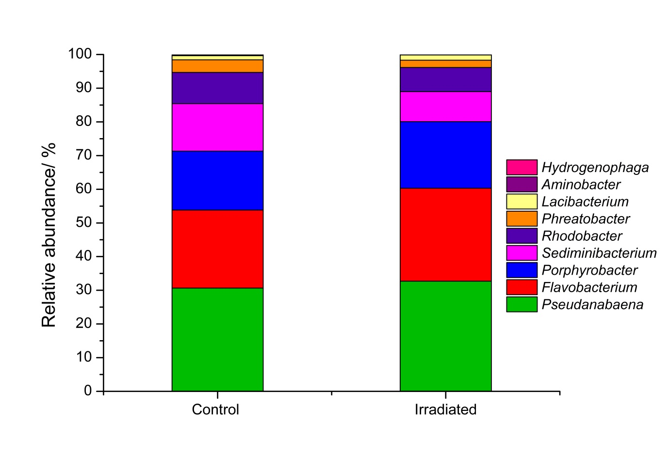
Supplementary figure 1: Genus-level microbial community analysis of the P. catenata culture at day 16, comparing the 16S rRNA gene irradiated community profile to that of the untreated control.

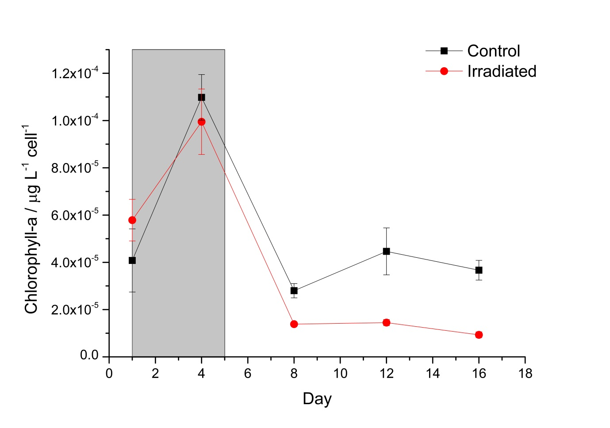
Supplementary Figure 2: Chlorophyll-a concentration (μg L⁻¹) normalised to average cell number. The grey box indicated the period where irradiation treatment was being administered. Error bars denote standard deviations of three replicates

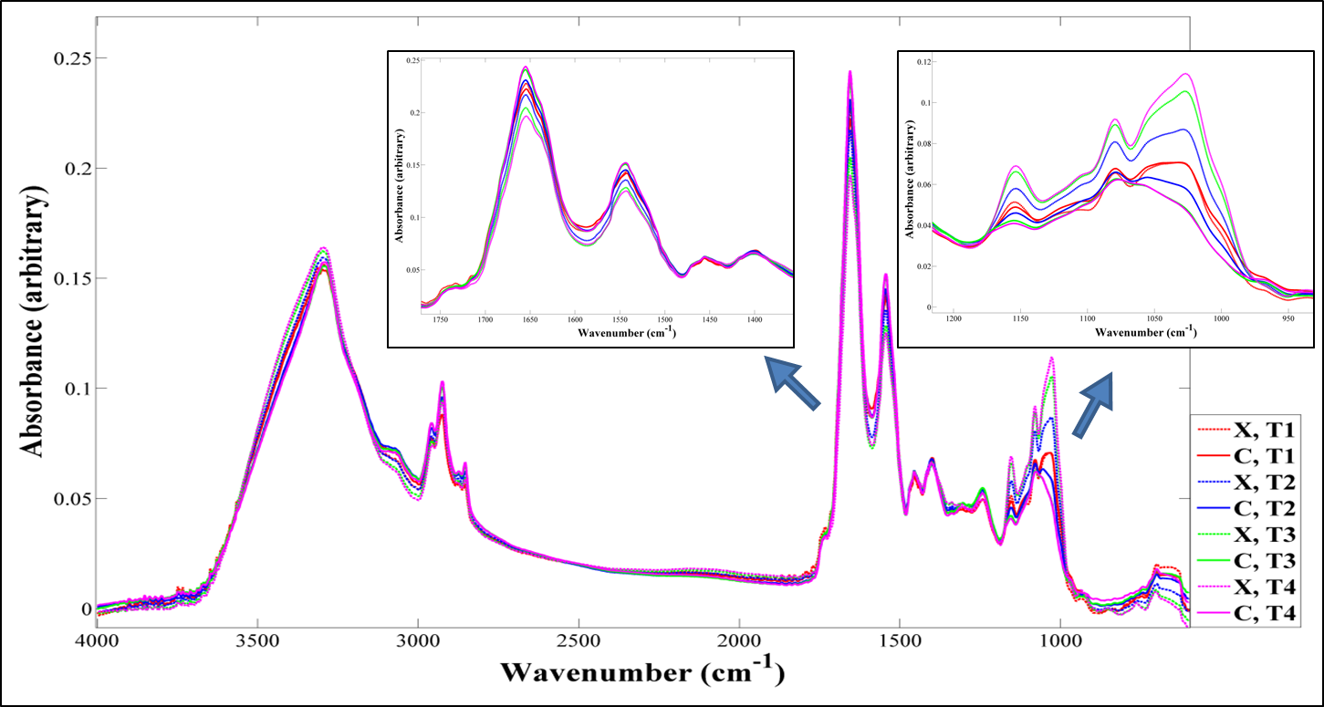
Supplementary Figure 3: Average absorbance FT-IR spectra, with zooms of important spectral features. X denotes irradiated samples and C denotes control samples. T1= day 4; T2= day 8; T3= day 12; and T4= day 16

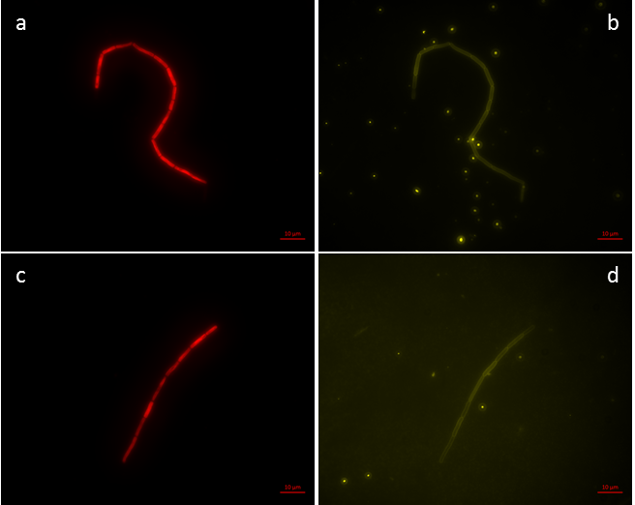
Supplementary Figure 4: Light microscopy of P. catenata filaments at day 4 after washing in normal saline: a) autofluorescence of control culture; b) calcofluor white stained control culture; c) autofluorescence of irradiated culture; and d) calcofluor white stained irradiated culture. The scale bars = 10 μm

