Parsimonious Models for Predicting Mortality from Choroidal Melanoma

*Bertil Damato MD, PhD^{1,2,3}, *Antonio Eleuteri PhD⁴, Rumana Hussain FRCOphth, MA(Oxon)², Helen Kalirai BSc, PhD³, Sophie Thornton BSc, PhD^{3,5}, Azzam Taktak PhD⁴, Heinrich Heimann MD² and Sarah E. Coupland MBBS, PhD^{3,5}.
*Equal first authors.

¹Nuffield Department of Clinical Neurosciences, University of Oxford; ²Ocular Oncology Service, Royal Liverpool University Hospital; ³Liverpool Ocular Oncology Research Group, Institute of Translational Medicine, University of Liverpool; ⁴Department of Medical Physics and Clinical Engineering, Liverpool University Hospital, Liverpool, UK; ⁵Liverpool Clinical Laboratories, Royal Liverpool University Hospital, Liverpool, UK.

Predicting mortality from choroidal melanoma
Word count: 3256
Grant information: Nil.

Corresponding author: Professor Sarah Coupland, MBBS, PhD.,
Liverpool Ocular Oncology Research Group
3rd Floor William Henry Duncan Building
6 West Derby Street,
Liverpool L7 8TX, UK.
E-mail: S.E.Coupland@Liverpool.ac.uk

Abstract
Purpose: To develop parsimonious models for estimating metastasis mortality in patients with choroidal melanoma for situations where the Liverpool Uveal Melanoma Prognosticator Online (LUMPO) and the Tumor Node Metastasis (TNM) staging system are not possible.
Methods: A backward-selection algorithm identified largest basal tumor diameter (LBTD) and chromosome 3 status (C3S) as the most informative predictors of metastasis death. We defined two prognostic models, based on LBTD with and without known C3S respectively, which took account of competing risk of death from other causes by using the Aalen estimator. The bootstrap procedure was used to estimate discrimination accuracy, expressed by the C-index.
Results: The cohort comprised 8348 patients with choroidal melanoma, 4174 of whom had known chromosome 3 status, with 1553 deaths, attributed to metastasis in 956 patients. The metastasis-death-specific C-indices at 2, 5, 10 years were 0.85, 0.85, 0.84 and 0.79, 0.77, 0.74 in our models including LBTD with and without known C3S respectively, as compared to 0.81, 0.79, 0.76 with Kaplan-Meier prognostication using the 8th edition of the TNM staging system.
Conclusions: We have developed parsimonious models for predicting absolute risk of metastasis death from choroidal melanoma, which take account of competing causes of death and which compare favourably with the current version of the TNM staging system. There is scope for further studies to validate these models for use in situations where TNM and LUMPO are not possible.

Precis: We have prepared parsimonious models for predicting death from choroidal melanoma according to basal tumor diameter, with and without known chromosome-3 status, adjusting for competing causes of death. These models are intended for situations where the TNM staging system and LUMPO are impractical.

Almost 50% of patients with choroidal melanoma develop metastatic disease, which is almost always fatal.¹ If sufficiently reliable, mortality prognostication can provide reassurance to patients with a good prognosis while enabling counseling, intensive systemic surveillance and systemic adjuvant therapy to be targeted at high-risk patients.

Prognostic factors include anatomic, histologic and genetic predictors.² Anatomic predictors comprise: largest basal tumor diameter; tumor thickness; extraocular spread, especially if extensive; and ciliary body involvement.³⁻⁵ Histologic predictors include presence of epithelioid cells, closed loops and some other types of extravascular matrix patterns, high mitotic count, high microvascular density, and high number of tumor-infiltrating macrophages.⁶⁻¹⁰ Genetic predictors include a growing number of factors, such as chromosome 3 loss, chromosome 8q gain, BAP1 aberration, a class 2 gene expression profile, PRAME abnormality, EIF1AX and SF3B1 mutation.^{2, 11-17}

As with other cancers, the Tumor, Node, Metastasis (TNM) staging system of the American Joint Committee on Cancer (AJCC) has become the standard method for estimating the risk of disease-related mortality according to the stage of choroidal melanoma.¹⁸ The 8th edition of the staging system for choroidal and ciliary-body melanomas was developed with data from more than 7000 patients, provided by members of the European Ophthalmic Oncology Group (OOG). This system stages tumors according to four anatomic predictors: basal tumor diameter, tumor thickness, ciliary body involvement and extraocular spread.^{19, 20} It was developed by empirically dividing basal tumor diameter and thickness into 3x3-mm fractions and grouping these into four size categories so that all fractions within a particular category showed similar survival probabilities (estimated by Kaplan-Meier) and so that all the size categories had similar numbers of patients. These groups were then sub-categorized according to the presence of ciliary body involvement and extraocular spread. Subcategories with similar survival probabilities were iteratively combined to form six prognostic stages. The TNM staging system has three main limitations. First, it does not account for genetic predictors of metastasis, such as chromosome 3 loss, BAP1 aberration and class 2 gene expression profile. Second, it requires the practitioner to consult to follow a number of steps to determine the stage of disease. Third, it does not account for competing risks, so that estimates of metastatic mortality are exaggerated due to the use of the Kaplan-Meier estimator. This latter aspect is particularly relevant, since in frail populations, such as elderly subjects, other causes of death may occur prior to the occurrence of metastasis death.²¹

In 2007, we showed that prognostication is improved by combining multiple predictive factors.²² This insight led us to develop the Liverpool Uveal Melanoma Prognosticator Online (LUMPO), which estimates the absolute risk (i.e. cumulative incidence) of metastatic and non-metastatic mortality according to anatomic, histologic and genetic data, also taking the patient’s age and sex into account.²¹ LUMPO also computes automatically the TNM tumor size category and stage of disease. A prototype of this tool is available on the Internet (www.LUMPO.net) (accessed 11/27/2019). It is easy and quick to use and has been validated internally and externally. A multicenter validation study has been completed and the manuscript is under review.

For situations where LUMPO is not available, we performed this study to develop a parsimonious, paper-based system that is easier and more convenient to use than the current TNM method.²³ Our aim was also to take account of any available genetic data and avoiding bias caused by competing risk of death from other causes.

Patients and Methods
Inclusion and exclusion criteria
Patients were included in this study if diagnosed with choroidal melanoma (with or without ciliary body involvement), confirmed histologically, and if they were treated by enucleation, endoresection, exoresection, plaque radiotherapy or proton beam radiotherapy at the Tennent Institute of Ophthalmology in Glasgow before 1993 or at the Ocular Oncology Service, Royal Liverpool University Hospital between January 1993 and August 2018. They were excluded if they did not reside in England, Scotland or Wales, because the National Health Service Cancer Registries informed us of the date and cause of death only if patients lived in these parts of the United Kingdom.

Investigations and Treatment
Pre-operative investigation included: full ocular and systemic history; slit-lamp examination and binocular indirect ophthalmoscopy, color photography, and B-scan ultrasonography, which was used to measure basal tumor dimensions and tumor thickness and to detect any extraocular tumor extension. Treatment was selected according to tumor size, location and extent as well as the patient’s wishes and concerns and consisted of various forms of radiotherapy, local resection and laser therapy, individually or in combination, with enucleation reserved for patients whose tumor was considered too extensive for conservation of useful vision.²⁴ Consent was obtained for the use of images, data and tissues for research, teaching and audit.

Laboratory methods
Histopathological examination included light microscopy with hematoxylin and eosin staining, immunohistochemistry for melanoma with Melan A, and, in tumors treated by enucleation, mitotic count per forty high-power fields and evaluation of extravascular matrix patterns, such as closed connective tissue loops. Since 1998, we offered patients genetic analysis of their tumor to detect lethal aberrations. Initially we used fluorescence in-situ hybridization (FISH)²²; however, in 2007, we replaced this method with multiplex ligation-dependent probe amplification (MLPA) and microsatellite analysis (MSA).²⁵ These methods were more sensitive than FISH and required smaller samples, making it possible for us to perform prognostic biopsy of tumors treated with plaque or proton beam radiotherapy. Tumors were categorized as having: (a) normal chromosome 3 and chromosome 8q; (b) chromosome 8q gain; (c) chromosome 3 loss and (d) both of these. Our criteria for considering these genetic aberrations to be significant were described previously.^{22, 25} Patients found to have chromosome 3 abnormality were referred to a medical oncologist for systemic management, which involved liver imaging and long-term surveillance.²⁶

Post-operative surveillance
After conservative therapy, we reviewed patients six months post-operatively, then every 6-12 months unless they lived far from our center, in which case they were discharged back to the referring hospital. Patients treated by enucleation received all follow-up at their local hospital unless they lived close to our hospital. Those with chromosome-3 loss were referred to an oncologist for systemic surveillance.

Patients residing in England, Scotland or Wales were flagged at the NHS Cancer Registry, which until September 2018 automatically notified us of the date and cause of death of all deceased patients. Cause of death was categorized as: (a) definite metastatic uveal melanoma; (b) probable metastatic uveal melanoma; (c) possible metastatic uveal melanoma; (d) other malignancy; (e) non-cancerous disease; and (f) unknown. Fatality was coded as being caused by the uveal melanoma if metastatic disease from this tumor was considered to be ‘definite’ or ‘probable’ (i.e., when no other cause of death and no other source of metastases were specified).

Statistical methods
A backward-selection algorithm²³ was applied to the original LUMPO model to identify the most informative predictors of the hazard rate of metastasis death. The relative importance of the risk factors was quantified using the rescaled Akaike Information Criterion (AIC)²³, which estimates the relative quality of statistical models for a given dataset. This revealed that basal tumor diameter (LBTD) and chromosome 3 status (C3S) were the factors most predictive of metastasis death. We therefore considered two parsimonious models for evaluation and comparison with the TNM staging system: (a) LBTD alone, for situations when genetic data are not available, and (b) LBTD combined with C3S. Using similar methods, we identified age as the most important predictor of death from other causes. Since we were interested in developing a simple estimator of absolute risks of death due to metastasis, we recoded LBTD into a six-level factor. C3S was expressed as a binary factor. Age at treatment was also coded into a binary factor by thresholding at 80 years, the age that maximises the separation of the absolute risk of non-metastasis death from the absolute risk of metastasis death (see Figure 1B). When C3S was not known, C3S was estimated at model fitting stage by applying an approximate Bayesian multiple imputation procedure as we did in the development of LUMPO.²¹

We defined the two models in terms of the Aalen estimator of absolute risk .²⁷ This estimates risk of metastasis death while taking account of competing risk of death from other causes:
(1)

where k denotes the group (six groups for the LBTD-only model and 12 groups for the LBTD/C3S model), N_{k}(t) is the number of metastasis death events by time t, Y_{k}(t) the number of subjects still at risk just prior to t, and is the left-hand limit of the Kaplan-Meier estimate of all-cause survival. No assumption was made about the independence of the competing risk of death from other causes. In conformity with the LUMPO3 model, we used a Cox model for the competing risk of death due to other causes, with risk factor the binary age at treatment of the subjects.

Point estimates for the absolute risks at 2, 5, and 10 years from treatment for each group were obtained as the average of the absolute risks over the M = 101 imputed data sets²⁸:

(2)

A 95% pointwise confidence interval for each estimated absolute risk was obtained by the pooled sample multiple imputation bootstrap technique to account for the uncertainty of the multiple imputation process.²⁸ Bootstrap resampling was applied 2000 times for each imputed dataset. The 2.5-percentile and 97.5-percentile of the bootstrap estimates were used as the lower and upper confidence limits, respectively. The bootstrap procedure was also used to obtain estimates of discrimination accuracy, expressed by the C-index (concordance index) for competing risks.²⁹ This provides an assessment of the model’s ability to rank event times according to the individual risk scores. The C-index reflects the model’s performance, with values of 0.6, 0.7, 0.8 and 1.0 conventionally indicating poor, good, strong, and perfect predictive ability respectively.

All the analyses were performed using the Microsoft R Open 3.5.3 language.³⁰ This was done with R programs written by one of the authors (A. Eleuteri) using the libraries boot, pec, riskRegression, rms and survival. Parallel bootstrap computation of the multiple-imputation model required about 15 hours on an Intel Core i5 computer with 16Gb RAM.

Ethical approval for the study was obtained from the Health Research Authority South Central - Hampshire B Research Ethics Committee (REC ref 15/SC/0611)). We adhered to the tenets of the Declaration of Helsinki.

Results
Patient Demographics
The entire cohort comprised 8348 patients with choroidal melanoma, 4174 of whom had known chromosome 3 status, with monosomy 3 (M3) in 1705 patients and disomy 3 (D3) in 2469 (Table 1).

Table 1. Patient demographics, according to LBTD, C3S and age at treatment as well as metastatic and non-metastatic deaths.
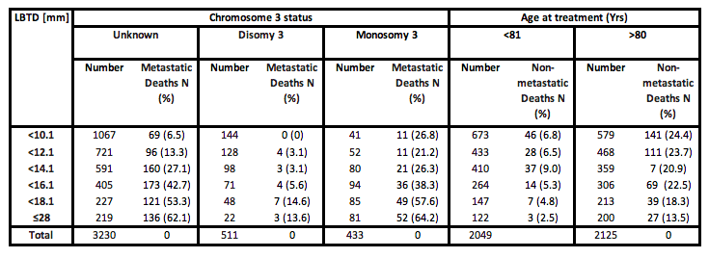

The median LBTD was 12 mm (range, 2.4 to 28 mm; interquartile range 9.6 to 14.8 mm). The median follow-up time was 7.1 years (range, 0.01 to 42.3 years; interquartile range, 3.2 to 13.6 years). A total of 1553 patients died by the study close, with death attributed to metastatic disease in 956 patients, 816 of whom had M3 (Table 1). Figure 1 shows the absolute risks of metastatic and non-metastatic death according to time after treatment (A) and according to age (B).
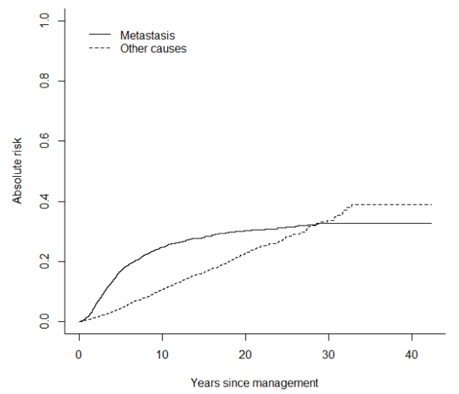 | 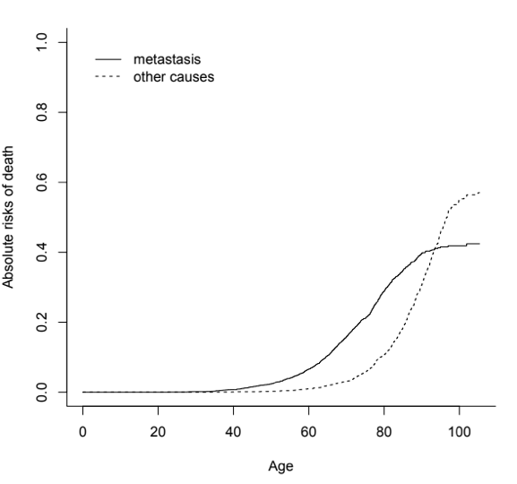
Fig1a. | Fig1b.

Figure 1. Absolute risk (cumulative incidence) of metastasis deaths and non-metastasis deaths according to time after treatment (a) and age (b).

The absolute risk of metastatic death accelerated during the first five post-operative years, reaching 25% at 10 years and settling at 30% whereas the risk of non-metastatic death increased at a constant rate, ultimately reaching a level of 40%. Metastatic and non-metastatic deaths accounted for approximately 40% and 60% of all observed mortality, with cumulative incidence of metastatic death accelerating almost 20 years earlier than that of non-metastatic death. The increase in non-metastatic mortality was especially marked after the age of 80 years.

Predictors most informative of metastatic death
Table 2A shows the risk factors for metastatic death, ranked in order of decreasing importance, according to the AIC. LBTD and C3S were the most informative factors, with rescaled AIC values of 124 and 519 respectively. Sex, ciliary body involvement and chromosome 8q status were not sufficiently informative to justify the increased complexity of the models, which would have occurred had they been included (negative AIC values denote an increased chance of model overfitting). The Cox model for competing risk of non-metastatic death depended only on age at treatment (Table 2B).

Table 2. Risk factors for metastatic death (A) and non-metastatic death (B).
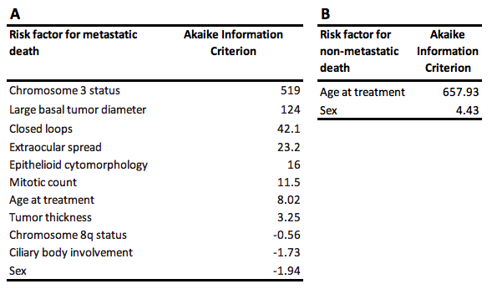

Mortality according to basal tumor diameter and chromosome 3 status
Table 3 shows the absolute risks of metastatic and non-metastatic death according to our two models, with 95% bootstrap confidence intervals. The 10-year metastatic mortality ranged from 1.4% in older patients with a small, disomy-3 melanoma to 80% in younger patients with a large, monosomy-3 tumor, with intermediate values in patients with no genetic data. In general, the risk of metastatic death was higher in younger patients.
Table 3. Absolute risk of metastatic and non-metastatic death (with 95% confidence intervals) according to: (A) LBTD in patients <81 years old at treatment; (B) LBTD in patients >80 years at treatment; (C) LBTD with disomy 3 and age <81 years; (D) LBTD with disomy 3 and age >80 years; (E) LBTD with monosomy 3 and age <81 years; and (F) LBTD with monosomy 3 and age >80 years.

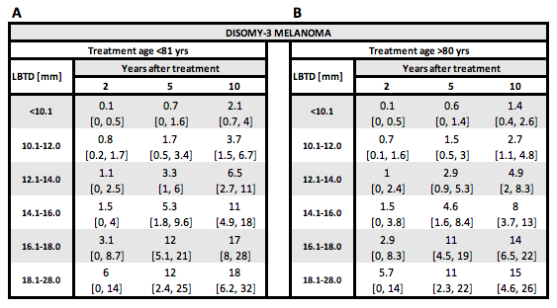
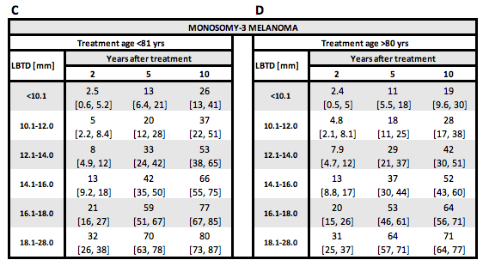
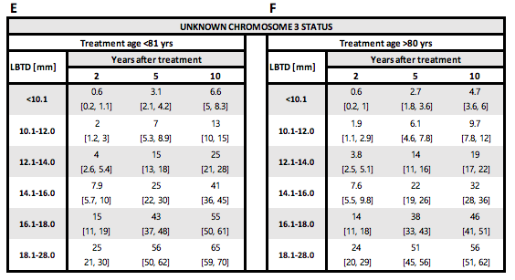
Accuracy of predictive models and TNM staging system
Metastatic death was predicted more accurately when C3S was known than when such genetic data did not exist, with metastasis death-specific C-indices at 2, 5, 10 years of 0.85, 0.85, 0.84 and 0.79, 0.77, 0.74, respectively (Table 4A). The C-indices of the TNM staging system at 2, 5, 10 years, were 0.81, 0.79, 0.76 (Table 4B). This indicated that it was slightly better than the model with LBTD alone but not as accurate as the model that included also C3S.
Table 4. C-index (with 95% confidence intervals) indicating discrimination accuracy of estimates of metastatic risk using (A) LBTD alone; (B) LBTD and C3S; and (C) TNM staging system.
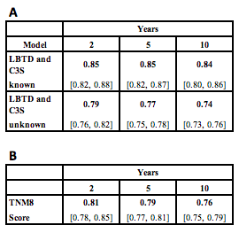

Discussion
Main findings
We have developed two nonparametric models estimating the risk of metastatic death in patients with choroidal melanoma, basing these on LBTD analyzed both with and without known C3S, also taking account of competing causes of death and patient age category. Compared to the TNM staging system, our predictive models had similar accuracy when C3S was unknown and were superior when C3S was known. We prepared a series of tables to make prognostication quicker and easier in busy clinical environments.

Strengths and Weaknesses
The main strengths of this study are the large number of patients, the long follow-up, and the prospective data collection. The main weakness is that certified cause of death was ambiguous in some death certificates and may have been false in some patients, especially in those who had a second primary malignancy. Other studies that include mortality data suffer from this problem as it is impractical to perform post-mortem examination on all patients. Another weakness is that when we staged tumors according to the TNM system we did not sub-classify them according to whether any extraocular tumor extension was greater or less than 5 mm in diameter; however, in view of the rarity of extraocular spread this did not detract significantly from our study.

Discussion of Methods
Patients with unknown C3S comprised 77% of our cohort. These were nevertheless included in our study because many patients with choroidal melanoma are still being treated without genetic typing of their tumor, because of small tumor size and/or because such investigation is not possible at their hospital. Furthermore, exclusion of such patients would have reduced our sample size and biased the analyses, because unknown C3S was not evenly distributed amongst the competing risks and censored events. For example, genetic typing was more likely to be omitted in patients with a small tumor, who had a lower risk of metastatic death because the genetic tumor type was more likely to be D3. For the same reasons, we also included genetic data from FISH analysis even though this method was relatively insensitive as compared to MLPA, which became our preferred method in the latter part of this study.

We did not include histologic predictors in this study because melanoma cytomorphology showed only borderline associations with metastatic death in our cohort and because categorization according to melanoma cell type is subjective and therefore likely to show variation between pathologists. We excluded mitotic count and extravascular matrix because these cannot be assessed in tiny biopsy samples, on which prognostication is based in patients undergoing radiotherapy. The backward-selection algorithm and AIC scores provide statistical support for the decision to remove these predictors.

The prognostic significance of genetic tests depends on their sensitivity in detecting lethal aberrations, and this sensitivity varies between methods. The findings of this study therefore pertain only to uveal melanomas analyzed by FISH, MLPA and/or MSA. We assume that our results can be extrapolated to other methods, such as next generation sequencing and gene expression profiling; however, our methods would need to be adapted for other genetic tests if the sensitivity and specificity of these tests in detecting lethal genetic alterations are different from the techniques we deployed in our study.

Discussion of Results
We found that the prognostic model based on LBTD alone performed reasonably well across the time range of 2-10 years (C-index of 0.74-0.79) without the inclusion of ciliary body involvement, tumor thickness and extraocular spread. Cai et al have reported similar findings.³¹ These predictors would have improved prognostication slightly, as with TNM staging (C-index of 0.76-0.81). In a previous study, we found that the association between extraocular spread and metastasis was relatively weak in comparison with LBTD, epithelioid cell type, closed loops and mitotic count.⁵
We and several others have shown that survival (or mortality, in LUMPO3’s case) prognostication is enhanced by combining largest basal tumor diameter with genetic data.^{22, 32, 33} This is because a significant proportion of small choroidal melanomas show lethal genetic aberrations and, conversely, such aberrations are not present in many large tumors.^{3, 31}
Interestingly, in the present study, we did not find chromosome 8q status to be strongly associated with metastasis (Table 2). This is possibly because the MLPA assay does not provide information pertaining to the precise number of copies of 8q, only whether there has been gain or loss of material. Other studies have shown that the association between 8q gain and metastasis mortality increases with the number of copies of 8q, especially when this number exceeds 3.³⁴⁻³⁶ Despite this, we feel that the compromises we have made in developing parsimonious models are unlikely to be clinically significant in view of discrepancies arising from methodological variations between clinicians and centers (e.g., measurement of tumor dimensions, obtaining mortality data, etc.).

Prognostic Form
We have developed a form with a selection of tables for estimating prognosis according to the data available (See Supplementary Figure S1).

Clinical Implications
When developing the next edition of the TNM staging system, the AJCC may wish to consider our approach to combining anatomic and genetic predictors of metastasis. This committee may also investigate whether to retain or omit predictors that do not have strong predictive power (i.e., ciliary body involvement and tumor thickness) when genetic data are entered into their models, as we have shown in this study and as others have shown previously.³¹ If our approach is validated externally and adopted by the AJCC committee it may increase the uptake of TNM staging if generally found to be more convenient than the current system, especially as it allows anatomic predictors to be combined with genetic data.
Some authors favor gene expression profiling, but this is not widely available outside the United States.

We emphasize that our prognostic system is not intended as a substitute for LUMPO, which
overcomes many of the limitations of Kaplan-Meier analysis. LUMPO allows multivariable analysis of anatomic, histologic and genetic data, without splitting continuous data into categories, also adjusting for missing data and competing causes of death so that it is more accurate. Further, by interpolating data, LUMPO provides mortality estimates for small subgroups of patients. It is likely that LUMPO will continue to evolve as more data accumulate, allowing inclusion of a wider range of predictors (e.g., gene mutational status).

Research Implications
There is need for external validation of our prognostic models, with long-term mortality data from cohorts of patients from other ocular oncology centers. There is also scope for comparing our system with other prognostic methods, including LUMPO.

There is scope for studies comparing the diverse genetic methods promoted by different groups to test the assumption that our prognostic scores are relevant with such techniques.

There is also scope for investigating the prognostic value of adding other metastasis predictors to statistical models, such as BAP1, PRAME, SF3B1 and EIF1AX. Although these factors are known to be associated with metastatic disease from uveal melanoma, it cannot be assumed that they improve prognostication in comparison with models using only LBTD and C3S or only LBTD and gene expression profiling.

Conclusions
In conclusion, this study confirms that estimating the risk of metastatic death from uveal melanoma is enhanced by multivariable analysis combining anatomic and genetic predictors, as has already been achieved with LUMPO. For situations where using LUMPO is not possible, we propose estimating metastatic risk according to LBTD, if possible also considering genetic predictors of metastasis and taking account of competing causes of death. We have devised prognostic tables, which may facilitate mortality estimation in routine clinical environments if validated by multicenter studies.

Acknowledgements
We are grateful to Miss Nicola Longrigg and Mr. Gary Cheetham for data management.
References
1. Kivela T, Kujala E. Long-term Risk of Melanoma-Related Mortality After Uveal Melanoma. JAMA ophthalmology 2016; 134(2): 238-239.

2. Damato B, Eleuteri A, Taktak AF, Coupland SE. Estimating prognosis for survival after treatment of choroidal melanoma. Progress in retinal and eye research 2011; 30(5): 285-295.

3. Damato B, Coupland SE. A reappraisal of the significance of largest basal diameter of posterior uveal melanoma. Eye 2009; 23(12): 2152-2160; quiz 2161-2152.

4. Shields CL, Furuta M, Thangappan A, Nagori S, Mashayekhi A, Lally DR et al. Metastasis of uveal melanoma millimeter-by-millimeter in 8033 consecutive eyes. Archives of ophthalmology 2009; 127(8): 989-998.

5. Coupland SE, Campbell I, Damato B. Routes of extraocular extension of uveal melanoma: risk factors and influence on survival probability. Ophthalmology 2008; 115(10): 1778-1785.

6. McLean IW, Foster WD, Zimmerman LE, Gamel JW. Modifications of Callender's classification of uveal melanoma at the Armed Forces Institute of Pathology. American journal of ophthalmology 1983; 96(4): 502-509.

7. Kivela T, Makitie T, Al-Jamal RT, Toivonen P. Microvascular loops and networks in uveal melanoma. Can J Ophthalmol 2004; 39(4): 409-421.

8. Makitie T, Summanen P, Tarkkanen A, Kivela T. Microvascular density in predicting survival of patients with choroidal and ciliary body melanoma. Investigative ophthalmology & visual science 1999; 40(11): 2471-2480.

9. Makitie T, Summanen P, Tarkkanen A, Kivela T. Tumor-infiltrating macrophages (CD68(+) cells) and prognosis in malignant uveal melanoma. Investigative ophthalmology & visual science 2001; 42(7): 1414-1421.

10. Angi M, Damato B, Kalirai H, Dodson A, Taktak A, Coupland SE. Immunohistochemical assessment of mitotic count in uveal melanoma. Acta ophthalmologica 2011; 89(2): e155-160.

11. Dogrusoz M, Jager MJ. Genetic prognostication in uveal melanoma. Acta ophthalmologica 2018; 96(4): 331-347.

12. Prescher G, Bornfeld N, Hirche H, Horsthemke B, Jockel KH, Becher R. Prognostic implications of monosomy 3 in uveal melanoma. Lancet 1996; 347(9010): 1222-1225.

13. Harbour JW, Onken MD, Roberson ED, Duan S, Cao L, Worley LA et al. Frequent mutation of BAP1 in metastasizing uveal melanomas. Science 2010; 330(6009): 1410-1413.

14. Onken MD, Worley LA, Char DH, Augsburger JJ, Correa ZM, Nudleman E et al. Collaborative Ocular Oncology Group Report Number 1: Prospective Validation of a Multi-Gene Prognostic Assay in Uveal Melanoma. Ophthalmology 2012.

15. Field MG, Decatur CL, Kurtenbach S, Gezgin G, van der Velden PA, Jager MJ et al. PRAME as an Independent Biomarker for Metastasis in Uveal Melanoma. Clinical cancer research : an official journal of the American Association for Cancer Research 2016; 22(5): 1234-1242.

16. Yavuzyigitoglu S, Koopmans AE, Verdijk RM, Vaarwater J, Eussen B, van Bodegom A et al. Uveal Melanomas with SF3B1 Mutations: A Distinct Subclass Associated with Late-Onset Metastases. Ophthalmology 2016; 123(5): 1118-1128.

17. Decatur CL, Ong E, Garg N, Anbunathan H, Bowcock AM, Field MG et al. Driver Mutations in Uveal Melanoma: Associations With Gene Expression Profile and Patient Outcomes. JAMA ophthalmology 2016; 134(7): 728-733.

18. Amin MB, Edge,S., Greene,F., et al AJCC Cancer Staging Manual, 8th edn. Springer International Publishing; 2017.

19. Kivela T, Kujala E. Prognostication in eye cancer: the latest tumor, node, metastasis classification and beyond. Eye 2013; 27(2): 243-252.

20. Kujala E, Damato B, Coupland SE, Desjardins L, Bechrakis NE, Grange JD et al. Staging of ciliary body and choroidal melanomas based on anatomic extent. Journal of clinical oncology : official journal of the American Society of Clinical Oncology 2013; 31(22): 2825-2831.

21. Eleuteri A, Taktak AFG, Coupland SE, Heimann H, Kalirai H, Damato B. Prognostication of metastatic death in uveal melanoma patients: A Markov multi-state model. Computers in biology and medicine 2018; 102: 151-156.

22. Damato B, Duke C, Coupland SE, Hiscott P, Smith PA, Campbell I et al. Cytogenetics of uveal melanoma: a 7-year clinical experience. Ophthalmology 2007; 114(10): 1925-1931.

23. Harrell FEJ Regression Modeling Strategies, 2nd edn. Springer: New York; 2015.

24. Damato B, Heimann H. Personalized treatment of uveal melanoma. Eye 2013; 27(2): 172-179.

25. Damato B, Dopierala JA, Coupland SE. Genotypic profiling of 452 choroidal melanomas with multiplex ligation-dependent probe amplification. Clinical cancer research : an official journal of the American Association for Cancer Research 2010; 16(24): 6083-6092.

26. Marshall E, Romaniuk C, Ghaneh P, Wong H, McKay M, Chopra M et al. MRI in the detection of hepatic metastases from high-risk uveal melanoma: a prospective study in 188 patients. The British journal of ophthalmology 2013; 97(2): 159-163.

27. Aalen O. Nonparametric inference in connection with multiple decrement models. Scand J Statist 1976; 3: 15-27.

28. Schomaker M, Heumann C. Bootstrap inference when using multiple imputation. Stat Med 2018; 37(14): 2252-2266.

29. Wolbers M, Blanche P, Koller MT, Witteman JC, Gerds TA. Concordance for prognostic models with competing risks. Biostatistics 2014; 15(3): 526-539.

30. . Available at: https://mran.microsoft.com/open. Accessed 24/10/2019, 2019.

31. Cai L, Paez-Escamilla M, Walter SD, Tarlan B, Decatur CL, Perez BM et al. Gene Expression Profiling and PRAME Status Versus Tumor-Node-Metastasis Staging for Prognostication in Uveal Melanoma. American journal of ophthalmology 2018; 195: 154-160.

32. Dogrusoz M, Bagger M, van Duinen SG, Kroes WG, Ruivenkamp CA, Bohringer S et al. The Prognostic Value of AJCC Staging in Uveal Melanoma Is Enhanced by Adding Chromosome 3 and 8q Status. Investigative ophthalmology & visual science 2017; 58(2): 833-842.

33. Walter SD, Chao DL, Feuer W, Schiffman J, Char DH, Harbour JW. Prognostic Implications of Tumor Diameter in Association With Gene Expression Profile for Uveal Melanoma. JAMA ophthalmology 2016.

34. Sisley K, Rennie IG, Parsons MA, Jacques R, Hammond DW, Bell SM et al. Abnormalities of chromosomes 3 and 8 in posterior uveal melanoma correlate with prognosis. Genes Chromosomes Cancer 1997; 19(1): 22-28.

35. Versluis M, de Lange MJ, van Pelt SI, Ruivenkamp CA, Kroes WG, Cao J et al. Digital PCR validates 8q dosage as prognostic tool in uveal melanoma. PloS one 2015; 10(3): e0116371.

36. Robertson AG, Shih J, Yau C, Gibb EA, Oba J, Mungall KL et al. Integrative Analysis Identifies Four Molecular and Clinical Subsets in Uveal Melanoma. Cancer cell 2017; 32(2): 204-220 e215.

