A METHOD FOR THE CONCURRENT DESIGN AND ANALYSIS OF NETWORKED MANUFACTURING SYSTEMS

Jelena Milisavljevic Syed Sesh Commuri
The Systems Realization Laboratory Electrical and Biomedical Engineering
The University of Oklahoma, Norman, OK USA University of Nevada, Reno, Nevada, USA

Janet K. Allen Farrokh Mistree
The Systems Realization Laboratory The Systems Realization Laboratory
The University of Oklahoma, Norman, OK USA The University of Oklahoma, Norman, OK USA
ABSTRACT
Multistage manufacturing processes (MMPs) require multiple stations and operations. Traditionally, analysis of MMPs focused on material planning and control strategies. For a given MMP, the effect of the strategy on the volume and rate of production, ability to handle product type variability, and the effects of process variability on production rate, on-process inventory, etc. have been studied individually. Such approaches, while necessary, do not address the combined effects of MMP design choices on the final product quality. In this paper a method based on the compromise Decision Support Problem (cDSP) and Stream of Variation (SoV) model is proposed to provide a way to evaluate suitable designs for the implementation of MMPs. Using dimensional quality of the product as a measure of quality, the proposed method is illustrated using a three stage MMP in automobile panel stamping process while considering the conflicting requirements of diagnosability and controllability.

Key words: Multistage manufacturing, decision support, tooling and sensing
GLOSSARY
Controllability | The ability to the mitigate effects of variations in a process
Cost-effectiveness | The ability to achieve desired output of the process and minimize process cost
Diagnosability | The ability to detect the cause of variations in the desired outcome
End-of-Process Variation | Variations at the last operational station
Operational Station | Station where manufacturing operations are preformed
Process Variables | Type, number, and location of tools and sensors used to describe the process
Stream of Variations | Process variations that accumulate and propagate
Sensing Characteristics | Type, number and the position of sensors in a process, and type and number of sensing stations
Sensing Station | A measuring station with sensors
Tooling Characteristics | Type, number and the position of tools in the process
FRAME OF REFERENCE
A multistage manufacturing process (MMP) refers to a system that consists of multiple operational stations, or components required to manufacture a product or perform a service [1]. Production in a MMP is continuous. The product is manufactured stage by stage and local variations at each stage as well as interactions amongst multiple stages affect the final product quality. Early analysis of manufacturing systems evolved around material planning and control strategies. While these methods are well known in the literature and have found extensive use in the analysis of manufacturing systems, they are not suited for use in MMP design to achieve a specified product quality.
Manufacture and assembly of parts is one of the largest applications of MMP. In these applications, the tools and sensors at each manufacturing stage are used to ensure that the component or subassembly at that stage meets pre-specified design criteria. However, errors arising from tool wear, incorrect part fixturing, component failure, process uncertainties etc., propagate from state to stage and can cause degradation in the overall product quality [2]. One approach is to study the cause of accumulated errors in MMPs and reduce their effect on product quality [3]. Another approach is to model the MMP as a dynamic system and consider parameters such as observability and controllability to study the effect of sensor placement and tooling on the MMP [4]. Optimality can also be considered to determine appropriate system parameters to minimize an overall MMP cost metric [4]. Regardless of the approach used, an understanding of the functional attributes of the mechanical and control systems that comprise the MMP and their effects on the properties of the MMP is necessary. In this paper, we focus on the specification of dimensional quality which must be met in the design of an MMP. The parameters of the mechanical system namely the type, number, and the position of fixture locators are assumed to be known. In addition, the parameters of the control system, namely the type, number, and the position of sensors and sensing stations required in the manufacturing process are assumed to be known. The design question is how to select the appropriate sensing characteristics to guarantee that occurrence and cause of dimensional variations is diagnosable, and how to ensure that the overall system is controllable?
The use of the Stream-of-Variation (SoV) model in analyzing diagnosability and controllability of MMPs has been discussed by various authors [3, 9, 11, 13, 14]. However, the analysis assumes that all model details are fixed, an assumption that is not true at design-time. As can be seen in Table 1, selection of multiple design variables affect the requirement of MMP be controllablity and diagnosablity.
Table 1: Requirements list for design of the MMP
An extensive survey (254 papers) of the literature is documented in Milisavljevic [5] and the key unresolved difficulties in MMPs design are extracted and summarized in Table 2:
- the appropriate selection of design parameters (Ding, Y., et. al., 2002a [13] in Table 2, Ding, Y., et. al., 2002b [14] in Table 2),
- the need for concurrent design (Liu, H., et. al., 2006 [19] in Table 2),
- integrating flexibility in the design itself (Mistree, F., et. al., 1993 [7] in Table 2),
- achieving diagnosability and controllability simultaneously (Ding, Y., et. al., 2002c [11] in Table 2),
- overcoming computational complexity (Xiao, A., 2003 [18] in Table 2), and
- developing a general method that can be applied to any type of MMP (Milisavljevic, J., 2015 [5] in Table 2).
Table 2: Overview of foundational papers for identifying key unresolved difficulties in the design of MMPs

Key difficulties in the design of MMP have been addressed individually by several authors, see Table 2. However, as recognized by Milisavljevic [5], it is necessary to address all difficulties in the design of MMP as a whole and develop a systematic method for the concurrent design and analysis of multistage manufacturing processes. This technique can be used to exploit the flexibility in the selection and determination of the values of process/system variables at design time to simultaneously address the requirements for controllability and diagnosability, and lower overall cost during the execution of MMP cDSPs [5] while ensuring that system constraints are satisfied [6].
Designing an MMP to simultaneously satisfy diagnosability and controllability requirements in a cost effective manner is a difficult and often computationally intractable problem. In concurrent design of MMPs computational complexity results from: (1) the large number of variables required to represent the process, and (2) multiple conflicting linear and non-linear constraints and goals, and continuous, Boolean and integer variables [5]. Concurrent design and computational complexity are managed by using the compromise Decision Support Problem (cDSP), where the MMP itself is described by a Stream of Variation (SoV) model to permit the exploration of the solution space in order to find a solution set of parameters that meet design criteria, improve product dimensional quality, and reduce overall cost.
The remainder of the paper is organized as follows. The proposed design method is presented in Section 2 with a focus on the appropriate selection of sensors and the management of computational complexity in MMP design. While the method described here is flexible and can accommodate modified or additional constraints, two commonly used constraints, namely diagnosability and controllability, are used to validate the approach. As an example a two-dimensional automobile panel stamping process in three stations is presented in Section 3. The proposed approach is applied to this example problem in Section 4. The results are presented in Section 5. Finally, closing remarks are included in Section 6.
THE PROPOSED METHOD
The method for concurrent design and analysis of multistage manufacturing systems proposed in this paper is carried out in three steps, Figure 1.
- Step A: Identification of flexible design parameters, establishing their connectivity, and representing the process with a comprehensive state space model, Section 2.1;
- Step B: Determination of the interconnections among MMP modules and the mathematical representation of the complete system, Section 2.2; and
- Step C: Exploration of the solution space for appropriate solutions, Section 2.3.
The mathematical construct that makes this possible is the compromise Decision Support Problem (cDSP) [15, 25].
Figure 1: Proposed design method for concurrent design of a multistage manufacturing process
2.1 Designing Multistage Manufacturing Processes (MMPs) Concurrently (Figure 1, Step A)
The concurrent design of a mechanical system and control system of a multistage manufacturing process includes three steps:
- Step A1: Determining the system variables of the MMP mechanical and control systems. Design parameters of the mechanical system are related to the operational stations and tooling characteristics (type, number, and position of fixture locators). Similarly, design parameters of the control systems are related to the sensing stations and the sensing characteristics (type, number, and position of sensors).
- Step A2: Establishing connectivity among design parameters of the mechanical and control systems. For example, on operational stations there are both fixture locators and sensors where panels are stamped, and positioning of fixture locators is measured by sensors, etc. The relationship between the design parameters and the dynamic behavior of the MMP at run time is expressed in terms of state-space models, Figure 2.
- Step A3: Representing the process with a comprehensive state-space model. The relationships in Step A2 result in models that are often distinct from one another. These models must be unified to obtain a description of the complete MMP. In this paper, the propagation of variations in the output of each process is considered using the ‘Stream of Variation (SoV)’ approach [3].
Figure 2: Connection between SoV and cDSPs
2.2 Managing Problem Structure (Figure 1, Step B)
The state-space model developed in Step A3 of Section 2.1 usually is high dimensional and complex. Solving such a problem is not straightforward and may be computationally expensive. Hence, the steps to develop a tractable method and manage the complexity of the mathematical representation are the following:
- Step B1: Partitioning the state-space model into sub-models formulated as cDSPs. The sub-models are cDSPs, which can be process decision models such as diagnosability, controllability; or models to estimate overall MMP cost [6], cost-effectiveness model, in the lower section of Figure 2. Process decision models are used to represent the effects of design decisions on the cost of the process. Further, a performance observation model (cDSP), PM in Figure 2, is used to estimate the output quality.
- Step B2: Establishing interconnectivity between the SoV and the cDSP models. The process decision and performance observation models are the foundations for a comprehensive state-space model (SoV), upper part of Figure 2.
Figure 3: Connecting process decision and performance observation models with a decision network structure
- Step B3: It is clear from Step B2 that process decision and performance observation cDSPs are interconnected. Step B3 is to connect all cDSPs in a decision network, Figure 3. To accomplish Step B3, first we propose a decision network to identify a possible solution for the design criteria for the MMP and its effect on the overall cost. For instance, decisions such as selection of sensing characteristics directly influence the process cost of the process, Figure 3. For example, different numbers of sensors or types of sensors that will be used in the process entail different costs. If the design constraints such as number of tools and their positions, process diagnosability and controllability are satisfied, the process decision models are integrated into a combined network model, Figure 3, and the process of searching for additional solutions that are diagnosable, controllable and cost-effective continues. The combined network model, Section 4, is used to integrate individual cDSPs for diagnosability, controllability, cost-effectiveness, DCE, in Figure 3. If there is no feasible solution to the overall MMP design problem, the next step is to go return to the process decision models, Figure 3, and with the knowledge of which process decision models must be reconfigured.
Figure 4: Measuring size of variations with performance observation model
Next the combined model is connected with a performance observation model where the size of variations is measured, Figure 3. The output of process decision models, Figure 4, such as the number, position, and distribution of sensors in the process, and the number of sensing stations is the input to the performance observation model where the size of variation in the three stage process at each station is measured, Figure 4. Further, the output of the performance observation model, dashed black link in Figure 4, are the size of variations which determine process quality. If the size of variations is within the prescribed limits, the gray point in Figure 4 is the decision point, process decision models are integrated into the combined model, DCE in Figure 3. However, if the size of variations is above the prescribed limits, then appropriate process decision models must be reconfigured. Finally, all the feasible solutions are consolidated and a solution space exploration procedure, is used to pick the best solution, Section 2.3.
2.3 Exploring the Solution Space (Figure 1, Step C)
In the proposed method for concurrent design of the MMP, solutions are determined as a tradeoff between process cost and process quality. A strategy for identifying and exploring a possible solution space in design of the MMP is:
- Step C1: Defining an aspiration space, gray triangle in Figure 5, by determining the goals for a particular case. The aspiration space is a design space framed by a designer’s wishes. For instance, a designer may wish to minimize variations in the dimensions of the product or at least keep them within a specified while minimizing the process cost.
- Step C2: Identifying model interconnectivity by determining regions where feasible designs exist. These designs satisfy the constraints and specified bounds or where feasible designs might exist by minimizing constraint violations. For example, by modifying the bound on allowable variations in the product dimensions, new solutions may be identified.
- Step C3: Identifying feasible designs from the neighborhood of feasible or near feasible regions, frame the boundary of the feasible design space using a preemptive representation of the goals, [17]. For instance, feasible regions of process decision models are framed by the preemptive representations of goals.
Figure 5: Solution space exploration
- Step C4: Locating solutions as a cost-quality tradeoff, having refined an understanding of the cDSPs, process decision models’ feasible design space, light gray region in Figure 5, and the regions of greatest interest in Step C3, move along the extreme values generating deeper understanding by exploring tradeoffs by using an Archimedean (weighted sum) formulation of the goals as in [17]. Regions of great interest are determined by what is most important to a design engineer, such as cost of the process, quality, etc. The goal is to minimize the deviation function, i.e., the distance between the aspiration space and feasible design space. The proposed method is iterative and in each run the deviation function is minimized and good solutions are located.
The proposed approach, Sections 2.1 – 2.3, covers different aspects from Table 2, such as concurrent design [13, 26], dealing with computational complexity [13, 18, 24, 25, 27], integrating flexibility and solution space exploration [13, 15. 16], integrating the SoV modeling from control theory [10, 11, 17] in design of the MMP while observing diagnosability and controllability simultaneously [5]. However, it is assumed that approach it is not for uncontemporary design [19 – 22]. Further, while the SoV approach is taken from control theory (SoV modeling [3], diagnosability [9] and controllability analysis [15]), from the methods section in Table 2, it is implemented in design of the MMP based on the cDSP [15. 16], with a foundation in collaborative multidisciplinary decision making [1], and model-based exploration through decision making [18, 25]. However, though the approach is based on the compromise decision support problem (cDSP) construct for the MMP, and the MMP itself is described by the Stream of Variation (SoV) model, the SoV model has its own limitations (inability to include time-variant, dynamic design parameters, such as, as working pressure, temperature, friction of the tool, etc.).
In this paper regions of solutions are observed where solutions are located as a tradeoff between the process cost and process quality. While the proposed method, discussed in this section, is illustrated for a two-dimensional panel stamping process in three stations, the method is flexible and can easily be extended to cover N-stage MMPs as long the system is discrete. In the next section, the process characteristics are described and formulated.
EXAMPLE
The design procedure outlined in the previous section is illustrated using an example of an automotive panel stamping process involving three stations, Figure 6. In the example, four parts are stamped in three stations. Each part is restrained by a set of fixtures, P_{i}, Figure 6, and each position of a part feature is measured by a coordinate sensor, M_{i}, Figure 6 [12]. The problem is to determine the number of sensors, $T_{sen}$, and their distribution in the process, $M_{i,k}$, the number of sensing stations, $T_{nss}$, the use of PT`s control actions, $T_{pt}$, and sensing penalties, $T_{ptnss}$, in order to minimize the overall cost, Goals 1-3, of the MMP while ensuring the process is diagnosabile and controllable (100%). Further, it is desirable to identify the source of dimensioning errors and trace them back to their source and use the method’s built in redundancy to make the system robust to these errors. In the discussion that follows, it is assumed that a 3-2-1 fixture is used and all parts are rigid.
Figure 6: Two-dimensional panel stamping process [11, 13, 14]
The mathematical foundations of goals Gi (i=1, 2, 3) from control theory is described in Sections 3.1 – 3.3.
Minimizing Sensing Cost Given Satisfactory Diagnosability – G1 (Figure 1 – Step B1)
In control theory, diagnosability means the ability to detect faults and identify their causes [19, 21, 22]. Diagnosability is based on dimensional SoV model. and for a given MMP problem, is expressed in state-space form as [3]:
$X_{k}=A_{k-1}∙X_{k-1}+B_{k}∙U_{k}+ξ_{k}$ (1)
$Y_{k}=C_{k}∙X_{k}+η_{k}$ (2)
where $X_{k}$ is the accumulated variation in the part up to and at Station k, $X_{k-1}$ is the accumulated variation in the part up to Station k-1, $U_{k}$ is the set of control parameters at Station k represented in a vector form, $Y_{k}$ is measurement of the manufactured part at Station k, $ξ_{k}$ is the process noise and represents the effects of modeling errors, $η_{k}$ is the sensor noise independent of the process, $A_{k-1}$ is a system matrix that characterizes the propagation of errors from Station k-1 to Station k, $B_{k}$ is input matrix that determines how fixture variation affects part variation at Station k, and $C_{k}$ is a vector of sensor locations at Station k. Further, complexity associated with the size of these vectors grows linearly as the number of stations in the process grows.
The state-space formulation in (1) and (2) is used to calculate the diagnosability matrix, D_{N}, [19, 21, 22]. The diagnosability index of the MMP is:
$μ=\frac{ρ\left(D_{N}\right)}{\sum_{k=1}^{N}{m_{k}}}$ (3)
where $D_{N}$ is the diagnosability matrix, $ρ\left(∙\right)$ is the rank of a matrix, and $m_{k}$ is the number of potential fixture faults at Station k. Here process diagnosability lies between [0, 1], where 1 means that the process is completely diagnosable. The process diagnosability index [19, 21, 22] is the diagnosability criteria used in design of MMP.
Sensing cost is the cost of the process regarding total number of sensors and sensing stations used in the process. The first goal is to minimize the sensing cost given diagnosability as a criterion:
$T_{sen,D}+T_{nss,D}+d_{1}^{-}- d_{1}^{+}=1$ (4)
where $T_{sen,D}$ is the total number of sensors used in the process, $T_{nss,D}$ is the total number of sensing stations in the process, and $d_{1}^{∓}$deviation variables. Equations 4, 7, and 9 are goal functions [4], adjusted to design MMPs using the cDSP formulation.
Minimizing Sensing Cost Given Satisfactory Controllability – G2 (Figure 1 – Step B1)
In system theory, controllability is a property of the system that guarantees the existence of input variables that can drive the system from an arbitrary state to a desired state along specified state trajectories [15]. The criterion for controllability is connected with output controllability [15]:
$U_{k}=T_{k}∙{\overline{u}}_{k}$ (5)
where ${\overline{u}}_{k}$ is the vector of input parameters at Station k, and $T_{k}$ is the realizability matrix. The term realizability is a property of the control vector $U_{k}$ signifying that there are solutions that are able to control the degrees of freedom of the workpiece [15].
The realizability matrix is further transformed into the controllability matrix [15] which becomes the process controllability index:
$μ_{C}=\frac{C_{k}}{Y_{k} }$ (6)
where $C_{k}$ is controllability matrix. Process controllability lies between [0, 1], where 1 means that the process is completely controllable.
The second goal is to minimize sensing cost given controllability as a criteria:
$T_{sen,C}+T_{nss,C}+d_{2}^{-}- d_{2}^{+}=1$ (7)
where $T_{sen,C}$ is the total number of sensors used in the process, $T_{nss,C}$ is the total number of sensing stations in the process, and $d_{2}^{∓}$ are the deviation variables.
Minimizing Sensing and Tooling Cost Given Satisfactory Diagnosability and Controllability – G3 (Figure 1 – Step B1)
The objective, cost-effectiveness, is to satisfy the desired diagnosability and controllability at a minimum cost. The cost of a process includes the sensing cost, i.e., total numbers of sensors used in the process, total numbers of sensing stations and sensing penalties due to minimizing the number of sensing stations, and the tooling costs, such as the use of programmable tooling (PT) control actions.
The third goal is to minimize sensing and tooling cost given satisfactory diagnosability and controllability:
$\left(c_{1}∙T_{sen,E}+c_{2}∙T_{nss,E}+{c_{3}∙T}_{pt,E}+{c_{4}∙T}_{ptnss,E}\right)+d_{3}^{-}- d_{3}^{+}=1$ (9)
where $c_{1}$ is average monetary cost per sensor, $T_{sen,E}$ is the total number of sensors in the process, $c_{2}$ is average monetary cost per sensing station, $T_{nss,E}$ is the total number of sensing stations, $c_{3}$ is average monetary cost per use of PT control actions, $T_{pt,E}$ is use of PT control actions, $c_{4}$ is average monetary cost of sensing penalties, $T_{ptnss,E}$ is the sensing penalties in the process, and $d_{3}^{∓}$ are deviation variables.
Goals $G_{i}\left( i=1,2,3\right)$ are different where in $G_{1,2}$ the sensing cost is analyzed and in $G_{3}$ tooling cost is analyzed and average monetary cost is included. Further, goals, $G_{i}$, are integrated in a combined cDSP for the MMP, Section 4. Results are further explained in Section 5.
THE cDSP FOR THE MMP
The cDSP construct is used to describe MMP in state-space form, Equations 1 and 2. The MMP cDSP is a superset of the diagnosability, controllability, and cost-effectiveness models and is obtained by combing the three cDSPs, Figure 3 in Section 2.3. The comprehensive state-space model for the test example considered in Section 3 has 8 system variables and 16 constraints. The design problem is then stated as determining the minimum numbers of sensing stations and sensors, and adequate sensors distribution scheme for the MMP, use of PTs control actions, and sensing penalties such that the constraints (4), (6), (14), and (15) are satisfied and the overall costs is minimized.
Given
Known | Number of operational stations in the process | N | [-]
 | Number of parts in the stamping | $$n_{p}$$ | [-]
 | Number and the position of fixture points in the process | $$P_{i}$$ | [-; x, z]
 | 4-way and 2-way pinholes are used as fixture locators
 | Potential number and the position of sensors in the process | $$M_{i}$$ | [-; x, z]
 | Dimensional quality (size of variations) boundary values are set | $$Y_{k}$$ | [mm]
Assume | A 3-2-1 fixture is used
 | All parts used in the process are rigid
 | The sum of system goal weight coefficients are equal
Find
Total number of sensors that satisfy diagnosability criteria | $$T_{sen,D}$$ | [-]
Total number of sensors that satisfy controllability criteria | $$T_{sen,C}$$ | [-]
Total number of sensors for optimal cost-effectiveness | $$T_{sen,E}$$ | [-]
Sensors distribution schemes that are diagnosable, controllable, and  cost-effective | $${\begin{aligned} \\ M\end{aligned}}_{i,k}$$ | [-]
Total number of sensing station that satisfy the diagnosability criteria | $$T_{nss,D}$$ | [-]
Total number of sensing station that satisfy the controllability criteria | $$T_{nss,C}$$ | [-]
Total number of sensing stations for optimal cost-effectiveness | $$T_{nss,E}$$ | [-]
Use of PT`s control actions in the process regarding cost-effectiveness | $$T_{pt,E}$$ | [-]
Total sensing penalties in the process | $$T_{ptnss,E}$$ | [-]
Deviation variables | $d_{i}^{-}, d_{i}^{+}$_{(i=1,…,3)} | [-]
Satisfy
Constraints
C1* The total number of sensors must be eight times less than the number of sensing stations, Eq. 4 | $$T_{sen,D}≤8T_{nss,D}$$ | [-]
C2* The total number of sensors must be less than four times the total number of sensing stations but at most eight, Eq. 4 | $$T_{sen,D}≤{4∙T}_{nss,D}+8$$ | [-]
C3* The total number of sensors must be greater than the total number of sensing stations at most by one, Eq. 4 | $$T_{sen,D}≤T_{nss,D}+1$$ | [-]
C4* The total number of sensors must be greater than the total number of sensing station by at least 2, Eq. 7 | $$T_{sen,C}≥T_{nss,C}+2$$ | [-]
C5* The total number of sensors must be eight time less than the total number of sensing station, Eq. 7 | $$T_{sen,C}≤8T_{nss,C}-4$$ | [-]
C6* The total number of sensing stations and sensing penalties is equal to three, Eq. 9. | $${T_{pt,E}+T}_{ptnss,E}=3$$ | [-]
C7 System variable weight coefficients must equal to 1, regarding the cost-effectiveness, Eq. 9 | c₁ + c₂ + c₃ + c₄ = 1 | [-]
C8 Sum of system goal weight coefficients must be equal to 1 | w₁ + w₂ + w₃ = 1 | [-]
C9 Fixture points $P_{i}$ and $P_{j}$ cannot have the same position (i, j =1,…, 8) | $P_{i,x}≠P_{j,x}$, $P_{i,z}≠P_{j,z}$ | [mm]
C10 Sensors points $M_{i}$ and $M_{j}$ cannot be the same points (i, j =1,…, 20) | $M_{i,x}≠M_{j,x}$, $M_{i,z}≠M_{j,z}$ | [mm]
C11 No three sensors can be collinear in x- or z- directions | $M_{i,x}≠M_{j,x}≠M_{r,x}$, $M_{i,z}≠M_{j,z}≠M_{r,z}$ | [mm]
C12 Fixture points $P_{1}$, $P_{2}$, $P_{3}$, $P_{4}$, $P_{7}$, $P_{8}$ must be collinear in z- direction | $$P_{1,z}=P_{2,z}=P_{3,z}=P_{4,z}=P_{7,z}=P_{8,z}$$ | [mm]
C13 Fixture points $P_{5}$, $P_{6}$ must be collinear in z- direction | $$P_{5,z}=P_{6,z}$$ | [mm]
C14 Process diagnosability has to be full, in Eq. 4 | $$μ=1$$ | [-]
C15 Process controllability has to be full, in Eq. 7 | $$μ_{C}=1$$ | [-]
C16 The product of deviation variables equal 0 | $$d_{i}^{-}×d_{i}^{+}=0$$ | [-]
*(Constraints C1-C6 in the combined model are obtained by exercising process decision models, therefore the sub-index (D, C, E) in design variables are inserted).
Goals
G1 Minimize sensing cost regarding diagnosability Eq. 4 | $$T_{sen,D}+T_{nss,D}+d_{1}^{-}- d_{1}^{+}=1$$ | [-]
G2 Minimize sensing cost regarding controllability criteria Eq. 7 | $$T_{sen,C}+T_{nss,C}+d_{2}^{-}- d_{2}^{+}=1$$ | [-]
G3 Minimize sensing cost and tooling cost regarding diagnosability and controllability criteria Eq. 9 | $$\begin{matrix}(c_{1}∙T_{sen,E}+c_{2}∙T_{nss,E}+{c_{3}∙T}_{pt,E} \\ +{c_{4}∙T}_{ptnss,E})+d_{3}^{-}- d_{3}^{+}=1\end{matrix}$$ | [-]
Goals $G_{i} \left(i=1, 2, 3\right)$ are normalized and their values lie between ${0≤G}_{i}≤100$. Coefficients $c_{j} \left(j=1,⋯,4\right)$ are monetary costs where $\sum_{j=1}^{4}{c_{j}}=1$.
Bounds
B1The total number of sensors must be between 3 and 20 | $$3≤T_{sen,D}≤20$$ | [-]
B2 The total number of sensors must be between 3 and 20 | $$3≤T_{sen,C}≤20$$ | [-]
B3 The total number of sensors must be between 4 and 20 | $${4≤T}_{sen,E}≤20$$ | [-]
B4 Total number of sensing stations must be between 1 and 3 | $${1≤T}_{nss,D}≤3$$ | [-]
B5 Total number of sensing stations must be between 1 and 3 | $${1≤T}_{nss,C}≤3$$ | [-]
B6 Total number of sensing stations must be between 2 and 3 | $${2≤T}_{nss,E}≤3$$ | [-]
B7 Use of control actions must be between 0 and 1 | $${0≤T}_{pt,E}≤1$$ | [-]
B8 Sensing penalties must be between 0 and 2 | $${0≤T}_{ptnss,E}≤2$$ | [-]
B9 Deviation variables must be greater than or equal to 0 | $$d_{i}^{-}, d_{i}^{+}≥0$$ | [-]
Minimize
The deviation function (Z): Archimedean formulation
$$Z=min\sum_{i=1}^{3}{\left(W_{i}d_{i}^{-}+W_{i}d_{i}^{+}\right); \sum_{i=1}^{3}{ W_{i}=1; W_{i}≥0 }}$$
The cDSP for the design of MMP formulated above is exercised for various scenarios using MATLAB. The solution algorithm that is based on the cDSP construct, Figure 7, provides an elegant and efficient way to explore the solution space and identify possible solutions and the associated costs.
Figure 7: Solution scheme
The solution scheme, Figure 7, includes the following:
- create cDSPs for process decision models D, C, and E;
- use the sensor distribution scheme algorithms developed in MATLAB to determine which sensor distribution schemes obtained from the process decision models satisfy the diagnosability and/or controllability criteria;
- exercise process decision models in order to discover system constraints and bounds and discover regions where feasible designs exist or might exist by minimizing the violation of system constraints;
- examine interconnectivity among cDSPs based on their characteristics, Figure 2;
- connect process decision models (D, C, and E) with the performance observation (PM) model with decision network structure, Figure 3;
- examine whether the sizes of variations are within prescribed boundaries, Figure 4, continue toward integration of process decision models, if necessary, reconfigure process decision models;
- integrate process decision models and create combined models by using an Archimedean formulation, Figure 3;
- connect the combined model, DCE in Figure 3, with the performance observation model, PM in Figure 3, with the decision network structure, Figure 3;
- examine whether the size of variations are within prescribed boundaries, Figure 4, locate solutions as a cost-quality tradeoff, if not reconfigure the combined model, DCE in Figure 3.
The cDSP construct and the solution algorithm is presented in this section. Solutions are presented and discussed in the next section and the results regarding the process cost, Section 5.1, and the dimensional quality of the process, Section 5.2, are summarized in Table 3.
RESULTS AND DISCUSSION
As discussed in Section 1, the specification of system variables and their effects on the overall cost of the MMP is difficult to ascertain prior to implementation. For the sake of illustration, five sensors are assumed to be available for use in the MMP. The results are obtained through simulation in MATLAB.
Cost of the Process
The data obtained by exercising the cDSP [5] is used by a designer to frame a design space based on feasible bounds, Figure 5. This gives us the insight in the selection of design parameters that are diagnosable, controllable and cost-effective, and how this influences the cost of the process.
Figure 8: Cost of the feasible designs according to diagnosability, controllability, and cost-effectiveness models
Three different goals are considered: (1) G1 – minimizing sensing cost given the diagnosability criterion, first row in Figure 8; (2) G2 – minimizing sensing cost given the controllability criterion, second row in Figure 8; and (3) G3 – minimizing sensing and tooling cost given diagnosability and controllability criteria, third row in Figure 8,. If one sensing station, Tnss, is implemented in design, G1, is achieved where the cost of the process is $16. If two sensing stations, Tnss, are implemented in design all three goals are achieved where the process cost for G1 is $17, G2 is $24, and G3 is $36. If three sensing stations, Tnss, are implemented in design all three goals are achieved where the process cost for G1 is $18, G2 is $26, and G3 is $39. It can be seen the cost of the process increases with the increase of sensing stations in the process and the highest cost occurs when three sensing stations are incorporated in the design. For detailed results see [5].
Process Quality
The dimensional accuracy of manufactured components is one of the important measures of the process qulaity. Dimensional quality is expressed in terms of the expected size of process variations. Therefore, to incorporate this aspect into the design of the MMP, the cDSP model is augmented with the performance observation model [5], to determine the expected size of process variations. The question to be answered is “Will dimensional quality increase with increase of sensing stations in the process?” The expected size of variations for feasible designs with one or more sensing stations in the process is presented in Figures 10 - 12.
If one sensing station, Tnss, is used in the process than the expected size of variations, Yk, is measured only for G1, Figure 9. However, dimensional quality is maintained within prescribed boundaries since the size of variations is minimized and close to 0 [mm] at Station 3. Further, it can be concluded that if a system is designed to be only diagnosable then this is an adequate solution with the lowest cost, Figure 8, and with satisfactory dimensional quality, Figure 9.
If two and three sensing stations, Tnss, are used in the process than the expected size of variations, Yk, is measured for all 3 goals, Figures 11 and 12. The expected size of variations for G1, first rectangle in Figure 10, at Station 3 is 0.015 [mm], for G2, second rectangle in Figure 10, at Station 3 is 0.01 [mm], and for G3, third rectangle in Figure 10, at Station 3 is 0 [mm]. Further, the expected size of variations for G1, first rectangle in Figure 11, at Station 3 is 0.02 [mm], for G2, second rectangle in Figure 11, at Station 3 is 0.01 [mm], and for G3, third rectangle in Figure 11, at Station 3 is 0.015 [mm].
The size of variations is much lower when two sensing stations are used in the process, regarding G1 and G3, Figure 10. Furthermore, dimensional quality is not improved by increasing the number of sensing stations but rather by the adequate selection of design parameters and sensors distributions in the process.
Figure 9: Expected size of variations in the process with one sensing station
Figure 10: Expected size of variations in the process with two sensing stations
Figure 11: Expected size of variations in the process with three sensing stations
The solution space of the cDSP that satisfies goals G1 – G3 is shown in Table 3. In Table 3, it can be seen that 1580 different sensors distribution schemes are diagnosable and satisfy G1; 16 are diagnosable and controllable, G1 and G2, and 16 are diagnosable, controllable and cost-effective, G1-G3, with the use of one or more sensing stations in the process. Further, the smallest End-of-Process Variation, Yk, is observed when two sensing stations are utilized. Therefore, by exercising the method a designer gains insight into which sensor distribution scheme is preferred with respect to the cost, size of variations, and process diagnosability and controllability.
Table 3: Solution space of the combined cDSP
In summary, the solution scheme, Figure 7, provides an elegant and efficient way to explore the solution space and identify possible solutions and the associated costs. This will provide a designer an insight into the tradeoffs at design time. This example offers the opportunity of visualizing the dependence of the cost on the number and location of the sensing stations in the process, Figure 8. However, dimensional quality is not improved by increasing the numbers of sensing stations in the process, Figures 10 – 12, but rather by the adequate selection of the design parameters and sensor distributions. Further, the size of end-of-line variations, Table 3, is much lower when two sensing stations are used in the process regarding goals Gi, (i=1-3).
CLOSURE
The proposed method in this paper is foundational to design any multistage process (stamping, machining, packaging, etc.), with different requirements. First explore the solution space and determine optimal sensors allocations, thereby reducing the time and the cost involved in determining the tooling and sensing characteristics of the process. However, the relationship between the design parameters and the dynamical behavior of the MMP during run time is expressed by the SoV model and the main limitation of the proposed method comes from the SoV model due to the inability to include dynamic design parameters. Further, it is assumed that the proposed method is applicable for concurrent design, and deals only with discrete time-invariant processes. The principal contributions of this work are:
- A method for the concurrent design of a mechanical system and a control system in design of MMPs, Section 2.
- A method to integrate diagnosability, controllability and cost-effectiveness into a single formulation, Section 2.2. This has not been done before [5].
The features of the method are:
- A systematic procedure to incorporate flexibility into MMPs at the time of their design, Section 2.1.
- A procedure, based on the cDSP construct where the MMP is described by a SoV model, to explore the solution space and thereby gain insight into the process characteristics (optimal sensors positions, sufficient numbers of sensors and sensing stations, and sensors distributions), Sections 2.3 and 4, and demonstrated in Section 5.
- A method that involves the integration of a SoV model from control theory with the cDSP construct in design of MMP, Section 2.1, and demonstrated in Sections 3 and 4.
ACKNOWLEDGEMENTS
Jelena Milisavljevic acknowledges financial support from NSF Eager 105268400 and from the John and Mary Moore Chair and the LA Comp Chair at the University of Oklahoma.
NOMENCLATURE
$N$ Total number of stations in the process
$M_{i,j}$ Total number of sensors in the process
$M_{i,k}$ Sensors distribution scheme that are diagnosable, controllable and cost-effective
$n_{p}$ Number of stamping parts (workpieces) in the process
$P_{i,j}$ Total number of fixture points in the process
$T_{sen,D}$ Total number of sensors in the process in D
$T_{nss,D}$ Total number of sensing stations in the process in D
$T_{sen,C}$ Total number of sensors in the process in C
$T_{nss,C}$ Total number of sensing stations in the process in C
$T_{sen,E}$ Total number of sensors in the process
$T_{nss,E}$ Total number of sensing stations
$T_{pt,E}$ Use of PT control actions
$T_{ptnss,E}$ Sensing penalties in the process
3-2-1 Principle of fixture design
REFERENCES
[1] Shi, J., and Zhou, S., 2009, “Quality Control and Improvement for Multistage Systems: A survey”, IIE Transactions, 41(9): 744-753.
[2] Jiao, Y. and Djurdjanovic, D., 2010, “Joint Allocation of Measurement Points and Controllable Tooling Machines in Multistage Manufacturing Processes”, IIE Transactions, 42(10): 703-720.
[3] Jin, J., and Shi, J., 1999, State Space Modeling of Sheet Metal Assembly for Dimensional Control, ASME Transactions, Journal of Manufacturing Science and Engineering, 121(4): 756-762.
[4] Ding, Y., Kim, P., Ceglarek, D., and Jin, J., 2003, “Optimal Sensor Distribution for Variation Diagnosis in Multistation Assembly Processes”, Robotics and Automation, IEEE Transactions, 19(4): 543-556.
[5] Milisavljevic, J., 2015, “Accounting for Uncertainty in the Realization of Multistage Manufacturing Processes”, Master’s Thesis, The School of Aerospace and Mechanical Engineering, University of Oklahoma, Norman, Oklahoma.
[6] Izquierdo, L. E., Shi, J., Hu, S.J., and Wampler, C. W., 2007, "Feedforward control of multistage assembly processes using programmable tooling", Transactions of NAMRI/SME, 35: 295 – 302.
[7] Mistree, F., Hughes, O. F. and Bras, B. A., 1993, “The Compromise Decision Support Problem and the Adaptive Linear Programming Algorithm,” Structural Optimization: Status and Promise, M. P. Kamat, ed., AIAA, Washington, DC, 247-286.
[8] Mistree, F., Hughes, O. F., and Bras, B., 1992, "Compromise Decision Support Problem and the Adaptive Linear Programming Algorithm," Structural Optimization: Status and Promise, M. P. Kamat, ed., AIAA, Washington, DC,. 251 - 290.
[9] Ding, Y., Ceglarek, D., and Shi, J., 2000, "Modeling and Diagnosis of Multistage Manufacturing Processes: Part I - State Space Model", In Proceedings of the 2000 Japan/USA Symposium on Flexible Automation, 23-26.
[10] Smith, W.F., Milisavljevic, J., Sabeghi, M., Allen, J.K. and Mistree, F., 2014, “Accounting for Uncertainty and Complexity in the Realization of Engineered Systems,” International Conference on Complex Systems Design & Management, Paris, France, November 12-14, Paper number 55.
[11] Ding, Y., Ceglarek, D., and Shi, J., 2002c, Diagnosability Analysis of Multi-station Manufacturing Processes, ASME Transactions, Journal of Dynamics Systems, Measurement, and Control, 124: 1-13.
[12] Apley, D., W., and Shi, J., 1998, "Diagnosis of multiple fixture faults in panel assembly", Journal of Manufacturing Science and Engineering, 120: 793 – 801.
[13] Ding, Y., Ceglarek, D., and Shi, J., 2002a, “Fault Diagnosis of Multistage Manufacturing Processes by Using State Space Approach”, ASME Transactions, Journal of Manufacturing Science and Engineering, 124: 313-322.
[14] Ding, Y., Ceglarek, D., and Shi, J., 2002b, “Design Evaluation of Multistation Manufacturing Processes by Using State Space Approach”, ASME Transactions, Journal of Mechanical Design, 124(4): 408-418.
[15] Mantripragada, R., and Whitney, D. E., 1999, “Modeling and Controlling Variation Propagation in Mechanical Assemblies Using State Transition Models”, Robotics and Automation, IEEE Transactions on, 15(1): 124-140.
[16] Marston, M., Allen, J. K., and Mistree, F., 2000, "The Decision Support Problem Technique: Integrating Descriptive and Normative Approaches," Engineering Valuation & Cost Analysis, Special Issue on Decision-Based Design: Status and Promise, 3: 107-129.
[17] Smith, W.F., Milisavljevic, J., Sabeghi, M., Allen, J.K. and Mistree, F., 2015, “The Realization of Engineered Systems with Considerations of Complexity,” ASME Design Automation Conference, Boston, MA, August 2-5. Paper Number DETC2015-46211.
[18] Xiao, A., 2003, “Collaborative Multidisciplinary Decision Making in a Distributed Environment”, PhD Dissertation, The G.W. Woodruff School of Mechanical Engineering, Georgia Institute of Technology, Atlanta, GA.
[19] Liu H., C. W., Kokkolaras M., Papalambros Y. P., and Kim M. H, 2006, "Probabilistic Analytical Target Cascading: A Moment Matching Formulation for Multilevel Optimization Under Uncertainty", Journal of Mechanical Design, 128:991 - 1000.

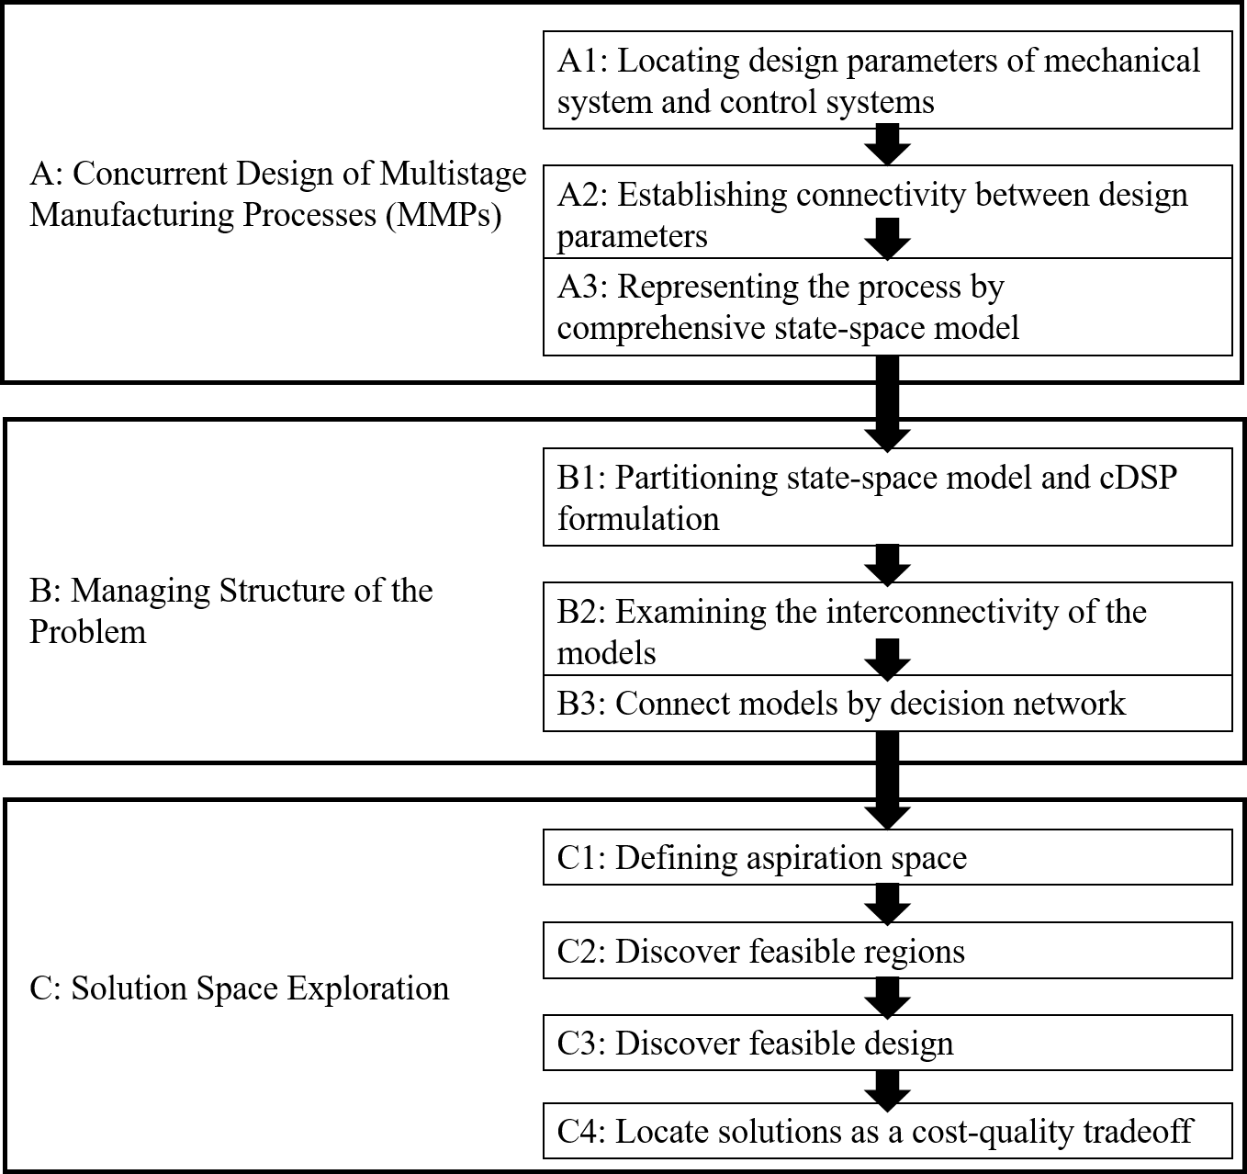
Figure 1: Proposed design method for concurrent design of a multistage manufacturing process
Figure 2: Connection between SoV and cDSPs
Figure 3: Connecting process decision and performance observation models with a decision network structure

Figure 4: Measuring size of variations with performance observation model

Figure 5: Solution space exploration

Figure 6: Two-dimensional panel stamping process [11, 13, 14]

Figure 7: Solution scheme

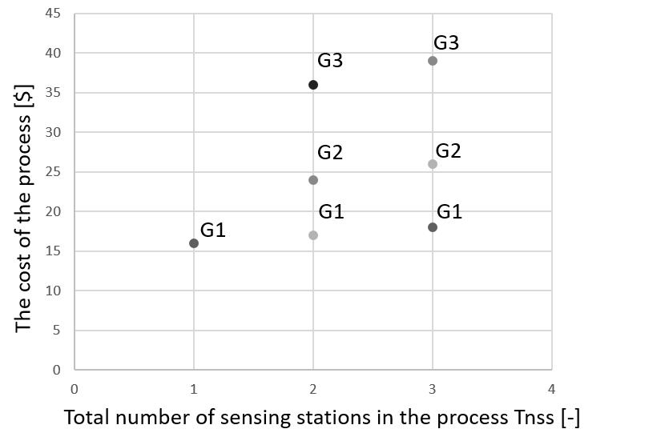
Figure 8: Cost of the feasible designs according to diagnosability, controllability, and cost-effectiveness models

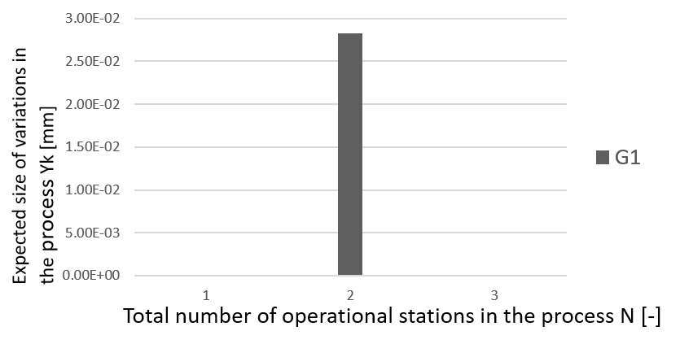
Figure 9: Expected size of variations in the process with one sensing station
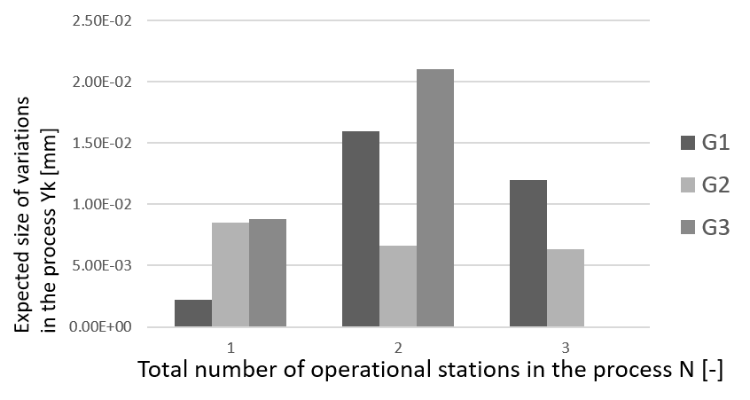
Figure 10: Expected size of variations in the process with two sensing stations
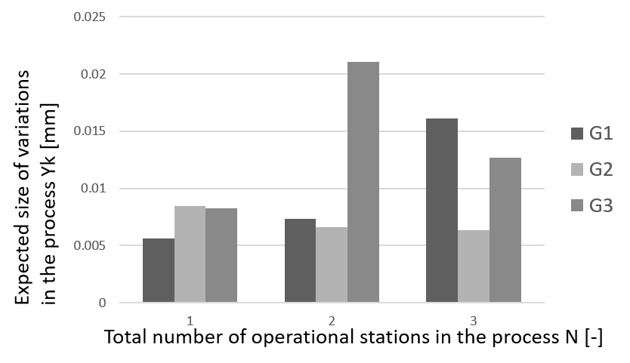
Figure 11: Expected size of variations in the process with three sensing stations

Table 1: Requirements list for design of the MMP
Requirements | Type of Requirements | Type of Design Variables | Mechanical/  Control System Parameters
type of fixture locator | flexible | Integer | M
number of fixture locator | flexible | Integer | M
position of fixture locator | flexible | Continuous | M
type of sensors | flexible | Integer | C
number of sensors | flexible | Integer | C
position of sensors | flexible | Continuous | C
distribution of sensors | flexible | Boolean | C
type of sensing stations | flexible | Integer | C
number of sensing stations | flexible | Integer | C
programmable tooling control actions | flexible | Boolean | C
process diagnosability | fixed | Boolean | C
process controllability | fixed | Boolean | C
reducing overall cost | flexible | Integer
improving dimensional quality of products | flexible | Continuous

Table 2: Overview foundational papers for identifying key unresolved difficulties in the design of MMPs

CONCURRENT DESIGN AND ANALYSIS OF MMPs
Paper | Aspects |  |  |  |  | Methods |  |  |  |  |  |  |  | Literature Evaluation |  |  |  |  |  |  |  |  |  |  |  | Research Gaps
 | Concurrent Design | Solving Multi-Objective Problems | Solution Space Exploration | Stream of Variation Modeling | Design of Control System | Collaborative Multidisciplinary Decision-Making Methodology | Model-Based Exploration through Decision Making | Objectives-Orientated Sensor Allocation by Multivariate Analysis | Compromise Decision Support Problem Construct | State-Space Model Variation Propagation in MMP | Diagnosability Analysis of MMP | Controllability Analysis of MMP | Cost-Orientated Sensors Distribution in Design of MMP | Partitioning Problems on Few Stakeholders | Game Theoretical Approach for Coupling | Solution Space Exploration in Design of Complex Systems  Solution Space Exploration in Design Of Complex Systems | Model-Based Approach Implemented In DSIDES | Objective-Orientated Coupling Or Interactions in Design of MMP | Locating Ranges of Solutions Instead of Single-Point Solutions | SoV for Systematic Analysis and Variation Propagation Control in MMP | SoV For Fault Diagnosis in Design of MMP | SoV for Generic MMPs | Design of Diagnosable MMP by Use of SoV | Design of Controllable MMP by Use of SoV | Design of Cost-Optimal MMP by Use of SoV
Xiao, A., et al. (2003) | * |  |  |  |  | * |  |  |  |  |  |  |  | * | * |  |  |  |  |  |  |  |  |  |  | Concurrent design of a mechanical and a control system in design of MMP
Liu, K., et al., (2006) |  | * |  |  |  |  |  | * |  |  |  |  |  |  |  |  |  | * |  |  |  |  |  |  |  | Finding range of solutions in design of MMP
Ding, Y., et al. (2003) |  |  |  |  | * |  |  |  |  |  |  |  | * |  |  |  |  |  |  |  |  |  |  |  | * | Observe cost and process diagnosability and controllability in design of MMP
Shi, J., et al. (2009) |  |  |  |  | * | * |  |  |  |  | * |  |  |  |  |  |  |  |  |  | * |  |  |  |  | Utilization of information from multiple disciplines to achieve in design of MMP
Izquierdo, L.E., et al. (2007) |  |  |  |  | * |  |  |  |  | * |  | * |  |  |  |  |  |  |  | * |  |  |  | * |  | Observe process controllability and product quality concurrently in design of MMP
Smith, W.F., et al. (2014) |  | * |  |  |  |  | * |  |  |  |  |  |  |  |  | * | * |  |  |  |  |  |  |  |  | Solving complex mathematical problems
Smith, W.F., et al. (2015) |  | * |  |  |  |  | * |  |  |  |  |  |  |  |  | * | *
Marston, M., et al. (2000) |  | * |  |  |  |  | * |  |  |  |  |  |  |  |  | * | *
Jin, J., et al. (1999) |  |  |  | * |  |  |  |  |  | * |  |  |  |  |  |  |  |  |  | * |  |  |  |  |  | Generalized method that can fit any MMP, requirements, etc.
Ding, Y., et al. (2000) |  |  |  | * |  |  |  |  |  |  | * |  |  |  |  |  |  |  |  |  | * | *
Jiao, Y., (2010) |  |  |  | * | * |  |  | * |  |  |  | * |  |  |  |  |  |  |  |  | * |  |  | *
Apley, D., et al. (1998) |  |  |  |  | * |  |  |  |  |  | * |  |  |  |  |  |  |  |  |  | * |  | *
Mistree, F., et al. (1993) |  |  | * |  |  |  |  |  | * |  |  |  |  |  |  |  |  |  | * |  |  |  |  |  |  | Cost-quality tradeoff in solution space exploration
Mistree, F., et al. (1992) |  |  | * |  |  |  |  |  | * |  |  |  |  |  |  |  |  |  | *
Ding, Y., et al. (2002) |  |  |  |  | * |  |  |  |  |  | * |  |  |  |  |  |  |  |  |  | * |  | * |  |  | Observe diagnosability and controllability concurrently in design of MMP
Mantripragada, R., et al. (1999) |  |  |  |  | * |  |  |  |  |  |  | * |  |  |  |  |  |  |  | * |  |  |  | *
Milisavljevic, J., (2015) | * | * | * | * |  | * | * |  | * | * | * | * | * |  |  | * | * | * | * |  |  | * | * | * | * | Forward mentioned research gaps

Table 3: Solution space of the combined cDSP
Goal Function | Number of Sensors Distribution Schemes Mi,k [-] | Total Number of Sensing Stations  Tnss [-] | Total Number of Sensors  Tsen [-] | Cost of the Process [$] | End-of-Process Variations Yk [mm]
G1 | 38 | 1 | 5 | 16 | 8.77E-06
 | 710 | 2 |  | 17 | 1.20E-02
 | 832 | 3 |  | 18 | 0.016088
Total | 1580
G2 | 8 | 2 | 5 | 24 | 0.006343
 | 8 | 3 |  | 26 | 0.006343
Total | 16
G3 | 8 | 2 | 5 | 36 | 8.77E-06
 | 8 | 3 |  | 39 | 0.012677
Total | 16

Corresponding author, janet.allen@ou.edu

