Making mounds: Monuments in Eurasian prehistory
Chris Gosden, Peter Hommel & Courtney Nimura

…and their Lordship passed, leaving only green mounds in the grassy hills.
Tolkien, 1954: 247

A Connected Continent
Eurasian archaeology is, above all, an archaeology of interaction. Its distributions of artefacts, materials, technologies and traditions define extensive networks of communication and exchange tying the dispersed communities of the continent together. Although these webs of connectivity can be traced in almost every period, their scale and character is constantly in flux. Here, we will follow just one thread in this shifting tapestry, using large funerary mounds as our primary evidence.
Across much of northern Eurasia, tumuli remain the most visible evidence of later prehistoric activity. Their appearance as a widespread phenomenon during the 4th and 3rd millennia BC permanently changed the landscapes in which they were constructed. Later fluctuations in the scale, character and distribution of mounds have defined archaeological periods and tested the boundaries of acceptable interpretation. If the word kurgan is substituted for tumulus, it reminds us that these striking archaeological features have often been a subject of considerable speculation (e.g. Gimbutas, 1956).
In this paper, we will examine this phenomenon of mound building in a Eurasian context and review broad chronological patterns in the distribution and relative prominence of mounds at a continental scale. We do so to highlight a remarkable resurgence of rich monumental burial at the beginning of the Iron Age and to explore a bold hypothesis. We suggest that a common pairing of extensive networks of contact, mapped out in the contents of these mounds and the explicit referencing of local social landscapes in their construction, highlight structural similarities in practices across much of the northern world. For us, this implies a greater connection amongst the communities of Iron Age Europe and Asia than is usually supposed. This coherence – perhaps rooted in sets of shared practices and beliefs (ontologies in today’s parlance) that were broadly animistic in nature – enabled a sudden and dramatic transmission of new ideas, new forms of contact, and new ways of life over the course of a few centuries at the beginning of the 1st millennium BC.
We believe that research into these latitudinal (east-west) links provides an important counter-balance to the traditional focus of Iron Age research, which remains dominated by discussions of longitudinal (south-north) relationships with the ‘civilized’ states of the Mediterranean and/or Western Asia. There are two main sources of material evidence for these links. The first lies in the study of relationships between so-called Celtic and Scythian art (in the broadest sense of the word; see e.g. Doan, 1983; Frey, 2000; Jacobsthal, 1944; Pare, 2012; Wells, 2013). The second is in the way this movable material is fixed within the landscape. Ultimately, we wish to consider these contexts in detail and in parallel with the specific technological and stylistic character of their grave goods, but this is far too much for one already over-ambitious paper. Our intention here is to operate at a more general level, simply to establish the plausibility of extensive connections across Eurasia in the period immediately preceding the emergence of Celtic art through the medium of mounds.

Creating Time and Space
For all human groups, the maintenance of continuity across space and through time is an issue that is often resolved by building monuments to mark or bound human space: mounds, enclosures, hillforts. This may be especially true for mobile peoples, who range over large areas in relatively small groups. Visible burial mounds and monuments are an ingenious mechanism in this regard. Located very firmly in space, they can become part of people’s movements, either on a seasonal basis or in response to periodic events, such as the death of an important member of the community. Mounds, therefore, gain a temporal dimension, compressing memories and expectations of past and future activities into the present. This combination of the temporal and spatial effects may partly explain why they remained a durable aspect of many Eurasian cultures over many millennia.
When looked at more empirically, mounds work at different scales simultaneously. Mounds are easily recognized, especially in open country like the steppe, and can help create a network of similarity across wide areas, being both useful waypoints and triggers for action for those who are knowledgeable about them. They are accumulations of material, usually some combination of earth, wood and stone, brought together to form the mound. The range of materials is to some extent governed by the affordances of the local environment, but they are not put together accidentally nor simply on the principle of least effort. People do not always use clay, wood or stone from the places nearest the mound, they actively choose their materials and sometimes alter their character with care. Although this is now widely acknowledged (see Nagler 2013), we are particularly influenced in these thoughts by recent work in Scandinavia. Specifically, Holst’s (2013; Holst & Rasmussen, 2012) study of Skelhøj in southern Jutland, Denmark – a barrow (31 m in diameter and 7 m high) of the 14th century BC – part of the northern extension of the Tumulus cultural phenomenon. In the centre of this mound, a male interment was placed in a coffin and covered with a stone packing onto which grass turves were laid. Individual turves were still recognizable through careful excavation, and analysis of the adhering soil showed significant compositional variation – not all of these turves were local with respect to the mound. To quote the excavator:
‘the site was radially divided into eight equally sized segments marked by large stones, in what was later to become the kerbstone demarcation of the completed barrow … The partitioning served as a division of the builders into separate work groups, with the sod for each segment being procured in a different part of the landscape, and with small systematic differences in the otherwise very regulated building principles between each radial segment of the barrow’ (Holst, 2013: 110).
Each construction team worked independently, but to a shared design – an eight-spoked wheel, derived from contemporary cosmological principles. It also appears that the work groups came to Skelhøj from different areas of the surrounding landscape, bringing with them the turves they would incorporate into the monument. Very considerable amounts of grass went into the making of such mounds, so that the turves represented not just work to a coordinated plan, but also a sacrifice of valuable grazing land. In a pastoral economy, this must have been an important offering to honour the dead. In Denmark alone, the sacrifice of grassland to build the many thousands of Bronze Age barrows constructed in this period was immense.
Neither this offering of the landscape itself, nor the intense local mapping of social space in the construction of mounds was unique to Skelhøj. The same patterns are repeated numerous times across Eurasia, in communities with very different ways of life. While it is unlikely that the same principles of selection and organization apply in each case, there are so many indications of conscious material choice and manipulation in the construction of mounds that we need to be aware of their potential. The work on Skelhøj also alerts us to the fact that we often take barrows as a finished form – a useful archaeological measure of their likely contents and chronology. Yet complex sequences of activity precede the barrow’s construction, with platforms, linear settings of posts and so on in evidence. Rare studies of the space around prominent prehistoric mounds across Eurasia have revealed similarly complex evidence of intensive landscape use (e.g. Gass et al., 2014). While the precise character of these activities is likely to have a local character, there may also be wider connections in play. Similarly, commonalities identified in barrow forms across a wide geographical area can be considered against the variability of local processes and the different ways of life of the people who constructed them (see Bourgeois & Fontijn, 2012).

Ups and Downs: monumental mound building in Eurasia
Although traditions of mound burial became widespread across the Eastern European forest steppe during the 5th millennium BC, the first great kurgans of the Eurasian Metal Age were constructed more than a millennium later, in the second half of the 4th millennium BC (Fig. 1). These tombs, situated along the northern edge of the Greater Caucasus, combined monumental scale and complex internal structures with extraordinarily rich burials and have been interpreted as critical to the subsequent development of the ‘kurgan phenomenon’ and the much discussed Yamnaya culture (Gimbutas, 1956). The latter have been seen as crucial in the spread of both metallurgical practices and Indo-European languages across Eurasia. The analysis of ancient DNA has been used recently to bolster this narrative and to identify close interaction between the inhabitants of Eastern Europe and the Eurasian steppe (Haak et al., 2015). Although the links of inference between material culture, language and genetics are still debatable and a greater range of explanations for the new data needs to be canvassed, such studies highlight the potential value of approaching European archaeology in its wider Eurasian context.
There is not a clean chronological succession between subsequent burial traditions in the western steppe during the 3rd and 2nd millennia BC (see Chernykh, 2017: 182), and there is in any case significant regional variation: from pit-graves and varied catacomb tombs to timber-lined burial chambers. The scale of these tombs, some of which incorporate large numbers of burials, is equally variable. If we look to the east of the Urals, this variety of mound building traditions, built on the foundations of a supposed Yamnaya expansion, multiplies again. However, after the Middle Bronze Age (2100–1800 BC) of the Urals— marked by multi-layered burial mounds of earth and wood, spoked-wheel chariots and abundant animal sacrifices—we see the beginnings of a significant pattern of change, which culminates in the ‘monotonous’ burial traditions of the later 2nd millennium BC (Chernykh, 2017: 193). In spite of substantial evidence for large-scale metal production and a significant increase in the spatial scale of archaeological connections, there appears to have been a strong social trend away from ostentatious burial, particularly after 1200 BC, with little differentiation in material wealth under kurgans and more limited local variation in type and size (Gryaznov, 1969; Jacobsen-Tepfer, 2015). A rather similar pattern is seen across Europe.

Leaving aside the question of Neolithic monumentality, we can trace an efflorescence of mound making and burial rituals across Europe at the end of the 3rd millennium BC. Although widespread at a macro-level, as was the case across Eurasia, the phenomenon of mound building was characterised by local and regional specificity both in burial practice and monumental structure (see Holst, 2013: 105–6 for a useful summary). In eastern Central Europe, this phase is most closely associated with the Únětice horizon – reaching a peak in the early 2nd millennium BC at sites like Łęki Małe in Poland (Czebreszuk, 2001). Here, richly furnished individual burial replete with gold ornaments and bronze weaponry were interred beneath a series of mounds made from clay, stone and soil c. 20–40 m in diameter. The largest of these mounds still rises 6 m above the surrounding fields (Kowieńska-Piaszykowa, 2008). In Britain and Atlantic Europe, these new monuments follow a broadly similar model, here ‘colonizing’ landscapes replete with earlier earthworks, but reflecting very different attitudes to burial and the treatment of the dead. Later echoes of this pattern appear in the Baltic and Nordic Bronze Age at the end of the 2nd millennium BC (e.g. Kristiansen, 1998). In the south, we see localized mound building in Greece and the southern Balkans from the early 3rd millennium, and the beginning of a more significant tradition around the Aegean from the final phase of the Early Helladic period (EHIII). However, mounds in these areas are most notable for their rarity and can in some senses be considered as epiphenomenal – at least from a northern Eurasian perspective (Harding, 2000; Müller-Celka, 2011).
In Europe, as in the steppe zone, it seems that by the beginning of the 1st millennium BC there was already a widespread trend away from the visible interment of wealth in graves and a substantial reduction in the scale of tumulus burial traditions, if not always in their distribution (see Harding, 2000, 84–103). With a few localised exceptions (such as Velatice, Očkov, and Čaka in the Czech Republic and Slovakia), large mound building in Central Europe diminished and, by the end of the 2nd millennium, it had been effectively replaced by new practices centred around less ostentatious cremation burials in extensive ‘Urnfield’ cemeteries. In almost all of the areas we have just described, the centuries around the turn of the 1st millennium BC saw similar changes. This pattern only serves to highlight the changes that occurred across Eurasia a few centuries later.

Resurgence of Riches
Of course, some areas stand out as exceptions to this pattern. Between the 14th and 9th centuries BC, rich ‘warrior’ burials and other inhumations with elaborate artefact forms, body ornaments and distinctive styles of human and animal imagery appear in cemeteries of simple, stone-lined flat graves on both sides of the Greater Caucasus range (Kozenkova, 1992; Reinhold, 2003; Tekhov, 1977). Meanwhile, in Mongolia, elaborately structured monumental complexes or khirigsuurs (also dating between c. 1400–800 BC) continued to be raised above graves containing few, if any, artefacts and often no burial at all. These monuments, typically focussed around a small stone mound, have a range of associated features, including extensive evidence of feasting and memorial rites around the mound, and the monumentalisation of the human body in the form of stone stele, commonly known as deerstones. This khirigsuur tradition is important in its own right, but also because some of the earliest mounds in a new phase of rich monumental burial across Eurasia seem to draw directly upon it.
Around the turn of the 8th century BC, in a valley between two low spurs of the Sayan mountains, a vast mound of interlocking timbers and stone was raised above the steppe, creating a dished platform 120 m across, rising 3–4 m above the surrounding plains (Gryaznov, 1980; Savinov, 2002). In plan, its layout and associated satellite complexes is comparable to many Mongolian mounds, from which it may have taken some inspiration, but its size, structure, and contents are remarkable. Looted in antiquity and damaged prior to its excavation in the middle of the 20th century, this mound – designated Arzhan I by its excavator – nevertheless contained numerous burials of humans and horses. The surviving artefacts, though clearly connected to earlier traditions of representation, contained all of the elements of later ‘animal style’ art (Grach, 1980). Over the subsequent centuries, three similar stone and timber platform kurgans were built – smaller and less structurally complex, but evidently far richer in their contents.
Arzhan II, a mound of stone and earth 80 m in diameter and 1.5 m high, was excavated by a Russian-German team from 2000–2004 and yielded an un-looted grave in a carefully constructed log-built chamber. It contained a paired adult burial (male and female) with more than 20 kg of gold (Chugunov et al., 2010). This wealth was predominantly in the form of personal ornaments and accoutrements for the dead – heavy torcs and pectorals, hairpins, bimetallic (gold/iron) daggers and knives, all ornamented with tessellating animal motifs, sheetwork ornaments for headgear, quivers, boots and shoes, hundreds of small appliqué plaques in the form of feline predators and boars, and thousands of tiny gold beads sewn to the trousers of the deceased. Other materials, including turquoise, glass and etched carnelian beads were also recovered from the tombs. Describing all these artefacts, and their many connections, required a colossal effort on the part of their excavators. Nevertheless, an unusually detailed analysis of the mound itself also revealed a multi-phase construction through which a series of enclosures and platforms were created in stone, clay and earth and used to define activity areas within and around the mound (Chugunov, 2011; Chugunov et al., 2010).
Similar and virtually contemporary patterns – as far as the challenges of archaeological chronology allow us to judge – can be traced in several other areas of the steppe. In Kazakhstan, the 8th–6th centuries saw rich kurgan burials appear widely, reflecting both the local traditions of the interred and their participation in extensive networks of interaction and exchange. The ‘Royal’ kurgan, Baygetobe, at Chilikty in eastern Kazakhstan, securely dated to the 8th–7th centuries BC, was constructed around a timber chamber built at ground level and ritual entrance-way (echoing earlier Bronze Age traditions in the region). Though looted in antiquity, this structure yielded 4303 gold artefacts, many with inlays of turquoise and, in one case, lapis lazuli. Around the wooden chamber a substantial stone mound was built, its outer surface covered with animal bones (sheep, goat and, less frequently, horse, see Toleubayev et al., 2013). Above, in a series of separate events, an earthen mound was raised and surrounded by a low stone façade.
The large and complex mound cemetery of Bes’ Shatyr, far to the south in the foothills of the Tian Shan, shows broadly similar construction traditions to the mounds at Chilikty, but includes specific technical elements of woodworking with exact parallels in Arzhan I and a comparable arrangement of ‘external’ memorial complexes (Akishev & Kushaev, 1963; Alekseev et al., 2005: 187–8). Although constructed primarily from layers of stone and earth gathered from the surrounding landscape, these tombs also incorporated other, more ‘distant’ materials. According to some estimates, the trees required to construct the wooden chambers at Bes’ Shatyr IV, a mound 104 m in diameter and 17 m tall, were carried from stands more than 150 km away from the site itself (Akishev & Kushaev, 1963; Rolle, 1980).
Far to the west, in the northern Caucasus, a modest return to mound building in the 8th century is followed by a sudden and dramatic shift in scale and ostentation. This shift is best exemplified in the kurgans at Kelermes and Kostromskaya. Radiocarbon date ranges for the earliest of these tombs span the 8th and 6th centuries BC, though the archaeologically accepted range falls towards the later end of these distributions (Alekseev et al., 2005, 146–8). These kurgans were of earth and covered complex internal constructions of wooden poles used to compartmentalize the burial space or, as at Kostromskaya, to create a tent-like framework within the barrow (Artamonov, 1966; Petrenko, 1995). The rich assembly of accompanying artefacts beneath these barrows and deposited within the mound itself (presumably during the construction), included gold, bronze, silver, and various semi-precious stones. Some of these reflect strong links with the South, with Uratu and western Anatolia, others display features seen at sites across the Scytho-Siberian world. The majority, however, are a complex mixture of stylistic influences (Petrenko, 1995).
Among these are some of the most famous items in the canon of Eurasian Iron Age art, including the large golden bowcase from Kelermes, made in the form of a panther (Artamonov, 1966, 18–22) and the shield ornament from Kostromskaya shaped in the form of a deer, its exaggerated antlers running along the length of its back. Like many other graves of this period, these kurgans also contained numerous horse sacrifices – at Kelermes, Galaninia (1983) notes the presence of horses from different communities or social strata, based on the study of their bridle fittings. The slightly later Ul’sky Kurgan, in the same region, which contained more than 360 sacrificial horses, carefully arranged beneath the mound, illustrates an enthusiasm for the destruction and burial of wealth – material and animal – that is hard to reconcile with any economic understanding of the world (Petrenko, 1995).
To the north of the Black Sea, ‘pre-Scythian’ interest in large mounds seems to revive in the 10th/9th centuries, but the associated burials remain sparsely furnished until the 7th–6th centuries. Most of these early graves were cut into existing Early–Middle Bronze Age kurgans. The earliest rich ‘Scythian’ graves in this region are also secondary burials, and it is not until the 6th–5th centuries that a significant tradition of primary burial was re-established (Melyukovo, 1995). However, the graves that were built in this region over the subsequent centuries are among the largest and most exquisitely furnished anywhere in the steppe zone. The Oguz kurgan, on the Dnieper River, is often cited as the largest of the mounds in Pontic Scythia. Built at the end of the 4th century, it stood more than 20 m in height and c. 120 m in diameter when it was excavated in the late 19th century (Boltrik & Fialko, 1991). These excavations, though poorly documented, revealed a square stone-packed central grave containing a corbelled vault of roughly hewn stone – echoing the syncretic Greco-Scythian tombs of the Bosphoran Kingdom. Over this was built a series of turf mounds finished with a krepis built of limestone from the banks of the Dnieper (Boltrik & Fialko, 1991: 178). Though repeatedly looted in antiquity, the mound still contained more than 200 items of gold and silver, predominantly horse gear and ornaments.
The largest mound at Chertomylk – also originally excavated in the 19th century and subsequently revisited by a Russian team in the 1980s – was very similar in size (Alekseev et al., 1991: 29–54). Meticulous excavations of the baulks left by earlier ‘archaeological’ research revealed that the mound was constructed in three phases from thousands of small turf blocks, laid grass-side down in regular rows. Each ‘mound’ was finished with a thin layer of silty clay, which by the time of the next phase had already been washed off the upper surfaces, leaving only an accumulation around the base. A final addition, a stone ring on top of the last of these silty layers, encircled the monument. Very similar features characterize many other large mounds in the northern Pontic steppe (e.g. Oguz or Zheltokamenka) and find parallels in other mounds, both east and west (Alekseev et al., 1991: 34–35; Zdanovich et al., 1984: 40–44). The finds from this tomb, not only gold and silver, but also iron, bronze, glass and ceramic, defy superficial description, but map out connections not only with the Greco-Macedonian world, but also with Western Asia and the Achaemenid Empire.
Still more remarkable excavations at Bajkara, in northern Kazakhstan – undertaken in partnership with the German Archaeological Institute (Parzinger et al., 2003) – revealed still greater levels of architectural complexity in the construction of Scythian period mounds, with turf, wood, bark, stone and loess used with deliberate and structured intent. Though no burials were associated with this structure, its complexity was far from unique within the region. Contemporary elite graves of the 5th and 4th centuries in the southern Urals, covered by mounds reaching up to 120 m in diameter, are scarcely less impressive. The ‘Royal’ tomb at Filippovka, near Orenburg, like every other mound described thus far, contained a wealth of local artefacts, whose use of visual tropes, motifs and materials tie it into the same extensive networks of artistic ideology in tour-de-force of production, based on the mineral wealth of the Urals. Alongside characteristic cauldrons, weapon sets and ornaments, are imported items or those which incorporate materials that actively display a network of material and stylistic connections stretching far to the south into Western Asia (Yablonsky, 2010).
Looking back to the west, we bypass apparently similar developments in the southern Balkans, Anatolia and Greece – which saw the widespread re-emergence of interest in rich mound burials between the 8th and 6th centuries BC (see chapters in Henry & Kelp, 2016) – to cross a major stylistic frontier into Western Europe and the ‘Celtic’ world. We argue that in both their general monumental character and numerous specific details, the Fürstengräber of the Central European plain share many of the same characteristics, concerns and complexities with contemporary and earlier graves across the Eurasian steppe. These so-called ‘princely’ tombs are found from Hallstatt C through to the end of La Téne A (c. 7th –4th centuries BC), and include such intriguing examples as the 7th century BC, 10–12 m mound at Magdalenenberg in Baden-Württemberg, Germany (Spindler, 2004); the 6th century BC, 53 m diameter mound at Oss–Vorstengrafdonk (which was erected directly on top of a Bronze Age barrow) in the southern Netherlands (Fontijn et al., 2013); and the 5th century burial mounds at Glauberg in Hesse, Germany (Baitinger, 2010; Baitinger & Pinsker, 2002). Some of the earlier mounds were erected alongside proto-urban settlements, such as the Heuneburg (Fernández-Götz, 2017; Fernández-Götz & Krausse, 2013). They find their best-known expression in the mid-6th century grave at Hochdorf in Baden-Württemberg, Germany (Biel, 1985).
The Hochdorf mound itself – composed primarily of turf and surface soil stripped from an area immediately around the monument – covered a sealed wooden burial chamber packed in stone and accessed through a low stone walled dromos to the northwest of the grave chamber. Like many of the other mounds we have discussed, the construction of the central grave was only the first in a series of phases, probably over an extended period of time. The mound was constructed in open grassland, with the first step being the digging of the 11 m square and 2 m deep grave pit, with the material from the excavation later placed in a low mound around the grave. The grave pit was lined with oak, the splinters of which are found beneath the primary mound. The stone wall was then constructed, but the grave remained open long enough for plant growth to occur, and it may be that the body was conserved in some way before burial, or the grave was prepared before death.
Charcoal, slag, melted bronze work tools, and half-made items of bronze and gold from three pits directly beneath the primary mound suggests that some of the grave goods buried here were made or modified as part of the burial rites. However, unlike the mounds of the Pontic steppe, no evidence of feasting was recovered around the mound. The body and grave goods were placed in the grave, following a procession approaching from the northwest. The walled entrance was sealed and the grave chamber covered layers of stone and turves. The entire inner mound was then covered with brown soil and yellow loess – it is generally assumed that this was taken from the surrounding ditch (30 m wide and 1.5 m deep). The base of the mound on the western side, and possibly all around it, was given a low façade of stones and wooden posts. The excavators estimate that the construction of the mound could have taken several years (Biel, 1985: 36–41). Given the number and range of people engaged in constructing the mound, it is possible that some material came from a distance, as well as locally.
The central grave contained a great range of grave goods both imported from the Mediterranean and locally made. Nevertheless, the golden dagger, dress fittings, neckrings and ornaments, right down to the shoes, also seem to echo those found in Arzhan II far to the east. In spite of their evident stylistic differences, such a comparison is tempting. We could even extend it to draw broad parallels in the extended construction of these two mounds (see Chugunov et al., 2010). However, this may be a step to far.
Although Hochdorf remains one of the best excavated and least disturbed examples of a so-called princely grave, a number of other large mounds were constructed over the subsequent centuries, most famously at the Glauberg, in Hesse, Germany. Here we see other kinds of evidence for the complexity of these structures, which are incorporated into wider monumental landscapes, including systems of banks and ditches with purported astronomically significant orientations (Deiss, 2008). This display of riches in burial mounds, however, was relatively short-lived – by the mid-fourth century BC the tradition was already past its prime, and by the end of the century there was a widespread shift toward simpler burial mounds.
To provide some summary of an extremely complex picture of mound building, we can see a fluctuating interest in large monumental burial mounds from at least the 4th millennium BC (Fig. 2). While this is discontinuous in both space and time and characterized by variety, there is a broadly synchronic picture – significant mound building appears to be contagious. When it begins in one area, it also appears in others. Wherever such evidence is recorded, it is clear that considerable care was taken in the choice of materials from which to construct these mounds, their internal structure, layout, (barely considered here) and their choice in the scale and character of material deposited in whatever graves these mounds contained. In other words, mounds are broadly recognizable features wherever they are constructed, but the processes and structures that eventuate in a finished form are highly variable. It is this combination of broad similarity with very considerable local variability which gives mounds both their power and longevity.

Making Monuments, Making Markers
While the preceding condensation of elite burial traditions of later Eurasian prehistory can only be a summary, we argue that there is significance in the fact that between the 8th and 4th centuries, vast mounds filled with richly ornamented and exotic material were being built anew from the Yenisei to the Enz. If we recognize this phenomenon as widespread, how do we account for it? Do these examples represent some form of contact – hardly impossible, given that materials are rapidly crossing vast swathes of Eurasia at around the same time – or are there deeper structural links between these societies that result in similar reactions to comparable changes at this time? A means of controlling comparisons is to think of the full life history of mounds, not just concentrating on the burial or its contents. We cannot write a full set of life histories here, but as a first step we can think of what they might consist.
Preliminary activity. In most instances the construction of these prehistoric mounds comes at the end of a sequence of activities in which built structures of wood, earth and stone were used to shape movement, visibility and action. These include circular enclosure, access controls – whether functional or ritualized – posts, pits and stone mounds. Many of these features were evidently laid out with care, orientated on astronomical alignments, or designed to partition space within the monument. Such features can remain visible, retained or elaborated in the finished form of the monument, as in the structure of many Mongolian khirigsuurs, or intentionally hidden, like the earliest phases of the mound at Bajkara, sealed beneath layers of birch bark prior to the construction of the mound (Parzinger et al., 2003).
Burial. Although there are instances of complex mound construction without evidence of primary ‘burials’ – whether human, animal, or material – such examples are rare. In most cases the building of mounds is actively entwined with other forms of structured deposition, which form part of an extended process of construction that culminates in the final form of the monument. Such burials are often treated as the ‘main event’ by archaeologists, and perhaps also by the people involved. But even today, anyone who has organized a funeral will recognize that the burial itself is a brief, but emotionally charged moment surrounded by intense activity. The creation of appropriate funerary structures, whether pit, chamber, tomb or pyre, and its furnishing necessarily precedes this moment, but the scale of preparation required varies dramatically. It may be necessary to gather materials at a distance. In some cases, the entire mound may need to be constructed in advance. The spectrum of opportunities for variance in the specifics of burial constructions is immense.
Set against the general pattern of rich mound building across the Early Iron Age of Eurasia, we see strong evidence for macro-regional trends in the specific character of mounds and the spatial-temporal organization of burial within them (cf. Chugunov et al., 2010 and Ochir-Goryaeva, 2015). At a still more local scale, we see huge variety of choices reflected in the internal structure of graves. This aspect of the mound is not only one of the most susceptible to elaboration but also the most personal part of the mound for the people who built it. Unpicking this variation – regionally and chronologically – is the subject of many books, but can be summarized in a visual summary of structural forms from a single area in our discussion (the northern Pontic Steppe; see Fig. 3 after Ol’khovskiy, 1991). Here, it serves only as reminder of the paradox of similarity and difference that we have already raised on several occasions in this paper.
Building barrows. Although some mounds, such as the Oguz kurgan, with its central stone chamber and long underground entrance, may have been built significantly in advance of the burial, it was perhaps more common in northern Eurasia for the building of a mound to serve as the final phase of the process of primary burial. At its simplest, this may be a contiguous process, but there are certainly cases where significant mound building is temporarily separated from burial: the final act that ends a longer sequence of un-mounded burial reflecting years or even decades of use.
Whenever the mound is built, material must be gathered to create it and be arranged within it. The architects of mounds were concerned not only with the goal of making a visible monument in the landscape, but also with social processes of construction and the significant materiality of the mounds. The materials assembled and deposited in these monuments were to some extent constrained by the local ecology, geomorphology and geology – the availability of local materials – but were given order and form by active choices, and often augmented by specific resources drawn from further afield. People were not only choosing materials that were conveniently available, but drawing in materials (often from a considerable distance) whose physical qualities held specific associations or symbolic roles. We could cite the acquisition and incorporation of rock art or enigmatic stelae taken from existing graves – as seen at Arzhan II and many other sites in the Sayan-Altai (Chugunov et al., 2010) – as an important example. But even seemingly mundane materials can hide deeper significance. According to Rolle (1980), the turf used in the construction of Scythian mounds in the Pontic steppe was itself an important gift, as the pasture on which the dead would raise their herds. Probably, this was grass selected for (or perhaps by) the dead and potentially brought into the site from a distance. At Skelhøj, it seems that the communities involved in its construction brought turf from different locations in the landscape. It has been argued that 140,000 m³ of turf used to create the mound at Oguz was brought from valley of the Serogozkiy Balka, 3–5 km from the site, while the limestone used in the construction of its stone chamber and krepis was carried more than 50 km (Boltrik & Fialko, 1991). Such examples are hardly unique. At Tolstaya Mogila, similar distances were cited in the selection of turf, supported through soil analysis of the surrounding region (Rolle, 1980). Further research, detailed excavation and greater concern for the nature of the materials in the mound are both necessary to extend beyond individual examples and explore the wider significance patterns of material use in the making of mounds.
After mounds. Looking back at our brief discussions of mounds, one of the most important features that emerges is that the processes of construction were not only mapped out over space, but also extended across time. Evidence of multiple construction events, whether separated by weeks, months, years or generations appear in almost every mound. At the coarsest level, this is usually restricted to discussions of significant secondary burials. These are often significantly later and may be seen as acquisitive, as discussed by Moreland (2001) in relation to the Anglo-Saxon burials at Wigber Low, but may also be relevant here in relation to the early Scythian ‘occupation’ of large Bronze Age barrows in the northern Pontic Steppe (see Melyukovo, 1995). Considerable work has been carried out on the after-life of barrows (Cooper, 2017; Bradley et al., 2016) and the activities that took place around them (e.g. Nagler, 2013; Gass et al., 2014). We mention this for completeness, but neither are topics that we can broach in any detail here. Of more immediate importance are examples where construction appears to be a cyclical process, socially (if not temporally) contiguous (e.g. Arzhan II, Chertomlyk). Repeated phases of rebuilding apparently completed at regular intervals, sometimes with closely contemporary burials, remind us that all of these monuments were routinely revisited, and that they would have operated as critical focal points for movement and action within the landscape, recognizable, revered and remembered, at least for a time.

Discussion
We argue that mounds form a technology that help shape time and space, and can therefore contribute to wider debates around the marking of landscapes and the creation of space. In this sense, they are similar to the other communal, monumental structures discussed in this volume. The building of monumental burial mounds—as a social technology for mapping and maintaining a communities space—is such a successful strategy that people have returned to it time and again over the last six millennia across Eurasia. The more contentious point is that there appears to be some synchronicity between these reoccurrences. This idea seems particularly alluring in the resurgence of large rich burials across Eurasia at the beginning of the Iron A.
Long-term temporal and spatial relationships are being rethought. Mobile pastoralists, it is increasingly recognized, order their spatial worlds at a whole series of scales (e.g. Frachetti, 2008; Honeychurch, 2014). The settlements, huts, pens and droveways of local landscapes help move people and animals between winter and summer pastures. Shared material culture, such as the various aspects of the Bronze Age Andronovo complex or the so-called Scytho-Siberian groups of the 1st millennium BC created differentiated wholes allowing long-distance connections and shared understandings. We have been looking at those phenomena – burial mounds, kurgans, tumuli and khirigsuurs – that bridge these scales. As we have seen, they are found across Eurasia from the Altai to Western Europe: we recognize similarities between these mounds today and it is likely that such recognition occurred in the past, too. On the other hand, a single mound can also map its landscape, being made primarily from local materials, though some may have come from tens or even hundreds of kilometres away.
The care with which mud, turf, stone or wood were selected indicates an appreciation of local material relations and a condensation of those relations into a single mound. Mounds are often the finished form of a sequence of actions, which might unfold over months, years or even generations. Such actions, which may include processions to the mound as well as activities around or within it, are performed with an appreciation of both astronomical orientation and landscape form.
The death of a person, or persons, punctuates a longer sequence of events and actions, which were of importance to the community. Mounds concern time at least as much as space – they create a tradition of action, but each is individually different. Cemeteries of mounds are increasingly seen to include a range of features, many of which leave little or no trace above ground today. Lastly, and not especially the focus of our attention here, the similarity of artefacts accompanying burials across large distances have been argued to form part of the links we now call Scythian or Celtic (Doan, 1983; Frey, 2000; Jacobsthal, 1944; Pare, 2012; Wells, 2013).
The broad similarities across Eurasia that we have highlighted in this paper, though widely recognized, draw attention to strong connections between Europe and the steppe zone (quite what form these connections took needs further investigation). These connections may reflect common approaches to the worlds of both the living and dead – but this raises as many questions as it answers. In the present state of knowledge, it appears that large mounds are extraordinarily widespread in the earlier Iron Age, but that their distribution is discontinuous. Where they are found, mounds must have resonated with local trajectories, modes of sensibility and group making. We need to think more about what those modes were and how deeply rooted in the past they were. There is a paradox or tension between the relatively small numbers of people buried in or under a mound and the large workforce needed for their construction. The size of these constructions and the fact that materials to construct them may have come from a wide area might be seen as indications of chiefly society, where individual control over a labour force was a measure of the erstwhile power of a chief or his successors. The investment in grave goods, another traditional index of power (and as characteristic a feature of these early Iron Age mounds as their size), almost always includes material whose origins reflect networks of elite communication that extend far beyond any plausible territorial domain. Fontijn and Fokkens’ (2007, 354) description of Early Iron Age mounds in the southern Netherlands as ‘a transformation in the attitude towards valuables and the construction of personal identities in burial contexts’ could apply equally in almost every example we have described (see also De Mulder & Bourgeois, 2012). However, while many of the objects deposited within these graves are intensely personal, mounds are not purely monuments to individuals. For us, their interest derives from a potential tension between the individual and the group. The careful choice of clay, wood and stone seem to indicate subtle mapping of the territories in which mounds sit, reinforcing the identity of the wider group. Perhaps these communities were connected via a shared set of beliefs, a set of beliefs that was potentially rooted in earlier belief systems.
The advantage of looking at mounds is that they are large, hard to miss, and difficult to destroy so fully that they leave no archaeological trace. Absence of evidence might really be evidence of absence in their case. While broad similarities can be highlighted in their construction, structure and contents, mounds are found in very different forms of society. Why such different culturally constructed groups carried out apparently similar activities, with much the same end result, is worth considering.

References
Akishev, K. A. & Kushaev, G. A. 1963. Drevnyaya Kul’tura Sakov I Usunei Dolini Reka Ili. Alma-Ata, Nauka.

Alekseev, A. Yu., Murzin, V. Yu. and Rolle, R. 1991. Chertomlyk. Skifskiy Tsarskiy Kurgan IV v. do n.e. Kiev, Naukova Dumka.

Alekseev, Yu. A., Bokovenko, N. A., Vasiliev, S. S., Dergachev, V. A., Zaitseva, G. I., Kovaliukh, N. N., Cook, G., van der Plicht, J., Possnert, G., Sementsov, A. A., Scott, E. M. and Chugunov, K. V. 2005. Evraziya v Skifsuyu Epokhu: Radiouglerodnaya i Arkheologicheskaya Khronologiya. St Petersburg, THESA.
,
Artamonov, M. I. 1966. Sokrovishcha Skifskikh Kurganov v Sobranii Gos. Ermitazh, Leningrad, Praga.

Baitinger, H. 2010. Der Glauberg - ein Fürstensitz der Späthallstatt-/Frühlatènezeit in Hessen. Materialien zur Vor- und Frühgeschichte von Hessen 26. Wiesbaden, Selbstverl. des Landesamtes für Denkmalpflege Hessen.

Baitinger, H. and Pinsker, B. (eds). 2002. Das Rätsel der Kelten vom Glauberg : Glaube - Mythos – Wirklichkeit. Stuttgart, Konrad Theiss Verlag.

Biel, J. 1985. Der frühkeltische Fürstengrabhügel von Hochdorf. In D. Planck, J. Biel, G. Süsskind and A. Wais (eds), Der Keltenfürst von Hochdorf, 31–42. Stuttgart, Landesdenkmalamt Baden-Würrtemberg.

Boltrik, Yu. V. and Fialko, E. O. 1991. Oguz – Kurgan Skifs’kogo Tsarya Kintsya IV st. do n. e. In Zoloto Stepu: Arkheologiya Ukraini, 178–80. Kiev, IAANU.

Bourgeois, Q. and Fontijn, D. 2012. Diversity in uniformity, uniformity in diversity: Barrow groups in the Netherlands. In D. Bérenger (ed.), Gräberlandschaften der Bronzezeit: internationales Kolloquium zur Bronzezeit, Herne, 15.-18. Oktober 2008, 533–51. Darmstadt, von Zabern.

Bradley, R., Haselgrove, C., Vander Linden, M. & Webley. L. 2016. The Later Prehistory of North-West Europe. Oxford, Oxford University Press.
,
Chernykh, E. N. 2017. Nomadic Cultures in the Mega-Structure of the Eurasian World. Trans. I. Savinetskaya and P. Hommel. Brighton, MA, Academic Studies Press.

Chugunov, K. V., Parzinger, H. and Nagler, A. 2010. Der Skythenzritliche Fürstenkurgan Aržan 2 in Tuva. Mainz, Verlag Philipp von Zabern.

Chugunov, K. V. 2011. Rekonstruktsiya Etapov Funktsionirovaniya Pogrebal’nogo-Ponima’nogo Kompleksa. I Nekotorye Voprosy ego Khronologii. Rossiyskiy Arkhaeologicheskiy Ezhegodnik 2011(1), 262–335.

Cooper, A. 2017. ‘Held in place’: Round barrows in the Later Bronze Age of lowland Britain. Proceedings of the Prehistoric Society 82, 291–322.

Czebreszuk, J. 2001. Schyłek Neolitu i Początki Epoki Brązu w Strefie Południowo-Zachodniobałtyckiej (3 i początki 2 tys: przed Chr.). Alternatywmy model kultury. Poznań, Wydawnictwo Naukowe Uniw. im. Adama Mickiewicza.

Deiss, B. 2008. Zur Struktur und Orientierung der Grabensysteme um die Fürstengrabhügel am Glauberg. In Der Glauberg in keltischer Zeit. Zum neuesten Stand der Forschung. Öffentliches Symposium 14-16 September 2006, Darmstadt, 279–94. Fundberichte aus Hessen, Beiheft 6. Wiesbaden, Landesamt für Denkmalpflege Hessen.

De Mulder, G. and Bourgeois, Q. 2012. Shifting centres of power and changing elite symbolism in the Scheldt fluvial basin during the Late Bronze Age and the Iron Age. In T. Moore and X.-L. Armada (eds), Atlantic Europe in the First Millennium BC: Crossing the divide, 302–18. Oxford, Oxford University Press.

Doan, J. E. 1983. The animal style in Celtic and Thracian art. Proceedings of the Harvard Celtic Colloquium 3(1983), 149–67.

Fernández-Götz, M. 2017. Urbanization in Iron Age Europe: Trajectories, patterns, and social dynamics. Journal of Archaeological Research, DOI 10.1007/s10814-017-9107-1.

Fernández-Götz, M. and Krausse, D. 2013. Rethinking Early Iron Age urbanisation in central Europe: The Heuneburg site and its archaeological environment. Antiquity 87, 473–87.

Fontijn, D. R. and Fokkens, H. 2007. The emergence of early Iron Age 'chieftains' graves' in the southern Netherlands: Reconsidering transformations in burial and depositional practices. In C. Haselgrove and R. Pope (eds), The Earlier Iron Age in Britain and the Near Continent, 354–73. Oxford, Oxbow.

Fontijn, D. R., Louwen, A., Vaart, S. and Wentink, K. (eds). 2013. Beyond Barrows: Current research on the structuration and perception of the prehistoric landscape through monuments. Leiden, Sidestone Press.

Frachetti, M. 2008. Pastoralist Landscapes and Social Interaction in Bronze Age Eurasia. Berkeley, CA, University of California Press.

Frey, O.-H. 2000. Zu den "Ostkontakten" der frühen keltischen Kunst. In A. Avram and M. Babeş (eds), Civilisation grecque et cultures antiques périphériques: hommage à Petre Alexandrescu à son 70e anniversaire, 60–67. Bucarest, Editura Enciclopedică.

Galaninia, L. K. 1983. Ranneskifskie Uzdechnye Nabory (Po Materialam Kelermesskikh Kurganov). Arkheologicheskiy Sbornik Gosudarstvenno Ermitazha 24, 32–55.

Gass, A., Fassbinder, J., Belinskiy, A. and Parzinger, H. 2014. Issledovaniya Perifereii Bol’shikh Kurganov RZhB Severnogo Kavkaza с Primeneniem Magnitometrii. In D. S. Korobov (ed.), E.I. Krupnov i Razvitie Arkheologii Severnogo Kavkaza. Proceedings of the International Scientific Conference. Moscow, April 21-25, 2014, 139–42. Moscow, Russian Academy of Sciences, Institute of Archaeology Press.

Gimbutas, M. 1956. Prehistory of Eastern Europe: Neolithic and Copper Age culture in Russia and the Baltic area. American School of Prehistoric Research, Bulletin No. 20. Cambridge, MA, Harvard University, Peabody Museum.

Grach, A. D. 1980. Drevnie kochevniki v tsentre Azii. Moscow, Nauka.

Gryaznov, M. P. 1969. Southern Siberia. Trans. J. Hogarth. Geneva, Nagel.

Gryaznov, M. P. 1980. Arzhan. Tsarskiy Kurgan Ranneskifskogo Vremeni. Leningrad, Nauka.

Haak, W., Lazaridis, I., Patterson, N., Rohland, N., Mallick, S., Llamas, B., Brandt, G., Nordenfelt, S., Harney, E., Stewardson, K., Fu, Q., Mittnik, A., Banffy, E., Economou, C., Francken, M., Friederich, S., Pena, R. G., Hallgren, F., Khartanovich, V., Khokhlov, A., Kunst, M., Kuznetsov, P., Meller, H., Mochalov, O., Moiseyev, V., Nicklisch, N., Pichler, S. L., Risch, R., Rojo, M. A., Roth, C., Szecsenyi-Nagy, A., Wahl, J., Meyer, M., Krause, J., Brown, D. Anthony, D., Cooper, A., Alt, K. W., Reich, D. 2015. Massive migration from the steppe was a source for Indo-European languages in Europe. Nature 522, 207–11.

Harding, A. F. 2000. European Societies in the Bronze Age. Cambridge, Cambridge University Press.

Henry, O. and Kelp, U. (eds). 2016. Tumulus as Sema: Space, politics, culture and religion in the first millennium BC. Berlin, De Gruyter.

Holst, M. K. 2013. Burials. In H. Fokkens and A. Harding (eds), The Oxford Handbook of the European Bronze Age, 105–17. Oxford, Oxford University Press.

Holst, M. K. & Rasmussen, M. (eds). 2012. Skelhøj and the Bronze Age barrows of Southern Scandinavia. I: The Bronze Age barrow tradition and the excavation of Skelhøj. Højbjerg, Jysk Arkæologisk Selskabs Skrifter 78.

Honeychurch, W. 2014. Alternative complexities: The archaeology of pastoral nomadic states. Journal of Archaeological Research 22(4), 277–326.

Jacobsen-Tepfer, E. 2015. The Hunter, the Stag, and the Mother of Animals: Image, monument, and landscape in ancient North Asia. New York, Oxford University Press.

Jacobsthal, P. 1944. Early Celtic Art. Oxford, Clarendon Press.

Kowieńska-Piaszykowa M. 2008. Cmentarzysko Kurhanowe z Wczesnej Epoki Brązu w Łękach Małych w Wielkopolsce. Poznan, Muzeum Archeologiczne w Poznaniu.

Kozenkova V. I. 1992. Seržen-Yurt. Ein Friedhof der späten Bronze und frühen Eisenzeit im Nordkaukasus. Mainz am Rhein, KAVA. AVA-Materialien 48.

Kristiansen, K. 1998. Europe Before History. Cambridge, Cambridge University Press.

Melyukovo, A. I. 1995. Scythians of Southeastern Europe. In J. Kimbal-Davies, V. A. Bashilov and L. T. Yablonsky (eds), Nomads of the Eurasian Steppes in the Early Iron Age, 27–62. Berekley, Zinat Press.

Moreland, J. 2001. Archaeology and Text. London, Duckworth.

Müller-Celka, S. 2011. Burial mounds and “ritual tumuli” of the Aegean Early Bronze Age. In E. Borgna and S. Müller-Celka (eds), Ancestral Landscapes: Burial mounds in the Copper and Bronze Ages (Central and Eastern Europe–Balkans–Adriatic–Aegean, 4th-2nd millennium B.C.). Lyon, Maison de l'Orient et de la Méditerranée.

Nagler, A. 2013. Grabanlagen der Frühen Nomaden in der Eurasischen Steppe im 1. Jahrtausend v. Chr. In T. Stöllner and Z. Samashev (eds), Unbekanntes Kasachstan. Archäologie im Herzen Asiens. Ausstellungskatalog Vol. II, 1–12. Bochum, Deutsches Bergbau-Museum.

Ochir-Goryaeva, M. 2015. The Scythian tombs: Construction and geographical orientation. European Journal of Archaeology 18, 477–96.

Ol’khovskiy, V. S. 1991. Pogrebal’no-Ponimal’naya Obryadnost’ Naseleniya Stepnoy Skifii (VII–III vv. do n.e.). Moscow, Nauka.

Pare, C. 2012. Eastern relations of early Celtic art. In C. Pare (ed.), Kunst und Kommunikation, 153–78. Mainz, Verlag des Römisch-Germanischen Zentralmuseums.

Parzinger, H., Zajbert, V., Nagler, A., & Plesakov, A. 2003. Der große Kurgan von Bajkara. Studien zu einem skythischen Heiligtum. Mainz, Philipp von Zabern.

Petrenko, V. G. 1995. Scythian culture in the North Caucasus. In J. Kimbal-Davies, V. A. Bashilov and L. T. Yablonsky (eds), Nomads of the Eurasian Steppes in the Early Iron Age, 5–26. Berekley, Zinat Press.

Piggott, S. 1973. Problems in the interpretation of chambered tombs. In G. Daniel and P. Kjaerum (eds), Megalithic Graves and Ritual: Papers presented at the Atlantic Colloquium, Moesgård, 1969, 9–15. Copenhagen, Nordisk Forlag.

Reinhold, S. 2003. Traditions in Transition: Some thoughts on Late Bronze Age and Early Iron Age burial costumes from the Northern Caucasus. European Journal of Archaeology 6, 25–54.

Rolle, R. 1980. The World of the Scythians. Translated by F. G. Walls. Berkeley, University of California Press.

Savinov, D. G. 2002. Ranniye kochevniki verkhnego Yeniseya: (Arkheologicheskie kultury i kulturogenez). St. Petersburg, St Petersburg State University Press.

Spindler, K. 2004. Der Magdalenenberg bei Villingen im Schwarzwald: Bilanz nach dreißig Jahren. In B. Hänsel (ed.), Parerga Praehistorica. Jubiläums- schrift zur Prähistorischen Archäologie. 15 Jahre UPA, 135–59. Universitätsforschungen zur Prähistorischen Archäologie 100. Bonn, Habelt.

Tekhov, B. V. 1977. Tsentralnyy Kavkaz v XVI–X vv. do n.e. Moscow, Nauka.

Toleubayev, A., Zhumanatayev, R. and Toleubayeva, K. 2013. Royal mound “Baygetobe” from the burial ground Shilikty. International Journal of Social, Behavioural, Educational Economic, Business, and Industrial Engineering 7, 1874–8.

Wells, P. 2013. Beyond Celts, Germans and Scythians: Archaeology and identity in Iron Age Europe. London, Duckworth.

Yablonsky, L. T. 2010. New Excavations of the Early Nomadic Burial Ground at Filippovka (Southern Ural region, Russia). American Journal of Archaeology 114, 129–43.

Zdanovich, G. B., Ivanov, I. V. and Khabdulina, M. K. 1984. Opyt Ispolzovaniya v Arkheologii Paleopochvennykh Metodov Issledovaniya (Kurgany Kara-Oba I Obaly v Severnom Kazakhstane). Sovetskaya Arkheologiya 1984(4), 35–48.

Figure captions

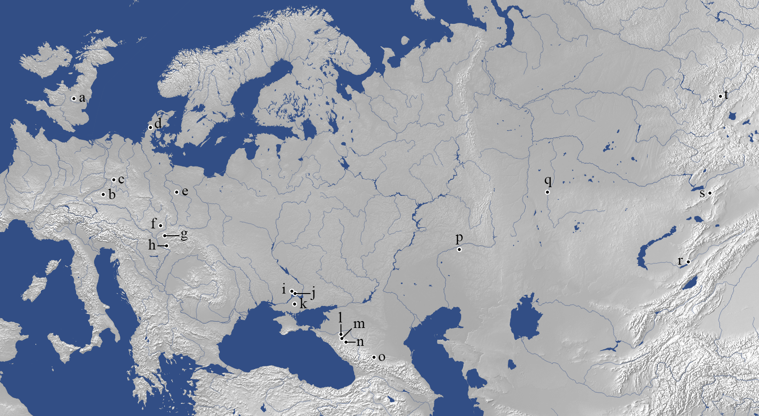
Fig. 1. Map of Eurasia showing the location of sites mentioned in the text: a) Wigber Low; b) Hochdorf; c) Glauberg; d) Skelhøj; e) Łęki Małe; f) Velatice; g) Očkov; h) Čaka; i) Zheltokamenka; j) Chertomlyk; k) Oguz; l) Ul’sky; m) Kelermes; n) Kostromskaya; o) Nal’chik; p) Filippovka; q) Bajkara; r) Bes’shatyr; s) Chilikty [Baygetobe]; t) Arzhan.

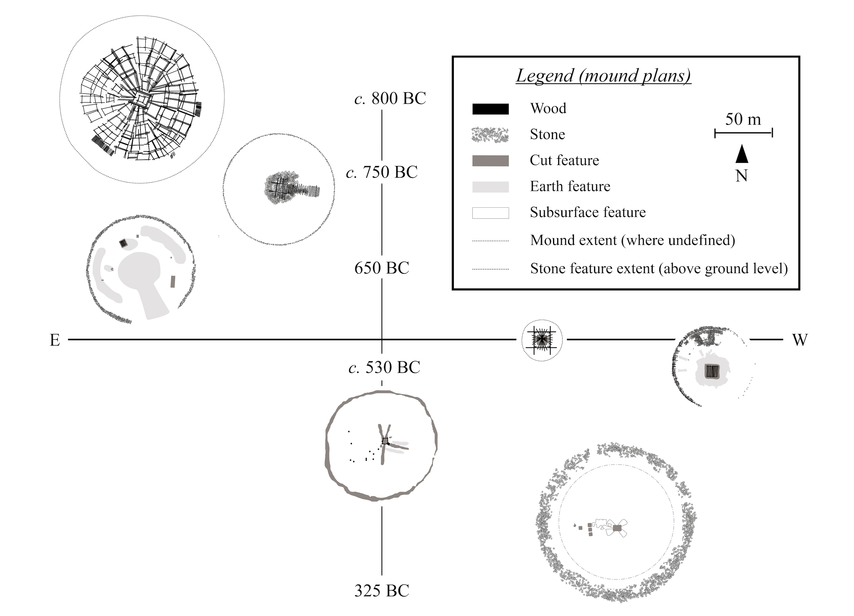

Fig. 2. A generalized representation of the distribution, character, and chronology of large Iron Age mounds across Eurasia – from east to west: Arzhan I & II, Baygetobe, Bajkara, Kostromskaya, Chertomlyk, and Hochdorf.
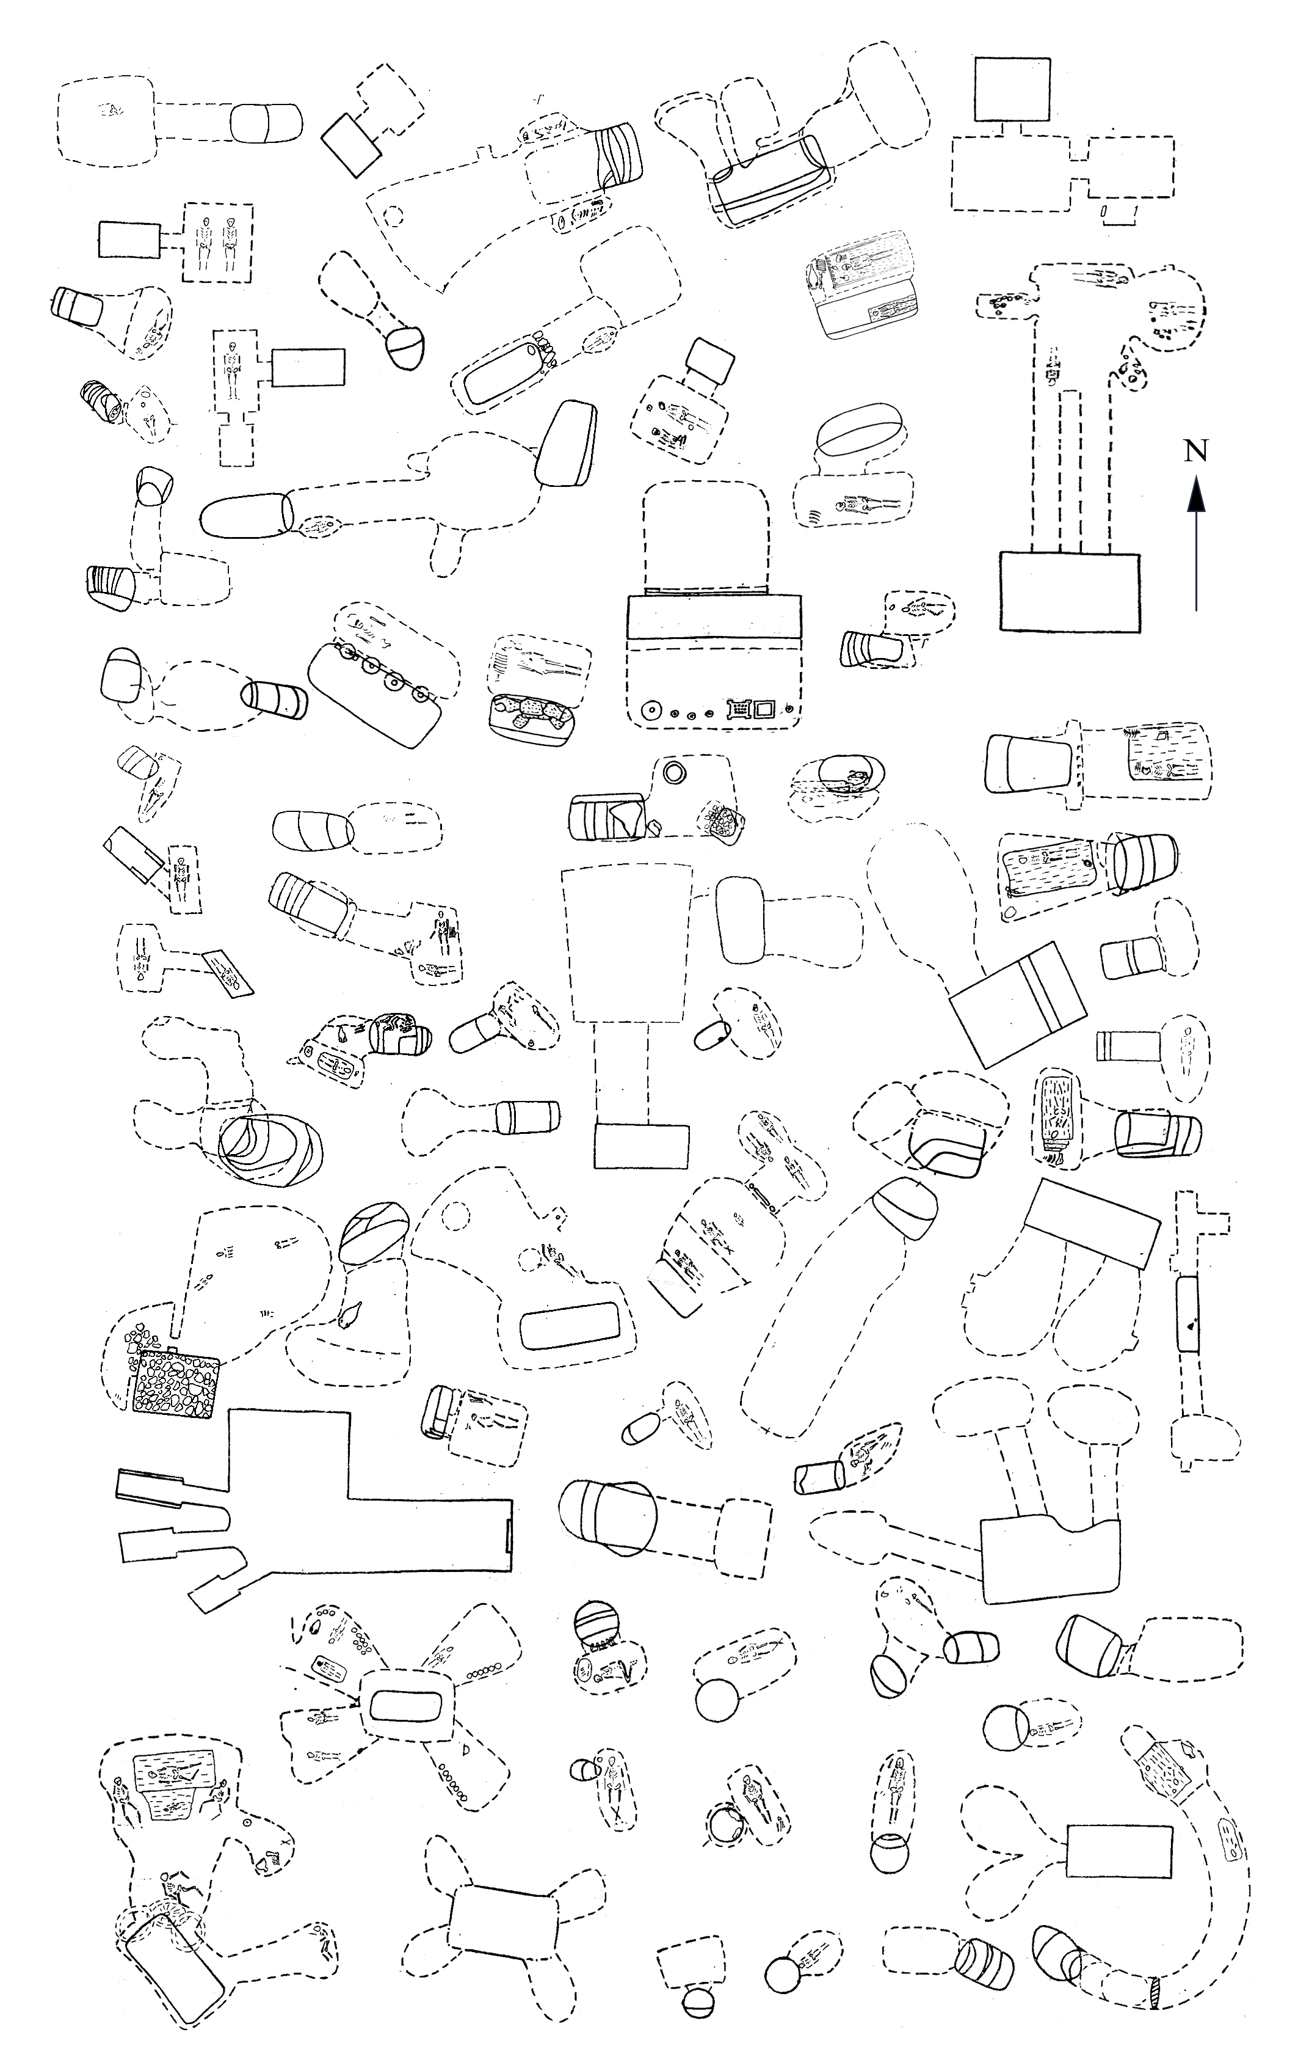
Fig. 3. The variation in the forms of Scythian period catacomb tombs in the northern Pontic Steppe (modfied after Ol’khovskiy 1991, figs 9–14).

We have recently completed a project on European Celtic art and its eastern links, building and analyzing databases of the main types of art objects and their contexts. We are very grateful to the Leverhulme Trust (grant number RPG-2014-384) for their support of this project ‘European Celtic Art in Context: Exploring Celtic art and its eastern links’. For more information on this project, see http://ecaic.arch.ox.ac.uk/.
Of course, as Ian Ralston’s predecessor to the Abercromby Chair in Edinburgh, Stuart Piggott, pointed out in relation to ‘Megaliths’ almost half a century ago, such broad comparative research is potentially undermined by its reliance on the ‘latent fallacy […] which accepts similarity of form and building material as denoting a fundamental unity across enormous tracts of time and space’ (Piggott, 1973: 10). Ian may well be similarly sceptical of our contribution here. Ian’s work has combined approaches that are intellectually ambitious and solidly grounded in empirical material. We are intrigued to see what he makes of this piece and await his usual humorous, accurate and insightful critique.
See Posluschny this volume.
This raises the question of what is ‘local’? It is a concept that is conceived very differently in different communities – in many cases, perhaps especially among more dispersed or mobile groups, absolute distance may not be a particularly useful index.

