Loh, C. E., Heng, T., & Wan, Z. H. (2019). Discipline and desire in spaces of reading. Cultural Geographies, 26(3), 401–408. https://doi.org/10.1177/1474474018824085

Discipline and Desire in Spaces of Reading
Chin Ee, Loh
National Institute of Education, Nanyang Technological University, Singapore
Terence Heng
University of Liverpool
Zhong Hao, Wan
National Institute of Education, Nanyang Technological University, Singapore

Abstract

Dominant visual narratives of reading tend to portray readers as solitary individuals deeply immersed in reading a single text in a quiet, undisturbed spot. Yet reading is both social and solitary, and takes place in different kinds of spaces, not all quiet and not all undisturbed. This visual essay examines how reading as everyday practice is situated in social spaces, and is appropriated by individuals as well as members of a collective for its own uses. In this visual essay, we draw on our ethnographic research of reading to examine the connections between space and reading as social practice. We focus on reading activities in school and particularly on the space of the school library, historically associated as a space for reading, to understand not only the kinds of reading that occur in a space meant for such purposes, but also how students negotiate such spaces and practices for their own purposes.

Discipline and Desire in Spaces of Reading

The act reading in dominant visual narratives tends to show readers as solitary individuals, deeply immersed in a single text, ensconsced in a quiet, undisturbed spot. This image of the reader as a lone individual in a study, surrounded by books, is well-illustrated in Alberto Manuel’s ode to reading in “The Library at Night”. Yet, we need to remember that these images of solitary reading are socially framed and that dominant representations of reading in mainstream media, literary texts and by bibliophiles may not represent the full range of what counts as reading and what kinds of spaces matter for reading.

Henri Lefebvre reminds us that spatial practice encompasses social practice, and that the organisation of space can shape social relations within that space. Reading as a form of everyday practice is situated in social spaces, and is appropriated by individuals as well as individuals as members of a collective for its own uses. Drawing on Michel de Certeau’s concepts of strategies and tactics to understand students’ uses of spaces designed for reading, we see how official conceptions of spaces are adjusted and adapted through everyday uses. A strategy assumes a proper place in the prescribed order of things whereas “a tactic insinuates itself into the other’s place, fragmentarily, without taking it over in its entirely, without being able to keep it at a distance”.

The library as an official school space, designated for particular forms of reading exemplifies a strategic use of space to encourage particular forms and ways of reading. However, we have found that students devise ways of re-appropriating and resisting spaces for their own conceptions of reading. Students’ re-working of space reflects tensions between the disciplinary tendencies of space and students’ desire to adhere and resist spatial constraints.

The small nation-state of Singapore has a highly central, structured and successful educational system, with its students topping international literacy tests such as the Programme for International Assessment (PISA). Yet, there is a national anxiety about reading with policymakers expressing concerns that Singaporeans do not read enough. There is a strong commitment to encouraging reading through the curriculum but little is known about the kinds of spaces within schools where informal reading takes place, and students’ behaviours within these spaces.

In this visual essay, we draw on our ethnographic research of reading to examine the connections between space and reading as a form of social practice. We focus on reading activities in school and particularly on the space of the school library, typically associated as a space for reading, to understand the kinds of reading that occur in a space meant for reading, where students negotiate these spaces and practices for their own desires.

Documentary Photography and Educational Spaces

The large-scale one-year study from which the data for this essay is drawn is a baseline study of the reading and school library practices of secondary school students in six secondary schools in Singapore. The decision to use documentary photography together with more traditional methods of observation, along with interviews and document analysis was driven by the desire to provide some form of evidence for advocacy with policy-makers and educators. The persuasive power of the visual was also seen as an important tool for researchers based in different schools at different times to come together to analyse the observations captured through the image. In total, more than 7,500 photographs were taken over approximately 720 hours (or 120 hours per school) of observation in these six schools over a period of nine months. The corpus of photographic images with its varied images of reading forced us as ‘reflective professionals’ to reconsider the different conceptions of reading and space that was emerging from the visual data.

The visual data allowed us to dwell on the data and to return to it with new lenses. Although visual data is arguably subjective in that the photographer imposes his or her interpretative frame through techniques such as framing, the photographs still allowed more scope for exploration than the fieldnotes written by a single researcher. Often, the background captured in the image was of interest, though not the main focus during the actual photo-taking session. Applying documentary photography techniques to educational research was a way to open up different ways of seeing reading and reading spaces.

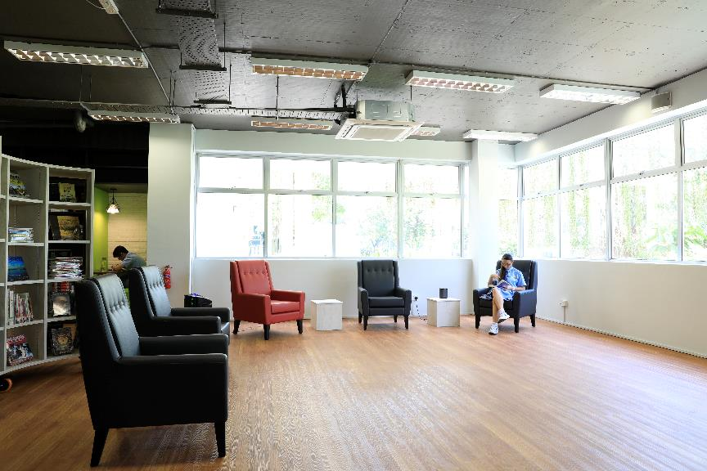
Figure 1: Reading and Studying as Conforming to Design Intentions

Dedicated and purposefully designed reading spaces are created to support dominant conceptions of reading as a solitary activity within the space of the school library. In Figure 1, we see a student in a disciplined act of sustained reading, using the reading corner as intended by space planners. However, this discipline blends with desire as the student engages in her solitary act of enjoyment. In the background, we see the green study corner in the wall, occupied ‘as intended’ by a single student studying under the focussed glow of the hanging lamp, revealing how the construction of space shapes student behavior towards particular ways of reading and learning. But how do students appropriate other spaces for their own conceptions of reading? We propose that this is done through undermining existing designed spaces and making use of non-determined spaces for their own desired activities.

Undermining Spaces
The design of library spaces can encourage or discourage particular ways of usage, and despite official perceptions of how space should be used, students exhibit their own agency in the process. Students can choose to use or not to use the library as an educational space, and their choice of actions may consist of both ‘legitimate’ (condoned by authority figures) or ‘illegitimate’ (not condoned by authority). In Figure 2, students undermine the intentions of the space’s design ‘for solitary activity’ to create a consociative environment. Here, students take a break from their work to engage in play through interaction around a picture-book, indulging in desires for rest and sociability within the structured quiet corner.

. 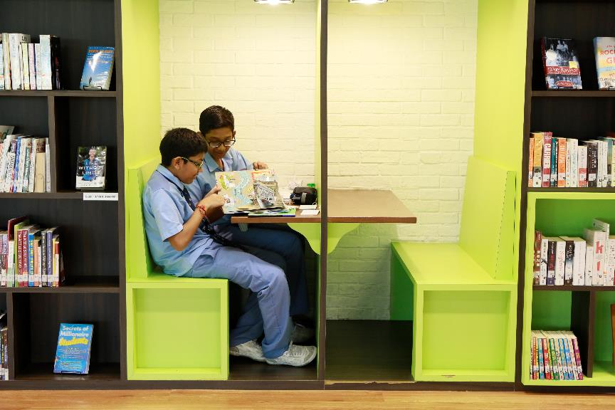
Figure 2: Undermining and Resisting Solitude

Figure 3: Strategic Positioning and Poses

Although the library is meant to be a quiet space, these students have turned it into a social space by gathering around a coffee table to do their work, read and chat. Students develop a tactical approach to justify their use of the space. Some adopt official postures of studying and reading as a cover for their socialising activities, whilst others exist on the periphery of the social group. Desire and discipline intermingle as students move in and out of individual and social modes, reading, socialising and studying.

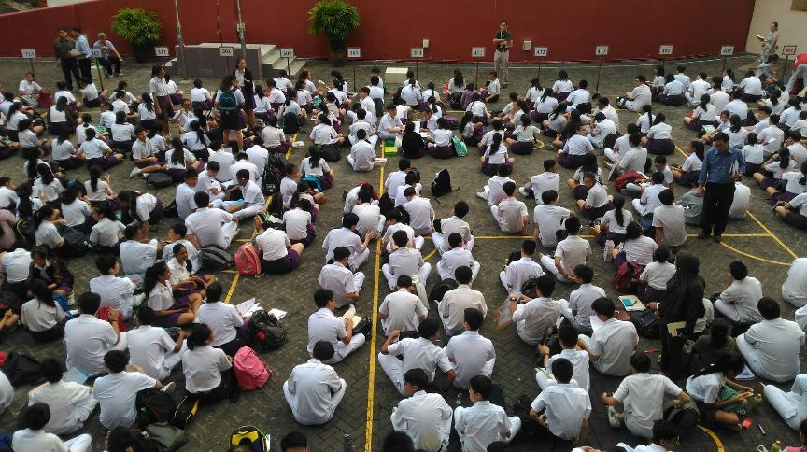
Figure 4: Reading Time, Panopticon-Style

Many schools in Singapore practice Sustained Silent Reading (SSR) by putting aside dedicated time for silent reading, whether in the classroom or, in this case, in the quadrangle mainly for purposes of monitoring students’ conformity. In an effort to discipline student reading, students are sometimes placed under the watchful eyes of teachers in a panopticon-like arrangement. While the postures of some students indicate engaged reading, other students have exercised their agency by gathering in smaller, subversive groups, again resisting the intent of the activity as a public show of reading and engaging in their own interpretation of what it means to ‘read’. Whether students desire to read or not can only be guessed from their postures and determined through conversations after the reading.

Appropriated Spaces
Not all spaces are undermined or subverted by student agency. Students also playfully reconstruct space within gaps in policies and procedures, by adhering to accepted modes of behavior to negotiate the ways of reading and using texts in ways promoted by the library.

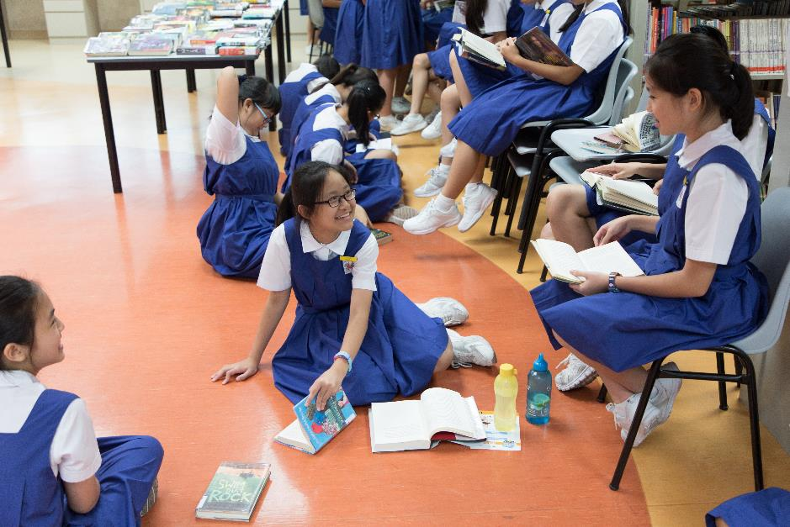
Figure 5: Appropriating and Adapting

Reading in Singapore schools is often encouraged through mass borrowing events, and the library space has been re-contextualized in this image for a mass borrowing event by the National Library Board where more than 3,000 books are brought to schools for students to borrow. The tables and chairs in the library have been reconfigured to make way for a large number of students to browse and borrow books, leaving rows of stacked chairs concentrated in particular areas. This, however, does not stop students from appropriating and adapting to the chairs and floor to create their own temporary social space. Here, students’ desires for reading aligns with school-approved behaviours, and legitimizes unorthodox use of space.
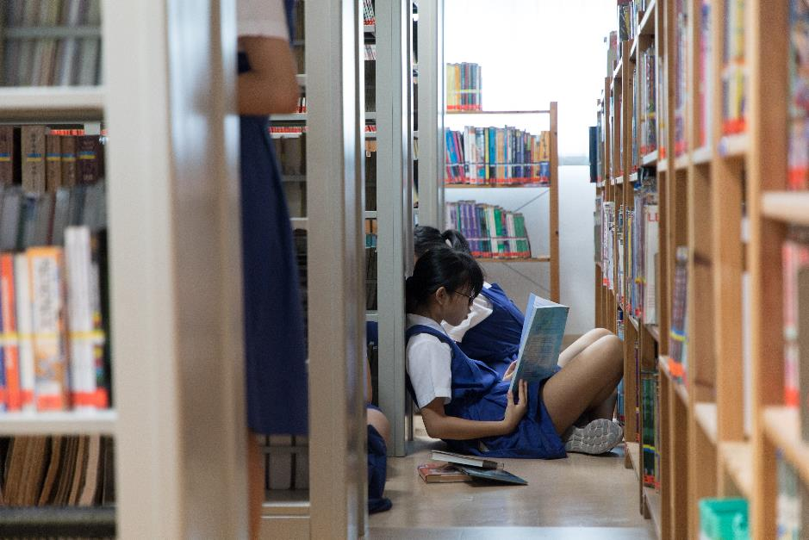
Figure 6: Finding the Liminal Spaces in a Library

When all the spaces in Figure 5 have been occupied, and/or when individuals decide to break away from larger groups, we found them seeking out the in-between and liminal areas of the library. Unlike other groups who socialised on a much larger scale, these individuals were often seen in pairs or alone, choosing instead to spend their allotted time in relative silence. Student desire for solitude directs reconstruction of empty space.

Figure 7. Informal Spaces

Students occupy corners and re-appropriate space in the library for engaging in the officially approved activity of doing homework while socializing in their groups. Slipping in and out of individual and group, work and play activity takes place in a mere matter of seconds. Corners are spaces for dynamic activity, and made permanent by repeated appropriation over days, weeks, months. The informal is etched into the space of the library by the occupation of warm bodies.

Conclusion
Studies of reading and space seldom look to the use of images as sources of research, yet images are a powerful source for re-imagining our concept of learning and space. The tensions between discipline and desire are made visible in these images located in school library spaces and provide new ways of understanding how students learn and interact in formal and informal ways in these spaces. The study highlights how spaces of learning are multiple and varied, occupied by individuals for both formal and informal uses. To understand students’ use of space, educators and researchers must attend to the discipline and desires that direct occupation of, movement around, and resistance to space.

Funding
This study was funded by Singapore Ministry of Education (MOE) under the Education Resaerch Funding Programme (OER5/16 LCE Building a Reading Culture) and administered by the National Institute of Education, Nanyang Technological University, Singapore. Any opinions, findings, and conclusions or recommendations expressed in this material are those of the authors and do not necessarily reflect the views of the Singapore MOE or NIE.

Alberto Manguel, The Library at Night. (Yale, Boston: Yale University Press, 2008)
Elizabeth Long, ‘Textual interpretation as collective action’, in J. Boyarin (ed) The Ethnography of Reading (Berkeley, CA: University of California Press, 1993), p. 180-211.
Henri Lefebvre, The Production of Space (Oxford, UK: Blackwell Publishing, 1984)
Michel de Certeau, The Practice of Everyday Life (Berkeley, California: University of California Press, 1984).
Ibid, p. xix.
OECD. 2016. Singapore tops Latest OECD PISA Global Education Survey. Retrieved from http://www.oecd.org/education/singapore-tops-latest-oecd-pisa-global-education-survey.htm. Accessed on September 3, 2017
Sin, Yuen. Less than half of Singaporeans read literacy texts, National Arts Council Survey Finds. Retrieved from http://www.straitstimes.com/singapore/less-than-half-of-singaporeans-read-literary-books-national-arts-council-survey-finds (March 14, 2016).
Donald A. Schon, The Reflective Practitioner: How Professionals Think in Action. (NY: Harper Books, 1984).
To remain for a time, to keep the attention directed (Merriam-Webster, https://www.merriam-webster.com/dictionary/dwell).
Terence Heng, Visual Method in the Field: Photography for the Social Sciences (NY: Routledge, 2017).
Eilliot W. Eisner, The enlightened Eye: Qualitative Inquiry and the Enhancement of Educational Practice (New Jersey: Prentice-Hall, Inc., 1998).
Chin Ee Loh, ‘Building a Successful Reading Culture through the School Library: A Case Study of a Singapore Secondary School’, IFLA Journal, 43(2), 2017, 335-347.
Chris Shilling and Fiona Cousins, ‘Social Use of the School Library: The Colonisation and Regulation of Educational Space’, British Journal of Sociology of Education, 11(4), 1990, p. 411-430.
Jan Pilgreen, The SSR Handbook: How to Organize and Manage a Sustained Silent Reading Programme (Portsmouth, NH: Heinemann, 2000).
Foucault, Michel, Discipline and Punish: the birth of the prison (New York: Pantheon Books, 1978)
Mark Dressman, ‘Congruence, Resistance, Liminality: Reading and Ideology in Three School Libraries’, Curriculum Inquiry, 27(3), 1997, p. 267-315.
Danielle Fuller and DeNel Rehberg Sedo, Reading Beyond the Book: The Social Practices of Contemporary Literary Culture (London: Routledge, 2013).

