Children must not be left behind in the aftermath of the COVID-19 pandemic

Ian Sinha¹, Davara Bennett², David C Taylor-Robinson¹,²

1. Alder Hey Children’s Hospital
2. Department of Public Health and Policy, The Farr Institute@HeRC, Waterhouse Building 2nd Floor Block F, Liverpool, L69 3GL

Corresponding author, Email: iansinha@liverpool.ac.uk

Competing interest statement:

The BMJ has judged that there are no disqualifying financial ties to commercial companies.
The authors declare the following other interest: David Taylor-Robinson is funded by the MRC on a Clinician Scientist Fellowship (MR/P008577/1).

Word count: 932
Children must not be left behind in the aftermath of the COVID-19 pandemic

When the Titanic sank there was a linear relationship between the social class of passengers and their risk of drowning – despite everybody crashing into the same iceberg.(1) During the Bubonic Plague, the upper classes fled Italian cities for safer country residences, heeding the public health advice ‘Cito, Longe, Tarde’ (Flee early, flee far, return late).(2) The less wealthy were left behind and died disproportionately as a result, as in New Orleans, during Hurricane Katrina.(3) History tells us that, during times of crisis, vulnerable groups lose out most. The COVID-19 pandemic is no different. Emerging data show the pandemic tracking along social fault-lines.(4) And although children are not the face of this pandemic they are deeply affected. The UN warns of “unprecedented risks to the rights and safety and development of the world’s children.” (5)

During childhood, we are especially vulnerable to the main determinants of health: living conditions, family income, employment, education, access to health services. The pandemic can be conceived as an additional systemic shock to these determinants. In the shorter term, with the focus squarely on adults with COVID-19, child health and social care services are being side-lined. These include acute services for life-threatening illnesses, outpatient services for chronic conditions, child protection services guarding against abuse and neglect, and preventative services that support early years development, routine checks and immunisations. Their demotion presents an immediate risk to children. Global modelling predicts a stark increase in child mortality as a result of diversion of care.(6) As soon and as seamlessly as possible, we must restore these services to full, and still greater, capacity.(5)

Within family homes, the unintended consequences of the lockdown will affect poor children the most. Greater “toxic stress” for many families will increase the risk of neglect and domestic violence for some children.(7) Exposure to these adversities can have life-long health impacts. Many children are going hungry, as foodbanks scramble to reconfigure services to meet the rising tide of food insecurity. The pandemic is taking a hold in a lesser Britain: already, too many families with children struggle to afford sufficient, nourishing food.(8) Lockdown in poor quality and overcrowded housing, with inequitable access to safe green space, will disrupt children’s lives, some more than others.(9) Social distancing measures and school closures are interrupting educational trajectories. Teachers must be commended for developing online resources, under huge pressure and in difficult circumstances, but for some children, the lack of internet, electronic devices, and quiet space at home will further exacerbate inequalities in educational outcomes. Plans for the phased reopening of schools have been mooted, but an ever-greater dependence on supplementary online learning seems assured.

In the longer term, we must consider the impacts of an economic recession on child health. COVID-19 has already caused an aggressive decline in the global economy that is deeper and steeper than anything seen in modern times.(10) The 2008 financial crash taught us that, of all age groups, children are most likely to fall into poverty.(11) In 2017, child poverty, a major driver of poor child health, had risen to 4.1 million children, or 30% of all English children.(12) The UN pronounced child poverty in the UK “not just a disgrace, but a social calamity and an economic disaster, all rolled into one”.(13) Before the pandemic, child poverty was predicted to rise dramatically in the coming years. Now we must revisit these predictions: 75% of children already in poverty belong to a family with one working parent; an estimated 6 million workers are likely to become unemployed in the UK as a result of the pandemic; parents working low hours contracts and within the ‘gig economy’ are particularly vulnerable.

Swift financial action has sought to mitigate the economic impact of COVID-19. But short-term macroeconomic stabilisation often comes at the expense of subsequent public spending. Austerity measures implemented in the UK in response to the Great Recession affected deprived children particularly. For example, child health services like Sure Start experienced deeper cuts in the poorest areas (figure 1). The rollout of Universal Credit, a reform borne of austerity, was predicted to be a major driver of child poverty (14).

Figure 1: Cuts to services to children following the Great Recession.
Biggest cuts to early years prevention in poorest areas. Data from Place-based Longitudinal Data Resource (PLDR) (15)
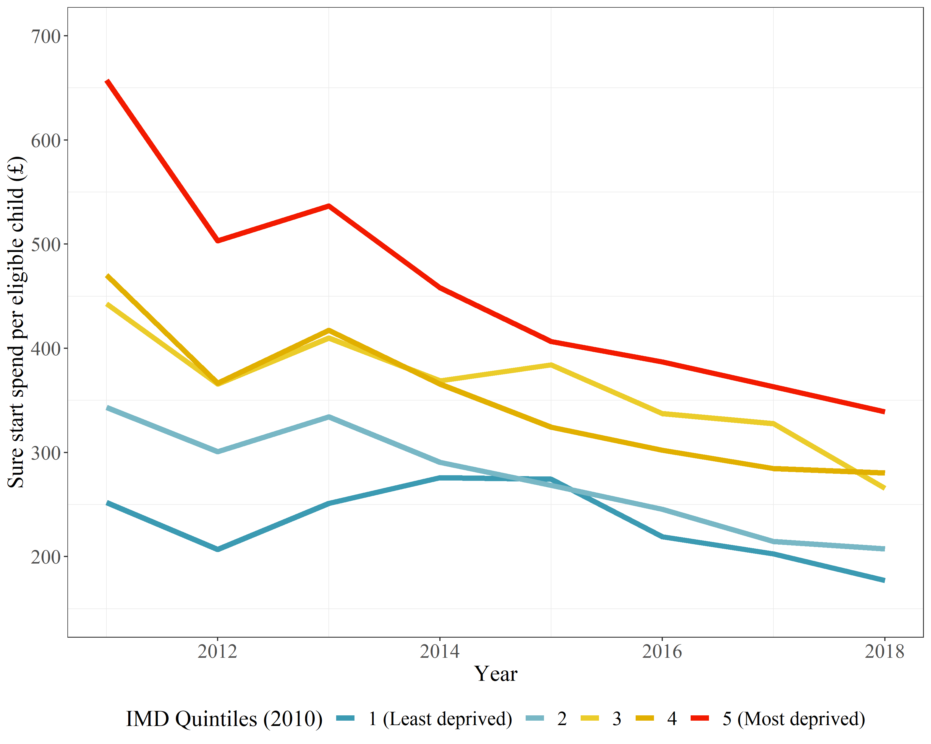

Immediate action is needed to put money in the pockets of families with children. A modest increase of £10 per child per week, through child benefit, would reduce child poverty levels by 5%.(16) More generous UC payments to families with children should be a policy priority, and the two-child limit should be scrapped.(17) The furlough scheme should be extended to caregivers who must look after their children. Even as schools reopen, the Department for Education should work with local authorities and digital providers to ensure all children’s access to a computer and broadband. In the longer term, funding for services that support children should be increased, and delivered according to need. Research and health equity impact assessments must shed light on the long-term consequences for children, and inform policy responses.

As child health doctors in a city with high levels of deprivation, many of the problems we see in children flow from restricted opportunities to be healthy – exposure to poverty, less healthy environments, lower quality nutrition, poor quality air, substandard housing, and chronic stress. We cannot accurately predict how this pandemic will play out, or for how long. What is certain is that, unless there is a proactive and concerted policy focus on vulnerable children, they will face the fall-out. The UN Convention on the Rights of the Child affords children special protection. We must ensure that these rights are not overlooked, as they have been in the past. Children will get left behind unless we act now.

References

1. Hall W. Social class and survival on the S.S. Titanic. Social Science & Medicine. 1986 Jan 1;22(6):687–90.
2. Cito, longe, tarde: fly quickly, go far, return slowly | The Repository | Royal Society [Internet]. [cited 2020 Apr 24]. Available from: https://blogs.royalsociety.org/history-of-science/2015/03/09/great-plague/
3. Sharkey P. Survival and Death in New Orleans: An Empirical Look at the Human Impact of Katrina. Journal of Black Studies. 2007;37(4):482–501.
4. Rose TC, Mason K, Pennington A, McHale P, Taylor-Robinson DC, Barr B. Inequalities in COVID19 mortality related to ethnicity and socioeconomic deprivation. medRxiv. 2020 Apr 30;2020.04.25.20079491.
5. United Nations. Policy Brief: The Impact of COVID-19 on children [Internet]. Available from: https://www.un.org/sites/un2.un.org/files/policy_brief_on_covid_impact_on_children_16_april_2020.pdf
6. Roberton T, Carter ED, Chou VB, Stegmuller AR, Jackson BD, Tam Y, et al. Early estimates of the indirect effects of the COVID-19 pandemic on maternal and child mortality in low-income and middle-income countries: a modelling study. The Lancet Global Health [Internet]. 2020 May 12 [cited 2020 May 19];0(0). Available from: https://www.thelancet.com/journals/langlo/article/PIIS2214-109X(20)30229-1/abstract
7. Editorial. The Guardian view on children in the pandemic: hidden victims | Editorial. The Guardian [Internet]. 2020 Apr 28 [cited 2020 May 19]; Available from: https://www.theguardian.com/commentisfree/2020/apr/28/the-guardian-view-on-children-in-the-pandemic-hidden-victims
8. COVID-19: latest impact on food - Food Foundation [Internet]. [cited 2020 Apr 24]. Available from: https://foodfoundation.org.uk/covid-19-latest-impact-on-food/
9. Rosenthal DM, Ucci M, Heys M, Hayward A, Lakhanpaul M. Impacts of COVID-19 on vulnerable children in temporary accommodation in the UK. The Lancet Public Health [Internet]. 2020 Mar 31 [cited 2020 Apr 24];0(0). Available from: https://www.thelancet.com/journals/lanpub/article/PIIS2468-2667(20)30080-3/abstract
10. McKee M, Stuckler D. If the world fails to protect the economy, COVID-19 will damage health not just now but also in the future. Nat Med. 2020 Apr 9;1–3.
11. Rajmil L, Fernandez de Sanmamed M-J, Choonara I, Faresjö T, Hjern A, Kozyrskyj AL, et al. Impact of the 2008 Economic and Financial Crisis on Child Health: A Systematic Review. Int J Environ Res Public Health. 2014 Jun;11(6):6528–46.
12. Taylor-Robinson DC, Lai ET, Whitehead M, Barr B. Child health unravelling in UK. BMJ. 2019 Mar 5;364:l963.
13. OHCHR | Statement on Visit to the United Kingdom, by Professor Philip Alston, United Nations Special Rapporteur on extreme poverty and human rights [Internet]. [cited 2020 May 19]. Available from: https://www.ohchr.org/en/NewsEvents/Pages/DisplayNews.aspx?NewsID=23881&LangID=E
14. Wickham S, Bentley L, Rose T, Whitehead M, Taylor-Robinson D, Barr B. Effects on mental health of a UK welfare reform, Universal Credit: a longitudinal controlled study. The Lancet Public Health. 2020 Mar 1;5(3):e157–64.
15. Place-based Longitudinal Data Resource [Internet]. [cited 2020 Feb 3]. Available from: https://pldr.org/
16. Jonathan Bradshaw and Antonia Keung. POOR CHILDREN NEED A CORONAVIRUS BONUS [Internet]. Available from: https://cpag.org.uk/sites/default/files/files/policypost/BRIEFING-Covid-19_income%20top%20up%20child%20poverty%20analysis.pdf
17. Children of the Pandemic [Internet]. IPPR. 2020 [cited 2020 Apr 24]. Available from: https://www.ippr.org/research/publications/children-of-the-pandemic

