Direct observation of plasmonic hot-carrier energy distributions via single molecule transport measurements

Harsha Reddy^{1,†}, Kun Wang^{2,†}, Zhaxylyk Kudyshev^{1,3}, Linxiao Zhu², Shen Yan², Andrea Vezzoli⁴, Simon J. Higgins⁴, Vikram Gavini^{2,5}, Alexandra Boltasseva¹, Pramod Reddy^{2,5,*}, Vladimir M. Shalaev^{1,*}, Edgar Meyhofer^{2,*}
¹School of Electrical and Computer Engineering, Purdue University, West Lafayette, IN 47907, USA.
²Department of Mechanical Engineering, University of Michigan, Ann Arbor, MI 48109, USA.
³Center for Science of Information, Purdue University, West Lafayette, IN, 47907, USA.
⁴Department of Chemistry, University of Liverpool, Crown Street, Liverpool L69 7ZD, UK.
⁵Department of Materials Science and Engineering, University of Michigan, Ann Arbor, MI 48109, USA.
†These authors contributed equally to this work.
*Corresponding authors. Email: pramodr@umich.edu (P.R.); shalaev@purdue.edu (V.M.S.); meyhofer@umich.edu (E.M.)

Abstract: Hot-carriers in plasmonic nanostructures, generated via plasmon decay, play key roles in applications like photocatalysis and in photodetectors that circumvent band-gap limitations. However, direct experimental quantification of steady-state energy distributions of hot-carriers in nanostructures has so far been lacking. We present transport measurements from single molecule junctions, created by trapping suitably chosen single molecules between an ultra-thin gold film supporting surface plasmon polaritons and a scanning probe tip, that can provide quantification of plasmonic hot-carrier distributions. Our results show that Landau damping is the dominant physical mechanism of hot-carrier generation in nanoscale systems with strong confinement. The technique developed in this work will enable quantification of plasmonic hot-carrier distributions in nanophotonic and plasmonic devices.

One Sentence Summary: Single molecule transport measurements are used to quantify the hot-carrier distributions in plasmonic nanostructures.

Hot-carriers, energetic electrons and holes with energy distributions that deviate significantly from equilibrium Fermi-Dirac distributions (1), are expected to arise in metallic nanostructures due to the non-radiative decay of surface plasmons. Such hot-carriers hold promise for the development of a variety of technologies, including plasmon-driven photochemistry (2–5), alternative solar-energy harvesting devices (6), and efficient photodetectors operating below bandgap (7–9). Central to the design and development of these applications is knowledge of the hot-carrier energy distributions (HCEDs) that are generated under steady-state conditions (10). While past work has tried to quantify HCEDs (11–15) a majority of this work has relied on first-principle calculations or semi-classical approaches, which involve assumptions on the dominant relaxation pathways of hot-carriers as well as material properties (15) that lead to significant uncertainties in the estimated HCEDs (12, 13). In fact, recent calculations (16) have even suggested that the deviations from the equilibrium Fermi-Dirac distribution are negligibly small, questioning past calculations. Therefore, direct experimental observations are critical for obtaining detailed insights into the HCEDs and for rationally engineering the aforementioned technologies.
Here, we show how scanning probe-based techniques (17–19) that measure charge transport in single molecules, when combined with nanoplasmonic experimental methods, can be leveraged to directly quantify the steady-state HCEDs (${\text{f}}_{\text{hot}}\text{(}\text{E}\text{)}$) in a key model system—a thin gold film that supports propagating surface plasmon polaritons (SPPs). Our basic strategy is to first create single molecule junctions (SMJs)—using carefully chosen molecules with appropriate transmission characteristics—between a plasmonic gold (Au) film and the Au tip of a scanning tunneling microscope (STM), and elucidate the current-voltage characteristics with and without plasmonic excitation at various voltage biases (${\text{V}}_{\text{bias}}$) (see Fig. 1A). The difference in the measured currents for the cases with (${\text{I}}_{\text{SPP}}\text{(}{\text{V}}_{\text{bias}}\text{)}$) and without (${\text{I}}_{\text{d}}\text{(}{\text{V}}_{\text{bias}}\text{)}$) plasmonic excitation, which we call the hot-carrier current ${\text{I}}_{\text{hot}}\left({\text{V}}_{\text{bias}}\right) \text{=} {\text{I}}_{\text{SPP}}\left({\text{V}}_{\text{bias}}\right)-{\text{I}}_{\text{d}}\text{(}{\text{V}}_{\text{bias}}\text{)}$, enables us to directly quantify ${\text{f}}_{\text{hot}}\text{(}\text{E}\text{)}$.
To elaborate, as depicted in Fig. 1B & 1C, ${\text{I}}_{\text{hot}}\text{(}{\text{V}}_{\text{bias}}\text{)}$ arises due to the generation of the non-equilibrium carriers under plasmonic excitation with an energy distribution ${\text{f}}_{\text{ne}}\left(\text{E}\right)$. We note that the energy distribution ${\text{f}}_{\text{hot}}\text{(}\text{E}\text{) }$represents the difference between ${\text{f}}_{\text{ne}}\left(\text{E}\right)$ and the equilibrium Fermi-Dirac distribution ${\text{f}}_{\text{eq}}\left(\text{E}\right)$ as ${\text{f}}_{\text{hot}}\left(\text{E}\right) \text{=} {\text{f}}_{\text{ne}}\left(\text{E}\right)-{\text{f}}_{\text{eq}}\text{(}\text{E}\text{)}$. As explained in detail in the Supplementary Materials (20), ${\text{f}}_{\text{hot}}\left(\text{E}\right)$and ${\text{I}}_{\text{hot}}\text{(}{\text{V}}_{\text{bias}}\text{)}$ are related by:
 | ${\text{I}}_{\text{hot}}\left({\text{V}}_{\text{bias}}\right) \text{=} \frac{\text{2}\text{e}}{\text{h}}\int_{\text{-∞}}^{\text{∞}}{\text{T} \left(\text{E}\right) {\text{f}}_{\text{hot}}\left(\text{E}-\frac{\text{e}{\text{V}}_{\text{bias}}}{\text{2}}\right)\text{d}\text{E}}$, | (1)
where $\text{T} \text{(}\text{E}\text{)}$ is the transmission function of the SMJ, e is the elemental charge and h is the Planck constant. When SMJs that feature a sharp peak in $\text{T} \text{(}\text{E}\text{)}$ are employed, ${\text{I}}_{\text{hot}}\left({\text{V}}_{\text{bias}}\right)$ is predominantly determined by the hot-carriers with energies close to the transmission peak, simplifying the above integral to ((20), section 1):
 | ${ \text{I}}_{\text{hot}}\left({\text{V}}_{\text{bias}}\right) \text{≈} \frac{\text{2}\text{e}}{\text{h}}{\text{f}}_{\text{hot}}\left({\text{E}}_{\text{0}}-\frac{\text{e}{\text{V}}_{\text{bias}}}{\text{2}}\right)\int_{\text{-∞}}^{\text{∞}}{\text{T} \left(\text{E}\right)\text{d}\text{E}}$, | (2)
where ${\text{E}}_{\text{0}}$ is the energy of the peak in $\text{T} \text{(}\text{E}\text{)}$ with respect to the Fermi energy (E_{F}). Eq. 2 relates ${\text{I}}_{\text{hot}}\left({\text{V}}_{\text{bias}}\right)$ to ${\text{f}}_{\text{hot}}\text{(}\text{E}\text{)}$ via a voltage and energy-independent constant scaling factor ($\frac{\text{2}\text{e}}{\text{h}}\int_{\text{-∞}}^{\text{∞}}{\text{T} \text{(}\text{E}\text{)d}\text{E}}$). Therefore, by varying ${\text{V}}_{\text{bias}}$ in the window $\left\{{\text{V}}_{\text{0 }}\text{:} {-\text{V}}_{\text{0}}\right\}$, the steady-state HCEDs can be mapped within the energy window $\left\{{\text{E}}_{\text{0}}-\frac{\text{e}{\text{V}}_{\text{0}}}{\text{2}} \text{:} {\text{E}}_{\text{0}}\text{+}\frac{\text{e}{\text{V}}_{\text{0}}}{\text{2}}\right\}$ (Fig. 1C.
We used the molecules shown in Fig. 1D (labeled L1, H1, L2) for experimental quantification of the HCEDs. Molecule L1 represents a charge-transfer complex of quaterthiophene (T4) and tetracyanoethylene (TCNE) with terminal thiophenes containing gold-binding methyl sulfides, while the H1 molecules, 3,4-ethylenedioxythiophene (EDOT), are flanked by two thiophenes with terminal thiophenes containing gold-binding methyl sulfides. The transmission characteristics of Au-L1-Au and Au-H1-Au SMJs are expected to be sharply peaked and dominated by the lowest unoccupied molecular orbital (LUMO) (21, 22) and highest occupied molecular orbital (HOMO) (23), respectively. Finally, we also utilize L2, 1,4-benzenediisonitrile molecules (see section 3 of (20) for additional details), SMJs created which are expected to feature weakly energy-dependent $\text{T} \text{(}\text{E}\text{)}$ also dominated by the LUMO level (24).
Plasmonic gold films (thickness 6 nm and 13 nm), with integrated grating couplers, were fabricated on fused silica substrates (Fig. 1A) to excite SPPs and generate hot-carriers ((20), section 4). The 6 nm-thick gold film with grating coupler was first exposed to a solution containing L1 molecules to create a monolayer of the molecules ((20), section 5). Next, we positioned a Au STM tip at a separation of ~1 $\text{μm}$ (along the x direction) from the grating edge (Fig. S2). Subsequently, the Au film was covered with an immersion oil matching the refractive index of fused silica to create a symmetric optical medium around the film, and a ${\text{V}}_{\text{bias}}\text{=} \text{0.1V}$ was applied to the STM tip while grounding the Au film. We then employed STM break-junction technique (17, 18) (see (20), section 2 for a detailed protocol) to identify the current through a Au-L1-Au SMJ. The peak in the current histogram created from over 2000 current vs displacement traces represents the most probable current (${\text{I}}_{\text{d}}$)—corresponding to a conductance of $\text{8.5 ×}{\text{10}}^{-\text{4}} {\text{G}}_{\text{0}}$ for a Au-L1-Au junction (Fig. 2A) under the absence of plasmonic excitation (G₀ $\text{≈}{ \left(\text{12.9 kΩ}\right)}^{\text{-1}}$ is the quantum of electrical conductance), in good agreement with prior work (22). Subsequently, we illuminated the gratings with a focused an 830 nm, linearly polarized laser beam ($\text{0.3 }\text{mW}\text{/}{\text{μm}}^{\text{2}}$ power density) perpendicular to the grating strips, launching SPPs in the Au film (Fig. 1A). Concurrently, we measured the electrical current under laser illumination and found that the most probable current ${\text{I}}_{\text{SPP}}$ is larger than ${\text{I}}_{\text{d}}$ (Fig. 2A). We then determined the hot-carrier current as ${\text{I}}_{\text{hot}}\left({\text{V}}_{\text{bias}}\text{=} \text{0.1V }\right) \text{=} {\text{I}}_{\text{SPP}}\text{(}{\text{V}}_{\text{bias}}\text{=} \text{0.1V ) }{- \text{I}}_{\text{d}}\text{(}{\text{V}}_{\text{bias}}\text{=} \text{0.1V )}$. The measured ${\text{I}}_{\text{hot}}\left({\text{V}}_{\text{bias}}\text{=} \text{0.1V }\right)$ displayed a strong dependence on the laser polarization (Fig. 2C), consistent with the polarization dependent SPP excitation efficiency, indicating that the measured ${\text{I}}_{\text{hot}}$ is due to the excitation of SPPs. Additional control experiments further confirmed that the measured ${\text{I}}_{\text{hot}}$is indeed due to hot-carrier effects and not due to an increased temperature or simple light-assisted transport ((20), section 6).
Next, we performed additional measurements from Au-L1-Au SMJs at the same location, while systematically varying ${\text{V}}_{\text{bias}}$ from $\left\{-\text{0.3V} \text{:} \text{0.3V }\right\}$. The measured bias-dependent ${\text{I}}_{\text{hot}}\text{(}{\text{V}}_{\text{bias}}\text{)}$ (Fig. S16A) displayed an asymmetric shape with a peak around 0.15V. Further, the transmission characteristics of Au-L1-Au junctions, necessary for determining the spectral distribution of hot carriers (see Eq. 1 and 2), were obtained using an experimental approach developed in (23) ((20), section 7). Figure 2D shows the $\text{(}\text{E}\text{)}$ obtained for Au-L1-Au junctions. Consistent with past work (23), we fit the measured $\text{T} \text{(}\text{E}\text{)}$ with a Lorentzian and obtained the energy of the peak to be ${\text{E}}_{\text{0}} \text{≈} \text{0.18 eV}$ relative to ${\text{E}}_{\text{F}}$ with a peak width of 2.6 meV (red curve in Fig. 2D), confirming the sharp nature of the peak ((20), section 7) in good agreement with past computational work (20). Subsequently, we determined ${\text{f}}_{\text{hot}}\text{(}\text{E}\text{)}$ from the measured ${\text{I}}_{\text{hot}}\text{(}{\text{V}}_{\text{bias}}\text{)}$ and $\text{T} \text{(}\text{E}\text{)}$ of L1 using Eqn. 2. The measured ${\text{f}}_{\text{hot}}\text{(E)}$ (see Fig. 3A) revealed the relative hot-electron energy distribution (HEED), displaying a peak around 100 meV followed by a decaying tail extending up to about 330 meV above ${\text{E}}_{\text{F}}$. It should be noted that, as the transmission function peak enters the window between the quasi Fermi levels of the two contacts, extremely large currents flow through the molecular junction making the junction unstable and limiting the ${\text{V}}_{\text{bias}}$ sweep window to $\left\{-\text{0.3V : 0.3V}\right\}$ and the energy window to$\left\{\text{0.03 eV} \text{:} \text{0.33 eV}\right\}$ with respect to ${\text{E}}_{\text{F}}$ ((20), section 7). However, this is not a fundamental limitation as additional measurements and analysis with Au-L2-Au SMJs enabled measurements of the HEED at higher energies, which revealed that there are negligibly few hot-electrons with energies beyond 0.4 eV (dashed line in the inset of Fig. 3A, (20), section 10).
To determine the hot-hole energy distribution (HHED), i.e. energies below ${\text{E}}_{\text{F}}$, we repeated measurements of ${\text{I}}_{\text{hot}}\text{(}{\text{V}}_{\text{bias}}\text{)}$ in Au-H1-Au SMJs for ${\text{V}}_{\text{bias}}$ in the range of $\left\{-\text{1.5V} \text{: 1V}\right\}$ (Fig. S16B). Unlike for L1, where large ${\text{I}}_{\text{hot}}\text{(}{\text{V}}_{\text{bias}}\text{)}$ was observed for positive ${\text{V}}_{\text{bias}}$, no perceptible ${\text{I}}_{\text{hot}}\text{(}{\text{V}}_{\text{bias}}\text{)}$ was recorded in H1 junctions for positive ${\text{V}}_{\text{bias}}$. Instead, ${\text{I}}_{\text{hot}}\text{(}{\text{V}}_{\text{bias}}\text{)}$ in H1 junctions increased above the noise floor for ${\text{V}}_{\text{bias}}$ below $-\text{0.6V}$ and peaked around $-\text{1.2V}$. Next, we measured the transmission characteristics of Au-H1-Au junctions, and obtained the Lorentzian-shaped transmission characteristics shown in Fig. 2E, which features a peak at ${\text{E}}_{\text{0}} \text{≈} -\text{0.7 eV}$ and a peak width of 6.8 meV, in good agreement with prior work (23). From the measured $\text{T} \text{(}\text{E}\text{)}$ and ${\text{I}}_{\text{hot}}\left({\text{V}}_{\text{bias}}\right)$, we obtained ${\text{f}}_{\text{hot}}\text{(E)}$ using Eqn. 2 over the energy range $\left\{-\text{1.2} \text{eV} \text{:} \text{0.05} \text{eV}\right\}$ (Fig. 3B). The HHED featured a peak around $-\text{0.1 eV}$ and a decaying tail that extends to energies about $-\text{0.4} \text{eV}$ with respect to ${\text{E}}_{\text{F}}$.
To gain insights into the microscopic origin of our observations, we performed first-principle density functional theory (DFT) calculations (11) to compute the hot-carrier generation rates and subsequently employed the Boltzmann transport equation under the relaxation time approximation (25) to obtain the steady-state HCEDs ((20), section 11). For our calculations, we considered a geometry consisting of a Au film surrounded by a symmetric dielectric environment with a refractive index $\text{n} \text{=} \text{1.45}$, mimicking the geometry in our experiments, which is known to support two plasmonic modes: a symmetric mode and an anti-symmetric mode with distinct dispersion relations (26–28).
The computed HCED arising from the symmetric plasmonic mode on a 6 nm-thick Au film, obtained using both an energy-dependent electron-electron collision rate from Landau’s Fermi liquid theory (FLT) (29) and an energy-independent scattering rate are shown in Fig. 4A. Additionally, electron-phonon scattering is included via an energy-independent relaxation rate (30). Note that these computational results are multiplied by a scaling factor so that the peak value is 1. The results obtained following FLT predict that hot-carriers are largely populated within the energy window of $\left\{-\text{0.4V : 0.4V}\right\}$ relative to E_{F}—in excellent agreement with our experiments. In contrast, an energy-independent scattering rate results in hot-carriers in a larger range of energies (Fig. 4A, blue curve) that disagree with our experimental observations. These findings establish the validity of employing the energy-dependent electron-electron collision for modelling hot-carriers in plasmonic nanostructures.
To understand the effect of film thickness we measured the HCED in thicker (13 nm-thick) Au films. The measured HCED (Fig. 3C & 3D) showed that the hot-carriers are mostly populated around E_{F}. Besides, the total number of hot-carriers (sum of hot-electrons and hot-holes, $\int_{{\text{E}}_{\text{F}}\text{-ℏ}\text{ω}}^{{\text{E}}_{\text{F}}\text{+ℏ}\text{ω}}{{\text{|} \text{f}}_{\text{hot}}\left(\text{E}\right)\text{|d}\text{E}}$) was found to be ~40% smaller than those measured on 6 nm film. The observed reduction in the magnitude of HCED in thicker films can be attributed to the effect of surface-assisted absorption—Landau damping (13, 15, 25) (see relevant discussion in (20), section 11). To quantify the role of Landau damping, we computed the HCED in a 13 nm film arising from the symmetric plasmonic mode, and scattering rates from FLT (Fig. 4A, red curve). As evident from Fig. 4A, the generated hot-carriers are populated close to E_{F}, similar to the 6 nm film. However, about 43% fewer hot-carriers are generated in the 13 nm film, in good agreement with our experiments.
To elucidate the distance-dependence of the observed hot-carrier generation rates, we measured ${\text{I}}_{\text{hot}}$ for Au-L1-Au SMJs at a ${\text{V}}_{\text{bias}} \text{=} \text{0.1V}$ for varying separations (d) from the grating edge on a 6 nm-thick gold film (Fig. 4C). The measured ${\text{I}}_{\text{hot}}$ decreases as the separation from the edge of the gratings increases and drops close to zero for $\text{d} \text{>} \text{7.5 }\text{μm}$. To understand the observed distance dependence, we simulated (using the Lumerical FDTD package) the intensity profile in the 6 nm film upon illuminating the grating coupler with an 830 nm laser. A beating profile was observed close to the gratings (Fig. 4D), which we attribute to the interference between the two plasmonic modes ((20), section 12 and inset in Fig. 4D). However, for $\text{d} \text{>} \text{10 }\text{μm}$ the symmetric mode decays while the anti-symmetric mode shows very little decay. Since there are no observed hot-carriers at large separations, despite the presence of the anti-symmetric mode, we conclude that the contribution of the anti-symmetric mode to hot-electron generation is negligible. Additional calculations (Fig. 4B) confirmed that the anti-symmetric mode is indeed much less effective in generating hot-electrons, resulting in 400-times (30-times) fewer carriers, in comparison to the symmetric mode for the 6 nm (13 nm)-thick film.
Our scanning probe-based approach combines single molecule quantum transport measurements and nanoplasmonics to directly map the steady-state energy distributions of hot-carriers. The approaches developed will enable fundamental insights into hot-carrier generation processes and are critical for future hot-carrier assisted technologies.

REFERENCES AND NOTES:

1. J. M. Ziman, Principles of the Theory of Solids (Cambridge University Press, ed. 2, 1972).
2. S. Linic, P. Christopher, D. B. Ingram, Plasmonic-metal nanostructures for efficient conversion of solar to chemical energy. Nat. Mater. 10, 911–921 (2011).
3. S. Linic, U. Aslam, C. Boerigter, M. Morabito, Photochemical transformations on plasmonic metal nanoparticles. Nat. Mater. 14, 567–576 (2015).
4. L. Zhou, D. F. Swearer, C. Zhang, H. Robatjazi, H. Zhao, L. Henderson, L. Dong, P. Christopher, E. A. Carter, P. Nordlander, N. J. Halas, Quantifying hot carrier and thermal contributions in plasmonic photocatalysis. Science 362, 69–72 (2018).
5. A. Naldoni, F. Riboni, U. Guler, A. Boltasseva, V. M. Shalaev, A. V. Kildishev, Solar-Powered Plasmon-Enhanced Heterogeneous Catalysis. Nanophotonics 5, 112–133 (2016).
6. C. Clavero, Plasmon-induced hot-electron generation at nanoparticle/metal-oxide interfaces for photovoltaic and photocatalytic devices. Nat. Photonics 8, 95–103 (2014).
7. M. W. Knight, H. Sobhani, P. Nordlander, N. J. Halas, Photodetection with active optical antennas. Science 332, 702–704 (2011).
8. H. Chalabi, D. Schoen, M. L. Brongersma, Hot-electron photodetection with a plasmonic nanostripe antenna. Nano Lett. 14, 1374–1380 (2014).
9. A. Sobhani, M. W. Knight, Y. Wang, B. Zheng, N. S. King, L. V. Brown, Z. Fang, P. Nordlander, N. J. Halas, Narrowband photodetection in the near-infrared with a plasmon-induced hot electron device. Nat. Commun. 4, 1643 (2013).
10. A. O. Govorov, H. Zhang, Y. K. Gun’Ko, Theory of photoinjection of hot plasmonic carriers from metal nanostructures into semiconductors and surface molecules. J. Phys. Chem. C 117, 16616–16631 (2013).
11. R. Sundararaman, P. Narang, A. S. Jermyn, W. A. Goddard, H. A. Atwater, Theoretical predictions for hot-carrier generation from surface plasmon decay. Nat. Commun. 5, 5788 (2014).
12. A. Manjavacas, J. G. Liu, V. Kulkarni, P. Nordlander, Plasmon-induced hot carriers in metallic nanoparticles. ACS Nano. 8, 7630–7638 (2014).
13. H. Zhang, A. O. Govorov, Optical generation of hot plasmonic carriers in metal nanocrystals: The effects of shape and field enhancement. J. Phys. Chem. C 118, 7606–7614 (2014).
14. T. Heilpern, M. Manjare, A. O. Govorov, G. P. Wiederrecht, S. K. Gray, H. Harutyunyan, Determination of hot carrier energy distributions from inversion of ultrafast pump-probe reflectivity measurements. Nat. Commun. 9, 1853 (2018).
15. J. B. Khurgin, Hot carriers generated by plasmons: Where are they generated and where do they go from there? Faraday Discuss. 214, 35–58 (2019).
16. Y. Dubi, Y. Sivan, “Hot” electrons in metallic nanostructures—non-thermal carriers or heating? Light Sci. Appl. 8, 89 (2019), doi:10.1038/s41377-019-0199-x.
17. B. Xu, N. J. Tao, Measurement of single-molecule resistance by repeated formation of molecular junctions. Science 301, 1221–1223 (2003).
18. P. Reddy, S.-Y. Jang, R. A. Segalman, A. Majumder, Thermoelectricity in molecular junctions. Science 315, 1568–1572 (2007).
19. L. Cui, W. Jeong, S. Hur, M. Matt, J. C. Klöckner, F. Pauly, P. Nielaba, J. C. Cuevas, E. Meyhofer, P. Reddy, Quantized thermal transport in single-atom junctions. Science 355, 1192–1195 (2017).
20. See supplementary materials.
21. A. Vezzoli, I. Grace, C. Brooke, K. Wang, C. J. Lambert, B. Xu, R. J. Nichols, S. J. Higgins, Gating of single molecule junction conductance by charge transfer complex formation. Nanoscale 7, 18949–18955 (2015).
22. K. Wang, A. Vezzoli, I. M. Grace, M. McLaughlin, R. J. Nichols, B. Xu, C. J. Lambert, S. J. Higgins, Charge transfer complexation boosts molecular conductance through Fermi level pinning. Chem. Sci. 10, 2396–2403 (2019).
23. B. Capozzi, J. Z. Low, J. Xia, Z. F. Liu, J. B. Neaton, L. M. Campos, L. Venkataraman, Mapping the Transmission Functions of Single-Molecule Junctions. Nano Lett. 16, 3949–3954 (2016).
24. W. Lee, K. Kim, W. Jeong, L. A. Zotti, F. Pauly, J. C. Cuevas, P. Reddy, Heat dissipation in atomic-scale junctions. Nature 498, 209–212 (2013).
25. L. V. Besteiro, X. T. Kong, Z. Wang, G. Hartland, A. O. Govorov, Understanding Hot-Electron Generation and Plasmon Relaxation in Metal Nanocrystals: Quantum and Classical Mechanisms. ACS Photonics 4, 2759–2781 (2017).
26. S. Bozhevolnyi, Plasmonic nanoguides and circuits (Pan Stanford Publishing Pte. Ltd., 2009).
27. P. Berini, Long-range surface plasmon polaritons. Adv. Opt. Photonics 1, 484–588 (2009).
28. A. V. Zayats, S. A. Maier, Active plasmonics and tuneable plasmonic metamaterials (John Wiley & Sons, Inc, 2013).
29. P. Coleman, Introduction to many body physics (Cambridge University Press, 2015).
30. R. H. M. Groeneveld, R. Sprik, A. Lagendijk, Femtosecond spectroscopy of electron-electron and electron-phonon energy relaxation in Ag and Au. Phys. Rev. B 51, 11433 (1995).
31. S. Datta, Electronic transport in mesoscopic systems (Cambridge University Press, 1995).
32. J. J. Apperloo, L. Bert Groenendaal, H. Verheyen, M. Jayakannan, R. A. J. Janssen, A. Dkhissi, D. Beljonne, R. Lazzaroni, J. L. Brédas, Optical and redox properties of a series of 3,4-ethylenedioxythiophene oligomers. Chem. - A Eur. J 8, 2384–2396 (2002).
33. J. B. Khurgin, How to deal with the loss in plasmonics and metamaterials. Nat. Nanotechnol. 10, 2–6 (2015).
34. G. V. Hartland, L. V. Besteiro, P. Johns, A. O. Govorov, What’s so Hot about Electrons in Metal Nanoparticles? ACS Energy Lett. 2, 1641–1653 (2017).
35. I. Doron-Mor, Z. Barkay, N. Filip-Granit, A. Vaskevich, I. Rubinstein, Ultrathin gold island films on silanized glass. Morphology and optical properties. Chem. Mater. 16, 3476–3483 (2004).
36. T. Karakouz, D. Holder, M. Goomanovsky, A. Vaskevich, I. Rubinstein, Morphology and refractive index sensitivity of gold island films. Chem. Mater. 21, 5875–5885 (2009).
37. A. Kossoy, V. Merk, D. Simakov, K. Leosson, S. Kéna-Cohen, S. A. Maier, Optical and Structural Properties of Ultra-thin Gold Films. Adv. Opt. Mater. 3, 71–77 (2015).
38. M. Hu, S. Noda, T. Okubo, Y. Yamaguchi, H. Komiyama, Structure and morphology of self-assembled 3-mercaptopropyltrimethoxysilane layers on silicon oxide. Appl. Surf. Sci. 181, 307–316 (2001).
39. C. A. Goss, D. H. Charych, M. Majda, Application of (3-Mercaptopropyl)trimethoxysilane as a Molecular Adhesive in the Fabrication of Vapor-Deposited Gold Electrodes on Glass Substrates. Anal. Chem. 63, 85–88 (1991).
40. B. Ren, G. Picardi, B. Pettinger, Preparation of gold tips suitable for tip-enhanced Raman spectroscopy and light emission by electrochemical etching. Rev. Sci. Instrum. 75, 837–841 (2004).
41. L. Cui, R. Miao, C. Jiang, E. Meyhofer, P. Reddy, Perspective: Thermal and thermoelectric transport in molecular junctions. J. Chem. Phys. 146, 092201 (2017).
42. B. Capozzi, J. Xia, O. Adak, E. J. Dell, Z. F. Liu, J. C. Taylor, J. B. Neaton, L. M. Campos, L. Venkataraman, Single-molecule diodes with high rectification ratios through environmental control. Nat. Nanotechnol. 10, 522–527 (2015).
43. A. Archambault, F. Marquier, J.-J. Greffet, C. Arnold, Quantum theory of spontaneous and stimulated emission of surface plasmons. Phys. Rev. B. 82, 035411 (2010).
44. A. D. Rakić, A. B. Djurišić, J. M. Elazar, M. L. Majewski, Optical properties of metallic films for vertical-cavity optoelectronic devices. Appl. Opt. 37, 5271–5283 (1998).
45. R. Sundararaman, K. Letchworth-Weaver, K. A. Schwarz, D. Gunceler, Y. Ozhabes, T. A. Arias, JDFTx: Software for joint density-functional theory. SoftwareX 6, 278–284 (2017).
46. J. P. Perdew, A. Ruzsinszky, G. I. Csonka, O. A. Vydrov, G. E. Scuseria, L. A. Constantin, X. Zhou, K. Burke, Restoring the density-gradient expansion for exchange in solids and surfaces. Phys. Rev. Lett. 100, 13640 (2008).
47. S. L. Dudarev, G. A. Botton, A. Y. Savrasov, C. J. Humphreys, A. P. Sutton, Electron-energy-loss spectra and the structural stability of nickel oxide: An LSDA+U study. Phys. Rev. B 57, 1505 (1998).
48. N. Marzari, D. Vanderbilt, Maximally localized generalized Wannier functions for composite energy bands. Phys. Rev. B 56, 12847 (1997).
49. I. Souza, N. Marzari, D. Vanderbilt, Maximally localized Wannier functions for entangled energy bands. Phys. Rev. B 65, 035109 (2001).
50. M. Lundstrom, Fundamentals of carrier transport (Cambridge University Press, ed. 2, 2000).
51. S. A. Maier, Plasmonics: Fundamentals and Applications (Springer, 2007).
52. I. P. Radko, S. I. Bozhevolnyi, G. Brucoli, L. Martin-Moreno, F. J. Garcia-Vidal, A. Boltasseva, Efficient unidirectional ridge excitation of surface plasmons. Opt. Express 17, 7228–7232 (2009).
53. J. M. Montgomery, S. K. Gray, Enhancing surface plasmon polariton propagation lengths via coupling to asymmetric waveguide structures. Phys. Rev. B 77, 125407 (2008).
54. F. P. Incropera, D. P. Dewitt, T. Bergman, A. Lavine, Fundamentals of Heat and Mass transfer (John Wiley & Sons, Inc, ed. 6, 2007).

ACKNOWLEDGEMENTS: The authors acknowledge fruitful discussions with Peter Nordlander, Supriyo Datta and Ravishankar Sundararaman. Funding: The work was supported by a grant from the Army Research Office (grant no. W911NF-19-1-0279 to P.R., V.M.S. and E.M. (design of plasmonic structures and modelling)). P.R. and E.M. acknowledge support from the Department of Energy (DOE-BES award No. DE-SC0004871 (scanning probe measurements and analysis)), the US Office of Naval Research (ONR award No. N00014-16-1-2672 (Synthesis of H1)) and from the US National Science Foundation 1803983). V.G., P.R., and E.M. thank the Department of Mechanical Engineering at the Univ. of Michigan for support via a RIP-ME grant (DFT calculations). A.B. and V.M.S. acknowledge support from Air Force Office of Scientific Research grant on transdimensional photonics (fabrication of ultra-thin gold films). V.G. acknowledges the support of the Army Research Office for a DURIP award (grant no. W911NF1810242), which provided the computational resources for the DFT calculations. Author contributions: H.R., K.W., P.R., V.M.S., and E.M. conceived the project; H.R. and K.W. designed and developed the experimental methods under the guidance of P.R., V.M.S. and E.M.; H.R. fabricated the ultra-thin gold plasmonic structures; K.W. and H.R. conducted the single molecule transport measurements; Z.K. performed the FDTD field profile and thermal simulations under the guidance of A.B.; L.Z. conducted the ab initio calculations on hot-carrier generation rates under the supervision of V.G.; S.Y. prepared the template stripped gold films for transmission function mapping measurements; A.V. synthesized the LUMO molecule L1 under the guidance of S.J.H.; P.R., V.M.S. and E.M. supervised the project; H.R., K.W., L.Z., A.B., P.R., V.M.S. and E.M. wrote the manuscript with comments and inputs from all other authors. Competing interests: The authors declare no competing interests. Data availability: All of the data pertaining to the work are available in the main text or supplementary materials.

Supplementary Materials:
Materials and Methods
Supplementary Text
Figures S1 – S23
References (31 – 54)

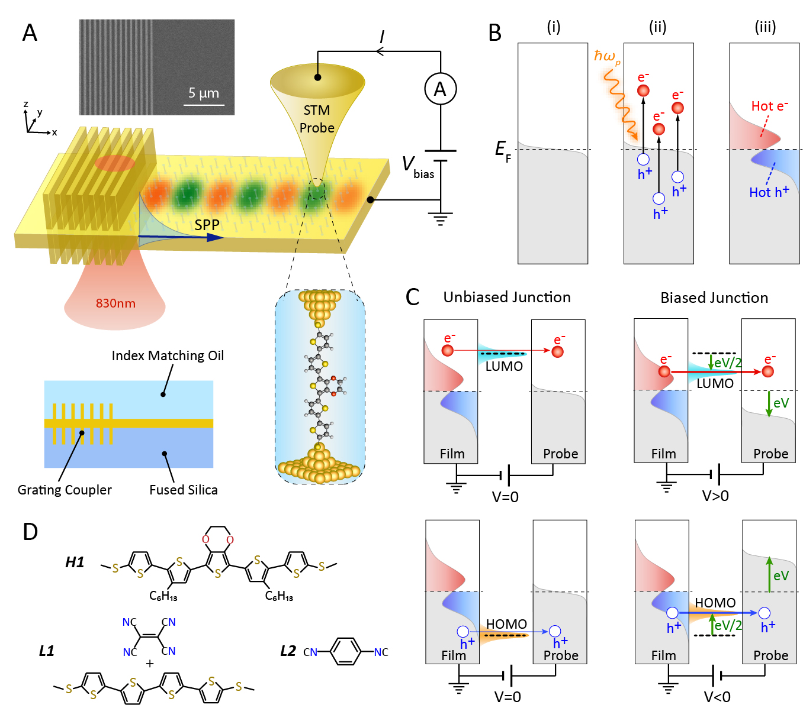
Fig. 1: Experimental setup and strategy to map hot-carrier energy distributions (HCEDs). (A) Schematic of the experimental set-up. Single molecule junctions (SMJs) are formed between a grounded nanodevice (Au film with integrated grating coupler) and a biased Au STM probe. Surface plasmon polaritons (SPPs) are excited by illuminating the grating coupler with 830 nm CW laser. The SEM image shows a fabricated nanodevice on 6 nm Au film. The bottom left graphic represents a cross-section of the nanodevice covered with index matching oil. (B) Schematic of hot-carrier generation. (i) Equilibrium Fermi function. (ii) Non-radiative decay of SPP energy ($\text{ℏ}{\text{ω}}_{\text{p}}$) generates electron-hole pairs, resulting in (iii) non-equilibrium distribution of hot-electrons and holes. (C) Schematic showing how LUMO or HOMO-dominated SMJs with sharp transmission peaks selectively transmit hot-carriers. Biasing the junctions shifts the transmission peak with respect to the equilibrium Fermi level enabling quantification of HCED. (D) Structures of molecules used in this work.

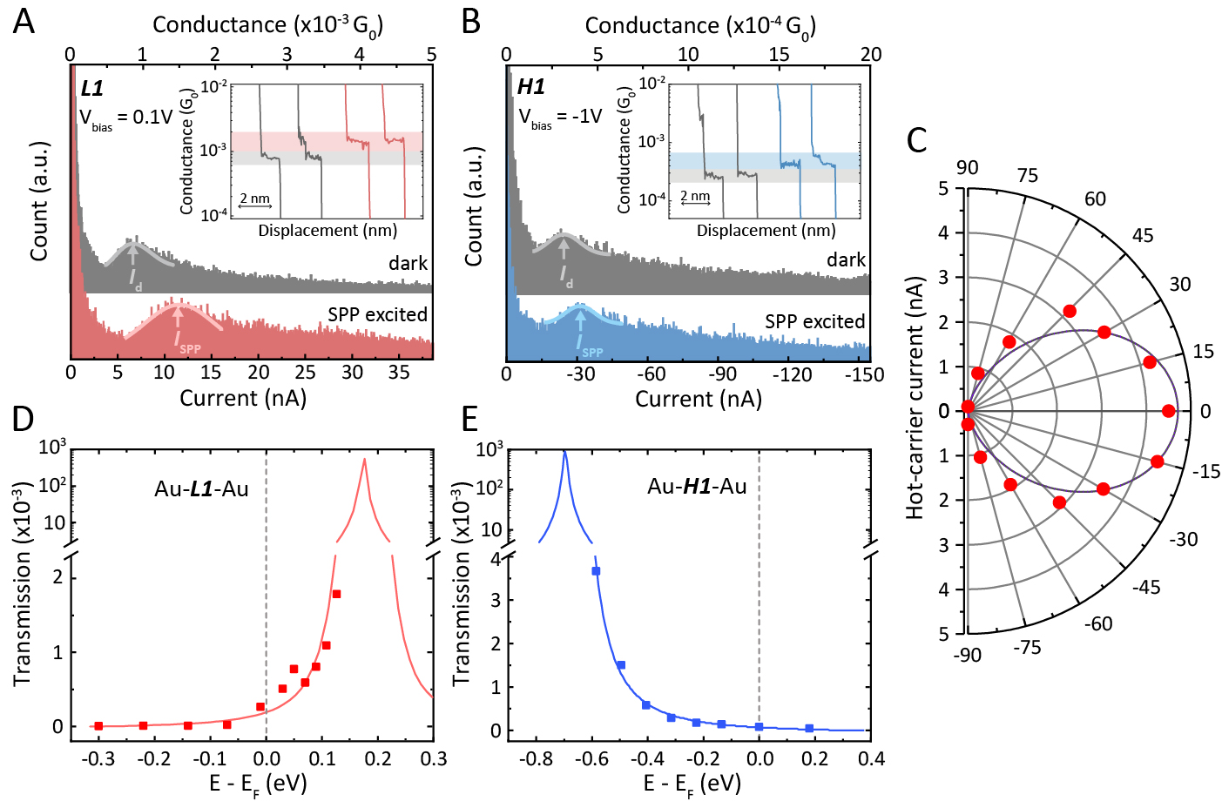
Fig. 2: Hot-carrier induced changes in SMJ currents, polarization-dependence, and transmission characteristics of L1 and H1 molecules. (A) Current and conductance histograms of Au-L1-Au SMJs from over 2000 traces of dark (grey) and SPP-excited (magenta) measurements at a voltage bias of 0.1V. Gaussian fits to the histogram peaks are represented as solid lines and the vertical arrows indicate the most probable conductance and current. Inset shows representative conductance traces following the same color coding. (B) Same as (A), but for Au-H1-Au junctions and -1.0V bias voltage. The grey and blue colors correspond to measurements from dark and SPP-excited cases, respectively. (C) Polarization-dependence of the hot-carrier current (${\text{I}}_{\text{hot}}$) for Au-L1-Au junctions (red circles) at 0.1V bias voltage along with the best-fit ${\text{cos}}^{\text{2}}\text{θ}$ dependence (black line). (D) and (E) Measured transmission functions (note the linear and logarithmic scales) of Au-L1-Au and Au-H1-Au junctions along with the Lorentzian fits (solid lines).

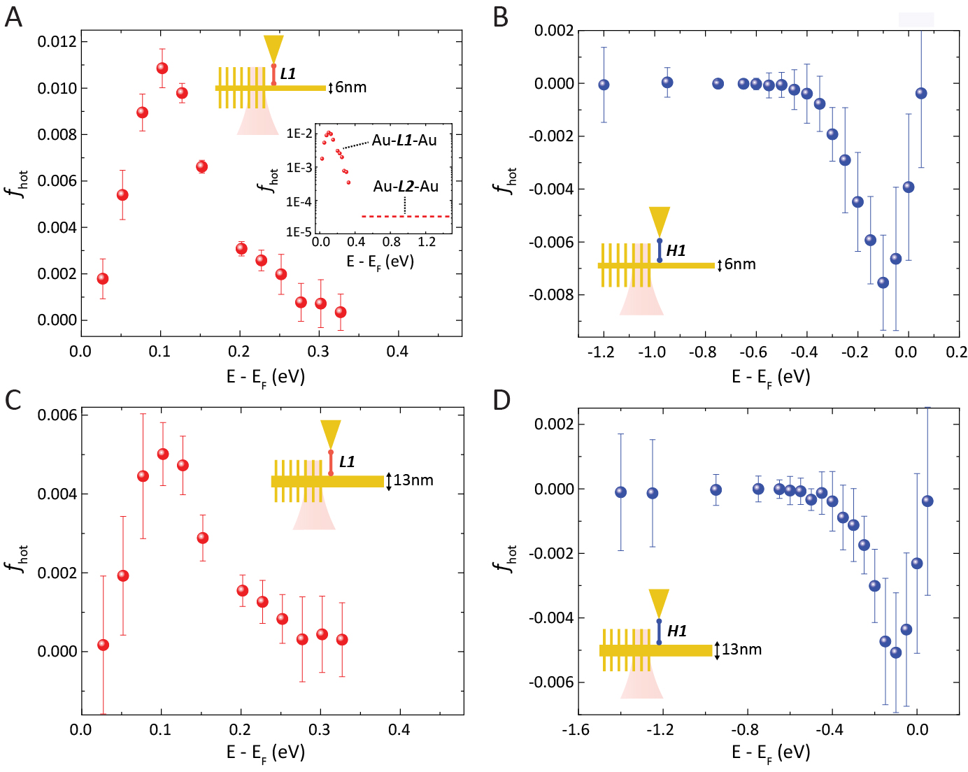
Fig. 3: Energy distributions of hot-carriers in 6 nm and 13 nm-thick Au films. (A) The measured HEED in a 6 nm Au film obtained from measurements on Au-L1-Au and Au-L2-Au SMJs. The energy distribution in the range up to 0.33 eV was measured with Au-L1-Au junctions. The inset shows the HEED on a log scale and the dashed line represents the upper bound on the average ${\text{f}}_{\text{hot}}\text{ (}\text{E}\text{)}$ in the energy window $\left\{\text{0.4 eV} \text{:} \text{1.45 eV}\right\}$ as determined with Au-L2-Au junctions. (B) The measured HHED in a 6 nm Au film using Au-H1-Au junctions under otherwise identical conditions compared to (A). (C) & (D) Measured HCEDs for 13nm Au film but otherwise as for (A) & (B). The error bars correspond to the propagated errors from uncertainties in the measured ${\text{I}}_{\text{hot}}\text{(}{\text{V}}_{\text{bias}}\text{)}$.

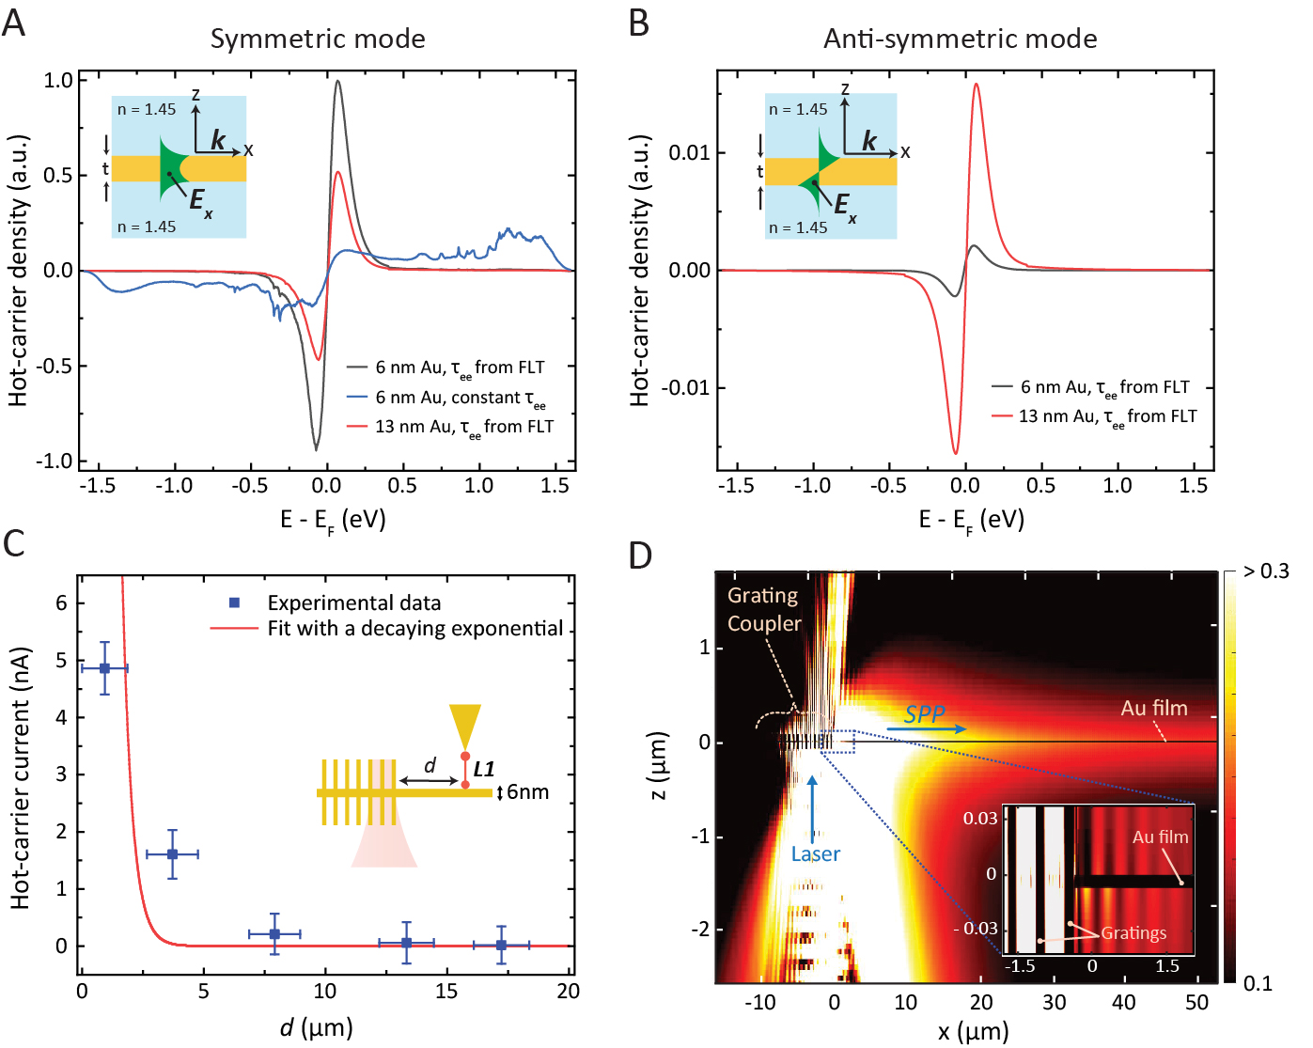
Fig. 4: Computed HCEDs, distance dependence and intensity profile. (A) Computed HCEDs in 6 nm- and 13 nm-thick Au films, arising from the symmetric plasmonic mode with electron-electron scattering rates from either Fermi liquid theory (FLT) or an energy-independent scattering rate. Inset shows the employed geometry and mode profile. (B) Same as (A), but for the anti-symmetric plasmonic mode. Note that the y-axis scale is smaller in (B) compared to (A). (C) Measured ${\text{I}}_{\text{hot}}$ through Au-L1-Au SMJs (at 0.1V bias voltage) for varying separations d between the probe tip and the grating edge. Error bars represent uncertainties in d and ${\text{I}}_{\text{hot}}$. The red curve is an exponential fit constrained to have a decay length of 405 nm, corresponding to the symmetric mode’s decay constant in 6 nm gold film (see (20), section 14).(D) Simulated intensity profile normalized to the incident field intensity upon illuminating the gratings with a focused 830 nm laser (spot size of 5.6 μm). Inset shows the intensity profile near the grating edge. The color map of the inset is adjusted to show the beating pattern, and is different from the main panel color map.

