**Enhancement on the Performance of Eco-friendly Solution-Processed InO/AlO Thin-film Transistors via Lithium Incorporation**

Tianshi Zhao1,2, Chun Zhao1,*, Jianfu Zhang3, Ivona Z Mitrovic2, Eng Gee Lim1, Li Yang4, Tao Song1 and Cezhou Zhao1

1. Department of Electrical and Electronic Engineering, Xi’an Jiaotong-Liverpool University, Suzhou 215123, China;

2. Department of Electrical Engineering and Electronics, University of Liverpool, Liverpool L69 3GJ, UK;

3. Electrical Electronic Engineering Research Centre, Liverpool John Moore University, Liverpool, UK;

4. Department of Chemistry, Xi’an Jiaotong-Liverpool University, Suzhou 215123, China;

*. Correspondence:

E-mail: Chun.Zhao@xjtlu.edu.cn

**Abstract**

Solution-processed fabrication of thin-film transistors (TFTs) has low cost and roll-to-roll capability. Indium oxide is one of the promising materials for the metal oxide semiconductor layer in TFTs. Early works used high temperature (~700 °C) anneal, which is not suitable for flexible substrates. The toxic solvents, such as 2-methoxyethanol (2-Me), have been widely used in the preparation of precursor solutions. To overcome these challenges, we propose a low temperature (≤ 250 ℃) and an eco-friendly process through the incorporation of lithium. Both X-ray photoelectron spectroscopy and electrical characterizations were carried out to optimize the process. The best result was obtained with 10 at.% lithium incorporation. The high field-effect mobility, averaged over 30 devices, is 21.6 cm2∙V-1∙s-1, which is 380% higher than the groups without lithium incorporation and is higher than or comparable with those reported by early works for the low-temperature solution prepared InO films. They were used to build an inverter successfully. Moreover, the bias stability of the transistors was also proved to be improved through lithium doping. This eco-friendly solution process has the potential for low-cost fabrication of TFTs on the flexible substrate.

**Keywords:** TFT, solution process, metal oxide semiconductor, high-*k* materials

**1. Introduction**

Owing to its potential for large-area deposition, equipment facility, roll-to-roll ability, non-vacuum processing, and low cost, solution-processed fabrication has attracted much attention, especially for fabricating metal oxide (MO) thin-film transistors (TFTs) [1-5]. Among various metal oxides, indium oxide (InO) is a promising semiconductor due to its high carrier mobility, a wide bandgap (3.6-3.75 eV), and superb transparency in the visible region [5-9]. These advantages make the solution-processed InO a promising candidate for fabricating high-performance MO TFTs.

Early work fabricated InO film with good quality through a high-temperature (~700 °C) annealing, which gives the critical energy needed for 1) dissociation, 2) condensation and densification, and 3) solvent residues removal for the network structure formation of metal−oxygen−metal (M−O−M) [10]. There is a trade-off between the annealing temperature and the film quality. Lowering temperature leads to an increase of oxygen vacancy (Vo) and metal-hydroxyl (M-OH) bonds, which possibly act as traps in the film. Since the high-temperature process is not suitable for fabricating MO TFT on flexible substrates, there is a need to develop a new low-temperature process. Another problem with the solution-based fabrication of MO TFTs is the common use of toxic solvents such as 2-methoxyethanol (2-Me) in preparing precursor solutions [11, 12].

The objective of this work is to tackle these challenges by developing an eco-friendly low temperature (<300 °C) process. To address the issue of the defect-rich phenomenon with a low-temperature process, we employed an alkali metal, lithium (Li) ion, as a dopant in the InO matrix. According to related research, Li+ ion could be an appropriate dopant due to its larger Lewis acid strength and smaller size than In ion [13, 14]. As a result, the electron cloud in MO films would be polarized away and the carrier scattering would be reduced [13]. Furthermore, the dissociation energy of Li oxide ( ~3.4 eV) is stronger than that of InO ( ~3.3 eV), so that the Li+ ion in the InO could be a suppressor of VO [15-17]. The defects could be reduced and the reliability of the device could be improved through the incorporation of Li+ ion, therefore. Moreover, although previous studies showed that the dopants of the divalent metal ion or trivalent metal ion (Dy3+, Ni2+, and Gd3+, etc.) enhance the device stability, the mobility of the transistors are sacrificed due to a reduction of carrier concentration [15, 18, 19]. In contrast, as a monovalent metal ion, Li+ ion could act as an electron donor in the InO networks and lead to an enhancement on mobility, which has been proved in zinc oxide TFTs in previous investigations [20, 21]. On the non-toxic solvent, we used deionized water (DI water) as the solvent of the precursors, which has better solubility for indium nitrate (In(NO3)3), lower molar mass, and lower boiling point (100 °C) than 2-Me (>130 °C).

For the insulator layer, the solution-processed high-*k* dielectric materials are being widely investigated on the application of TFT, since they can simultaneously guarantee the large insulation capacitance and low leakage current [22]. In this research, we chose solution-processed AlO as the high-*k* dielectric. Although there are some other MO dielectrics such as HfO [23-27], ZrO [28], YO [29] and SrO [30], etc. have been reported to shows higher permittivity (>10) than AlO (~9), the AlO exhibit a better leakage performance due to its wide bandgap (~8.7 eV), and which is the main issue for the InO based TFTs [15, 18, 31]. Moreover, the aluminum nitrate (Al(NO3)3), a widely used precursor for solution-processed AlO films, has been proved to have excellent solubility in water and able to decomposition under a low-temperature process (<300 ℃) [1, 12].

In this work, we first report on the optimization of Li incorporated aqueous solution-processed InO semiconductor layers. InO films with 0 at.%, 5 at.%, 10 at.% and 15 at.% Li incorporation were prepared, tested, and analyzed in detail. TFTs were then fabricated after combining the InO films with the solution-processed AlO dielectric. Under a processing temperature below 250 ℃, the devices showed a mobility of 21.6 cm2∙V-1∙s-1, a subthreshold swing (S.S.) of 0.25 V/dec, and a threshold voltage (Vth) of 0.5 V. It should be noted that these results were averaged over 30 samples. Compared with the solution-processed In-based TFTs reported by recent works (**Table Ⅰ**), the TFTs in this study exhibit comparable or superior mobility [30, 32-40]. Next, through connecting the drain of TFT with a resistor, an inverter was successfully set up and tested. Finally, to further understand and optimize the TFT reliability, a positive gate bias (PGB) stress was conducted. The stability of the Li incorporated group was improved and the mechanism was analyzed.

**2. Experimental**

All of the chemicals were supplied by Aladdin and used as received. The AlO precursor solution was prepared by dissolving 0.6 M aluminum nitrate nonahydrate (Al(NO3)3∙9H2O, Aladdin) in DI water. 7.5 M hydrogen peroxide (H2O2, Aladdin) was added to reduce the defects in the dielectric layer. The InO precursor solution was prepared by dissolving 0.1 M indium nitrate hydrate (In(NO3)3∙xH2O, Aladdin) in DI water. Different Li concentrations (0, 5, 10 and 15 at.%) were obtained by dissolving 0, 0.005, 0.01 and 0.015 M lithium acetate (LiOOCCH3, Aladdin) in the InO precursor solution, respectively. The solutions were ultra-sonically cleaned and filtered through a 0.45 μm poly(ether sulfone) (PES) syringe.

For TFTs fabrication, Fig. 1 shows that the AlO precursor solution was spun onto the heavily doped silicon substrates to prepare the dielectric layer. After that, the InO precursor solutions were spun onto the surface of the AlO layer, followed by annealing at 250 °C under ambient atmosphere for 1 hour. This temperature was selected based on the thermogravimetric analysis (TGA) in Fig. 2. It clearly shows that the solvent residues for the aqueous-based solution can be effectively removed at a temperature of 250 ℃ or above, which is consistent with the previous reports [41, 42]. 250 ℃ is a good trade-off between the physically stable thin films and a low thermal budget, therefore.

Al source and drain electrodes were deposited onto the semiconductor layer through a shadow mask with a Width/Length (W/L) ratio of 15. It should be noted here that a W/L more than 10 could effectively reduce the overestimation of the field-effect mobility according to the previous report [43].

The surface morphologies of the InO layers were observed by atomic force microscopy (AFM, BRUKER Nanoscope V). The thermal behavior of the InO precursor powders was characterized by the thermogravimetric analyzer and differential scanning calorimeter (TGA-DSC, Jupiter STA449F3) at a heating rate of 10 °C/min from 20 to 500 °C after dehydration at 105 °C for 12 hours. The crystallization and structural information of the sol-gel derived films were displayed using x-ray diffraction (XRD, BRUKER D8 ADVANCE) with Cu Kα radiation (𝜆=1.542 Å). The oxygen chemical bonds were analyzed through X-ray Photoemission Spectroscopy (XPS, Thermo scientific ESCALAB 250Xi with Al Ka X-ray source). The electrical characteristics of the TFTs were revealed utilizing a semiconductor analyzer (Keysight, B1500 A) in the dark at room temperature. Vth was obtained from the result of IDS-VGS in the saturation region by plotting (IDS1/2) vs VGS. The mobility (μ) and S.S. were calculated by the following equations:

|  |  |
| --- | --- |
| $I_{DS} =\left(\frac{μC_{i}W}{2L}\right){\left(V_{GS}-V_{th}\right)}^{2}$, | (1) |
| $S.S. ={\left(\frac{d(\log_{10}{I_{DS}})}{dV_{GS}}\right)}^{-1}$. | (2) |

**3. Results and Discussion**

As depicted in Fig. 2, for all the 4 groups, the samples exhibit great weight loss at from 200 ℃ to 250 ℃. This could be attributed to the decomposition of the residual nitrates [42]. For 10 at.% and 15 at.% groups, both of them start losing weight obviously at about 100 ℃ and 15 at.% group shows a greater extent. This could be mainly explained by the dihydroxylation procedure (from In(OH)63+ to In2O3) and the incorporation of Li+ ion intensifies this procedure [41]. After 250 ℃, the curve tends to flatten, which means that the compositions of the films become steady. However, due to the addition of lithium acetate in solution precursor, the slightly different rate of weight-losing and the variation in the final percentage weight is difficult to explain with a single cause. It might have resulted from the extra decomposition procedures (such as the decomposition of the acetate and so on) and the composition variation of the final product (such as the different concentrations of Li element in MO network). To accurately evaluate the quality of the films, further physical measurements were carried out.

Fig. 3 shows the XRD patterns of InO thin films with different concentrations of Li incorporation. The group of pure InO films exhibit an amorphous structure after 250 ℃ annealing. This agrees with the previous studies that the aqueous solution-processed pure InO presents an obvious crystalline peak at 30.6° corresponding to the (222) plane only when the annealing temperature was up to 300 ℃ [41, 44, 45]. Furthermore, it was reported that the Li+ ion dopants in the InO layer suppress the crystallization of InO lattice, because of the ionic radius difference between Li+ and In3+ in Li incorporated InO films [46]. All films show an amorphous structure, which is favorable since crystallization causes non-uniformity for TFTs [46].

Surface morphologies of all InO films were observed through AFM measurements. The results are displayed in Fig. 4 and the root-mean-square (RMS) roughness of the groups with 0, 5, 10 and 15 at.% Li incorporation are summarized in Table Ⅱ. For the Li+ ion concentration of 0, 5, 10 and 15 at.%, the films showed RMS roughness of 0.263, 0.277, 0.291 and 0.332 nm, respectively. These results prove that the film fabricated in this study was extremely smooth. The incorporation of Li+ ion leads to a slightly rougher surface, which could be explained by the phase-separation of the Li+ and In3+ during the film formation process [47].

To investigate the impact of Li incorporation on the chemical bonding states and compositions of InO layers, the X-ray photoelectron spectra (XPS) were measured and plotted in Figs. 5(a) to (e). The O 1s XPS spectra can be divided into three sub-peaks through deconvolution. They are centered at 529.8, 531.0, and 531.8 eV, which correspond to the M-O bonds (OM), the O2− ions near Vo (OV), and the M-OH bonds (OH), respectively [42, 48, 49]. The M-O bonds are the final product transformed from the precursor solution and provide a stable conductive channel while the gate voltage is applied [22]. The VO is generated by the loss of oxygen in the M-O network during the transformation process, while the M-OH bonds are mainly generated from the incomplete conversion of the metal hydroxide residues and the reaction of the film’s surface with the absorbed moisture [50, 51]. Both of the VO and M-OH bonds are unstable, which may lose electrons and induce positive ions that act as defect states under the application of gate bias [50]. As shown in Table Ⅱ, the area ratios of M-O peaks (centered at 529.8 eV) increases with Li+ concentration and reach a maximum of 67.1 % at 10 at.% Li. This phenomenon could be attributed to Li assisting the formation of In-O network and the suppression effect on Vo [15, 18, 32]. Excessive doping of Li to 15 at.%, however, has an adverse effect: an increase of M-OH peak and a decrease of M-O peak. This can be mainly attributed to the increase in lithium hydroxide (LiOH) and the degradation of InO microstructure [17]. As a result, 10 at.% Li incorporation is the optimal condition.

Fig. 6(a) shows the transfer characteristics of Li-InO/AlO TFTs with Li at 0, 5, 10, and 15 at.%, respectively. Fig. 6(b) gives the output characteristics under different gate voltage (Vg) for TFTs with 10 at % Li. They exhibit convincing n-channel field-effect transistor characteristics. Drain voltage in Fig. 6(b) was swept in both directions and hysteresis is negligible. Their key properties are summarized in Table Ⅲ, which are the average values of 30 devices and the histogram are plotted in Figs. 7(a) to (d). The samples with 10 at.% Li incorporation have the highest mobility of 21.6 cm2∙V-1∙s-1, the lowest subthreshold swing (S.S.) of 0.25 V/dec, a Vth of 0.5 V, and an on/off current ratio of approximately 104. The defects induced by VO and M-OH at the interface of the InO/AlO layers could ruin the conduction channel and cause degradation on mobility as well as the S.S. [21]. Therefore, the transfer characteristics of the groups with different Li concentration agrees with previous XPS results. As Li+ concentration reaches 15 at.%, the on/off ratio is reduced significantly to less than 1000. The devices can no longer be switched off properly and the leakage current increased by over one order of magnitude. It appears that there is a limit for the Li incorporation into InO. Once this limit is reached, the excessive Li introduces defects in the film [52]. They cause resistor-like conduction between source and drain, which is not controlled by the gate.

As the Li concentration increasing, Fig. 6(a) shows that the off current of the devices increases as well. This could be explained by the extra electron provided by Li+. According to recent research, the increasing trend of mobility is always accompanied by a rising trend of the off current [15, 18]. When Li concentration is below 10 at.%, the simultaneous increase of off current and mobility with Li concentration in Fig. 6(a) maintains the on/off current ratios at the magnitude of 104 for all these groups.

To explore the applications of the TFTs in circuits, a resistor-loaded inverter was built by connecting the 10 at.% Li incorporated InO/AlO TFTs in series with a 220 kΩ resistor, as illustrated in Fig. 8(a). The static voltage transfer characteristics (VTC) and the voltage gain values are displayed in Fig. Fig. 8(b). The device exhibits a gain value of more than 6 under a VDD of 3.0 V. In addition, the output high (VOH) and low (VOL) voltage, as well as the input high (VIH) and low (VIL), could be extracted from the VTC curve. Under the VDD of 3.0 V, the noise margin was calculated ((VOH-VIH+VIL-VOL)/VDD) with a high value of 65 %, indicating a strong noise tolerance that has potential to be applicated in multi-stage circuits [53]. The dynamic behavior of the inverter was measured with an input voltage of a square waveform at 1, 10 and 100 Hz, depicted in Figs. 8(c) to (e), respectively. These results show that the output voltage has the inverter-like on/off states up to 100 Hz. This compares well with the sub-10 Hz reported by recent works [32, 54].

To investigate the reliability of the TFTs with Li incorporation, a 1000 s positive gate bias (PGB) stress was applied to the samples with 10 at.% and without Li incorporation. As shown in Fig. 9(a), the Vth of the devices without Li incorporation was shifted by 1.3 V, while the ones with 10 at.% incorporation were shifted by only 0.85 V along the negative direction. The Vth-stability is improved by 35% through Li incorporation, therefore. It should be noticed that, unlike most reports of a positive shift for Vth under a PGB test, the devices in this work show a negative shift. This could be explained by the positive charge accumulation at the backchannel of the devices (the side far from the interface between InO and AlO layers), as shown in Figs. 9(b) and (c) [50]. For a bottom-gate n-channel TFT, once the bias applied on the bottom gate has reached the Vth, a conductive channel is formed by the electrons near the dielectric layer (the small-blue dots in Fig. 9(c)). Under a duration PGB stress, the VO and M-OH bonds in the bulk of semiconductors can become positively charged and accumulated at the backchannel (the big-red dots in Fig. 9(c)). These positive charges effectively act as an extra positive “top gate” bias, which assists in the formation of the conductive channel [50]. In addition, due to no real gate dielectric between the positive ions (in the backchannel) and the channel, the capacitance of “top-gate” in this work is much larger than that in the conventional dual-gate TFTs according to equation (3),

|  |  |
| --- | --- |
| $C=\frac{ɛɛ_{0}S}{d}$, | (3) |

where ɛ is the relative permittivity of the InO, $ɛ_{0}$ is the dielectric constant of vacuum, S is the area of the surface and d is the thickness of the layer between the “top gate” and the electron channel. Therefore, the top gate has a strong gate-control ability on the channel and even a small amount of positive ions can lead to a significant negative ΔVth [50]. The Li-incorporation reduces the amount of Vo and M-OH bonds, weakens the effect of “top gate”, and improves the Vth–stability.

**4. Conclusion**

In this work, we have presented a fully solution-processed fabrication scheme for Li-incorporated InO/AlO thin-film transistors using an eco-friendly solvent. The effects of Li concentration were studied through both physical and electrical characterizations and the optimal level is found to be 10 at.%. The XPS results suggest that Li+ ion incorporation assists in forming a strong InO network. The low-temperature InO TFTs were successfully fabricated with mobility of 21.6 cm2∙V-1∙s-1, a threshold voltage of 0.5 V, subthreshold swing of 0.25 V/dec, and on/off ratio of ~104, averaged over 30 samples. Utilizing the devices in this group, a resistor-loaded inverter was demonstrated with a frequency of up to 100 Hz. Moreover, a PGB test was carried out and the improvement on device bias stability was proved through Li incorporation.

**5. Acknowledgments**

This research was funded in part by the National Natural Science Foundation of China (21503169, 2175011441, 61704111), Key Program Special Fund in XJTLU (KSF-P-02, KSF-A-04, KSF-A-05, KSF-A-07, KSF-T-03).

**References**

[1] Y. Chen, W. Huang, V.K. Sangwan, B. Wang, L. Zeng, G. Wang, Y. Huang, Z. Lu, M. Bedzyk, M. Hersam, Polymer Doping Enables a Two‐Dimensional Electron Gas for High‐Performance Homojunction Oxide Thin‐Film Transistors, Adv. Mater., 31 (2019) 1805082. https://doi.org/10.1002/adma.201805082.

[2] W. Cai, S. Park, J. Zhang, J. Wilson, Y. Li, Q. Xin, L. Majewski, A. Song, One-Volt IGZO Thin-Film Transistors With Ultra-Thin, Solution-Processed AlxOy Gate Dielectric, IEEE Electr. Device L., 39 (2018) 375-378. https://doi.org/10.1109/LED.2018.2798061.

[3] Z. Wang, J. Zheng, M. Li, Q. Wu, B. Huang, C. Chen, J. Wu, C. Liu, Solution-based SnGaO thin-film transistors for Zn-and In-free oxide electronic devices, Appl. Phys. Lett., 113 (2018) 122101. https://doi.org/10.1063/1.5046119.

[4] W. Xu, J. Zhang, Y. Li, L. Zhang, L. Chen, D. Zhu, P. Cao, W. Liu, S. Han, X. Liu, p-Type transparent amorphous oxide thin-film transistors using low-temperature solution-processed nickel oxide, J. Alloy. and Compd., 806 (2019) 40-51. https://doi.org/10.1016/j.jallcom.2019.07.108.

[5] N.K. Chourasia, A. Sharma, V. Acharya, N. Pal, S. Biring, and B.N. Pal, Solution processed low band gap ion-conducting gate dielectric for low voltage metal oxide transistor, J. Alloy. and Compd., 777 (2019) 1124-1132. https://doi.org/10.1016/j.jallcom.2018.10.163.

[6] C.-Y. Zhao, J. Li, D.-Y. Zhong, C.-X. Huang, J.-H. Zhang, X.-F. Li, X.-Y. Jiang, Z.-L. Zhang, Effect of La Addition on the Electrical Characteristics and Stability of Solution-Processed LaInO Thin-Film Transistors With High-*k* ZrO2 Gate Insulator, IEEE T. Electron Dev., 65 (2018) 526-532. https://doi.org/10.1109/TED.2017.2781725.

[7] Y.-R. Lyu, T.-E. Hsieh, A characterization on emission property of In2O3–SiO2 nanocomposite thin films, Surf. Coat. Tech., 231 (2013) 219-223. https://doi.org/10.1016/j.surfcoat.2012.06.037.

[8] J. Cheng, X. Li, J. Guo, H. Xu, Y. Chen, Y. He, J. Xue, T. Zhang, Z. Yu, The role of the sequence of plasma treatment and high temperature annealing on solution-processed a-IMZO thin film transistor, J. Alloy. and Compd., 793 (2019) 369-374. https://doi.org/10.1016/j.jallcom.2019.04.115.

[9] X. Li, J. Cheng, Y. Gao, M. Li, D. Kuang, Y. Li, J. Xue, T. Zhang, Z. Yu, Impact of NH3 plasma treatment for solution-processed indium oxide thin-film transistors with low thermal budget, J. Alloy. and Compd., (2019) 152720. https://doi.org/10.1016/j.jallcom.2019.152720.

[10] J.-W. Jo, Y.-H. Kim, J. Park, J.S. Heo, S. Hwang, W.-J. Lee, M.-H. Yoon, M.-G. Kim, S.K. Park, interfaces, Ultralow-Temperature Solution-Processed Aluminum Oxide Dielectrics via Local Structure Control of Nanoclusters, ACS Appl. Mater. Inter., 9 (2017) 35114-35124. https://doi.org/10.1021/acsami.7b09523.

[11] H.S. Kim, P.D. Byrne, A. Facchetti, T.J. Marks, High performance solution-processed indium oxide thin-film transistors, J. Am. Chem. Soc., 130 (2008) 12580-12581. https://doi.org/10.1021/ja804262z.

[12] J.H. Park, Y.B. Yoo, K.H. Lee, W.S. Jang, J.Y. Oh, S.S. Chae, H.K. Baik, Low-temperature, high-performance solution-processed thin-film transistors with peroxo-zirconium oxide dielectric, ACS Appl. Mater. Inter., 5 (2013) 410-417. https://doi.org/10.1021/am3022625.

[13] S. Parthiban, J.-Y. Kwon, Role of dopants as a carrier suppressor and strong oxygen binder in amorphous indium-oxide-based field effect transistor, J. Mater. Res., 29 (2014) 1585-1596. https://doi.org/10.1557/jmr.2014.187.

[14] D.R. Lide, CRC handbook of chemistry and physics: a ready-reference book of chemical and physical data, CRC press, 1995.

[15] Y. Li, W. Xu, W. Liu, S. Han, P. Cao, M. Fang, D. Zhu, Y. Lu, High-Performance Thin-Film Transistors with Aqueous Solution-Processed NiInO Channel Layer, ACS Appl. Electr. Mater., 1 (2019) 1842-1851. https://doi.org/10.1021/acsaelm.9b00377.

[16] S.-Y. Han, M.-C. Nguyen, A.H.T. Nguyen, J.-W. Choi, J.-Y. Kim, R. Choi, Effect of Li-doping on low temperature solution-processed indium–zinc oxide thin film transistors, Thin Solid Films, 641 (2017) 19-23. https://doi.org/10.1016/j.tsf.2017.05.024.

[17] D. Khim, Y.H. Lin, S. Nam, H. Faber, K. Tetzner, R. Li, Q. Zhang, J. Li, X. Zhang, T.D. Anthopoulos, Modulation-Doped In2O3/ZnO Heterojunction Transistors Processed from Solution, Adv. Mater., 29 (2017). https://doi.org/10.1002/adma.201605837.

[18] L. Hong, W. Xu, W. Liu, S. Han, P. Cao, M. Fang, D. Zhu, Y. Lu, High Performance Indium Dysprosium Oxide Thin-Film Transistors Grown from Aqueous Solution, Appl. Surf. Sci., (2019) 144499. https://doi.org/10.1016/j.apsusc.2019.144499.

[19] S.-H. Lee, T. Kim, J. Lee, C. Avis, J. Jang, Solution-processed gadolinium doped indium-oxide thin-film transistors with oxide passivation, Appl. Phys. Lett., 110 (2017) 122102. https://doi.org/10.1063/1.4978932.

[20] H.-j. Jeon, S.-G. Lee, H. Kim, J.-S. Park, Enhanced mobility of Li-doped ZnO thin film transistors fabricated by mist chemical vapor deposition, Appl. Surf. Sci., 301 (2014) 358-362. https://doi.org/10.1016/j.apsusc.2014.02.080.

[21] B.-Y. Su, S.-Y. Chu, Y.-D. Juang, Improved electrical and thermal stability of solution-processed Li-doped ZnO thin-film transistors, IEEE T. Electron Dev., 59 (2012) 700-704. https://doi.org/10.1109/TED.2011.2179549.

[22] A. Liu, H. Zhu, H. Sun, Y. Xu, Y.Y. Noh, Solution Processed Metal Oxide High‐*k* Dielectrics for Emerging Transistors and Circuits, Adv. Mater., 30 (2018): 1706364. https://doi.org/10.1002/adma.201706364.

[23] J.T. Anderson, C.L. Munsee, C.M. Hung, T.M. Phung, G.S. Herman, D.C. Johnson, J.F. Wager, D.A. Keszler, Solution‐processed HafSOx and ZircSOx inorganic thin‐film dielectrics and nanolaminates, Adv. Funct. Mater., 17 (2007) 2117-2124. https://doi.org/10.1002/adfm.200601135.

[24] F. Zhang, G. Liu, A. Liu, B. Shin, F. Shan, Solution-processed hafnium oxide dielectric thin films for thin-film transistors applications, Ceram. Int., 41 (2015) 13218-13223. https://doi.org/10.1016/j.ceramint.2015.07.099.

[25] A. Liu, Z. Guo, G. Liu, C. Zhu, H. Zhu, B. Shin, E. Fortunato, R. Martins, F. Shan, Redox Chloride Elimination Reaction: Facile Solution Route for Indium‐Free, Low‐Voltage, and High‐Performance Transistors, Adv. Electron. Mater., 3 (2017) 1600513. https://doi.org/10.1002/aelm.201600513.

[26] M.S. Rao, M. Pacheco-Zuñiga, L. Garcia-Cerda, G. Gutiérrez-Heredia, J.T. Ochoa, M.Q. López, R. Ramírez-Bon, Low-temperature sol-gel ZrHfO2-PMMA hybrid dielectric thin-films for metal oxide TFTs, J Non-Cryst Solids, 502 (2018) 152-158. https://doi.org/10.1016/j.jnoncrysol.2018.08.014.

[27] R.N. Bukke, N.N. Mude, J. Lee, C. Avis, J. Jang, Effect of Hf Alloy in ZrOx Gate Insulator for Solution Processed a-IZTO Thin Film Transistors, IEEE Electr. Device L., 40 (2019) 32-35. https://doi.org/10.1109/LED.2018.2880177.

[28] R.N. Bukke, C. Avis, M.N. Naik, J. Jang, Remarkable increase in field effect mobility of amorphous IZTO thin-film transistors with purified ZrOx gate insulator, IEEE Electr. Device L., 39 (2018) 371-374. https://doi.org/10.1109/LED.2018.2791633.

[29] A. Liu, G. Liu, H. Zhu, Y. Meng, H. Song, B. Shin, E. Fortunato, R. Martins, F. Shan, A water-induced high-*k* yttrium oxide dielectric for fully-solution-processed oxide thin-film transistors, Curr. Appl. Phys., 15 (2015) S75-S81. https://doi.org/10.1109/LED.2018.2791633.

[30] C. Fan, A. Liu, Y. Meng, Z. Guo, G. Liu, F. Shan, Solution-Processed SrOx-Gated Oxide Thin-Film Transistors and Inverters, IEEE T. Electron Dev., 64 (2017) 4137-4143. https://doi.org/10.1109/TED.2017.2742060.

[31] J.-W. Jo, K.-H. Kim, J. Kim, S.G. Ban, Y.-H. Kim, S.K. Park, High-mobility and hysteresis-free flexible oxide thin-film transistors and circuits by using bilayer sol–gel gate dielectrics, ACS Appl. Mater. Inter., 10 (2018) 2679-2687. https://doi.org/10.1021/acsami.7b10786.

[32] L. Zhu, G. He, Y. Long, B. Yang, J. Lv, Eco-Friendly, Water-Induced In₂O₃ Thin Films for High-Performance Thin-Film Transistors and Inverters, IEEE T. Electron Dev., 65 (2018) 2870-2876. https://doi.org/10.1109/TED.2018.2824336.

[33] C.-Y. Zhao, J. Li, D.-Y. Zhong, C.-X. Huang, J.-H. Zhang, X.-F. Li, X.-Y. Jiang, Z.-L. Zhang, Effect of La Addition on the Electrical Characteristics and Stability of Solution-Processed LaInO Thin-Film Transistors With High-*k* ZrO2 Gate Insulator, IEEE T. Electron Dev., 65 (2017) 526-532. https://doi.org/10.1109/TED.2017.2781725.

[34] Y.-H. Zhou, J. Li, D.-Y. Zhong, X.-F. Li, J.-H. Zhang, Enhanced Stability of Sr-Doped Aqueous In2O3 Thin-Film Transistors Under Bias/Illumination/Thermal Stress, IEEE T. Electron Dev., 66 (2019) 1308-1313. https://doi.org/10.1109/TED.2017.2781725.

[35] K. Banger, C. Warwick, J. Lang, K. Broch, J.E. Halpert, J. Socratous, A. Brown, T. Leedham, H.J.C.s. Sirringhaus, Identification of dipole disorder in low temperature solution processed oxides: its utility and suppression for transparent high performance solution-processed hybrid electronics, Chem. Sci., 7 (2016) 6337-6346. https://doi.org/10.1039/C6SC01962E.

[36] T. Kim, B. Jang, J.-H. Bae, H. Park, C.S. Cho, H.-J. Kwon, J. Jang, Improvement in the performance of sol–gel processed In2O3 thin-film transistor depending on Sb dopant concentration, IEEE Electr. Device L., 38 (2017) 1027-1030. https://doi.org/10.1109/LED.2017.2715374.

[37] C. Zhu, A. Liu, G. Liu, G. Jiang, Y. Meng, E. Fortunato, R. Martins, F. Shan, Low-temperature, nontoxic water-induced high-*k* zirconium oxide dielectrics for low-voltage, high-performance oxide thin-film transistors, J. Mater. Chem. C, 4 (2016) 10715-10721. https://doi.org/10.1039/C6TC02607A.

[38] B.D. Choi, H.S. Kim, Y.-G. Ha, J. An, K. Ahn, J. Hong, S.K. Park, M.-G. Kim, Solution-Processed Amorphous Zn–In–Sn–O/ZrO2 Based Field-Effect Transistors, J. Nanosci. Nanotechno., 16 (2016) 11406-11412. https://doi.org/10.1166/jnn.2016.13518.

[39] Z. Lin, L. Lan, S. Sun, Y. Li, W. Song, P. Gao, E. Song, P. Zhang, M. Li, L. Wang, Solution-processed high-mobility neodymium-substituted indium oxide thin-film transistors formed by facile patterning based on aqueous precursors, Appl. Phys. Lett., 110 (2017) 133502. https://doi.org/10.1063/1.4979318.

[40] W. Lee, J. Kim, Y.-H. Kim, High-performance InOx/GaOx bilayer channel thin-film transistors made using persistent high-surface-energy induced by photochemical activation, J. Alloy. and Compd., 723 (2017) 627-632. https://doi.org/10.1016/j.jallcom.2017.06.188.

[41] Y.H. Hwang, J.-S. Seo, J.M. Yun, H. Park, S. Yang, S.-H.K. Park, B.-S. Bae, An ‘aqueous route’ for the fabrication of low-temperature-processable oxide flexible transparent thin-film transistors on plastic substrates, NPG Asia Mater., 5 (2013) e45-e45. https://doi.org/10.1038/am.2013.11.

[42] W. Xu, M. Long, T. Zhang, L. Liang, H. Cao, D. Zhu, J.-B. Xu, Fully solution-processed metal oxide thin-film transistors via a low-temperature aqueous route, Ceram. Int., 43 (2017) 6130-6137. https://doi.org/10.1016/j.ceramint.2017.02.007.

[43] W. Xu, H. Li, J.B. Xu, L. Wang, Recent Advances of Solution-Processed Metal Oxide Thin-Film Transistors, ACS Appl. Electr. Mater., 10 (2018): 25878-25901. https://doi.org/10.1021/acsami.7b16010.

[44] M.G. Kim, M.G. Kanatzidis, A. Facchetti, T.J. Marks, Low-temperature fabrication of high-performance metal oxide thin-film electronics via combustion processing, Nat. Mater., 10 (2011) 382-388. https://doi.org/10.1038/nmat3011.

[45] W. Xu, H. Wang, L. Ye, J. Xu, The role of solution-processed high-*k* gate dielectrics in electrical performance of oxide thin-film transistors, J. Mater. Chem. C, 2 (2014) 5389-5396. https://doi.org/10.1039/C4TC00334A.

[46] J. Ren, K. Li, J. Yang, D. Lin, H. Kang, J. Shao, R. Fu, Q. Zhang, Solution-processed amorphous gallium-tin oxide thin film for low-voltage, high-performance transistors, Sci. China Mater., 62 (2019) 803-812. https://doi.org/10.1007/s40843-018-9380-8.

[47] M.-C. Nguyen, M. Jang, D.-H. Lee, H.-J. Bang, M. Lee, J.K. Jeong, H. Yang, R. Choi, Li-assisted low-temperature phase transitions in solution-processed indium oxide films for high-performance thin film transistor, Sci. Rep-uk., 6 (2016) 25079. https://doi.org/10.1038/srep25079.

[48] J.S. Lee, Y.-J. Kwack, W.-S. Choi, Inkjet-printed In2O3 thin-film transistor below 200° C, ACS Appl. Mater. Inter., 5 (2013) 11578-11583. https://doi.org/10.1021/am4025774.

[49] J. Lee, H. Seul, J.K. Jeong, Solution-processed ternary alloy aluminum yttrium oxide dielectric for high performance indium zinc oxide thin-film transistors, J. Alloy. and Compd., 741 (2018) 1021-1029. https://doi.org/10.1016/j.jallcom.2018.01.249.

[50] X. Huang, J. Song, P. Lai, Improved Stability of *ɑ*-InGaZnO Thin-Film Transistor under Positive Gate Bias Stress by Using Fluorine Plasma Treatment, IEEE Electr. Device L., 38 (2017) 576-579. https://doi.org/10.1109/LED.2017.2678468.

[51] J.M. Kwon, J. Jung, Y.S. Rim, D.L. Kim, H.J. Kim, Improvement in negative bias stress stability of solution-processed amorphous In–Ga–Zn–O thin-film transistors using hydrogen peroxide, ACS applied materials & interfaces, 6 (2014) 3371-3377. https://doi.org/10.1021/am4054139.

[52] Z. Lin, Y. Liu, U. Halim, M. Ding, Y. Liu, Y. Wang, C. Jia, P. Chen, X. Duan, C. Wang, F. Song, M. Li, C. Wan, Y. Huang, X. Duan, Solution-processable 2D semiconductors for high-performance large-area electronics, Nature, 562 (2018) 254-258. https://doi.org/10.1038/s41586-018-0574-4.

[53] F.S. Stinner, Y. Lai, D.B. Straus, B.T. Diroll, D.K. Kim, C.B. Murray, C.R. Kagan, Flexible, high-speed CdSe nanocrystal integrated circuits, Nano Lett., 15 (2015) 7155-7160. https://doi.org/10.1021/acs.nanolett.5b03363.

[54] A. Liu, H. Zhu, G. Liu, Y.Y. Noh, E. Fortunato, R. Martins, F. Shan, Draw Spinning of Wafer‐Scale Oxide Fibers for Electronic Devices, Adv. Electron. Mater., 4 (2018) 1700644. https://doi.org/10.1002/aelm.201700644.

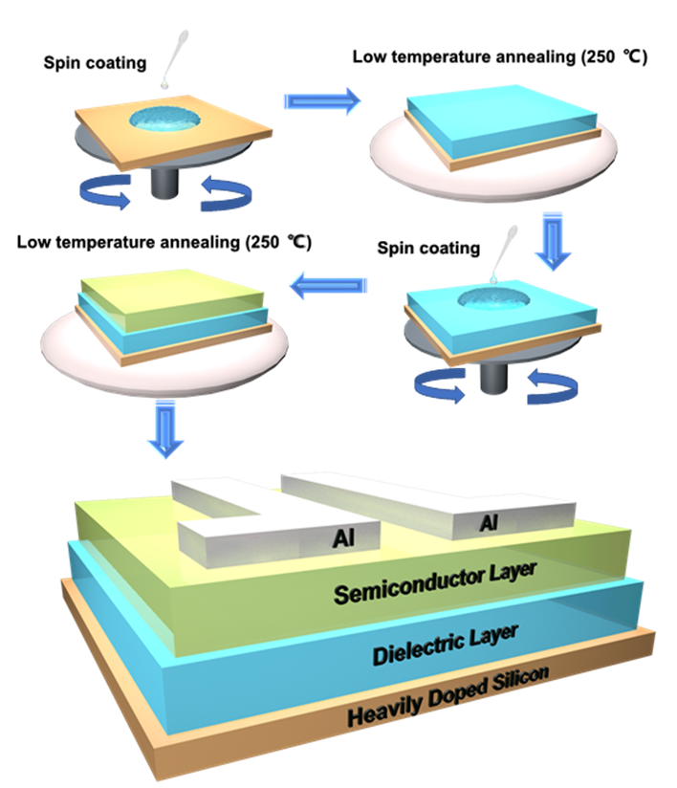

**Fig. 1** Schematic diagrams of the fabrication process flow of the Li-InO/AlO TFTs.

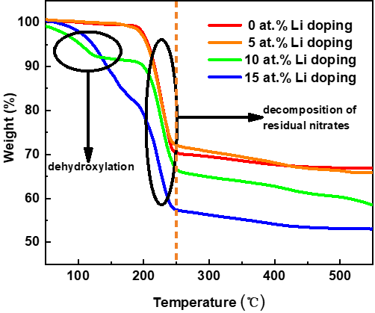

**Fig. 2** TGA results of InO incorporated by different Li concentrations.

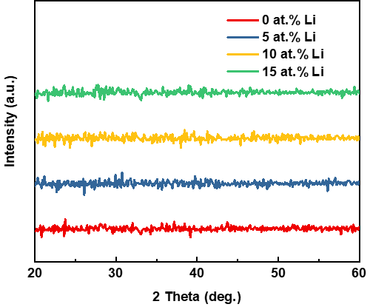

**Fig. 3** XRD spectra of InO incorporated by different Li concentrations.

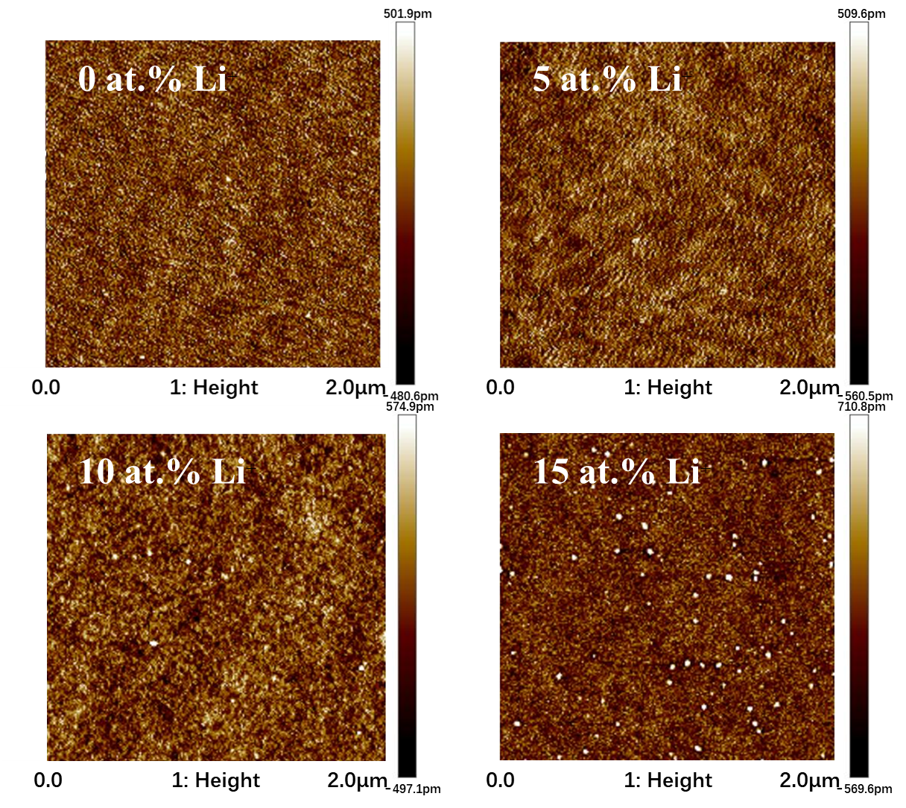

**Fig. 4** AFM spectra of InO incorporated by different Li concentrations.

|  |  |
| --- | --- |
| (a) | (b) |
| (c) | (d) |
| (e) | |

**Fig. 5** XPS spectra of (a) 0 at.%, (b) 5 at.%, (c) 10 at.%, and (d) 15 at.% Li doped samples. (e) Atomic percentage of M-O bonds, Vo, and M-OH bonds at different Li concentrations.

|  |  |
| --- | --- |
| (a) | (b) |

**Fig. 6** (a) Transfer characteristics of 0, 5, 10, and 15 at.% Li incorporated samples. (b) Output characteristics of 10 at.% Li doped samples.

|  |
| --- |
| (a) (b) (c) (d) |
| (e) (f) (g) (h) |

**Fig. 7** Histogram and line graph of mobility and Vth of InO TFTs

incorporated with various Li+ concentrations: (a), (e) 0 at.%, (b), (f) 5 at.%, (c), (g) 10 at.% and (d), (h) 15 at.%.

|  |  |  |  |
| --- | --- | --- | --- |
| (a) | | (b) | |
| (c) | (d) | | (e) |

**Fig. 8** (a) An inverter by connecting a 10 at.% Li-InO/AlO TFT with a 220 kΩ external resistor. (b) The static voltage transfer characteristics and the voltage gain of the resistor-loaded inverter at different VDD values. Dynamic measurements of the inverter at (c) 1 Hz (d) 10 Hz and (e) 100 Hz.

|  |  |
| --- | --- |
| (a) | (b) |
| (c) | |

**Fig. 9** (a)Vth shifts for the InO/AlO TFT with/without 10 at.% Li incorporation. (b) Energy band diagram of the TFTs under a PGB test. (c) The microscopic schematic of channel layers with/without Li incorporation under PGB stress.

**Table Ⅰ.** Recent Reports of Solution-Processed Indium Based TFTs

|  |  |  |  |  |
| --- | --- | --- | --- | --- |
| **Semiconductor** | **Temp. (℃)/Solvent** | **Mobility (cm2·V-1·s-1)** | **Year** | **Ref.** |
| Sr-InO | 300/DI water | 5.41 | 2019 | [34] |
| La-InO | 500/2-Me | 32.7 | 2018 | [33] |
| InO | 260/DI water | 6.67 | 2018 | [32] |
| InOx/GaOx | 350/2-Me | Average 11.2 | 2017 | [40] |
| Nd-InO | 350/DI water | 15.6 | 2017 | [39] |
| Sb-InO | 500/Ethanol | 1.6 | 2017 | [36] |
| InO | 600/2-Me | 5.61 | 2017 | [30] |
| InO | 200/2-Me | ≈5 | 2016 | [35] |
| InZnSnO | 400/DI water | 14 | 2016 | [38] |
| InO | 250/DI water | 10.78 | 2016 | [37] |
| Li-InO | 250/DI water | Average 21.6 | This work | |

**Table Ⅱ.** The RMS roughness and the ratios of the O 1s peaks for the InO films with 0, 5, 10 and 15 at.% Li+ incorporation concentrations.

|  |  |  |  |  |
| --- | --- | --- | --- | --- |
| Li+ concentration | 0 at.% | 5 at.% | 10 at.% | 15 at.% |
| RMS roughness | 0.263 nm | 0.277 nm | 0.291 nm | 0.332 nm |
| OM/(OM+OV+OH) | 41.9% | 43.7% | 67.1% | 59.8% |
| OV/(OM+OV+OH) | 29.9% | 30.0% | 18.9% | 18.6% |
| OH/(OM+OV+OH) | 28.3% | 26.3% | 14.1% | 21.6% |

**Table Ⅲ.** Electrical Properties of Li-InO/AlO TFTs

|  |  |  |  |  |
| --- | --- | --- | --- | --- |
| Li+ concentration | Mobility (cm2·V-1·s-1) | S.S. (V/dec) | Vth (V) | On/off Ratio |
| 0 at.% | 4.5 (±1.77) | 0.35 | 0.8(±0.12) | ~6×104 |
| 5 at.% | 17.3(±2.22) | 0.28 | 0.6(±0.21) | ~2×104 |
| 10 at.% | 21.6(±1.71) | 0.25 | 0.5(±0.18) | ~1×104 |
| 15 at.% | 19.2(±8.49) | 1.03 | 0.4(±0.36) | ~4×102 |