Abstract
Aim: A preclinical safety assessment of a novel nanoemulsion drug delivery system, initially developed to improve the posology of efavirenz (EFV), was conducted with a specific focus on possible immunological and haematological complications.
Materials and methods: Assessment of common acute toxicities, such as complement activation and cytokine secretion, was performed using validated assays known to have good correlation with in vivo endpoints.
Results and Conclusion: Compared with a standard aqueous solution of EFV, the EFV nanoemulsion showed no, significant, effect on immune cell function or phenotype. Prolongation of activated partial thromboplastin time (aPTT) was observed for EFV-loaded nanoemulsions (88% at 4 µg/mL) as well as unloaded nanoemulsions (52%) highlighting the potential for drug-free anticoagulant activity and warranting further investigation of the mechanism and utility of these materials.
Keywords: Nanomedicine, preclinical, HIV, safety, nanoemulsion, immunotoxicity

Introduction
The development of a novel nanoemulsion drug delivery system for the non-nucleoside reverse transcriptase inhibitor efavirenz (EFV) was previously reported. The formulation showed improved transcellular permeability across Caco-2 cells compared to an aqueous solution of EFV, and equivalent antiviral activity against HIV-1 IIIB [1]. Following pharmacological assessment of the lead nanoemulsion candidate, a preclinical assessment of common acute toxicities was conducted. This analysis focused upon pathways that have previously been illustrated to be important for nanomaterials[2,3].
Nanoemulsions have, previously, been shown to be inducers of the pro-inflammatory chemokine IL-8 [4], which has multiple immunological roles including, but not limited to, chemotaxis and promotion of phagocytosis. Work by Sakurai et al has shown that lipid-based delivery vehicles have a greater tendency to induce pro-inflammatory cytokines compared to nanoparticle delivery systems with a different composition [5]. Lipid-based nanoparticles have also shown a propensity for entrapment of endotoxin, which can lead to enhanced cytokine secretion, mitigating their use in parenteral administration formats and complicating robust preclinical assessment of immunological safety [6]. This phenomenon has previously been linked to positive charge on the surface of lipid- and polymer-based nanoparticles [7]. In an attempt to overcome these issues, the nanoemulsion described here was developed with no surface charge [1] to minimise affinity for binding directly to endotoxins.
Certain nanoparticles have previously been shown to interact with blood coagulation [8-11]. These interactions can be either beneficial or detrimental to the patient, and in some cases cause serious complications. If nanoparticles interact directly with the factors which regulate coagulation in such a way as to deplete these factors, it can lead to a condition known as disseminated intravascular coagulation (DIC). This is an acute toxicity that leads to the formation of clots and if untreated can progress to organ failure and ultimately death. It has been reported that a certain type of nanoparticulate silica was shown to induce DIC when administered intravenously in an in vivo setting[12]. In another report different forms of carbon nanoparticles where demonstrated to increase the rate of platelet aggregation, leading to formation of deep vein thromboses in rodent models. Part of the mechanism of interaction reported was the ability of these carbon nanoparticles to upregulate glycoprotein IIb/IIIa, which is a receptor for both fibrinogen and von Willebrand factor, which are involved in the aggregation of platelets [13].
The protein corona is a layer of proteins and biomolecules that can absorb to the surface of nanomaterials[14], these proteins include the factors which regulate the coagulation pathways, such as fibrinogen and factor VIII. Any interaction with nanomaterial surfaces (or indeed any biomaterial) can lead to changes in the activity or conformation of the proteins[15], which in turn will modulate their immunological effect. An example of this is the activation of coagulation factor XII after interaction with a negatively surface[16], or the size dependant activation of intrinsic coagulation after interaction with negatively charged polystyrene nanoparticles[17]. Interestingly some clinical data available for nanoemulsion formulations of propofol show conflicting reports of having both a prothrombotic [18] and antithrombotic [19] in patients, with this ambiguity potential linked to underlying conditions in specific patients.
Thus, nanoparticles could be used to specifically induce interactions within coagulation pathways in order to modulate pre-existing complications in patients that have underlying pathologies and the need for anticoagulant therapy. Indeed, there are reports in the literature of nanomaterials specifically designed and engineered to either induce or inhibit coagulation. For example haemophilia requires treatment by administration of recombinant coagulation factors, to overcome the inherent deficiency in affected patients. In order to increase the effectiveness of these factors and to increase the half-life in plasma, formulation and conjugation to PEGylated liposomes has been demonstrated, with both factor VIIa and factor VIII attached to the outer surface of the liposome. This strategy both increased the half-life of the recombinant factors used, and reduced the number of infusions needed to complete the treatment in patients[20-22]. Conversely, other work has focused on the inhibition of coagulation for disease states that place a patient in a procoagulant state. Heparin, for instance, has been developed using nanoformulation to be delivered via oral or topical administration routes, negating the need for invasive intravenous administration as has been the traditional route, with this work showing efficacy in both in vitro and in vivo testing[23,24].
Perhaps most interestingly is the potential for nanoformulation to provide dual application via both the therapeutic compound being delivered and the delivery system itself. This could be particularly useful for conditions in which the disease being treated also causes changes to a patient’s coagulation state, such as cancer. The progression of cancer has been linked with increased procoagulant state and the increased likelihood of formation of thrombosis [25]. Therefore developing a suitable carrier system for cancer therapeutics that inherently inhibited coagulation could provide a route to treating two disease states within a single dosage form.
Nanocarrier systems such as nanoemulsions are being investigated for a range of different routes of administration, which include direct systemic delivery via intravenous injection or infusion. Indeed, other lipid-based systems such as liposomes have already reached clinical application via this route [26]. In order to mitigate potential downstream risks and minimise the use of vertebrate animals in early development, the preclinical safety of these nanoemulsions is presented here. Importantly, nanoemulsions have previously been shown to exhibit lower haematological toxicity than comparator polymer micelles [27]. Nonetheless, all nanomaterials have the potential to interact on contact with blood components, and a battery of assays is recommended to de-risk translation. Therefore, a range of in vitro immunological and haematological assays has been employed to determine potential interactions when primary human immune cells and other blood constituents were exposed to these nanoemulsions. This work represents a complementary component of the nanoemulsion preclinical assessment [4,28] and relates to common acute toxicities associated with nanomaterial exposure.

Materials and Methods
Roswell Park Memorial Institute 1600 medium (RPMI 1600) and Hank’s balanced saline solution (HBSS) were bought from Sigma-Aldrich (Dorset, UK). Life Technologies (Paisley, UK) supplied foetal bovine serum. Cell culture flasks, cell culture plates, 10 and 25 mL pipettes, pipette tips, transfer pipettes, Ficoll-Paque, and isopropyl alcohol were purchased from Fisher Scientific (Loughborough, UK). Buffy coats were obtained from the National Health Service Blood and Transplant Special Health Authority (Liverpool, UK). FITC fluorescently labelled CD4 and CD8 antibodies, APC fluorescently labelled CD44 and CD69 antibodies and PE fluorescently labelled CD25 and CD95 were all bought from Miltenyi Biotec GmbH (Bergisch Gladbach, Germany). Miltenyi also supplied MACSQuant® running buffer, MACSquant® calibration beads, MACS separation beads (human CD8, CD56 and CD4), QuadroMACSTM magnetic separator, MACS LS separation columns, and human T-cell activation/expansion kit containing: Anti-Biotin MACSiBeadTM particles cell culture grade, human CD2-Biotin, human CD2-Biotin, and human CD28-Biotin. All reagents for cytokine secretion studies were supplied by Bio-Rad Laboratories LTD (Hemel Hempstead, UK) in the form of a Bio-Plex Pro kit, containing: coupled magnetic beads, detection antibodies (for IL-1β, IL-2, IL-6, IL-8 IL-10, TNF-α and IFN-γ), cytokine standards, standard diluent, sample diluent, assay buffer, wash buffer, detection antibody diluent, streptavidin-PE and a 96 well filter plate. Bio-Plex calibration and validation kits, along with Bio-Plex sheath fluid were also purchased from Bio-Rad Laboratories LTD. For NK cell studies, phosphate buffered saline, horse serum fetal bovine serum, MEM alpha modification, RPMI-1640, L-glutamine were purchased from GE Healthcare HyClone (Logan, USA), Myo-inositol and folic acid were purchased from Sigma-Aldrich (St Louis, USA), while 2-mercaptoethanol and trypan blue solution were bought from Invitrogen (Life Technologies, New York, USA). NK92 cells were purchased from the American Tissue Culture Collection (ATCC) (Manassas, US). For LAL studies sodium hydroxide and hydrochloric acid were bought from Sigma-Aldrich (St Louis, USA) while control endotoxin standard, LAL reagent and LAL water were purchased from Associates of Cape Cod (East Falmouth, USA). EFV was produced and supplied by LGC Pharma (London, UK), ³H thymidine was supplied by Moravek Biochemicals (California, USA).

Synthesis and physical characterisation of nanoemulsions
Nanoemulsions were prepared and characterised as previously described [1]. Briefly, 2.970 mL of volatile co-solvent (ethyl acetate) was added to 30 μL of non-volatile oil (castor oil, containing 50 mg/mL dissolved EFV), to make a total oil/co-solvent phase of 3.00 mL. To this, 3 mL of a 5% w/v concentration of polymer (poly(OEGMA₉₀-co-EGMDA_{0.95}, Mw 3,181,000 g/mol) dissolved in water was added and this two-phase mixture was homogenised for 2 minutes using an Ultra Turrax T-25 digital homogeniser fitted with an S 25 N -10G dispersing element and set to maximum speed of 25,000 RPM. After homogenisation, the co-solvent was evaporated over a period of 24 hours by removing the vial cap and leaving in a fume hood at ambient temperature. Dynamic Light Scattering (DLS) was used to determine droplet diameter and surface charge using a Malvern ZetaSizer Nano ZS instrument (table 1).
Table 1. Physical characterisation of loaded and blank nanoemulsions
Sample | Dz (nm) | PDI | ζ-potential (mV)
EFV loaded nanoemulsions | 210 | 0.07 | -0.901
Blank nanoemulsions | 217 | 0.06 | -0.933

Assessment of possible biological contamination of nanoemulsion samples prior to immunological assessment
Determination of biological contamination from endotoxin, mycoplasma, and bacteria was carried out as described previously [29]. Concentrations of test samples at 4 μg/ml and 40 μg/ml were used for LB agar plate streaking. H460 cells were treated with 4 μg/mL of sample. Contamination of the nanoemulsion samples was avoided by use of pyrogen free glass and plasticware, with homogenisation and preparation of nanoemulsion samples carried out in a BSC Class II laminar flow hood. To preserve droplet size distribution, nanoemulsions were not passed through a sterile 0.22 µm filter at any point.
Preparation of peripheral blood mononuclear cells from human whole blood and separation of immune cell subsets
Peripheral Blood Mononuclear Cells (PBMCs) were isolated from buffy coats using, Ficoll-paque based, density centrifugation. PBMCs were placed in T-175 cell culture flasks and left in a cell incubator overnight at 37°C and 5% CO₂. Immune cell subsets were isolated from PBMCs using Miltenyi Biotec QuadroMacsTM system (Miltenyi Biotec GmbH, Bergisch Gladbach, Germany), carried out as per manufacturer’s instructions, using CD4, CD14 and CD8 microbeads.

Determination of cytokine secretion from, primary, human immune cells
1 x 10⁶ cells were seeded per well in 24-well culture plates. EFV aqueous solution was prepared by diluting DMSO/EFV solution into media, resulting in <1% DMSO,and EFV nanoemulsion diluted in media, added to appropriate wells to give a final concentration of 3.15 µg/mL of drug in 1 mL total of suspension. After incubation the supernatant fraction was collected and cytokine concentrations analysed using the Bio-Plex 200 Luminex Plate Reader (Bio-Rad Laboratories LTD, Hemel Hampstead, UK), as per manufacturer’s instructions and using the Bio-Plex ProTM Human Cytokine Standard 27-Plex Group 1 analytes. CD14+ cells were seeded at a density of 500,000 cells per well in 24-well plates to which 50 ng/mL of macrophage colony-stimulating factor (MCSF) was added and left for 7 days to allow the CD14+ cells to differentiate into macrophages, and cytokine concentrations analysed as previously described.
Lymphocyte proliferation response to nanoemulsions and known mitogens
PBMCs were added to 96-well plates at a density of 250,000 cells per well and incubated with 50 μL of Phytohaemagglutinin (PHA, 20 µg/mL) to induce lymphocyte proliferation, whilst another set of PBMC were left un-stimulated. DMSO/EFV solution or EFV nanoemulsion was added to both the PHA+ and PHA- plates to give a final concentration of 3.15 µg/mL and incubated for 72 hours at 37°C and 5% CO_{2.} During the last 16 hours of the incubation period, 1 mCi/mL stock solution of ³H labelled thymidine was added to each well to give a final concentration of 1 μCi of ³H thymidine per well. A MicroBeta counter (Perkin Elmer, Ohio, USA) was used to determine the level of ³H thymidine incorporation quantified to give a measure of lymphocyte proliferation.

Determination of lymphocyte activation markers by flow cytometry
PBMCs were isolated from buffy coats as described above. 1 x 10⁶ cells were seeded per well in 1 mL volume within a 24-well plate. 1 mL of either DMSO/EFV solution or EFV nanoemulsion diluted in media was added to each well at a final concentration of 3.15 µg/mL of EFV. After 24-hour incubation samples were extracted and analysed on a MACSQuant® flow cytometer (Miltenyi Biotec GmbH, Bergisch Gladbach, Germany) using anti-CD4, CD8, CD25, CD44, CD69, or CD95 antibodies. Anti-CD2/CD3/CD28 beads were used as a positive control of activation, used as per manufacturer’s instructions. The PBMC population was gated using linear forward and side scatter and a previously optimised compensation matrix applied, suitable for the antibody conjugates used. All samples and buffers were prepared as per manufacturer’s instructions.
Assessment of the haemocompatability of nanoemulsions
The effect of nanoemulsions on the haemolysis of red blood cells, activation of complement, and aggregation of platelets, was determined as per the previously described experimental protocols [29]. For haemolysis studies, DMSO/EFV solutions and loaded and unloaded nanoemulsions were tested at final concentrations of 0.16, 0.8, 4 and 40 µg/mL. Platelet aggregation experiments used final concentrations of 4 µg/mL or 40 µg/mL of samples. For coagulation studies samples of DMSO/EFV solution, unloaded nanoemulsion, and EFV loaded nanoemulsion were added to test plasma at 40 µg/mL, 4 µg/mL, 0.8 µg/mL and 0.16 µg/mL.

Statistical analysis
Statistical analysis was performed using GraphPad Prism 7 for Mac. Distribution of the data was assessed using a Shapiro-Wilk test. Where data were normally distributed, an independent samples t-test was performed to assess differences. Where data were non-normally distributed, a non-parametric Mann-Whitney U test was performed. A P value less than 0.05 was considered statistically significant.

Results

Nanoemulsion sterility and contamination testing
Results from the turbidimetric endotoxin analysis showed that there were 0.8 endotoxin units per mL (EU/mL) of blank emulsion sample and 0.1 EU/mL of EFV loaded nanoemulsion. This was confirmed by gel-clot assay confirmed the results of the LAL assay. Visual analysis of the LB agar plates (figure S1) that had been streaked with blank and EFV loaded nanoemulsion samples showed that there was no bacterial growth after 2 days incubation. Samples from H460 cells that had been exposed to 4 μg/mL of either blank or EFV loaded nanoemulsions were sent to the Fredrick National Laboratory for Cancer Research (Fredrick, USA). The results from that analysis showed that there was no mycoplasma present in the nanoemulsion samples.
Impact of nanoemulsions on cytokine secretion from PBMCs, monocyte-derived macrophages, and proliferation of lymphocytes
The extracellular media from the cell surface marker expression assay was isolated and analysed for the secretion levels of cytokines IL-2, IL-10 and IFN-γ using a Bioplex 200 system and assay kit (Bio-Rad). Data for cells that were pre-stimulated with a T-cell activation kit showed that the levels of IL-10 were the same between control cells, EFV aqueous solution and nanoemulsion EFV (p > 0.05). For IL-2, there was no difference observed between the control cells and either EFV aqueous solution or EFV nanoemulsion (p > 0.05 for all conditions) and the same was true for IFN-γ (p > 0.05). The same experiment was conducted on un-stimulated cells, where cytokines were undetectable across all conditions (figure 1 (A)). Cytokine secretion from monocyte-derived macrophages is shown in figure 1 (B). The secretion of IL-6 showed no difference from the control cells for both EFV aqueous solution and EFV nanoemulsion (p > 0.05), whilst IL-8 also showed no difference between the EFV aqueous solution and EFV nanoemulsion as compared with the cellular control (p = 1.000). No significant difference in the incorporation of ³H thymidine was observed for PBMC samples treated with either EFV aqueous solution or EFV nanoemulsion (p > 0.2). Similarly, the aqueous solution and nanoemulsion had no significant inhibitory effect on the proliferation caused by addition of PHA (p> 0.3) (figure S2).
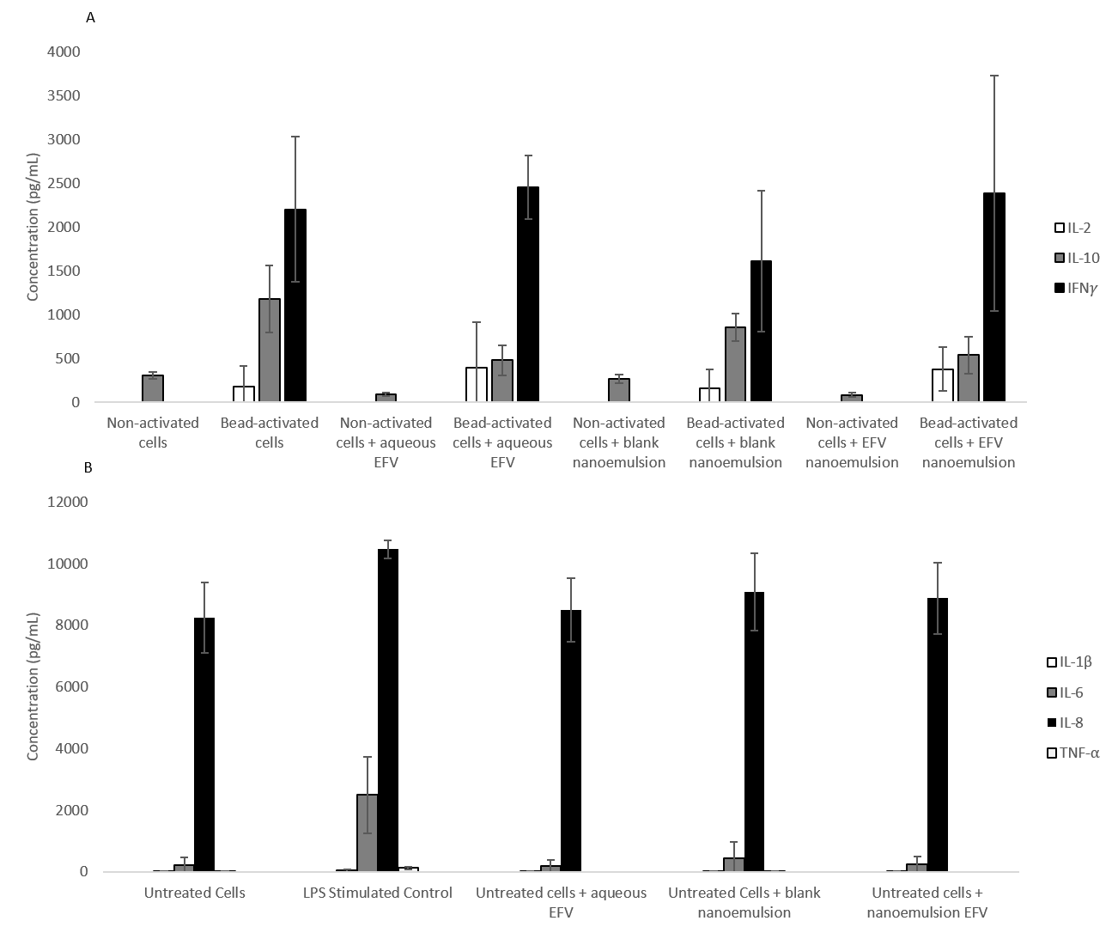
Figure 1. A) Secretion of IL-2, IL-10 and IFN-γ from 1x10⁶ T-cells per well in a 24-well plate. Cells were separated from PBMCs and incubated with 3.15 µg/mL of either aqueous EFV, blank nanoemulsions or EFV loaded nanoemulsion sample for 24 hours prior to analysis. Data shown as +/- standard deviation N=3. Data for IL-2 and IFNg for non-activated PBMCs was below the limit of detection for the assay (0.85 pg/mL and 2.13 pg/mL respectively) B) Secretion of cytokines IL-1β, IL-6, IL-8 and TNF-α from 0.5x10⁶ monocyte derived macrophages per well in a 24-well plate. Cells were incubated either aqueous EFV, blank nanoemulsion, or EFV loaded nanoemulsion sample for 24 hours prior to analysis. Data shown as +/- standard deviation N=4.
Effect of nanoemulsions on the expression of immune cell surface antibodies
The expression of cell surface activation markers (CD25, CD44, CD69 and CD95) were determined using both CD4+ cells (figure 2a) and CD8+ cells (figure 2b) separated from the PBMC’s. The data for the non-activated PBMC showed that there was no difference in the expression of the activation markers as a result of exposure to the EFV nanoemulsion or EFV aqueous solution, when compared to untreated control cells. The data for the bead-activated PBMC set again showed no difference in the expression of these surface markers and showed that neither EFV nanoemulsion nor EFV aqueous solution impacted the expression by either inducing or supressing surface marker expression.
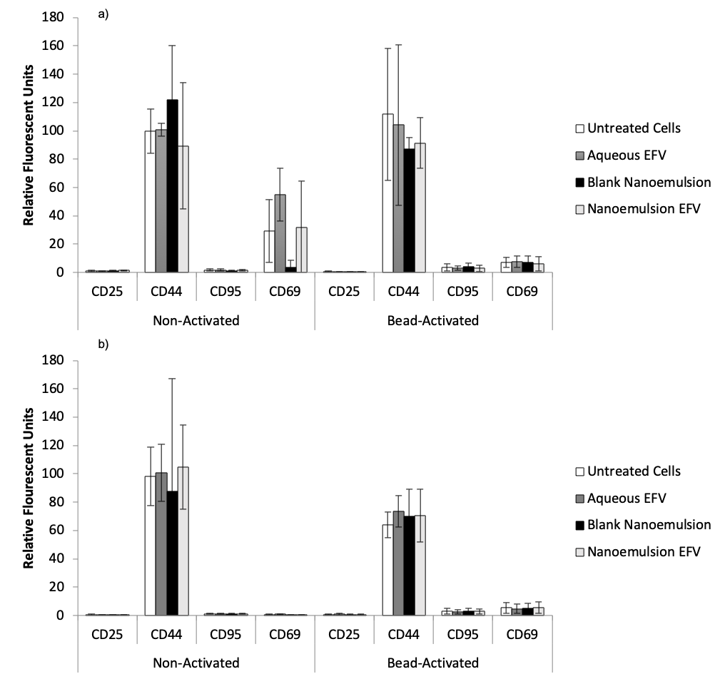
Figure 2. Expression of cell surface markers on both bead-activated (anti CD2/CD3/CD28) and non-activated PBMCs after exposure to EFV aqueous solution, EFV nanoemulsion and blank nanoemulsion. CD4+ cells are shown in (a), whilst CD8+ cells are shown in (b). PBMCs were seeded at a density of 1x10⁶ cells per well in a 24-plate, and samples incubated for 24 hours prior to analysis. Cell population was gated on the flow cytometer using linear forward and side scatter, and a previously optimised compensation matrix. Data is showed as +/- standard deviation, N=4.

Haemolysis studies
The data showed that for the aqueous solution of EFV at 40 μg/mL there was a significantly greater percentage of haemolysis observed as compared to the negative control (0.9% w/v saline) with values of 86% and 3% respectively (p = < 0.001). At the lower concentrations, the percentage haemolysis was similar to that of the negative control (p = > 0.05). There was no haemolysis observed for the blank nanoemulsion formulation at any of the concentrations tested (p > 0.8). For the EFV loaded nanoemulsion greater haemolysis was observed in the at 40 μg/mL with values of 17% compared with 3% for the negative control, but this was not significant (p = 0.96) however there was a significant decrease in the amount of haemolysis observed when EFV loaded nanoemulsions were compared with aqueous EFV solutions (P= 0.0002), with the same being true for blank nanoemulsion compared to aqueous EFV solutions (P=0.0001) There was no haemolysis observed for the EFV loaded nanoemulsion at 4.0, 0.8 and 0.16 μg/mL concentrations (figure 3). 1% (w/v) Triton was used as the positive control.
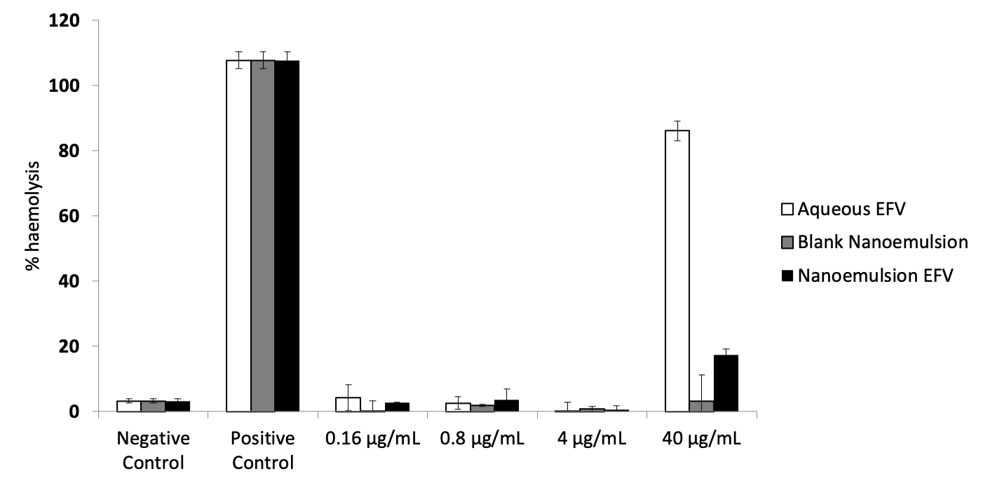
Figure 3. Haemolysis of erythrocytes following addition of aqueous EFV (white bars), blank nanoemulsion (grey bars), and nanoemulsion EFV (black bars). Samples were incubated for 3 hours at 37°C, and were mixed every 30 minutes. Triton X 1% (w/v) Data expressed as percentage haemolysis as compared to positive control, +/- standard deviation.

Platelet aggregation studies
No aggregation of platelets was observed after exposure to either the aqueous solution or the nanoemulsion at 4 μg/mL and 40 μg/mL EFV concentrations. These two conditions had the same values as for the negative control of 0.9% saline solution and significantly lower than the collagen spiked positive control sample (figure 4A). When the collagen positive control was also added to the aqueous and nanoformulations there was no effect seen on aggregation, with both aqueous EFV and nanoemulsion EFV showing the same levels of aggregation as the positive control, showing that aggregation was not being prevented when stimulated (figure 4B). The data for ATP release from platelets mirrored that of the aggregation data in that both formulations at both concentrations had no effect on causing aggregation to occur, or from preventing it when stimulated to aggregate (figure 4).

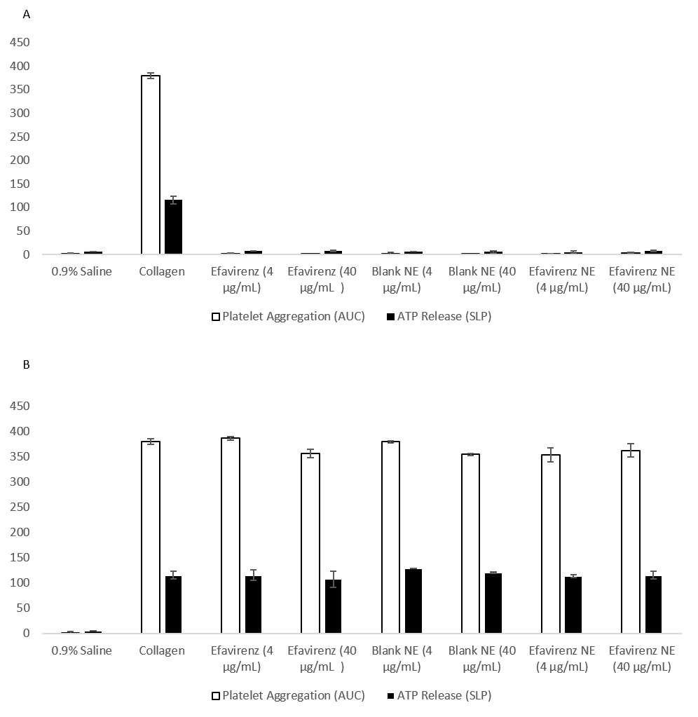
Figure 4. Amount of platelet aggregation after 15-minute exposure to collagen (positive control), saline (negative control), aqueous EFV solution, blank nanoemulsion and EFV nanoemulsion, without 1 µg/mL collagen co-incubation (A), and with 1 µg/mL collagen co-incubation. Samples were incubated at 37°C with data shown as both area under the curve (AUC) and ATP release (SLP), +/- standard deviation.

Effect of nanoemulsions on the coagulation of plasma via either tissue factor, common, or contact activation pathways
The data for coagulation of plasma was separated into 3 areas to assess 3 major pathways to coagulation. In both the prothrombin time (PT) (to assess the tissue factor pathway) and thrombin time (TT) (to assess common pathway) data sets, there was no difference observed between aqueous DMSO/EFV solution, blank nanoemulsion and EFV-loaded nanoemulsion, in the time taken for plasma coagulation to occur). A significant prolongation in activated partial thromboplastin time (APTT) (to assess contact activation pathway) was observed for the EFV loaded nanoemulsions at 40 and 4 μg/mL, which demonstrated a 147% and 88% greater coagulation time as compared to test plasma respectively (p < 0.001). Similarly, for the unloaded nanoemulsions, significant prolongation of APTT were observed at both 4 μg/mL (52 % increase) and 40 μg/mL (159% increase) (p < 0.001) (figure 5).
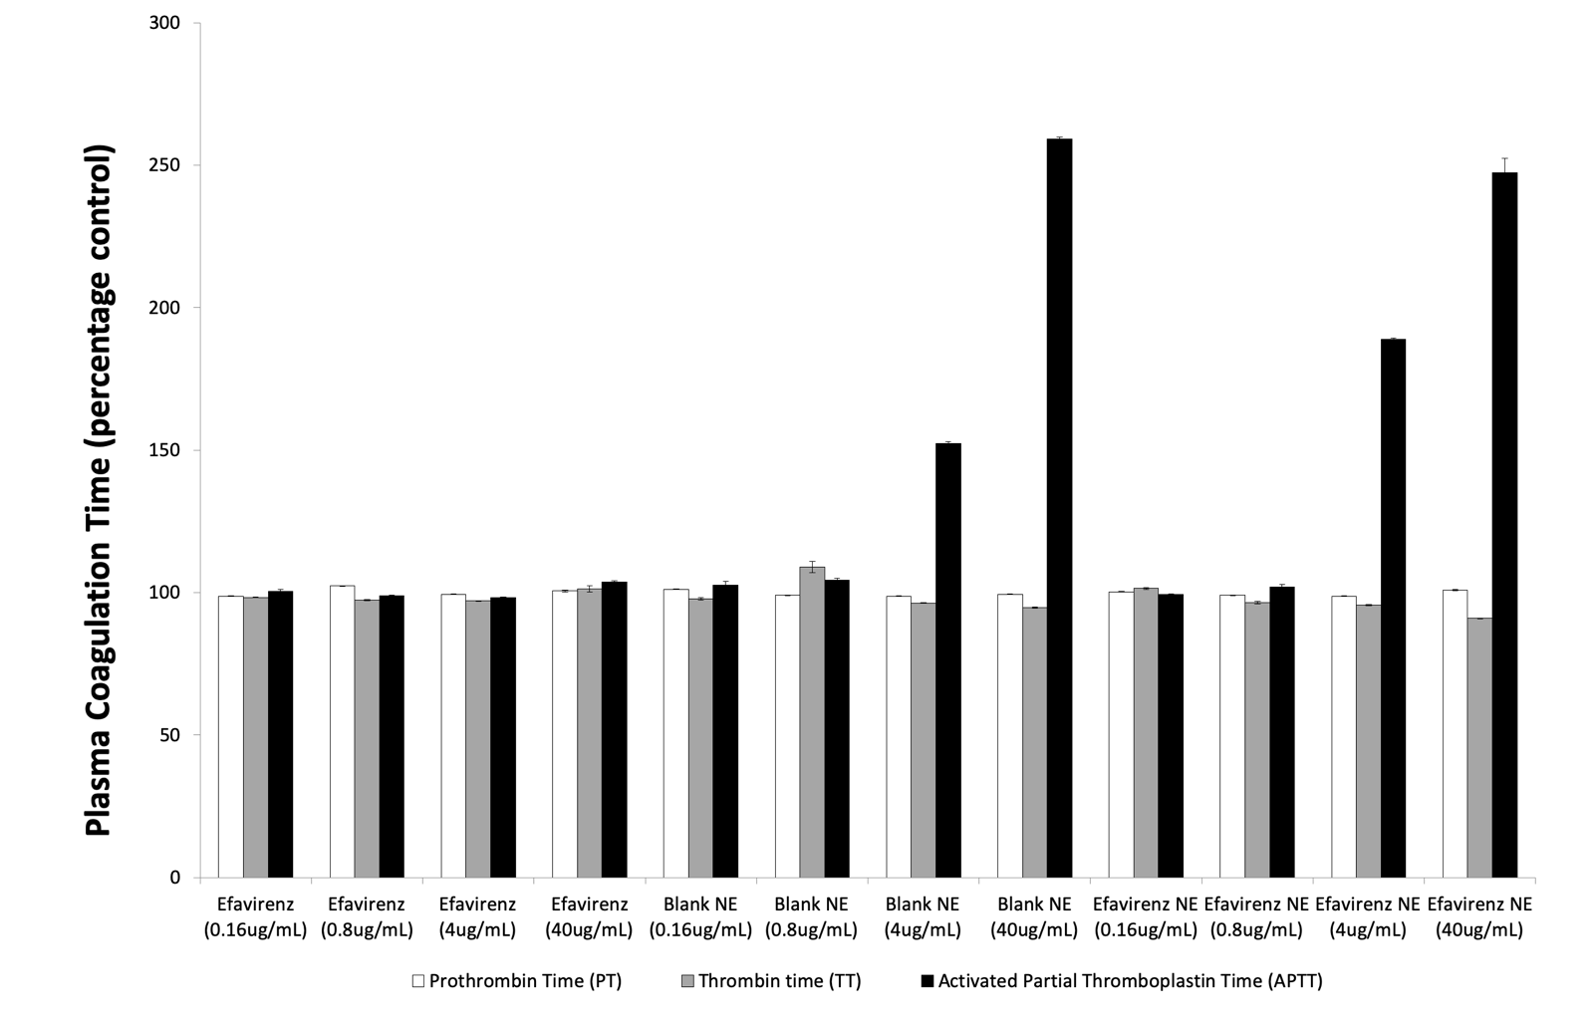
Figure 5. Prothrombin time induced by neoplastine (white bars), thrombin time induced by thrombine (grey bars), and Activated Partial Thromboplastine time induced by CaCl₂, in healthy volunteer plasma in response to DMSO/EFV solution, blank nanoemulsion, and EFV nanoemulsion. Data expressed as % difference in time taken for coagulation, compared to controls. N= 4.

Discussion
The amount of endotoxin present in nanoemulsions was below that of the USP and FDA limit of 5 EU/mL [30], which suggests the synthesis protocol and subsequent handling and storage was appropriate to prevent contamination. The low concentrations of endotoxin also enabled progression to subsequent immunological assays, because it has previously been shown to interfere and skew the results of some immunological tests [31]. If endotoxin is detected in a nanomaterial, sterilisation is complicated because traditional techniques involving high temperature incubations (e.g. autoclaving) damage polymer and lipid structures. This can also impact stability of the pharmaceutical cargo. Mycoplasma and bacterial contaminations were also not detected, which again supports the suitability of the synthesis and the progression to immunological assessments. This has been demonstrated to be problematic for other materials [32,33].

Cytokines have a wide-ranging effect on the immune system, and have therefore been suggested to be a good marker for investigating nanomaterial immunotoxicity [34]. Accordingly, the data from the cytokine secretion assays is very promising as it clearly shows the absence of inhibitory or enhancing effects in primary human immune cells. All three cytokines assayed (IL-2, IL-10 and IFN-γ) were unchanged compared to untreated control cells. A number of reports have shown other nanomaterials that have no effect on the secretion of cytokines [35,36], but other studies have demonstrated nanoparticle induced activation of cytokine secretion[37,38]. Therefore, assessment of cytokine release is required on a case-by-case basis. Indeed, previous work in Liverpool demonstrated that gold nanoparticles augment release of cytokines from PBMCs [39], but that solid drug nanoparticles do not [40,41]. A lack of immune stimulation in response to nanoemulsions was also seen when looking at the secretion of cytokines from macrophages. When LPS was used as a positive control, greater secretion of IL-1β, IL-6 and TNF-α was observed. Previously, nanoparticles have been shown to interact with macrophages, affecting their function and cytokine secretion [42-45], with nanoemulsions in particular being inducers of IL-8 secretion [4].

In addition to cytokine secretion, expression of cell surface markers was unaffected by nanoemulsions. These markers were selected for analysis for different reasons; CD25 is the alpha chain of the IL-2 receptor [46] whereas CD44 is involved in cell-to-cell interactions and is used to assess cell migration due to chemoattraction [47]. CD69 is one of the earliest cell surface markers for lymphocyte proliferation [48] and CD95 is the FAS receptor, involved in apoptosis [49]. As these data were produced using primary immune cells from 4 separate blood donors, inter-sample variability was expected. Thus, primary immune cells are more representative than immune cell lines, such as CEM or THP-1 [50]. It is well documented that immortalised cell lines, although convenient, lack the expression of important enzymes and proteins compared to primary cells [51]. T-cells play a vital role in the immune response and dysregulation can have profound consequences. T-cell proliferation was seen to be like that of untreated control T-cells when incubated with nanoemulsions, regardless of whether the T-cells were stimulated with PHA. Therefore, the nanoemulsions had neither a stimulatory nor a suppressive effect. However, this assay was conducted with isolated T-cells and should be interpreted in the context that the interplay between cells of the immune system is complex and often involves multiple cell types in concert.
Over 80% haemolysis of red blood cells was observed at 40 μg/mL of an EFV/DMSO aqueous solution, but not at 4 μg/mL. However, no haemolysis was observed with unloaded or EFV-loaded nanoemulsions at either of the tested concentrations. These data suggest that the haemolysis was due to high concentrations of free EFV, and that encapsulation within the nanoemulsion prevented this effect. This observation is encouraging, particularly in the context that the antiretroviral activity of EFV was not impacted in previous experiments[1].
The experiments on coagulation took into consideration the three main routes by which coagulation can be triggered, the intrinsic [52], extrinsic [53], and common pathways. The extrinsic pathway was assessed by inducing coagulation using neoplastine and then measuring the prothrombin time, and no difference was observed between the aqueous solutions or nanoemulsions. The same was true for the common pathway, which was assessed by triggering coagulation using thrombine and then measuring the thrombin time. Again, there was no difference observed in the thrombin time between aqueous solution and the nanoemulsion. Differences were seen when assessing the intrinsic pathway, which was measured by inducing coagulation with CaCl₂ and recording the activated partial thromboplastine time (APTT). These data showed a prolongation in APTT for both the blank nanoemulsion and the EFV-loaded nanoemulsion at 4 and 40 μg/mL EFV equivalents. One possible explanation for this prolongation of coagulation time may be the sequestration of factors involved in the coagulation cascade by the particles found in the nanoemulsions. Protein adsorption by nanoparticles is well documented and is known to affect both their biodistribution and immunocompatibility [54-63].The prolonged APTT times, observed here, may be partially explained by the potential for the nanoemulsion to interact with factor VIII (FVIII) as this interaction has previously been shown to result in prolongation of APTT times [64]. Whilst this may, initially, indicate a possibility of complications when used clinically, it is vital to now determine the mechanism of this anticoagulant effect and to investigate the impact in vivo as any effects may be transient and linked to the dose used. Additionally, these data may indicate that this drug-free nanoemulsion system may have benefits when used as a carrier system for certain disease applications. It is well known that, during the management of cancer patients, monitoring must be performed for thromboembolic changes that may increase the risk of developing adverse events [65-68]. Therefore, a nano-carrier system that does not induce coagulation and may inhibit coagulation could prove beneficial in the delivery of chemotherapeutic drugs. Indeed, inhibition of the intrinsic pathway has been demonstrated to provide an anticoagulant effect, without increased bleeding risk[69,70].
In summary, the reported nanoemulsion system has a favourable safety profile across the selected assays reported here. Interference with the intrinsic coagulation pathway should be considered during further development of this platform but may present bespoke therapeutic opportunities for indications beyond HIV. These data open the path to further translation of the nanoemulsions through in vivo studies, as well as programmes to investigate utility of the platform for other diseases.
Summary Points
- Nanoemulsions loaded with EFV were tested for their sterility and suitability for a battery of preclinical immunological safety assays
- Nanoemulsions were found to be well within the USP limits for endotoxin content
- EFV-loaded nanoemulsions were shown to have no impact on health and expression of a range of T-cell subsets
- Drug-loaded and unloaded nanoemulsions were shown to prolong coagulation of plasma via the APTT assay, but not via PT or thrombin time assays
- EFV-loaded nanoemulsions were shown to elicit lower hemolysis as compared to an equivalent concentration of DMSO/EFV aqueous solution
- Nanoemulsions appear to be a suitable delivery vehicle for therapeutic agents
- Further studies are needed in vivo to confirm the utility of this system

Acknowledgements
To be added here once blinded review is over.

References

1. Hobson JJ, Edwards S, Slater RA, Martin P, Owen A, Rannard SP. Branched copolymer-stabilised nanoemulsions as new candidate oral drug delivery systems. RSC Advances, 8(23), 12984-12991 (2018).**
2. Zolnik BS, González-Fernández A, Sadrieh N, Dobrovolskaia MA. Nanoparticles and the immune system. Endocrinology, 151(2), 458-465 (2010).
3. Alsaleh NB, Brown JM. Immune responses to engineered nanomaterials: Current understanding and challenges. Current Opinion in Toxicology, 10, 8-14 (2018).
4. Dobrovolskaia MA. Pre-clinical immunotoxicity studies of nanotechnology-formulated drugs: Challenges, considerations and strategy. Journal of Controlled Release, 220, 571-583 (2015).
5. Sakurai H, Kawabata K, Sakurai F, Nakagawa S, Mizuguchi H. Innate immune response induced by gene delivery vectors. International Journal of Pharmaceutics, 354(1), 9-15 (2008).
6. Brooks RA, Wimhurst JA, Rushton N. Endotoxin contamination of particles produces misleading inflammatory cytokine responses from macrophages in vitro. J. Bone Joint Surg.-Br. Vol., 84B(2), 295-299 (2002).
7. Poxon SW, Poxon S, Hughes JA. Characterization of Endotoxin and Cationic Liposome Interaction. Pharmaceutical Development and Technology, 4(2), 135-143 (1999).
8. Liu X, Sun J. Time-Course Effects of Intravenously Administrated Silica Nanoparticles on Blood Coagulation and Endothelial Function in Rats. Journal of Nanoscience and Nanotechnology, 13(1), 222-228 (2013).
9. Oslakovic C, Cedervall T, Linse S, Dahlback B. Polystyrene nanoparticles affecting blood coagulation. Nanomedicine-Nanotechnology Biology and Medicine, 8(6), 981-986 (2012).
10. Steuer H, Krastev R, Lembert N. Metallic oxide nanoparticles stimulate blood coagulation independent of their surface charge. Journal of Biomedical Materials Research Part B-Applied Biomaterials, 102(5), 897-902 (2014).
11. Stevens KNJ, Crespo-Biel O, van den Bosch EEM et al. The relationship between the antimicrobial effect of catheter coatings containing silver nanoparticles and the coagulation of contacting blood. Biomaterials, 30(22), 3682-3690 (2009).
12. Nabeshi H, Yoshikawa T, Matsuyama K et al. Amorphous nanosilicas induce consumptive coagulopathy after systemic exposure. Nanotechnology, 23(4), 045101 (2012).
13. Radomski A, Jurasz P, Alonso-Escolano D et al. Nanoparticle-induced platelet aggregation and vascular thrombosis. British journal of pharmacology, 146(6), 882-893 (2005).
14. Lynch I, Dawson KA. Protein-nanoparticle interactions. Nano Today, 3(1), 40-47 (2008).
15. Nel AE, Mädler L, Velegol D et al. Understanding biophysicochemical interactions at the nano–bio interface. Nature Materials, 8, 543 (2009).
16. Sperling C, Fischer M, Maitz MF, Werner C. Blood coagulation on biomaterials requires the combination of distinct activation processes. Biomaterials, 30(27), 4447-4456 (2009).
17. Oslakovic C, Cedervall T, Linse S, Dahlback B. Polystyrene nanoparticles affecting blood coagulation. Nanomedicine, 8(6), 981-986 (2012).
18. Thomson H, Ali A, Harper NJ. Spurious propofol-induced coagulopathy in a patient with hepatic rupture. Anaesthesia, 63(9), 1024-1025 (2008).
19. Beule AG, Wilhelmi F, Kuhnel TS, Hansen E, Lackner KJ, Hosemann W. Propofol versus sevoflurane: bleeding in endoscopic sinus surgery. Otolaryngology--head and neck surgery : official journal of American Academy of Otolaryngology-Head and Neck Surgery, 136(1), 45-50 (2007).
20. Yatuv R, Robinson M, Dayan-Tarshish I, Baru M. The use of PEGylated liposomes in the development of drug delivery applications for the treatment of hemophilia. Int J Nanomedicine, 5, 581-591 (2010).
21. Spira J, Plyushch O, Zozulya N et al. Safety, pharmacokinetics and efficacy of factor VIIa formulated with PEGylated liposomes in haemophilia A patients with inhibitors to factor VIII--an open label, exploratory, cross-over, phase I/II study. Haemophilia : the official journal of the World Federation of Hemophilia, 16(6), 910-918 (2010).
22. Spira J, Plyushch O, Andreeva T et al. Safety and efficacy of a long-acting liposomal formulation of plasma-derived factor VIII in haemophilia A patients. British journal of haematology, 158(1), 149-152 (2012).
23. Jiao Y, Ubrich N, Marchand-Arvier M et al. In Vitro and In Vivo Evaluation of Oral Heparin–Loaded Polymeric Nanoparticles in Rabbits. Circulation, 105(2), 230-235 (2002).
24. Loira-Pastoriza C, Sapin-Minet A, Diab R, Grossiord JL, Maincent P. Low molecular weight heparin gels, based on nanoparticles, for topical delivery. Int J Pharm, 426(1-2), 256-262 (2012).
25. Prandoni P, Falanga A, Piccioli A. Cancer, thrombosis and heparin-induced thrombocytopenia. Thrombosis research, 120 Suppl 2, S137-140 (2007).
26. Bulbake U, Doppalapudi S, Kommineni N, Khan W. Liposomal Formulations in Clinical Use: An Updated Review. Pharmaceutics, 9(2) (2017).
27. Gupta R, Shea J, Scafe C, Shurlygina A, Rapoport N. Polymeric micelles and nanoemulsions as drug carriers: Therapeutic efficacy, toxicity, and drug resistance. Journal of Controlled Release, 212, 70-77 (2015).
28. Dobrovolskaia MA, Aggarwal P, Hall JB, McNeil SE. Preclinical studies to understand nanoparticle interaction with the immune system and its potential effects on nanoparticle biodistribution. Molecular Pharmaceutics, 5(4), 487-495 (2008).
29. Liptrott NJ, Giardiello M, McDonald TO, Rannard SP, Owen A. Assessment of interactions of efavirenz solid drug nanoparticles with human immunological and haematological systems. J. Nanobiotechnol., 16, 15 (2018).*
30. Malyala P, Singh M. Endotoxin limits in formulations for preclinical research. Journal of Pharmaceutical Sciences, 97(6), 2041-2044 (2008).
31. Oostingh GJ, Casals E, Italiani P et al. Problems and challenges in the development and validation of human cell-based assays to determine nanoparticle-induced immunomodulatory effects. Part. Fibre Toxicol., 8, 21 (2011).
32. Souza FTS, Sostruznik LS, Scolari RC, de Castro KJM, Glugliani R, Coelho JC. Comparison of the measurement of lysosomal hydrolase activity in mycoplasma-contaminated and non-contaminated human fibroblast cultures treated with mycoplasma removal agent. Clin. Biochem., 40(8), 521-525 (2007).
33. Romero-Rojas A, Reyes-Esparza J, Estrada-Parra S, Hadden JW. Immunomodulatory properties of Mycoplasma pulmonis. III. Lymphocyte stimulation and cytokine production Mycoplasma pulmonis products. Int. Immunopharmacol., 1(9-10), 1699-1707 (2001).
34. Elsabahy M, Wooley KL. Cytokines as biomarkers of nanoparticle immunotoxicity. Chem. Soc. Rev., 42(12), 5552-5576 (2013).
35. Hussain S, Al-Nsour F, Rice AB et al. Cerium dioxide nanoparticles do not modulate the lipopolysaccharide-induced inflammatory response in human monocytes. International Journal of Nanomedicine, 7, 1387-1397 (2012).
36. Ziady AG, Gedeon CR, Muhammad O et al. Minimal toxicity of stabilized compacted DNA nanoparticles in the murine lung. Mol. Ther., 8(6), 948-956 (2003).
37. Beyerle A, Irmler M, Beckers J, Kissel T, Stoeger T. Toxicity pathway focused gene expression profiling of PEI-based polymers for pulmonary applications. Mol Pharm, 7(3), 727-737 (2010).
38. Moyano DF, Goldsmith M, Solfiell DJ et al. Nanoparticle Hydrophobicity Dictates Immune Response. Journal of the American Chemical Society, 134(9), 3965-3967 (2012).
39. Liptrott NJ, Kendall E, Nieves DJ et al. Partial mitigation of gold nanoparticle interactions with human lymphocytes by surface functionalization with a 'mixed matrix'. Nanomedicine (London, England), 1-13 (2014).
40. Liptrott NJ, Giardiello M, McDonald TO, Rannard SP, Owen A. Lack of interaction of lopinavir solid drug nanoparticles with cells of the immune system. Nanomedicine, 12(17), 2043-2054 (2017).
41. Liptrott N, Giardiello M, McDonald T, Rannard S, Owen A. Assessment of interactions of efavirenz solid drug nanoparticles with human immunological and haematological systems (2018).
42. Castillo PM, Herrera JL, Fernandez-Montesinos R et al. Tiopronin monolayer-protected silver nanoparticles modulate IL-6 secretion mediated by Toll-like receptor ligands. Nanomedicine, 3(5), 627-635 (2008).
43. Qu G, Wang X, Wang Z, Liu S, Jiang G. Cytotoxicity of quantum dots and graphene oxide to erythroid cells and macrophages. Nanoscale Research Letters, 8 (2013).
44. Scholer N, Olbrich C, Tabatt K, Muller RH, Hahn H, Liesenfeld O. Surfactant, but not the size of solid lipid nanoparticles (SLN) influences viability and cytokine production of macrophages. International Journal of Pharmaceutics, 221(1-2), 57-67 (2001).
45. Ufkin M, Hall D. Immunological impact on macrophages exposed to nanoparticles. Faseb Journal, 20(5), A978-A978 (2006).
46. Thornton AM. Signal transduction in CD4(+)CD25(+) regulatory T cells: CD25 and IL-2. Front. Biosci., 11, 921-927 (2006).
47. Iczkowski KA. Cell adhesion molecule CD44: its functional roles in prostate cancer. Am. J. Transl. Res., 3(1), 1-7 (2011).
48. Lindsey WB, Lowdell MW, Marti GE et al. CD69 expression as an index of T-cell function: assay standardization, validation and use in monitoring immune recovery. Cytotherapy, 9(2), 123-132 (2007).
49. Ciusani E, Perego P, Carenini N et al. Fas/CD95-mediated apoptosis in human glioblastoma cells: a target for sensitisation to topoisomerase I inhibitors. Biochem. Pharmacol., 63(5), 881-887 (2002).
50. Schildberger A, Rossmanith E, Eichhorn T, Strassl K, Weber V. Monocytes, Peripheral Blood Mononuclear Cells, and THP-1 Cells Exhibit Different Cytokine Expression Patterns following Stimulation with Lipopolysaccharide. Mediators of Inflammation, (2013).
51. Schildberger A, Rossmanith E, Eichhorn T, Strassl K, Weber V. Monocytes, Peripheral Blood Mononuclear Cells, and THP-1 Cells Exhibit Different Cytokine Expression Patterns following Stimulation with Lipopolysaccharide. Mediators of Inflammation, 10 (2013).
52. Chatterjee K, Guo Z, Vogle EA, Siedlecki CA. Contributions of contact activation pathways of coagulation factor XII in plasma. J. Biomed. Mater. Res. Part A, 90A(1), 27-34 (2009).
53. Chu AJ. Tissue factor, blood coagulation, and beyond: an overview. International journal of inflammation, 2011, 367284-367284 (2011).
54. Cai R, Chen C. The Crown and the Scepter: Roles of the Protein Corona in Nanomedicine. Advanced Materials, 0(0), 1805740 (2018).
55. Chen D, Ganesh S, Wang W, Amiji M. Plasma protein adsorption and biological identity of systemically administered nanoparticles. Nanomedicine (London, England), 12(17), 2113-2135 (2017).
56. Ekdahl KN, Fromell K, Mohlin C, Teramura Y, Nilsson B. A human whole-blood model to study the activation of innate immunity system triggered by nanoparticles as a demonstrator for toxicity. Science and Technology of Advanced Materials, 20(1), 688-698 (2019).
57. Giulimondi F, Digiacomo L, Pozzi D et al. Interplay of protein corona and immune cells controls blood residency of liposomes. Nature Communications, 10(1), 3686 (2019).
58. Grenier P, Viana IMdO, Lima EM, Bertrand N. Anti-polyethylene glycol antibodies alter the protein corona deposited on nanoparticles and the physiological pathways regulating their fate in vivo. Journal of Controlled Release, 287, 121-131 (2018).
59. Mo J, Xie Q, Wei W, Zhao J. Revealing the immune perturbation of black phosphorus nanomaterials to macrophages by understanding the protein corona. Nature Communications, 9(1), 2480 (2018).
60. Shannahan J. The biocorona: a challenge for the biomedical application of nanoparticles. Nanotechnology reviews, 6(4), 345-353 (2017).
61. Srivastav AK, Dhiman N, Khan H et al. Impact of Surface-Engineered ZnO Nanoparticles on Protein Corona Configuration and Their Interactions With Biological System. Journal of Pharmaceutical Sciences, 108(5), 1872-1889 (2019).
62. Tavano R, Gabrielli L, Lubian E et al. C1q-Mediated Complement Activation and C3 Opsonization Trigger Recognition of Stealth Poly(2-methyl-2-oxazoline)-Coated Silica Nanoparticles by Human Phagocytes. ACS Nano, 12(6), 5834-5847 (2018).
63. Xiao W, Gao H. The impact of protein corona on the behavior and targeting capability of nanoparticle-based delivery system. Int J Pharm, 552(1-2), 328-339 (2018).
64. Mehmedagic A, Skrbo S, Softic D, Haracic M. In vitro modeling of the influence of FVIII activity and heparin induced prolongation of APTT. Bosnian journal of basic medical sciences / Udruzenje basicnih mediciniskih znanosti = Association of Basic Medical Sciences, 5(3), 26-29 (2005).
65. ten Cate H, Falanga A. Overview of the postulated mechanisms linking cancer and thrombosis. Pathophysiol. Haemost. Thromb., 36(3-4), 122-130 (2008).
66. Lima LG, Monteiro RQ. Activation of blood coagulation in cancer: implications for tumour progression. Biosci Rep, 33(5), e00064 (2013).
67. Sallah S, Husain A, Sigounas V et al. Plasma coagulation markers in patients with solid tumors and venous thromboembolic disease receiving oral anticoagulation therapy. Clinical cancer research : an official journal of the American Association for Cancer Research, 10(21), 7238-7243 (2004).
68. Sporn JR, Rickles FR. Coagulation Abnormalities in Cancer Patients: Clinical Relevance. CHEST, 105(6), 1639 (1994).
69. Younis HS, Crosby J, Huh JI et al. Antisense inhibition of coagulation factor XI prolongs APTT without increased bleeding risk in cynomolgus monkeys. Blood, 119(10), 2401-2408 (2012).
70. Wheeler AP, Gailani D. The Intrinsic Pathway of Coagulation as a Target for Antithrombotic Therapy. Hematology/oncology clinics of North America, 30(5), 1099-1114 (2016).*

Reference annotations
** 1. This publication is of considerable interest as it details the development and synthesis of the nanoemulsion detailed within this manuscript, including full physical characterisation and in vitro pharmacological assessment.
*29. This publication is of interest as it details the use of the set of immunological safety assays that appear in this manuscript, carried out on a different nanoformulation.
*70. This publication is of interest as it details why the intrinsic pathway is a potential target in the treatment of prothrombotic disease states

