Journal of Contemporary Chinese Art Volume 6 Numbers 2 & 3
© 2019 Intellect Ltd Article. English language. doi: 10.1386/jcca_00008_1

Angela Becher
University of Liverpool

Back to the future? Chinese artistic tradition and topologies of urban modernity

Abstract
The radical nature of China’s urban transformation has become a key subject in contemporary Chinese art. The ruthless eradication of material remnants of the past, moreover, has reinvigorated an urgency in Chinese art to look to the past for inspiration in the envisioning of a better future. This article examines three works that are firmly located at the intersection of these two important strands of artistic production in China. While they negotiate the recent phenomenon of the radical transformation of landscapes and cityscapes, they opt to do so via a return to traditional Chinese artistic practices. This article will look at the imaginary and fantastical topologies of modernity in both analogue and new media, including the installation and oil painting of Shen Yuan and Wang Mingxian respectively, and the digital ink painting of Miao Xiaochun. In examining closely the artists’ choices of medium and their representations of architecture and urban space, this article probes some of the key social, environmental and aesthetic predicaments that underlie China’s developmental process. It will argue that responses in Chinese art counter the officially sanctioned grand narrative that equates urbanization, urban renewal and modernization with unequivocal social betterment. Instead, artists create in-between spaces that lie between the material and the ideal.

Keywords:

contemporary Chinese art
urban transformation
tradition
modernity
imaginary topologies
Introduction

A few years ago, at the British Museum in London, I spoke to a British tour guide who was in the process of guiding a group of young Chinese children who had come to visit the United Kingdom on a school trip. I inquired about how the children were enjoying their stay, and he told me that the little ones had expressed great disappointment in the fact that a western city like London had so many old houses rather than shiny new skyscrapers. We both smiled forgivingly at this innocuous but ahistorical understanding of what the capital of a developed country should look like. The children’s reactions to London, however, mirror the past decades of largely ahistorical ‘urban transformation’ in China, a term by which I denote a variety of parallel processes: ‘urbanization’ or the move of rural populations to the cities; the related yet distinct ‘urban sprawl’, which is the expansion of cities into rural territories, devouring natural areas and impacting wildlife habitat; and ‘urban renewal’, which encompasses the modernization of existing urban areas as well as a globally outstanding building frenzy. The latter has been accompanied by the emergence of architectural hypermodernity, mostly in the form of skyscrapers but also embodied in other extraordinary architectural and urban designs. While at least some of these dynamics are natural to the trajectory of developing countries, it is no exaggeration to say that since the economic reforms of the late 1970s, China’s development has been unprecedented in human history. In a little more than three decades, China has developed from a predominantly rural and poor society to a predominantly urban society, with a staggering growth in the population residing in urban areas from 17.9 per cent in 1978 to more than 54.8 per cent in 2014 (Zhang, LeGates and Zhao 2016: 12).

During this process, millions of inner-city and rural residents were displaced. They were usually compensated with money or offers of new apartments, but forced evictions and violent disputes over land have been a regular part of this transformation, too. The degree to which China is changing on a daily basis is particularly noticeable to regular visitors to the country, who will find that during even brief periods of absence entire neighbourhoods have been overhauled and familiar low-storey houses and small alleyways replaced by tall skyscrapers and big boulevards in the blink of an eye. It comes as no surprise, therefore, that these dramatic changes became key subject matter in the works of Chinese artists, as well as the accompanying academic investigations thereof (Wu 2004b; Braester 2010; Visser 2010; Wu 2012; Wang 2015). At the same time, major exhibitions on the contemporary Chinese art of recent years have acknowledged Chinese artists’ intricate connection with the past. One such exhibition was Ink Art: Past as Present in Contemporary China (2013), held at the Metropolitan Museum of Art, New York, which examined a wide range of revisitations of traditional ink paintings even in seemingly unconnected works of video art.

The returns of Chinese artists to the past have been identified in terms of materiality and narrative tropes (Wu 2004a; Wu 2004b; Gao 2005; Gladston 2014) as well as how they negotiate memory associated with specific places (Pan 2012; Jiang 2015; Hillenbrand 2017). The longstanding discourse regarding the antithetical dynamic of tradition and modernity that has preoccupied Chinese intellectuals since the nineteenth century has entered an entirely new path under the regime of global capitalism following China’s reform and opening up (Dirlik 2007: 98). From submerged heritage sites near the Three Gorges hydroelectric dam to the millions of square kilometres of old houses and alleyways that have been razed for the sake of new construction projects, the tension between tradition and modernity has dominated societal debates and is arguably reflected not only in artistic tropes but also (as will be argued) in artistic practice itself. Architecture thereby has a crucial function, given that the built environment functions as a material signifier of modernity and prowess while simultaneously embodying some of the major contradictions inherent in the modernization process. The often-antithetical relationship between modernity and tradition that is condensed in architecture has been expressed in art via the juxtaposition of symbolic elements pertaining to both notions. Examples include the photographic works of Wang Tong (b. 1967), who poses for photographs impersonating Mao Zedong in the gown of a literatus against the backdrop of the high-rise density of Shanghai’s Pudong, and the paintings of Zhao Shuo (b. 1980), who uses the same backdrop for his portrayal of a premodern Chinese warrior in a marriage with an anthropomorphized Statue of Liberty. In light of these trends, the questions this article aims to address are: in what ways can the identification of continuities and connectedness in Chinese art practice help us understand the spatial and societal discontinuities that accompany China’s changing society? How does the return to tradition by Chinese artists parallel similar trends in global art in defiance of art’s inescapable reformulation of how it is produced, digitally disseminated and consumed today? And can Chinese artists’ deployment of old and new media help us reconsider synthetic disciplinary boundaries in Chinese and global art historiography? This article will demonstrate that the hybridity of the artworks and the creative reinventions of traditional materiality blur all-too-rigid conceptual boundaries between artistic tradition and contemporaneity. Moreover, it will argue that, in China, appropriations of tradition and narratives of bucolic nature stem not so much from a desire for the restoration of a lost presence but from a desire to formulate a new and forward-looking cultural paradigm. This is one that does not equate societal progress with the blind pursuit of newness but which is based on a deep-rooted appreciation for history, heritage and collective memory, as well as a concern for the individual and for nature that aims to defy the relentless exigencies of a society in flux. In the following, I discuss three works that approach Chinese urban contemporaneity by way of three very different returns to the past using different media. What all of these works have in common is the imaginary of a fantastical, impossible topology that conceptualizes urban modernity in the context of China’s premodern artistic tradition. I will argue that in all three works, factual and imaginary topologies coalesce to create meaning that transcends time as well as mundane civilizational aspirations.

Shen Yuan (b. 1959, Xianyou County, Fujian Province) graduated from the Zhejiang Academy of Fine Arts (Zhejiang Meishu Xueyuan) in 1982, thereby belonging to the first generation of university graduates after the Cultural Revolution. In February 1989, she and her artist husband Huang Yongping (b. 1954) participated in the China/Avant-Garde exhibition. She was part of the chuguo re, the craze for going abroad that took place among many Chinese artists, particularly in the post-1989 period. In 1990, together with Huang Yongping, Shen Yuan left for France, where they have since resided. Since emigrating to France, Shen Yuan has continued to exhibit widely in numerous solo exhibitions, including a ‘landscape’ installation made of combs and hair driers entitled Hurried Words (jicu de huayu), 2009, at the Ullens Centre for Contemporary Art (UCCA) in Beijing’s 798 art district, and the installation of a non-useable ceramic bridge (Pont, 2004) in the Tuileries Gardens of Paris in 2013. One of the works that demonstrates her interest in China’s urban transformation and its old and new architecture strongly is the 1999 mixed media installation entitled One World’s Morning (Yige shijie de zaochen). This work emulates the courtyard of a vernacular building with its characteristic roof tiles, transposed into the gallery space in a manner not dissimilar to Yin Xiuzhen’s installation Ruined Capital of the same year, which was exhibited at the Museum of Capital Normal University in Beijing.
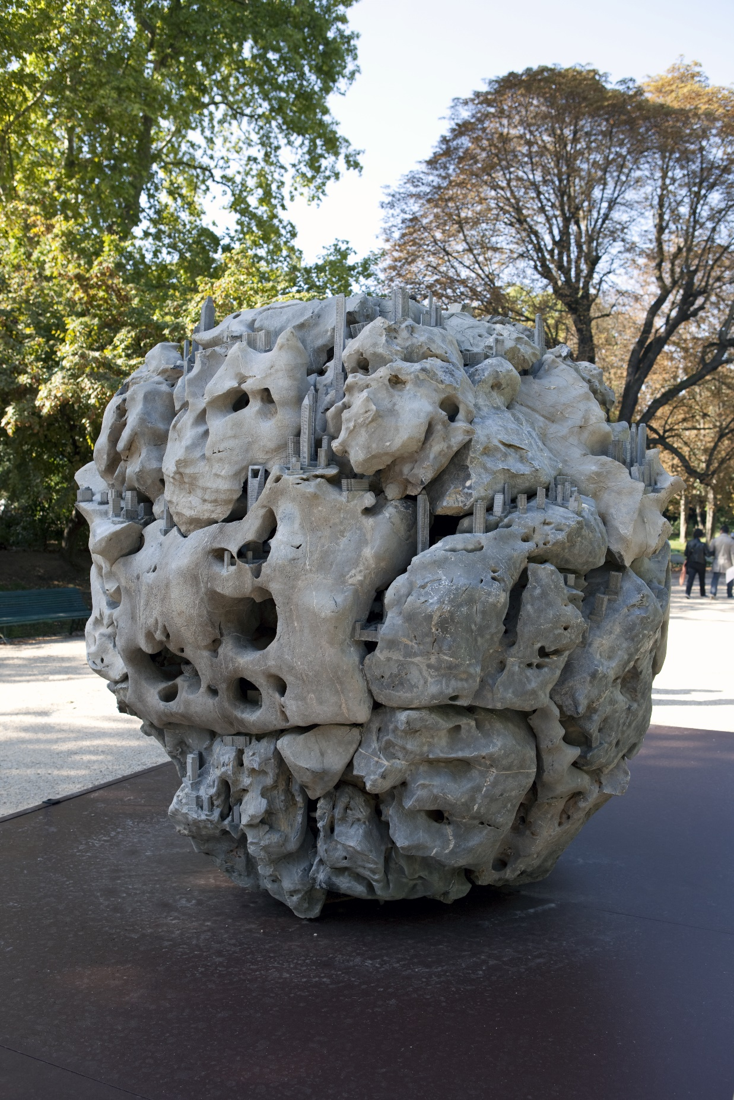
Figure 1: Shen Yuan, 2011, Crâne de la Terre, Stone and cement, 220 × 220 × 220 cm.
Installation view, Parc Monceau, Paris, as part of the group exhibition ‘Artistes Chinois
à Paris’, Musée Cernuschi, Paris, 2011. ©ADAGP Shen Yuan, Paris. Photo: archives
kamel mennour. Courtesy the artist and Fondation Bernard Magrez.
Shen Yuan’s installation with the French title Crâne de la Terre (2011) (The Skull of the Earth) is yet another work that negotiates China’s urban transformation. It is the conversion of a traditional Chinese scholar’s rock or spirit stone (gongshi; guaishi) (see figure 1) into an urban jungle. The scholar’s rock, with its characteristic porous structure of holes unevenly shaped by the forces of nature, traditionally served as pleasing aesthetic objects for the literati class. Shen Yuan’s installation is based on a Taihu rock, a precious artefact from the Taihu Lake near Shanghai. Shen Yuan takes the natural stone as her base, onto which she places numerous small cement skyscrapers in various locations. The most recognizable of these figures is the Shanghai World Financial Centre (Shanghai huanqiu jinrong zhongxin), located in Shanghai’s hypermodern Pudong district and popularly called the ‘bottle opener’ for the fengshui-inspired trapezoid aperture it features at its top (see figure 2, centre). With its 492-metre height, it was the world’s tallest skyscraper in 2007, and in 2009 still figured as the tallest building in Asia (Sohu Financial News 2009). In her installation Shen Yuan references both identifiable and imaginary skyscrapers, and the miniaturization of the monumental urban behemoths is reinforced via the sculpted buildings’ relation to the natural rock. The peculiar adjacency of dimensions as well as of the natural and the synthetic turn the installation into an uncanny urban topography. The rock itself constitutes the largest component of the installation, which is over two metres high, whereas the skyscrapers barely exceed a dozen centimetres and therefore appear particularly minuscule.
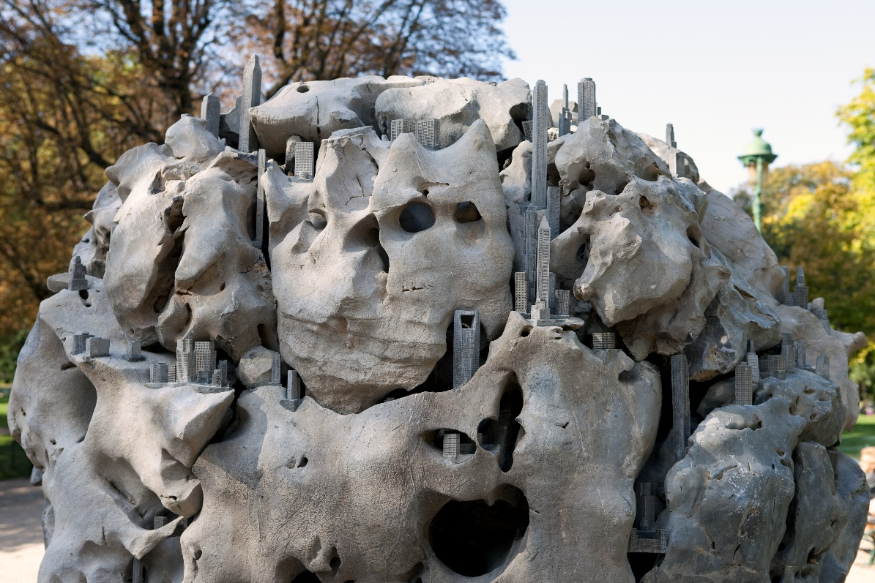
Figure 2: Shen Yuan, 2011, Crâne de la Terre, detail. © ADAGP Shen Yuan. Photo:
archives kamel mennour. Courtesy the artist and Fondation Bernard Magrez.
In this installation, Shen Yuan places the contemporary building within the context of traditional Chinese material culture, and the choice of the scholar’s rock as her base material references its historical importance in Chinese aesthetics. Scholar’s rocks were characteristic elements of traditional Chinese gardens, representing nature and imbued with symbolic importance so that they lent themselves to reverie, contemplation and mental travel. As Wen C. Fong and Alfreda Murck explain,

A ‘good’ rock reminds the viewer of the drama of mountains visited and stimulates the imagination with repeated examination. Described in literature as ‘bones of the earth,’ the rocks in a garden can symbolize the Five Sacred Mountains of China. Set in water, the rocky masses become islands in the Eastern Sea, the home of the Taoist immortals. [...] The meaning of the rocks […] lies in the beholder’s mind. (Fong and Murck 1980: 52)

The highly symbolic and even magical nature of the scholar’s rocks in Chinese aesthetic tradition turned them into collector’s objects, and a sophisticated connoisseurship developed around them. Those who owned extraordinary scholar’s rocks had a high social status, which made the rocks all the more desirable. Stephen Little contends that this culture ‘focused on stones as representations of the universe in miniature, or, more precisely, on the inchoate energies that created the universe’ (Little 1999a: 16).
In her contemporary installation, Shen Yuan thereby juxtaposes two miniatures: that of the universe embodied in the rock and the minuscule effigies of high-rises in contemporary China. However in her work, the magical ontology symbolized by the scholar’s rock is, quite noticeably, thwarted by the skyscrapers that mushroom on top of the rock and which represent an invasive presence. Indeed, the tiny buildings can be compared to an ever-expanding parasitic colony, firmly rooted in their inorganic host. They are seemingly involved in a process of continuous and inexorable reproduction, which echoes the increasing density of skyscrapers in Chinese cities and in Shanghai’s Pudong in particular. This image of relentless reproduction is not unfamiliar to architectural discourse, and has been put forth in discussions of North American urban and architectural homogeneity described as a process of ‘self-referential cloning’, most notably in the form of the skyscraper. Continuing with the image of parasites, one should note that in the natural sciences parasites are usually classified as not killing their hosts (unlike parasitoids); they do, however, debilitate them by extracting necessary nutrients. Skyscrapers are embodiments of the most sophisticated high technology that humans have invented, and simultaneously stand for the bustling ambition of the human to conquer nature and defy the laws of gravity. Shen Yuan places this very productive (though probably equally destructive) impetus of humankind in clear opposition to nature. She thereby achieves to formulate an alternative scopic regime, one that deviates from the Western, descriptive one, whose Cartesian understanding of space is characterised by ‘faith in optical veracity, material solidity, and legible mapping strategies’ (Clarke 2005: 56). She also evokes the works of other artists, including that of photographer Jiang Pengyi (b. 1977), who photomontages skyscrapers into a miniaturized pile of rubbish that he contrasts against a bucolic scene of nature, as well as Zhan Wang’s (b. 1962) manufactured and modernized version of a scholar’s rock made of shiny stainless steel.

The antagonism between nature and civilization in Shen Yuan’s work is also reflected in the work’s materiality. The Taihu rocks are the most precious of all garden rocks. They are taken from the bottom of Lake Tai, where they have been ‘cured’ through encounter with water and sand to attain porous, eroded surfaces. Scholar’s rocks did not always feature absolute and unmitigated natural purity, but were at times manipulated by craftsmen, who, if unsatisfied with the stone would put them back into the water to allow them to transform into a better shape (Wen Fong and Murck 1980: 52). In the case of the scholar’s rock, therefore, time adds value and intensifies the possibilities for meaning to suffuse the indexical porosity of the rock. On the other hand, cement, which Shen Yuan uses for sculpting the tiny skyscrapers, is not precious but merely a finely ground powder which turns into a binder in combination with water. Malleable and versatile, cement only obtains intrinsic value by helping to link other materials. The parameter of time also differentiates the two materials; cement, as opposed to the cured Taihu stone, is a ‘quick’ fix, used, among other things, for the mundane purpose of temporary tooth fillings, and its functionality might be Shen Yuan’s nod to constructivism and its penchant for modern materials. By choosing unpainted, grey cement, which features a colour not dissimilar to the Taihu stone, Shen Yuan further reinforces the notion of parasitism. Had she opted, for instance, for tiny glass high-rises, the stark contrast of material would make them stand out as alien elements, which, concomitantly, could be eliminated with ease. Yet it is precisely the similitude of surfaces of the natural stone and the cement that make both coalesce uncannily into one inseparable, fallacious, and desecrated mass.
Tall skyscrapers tend to create an economic stimulus for further development in their vicinity. This becomes particularly apparent in the case of Shanghai’s Pudong area where the Shanghai World Financial Centre is prominently erected. For a period of time, the Oriental Pearl Tower was the tallest building in Shanghai but was in 2008 surpassed by the World Financial Centre with its 101 floors, which was in turn surpassed by the 128-floor Shanghai Tower – and the story continues. The ubiquity of skyscrapers on Shen Yuan’s Taihu stone is therefore an abstract mimesis of factual urban development in the Chinese metropolis with its inexorable growth in density that gradually replaces landscape with urbanized space. Shen Yuan’s installation represents the transnational skyscraper as ontologically (and aesthetically) disjointed from the Chinese context in which it emerges. This is due to its vertical appearance, which stands in contrast to the traditionally horizontal Chinese vernacular architecture. Moreover, it hints at larger bifurcations in the conceptualizations of nature. In the West, the modern understanding of the relationship of the human to its natural environment is largely based on the Cartesian–Newtonian idea of a mathematically measurable and quantifiable matter. This understanding of matter thereby ‘yields a conceptual and practical domination of nature as well as a specifically modern attitude or ethos of subjectivist potency’ (Coole and Frost 2010: 7–8). This sense of potency and its resulting domination of nature is quite clearly epitomized in the modern architecture that has emerged in the West. The reason why the Chinese planners of areas such as Pudong capitalize so fervently on verticality is precisely derived from the belief that, if China wants to achieve modernity, it has to visually model it on Western notions of the domination of nature, and hence emulate the central business districts of places like New York and Paris (King 2004: 17). Anthony King sees therein a case of how modernity’s signs are transposed and misplaced. He derives his assessment not least from the differing relationships of Western and Chinese architecture to their natural environment. He argues:

Throughout its 5,000 years of urban civilization, the Chinese architectural tradition has been especially characterized by architectural principles that have emphasized harmony with the landscape, ‘building with nature’ and the spiritual ecology of feng shui. In domestic as well as more formal architecture, single-storey building has predominated. (King 2004: 18)

It seems that Shen Yuan’s installation offers a similar critique. Through her imaginative juxtaposition of mundane technological progress with the ethereal, contemplative magic of the scholar’s rock, she recodes the idea of a Western-style architectural modernity, and allegorically transforms the skyscraper of modern betterment into the antithetical doom of parasitical and virulent colonization. The cityscape she creates rather evokes the abject: the high-rise building is unloved but it cannot be disposed of. It is dangerously camouflaged and clings stubbornly and infectiously to its bedrock.

Departing from Shen Yuan’s dystopian topology of virulent colonization, I now turn to look at other works which also envision fantastical urban topologies via a return to traditional artistic practices, albeit incorporating a somewhat more subtle message. Wang Mingxian’s (b. 1954, Beijing) critique of China’s architectural modernity is less harsh than Shen Yuan’s, but it too reveals a defiant impetus to relegate modernity to a less prominent place in our consciousness. Wang Mingxian is an artist who is simultaneously invested in the worlds of architecture and art, given that he is an architectural critic, academic and painter. His research focuses on fine arts, architectural aesthetics, architectural history and contemporary Chinese architecture. His own academic writing is diverse and can be found for instance in volumes on postmodernism and China (Wang 1997), and on the revolutionary past such as in Burden or Legacy: From the Chinese Cultural Revolution to Contemporary Art, edited by Jiang Jiehong (Wang, 2007).
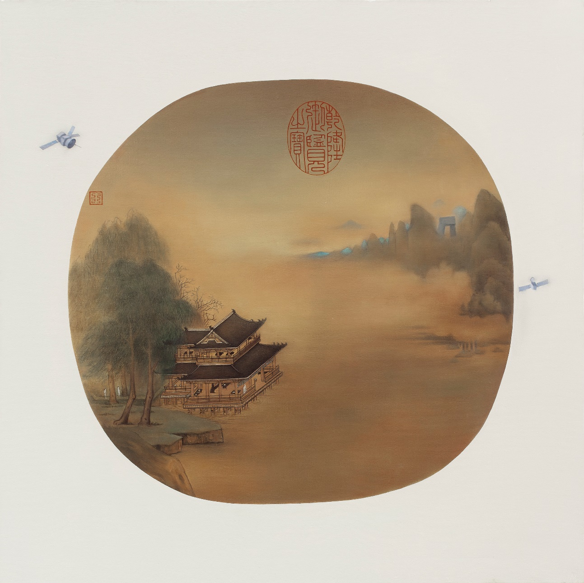
Figure 3: Wang Mingxian, 2012, Spring Musings in the Jade Pavillion + CCTV, oil on canvas, 100 × 100 cm. Courtesy of Wang Mingxian.

In 1989, Wang Mingxian was part of the organizing committee of the seminal China Avant-Garde exhibition, in which Shen Yuan also participated. In 1999, he curated the exhibition Experimental Architecture by Young Chinese Architects, which took place during the Union of International Architects (UIA) Conference in Beijing. In 2005, he was part of the executive committee of the Chinese Pavilion at the 51st Venice Biennale, and in 2006 curated the Chinese Pavilion at the 10th Venice Biennale on Architecture. He is also, quite famously, an expert on the art of the Cultural Revolution, and has a comprehensive collection of Cultural Revolution artefacts. Wang has exhibited his own works in China and internationally, such as in the solo exhibition curated by Gao Minglu, The Missing Memory of Fine Arts History: Wang Mingxian Contemporary Art + Collection Exhibition (2007), at the Wall Art Gallery, Beijing.
His 2012 oil painting entitled Spring Musings in the Jade Pavillion + CCTV (Yulou chunsi tu + CCTV) is an emulation of a premodern fan painting mounted on a white frame (see figure 3). It evokes the architectural paintings (jiehua) of the Southern Song (1127–1279) or the Yuan (1271–1368) Dynasties, both periods of realism in the rendering of architectural detail and periods when fan paintings were particularly widespread. An example of a Yuan Dynasty painter who excelled in architectural renderings was Xia Yong, who was active in the mid-fourteenth century and whose renowned works include The Yellow Pavilion (Huanglou tu) from ca. 1350 (see figure 4).
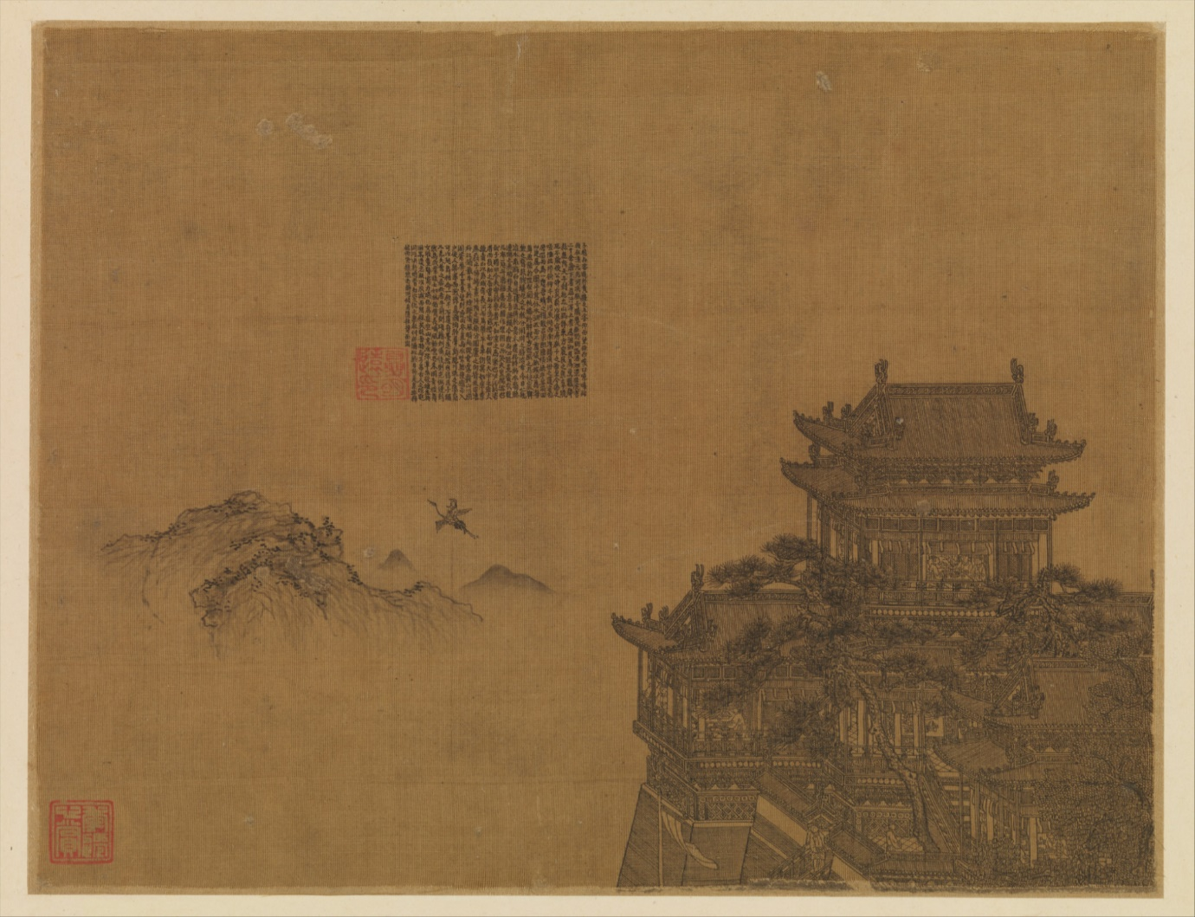
Figure 4: Xia Yong, ca. 1350, The Yellow Pavillion, album leaf; ink on silk, 20.6 × 26.7 cm. Metropolitan Museum of Art
(1991.438.3).
In Spring Musings, Wang Mingxian emulates a traditional fan painting by combining architectural realism with abstract brushwork in order to create a diachronic, symbolic landscape, and he recourses to oil on canvas, an originally Western medium that reached China during the Qing Dynasty. The inner, circular part represents a landscape painting which can be further separated into three planes. The lower left corner features a traditional Chinese building in descriptive realism with meticulously drawn details as well as human figures who, in contrast to the building, are rendered in a blurry wash. Vegetation and landscape are wrapped in soft mist and are generally lacking in detailed brushstrokes. The pictorial composition is divided into two planes and develops diagonally from the lower left to the upper right corner. The two planes are divided from one another by a river or lake that flows swiftly between them and which is enshrouded in mist. Wang Mingxian’s faithful emulation of a traditional architectural painting is, however, wittily counterpointed in the distant horizon, where we can identify Beijing’s contemporary China Central Television (CCTV) tower peeking through a protruding mountain chain. The misty stream of water that separates both planes, therefore, embodies within the painting a diachronic passage through time and space. Moreover, like we saw in Shen Yuan’s Crâne de la Terre, the super-tall, towering and arguably monumental CCTV building that stands in Beijing’s central business district appears miniaturized, particularly given the distance of the tower to the more prominent traditional building in the foreground. Wang Mingxian subversively banishes the imposing building to the most distant corner of the pictorial composition, where it is not only hardly discernible but where it blends into the blue mountain range, akin to the archaistic ‘blue and green’ coloured landscape manner (qinglü) that was particularly popular during the Tang Dynasty (618–907) (Hearn 2008: 74). Schematic and clustered mountain ranges were coloured with azurite to achieve a bright blue, or with malachite and copper carbonate to achieve green (Fong 1992: 104), and they are often associated precisely with impossible topologies as representing the Daoist immortals or as deliberately referencing the past (Ebrey 2014: 215). Wang Mingxian plays with traditional artistic symbolism to negotiate the CCTV tower that has caused much debate among locals as well as the architectural world globally, both for its unusually imposing and towering presence in Beijing’s cityscape and for the political implications inscribed in it as the headquarters of CCTV, the state broadcaster and the government’s mouthpiece.
A red seal features prominently at the top of the fan painting. It reads Qianlong yu lan zhi bao, which was a frequently used collectors’ seal of the Qing Emperor Qianlong (r. 1736–96) that identified a painting as belonging to his collection. Wang appropriates this seal and adds a further seal to the upper left corner containing a fictitious script. Another unusual element which further distinguishes it from original premodern paintings, is the white frame that surrounds the inner circular part, and which emulates modern display techniques. Wang thereby appropriates some of the features of the traditional medium and adds contemporary elements to form a postmodern pastiche that incorporates temporal and spatial fragmentations and incongruities. Catalogue renderings of premodern fan paintings generally show a plain white frame, which can occasionally feature a collector’s seal. Wang Mingxian, however, adds two grey satellites to the screen, which turns the frame into an instantiation of a self-referential meta-narrative on modernity, possibly referencing contemporary Chinese urban propaganda posters where satellites appear as signifiers for progress, modernity and China’s role as leader in scientific advancement (see figure 5).

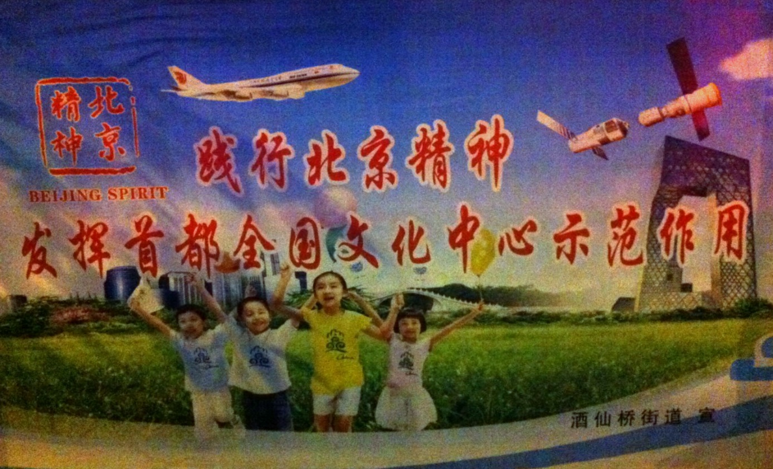
Figure 5: Jianxing Beijing jingshen, fahui shoudu quanguo wenhua zhongxin shifan zuoyong (Practising the Beijing Spirit, demonstrating the exemplary role of the capital as the cultural centre of the nation), urban propaganda poster, published by the Beijing Jiuxianqiao subdistrict.Photo: the author, 2013.

In these posters, satellites are juxtaposed with announcements of property developments, and nurture the illusion that urbanization not only equates modernity and scientific progress but that it is also idyllic and utopian. This narrative stands in contrast to the experiences of the many evicted inner-city residents for whom urbanization is mainly associated with bulldozers confronting their homes, turning them to rubble and debris – the disconcerting contemporary equivalent of the aesthetically rather pleasing ruins of antiquity. Wang Mingxian counters this narrative by prioritizing tradition in his painting’s composition, and by allegorically relegating urban hypermodernity to the corner of history. The painting quietly acknowledges the existence of this modernity but firmly underlines its irrelevance. By focusing on bucolic scenes of nature and idyllic traditional architecture, the painting rather seems to serve as a pictorial hermitage in the city and facilitate mental travel, a traditional Chinese notion of mental reclusion that surfaced in the Ming Dynasty (Clunas 1996: 93). An early text of that time states that
The ancients had a saying that the place where one is mentally alive need not be remote. With a thick grove of trees, the fish and the birds will imperceptibly approach of their own accord. […] Now this studio is sited in the city, but will cause people to think of the hills and woods; is this not beautiful? (Yu Zhenmu, Record of the Deep Purple Studio, cited in Clunas 1996: 93)
Wang Mingxian’s return to an idealized past could represent this mental space where one can feel alive in the city, a modality very similar to the spirit stones, which, independent of the potentially urban surrounding of the beholder, allow for the imaginary escape to nature and the universe via the metonymy of natural rock.

While Shen Yuan and Wang Mingxian have opted for traditional media for their allegorical return to the past, media artist Miao Xiaochun (b. 1964, Wuxi, Jiangsu) has always been invested in linking the traditional masterpieces and artistic techniques of Western and Chinese art history with the latest technological possibilities. He is convinced that ‘If you imitate the works of our predecessors with the same medium, it is very difficult to jump out of the restraints of the original technique or style’ (Jiang and Miao 2007). This has resulted – among others – in 3D animations, digital ink paintings, embroideries and digital woodcuts, alongside photography and painting. Following a degree in German Language and Literature at Nanjing University, Miao graduated from the Central Academy of Fine Arts (CAFA) in Beijing and spent several years in Germany where he studied at the Kassel Academy of Fine Arts exploring western art history. His first animation film, Zuihou shenpan (The Last Judgement in Cyberspace) (2005), was exhibited internationally, including at the Birmingham exhibition View Beyond the Window: Contemporary Art from China in 2007. In the film, Miao transposes Michelangelo’s late Renaissance fresco The Last Judgment (1533–41) into a virtual space, and mischievously substitutes the original fresco’s 400 male and female figures with 3D-modelled clones that feature the artist’s own countenance. Technically, the 3D environment of the computer was used to enable views of static, photographic prints from various angles (Panhans-Buehler 2010: 13). The digitally transformed figures and objects could then be moved 360 degrees and filmed with varying lighting and shading, in order to add to the original artwork a three-dimensionality as well as time and motion.

In Beijing Handscroll (2007–09), a digital ink painting based on 360 degree photography, Miao returns again to explorations of the artistic past, in this case that of China itself, via technology-enabled digital imagery (see figures 6–9). In Beijing Handscroll he pays homage to one of the most famous scrolls of Chinese painting history, the Qingming shanghe tu (‘Going Up the River at the Qingming Festival’), which is ascribed to court artist Zhang Zeduan (1085–1145). This classic masterpiece was painted in ink on silk and is now part of the collection of the National Palace Museum in Beijing. The original scroll depicts a meticulous yet panoramic view of the myriad daily lives of people in what scholars largely agree is Kaifeng, the capital of the Northern Song Dynasty (960–1127). The scroll is only 25 centimetres high but more than five metres long and depicts a variety of scenes of life in the city. It includes rustic landscapes of water, trees and thatched cottages. It allows us to observe travellers, busy peasants transporting produce and people invested in such mundane daily activities as eating and cleaning. Unrolled and viewed from right to left, the scroll’s extraordinary amount of detail provides a fascinating and cinematic insight into daily life in China at this time, and inspired numerous painters in subsequent centuries to make creative reproductions of it.
Figure 6: Miao Xiaochun, 2007–2009, Beijing Handscroll, digital ink painting.

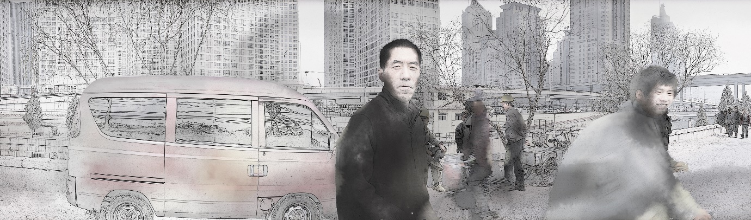
Figure 7: Miao Xiaochun, Beijing Handscroll, detail showing breakfast stall.
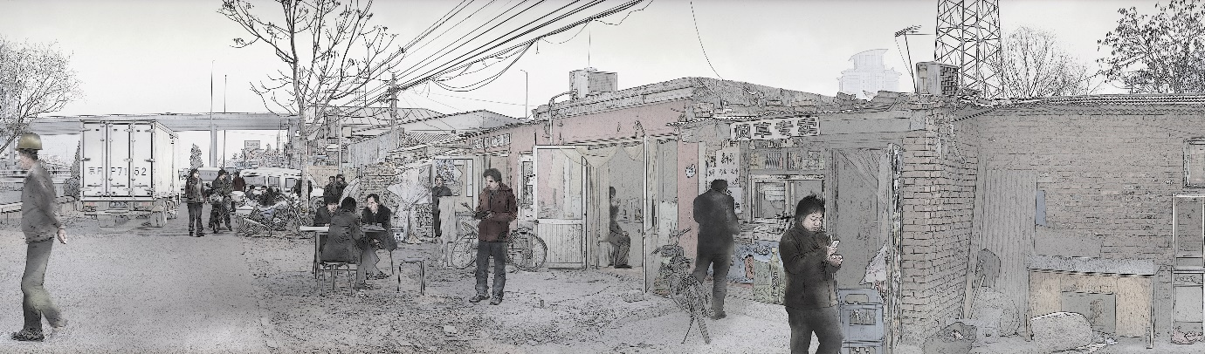
Figure 8: Miao Xiaochun, Beijing Handscroll, detail showing breakfast stall.

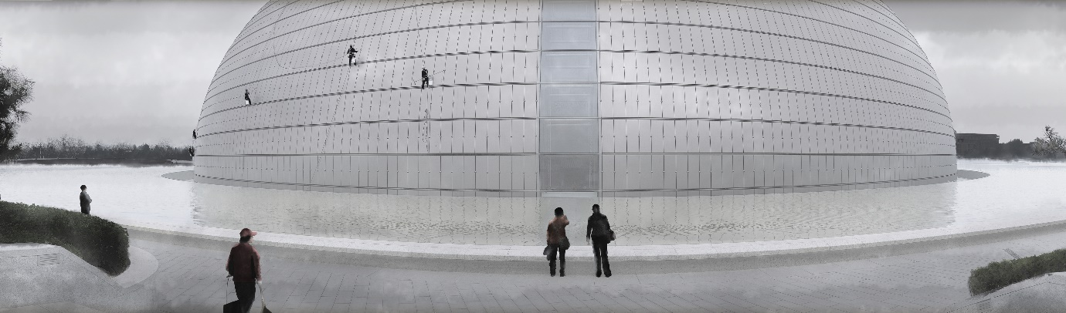
Figure 9: Miao Xiaochun, Beijing Handscroll, detail showing Grand National Theatre.

Miao Xiaochun’s own computer-generated version is based on long 360 degree photographs taken in different corners of Beijing, which were then scanned, manipulated using computer software and desaturated to create the appearance of a traditional painting before being mounted on silk (Art Radar Journal, 2010). Not dissimilar to Zhang Zeduan’s Qingming shanghe tu, this contemporary version of the scroll also depicts scenes of people eating, chatting, selling things and cleaning. But the premodern scenery of Kaifeng in Zhang’s painting is substituted by its contemporary Beijing counterpart: we find hutongs (the traditional Beijing small alleyways lined by courtyard houses) and also high-rise buildings and cutting-edge architecture, such as the egg-shaped Grand National Theatre (see figure 9), yet another towering and monumental example of architectural spectacle in Beijing’s modernized cityscape. The portrayal of people, moreover, draws the viewer into this metonymic pictorial universe. We see many people busily moving from one place to the next, working, serving, transporting, but also many who seem to be standing around idly as if waiting for something. Some of the scenes convey a sense of collective boredom (figure 10) and the absence of purpose or time pressure, yet bulldozers and numerous scenes of rubble evidence the fast-paced spatial reconfiguration of the city. Miao creates a representational space that plays with contingent temporality and which can be explained with what Elizabeth Grosz calls the ‘in-between.’ This is a space which is ‘the locus for social, cultural, and natural transformations […] – the [only] place around identities, between identities – where becoming, openness to futurity, outstrips the conservational impetus to retain cohesion and unity’ (Grosz 2001: 90). Miao Xiaochun thereby places emphasis on perception or the embodied experience in a transforming capital. Many of the depicted people look directly towards the camera and incite speculation about their stories and their role in the city at this particular moment in time. Miao only provides a glimpse into these myriad individual stories, but despite showing just fragmentary scenes he ends up telling the larger story of the radically transforming capital of a country that has embarked on the global capitalist journey. When comparing Miao’s scroll with the Qingming scroll, it seems that the only constant is the people and their daily needs, activities and desires. What has changed is the physical context in which these activities occur. And Miao’s scroll captures still further change in process. Surrounded by the ubiquitous rubble and bulldozers, one cannot help but wonder, however, how these changes might alter people’s established sense of identity.
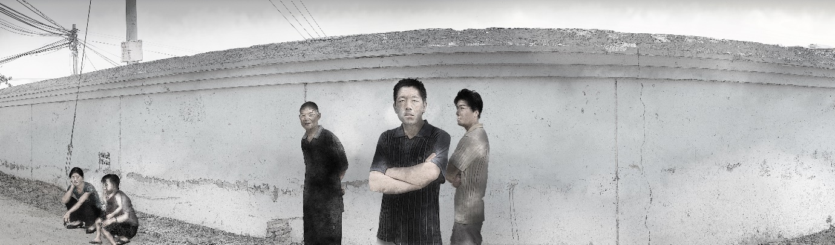
Figure 10: Miao Xiaochun, Beijing Handscroll, detail showing parents waiting in front of primary school.

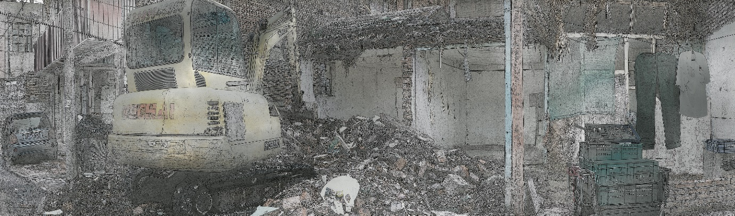
Figure 11: Miao Xiaochun, Beijing Handscroll, detail showing urban demolition.

Different parts of Miao’s scroll seem to tell different stories and further enhance the sense of unlikely juxtapositions of old and new, of hutongs alongside spectacular new monumentality just as they indeed occur in the city of Beijing. The result is a postmodern pastiche in which the represented urban space seems disconnected and disjointed, like the factual Beijing topology with its notoriously unusual clashes of architectural styles. The distortion resulting from the 360 degree perspective enhances this sense of fragmentation as it hampers rather than facilitate a comprehensive view of the city. This is particularly apparent in a segment that depicts the Grand National Theatre, which is located along the very busy Chang’an Avenue – the grand boulevard in the heart of Beijing’s centre of power near Tiananmen Square. In Miao’s scroll, however, the distorted 360 degree representation suggests that the imposing building is nothing but a small, round curiosity at the corner of two very quiet alleyways that have people going for a stroll and cycling with seeming tranquillity (see figure 9).

The twofold way in which this work was exhibited is also interesting. In one form, Miao printed the images onto rice paper and mounted them one after another in traditional fashion on a long piece of silk with rice-starch glue to create a scroll. This scroll rolled up could then, just like the traditional scroll, be unrolled and re-rolled one section at a time to reveal ever new parts of the contemporary cityscape. The other form of exhibition consisted of a series of eight digital screens placed alongside each other so as to recreate the composition of the original 360 degree panorama photographs (Carter, n.d.: n.pag.). In either exhibition modality, Miao’s many panorama photographs align to form an entirely new cityscape that purposely defies realism in spite of its photographic origin. It forms a fantastical topology of Beijing’s everyday life today, but it might still serve as an imaginary socio-spatial archive of the city when looked at in the future. Miao’s choice to draw on new media for his revisitation of the Qingming scroll is thereby telling. As Elana Gomel points out in her discussion of impossible topologies in literature, our lives today are already based on an experience of space that is alienated from the ‘operational space’ of our bodies, but which is informed ‘by the simultaneity, semantic propinquity, and instant accessibility of cyberspace’ (Gomel 2014: 5). She names as examples web-based sites of connectivity, such as Facebook in the realm of interpersonal connections or Google Earth, which helps us transcend distances in the blink of an eye by instantly placing images of remote places before us (Gomel 2014: 5). She argues, moreover, that ‘with the shift from realism to modernism and eventually postmodernism, impossible spaces have become central to spatial representation’ (Gomel 2014: 6). Miao Xiaochun carves out these impossible spaces in many of his other works too, including in Beijing Index, a photographic project involving thousands of photos taken on the intersections of meridians and parallels in Beijing between 2007 and 2008, which form an unlikely image of Beijing composed of 360 degree photos showing an unknown but fascinating side of the city that does not feature on propaganda posters or in travel brochures.

The works discussed in this article all confront us with impossible spaces by way of a return to tradition as an allegorical negotiation of globalization and its impact on the Chinese landscape. Deliberately exploring the tensions between realism and postmodernism, these works negotiate the contentious nature of factual space by way of impossible and fantastical topologies, accompanied, moreover, by the suspension of conventional notions of time. These Chinese artists’ returns to tradition are thereby not extraordinary per se. Global art has always manifested a propensity to revisit the past, and this even includes media artists working with the latest technologies, who increasingly opt for a return to materiality and object-based exhibitions. Some of these revisitations of the past in global art are also responses to globalization and its often ambiguous impact on societies. Throughout the centuries, China has moreover seen the referencing and copying of old masters, accompanied by vivid discourses, as the history of the Qingming scroll demonstrates rather clearly. Moreover, these artistic endeavours have to be seen in the context of related returns to tradition, memory, history or nativity in the wider Chinese cultural and intellectual discourse. Since the mid-1980s, a number of similar trends emerged, even if manifesting different political concerns or ideological proclivities. The roots movement in literature (xungen wenxue), for instance, investigated Chinese native and minority culture to come to terms with radically different realities of the post-revolutionary 1980s. Nostalgia for the socialist past, too, including for Maoist or Red Guard legacies form part of this trend (see Williams forthcoming 2020), just like the recent revival of the cultural nationalist ‘national learning’ movement (guoxue) that focuses on the study of traditional Chinese philosophy, literature and history. These tendencies can all be seen as attempts to mend the ‘fragile vestiges of continuity, community and self-identity’ in a radically transforming China (Wang 2004: 6). While the artistic engagements with tradition in the context of urban transformation explored in this article surely differ from these examples in myriad ways that cannot be examined in detail here, the commonality of the return to tradition nevertheless underlines that in Chinese intellectual history the past has always served as a form of anchor to counter the teleological narratives pertaining to an often ideologically manipulated present.

The subject matter of urban transformation, I argue, provides a particularly illuminating lens. The West, too, experienced a transition from an agrarian system to industrialization and urbanization that is frequently evoked by Chinese authorities to rationalize and justify Chinese developmental problems, including the pollution of the environment. Yet the Chinese case is special in its extraordinary pace and scale. The built environment in China is more than just a physical marker of economic development, it is also a matrix of meaning inscribed by the hegemonic processes of globalization and modernization, and in part also by the traumatic memories of imperialism, colonialism, revolution and hardship. Within these dynamics, the return to artistic tradition, both in terms of the materiality of the medium as well as its narrative tropes, can be seen as a vehicle to come to terms with the complex meanings associated with China as a globalized nation-state. It is the attempt to creatively redress the spatial and social ruptures experienced in this process, and to envision much desired and increasingly elusive notions of continuity. The ways in which this almost subversive yearning for continuity plays out in these works, I argue, is via a celebration of the permanence of nature and the universe and via the legacy of (artistic) tradition itself. Both in Shen Yuan’s installation and Wang Mingxian’s painting, a return to tradition serves as a perspective onto the world that transcends the mundane. In Shen Yuan’s case, the spirit stone symbolizes not only purity, in contrast to the clogging encroachment of civilization in the form of skyscrapers, but also an ‘ontological continuum, flowing with and energized by qi (breath, vital energy, or spirit) in which stones reflect li (the organic order) of the world.’ This continuum and the vastness of the universe that is embodied in the miniature of the stone thereby hints at a power of nature that ultimately far outweighs the minuscule and ephemeral ambitions of mankind. Wang Mingxian, too, deploys misty water as symbolical pictorial space to simultaneously depict past and present in the same picture plane, whereas the satellites that orbit in his frame allegorically extend the notion of ‘place’ to include the ‘space’ of the cosmos. He thereby achieves the relegation of the CCTV tower to a negligible, seemingly mundane detail of history. The choice of medium is significant too. By opting for the traditionally western medium of oil on canvas, Wang blurs the boundaries of traditionally ‘Chinese’ and western art in his diachronic topology that negates discrete conceptions of time. The notion of a temporal continuum and the vastness of space as opposed to the operational space of our time is similarly evoked in Miao Xiaochun’s large panorama photographs whose distorted perspective engendered by 360 degree photography lends representational space a chimerical quality. Rather than allowing for a genuine photorealistic familiarity or representation of reality in 360-degree perspective, the viewer instead experiences segmented and distorted glimpses of Beijing that are indeed much more akin to abstraction. Moreover, the illusion arguably lies in the medium itself and its concocted ontology. While desaturating the photos and mounting them on traditional materials can achieve the deceptive appearance of a traditional handscroll, in truth – as Miao himself purposefully and emphatically states – ‘everything was created on the computer.’ (Carter, n.d.: n.pag.). It is precisely the synthetic materiality of Miao’s, Shen’s and Wang’s works, I argue, that allows for a return to the past that is neither restorative in its ambition nor outright opposed to modernity (Boym 2001). Rather, they are playful artistic responses to the discontinuity engendered by China’s radical transformation and the hybridity of the media suggests that an ideal future will have to be located at the crossroads between modernization and historical consciousness.

Conclusion

This article has looked at three works of Chinese contemporary art which negotiate China’s urban transformation by way of returning to or evoking premodern artistic practices, tropes or narratives. It has examined the fantastical topologies of modernity represented in these works by carving out the meaning of the presented spatial imaginaries as well as the artists’ choice of medium. I have argued that China’s urban transformation is much more than a physical signifier of economic development and progress, and that artists perceive urban space and the built environment as inscribed with historical memory as well as with the human and environmental cost of development. I have shown that both the analogue and new media artworks under discussion aim to restore a sense of continuity as a counterpoint to the disjunctive nature of a relentlessly transforming China. This article thereby situates contemporary Chinese artworks within the realm of Chinese intellectual history, both in terms of Chinese art historiography and its preoccupation with artistic tradition and emulations of old masters, but also in terms of more recent (nostalgic and other) revivals of the past for the sake of envisioning a better Chinese future. It moreover demonstrates that these artworks embody not only a desired connection of past and present but that they also connote connectivity of Chinese contemporary art with global art and global art historiography through specifically Chinese artistic responses to globalization by focussing on the extraordinary effects of urban transformation in China.
Bibliography

Art Radar Journal (2010), ‘Miao Xiaochun pushes limits of digital art – an Art Radar interview’, 1 December. Available at: http://artradarjournal.com/2010/12/01/miao-xiaochun-pushes-limits-of-digital-art-an-art-radar-interview (Accessed: 18 March 2019).
Boym, Svetlana (2001), The Future of Nostalgia. New York: Basic Books.
Braester, Yomi (2010), Painting the City Red: Chinese Cinema and the Urban Contract, Durham NC: Duke University Press.
Carter, Carol (n.d.), Miao Xiaochun. Available at: http://www.chinaphotoeducation.com/Carol_China/Miao_Xiaochun.html (Accessed: 18 March 2019).
Clarke, Holly A. Getch (2005), 'Land-scopic Regimes: Exploring Perspectival Representation Beyond the "Pictorial" Project', Landscape Journal, 24:1, pp. 50-68.
Clunas, Craig (1996), Fruitful Sites: Garden Culture in Ming Dynasty China, London: Reaktion Books.
Coole, Diana and Frost, Samantha (2010), ‘Introducing the New Materialisms’, in D. Coole and S. Frost (eds), New Materialisms: Ontology, Agency, and Politics, Durham NC: Duke University Press, pp. 1–46.
Dirlik, Arif (2007), ‘The Historiography of Colonial Modernity: Chinese History between Eurocentric Hegemony and Nationalism’, Journal of Modern Chinese History, 1:1, pp. 97–115.
Ebrey, Patricia Buckley (2014), Emperor Huizong, Cambridge MA: Harvard University Press.
Fong, Wen C. (1992), Beyond Representation: Chinese Painting and Calligraphy 8th-14th Century, New Haven: Yale University Press and Metropolitan Museum of Art.
Fong, Wen C. and Murck, Alfreda (1980), A Chinese Garden Court: The Astor Court at the Metropolitan Museum of Art, New York: Metropolitan Museum of Art.
Gao, Minglu (2005), The Wall: Reshaping Contemporary Chinese Art, Buffalo NY: Albright Knox Art Gallery.
Gladston, Paul (2014), Contemporary Chinese Art: A Critical History, London: Reaktion Books.
Gomel, Elana (2014), Narrative Space and Time: Representing Impossible Topologies in Literature, London; New York: Routledge.
Hearn, Maxwell K. (2008), How to Read Chinese Paintings, New York: Metropolitan Museum of Art.
Hillenbrand, Margaret (2017), ‘Remaking Tank Man, in China’, Journal of Visual Culture, 16:2, pp. 127–66.
Jiang, Jiehong and Miao, Xiaochun (2007), ‘H2O: A Dialogue between Jiang Jiehong and Miao Xiaochun (September 10, 2007, Beijing)’, Eli Klein Gallery. Available at: http://www.galleryek.com/attachment/en/559aad566aa72c9c3d07911a/Press/5734ce9e7cc13894395dfe9a (Accessed: 2 March 2019).
Jiang, Jiehong (2015), An Era Without Memories: Chinese Contemporary Photography on Urban Transformation, New York: Thames and Hudson.
King, Anthony (2004), Spaces of Global Cultures: Architecture, Urbanism, Identity, London, New York: Routledge.
Little, Stephen (1999a), [Guaishi] 怪石 Spirit Stones of China: The Ian and Susan Wilson Collection of Chinese Stones, Paintings, and Related Scholars’ Objects, Berkeley: University of California Press in association with The Art Institute of Chicago.
——— (1999b), ‘Spirit Stones of China’, in [Guaishi] 怪石 Spirit Stones of China: The Ian and Susan Wilson Collection of Chinese Stones, Paintings, and Related Scholars’ Objects, Berkeley: University of California Press in association with The Art Institute of Chicago, pp. 15–28.
Morris, Meaghan (1992), ‘Great Moments in Social Climbing: King Kong and the Human Fly’, in Colomina, B. (ed.), Sexuality and Space, Princeton: Princeton Architectural Press, pp. 1–52.
Pan, Lu (2012), ‘Visualizing Amnesia: Memory and Space in the Photography of Shanghai’s “New Village”’, Media Fields Journal, 5, pp. 1–14.
Panhans-Buehler, Ursula (2010), ‘Double Interface: Miao Xiaochun’s RESTART’, in Miao Xiaochun: Macromania, Hong Kong: Timezone 8, pp. 13–43.
Sohu Financial News (2009), ‘Shanghai huanqiu jinrong zhongxin zudiao le daban ('Majority of Shanghai World Financial Centre’s space rented out')’, 18 December. Available at: http://business.sohu.com/20091218/n269037313.shtml (Accessed: 23 November 2016).
Visser, Robin (2010), Cities Surround the Countryside: Urban Aesthetics in Post-Socialist China, Durham NC: Duke University Press.
Wang, Ban (2004), Illuminations from the Past: Trauma, Memory, and History in Modern China, Stanford: Stanford University Press.
Wang, Meiqin (2015), Urbanization and Contemporary Chinese Art, New York: Routledge.
Wang, Mingxian (2007), ‘From Red Guard Art to Contemporary Art’, in Jiang, J. (ed.), Burden or Legacy: From the Chinese Cultural Revolution to Contemporary Art, Hong Kong: Hong Kong University Press, pp. 34–47.
——— (1997), ‘Notes on Architecture and Postmodernism in China’, Boundary 2 (Postmodernism and China) (trans. Zhang Xudong), 24:3, pp. 163–75.
Williams, Emily (forthcoming 2020), 'Who will serve the people? Red Collecting & China´s Moral Crisis', in Z. Wang and D. Pavlićević (eds), China into the New Era, London: Routledge.
Wu, Hung (2004a), Between Past and Future: New Photography and Video from China, Chicago: David and Alfred Smart Museum of Art.
Wu, Hung (2004b), Transience: Chinese Experimental Art at the End of the Twentieth Century, Chicago: University of Chicago Press.
Wu, Hung (2012), A Story of Ruins: Presence and Absence in Chinese Art and Visual Culture, London: Reaktion Books.
Zhang, Li, LeGates, Richard and Zhao, Min (2016), Understanding China’s Urbanization: The Great Demographic, Spatial, Economic, and Social Transformation, Cheltenham: Edward Elgar.

Glossary

Beijing shoujuan 北京手卷 Beijing Handscroll
chuguo re 出国热 craze for going abroad
Fujian 福建省
Gao Minglu 高名潞
gongshi 供石 spirit stone
guaishi 怪石 spirit stone
guoxue 国学 ‘national learning’ movement
Huanglou tu 黃樓圖 The Yellow Pavilion
Huang Yongping 黄永砯
jicu de huayu 急促的话语 Hurried Words
jiehua 界画 architectural paintings
Kaifeng 開封
li 理 the organic order
Miao Xiaochun 缪晓春
qi 氣 breath, vital energy, or spirit
Qianlong yu lan zhi bao 乾隆御览之宝 collectors’ seal of the Qing Qianlong 乾隆 (r. 1736-96)
Qinglü 青綠 ‘blue and green’ coloured landscape manner
Qingming shanghe tu 清明上河圖 Going Up the River at the Qingming Festival
Shanghai huanqiu jinrong zhongxin 上海环球金融中心 Shanghai World Financial Centre
Shen Yuan 沈遠
Taihu Lake 太湖
Wang Mingxian 王明贤
Wang Tong 王彤
Xia Yong 夏永
Xianyou County 仙游县
xungen wenxue 寻根文学 roots movement in literature
Yige shijie de zaochen 一个世界的早晨 One World’s Morning
Yulou chunsi tu 玉楼春思图 + CCTV Spring Musings in the Jade Pavillion + CCTV
Zhang Zeduan 張擇端
Zhao Shuo 赵朔
Zhejiang Meishu Xueyuan 浙江美术学院 Zhejiang Academy of Fine Arts
Zhongguo yishu yanjiuyuan jianzhu yishu yanjiusuo 中国艺术研究院建筑艺术研究所Chinese National Academy of Arts, School of Architecture
Zuihou shenpan 最后审判 The Last Judgement in Cyberspace

See for details: Galerie Kamel Mennour, artist page Shen Yuan, http://www.kamelmennour.com/artists/18/shen-yuan.html (Last accessed January 15, 2016).
Meaghan Morris, making reference to Robert Somol's analysis of the North American city of Chicago. Morris, ‘Great Moments in Social Climbing: King Kong and the Human Fly’, in Colomina, B. (ed.), Sexuality and Space (Princeton: Princeton Architectural Press, 1992), 11.
Other media he investigated in that respect include drawing and copperplate. According to Miao, he purposely pushes new media back into traditional media. (Miao Xiaochun, unpublished Statement on Restart (16 March, 2010), courtesy of Miao Xiaochun.)
The most prominent example is probably the air pollution in London (‘the big smoke’), which apologists cite as a predecessor to denote the inevitability of the Chinese case.
Outlined in John Hay’s catalogue of the exhibition Kernels of Energy, Bones of Earth (1985) as mentioned in (Little 1999b: 16).

