Khosravi, F.; Fischer, T. B. and Jha-Thakur, U. 2020. Multi-criteria analysis for rapid strategic environmental assessment in tourism planning, Journal of Environmental Assessment Policy and Management, https://doi.org/10.1142/S1464333219500133.

Multi-criteria analysis for rapid strategic environmental assessment in tourism planning

Abstract
Multi-Criteria Analysis (MCA) is a group of analytical approaches allowing to compare criteria or alternatives when making complex decisions. It can be applied in Strategic Environmental Assessment (SEA) for supporting the integration of environmental, social and economic aspects into the development of strategies, policies, plan and programme making. This paper reports on an application of analytical hierarchy process (AHP) as one of MCA approaches to assess Gilan Tourism Development Plan, in Iran. Here, the Global Sustainable Tourism criteria were weighted by AHP on the basis of experts' opinions. The extent to which development options for Gilan Tourism Development Plan were likely to be sustainable was assessed, using a list of weighted criteria. The evaluation of the findings suggests that the plan has not met all the sub-criteria of sustainable tourism.

Keywords: Multi-criteria analysis, Strategic environmental assessment (SEA), Sustainable tourism criteria, Iran

- Introduction
Strategic environmental assessment (SEA) was initially proposed to address the inability of EIA to consider environmental integration at strategic levels (Fischer 1999; Victor & Agamuthu 2014). The main aim of SEA was suggested to be associated with checking whether a proposed policy, plan or programme (PPP) is environmentally sustainable (McCluskey & Joao 2011). Importantly, SEA provides decision-makers with an evaluation of alternatives to avoid, mitigate, or compensate negative impacts (Fischer 2002; Liou et al., 2006; João 2007; Zhu & Ru 2008; Wang et al., 2009).

1.1. SEA and tourism planning
The tourism industry is an important economic sector internationally (Maswera et al., 2009; Kabassi 2010), with a contribution of 10.4% of the global gross domestic product (GDP) in 2017 (World Travel and Tourism Council 2018). Many developing countries are encouraging tourism for development (Lemos et al., 2012). This is often supported by investment programs from bilateral agencies as a poverty reduction strategy and generation of unskilled jobs (Retief et al., 2008; Lemos et al., 2012). Related SEA practice in developing countries is progressively growing and is now considered to be critically important, as tourism like economic activities such as agriculture and mining can often lead to severe environmental degradation (Retief et al., 2008; Michalena et al., 2008). Environmental Assessment (EA) can help to avoid or mitigate negative impacts and enhance positive outcomes at all levels of tourism planning from policies, plans, programmes (referred to as SEA) to projects (referred to as Environmental Impact Assessment-EIA) (Fischer 2003). SEA is used in numerous sectors and has been applied in tourism planning since the 1990s (D’leteren 2008; Lemos et al., 2012). However, compared with many other sectors, here its practice is still limited (Lemos et al., 2012).
In order to become more environmentally sustainable, a cooperative approach between decision makers and stakeholders is imperative. Participatory governance is an established concept of sustainable tourism (Landrof, 2009). Sustainable tourism management practice requires that stakeholders work together (Tubb 2003; Hawkins 2004; Cottrell & Vaske 2006; Ballantyne et al., 2009; García-Melón et al., 2012) and consider local communities’ values in tourism planning process (Mak et al., 2017). Iran, India, Bangladesh, Sri Lanka, Thailand, Indonesia, Malaysia, Pakistan, Egypt, Abu Dhabi and Bahrain are all examples of developing countries that lack stakeholder and public participation in their EA systems (Momtaz 2002; Nadeem & Hameed 2008; Paliwal 2006; Badr 2009; Heaton & Burns 2014; Naser 2012; Khosravi et al., 2019a).
MCA is increasingly applied to enhance stakeholder participation in environmental planning (e.g., Hajkowicz & Collins 2007; Munda 2008; Marttunen & Hämäläinen 2008; Marttunen et al., 2013; Karjalainen et al., 2013). Therefore, in this paper we suggest that MCA in SEA can facilitate stakeholder’s participation, in particular in SEA systems that lack stakeholder participation. Furthermore, we suggest that SEA is potentially able to make tourism planning more environmentally sustainable.

  - Multi-criteria analysis (MCA)
MCA is an analytical method that can be used to support the integration of environmental, social and economic aspects into development strategies, policies, plans and programmes (Garfi et al., 2011). It scores and ranks the performance of options against multiple social, environmental and economic criteria (Garfi et al., 2011; Hajkowicz 2007) and can be used at all levels of decision-making, potentially supporting a transition towards sustainability (IAIA 2010).
MCA consists of a group of analytical approaches that can be used to compare criteria or options; including Multi Attribute Utility Theory (MAUT), Analytical Hierarchy Process (AHP), Elimination and Choice Expressing Reality (ELECTRE) and Preference Ranking Organization Method for Enrichment of Evaluations (PROMETHEE) (Cinelli et al., 2014). AHP is one of the more widely applied MCA approaches (Huang et al., 2011) for developing solutions to decision-making problems (Huang & Bian 2009) and facilitating stakeholder participation whilst evaluating planning options, which is critical in situations with multi-stakeholder involvement (Herath 2004; Hajkowicz 2008).
AHP was originally introduced by Saaty (1980) with the aim of evaluating numbers of criteria by means of absolute scale (also see Saaty 2005; Cinelli et al., 2014). It is a mathematical approach which determines relative weights of criteria based on experts' opinions (Garfì et al., 2011; Ghamgosar et al., 2011; Thirumalaivasan et al., 2003) that are collected, using questionnaires to determine the relative importance of each criterion over others in pair-wise comparison matrices (Akincilar and Dagdeviren, 2014). Relative scores are aggregated, using the geometric mean method (Wu et al., 2007). All weights are compared by considering the expert’s preference on a scale from 1 to 9, with 1 indicating equal preference and 9 absolute preference (Saaty 1980, 2005; Cinelli et al., 2014) (Table 1). Subsequent analysis may be performed using Expert Choice software (Malczewski 2006; Yang & Shi 2002). The pair-wise comparison approach is done in two steps; firstly, between main categories of criteria and secondly each criterion is compared with all other criteria (Akincilar and Dagdeviren, 2014).

Table 1. Scale of relative importance (According to Saaty 1980)
Intensity of importance | Definition
1 | Equal importance
2 | Weak
3 | Moderate importance
4 | Moderate plus
5 | Strong importance
6 | Strong plus
7 | Very strong
8 | Very, very strong
9 | Extreme importance

1.3. MCA in SEA
SEA provides a framework within which a range of different methods can be applied (Fischer 2007). MCA approaches can support the EIA process in its different stages, including stakeholder participation and assessment of alternatives (Neste & Karjalainen 2013; Huang et al., 2011). The literature shows that MCA cannot only be used in EIA, but has also been applied within SEA in the energy, waste management and urban infrastructure sectors to assess environmental impacts (Fischer et al., 2011; Garfi et al., 2011; Bobylev 2006; Fischer 2003; Jay 2010; Sharifzadegan et al., 2011; Salhofer et al., 2007). Garfi et al (2011) report on the use of MCA to assess two water programme alternatives. Josimovic et al (2015) also applied MCA within SEA for the Belgrade Waste Management Plan (2011-2020).
To date, the use of MCA in SEA within the tourism sector has not been evaluated. The aim of this paper is to contribute to filling this gap by reporting on the application of MCA in facilitating rapid SEA of Gilan Tourism Development Plan. The remainder of this paper is divided into five sections. First, the context for EA in Iran is set. This is followed by a description of the methodology that has been adopted for the research. In the third section results are evaluated and in the fourth section, the wider international implications of the results are discussed. Finally, conclusions are drawn.

- Setting the Context
2.1 EA in Iran
In some countries, EIA legislation forms part of a general – rather than a specific – environmental law (Sadler 1996; Wood 2003). However, in Iran, the legal basis for EIA is an article in the National Development Plan (NDP) (Khosravi et al., 2019b). NDPs are programmes, provided by the government and presented to parliament every five years (Zaboli et al., 2016; Khosravi & Jha-Thakur 2018). EIA in Iran was first introduced in 1994 by the 2nd NDP (Khosravi et al., 2018; Khosravi et al., 2019a). Iran’s EIA system does suffer from weaknesses such as insufficient legal basis, inadequate scoping, lack of public participation, alternative consideration, EIA implementation and follow-up (Khosravi et al., 2019a). Moreover, SEA practice is rather limited (Khosravi & Jha-Thakur 2018) and only one SEA at policy level has been conducted (in 2004). This was initiated as a result of the Iranian government’s request to the World Bank for assistance in reforming Iran’s energy policy to enhance economic and environmental sustainability.

The main reasons for not applying SEA in Iran has been suggested to include a lack of capacity and understanding (Khosravi et al., 2019a). Moreover, The Iranian decision-making culture currently hinders the development of public participation in the EIA process (Khosravi et al., 2018). Hence, planning and EIA systems lack transparency (Moradi 2009; Khosravi & Jha-Thakur 2018; Khosravi et al., 2019b). However, an introduction of participatory approaches to SEA could enhance transparency in the Iranian decision- making process. Finally, EIA is conducted at the latter stages of planning in Iran, which does not enable changes to be incorporated within a plan (Khosravi et al., 2018). Applying SEA as an ex-ante tool could help achieving a more proactive assessment approach in Iran.
2.2 Case study
Gilan is one of the most important tourist attractions in Iran (Khosravi and Jha-Thakur 2018). This province is in the northern part of the country between the Caspian Sea and Alborz Mountains. The province’s natural resources (forests, mountains, sea) are perceived as being very attractive and this has made it one of the main destinations for domestic tourism, attracting many tourists in different seasons (Azimi et al., 2013; Khosravi & Jha-Thakur, 2018). Whilst tourism is creating income and employment for local people, the irreversible destruction of natural coastal habitats has been observed in the region (Hossein nia et al., 2012). Attracting millions of people through tourism is threatening Hyrcanian forests, leading to a loss of biodiversity and habitats. Between 1955 and 2000, Caspian Hyrcanian forests shrank from 3.4 million ha to 1.85 million ha (UNDP 2013). Gilan is one of the provinces of Iran which makes the majority of Caspian Hyrcanian Mixed Forest Ecoregion and has been labelled a Global 200 Ecoregion by WWF. The region is also listed as an Important Bird Area (IBA) and it is a resting area for migrating birds (UNDP 2013).
The Gilan Tourism Development Plan is a long-term plan for the period of 2002 to 2027 (SAP 2009) which has not been subject to SEA during plan making. Therefore, in this paper we will provide a rapid assessment of the plan against sustainability objectives based on the Global Sustainable Tourism Criteria (GSTC). Here, we will show how the MCA approach could be applied to the SEA of tourism plans, enabling to make comparisons amongst the options available for sustainable tourism criteria.

3. Research methodology
The MCA approach is being proposed to be used in SEA for the Gilan Tourism Development Plan. This approach has been used through documentary review of the plan and subsequently, the main steps of the methodology are described. The associated procedure is shown in Figure 1.
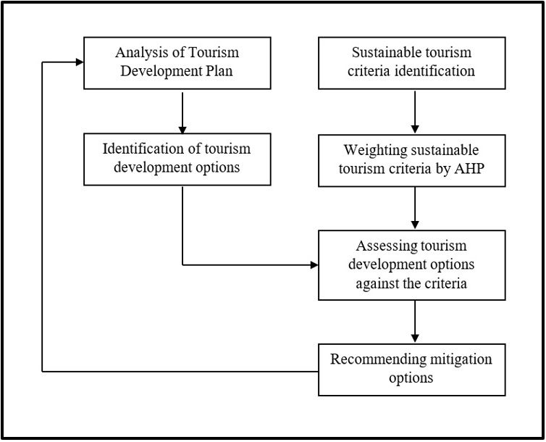

Figure 1. Methodological framework for MCA in SEA

3.1 Framework of analysis
The process starts with the identification of evaluation criteria (Cinelli et al., 2014). In this context, the authors reviewed the literature to identify suitable tourism criteria that can be applied. The World Tourism Organisation’s Global Sustainable Tourism Council (GSTC) were selected as they are applicable to the entire tourism industry (GSTC-Industry 2015). The GSTC is an initiative addressing the promotion of sustainability issues within the tourism industry in the world (Huang 2011). The main aim of the GSTC is to define criteria to protect scarce natural and cultural resources, but to also support tourism development at the same time. As is shown in Figure 2 there are four main groups of criteria, including 1) Effective sustainable management, 2) Social and economic benefits to the local community, 3) Cultural heritage, and 4) Environment (UNF 2011).
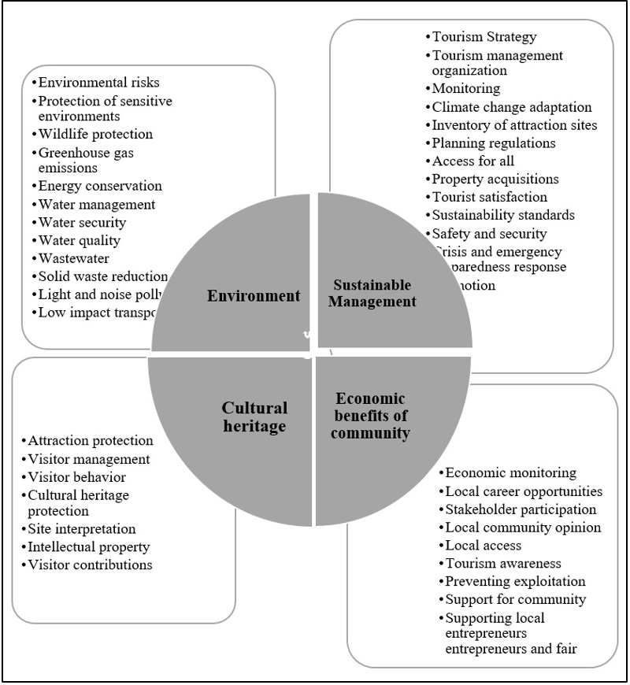

Figure 2.
Source: Adapted from Global Sustainable Tourism Council (GSTC) criteria

3.2. Method
At this stage the sustainable tourism criteria were weighted, then the Tourism Development Plan was reviewed and scored against the criteria framework. This was followed by pairwise comparisons to weigh criteria (scoring) (Belton and Stewart 2002; Cinelli et al., 2014). In doing so, the criteria and sub-criteria of sustainable tourism were weighted by using AHP, based on questionnaire and experts’ opinions. The opinions of twenty experts were established, using questionnaires to determine the relative importance of each criterion in comparison with others in pair-wise comparison matrices.

These experts were selected by snowball sampling from tourism planners, working in tourism consultancies, and the Cultural Heritage and Tourism Organization of Iran. Each questionnaire consisted of five pair-wise comparison matrices.
The pair-wise comparison approach was used in two steps; firstly, between four main categories of sustainable tourism criteria and secondly each criterion was compared with all other criteria. The experts compared sub criteria based on a scale of relative importance (See Table 1) by questionnaire.
At the next stage, the plan was reviewed and scored against the relative weight of sustainable tourism sub-criteria. This step therefore helped in establishing the score of the plan against the framework of analysis. Table 2 shows the score scale, consisting of five levels in which different levels depict the consideration of the plan towards each of the sub-criteria. That is, if a tourism sub-criterion had been considered comprehensively in development options of the plan, it got a score of nine, however, if the tourism plan had not paid enough attention or low attention to special sub-criteria, it got a lower score. Finally, the mitigation options were recommended for the criteria that had not been considered in Gilan Tourism Development Plan by tourism planners. This step helps to improve the sustainability of the plan in light of used criteria and SEA application.

Table 2. Score levels of Gilan tourism options against sustainable tourism criteria
Score | Attention levels in plan
1 | Very low
3 | Low
5 | Average
7 | High
9 | Very high

4. Results

This section presents the findings and it is organized along the headings of weighting sustainable tourism criteria and assessing Gilan tourism development plan.
4.1. Weighting sustainable tourism criteria
The comparison of the four main categories shows that participants assigned high importance to criteria related to economic issues and cultural heritage. Low scores were assigned to environmental criteria, including e.g. water quality and wastewater. The comparison of all sub-criteria indicates that the criteria and sub-criteria of sustainable tourism are not equal in value and importance. Some sub-criteria attain higher scores, for example, ‘Cultural heritage protection (0.70), and ‘Attraction protection’ (0.77) within the group of cultural heritage criteria was assigned the highest scores. Some economic criteria such as ‘Stakeholders participation’ (0.46) and ‘Supporting local entrepreneurs’ (0.58) obtained the highest score. Figure 3 shows the relative weights of four main categories of sustainable tourism criteria and sub-criteria within each category.
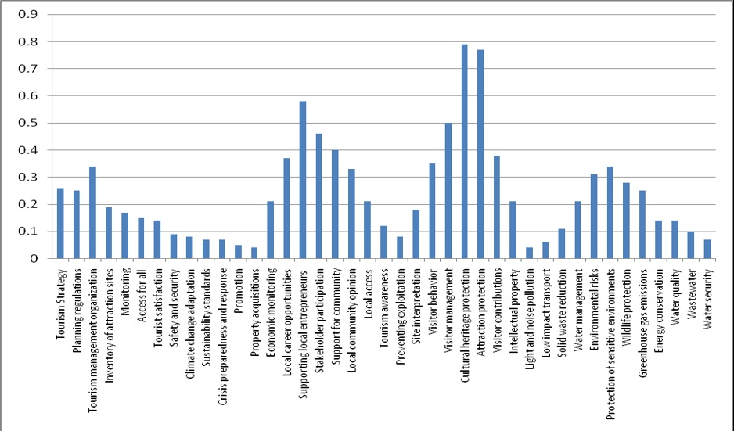

Figure 3. Final weight of sustainable tourism sub-criteria by AHP

4.2. Assessing Gilan tourism development plan
At this stage, the Gilan tourism options were reviewed and scored against the weighted tourism sub-criteria. Results were presented in Figure 3. The fourth column of Table 3 shows the sub-criteria scores of the plan’s options. Based on the analysis and data provided in Table 3, it is important that some tourism sub-criteria that are thought to be of high importance have not been considered in the Gilan tourism development plan. Gilan Tourism Development Plan was given the highest attention to four sub-criteria in its development options, namely ‘attraction protection’, ‘the presence of a tourism management organization’, ‘the promotion of tourism products’, and ‘monitoring’. Some sub criteria such as stakeholder participation, greenhouse emission, solid waste reduction, and climate change adaptation were given high weights by the experts. However, to date, tourism planners have given insufficient consideration to them. Thus, some recommendations will be presented in discussion section for those sub-criteria to steer tourism plan towards sustainability.

Table 3. The level of sustainability of Gilan tourism plan options
Score of plan’s options from sub-criteria | Importance of sub-criteria | Sub-criteria | Criteria
5 | 0.26 | Tourism Strategy | Demonstrate Sustainable Management
9 | 0.34 | Tourism management organization
7 | 0.17 | Monitoring
3 | 0.80 | Climate change adaptation
5 | 0.19 | Inventory of attraction sites
7 | 0.25 | Planning regulations
9 | 0.15 | Access for all
5 | 0.04 | Property acquisitions
3 | 0.14 | Tourist satisfaction
3 | 0.07 | Sustainability standards
1 | 0.09 | Safety and security
1 | 0.07 | Crisis and emergency preparedness response
9 | 0.05 | Promotion of production
7 | 0.21 | Economic monitoring | Maximize economic benefits to the host community and minimize negative impacts
5 | 0.37 | Local career opportunities
3 | 0.76 | Stakeholder participation
5 | 0.43 | Local community opinion
9 | 0.21 | Local access
5 | 0.12 | Tourism awareness
5 | 0.08 | Preventing exploitation
3 | 0.40 | Support for community
3 | 0.58 | Supporting local entrepreneurs’ entrepreneurs entrepreneurs entrepreneurs entrepreneurs and fair trade
9 | 0.77 | Attraction protection | Maximize benefits to communities, and cultural heritage and minimize negative impacts
3 | 0.50 | Visitor management
1 | 0.35 | Visitor behavior
5 | 0.79 | Cultural heritage protection
3 | 0.28 | Site interpretation
5 | 0.21 | Intellectual property
7 | 0.38 | Visitor contributions
1 | 0.31 | Environmental risks | Maximize benefits to the environment and minimize negative impacts
7 | 0.34 | Protection of sensitive environments
5 | 0.28 | Wildlife protection
1 | 0.45 | Greenhouse gas emissions
1 | 0.14 | Energy conservation
3 | 0.21 | Water management
3 | 0.07 | Water security
3 | 0.14 | Water quality
5 | 0.10 | Wastewater
1 | 0.41 | Solid waste reduction
1 | 0.04 | Light and noise pollution
1 | 0.06 | Low impact transport

- Discussion
Economic criteria have been considered extensively in the Gilan Tourism Development Plan. Cultural heritage criteria obtained the second highest weighting in our analysis and Gilan tourism plan considered associated measures. The reason behind this attention could be the history of cultural heritage law in Iran. The first domestic law on cultural heritage was approved more than 80 years ago (Rouhani, 2011). Whilst environment criteria were given the least attention by planners, decision makers should consider options that enhance social equity, environmental integrity and sustainable economic development (Brown 2011; Agyeiwaah et al, 2017; Tseng et al, 2018). Subsequently, we explore some of the identified weaknesses and present come initial recommendations for how to steer tourism towards sustainability within the case study area.
Some tourism sub-criteria have not been considered in Gilan Tourism Plan regardless of their high priority, including stakeholder participation, engagement with local communities, supporting local entrepreneurs, greenhouse emissions, and solid waste reduction. In other words, tourism planners didn’t consider all sustainable criteria fully. We suggest that providing recommendations and feedback on the tourism plan can enhance its overall sustainability.
Stakeholder participation is a fundamental concept of sustainable tourism (Landrof 2009). However, reviewing the plan confirms that it has not given sufficient attention to stakeholder and local community participation, which is in line with current Iranian governance being dominated by a culture of centralized decision making (Khosravi et al; 2018b). Generally speaking, stakeholder participation is valued less in countries where the political culture is less open and less democratic (Chen 2013; Purnama 2003; Khosravi et al., 2019b). It means the planning system lacks public participation (Moradi 2009; Khosravi & Jha-Thakur 2018; Khosravi et al., 2019a). From a methodological point of view, MCA is applied to enhance stakeholder participation in environmental planning (Hajkowicz & Collins 2007; Munda 2008; Marttunen & Hämäläinen 2008; Marttunen et al., 2013; Karjalainen et al., 2013). Therefore, its advantage lies in its ability to involve and engage stakeholders in the decision-making process. Within the Iranian context where lack of transparency and participation are weaknesses in planning and the EA system (Moradi 2009; Khosravi & Jha-Thakur, 2018), the introduction of MCA in SEA could be an important step towards improving participatory decision-making. The flexibility of MCA makes it an effective method for environmental strategy assessment. Inadequacies in public participation in Iran is similar to many developing countries in Asia and Africa where public participation is very limited and does not appear to influence decision-making much (Adomokai & Sheate, 2004; Wood, 2003; Nadeem & Fischer, 2011; Hasan et al., 2018).
Although cultural heritage is the second category considered in the plan, some sub criteria like visitor behaviour and interpretation have not been mentioned in it. Interpretation is a key instrument for sustainable management of natural and heritage tourism, particularly important for visitors (Loulanski & Loulanski, 2011). Poria et al. (2009) highlighted that visitors prefer on-site interpretation as an essential element in the management of heritage tourist attractions. Providing guidelines can help people to understand, appreciate and care about the natural and cultural environment. Hence, interpretation should be defined as a mitigation option to increase sustainability of Gilan Tourism plan.
Overall though, environmental impacts of tourism are mostly ignored within the plan, also including climate change adaptation and greenhouse emissions. Whilst technological improvements for reducing greenhouse emissions are highly recommended, it is unclear what exactly is meant by that (in particular as up to now technological improvements alone have been insufficient in compensating for the carbon emissions caused by the rapid expansion of tourism). In this context, air and land transportation should be important areas for action (Yen Sun 2016). However, in Iran there is currently a lack of coordination between ministries of different sector, hindering effective and sustainable decision-making (Wayakone & Makoto 2012; Khosravi et al., 2019a). Solid waste reduction is another environmental sub-criterion that has been ignored in the plan. Municipal solid waste (MSW) sets important challenges for the tourism industry (Giurea et al, 2018). MSW systems are mostly the responsibility of the public authority (Sawell et al., 1996; Shekdar 2009; Arbulú et al., 2016) and SEA has been used to assess them (Fischer et al., 2011). Over recent years several authors have suggested that cooperation between the public and private sectors like tourism destinations can improve the efficiency of MSW Systems (Arbulú et al., 2016). For example, Gilan tourism plan should set different incentives to tourists in order to minimize waste.
The methodological approach introduced in this paper can be a starting point to engage with SEA, in particular for countries that currently lack adequate stakeholder involvement. Future research should focus on how to increase stakeholder participation by choosing a wider group of experts and also public stakeholders. However, it is also possible to carry out MCA in SEA without the use of a mathematical methods such as AHP (Ismail & Abdullah, 2012; Josimovic et al., 2015) in particular where there is lack of sufficient technical input. Josimovic et al (2015) applied MCA without AHP to assess waste management plan in the city of Belgrade. However, the use of AHP and experts’ opinion expressed through it can reduce bias in the evaluation process.
Our suggested method is flexible as it can contribute to the different stages of the SEA process. We used AHP integrated MCA to assess the plan’s strategies, while Garfi et al (2011) used them to assess two alternatives in a water programme. It can also be used in the other stages of the SEA process. Moreover, with regards to research into the use of MCA, Huang et al., (2011) conducted a review in environmental science and established that 42 EIA related paper had focused on the MCA method (Neste & Karjalainen, 2013). The results of their review indicate that MCA methods can support EIA processes at different stages, such as stakeholder participation and assessment of alternatives (Neste & Karjalainen, 2013). Therefore, our method can be used for different levels of planning, including project to policy levels and isapplicable for the different stages of the EA (SEA and EIA).
- Conclusions
In this paper, we assess the sustainability of Gilan tourism development plan with the help of Global Sustainable Tourism criteria and MCA. The assessment reveals that the plan is economically driven, with many social and environmental considerations being ignored during the planning process. We identified some important sustainability criteria and options, such as solid waste reduction, climate change adaptation, greenhouse emissions, visitor’s behaviour and interpretation of natural and cultural sites that should be included to the Gilan tourism development plan’ options to improve sustainability.
Our methodology can be a rapid approach to assess a development plan to ensure the plan has met all sustainability criteria/sub-criteria. AHP as one of MCA approaches is an acceptable tool for SEA, which can be applied not only to tourism plans but in all development plans. It requires definition of specific sustainable criteria or SEA objectives. Moreover, MCA can be applied and used at all levels of decision-making, from project to policy levels, guiding a transition towards sustainability. It can also be used at different stage of the process including alternatives' consideration, recommendations, and stakeholder participation. There is already evidence to suggest the popularity of MCA methods within EIA (Huang et.al. 2011). However, MCA is rarely used at strategic levels (i.e. at the levels of policies, plans and programmes). Thus, there is a need for innovative approaches and applied examples for how MCA can be used in SEA.
References
Adomokai, R., & Sheate, W. R. (2004). Community participation and environmental decision making in the Niger Delta. Environmental Impact Assessment Review, 24 (5): 495–518.
Agyeiwaah, E., Mckercher, B., & Suntikul, W. (2017). Identifying core indicators of sustainable tourism: a path forward? Tourism Management Perspectives, 24: 26-33.
Akincilar & Dagdeviren. (2014). A hybrid multi-criteria decision-making model to evaluate hotel websites. International Journal of Hospitality Management, 36: 263-271.
Arbulú, I., Lozano, J., & Rey-Maquieira, J. (2016). The challenges of municipal solid waste management systems provided by public-private partnerships in mature tourist destinations: The case of Mallorca. Waste Management, 51: 252-258.
Arts, J., Runhaar, H. Fischer, TB. Jha-Thakur, U. van Laerhoven F., Driessen, P. & Onyango. V. (2012). The Effectiveness of EIA as an Instrument for Environmental Governance –A Comparison of the Netherlands and the UK. Journal of Environmental Assessment Policy and Management. 14(4):1-40.
Azimi, M., Hoseini, M. Ildormi, A. & Abroofarakh. M. (2013). The role of road transport in tourism development (Gilan Province). Journal of business economic and management studies. 1:111-124.
Badr, E. (2009). Evaluation of the environmental impact assessment system in Egypt. Impact Assessment and Project Appraisal. 27(3):193–203.
Ballantyne, R., Packer, J. & Hughes. K. (2009). Tourists' support for conservation messages and sustainable management practices in wildlife tourism experiences. Tourism Management 30:658–64.
Bashour, L. (2016). Comparative analysis of enabling legislation for EIA follow-up in Lebanon, Palestine, and Jordan (and Aqaba). Impact Assessment and Project Appraisal. 34(1): 72-78.
Belton, V., & Stewart, T.J. (2002). Multiple Criteria Decision Analysis: An Integrated Approach. Kluwer Academic Publisher.
Bobylev, N. (2006). Strategic environmental assessment of urban underground infrastructure development policies. Journal of Tunnelling and Underground Space Technology, 21:469– 479.
Bond, A., Fischer, T.B. & Fothergill. J. (2017). Progressing quality control in environmental impact assessment beyond legislative compliance: An evaluation of the IEMA EIA Quality Mark certification scheme. Environmental Impact Assessment Review. 63: 160–171.
Brown, K. (2011). Sustainable adaptation: an oxymoron? Climate and Development. 3 (1): 21-31.
Chen, J. (2013). Public participation provisions in Environmental Impact Assessment (EIA) legal system Case studies in China, India and Indonesia. Master Thesis.
Cinelli, M., Coles, S.R., & Kirwan. K. (2014). Analysis of the potentials of multi-criteria decision analysis methods to conduct sustainability assessment. Ecological Indicators 46:138–148.
Cottrell, S., &Vaske, J. (2006). A framework for monitoring and modeling sustainable tourism. e-Review of Tourism Research, 4(4):74–84.
D'Ieteren, E. (2008). L'integration de l'environnement dans les processus de developpement touristique: contributions et limites de l'application de l'evaluation environne-mentale strategique au secteur du tourisme en region Wallonne. [dissertation]. Université Libre de Bruxelles.
Dodgson, JS., Spackman, M., Pearman, A. & Phillips, L.D. (2009). Multi-criteria analysis: a manual. Department for Communities and Local Government: London.
Fischer, T.B. (1999). Benefits from SEA application - a comparative review of North West England, Noord-Holland and EVR Brandenburg-Berlin. Environmental Impact Assessment Review, 19(2): 143-173.
Fischer, T.B. (2002). Strategic Environmental Assessment in Transport and Land-use Planning, Earthscan, London.
Fischer, T.B. (2003). Strategic environmental assessment in post-modern times. Environmental Impact Assessment Review, 23:155-170.
Fischer, T.B. (2006). SEA in spatial/land use planning in the 25-member states – a July 2006 update. UVP report 20 (3): 127-131.
Fischer, T.B. (2007). Theory and practice of Strategic environmental assessment toward a more systematic approach.
Fischer, T.B., Potter, K., Donaldson, S., & Scott, T. (2011). Municipal waste management strategies, strategic environmental assessment and the consideration of climate change in England. Journal of Environmental Assessment Policy and Management, 13(4): 541-565.
Garfi, M., Martí, L. Bonoli, A. & Tondelli, S. (2011). Multi-criteria analysis for improving strategic environmental assessment of water programmes. a case study in semi-arid region of Brazil. Environmental Management, 92: 665-675.
García-Melón, M., Gómez-Navarro, T., & Acuña-Dutra. S.A. (2012). Combined ANP-delphi approach to evaluate sustainable tourism. Environmental Impact Assessment Review, 34. 41–50.
Gauthier, M., Simard, L., & Waaub, JP. (2012). Public Participation in Strategic Environmental Assessment (SEA): Critical Review and the Quebec (Canada) Approach. Environmental Impact Assessment Review, 31: 48-60.
Ghamgosar, M., Haghighi, M., Mehrdoust, F., &Arshad, N. (2011). Multi criteria Decision Making Based on analytical Hierarchy Process (AHP) in GIS for Tourism. Middle-East Journal of Scientific Research .10: 501-507.
Giurea, R., Precazzini, I., Ragazzi, M., Achim, M.I., Cioca, L.I., Conti, F., Torretta, E.C. (2018). Good Practices and Actions for Sustainable Municipal Solid Waste Management in the Tourism Sector. Resources.
Hajkowicz, S., & Collins, K. (2007). A Review of multiple criteria analysis for water resource planning and management. Water Resource Management, 21: 1553–1566.
Hajkowicz, S. (2007). A comparison of multiple criteria analysis and unaided approaches to environmental decision making. Environmental Science Policy, 10:177-184.
Hajkowicz, S. (2008). Supporting multi-stakeholder environmental decisions. Journal of Environmental Management, 88:607-614.
Hasan, MDA., Nahiduzzaman, Kh. M., & Aldosary, A.S. (2018). Public participation in EIA: A comparative study of the projects run by government and non-governmental organizations. Environmental Impact Assessment Review, 72: 12–24.
Hawkins, D. (2004). A protected areas ecotourism competitive cluster approach to catalyze biodiversity conservation and economic growth in Bulgaria. Journal of Sustainable Tourism,12(3), 219–44.
Heaton, C., & Burns, S. (2014). An evaluation of environmental impact assessment in Abu Dhabi, United Arab Emirates. Impact Assessment and Project Appraisal. 32(3): 246–251.
Herath, G. (2004). Incorporating community objectives in improved wetland management: the use of the analytic hierarchy process. Journal of Environmental Management, 70: 263-273.
Hossein nia, E., Shoja, B., & Khoshkam, M. (2012). Balancing Environmental Conservation and Sustainable Ecotourism Development in Gilan, Iran. Journal of Humanities and Social Science 1:33-40.
Huang, IB., Keisler J, and J. Linkov. (2011). Multi-criteria decision analysis in environmental sciences: Ten years of applications and trends. Science of the Total Environment, 409 (19), 3578–3594. United States.
Huang, W. (2011). Good Practice in Sustainable Tourism Developing a Measurement System by Providing a Model Assessment Procedure [master’s thesis]. Lund University.
Huang, Y., and Bian, L. (2009). A Bayesian network and analytic hierarchy process based personalized recommendations for tourist attractions over the Internet. Expert System with Application. 36:933–943.
Huibin, X., Marzuki, A. & Abdul Razak, A. (2012). Protective development of cultural heritage tourism: The case of Lijiang China. Theoretical and Empirical Researches in Urban Management 7 (1): 39-51.
Josimovic, B., Maric, I., & Milijic, S. (2015). Multi-criteria evaluation in strategic environmental assessment for waste management plan, a case study: The city of Belgrade. Waste Management. 36: 331–342.
Jay, S. (2010). Strategic environmental assessment for energy production. Energy Policy. 38:3489-3497.
João, B. (2007). A research agenda for data and scale issues in Strategic Environmental Assessment (SEA). Environmental Impact Assessment Review. 27:479–91.
Kabassi, K. (2010). Personalizing recommendations for tourists. Telematics and Informatics. 27:51–66.
Karjalainen1, TP., Rossi, P.M., Ala-aho, P., Eskelinen, R., Reinikainen, K., Kløve, B., Pulido-Velazquez, M., Yang. H. (2013). A decision analysis framework for stakeholder involvement and learning in groundwater management. Hydrology and Earth System Science. 17: 1–13.
Khosravi, F., & Jha-Thakur, U. (2018). Managing uncertainties through scenario analysis in strategic environmental assessment. Journal of Environmental Planning and Management. https://doi.org/10.1080/09640568.2018.1456913.
Khosravi, F., Jha Thakur, U., &Fischer, T.B. (2018). The role of Environmental Assessment (EA) in Iranian water management. Journal of Environmental Planning and Management. http://dx.doi.org/10.1080/14615517.2018.1526998.
Khosravi, F., Jha Thakur, U. & Fischer, T.B. (2019a). Evaluation of the environmental impact assessment system in Iran. Journal of Environmental Impact Assessment Review. 74: 63–72
Khosravi. F., Jha Thakur, U., & Fischer. TB. (2019b). Enhancing EIA Systems in Developing Countries: A focus on capacity development in the case of Iran. Science of the Total Environment, 670: 425-432.
Landrof, Ch. (2009). Managing for sustainable tourism: A review of six cultural World Heritage Sites. Journal of Sustainable Tourism, 17(1), 53-70.
Lemos, C., Fischer, T.B., & Souza, M.P. (2012). Strategic environmental assessment in tourism planning—Extent of application and quality of documentation. Environmental Impact Assessment Review, 35:1–10.
Liou, ML., Yeh SC, Yu YH. (2006). Reconstruction and systemization of the methodologies for strategic environmental assessment in Taiwan. Environmental Impact Assessment Review, 26:170–84.
Loulanski, T., & Loulanski. V. (2011). The sustainable integration of cultural heritage and tourism: a meta-study. Journal of Sustainable Tourism, 19(7): 837-862.
Malczewski, J. (2006). GIS-based multi-criteria decision analysis: a survey of the literature. International of Journal Geography Information System, 20:703–726.
Mak, B.K.L., Cheung, L.T.O., & Hui, D.L.H. (2017). Community Participation in the decision-Making Process for Sustainable Tourism Development in Rural Areas of Hong Kong, China. Sustainability. 9: 1695; doi:10.3390/su9101695.
Marttunen, M., & Hämäläinen, R. (2008). The Decision Analysis Interview Approach in the Collaborative Management of a Large Regulated Water Course. Environmental Management, 42: 1026–1042.
Marttunen, M., Mustajoki, J., Dufva, M., & Karjalainen, T.P. (2013). How to design and realize participation of stakeholders in MCDA processes? A framework for selecting an appropriate approach. EURO Journal on Decision Processes, 3: 1–28.
Maswera, T., Edwards, J., & Dawson. R. (2009). Recommendations of e-commerce systems in the tourism industry of sub-Saharan Africa. Telematics and Informatics, 26: 12–19.
McCluskey, D., & Joao. E. (2011). The promotion of environmental enhancement in Strategic Environmental Assessment. Environmental Impact Assessment Review, 31: 344-351.
Michalena, E., Hills, J., & Amat, J.P. (2008). Developing sustainable tourism using a multicriteria analysis on renewable energy in Mediterranean Islands. Energy Sustainable Development, 13:129–136.
Momtaz, S. (2002). Environmental impact assessment in Bangladesh: a critical review. Environmental Impact Assessment Review, (22):163–79.
Moradi, H. (2009). Biodiversity, climate change, and environmental impact assessment. [dissertation]. University of Zurich.
Morgan, R.K. (2012). Environmental impact assessment: the state of the art. Impact Assessment and Project Appraisal, 30 (1): 5–14.
Morrison-Saunders, A., & Retief, F. (2012). Walking the sustainability assessment talk —Progressing the practice of environmental impact assessment (EIA). Environmental Impact Assessment Review, 36: 34–41.
[IAIA] International Association for Impact Assessment. (2010). Multi-Criteria Analysis (MCA): A tool for sustainability Assessment, Training Course.
Munda, G. (2008). Social Multi-Criteria Evaluation for a Sustainable Economy. Springer-Verlag, Berlin.
Nadeem, O., & Fischer, T.B. (2011). An Evaluation Framework for Effective Public Participation in EIA in Pakistan. Environmental Impact Assessment Review, 31(1): 36-47.
Nadeem, O., & Hameed, R. (2008). Evaluation of environmental impact assessment system in Pakistan. Environmental Impact Assessment Review, 28: 562–571.
Naser, H. (2012). Evaluation of the environmental impact assessment system in Bahrain. Journal of Environmental Protection. 3:233–239. [PNA] Palestine. Palestinian National Authority. 2000. Palestinian Environmental Assessment Policy.
Paliwal, R. (2006). EIA practice in India and its evaluation using SWOT analysis. Environmental Impact Assessment Review, 26:492–510.
Poria, Y., Butler, R., & Airey, D. (2003). The core of heritage tourism. Annals of Tourism Research. 30(1): 238–254.
Purnama, D. (2003). Reform of the EIA process in Indonesia: improving the role of public involvement. Environ. Environmental Impact Assessment Review, (23): 415–439.
Retief F, Jones C, Jay S. (2008). The emperor's new clothes — reflections on strategic environmental assessment (SEA) practice in South Africa. Environmental Impact Assessment Review, 28(7): 504–14.
Rouhani, B. (2011). Development and cultural heritage in Iran. ICOPMAS: Paris
Saaty, T. (1980). The Analytic Hierarchy Process. New York, McGraw-Hill.
Saaty, T.L. (1990). How to make a decision: The Analytic Hierarchy Process. European Journal of Operational Research 48:9-26.
Saaty, T.L. (1995). Decision Making for Leaders: The Analytic Hierarchy Process in a Complex World. 3th Edition, RWS Publications, Pittsburgh.
Saaty, T.L. (2005). The analytic hierarchy and analytic network processes for the measurement of intangible criteria and for decision-making. In: Fiigueira, J., Greco, S., Greco, S., Ehrgott, M., Ehrgott, M. (Eds.), in. Springer, New York.
Sadler, B. (1996). Environmental Assessment in a Changing World: Evaluating Practice to Improve Performance. (Final Report of the International Study of the Effectiveness of Environmental Assessment). Canadian Environmental Assessment Agency and International Association for Impact Assessment, Ottawa, Canada.
Salhofer, S., Wassermann, G., & Binner, E. (2007). Strategic environmental assessment as an approach to assess waste management systems. Experiences from an Austrian case study. Environmental Modelling Software, 22:610-618.
SAP (Sabz Andish Payesh Consulting Engineers Company) (2009). Tourism Development Studies in Gilan’s Tourist Regions and Coastal Zones. Tehran: SAP.
Sawell, S., S. Hetherington, and A. Chandler. (1996). An overview of municipal solid waste management in Canada. Waste Management, 16 (5/6), 351–359.
Sharifzadegan, M., Joudi Gollar, P., & Azizi, H. (2011). Assessing the strategic plan of Tehran by sustainable development approach, using the method of “Strategic Environmental Assessment (SEA). Procedia Engineering, 21:186–195.
Shekdar, A. (2009). Sustainable solid waste management: an integrated approach for Asian countries. Waste Management 29, 1438–1448.
Slunge, D., & Huyen Tran, T.T. (2014). Challenges to institutionalizing strategic environmental assessment, The case of Vietnam. Environmental Impact Assessment Review 48:53–61.
Thirumalaivasan, D., Karmegam, M., & Venugopal, K. (2003). AHP-DRASTIC: software for specific aquifer vulnerability assessment using Drastic model and GIS. Environmental Modelling Software,18:645–656.
Tseng, ML., Wu, K.J., Lee, Ch., Lim, M.K., Bui, T.D., Chen, Ch. (2018). Assessing sustainable tourism in Vietnam: A hierarchical structure approach. Journal of Cleaner Production, 195: 406-417.
Tubb, K. (2003). An evaluation of the effectiveness of interpretation within Dart moor National Park in reaching the goals of sustainable tourism development. Journal of Sustainable Tourism, 11(6):476–98.
UNDP (United Nations Development Programme) (2003). Sustainable Development Strategy and Strategic Environmental Assessment: Enabling Activities and Capacity Building. New York: UNDP.
UNDP (United Nations Development Programme) (2013). Building a Multiple Use Forest Management Framework to Conserve Biodiversity in the Caspian Hyrcanian Forest Landscape. New York: UNDP.
UNF (United Nations Foundation) (2011). Global Sustainable Tourism Criteria: Working together for the universal adoption of sustainable tourism principles. Available at: http://www.unfoundation.org/global-issues/sustainable-development/global-sustainable-tourism-criteria.html.
Victor, D., & Agamuthu, P. (2014). Policy trends of strategic environmental assessment in Asia. Environmental Science policy, 41:63–76.
Wang, Sh., Liu. J., Ren, L., Zhang, K., & Wang, R. (2009). The development and practices of Strategic Environmental Assessment in Shandong Province, China. Environmental Impact Assessment 29:408–420.
Wan, I., Wan, Kh., & Abdullah, L. (2012). A new environmental performance index using analytic hierarchy process: a case of ASEAN countries. Environmental Skeptics and Critics 1 (3): 39–47.
Wayakone, S., & Makoto, I. (2012). Evaluation of the environmental impacts assessment (EIA) system in Lao PDR. Journal of Environmental Protection, 3: 1655–1670.
Wood, C. (2003). Environmental Impact Assessment: A comparative Review. 2nd Edition, Longman, Harlow.
World Bank. (2012). Strategic Environmental Assessment in the World Bank — Learning from Recent Experience and Challenges. F Loayza (ed.), Washington, DC: The World Bank Group.
Wu, CR., Lin, C.T., & Chen, H.C. (2007). Optimal selection of location for Taiwanese hospitals to ensure a competitive advantage by using the analytic hierarchy process and sensitivity analysis. Building Environment 42:1431–1444.
World Travel and Tourism Council. (2018). The Economic Impact of Travel and Tourism.
Yang, J., & Shi, P. (2002). Applying Analytic Hierarchy Process in Firm's Overall Performance Evaluation: A Case Study in China. International journal of business, 7:29-46.
Yen Sun, Y. (2016). Decomposition of tourism greenhouse gas emissions: Revealing the dynamics between tourism economic growth, technological efficiency, and carbon emissions. Tourism Management, 55: 326-336.
Zaboli, P., Hashemi-Meshkini, A., Varmaghani, M., Gholami, H., Vazirian, I., Zekri, H., Eslamitabar, SH., Kebriaeezadeh, A. (2016). Pharmaceutical laws and regulations in Iran: An overview. Journal of Research in Pharmacy Practice, 5(3): 155–161.
Zhu, D., & Ru, J. (2008). Strategic environmental assessment in China: motivations, politics, and effectiveness. Journal of Environmental of Management, 88:615–26.

