Impact of idelalisib on health-related quality of life in patients with relapsed chronic lymphocytic leukemia in a phase 3 randomized trial
Running head: Idelalisib in CLL - Quality of Life
Paolo Ghia,¹ Steven E. Coutre,² Bruce D. Cheson,³ Jacqueline C. Barrientos,⁴ Peter Hillmen,⁵ Andrew R. Pettitt,⁶ Andrew D. Zelenetz,⁷ Sanatan Shreay,⁸ Michael Hallek,⁹ and Richard R. Furman¹⁰

¹Università Vita-Salute San Raffaele and IRCCS Ospedale San Raffaele, Milano, Italy
²Stanford School of Medicine, Stanford, CA, USA
³Georgetown University Hospital, Washington D.C., USA
⁴Zucker School of Medicine at Hofstra/Northwell, Hempstead, NY, USA
⁵St. James's University Hospital, Leeds, UK
⁶University of Liverpool, Liverpool, UK
⁷Memorial Sloan Kettering Cancer Center, New York, NY, USA
⁸Gilead Sciences, Inc, Foster City, CA, USA
⁹Dept I of Internal Medicine, University Hospital of Cologne, Cologne, Germany
¹⁰Weill Cornell Medical College, New York, NY, USA

Corresponding author:
Paolo Ghia, MD
Università Vita-Salute San Raffaele
c/o DIBIT 1
via Olgettina 58
20132, Milano, Italy
Email: ghia.paolo@hsr.it

Word count
Text: 1486/1500
Tables/figures: 3/3
References: 14/15

Trial registration: clinicaltrials.gov NCT01539512; EudraCT 2011-005180-24

Acknowledgements
The authors and Gilead Sciences, Inc., are grateful to the late Professor Bertrand Coiffier for his contributions to the study and this manuscript. We thank the patients for their dedication to this clinical trial and the clinical personnel at each of the study sites for their diligence in caring for patients and collecting study data. This study was sponsored by Gilead Sciences, Inc. (Foster City, CA). The authors would like to thank Ronald Dubowy, Lyndah Dreiling and Yeonhee Kim, former employees of Gilead Sciences, Inc., for their invaluable assistance with the draft of early stages of this manuscript. Medical writing and editorial assistance was provided by Timothy DiChiara, PhD, of Gilead Sciences, Inc.; and by Ewa Wandzioch, PhD, and Meryl Gersh, PhD, of AlphaBioCom, LLC, King of Prussia, PA, which was funded by Gilead Sciences, Inc.

Patients with chronic lymphocytic leukemia (CLL) have overtly impaired well-being relative to healthy controls.^{1, 2} Factors associated with lower overall health-related quality of life (HRQoL) in patients with CLL include older age, greater fatigue, severity of comorbid health conditions, advanced disease stage, and ongoing treatment for CLL.^{2, 3} The use of standardized patient-reported outcomes (PROs) has become an increasingly important component of therapeutic assessment in clinical trials, allowing for determination of the impact of treatment on HRQoL.⁴
Idelalisib, a potent, highly selective, oral small-molecule inhibitor of phosphoinositol-3 kinase δ, is approved by the US Food and Drug Administration and the European Medicines Agency, in combination with rituximab, for the treatment of relapsed CLL.^{5, 6} In the pivotal randomized, double-blind, placebo-controlled trial of 220 elderly patients with relapsed or refractory CLL and comorbid conditions, idelalisib plus rituximab demonstrated statistically significant and clinically meaningful improvements in overall response rate, progression-free survival, and overall survival, with an acceptable toxicity profile compared with the placebo plus rituximab control.⁷ Grade ≥3 diarrhea, rash, and hepatic transaminase elevations were more frequent in the idelalisib/rituximab arm.⁷
A prespecified analysis evaluated the impact of idelalisib plus rituximab vs rituximab plus placebo on HRQoL—in the absence of the typical chemotherapy-related toxicity—using the 44-item Functional Assessment of Cancer Therapy–Leukemia (FACT-Leu) scale. FACT-Leu instrument has well-established psychometric properties⁸⁻¹¹ that yield a total score and subscales for physical well-being (PWB), functional well-being (FWB), social/family well-being (S/FWB), and emotional well-being (EWB),⁹ and a diagnosis-specific measure for patients with leukemia-specific symptoms (LeuS) such as fevers, chills, night sweats, nodal swelling and fatigue.¹¹ The FACT-Leu Total score is the sum of all subscales, and the Trial Outcome Index (TOI) is the sum of PWB, FWB, and LeuS. Higher scores reflect better HRQoL. The number of items, scoring ranges, and minimally important differences (MID) for each subscale are listed in Supplementary Table 1. The survey was administered every 2 weeks until week 8, every 4 weeks until week 24, every 6 weeks until week 48, and every 12 weeks thereafter until unblinding on November 8, 2013; no HRQoL or performance status data were collected after CLL disease progression. To avoid biasing HRQoL results, the FACT-Leu was administered in person at each visit before other procedures were performed, and before any study information was conveyed to the patient. FACT-Leu was scored based on the Functional Assessment of Chronic Illness Therapy-3 scoring guideline and user manual.¹²
Questionnaire compliance was defined as the proportion of patients who answered at least one question at a scheduled time point relative to all patients available at that time point (ie, not including patients excluded for other reasons). Missing items in a subscale were imputed. Data collected from the FACT-Leu instrument were not reconciled with adverse event or laboratory data. Repeated measures mixed-effects models were used to assess mean change from baseline within and between treatment arms.
Since a significant portion of the patients had CLL disease progression during the study, and no HRQoL or performance status data were collected after disease progression, the duration of data collection varied. Missing data was not imputed for patients lost to follow-up without progression. The varied durations of FACT-Leu score collection were handled by the repeated measure mixed-effects model, which provides robust estimates by analyzing the observed data when data missing at random was reasonably assumed. Kaplan-Meier methods and log-rank tests were performed for each of the FACT-Leu subscale scores, assessing time to changes in each variable.
Enrollment of 220 patients occurred between May 2012 and August 2013. The study was stopped due to superior efficacy of idelalisib/rituximab over placebo/rituximab. Upon study termination and unblinding, patients could transition to the extension study (NCT01539291) to receive open-label idelalisib monotherapy. The HRQoL data were collected during the blinded phase of the study and analyzed as of the unblinding date of November 8, 2013.
Patient demographic characteristics were well balanced between the two treatment arms, and between-group HRQoL scores were comparable at baseline. Median patient age (range) was 71 (47–92) years with 78% of patients ≥65 years of age. Forty percent had at least moderate renal dysfunction (creatinine clearance <60 mL/min), 35% had cytopenias (grade ≥3 anemia, thrombocytopenia, or neutropenia), and 85% had a Cumulative Illness Rating Scale (CIRS) score >6. The median CIRS score in each arm was 8. Almost two-thirds of patients had advanced-stage disease, and median time since initial diagnosis of CLL was approximately 9 years. More than 80% had unmutated IGHV, and more than 40% had either del(17p) orTP53 mutations. Patients in both arms had received a median of 3 prior therapies, including regimens containing rituximab, cyclophosphamide, fludarabine, and bendamustine.⁷
Compliance and subscale completion rates for the FACT-Leu questionnaire across all time points were high and comparable between treatment arms (Supplementary Table 2). At week 2, compliance rates in the placebo and idelalisib arms were 93.5% and 95.5%, respectively, and declined to 70.0% and 80.8%, respectively, of participants still on treatment by week 48. Missing data were randomly and evenly distributed in the two arms.

Treatment with idelalisib/rituximab translated into subjective benefits in patients’ HRQoL, particularly for the FACT-Leu PWB and FWB scores, as well as those related to leukemia symptoms. Compared with placebo/rituximab, treatment with idelalisib/rituximab led to significant improvement in the LeuS scores observed already after 8 weeks, and the score difference from baseline exceeded the MID of 4 by 12 weeks (P <0.05). This improvement was maintained in the mixed model through weeks 8, 16, 20, 24, and 36 in patients available for each assessment (Table 1, Figure 1A). The overall treatment effect was significant (P = 0.001) based on a longitudinal analysis. Significant treatment effects in the idelalisib/rituximab group were also seen on the PWB (P = 0.015) and FWB (P = 0.014) subscales (Table 1, Figures 1B and 1E).

EWB and SWB scores did not show any meaningful trend between the two arms (P = 0.08 and P = 0.77, respectively) (Figure 1C and 1D). This may be due to patient awareness of potential for rescue in the extension study, or because the psychological burden of having a disease—or not achieving a response—was less relevant for patients in this trial, who had a long history of CLL including past treatment failure. Alternatively, patients may have had enough time to learn how to live with a disease that can repeatedly progress and relapse and reached an overall emotional and social plateau that was no longer affected by the treatment.
On the composite scales, patients treated with idelalisib/rituximab scored their HRQoL significantly higher than patients in the placebo/rituximab group (Figure 2). For the TOI (LeuS + PWB + FWB), mixed model analysis showed improvements at weeks 12, 16, 20, 24, and 48 (P <0.05) over the control group, producing a significant and clinically meaningful effect of idelalisib vs placebo on composite TOI over the entire course of treatment (P = 0.002) (Table 1; Figure 2A). A similar improvement was observed on the FACT-Leu Total Score (LeuS + PWB + S/FWB + EWB + FWB): patients treated with idelalisib/rituximab reported significantly higher scores on weeks 16, 20, and 24 (P <0.05), compared with patients treated with placebo/rituximab, for a significant and clinically meaningful treatment effect over the entire study (P = 0.006) (Table 1; Figure 2B). Similarly, time to symptom deterioration was longer in the treatment arm relative to the placebo arm (Supplementary Table 3). Improvement in composite scores in the idelalisib/rituximab arm compared with the placebo/rituximab arm was seen in both younger (<65 years) and older (≥65 years) patients (Supplementary Table 4, Supplementary Figure 1).
In summary, patients treated with the combination of idelalisib and rituximab experienced increased HRQoL, possibly associated with response of disease-related symptoms to treatment, beginning as early as 4 weeks after initiation of treatment. This contrasts with HRQoL changes following classic chemoimmunotherapy, where increased HRQoL due to symptomatic improvement from treatment efficacy might be offset in the short term by initial chemotherapy-related toxicity. For example, COMPLEMENT 1 (ofatumumab plus chlorambucil vs chlorambucil alone) and COMPLEMENT 2 (ofatumumab plus fludarabine and cyclophosphamide vs fludarabine and cyclophosphamide)—randomized studies that used chemotherapy as part of the experimental arm—reported small and delayed improvements in disease symptoms and HRQoL.^{13, 14} In contrast, patients taking idelalisib plus rituximab experienced the HRQoL benefits of disease control without the initial adverse effects of cytotoxicity. Potential limitations include the small numbers of patients available for assessment at later time points (Supplementary Table 2), although this was accounted for in the mixed-effects model analysis as the missing data were randomly and evenly distributed between the treatment arms.
Idelalisib plus rituximab is among the first noncytotoxic treatment regimens for the management of relapsed/refractory CLL. This analysis of PRO demonstrates that idelalisib plus rituximab improves not only clinical outcomes but also HRQoL, including a reduction in leukemia-related symptoms and an improvement in physical and functional well-being. These data may help patients and clinicians make more informed treatment decisions.

Contributions
MH and RRF contributed to study design. PG, SEC, BDC, JCB, PH, ARP, ADZ, MH, and RRF provided patients or study materials. JCB, ARP, MH, and RRF collected and assembled data. PG, SEC, BDC, JCB, PH, ADZ, MH, and RRF analyzed and interpreted data. All authors contributed to manuscript preparation and approved the final version for submission.

Disclosures
PG reports honoraria for consulting or advisory roles from AbbVie; Acerta/AstraZeneca; Arqule; BeiGene; Celgene/Juno; Gilead Sciences, Inc.; Janssen; Sunesis; and Tolero Pharmaceuticals; and research funding from AbbVie; Gilead Sciences, Inc.; Janssen; and Sunesis. SEC reports consulting or advisory roles with AbbVie, Celgene, Janssen, and Pharmacyclics; research funding from AbbVie; Acerta; Celgene; Gilead Sciences, Inc.; Janssen; and Takeda; travel, accommodations, and expenses paid by AbbVie; Celgene; Janssen; and Pharmacyclics; and participating in a Data Safety Monitoring Committee for BeiGene. BDC reports institutional research funding from Roche; Genentech; Acerta Pharma; Gilead Sciences, Inc.; AbbVie; and TG Therapeutics; and consulting or advisory roles with Acerta Pharma, TG Therapeutics, Bayer, Roche, Genentech, AbbVie, Pharmacyclics, Janssen, Morphosys, Sunesis Pharmaceuticals, and Celgene. JCB reports consulting or advisory roles with Pharmacyclics/AbbVie; Janssen; Gilead Sciences, Inc.; and Genentech; honoraria from Janssen; and institutional research funding from Pharmacyclics/AbbVie; Gilead Sciences, Inc.; and Acerta. BC reports honoraria from Celgene; Mundipharma; Gilead Sciences, Inc.; AstraZeneca; Pfizer; Celltrion; and Novartis; and consulting or advisory roles with Celgene; Mundipharma; Gilead Sciences, Inc.; AstraZeneca; Pfizer; Celltrion; and Novartis. PH reports honoraria from Gilead Sciences, Inc.; Pharmacyclics; Janssen; and Roche; and research funding from Gilead Sciences, Inc.; Pharmacyclics; Janssen; and Roche. ARP reports research funding to his institution from Celgene; Gilead Sciences, Inc.; Roche; NAPP Pharmaceuticals; GlaxoSmithKline/Novartis; and Verastem; and travel, accommodations, and expenses paid by Gilead Sciences, Inc.; Kite; and Celgene. ADZ reports honoraria from Genentech/Roche; Gilead Sciences, Inc.; Celgene; Janssen; Amgen; Novartis; and Adaptive Biotech; consulting or advisory roles with Genentech/Roche; Gilead Sciences, Inc.; Celgene; Janssen; Amgen; AstraZeneca; Novartis; Adaptive Biotechnologies; and MEI Pharma; research funding from MEI Pharma; Genentech/Roche; Gilead Sciences, Inc.; BeiGene; and AbbVie; travel, accommodations, and expenses paid by Roche; Gilead Sciences, Inc.; and Celgene; and acting as a Data Monitoring Committee Chair for BeiGene. SS is an employee of Gilead Sciences, Inc., and may hold stock. MH reports honoraria from Gilead Sciences, Inc.; consulting or advisory roles with Roche; Gilead Sciences, Inc.; Mundipharma; Janssen; Celgene; Pharmacyclics; AbbVie; and Boehringer Ingelheim; speakers’ bureau fees from Roche; Gilead Sciences, Inc.; Mundipharma; Janssen; Celgene; Pharmacyclics; and AbbVie; research funding to his institution from Roche; Gilead Sciences, Inc.; Mundipharma; Janssen; Celgene; Pharmacyclics; AbbVie; and Boehringer Ingelheim; and travel, accommodations, and expenses paid by Roche; Gilead Sciences, Inc.; Janssen; and AbbVie. RRF reports honoraria from Janssen and Genentech/Roche; consulting or advisory roles with Pharmacyclics; Janssen; Gilead Sciences, Inc.; Genentech/Roche; AbbVie; Sunesis Pharmaceuticals; Loxo; TG Therapeutics; Verastem; Acerta Pharma; and AstraZeneca; research funding from Acerta Pharma and TG Therapeutics; and travel, accommodations, and expenses paid by Janssen; Pharmacyclics; Genentech/Roche; AbbVie; Sunesis Pharmaceuticals; and Verastem; and participation in a Data and Safety Monitoring Board for Incyte.

References

1. Else M, Smith AG, Cocks K, et al. Patients' experience of chronic lymphocytic leukaemia: baseline health-related quality of life results from the LRF CLL4 trial. Br J Haematol. 2008;143(5):690-697.
2. Shanafelt TD, Bowen D, Venkat C, et al. Quality of life in chronic lymphocytic leukemia: an international survey of 1482 patients. Br J Haematol. 2007;139(2):255-264.
3. Levin TT, Li Y, Riskind J, Rai K. Depression, anxiety and quality of life in a chronic lymphocytic leukemia cohort. Gen Hosp Psychiatry. 2007;29(3):251-256.
4. Efficace F, Gaidano G, Lo-Coco F. Patient-reported outcomes in hematology: is it time to focus more on them in clinical trials and hematology practice? Blood. 2017;130(7):859-866.
5. ZYDELIG® (idelalisib) tablets, for oral use. Full prescribing information. Gilead Sciences, Inc., Foster City, CA, USA. 2018.
6. Zydelig (idelalisib). Summary of product characteristics. Gilead Sciences Ireland UC, Carrigtohill, County Cork, Ireland. 2019.
7. Furman RR, Sharman JP, Coutre SE, et al. Idelalisib and rituximab in relapsed chronic lymphocytic leukemia. N Engl J Med. 2014;370(11):997-1007.
8. Cella D, Webster K, Cashy J, et al. Development of a measure of health-related quality of life for non-Hodgkin’s lymphoma clinical research: The Functional Assessment of Cancer Therapy - Lymphoma (FACT-Lym). Blood. 2005;106 (suppl):Abstract 750.
9. Cella DF, Tulsky DS, Gray G, et al. The Functional Assessment of Cancer Therapy scale: development and validation of the general measure. J Clin Oncol. 1993;11(3):570-579.
10. Victorson D, Barocas J, Song J, Cella D. Reliability across studies from the functional assessment of cancer therapy-general (FACT-G) and its subscales: a reliability generalization. Qual Life Res. 2008;17(9):1137-1146.
11. Webster K, Chivington K, Shonk C, Eremenco S, Yount S, Hahn E. Measuring quality of life (QOL) among patients with leukemia: The Functional Assessment of Cancer Therapy- Leukemia (FACT-LEU). Qual Life Res. 2002;11(7):Abstract 678.
12. FACIT.org, 2015. http://www.facit.org/FACITOrg/Questionnaires. Accessed March 09, 2017.
13. Hillmen P, Janssens A, Babu KG, et al. Health-related quality of life and patient-reported outcomes of ofatumumab plus chlorambucil versus chlorambucil monotherapy in the COMPLEMENT 1 trial of patients with previously untreated CLL. Acta Oncol. 2016;55(9-10):1115-1120.
14. Robak T, Warzocha K, Govind Babu K, et al. Health-related quality of life and patient-reported outcomes of ofatumumab plus fludarabine and cyclophosphamide versus fludarabine and cyclophosphamide in the COMPLEMENT 2 trial of patients with relapsed CLL. Leuk Lymphoma. 2017;58(7):1598-1606.

Table 1. Mean differences in patient-reported FACT-Leu outcome score changes from baseline between treatment arms

Week | Mean change from baseline score difference (SEM)
 | LeuS | PWB | FWB | TOI | FACT-Leu Total
2 | 0.4 (1.31) | -0.1 (0.65) | 0.6 (0.80) | 1.3 (2.38) | 1.1 (2.96)
4 | 2.5 (1.33) | 0.8 (0.66) | 1.0 (0.81) | 4.0 (2.41) | 4.0 (3.01)
6 | 2.2 (1.37) | 0.1 (0.68) | 1.0 (0.84) | 2.9 (2.48) | 3.9 (3.09)
8 | 3.5 (1.43)* | 0.6 (0.71) | 0.7 (0.87) | 4.6 (2.57) | 5.2 (3.2)
12 | 4.7 (1.51)† | 1.1 (0.75) | 1.5 (0.92) | 7.0 (2.72)† | 6.5 (3.39)
16 | 5.3 (1.66)† | 1.9 (0.83)* | 1.3 (1.01) | 8.4 (2.99)† | 9.2 (3.72)†
20 | 5.4 (1.85)† | 1.6 (0.91) | 1.4 (1.13) | 9.0 (3.33)† | 9.0 (4.14)†
24 | 5.0 (2.06)† | 1.8 (1.02) | 1.9 (1.26) | 9.1 (3.69)† | 10.0 (4.58)†
30 | 3.0 (2.32) | 2.1 (1.14) | 2.6 (1.41) | 7.7 (4.13) | 9.6 (5.13)
36 | 5.1 (2.54)† | 1.5 (1.26) | 2.8 (1.56) | 8.2 (4.59) | 9.1 (5.69)
42 | 3.9 (3.16) | 2.1 (1.57) | 2.8 (1.93) | 8.1 (5.57) | 9.1 (6.92)
48 | 5.5 (3.60) | 3.6 (1.79)† | 3.6 (2.20) | 12.4 (6.32)† | 13.1 (7.85)
*P <0.05 and †P <0.05 and exceeded established minimally important difference (MID) change scores of 4 (LeuS), 2 (PWB), 5 (TOI), and 6 (FACT-Leu Total) between arms.
FACT-Leu, Functional Assessment of Cancer Therapy–Leukemia; FWB, functional well-being; LeuS, leukemia sub-scale; PWB, physical well-being; SEM, standard error of the mean; TOI; trial outcome index.
Figure legends

Figure 1. Change in mean (SEM) sub-scale scores over time between treatment groups. A, leukemia sub-scale; B, physical well-being; C, social/family well-being; D, emotional well-being; E, functional well-being. Dashed lines correspond to the lower end of the MID range. *P <0.05 for treatment difference based on a mixed model analysis. MID, minimally important difference; SEM, standard error of the mean.

Figure 2. Change in mean (SEM) composite measures over time between treatment groups. A, FACT-Leu total score; B, trial outcome index. Dashed lines correspond to the lower end of the MID range. *P <0.05 for treatment difference based on a mixed model analysis. MID, minimally important difference; SEM, standard error of the mean.

Figure 1. Change in mean (SEM) sub-scale scores over time between treatment groups. A) leukemia subscale; B) physical well-being; C) social/family well-being; D) emotional well-being; E) functional well-being.
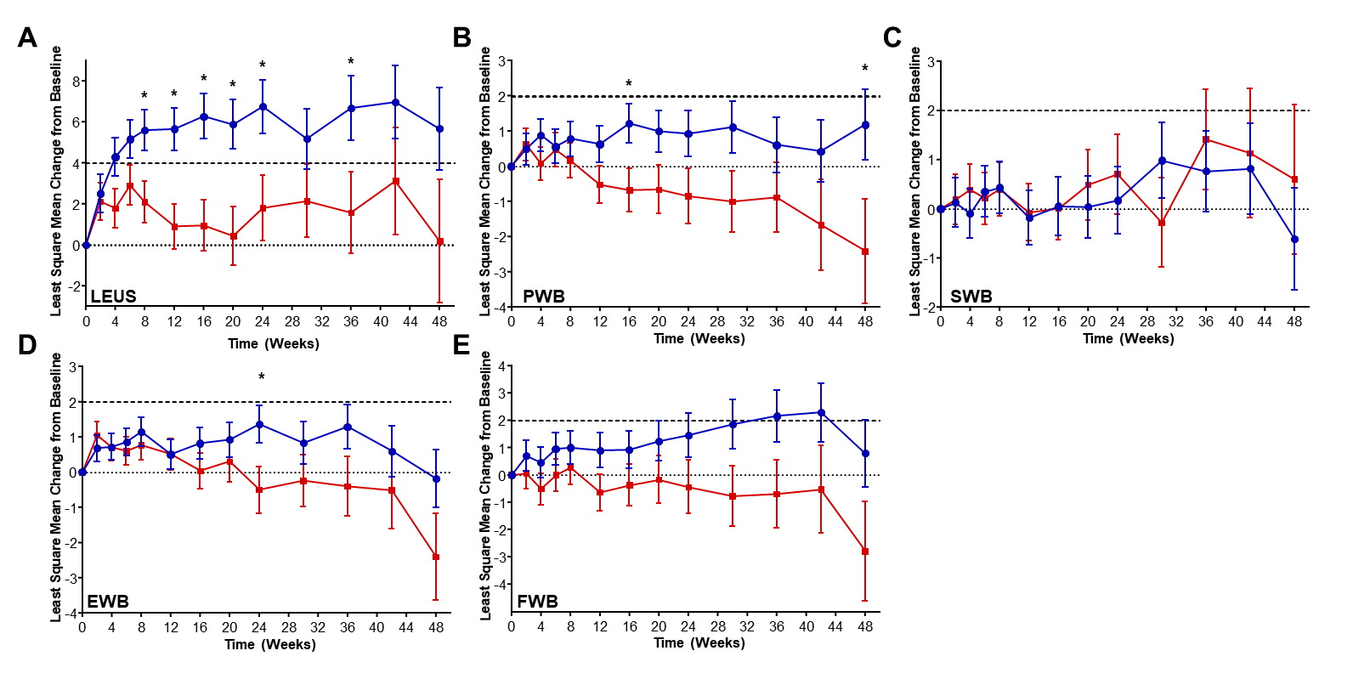
(●) idelalisib plus rituximab (■) placebo plus rituximab
Dashed lines correspond to the lower end of the MID range.
*P <0.05 for treatment difference based on a mixed model analysis.
EWB, emotional well-being; FWB, functional well-being; LeuS, leukemia sub-scale; MID, minimally important difference; PWB, physical well-being; SEM, standard error of the mean; SWB, social/family well-being.

Figure 2. Change in mean (SEM) composite measures over time between treatment groups. A) FACT-Leu total score; B) trial outcome index.
(●) idelalisib plus rituximab (■) placebo plus rituximab

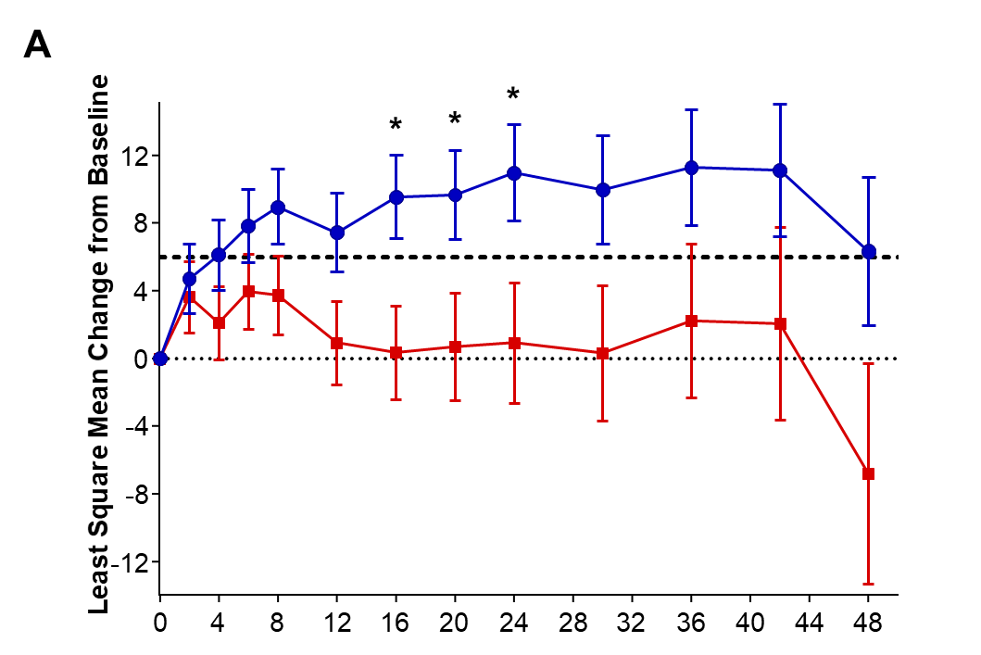

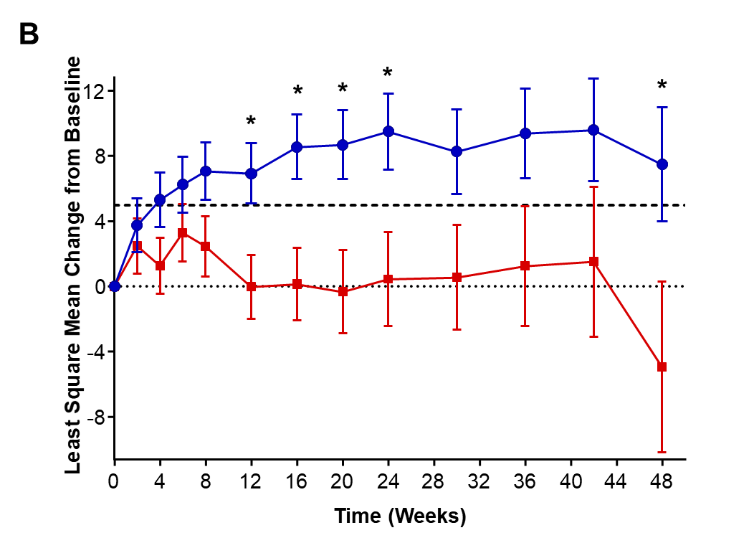
Dashed lines correspond to the lower end of the MID range.
*P <0.05 for treatment difference based on a mixed model analysis.
FACT-Leu, Functional Assessment of Cancer Therapy–Leukemia; MID, minimally important difference; SEM, standard error of the mean.
SUPPLEMENTARY MATERIALS

Impact of idelalisib on health-related quality of life in patients with relapsed chronic lymphocytic leukemia in a phase 3 randomized trial
Paolo Ghia,¹ Steven E. Coutre,² Bruce D. Cheson,³ Jacqueline C. Barrientos,⁴ Peter Hillmen,⁵ Andrew R. Pettitt,⁶ Andrew D. Zelenetz,⁷ Sanatan Shreay,⁸ Michael Hallek,⁹ Richard R. Furman¹⁰

¹Università Vita-Salute San Raffaele and IRCCS Istituto Scientifico San Raffaele, Milano, Italy
²Stanford School of Medicine, Stanford, CA, USA
³Georgetown University Hospital, Washington D.C., USA
⁴Zucker School of Medicine at Hofstra/Northwell, Hempstead, NY, USA
⁵St. James's University Hospital, Leeds, UK
⁶University of Liverpool, Liverpool, UK
⁷Memorial Sloan Kettering Cancer Center, New York, NY, USA
⁸Gilead Sciences, Inc, Foster City, CA, USA
⁹University Hospital of Cologne, Cologne, Germany
¹⁰Weill Cornell Medical College, New York, NY, USA

Supplementary Table 1. Assessment endpoints of FACT-Leu

Domain | Number of Items | Score Rangeª | MID^{b}
Leukemia subscale (LeuS) | 17 | 0–68 | 4–7
Physical well-being (PWB) | 7 | 0–28 | 2–3
Social/family well-being (S/FWB) | 7 | 0–28 | 2–3
Functional well-being (FWB) | 7 | 0–28 | 2–3
Emotional well-being (EWB) | 6 | 0–24 | 2
Composites  Trial outcome index (TOI)^{c}  FACT-Leu total^{d} | 31  44 | 0–124  0–176 | 5–6  6–12
ªHigher scores reflect better HRQL and lower symptom burden.
^{b}When examining differences for groups in a randomized trial, the lower end of the MID range is utilized (Trask PC, et al. Leuk Res. 2012 Apr;36(4):438-42).
^{c}TOI = LeuS + PWB + FWB
^{d}FACT-Leu Total = LeuS + PWB + S/FWB + EWB + FWB
EWB, emotional well-being; FACT-Leu, Functional Assessment of Cancer Therapy–Leukemia; FWB, functional well-being; LeuS, leukemia sub-scale; MID, minimally important difference; PWB, physical well-being; S/FWB; social/family well-being.

Supplementary Table 2. Compliance and completion rates of FACT-Leu questionnaire

Visit | Treatment | N | Compliance Rate | Completion Rate
 |  |  |  | PWB | S/FWB | EWB | FWB | LEUS
Week 2 | Idelalisib | 110 | 95.5 | 100 | 100 | 99 | 99 | 100
 | Placebo | 108 | 93.5 | 99 | 98 | 98 | 98 | 99
Week 4 | Idelalisib | 108 | 95.4 | 100 | 100 | 99 | 99 | 99
 | Placebo | 106 | 92.5 | 98 | 98 | 98 | 98 | 100
Week 6 | Idelalisib | 107 | 89.7 | 100 | 100 | 99 | 100 | 97.9
 | Placebo | 106 | 89.6 | 98.9 | 97.9 | 96.8 | 97.9 | 97.9
Week 8 | Idelalisib | 106 | 88.7 | 100 | 98.9 | 100 | 100 | 98.9
 | Placebo | 100 | 92.0 | 98.9 | 98.9 | 98.9 | 100 | 98.9
Week 12 | Idelalisib | 99 | 83.8 | 100 | 100 | 100 | 100 | 98.8
 | Placebo | 93 | 84.9 | 100 | 100 | 98.7 | 100 | 97.5
Week 16 | Idelalisib | 85 | 82.4 | 98.6 | 100 | 100 | 100 | 100
 | Placebo | 71 | 74.6 | 98.1 | 100 | 100 | 100 | 100
Week 20 | Idelalisib | 72 | 84.7 | 100 | 100 | 100 | 100 | 100
 | Placebo | 54 | 75.9 | 100 | 100 | 100 | 100 | 100
Week 24 | Idelalisib | 59 | 86.4 | 100 | 100 | 100 | 100 | 98
 | Placebo | 40 | 77.5 | 100 | 100 | 100 | 100 | 100
Week 30 | Idelalisib | 51 | 76.5 | 100 | 100 | 100 | 100 | 100
 | Placebo | 31 | 80.6 | 100 | 100 | 100 | 100 | 100
Week 36 | Idelalisib | 39 | 79.5 | 100 | 100 | 100 | 100 | 100
 | Placebo | 25 | 72.0 | 100 | 100 | 100 | 100 | 100
Week 42 | Idelalisib | 30 | 90.0 | 100 | 100 | 96.3 | 96.3 | 96.3
 | Placebo | 15 | 66.7 | 100 | 100 | 100 | 100 | 100
Week 48 | Idelalisib | 26 | 80.8 | 100 | 100 | 100 | 100 | 95.2
 | Placebo | 10 | 70.0 | 100 | 100 | 100 | 100 | 100
Subscale completion was defined as the proportion of patients who completed all questions in a domain at a scheduled time point relative to all patients who completed any question at that time point.
EWB, emotional well-being; FACT-Leu, Functional Assessment of Cancer Therapy–Leukemia; FWB, functional well-being; LeuS, leukemia sub-scale; PWB, physical well-being; S/FWB; social/family well-being.
Supplementary Table 3. Summary of time to symptom deteriorationª

Subscale | Idelalisib + rituximab  (N = 110) | Placebo + rituximab  (N = 110)
PWB  n  KM median (95% CI), weeks | 105  35.9 (19, NR) | 104  16.6 (11.7, 48.6)
FWB  n  KM median (95% CI), weeks | 103  38.3 (8.6, NR) | 102  20.1 (12.1, 64.3)
EWB  n  Median (95% CI), weeks | 103  42.1 (24, NR) | 102  47.9 (23.7, 48.6)
S/FWB  n  KM median (95% CI), weeks | 104  NR (20.9, NR) | 102  NR (12.6, NR)
ªSymptom deterioration is defined as a decrease of ≥3 points from baseline. Patients who did not experience a symptom deterioration compared with baseline were censored at their last available HRQL assessment time. To calculate symptom deterioration time, the following was used: Time to symptom deterioration (weeks) = (date of first symptom deterioration − date of randomization + 1)/7.
CI, confidence interval; EWB, emotional well-being; FWB, functional well-being; KM, Kaplan-Meier; n, number; NR, not reached; PWB, physical well-being; S/FWB; social/family well-being.

Supplementary Table 4. Mean and standard deviation of change from baseline in composite scores over time by age of patient

Subscale | Idelalisib + rituximab |  | Placebo + rituximab
 | Age (y) |  | Age (y)
 | <65  (n = 21) | ≥65  (n = 89) | <65  (n = 27) | ≥65  (n = 83)
FACT-Leu
Week 2 | 7.32 (12.5) | 3.99 (15.9) | 5.70 (19.1) | 3.02 (15.7)
Week 4 | 11.9 (19.7) | 5.05 (19.8) | 1.57 (24.5) | 2.34 (16.4)
Week 6 | 10.5 (23.3) | 8.45 (21.1) | 1.02 (22.5) | 3.99 (16.4)
Week 8 | 14.2 (28.4) | 8.37 (23.5) | 3.62 (24.7) | 4.66 (17.5)
Week 12 | 9.39 (27.7) | 7.35 (20.4) | −0.98 (30.7) | 3.44 (17.2)
Week 16 | 19.0 (23.2) | 7.44 (19.7) | 5.48 (22.9) | 4.04 (21.8)
Week 20 | 22.1 (22.0) | 7.89 (20.0) | 11.4 (17.5) | 8.49 (15.8)
Week 24 | 23.8 (25.6) | 7.01 (25.2) | 14.8 (15.2) | 3.90 (19.3)
Week 30 | 19.1 (29.9) | 5.20 (24.4) | 10.3 (22.9) | −0.90 (19.6)
Week 36 | 26.0 (26.5) | 10.7 (25.7) | 17.6 (10.1) | 3.25 (16.2)
Week 42 | 25.8 (32.6) | 6.32 (30.5) | 14.3 (18.4) | 9.42 (13.0)
Week 48 | 12.6 (14.1) | 7.67 (28.5) | 17.4 (15.5) | −12.7 (24.1)
TOI
Week 2 | 6.57 (10.2) | 3.33 (12.2) | 3.63 (16.4) | 2.03 (12.9)
Week 4 | 11.0 (16.7) | 4.13 (15.1) | 1.39 (21.2) | 1.03 (13.4)
Week 6 | 8.60 (20.6) | 7.14 (16.4) | 1.89 (20.4) | 3.08 (14.3)
Week 8 | 11.5 (25.6) | 6.90 (17.2) | 3.16 (21.6) | 3.00 (14.9)
Week 12 | 8.08 (25.2) | 7.94 (15.5) | −0.39 (26.4) | 2.30 (13.0)
Week 16 | 17.5 (21.0) | 6.74 (15.9) | 6.29 (18.5) | 2.52 (16.9)
Week 20 | 18.5 (20.0) | 7.39 (16.4) | 9.50 (16.4) | 4.94 (11.7)
Week 24 | 19.8 (23.1) | 7.08 (19.6) | 10.3 (14.5) | 3.60 (14.4)
Week 30 | 15.3 (27.2) | 6.66 (20.2) | 9.25 (21.1) | 0.47 (14.5)
Week 36 | 21.4 (23.6) | 10.64 (19.6) | 14.50 (10.5) | 2.78 (12.1)
Week 42 | 21.5 (28.1) | 7.38 (23.2) | 12.7 (17.2) | 6.91 (11.0)
Week 48 | 11.0 (11.4) | 10.5 (16.8) | 15.3 (13.1) | −8.50 (19.0)
Data presented as mean (standard deviation).
The number of evaluable subjects n is shown for baseline decreases over time.

Supplementary Figure 1. Mean change from baseline in composite scores over time stratified by age of patient

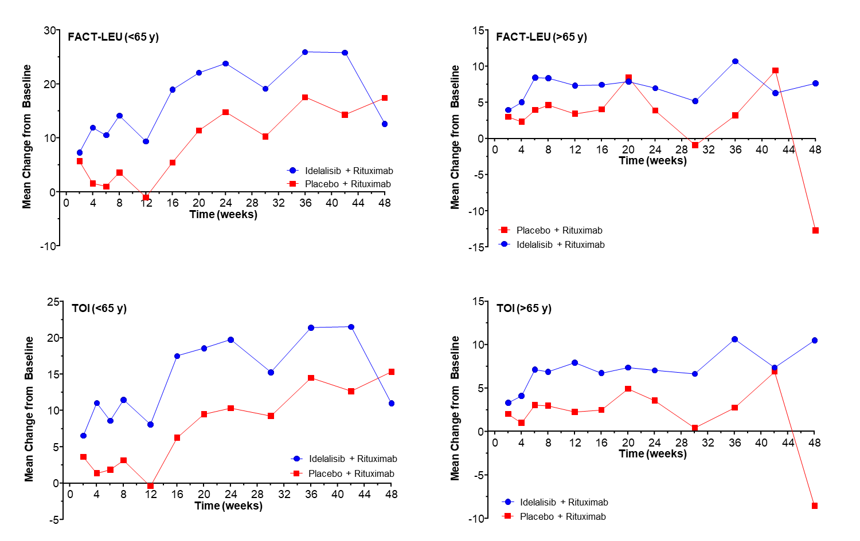
FACT-Leu, Functional Assessment of Cancer Therapy–Leukemia; TOI, trial outcome index.

