Controlling gas selectivity in molecular porous liquids by tuning the cage window size

Benjamin D. Egleston,[a] Konstantin V. Luzyanin,[b] Michael C Brand,[a] Rob Clowes,[a] Michael E. Briggs,[a] Rebecca L. Greenaway*[b] and Andrew I. Cooper*[a]

[a] B. D. Egleston, M. C Brand, R. Clowes, Dr. M. E. Briggs, Prof. A. I. Cooper  
Department of Chemistry and Materials Innovation Factory  
University of Liverpool  
Oxford Street, Liverpool, L7 3NY, U.K.  
E-mail: aicooper@liverpool.ac.uk

[b] Dr. K. V. Luzyanin, Dr. R. L. Greenaway  
Department of Chemistry  
University of Liverpool  
Crown Street, Liverpool, L69 7ZD, U.K.

E-mail: rebecca.greenaway@liverpool.ac.uk

Supporting information for this article is given via a link at the end of the document.

**Abstract:** Control of pore window size is the standard approach for tuning gas selectivity in porous solids. Here, we present the first example where this is translated into a molecular porous liquid formed from organic cage molecules. Reduction of the cage window size by chemical synthesis switches the selectivity from Xe-selective to CH4-selective, which is understood using 129Xe, 1H, and pulsed-field gradient NMR spectroscopy.

Porous liquids (PLs) are a new class of porous material.[1–3] They differ from conventional liquids because they have permanent, intrinsic micropores, in contrast to the transient, sub-molecular extrinsic voids found in all liquids (Figure 1). PLs can be categorized by their composition: Type 1 PLs are neat molecular liquids containing internal cavities; Type 2 PLs (Figure 1b) are solutions of porous molecules in a solvent that is size-excluded from the pores; and Type 3 PLs are dispersions of porous particles suspended in a cavity excluded liquid.[4] Examples of all three types of PL have been described recently,[5–12] and molecular simulations have led to a better understanding of their microstructure.[13–16]

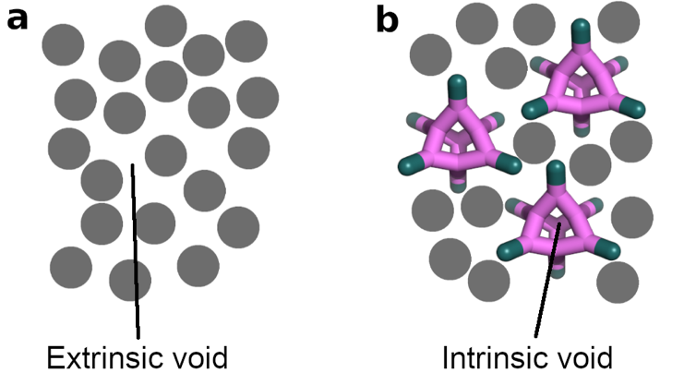

**Figure 1.** Diagram representing (a) conventional molecular liquids and (b) Type 2 molecular porous liquids. Solvent molecules are displayed as grey circles.

Porous organic cages (POCs) are a relatively new class of microporous solids that, unlike extended frameworks, are constructed from discrete organic molecules.[17–19] POCs are shape-persistent molecules containing an internal cavity, which allows them to be dissolved in solvents while retaining their pore structure, setting them apart from many other types of insoluble porous materials, such as zeolites, metal organic frameworks and covalent organic frameworks.[20] The discrete nature of POCs has led to attempts to produce Type 1 PLs,[13,21] and to the successful production of Type 2 PLs.[1,22] The latter PLs were obtained by dissolving POCs at high concentration in a solvent that was too bulky to pass through the windows of the cage. Recently, we investigated the uptake, gas selectivity and diffusion of different gases in a PL consisting of a scrambled [4+6] imine POC mixture dissolved in a bulky chlorinated solvent, hexachloropropene (HCP).[22] Dynamic covalent scrambling was used to produce highly soluble vertex-disordered POC mixtures.[23] The POC used in our first scrambled cage PL, **CC33:133**-*R* (Scheme 1), was based on the scrambling of the discrete POCs **CC3** and **CC13**. The gas uptake capacity of this PL correlated with the heats of adsorption of the respective solid, crystalline POC, **CC3**. This showed that the thermodynamic gas selectivity of the PL was governed by the structure and interactions of the constituent POC, suggesting to us a scheme for tuning selectivity in PLs.



**Scheme 1.** Synthesis of POCs for PLs. Conditions: (**CC33:133**-*R*) dichloromethane, room temperature, 72 h; (**CC15**-*R*) dichloromethane, 3Å molecular sieves, 50 °C, reverse Dean Stark, 24 h.

Here, we exploited the synthetic modularity of POC molecules to produce PLs with different gas selectivities. This is the first example of tuning gas selectivity in a Type 2 PL by using chemistry. The imine POC, **CC15**-*R* (Scheme 1), is a close analogue of **CC3**-*R* that has smaller pore windows, which are partially occluded by methyl groups (Figure 2a).[24] As a result,

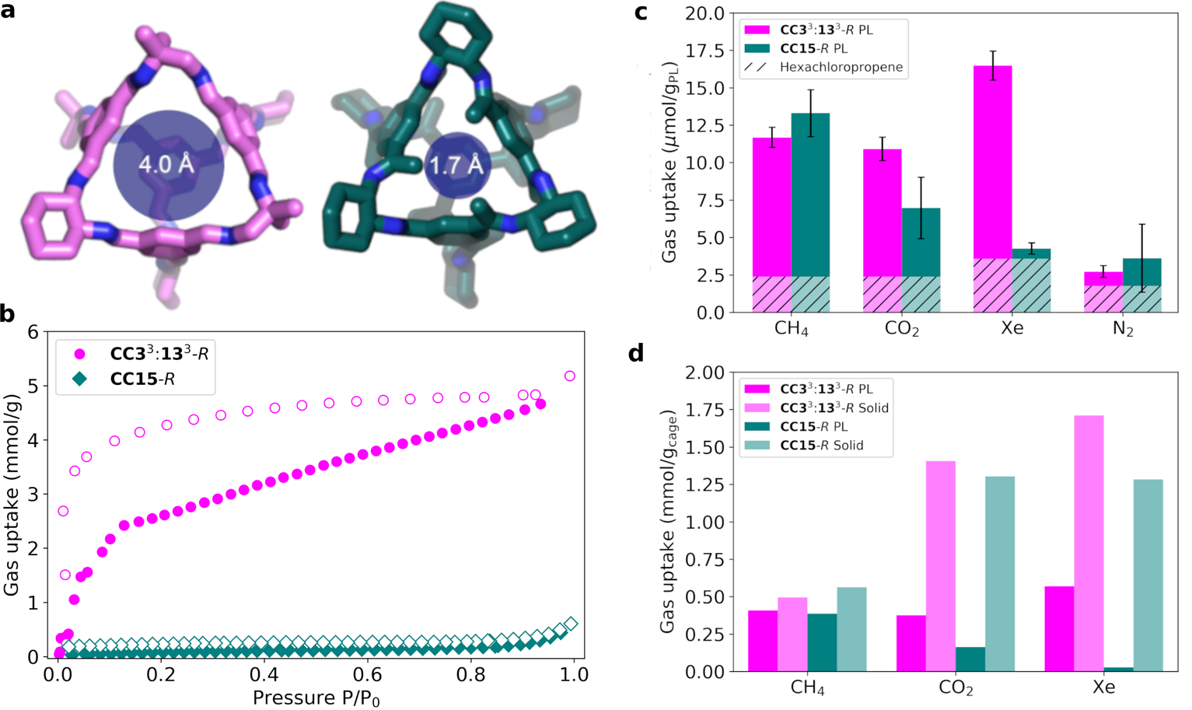

**Figure 2.** (a) Structures of the *trans*-**33133** component of the scrambled cage mixture **CC33:133**-*R* (magenta, left) and **CC15**-*R* (teal, right) with the average window diameters calculated using the pywindow package;[25] (b) N2 adsorption (filled) and desorption (empty) isotherms for **CC33:133**-*R* and **CC15**-*R*; (c) Uptake by volumetric gas evolution for CH4, CO2, Xe, and N2 for **CC33:133**-*R* (magenta) and **CC15**-*R* (teal) PLs, compared with uptake in hexachloropropene (HCP, dashed lines, overlaid). **CC33:133**-*R* PL at 4% w/v and **CC15**-*R* PL at 5% w/v; (d) Comparison of gas uptake in the liquid and solid state at 298 K for each POC. Uptake for PLs is adjusted by subtracting the native gas capacity of HCP to show the POC uptake only, and normalized to the mass of cage present.

**CC15**-*R* adsorbs very little N2 in the solid state, quite unlike **CC3**-*R* (Figure 2b). **CC15**-*R* still adsorbs smaller gas molecules, such as H2;[24] this is because the window size modulates the gas selectivity in the solid, crystalline state.

Here we sought to translate this principle for the first time into PLs. **CC15**-*R* was found to be soluble in HCP at a concentration (50 mgcage in 1 mLHCP, 5% w/v) that was high enough to investigate gas uptake properties, albeit at a significantly lower concentration than our previous **CC33:133**-*R* scrambled cage in this solvent (200 mgcage in mLHCP, 20% w/v).[22] We also tried to increase the solubility by forming a scrambled analogue of **CC15**-*R*, but HPLC analysis indicated that only **CC15**-*R* was formed; no scrambling occurred, possibly because the three methyl groups in 1,3,5-triacetylbenzene clash sterically with the methyl groups in 1,2-diamino-2-methylpropane, preventing scrambling.

To compare these PL systems directly, equimolar solutions (39 µmolcage in 1 mLHCP) were prepared in HCP of **CC33:133**-*R* (40 mgcage in 1 mLHCP, 4% w/v) and **CC15**-*R* (5% w/v), thus ensuring the same volumetric density of pore cavities in each case. Gas uptakes were determined for both PLs for CH4, CO2, Xe, and N2, using a guest displacement method that we described previously.[22] In all cases, the gas uptake was enhanced in the PLs compared to the neat solvent (Figure 2c). Because of the significantly lower cage concentration in these two PLs, gas uptakes were reduced for all gases with respect to our previous 20% w/v scrambled PL; for example, the CH4 uptake in the **CC33:133***-R* scrambled PL was 45.8 µmol/gPL at 20% w/v[22] compared to 11.7 µmol/gPL at 4% w/v here. In the case of N2, the improvement in uptake with respect to the neat solvent was low for both PLs compared to neat HCP (Figure 2c), reflecting our previous observations at higher cage concentrations.[22] For other gases, the gas solubility improvements were more marked and there were large differences between the two PLs. The Xe uptake in **CC33:133***-R* PL (16.6 µmol/gPL) was almost four times that measured for **CC15**-*R* PL (4.3 µmol/gPL) at the same pore concentration. The **CC33:133***-R* PL absorbs more Xe than the other gases tested, reflecting the thermodynamic preference for Xe observed previously in these imine POCs,[26] but this is totally lost in the PL derived from the methylated analogue, **CC15**-*R*. Furthermore, the **CC15**-*R* PL absorbs CH4 most preferentially, and more effectively than **CC33:133***-R*; that is, the **CC33:133***-R* PL is xenon selective, while the **CC15**-*R* PL is CH4 selective.

The gas uptake in these two PLs can be compared directly to the gas uptake in the corresponding POC solids by subtracting the baseline solubility in HCP and normalizing to the mass of cage present (Figure 2d). Nitrogen was not included in these comparisons since the solid-state sorption measurements were carried out at 77 K, not at 298 K. For CH4, the mass-normalized gas uptake in the cages in the PLs (0.409 mmol/gcage for **CC33:133**-*R* PL, 0.386 mmol/gcage for **CC15**-*R* PL) is broadly comparable to the uptake observed in the solid state (0.495 mmol/gcage for **CC33:133**-*R* solid, 0.562 mmol/gcage **CC15**-*R* solid). However, this does not hold for Xe and CO2. The solid state CO2 uptakes for the cages (1.407 mmol/gcage for **CC33:133**-*R* solid, 1.304 mmol/gcage for **CC15**-*R* solid) are around one order of magnitude higher than the mass-normalized uptakes for the PLs (0.375 mmol/gcage for **CC33:133**-*R* PL, 0.164 mmol/gcage for **CC15**-*R* PL). This difference can be attributed, at least in part, to the interconnected solid-state porosity that comprises both intrinsic pores (inside cages) and extrinsic pores (between cages), whereas these PLs only have intrinsic pores.

For Xe, there is a much larger disparity in gas uptakes in these PLs (0.568 mmol/gcage for **CC33:133**-*R* PL, 0.027 mmol/gcage for **CC15**-*R* PL); this does not reflect the solid state trend for these POCs, where both of the cage materials adsorb significant amounts of Xe (1.710 mmol/gcage for **CC33:133**-*R* solid, 1.283 mmol/gcage for **CC15**-*R* solid). Effectively, the Xe uptake has been ‘shut off’ for **CC15**-*R* when it is translated into the PL state. This suggests that the Xe uptake in solid **CC15**-*R* may be facilitated by extrinsic intermolecular pores that are accessible by slow diffusion through the cage cavities.[24]

To investigate these differences, 1H and 129Xe NMR spectroscopy were used to characterize the chemical environment of the gases in both the PLs and in the neat solvent, HCP (Figure 3). This allowed us to probe the extent of gas binding in each PL, since the 1H and 129Xe nuclei are highly sensitive to their chemical environment, leading to upfield shifts when the cage cavities are occupied. In the 129Xe spectra, the **CC33:133***-R* PL exhibits a large upfield shift relative to HCP (Δδ = −38.6 ppm), whereas this shift is relatively small for the **CC15**-*R* PL (Δδ = −4.7 ppm), where the Xe signal is also weak. This shows that the Xe gas cannot easily occupy the pores in the **CC15**-*R* PL, whereas in **CC33:133***-R* PL, the much larger downfield shift is due to the Xe gas readily occupying the cage cavities. This confirms that Xe uptake in the **CC15**-*R* PL is switched off by reducing the cage window size.

This relationship between gas uptake and downfield chemical shift also holds for CH4. In both PLs, there is a significant upfield shift compared to HCP (Δδ = −1.50 ppm in **CC33:133***-R* PL, Δδ = −2.38 ppm in **CC15**-*R* PL). The larger shift observed in the **CC15**-*R* PL shows that CH4 is experiencing a larger shielding effect. 1H NMR spectroscopy can be used to quantify the saturation concentrations of CH4 by using a sealed, calibrated d2-DCM/TMS capillary. The gas uptakes measured by NMR (17.5 µmol/gPL in **CC33:133**-*R* PL, 21.5 µmol/gPL in **CC15**-*R* PL) are higher than for the gas displacement measurements (11.6 µmol/gPL in **CC33:133**-*R* PL, 13.3 µmol/gPL in **CC15**-*R* PL), reflecting trends in a previous study.[22] This is because gas evolution experiments cannot release all of the gas dissolved in a PL because of the baseline gas solubility in both HCP and in the displacement solvent.

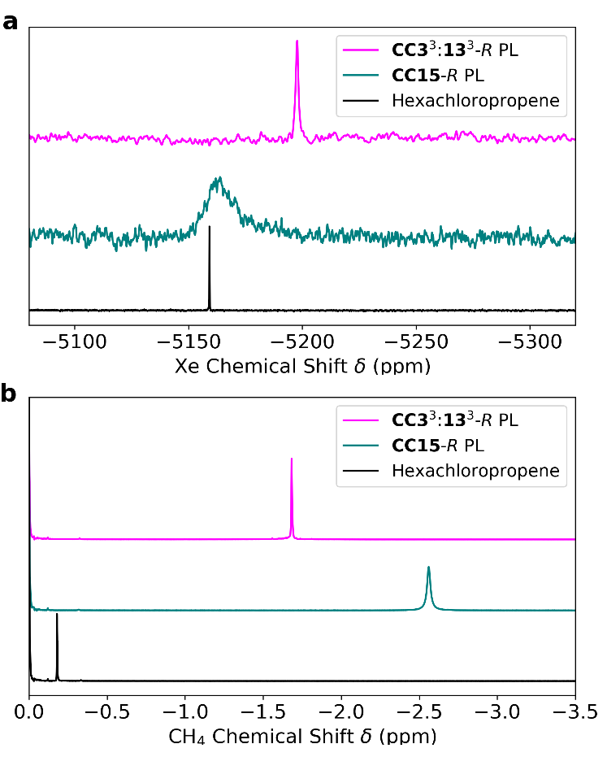

**Figure 3.** (a)129Xe and (b) 1H NMR spectra for Xe and CH4 gas in **CC33:133**-*R* and **CC15**-*R* PLs compared to in neat HCP. **CC33:133***-R* PL at 4% w/v and **CC15**-*R* PL at 5% w/v.

Next, pulsed-field gradient (PFG) NMR experiments were carried out to measure diffusion of CH4 in the two PL systems. The results of these experiments are related to the binding of CH4 in the PLs. The measured diffusion co-efficients for each POC (6.14 × 10-11 m2/s for **CC33:133**-*R*, 6.33 × 10-11 m2/s for **CC15**-*R*) and sample viscosities (Table S6) were used to calculate solvodynamic radii using the Stokes-Einstein equation for the two POCs in the PLs (8.2 Å for **CC33:133**-*R*, 8.3 Å for **CC15**-*R*); these values agree with the expected size of a [4+6] imine cage.[27] The diffusion co-efficients for CH4 in the two PLs (5.43 × 10-10 m2/s in **CC33:133**-*R* PL, 4.58 × 10-10 m2/s in **CC15**-*R* PL) are significantly lower than in neat HCP (1.34 × 10-9 m2/s), indicating that association of the gas with the cage is occurring and that this is observable by PFG NMR. This information can be used to calculate the fraction of gas molecules occupying the cage cavities (Xocc), as well as the association constant (Ka) for each system.[28] In the **CC33:133**-*R* PL, Xocc = 0.49, while for the **CC15**-*R* PL Xocc = 0.60. The corresponding association constants for CH4 in each PL can be calculated from the diffusion co-efficients measured for CH4 in each PL (Ka = 2.71 × 104 mol-1 dm3 for CH4 in **CC33:133**-*R* PL, Ka = 4.36 × 104 mol-1 dm3 for CH4 in **CC15**-*R* PL). These measurements confirm that CH4 more preferentially occupies the cavity in the **CC15**-*R* PL than in the **CC33:133**-*R* PL, in keeping with the gas uptake measurements, where the **CC15**-*R* PL absorbs more CH4 (Figure 2c).

Retention of CH4 in these PLs was also examined by measuring the kinetics of gas loss using 1H NMR spectroscopy. The CH4 concentration at a series of time intervals was recorded and the rate of loss of CH4 was compared after normalizing the curves to the saturation concentration for each porous liquid (Figure S13). After 1 day, the **CC15**-*R* PL retained 23% more of the initial CH4 concentration when compared with **CC33:133**-*R* PL, and over a period of *ca.* 2 days, the CH4 was lost more slowly from the **CC15**-R PL than from the **CC33:133**-*R* PL. This shows that narrowing the pore diameter in the molecular cage component in a PL can also improve the retention of gases over time.

In summary, modification of the window size in POCs can modulate the gas selectivity in PLs, demonstrating that a key structure-function design principle in porous solids can be translated into these new materials: for example, we can shut off Xe absorption by narrowing the cage window in the **CC15**-*R* PL (Figure 2d). There are also some differences between these two types of porous materials: for example, for CO2 (Figure 2d), the amount of gas per cage is significantly lower in the PLs, probably because the PLs, unlike the corresponding porous solids, lack intermolecular pores between cages that allow multilayer adsorption and pore filling as saturation is approached.

In the longer term, this offers the potential of flowable, gas-selective liquids for separation processes; for example, where a gas-selective PL is cycled between a cold absorption zone and a hot desorption zone. The relatively modest viscosities of these PLs (up to 11.7 cP at 20% w/v)[22] should allow such processes. The selectivity might be increased further by designing analogous cage materials with higher solubilities; likewise, eliminating the solvent altogether could enhance selectivity since the carrier solvent in these Type 2 PLs is relatively unselective, although in that case, liquid viscosity might be a major challenge.

Acknowledgements

We thank the Engineering and Physical Sciences Research Council (EPSRC) under the Grants EP/N004884/1 and EP/R005710/1, and the European Research Council under FP7, RobOT, ERC Grant Agreement No. 321156, for financial support. R.L.G. thanks the Royal Society for a University Research Fellowship. We acknowledge the MicroBioRefinery for assistance with QTOF-MS measurements. We thank Dr. Tom Hasell (University of Liverpool) and Prof. Stuart James (Queen’s University Belfast) for helpful discussions.

**Keywords:** adsorption selectivity • porous organic cages • porous liquids

[1] N. Giri, M. G. Del Pópolo, G. Melaugh, R. L. Greenaway, K. Rätzke, T. Koschine, L. Pison, M. F. C. Gomes, A. I. Cooper, S. L. James, *Nature* **2015**, *527*, 216–220.

[2] S. L. James, *Adv. Mater.* **2016**, *28*, 5712–5716.

[3] A. I. Cooper, *ACS Cent. Sci.* **2017**, *3*, 544–553.

[4] N. O’Reilly, N. Giri, S. L. James, *Chem. - A Eur. J.* **2007**, *13*, 3020–3025.

[5] J. Zhang, S. H. Chai, Z. A. Qiao, S. M. Mahurin, J. Chen, Y. Fang, S. Wan, K. Nelson, P. Zhang, S. Dai, *Angew. Chemie - Int. Ed.* **2015**, *54*, 932–936.

[6] P. Li, J. A. Schott, J. Zhang, S. M. Mahurin, Y. Sheng, X. Hu, G. Cui, D. Yao, S. Brown, Y. Zheng, et al., *Angew. Chemie Int. Ed.* **2017**, *56*, 14958.

[7] S. Liu, J. Liu, X. Hou, T. Xu, J. Tong, J. Zhang, B. Ye, B. Liu, *Langmuir* **2018**, *34*, 3654–3660.

[8] X. Li, Y. Ding, L. Guo, Q. Liao, X. Zhu, *Energy* **2019**, *171*, 109–119.

[9] P. Li, H. Chen, J. A. Schott, B. Li, Y. Zheng, **2019**, 1515–1519.

[10] W. Shan, P. F. Fulvio, L. Kong, J. A. Schott, C. L. Do-Thanh, T. Tian, X. Hu, S. M. Mahurin, H. Xing, S. Dai, *ACS Appl. Mater. Interfaces* **2018**, *10*, 32–36.

[11] T. Shi, Y. Zheng, T. Wang, P. Li, Y. Wang, D. Yao, *ChemPhysChem* **2018**, *19*, 130–137.

[12] X. Wang, D. Shang, S. Zeng, Y. Wang, X. Zhang, X. Zhang, J. Liu, *J. Chem. Thermodyn.* **2019**, *128*, 415–423.

[13] G. Melaugh, N. Giri, C. E. Davidson, S. L. James, M. G. Del Pópolo, *Phys. Chem. Chem. Phys.* **2014**, *16*, 9422–31.

[14] F. Zhang, F. Yang, J. Huang, B. G. Sumpter, R. Qiao, *J. Phys. Chem. B* **2016**, *120*, 7195–7200.

[15] F. Zhang, Y. He, J. Huang, B. G. Sumpter, R. Qiao, *J. Phys. Chem. C* **2017**, *121*, 12426.

[16] M. Costa Gomes, L. Pison, C. Červinka, A. Padua, *Angew. Chemie Int. Ed.* **2018**, *54*, 932-936.

[17] F. Beuerle, B. Gole, *Angew. Chemie - Int. Ed.* **2018**, 2–31.

[18] P. S. Mukherjee, K. Acharyya, *Angew. Chemie Int. Ed.* **2019**, DOI 10.1002/anie.201900163.

[19] M. Mastalerz, *Acc. Chem. Res.* **2018**, *51*, 2411–2422.

[20] T. Hasell, A. I. Cooper, *Nat. Rev. Mater.* **2016**, *1*, 16053.

[21] N. Giri, C. E. Davidson, G. Melaugh, M. G. Del Pópolo, J. T. a. Jones, T. Hasell, A. I. Cooper, P. N. Horton, M. B. Hursthouse, S. L. James, *Chem. Sci.* **2012**, *3*, 2153.

[22] R. L. Greenaway, D. Holden, E. G. B. Eden, A. Stephenson, C. W. Yong, M. J. Bennison, T. Hasell, M. E. Briggs, S. L. James, A. I. Cooper, *Chem. Sci.* **2017**, *8*, 2640–2651.

[23] S. Jiang, J. T. a Jones, T. Hasell, C. E. Blythe, D. J. Adams, A. Trewin, A. I. Cooper, *Nat. Commun.* **2011**, *2*, 207.

[24] A. G. Slater, P. S. Reiss, A. Pulido, M. A. Little, D. L. Holden, L. Chen, S. Y. Chong, B. M. Alston, R. Clowes, M. Haranczyk, et al., *ACS Cent. Sci.* **2017**, *3*, 734–742.

[25] M. Miklitz, K. E. Jelfs, *J. Chem. Inf. Model.* **2018**, *58*, 2387–2391.

[26] L. Chen, P. S. Reiss, S. Y. Chong, D. Holden, K. E. Jelfs, T. Hasell, M. A. Little, A. Kewley, M. E. Briggs, A. Stephenson, et al., *Nat Mater* **2014**, *13*, 954–960.

[27] R. L. Greenaway, V. Santolini, M. J. Bennison, B. M. Alston, C. J. Pugh, M. A. Little, M. Miklitz, E. G. B. Eden-Rump, R. Clowes, A. Shakil, et al., *Nat. Commun.* **2018**, *9*, 2849.

[28] K. S. Cameron, L. Fielding, *J. Org. Chem.* **2001**, *66*, 6891–6895.

|  |  |  |  |  |
| --- | --- | --- | --- | --- |
| COMMUNICATION | | | | |
| Narrowing the windows of the organic cage used to form molecular porous liquids leads to tuning of the gas selectivity. |  | ((Insert TOC Graphic here)) |  | Benjamin D. Egleston, Konstantin V. Luzyanin, Michael C Brand, Rob Clowes, Michael E. Briggs, Rebecca L. Greenaway and Andrew I. Cooper  Page No. – Page No.  Controlling gas selectivity in molecular porous liquids by tuning the cage window size |
|  |  |