30th CIRP Design 2020 (CIRP Design 2020)

A computational approach for using social networking platforms to support creative idea generation
Ji Hana,*, Dongmyung Park^{b}, Hannah Forbesa, Dirk Schaefera
a Systems Realization Laboratory, Division of Industrial Design, University of Liverpool, Liverpool, L69 3GH, UK
b Dyson School of Design Engineering, Imperial College London, 25 Exhibition Road, London, SW7 2DB, UK
* Corresponding author. Tel.: +44-151-795-7360. E-mail address: ji.han@liverpool.co.uk

Abstract

Good design relies upon the generation of good ideas, but producing ideas, especially creative ones, is increasingly challenging. This may be due to limited relevant information, lack of creative skills, design fixation, or as a result of too many previously existing ideas. Conventional creativity tools, such as brainstorming and TRIZ, as well as advanced methods, such as design-by-analogy, are often employed by designers for idea generation to alleviate some of these challenges. In recent years, computational creativity tools have emerged to support creative idea generation. However, most of these computational tools are data-driven, and thereby employ various databases, for example, existing databases such as the ConceptNet containing past common-sense knowledge, and customized ones containing limited information. The limitations of these databases have constrained the capability of the computational creativity tools. Social media platforms, such as Twitter and Wikipedia, which allow users to create web-based content, have been reported to have billions of users. It can be considered a huge ‘unorganized’ database of information created by a crowd. However, to date little work has been done on the utilization of such crowd-generated knowledge from social media to support actual design activities, especially during the early stages of the design process. In this paper, the authors propose a computational approach to retrieve, process, and reuse the textual knowledge from social networks to prompt designers’ creative mind in producing ideas for new product design and development. They also propose a novel approach to construct crowd knowledge databases, which can be employed by computational tools, as well as used individually, for supporting creative idea generation. A case study involving the use of an existing social media analysis tool to construct a crowd database for helping designers produce ideas has been conducted to provide insights on implementing the proposed approach for creative idea generation.

©2020 The Authors. Published by Elsevier B. V.
Peer-review under responsibility of the scientific committee of the CIRP Design Conference 2020

Keywords: Creativity; Social Media; Idea Generation; Social Networking; Ideation.

Introduction

Design plays an increasingly significant role in modern day industry. For instance, a recent report indicates that, in the UK, design contributed £85.2 billion in gross value added (GVA) which is equivalent to 7% of the UK total GVA in 2016 [1]. It is equivalent to the size of the distribution, transportation, accommodation and food sectors. Coming up with good designs relies upon the generation of good ideas. However, producing ideas, especially creative ones, is increasingly challenging. This is due to issues such as numerous pre-existing ideas, limited relevant knowledge, lack of creative minds or creativity-fostering skills, and time pressure [2].

Many methods have been explored to support designers in generating creative ideas, such as brainstorming [3], TRIZ [4], design-by-analogy [5, 6], and concept synthesis [7]. However, these conventional methods rely heavily on the user’s experience and knowledge, and some are also difficult to master. Many designers prefer not to use any of these idea generation methods because of ‘seemingly cumbersome steps that create long bouts of work’ [8]. In recent years, several computational (using or relating to computers) creativity tools have emerged for supporting idea generation, such as the Combinator [9], the Retriever [2], and Idea Inspire 4.0 [10]. However, most of the tools employ existing databases, such as the ConceptNet [11, 12], which have limitations, such as a limited amount and variety of knowledge, and lack of up-to-date knowledge. The limitations of the databases have thereby constrained the capability of the computational creativity tools. Therefore, there is a need to explore a new approach of constructing databases, using up-to-date sources that involve various information, for supporting computational design tools.
Industry 4.0 has highlighted the use of networking technologies to provide opportunities for machines, devices and people to communicate and connect with each other. Social media platforms, such as Facebook and Wikipedia, allow users to create, share and edit information, and construct relationships through interactions and collaborations [13]. Thereby, social media has great potential to be applied within the Industry 4.0 realm to support connection, communication, collaboration, and interaction among people. It could be considered a source containing a great amount of knowledge, which is up-to-date, useful, and diverse, created by a crowd of users.
In this paper, the authors propose a computational approach to retrieve, process, and reuse the textual knowledge from social networking platforms. It aims to prompt designers’ creative mind in producing ideas for new product design and development. A novel approach to create design databases for computational idea generation support tools, as well as for supporting designers in idea generation directly, is included in the computational approach. The following sections 2 and 3 present related work in terms of design creativity and social media in design. Section 4 describes the computational approach, and section 5 provides a case study demonstrating the use of the computational approach or the database in solving practical design problems. Discussions and conclusion are provided in section 6 and 7, respectively.

Design creativity

Creativity is an essential feature of human intelligence [14], but it has often been considered an elusive term. The complex nature of creativity has led to various definitions, such as ‘the act of making new relationships from old ideas’ [15] and ‘the production of novel, useful products’ [16]. Among them, the definition given by Amabile [17], ‘the process by which something so judged (to be creative) is produced’, is the most frequently used one. Creativity is central to human activity, which is considered a powerful force in individual and team success [18] and a key to business success [19]. Goldschmidt and Tatsa [20] have indicated that good ideas are considered the source from which creativity springs. This shows that idea generation, especially creative (good) idea generation, is positively related to creativity.
In design, Sarkar and Chakrabarti [21] have indicated that novelty and usefulness are the two core elements constituting creativity. However, through reviewing a number of recent publications in design journals, Han et al. [22] reveal that novelty, usefulness and surprise are the three core elements used to define and describe creativity in design. Thereby, in order to support creative design, a method or tool need to support designers in producing creative ideas that are novel, useful and surprising.

As previously illustrated, there is a growing interest in exploring computational idea generation support tools, also known as computational creativity tools. However, the databases employed by such tools have frequently limited their performance. For example, the Combinator [9] uses a customized database, which was created by crawling texts from product design websites, for producing combinational ideas (stimuli) in text forms. However, the database contains many noise data reducing the effectiveness of the tool. The Retriever [2] produces new ontologies to support reasoning for prompting creative idea generation, which has employed the ConceptNet as its database. The ConceptNet [11, 12] is a knowledge network used to support computers to understand the meanings of words. However, most of the data contained represents commonsense knowledge. Idea Inspire 4.0 [10] supports analogical design in engineering design problems, but the development of its database is slow and time-consuming. Therefore, there exists a need for an efficient and effective approach to construct design databases that involve various valuable up-to-date knowledge.
In convention, creativity has been classified into Big-C creativity or H-creativity (Historical-creativity) and little-c creativity or P-creativity (psychological-creativity) [23, 24]. Big-C creativity indicates generating an idea that is not existed in history, while little-c creativity represents producing ideas that are new to an individual. Many design creativity studies have focused on little-c creativity, exploring creativity at an individual level, and have neglected the importance of groups, teams and crowds in supporting design creativity. In recent years, several studies have explored team or group creativity, such as Paulus and Dzindolet [25], Hülsheger et al. [26] and Nijstad and Stroebe [27]. They have revealed the importance of collaboration in creative activities. Further studies have indicated that this kind of collaborative creativity can produce superior outcomes comparing to individual creativity [28]. Besides, a few studies have explored design creativity at the crowd level. Goucher-Lambert and Cagan [29] have explored the use of crowd workforce to support designers in idea generation. The study result indicates that crowdsourcing has the potential to produce impactful inspirational stimuli to solve open-ended design problems. Open design and innovation is a growing trend which acknowledges and facilitates ‘non-professional’ forms of creativity, emphasizing the power of the crowd [30]. The Hyperloop design competition, proposed by Elon Musk, is an example of open design. Therefore, employing the crowd or using crowd knowledge for design knowledge database construction could potentially benefit designers in generating creative ideas.

Social media, social networking platforms, and design

Social media is defined as ‘a group of Internet-based applications that build on the ideological and technological foundations of Web 2.0, and that allow the creation and exchange of User Generated Content’ [31]. A recent report stated that there are 3.48 billion social media users in 2019 [32], creating millions of posts each minute. Although there exists misinformation on social media, a recent study shows that the misinformation on Facebook have fallen sharply since 2016 due to implemented combat misinformation actions [33]. Thereby, social media could be considered a reasonably reliable source containing a huge amount of knowledge generated by the crowd.

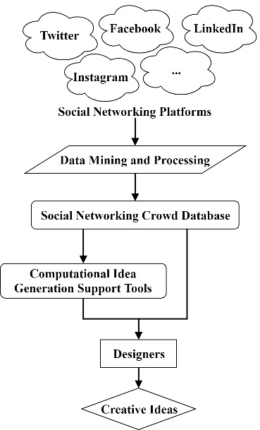
Social presence/ media richness and self-presentation/ self-disclosure are the two core elements of social media [31]. Social presence/ media richness represents the amount of information that can be transmitted in a given interval of time, and self-presentation/ self-disclosure shows the revelation of personal information, either conscious or unconscious, consistent with the image that someone would prefer to give [31]. Social media has been classified into six different types based on social presence/ media richness and self-presentation/ self-disclosure, as shown in Fig. 1.
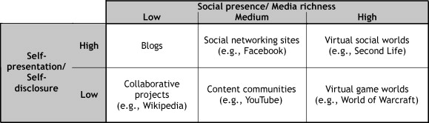

Fig. 1. Classification of social media [31]

The classification involves social media ranging from low social presence and low self-presentation ones such as collaborative projects, for example, Wikipedia, to high social presence and high self-presentation ones such as virtual social worlds, for example, Second Life. The social media that is focused in this study is the medium social presence and high self-presentation ones, known as social networking platforms. Social networking platforms are referred to by various names, such as social networking sites, social network sites, social networking websites, and social networks. It is one of the fastest-growing areas on the Internet, which is regarded an online communication tool allowing users to create public profiles and to interact with each other in their respective networks [34]. Social networking platforms have been used for word-of-mouth marketing [35], internal communications within larger enterprises [36], and so forth.
In recent years, social networking platforms have been increasingly used to support design activities, but mainly focused on consumer and product research. For instance, Carr et al. [37] explored the use of social networking platforms in product development to acquire consumer and product relevant information. They indicated that insights collected from social networking sites platforms are in line with those obtained from traditional methods. This has confirmed the validity of using the outputs from social networking platforms to support design. However, further studies on employing social networking platforms in design, especially idea generation, are needed.

Using social networking platforms to support creative idea generation

Based on the preceding, social networking platforms have the potential to be used to support designers in their idea generation by utilizing the contained up-to-date crowd-provided information. Thereby, an approach retrieving, processing and reusing the textual knowledge from social networking platforms to support designers in generating creative ideas is proposed, as shown in Fig. 2. The approach could also be used to support computational idea generation support tools via the constructed social networking crowd database.

Fig. 2. An approach of using social networking platforms to support the generation of creative ideas

As shown in the figure, the approach starts with retrieving required data from social networking platforms by using data mining techniques, and following by data processing. In the current formula, the approach is mainly targeting on textual data rather than pictorial data, as it is more efficient and effective to retrieve and process textual data with existing techniques. Although pictorial stimuli have been shown to have better effects than textual stimuli in supporting creative idea generation [38], textual stimuli are still considered useful in idea generation, especially for improving idea novelty [39]. Examples of using textual stimuli to prompt creativity involves Georgiev et al. [40] who proposed an approach to support the generation of creative ideas by creating new textual scenes through combining existing textual scenes from different contexts, and Taura and Nagai [7, 41, 42] who have investigated different linguistic interpretations of synthesized ideas in idea generation.
Data retrieved from social networking platforms is based on user’s query by using data mining techniques. For instance, if a user is planning to generate new ideas for designing a kettle, then a huge number of posts that involve ‘kettle’ posted during a certain period of time will be retrieved from various social networking platforms, such as Twitter and Facebook. Existing data mining tools, such as Scrapy, could be used to support this process. After this, the textual data retrieved needs to be processed to extract useful knowledge, or ideas in this paper, by employing natural language processing techniques. This could be done by using NLTK (Natural Language Toolkit). Using the ‘kettle’ example, words or phrases that appeared commonly with ‘kettle’ in social networks posts could be extracted, such as ‘coffee’, and ‘morning’. This could explore the ideas that are most related to the targeting idea ‘kettle’.
The information created by the crowd (the users) on social networking platforms often involves sentimental and emotional aspects. Thereby, sentiment and emotionality of the retrieved textual data could also be analyzed to provide more insights. This could support designers in making decisions during idea generation. For instance, if ‘coffee’ is positively related to ‘kettle’, then it indicates that the designer should enhance features that are related to this positive idea when designing a new kettle, and vice versa.

Table 1. A proposed structure of the social networking crowd database at an individual level

 | Targeting Idea
 | Relatedness | Sentiment
Idea 1 | 0.82 | +0.25
Idea 2 | 0.56 | +0.66
Idea 3 | 0.82 | -0.42
… | … | …

Based on the brief discussion above, a potential structure of the social networking crowd database has been proposed, as shown in Table 1. However, please note that the proposed database structure is at an individual level rather than an overall level. In other words, the proposed structure only indicates the relationships between a targeting idea and other co-appeared ideas. The targeting idea represents the user’s query, such as ‘kettle’ in the example above. The other co-appeared ideas represent the ideas extracted from the retrieved posts which contain the user’s query or the targeting idea, such as ‘coffee’ and ‘morning’ in the ‘kettle’ example. The overall structure of the proposed social networking crowd database will be explored in further studies.
The current individual-level database structure involves two core parameters: relatedness and sentiment. In this study, relatedness indicates how close two ideas are, or how frequent two ideas have appeared together in the retrieved posts. Sentiment indicates whether an idea is positive or negative, which could be measured on individual text segments as well as a whole text.
The database could then be used to support designers in generating creative ideas according to the specific retrieval query. It could provide designers with knowledge of how the crowd perceive the targeting idea. To be more specific, relatedness could support users understand how close an idea to the targeting idea is, and sentiment could provide additional insights to help users in decision making.
In addition to supporting designers in a direct manner, the social networking crowd database could also be employed by computational idea generational support tools. The database could support the tools in creating useful stimuli for prompting the tool users’ creative minds. In order for computers to understand the database, the two parameters, relatedness and sentiment, need to be described using numerical values, as shown in Table 1. For instance, relatedness could be measured with a value from 0 to 1, ranging from low to high relatedness. Sentiment could be represented by a value ranging from -1 to +1. A negative value indicates a negative sentiment and vice versa, of which a higher absolute value suggests a stronger sentiment. A sentiment values close to 0 implies a neutral sentiment.

Case study

A case study is conducted to demonstrate the use of the proposed computational approach of employing social networking platforms to support the generation of creative ideas. The case study involves individual designers coming up with ideas to tackle a design challenge with the support of a pre-constructed social networking crowd database and following by evaluations as well as interviews.

However, the current case study is focused on using the database to support designers in a direct manner, rather than employing the database in a computational idea generation support tool, which will be explored in further studies.
Dedicated social networking platforms data mining and processing tools have not been developed in this study, as there are many available social media analysis tools. For example, Netbase is designed to deliver accurate and deep customer insights by analyzing customer data from social media, which is mainly used to support marketing research and customer service; Keyhole is developed to monitor campaigns, brands, events through analyzing hashtags in social media; and Awario is specialized in tracking brand mentions on social media to support customer engagement, market research, and brand awareness.
In this study, Condor, a social media analysis tool developed by Gloor [43], is employed, as the tool is free for academic use. Condor allows users to visualize and measure the content and sentiment of social networking platforms. This is in line with the ‘Data Mining and Processing’ for constructing the social networking crowd database in the proposed creative idea generation approach. It can fetch textual data from social networking platforms, such as Facebook and Twitter, based on a user query. The tool can then analyze the data and calculate the number of appearances of words and phrases. Also, it can indicate the sentiment of words and phrases through measuring the sentiment of the whole text where the words and phrases belong. The tool will indicate the number of positive, negative and neutral texts of the words and phrases. These data can be visualized in a word cloud view as well as a static view.
In this case study, the relatedness values are calculated by equation (1). R_{i} is the relatedness value of idea i, while A_{i} and A_{t} are the number of appearances of idea i and the targeting idea t in the retrieved texts, respectively. It indicates how close idea i to the targeting idea t is. The sentiment values are computed with equation (2). In the equation, S_{j} is the sentiment value of idea j. Pos_{j}, Neg_{j}, Neu_{j} represent the number of positive, negative and neutral texts of idea j, and A_{j} is the overall number of appearances of texts of idea j, respectively.

$$R_{i}=\frac{A_{i}}{A_{t}} (1)$$

$$S_{j}=\frac{{Pos}_{j}×\left(+1\right)+{Neg}_{j}×\left(-1\right)+{Neu}_{j}×0}{A_{j}} (2)$$

The design challenge of the case study is an idea generation session to produce ideas for designing a new chair. Three designers have participated in this design challenge and the following interview voluntarily. They have signed up with standard case-study consensus forms concerning the use of data. The three designers are named as Designer 1, 2 and 3 in the case study. Designer 1, 2 and 3 have professional design experience of 1, 5, 9 years, and are considered representatives of novice, competent and expert designers, respectively. All three designers conduct the design challenge individually in a quiet room to avoid interruptions. They are given the same amount of time to produce one idea for a new chair design. Paper and pens are provided to the designers for recording their ideas.

A social networking crowd-generated database on ‘chair’ has been created using Condor by fetching 25,000 Twitter messages. The database in the structural view, as shown in Table 2, with the support of an additional word cloud view created by Condor, as shown in Fig. 3, are provided to the three designers for supporting them in idea generation. The structural view indicates the relatedness and sentiment between the targeting idea and the others in a numerical perspective. The word cloud view provides a more visualized approach to perceive relatedness and sentiment. In Fig. 3, the size of a word indicates its number of appearance, and the color represents its sentiment, of which red, green and black indicate negative, positive and neutral, respectively. After completing the idea generation activity, the ideas are collected for evaluation and the designers are interviewed.

Table 2. The ‘chair’ database in structural view

 | Chair
 | Relatedness | Sentiment
Today | 0.055 | +0.32
Committee | 0.046 | +0.21
Board | 0.045 | +0.29
Day | 0.043 | +0.09
Year | 0.042 | -0.11
Time | 0.039 | -0.32
People | 0.034 | -0.40
House | 0.032 | -0.32
… | … | …
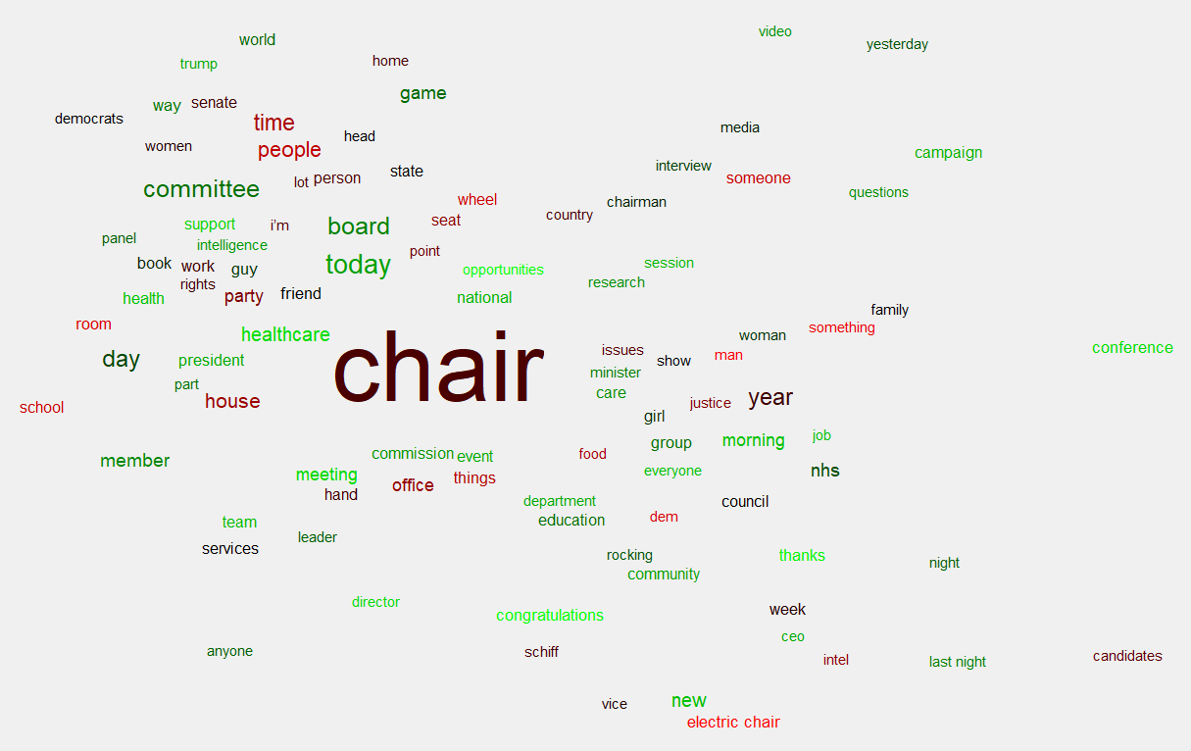
Fig. 3. The ‘chair’ database in word cloud view

Results and discussions

The three ideas 1, 2, and 3 generated by Designers 1, 2, and 3, respectively, are resketched by the authors and shown in Fig. 4 below. The ideas are evaluated by means of expert evaluation, measuring the novelty, usefulness and surprise, which are the three core elements of design creativity [22], of the ideas. Employing expert evaluation to assess creativity is a dominant approach in design research, and has been used by many researchers, such as Han et al. [22], Cropley and Kaufman [44], and Sarkar and Chakrabarti [45]. A design expert with over 10 years’ experience in design has participated in the evaluation with intrinsic motivation. The expert is presented with the three ideas in a random order, and asked to score the ideas in terms of novelty, usefulness and surprise.

A 5-point Likert rating scale is used, ranging from ‘very low’ (1) to ‘medium’ (3) and to ‘very high’ (5). An overall creativity score is calculated by summing up the scores of novelty, usefulness, and surprise. The evaluation results are shown in Table 3. The creativity scores are also converted into percentages to provide more direct comprehension.
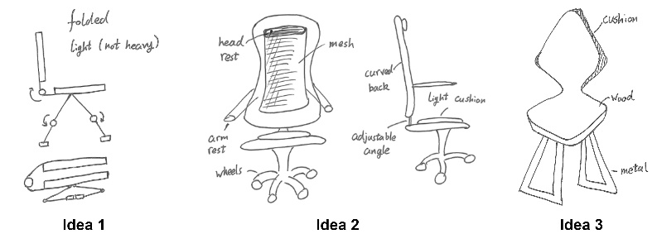
Fig. 4. Ideas produced by the three designers

Table 3. Evaluation results

 | Novelty | Usefulness | Surprise | Creativity
Idea 1 | 2 | 4 | 1 | 7 (47%)
Idea 2 | 1 | 4 | 1 | 6 (40%)
Idea 3 | 2 | 3 | 1 | 6 (40%)

As shown in the table, the overall creativity scores are below 50% which has indicated that the ideas produced are not highly creative. To be more specific, all three ideas have low novelty and surprise values, but high usefulness values. The expert for evaluation states that all the generated ideas are commonly seen in the market, but are highly useful. Therefore, the results of the conducted design challenge have indicated that the use of the pre-constructed database might have positive effects on usefulness rather than overall creativity, albeit with a low number of samples.
Interviews are conducted after the idea generation sessions, all three participants have indicated that the database is very useful. They all claimed that the database has provided them with useful information on how the crowd perceives ‘chair’, which has not been considered previously. Designer 2 has indicated that the provided database could constrain a designer’s creative mind, as the designer might only focus on the knowledge or ideas provided in the database.
However, the paper is aimed at proposing a new computational approach to support creativity by employing crowd knowledge, while the case study conducted is used to provide insights into and demonstrate how the proposed approach can be employed in idea generation activities. Thereby, it is challenging to indicate the effectiveness of the proposed approach, as well as how the approach functions in a computational design support tool, from the case study conducted. Nevertheless, all the designers involved have provided positive feedback on the pre-constructed database, which implies positive feedback on the proposed approach, for the case study concerned.

Conclusion

Producing ideas, especially creative ones, is challenging. Currently, there is a growing trend in exploring the use of computational tools to support the generation of creative ideas. However, the databases the tools employed have constrained the tools’ capabilities. Thereby, there is a need to come up with a new computational approach for assisting designers in idea generation, involving a novel method to construct the database.

Social media, which has billions of users, produces numerous knowledge and ideas every day. It can be considered a valuable source of crowd knowledge which can be used to support early phases design activities. This paper has proposed a computational approach using social networking platforms to support the generation of creative ideas. A novel approach of constructing social networking crowd databases is involved in the approach. The crowd database is aimed to support designers in creative idea generation in a direct manner as well as through computational idea generation support tools. A limited case study, which involves the use of a social networking crowd database constructed by using Condor, is undertaken to provide insights into how the proposed approach could support designers in generating creative ideas in a direct manner. For the case study concerned, the proposed approach has been considered useful for supporting idea generation by the participated designers.
Besides, the conducted case study has shown the needs of potential further studies, which will involve more participants, expert evaluators, and social media analysis tools, for providing additional insights and valuable conclusions. For examples, a controlled experiment to measure the effectiveness and usefulness of the approach; and an exploration of implementing the approach within a computational idea generation support tool. A limited number of studies have investigated the use of social media in design creativity research, and thereby the planned future studies will provide further scientific contributions of social media in design creativity research.

References

[1] DesignCouncil. The Design Economy 2018. 2018.
[2] Han J, Shi F, Chen L, Childs PRN. A computational tool for creative idea generation based on analogical reasoning and ontology. AI EDAM. 2018; 32(4):462-77.
[3] Osborn AF. Applied imagination: Principles and procedures of creative problem-solving. 3 ed. New York, USA: Charles Scribener's Sons; 1979.
[4] Altshuller GS. Creativity as an exact science: The theory of the solution of inventive problems. Amsterdam, Netherlands: Gordon and Breach Publishers; 1984.
[5] Goldschmidt G. Visual Analogy - a Strategy for Design Reasoning and Learning. Design Knowing and Learning: Cognition in Design Education. Oxford: Elsevier Science; 2001. p. 199-219.
[6] Linsey JS. Design-by-analogy and representation in innovative engineering concept generation: The University of Texas; 2007.
[7] Nagai Y, Taura T, Mukai F. Concept blending and dissimilarity: Factors for creative concept generation process. Des Stud. 2009; 30(6):648-75.
[8] Oman SK, Tumer IY, Wood K, Seepersad C. A comparison of creativity and innovation metrics and sample validation through in-class design projects. Res Eng Des. 2013; 24(1):65-92. doi: 10.1007/s00163-012-0138-9
[9] Han J, Shi F, Chen L, Childs PRN. The Combinator – a computer-based tool for creative idea generation based on a simulation approach. Design Science. 2018; 4:e11.
[10] Siddharth L, Chakrabarti A. Evaluating the impact of Idea-Inspire 4.0 on analogical transfer of concepts. AI EDAM. 2018; 32(4):431-48.
[11] Speer R, Havasi C. Representing general relational knowledge in ConceptNet 5. Proceedings of the Eight International Conference on Language Resources and Evaluation. 2012.
[12] Speer R, Chin J, Havasi C. ConceptNet 5.5: an open multilingual graph of general knowledge. Proceedings of the Thirty-First AAAI Conference on Artificial Intelligence; San Francisco, California, USA. 3298212: AAAI Press; 2017. p. 4444-51.
[13] Mount M, Martinez MG. Social Media: A Tool for Open Innovation. CALIF MANAGE REV. 2014; 56(4):124-43.
[14] Cross N. Design thinking: Understanding how designers think and work. New York, USA: Berg Publishers; 2011.
[15] Koestler A. The act of creation. London: Hutchinson; 1964.
[16] Mumford MD. Taking stock in taking stock. Creativity Res J. 2003; 15:147-51.

[17] Amabile TM. The social psychology of creativity. New York, USA: Springer-Verlag; 1983.
[18] Shai O, Reich Y, Hatchuel A, Subrahmanian E. Creativity and scientific discovery with infused design and its analysis with C–K theory. Res Eng Des. 2013; 24(2):201-14.
[19] Stewart D, Simmons M. Business Playground: Where Creativity and Commerce Collide, The: Pearson Education; 2010.
[20] Goldschmidt G, Tatsa D. How good are good ideas? Correlates of design creativity. Des Stud. 2005; 26(6):593-611.
[21] Sarkar P, Chakrabarti A, editors. Development of a method for assessing design creativity. Proceedings of the 16th International Conference on Engineering Design (ICED07); 2007; Paris, France.
[22] Han J, Forbes H, Schaefer D. An Exploration of the Relations between Functionality, Aesthetics and Creativity in Design. Proceedings of the Design Society: International Conference on Engineering Design. 2019; 1(1):259-68.
[23] Boden MA. The creative mind: Myths and mechanisms. 2 ed. London, UK: Routledge; 2004.
[24] Simonton DK. Big-C Versus Little-c Creativity: Definitions, Implications, and Inherent Educational Contradictions. In: Beghetto RA, Sriraman B, editors. Creative Contradictions in Education: Cross Disciplinary Paradoxes and Perspectives. Cham: Springer International Publishing; 2017. p. 3-19.
[25] Paulus PB, Dzindolet M. Social influence, creativity and innovation. Social Influence. SOC INFLUENCE. 2008; 3(4):228-47.
[26] Hülsheger UR, Anderson N, Salgado JF. Team-level predictors of innovation at work: A comprehensive meta-analysis spanning three decades of research. J APPL PSYCHOL. 2009; 94(5):1128-45.
[27] Nijstad BA, Stroebe W. How the Group Affects the Mind: A Cognitive Model of Idea Generation in Groups. Pers Soc Psychol Rev. 2006; 10(3):186-213.
[28] Paulus PB, Dzindolet M, Kohn NW. Chapter 14 - Collaborative Creativity—Group Creativity and Team Innovation. In: Mumford MD, editor. Handbook of Organizational Creativity. San Diego: Academic Press; 2012. p. 327-57.
[29] Goucher-Lambert K, Cagan J. Crowdsourcing inspiration: Using crowd generated inspirational stimuli to support designer ideation. Des Stud. 2019; 61:1-29.
[30] Cruickshank L. Open Design and Innovation: facilitating creativity in everyone: Routledge; 2016.
[31] Kaplan AM, Haenlein M. Users of the world, unite! The challenges and opportunities of Social Media. Business Horizons. 2010; 53(1):59-68.
[32] Kemp S. Digital in 2019. Available from: https://wearesocial.com/global-digital-report-2019. 2019.
[33] Allcott H, Gentzkow M, Yu C. Trends in the diffusion of misinformation on social media. Research & Politics. 2019; 6(2):2053168019848554.
[34] Subrahmanyam K, Reich SM, Waechter N, Espinoza G. Online and offline social networks: Use of social networking sites by emerging adults. J Appl Dev Psychol. 2008; 29(6):420-33.
[35] Trusov M, Bucklin RE, Pauwels K. Effects of Word-of-Mouth versus Traditional Marketing: Findings from an Internet Social Networking Site. J Marketing. 2009; 73(5):90-102.
[36] DiMicco J, Millen DR, Geyer W, Dugan C, Brownholtz B, Muller M. Motivations for social networking at work. Proceedings of the 2008 ACM conference on Computer supported cooperative work; San Diego, CA, USA. 1460674: ACM; 2008. p. 711-20.
[37] Carr J, Decreton L, Qin W, Rojas B, Rossochacki T, Yang Yw. Social media in product development. FOOD QUAL PREFER. 2015; 40:354-64.
[38] Malaga RA. The effect of stimulus modes and associative distance in individual creativity support systems. Decis Support Syst. 2000; 29(2):125-41.
[39] Goldschmidt G, Sever AL. Inspiring design ideas with texts. Des Stud. 2011; 32(2):139-55.
[40] Georgiev GV, Sumitani N, Taura T. Methodology for creating new scenes through the use of thematic relations for innovative designs. International Journal of Design Creativity and Innovation. 2017; 5(1-2):78-94.
[41] Taura T, Nagai Y. A systematized theory of creative concept generation in design: First-order and high-order concept generation. Res Eng Des. 2013; 24(2):185-99.
[42] Taura T, Nagai Y, Morita J, Takeuchi T. A Study on Design Creative Process Focused on Concept Combination Types in Comparison With Linguistic Interpretation Process. Proceedings of the 16th International Conference on Engineering Design ICED07. Paris, France2007. p. 317-8.
[43] Gloor PA. Sociometrics and human relationships: Analyzing social networks to manage brands, predict trends, and improve organizational performance: Emerald Publishing Limited; 2017.
[44] Cropley DH, Kaufman JC. The siren song of aesthetics? Domain differences and creativity in engineering and design. P I Mech Eng C-J Mec. 2018; 233(2):451-64.
[45] Sarkar P, Chakrabarti A. Assessing design creativity. Des Stud. 2011; 32(4):348-83.

