Autoimmune encephalitis as an increasingly recognised cause of non-convulsive status epilepticus: a retrospective, multicentre evaluation of patient characteristics and electroencephalography (EEG) results

Introduction

Status epilepticus (SE) is a common acute neurological presentation and is associated with a high mortality and disability burden in patients who survive an episode. It is classified as convulsive or non-convulsive status epilepticus (NCSE), both of which require prompt diagnosis and management. NCSE represents 5-49% of all cases of SE and can be underdiagnosed given its heterogeneous nature, with patients displaying a wide range of clinical presentations, typically with minimal signs on examination that there is ongoing seizure activity [1]. The diagnosis of NCSE is therefore critically dependent on the results of electroencephalography (EEG) [2].

There is increasing evidence pertaining to the typical clinical characteristics, diagnosis and outcomes of patients diagnosed with NCSE. These data are required to assist the physician in determining which patients with altered consciousness require an urgent EEG from the wider cohort with a similar clinical presentation. Indeed, it is likely that some patients presenting with clinical features consistent with NCSE will receive delayed diagnosis and management due to the subtle presentation which may have an impact on long term morbidity [1].

We undertook a retrospective multicentre study to identify aetiological and clinical features of EEG-confirmed NCSE which distinguished these patients from the wider cohort with suspected NCSE or encephalopathy.

Methods

EEG request forms from a Neurophysiology service covering a regional Neurology referral centre as well as four secondary care facilities for general medical and surgical patients in the Northwest of England were screened between January 2015 and December 2018 independently by two authors (JM and SRV). Cases suspected to have possible NCSE were selected using the following inclusion and exclusion criteria:

Inclusion
- Age ≥18 AND

- Clear clinical query of NCSE using any following terms: NCSE, partial status, absence status, subtle status or myoclonic status OR
- Clinical query of encephalopathy, encephalitis, personality change or cognitive impairment.

Exclusion
- EEG had not been reported by neurophysiologist.

Cases were divided into two groups: those with an EEG request where clinicians had specifically suspected NCSE and those where clinicians had requested EEG due to encephalopathy, encephalitis, personality change or cognitive impairment (Figure-1). This was to characterise the case-mix of positive cases in relation to initial clinical assessment. Encephalitis diagnoses were corroborated retrospectively at time of analysis in line with operational diagnostic criteria for possible, probable and confirmed encephalitis outlined by Venkatesan et al. [3]. Case note review was performed for each case with detailed review of EEG reports to identify negative and positive cases with electrographic evidence of NCSE.

NCSE definition was in line with current consensus criteria[2]:

- EDs > 2.5 Hz, OR
- EDs ≤ 2.5 Hz or rhythmic delta/theta activity (>0.5 Hz) AND one of the following:
  - EEG and clinical improvement after IV antiepileptic drug OR
  - Subtle clinical ictal phenomena during the EEG patterns mentioned above, OR
  - Typical spatiotemporal evolution (Incrementing onset, evolution in pattern or decrementing termination)

EEG-negative cases were identified by random number generation from those in whom the EEG was requested for suspected NCSE until we had a control group of n=40. Demographic, clinical, and aetiological characteristics were recorded in addition to EEG and outcome data. Clinical features such as myoclonus, eyelid twitching, perioral twitching, facial myokymia and subtle limb twitching were grouped into a ‘subtle motor signs’ domain for analysis. It should be noted that facial myokymia is a movement disorder due to intrinsic brainstem or facial nerve damage, rather than an epileptic phenomenon. This was included since subtle motor seizures involving the face may be incorrectly classified clinically, and we were keen not to miss any cases of NCSE. Outcome was scored within 6 months of the EEG request, using the Modified Rankin Scale (MRS) [4]. For missing data, imputation methods were not used given the small sample size in the positive case group.

Descriptive statistics were reported for baseline demographic and clinical characteristics. For comparative analysis, Fisher’s Exact test (FET) was used to compare proportions as the expected counts for the positive case group were small. Wilcoxon rank-sum (Mann-Whitney) tests were used for continuous variables where the distributions were not normal. Odds ratios (OR) have been presented where appropriate. Discriminant function analysis was used for patients with a diagnosis at hospital discharge, to demonstrate which combined variables were able to discriminate patients with and without NCSE.

Results

In total, 358 EEGs were requested due to a clinical suspicion of NCSE, encephalopathy, encephalitis, behavioural change or cognitive impairment over the 3-year period. Eight cases of patients in NCSE were identified from this population, 7 patients where the clinical suspicion was specifically NCSE, and 1 patient where the request was due to a suspicion of metabolic encephalopathy in the context of hyperammonaemia (Figure 1.). Where EEGs were performed on patients with clinical suspicion of NCSE, 7.8 percent (95%CI=2.2%-13.3%)
confirmed electrographic evidence of this diagnosis.

Figure 1. Proportion of cases with NCSE as demonstrated by EEG

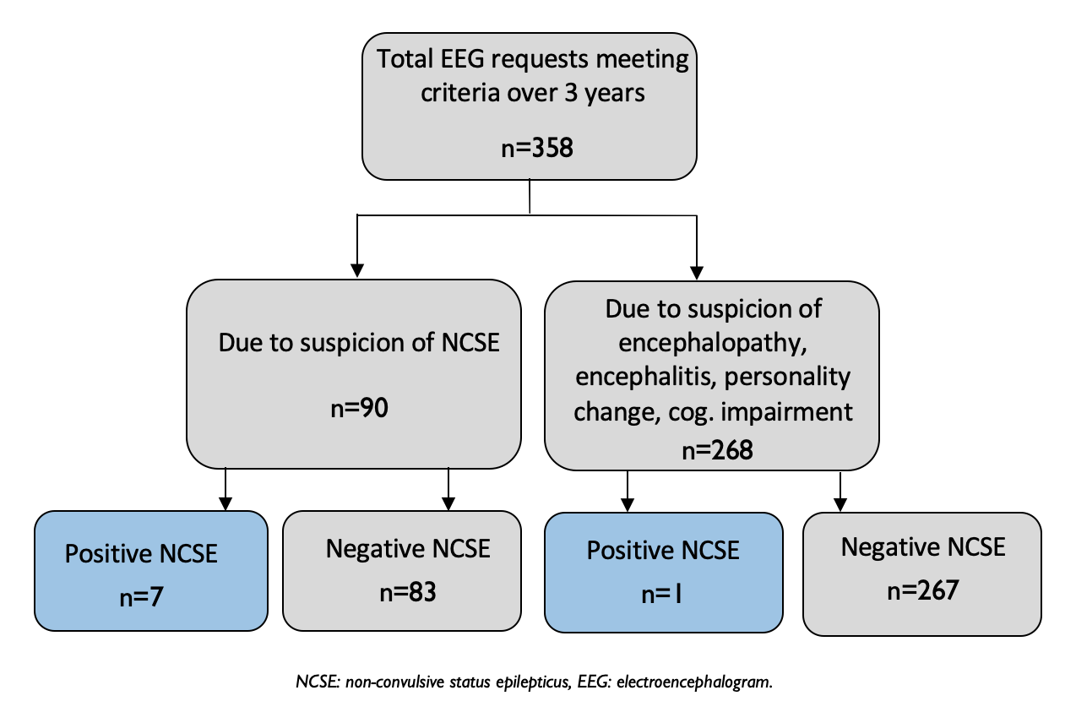

There was no significant difference in baseline demographic characteristics in patients with and without NCSE (Table 1.). Location of EEG recording differed significantly between groups, with a significantly higher proportion without NCSE well enough to have the EEG performed in neurophysiology department, not requiring portable ward EEG (FET, p=0.021). In patients with EEG-confirmed NCSE, alcohol excess recorded as a comorbidity was significantly more likely compared to the NCSE negative cases (FET, p=0.005). A higher proportion of patients in the NCSE group had known epilepsy, although this did not reach statistical significance. Whilst impaired consciousness and behavioural disturbance were common in both patients with and without EEG confirmed NCSE, subtle motor signs were observed in 50.0% (95%CI 15.4-84.6) of the positive NCSE cohort as opposed to only 15% (95% CI 3.9-26.1) of negative cases (OR=5.67, 95% CI=1.10-29.07).

Two out of 8 patients with NCSE had an autoimmune encephalitis, compared to 4 out of 40 patients in the negative group. Out of patients with autoimmune encephalitis, one exhibited N-methyl-D-aspartate (NMDA) receptor antibody positivity and one voltage gated potassium channel antibody positivity.
Table 1. Demographic and clinical characteristics

 |  | NCSE +ve group n=8 |  | NCSE -ve group n=40 | Test statistic
Variable |  | Years (IQR) |  | Years (IQR)
Median age |  | 54 (45.3-64.5) |  | 62.5 (49.5-75.5) | U=139, p=0.569
 | Freq. n=8 | Proportion, % (95% CI) | Freq.  n=40 | Proportion, % (95% CI)
Male | 3 | 37.5 (4.0-71.0) | 18 | 45.0 (29.6-60.4) | FET, p=1.00
Location
ITU – portable EEG | 2 | 25.0 (0.0-55.0) | 4 | 10.0 (0.7-19.3) | FET, P<0.021*
Ward – portable EEG | 6 | 75.0 (45.0-1.00) | 17 | 42.5 (27.2-57.8)
Outpatient department | 0 | - | 19 | 47.5 (32.0-63.0)
Co-morbidity:
Epilepsy | 3 | 37.5 (4.0-71.0) | 4 | 10.0 (0.7-19.3) | FET, p=0.080
Previous encephalitis | 1 | 12.5 (0.0-35.4) | 2 | 5.0 (0.0-11.8) | FET, p=0.428
Previous meningoencephalitis | 1 | 12.5 (0.0-35.4) | 2 | 5.0 (0.0-11.8) | FET, p=0.428
Alcohol excess | 4 | 50.0 (15.4-84.6) | 2 | 5.0 (0.0-11.8) | FET, p=0.005*
Previous stroke | 1 | 12.5 (0.0-35.4) | 8 | 20.0 (7.6-32.4) | FET, p=1.00
Presenting clinical features
Impaired consciousness | 6 | 75.0 (45.0-1.00) | 19 | 47.5 (32.0-63.0) | FET, p=0.248
Behavioural disturbance | 3 | 37.5 (4.0-71.0) | 23 | 57.5 (42.2-72.8) | FET, p=0.441
Subtle motor signs | 4 | 50.0 (15.4-84.6) | 6 | 15.0 (3.9-26.1) | FET, p=0.047*
 | Freq. n=7 | Proportion, % (95% CI) | Freq.  n=38 | Proportion, % (95% CI)
Modified Rankin Scale
0,1 | 2 | 28.6 (0.0-62.0) | 16 | 42.1 (26.4-57.8) | FET, p=0.684
2-6 | 5 | 71.4 (38.0-1.00) | 22 | 57.9 (42.2-73.6)
Diagnosis | Freq.  n-8 | Proportion, % (95% CI) | Freq.  n=40 | Proportion, % (95% CI)
Epilepsy | 2 | 25.0 (0.0-55.0) | 4 | 10.0 (0.7-19.3) | FET, p=0.571
Infective meningoencephalitis | 0 | - | 1 | 2.5 (0.0-7.3)
Autoimmune encephalitis | 2 | 25.0 (0.0-55.0) | 3 | 6.2 (0.0-15.7) | FET, p=0.189
Tumour | 0 | - | 3 | 6.2 (0.0-15.7)
Neurodegenerative disease | 0 | - | 1 | 2.5 (0.0-7.3)
Other neuroinflammatory disorder | 1 | 12.5 (0.0-35.4) | 2 | 5.0 (0.0-11.8) | FET, p=0.428
Stroke / vascular pathology | 1 | 12.5 (0.0-35.4) | 4 | 10.0 (0.7-19.3) | FET, p=1.00
Brain injury | 2 | 25.0 (0.0-55.0) | 2 | 5.0 (0.0-11.8) | FET, p=0.124
Functional neurological disorder / psychiatric presentation | 0 | - | 3 | 6.2 (0.0-15.7) | -
Neurosurgical complication | 0 | - | 2 | 5.0 (0.0-11.8) | -
Unclear diagnosis | 0 | - | 15 | 37.5 (22.5-52.5) | -
NCSE: non-convulsive status epilepticus, FET: Fisher Exact Tests, 95% CI: 95 percent confidence interval: p=2 tailed significance value: CNS: central nervous system

Discussion

NCSE is an important diagnosis not to miss as early treatment with antiepileptic medications is associated with a better outcome [1,5]. Although NCSE is often considered early in patients with known epilepsy, and it is known that NCSE if frequent in acutely ill patients with alteration of consciousness [6], it can be challenging to identify patients with NCSE on clinical grounds alone due to the often-subtle features and broad range of potential aetiologies. Therefore, an improved understanding of the aetiological and clinical features that should prompt urgent EEG to confirm NCSE are required.

Whilst previous literature has demonstrated that prior overt clinical seizures are the most prevalent risk factor for NCSE [6], our results suggest that autoimmune encephalitis might be as common as known epilepsy as the cause of NCSE. Whilst autoimmune encephalitis is a well-established cause of convulsive SE, there is now an increasing body of literature describing NCSE in the context of autoimmune encephalitis [7–12]. Autoimmune encephalitis is an increasingly recognised cause of encephalitis and over the last 10 years there has been a marked expansion in the range of antibodies identified [13]. Some specific clinical phenotypes are reported to correspond with specific antibodies, such as orofacial dyskinesia with N-methyl-D-aspartate receptor antibodies [14]. However, in the majority there is significant clinical overlap with the most common features reflecting a limbic encephalitis, behavioural change or psychosis and seizures, which may be refractory [15]. Clinicians should have a high index of suspicion of NCSE as an explanation of reduced level of consciousness in patients presenting with suspected or previous encephalitis, particularly where subtle motor signs are evident on examination, and have a low threshold for requesting an urgent EEG. This is particularly important given that electrographic evidence of seizures in patients with autoimmune encephalitis have recently been demonstrated to confer poor prognosis, regardless of the underlying specific antibody [10].

We also identified that alcohol excess as a comorbidity and subtle motor signs on examination were associated with a diagnosis of NCSE. Alcohol withdrawal is well established risk factor for convulsive status epilepticus but an encephalopathic patient with a history of alcohol addiction might often be suspected to be either intoxicated or suffering hepatic encephalopathy [16]. Subtle motor signs, particularly facial or periorbital twitching have previously shown to be strongly associated with electrographic seizures in inpatient cohorts, as evidenced by a retrospective study of continuous EEG on patients in an intensive care setting [17]. Therefore, in patients with a history of alcohol excess the timing of the last alcohol consumption, blood alcohol and ammonia levels as well as clinical evidence of subtle motor signs should be sought when considering possible NCSE. Furthermore, our results reflect previous literature demonstrating epilepsy, CNS vascular disorders and brain injury as risk factors for NCSE [1,5,18].

The prevalence of NCSE in this cohort was lower than expected by the authors, particularly compared to previous work investigating EEG findings in acutely unwell populations. This likely explained by the fact that the majority of EEGs in this setting were of short duration, with continuous EEG rarely performed.

It should be noted that this study was limited by the data available, due to the retrospective, multicentre casenote retrieval; in particular treatment and clinical response data were not available for the majority and therefore are not presented. However, this approach allowed us to screen a large sample size over a 3-year sampling window to increase the number of cases of NCSE available for analysis. Future prospective work should aim to describe the spectrum of clinical and EEG findings in a larger cohort of patients with autoimmune encephalitis and identify clinical and electroencephalographic markers of response to antiepileptic drugs which might assist in directing treatment.

Conclusion

There is increasing evidence that previous or concomitant encephalitis, particularly of autoimmune aetiology, is a common cause of NCSE. Therefore, in patients with altered consciousness NCSE should be considered urgently, especially when encephalitis is suspected and subtle motor signs are present.

References

- Meierkord H, Holtkamp M. Non-convulsive status epilepticus in adults: clinical forms and treatment. Lancet Neurol 2007;6(4):329-39. doi:10.1016/S1474-4422(07)70074-1

- Beniczky S, Hirsch LJ, Kaplan PW, et al. Unified EEG terminology and criteria for nonconvulsive status epilepticus. Epilepsia 2013;54(6):28-9. doi:10.1111/epi.12270

- Venkatesan A, Tunkel AR, Bloch KC, et al. Case definitions, diagnostic algorithms, and priorities in encephalitis: Consensus statement of the international encephalitis consortium. Clin Infect Dis 2013;57(8):1114-1128. doi:10.1093/cid/cit458

- Rankin J. Cerebral Vascular Accidents in Patients over the Age of 60: II. Prognosis. Scott Med J 1957;2(5):200-15. doi:10.1177/003693305700200504

- Kang BS, Jhang Y, Kim YS, et al. Etiology and prognosis of non-convulsive status epilepticus. J Clin Neurosci 2014;21(11):1915-9. doi:10.1016/j.jocn.2014.03.018

- Limotai C, Ingsathit A, Thadanipon K, et al. How and Whom to Monitor for Seizures in an ICU. Crit Care Med 2019;4(4):e366-e373. doi:10.1097/ccm.0000000000003641

- Solanki D, Anand S. Autoimmune Encephalitis: An Unusual Presentation as Nonconvulsive Status Epilepticus. J Neuroanaesth Crit Care Published Online: 2019. doi:10.1055/s-0039-1685246

- Kirkpatrick MP, Clarke CD, Sonmezturk HH, et al. Rhythmic delta activity represents a form of nonconvulsive status epilepticus in anti-NMDA receptor antibody encephalitis. Epilepsy Behav 2011;20(2):392-4. doi:10.1016/j.yebeh.2010.11.020

- Johnson N, Henry C, Fessler AJ, et al. Anti-NMDA receptor encephalitis causing prolonged nonconvulsive status epilepticus. Neurology 2010;75(16):1480-2. doi:10.1212/WNL.0b013e3181f8831a

- Moise A-M, Karakis I, Herlopian A, et al. Continuous EEG Findings in Autoimmune Encephalitis. J Clin Neurophysiol Published Online: 2019. doi:10.1097/wnp.0000000000000654

- Viarasilpa T, Panyavachiraporn N, Osman G, et al. Electrographic Seizures in Patients with Acute Encephalitis. Neurocrit Care 2019;30(1):207-15. doi:10.1007/s12028-018-0599-4

- Gaspard N, Foreman BP, Alvarez V, et al. New-onset refractory status epilepticus: Etiology, clinical features, and outcome. Neurology 2015;85(18):1604-13. doi:10.1212/WNL.0000000000001940

- Venkatesan A, Michael BD, Probasco JC, et al. Acute encephalitis in immunocompetent adults. Lancet. 2019;393(10172):702-716. doi:10.1016/S0140-6736(18)32526-1

- O’Sullivan BJ, Steele T, Ellul MA, et al. When should we test for voltage-gated potassium channel complex antibodies? A retrospective case control study. J Clin Neurosci 2016;33:198-204. doi:10.1016/j.jocn.2016.04.021

- Solomon T, Michael BD, Smith PE, et al. Management of suspected viral encephalitis in adults - Association of British Neurologists and British Infection Association National Guidelines. J Infect 2012;64(4):347-73. doi:10.1016/j.jinf.2011.11.014

- Hillbom M, Pieninkeroinen I, Leone M. Seizures in Alcohol-Dependent Patients: Epidemiology, Pathophysiology and Management. CNS Drugs 2003;17(14):1013-30. doi:10.2165/00023210-200317140-00002

- Schmitt SE. Utility of Clinical Features for the Diagnosis of Seizures in the Intensive Care Unit. J. Clin. Neurophysiol 2017;34(2):158‐161. doi:10.1097/WNP.0000000000000335

- Husain AM, Horn GJ, Jacobson MP. Non-convulsive status epilepticus: Usefulness of clinical features in selecting patients for urgent EEG. J Neurol Neurosurg Psychiatry 2003;74(2):189-91. doi:10.1136/jnnp.74.2.189

