Vein of Galen aneurysmal malformation (VGAM) affecting co-twin in a dichorionic diamniotic (DCDA) pregnancy: case report and review of literature
Short title: Vein of Galen aneurysmal malformation affecting co-twin

Hackett, James^{1,2}
Hall, Lewis³
Sadiq, Mustafa⁴
Putheran, Mani⁵
Hall, Benjamin⁶
Burn, Sasha⁵
Sharp, Andrew⁷
Alfirevic, Zarko⁷
Agarwal, Umber¹
¹ Liverpool Women’s NHS Foundation Trust, Liverpool, UK
² Royal Bolton Hospital, Bolton, UK
³ University of Birmingham, Birmingham, UK
⁴ Warrington Hospital, Warrington, UK
⁵ Alder Hey Children's Hospital, Liverpool, UK
⁶ Aintree University Hospital, Liverpool, UK
⁷ University of Liverpool, Liverpool, UK

Corresponding author:
James Hackett
Postgraduate Department
Royal Bolton Hospital
Minerva Road
Farnworth, BL4 0JR
E: james.hackett@boltonft.nhs.uk
T: +44 1204 390 390

Keywords: Vein of Galen aneurysm, vascular abnormalities, materno-fetal medicine

Vein of Galen Aneurysmal Malformation (VGAM) affecting co-twin in a DCDA Pregnancy- Case Report and Review of Literature
Hackett J^{1,2}, Hall L³, Sadiq M⁴, Putheran M⁵, Hall B⁶, Burn S⁵, Sharp A⁷, Alfirevic Z⁷, Agarwal U⁸

Introduction
The Vein of Galen Malformation (VGAM) is a rare congenital abnormality of the embryonic choroid plexus, accounting for 1% of intracranial vascular malformations^{[1]}. First described by Raybaud, the malformation develops during weeks 6-11 of fetal development and the pathology consists of a direct communication between feeding arteries and the median prosencephalic vein of Markowski.^{[2]}. Whilst VGAM may account for 30% of all paediatric vascular malformations ^{[1]}, a prevalence of 1:25,000 in singleton births makes it extremely rare; with fewer still having been described in the setting of twins. ^{[3, 4, 5].}
We report a case of VGAM affecting one of twin in a spontaneously conceived dichorionic diamniotic twin pregnancy. To the best of our knowledge, this is only the fourth reported case of its kind.

Case Description
An 18-year-old Caucasian woman expecting dichorionic diamniotic twins was referred to the fetal-medicine unit at Liverpool Women’s Hospital in February 2018 at 31 weeks + 4 days gestation due to suspected ventriculomegaly in Twin 2. Twin 1 (female) was breech but otherwise had normal anatomy. In Twin 2 (male) a cystic structure measuring 32x30x28mm demonstrating turbulent flow was identified in the posterior part of the brain, accompanied by numerous feeding vessels. Cerebellar compression secondary to the structure was present, with evidence of associated bilateral ventriculomegaly of 18mm. Twin 2’s heart appeared structurally normal but showed signs of cardiomegaly, likely secondary to hyperdynamic circulation. The images obtained during scanning strongly supported a diagnosis of Vein of Galen aneurysm. MRI scan confirmed the diagnosis. The report also suggested a thrombus in the VGAM and its inferior extension, causing significant compression of the brain stem.
Following multidisciplinary review of MRI images by the neurosurgical and interventional neuroradiology teams, the parents were counselled about the very poor prognosis of the condition and the high likelihood that Twin 2 would not survive to delivery, or beyond the neonatal period due to heart failure. Parents declined selective fetocide and input from the palliative care team.
The family were seen twice weekly in our fetal medicine unit. The situation remained stable for Twin 2 with no worsening of cardiac status. Both babies were born by elective caesarean section at 37 weeks + 2 days following administration of antenatal steroids. Twin 1 was well at birth and discharged as normal. Twin 2 made no spontaneous respiratory effort following delivery; requiring intubation and ventilation. High output cardiac failure was identified, with dilated vessels and retrograde flow in the transverse and descending aorta secondary to the large VGAM. On arrival to the paediatric ICU, inotropic support was required to maintain adequate cardiac output and blood products to correct coagulopathy. Despite passing urine, renal function was deranged on serology.
The interventional endovascular procedure was attempted but unfortunately due to the extent of tributary involvement, feeding vessels and fistulae, the intervention was deemed futile and abandoned. The patient returned to ICU and after further discussions with the parents, they decided to stop active interventions. Twin 2 passed away some hours later. Parents declined a post-mortem examination.
Table 1 shows review of 3 other reported cases and outcome – our case adds to the evidence in this area.

References
- Raybaud CA, Strother CM, Hald JK. Aneurysms of the vein of Galen: embryonic considerations and anatomical features relating to the pathogenesis of the malformation. Neuroradiology 1989; 31: 109–128.

- Vein of Galen aneurysmal malformation (VGAM) in the fetus: retrospective analysis of perinatal prognostic indicators in a two‐center series of 49 cases, Paladini et al 12/08/2016 Ultrasound in Obstetrics and Gynaecology https://doi-org.liverpool.idm.oclc.org/10.1002/uog.17224

- Prenatal Sonographic Diagnosis of a Vein of Galen Aneurysmal Malformation in a Twin Liriano B, Levy R, 2003, JDMS 19:242–247 OI: 10.1177/8756479303251460

- Vein of Galen Aneurysmal Malformation in Monozygotic Twin MasakiKomiyama¹SatokoMiyatake²AikoTerada¹TomoyaIshiguro¹HiroyukiIchiba³NaomichiMatsumoto² https://doi.org/10.1016/j.wneu.2016.04.031 World Neurosurgery Volume 91, July 2016, Pages 672.e11-672.e15

- Geibprasert S, Krings T, Armstrong D, Terbrugge KG, Raybaud CA. Predicting factors for the follow‐up outcome and management decisions in vein of Galen aneurysmal malformations. Childs Nerv Syst 2010; 26: 35–46

Figure legends
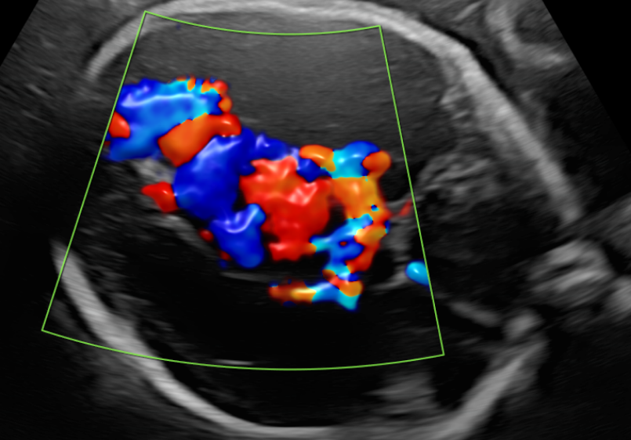
Figure 1: Transabdominal scan showing fetal VGAM on colour doppler flow

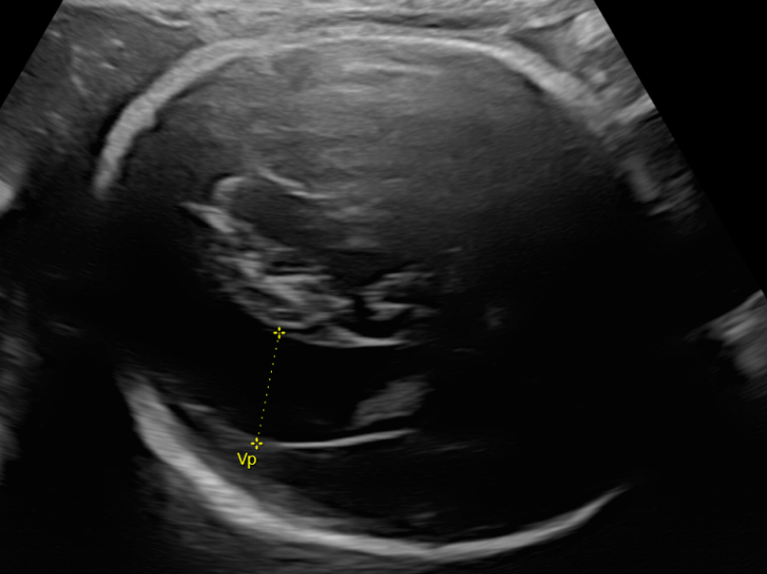
Figure 2: Transabdominal ultrasound scan showing severe ventriculomegaly

Table 1. supporting information
Case report | Twins | VGAM diagnosis | Affected twin outcome | Unaffected twin outcome
Liriano et al 2003 | Dichorionic | Prenatal | Died | ?
Steggerda et al 2006 | Monochorionic, diamniotic | Postnatal | Died | Died (likely secondary to TTTS)
Komiyama et al 2016 | Monochorionic, diamniotic | Postnatal | Survived | Survived
Hackett et al 2019 | Dichorionic, diamniotic | Prenatal | Died | Survived
Table 1. All known reports of Vein of Galen malformations found in the setting of twins (PubMed).

