A Turbulence Model for Flight Simulation and Handling Qualities Analysis based on a Synthetic Eddy Method
Sergio Henriquez Huecas  PhD. Student  University of Liverpool  Liverpool, United Kingdom | Prof. Mark White  Professor  University of Liverpool  Liverpool, United Kingdom | Prof. George Barakos  Professor  University of Glasgow  Glasgow, United Kingdom

Abstract
A turbulence model based on a Synthetic Eddy Method has been adapted for flight simulation purposes and coupled to two FlightLab helicopter models. The model is based on the generation of a random distribution of turbulence generating Eddies within a control model surrounding the aircraft. Eddies are convected by the flow and regenerated at the inflow as they leave the simulation domain. Adjustment of Reynolds stresses and Eddy shape and sizes should allow adjustment of turbulence intensities and frequency spectra. Compared to other random turbulence models, preserving the location of the Eddies in the control volume ensures automatically that turbulence across different aircraft locations is automatically correlated. Offline and piloted flight simulation has been conducted to test the viability of the concept. Results show that the turbulence model generates upsets in all aircraft axis which result in higher workload requirements for the pilot.

Notation
Nomenclature
$A$ ; $A_{ij}$ | Cholesky decomposition of Reynolds Stresses
$$f_{σ}(x-x^{k})$$ | Three dimensional Eddy shape function
$$f\left(x\right)$$ | One dimensional Eddy shape function
$$F_{u_{i}}$$ | Kurtosis of velocity component along axis $i$
$$N$$ | Number of Eddies
$$p_{m}$$ | Scaler for Reynolds Stress tensor
$$q_{m}$$ | Scaler for Eddy Size
$$r$$ | Distance vector
$$R_{ij}$$ | Cross – correlation between axis $i$ and $j$ components
$${Re}_{ij}$$ | Reynolds Stress Tensor
$$S_{u_{i}}$$ | Skewness of velocity component along axis $i$
$$u'=[{u'}_{x},{u'}_{y},{u'}_{z}]$$ | Turbulence velocity
$$V_{B}$$ | Domain of control volume
$$V_{flow}$$ | Flow velocity
$$ε_{j}^{k}$$ | Sign of velocity generated by Eddy $k$ along axis $i$
$$σ=\left[σ_{x},σ_{y},σ_{z}\right]$$ | Eddy size
$$ϕ_{ij}$$ | Power spectral density between axis $i$ and $j$ components
$$ω$$ | frequency
Abbreviations
ACP | Aerodynamic Computation point
MTE | Mission task element
PSD | Power Spectral Density
RCAH | Rat Command Attitude Hold
RMS | Root Mean Square
SCAS | Stability Control Augmentation System
SEM | Synthetic Eddy Method

Introduction
NITROS (Network for Innovative Training on ROtorcraft Safety) [1] is a European Joint Action Project, conducted as part of the Marie Sklowdoska Curie program, with the aim to train future engineering researchers to understand the complex phenomena characterizing rotorcraft and take considerable measures to improve actual rotorcraft safety standards. To this end, twelve double doctorate projects have been initiated at four leading european universities in the field of aerospace engineering (Politecnico Di Milano, Technical University of Delft, University of Glasgow and University of Liverpool). The projects are strongly interrelated and focused on rotorcraft safety, andmainly rotorcraft modelling and design, pilot training and human-machine interface and environment – rotorcraft interaction.
This paper??? will be focused in addressing the interactions between helicopter, pilot and the surrounding aerodynamic environment. Helicopters are used in a wide variety of roles, such as shipborne and offshore missions [2], [3] during which they might be subjected to a large range of environmental hazards where the risk of an accidental encounter with an airwake might affect flight safety. An increasingly relevant area is the issue of hazards resulting from encounters with wind turbine airwakes [4]. Initial results from testing conducted for the GARTEUR HC/AG-23 [5] action group shows that further research is needed to adequately understand how the combination of environment and aircraft handling qualities influence the outcome of an accidental wake encounter.
As of now, there is no unified approach to the assessment of turbulence or gust effects on rotorcraft operations or for severity mitigation through design, regulations or training. EASA certifications for small (CS – 27, [6]) and large (CS – 29, [7]) rotorcraft only establish the need to ensure controllability and structural resistance under expected gust conditions. ADS – 33 [8] sets yaw rate limits in response to step lateral gusts for all aircraft. For attitude hold control systems, Level 1 requires return to less than 10% of peak deviations in roll and pitch within 10s (20s for pitch under good visual conditions) after a pulse disturbance and same response bandwidth to disturbances as to pilot control inputs. For certification, disturbances shall be modelled as inputs to the actuator surfaces. There seems to be little supporting data for this criteria [9] and it is intended to be replaced by a disturbance response bandwidth criteria in the future [10]. Other requirements set limits on the environmental conditions aircraft are allowed to operate. The UK Civil Aviation Authority (CAA) establishes a maximum of 1.75m/s on standard deviation of vertical wind velocity over landing areas on offshore platforms to allow operations [11]. These limits were defined after a series of piloted and offline flight simulation studies using airwake data collected from wind tunnel tests [3], [12] and replace a previous requirement defining an absolute maximum vertical wind speed.
Flight dynamic analysis and piloted flight simulation will certainly be helpful in the development and testing of common criteria. However, adequately modeling the interaction between a rotorcraft and its surrounding aerodynamic environment has proved to be a challenging endeavor, especially for real-time piloted simulation. The current state of the art is the use of stored time accurate airwake solutions which have been precomputed using Computational Fluid Dynamics tools (CFD) and are reproduced during simulated flight [2]. This results in more realistic simulation of environmental effects and corresponding aircraft responses. However, computational costs and storage requirements means that only a limited number of short duration airwake solutions will usually be available. Also, only one way coupling of airwake effects on aircraft can be modelled this way. Two way coupling, where the airwake responds to the presence of the aircraft is might be required for accurate modelling of hover and low speed flight [13]. This requires the complete solution of the fluid field and resulting aircraft dynamics. Crozon et al. [14] demonstrate the technical feasibility of non-real-time fully coupled CFD – flight mechanics simulations. The process is, however, too computationally expensive for real-time simulation with current computational capabilities.
To address some of these issues, stochastic turbulence models can generate random, low intensity, high frequency turbulent flow in real time superimposed over lower fidelity airwake solutions.
Most turbulence models are usually built around the implementation of Von Karman’s formula [15] or Dryden models [16] commonly used for fixed wing aircraft simulation, design and certification [17]. Both are based on the assumption of a homogeneous, isotropic and frozen turbulence field that approaches towards the aircraft with its aerodynamic velocity [18]. However direct application of these models is inadequate for the broad range of possible flight and environmental conditions in which helicopters can operate, especially for low speed and low level flight [19]. The rotation effect of the blades must be taken into account when computing the resulting spatial and temporal cross correlation functions. This is done by defining a distance metric between all combinations of two blade elements at consecutive time steps [20], [21]. The resulting algorithms however are complex and difficult to validate or calibrate to produce realistic results for a variety of environments and flight conditions.
A simpler approach was suggested by McFarland et al. in [22]. A turbulent velocity field distributed over the rotor plane across a number of stations oriented according to the projection of the velocity of incoming flow. On each time step, the velocity field is displaced by one station and new correlated turbulent velocities are computed at onset points at the first station. Velocities at each blade element are computed by means of a Gaussian interpolation. This method automatically correlates the turbulence on each blade element and the rotor hub. Ji et al, proposes a three dimensional extension of this method in [23] which considers turbulence effects across the whole aircraft. In both cases however, the precomputed turbulence field is always displaced by one station over the rotor disk at each time step, independently of how much the direction and magnitude of aerodynamic velocities change, making it difficult to accurately reproduce realistic turbulent conditions.
Lusardi et al. [24] and Seher-Weiss et al. [25] describe the use of System Identification techniques from flight test measurements for modelling turbulence upsets as equivalent control inputs. Pilot control inputs and aircraft attitudes are recorded during flight-testing under turbulence. The difference between actual recorded pilot inputs and those that would have been required to achieve actual recorded aircraft attitude rates under calm conditions is used to generate equivalent turbulence control inputs. This results in the generation of turbulence models which include effects related to rotorcraft systems and interaction with the environment that are not usually captured by other methods such as precomputed airwakes or random turbulence models. These models however are valid only for the very specific combinations of aircraft, environmental conditions and flight task for which both flight test data and aircraft dynamics model are available and are therefore not broadly applicable.
The challenge is the development of a turbulence model that is easy to couple and adapt to the environment surrounding the aircraft in order to generate realistic disturbances and has low computational costs to allow for real time piloted simulation. The turbulence model based on a synthetic eddy method proposed in this paper is being studied as a first step towards this aim. It is based on the random placement of turbulence generating Eddies on a control volume of interest and their displacement with ambient flow velocities. Alteration of the shape, size, strength and movement of the Eddies should allow for the simulation of a broad range of turbulence conditions.
The resulting method is similar to a three – dimensional extension of McFarland’s SORBET model. However, instead of storing the turbulence field for a number of time steps, the physical location of each Eddy in the vicinity of the aircraft is preserved. This results in the automatic correlation of turbulent flow velocities across the aircraft and should allow to adjust the properties of the Eddies based on their location in order to obtain a more realistic turbulence field. The algorithm is also easy to parallelize. This should help tackle the main disadvantage of the model which is the increase in computational cost when simulating higher frequency turbulence.
The paper details the theoretical basic of the synthetic Eddy turbulence model and one way coupling with FlightLab for flight simulation applications as well as an initial analysis of flight simulation tests performed to test the feasibility of the concept. Ongoing plans for more comprehensive flight simulation testing are also discussed.

The Synthetic EddY turbulence model for flight simulation

Theoretical background
The Synthetic Eddy Method (SEM) was proposed by N. Jarrin [26] to generate realistic random turbulent oscillations at the inflow of CFD simulations.

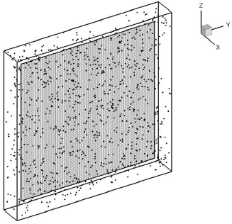
Figure 1: Control volume filled by Eddies surrounding inflow grid.[27]
A control volume surrounding the area of interest is populated by a uniform random distribution of N Eddies (see Figure 1). On each time step, an Eddy located on $x^{k}$ generates a turbulent velocity perturbation at location $x$ characterized by:
$${{u'}_{i}}^{k}=\frac{1}{\sqrt{N}}A_{ij}ε_{j}^{k}f_{σ}(x-x^{k})$$ | 1
Where $ε_{j}^{k}$ is a randomly assigned sign and A is the Cholesky decomposition of the Reynolds stress tensor (${Re}_{ij}= 〈{u'}_{i}u_{j}^{'}〉$):
$$A= \left[\begin{matrix}\sqrt{{Re}_{11}} & 0 & 0 \\ \frac{{Re}_{21}}{A_{11}} & \sqrt{{Re}_{22}-A_{21}^{2}} & 0 \\ \frac{{Re}_{31}}{A_{11}} & \frac{{Re}_{32}-A_{21}A_{31}}{A_{22}} & \sqrt{{Re}_{33}-A_{31}^{2}-A_{32}^{2}}\end{matrix}\right]$$ | 2
The velocity distribution of each Eddie across the control volume is defined by $f_{σ\left(x\right)}(x-x^{k})$ and depends on the shape of the Eddies, defined by a characteristic length on each direction σ:
$$f_{σ\left(x\right)}\left(x-x^{k}\right)=\sqrt{\frac{V_{B}}{σ^{3}}}*f\left(\frac{x-x^{k}}{σ_{x}}\right)*f\left(\frac{y-y^{k}}{σ_{y}}\right)f\left(\frac{z-z^{k}}{σ_{z}}\right)$$ | 3
Where each component fulfils the normalization condition:
$$\int_{-∞}^{+∞}{f^{2}\left(x\right)}=\int_{-σ}^{+σ}{f^{2}\left(x\right)}=1$$ | 4
The resulting velocity on each cell is obtained by adding the contribution of each Eddy to the inflow velocity:
$$u_{i}={\overline{u}}_{i}+\sum_{k=1}^{N}{{{u'}_{i}}^{k}}$$ | 5
After each time step the population of Eddies is displaced following the flow velocity:
$$x^{k}\left(t+dt\right)= x^{k}\left(t\right)+ \overline{u}*dt$$ | 6
Should an Eddy leave the control volume, it is regenerated at the inflow at a location selected by a uniform random distribution.
The values of $R_{ij}$ determine the resulting standard deviation in turbulent velocities generated for each axis, while the shape of the Eddies determines the scale length of turbulence and therefore spatial correlation, $R_{ij}\left(r\right)$, between turbulent velocities at two different locations $x$ and $x+ r$.
$$R_{ij}\left(r\right)={Re}_{ij}\prod_{l=1}^{3}{\left[f*f\right]\left(\frac{r_{l}}{σ_{l}}\right)}$$ | 7
The total number of Eddies is chosen so that they completely fill the control volume:
$$N= \frac{V_{B}}{σ_{x}*σ_{y}*σ_{z}}$$ | 8
Adjusting the size and shape of Eddies also defines the resulting frequency spectra.
$$ϕ_{ij}\left(x,ω\right)={Re}_{ij}\frac{σ}{\left|\overline{u}\right|}{\left|F_{\frac{σω}{\left|\overline{u}\right|}}\left\{f\right\}\right|}^{2}$$ | 9
Where $F_{\frac{σω}{\left|\overline{u}\right|}}\left\{f\right\}$ is the fourier transform of function f at a frequency scaled by $\frac{σω}{\left|\overline{u}\right|}$. For a control volume completely filled with a uniform distribution of eddies, the value of average frequency is proportional to the ratio between incident flow velocity and characteristic eddy length, $\frac{V_{flow}}{σ}$ , or proportional to the cubic root of the number of eddies, $\sqrt[3]{N_{Eddies}}$.
Values for the strength, size and shape of the Eddies can be obtained from measurements or CFD simulations [28] allowing the Synthetic Eddie method to model different conditions of environmental turbulence.

Coupling to a flight dynamics model
A derivation of this method has been developed and coupled with FLIGHTLAB [29] helicopter models of a Bo105 and a Bell 412. A box–shaped control volume is defined around the aircraft and populated by a random distribution of Eddies, an inflow is defined facing towards the direction of the incoming aerodynamic velocity (see Figure 2). In its current implementation the Eddies represent a randomly generated frozen turbulence field which displaces itself with ambient wind velocity.
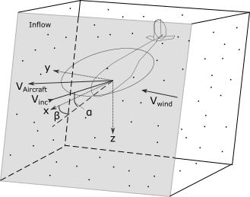
Figure 2: Diagram of the control volume used for the synthetic eddie method.
FLIGHTLAB computes aerodynamic forces and moments on the aircraft by sampling flow velocities at a series of Airload Computation Points (ACPs) located around the airframe and rotor blades. On each time step an eddy located on $x^{k}$ generates a turbulent velocity perturbation on an ACP located at $x^{ACP}$. The total induced turbulence on each ACP is obtained by adding the contribution of each eddy:
$${u^{'}}_{i}^{ACP}=\frac{1}{\sqrt{N}}\sum_{k=1}^{N_{Eddies}}{\left.A_{ij}ε_{j}^{k}f_{σ}(x^{ACP}-x^{k}\right)}$$ | 10
Where $ε_{j}^{k}$ is a randomly assigned sign and A is the Cholesky decomposition of the Reynolds stress tensor (${Re}_{ij}= 〈{u'}_{i}u_{j}^{'}〉$). The function $f_{σ\left(x\right)}\left(x-x^{k}\right)$ relates the shape and size of the eddies, $σ_{i}$, with the decay of their effect with distance.
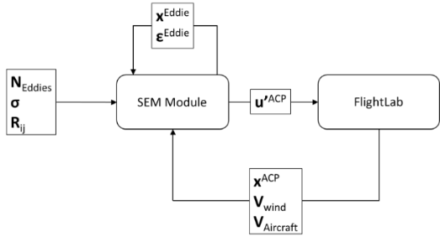
Figure 3: Flow chart of data exchanged between the SEM module and FLIGHTLAB.
The SEM module passes the induced turbulent velocities to FLIGHTLAB on each time step (see Figure 3), which adds them to the external flow velocities. FLIGHTLAB computes the resulting aerodynamic forces at each ACP and solves the dynamic of the aircraft obtaining the new position of each ACP for the next time step.
These values are then passed on to the SEM module which updates the location and orientation of the control volume so that it follows the movement of the aircraft and faces towards the incoming flow and displaces the Eddies with wind velocity. Eddies falling outside the control volume at the start of the time step are regenerated at a random locations between the inflow and the distance covered by the incoming velocity during the last time step, $\left|V_{inc}\right|*dt$.

Implementation of multi-Scale Eddies
An upgrade over Jarrin’s model that is currently being implemented within the flight simulation SEM module is the capability to use multiple series of Eddies. By adequately relating Eddy strength and size for each series, it is possible to adjust the slope of the resulting turbulence power density with frequency. The applied algorithm is an adaptation to the one described by Y. Luo in [30]. The control volume surrounding the aircraft is populated by $N_{Series}$ different series of Eddies. The size and strength of the Eddies in each series are given by:
$$σ^{m}=q_{m}*σ$$  $$A_{m}= \sqrt{p_{m}}*A$$ | 11
Where $q_{m}$ and $p_{m}$ are scaling values relating Eddy size and Reynolds Stress tensor to a reference value.
The total number of Eddies in each series is selected so that each of them completely fills the control volume:
$$N^{m}= \frac{V_{B}}{σ_{x}^{m}*σ_{y}^{m}*σ_{z}^{m}}$$ | 12
The main reason for this implementation, rather than using different control volumes with the same number of Eddies for each series, is to keep the total number of Eddies as low as possible in order to limit the increase in computational costs. Should this formula produce less than a certain minimum number of Eddies for a given series, an additional larger control volume, surrounding the main one will be used for this series only:
$$V_{B}^{m}=N_{min}^{m}*σ_{x}^{m}*σ_{y}^{m}*σ_{z}^{m}$$ | 13
The resulting turbulence is the sum off the turbulence induced by each of the Eddy series:
$${u^{'}}_{i}^{ACP}=\sum_{m=1}^{N_{Series}}{\left(\frac{1}{\sqrt{N^{m}}}\sum_{k=1}^{N_{Eddies}^{m}}{\left.A_{ij}^{m}ε_{j}^{k}f_{σ_{m}}(x^{ACP}-x^{k}\right)}\right)}$$ | 14

Offline Simulation results

Verification and characterization Of the SEM model
Offline simulations have been performed with the aim to validate and characterize the turbulence induced by the SEM module and the resulting effects on the rotorcraft. Simulations have been conducted with the aircraft on hover and forward flight subjected to a wind with 90deg right (green) azimuth. Simulations performed to characterize the SEM model have been performed with all aircraft movements and rotations frozen (except for simulations in forward flight) in order to measure turbulence at a fixed point.
The turbulence field simulated is Isotropic. Eddie scales are equal in all directions and their number is set in order to completely fill the control volume with a random distribution of uniform density:
$${Re}_{xx}={Re}_{yy}={Re}_{zz}={Re}_{St}$$  ${Re}_{ij}=0$ for $i≠j$ | 15
$$σ_{x}=σ_{y}=σ_{z}=σ$$ | 16
$$N_{Eddies}=\frac{V_{B}}{σ_{x}*σ_{y}*σ_{z}}= \frac{V_{B}}{σ^{3}}$$ | 17
Two distinct Eddie shape functions where employed for the simulations shown in this paper. Most of the cases shown correspond to the use of a shape function to describe the velocity distribution function for each Eddy (see Eq. [3]):
$$f\left(x\right)= \left\{\begin{aligned}\sqrt{\frac{3}{2}}*\left(1-\left|x\right|\right), if \left|x\right|<1 \\ 0, if \left|x\right|>1\end{aligned}\right.$$ | 18
The tent shape function has been used to test the behavior of the SEM model against changes in the different parameters and for initial assessment of rotorcraft response for the Bo105 helicopter model.
The other Eddy shape being studied is represented by the following Gaussian function:
$$f\left(x\right)= \left\{\begin{aligned} C*e^{-k*x^{2}}, if \left|x\right|<1 \\ 0, if \left|x\right|>1\end{aligned}\right.$$ | 19
With the value of C, chosen in order to comply with the normalization condition (see Equation 4):
$$C^{2}=\frac{\sqrt{2*k}}{\sqrt{π}*\int_{-\sqrt{2k}}^{\sqrt{2k}}{e^{-x^{2}}}dx}$$ | 20
The Gaussian shape function has been used for the implementation of the multi scale Eddy SEM and has been used for simulations with the Bell 412 helicopter model. It is expected that most future testing will be performed using the Gaussian shape function.
Behavior of values and power spectral density of vertical turbulent velocities at the fuselage ACP with changes in $R_{ii}$, eddy size ($σ$), wind velocity and aircraft speed are depicted in Figure 4. All graphs correspond to the use of a tent shape function. For a 20kts wind and an Eddy size of $σ_{x}=σ_{y}=σ_{z}=3m$, the main turbulence oscillations are within the 0Hz – 1Hz range and an average frequency of around 0.7Hz, this falls within the 0.1Hz – 2Hz frequency range that affects aircraft handling [31]. Velocities in the horizontal plane follow the same behavior. As can be seen, changing the values of Reynold Stresses and Eddy size allows for adjustment of resulting turbulence intensity and average frequency.
The tested conditions are:
Case | Shape | Re_{ii} (m²/s²) | $σ$ (m) | Wind (kts) | AC IAS (kts)
1 | Tent | 1 | 3 | 20 | 0
2 | Tent | 3 | 3 | 20 | 0
3 | Tent | 3 | 5 | 20 | 0
4 | Tent | 3 | 3 | 20 | 0
5 | Tent | 3 | 3 | 10 | 0
6 | Tent | 3 | 3 | 20 | 30
7 | Tent | 3 | 3 | 20 | 50
Table 1: Summary of Turbulence parameters tested in Figure 4 (Effect of Reynolds Stress, Eddy size and aerodynamic velocity).
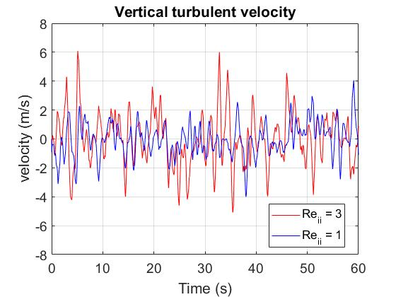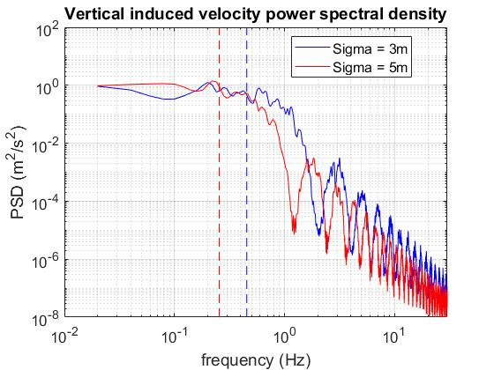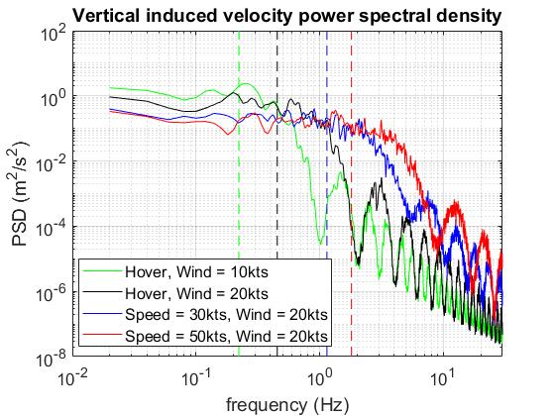
Figure 4: Up: Time history of vertical component of turbulent velocity against R_{ii} values. Center: PSD of vertical induced turbulent velocities against wind and aircraft speed. Down: PSD of vertical induced turbulent velocities against eddy size. Vertical dashed lines indicate power spectral density averaged frequency.
Figure 5 shows the effect of the Eddy shape function on the induced turbulence. Compared to a tent shaped Eddy, a Gaussian shape function with a value of $k=4.5$ shows a shift in the fall of power density towards higher frequencies and a reduction at lower frequencies. Another effect is a reduction in the appearance of low intensity high frequency peaks. This “cleaner” behavior of the Gaussian function should allow for an easier adjustment of the intensity to frequency slope through the use of Eddies of multiple sizes. These effects increase with increases in the value of the decay exponential $k$.
Case | Shape | k | Re_{ii} (m²/s²) | $σ$ (m) | Wind (kts)
8 | Tent | -- | 3 | 3 | 20
9 | Gauss | 4,5 | 3 | 3 | 20
10 | Gauss | 9 | 3 | 3 | 20
Table 2: Summary of Turbulence parameters tested in Figure 5 (Effect of Eddy shape).
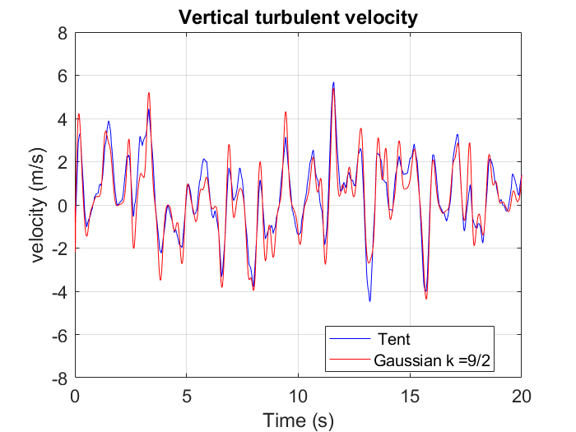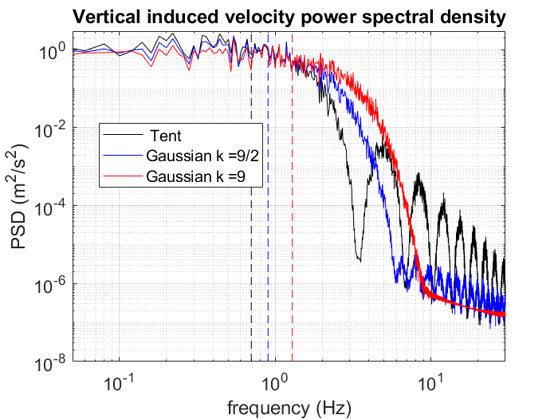
Figure 5: Effect of Eddy shape function on induced turbulence. Above: Time history of induced turbulence for tent and Gaussian shape function. Below: Power spectral density of induced turbulence for tent and Gaussian shape, including effect of power decay (k).
Randomly placing recycled Eddies following a uniform distribution implies that, after enough time has passed, the resulting turbulence is unrelated to previous states, therefore following a stationary ergodic random process. As a result the time averaged values of generated turbulent velocities should tend to their statistical mean as time growths [27]. Time average values of velocity and Reynolds stresses tend to their initial values, skewness tends to zero and kurtosis (or flatness) tends to a fixed value dependent on the number of Eddies, the ratio between their size and the control volume and the velocity and intensity distributions.
$$〈u_{i}^{'}〉=0$$ | 21
$$〈u_{i}^{'}u_{j}^{'}〉=A_{im}A_{jm}={Re}_{ij}$$ | 22
$$S_{u_{i}}=\frac{〈u_{i}^{'3}〉}{{〈u_{i}^{'2}〉}^{\frac{3}{2}}}=0$$ | 23
$$F_{u_{i}}=\frac{〈u_{i}^{'4}〉}{{〈u_{i}^{'2}〉}^{2}}=3+\frac{1}{N}\left(4*{F_{f}}^{3}*F_{ε}*\frac{V_{B}}{σ^{3}}-3\right)$$ | 24
With F_{f} and F_{ε} being the kurtosis of the velocity and intensity distribution functions respectively.
Correct implementation of the model has been verified by ensuring that over the long term, time averages values of turbulence induced velocities, Reynolds stresses, skewness and flatness (or kurtosis) behave as expected for an stationary, ergodic random process [27], [32]. Figure 6 depicts the evolution with time of these values for the first case in Table 1 (tent shape Eddy function, $R_{ii}=1 m^{2}/s^{2}$, $σ=3m$ and wind speed of 20kts).
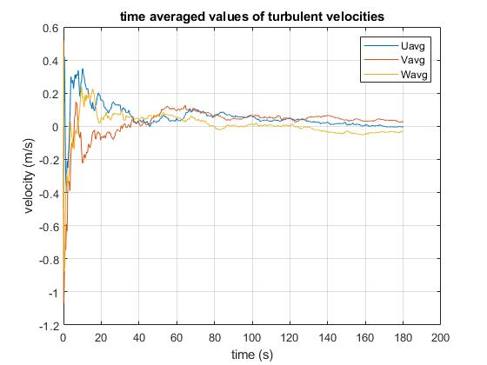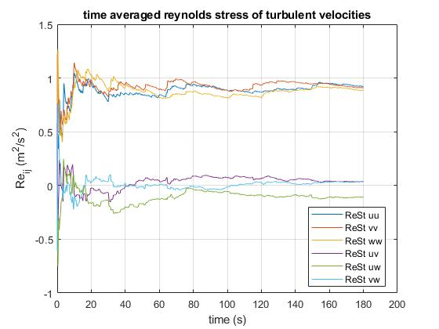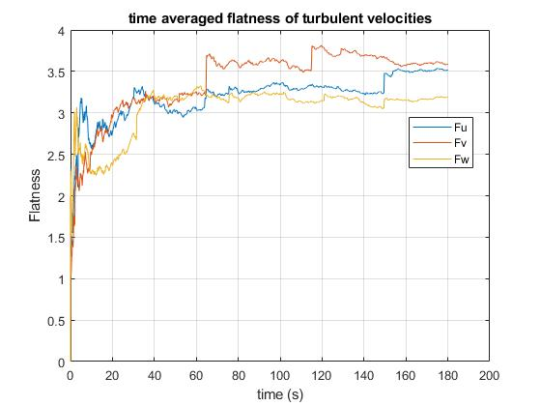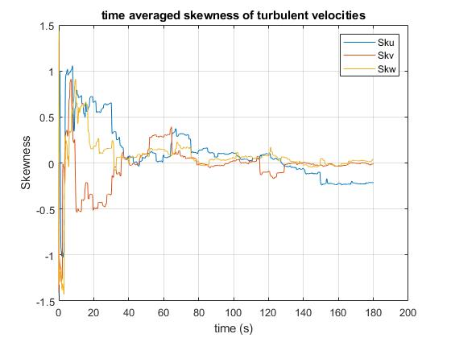
Figure 6: From top to bottom: Time average values on fuselage ACP of: turbulent velocity components, Reynolds stresses, flatness and skewness.
Figure 7 shows the behavior of power spectral density averaged frequency obtained from different simulations. As expected from Equation (9), average frequency is proportional to the ratio of incoming flow velocity and characteristic Eddy size.

Figure 7: Average mean frequency of vertical induced velocity at fuselage against ratio of incoming flow velocity and Eddie size (cases 2, 3, 5, 6 and 7 of Table 1).
Using multi scale Eddy series offers an additional option to adjust the induced turbulence spectra. Total induced turbulence is the sum of the turbulence induced by each of the different Eddy series (see Figure 8). Each individual series presents the characteristic behavior and average frequency for its Eddy strength and size, including the time average values of induced velocities, skewness, flatness and Reynolds stresses. Time average Reynolds stresses of total induced turbulence will tend to the sum of Reynolds Stresses induced by each individual series (see Figure 9).
Figure 10 shows power spectral density of induced vertical turbulence for three different Eddy distributions (see Table 3). Total turbulence in all the cases results in the same total values of $Re_{ii}=3m^{2}/s^{2}$. For simplicity and as a case study, values of $Re_{ii}^{m}$ for each series have been chosen to be proportional to $σ^{m}$. The resulting turbulence spectra show a shift of power density towards lower frequencies and a slower fall in power density with increased frequencies. Adjustment of the number of Eddy series and the relationship between Eddy size and strength should allow adjusting the slope of the turbulence spectra to better match real world conditions.
Case | Shape | k | No of Series | Re^{m}_{ii} (m²/s²) | $σ^{m}$ (m)
11 | Tent | 4,5 | 1 | 3 | 3
12 | Gauss | 4,5 | 2 | 1 , 2 | 3 , 6
13 | Gauss | 4,5 | 3 | 0.5 , 1 , 1.5 | 3 , 6 , 9
Table 3: Summary of Turbulence parameters tested in Figure 8, Figure 10 and Figure 9 (effect of multi – scale SEM)
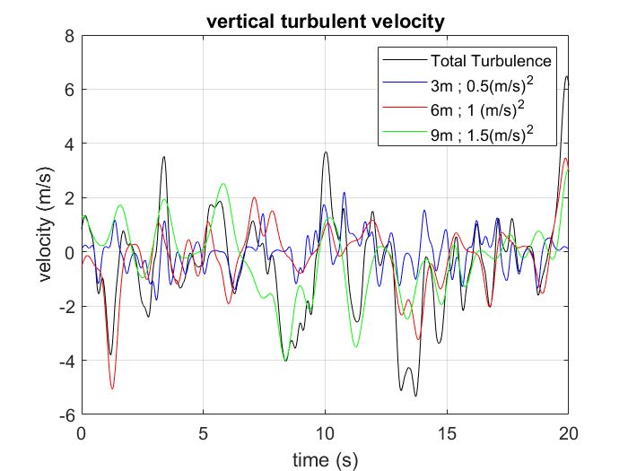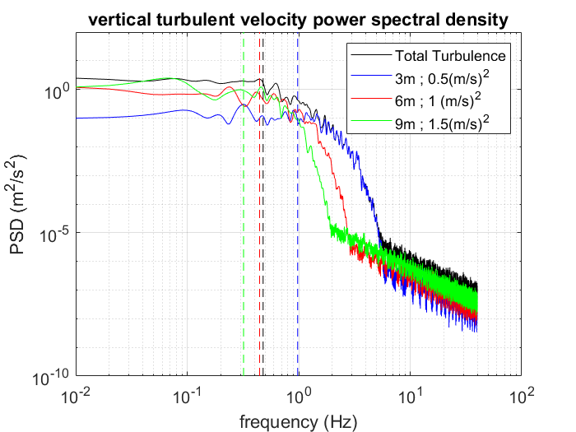
Figure 8: Turbulence induced by each of the Eddy series and total sum. Above: Time history. Below: Power spectral density.

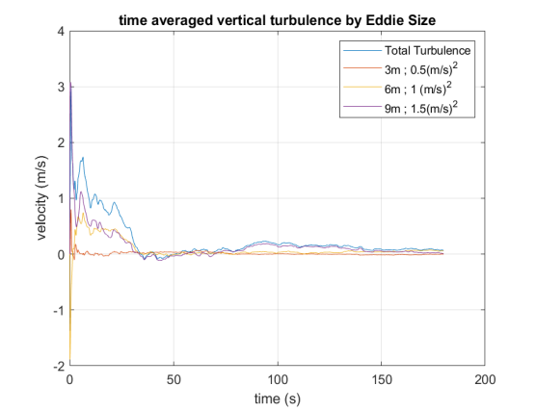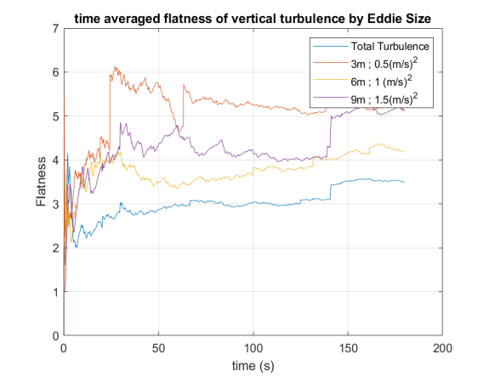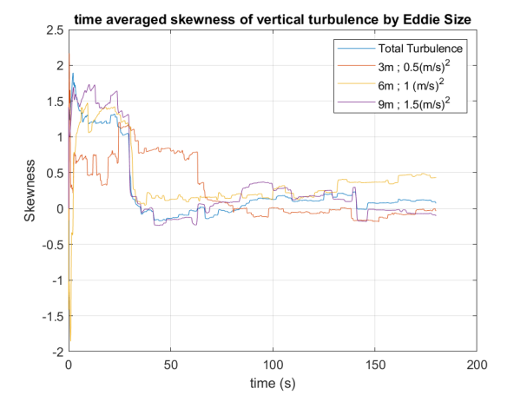
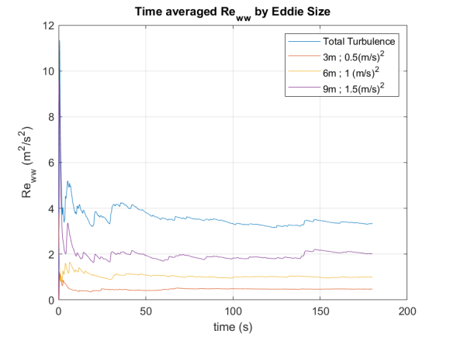
Figure 9: From top to bottom: Time average values of induced turbulent velocity, flatness, skewnes and Reynolds Stress values of vertical turbulence velocity for each Eddy series and of total induced turbulence.
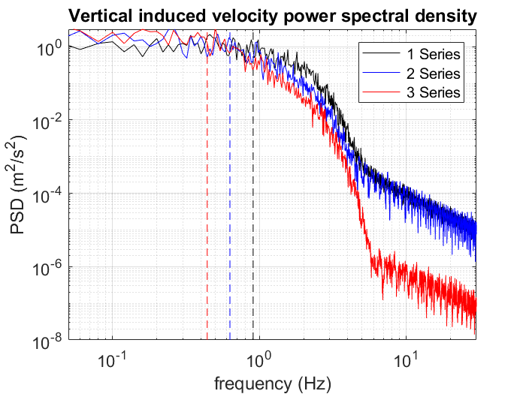
Figure 10: Power spectral density of induced turbulence for three different distributions of Eddy size and strength.

Rotor and aircraft response – Bo105
Offline simulations with the FLIGHTLAB Bo105 helicopter model where performed to better understand the effects of the turbulence and the resulting aircraft response. All simulations performed correspond to the aircraft in hover with all displacements and rotations frozen to avoid the aircraft from crashing during the simulation.
Case | Shape | Re_{ii} (m²/s²) | $σ$ (m) | Wind (kts) | AC IAS (kts)
1 | -- | 0 | -- | 20 | 0 (Frozen)
2 | Tent | 1 | 3 | 20 | 0 (Frozen)
3 | Tent | 3 | 3 | 20 | 0 (Frozen)
4 | Tent | 1 | 3 | 10 | 0 (Frozen)
5 | Tent | 3 | 3 | 10 | 0 (Frozen)
Table 4: Offline simulations performed for the Bo105
As stated previously the location of all the Eddies surrounding the aircraft is being preserved across all time steps, this ensures that the turbulence induced on all the aircraft ACPs is coherent with the effects on the rest of the aircraft. This automatic correlation also extends to the induced turbulence seen by all the rotor blade elements (see Figure 11). Over a long enough period of time, time averaged turbulence induced velocities tends towards zero [27], (see Figure 6). Time average values of lift and drag coefficients and their distribution across the blade are therefore unaffected by the turbulence (Figure 12 Top). However, as the induced turbulence is of the same intensity and frequency across the entire aircraft, its effect are of greater relevance when compared to the lover relative flow velocities at the blade root. This is evidenced in larger variations of the local angle of attack due to turbulence (Figure 12 Center) and results in lift coefficient oscillations of greater amplitude and higher frequency near the blade root (Figure 12 Bottom).
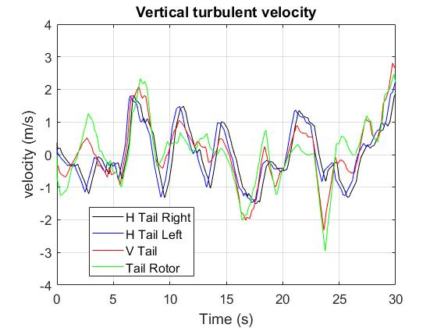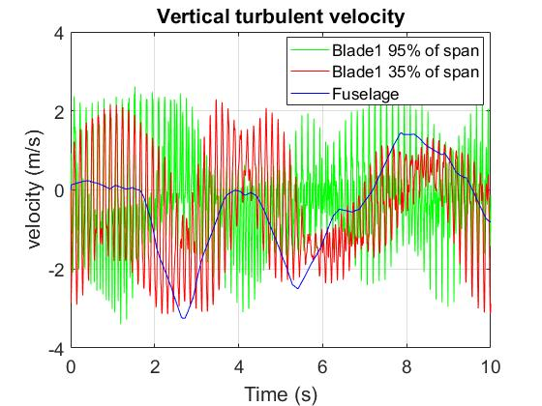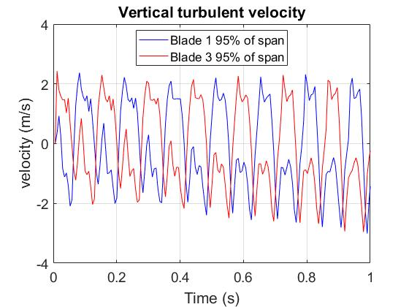
Figure 11: Correlation between turbulence induced vertical flow velocities in hover under a 10kts, 90deg green wind (case 4 in Table 4): Top: At tail and tail rotor. Center: At fuselage, blade root and blade tip. Bottom: At the tip of opposite blades.
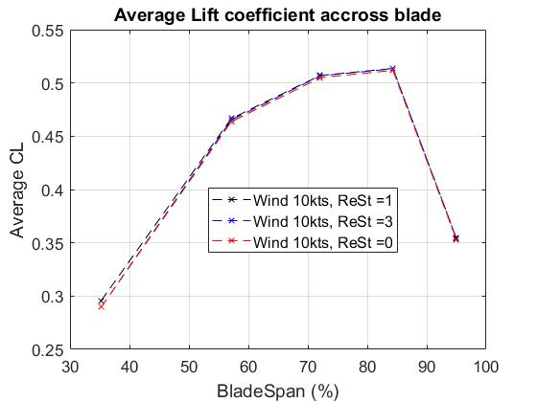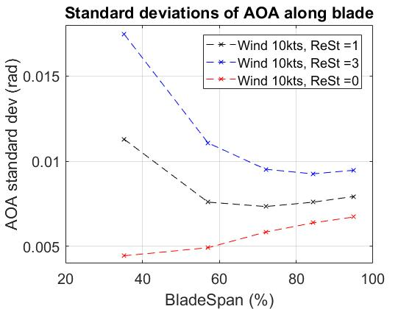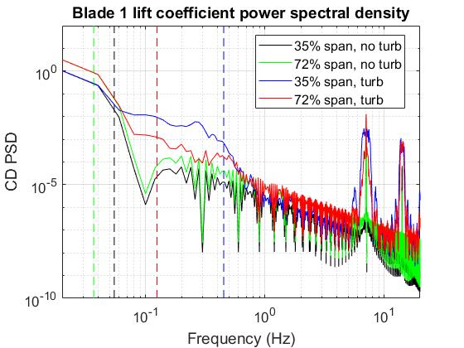
Figure 12: Top: Average lift coefficient along main rotor blade span. Center: Standard deviation of angle of attack along main rotor blade span. Bottom: Power spectral density at two main rotor blade locations under turbulence with Re_{ii} = 1 (m²/s²) and without turbulence. All runs conducted under a 10kts wind (case 4 and 5 in Table 4).
Figure 13 shows PSD of main rotor blade flapping and thrust coefficient for the aircraft in hover under a 20kts strength 90deg azimuth wind under conditions of no turbulence and turbulence with values of ${Re}_{ii}=1{\left(\frac{m}{s}\right)}^{2}$ and ${Re}_{ii}=3{\left(\frac{m}{s}\right)}^{2}$ (cases 1, 2 and 3 in Table 4). Blade flapping response to turbulence follows induced lift on the rotor blade, amplitude increases are appreciable within the 0.1Hz to 1Hz frequency range. Largest effects can be seen around frequencies near one and two times the main rotor frequency and frequencies near multiples of the rotor frequency are also excited. Power spectra of main rotor thrust shows a similar but milder effect within the 0.1Hz to 1Hz range and a smaller variation at four times the rotor frequency corresponding to the one per rotor cycle load changes from the four blades.
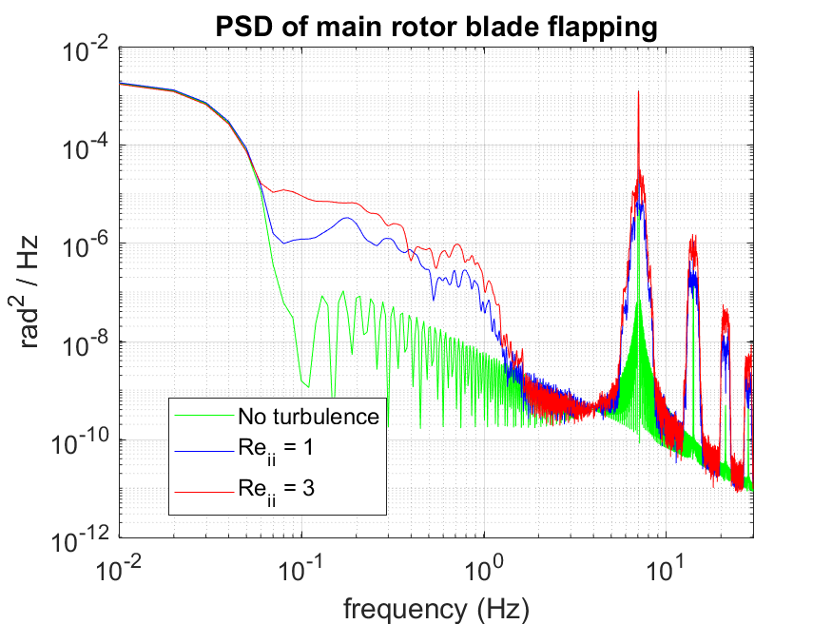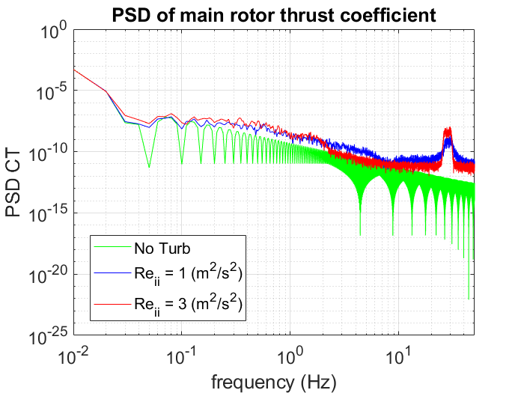
Figure 13: Top: Power spectral density of main rotor blade flapping. Bottom: Power spectral density of main rotor thrust coefficient.
Figure 14 shows PSD of coefficients for roll, pitch and yaw moments acting on the aircraft under conditions of no turbulence and turbulence with values of values of ${Re}_{ii}=1{\left(\frac{m}{s}\right)}^{2}$ and ${Re}_{ii}=3{\left(\frac{m}{s}\right)}^{2}$. The effect of turbulence induced disturbances is strongest within the 0Hz to 1Hz range and decays rapidly after that, but extends across the whole frequency spectrum with reduced peaks at multiples of four times the rotor frequency.
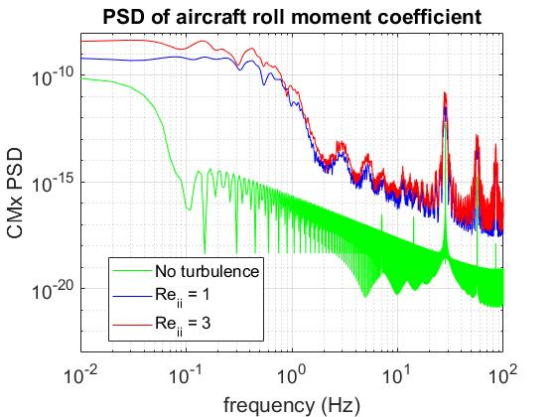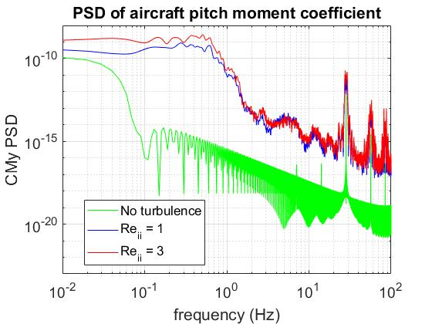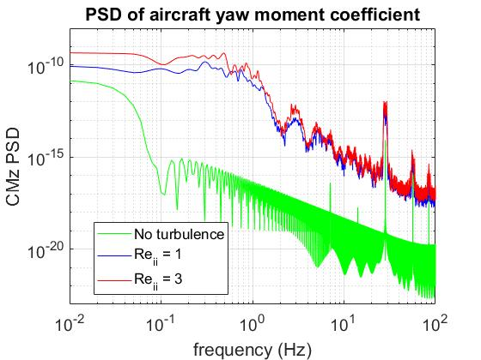
Figure 14: From top to bottom: Power spectral density of roll moment coefficients acting on aircraft in roll, pitch and yaw.

Rotor and aircraft response – Bell 412
For flight simulation testing, the SEM turbulence model has been coupled to the University of Liverpool’s Bell 412 FlightLab model [33] based on the Advanced Systems Research Aircraft (ASRA) operated by the Canadian National Research Council (NRC) [34]. The model includes a variable stability control system that can be configured as rate damping or rate command attitude hold (RCAH) in roll, pitch and yaw and as attitude command attitude hold in roll and pitch.
In preparation of piloted simulation tests, offline analysis the aircraft response to the SEM induced turbulence has been performed. The SCAS system was configured in RCAH mode to study the response of the aircraft when attitude and lateral displacements are unfrozen and to assess whether the SCAS system is capable of counteracting the turbulence. Simulations presented in this chapter focus on the response of the SCAS system and how the aircraft responds to changes in Eddy shape and size and to the use of multi-scale turbulence. All simulations correspond to the aircraft in hover under a 10 kts wind with a 90 deg azimuth from the right (see Table 5). Wind velocity was lowered with respect to the previous simulations in order to reduce the probability of the aircraft achieving unrealistic attitudes when freeing aircraft states. Displacements in the vertical axis where left frozen in order to avoid the aircraft crashing into the ground.
Case | Shape | k | Re_{ii} (m²/s²) | $σ$ (m) | SCAS | Mov
1 | -- | -- | 0 | -- | RCAH | free
2 | Gauss | 4.5 | 1 | 3 | OFF | frozen
3 | Gauss | 4.5 | 3 | 3 | RCAH | free
4 | Gauss | 9 | 3 | 3 | RCAH | free
5 | Tent | -- | 3 | 3 | RCAH | free
6 | Gauss | 4.5 | 3 | 6 | RCAH | free
7 | Gauss | 4.5 | 3 | 9 | RCAH | free
8 | Gauss | 4.5 | [3 , 6] | [3 , 6] | RCAH | free
9 | Gauss | 4.5 | [0.5 , 1 , 1.5] | [3 , 6 , 9] | RCAH | free
Table 5: Offline simulations performed for the Bell 412
Figure 15 shows PSD plots of turbulence induced aircraft moments in hover with all axis frozen and stability system deactivated and with all axis except vertical displacement unfrozen and the stability system configured for RCAH. Under conditions of deactivated SCAS system and frozen aircraft, induced moments follow a similar behavior as for the Bo105 helicopter model with disturbances being strongest for frequencies up to 1Hz, with pitch response presenting a peak at around 0.3Hz – 0.5Hz. Amplitude of moment coefficients decay sharply for higher frequencies, but present peaks at multiples of four times the main rotor frequency.
From the figure it can be seen that the SCAS system is capable of counteracting turbulence induced moments in the low frequency (below 0.5Hz) domain for all three axis, especially in the longitudinal and lateral axis, resulting in an overall decrease in the amplitude of induced disturbances. Above 0.5Hz this reduction becomes less noticeable, resulting in an overall shift of disturbances towards higher frequencies and the appearance of peaks in roll and pitch disturbances at around 1Hz and 0.5Hz. These frequencies are near to the Bell 412 longitudinal and lateral control bandwidth limits in attitude command and attitude hold configuration [33].
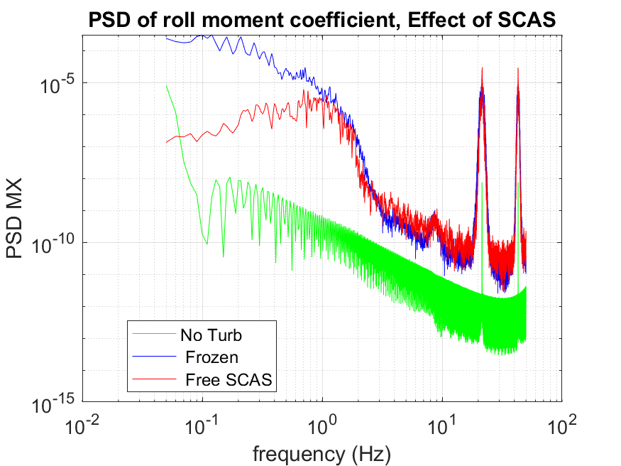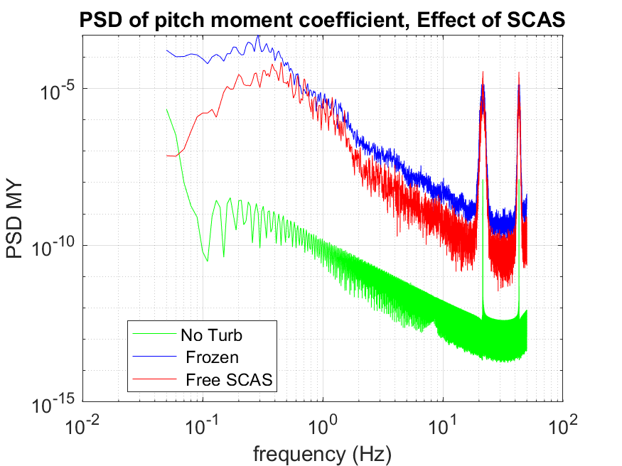
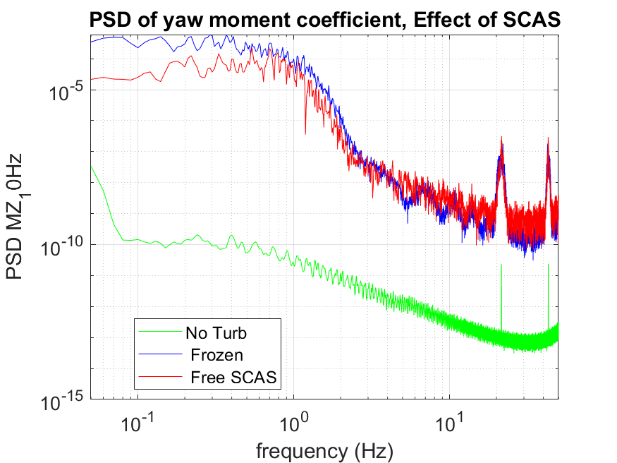
Figure 15: From top to bopttom: Comparison of turbulence induced aircraft moment coeffcients in roll, pitch and yaw. Cases include: hover without turbulence, frozen aircraft under turbulence, unfrozen aircraft with stability system activated and configured as RCAH.

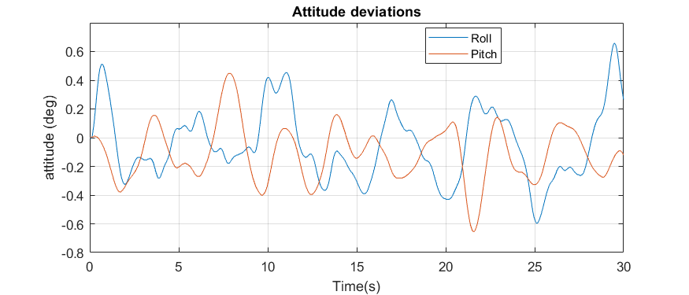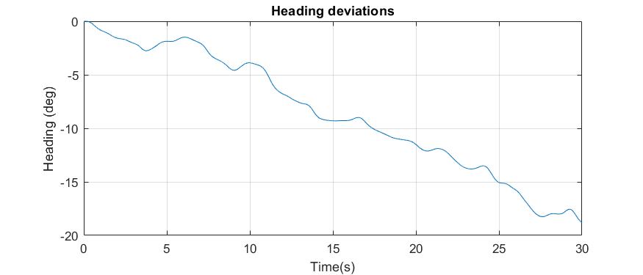
Figure 16: Attitude deviations for the first 30s under turbulence with ReSt = 3 m²/s² , Eddy size = 3m and k = 4.5
A better insight into the response of the stability system can be gained from Figure 17, which presents PSD plots of main rotor longitudinal and lateral pitch and tail rotor collective pitch under conditions of no turbulence and two different turbulence intensities. As can be seen, the system responds mainly to low frequency disturbances with the response in frequencies above 0.5Hz no longer scaling with turbulence intensity.SCAS input power density decays rapidly for frequencies higher than 1Hz in line with the behavior of induced turbulence and induced moments.
Aircraft response to turbulence resulting from different Eddy shapes is shown in Figure 18. Amplitude of low frequency disturbances does not seem to be significantly affected by Eddy shape, probably as a result of stability system activity. Differences start to appear in the frequency range between 0.5Hz and 1Hz where induced moments follow a similar shape as the induced turbulence (see Figure 5). The effect is most noticeable in the lateral axis, where the higher amplitude of induced turbulence around 1Hz for a value of $k=9$ (see eq [19]) results in an increase in the amplitude of the aircrafts response.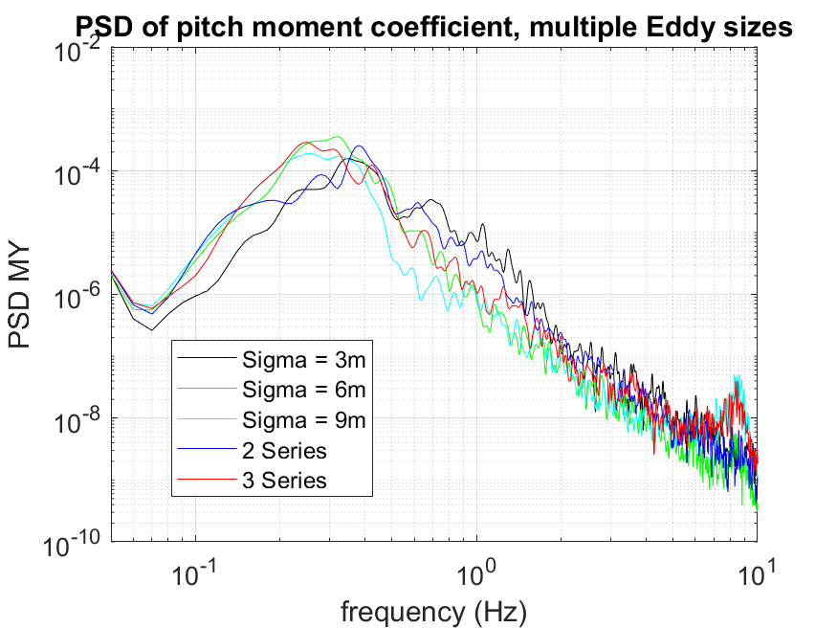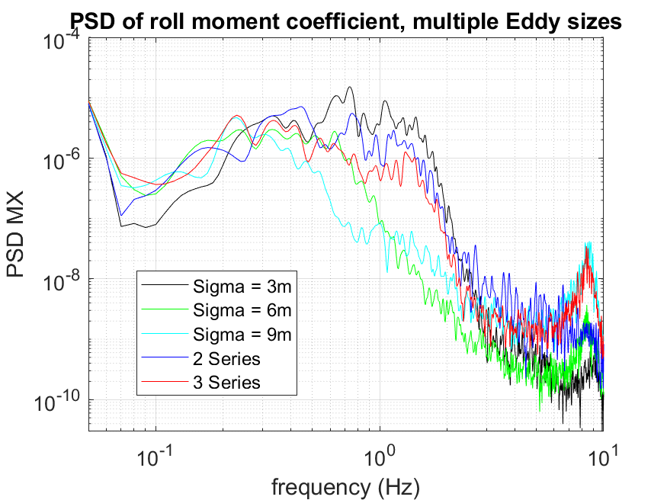
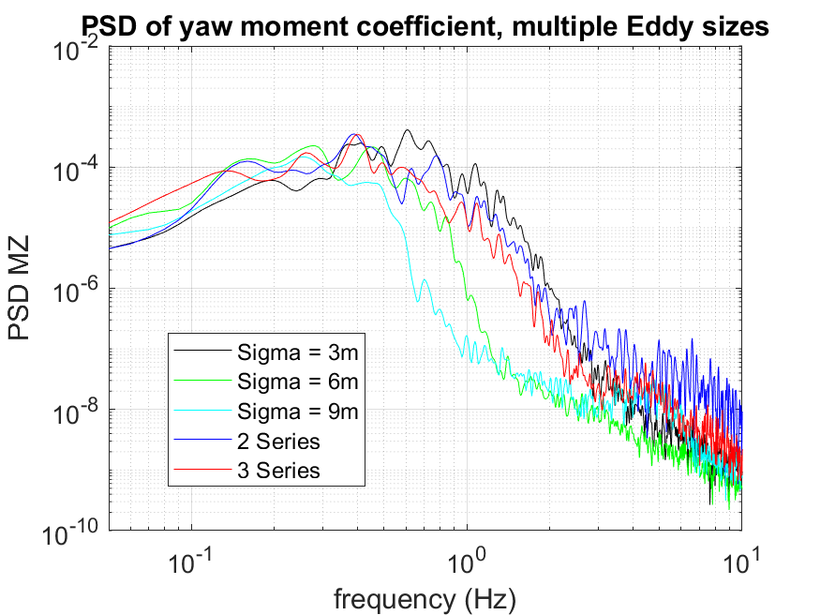Figure 19 shows the effect of differences in Eddy size and of including multiple Eddy series of different size. Graphs correspond to the cases 3, 6, 7, 8 and 9 of Table 5. As can be seen increasing Eddy size, decreases the frequency after which power density of disturbances starts to rapidly decay, in line with the behavior of turbulent flow, resulting in lower average frequencies for induced disturbances. Aircraft response to multi-scale SEM turbulence presents an intermediate situation that result in turbulence induced disturbances across a wider frequency spectrum than under a single Eddy size, despite the total induced turbulence intensity being of the same value. This presents an interesting condition for testing, because while there is evidence that low frequency, large amplitude turbulence as greater effects on pilot workload [35], the Bell 412 SCAS system seems to be better able to mitigate them leaving the high frequency disturbances almost intact.
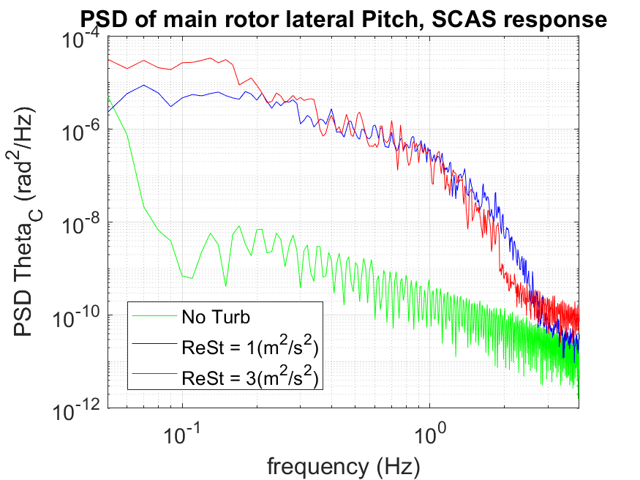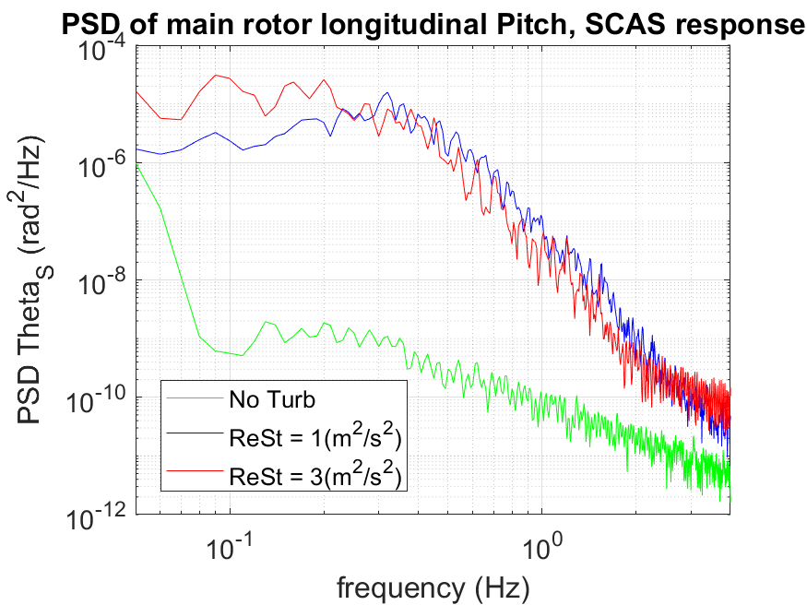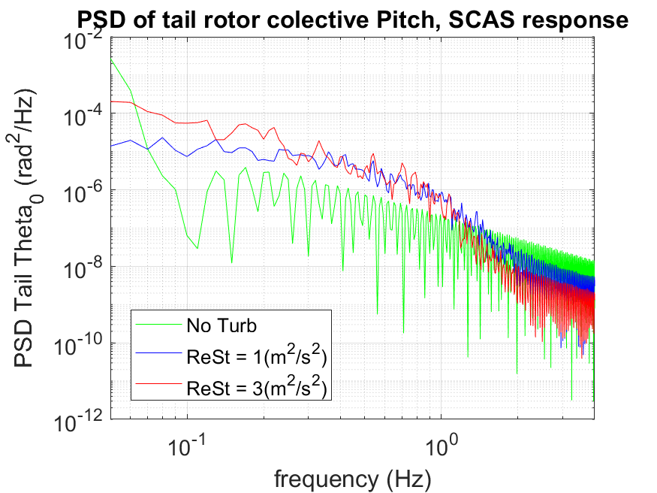
Figure 17: Power spectral density of main and tail rotor actuators, indicating SCAS system response to disturbances.
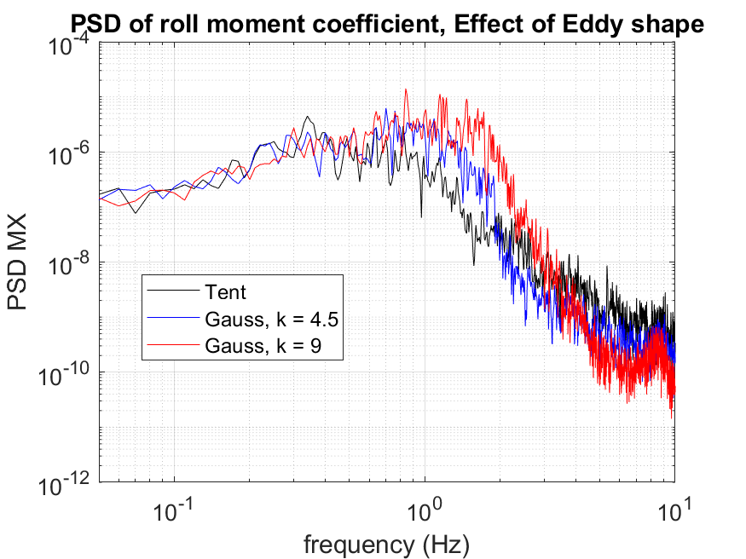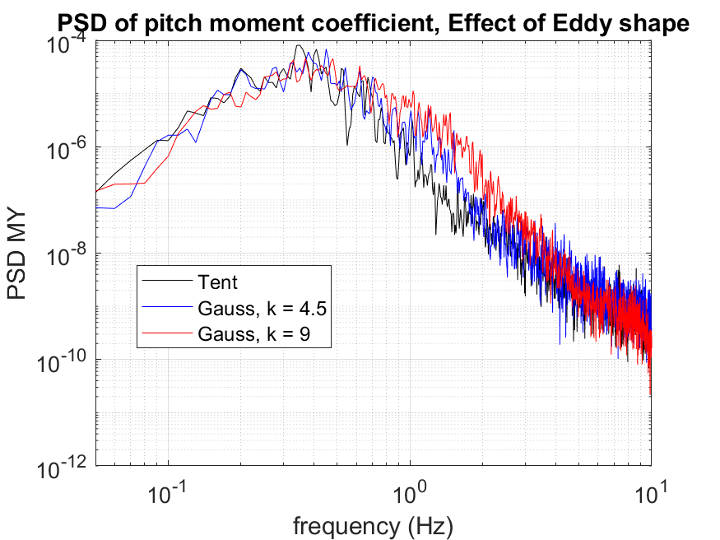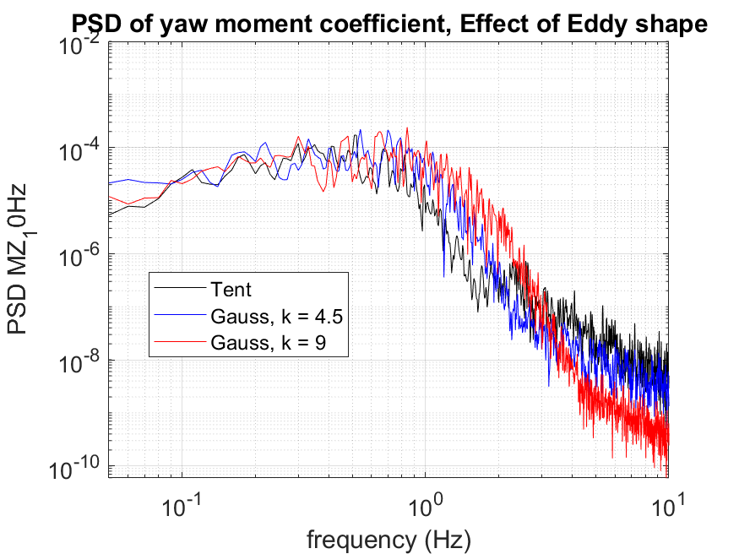
Figure 18: Effect of Eddy shape on turbulence induced aircraft moments.
Figure 19: Effect of Eddy size and multiple Eddy sizes on turbulence induced aircraft moments.

Piloted Flight Simulation Testing

BO105 Station Keepig and steady flight
A piloted flight simulation test was performed to assess the feasibility of applying the developed SEM model for piloted flight simulation and provide an initial insight of both, its capabilities and the effects of induced turbulence on aircraft handling and pilot workload. The aircraft flown was a FLIGHTLAB model of a Bo105 helicopter, with no stability augmentation system.
The pilot was instructed to attempt two tasks: The first one was a station keeping task as defined for the ADS - 33 hover mission task element [8] (see Figure 20 and Table 6). The second one was to perform a steady, low speed (30kts), low altitude forward flight. Due to lack of visual reference elements, no desired or adequate deviations were defined for the forward flight task, instead the pilot was instructed to follow a runway (Figure 21) while maintaining initial heading altitude, lateral position and velocity and, if disturbed, to return to the original conditions as soon as he deemed feasible for safe flight. All flights were performed under a 10kts, 90deg green (from the right) wind and turbulence with Re_{ii} values of 0, 0.5 (m/s)² and 0.75 (m/s)², the size of the eddies was kept constant at $σ_{x}=σ_{y}=σ_{z}=3m$ for all test flights (see Table 7), all flights where performed using the tent based Eddy shape.
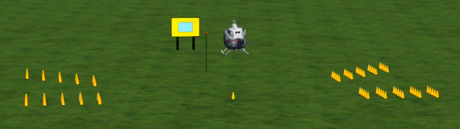
Figure 20: Setup for the Position hover task for the simulator trial.
Parameter | Desired | Adequate
Maintain horizontal position within: | 3 ft | 6 ft
Maintain vertical position within: | 2 ft | 4 ft
Table 6: Limits on desired and adequate deviations for the position keeping task
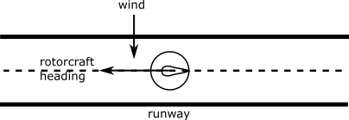
Figure 21: Schematics of the steady flight task.
Run | MTE | Re_{ii} (m²/s²) | $σ$ (m) | Wind (kts) | AC IAS (kts) | WL Rating
1 | Pos keeping | 0 | -- | 0 | 0 | 5
2 | Pos keeping | 0 | -- | 10 | 0 | 5
3 | Pos keeping | 0.5 | 3 | 10 | 0 | 7
4 | Pos keeping | 0.75 | 3 | 10 | 0 | 8
5 | Fwd Flight | 0 | -- | 10 | 30 | 3
6 | Fwd Flight | 0.5 | 3 | 10 | 30 | 3
7 | Fwd Flight | 0.75 | 3 | 10 | 30 | 4
Table 7: Piloted simulation runs performed.
Workload ratings awarded by the pilot on the Bedford workload scale [36] show that increases in turbulence intensity lead to increases in required task workload and reduced spare capacity (see Figure 22). Pilot comments indicate that the turbulence results in multiaxis disturbances. He also indicated that lack of an aircraft stability system and that, even without turbulence, strong inter-axis couplings of the Bo105 [37] are strong contributors to the difficulty of the task making it difficult to discern between turbulence induced disturbances and aircraft off axis response to the pilots own inputs. This is particularly evident during the hover task, not only did the turbulence have a greater effect on pilot workload, leading him to award a level 3 rating, but even without turbulence, the awarded rating fell within level 2.
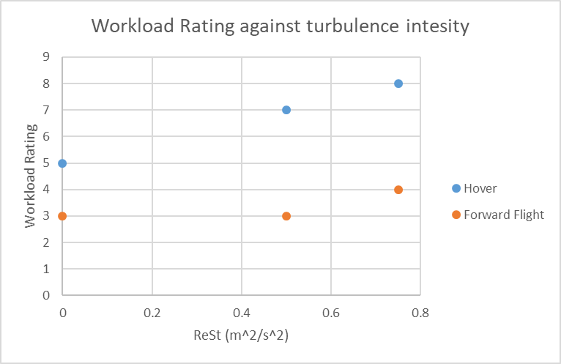
Figure 22: Awarded workload ratings against turbulence intensity
The nature of the hover task, which requires a greater effort from the pilot in stabilizing the aircraft rather than guidance and the more stringent definition of upset limits for the hover task compared to the forward flight task during these tests, probably led to a more difficult task and might be in part responsible for the worse ratings awarded. Recorded test data, however also suggest a greater susceptibility of aircraft disturbances and pilot activity to induced turbulence.
Figure 23 shows position and heading during the hover task. The effects of turbulence are clearly visible as a leftward turn, lateral and, especially, longitudinal displacements from the starting position and a tendency tom climb above it.
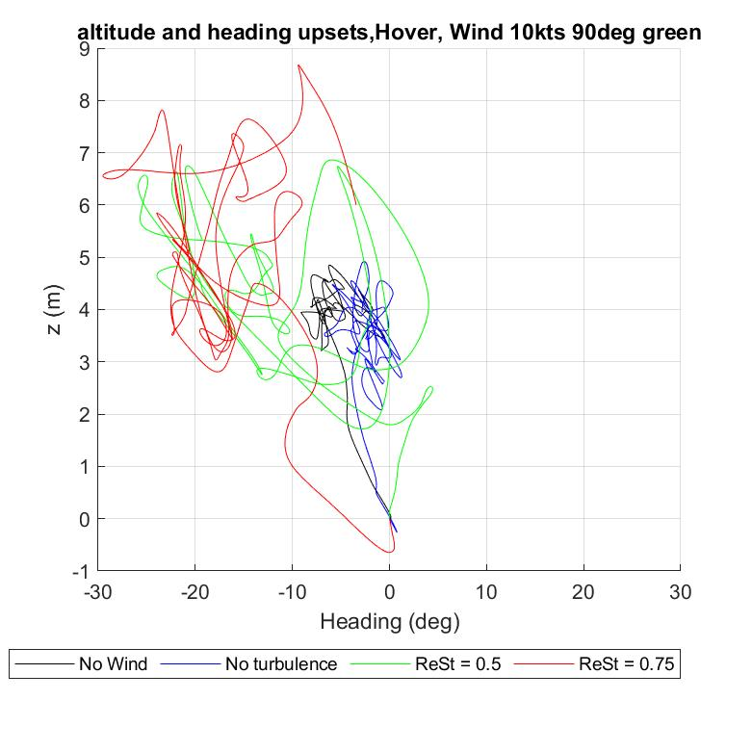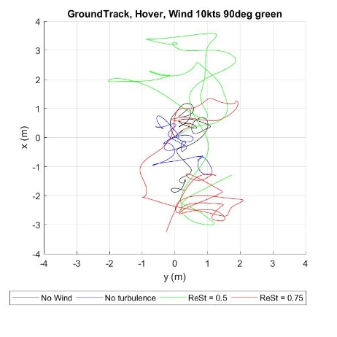
Figure 23: Performance of hover task: Top: Altitude above ground. Center: Lateral and longitudinal displacements. Bottom: Pitch and heading deviations.
Altitude path and ground track along the flight for the steady flight task are shown in Figure 24. In contrast with the hover task, turbulence seems to have a more limited effect on task performance. Absolute altitude displacements stay within the ± 2m range and lateral deviations from the flight path do not exceed 4m in all run. The run under turbulence conditions of $Re_{ii}=0.5 m^{2}/s^{2}$ shows little appreciable differences when compared to the run without turbulence with deviations taking the form of a continuous drift and the pilot awarding the same workload ratings in both cases. Suggesting that the uniform lateral wind has a greater effect on task performance than the turbulence. Influence of turbulence becomes evident for the run under $Re_{ii}=0.75 m^{2}/s^{2}$ as more frequent oscillations in lateral position and especially in altitude.
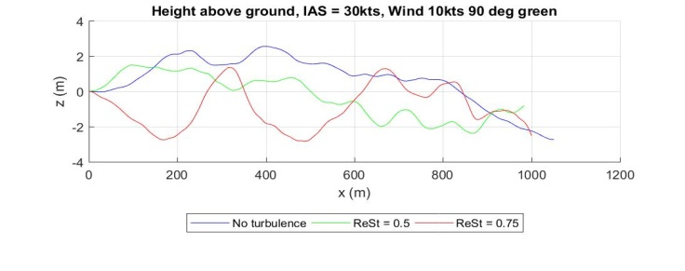
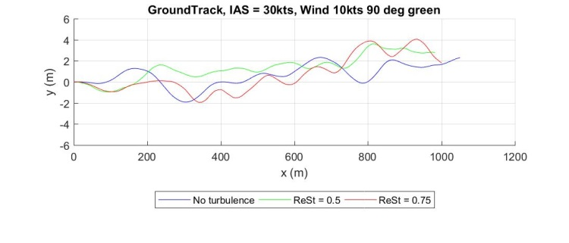
Figure 24: Performance during forward flight task: Top: Height above ground. Bottom: Lateral displacement along ground track during forward flight test.
Pilot comments suggest that the relatively uniform nature of the induced disturbances and their higher frequency during forward flight results in a lower buildup of deviations in aircraft attitudes and position. Sudden aircraft upset some 10s within the flight that required large pilot inputs in collective and corresponding inputs in pedal and stick to compensate for cross couplings, seem to be main reason for the higher workload ratings awarded during the run under $Re_{ii}=0.75 m^{2}/s^{2}$.
Analysis of aircraft attitudes show a multi-axis disturbance and a clear influence of turbulence. Amplitude of oscillations in aircraft roll and pitch rates in hover increase with higher levels of turbulence intensity (see Figure 25. top and middle), requiring an increase in the amplitude of pilot control inputs to counteract them. The pilot indicated that he tried to avoid the buildup of large attitude and it can be seen that deviations in roll and pitch do show a limited with increased values of turbulence. The opposite is true for yaw upsets where large deviations are apparent for both flights during hover and plots (see Figure 25 bottom) suggesting that the pilot put priority in limiting lateral and longitudinal upsets.
By contrast, aircraft deviations and pilot activity during forward flight under turbulence of $Re_{ii}=0.5 m^{2}/s^{2}$ show little difference to the case without turbulence (see Figure 26 top and middle). In the case of $Re_{ii}=0.75 m^{2}/s^{2}$ however, the sudden upset in altitude requires compensating pilot action in collective which leads to additional upsets in pitch and yaw, probably as a result of aircraft cross couplings.
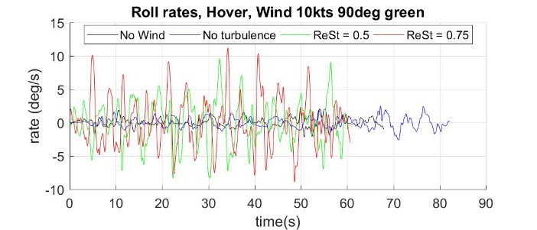
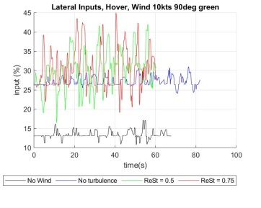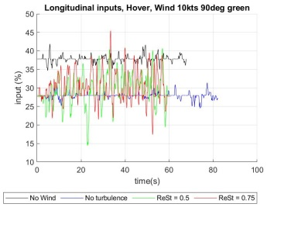
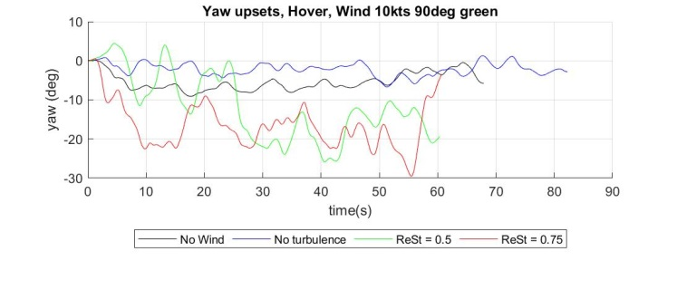
Figure 25: Top Aircraft roll rates in hover. Center: Lateral and longitudinal pilot control inputs. Bottom: Yaw deviations in hover.
These overall trends are visible in Figure 27 and Figure 28, which show standard deviations of attitude rates and attitudes and RMS of pilot control inputs respectively. The effect of turbulence resulting in larger disturbances and the required pilot response in the different axis becomes apparent as does the distinct nature of the hover and forward flight task.
Figure 29 shows the root mean square (RMS) of aircraft moments and total thrust for the hover and forward flight runs against the values of $Re_{ii}$. This value which is defined as the root square of power spectral density between the frequencies of 0.1Hz and 2Hz has been positively correlated with pilot workload during flight simulation trials of shipboard landings [38] [39]. The overall trend shown here suggests that this correlation might also predict workload requirements in this case.
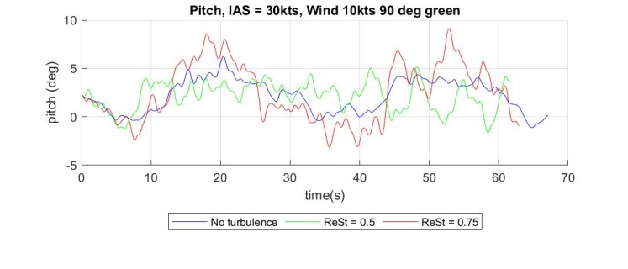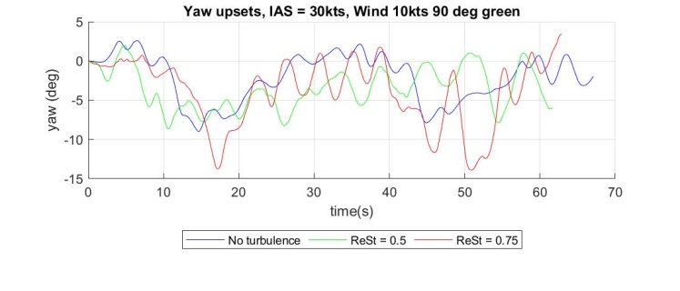
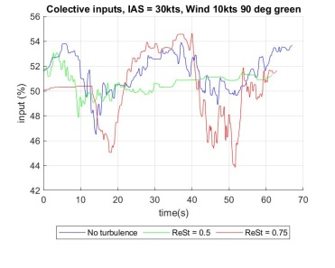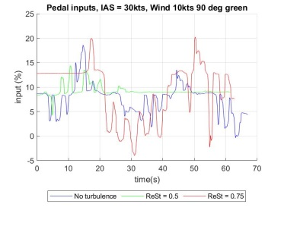
Figure 26: Top: Aircraft pitch angle during forward flight. Center: Yaw deviations during forward flight. Bottom: collective and pedal pilot control inputs
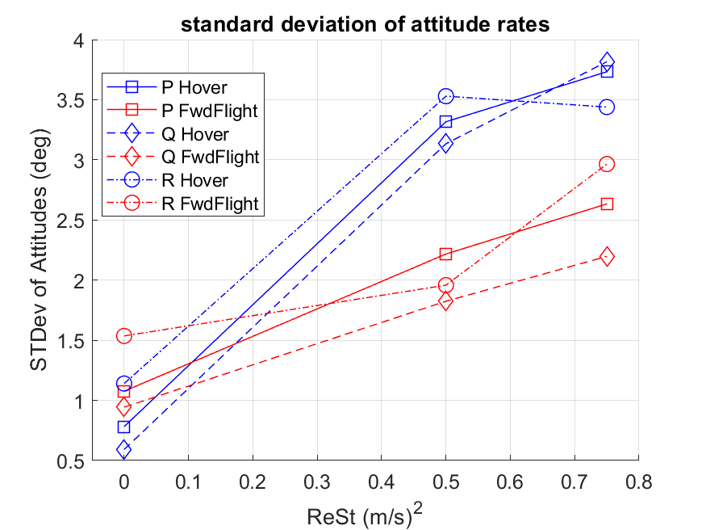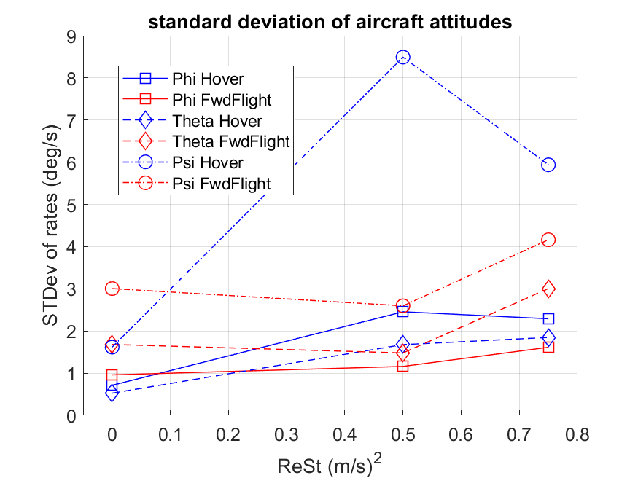
Figure 27: Standard deviation of aircraft attitude rates and attitudes.
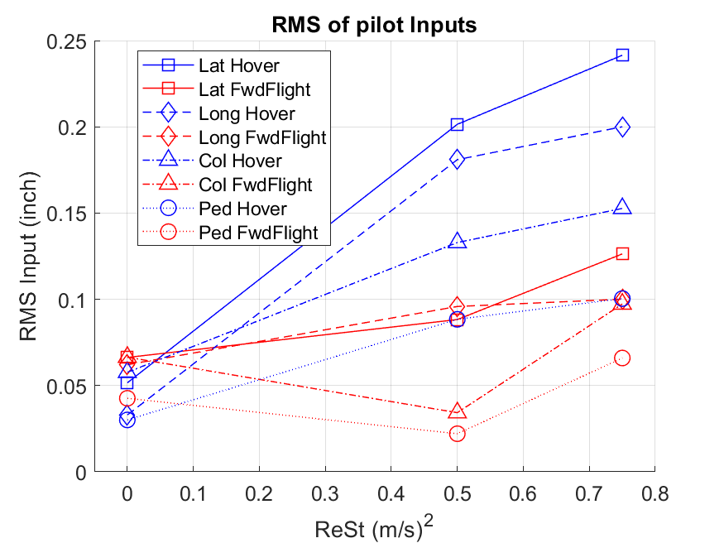
Figure 28: RMS of pilot control inputs.
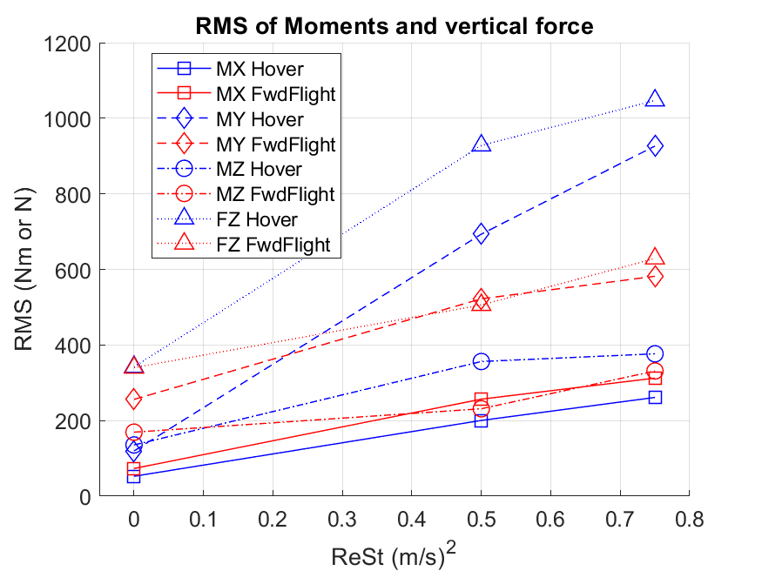
Figure 29: RMS of aircraft moments and vertical forces.

Planning for Bell 412 flight simulation testing
Initial flight simulation testing has shown that the current implementation of the SEM model is capable of working in real time for piloted flight simulation and of generating turbulence that affects pilot workload and task performance. The test also point towards a possible relation between turbulence intensity, RMS of moments and forces on rotorcraft, oscillations in aircraft attitude rates, pilot activity and resulting pilot workload ratings.
These findings are very preliminary and should be taken with caution. The test performed involves too few testing points and the strong interaxis couplings of the Bo105 model make it difficult to discern between effects from the turbulence and unwanted aircraft response to control inputs.
Further testing is needed to verify these findings and continue calibrating the model. To this end, a FlightLab model of a Bell412 helicopter has been coupled with the SEM module. Reduced interaxis coupling of the airframe and the availability of a stability system should make it easier to discern the effects of the turbulence in future testing.
A series of piloted simulation experiments are being planned with the aim to better understand the impact of different turbulence parameters and flight conditions on aircraft handling. Main objectives of the testing campaign would be:
- Identifying turbulence intensity limits at which aircraft handling or motion based flight simulation is still feasible:
Initial tests were performed under very low levels of turbulence intensity. It is expected that the improved handling qualities of the Bell 412 airframe will allow increasing the value of $Re_{ii}$ before until the task can no longer be completed, pilot workload becomes unreasonably high or the motion of the platform becomes excessive. Analysis of the results will also study if the correlations shown in Figure 29, Figure 27 and Figure 28 are still valid for a different airframe and a greater range of turbulence intensities.
- Studying the effect of turbulence frequency on handling:
Keeping turbulence intensity constant, different Eddy sizes will be tested, resulting in turbulence with different values of average frequency. Previous research points towards lower frequency oscillations being the main cause for increases in pilot workload, but offline simulation shows that the stability system of the Bell412 is less effective in dealing with high frequency disturbances (see Figure 15).
- Studying the effect of different distributions of Eddy sizes:
In a similar manner as the previous case, turbulence will be dispersed across different Eddy sizes while keeping total intensity constant.
- Studying the effect of different Eddie shapes:
Most of the runs will be performed using the Gaussian shape as it will allow for better adjustment of the turbulence spectra in the future. A comparison of the aircraft response to tent shaped function and different decay power values for Gaussian Eddies will be performed.
- Studying the impact of turbulence on different flight conditions and mission tasks:
Turbulence seems to have a greater effect on workload during hover than steady forward flight. Therefore most testing will be based on the complete hover MTE as defined by ADS-33 [8], which includes transition to hover and station keeping. Influence of turbulence across a range of flight speeds will also be tested. A more stringent forward flight task has been defined based on the ADS – 33 acceleration and deceleration MTE.

Discussion
A working turbulence component for flight simulation based on SEM has been developed and coupled with FlightLab flight dynamics models of an MBB Bo105 and a Bell412 helicopters.
Among its main advantages is that it preserves the location of the eddies near the aircraft, ensuring that the turbulence induced on each of the ACPs is coherent with the effects on the rest of the aircraft even if aircraft flight velocities experience large changes in a small number of time steps. The rotation of the rotor blades relative to the turbulence field is also automatically included (see Figure 11). It also opens the possibility of coupling the displacement and parameters of the eddies with precomputed airwake solutions or with the aircrafts own airwake, venues that will be explored in the future. The method also lends itself very well to parallelization, as the computations on each aircraft ACP can be done independently.
Its main disadvantage is that the frequency content of the turbulence is directly linked to the size and number of eddies (see appendix A) which means that simulating turbulence with higher frequency content requires a larger number of operations, increasing the computational cost. In its current implementation with Simulink, the model is too computationally heavy and this limits the minimum eddy size that is feasible for real time piloted flight simulation. It also presents an obstacle for any attempts of coupling with the environment or aircraft. Future development of the model will focus on addressing this issue.
Initial piloted flight simulation tests demonstrated the feasibility of the concept and the capability of the model to function in real time. Flight simulation results also show that that induced turbulence generates noticeable aircraft disturbances on the aircraft that result in increasing workload for the pilot. These effects are greater during hover than forward flight. These tests also provide some cues on possible parameters that might relate turbulence, aircraft response and workload.
These results are still preliminary and will require further testing to validate. Immediate future steps will be focused on calibrating the model and conduct an assessment of its effects on rotorcraft handling. This will imply finding an adequate correlation between the different model parameters and environmental conditions as well as conducting a series of flight simulation tests to assess the effect of these parameters on aircraft handling and collect pilot feedback.
In the longer term, the aim is to improve the performance of the turbulence model, by migrating it to another programming language and applying parallelization, and to couple it with precomputed airwake solutions and the aircraft’s airwake. The ultimate aim is to allow a method that can provide a computationally cheap and realistic random turbulence component and aircraft coupling for lower fidelity airwake solutions.

Appendix – Implementation for real time flight simulation
- Flightlab Time Step adjustments for real time simulation
Exchange of data between FlightLab and the Simulink turbulence model is performed via a communications function known as flcomms. In order to always ensure that the flight model operates in real time even if Simulink freezes, FlightLab needs to operate independently from the turbulence model. It always uses the most recent data sent to it from the turbulence model independently even if the time-step does not correspond.
Therefore, the task of ensuring synchronization between flight and turbulence model falls completely on the turbulence model. A trigger within the model ensures that the SEM module always waits for FlightLab to perform a time step before updating the turbulence field. It is also necessary to ensure that the time required for this is always lower than the duration of a FlightLab time step.
The spectrum of the induced turbulence is a function of the wind speed and Eddy size (Eq. [9]). Since the control volume needs to be completely filled by Eddies (Eq. [15]), that average frequency of turbulent velocity components should scale with the cubic root of the number of Eddies. For computational performance of the model, the number of Eddies is the most important parameter. Given the size of the control volume surrounding the helicopter, some 300 to 400 Eddy are required to generate disturbances within a frequency range of up to 1Hz.
To allow for real time simulation at the Heliflight flight simulator at the University of Liverpool, the timestep of the employed helicopter models had to be modified. FlightLab defines the time step of an aircraft model as a fraction of the main rotor period under nominal conditions. The default time step duration was extended from $\frac{1}{24}th$ to $\frac{1}{12}th$ of the main rotor period. Correct behavior of the aircraft model was checked by comparing the aircraft response to a step input in all controls (see Figure 30) and through piloted simulation. This process was performed for the University of Liverpool’s FlightLab models of the MBB Bo105 and the Bell 412. These modifications allow the model to run smoothly with over 400 Eddies.
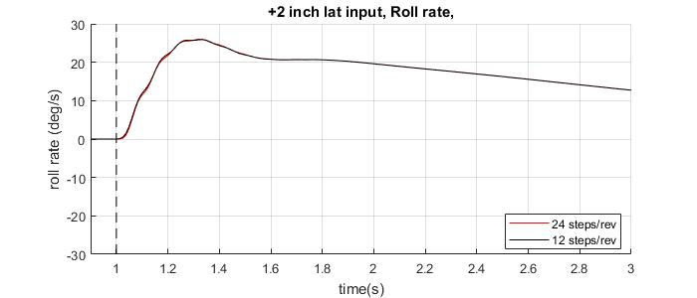
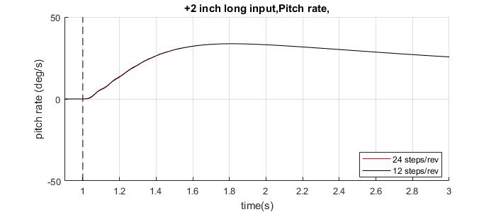
Figure 30: Comparison of Bo-105 model response to step input for two different time steps.
Testing of real time capability was performed by comparing the number of time steps performed by FlightLab and the turbulence model (see ¡Error! No se encuentra el origen de la referencia., missed time steps are characterized as jumps). Even under ideal conditions the possibility exists that the Simulink model slows down and a step is missed. The algorithm of Eddy regeneration has been adapted to ensure that the number and placement of new Eddies covers the required fraction of the control box to ensure a uniform distribution.
No of Eddies | FlightLab Steps | Simulink Steps | Jumps/Steps
296 | 2566 | 2566 | 0,0000
305 | 2325 | 2325 | 0,0000
314 | 2580 | 2580 | 0,0000
342 | 2707 | 2706 | 0,0004
394 | 2084 | 2084 | 0,0000
406 | 6148 | 6108 | 0,0065
495 | 6217 | 6175 | 0,0068
543 | 2642 | 2599 | 0,0163
Table 8: Comparison of time steps missed by the turbulence model during real time simulation.

Authors contact:
Sergio Henriquez Huecas S.Henriquez-Huecas@liverpool.ac.uk
Prof. Mark White mdw@liverpool.ac.uk
Prof. George Barakos: George.Barakos@glasgow.ac.uk

Acknowledgments
The project NITROS has received funding from the European Union’s Horizon H2020 research and innovation program under the Marie Skłodowska-Curie grant agreement No. 721920.

References
[1] G. Quaranta, M. Pavel, G. Barakos, M. White, and M. Mulder, “NITROS : An Innovative Training Program to Enhance Rotorcraft Safety,” AHS International 74th Annual Forum & Technology Display, 2018.
[2] I. Owen, M. D. White, G. D. Padfield, and S. J. Hodge, “A virtual engineering approach to the ship-helicopter dynamic interface – a decade of modelling and simulation research at the University of Liverpool,” The Aeronautical Journal, vol. 121, no. 1246, pp. 1833–1857, Dec. 2017.
[3] Safety Regulation Group CAA, “CAA PAPER 2004/03 Helicopter Turbulence Criteria for Operations to Offshore Platforms,” 2004.
[4] Y. Wang, M. White, and G. N. Barakos, “Wind Turbine Wake Encounter Study; University of Liverpool Report for CAA,” 2015.
[5] R. (NLR) Bakker et al., “Wind turbine wakes and helicopter operations, an overview of the GARTEUR HC-AG23 activities,” 44th European Rotorcraft Forum, 2018.
[6] CS - 27 Certification Specifications and Acceptable Means of Compliance for Small Rotorcraft. European Aviation Safety Agency, 2016.
[7] CS - 29 Certification Specifications and Acceptable Means of Compliance for Large Rotorcraft. European Aviation Safety Agency, 2016.
[8] “Aeronautical Design Standards - Performance Specification Handling Qualities Requirements for Military Rotorcraft,” United States Army Aviation and Missile Command, vol. E-PRF, 2000.
[9] R. H. Hoh, D. G. Mitchell, B. L. Aponso, D. L. Key, and C. Blanken L., “Special Report RDMR-AD-16-01: Background Information and User’s Guide for Handling Qualities Requirements for Military Rotorcraft,” Aviation Development Directorate, Ames Research Center, 1989.
[10] T. Berger, C. M. Ivler, M. G. Berrios, M. B. Tischler, and D. G. Miller, “Disturbance Rejection Handling Qualities Criteria for Rotorcraft,” American Helicopter Society 72nd Annual Forum, West Palm Beach, FL, 2016.
[11] UK Civil Aviation Authority, “CAP 437 Standards for Offshore Helicopter Landing Areas,” p. 164, 2013.
[12] “CAA Paper 2009 / 03: Offshore Helideck Environmental Research Part,” 2009.
[13] G. R. Whitehouse and R. E. Brown, “Modeling the mutual distortions of interacting helicopter and aircraft wakes,” Journal of Aircraft, vol. 40, no. 3, pp. 440–449, 2003.
[14] C. Crozon, R. Steijl, and G. N. Barakos, “Coupled flight dynamics and CFD – demonstration for helicopters in shipborne environment,” The Aeronautical Journal, vol. 122, no. 1247, pp. 42–82, Jan. 2018.
[15] T. von Karman, “Progress in the Statistical Theory of Turbulence,” Proceedings of the National Academy of Sciences, vol. 34, no. 11, pp. 530–539, Nov. 1948.
[16] H. L. Dryden, “A review of the statistical theory of turbulence,” Quarterly of Applied Mathematics, vol. 1, no. 1, pp. 7–42, Apr. 1943.
[17] “MIL-STD-1797A: Interface Standard, Flying qualities of piloted aircraft,” Department of Defense Handbook, 1997.
[18] B. Etkin, “Turbulent Wind and Its Effect on Flight,” Journal of Aircraft, vol. 18, no. 5, pp. 327–345, May 1981.
[19] G. H. Gaonkar, “Review of Turbulence Modeling and Related Applications to Some Problems of Helicopter Flight Dynamics,” Journal of the American Helicopter Society, vol. 53, no. 1, p. 87, 2008.
[20] Mark F. Costello, “A Theory for the Analysis of Rotorcraft Operating In Atmospheric Turbulence,” American Helicopter Society 46th Annual Forum, Wahsington DC, pp. 1689-, 1990.
[21] Y. Y. Dang, S. Subramanian, and G. H. Gaonkar, “Modeling Turbulence Seen by Multibladed Rotors for Predicting Rotorcraft Response with Three-Dimensional Wake,” Journal of the American Helicopter Society, vol. 42, no. 4, pp. 337–349, 2009.
[22] R. E. McFarland, “Finite Element Aircraft Simulation of Turbulence,” 1997.
[23] H. Ji, R. Chen, and P. Li, “Distributed atmospheric turbulence model for helicopter flight simulation and handling-quality analysis,” Journal of Aircraft, vol. 54, no. 1, pp. 190–198, 2017.
[24] J. A. Lusardi, M. B. Tischler, C. L. Blanken, and S. J. Labows, “Empirically Derived Helicopter Response Model and Control System Requirements for Flight in Turbulence,” Journal of the American Helicopter Society, vol. 49, no. 3, pp. 340–349, 2009.
[25] S. Seher-Weiss and W. Von Gruenhagen, “Development of EC 135 turbulence models via system identification,” Aerospace Science and Technology, vol. 23, no. 1, pp. 43–52, 2012.
[26] N. Jarrin, S. Benhamadouche, D. Laurence, and R. Prosser, “A synthetic-eddy-method for generating inflow conditions for large-eddy simulations,” International Journal of Heat and Fluid Flow, vol. 27, no. 4, pp. 585–593, 2006.
[27] N. Jarrin, “Syntethic Inflow Boundary Conditions for the Numerical Simulation of Turbulence,” University of Manchester - PhD Thesis, 2008.
[28] N. Jarrin, R. Prosser, J. C. Uribe, S. Benhamadouche, and D. Laurence, “Reconstruction of turbulent fluctuations for hybrid RANS/LES simulations using a Synthetic-Eddy Method,” International Journal of Heat and Fluid Flow, vol. 30, no. 3, pp. 435–442, 2009.
[29] R. W. Du Val and C. He, “Validation of the FLIGHTLAB virtual engineering toolset,” The Aeronautical Journal, vol. 122, no. 1250, pp. 519–555, Apr. 2018.
[30] Y. Luo, H. Liu, Q. Huang, H. Xue, and K. Lin, “A multi-scale synthetic eddy method for generating inflow data for LES,” Computers and Fluids, vol. 156, no. March 2019, pp. 103–112, 2017.
[31] G. D. Padfield, Helicopter Flight Dynamics, 2nd ed. Blackwell Publishing, 1996.
[32] S. B. Pope, Turbulent Flows. Cambridge: Cambridge University Press, 2000.
[33] P. Perfect, M. D. White, G. D. Padfield, and A. W. Gubbels, “Rotorcraft simulation fidelity: new methods for quantification and assessment,” The Aeronautical Journal, vol. 117, no. 1189, pp. 235–282, 2013.
[34] A. W. Gubbels, S. J. R. P. Carignan, and D. K. Ellis, “The NRC Bell 412 Advanced Systems Research Aircraft - Facility description and results of initial in-flight evaluation,” American Helicopter Society 58th Annual Forum, Montreal, 2002.
[35] J. S. Forrest, I. Owen, G. D. Padfield, and S. J. Hodge, “Ship-Helicopter Operating Limits Prediction Using Piloted Flight Simulation and Time-Accurate Airwakes,” Journal of Aircraft, vol. 49, no. 4, pp. 1020–1031, 2012.
[36] A. H. Roscoe and A. H. Ellis, “Technical Report TR 90019: A subjective rating scale for assessing pilot workload in flight: A decade of practical use,” Royal Aerospace Establishment, 1990.
[37] C. J. Ockier, “Forschungsbericht 98-07: Evaluation of the ADS-33 Handling Qualities Criteria Using the Bo 105 Helicopter,” DLR, 1998.
[38] C. H. Kääriä, J. S. Forrest, and I. Owen, “The virtual AirDyn: A simulation technique for evaluating the aerodynamic impact of ship superstructures on helicopter operations,” Aeronautical Journal, vol. 117, no. 1198, pp. 1233–1248, 2013.
[39] N. A. Watson, M. F. Kelly, I. Owen, and M. D. White, “The aerodynamic effect of an oblique wind on helicopter recovery to the Queen Elizabeth class aircraft carrier,” The Vertical Flight Society - Forum 75, Philadelphia, PN, 2019.
[40] G. E. Cooper and R. P. Harper, “NASA Tecnical Note: TN-D-5153: The use of pilot rating in the evaluation of aircraft handling qualities,” Moffett Field, CA, 1969.

Presented at the Vertical Flight Society’s 76th Annual Forum & Technology Display, Montreal, Quebec, Canada, May 19-21, 2020. Copyright © 2020 by the Vertical Flight Society. All rights reserved.

