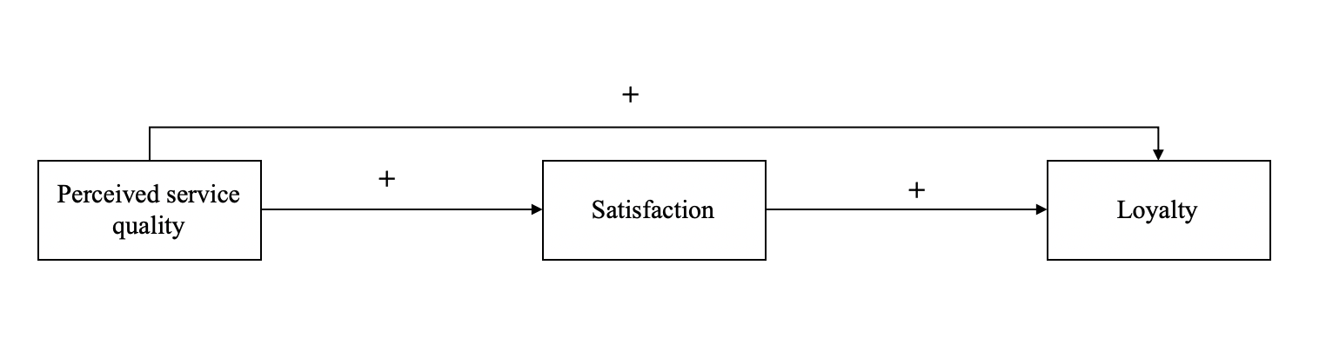

Figure 1. The basic satisfaction-loyalty theory (sourced from Fu et al. 2018)

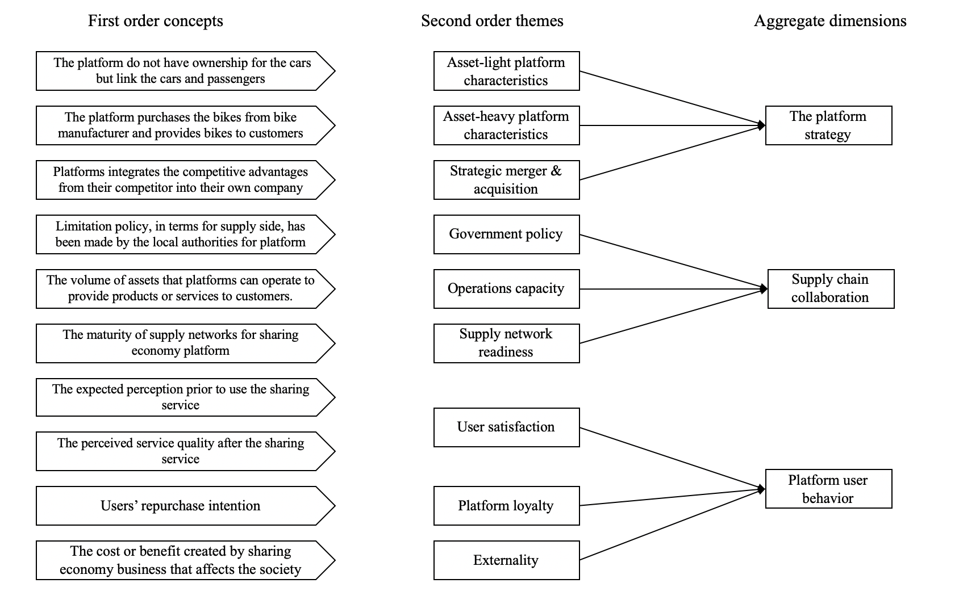
Figure 2. Coding structure

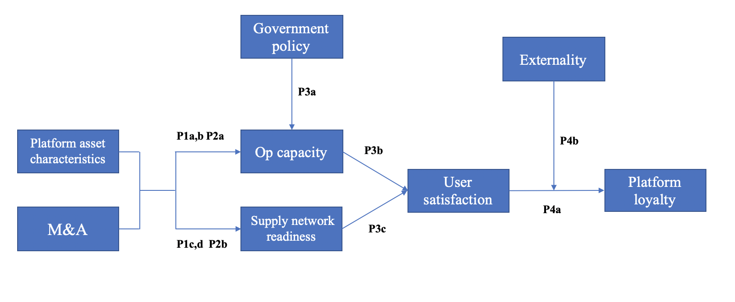
Figure 3. Theoretical framework

Industries | Case company | Interviewee | Location | Time (hours)
Ride-sharing | DiDi | Regional GM | Beijing | 1
 |  | Senior manager in safety department | Beijing | 3
 |  | Operations manager in fast ride department | Beijing | 3
 |  | Senior manager in strategy department | Hangzhou | 2
 |  | Senior manager of financial and risk department in XiaoJu car service | Hangzhou | 2
 |  | Senior manager in safety department | Beijing | 2
 | Uber China | Senior manager in PR | Yangzhou | 2
 |  | Senior manager in PR | Beijing | 2
 |  | Senior manager in GR | Beijing | 1
 |  | GM of city | Hangzhou | 2.5
 |  | Senior manager in engineering department | Shanghai | 3
 |  | Operations manager of city  Marketing manager of city  GM of city | Beijing  Hangzhou  Shanghai | 1.5  1  1.5
Bike-sharing | Mobike | Senior manager in PR&GR | Beijing | 1.5
 |  | Senior Manager in operations department of city | Beijing | 2
 |  | Senior manager in PR&GR | Beijing | 1
 |  | Senior manager in operations department of city | Beijing | 2
 |  | Senior manager in supply chain department | Beijing | 1.5
 |  | Director of daily operations department of city | Beijing | 2
 |  | Director of storage operations department of city | Beijing | 2.5
 |  | Senior manager in operations department of city  Regional GM | Beijing  Shanghai | 2  2
 | OfO | Regional GM | Hangzhou | 2
 |  | Regional GM | Beijing | 3
 |  | Senior operations manager of city | Beijing | 1
 |  | Operations manager of city | Beijing | 2
 |  | Senior operations manager of overseas city | Beijing | 2
 |  | GM of overseas countries | Hangzhou | 1
 |  | Regional GM | Beijing | 2
Table 1. Summary of interviews

Case company | Platform assets characteristics | Merger and acquisition
DiDi | DiDi mainly adopts an asset-light platform strategy. It means DiDi provides online matchmaking service to drivers and passengers’ (Operations manager in fast ride department, DiDi). | ‘We have experienced two significant M&A. Specifically, we first merged with Kuaidi in 2015 and then acquired Uber China in 2016 and became the largest ride-sharing platform company in China. The main purpose of these two M&As is to integrate the resources in the ride-sharing market and continually extend the market share’ (Regional GM, DiDi).
Uber China | We link the passengers and drivers and provide a matchmaking service to them; we belong to asset-light operations’ (Senior manager in PR, Uber China). | ‘Before we were acquired by DiDi, Uber China kept positive relationships with its investors, such as CITICS (Citic Securities) and Baidu. We also have the same goal as our investors, for example, when our investors say the best way to live in the ride-sharing market is to be merged, the senior management team of Uber China tended to agree. Consequently, Uber China eventually was acquired by DiDi in 2016’ (Senior manager in PR, Uber China).
Mobike | The strategy of Mobike is an asset-heavy platform strategy. It means Mobike not only offers the mobile-based services to customers but also pays more attention to offline bike operations management, such as moving, repairing and recycling bikes’ (Senior manager in PR&GR, Mobike). | From my perspective, we have been competing with OfO since we set up. After two year’s over-competition, both sides spent too much. Then, we received news that OfO wanted to merge with us in 2017. But it eventually failed’ (Senior manager in PR&GR, Mobike).
OfO | ‘We are mainly responsible for operating the offline bikes and providing mobile services to customers’ (Regional GM, OfO). | ‘The issue of merger and acquisition could be regarded a factor for us. Both of us (OfO and Mobike) at the beginning have quickly taken up certain market shares through a wild expansion model of burning money. There was a precious opportunity for us to merge with Mobike, but we did not catch up with it. Specifically, in early 2017, one of our investors reached the term sheet stage with our founder Wei Dai, indicating that OfO would be given 2 billion U.S. dollars to merge with Mobike if the daily order volume breaks through 30 million bike-sharing orders. We eventually achieved the goal in November 2017. However, the investor told us that the original start-up team would lose their dominant rights in the new company after the OfO merger with Mobike. Our founder disagrees with this, and thus, we missed it’ (Regional GM, OfO).
Table 2. Platform assets characteristics and merger and acquisition

Case company | Supply network readiness | Policy from government | Operational capacity
DiDi | In the early stage, we only linked passengers and drivers. Later, with the help of capital, we first merged with Kuaidi and then acquired Uber China, integrating their resources, such as cars, users and data. We become the largest ride-sharing company in China. Thus, more stakeholders are attracted into our network, such as car-leasing companies, gas stations and repair facilities. Our interactions with customers and other stakeholders also increased, which can be measured by the daily order volume’ (Senior manage in XiaoJu car service, DiDi). | Now, the government makes some strict policies to restrict DiDi. For example, we are asked by the local government to comply with a ban on cars that do not register a local license plate but receive orders in local places. Moreover, neither are drivers who live in cities such as Beijing and Shanghai but do not have local identification are not allowed to work as a DiDi driver (Senior manager in safety department, DiDi). | ‘Basically, we must obey the government’s policy, although it decreases the operational capacity of DiDi, as many cars registered on DiDi are not qualified ones. The nature of the sharing economy is to use idle assets, including people or products. However, by complying with the policy, some idle cars and drivers have been banned’ (Regional GM, DiDi).
Uber China | Before being acquired by DiDi, our network is simple; we mainly connect with drivers and passengers, and we also cooperate with some car-leasing companies in China’ (GM of City, Uber China). | Before being acquired by DiDi, Uber China did not suffer from strict, related government policies’ (GM of City, Uber China). | ‘There was no significant impact of government policy on the operations capacity of Uber China before being acquired by DiDi in 2016’ (GM of City, Uber China).
Mobike | We link bike manufacturing and customers both upstream and downstream, respectively. We do not further involve other stakeholders into our network due to insufficient financial support. Thus, the interactions between us and our stakeholders are limited. But our products are more technical than those of OfO; specifically, Mobike’s bikes have GPS (global position system) and mobile chips, allowing all activities of a bike to be traced by the background terminal of the platform, forming the big data. Therefore, the bike manufacturers are linked by three related component manufacturers: solar panel manufacturer, mobile chip manufacturer and smart lock manufacturer’ (Senior manager in supply chain department, Mobike). | The year of 2018 is not good for us, particularly for the bike-sharing industry, as the government makes policies to manage the bike-sharing market after the famous event of the“bike grave”. Specifically, the government gives a different quota to each bike-sharing company in each city’ (Director of storage operations department of city, Mobike). | Compliance with the policy leads to a decrease of operational capacity due to the diminished bike supply for Mobike’ (Director of storage operations department of city, Mobike).
OfO | OfO’s supply chain is very simple; we only connect bike manufacturing and customers. Unlike Mobike’s bikes, our products are cheaper and not very qualified; thus, we do not have other manufacturers, such as a mobile chip manufacturer or a smart lock manufacturer’ (Operations manager of city, OfO).
Table 3. supply network readiness, government policy and operations capacity

Case company | User satisfaction | Platform loyalty
DiDi | ‘DiDi has our own rating system which is used to investigate the level of user satisfaction from both driver and passenger sides. Compared with traditional taxi market, in which there are most significant problems, such as low operations capacity and information asymmetry. Think about it, that would be great if passengers do not need to stand on the street and wait the taxi for a long time and drivers also do not need to drive around the whole city to look for someone who need a car. Because of DiDi, users could enjoy the excellent ride-sharing service. In order words, users are happy to use DiDi due to high level of service quality’ (Regional GM, DiDi) | ‘Actually, we have a plenty of loyal users from driver or passenger side due to continually give out subsidies to them During this time. However, the platform loyalty in DiDi is not decent until the famous safety issue happened. Because no matter driver or passenger actually are the stranger to each other, no one can guarantee what will happen during the ride-sharing service. Now according to the statistics, the quantity of our daily active users and monthly active users is decreasing due to this safety issue. but I believe users would continue using DiDi after we deal with the safety issue in the long term.’ (Senior manager in XiaoJu car service, DiDi).
Uber China
Mobike | ‘Initially, customers are very happy to use sharing bike. Because all bikes are almost free at that time and we will give customers many subsidies for encouraging them continually use our products. However, the level of customer satisfaction towards the bike-sharing industry is not very decent later, especially after government make related policy to restrict the sharing bikes on the street. Sometime, people cannot find a sharing bike no matter Mobike or OfO it is to deal with the last three miles issue. moreover, the bike-shaing business model is simple, we cannot provide more value-added services to the users’ (Regional GM, Mobike) | ‘We usually use the daily active users and monthly active users to measure the level of platform loyalty. Actually, the platform loyalty of Mobike or OfO is not as good as they expect; specifically, it has been diminishing gradually after OfO failed to merge with Mobike in 2017. I summarise three reasons that can explain it. First, a great number of bikes have been broken deliberately and discarded into the places far away from the city centre, significantly leading to a decrease in the bike supply. Then, rather than ocusing on improving operations efficiency, these two companies are willing to over-purchase a great number of bikes from the bike manufacturers to expand their market shares, which leads to low efficiency of operations. Consequently, the quality of services and products cannot catch up with the customer’s basic requirements. Moreover, these two companies failing to merge with each other leads to the failure of integration of related resources and attraction of other stakeholders. Thus, it is not possible to attract customers to stay with the platform by providing a single service’ (Regional GM, OfO).
OfO
Table 4. Satisfaction and Platform loyalty

Case company | Exemplar quotes: Externality
 | Positive externalities | Negative externalities
DiDi | ‘We create many benefits for society; for example, first, passengers do not have to walk to the roadside and wait for an empty taxi, or passengers are sometimes worried about whether they can take a taxi or car when they are in the rush, which increases social transport capacity to some extent. Moreover, we also create numerous job opportunities for those who do have not a decent job but do have a driving licence’ (Senior manager in strategy department, DiDi). | ‘We also have some drawbacks. For example, DiDi or Uber China sometimes cannot guarantee the safety issue of drivers, as they are not the ones who directly provide ride services to customers; the driver is the direct service provider, which means DiDi or Uber China was not able to stop some terrible crimes happening without proper measures in place’ (Senior manager in safety department, DiDi).
Uber China
Mobike | ‘Mobike can create many advantages. For example, people now can ride sharing bikes with a much cheaper way to travel their last one mile, which could be regarded as a way of alleviating local traffic congestion and simultaneously decreasing air pollution (i.e., diminish CO₂ emission) to a large extent. Moreover, no matter OfO or Mobike, people regard them as a new type of public transportation. The bike-sharing has been praised by the prime minister of Chinese government as among “four new great inventions”’ (Senior manager in operations department of city, Mobike). | ‘Bike-sharing platform companies also have some negative effects. For example, bike-sharing platform companies got used to over-purchasing a great number of bikes from the bike manufacturers and deploying them into city streets, which led to irrational competition that occurred in the early stage of the bike-sharing industry, consequently forming the “bike grave” that destroyed the city’s image to a large extent. Moreover, we take up public space as our bike parking place, which could be regarded as a sort of waste of a public resource’ (Regional GM, OfO).
OfO
Table 5. Externalities created by sharing economy platform

Constructs | Operationalised definition
Asset-light and asset-heavy platform characteristics | Asset-light characteristics is operationalised as SEST platforms that do not own fixed and heavy assets, but provide pure services to service suppliers and customers; asset-heavy characteristics refers to sharing economy platforms that are not only responsible for the operations of assets but provide related services to customers.
Strategy of merger and acquisition | Refers to transactions in which the ownership of sharing economy platforms is transferred to, or consolidated with, other entities.
Government policy | Operationalized as the government allocating limited quotas in relation to operational capacity to sharing economy platform companies.
Operations capacity | Operationalized as the volume of assets that sharing economy platforms can operate to provide products or services to customers.
Supply network readiness | Operationalized as the degree of maturity of supply networks, in terms of two dimensions of network connectedness (i.e., frequency of interactions) and comprehensiveness of stakeholders (i.e., varieties of stakeholders).
Externality | Operationalized as the cost or benefit that affects a party who did not choose to incur that cost or benefit. The study mainly focuses on social and environmental dimension of externality.
User satisfaction | The level of satisfaction from both service supplier and customer sides towards to service they obtained
Platform loyalty | Operationalized as the presence of unique attributes of sharing economy platforms that make its products and/or service indispensable and valuable to its owner.
Table 6. Operationalized constructs

Appendix 1. Interview protocol

- What is the evolution process of your company? What is the organizational structure of the company? E.g., how many departments your company have?

- What is your job?

- Could you please tell your company’s business model? How does this business model form?

- How can this business model create value from a triad perspective?

- Could you please give me a detailed introduction about the company’s supply chain? for example, what’s your upstream and downstream?

- What platform strategy the company carried out to entry this market?

- What role does capital play in the development of your company?

- What role does competitors play in the development of your company?

- What role does government play in the development of your company?

- How to improve the service quality?

Appendix 2. Reliability and validity in case research

Tests | Explanation in this study
Reliability  Construct validity  Internal validity  External validity | Apply a research protocol to help complete the research design and guide field research and analysis  Develop a case study database including recording, transcripts, field notes, company documents, academic case studies, new coverage and field photos  Iterative discussion with uninvolved senior academics  Ground the research protocol in the extant literature  Multiple sources of evidence, including semi-structured interviews, various forms of secondary data and observations  Combination of primary and secondary data into theoretical conceptualisations  Review of findings by uninvolved senior academics  At least the senior managers of each platform company reviewed the draft case analysis and offered feedback  Structured data coding and analysis  Propose the proposition based on multiple sources of evidence  Theoretical sampling approach  Thick descriptive data

