Highly efficient and selective metal oxy-boride electrocatalysts for oxygen evolution from alkali and saline solutions
Suraj Guptaª*, Mark Forster^{b}, Asha Yadav^{c}, Alexander J. Cowan^{b}, Nainesh Patel^{c}, Maulik Patelª

ªSchool of Engineering, University of Liverpool, Liverpool, L69 3GH, United Kingdom.
^{b}Department of Chemistry and Stephenson Institute for Renewable Energy, University of Liverpool, Liverpool, L69 7ZD, United Kingdom.
^{c}Department of Physics, University of Mumbai, Vidyanagari, Santacruz (East), Mumbai 400098, India.

Corresponding author:
Dr. Suraj Gupta
Email: Suraj.Gupta@liverpool.ac.uk

Abstract:
With a motivation to discover efficient materials for direct electrolysis of seawater, bi-metallic oxy-boride (Co-Fe-O-B) nanostructures were developed using a facile hydrothermal synthesis strategy, with varying content of Fe. The oxygen evolution performance of the optimized Co-Fe-O-B catalyst in alkali water (1 M KOH), showed higher reaction rates owing to a Co₃O₄₋core-Co₂B-shell structure, which assists in the formation of active CoOOH species at lower potentials and offers a smaller charge-transfer resistance. The best-performing catalyst in alkali water was found to be highly active (294 mV to achieve 10 mA/cm²) in saline water (1 M KOH + 0.5 M NaCl), with 100% O₂ selectivity, establishing its potential for seawater electrolysis. The high activity and selectivity of the oxy-boride catalyst in alkaline saline electrolyte presents a fresh avenue for research in low-cost materials, especially boron-containing compounds, for selective seawater splitting.
Keywords: Metal oxy-borides, oxygen evolution, alkali water-splitting, seawater electrolysis, chlorine oxidation.
- Introduction
Hydrogen (H₂) as a clean fuel has become an inevitable component in the clean energy mix for economies world-wide developing decarbonisation strategies. Electrocatalytic water-splitting remains the most feasible and mature low-carbon technology to produce fuel-cell grade H₂, in conjunction with input energy from renewables (solar, wind, nuclear)^{1,2}. Despite the technological readiness, costs remain high for industrial water electrolyzers, in part due to the low efficiency and stability of electrocatalysts for the cathodic hydrogen evolution reaction (HER) and anodic oxygen evolution reaction (OER)^{3,4} and the use of high-cost elements. Hence, major research efforts in this area are focused towards development of cost-effective, efficient and stable electrode materials, especially for the more complex OER^{5,6}. Over the years, there have been numerous reports of low-cost electrocatalysts that present promising performance and stability, conducive for incorporation in commercial setup^{5–8}. However, a serious concern which remains unaddressed in literature is the use of high purity water for both electrochemical tests of catalysts and during application in commercial electrolyzers. Pure water is essentially a “rare commodity” in many parts of the world^{9,10}. Global scale implementation of current electrolyzers will be a challenge, especially in those parts of the world which face scarcity of pure water even for drinking purposes^{11,12}. Therefore, it becomes important to push the technological boundaries and explore the use of low purity water and potentially seawater, the most abundant water resource, as an input for water electrolyzers. This stresses the need to discover potential electrode materials that work well in saline conditions. From the limited literature available on seawater/saline water electrolysis, one of the most serious challenges for the use of electrocatalysts in natural seawater is avoiding the chlorine evolution reaction (ClER, 2Cl⁻ Cl₂, E⁰ = 1.36 V_{SHE}, pH 0) at low pH and the formation of hypochlorous acid/hypochlorite at neutral and high pHs (Cl⁻ + 2OH⁻ ClO⁻ + H₂O + 2e⁻, E⁰ = 0.89 V_{SHE}, pH 14), both of which competes with OER owing to their similar equilibrium potentials^{11–13}. The chloride oxidation reactions are kinetically simpler (2 electrons) compared to OER (4 electrons) making them favourable even at low current densities, leading to the evolution of toxic chlorine gas. One strategy to avoid chloride oxidation products is to increase the pH of the seawater, which changes the equilibrium potential of water oxidation and provides a larger thermodynamic window for avoiding chloride oxidation^{13,14}. At pH 0, the difference in equilibrium potentials for water and chloride oxidation is only 130 mV, which in contrast rises to 480 mV at pH 14. Therefore, an opportunity exists; if an efficient alkaline water electrocatalyst can achieve a suitably high current density with a suitably low overpotential (< 480 mV), it is likely to be viable for alkaline seawater electrolysis.
Amongst the low-cost families of electrocatalysts for water electrolysis, transition-metal borides (TMBs) have emerged as one of the most promising ones in alkaline electrolytes^{15,16}. Bi-metallic borides, especially the ones comprising of Co, Ni, Fe and Mo have gained immense interest owing to their stability and promising current densities at low overpotentials, in many cases outperforming equivalent oxide catalysts¹⁵. From recent reports¹⁷, it is proposed that boron facilitates water oxidation by modulating the energies of the reaction intermediates on the surface of metal oxide/hydroxide active centres. In the case of cobalt boride, boron prevents complete oxidation of Co sites and expedites formation of active Co-OOH species¹⁸. Chemical reduction of Ni-Fe based catalysts by NaBH₄ leads to formation of oxygen vacancies and under-coordinated metal sites that improve the conductivity and the OER activity¹⁹. Despite their established performances, none of these borides have ever been reported for alkaline saline water electrolysis. Here, we report on the synthesis of cobalt-iron-oxy-boride (Co-Fe-O-B) nanostructures and their OER activity in alkaline pure water and saline water (alkaline and neutral) containing Cl⁻ ions, to observe the performance, stability and selectivity for OER over ClER.
- Experimental Methods
Chemicals and Materials:
Cobalt nitrate hexahydrate [CoCl₂.6H₂O, 98%, Alfa Aesar], iron nitrate nonahydrate [Fe(NO₃)₂.9H₂O, 98%, Alfa Aesar], Urea [CO(NH₂)₂, 99.5%, ACROS Organics], sodium fluoride [NaF, 99%, Alfa Aesar] and sodium borohydride [NaBH₄, 98%, Alfa Aesar] were used for synthesizing the catalysts. Potassium hydroxide [KOH, 85%, Alfa Aesar] and sodium chloride [NaCl, 99.5%. ACROS Organics] were used to prepare the electrolytic solutions. Ruthenium (IV) Oxide [RuO₂, 99.95% (metals basis), Alfa Aesar] was used as the reference catalyst. Iso-propyl alcohol [IPA, 99%, Alfa Aesar] and deionized water (18.2 MΩ.cm, Millipore) were used for all practical purposes. Nafion (5wt% perfluorinated resin, Sigma-Aldrich) was used as the conducting binder to deposit the catalysts on the electrode surface.
Synthesis of catalysts:
Co-Fe-O nanostructures were synthesized using hydrothermal synthesis route, as optimised in our previous report²⁰. Co nitrate and Fe nitrate were used as metal ion precursors, while urea and NaF were used as precipitating and morphology controlling agents, respectively. Briefly, metal ion salts (1 mmol), NaF (3 mmol) and urea (5 mmol) were dissolved in deionised (DI) water until a clear homogenous solution is obtained. This solution was transferred and sealed in a Teflon-lined autoclave and heated at 140 °C for 2 hours in an oven. After the reaction is completed, the precipitated product is removed, filtered, washed with DI water and IPA, followed by drying in air at 80 °C. The concentration of Co and Fe was varied in the samples by adjusting the molar ratios of the respective salts. Control samples of Co-O and Fe-O were also synthesized using a similar route, by using only Co and Fe salts, respectively. The powders obtained after drying are amorphous intermediary phases, as verified in our previous report²⁰. These powders were heated in a furnace at 350 C° for 3 hours, to convert them into crystalline products.
The obtained powders were then subjected to boronation by chemically reducing them with NaBH₄. In this procedure, 40 mg of annealed powder is added to 50 mL of aqueous NaBH₄ solution, such that the weight ratio of powder to NaBH₄ is maintained at 1:20. The mixture is sonicated for 60 s to disperse the powder uniformly in the solution and then left isolated for 20 hours. After an initial time lag, bubbles start erupting in the solution, indicating initiation of the boronation process. At the end of the reaction, the precipitated powder is separated, washed with DI water and IPA, followed by vacuum drying at room temperature. The final boronized products are termed as Co-O-B, Co-Fe-O-B-10, Co-Fe-O-B-20, Co-Fe-O-B-30, Co-Fe-O-B-40 and Fe-O-B, corresponding to Fe/(Fe+Co) molar ratios of 0%, 10%, 20%, 30%, 40% and 100% respectively. Actual elemental distribution of metals and oxygen in all the boronized phases was detected from SEM-EDAX and is reported in Table S1.
Materials characterization:
The morphology of the synthesized materials was characterized by scanning electron microscope (SEM, JEOL JSM 7001F) and scanning transmission electron microscope (STEM, JEOL 2100F Cs-corrected). Elemental identification of the samples was carried out on energy dispersive spectroscopy (EDS, Octane T Optima) attached to STEM. Powder X-ray diffraction (PXRD) patterns were recorded in Bragg-Brentano (2θ- θ) configuration using X’pert³ Powder from Malvern Panalytical, with Co K_{α} radiation (λ = 1.7889 Å). Surface elemental composition and chemical states were determined using X-ray photoelectron spectroscopy (XPS, AXIS Supra, Kratos Analytical) equipped with a monochromatic Al K_{α} (1486.6 eV) X-ray source. The binding energy peak positions were referenced with respect to that of C 1s peak at 284.8 eV. For post-OER characterizations, the samples were scraped off the surface of the glassy carbon electrode and used for STEM measurements. Inductive coupled plasma – optical emission spectroscopy (ICP-OES) measurements were performed using an Agilent 5110 ICP-OES spectrometer with SVDV detection, equipped with a sample changer.

Preparation of electrode:
For electrocatalytic measurements, the boronized powders were deposited on a glassy carbon (GC, 3mm, Gamry) electrode. For deposition, a slurry was made by dispersing 2 mg of the catalyst powder in 2 mL of solution (v/v 3:1 ratio of DI water and IPA) and 20 µL of Nafion. This mixture was kept in an ultrasonication bath for 1 min and then 20 µL of the slurry was dropcasted on a polished GC surface. The slurry was dried under an infrared lamp yielding a catalyst loading of 0.1 mg/cm².
Electrochemical characterization:
All the electrochemical tests were run on a Gamry potentiostat (Interface 1001), equipped to carry out electrochemical impedance spectroscopy (EIS). Electrochemical measurements were performed in a customised electrochemical cell, following 3-electrode configuration consisting of a working electrode (GC), reference electrode (Hg/HgO, E_{ref} = 0.098 V vs SHE) and counter electrode (Pt wire). Nitrogen (N₂) gas saturated 1 M KOH, a mixture of 1 M KOH + 0.5 M NaCl and 0.5 M NaCl were used as electrolytes for electrochemical tests in alkaline pure water, alkaline saline water and neutral saline water, respectively. During tests, the electrolyte was continuously stirred using a magnetic bead, to avoid accumulation of bubbles over the working electrode. Anodic linear sweep voltammetry (LSV) was performed in the range of 0.0 V to 1.0 V (vs Hg/HgO) at a scan rate of 10 mV/s and a step size of 2 mV. Prior to recording the LSV curve, the catalyst was subjected to cyclic voltammetry (CV) scans (15 cycles) in the same potential range at 50 mV/s, to stabilize the observed current. Uncompensated resistance (R_{u}) was determined by current interrupt method, available within the software, and was subtracted from the observed data. The value of R_{u} was also confirmed by fitting the Nyquist plot data obtained from EIS tool. EIS measurements were performed in the range of 2 MHz to 0.5 Hz by passing an input sinusoidal wave of amplitude 5 mV, at the open circuit potential (OCP). Electroactive surface area (ESA) was estimated through double layer capacitance (C_{DL}) values determined by performing CV scans in the non-ohmic potential range of 1.275 V to 1.475 V (vs RHE) at increasing scan rates from 40 mV/s to 200 mV/s. The difference in cathodic and anodic current densities at 1.375 V (vs RHE) was plotted against the respective scan rates to obtain a straight line, the slope of which is numerically equivalent to twice the value of C_{DL}. LSV tests in neutral saline water (0.5 M NaCl) were carried out in the potential range of 0.0 V to 1.2 V vs saturated calomel electrode (SCE, E_{ref} = 0.242 V vs SHE). All the experiments were replicated at least 3 times to ascertain their repeatability.
Faradaic Efficiency measurement:
The Faradaic efficiency (FE) during OER was determined by measuring the evolved oxygen gas using a benchtop NeoFox fluorometer coupled with a FOSPOR photoluminescence probe with a protective coating. The electrochemical cell consisted of a glass body with gas-tight BOLA neck fittings. The probe tip was placed into the headspace of the vessel to monitor O₂ concentration during and after electrochemistry. Before the measurement, the cell was degassed thoroughly for 1 hour with argon to provide an initial 0% O₂ concentration. The Faradaic efficiency was calculated using the total charge passed and the ratio between the final O₂ concentration measured and the 100% theoretical O₂ yield calculated based on total charge passed. Each measurement was carried out in triplicate. Due to a detection time lag, there is a small delay between O₂ generated and O₂ measured.
- Results and Discussion
Mono metallic (Co/Fe) and bi-metallic (Co and Fe) oxide nanostructures were synthesized by mixing appropriate concentrations of ions in an aqueous solution and subjecting them to hydrothermal treatment, yielding a multi-phase intermediary product (see synthesis details in supporting information). This intermediary product was annealed to obtain crystalline structures and the samples are labelled as Co-O, Co-Fe-O-10, Co-Fe-O-20, Co-Fe-O-30, Co-Fe-O-40 and Fe-O, corresponding to Fe/(Fe+Co) molar ratios of 0%, 10%, 20%, 30%, 40% and 100% respectively. SEM images of these annealed samples (Fig. S1) indicate that absence of Fe (Co-O) leads to formation of 1D wire-like structures (Fig. S1a) and with inclusion of Fe, these wires are transformed into sheets. As the concentration of Fe is increased in Co-O, the density of sheets increases, and as the molar ratio reaches 30% (Co-Fe-O-30) only sheet-like structures are seen. In contrast to these structures, Fe-O (Fig. S1f) shows particles with a spherical morphology, with sizes ranging from hundreds of nanometres to a few microns. The information about the crystal structure of these annealed nanostructures was obtained by XRD (Fig. S2). All the samples show a highly crystalline structure, owing to the annealing process. The diffraction peaks for Co-O matches perfectly with the signature peaks of spinel Co₃O₄ reference spectra (ICSD No. 36256). With addition of Fe into Co-O, for Co-Fe-O-10 and Co-Fe-O-20, the peak positions remain unchanged, but the intensity of the peaks start diminishing, indicating a decline in the spinel phase of the samples. As the concentration of Fe is increased further, in Co-Fe-O-30 and Co-Fe-O-40, new peaks emerge, in addition to the existing ones. The positions of these new additional peaks are close to that of the α-Fe₂O₃ phase, suggesting the evolution of a secondary corundum phase in these samples. The XRD spectrum for Fe-O matches well with that of a pure α-Fe₂O₃ phase (ICSD No. 40142).
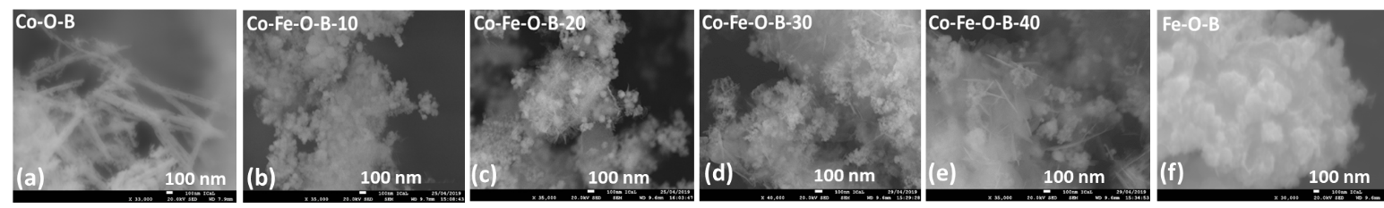
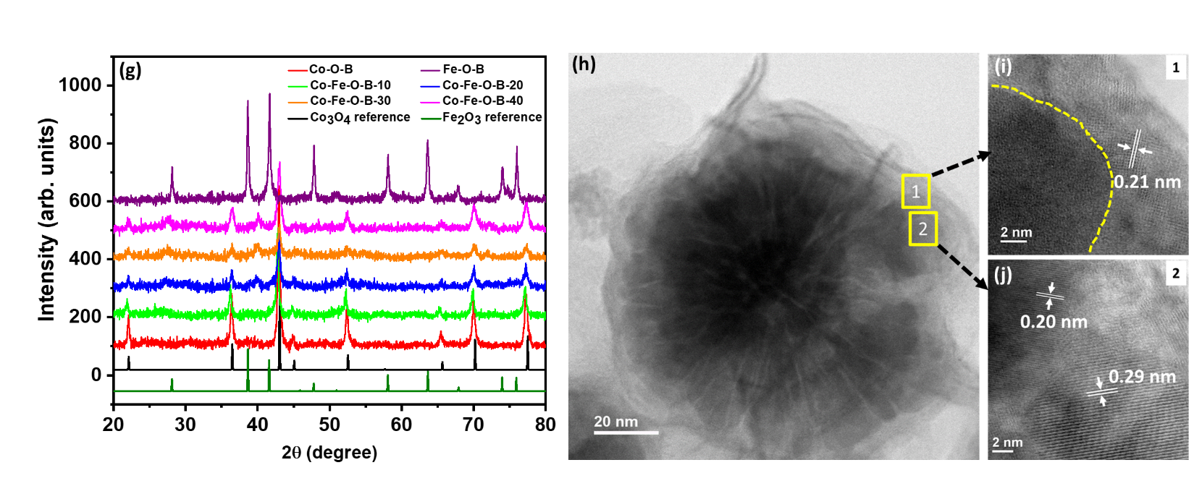
Fig. 1. (a-f) SEM images of boronized Co-O-B, Co-Fe-O-B and Fe-O-B nanostructures; (g) XRD pattern for Co-O-B, Co-Fe-O-B and Fe-O-B samples along with reference patterns of Co₃O₄ and α-Fe₂O₃; (h) STEM image of one of the flower-like structures in Co-Fe-O-B-10; (i-j) HR-STEM images of Co-Fe-O-B-10 depicting core-shell assembly and the corresponding lattice planes.
To convert these pure and mixed-phase oxide nanostructures into borides, the powders were subjected to a chemical boronation process. Fig. 1a-f shows the SEM images of the same samples as in Fig. S1a-f, after reduction with NaBH₄, depicting disintegration of the original morphology. In Co-O-B (Fig. 1a), the wire-like structures are still present, but most of the wires have disintegrated into nanoparticles. Interestingly, the morphology of all Co-Fe-O-B samples appear the same, with presence of cotton-like sheets and spherical particles dispersed over them. In the case of Fe-O-B, the spherical morphology is destroyed, and small agglomerated clusters of sheets are formed. The boronation process is expected to disrupt the crystalline structure on the surface by diffusion of boron in the peripheral areas while maintaining the core structure. This phenomenon is confirmed in the present boronized samples, as the XRD spectra (Fig. 1g) shows the existence of peaks at the same positions, as in Co-Fe-O, but with highly diminished intensities. In fact, most of the additional peaks that were seen in Co-Fe-O-30 and Co-Fe-O-40 are suppressed after boronation and only those belonging to pure Co₃O₄ phase were visible. This suggests that the chemical reduction reaction partially disrupts the crystalline arrangement near the surface, leading to formation of boride phases.
To understand the detailed morphology of these nanostructures, STEM images were recorded for the boronized samples. From SEM and XRD data, the morphology and crystal structure of all Co-Fe-O-B nanostructures are similar. Hence, amongst Co-Fe-O-B samples, further investigations were only carried out on Co-Fe-O-B-10 and Co-Fe-O-B-40, to consider the samples with lowest and highest Fe concentrations. STEM images in Fig. S3 confirm the presence of the wire-like morphology of Co-O-B, made up of distinct nanoparticles as their building-blocks. HR-STEM image of a single particle indicates a d-spacing value of 0.29 nm that corresponds to (022) planes of Co₃O₄²¹. STEM images of Co-Fe-O-B-10 (Fig. S4a-b) shows that the spherical particles seen from SEM images are flower-like structures, with sizes ranging from 40 to 100 nm, dispersed all across the matrix of the thin graphene-like sheets. STEM-EDAX maps (Fig. S4d) indicate uniform distribution of all elements across the sample. A representative image of one of the flower-like structures is shown in Fig. 1h. Each of the petals in this flower-like assembly is made up of smaller nanoparticles similar to that in Co-O-B, evidently visible in Fig. S4c. However, unlike Co-O-B, HR-STEM images obtained from these nanoparticles have a distinct core-shell assembly (Fig. 1i). The d-spacing of 0.21 nm is calculated from the lattice fringes observed in the shell, which confirms the formation of Co₂B phase²², a consequence of the boronation process. The core of the nanoparticles shows two distinct sets of lattice planes with d-spacing of 0.20 nm and 0.29 nm (Fig. 1j), that can be assigned to (004) and (022) planes of spinel phase of Co₃O₄. Thus, it becomes clear that the boronation process leads to formation of a distinct shell of Co₂B around the oxide nanoparticles in Co-Fe-O-B-10. In the case of Co-Fe-O-B-40, the formation of a flower-like assembly was not seen, instead the sample consisted of thin graphene-like sheets (Fig. S5 a-b). HR-STEM image (Fig. S5c) of the sheets indicated a lattice d-spacing of 0.47 nm, which is slightly higher than the d-spacing value of 0.46 nm²³ ascribed to (111) planes of Co₃O₄. The marginally higher d-spacing value is attributed to the inclusion of Fe in the Co₃O₄ lattice, which is expected due to a larger concentration of Fe in Co-Fe-O-B-40. No distinct planes of α-Fe₂O₃ phase were observed in Co-Fe-O-B-10 or Co-Fe-O-B-40, which is expected as they did not show any residual peaks of α-Fe₂O₃ phase in XRD either. STEM images of Fe-O-B were also recorded (Fig. S6 a-b) and they showed formation of small flake-like sheets, agglomerated together. HR-STEM imaging (Fig. S6c) revealed a d-spacing of 0.25 nm which matches well with the (110) plane of corundum α-Fe₂O₃ phase²⁴. Thus, it is clear now that the boronation process leads to formation of a distinct core-shell assembly only in Co-Fe-O-B-10, where there is a good balance between spherical particles and sheets. Such a core-shell assembly is absent in Co-O-B, where there are no sheets and also in Co-Fe-O-B-40 and Fe-O-B, where there is an abundance of sheets. Another distinct feature observed only in Co-Fe-O-B-10 is the formation of nano-crystalline Co₂B phase, which is not observed in other boronized samples. This suggests that a Fe/(Fe+Co) ratio of 10 leads to a core-shell structure comprising of a Co₃O₄ core and Co₂B shell, that provides an ideal architecture to facilitate water oxidation reaction^{25–29}.
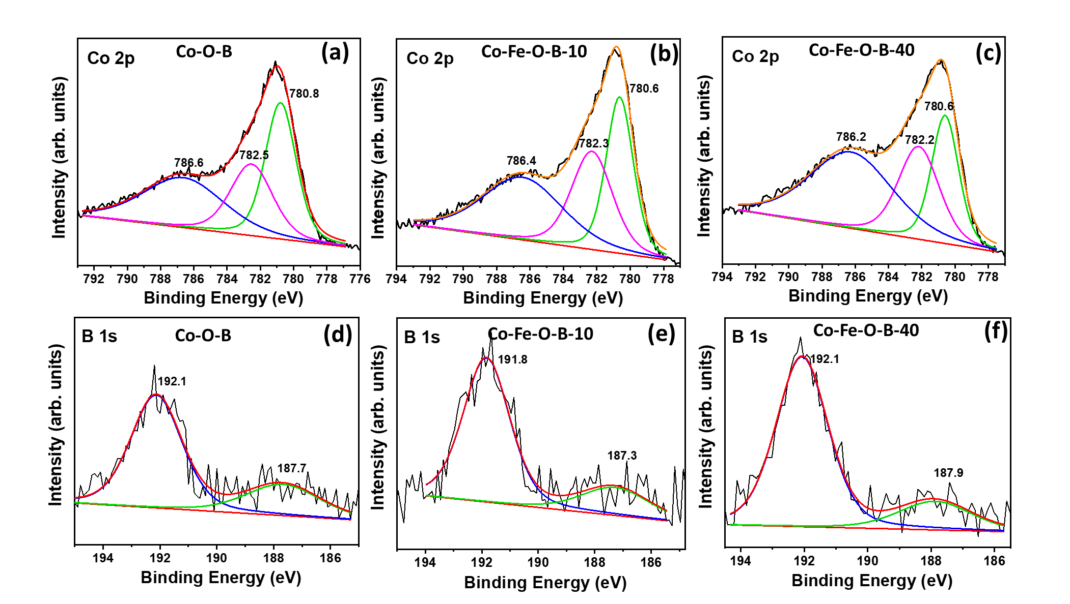

Fig. 2. XPS spectra showing (a-c) Co 2p states and (d-f) B 1s states in Co-O-B, Co-Fe-O-B-10 and Co-Fe-O-B-40 samples respectively.

XPS spectra of the boronized samples are shown in Fig. 2 a-f and Fig. S7. For Co 2p_{3/2} (Fig. 2 a-c), Co-O-B, Co-Fe-O-B-10 and Co-Fe-O-B-40 showed two peaks at binding energy (BE) values of 780.6-780.8 eV and 782.2-782.5 eV, with a broad satellite at 786.4-786.6 eV, all corresponding to Co²⁺ state as in Co(OH)₂²³. When the BE position of the peaks corresponding to Co²⁺ states are compared, it is noticed that with Fe incorporation, the BE peak shifts positively by 0.2 eV. This represents an electronic interaction between Fe and Co atoms and suggests that inclusion of Fe promotes Co to attain a higher oxidation state, which is advantageous for water oxidation^{30,31}. B 1s data (Fig. 2 d-f) for these 3 samples show a high-intensity peak in the range of 191.8-192.1 eV, corresponding to oxy-boron species. A tiny signature at about 187.3-187.9 eV is also detected in all samples attributed to metallic boron in Co₂B^{32,33}. In the case of O 1s states (Fig. S7 a-c), all three Co containing samples show a BE peak at 531.1-531.5 eV assigned to oxidised Co, usually in Co₃O₄ phase²³. The other peaks are all assigned to the Co(OH)₂ phase. For Fe 2p states (Fig. S7 d-e), Co-Fe-O-B-10 shows a peak at 711.9 eV along with its satellite at 714.8 eV, corresponding to Fe³⁺ state. For Co-Fe-O-B-40, in addition to the Fe³⁺ peak (710.2 eV), a peak at 708.3 eV assigned to Fe-B is also observed^{34,35}. From these data, it becomes clear that Co(OH)₂ is the dominant surface species in all the Co containing samples, while B is present mainly in the oxidised form. Though, tiny signatures of metallic B were evidenced, the peaks are too small for any consequential inference. In samples containing Fe, Fe³⁺ is the lone phase detected, with a signature of Fe-B seen in Co-Fe-O-B-40. The absence of this signature in Co-Fe-O-B-10 might be due to the lower concentration of Fe in the sample.
Having established the morphology, phase and chemical states of the boronized samples, they were initially tested in 1 M KOH to establish their OER performance in alkali water. Anodic polarization curves for all the boronized samples are illustrated in Fig. 3a, along with that of RuO₂ as reference. Fig. 3b depicts the variation in overpotential values (at 10 mA/cm²) for the boronized samples, with varying Fe concentration. The lowest overpotential is achieved when the Fe/(Fe+Co) molar ratio is 10% and increases as the amount of Fe increases further. The OER curves for Co-Fe-O-B-10 and Co-Fe-O-B-20 are almost similar, which is expected, as they both exhibit similar morphology and crystal structure. Table S2 represents the overpotential to achieve the commonly used metric of 10 mA/cm² and higher current density of 100 mA/cm² for all boronized samples, where Co-Fe-O-B-10 and Co-Fe-O-B-20 display the best performance (310 mV and 415 mV for 10 mA/cm² and 100 mA/cm², respectively), while that of Fe-O-B is the lowest. It is striking that the activities of all boronized samples, except Co-Fe-O-B-40 and Fe-O-B are improved compared to RuO₂ at lower potentials, and thus require lower overpotentials to achieve current densities >10 mA cm⁻². Fig. S8 shows a comparison in activity between a non-boronized sample (Co-Fe-O-10) and a boronized sample (Co-Fe-O-B-10), which clearly signifies the role of boronation in improving OER rates. Tafel plots (Fig. S9) suggest two electrocatalytic regimes for the boronized samples, indicating a change in the mechanism when moving from low to high overpotentials. In the low potential regime (< 1.6 V vs RHE), Co-Fe-O-B-10 is the boronized sample with the best activity and possesses a Tafel slope of 47.3 ± 0.3 mV/dec, compared to 90.0 ± 0.1 for RuO₂. The ability to generate higher current densities at these low overpotentials can be especially beneficial in saline water applications in which overpotentials less than 480 mV are desired at pH 14.
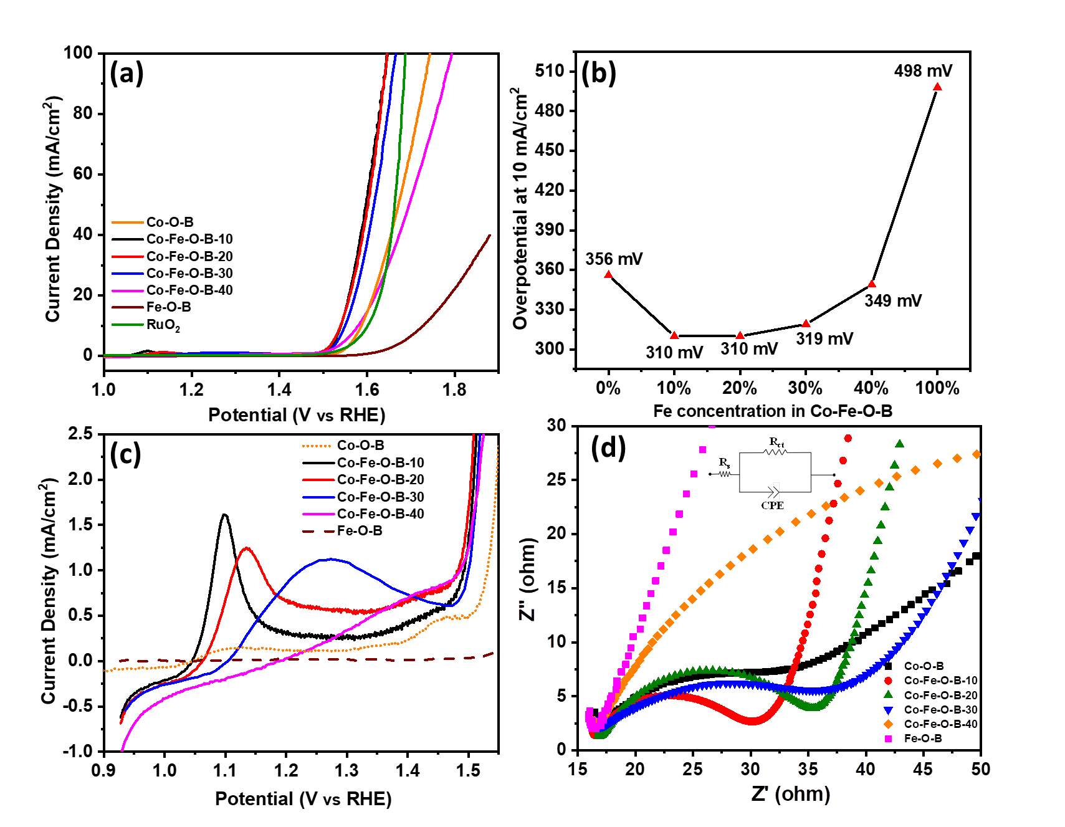
Fig. 3 (a) Anodic polarization curves for Co-O-B, Co-Fe-O-B and Fe-O-B samples along with RuO₂ as reference in 1 M KOH, 10 mV s⁻¹; (b) Variation in overpotential values to achieve 10 mA cm⁻² with varying Fe concentration; (c) pre-OER oxidation peaks and (d) Nyquist plots obtained from EIS (at OCP) for all the boronized samples, inset in (d) shows the equivalent circuit model used to fit the data.
In order to rationalise the activity of the boronized samples, the LSV curves in Fig. 3a are expanded to observe the pre-OER oxidation peaks (Fig. 3c). The first oxidation peak for Co-O-B and Co-Fe-O-B-10 are at the same position (1.1 V vs RHE), corresponding to transformation of Co(OH)₂ (Co²⁺) to OER active CoOOH (Co³⁺) species. The area under the peak gives a good estimate of the number of charges that have undergone the transformation from Co²⁺ to Co³⁺ state. By this measure, the peak area of Co-Fe-O-B-10 (615.5 µC) is much higher than that of Co-O-B (99.5 µC), indicating formation of CoOOH type species in large amounts. This suggests that incorporation of Fe promotes the conversion of Co²⁺ to higher oxidation state (also seen in XPS) and formation of active CoOOH species. Thus, the peak areas are higher in all Co-Fe-O-B samples, with the highest value observed for Co-Fe-O-B-30 (1857.3 µC). As the amount of Fe is increased, the Co²⁺ to Co³⁺ oxidation peak position shifts towards higher potentials, indicating modification in the electronic structure induced due to strong interaction between Fe and Co³⁶. Thus, incorporation of Fe modifies the electronic structure of the catalyst to promote formation of higher oxidation state CoOOH species. Some reports suggest that Fe may also provide dynamic active sites for OER with the presence of impurity Fe ions in the electrolyte often contributing to catalytic activity³⁷. Here, the role of trace Fe is minimal from electrolytes, compared to the controlled inclusion of Fe within the synthesis, as we see profound differences in catalytic activity between Co-Fe-O-B-10 and Co-O-B when both are used in a KOH electrolyte containing trace impurities of Fe (Table S4). But we cannot rule out the catalytic role of Fe sites in Co-Fe-O-B-10, which in addition to the role in facilitating CoOOH formation, is a possible causes of the improved activity. What is certain is that the optimum Fe content in Co-Fe-O-B-10 makes it the ideal pre-catalyst and hence shows the best OER activity. It must be noted that the boronation also assists the formation of surface CoOOH species, as evident from the inset image of Fig. S8, where non-boronized Co-Fe-O-10 shows almost no oxidation peak. The role of boron in facilitating the formation of surface CoOOH species was investigated in detail in our past report¹⁸ and we assign the same mechanism here as well. The intimate co-ordination between cobalt and boron achieved in Co-Fe-O-B-10 also assists in reducing the kinetic barrier for conversion of surface Co oxides into CoOOH, evident from the occurrence of oxidation peak at lower overpotential.
One of the significant contributors to OER performance is the charge-transfer resistance (R_{ct}), which indicates the ease through which charges are transferred across the electrode/electrolyte interface and can be determined using electrochemical impedance spectroscopy (EIS), as represented by the Nyquist plots in Fig. 3d. To obtain the values of R_{ct}, the curves were fit using an equivalent circuit (inset of Fig. 3d) comprising of two model resistances (R_{s} and R_{ct}) and a constant phase element (CPE). From Table S2, it is seen that Co-Fe-O-B-10 has the lowest R_{ct} value (16.45 Ω), also evident from the smallest diameter of the semicircle in Fig. 3d. The lower R_{ct} offers improved charge conductivity in Co-Fe-O-B-10 and thus explains the reason for its ability to convert surface Co²⁺ to Co³⁺ at the lowest potential, as seen in Fig. 3b. It must be noted that the trend of R_{ct} values matches exactly with the trend in OER performance in Fig. 3a, signifying the role of R_{ct} in facilitating OER.
Another important parameter affecting catalytic activity is the electroactive surface area (ESA), which is indirectly estimated by determining the value of the double layer capacitance (C_{DL}). Fig. S10a shows the C_{DL} values for all samples, from CV measurements at different scan rates (Fig. S10b-g). The highest values of C_{DL} are obtained for Co-O-B (20.6 ± 0.6 mF/cm²), Co-Fe-O-B-30 (20.0 ± 1.1 mF/cm²) and Co-Fe-O-B-20 (18.6 ± 1.6 mF/cm²), while that of Co-Fe-O-B-10 (12.9 ± 0.6 mF/cm²) is lower than these. The C_{DL} and thus the ESA represents the surface area of the sample that is active for electrochemical adsorption of charged species from the electrolyte. In the case of Co-O-B, 1D nanostructure offers a large number of such sites and hence it shows a higher C_{DL} value. Similarly, in Co-Fe-O-B-20 and Co-Fe-O-B-30, there is dominance of 2D sheet-like structures, compared to Co-Fe-O-B-10, and hence they depict higher C_{DL} values. This is also the reason for the higher peak areas observed in Fig. 3c for these samples. Despite a smaller ESA, Co-Fe-O-B-10 shows the best OER performance, implying that the intrinsic activity of each of its surface sites is higher. To quantify this fact, the contribution from ESA was eliminated from the OER activity and C_{DL} normalized graphs were obtained (Fig. S11). It becomes clear that inclusion of Fe improves the per-site catalytic activity and Co-Fe-O-B-10 portrays the highest activity per catalytic site (~2.5 times higher than Co-O-B, at 1.8 V). However, it must be noted that with further increasing the content of Fe, the intrinsic activity declines, reinforcing that the optimal electronic structure is achieved with Co-Fe-O-B-10. The better intrinsic activity of Co-Fe-O-B-10 can also be attributed to the smaller R_{ct} and the kinetically favourable formation of active CoOOH species on its surface. The samples containing the highest Fe content - Co-Fe-O-B-40 and Fe-O-B, show extremely low values of C_{DL}, suggesting that Fe sites in these systems are not favourable for adsorption of electrolytic species, compared to Co sites, resulting in poor OER rates (hence not included in Fig. S11).
So far, it has been established that, of the materials studied here, Co-Fe-O-B-10 possesses the optimum ratio of Fe/(Fe+Co) and best intrinsic activity for alkaline water oxidation, owing to its core-shell assembly, capability of forming surface CoOOH species at lower potentials and lower R_{ct}. To establish the suitability of this class of borides for the OER in seawater, Co-Fe-O-B-10 was tested in alkaline (0.5 M NaCl + 1 M KOH) and neutral (0.5 M NaCl) saline electrolytes, containing Cl⁻ ions. Fig. 4a displays the anodic polarization curves for Co-Fe-O-B-10 in both solutions, indicating a comparable activity between 1 M KOH and 1M KOH + 0.5 M NaCl, and low activity in 0.5 M NaCl. In alkaline saline water, overpotentials of 294 mV and 434 mV were required to achieve 10 mA/cm² and 100 mA/cm², respectively, with a Tafel slope of 52.6 ± 0.4 mV/dec (Fig. S12). Here, it is interesting to note that the initial OER performance in alkaline saline water containing a mixture of KOH and NaCl is marginally better than that in alkaline pure water containing only KOH. Recently, Cheng et al.³⁸ reported a similar improvement in OER performance when measured in saline water containing a mixture of ions, as compared to solutions containing a single salt. We also observe that the addition of NaCl to KOH improves the conductivity of the solution, improving charge transfer and resulting in better OER kinetics. A table comparing the OER performances for some of the recently reported non-noble metal electrocatalysts in alkaline saline water is presented in Table S3. While Co-Fe-O-B-10 performs well in alkaline saline water, the OER performance observed in neutral saline water (0.5 M NaCl, pH ~7) is poor, requiring large overpotentials to achieve small current densities. It should be noted that lower current densities are expected for this class of materials at lower pH, as summarised in a recent review¹⁵. Nevertheless, it could still be an application of interest if O₂ selectivity can be maintained in these conditions.
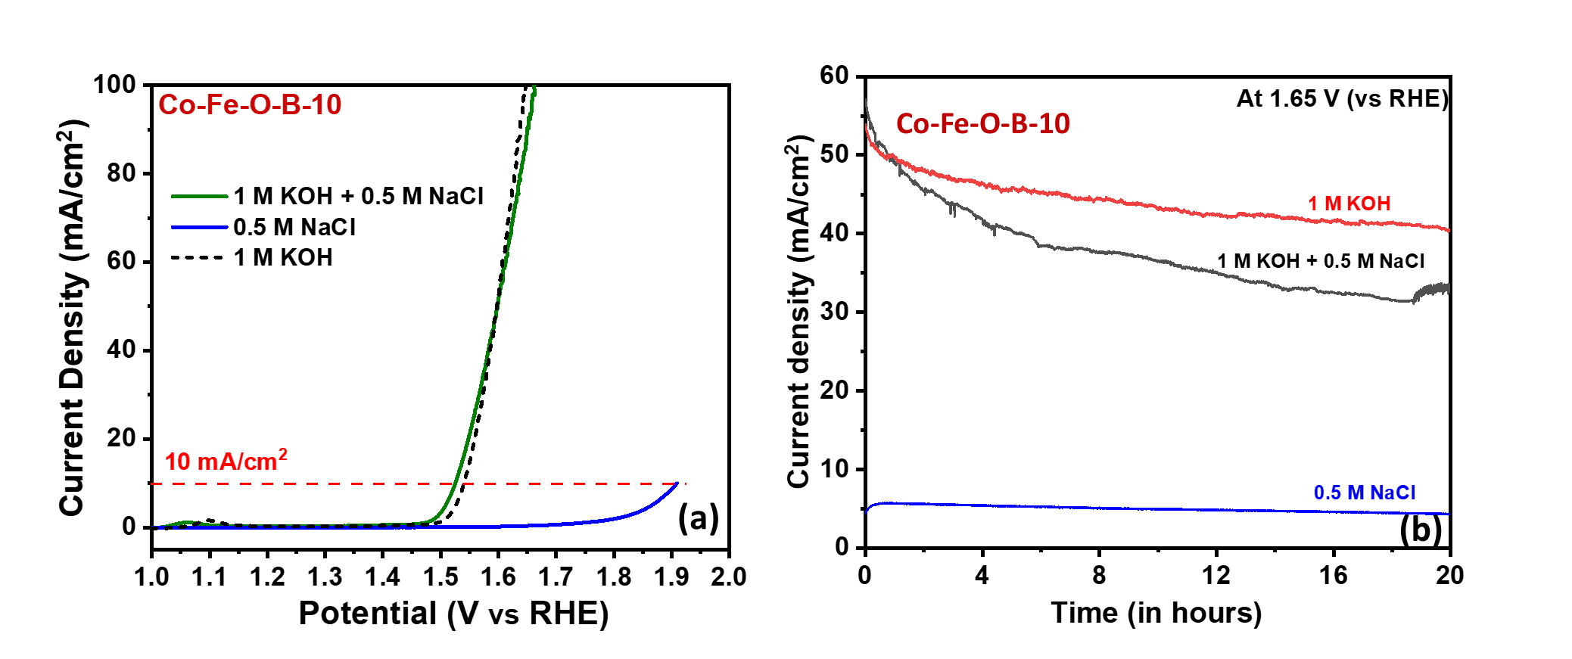
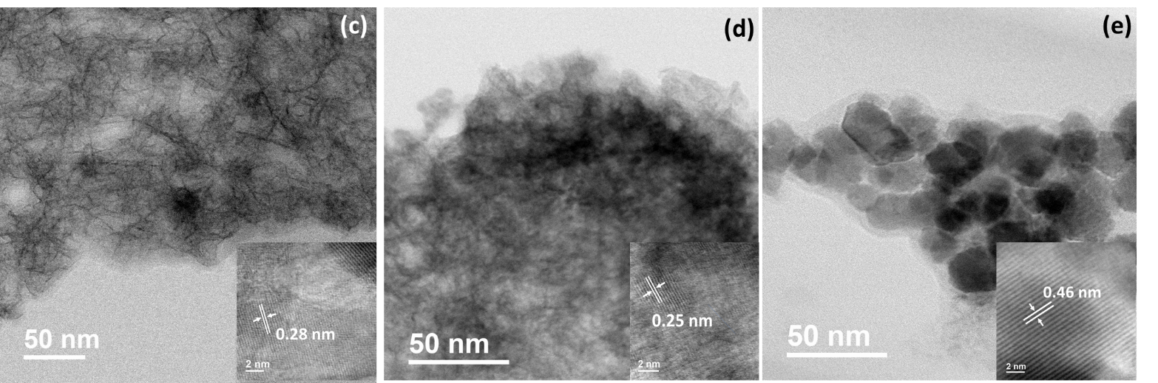
Fig. 4. (a) Anodic polarization curves for Co-Fe-O-B-10 in alkaline and neutral saline water; (b) Long-term chronoamperometric stability test for Co-Fe-O-B-10 in alkaline pure and saline water and neutral saline water; STEM and HR-STEM (inset) images of Co-Fe-O-B-10 post long-term OER test in (c) alkaline pure water; (d) alkaline saline water and (e) neutral saline water, inset shows the respective lattice fringes.
Selectivity for OER over chloride oxidation is one of the main challenges in seawater splitting and while high activity is desirable, 100% selectivity for O₂ over Cl₂ is critical. Selectivity can be addressed to some extent by operating at high pH^{12–14}. To further understand the suitability of Co-Fe-O-B-10 for the OER in seawater, Faradaic efficiencies were measured using a fluorescence lifetime probe during and after chronoamperometry tests (see supporting information for the full details). Co-Fe-O-B-10 exhibited ~100±4% Faradaic efficiency in both alkaline pure and saline water at 1.65 V (vs RHE) after 5 hours, as shown in Fig. S13a & S13b. At higher current densities (100 mA cm⁻²), the Faradaic efficiency of Co-Fe-O-B-10 dropped to ~74±4%, indicating Cl⁻ oxidation begins to occur (Fig S12c). In neutral saline water, a 0% Faradaic efficiency was observed for Co-Fe-O-B-10, indicating a preference for Cl⁻ oxidation (Fig. S13d).
Having established the performance and selectivity of Co-Fe-O-B-10 for OER in alkaline pure water and saline water, their long-term stability was then tested. Fig. 4b shows the chronoamperometry tests for Co-Fe-O-B-10 in all three electrolytes, at an applied potential of 1.65 V (vs RHE) for 20 hours of continuous electrolysis. The highest stability is observed in 1 M KOH (performance loss of 18%), while in alkaline saline water, the current decreases by almost 35% in 20 hours. The lower stability in saline electrolyte is attributed to the corrosive action of Cl⁻ ions, which can ideally be reduced by using Cl⁻ repellent layers or semi-permeable overlayers¹². In neutral saline water, although stability is maintained over 20 hours, the initial current density is very low, and this is attributed to Cl⁻ oxidation. ICP-OES analysis (Table S4) was carried out on the electrolytes following OER tests to determine the dissolution of elements, if any, during OER. Leaching of Co and Fe into the electrolyte was observed in both 1 M KOH and alkaline saline water, in similar amounts. This loss of Fe and Co may explain the loss in catalyst activity over time, as observed in Fig. 4b. In contrast to the metals, the concentration of B did not increase in the electrolytes post OER tests, suggesting that boron is not leached out. For OER tests in neutral saline water, leaching of Co and Fe atoms was not observed but there was an appreciable dissolution of boron from the catalyst.
To observe the effect of respective electrolytes on the morphology of the samples, STEM analysis was carried out after OER stability tests. From Fig. S14a-b and Fig. 4c, it is seen that the flower-like structures of Co-Fe-O-B-10 have coalesced and transformed into cotton-like sheets, after OER tests in alkaline pure water. A d-spacing of 0.29 nm corresponding to Co₃O₄ phase and uniform distribution of all elements in STEM-EDAX maps (Fig. S14c), both imply integrity of the crystalline structure and elemental composition, respectively. However, when compared to pristine Co-Fe-O-B-10, the concentration of oxygen is much higher in the post-OER samples, resulting from the oxidation process. Similarly, for post OER stability test in alkaline saline water, Co-Fe-O-B-10 shows that the flower-like assembly is maintained (Fig. S15 a-b) but the distinct core-shell assembly is destroyed, as seen in Fig. 4d. A d-spacing of 0.25 nm is seen here, which can be attributed to the formation of CoOOH type species on the surface³⁹. STEM-EDAX maps (Fig. S15c) resemble that of Co-Fe-O-B-10 in alkaline pure water with only addition of Cl, which is expected due to the presence of NaCl in the electrolyte. The oxygen content is higher here as well, indicating the prevalence of the water oxidation process. For neutral saline water, the flower-like morphology of Co-Fe-O-B-10 is lost and only small nanoparticles, surrounded by an amorphous layer are observed (Fig. 4e and Fig. S16a-b). Based on the lattice plane spacing of 0.46 nm, it can be confirmed that the nanoparticles exhibit the Co₃O₄ phase. From STEM-EDAX maps (Fig. S16c), it was observed that the distribution of Co, Fe and O was similar to that of the pristine sample, however, a negligible concentration of B was observed. This observation is in accordance with the ICP-OES test which indicate appreciable leaching of boron in neutral solutions containing NaCl. It must also be noted that the concentration of O is not increased, as was observed in solutions containing KOH (Fig. 4c-d), further indicating that OER is not favoured in NaCl solutions and hence the oxidation of the catalyst surface is not seen.
- Conclusions
In summary, this article reports the first use of a bi-metallic oxy-boride (Co-Fe-O-B) catalyst for OER in saline electrolytes. The most active composition of the catalyst (Co-Fe-O-B-10) possessed a unique flower-like architecture comprising of small nanoparticles of Co₃O₄ with a shell of boron; a consequence of the boronation process. The higher OER activity of the boronized catalyst in alkaline pure water was attributed to the incorporation of Fe and presence of a boron-rich shell which assists in the formation of a large number of active CoOOH species on the surface, an inherently low R_{ct} and improved per-site activity. Current densities of 10 and 100 mA/cm² required overpotentials of only 294 and 434 mV in 1 M KOH + 0.5 M NaCl making the Co-Fe-O-B catalyst of great interest given the potential window of 480 mV that exists between the thermodynamic potential for OER and chloride oxidation at high pH. While Co-Fe-O-B-10 could maintain high activity in alkaline saline media, it did not perform well in neutral solutions. In alkaline solutions (both pure water and saline water), the catalyst achieved Faradaic efficiencies of ~100±4% at moderate current densities establishing their selectivity for OER. At higher current densities (100 mA cm⁻²) in alkaline saline water, the Faradaic efficiency did begin to drop, indicating some Cl⁻ oxidation, however, ~74±4% O₂ selectivity was still maintained at these high current densities, providing motivation for further improvement. The effect of electrolyte on the morphology and chemical composition of the catalyst was evaluated, which indicated disruption of the core-shell assembly and minor leaching of metal ions (Co and Fe) in alkaline saline water, in addition to the incorporation of O into the catalyst. In neutral saline water, initial activity was low, and complete loss of the nano-architecture and substantial leaching of boron was observed following prolonged operation. This work is a first crucial step in exploring the family of boron containing alloys for selective water oxidation from seawater and the results obtained here can serve as the steppingstone for improving their performance further.
Associated Content
Supporting information: Additional characterization data (SEM, STEM, HR-STEM, EDAX maps, XRD, XPS and ICP-OES), additional electrochemical data (LSV, CV profiles, Tafel plots, Faradaic efficiency graphs) and data representation tables.
Notes
The authors declare no competing financial interests or other conflicts of interest.
Acknowledgements
S. Gupta acknowledges the research grant from the UK Commonwealth Scholarship Commission through the Commonwealth Rutherford Fellowship (INRF-2017-139). N. Patel acknowledges UGC and SERB-DST for providing financial support through Faculty recharge program and Extra Mural project (FILE NO. EMR/2016/003028). M. Patel acknowledges the seed funding obtained from EPSRC-GCRF No. 141131/155337. M. Patel and S. Gupta also acknowledge Research England (UK) for funds through the Industrial Strategy HEIF Allocation 2019-2020 Pump Priming Fund Round 6 (Project No. 163792). M. Forster and A. J. Cowan acknowledge financial support from the INTERREG Atlantic Area programme (Grant reference EAPA_190_2016) and the EPSRC (EP/P034497/1). We also acknowledge the use of electron microscopy facilities at Imaging Centre at Liverpool (ICaL).
References:
(1) Nocera, D. G. Solar Fuels and Solar Chemicals Industry. Acc. Chem. Res. 2017, 50 (3), 616–619.
(2) Sapountzi, F. M.; Gracia, J. M.; Fredriksson, H. O. A.; Niemantsverdriet, J. W. H. Electrocatalysts for the Generation of Hydrogen, Oxygen and Synthesis Gas. Prog. Energy Combust. Sci. 2017, 58, 1–35.
(3) Schalenbach, M.; Zeradjanin, A. R.; Kasian, O.; Cherevko, S.; Mayrhofer, K. J. J. A Perspective on Low-Temperature Water Electrolysis–Challenges in Alkaline and Acidic Technology. Int. J. Electrochem. Sci 2018, 13, 1173–1226.
(4) Kibsgaard, J.; Chorkendorff, I. Considerations for the Scaling-up of Water Splitting Catalysts. Nat. Energy 2019, 1.
(5) Sivanantham, A.; Ganesan, P.; Vinu, A.; Shanmugam, S. Surface Activation and Reconstruction of Non-Oxide-Based Catalysts Through in Situ Electrochemical Tuning for Oxygen Evolution Reactions in Alkaline Media. ACS Catal. 2019, 10 (1), 463–493.
(6) Kim, J. S.; Kim, B.; Kim, H.; Kang, K. Recent Progress on Multimetal Oxide Catalysts for the Oxygen Evolution Reaction. Adv. Energy Mater. 2018, 8 (11), 1702774. https://doi.org/10.1002/aenm.201702774.
(7) Yu, P.; Wang, F.; Shifa, T. A.; Zhan, X.; Lou, X.; Xia, F.; He, J. Earth Abundant Materials beyond Transition Metal Dichalcogenides: A Focus on Electrocatalyzing Hydrogen Evolution Reaction. Nano Energy 2019, 58, 244–276. https://doi.org/https://doi.org/10.1016/j.nanoen.2019.01.017.
(8) Suen, N.-T.; Hung, S.-F.; Quan, Q.; Zhang, N.; Xu, Y.-J.; Chen, H. M. Electrocatalysis for the Oxygen Evolution Reaction: Recent Development and Future Perspectives. Chem. Soc. Rev. 2017, 46 (2), 337–365.
(9) Stikker, A. Water Today and Tomorrow: Prospects for Overcoming Scarcity. Futures 1998, 30 (1), 43–62.
(10) Vörösmarty, C. J.; McIntyre, P. B.; Gessner, M. O.; Dudgeon, D.; Prusevich, A.; Green, P.; Glidden, S.; Bunn, S. E.; Sullivan, C. A.; Liermann, C. R. Global Threats to Human Water Security and River Biodiversity. Nature 2010, 467 (7315), 555–561.
(11) Dresp, S.; Dionigi, F.; Klingenhof, M.; Strasser, P. Direct Electrolytic Splitting of Seawater: Opportunities and Challenges. ACS Energy Lett. 2019, 4 (4), 933–942.
(12) Tong, W.; Forster, M.; Dionigi, F.; Dresp, S.; Erami, R. S.; Strasser, P.; Cowan, A. J.; Farràs, P. Electrolysis of Low-Grade and Saline Surface Water. Nat. Energy 2020, 1–11.
(13) Kuang, Y.; Kenney, M. J.; Meng, Y.; Hung, W.-H.; Liu, Y.; Huang, J. E.; Prasanna, R.; Li, P.; Li, Y.; Wang, L. Solar-Driven, Highly Sustained Splitting of Seawater into Hydrogen and Oxygen Fuels. Proc. Natl. Acad. Sci. 2019, 116 (14), 6624–6629.
(14) Dionigi, F.; Reier, T.; Pawolek, Z.; Gliech, M.; Strasser, P. Design Criteria, Operating Conditions, and Nickel–Iron Hydroxide Catalyst Materials for Selective Seawater Electrolysis. ChemSusChem 2016, 9 (9), 962–972.
(15) Gupta, S.; Patel, M. K.; Miotello, A.; Patel, N. Metal Boride‐Based Catalysts for Electrochemical Water‐Splitting: A Review. Adv. Funct. Mater. 2020, 30 (1), 1906481.
(16) Chen, Z.; Duan, X.; Wei, W.; Wang, S.; Zhang, Z.; Ni, B.-J. Boride-Based Electrocatalysts: Emerging Candidates for Water Splitting. Nano Res. 2020, 1–22.
(17) Masa, J.; Schuhmann, W. The Role of Non-Metallic and Metalloid Elements on the Electrocatalytic Activity of Cobalt and Nickel Catalysts for the Oxygen Evolution Reaction. ChemCatChem 2019, 11 (24), 5842–5854. https://doi.org/10.1002/cctc.201901151.
(18) Gupta, S.; Jadhav, H.; Sinha, S.; Miotello, A.; Patel, M. K.; Sarkar, A.; Patel, N. Cobalt-Boride Nanostructured Thin Films with High Performance and Stability for Alkaline Water Oxidation. ACS Sustain. Chem. Eng. 2019, 7 (19), 16651–16658. https://doi.org/10.1021/acssuschemeng.9b03995.
(19) Asnavandi, M.; Yin, Y.; Li, Y.; Sun, C.; Zhao, C. Promoting Oxygen Evolution Reactions through Introduction of Oxygen Vacancies to Benchmark NiFe–OOH Catalysts. ACS Energy Lett. 2018, 3 (7), 1515–1520.
(20) Gupta, S.; Yadav, A.; Bhartiya, S.; Singh, M. K.; Miotello, A.; Sarkar, A.; Patel, N. Co Oxide Nanostructures for Electrocatalytic Water-Oxidation: Effects of Dimensionality and Related Properties. Nanoscale 2018, 10 (18), 8806–8819. https://doi.org/10.1039/C8NR00348C.
(21) Dong, Z.; Fu, Y.; Han, Q.; Xu, Y.; Zhang, H. Synthesis and Physical Properties of Co3O4 Nanowires. J. Phys. Chem. C 2007, 111 (50), 18475–18478.
(22) Masa, J.; Weide, P.; Peeters, D.; Sinev, I.; Xia, W.; Sun, Z.; Somsen, C.; Muhler, M.; Schuhmann, W. Amorphous Cobalt Boride (Co2B) as a Highly Efficient Nonprecious Catalyst for Electrochemical Water Splitting: Oxygen and Hydrogen Evolution. Adv. Energy Mater. 2016, 6 (6), 1502313.
(23) Yang, J.; Liu, H.; Martens, W. N.; Frost, R. L. Synthesis and Characterization of Cobalt Hydroxide, Cobalt Oxyhydroxide, and Cobalt Oxide Nanodiscs. J. Phys. Chem. C 2009, 114 (1), 111–119.
(24) Chen, Z.; Cvelbar, U.; Mozetič, M.; He, J.; Sunkara, M. K. Long-Range Ordering of Oxygen-Vacancy Planes in α-Fe2O3 Nanowires and Nanobelts. Chem. Mater. 2008, 20 (9), 3224–3228. https://doi.org/10.1021/cm800288y.
(25) Lu, W.; Liu, T.; Xie, L.; Tang, C.; Liu, D.; Hao, S.; Qu, F.; Du, G.; Ma, Y.; Asiri, A. M. In Situ Derived Co B Nanoarray: A High‐Efficiency and Durable 3D Bifunctional Electrocatalyst for Overall Alkaline Water Splitting. Small 2017, 13 (32), 1700805.
(26) Jiang, J.; Wang, M.; Yan, W.; Liu, X.; Liu, J.; Yang, J.; Sun, L. Highly Active and Durable Electrocatalytic Water Oxidation by a NiB0. 45/NiOx Core-Shell Heterostructured Nanoparticulate Film. Nano Energy 2017, 38, 175–184.
(27) Jiang, W.-J.; Niu, S.; Tang, T.; Zhang, Q.-H.; Liu, X.-Z.; Zhang, Y.; Chen, Y.-Y.; Li, J.-H.; Gu, L.; Wan, L.-J.; et al. Crystallinity-Modulated Electrocatalytic Activity of a Nickel(II) Borate Thin Layer on Ni3B for Efficient Water Oxidation. Angew. Chemie Int. Ed. 2017, 56 (23), 6572–6577. https://doi.org/10.1002/anie.201703183.
(28) Xie, C.; Wang, Y.; Yan, D.; Tao, L.; Wang, S. In Situ Growth of Cobalt@ Cobalt-Borate Core–Shell Nanosheets as Highly-Efficient Electrocatalysts for Oxygen Evolution Reaction in Alkaline/Neutral Medium. Nanoscale 2017, 9 (41), 16059–16065.
(29) Xie, L.; Qu, F.; Liu, Z.; Ren, X.; Hao, S.; Ge, R.; Du, G.; Asiri, A. M.; Sun, X.; Chen, L. In Situ Formation of a 3D Core/Shell Structured Ni 3 N@ Ni–Bi Nanosheet Array: An Efficient Non-Noble-Metal Bifunctional Electrocatalyst toward Full Water Splitting under near-Neutral Conditions. J. Mater. Chem. A 2017, 5 (17), 7806–7810.
(30) Yoshida, M.; Iida, T.; Mineo, T.; Yomogida, T.; Nitta, K.; Kato, K.; Nitani, H.; Abe, H.; Uruga, T.; Kondoh, H. Electrochromic Characteristics of a Nickel Borate Thin Film Investigated by in Situ XAFS and UV/Vis Spectroscopy. Electrochemistry 2014, 82 (5), 355–358.
(31) Bediako, D. K.; Lassalle-Kaiser, B.; Surendranath, Y.; Yano, J.; Yachandra, V. K.; Nocera, D. G. Structure–Activity Correlations in a Nickel–Borate Oxygen Evolution Catalyst. J. Am. Chem. Soc. 2012, 134 (15), 6801–6809.
(32) Chunduri, A.; Gupta, S.; Bapat, O.; Bhide, A.; Fernandes, R.; Patel, M. K.; Bambole, V.; Miotello, A.; Patel, N. A Unique Amorphous Cobalt-Phosphide-Boride Bifunctional Electrocatalyst for Enhanced Alkaline Water-Splitting. Appl. Catal. B Environ. 2019, 118051. https://doi.org/10.1016/j.apcatb.2019.118051.
(33) Nsanzimana, J. M. V.; Gong, L.; Dangol, R.; Reddu, V.; Jose, V.; Xia, B. Y.; Yan, Q.; Lee, J.; Wang, X. Tailoring of Metal Boride Morphology via Anion for Efficient Water Oxidation. Adv. Energy Mater. 2019, 1901503.
(34) Li, H.; Wen, P.; Li, Q.; Dun, C.; Xing, J.; Lu, C.; Adhikari, S.; Jiang, L.; Carroll, D. L.; Geyer, S. M. Earth-Abundant Iron Diboride (FeB2) Nanoparticles as Highly Active Bifunctional Electrocatalysts for Overall Water Splitting. Adv. Energy Mater. 2017, 7 (17), 1700513. https://doi.org/10.1002/aenm.201700513.
(35) Li, Y.; Huang, B.; Sun, Y.; Luo, M.; Yang, Y.; Qin, Y.; Wang, L.; Li, C.; Lv, F.; Zhang, W. Multimetal Borides Nanochains as Efficient Electrocatalysts for Overall Water Splitting. Small 2019, 15 (1), 1804212.
(36) Burke, M. S.; Kast, M. G.; Trotochaud, L.; Smith, A. M.; Boettcher, S. W. Cobalt–Iron (Oxy) Hydroxide Oxygen Evolution Electrocatalysts: The Role of Structure and Composition on Activity, Stability, and Mechanism. J. Am. Chem. Soc. 2015, 137 (10), 3638–3648.
(37) Chung, D. Y.; Lopes, P. P.; Martins, P. F. B. D.; He, H.; Kawaguchi, T.; Zapol, P.; You, H.; Tripkovic, D.; Strmcnik, D.; Zhu, Y. Dynamic Stability of Active Sites in Hydr (Oxy) Oxides for the Oxygen Evolution Reaction. Nat. Energy 2020, 5 (3), 222–230.
(38) Cheng, F.; Feng, X.; Chen, X.; Lin, W.; Rong, J.; Yang, W. Synergistic Action of Co-Fe Layered Double Hydroxide Electrocatalyst and Multiple Ions of Sea Salt for Efficient Seawater Oxidation at near-Neutral PH. Electrochim. Acta 2017, 251, 336–343.
(39) Hu, E.; Ning, J.; Zhao, D.; Xu, C.; Lin, Y.; Zhong, Y.; Zhang, Z.; Wang, Y.; Hu, Y. A Room-Temperature Postsynthetic Ligand Exchange Strategy to Construct Mesoporous Fe-Doped CoP Hollow Triangle Plate Arrays for Efficient Electrocatalytic Water Splitting. Small 2018, 14 (14), 1704233. https://doi.org/10.1002/smll.201704233.

Table of Contents
