How effective are pharmaceuticals for cognitive enhancement in healthy adults? A series of meta-analyses of cognitive performance during acute administration of modafinil, methylphenidate and d-amphetamine.

Carl A Roberts¹, Andrew Jones¹, Harry Sumnall², Suzanne H Gage^{1*} & Catharine Montgomery^{3*}
¹Department of Psychological Sciences, University of Liverpool, UK
² Public Health Institute, Liverpool John Moores University, Liverpool, UK
³ Department of Psychology, John Moores Liverpool University, Liverpool, UK.
* These authors contributed equally to the manuscript

Corresponding Author:
Dr Carl Roberts, Department of Psychological Sciences, Institute of Psychology, Health and Society, University of Liverpool, Eleanor Rathbone Building, Bedford Street South, Liverpool, L69 7ZA. Email: Carl.roberts@liverpool.ac.uk.

Abstract:
Modafinil, methyphenidate (MPH) and d-amphetamine (d-amph) are putative cognitive enhancers. However, efficacy of cognitive enhancement has yet to be fully established. We examined cognitive performance in healthy non-sleep-deprived adults following modafinil, MPH, or d-amph vs placebo in 3 meta-analyses, using subgroup analysis by cognitive domain; executive functions (updating, switching, inhibitory control, access to semantic/long term memory), spatial working memory, recall, selective attention, and sustained attention. We adhered to PRISMA. We identified k=47 studies for analysis; k=14 studies (64 effect sizes) for modafinil, k=24 studies (47 effect sizes) for Methylphenidate, and k=10 (27 effect sizes) for d-amphetamine. There was an overall effect of modafinil (SMD=0.12, p=.01). Modafinil improved memory updating (SMD=0.28, p=0.03). There was an overall effect of MPH (SMD=0.21, p=.0004) driven by improvements in recall (SMD=0.43, p=0.0002), sustained attention (SMD=0.42, p=.0004), and inhibitory control (SMD=0.27, p=.03). There were no effects for d-amph. MPH and modafinil show enhancing effects in specific sub-domains of cognition. However, data with these stimulants is far from positive if we consider that effects are small, in experiments that do not accurately reflect their actual use in the wider population. There is a user perception that these drugs are effective cognitive enhancers, but this is not supported by the evidence so far.

Introduction:
Cognitive enhancement strategies refer to techniques intended to improve cognitive capabilities of cognitively healthy individuals, usually by administration of psychoactive drugs, particularly in cognitively demanding education and employment settings (Battleday & Brem, 2015; Bellabaum et al., 2017; Repantis et al., 2010). Popular interest in cognitive enhancement has increased recently (Advokat and Scheithauer 2013; Maier et al. 2015) and there are high user expectations and perceptions of efficacy (e.g. Bagot and Kaminer (2014); Battleday and Brem (2015); Linssen et al. (2014)). This may partly be driven by media coverage, which suggests that use is widespread among university students (Partridge et al., 2011). Prevalence studies are often methodologically limited and depending on target drug definition, available data suggests lifetime use of between 5-55% in the USA and Europe (McCabe et al. 2014; Smith & Farah, 2011; Singh et al., 2014; Schelle et al. 2015; Miscoulaud-Franchi et al., 2014). Nevertheless, it is has been suggested that the use of pharmacological cognitive enhancers in competitive academic settings is likely to increase (Vargo & Petróczi, 2016). Similarly, in the wider context of the adult workforce, there is evidence of increasing willingness to experiment with cognitive enhancers, in line with increased job-market competition, and preoccupation with job stability (Vargo et al., 2014).
There are three main drugs which are most likely to be used as cognitive enhancers, to improve performance; modafinil, methylphenidate and d-amphetamine (Ragan et al., 2013). This is a pharmacologically diverse group of drugs, used to treat the medical conditions of ADHD (methylphenidate in UK and USA, d-amph in USA only), or narcolepsy (modafinil in UK and USA, dextroamphetamine in USA). Amphetamine and methylphenidate are Schedule II substances under UN Conventions, and all three are subject to national illicit drug and medicines controls.
Dextroamphetamine (d-amph) and other amphetamine enantiomers (including methylphenidate) are psychostimulants that are structurally related to, and stimulate the release of, the catecholamine neurotransmitters norepinephrine and dopamine (Iverson, 2008). Methylphenidate (MPH; trade name Ritalin) is another psychostimulant similar to amphetamine which increases monoaminergic activity and is prescribed for ADHD (Ragan et al., 2013). Modafinil (Provigil), is a wakefulness promoting agent used in the treatment of narcolepsy. Like MPH and d-amph, modafinil is a psychostimulant (Battleday & Brem, 2015) but is a weak dopamine transporter inhibitor (Avelar et al., 2017; Cao et al., 2016). Modafinil is considered to have lower abuse potential than d-amph and MPH (Jasinski, 2000), and is currently being studied as a candidate for pharmacotherapy treatment in cocaine addiction, due to its atypical action at the dopamine transporter (Zhang et al., 2017). The exact cognitive enhancement mechanisms of all three drugs are currently unknown.
Whilst there are extensive experimental data assessing neurocognition after clinical administration of cognitive enhancers in healthy volunteers, there is considerable heterogeneity in the findings which make interpretation of their overall efficacy difficult. For example, in the domain of set-shifting alone, several studies suggest no benefit of modafinil (Randall et al., 2003; Randall et al., 2005), others show improvements (Marchant et al., 2009), and others still show a decrease in performance (Randall et al., 2004). Battleday and Brem (2015) concluded that overall it is likely that modafinil improves executive functioning, but the evidence for attention and learning is less convincing, and cognitive enhancement was more robust with increased task complexity.
A meta-analysis from 2010 on cognitive enhancement after administration of modafinil and MPH in healthy volunteers (Repantis et al., 2010) studied the efficacy of these two cognitive enhancers on 1) mood, 2) motivation, 3) wakefulness, 4) attention and vigilance, 5) memory and learning 6) executive functions and information processing. The authors found that MPH improved memory, whereas modafinil only improved attention in non-sleep deprived individuals (but had a greater effect on wakefulness, memory and executive function in the sleep deprived relative to placebo). Repantis and colleagues (2010), concluded that these drugs may lead to overestimation of subjective cognitive performance. However, this analysis was limited as it did not effectively differentiate between cognitive domains and there has been considerable data published since. Other more recent meta-analyses have studied stimulants as a broad drug class, on working memory, inhibitory control, immediate and delayed episodic memory (Illieva et al., 2015) and processing speed, planning, decision making, and cognitive perseveration (Marraccini et al., 2016) by pooling data from MPH and amphetamine. Illieva et al. (2015) report that stimulants (methylphenidate and amphetamine results pooled) produced a small (Hedge’s g = 0.20) but significant improvement in inhibitory control, and short term episodic memory, and a significant medium sized (Hedge’s g = .45) in delayed episodic memory. The same analysis showed non-significant effects on working memory. Marracini et al. (2016) report a small but significant effect of stimulants on processing speed accuracy, but not on planning time, planning accuracy, decision making, or cognitive perseveration. However, no meta-analysis to date has assessed the separate effects of the 3 drugs included in the current analysis, over numerous domains.
Consequently, the aim of the current study was to assess the nature and extent of modafinil, MPH or d-amph cognitive enhancement on separable components of executive function (updating, switching, inhibitory control, access to semantic/long term memory based on theoretical frameworks of executive function e,g. Miyake et al. 2000; Fisk and Sharp 2004), spatial working memory, recall, selective attention, and sustained attention. This is important due to differential patterns of task performance based on cognitive domain and underpinning psychopharmacological mechanism of action.
Methods
Information source and search strategy: Literature searches were guided by Preferred Reporting Items for Systematic Reviews and Meta Analyses (PRISMA). The formal search strategy comprised searching three electronic databases (PubMed, Scopus and Web of Science) in November 2019. We searched the 3 databases using the following string: (eugeroics OR modafinil OR armodafinil OR methylphenidate OR amphetamines OR adderall OR dextroamphetamine OR lisdexamfetamine OR racetams OR piracetam OR oxiracetam OR aniracetam) AND cogniti* AND healthy. Electronic searches were supplemented with manual searches of the reference lists of previously published systematic reviews (Bagot & Kaminer, 2014; Battleday & Brem, 2014). The additional searches yielded a further 7 studies for the final analyses. During the review process, it was suggested that the search term ‘Ritalin’ ought to be included in the search string. We ran the searches using Ritalin AND cogniti* AND healthy. This did not lead to the inclusion of any additional data.
Eligibility Criteria:
Studies: Studies comparing cognitive performance following acute administration of a pharmaceutical cognitive enhancer (modafinil, methylphenidate, d-amphetamine) relative to placebo in a repeated measures or between subject’s design were included. The following domains were included in this meta-analysis: executive functions; updating, switching, inhibitory control, access to sematic/LTM, spatial working memory, recall, selective attention, and sustained attention. Tasks eligible for inclusion and the cognitive domain that they assess are detailed in Table 1. There was no early date limitation, but the final date limitation was November 2019.
<< Insert Table 1 here>>
Participants: We included studies assessing cognitive function (inhibitory control, switching, access to semantic/long term memory, updating, spatial working memory, recall selective attention, and sustained attention) following acute administration of modafinil, MPH, and d-amph or placebo in healthy adults (18+ years) who reported having no history of psychiatric of neurological disorder. We initially also wanted to include racetams, however we found only one study which met this eligibility criteria (Meador et al., 2011) and so this was subsequently excluded from the final analysis
Outcome measures: As each cognitive function can be assessed using several tasks, there are a number of outcome measures. Outcome measures were chosen based on discussion between CAR and CM about which measures reflect the best performance indicator, and reflect those used in previously published meta-analyses (e.g. Roberts et al., 2016). Thus each task contributes one outcome measure to the analysis only. Tasks and outcome measures are described in Table 1.
Data Search and Extraction
Article selection and data extraction:
Initial and supplementary searches were conducted by CAR and SG. CAR, SG and CM extracted the data. Several studies that met the eligibility criteria did not report necessary information to compute effect size; in each case, data requests were submitted to the corresponding authors of the manuscript via email. Data requests were not met for 23 studies.
Additional handling of data: In cases where varying doses of a drug were administered (e.g. Batistela et al., 2016), we included data from the highest dose only. This was decided due to previous reports suggesting varying optimum doses for different cognitive domains e.g. (Linsenn et al. 2014). Most of the data included in this analysis would be described as medium or high by Linsenn’s definition for MPH (see table 2 for dose data) which is optimum for the domains most closely resemble the domains included in our analysis. Optimum performance by dose and domain is also likely to differ for d-amph and modafinil as well, and so difficulties arise for synthesising varying doses in a meaningful way. Highest doses were chosen in the individual studies due to them being representative of putative ‘enhancing’ doses. There was heterogeneity in the amount of time elapsed post administration to commence cognitive testing across studies (see Table 2). If a paper reported cognitive testing at several time points post administration data were taken from the time point that most accurately reflected peak plasma concentration for each drug (Modafinil = 3.5h, Methylphenidate = 120min, d-amphetamine = 3h, FDA medication guides). In cases where performance data was reported for several levels of difficulty of a task, we included performance scores for the most difficult (e.g. Studer et al., 2010) whereby correct responses are reported for condition with the highest working memory load). In Batistela et al. (2016), there were a number of outcome measures for each task, it was decided upon discussion between authors to include the measures listed in Table 1. In cases where there was a prolonged dosing regimen (e.g. Chevassus et al., 2013) we included results from testing at day 1 of dosing, so to be comparable with the other studies included in the meta-analysis.
A number of studies employed more than one task to measure one cognitive function (Batistela et al., 2016; Randall et al., 2003; Randall et al., 2005; Turner et al., 2003; Muller et al., 2013; Franke et al., 2017; Illieva et al., 2013; Lees et al., 2017; Kollins et al., 2015; Muller et al., 2004; Oken et al., 1995; Silber et al., 2006; Chevassus et al., 2013; Unrug et al., 1997). In these cases, means and SDs were entered for each task, however the total n was divided by the number of tasks included for that domain (as per Roberts et al., 2016). In Oken et al. (1995) they report three tasks which assessed selective attention (Covert orienting to spatial attention, parallel search task, and serial search task), however only 14 out of the total sample (n=22) completed the covert orienting to spatial attention task. As such, it was decided to exclude this task, as there were already two tasks in this paper with the full sample which assessed selective attention. Means and SDs for delayed and immediate recall were estimated from the figure presented in Linssen et al. (2012), using Web Plot Digitizer 3.8 (Rohatgi et al., 2015). In two studies that used the Stroop task (Barch & Carter, 2005; Fernandez et al., 2015), Stroop interference cost was not presented in the paper. In these instances, we extracted reaction time on incongruent trials as the measure of inhibitory control. In the Flankers’s task inhibition cost was the extracted outcome measure except in the case of De Bruijn et al. (2005), where inhibition cost was not available, therefore errors on incongruent trials was extracted. In addition to this Servan-Schrieber et al. (1998) use a modified Eriksen flanker’s task to measure selective attention, in this instance accuracy on that task is included in the selective attention subgroup. Two studies used the sustained attention task (SART); Batistela et al. (2016) report reaction time, therefore this is included in the sustained attention subgroup, however Sofuoglu et al. (2008) report commission errors, as such this is included in the inhibitory control subgroup. Finally the inclusion of the Tower of Hanoi, and Tower of London tasks in the inhibitory control domain is based on work by Miyake et al. (2000) which suggest that these tasks should be conceptualised as inhibitory control tasks, rather than planning tasks.
Data Extracted: The following information was extracted for each study: number of participants; gender; age; drug administered; dose; time to testing; cognitive function; task; outcome measure (Table 2) and means and SD’s for each outcome measure.
Statistical and subgroup analysis:
Standardised Mean Difference (SMD) and standard error (S.E) of the mean were calculated between experimental conditions (Durlak 2009), and separately for each cognitive task outcome in each study. SMDs were used to control for the variation in outcome measures from cognitive tasks included in analysis (SMD = ^{mean}Cognitive enhancer – ^{mean}Placebo / pooled within-group S.D.). SMD magnitude can be interpreted; 0.2 = small, 0.5 = moderate and 0.8 = a large effect (Higgins & Green, 2011). SMD quantifies the size of intervention effect in each study relative to the variability in that study. In our analysis we included data from studies which used both repeated measures/crossover trials, and between groups/parallel groups trials; as such the within-subject correlations were taken into account when calculating the standard error of the SMD for studies which included within-group contrasts (following recommendations by Elbourne et al., 2002). If the within-group correlation was not reported in the paper, and could not be acquired by other means, we used a conservative estimate (r = .70), as per Khoury et al. (2015), and the recommendation by Rosenthal (1991).
As SMD provides an estimate of the differences between experimental conditions on a given outcome variable, subgroup analyses were conducted by cognitive function (inhibitory control, access, switching, updating, spatial WM, recall, selective attention, and sustained attention). We separated our analysis into three meta-analyses, one for each drug (modafinil, methylphenidate, and d-amphetamine). Meta-analyses were conducted using the software package RevMan 5.3 (Cochrane Informatics & Knowledge Management Department, UK, 2014).
Analytic Strategy: Each meta-analysis was conducted by separating effect sizes from tasks reported in each study into distinct cognitive functions. The main effects, and formal subgroup analyses were examined, wherein each cognitive function was considered a subgroup. We reviewed the outcome measures of each task included in our analyses, so that a positive SMD reflected better performance in the cognitive enhancer condition, and a negative SMD reflected better performance under placebo. This meant that outcome measures were negatively coded where appropriate. For example, greater number of perseveration errors on WCST would be indicative of impaired performance, yet would contribute a positive SMD, if it were not recoded (in cases where participants in the cognitive enhancer condition had made more errors). We used random effects models for meta-analysis due to the high heterogeneity in the data across studies. Studies considered outliers if their contributing SMD had a z-score > 3.30, or confidence intervals that don’t overlap with any other contributing experiment in that domain. We also conducted Two One-Sided T-test (TOST) equivalence tests (Lakens, 2017) to examine whether any non-significant comparisons had an effect size which was equivalent to a small effect (our smallest effect size of interest: Lower bound d = -.20, Upper bound d = .20). This would allow us to provide support that our pooled effect sizes were statistically equivalent to a small effect, and allow us to infer the absence of a meaningful effect.
Results:
Study selection (Fig. 1).
Literature searches were conducted in November 2019. Our search strategy identified 595 studies using web of science, 585 using Scopus, and 391 using PubMed. After removing 693 duplicated papers 878 remained for initial review. After initial screening of titles and abstracts for relevance 110 articles remained for full text review. Review of titles of articles and abstracts led to the exclusion of a further 47 papers (see Figure 1, for reasons for exclusion). A further 22 papers were excluded for not reporting required statistics in the articles or supplementary material, and necessary data were not available upon request. Seven additional paper was included following supplementary searches, and one paper (Meador et al., 2011) was excluded prior to final analysis due to this being the only paper which studied effects of racetams on cognition. A total of 47 articles were included in the final analysis.
Overview
Individual study information from all studies included in our analyses, including sample sizes, dose and participant characteristics are included in Table 2. The majority of studies carried out cognitive testing after 90-150 mins post drug administration. The mean age of participants in the d-amph studies was 27.54 The mean age of participants in the crossover trials with MPH was 23.64, in the between groups designs MPH participants had a mean age of 24.33, and placebo participants had a mean age of 24.26. The mean age of the participants in the modafinil crossover trials was 25.40, and in the between groups designs modafinil participants had a mean age of 24.39, and placebo participants had a mean age of 23.5. Of the d-amph studies, 2 had 0% females in the sample, a further 4 studies had no gender distribution information, of the remaining 5 studies a mean of 32.67% were female participants. Six MPH studies were all male samples, a further 3 did not report gender distribution, in the remaining 14 studies there was a mean of 51.50% females in these samples. Three modafinil studies had all male samples, a further 4 report no gender distribution, of the remaining 5 studies a mean of 41.73% were female.
Meta-analysis of cognitive function after modafinil vs placebo
Data from 14 published studies, contributing 64 effect sizes were included in analysis. The sample consisted of 260 participants from repeated measures designs and 312 from between groups designs (135 modafinil, 177 placebo). For study descriptions please refer to Table 2.
Meta-analysis (Fig. 2):
There was evidence of a small overall effect of modafinil vs placebo [SMD = 0.12, 95% confidence interval (CI) 0.02 to 0.21, Z = 2.45, p= 0.01, I² = 72%], although the TOST procedure indicated that the observed effect size (d = 0.12) was significantly within the equivalent bounds of d = -0.2 and d = 0.2, Z = -1.65, p = 0.05. There was no evidence of a subgroup effect (χ² = 9.00, df = 7, p = 0.25, I² = 22.2%). Individual analyses are reported below. The pattern of results did not change with removal of outliers.
Inhibitory control: A total of 8 studies, contributing 10 effect sizes assessed inhibitory control. Performance on this function did not differ between groups (SMD = 0.27, 95% CI −0.04 to 0.57, Z = 1.71, p = 0.09, I² = 87%), TOST (Z = 0.45, p=.97)
Access: Only two studies assessed access to long term/semantic memory with modafinil. There was no evidence of an effect in this function (SMD = 0.15, 95% CI −0.48 to 0.79, Z = 0.48, p = 0.63, I² = 82%), TOST (Z = -0.15, p = .44).
Switching: Five studies assessed switching performance between modafinil and placebo conditions, contributing 10 effect sizes. No statistical evidence of an effect was observed here (SMD = -0.02, 95% CI −0.16 to 0.12, Z = 0.29, p = 0.77, I² = 0%). TOST procedure indicated that the observed effect size (d = 0.02) was significantly within the equivalent bounds of d = -0.2 and d = 0.2, Z = -2.35, p = 0.01.
Updating: There were 5 studies assessing updating, contributing 5 effect sizes. Modafinil enhanced updating performance relative to placebo. (SMD = 0.28, 95% CI 0.02 to 0.54, Z = 2.11, p = 0.03, I² = 71%), TOST (Z = 0.6, p = .73).
Spatial WM: Six studies assessed spatial WM, contributing 8 effect sizes. There was no evidence of between group effects in spatial WM (SMD = 0.21, 95% CI −0.03 to 0.44, Z = 1.73, p = 0.08, I² = 62%), TOST (Z = 0.08, p = .53)
Recall: Seven studies reported recall performance after modafinil and placebo, contributing 15 effect sizes. We report no evidence of a between groups effect here (SMD = 0.09, 95% CI −0.02 to 0.19, Z = 1.58, p = 0.11, I² = 0%), TOST (Z = -2.05, p = 0.02).
Selective attention: A total of 5 studies investigated simple attention, contributing 5 effect sizes. There was no statistical evidence of a between group effect in this domain (SMD = -0.01, 95% CI −0.16 to 0.15, Z = 0.09, p = 0.93, I² = 0%), TOST (Z = -2.4, p = .01).
Sustained attention: A total of 8 studies investigated simple attention, contributing 9 effect sizes. There was no evidence of a between group effect in this domain (SMD = -0.13, 95% CI −0.52 to 0.26, Z = 0.65, p = 0.52, I² = 89%), TOST (Z = 0.35, p = .36).
Meta-analysis of cognitive function after MPH vs placebo.
Data from 24 published studies, contributing 47 effect sizes were included in the methylphenidate vs placebo analysis. The sample consisted of 501 participants from repeated measures designs and 144 from between-groups designs (92 MPH, 92 placebo). For descriptive information see Table 2.
Meta-analysis (Fig. 3):
Our analyses indicated that MPH improved overall cognitive performance relative to controls (small effect) (SMD = 0.21, 95% CI 0.09 to 0.32, Z = 3.54, p = .0004, I² = 66%), TOST (Z = 0.17, p = .56). The test for subgroup differences showed statistical evidence of an effect (χ² = 18.27, df = 7, p = .01, I² = 61.7%). Individual analyses are reported below. The pattern of results do not change with removal of outliers.
Inhibitory control: There were 12 studies assessing inhibitory control under MPH and placebo conditions, contributing 15 effect sizes to our analysis. Inhibitory control performance was enhanced in the MPH condition relative to placebo, and this was a small effect (SMD = 0.27, 95% CI 0.02 to 0.51, Z = 2.16, p = 0.03, I² = 74%). TOST (Z = 0.56, p = .71).
Access: There was only one study which assessed access, for completeness this remains included to contribute to the overall effect size, however the subgroup effects are not reported here.
Switching: Three studies investigated switching, contributing a total of 4 effect sizes. There was no evidence of an effect in this cognitive function (SMD = 0.02, 95% CI -0.14 to 0.18, Z = 0.25, p = 0.80, I² = 0%), TOST suggests equivalence (Z = 2.21, p = .01).
Updating: Five studies, contributing 7 effect sizes assessed updating. There was no evidence of an effect in this domain (SMD = 0.06, 95% CI -0.24 to 0.37, Z = 0.42, p = 0.67, I² = 48%). TOST (Z = -0.9, p = .18).
Spatial working memory: There were only 2 studies, which contributed an effect size each to the spatial working memory analysis. There was no statistical evidence of an effect in this domain (SMD = -0.14, 95% CI -0.50 to 0.21, Z = 0.79, p = 0.43, I² = 0%). TOST (Z = 0.33, p = .37).
Recall: Four studies contributing 7 effect sizes were included for the recall analysis. MPH enhances recall relative to placebo, and this is a small to medium sized effect. (SMD = 0.43, 95% CI 0.20 to 0.65, Z = 3.70, p = 0.0002, I² = 0%). TOST (Z = 1.06, p = .86).
Selective attention: A total of 5 studies, contributing 6 effect sizes assessed selective attention. There was no evidence of an effect in this domain (SMD = 0.03, 95% CI -0.36 to 0.42, Z = 0.15, p = 0.88, I² = 78%). TOST (Z = -0.85, p = .20).
Sustained attention: A total of 5 studies, contributing 5 effect sizes assessed sustained attention. There was a small to medium, statistically significant effect in this domain (SMD = 0.42, 95% CI -0.36 to 0.42, Z = 3.55, p = .0004, I² = 55%), whereby sustained attention performance was improved with MPH relative to placebo. TOST (Z = 1.11, p = .87).
Meta-analysis of cognitive function after d-amph vs placebo
After removal of one effect size (Servan-Schriber et al., 1998) due to their contributing effect size having z-score > 3.30, data from 10 published studies, contributing 27 effect sizes were included in the d-amph vs placebo analysis. The sample consisted of 337 participants from repeated measures designs. For descriptive information see Table 2.
Meta-analysis (Fig. 4):
There was no evidence of an effect of d-amph vs placebo (SMD = 0.21, 95% CI -0.06 to 0.47, Z = 1.52, p = 0.13, I² = 91), TOST (Z = 0.07, p = .53). There was also no evidence of an effect of subgroups (χ² = 7.09, df = 6, p = .31, I² = 15.3%). Individual analyses are reported below.
Inhibitory control: There were 5 studies assessing inhibitory control, contributing 6 effect sizes. There was no evidence of between group differences (SMD = 0.21, 95% CI -0.15 to 0.57, Z = 1.15, p = .25, I² = 65%), TOST (Z = 0.05, p = .52).
Switching: There was only one study which assessed switching, for completeness this is included in the analysis for the overall effect size, however the subgroup effects are not reported here.
Updating: Four studies, contributing 5 effect sizes assessed updating. There was no statistical between group difference in this domain (SMD = 0.03, 95% CI -0.19 to 0.24, Z = 0.23, p = .82, I² = 0%), TOST (Z = -1.55, p = .06).
Spatial working memory: There were 4 studies which contributed to the spatial working memory analysis. There was no evidence of an effect in this domain (SMD = -0.01, 95% CI -0.50 to 0.48, Z = 0.03, p = .97, I² = 88%), TOST (Z = 0.76, p = .22).
Recall: Three studies contributing 6 effect sizes were included for the recall analysis. There were no statistical differences between groups (SMD = -0.10, 95% CI -0.32 to 0.11, Z = 0.94, p = 0.35, I² = 0%),TOST (Z = 0.91, p = .18).
Selective attention: A total of 2 studies, contributing 2 effect sizes assessed selective attention (after the removal of one outlier Servan-Scrieber et al. 1998 – however inclusion of this study does not change the overall result). There was no evidence of effects in this domain (SMD = 0.98, 95% CI -1.15 to 3.11, Z = 0.90, p = 0.37, I² = 98%), TOST (Z = 0.72, p = .76).
Sustained attention: A total of 3 studies, contributing 3 effect sizes assessed sustained attention. There was no evidence of effects in this domain (SMD = 1.08, 95% CI -0.40 to 2.55, Z = 1.43, p = 0.15, I² = 97%), TOST (Z = 1.17, p = 0.88).
Leave-one-out jack-knife analysis
We conducted leave-one-out kack-knife analyses to examine whether any results were particularly sensitive to individual effect sizes . For each primary meta-analysis, we assessed how the overall effect, and domain specific effects, change following the removal of each contributing effect size (in domains with 3 or more contributing effect sizes), one at a time (See supplementary Table 1). The overall effects of each primary analysis (modafinil, MPH, d-amph) were robust to removal of individual effect sizes, showing minimal change in overall effect size. However, due to fewer studies contributing to domain specific effects, some of these are susceptible to change following removal on individual contributing effect sizes. For example, inhibitory control, updating, spatial WM and recall show changes that are sensitive to this analysis in the modafinil analysis. MPH domain specific results are robust to this sensitivity analysis, with the exception of inhibitory control which becomes non-significant after removal of Bennsamn et al. (2018), Nandam et al. (2011), Nandam et al. (2014) and Schmidt et al. (2017). D-amph analyses are also robust to ssensitivity analysis with the exception of sustained attention, following removal of Dolder et al. (2018).

Evidence of publication bias
As there was asymmetry in the funnel plots for modafinil and MPH, we conducted Egger’s tests of publication bias (Egger et al., 1997) on the 64 effect sizes contributing to the modafinil meta-analysis, and the 47 contributing to the MPH analysis. We based evidence of asymmetry on p < 0.1. The same significance level has been used in previous analyses of heterogeneity in meta-analysis. Egger’s test was not significant for modafinil (t (63) = 1.32, p = 0.19), or MPH (t (46) = 1.62, p = 0.11), suggesting no evidence of publication bias.
Discussion:
We undertook a meta-analysis of the cognitive enhancing effects of acute administration of d-amph, modafinil, and MPH or placebo in healthy non-sleep deprived adults. We found a differential pattern of cognitive enhancement based on drug administered and cognitive domain assessed. In terms of overall effects on a broad range of cognitive functions, modafinil and MPH produced a small improvement in cognitive performance, and d-amph showed no evidence of an overall effect. D-amph also showed no evidence of cognitive enhancement in subgroup analysis by cognitive domain. There was evidence of a small effect of modafinil on the updating component of working memory in subgroup analyses. The overall effect of MPH on cognition was produced by improvements in recall (small to medium effect), inhibitory control (small effect) and sustained attention (small to medium effect).
Methylphenidate: A previous meta-analysis reported no consistent effects, other than a small positive effect on memory, relative to placebo (Repantis et al., 2010). However, meta-analyses combining methylphenidate studies with other stimulants suggest effects on inhibitory control, episodic memory, and processing speed accuracy (Illieva et al., 2015; Marraccini et al., 2016). Our data suggest that it is the specific cognitive component of “recall” which is most likely to account for the greatest enhancement in memory.
In addition, our analysis showed evidence of an effect of MPH on inhibitory control in healthy adults. The effects of MPH on inhibitory control are perhaps not surprising given the licensed indication of MPH in the treatment of ADHD; a disorder characterised by high impulsivity, and low inhibitory control (American Psychiatric Association, 2013). However, previous findings on the effects of prescription stimulants on this domain in healthy participants have only shown small effects (Ilieva et al. 2013; Smith & Farah, 2011). This is consistent with evidence that MPH improved inhibitory control in healthy people (as per Nandam et al., 2011; Schmidt et al., 2017; Nandam et al., 2014). However, whether this translates to increased productivity/performance in the workplace or academic achievement is speculative. Perhaps the suggested improvement in recall and sustained attention would be more valuable for students in the run up to exams. However, effects are small to moderate, and probably transient (Sahakian & Morein-Zamir, 2007) and experimental studies do not accurately reflect the pattern of use in students in the run up to exams.
Modafinil; Previous studies of the efficacy of modafinil on executive functions have been mixed (Battleday & Brem, 2015). However, separating out executive functions, showed that modafinil had a positive effect on the updating component of executive function. The mechanism underlying this effect is likely to stem from increases in cortical activation in the prefrontal cortex following modafinil administration (Minzberg et al., 2008; Minzberg et al., 2014). Like other psychostimulant cognitive enhancers, which preferentially increase catecholamine neurotransmission in the PFC (e.g. MPH, as observed in Berridge et al., 2006), modafinil has been shown to potentiate dopamine and norepinephrine neurotransmission (Minenzberg & Carter, 2008). However, unlike typical psychostimulants, modafinil only shows weak affinity for the DA transporter, and has an atypical neurochemical profile. The reduced affinity for the DA transporter underlies its reduced potential for abuse relative to typical psychostimulants. In addition to this, modafinil has a reduced risk of producing adverse cardiovascular effects relative to MPH and d-amph (although this does not mean ‘no’ or ‘low’ risk, hence restricted indications of modafinil by the EMA), which may contribute to its popularity for cognitive enhancement in healthy individuals (Rasetti et al., 2010; Minzberg & Carter, 2008).
Strengths and limitations: The main strength of this analysis is that it is the most comprehensive to date in terms of conducting an analysis for each of the three most frequently used cognitive enhancers. Similarly, the inclusion of subgroup analysis has afforded comprehensive analysis of cognitive enhancement by cognitive domain. We also have a large sample of contributing experiments, despite employing stringent inclusion/exclusion criteria, and the large number of studies for which no data was available. Our formal analysis of publication bias suggested no evidence of publication bias. However, there were 22 published papers which did not have extractable data, which does mean that the current analysis does necessarily omit data that could potentially affect the results. However, many of these omitted papers report null effects (for summary of findings of these studies see supplementary table 1), which suggests that many overall effects reported in our analysis, may in fact, be smaller if inclusion of these data were permitted.
Meta-analyses are conducted to produce a quantitative analysis of all available data in order to avoid interpretation generalisations from individual studies. It is therefore essential that research reporting conforms to consistent and transparent data reporting, and improved data sharing practises (Munafo et al., 2017).
Despite having a large sample of contributing experiments, results suggesting there are no statistical differences between groups need to be treated with caution. In order to better determine whether non-significant results support evidence of a null effect, we also employed equivalence testing (as per Quintana, 2018). Although for modafinil the overall effect is of statistical equivalence, as is switching, recall, and selective attention, there was no other evidence of statistical equivalence in other domains for modafinil, or any domains for MPH and d-amph. Thus it could be that as yet the data are not substantial enough to show a drug effect in these areas, as opposed to them not having an effect per se.
In meta-analyses such as this it is also difficult to incorporate varying doses of each drug across studies in a meaningful way. It has been suggested previously that there is an inverted U-shape for cognitive effects of catecholaminergic drugs, and that to achieve an optimum level of catecholamines, first it is necessary to consider baseline levels (Cools & D’Esposito, 2011). Alternatively, it has been suggested that for MPH there are differing optimum doses for different cognitive domains, with medium or high doses appearing to be best for domains of “working memory” and “attention” (Linnsen et al., 2014) which are the domains that most closely resemble the domains we investigated. Optimum performance by dose and domain is likely to differ again for d-amph and modafinil, so dose effects needs to be considered when interpreting our results. Nevertheless, our data are representative of studied putative ‘enhancing’ doses, and provide the most comprehensive analysis to date of effects in several cognitive domains.
On a similar note, it is perhaps the individual differences in baseline levels of catecholamine’s which contribute to the heterogeneity of results, and thus small effect sizes. For example therapeutic effects of d-amph and MPH on cognition and behaviour in ADHD patients is driven by a mechanism of action whereby the stimulant increases catecholamine levels in the PFC, and related cortical and subcortical regions. This is due to individuals with ADHD having consistently low levels of catecholamines (Smith & Farah, 2011; Volkow et al., 2007). If we assume that non-clinical populations have baseline catecholamine levels that fall within a range that is higher than the range observed in ADHD populations, then this is a potential neurobiological mechanism underpinning positive effects seen in clinical populations.
Finally, there were only data available to conduct meta-analyses on acute short-term administration studies. Moreover, although many experimental assessments of cognition provide important information about the underlying mechanisms for many day-to-day functions, they do not necessarily reflect utilisation outside the laboratory. For example, students report use of pharmacological cognitive enhancers for diverse reasons including improving assessment and revision performance, the regulation of emotions in study settings, and to provide distinction between social and study activities (Schelle et al., 2014; Vargo et al., 2016). Future research in this area needs to explore the pattern of use and type of cognitive performance that users are seeking to enhance. This information should then be used to inform the design of experimental studies that can assess the efficacy of cognitive enhancement in the real world.
Conclusions: MPH has the strongest effects on cognition of the three stimulants observed. However, the positive effects are small to moderate, and limited to recall, inhibitory control and sustained attention. Clinical studies also suggest that MPH also has high abuse potential, and high toxicity through excessive extracellular dopamine and norepinephrine, whereby in overdose patients show delirium, hallucinations, agitation, paranoia and seizures, as well as cardiovascular effects (Spiller et al., 2013). Modafinil has a lower abuse potential and toxicity problems (although doses of up to 8g i.e. 20 times recommended daily dose, can cause overdose which presents as mainly neurological effects such as anxiety, agitation headache, insomnia, and tremor – Spiller et al. 2013) and has a small positive effect on memory updating. D-amphetamine produces no improvements in cognition, and so can probably be ruled out of future investigation for safe, effective cognitive enhancement. The data with these stimulants is far from positive if we consider that effects are small and likely transient, in experiments that do not accurately reflect their actual use in the wider population.
Author Disclosures: All authors declare that they have no conflict of interest
References:
Advokat, C. D., & Scheithauer, M. (2013). Attention-deficit hyperactivity disorder (ADHD) stimulant medications as cognitive enhancers. Frontiers in neuroscience, 7, 82.
American Psychiatric Association. Diagnostic and Statistical Manual of Mental Disorders, Fifth Edition. 2013.
Asghar, S. J., Tanay, V. A., Baker, G. B., Greenshaw, A., & Silverstone, P. H. (2003). Relationship of plasma amphetamine levels to physiological, subjective, cognitive and biochemical measures in healthy volunteers. Human Psychopharmacology: Clinical and Experimental, 18(4), 291-299.
Avelar, A. J., Cao, J., Newman, A. H., & Beckstead, M. J. (2017). Atypical dopamine transporter inhibitors R-modafinil and JHW 007 differentially affect D2 autoreceptor neurotransmission and the firing rate of midbrain dopamine neurons. Neuropharmacology, 123, 410-419.
Bagot, K. S., & Kaminer, Y. (2014). Efficacy of stimulants for cognitive enhancement in non‐attention deficit hyperactivity disorder youth: a systematic review. Addiction, 109(4), 547-557.
Barch, D. M., & Carter, C. S. (2005). Amphetamine improves cognitive function in medicated individuals with schizophrenia and in healthy volunteers. Schizophrenia research, 77(1), 43-58.
Batistela, S., Bueno, O. F. A., Vaz, L. J., & Galduróz, J. C. F. (2016). Methylphenidate as a cognitive enhancer in healthy young people. Dementia & Neuropsychologia, 10(2), 134-142.
Battleday, R. M., & Brem, A. K. (2015). Modafinil for cognitive neuroenhancement in healthy non-sleep-deprived subjects: a systematic review. European Neuropsychopharmacology, 25(11), 1865-1881.
Bellebaum, C., Kuchinke, L., & Roser, P. (2017). Modafinil alters decision making based on feedback history–a randomized placebo-controlled double blind study in humans. Journal of Psychopharmacology, 31(2), 243-249.
Bensmann, W., Roessner, V., Stock, A. K., & Beste, C. (2018). Catecholaminergic modulation of conflict control depends on the source of conflicts. International Journal of Neuropsychopharmacology, 21(10), 901-909.
Berridge, C. W., Devilbiss, D. M., Andrzejewski, M. E., Arnsten, A. F., Kelley, A. E., Schmeichel, B., ... & Spencer, R. C. (2006). Methylphenidate preferentially increases catecholamine neurotransmission within the prefrontal cortex at low doses that enhance cognitive function. Biological psychiatry, 60(10), 1111-1120.
Brignell, C. M., Rosenthal, J., & Curran, H. V. (2007). Pharmacological manipulations of arousal and memory for emotional material: effects of a single dose of methylphenidate or lorazepam. Journal of Psychopharmacology, 21(7), 673-683.
Cao, J., Slack, R. D., Bakare, O. M., Burzynski, C., Rais, R., Slusher, B. S., ... & He, Y. (2016). Novel and high affinity 2-[(diphenylmethyl) sulfinyl] acetamide (modafinil) analogues as atypical dopamine transporter inhibitors. Journal of medicinal chemistry, 59(23), 10676-10691.
Chevassus, H., Farret, A., Gagnol, J. P., Ponçon, C. A., Costa, F., Roux, C., ... & Petit, P. (2013). Psychological and physiological effects of bupropion compared to methylphenidate after prolonged administration in healthy volunteers (NCT00285155). European journal of clinical pharmacology, 69(4), 779-787.
Cope, Z. A., Minassian, A., Kreitner, D., MacQueen, D. A., Milienne-Petiot, M., Geyer, M. A., ... & Young, J. W. (2017). Modafinil improves attentional performance in healthy, non-sleep deprived humans at doses not inducing hyperarousal across species. Neuropharmacology, 125, 254-262.
De Bruijn, E. R., Hulstijn, W., Verkes, R. J., Ruigt, G. S., & Sabbe, B. G. (2004). Drug-induced stimulation and suppression of action monitoring in healthy volunteers. Psychopharmacology, 177(1-2), 151-160.
Dockree, P. M., Barnes, J. J., Matthews, N., Dean, A. J., Abe, R., Nandam, L. S., ... & O’Connell, R. G. (2017). The effects of methylphenidate on the neural signatures of sustained attention. Biological psychiatry, 82(9), 687-694.
Dolder, P. C., Strajhar, P., Vizeli, P., Odermatt, A., & Liechti, M. E. (2018). Acute effects of lisdexamfetamine and D-amphetamine on social cognition and cognitive performance in a placebo-controlled study in healthy subjects. Psychopharmacology, 235(5), 1389-1402.
Durlak, J. A. (2009). How to select, calculate, and interpret effect sizes. Journal of pediatric psychology, 34(9), 917-928.
Egger, M., Smith, G. D., Schneider, M., & Minder, C. (1997). Bias in meta-analysis detected by a simple, graphical test. Bmj, 315(7109), 629-634.
Elbourne, D. R., Altman, D. G., Higgins, J. P., Curtin, F., Worthington, H. V., & Vail, A. (2002). Meta-analyses involving cross-over trials: methodological issues. International journal of epidemiology, 31(1), 140-149.
Fisk, J. E., & Sharp, C. A. (2004). Age-related impairment in executive functioning: Updating, inhibition, shifting, and access. Journal of clinical and experimental neuropsychology, 26(7), 874-890.
Fernández, A., Mascayano, F., Lips, W., Painel, A., Norambuena, J., & Madrid, E. (2015). Effects of modafinil on attention performance, short-term memory and executive function in university students: a randomized trial. Medwave, 15(05).
Franke, A. G., Gränsmark, P., Agricola, A., Schuehle, K., Rommel, T., Sebastian, A., ... & Ruckes, C. (2017). Methylphenidate, modafinil, and caffeine for cognitive enhancement in chess: A double-blind, randomised controlled trial. European Neuropsychopharmacology, 27(3), 248-260.
Gvirts, H. Z., Mayseless, N., Segev, A., Lewis, D. Y., Feffer, K., Barnea, Y., ... & Shamay-Tsoory, S. G. (2017). Novelty-seeking trait predicts the effect of methylphenidate on creativity. Journal of Psychopharmacology, 31(5), 599-605.
Hamidovic, A., Dlugos, A., Palmer, A. A., & de Wit, H. (2010). Catechol-O-methyltransferase val158met genotype modulates sustained attention in both the drug-free state and in response to amphetamine. Psychiatric genetics, 20(3), 85.
Higgins, J. P., & Green, S. (Eds.). (2011). Cochrane handbook for systematic reviews of interventions (Vol. 4). John Wiley & Sons.
Ikeda, Y., Funayama, T., Tateno, A., Fukayama, H., Okubo, Y., & Suzuki, H. (2017). Modafinil enhances alerting-related brain activity in attention networks. Psychopharmacology, 234(14), 2077-2089.
Ilieva, I., Boland, J., & Farah, M. J. (2013). Objective and subjective cognitive enhancing effects of mixed amphetamine salts in healthy people. Neuropharmacology, 64, 496-505.
Ilieva, I. P., Hook, C. J., & Farah, M. J. (2015). Prescription stimulants' effects on healthy inhibitory control, working memory, and episodic memory: a meta-analysis. Journal of cognitive neuroscience, 27(6), 1069-1089.
Jasinski, D. R. (2000). An evaluation of the abuse potential of modafinil using methylphenidate as a reference. Journal of Psychopharmacology, 14(1), 53-60.
Khoury, B., Sharma, M., Rush, S. E., & Fournier, C. (2015). Mindfulness-based stress reduction for healthy individuals: A meta-analysis. Journal of psychosomatic research, 78(6), 519-528.
Kollins, S. H., Schoenfelder, E. N., English, J. S., Holdaway, A., Van Voorhees, E., O’Brien, B. R., ... & Chrisman, A. K. (2015). An exploratory study of the combined effects of orally administered methylphenidate and delta-9-tetrahydrocannabinol (THC) on cardiovascular function, subjective effects, and performance in healthy adults. Journal of substance abuse treatment, 48(1), 96-103.
Kulendran, M., Wingfield, L. R., Sugden, C., Darzi, A., & Vlaev, I. (2016). Pharmacological manipulation of impulsivity: A randomized controlled trial. Personality and Individual Differences, 90, 321-325.
Lees, J., Michalopoulou, P. G., Lewis, S. W., Preston, S., Bamford, C., Collier, T., ... & Kapur, S. (2017). Modafinil and cognitive enhancement in schizophrenia and healthy volunteers: the effects of test battery in a randomised controlled trial. Psychological medicine, 47(13), 2358-2368.
Linssen, A. M. W., Sambeth, A., Vuurman, E. F. P. M., & Riedel, W. J. (2014). Cognitive effects of methylphenidate in healthy volunteers: a review of single dose studies. International Journal of Neuropsychopharmacology, 17(6), 961-977.
Linssen, A. M. W., Vuurman, E. F. P. M., Sambeth, A., & Riedel, W. J. (2012). Methylphenidate produces selective enhancement of declarative memory consolidation in healthy volunteers. Psychopharmacology, 221(4), 611-619.
Marchant, N. L., Kamel, F., Echlin, K., Grice, J., Lewis, M., & Rusted, J. M. (2009). Modafinil improves rapid shifts of attention. Psychopharmacology, 202(1-3), 487-495.
Maier, L. J., & Schaub, M. P. (2015). The use of prescription drugs and drugs of abuse for neuroenhancement in Europe: Not widespread but a reality. European Psychologist, 20(3), 155.
Marraccini, M. E., Weyandt, L. L., Rossi, J. S., & Gudmundsdottir, B. G. (2016). Neurocognitive enhancement or impairment? A systematic meta-analysis of prescription stimulant effects on processing speed, decision-making, planning, and cognitive perseveration. Experimental and clinical psychopharmacology, 24(4), 269.
Mattay, V. S., Callicott, J. H., Bertolino, A., Heaton, I., Frank, J. A., Coppola, R., ... & Weinberger, D. R. (2000). Effects of dextroamphetamine on cognitive performance and cortical activation. Neuroimage, 12(3), 268-275.
McCabe, S. E., DiRaimo, C. G., Grayson, J. P., West, B. T., & Teter, C. J. (2014). Nonmedical use of prescription stimulants to help study among US high school seniors. Drug & Alcohol Dependence, 140, e138-e139.
Meador, K. J., Gevins, A., Leese, P. T., Otoul, C., & Loring, D. W. (2011). Neurocognitive effects of brivaracetam, levetiracetam, and lorazepam. Epilepsia, 52(2), 264-272.
Micoulaud-Franchi, J. A., MacGregor, A., & Fond, G. (2014). A preliminary study on cognitive enhancer consumption behaviors and motives of French Medicine and Pharmacology students. Eur Rev Med Pharmacol Sci, 18(13), 1875-8.
Minzenberg, M. J., & Carter, C. S. (2008). Modafinil: a review of neurochemical actions and effects on cognition. Neuropsychopharmacology, 33(7), 1477.
Minzenberg, M. J., Watrous, A. J., Yoon, J. H., Ursu, S., & Carter, C. S. (2008). Modafinil shifts human locus coeruleus to low-tonic, high-phasic activity during functional MRI. Science, 322(5908), 1700-1702.
Minzenberg, M. J., Gomes, G. C., Yoon, J. H., Watrous, A. J., Geng, J., Firl, A. J., & Carter, C. S. (2014). Modafinil augments oscillatory power in middle frequencies during rule selection. Psychophysiology, 51(6), 510-519.
Moeller, S. J., Honorio, J., Tomasi, D., Parvaz, M. A., Woicik, P. A., Volkow, N. D., & Goldstein, R. Z. (2012). Methylphenidate enhances executive function and optimizes prefrontal function in both health and cocaine addiction. Cerebral cortex, 24(3), 643-653.
Müller, U., Steffenhagen, N., Regenthal, R., & Bublak, P. (2004). Effects of modafinil on working memory processes in humans. Psychopharmacology, 177(1-2), 161-169.
Müller, U., Rowe, J. B., Rittman, T., Lewis, C., Robbins, T. W., & Sahakian, B. J. (2013). Effects of modafinil on non-verbal cognition, task enjoyment and creative thinking in healthy volunteers. Neuropharmacology, 64, 490-495.
Munafò, M. R., Nosek, B. A., Bishop, D. V., Button, K. S., Chambers, C. D., Du Sert, N. P., ... & Ioannidis, J. P. (2017). A manifesto for reproducible science. Nature human behaviour, 1(1), 0021.

Nandam, L. S., Hester, R., & Bellgrove, M. A. (2014). Dissociable and common effects of methylphenidate, atomoxetine and citalopram on response inhibition neural networks. Neuropsychologia, 56, 263-270.
Nandam, L. S., Hester, R., Wagner, J., Cummins, T. D., Garner, K., Dean, A. J., ... & Bellgrove, M. A. (2011). Methylphenidate but not atomoxetine or citalopram modulates inhibitory control and response time variability. Biological psychiatry, 69(9), 902-904.
Oken, B. S., Kishiyama, S. S., & Salinsky, M. C. (1995). Pharmacologically induced changes in arousal: effects on behavioral and electrophysiologic measures of alertness and attention. Electroencephalography and clinical Neurophysiology, 95(5), 359-371.
Partridge, B. J., Bell, S. K., Lucke, J. C., Yeates, S., & Hall, W. D. (2011). Smart drugs “as common as coffee”: media hype about neuroenhancement. PloS one, 6(11), e28416.
Pauls, A. M., O'Daly, O. G., Rubia, K., Riedel, W. J., Williams, S. C., & Mehta, M. A. (2012). Methylphenidate effects on prefrontal functioning during attentional-capture and response inhibition. Biological psychiatry, 72(2), 142-149.
Quintana, D. S. (2018). Revisiting non-significant effects of intranasal oxytocin using equivalence testing. Psychoneuroendocrinology, 87, 127-130.
Ragan, C. I., Bard, I., & Singh, I. (2013). What should we do about student use of cognitive enhancers? An analysis of current evidence. Neuropharmacology, 64, 588-595.
Ramasubbu, R., Singh, H., Zhu, H., & Dunn, J. F. (2012). Methylphenidate‐mediated reduction in prefrontal hemodynamic responses to working memory task: a functional near‐infrared spectroscopy study. Human Psychopharmacology: Clinical and Experimental, 27(6), 615-621.
Randall, D. C., Fleck, N. L., Shneerson, J. M., & File, S. E. (2004). The cognitive-enhancing properties of modafinil are limited in non-sleep-deprived middle-aged volunteers. Pharmacology Biochemistry and Behavior, 77(3), 547-555.
Randall, D. C., Shneerson, J. M., Plaha, K. K., & File, S. E. (2003). Modafinil affects mood, but not cognitive function, in healthy young volunteers. Human Psychopharmacology: Clinical and Experimental, 18(3), 163-173.
Randall, D. C., Viswanath, A., Bharania, P., Elsabagh, S. M., Hartley, D. E., Shneerson, J. M., & File, S. E. (2005). Does modafinil enhance cognitive performance in young volunteers who are not sleep-deprived?. Journal of Clinical Psychopharmacology, 25(2), 175-179.
Rasetti, R., Mattay, V. S., Stankevich, B., Skjei, K., Blasi, G., Sambataro, F., ... & Weinberger, D. R. (2010). Modulatory effects of modafinil on neural circuits regulating emotion and cognition. Neuropsychopharmacology, 35(10), 2101.
Repantis, D., Schlattmann, P., Laisney, O., & Heuser, I. (2010). Modafinil and methylphenidate for neuroenhancement in healthy individuals: a systematic review. Pharmacological research, 62(3), 187-206.
Roberts, C. A., Jones, A., & Montgomery, C. (2016). Meta-analysis of executive functioning in ecstasy/polydrug users. Psychological medicine, 46(8), 1581-1596.
Rosenthal, R. (1991). Meta-analytic procedures for social research (Vol. 6). Sage.
Rohatgi, A. (2015). WebPlotDigitalizer: HTML5 based online tool to extract numerical data from plot images.
Sahakian, B., & Morein-Zamir, S. (2007). Professor's little helper. Nature, 450(7173), 1157.
Schelle, K. J., Faulmüller, N., Caviola, L., & Hewstone, M. (2014). Attitudes toward pharmacological cognitive enhancement—a review. Frontiers in systems neuroscience, 8, 53.
Schelle, K. J., Olthof, B. M., Reintjes, W., Bundt, C., Gusman-Vermeer, J., & van Mil, A. C. (2015). A survey of substance use for cognitive enhancement by university students in the Netherlands. Frontiers in systems neuroscience, 9, 10.
Schmidt, A., Müller, F., Dolder, P. C., Schmid, Y., Zanchi, D., Liechti, M. E., & Borgwardt, S. (2017). Comparative effects of methylphenidate, modafinil, and MDMA on response inhibition neural networks in healthy subjects. International Journal of Neuropsychopharmacology, 20(9), 712-720.
Servan-Schreiber, D., Carter, C. S., Bruno, R. M., & Cohen, J. D. (1998). Dopamine and the mechanisms of cognition: Part II. D-amphetamine effects in human subjects performing a selective attention task. Biological psychiatry, 43(10), 723-729.
Silber, B. Y., Croft, R. J., Papafotiou, K., & Stough, C. (2006). The acute effects of d-amphetamine and methamphetamine on attention and psychomotor performance. Psychopharmacology, 187(2), 154-169.
Singh, I., Bard, I., & Jackson, J. (2014). Robust resilience and substantial interest: a survey of pharmacological cognitive enhancement among university students in the UK and Ireland. PloS one, 9(10), e105969.
Smith, M. E., & Farah, M. J. (2011). Are prescription stimulants “smart pills”? The epidemiology and cognitive neuroscience of prescription stimulant use by normal healthy individuals. Psychological bulletin, 137(5), 717.
Sofuoglu, M., Waters, A. J., Mooney, M., & Kosten, T. (2008). Riluzole and d-amphetamine interactions in humans. Progress in Neuro-Psychopharmacology and Biological Psychiatry, 32(1), 16-22.
Spiller, H. A., Hays, H. L., & Aleguas, A. (2013). Overdose of drugs for attention-deficit hyperactivity disorder: clinical presentation, mechanisms of toxicity, and management. CNS drugs, 27(7), 531-543.
Sripada, C., Kessler, D., & Jonides, J. (2014). Methylphenidate blocks effort-induced depletion of regulatory control in healthy volunteers. Psychological science, 25(6), 1227-1234.
Studer, P., Wangler, S., Diruf, M. S., Kratz, O., Moll, G. H., & Heinrich, H. (2010). ERP effects of methylphenidate and working memory load in healthy adults during a serial visual working memory task. Neuroscience letters, 482(2), 172-176.
Ter Huurne, N., Fallon, S. J., van Schouwenburg, M., van der Schaaf, M., Buitelaar, J., Jensen, O., & Cools, R. (2015). Methylphenidate alters selective attention by amplifying salience. Psychopharmacology, 232(23), 4317-4323.
Turner, D. C., Robbins, T. W., Clark, L., Aron, A. R., Dowson, J., & Sahakian, B. J. (2003). Cognitive enhancing effects of modafinil in healthy volunteers. Psychopharmacology, 165(3), 260-269.
Unrug, A., Coenen, A., & van Luijtelaar, G. (1997). Effects of the tranquillizer diazepam and the stimulant methylphenidate on alertness and memory. Neuropsychobiology, 36(1), 42-48.
Van Der Schaaf, M. E., Fallon, S. J., Ter Huurne, N., Buitelaar, J., & Cools, R. (2013). Working memory capacity predicts effects of methylphenidate on reversal learning. Neuropsychopharmacology, 38(10), 2011.
Vargo, E. J., & Petróczi, A. (2016). “It was me on a good day”: exploring the smart drug use phenomenon in england. Frontiers in psychology, 7, 779.
Vargo, E. J., James, R. A., Agyeman, K., MacPhee, T., McIntyre, R., Ronca, F., & Petróczi, A. (2014). Perceptions of assisted cognitive and sport performance enhancement among university students in England. Performance Enhancement & Health, 3(2), 66-77.
Volkow, N. D., Wang, G. J., Newcorn, J., Fowler, J. S., Telang, F., Solanto, M. V., ... & Schulz, K. (2007). Brain dopamine transporter levels in treatment and drug naive adults with ADHD. Neuroimage, 34(3), 1182-1190.
Weyandt, L., White, T., Gudmundsdottir, B., Nitenson, A., Rathkey, E., De Leon, K., & Bjorn, S. (2018). Neurocognitive, Autonomic, and Mood Effects of Adderall: A Pilot Study of Healthy College Students. Pharmacy, 6(3), 58.
Winder-Rhodes, S. E., Chamberlain, S. R., Idris, M. I., Robbins, T. W., Sahakian, B. J., & Müller, U. (2010). Effects of modafinil and prazosin on cognitive and physiological functions in healthy volunteers. Journal of Psychopharmacology, 24(11), 1649-1657.
Zhang, H. Y., Bi, G. H., Yang, H. J., He, Y., Xue, G., Cao, J., ... & Xi, Z. X. (2017). The novel modafinil analog, JJC8-016, as a potential cocaine abuse pharmacotherapeutic. Neuropsychopharmacology, 42(9), 1871.

Table 1. Domains, tasks and outcome measures included in meta-analyses
Executive Function | Task | Outcome measure
Inhibitory control | Stroop | Stroop interference reaction time cost*; Reaction time on incongruous trials*
 | Random Number Generation | Errors*
 | Eriksen Flankers | Interference reaction time cost*, Errors on Incongruous Trials*
 | Go/no-go | Commission errors*; probability of inhibition
 | Conners CPT | Commission errors*
 | Stop Signal Reaction Time (SSRT) | SSRT*; % correct on stop trials
 | Tower of London | % correct on level 5; mean attempts (all moves)*; time*
 | Tower of Hanoi | Time to completion (seconds)*
 | Sustained Attention to Response | Commission errors*
Switching | Trail Making Test - B | Items Correct, time to complete*
 | Wisconsin Card Sorting Task | Perseverative Errors*
 | CANTAB IED | Errors*
 | CANTAB OTS | Errors*
 | Stockings of Cambridge | Number correct
Updating | Digit Span Backwards | Number correct
 | Operation Span Sums | Number correct
 | Corsi Blocks Backwards | Items correctly recalled
 | n-back task | Omission errors*
 | n-back task | % correct
 | Number updating | Error rate*
Access | Verbal Fluency | Number correct
 | COWA | Number correct
Spatial Working Memory | SWM task | Immediate reaction time*; Delayed reaction time*; errors*,
 | Digit Symbol Substitution Test | Number correct; % correct
 | CANTAB SWM | Number correct; strategy score
 | Object relocation | % correct
 | Modified Sternberg item recognition task | Accuracy
 | Visuospatial DMTS | 8-second error rate*
 | Serial visual WM task | Number correct
Verbal Working Memory | VWM task | Total score
Planning/Decision Making | Logical Episodic Recall | Delayed recall score
 | Zoo Test | Score of correct planning
 | Matrics Consensus Cognitive Battery – Reasoning | Number correct
 | Group Embedded Figures Task | Number correct
Selective Attention | Selective Attention Reaction Time Task | Reaction time change from baseline*
 | Eriksen response competition task | Accuracy on incompatible condition
 | Trail Making Test - A | Reaction time*
 | Visual Attention Test (selective) | Reaction time*
 | Parallel search task | Errors*
 | Serial search task | Errors*
 | Alertness Task | Phasic alertness reaction time*
 | Attention Network Task | Alerting effect reaction time*
 | Matrics Consensus Cognitive Battery | Vigilance reaction time*
Sustained Attention | Digit vigilance | Reaction time*
 | Mackworth clock test | Accuracy
 | Conners CPT | Reaction time*, Omission errors*, Reaction time standard error*
 | Visual Attention Test (sustained) | Reaction time*
 | Continuous Temporal Expectancy | Proportion of correct responses
 | 5-choice Continuous Performance Task | D-prime
 | Rapid Visual Information Processing | Latency*
 | Sustained Attention to Response Test | Reaction time*
 | Modified letter e regulation task | Reaction time variability*
Recall | Feedback Learning Task | Learning Accuracy
 | Kendrick Object Learning Task | Objects correctly recalled
 | Digit Span | Number correct
 | Picture Recall | Number correct
 | Face memory | Number correct
 | Word recall | Number correct
 | Matrics Consensus Cognitive Battery | Verbal learning correct, visual learning correct
 | CANTAB PAL | Total adjusted errors*; mean trials to success*
 | CANTAB VRM | Immediate recall score
 | Immediate Recall | Number correct; % correct
 | Delayed Recall | Number correct; % correct
 | Delayed word Recognition | % correct
 | MCG paragraph memory immediate and delayed | Number correct
 | Spatial Span | Span
 | Pattern Recognition | Number Correct
 | Woodcock Johnson Story Recall | Scaled score
*Higher score reflects worse performance

Authors and study | Drug, dose, time post-admin | participants, design | Tasks(s) used | Results
AdelhÖfer et al. (2018) | MPH (0.25mg/kg) | n=24 (50%F, mean age 23.38±2.4)  Double blind placebo controlled crossover design | focused‐attention dichotic listening task | MPH improved accurace
Asghar et al. (2003) | D-amph, 90 min | n=25 (0%F, mean age 27, 18-45 years)  Double blind placebo controlled crossover design | Selective Attention Task | d-amph improved reaction time
Barch & Carter (2005) | D-Amph (0.25mg/kg), 150 min | n=22 (10%F, age 36.6±8.7 years) placebo controlled crossover design | Stroop, Spatial WM | d-amph reduced RT on both tasks
Batistela et al. (2016) | MPH (40mg) 90 min | double blind placebo controlled between groups design MPH n=9 (mean age 22.56±2.6), placebo n=9 (mean age 22.22±2.59) | Stroop, RNG, BDS, op span, spatial updating, TMT-B, Zoo test, VAT | No differences were observed on any task
Bellebaum et al. (2017) | Modafinil (200mg) 120 min | double blind placebo controlled between groups design Modafinil n=18, placebo n=22 | Alertness task, feedback learning task | No effect of modafinil on these tasks
Bensmann et al. (2018) | MPH (0.5mg/kg) 120 min | n=25 (60%F, age 23.92±2.88) Double blind placebo controlled crossover design | Flankers task | MPH decreased flanker conflicts
Bennsman et al. (2019) | MPH (0.5mg/kg) 120 min | n=28 (57.14%F, mean age 23.89±2.79)  Double blind placebo controlled crossover design | Go NoGo | No overall effect on inhibitory control
Brignell et al. (2007) | MPH (40mg) 60 min | placebo controlled between groups design MPH n=16 (56.3%F, mean age 23.44±4.13), placebo n=16 (43.8%F, mean age 23.56±5.82) | Kendrick object learning test | Information processing performance not reported in the paper – data provided by author
Chevassus et al. (2013) | MPH (10mg) 150 min | n=12 (0%F, age 16, 21-35 years) Double blind placebo controlled crossover design | SRT, Stroop, digit span, picture recall | No significant differences reported on any measure
Cope et al. (2017) | Modafinil (400mg) | placebo controlled between groups design Modafinil n=15 (41.7%F, mean age 25.54±5.3), placebo n=33 (45.5%F, mean age 23.4±4.2) | 5 choice CPT, WCST | Modafinil significantly improved attention, but not mental set switching performance
de Bruijn et al (2005) | D-Amph (15mg) 270 min | n=12 (41.7%F, age 22.58±5.7) Double blind placebo controlled crossover design | Eriksen Flankers | No between condition differences observed
Dockree et al. (2017) | MPH (30mg) 90 min | n=40 (0%F, age 24.3±5.6) Double blind placebo controlled crossover design | Continuous temporal expectancy | Significantly improved performance with MPH relative to placebo
Dolder et al. (2018) | D-Amph (40mg) 225min | n=24 (50%F, age 25.3±3.0) Double blind placebo controlled crossover design | Digit symbol substitution, digit span, SST. | D-amph improved accuracy on SST, accuracy of mackworth clock test, and processing speed on digit symbol substitution. D-amph had no effect on digit span
Fernandez et al. (2015) | Modafinil (200mg) 120 min | n=128 (59.4%F, age 21.3±2.68) Double blind placebo controlled crossover design | Stroop, digit span, digit span backwards | Modafinil improved Stroop performance. No differences between groups on digit span measures.
Franke et al. (2017) | MPH (2x20mg) 150 min, modafinil (2x200mg) 150 min | n=39 (age 37.3±12.5) Double blind placebo controlled crossover design | Psychomotor vigilance, TMT-A, TMT-B, Stroop, WCST, ToH | Stroop performance improved in MPH condition relative to placebo. No other between groups differences observed
Froböse et al. (2018) | MPH (20mg) | n=100 (50%F, age 21.5±2.31) Double blind placebo controlled crossover design | Demand selection task | No between condition differences observed.
Gvirts et al. (2017) | MPH (20mg) 45 min | n=39 (52.63%F, age 25.36±3.88) Double blind placebo controlled crossover design | Verbal fluency | No differences found
Harnidovic et al. (2010) | D-Amph (20mg) 180 min | n=157 Double blind placebo controlled crossover design | Digit symbol substitution task | Improved performance after d-amphetamine administration in val/val and val/met carriers, but not met/met carriers.
ter Huurne et al. (2015) | MPH (20mg) 180 min | n=20 (60%F, age 21.6, 19-28.4 years) Double blind placebo controlled crossover design | Visuospatial attention task | Improved task performance with MPH
Ikeda et al. (2017) | Modafinil (200mg) 150 min | n=23 (39.13%F, age 29.5±5.0) Double blind placebo controlled crossover design | Attention network task | Modafinil improved performance in attention network task
Ilieva et al. (2013) | D-Amph (20mg) 75 min | n=42-45 Double blind placebo controlled crossover design | Face memory, word recall, digit span, backwards digit span, n-back, Go-NoGo, flankers task | No between group differences observed
Kollins et al. (2015) | MPH (40mg) 150 min | n=16 (37.5%F, age 24.6) Double blind placebo controlled crossover design | N-back, Conners CPT (inhibitory control, vigilance, psychomotor function, attentional lapse) | Direct comparison between MPH and placebo not reported in manuscript
Kulendran et al | Modafinil (200mg) | Between subjects placebo compared RCT. Modafinil n = 20 (0% F), placebo n = 40 (0% F) | SSRT | Modafinil improved SSRT performance
Lees et al. (2017) | Modafinil (200mg) 120 min | n=21 (29%F, age 25.81±4.82) Double blind placebo controlled crossover design | MCCB (verbal working memory, vigilance, reasoning and problem solving, verbal learning, visual learning) CANTAB (SWM, RVP-A, VRM, PAL) | In healthy volunteers, there were no performance differences between modafinil and placebo on our included measures from MCCB. However modafinil did improve Rapid Visual Processing and verbal recall accuracy on CANTAB.
Linssen et al. (2012) | MPH (40mg) 150-270min | n=19 (0%F, age 23.4±5.4) Double blind placebo controlled crossover design | Immediate recall, delayed recall, object relocation, SST, ToL | MPH improved delayed recall, and stop signal performance. No other differences were observed at 40mg dose.
Mattay et al. (2000) | D-Amph (0.25mg/kg) 120min | n=10 (20%F, age 30) Double blind placebo controlled crossover design | n-back | d-amph improved performance in participants with low WM capacity, but impaired performance of participants with high baseline WM capacity.
Moeller et al. (2012) | MPH (20mg) 90 min | n=15 (6.67%F, age 38.9±7.1) within subjects placebo controlled study | Stroop | No performance differences observed
Muller et al. (2004) | Modafinil (200mg) 90-180 min | n=16 (37.5%F, age 24.1±1.9) Double blind placebo controlled crossover design | Number updating, visuospatial delayed matching to sample task, TMT-A | Modafinil reduced error rates in the long-delay condition of the visuospatial task, but not in the maintenance condition of the numeric task. Attentional control tasks were not affected by modafinil
Muller et al. (2013) | Modafinil (200mg) 120 min | Double blind placebo controlled parallel groups design. Modafinil n =32 (age 26.2±4.2), placebo n = 32 (age 24.6±3.6) | Backwards digit span, SWM, SoC, immediate recall, delayed recall, PAL | Modafinil improved performance on spatial WM, planning and decision making (at most difficult level) and visual pattern recognition memory tasks
Nandam et al. (2014) | MPH (30mg) 90-150 min | n=27 (0%F, age 18-35) Double blind placebo controlled crossover design | Go-NoGo | MPH improved inhibition performance compared to placebo, atomoxetine or citalopram
Nandam et al. (2011) | MPH (30mg) 150-180 min | n=24 (0%F, age 18-35) Double blind placebo controlled crossover design | SST | MPH improved SSRT
Oken et al. (1995) | MPH (0.2mg/kg) 60 min | n=23 – although not all completed each task (52.17%F, age 25, 21-39). Double blind placebo controlled crossover design | Backwards digit span, parallel search, serial search | MPH improved performance on covert orienting to spatial attention. It did not impact on the other tasks
Pauls et al. (2012) | MPH (40mg) 90 min | n=16 (0%F, age 23.6±3.6) Double blind placebo controlled crossover design | SST | SSRT was reduced following MPH compared to placebo in the cSST.
Ramasubbu et al. (2012) | MPH (20mg) 60 min | n=13 (61.54%F, age 28±3.5) Double blind placebo controlled crossover design | n-back | MP improved performance on the n-back in relation to correct responses and missed responses
Randall et al. (2003) | Modafinil (200mg) 180 min | Placebo controlled between groups design. Modafinil n = 10 (age 20.7±0.3), placebo n = 10 (age 20.7±0.4) | Delayed matching to sample, IED, SoC, RVIP, Stroop, TMT-A, TMT-B, COWAT | Modafinil did not influence performance on any of the tasks
Randall et al. (2005) | Modafinil (200mg) 120 min | Placebo controlled between groups design. Modafinil n = 20 (age 19-22), placebo n = 20 (age 19-22) | TMT-A, digit symbol substitution, RVIP, backwards digit span, SWM, immediate recall, delayed recall, TMT-B, SoC, Stroop, COWAT, IED | Modafinil improved performance on backward and forward digit span (at 100mg), although latency was slower at higher dose (200mg). There was no effect of modafinil on the other cognitive tasks presented
Schmidt et al. (2017) | MPH (60mg), Modafinil (600mg) 90-150min | n=21 Double blind placebo controlled crossover design | Go NoGo | Relative to placebo, methylphenidate and modafinil improved inhibitory controlk
Servan-Schreiber et al. (1998) | D-Amph (0.25mg/kg) | n=8 (age 24-39) Double blind placebo controlled crossover design | Eriksen response competition task | d-amph improved reaction times only in the task condition requiring selective attention
Silber et al. (2006) | D-Amph (0.42mg/kg) 180-240 min | n=20 (0%F, age 23.6±3.6) Double blind placebo controlled crossover design | Backwards digit span, digit symbol substitution, digit vigilance, tracking task, TMT-A, TMT-B | d-amph improved digit vigilance, digit symbol substitution and movement estimation performance
Sofuoglu et al. (2008) | D-Amph (20mg) 120 min | n=12 (41.67%F, age 27.7±6.9) Double blind placebo controlled crossover design | Selective Attention Reaction time Task | d-amph improved reaction time on the SART, but also increased the number of errors to commission
Sripada et al. (2014) | MPH, 60 min | Placebo controlled between groups design. MPH n = 27, placebo n = 27 | Modified letter e regulation task | There was weak evidence that MPH reduced RTV during incongruent trials, and improved mean accuracy, compared to placebo
Studer et al. (2010) | MPH (20mg) 120 min | n=11 (54.54%F, age 29.7±4.8) Double blind placebo controlled crossover design | Serial visual WM task | MPH did not improve performance on the task
Turner et al. (2003) | Modafinil (200mg) 120-240 min | Placebo controlled between groups design. Modafinil n = 20 (0%F, age 25.1±4.61), placebo n = 20 (0%F, age 25.3±5.09) | Backwards digit span, pattern recognition, PAL, delayed matching to sample, SWM, spatial span, ToL, RVIP, IDED, SST | Modafinil enhanced performance on digit span, visual pattern recognition memory, spatial planning and SSRT. It slowed latency on delayed matching to sample, a decision-making task, and a spatial planning task
Unrug et al. (1997) | MPH (20mg) 60 min | n=12 (52.63%F, age 24, 19-27) Double blind placebo controlled crossover design | Immediate recall, delayed recall | MPH did not impact performance on these memory tasks
van der Schaaf et al. (2013) | MPH (20mg) 185 min | n=19 (50%F, age 20.9, 19-24.4) Double blind placebo controlled crossover design | Backwards digit span | MPH did not impact performance on digit span
Weyandt et al. (2018). | D-Amph (30mg) 90 min | n=13, Double blind placebo controlled crossover design | Conners CPT, digit span, backwards digit span, Woodcock Johnson story recall | D-amph had little impact on cognitive performance
Winder-Rhodes et al. (2010) | Modafinil (300mg) 120 min | n=12 (0%F, age 26.3±6.6) Double blind placebo controlled crossover design | Pattern recognition, SST, backwards digit span, RVIP, SoC | Modafinil improved performance only at the difficult levels of the SoC

Figure 1. Study selection
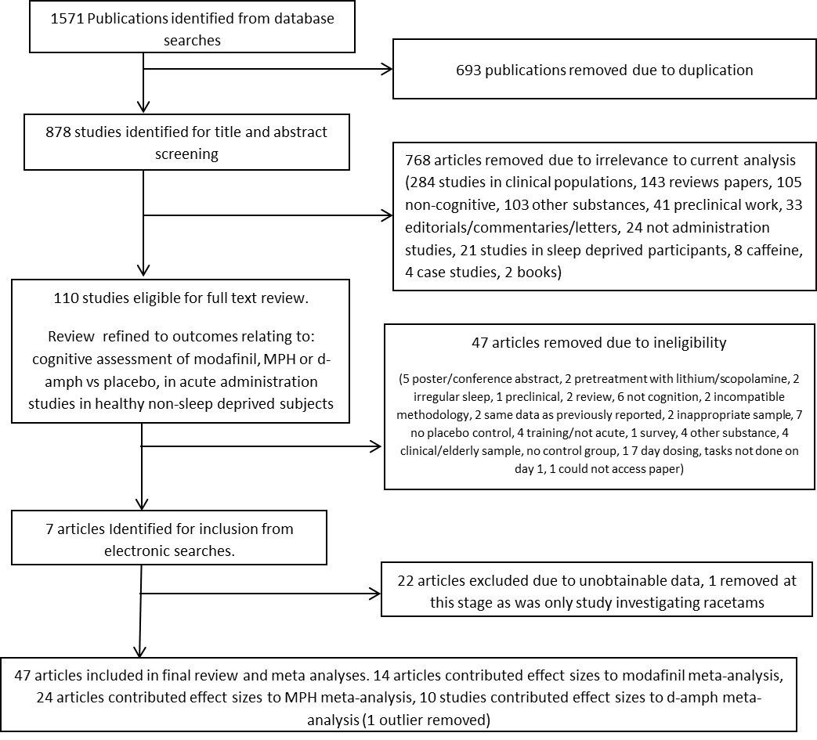

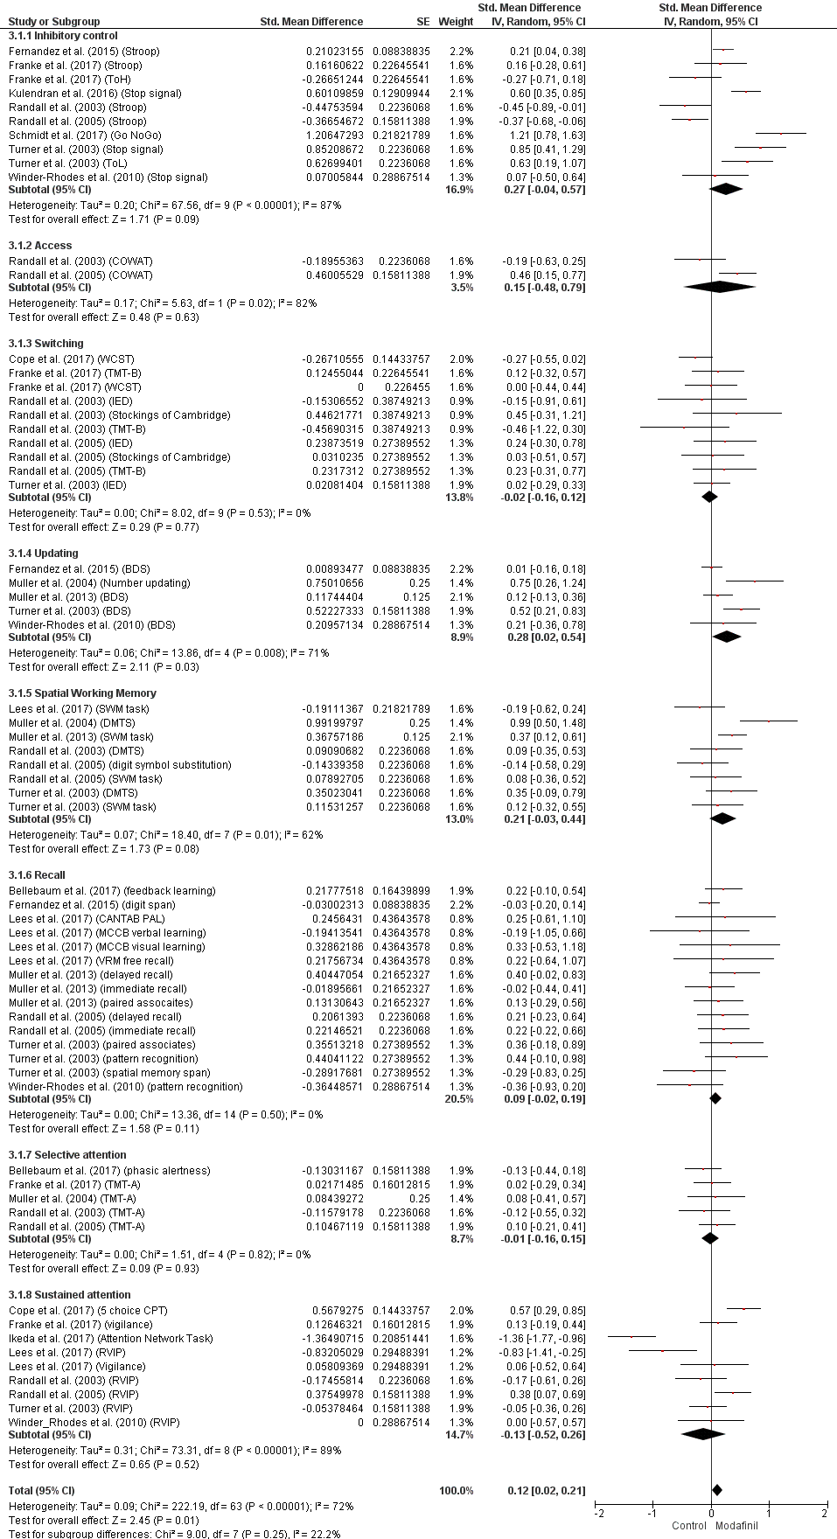
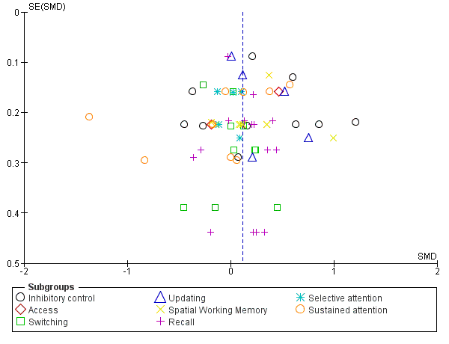
Figure 2. Forest plot and funnel plot of studies comparing cognitive performance after administration of modafinil and placebo. I² is an indicator of heterogeneity between comparisons. Inverse variance (IV) meta-analysis using standardized (Std.) mean differences. SE, Standard error; CI, confidence interval; df, degrees of freedom.

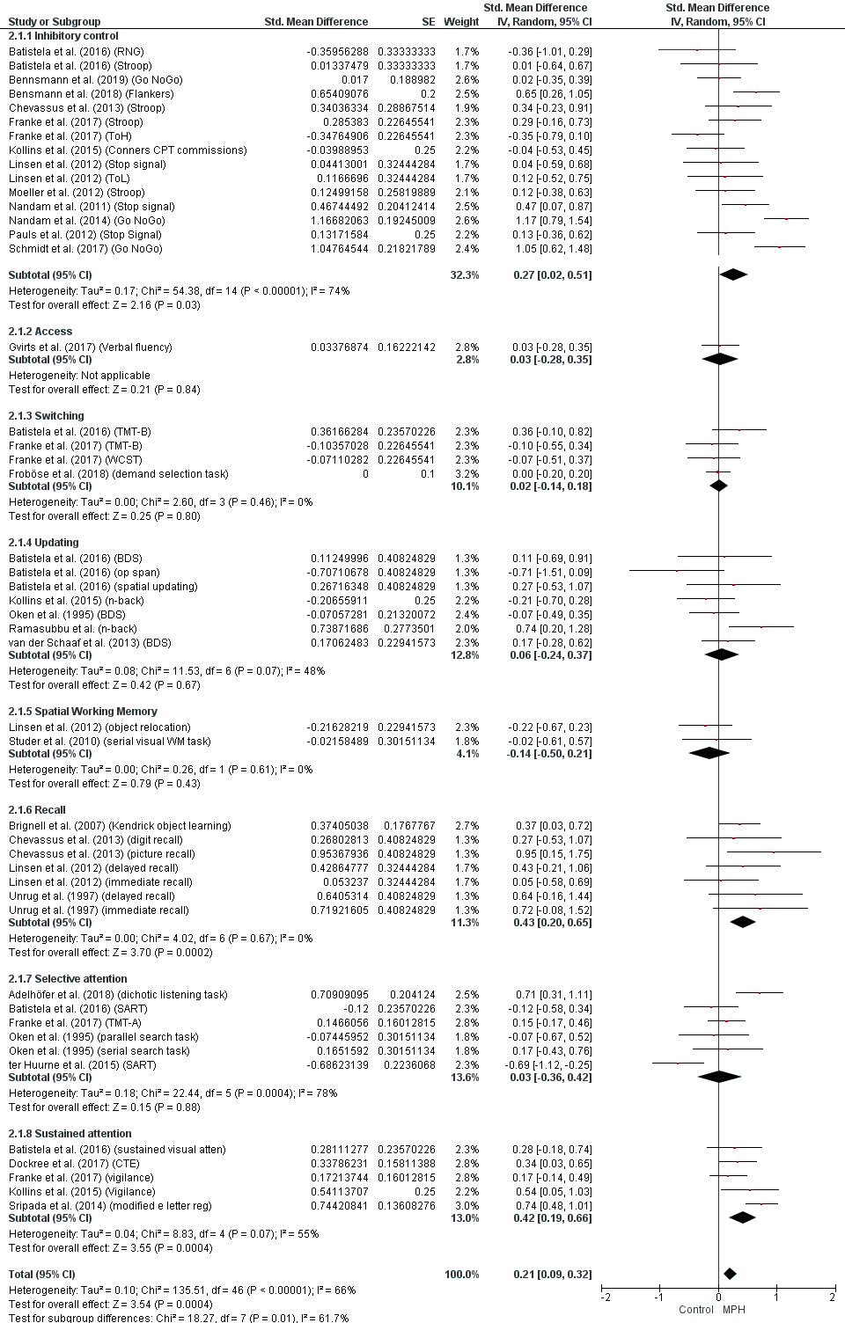

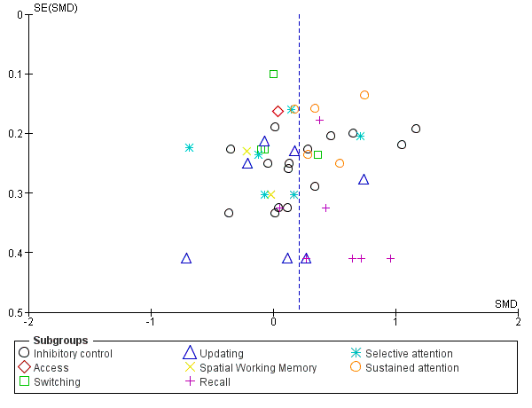
Figure 3. Forest plot and funnel plot of studies comparing cognitive performance after administration of methylphenidate and placebo. I2 is an indicator of heterogeneity between comparisons. Inverse variance (IV) meta-analysis using standardized (Std.) mean differences. SE, Standard error; CI, confidence interval; df, degrees of freedom.

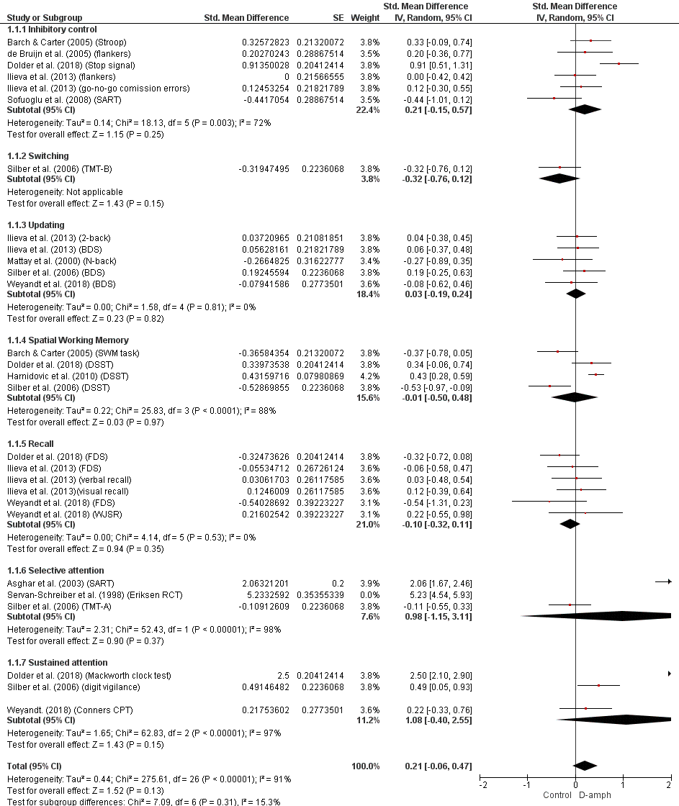

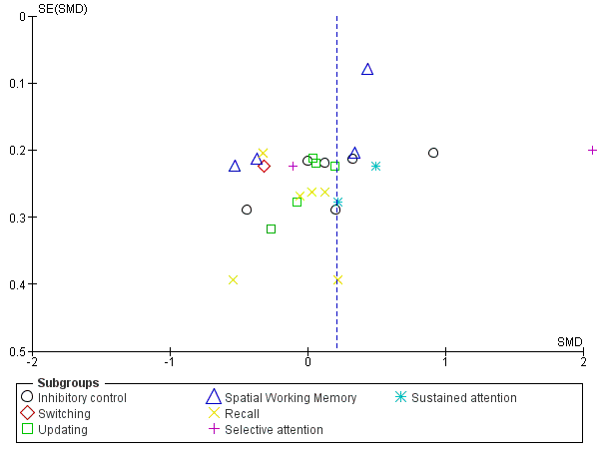

Figure 4. Forest plot of studies comparing cognitive performance after administration of d-amphetamine and placebo. I² is an indicator of heterogeneity between comparisons. Inverse variance (IV) meta-analysis using standardized (Std.) mean differences. SE, Standard error; CI, confidence interval; df, degrees of freedom.

SUPPLEMENTARY MATERIAL
Leave-one-out jack-knife analysis
Discarded study | Domain SMD | p value | Overall SMD | p value
Modafinil | Inhibitory control
Fernandez et al. (2015) (Stroop) | 0.27 [-.011, 0.66] | .16 | 0.11 [0.02, 0.21] | .02
Franke et al. (2017) (Stroop) | 0.28 [-0.06, 0.61] | .10 | 0.11 [0.02, 0.21] | .02
Franke et al. (2017) (ToH) | 0.32 [0.00, 0.64] | .05 | 0.12 [0.03, 0.21] | .01
Kulendran et al. (2016) (Stop signal) | 0.22 [-0.11, 0.56] | .19 | 0.11 [0.01, 0.20] | .02
Randall et al. (2003) (Stroop) | 0.34 [0.03, 0.65] | .03 | 0.12 [0.03, 0.22] | .008
Randall et al. (2005) (Stroop) | 0.34 [0.04, 0.64] | .03 | 0.12 [0.03, 0.22] | .008
Schmidt et al. (2017) (Go NoGo) | 0.16 [-0.12, 0.45] | .25 | 0.10 [0.01, 0.19] | .03
Turner et al. (2003) (Stop signal) | 0.20 [-0.11, 0.52] | 0.21 | 0.10 [0.01, 0.19] | .03
Turner et al. (2003) (ToL) | 0.23 [-0.10, 0.55] | .17 | 0.11 [0.01, 0.20] | .02
Winder-Rhodes et al. (2010) (Stop signal) | 0.28 [-0.04, 0.61] | .09 | 0.12 [0.02, 0.21] | .01
 | Updating
Fernandez et al. (2015) (BDS) | 0.38 [0.08, 0.67] | .01 | 0.12 [0.02, 0.21] | .02
Muller et al. (2004) (Number updating) | 0.19 [-0.04, 0.42] | .11 | 0.11 [0.01, 0.20] | .02
Muller et al. (2013) (BDS) | 0.35 [-0.02, 0.72] | .07 | 0.11 [0.02, 0.21] | .02
Turner et al. (2003) (BDS) | 0.20 [-0.06, 0.46] | .13 | 0.11 [0.01, 0.20] | .02
Winder-Rhodes et al. (2010) (BDS) | 0.30 [-0.00, 0.59] | .05 | 0.11 [0.02, 0.21] | .02
 | Switching
Cope et al. (2017) (WCST) | 0.06 [-0.10, 0.23] | .45 | 0.12 [0.03, 0.22] | .01
Franke et al. (2017) (TMT-B) | -0.04 [-0.19, 0.11] | .62 | 0.11 [0.02, 0.21] | .02
Franke et al. (2017) (WCST) | -0.02 [-0.18, 0.13] | .76 | 0.12 [0.02, 0.21] | .02
Randall et al. (2003) (IED) | -0.02 [-0.16, 0.13] | .83 | 0.12 [0.02, 0.21] | .01
Randall et al. (2003) (Stockings of Cambridge) | -0.04 [-0.18, 0.11] | .61 | 0.11 [0.02, 0.20] | .02
Randall et al. (2003) (TMT-B) | -0.01 [-0.15, 0.14] | .95 | 0.12 [0.03, 0.21] | .01
Randall et al. (2005) (IED) | -0.04 [-0.19, 0.11] | .59 | 0.11 [0.02, 0.21] | .02
Randall et al. (2005) (Stockings of Cambridge) | -0.03 [-0.17, 0.12] | .74 | 0.12 [0.02, 0.21] | .01
Randall et al. (2005) (TMT-B) | -0.04 [-0.19, 0.11] | .59 | 0.11 [0.02, 0.21] | .02
Turner et al. (2003) (IED) | -0.03 [-0.19, 0.13] | .69 | 0.12 [0.02, 0.21] | .01
 | Spatial WM
Lees et al. (2017) (SWM task) | 0.26 [0.02, 0.50] | .03 | 0.12 [0.03, 0.21] | .01
Muller et al. (2004) (DMTS) | 0.13 [-0.04, 0.31] | .14 | 0.10 [0.01, 0.19] | .03
Muller et al. (2013) (SWM task) | 0.17 [-0.10, 0.45] | .22 | 0.11 [0.02, 0.20] | .02
Randall et al. (2003) (DMTS) | 0.22 [-0.04, 0.49] | .10 | 0.12 [0.02, 0.21] | .02
Randall et al. (2005) (digit symbol substitution) | 0.25 [0.01, 0.50] | .04 | 0.12 [0.03, 0.21] | .01
Randall et al. (2005) (SWM task) | 0.22 [-0.04, 0.49] | .10 | 0.12 [0.02, 0.21] | .02
Turner et al. (2003) (DMTS) | 0.19 [-0.08, 0.45] | .17 | 0.11 [0.02, 0.20] | .02
Turner et al. (2003) (SWM task) | 0.22 [-0.05, 0.48] | .11 | 0.12 [0.02, 0.21] | .02
 | Recall
Bellebaum et al. (2017) (feedback learning) | 0.07 [-0.04, 0.18] | .22 | 0.11 [0.02, 0.21] | .02
Fernandez et al. (2015) (digit span) | 0.15 [0.02, 0.29] | .02 | 0.12 [0.02, 0.21] | .01
Lees et al. (2017) (CANTAB PAL) | 0.09 [-0.02, 0.20] | .12 | 0.11 [0.02, 0.21] | .02
Lees et al. (2017) (MCCB verbal learning) | 0.09 [-0.02, 0.20] | .10 | 0.12 [0.02, 0.21] | .01
Lees et al. (2017) (MCCB visual learning) | 0.08 [-0.02, 0.19] | .13 | 0.11 [0.02, 0.21] | .02
Lees et al. (2017) (VRM free recall) | 0.09 [-0.02, 0.20] | .12 | 0.11 [0.02, 0.21] | .02
Muller et al. (2013) (delayed recall) | 0.06 [-0.04, 0.17] | .25 | 0.11 [0.02, 0.20] | .02
Muller et al. (2013) (immediate recall) | 0.09 [-0.02, 0.21] | .09 | 0.12 [0.02, 0.21] | .01
Muller et al. (2013) (paired associates) | 0.09 [-0.03, 0.20] | .13 | 0.11 [0.02, 0.21] | .02
Randall et al. (2005) (delayed recall) | 0.08 [-0.03, 0.19] | .16 | 0.11 [0.02, 0.21] | .02
Randall et al. (2005) (immediate recall) | 0.08 [-0.03, 0.19] | .17 | 0.11 [0.02, 0.21] | .02
Turner et al. (2003) (paired associates) | 0.07 [-0.03, 0.18] | .18 | 0.11 [0.02, 0.20] | .02
Turner et al. (2003) (pattern recognition) | 0.07 [-0.04, 0.18] | .20 | 0.11 [0.02, 0.20] | .02
Turner et al. (2003) (spatial memory span) | 0.10 [-0.01, 0.21] | .07 | 0.12 [0.03, 0.21] | .01
Winder-Rhodes et al. (2010) (pattern recognition) | 0.10 [-0.01, 0.21] | .06 | 0.12 [0.03, 0.21] | .01
 | Selective attention
Bellebaum et al. (2017) (phasic alertness) | 0.04 [-0.15, 0.22] | .70 | 0.12 [0.03, 0.21] | .01
Franke et al. (2017) (TMT-A) | -0.02 [-0.20, 0.16] | .85 | 0.12 [0.02, 0.21] | .01
Muller et al. (2004) (TMT-A) | -0.02 [-0.18, 0.15] | .83 | 0.12 [0.02, 0.21] | .02
Randall et al. (2003) (TMT-A) | 0.01 [-0.16, 0.18] | .92 | 0.12 [0.03, 0.21] | .01
Randall et al. (2005) (TMT-A) | -0.05 [-0.23, 0.14] | .62 | 0.12 [0.02, 0.21] | .02
 | Sustained attention
Cope et al. (2017) (5 choice CPT) | -0.22 [-0.63, 0.18] | .28 | 0.11 [0.01, 0.20] | .02
Franke et al. (2017) (vigilance) | -0.17 [-0.62, 0.29] | .48 | 0.11 [0.02, 0.21] | .02
Ikeda et al. (2017) (Attention Network Task) | 0.05 [-0.21, 0.32] | .69 | 0.14 [0.06, 0.22] | .0008
Lees et al. (2017) (RVIP) | -0.05 [-0.45, 0.35] | .81 | 0.13 [0.04, 0.22] | .006
Lees et al. (2017) (Vigilance) | -0.15 [-0.58, 0.27] | .49 | 0.12 [0.02, 0.21] | .01
Randall et al. (2003) (RVIP) | -0.12 [-0.56, 0.31] | .57 | 0.12 [0.03, 0.21] | .01
Randall et al. (2005) (RVIP) | -0.20 [-0.64, 0.24] | .37 | 0.11 [0.02, 0.20] | .02
Turner et al. (2003) (RVIP) | -0.14 [-0.60, 0.32] | .54 | 0.12 [0.02, 0.21] | .01
Winder_Rhodes et al. (2010) (RVIP) | -0.14 [-0.57, 0.28] | .51 | 0.12 [0.02, 0.21] | .01
Methylphenidate | Inhibitory control
Batistela et al. (2016) (RNG) | 0.31 [0.06, 0.55] | .01 | 0.22 [0.10, 0.33] | .0002
Batistela et al. (2016) (Stroop) | 0.28 [0.03, 0.54] | .03 | 0.21 [0.09, 0.33] | .0004
Bennsmann et al. (2019) (Go NoGo) | 0.29 [0.03, 0.55] | .03 | 0.21 [0.10, 0.33] | .0004
Bensmann et al. (2018) (Flankers) | 0.24 [-0.02, 0.50] | .07 | 0.20 [0.08, 0.31] | .0009
Chevassus et al. (2013) (Stroop) | 0.26 [0.00, 0.52] | .05 | 0.21 [0.09, 0.32] | .0006
Franke et al. (2017) (Stroop) | 0.27 [0.00, 0.53] | .05 | 0.21 [0.09, 0.33] | .0006
Franke et al. (2017) (ToH) | 0.32 [0.08, 0.56] | .009 | 0.22 [0.11, 0.34] | .0002
Kollins et al. (2015) (Conners CPT commissions) | 0.29 [0.03, 0.55] | .03 | 0.21 [0.10, 0.33] | .0004
Linsen et al. (2012) (Stop signal) | 0.28 [0.02, 0.54] | .03 | 0.21 [0.09, 0.33] | .0004
Linsen et al. (2012) (ToL) | 0.28 [0.02, 0.53] | .03 | 0.21 [0.09, 0.33] | .0004
Moeller et al. (2012) (Stroop) | 0.28 [0.02, 0.54] | .04 | 0.21 [0.09, 0.33] | .0005
Nandam et al. (2011) (Stop signal) | 0.25 [-0.01, 0.52] | .06 | 0.20 [0.08, 0.32] | .0008
Nandam et al. (2014) (Go NoGo) | 0.20 [-0.01, 0.41] | .06 | 0.18 [0.08, 0.29] | .0008
Pauls et al. (2012) (Stop Signal) | 0.28 [0.02, 0.54] | .04 | 0.21 [0.09, 0.33] | .0005
Schmidt et al. (2017) (Go NoGo) | 0.21 [-0.02, 0.45] | .08 | 0.19 [0.08, 0.30] | .0009
 | Switching
Batistela et al. (2016) (TMT-B) | -0.02 [-0.19, 0.14] | .77 | 0.21 [0.09, 0.32] | .0007
Franke et al. (2017) (TMT-B) | 0.05 [-0.15, 0.24] | .64 | 0.22 [0.10, 0.33] | .0003
Franke et al. (2017) (WCST) | 0.04 [-0.16, 0.25] | .68 | 0.22 [0.10, 0.33] | .0003
Froböse et al. (2018) | 0.06 [-0.23, 0.35] | .71 | 0.22 [0.10, 0.34] | .0004
 | Updating
Batistela et al. (2016) (BDS) | 0.06 [-0.28, 0.40] | .74 | 0.21 [0.09, 0.33] | .0004
Batistela et al. (2016) (op span) | 0.14 [-0.13, 0.42] | .31 | 0.22 [0.11, 0.34] | .0002
Batistela et al. (2016) (spatial updating) | 0.04 [-0.30, 0.38] | .81 | 0.21 [0.09, 0.33] | .0005
Kollins et al. (2015) (n-back) | 0.12 [-0.23, 0.46] | .50 | 0.22 [0.10, 0.34] | .0003
Oken et al. (1995) (BDS) | 0.09 [-0.28, 0.47] | .63 | 0.22 [0.10, 0.33] | .0003
Ramasubbu et al. (n-back) | -0.05 [-0.27, 0.18] | .68 | 0.20 [0.08, 0.31] | .0008
van der Schaaf et al. (2013) (BDS) | 0.04 [-0.33, 0.41] | .84 | 0.21 [0.09, 0.33] | .0005
 | Recall
Brignell et al. (2007) (Kendrick object learning) | 0.47 [0.17, 0.77] | .002 | 0.20 [0.09, 0.32] | .0007
Chevassus et al. (2013) (digit recall) | 0.44 [0.21, 0.68] | .0002 | 0.21 [0.09, 0.33] | .0005
Chevassus et al. (2013) (picture recall) | 0.38 [0.15, 0.62] | .002 | 0.20 [0.08, 0.32] | .0007
Linsen et al. (2012) (delayed recall) | 0.43 [0.18, 0.67] | .0005 | 0.21 [0.09, 0.32] | .0006
Linsen et al. (2012) (immediate recall) | 0.48 [0.24, 0.72] | <.0001 | 0.21 [0.09, 0.33] | .0004
Unrug et al. (1997) (delayed recall) | 0.41 [0.17, 0.64] | .0007 | 0.20 [0.09, 0.32] | .0006
Unrug et al. (1997) (immediate recall) | 0.40 [0.17, 0.64] | .0008 | 0.20 [0.09, 0.32] | .0007
 | Selective attention
Adelhöfer et al. (2018) | -0.12 [-0.44, 0.21] | .48 | 0.20 [0.08, 0.31] | .0009
Batistela et al. (2016) (SART) | 0.06 [-0.41, 0.52] | .81 | 0.22 [0.10, 0.33] | .0003
Franke et al. (2017) (TMT-A) | 0.00 [-0.51, 0.51] | 1.00 | 0.21 [0.09, 0.33] | .0005
Oken et al. (1995) (parallel search task) | 0.05 [-0.40, 0.50] | .81 | 0.21 [0.10, 0.33] | .0003
Oken et al. (1995) (serial search task) | 0.01 [-0.45, 0.46] | .98 | 0.21 [0.09, 0.33] | .0005
ter Huurne et al. (2015) (SART) | 0.19 [-0.11, 0.49] | .22 | 0.23 [0.12, 0.34] | .0001
 | Sustained attention
Batistela et al. (2016) (sustained visual atten) | 0.45 [0.17, 0.73] | .001 | 0.21 [0.09, 0.33] | .0006
Dockree et al. (2017) (CTE) | 0.44 [0.14, 0.75] | .004 | 0.21 [0.09, 0.32] | .0008
Franke et al. (2017) (vigilance) | 0.50 [0.27, 0.74] | .0001 | 0.21 [0.09, 0.46] | .0006
Kollins et al. (2015) (Vigilance) | 0.40 [0.12, 0.68] | .005 | 0.20 [0.08, 0.32] | .0008
Sripada et al. (2014) (Modified e letter reg) | 0.30 [0.12, 0.48] | .001 | 0.19 [0.08, 0.31] | .0008
D-amphetamine | Inhibitory control
Barch & Carter (2005) (Stroop) | 0.18 [-0.27, 0.62] | .43 | 0.20 [-0.08, 0.48] | .15
de Bruijn et al. (2005) (flankers) | 0.21 [-0.21, 0.63] | .34 | 0.21 [-0.07, 0.48] | .14
Dolder et al. (2018) (Stop signal) | 0.07 [-0.16, 0.31] | .55 | 0.18 [-0.09, 0.45] | .20
Ilieva et al. (2013) (flankers) | 0.25 [-0.17, 0.67] | .25 | 0.21 [-0.06, 0.49] | .13
Ilieva et al. (2013) (go-no-go comission errors) | 0.12 [-0.22, 0.66] | .32 | 0.21 [-0.07, 0.49] | .14
Sofuoglu et al. (2008) (SART) | 0.32 [-0.01, 0.66] | .06 | 0.23 [-0.04, 0.50] | .10
 | Updating
Ilieva et al. (2013) (2-back) | 0.02 [-0.22, 0.27] | .87 | 0.21 [-0.06, 0.49] | .13
Ilieva et al. (2013) (BDS) | 0.02 [-0.23, 0.26] | .90 | 0.21 [-0.06, 0.49] | .13
Mattay et al. (2000) (N-back) | 0.06 [-0.16, 0.29] | .58 | 0.22 [-0.05, 0.50] | .11
Silber et al. (2006) (BDS) | -0.03 [-0.27, 0.22] | .84 | 0.21 [-0.07, 0.48] | .14
Weyandt et al. (2018) (BDS) | 0.04 [-0.19, 0.27] | .71 | 0.22 [-0.06, 0.49] | .12
 | Spatial working memory
Barch & Carter (2005) (SWM task) | 0.11 [-0.43, 0.65] | .70 | 0.23 [-0.04, 0.50] | .10
Dolder et al. (2018) (DSST) | -0.13 [-0.82, 0.55] | .71 | 0.20 [-0.08, 0.48] | .16
Harnidovic et al. (2010) (DSST) | -0.18 [-0.71, 0.35] | .51 | 0.19 [-0.11, 0.50] | .21
Silber et al. (2006) (DSST) | 0.16 [-0.30, 0.62] | .49 | 0.24 [-0.03, 0.51] | .09
 | Recall
Dolder et al. (2018) (FDS) | -0.01 [-0.27, 0.25] | .94 | 0.23 [-0.04, 0.50] | .10
Ilieva et al. (2013) (FDS) | -0.11 [-0.36, 0.13] | .36 | 0.22 [-0.06, 0.49] | .12
Ilieva et al. (2013) (verbal recall) | -0.13 [-0.38, 0.11] | .27 | 0.21 [-0.06, 0.49] | .13
Ilieva et al. (2013)(visual recall) | -0.16 [-0.40, 0.09] | .21 | 0.21 [-0.07, 0.48] | .13
Weyandt et al. (2018) (FDS) | -0.07 [-0.29, 0.16] | .57 | 0.23 [-0.04, 0.50] | .09
Weyandt et al. (2018) (WJSR) | -0.13 [-0.36, 0.10] | .25 | 0.21 [-0.07, 0.48] | .14
 | Sustained attention
Dolder et al. (2018) (Mackworth clock test) | 0.38 [0.04, 0.72] | .03 | 0.12 [-0.09, 0.33] | .26
Silber et al. (2006) (digit vigilance) | 1.37 [-0.87, 3.60] | .23 | 0.20 [-0.08, 0.47] | .17
Weyandt. (2018) (Conners CPT) | 1.50 [-0.47, 3.47] | .14 | 0.21 [-0.07, 0.48] | .14

Supplementary table of missing data

Authors (year) | Summary of findings
Agay et al. (2010). | Average digit span (recall) test score higher in groups (with and without ADHD) receiving MPH than placebo
Baranski et al. (2004). | Modafinil had no effect on serial reaction time accuracy (sustained attention). Modafinil improved performance on a detection of repeated numbers vigilance task (sustained attention) relative to placebo
Bullmore et al. (2003). | Main effect of drug treatment (MPH, scopolamine, sulpiride and placebo) non-significant on performance of Object-location learning task (recall).
Camp-Bruno & Herting (1994). | MPH improved vigilance reaction time (selective attention) compared to placebo. No difference between MPH and placebo on immediate/delayed recall.
Clatworthy et al. (2009). | MPH did not exert a significant effects on a spatial working memory task compared to placebo.
Cooper et al. (2005). | Effect of increasing dose of MPH on omission errors and reaction time on a continuous performance task (sustained attention). Direct comparisons of MPH to placebo not reported.
Dodds et al. (2008). | No main effect of MPH on performance of a probabilistic reversal task (switching)
Elliot et al. (1997). | MPH had significant effects on spatial working memory and planning, but not on set-shifting, sustained attention or verbal fluency
Ernst et al. (2016). | No significant effect of MPH on performance on n-back task (updating)
Fillmore et al. (2005). | No improvement of response inhibition with d-amphetamine compared to placebo.
Finke et al. (2010). | Tested MPH, Modafinil and placebo on visual processing speed (sustained attention), analysis based on baseline performance (e.g. low baseline performance, high baseline performance). Analysis on whole sample not conducted.
Ghahremani et al. (2011). | Modafinil had no effect on associative learning task (recall) performance compared to placebo in non-MPH-dependent control group
Hamidovic et al. (2010). | Overall effect of d-amphetamine on Digit Symbol Substitution Task (Spatial working memory) performance relative to placebo was non-significant.
Hermens et al. (2007). | Direct comparisons of MPH to placebo on cognitive test battery not reported.
Johnson et al. (1996). | D-amphetamine improved rapid visual information processing (sustained attention) compared to placebo.
Makris et al. (2007). | No overall effects of modafinil or d-amphetamine on accuracy on Digit Symbol Substitution Task (spatial working memory) compared to placebo. Dose x time interactions reported for two recall tasks, but comparison to placebo not reported.
Marchant et al. (2009). | No main effect of modafinil on Digit Symbol Substitution Task (spatial working memory), attention shift (switching), or word recall performance
Moeller et al. (2012). | Effect of MPH relative to placebo on Stroop task (inhibitory control) performance in healthy controls not reported.
Mohamed & Lewis (2014). | Modafinil did not enhance accuracy of response inhibition performance on Hayling Sentence Completion Test
Tipper et al. (2005). | No performance differences between d-amphetamine and placebo groups on a modified Sternberg working memory task (updating)
Volkow et al. (2008). | No performance differences between MPH and placebo in numerical calculations task
Wardle et al. (2012). | d-amphetamine did not improve accuracy on 3-back task (updating)

Table S1: Summary table of missing data.

References for S1
Agay, N., Yechiam, E., Carmel, Z., & Levkovitz, Y. (2010). Non-specific effects of methylphenidate (Ritalin) on cognitive ability and decision-making of ADHD and healthy adults. Psychopharmacology, 210(4), 511-519.
Baranski, J. V., Pigeau, R., Dinich, P., & Jacobs, I. (2004). Effects of modafinil on cognitive and meta‐cognitive performance. Human Psychopharmacology: Clinical and Experimental, 19(5), 323-332.
Bullmore, E., Suckling, J., Zelaya, F., Long, C., Honey, G., Reed, L., ... & Williams, S. C. (2003). Practice and difficulty evoke anatomically and pharmacologically dissociable brain activation dynamics. Cerebral Cortex, 13(2), 144-154.
Camp-Bruno, J. A., & Herting, R. L. (1994). Cognitive effects of milacemide and methylphenidate in healthy young adults. Psychopharmacology, 115(1-2), 46-52.
Clatworthy, P. L., Lewis, S. J., Brichard, L., Hong, Y. T., Izquierdo, D., Clark, L., ... & Robbins, T. W. (2009). Dopamine release in dissociable striatal subregions predicts the different effects of oral methylphenidate on reversal learning and spatial working memory. Journal of Neuroscience, 29(15), 4690-4696.
Cooper, N. J., Keage, H., Hermens, D., Williams, L. M., Debrota, D., Richard Clark, C., & Gordon, E. (2005). The dose-dependent effect of methylphenidate on performance, cognition and psychophysiology. Journal of Integrative Neuroscience, 4(01), 123-144.
Dodds, C. M., Müller, U., Clark, L., van Loon, A., Cools, R., & Robbins, T. W. (2008). Methylphenidate has differential effects on blood oxygenation level-dependent signal related to cognitive subprocesses of reversal learning. Journal of Neuroscience, 28(23), 5976-5982.
Elliott, R., Sahakian, B. J., Matthews, K., Bannerjea, A., Rimmer, J., & Robbins, T. W. (1997). Effects of methylphenidate on spatial working memory and planning in healthy young adults. Psychopharmacology, 131(2), 196-206.
Ernst, M., Lago, T., Davis, A., & Grillon, C. (2016). The effects of methylphenidate and propranolol on the interplay between induced-anxiety and working memory. Psychopharmacology, 233(19-20), 3565-3574.
Fillmore, M. T., Kelly, T. H., & Martin, C. A. (2005). Effects of d-amphetamine in human models of information processing and inhibitory control. Drug and alcohol dependence, 77(2), 151-159.
Finke, K., Dodds, C. M., Bublak, P., Regenthal, R., Baumann, F., Manly, T., & Müller, U. (2010). Effects of modafinil and methylphenidate on visual attention capacity: a TVA-based study. Psychopharmacology, 210(3), 317-329.
Ghahremani, D. G., Tabibnia, G., Monterosso, J., Hellemann, G., Poldrack, R. A., & London, E. D. (2011). Effect of modafinil on learning and task-related brain activity in methamphetamine-dependent and healthy individuals. Neuropsychopharmacology, 36(5), 950-959.
Hamidovic, A., Dlugos, A., Palmer, A. A., & de Wit, H. (2010). Polymorphisms in dopamine transporter (SLC6A3) are associated with stimulant effects of D-amphetamine: an exploratory pharmacogenetic study using healthy volunteers. Behavior genetics, 40(2), 255-261.
Hermens, D. F., Cooper, N. J., Clark, C. R., Debrota, D., Clarke, S. D., & Williams, L. M. (2007). An integrative approach to determine the best behavioral and biological markers of methylphenidate. Journal of integrative neuroscience, 6(01), 105-140.
Johnson, B. A., Oldman, D., Goodall, E. M., Chen, Y. R., & Cowen, P. J. (1996). Effects of GR 68755 on d-amphetamine-induced changes in mood, cognitive performance, appetite, food preference, and caloric and macronutrient intake in humans. Behavioural pharmacology, 7(3), 216-227.
Makris, A. P., Rush, C. R., Frederich, R. C., Taylor, A. C., & Kelly, T. H. (2007). Behavioral and subjective effects of d-amphetamine and modafinil in healthy adults. Experimental and clinical psychopharmacology, 15(2), 123.
Marchant, N. L., Kamel, F., Echlin, K., Grice, J., Lewis, M., & Rusted, J. M. (2009). Modafinil improves rapid shifts of attention. Psychopharmacology, 202(1-3), 487-495.
Moeller, S. J., Tomasi, D., Honorio, J., Volkow, N. D., & Goldstein, R. Z. (2012). Dopaminergic involvement during mental fatigue in health and cocaine addiction. Translational psychiatry, 2(10), e176-e176.
Mohamed, A. D., & Lewis, C. R. (2014). Modafinil increases the latency of response in the Hayling Sentence Completion Test in healthy volunteers: a randomised controlled trial. PloS one, 9(11).
Tipper, C. M., Cairo, T. A., Woodward, T. S., Phillips, A. G., Liddle, P. F., & Ngan, E. T. (2005). Processing efficiency of a verbal working memory system is modulated by amphetamine: an fMRI investigation. Psychopharmacology, 180(4), 634-643.
Volkow, N. D., Fowler, J. S., Wang, G. J., Telang, F., Logan, J., Wong, C., ... & Swanson, J. M. (2008). Methylphenidate decreased the amount of glucose needed by the brain to perform a cognitive task. PLoS One, 3(4).
Wardle, M. C., Yang, A., & de Wit, H. (2012). Effect of d-amphetamine on post-error slowing in healthy volunteers. Psychopharmacology, 220(1), 109-115.

