Ant colony nest networks adapt to resource disruption
Dominic D.R. Burns^{a,b}, Daniel W Franks^{a,b,c}, Catherine Parr^{d,e,f}, Elva JH Robinson^{a,b}
ª Department of Biology, University of York, York, UK
^{b} York Cross-disciplinary Centre for Systems Analysis, University of York, York, UK
^{c} Department of Computer Science, University of York, York, UK
^{d} Department of Earth, Ocean and Ecological Sciences, University of Liverpool, Liverpool, UK
^{e} Centre for African Ecology, School of Animal, Plant and Environmental Sciences, University of Witwatersrand, Johannesburg, South Africa
^{f} Department of Zoology & Entomology, University of Pretoria, South Africa
Corresponding author: Dominic Burns, Department of Biology, University of York, York, UK.
Email: db1133@york.ac.uk

Abstract
1. Animal social structure is shaped by environmental conditions, such as food availability. This is important as conditions are likely to change in the future and changes to social structure can have cascading ecological effects. Wood ants are a useful taxon for the study of the relationship between social structure and environmental conditions, as some populations form large nest networks and they are ecologically dominant in many northern hemisphere woodlands. Nest networks are formed when a colony inhabits more than one nest, known as polydomy. Polydomous colonies are composed of distinct sub-colonies that inhabit spatially distinct nests and that share resources with each other.
2. In this study, we performed a controlled experiment on ten polydomous wood ant (Formica lugubris) colonies to test how changing the resource environment affects the social structure of a polydomous colony. We took network maps of all colonies for five years before the experiment to assess how the networks changes under natural conditions. After this period, we prevented ants from accessing an important food source for a year in five colonies and left the other five colonies undisturbed.
4. We found that preventing access to an important food source causes polydomous wood ant colony networks to fragment into smaller components and begin foraging on previously unused food sources. These changes were not associated with a reduction in the growth of populations inhabiting individual nests (sub-colonies), foundation of new nests or survival, when compared with control colonies.
5. Colony splitting likely occurred as the availability of food in each nest changed causing sub-colonies to change their inter-nest connections. Consequently, our results demonstrate that polydomous colonies can adjust to environmental changes by altering their social network.
Key words: social network analysis, resilience, foraging ecology, dynamic networks, polydomy, wood ants
Introduction
Changes to environmental conditions influence not only the composition of assemblages in different habitats, but also affect the social structure of many animal societies (Sueur et al. 2019). Social structure is the organization of units (e.g. individuals, groups) that emerges from their social behaviour. Understanding how social structure responds to environmental conditions is important because changes to social structure can have cascading effects within an ecosystem, for example changes to wolf pack size, caused by an altered climate, influences plant growth in certain areas (Post et al. 1999). Furthermore, in many places environmental change is occurring at an increased rate due to human activity and, consequently, understanding the effect that this may have on animal social structure is important for conservation (Snijders et al. 2017).
Social network analysis is a tool for studying social behaviour, where systems of socially connected units are modelled as networks with nodes representing units and connections representing the flow of resources, such as food or information (Croft et al. 2011; Brent 2015). Most research on animal social networks has focused on the structure and function of static networks. However, animal social networks are dynamic: the identities of the nodes present, their characteristics and their connections change over time (Blonder et al. 2012). Changes in animal social networks can occur in response to an internal network change, such as nodes strengthening their connections when another node is removed (Firth et al. 2017); however, in many cases, social network structure changes in response to changing environmental conditions (Sueur et al. 2019).
There are a variety of environmental factors, including habitat complexity, availability of food and predation, that can influence social structure, and spatial variation of these factors can cause social structure to vary spatially (Lattanzio & Miles 2014; Lantz & Karubian 2017; Tavares, Samarra & Miller 2017). One important environmental factor in influencing changes to social structure in many animal social groups is resource distribution. For example, in years when food is scarce, killer whales (Orcinus orca) form less connected networks than in years when food is abundant, possibly as a consequence of having more time available for social interactions, rather than searching for prey (Foster et al. 2012). Although there is some evidence from observational studies for the effect of resource distribution on social structure (Ansmann et al. 2012; Silk et al. 2014; Foster et al. 2012; (Henzi et al. 2009), few empirical tests exist (Sendova-Franks et al. 2010; Firth & Sheldon 2015; Bles, Deneubourg & Nicolis 2018). This is because resource distribution is often difficult to manipulate in the field, and networks are time consuming to map, meaning that multiple time points or replication at the network level are often infeasible. One system that overcomes these limitations is colony nest networks of ants (Robinson 2014). Colony nest networks are found in certain species of ants where colonies divide into several sub-colonies that inhabit spatially discrete nests, a strategy known as polydomy. Polydomous nest networks are a useful system for studying dynamic social networks because: (1) Complete networks can be mapped quickly without disturbing the animals; (2) Local environmental factors, such as the distribution of food, can be manipulated; and (3) Multiple networks can be mapped allowing replication at the network level.
Polydomy may benefit colonies by increasing foraging efficiency, reducing vulnerability to predators, and increasing competitive dominance (Robinson 2014; Burns et al. 2019a). Polydomy can also carry some costs for colonies such as limitations to communication and costs incurred by moving resources between nests (Robinson 2014). This trade-off between multiple costs and benefits has led to polydomy evolving independently several times in a diverse set of taxa (Debout et al. 2007).
An important taxon group with polydomous colonies are wood ants, considered keystone species in many northern hemisphere woodlands (Stockan & Robinson 2016). Many populations of wood ants have polydomous colonies, with nests that share resources almost exclusively on foraging trails (Ellis & Robinson 2014; Procter et al. 2016). Although wood ants do predate many invertebrates, they rely heavily on carbohydrates from exudates secreted by aphid colonies that they farm on a variety of tree species (Rosengren 1991; Stockan & Robinson 2016). Because of their dependence on aphids, wood ants are vulnerable to tree loss: clear-felling of forest plantations has consequences for nest survival, the presence of ant-associated species and rates of decomposition on the forest floor (Sorvari & Hakkarainen 2007; Sorvari, Elo & Härkönen 2016; Elo, Penttinen & Sorvari 2018; Härkönen & Sorvari 2018). However, due to the difficulties of manipulating resource distribution and producing accurate network maps, the effect of changes to resource distribution on the social network structure of polydomous ant colonies has not yet been studied.
Social network structure has been shown to be important for buffering the effects of environmental variability in some species (Henzi et al. 2009; Silk et al. 2014), but consequences may also be undesirable, such as facilitating the spread of disease through a system (e.g. Hamede et al. 2009). However, social network structures can be modified to limit the spread of negative effects, such as disease, by changing the interactions between certain groups (Stroeymeyt et al. 2018). As a result, the way that networks adapt to environmental changes and the consequences of changes to social structure on the growth, survival and reproduction of individual nodes are difficult to predict.
In this study, we aimed to investigate how environmental factors influence colony topology. Nest locations in polydomous wood ant networks are heavily influenced by the distribution of food sources and trail networks are formed in response to the relative distribution of food in these nests (Ellis, Franks & Robinson 2014; Ellis & Robinson 2016). Consequently, changes in resource distribution may cause significant disruption to trail networks. To investigate this hypothesis, we experimentally manipulated resource availability in multiple polydomous ant colonies by removing a key food source. We predicted that manipulation of resource distribution in polydomous colonies would cause changes to foraging networks and, subsequently, to inter-nest networks, as resource flow would be disrupted.
Materials and methods
Study system
This study was conducted at Longshaw Estate in the Peak District, UK (N53° 18’ 33’’, E-1° 36’ 96’’). At the site there are over 900 ant nests from a number of polydomous colonies (Ellis, Franks & Robinson 2014). Most of the site is grazed by sheep and cattle, which means that trails from each nest are easily identifiable. The wood ant colonies at the site are all Formica lugubris, which forage predominantly by farming aphids that feed on a variety of tree species, including Scot’s Pine (Pinus sylvestris), Birch (Betula spp.), Oak (Quercus spp.) and Larch (Larix decidua) through the active season (roughly April-September) and are inactive for the rest of the year, when it is too cold to forage. Foraging and inter-nest trails that are used by the ants are established at the start of the foraging season; new trails are often added, and old trails may be abandoned. Both the difference in foraged food available to two sub-colonies and the distance between the nests are important factors in determining the presence and strength of an inter-nest trail between the nests (Ellis, Franks & Robinson 2014). Thus, inter-nest networks are neither minimal spanning nor highly connected. Instead they are formed in a way that trades off efficiency and robustness (Cook, Franks & Robinson 2014). Similarly, foraging networks are connected in a way that trades off trail length and the distance between the nest and foraging sites (Buhl et al. 2009).
This study used ten polydomous colonies which had been mapped (see Mapping of colonies) at least once every year for four years (2012-2015) before the beginning of this study during previous observational work on this system (see e.g. Ellis & Robinson 2015). Between-colony differences are likely to exist due to factors such as varying environmental conditions and different network sizes. At the start of this study, colonies had a median of 11 nests (range: 4-20) and a median estimated colony population size of 658,059 ants (range: 78,798 – 1,218,878). Sub-colonies inhabiting nests in each of the 10 colonies foraged on an average of 1 (median = 1, I.Q.R. = 1) foraging trail to trees and an average of 1 (median = 1, I.Q.R. = 1) inter-nest trails to other nests at the start of the study. In total colonies foraged on an average of 6 (median = 6, I.Q.R. = 3) trees at the start of the study. Ten colonies were used to provide replication at the network level, which was important as we were interested in colony-level effects (James, Croft & Krause 2009).
Mapping of colonies
Colonies were mapped only on warm and sunny days between 10.00 and 18.00, when the ants are most active. Each time we mapped a colony we recorded the spatial position of nodes: inhabited nests and food sources. We also recorded the nodes connected by inter-nest and foraging trails. We estimated the strength of each trail by recording the length of trail required to count 10 foragers; the minimum and maximum lengths it was possible to do this accurately were 10 mm and 4 m respectively. We estimated the number of ants active on a trail by multiplying the strength of the trail by the length of the trail. Finally, we used the volume of each nest to estimate the population inhabiting the nest using the mound-volume technique described in Chen and Robinson (2013) Although not as accurate as mark-recapture methods, the mound-volume method for estimating colony size has been found to be a useful measure of colony size when avoiding disturbance is important, (Chen and Robinson 2013) and has been calibrated against mark-recapture data at this site in a previous study (Ellis, Franks & Robinson 2014) This network mapping protocol follows previous work on this population (Ellis and Robinson, 2015).
Experimental design
We split the ten colonies being used in the experiment into pairs with a similar number of nests and then randomly allocated one colony into the control group and the other into the treatment group. We then selected a focal tree which was to be excluded in the treatment colonies or undisturbed in control colonies. Focal trees were selected by two criteria: (1) The tree must have been foraged on at every previous time point; and (2) The tree must be suitable for fitting with an exclusion collar to prevent ants accessing it (i.e. no branches touching the ground and a single trunk, e.g. Figure 1). If more than one tree in a colony matched these criteria, we chose the tree that had the strongest total trail strength going to it at the previous time point (August 2016). We used this method so that we selected only trees that were important food sources for the colony. At the start of this study, the focal trees were foraged on by an average of 3 ± 1 (median ± IQR) nests and accounted for 33.3 ± 22.9 % (median ± IQR) of the foraging trails in the colonies.
In each of the excluded colonies we limited ant access to the focal tree before foraging began in early 2017 by fitting an exclusion collar (Figure 1). Each exclusion collar consisted of a plastic cone wrapped around the tree with any gaps between the cone and the tree being filled with clear aquarium grade silicone sealant (Everbuild AquaMate Sealant®). The underside of the plastic cone was painted with Fluon (Whitford®), to prevent ants from accessing the tree’s canopy. We found that these exclusion collars were effective for four out of the five trees they were fitted to, with a mean reduction of 98.3% in foraging trail strength to the trees. However, in one colony ants accessed the canopy of the focal tree through the canopy of a neighbouring tree (Burns DDR, personal observation). This colony was removed from all analyses. We left the collars in place for one year, after which we removed them, before foraging began in Spring 2018. Before the experiment began these colonies had been mapped at least once every year for 4 years. For this study we mapped each colony at four time points: (1) Before we installed the collars, in August 2016; (2) After we installed the collars, in June 2017; (3) Late in the season, in August 2017; and (4) After the first overwinter since the collars were installed, in June 2018. Here, we use the August 2016 and August 2017 time points to assess changes to colonies and nests. These time points were selected as it allows comparison between colonies a year before the installation of the exclusion collars (August 2015 – August 2016) and a year after the installation of the exclusion collars (August 2016 – August 2017). All data, including maps not used in the analysis here, are available from the OSF Data Repository (Burns et al. 2019b).
Statistical analyses
To test whether there was an effect of the exclusion on the number of independent groups of connected nests (hereafter referred to as network components), number of inter-nest trails, survival of nest populations, change in growth of nest population compared to previous year (2015-2016) and new nest foundation we used Brunner-Langer f1-ld-f1 models to compare the effect of time on both excluded and control colonies using the ANOVA-type test within that model (Brunner et al. 2002). Brunner-Langer f1-ld-f1 models are an extension of the Wilcoxon-Mann-Whitney test designed specifically for use for non-parametric analysis of repeated-measures of samples divided into different treatments, as was performed in our experiment. Brunner-Langer f1-ld-f1 models have similar assumptions to the Wilcoxon-Mann-Whitney test, such as that samples and treatments are independent of each other, the independent variables are distinct groups and that the dependent variable is either continuous or ordinal (Brunner et al. 2002). The models were fitted using the nparLD package in R (Noguchi et al. 2012) in R version 3.5.0 (R Core Team 2013).
Results
Change in number of network components
Before the installation of the exclusion collars, most colonies were composed of a single network component (median = 1, IQR = 0). However, after a year, colonies in which a single important food source was removed had split into several network components (Figure 2; median = 5, IQR = 3.25), which was a significant change from the previous year (f1-ld-f1: F = 13.36, p < 0.0005). In contrast, control colonies were not composed of significantly more network components (Figure 2; median = 1, IQR = 2; f1-ld-f1: F = 2.61, p = 0.11).
Changes to inter-nest trails
Before the excluders were installed, exclusion colonies had a median of 12 and an IQR of 6.5 inter-nest trails, while control colonies had a median of 13 and an IQR of 4 inter-nest trails. Following the installation of the excluders the number of inter-nest trails in the excluded colonies reduced by a non-significant amount (median = 9.5, IQR = 3) trails (f1-ld-f1: F = 1.51, p = 0.22). Control colonies had roughly the same number of inter-nest trails as the previous timepoint (median = 15, IQR = 14), which was also not a significant change (f1-ld-f1: F = 0.098, p = 0.75). However, there was a significant reduction in number of internest trails to nests that were previously foraging to the focal tree in exclusion colonies (Figure 3; f1-ld-f1: F = 4.65, p < 0.05), but not control colonies (Figure 3; f1-ld-f1: F = 0.91, p = 0.34).
Total inter-nest trail lengths for excluded networks did not change significantly after the exclusion (f1-ld-f1: F = 2.21, p = 0.14). Control colonies had roughly the same length of inter-nest trails as the previous timepoint, which was also not a significant change (f1-ld-f1: F = 0.013, p = 0.91). Similarly to the number of inter-nest trails, there was a significant reduction in the length of inter-nest trails to nests that previously foraged on the focal tree in exclusion colonies (f1-ld-f1: F = 6.95, p < 0.01), but not control colonies (f1-ld-f1: F = 0.0066, p = 0.94).
Nest abandonment and growth
Across all colonies, 78 of the 109 nests (71.6 %) that were inhabited in August 2016 were still inhabited in August 2017. There was no difference in the number of nests that were abandoned in the excluded condition (f1-ld-f1: F = 0.13, p = 0.72) or the control condition (f1-ld-f1: F = 0.0027, p = 0.96), when compared to nest abandonment in the same colonies from August 2015 to August 2016.
Between August 2016 and August 2017, growth in excluded colonies was not significantly different to the previous year (f1-ld-f1: F = 1.83, p = 0.18; Figure 4). In contrast, control colonies grew less between August 2016 and August 2017 than in the previous year (f1-ld-f1: F = 28.93, p < 0.0001; Figure 4). However, the difference in growth between control and excluded colonies appears to be due to higher variance in colony growth of excluded colonies than in control colonies. Before the experiment began, control colonies grew at a median rate of 60 % with an IQR of 0.5%, while excluded colonies grew at a median rate of 31 % with an IQR of 80%. This high initial variance in excluded colonies means that we have little power to detect changes in growth. Furthermore, the difference in growth between control and excluded colonies were not different before (Kruskal-Wallis: χ² = 0.96, p = 0.33) or after (Kruskal-Wallis: χ² = 0.06, p = 0.81) the excluders were installed (Figure 4).
Nest foundation
Across all colonies 44 new nests were founded between August 2016 and August 2017. We standardized nest foundation for the number of nests in each colony by dividing the number of new nests by the number of nests in the colony at the previous time point. We found no difference in the number of nests founded in excluded (f1-ld-f1: F = 0.62, p = 0.43) or control colonies (f1-ld-f1: F = 1.15, p = 0.28) compared with the number of nests founded in the previous year (Figure 5).
Change in foraging networks
After exclusion, exclusion treatment colonies started foraging to a median of 1.5 and IQR of 1.5 new trees (see foraging maps in Appendix 2), which was significantly more than in the year before exclusion (f1-ld-f1: F = 8.40, p < 0.005; Figure 6). In contrast, control colonies started foraging to a median of 0 and IQR of 5 new trees, which was not significantly different compared to the previous year (f1-ld-f1: F = 1.48, p = 0.22; Figure 6).
The proportion of the colony population active on foraging trails decreased in treatment colonies after the exclusion (f1-ld-f1: F = 5.42, p < 0.05; Figure 7), while in control colonies the proportion of the colony population active on foraging trails remained the same (f1-ld-f1: F = 0.030, p = 0.86; Figure 7).
Discussion
Our study demonstrates that animal social networks adapt to changes in environmental conditions by changing their social network structure. We found that polydomous wood ants change their inter-nest networks in response to changes in resource distribution. Specifically, we found that nests that were previously foraging on an excluded food source lost inter-nest trails, contributing to fragmentation of inter-nest networks. We also found that colonies began foraging on new food sources in response to the loss of a key food source. The likely mechanism that ties these results together is that changes in resource availability causes sub-colonies to alter their foraging patterns, which results in changes to the distribution of resources across the colony. This change in resource distribution modifies the utility of inter-nest trails used in resource sharing, and thus leads to alterations in inter-nest network structure, which can result in formerly stable colonies splitting into many components.
Resource redistribution in polydomous nest networks occurs on a local scale: sub-colonies share resources with other nearby nests (Ellis, Franks & Robinson 2014; Procter et al. 2016). In our study, changes to inter-nest networks in excluded colonies appear to be due to a shift in the distribution of resources in the colony. Previous work has found that the relative abundance of resources entering each of a pair of nests is a key predictor of whether those two sub-colonies will connect via an inter-nest trail: sub-colonies with fewer resources connect to sub-colonies with abundant resources (Ellis & Robinson 2015). This previous work supports our hypothesis that the changes observed in inter-nest networks in our study are likely to have occurred because of changes in the relative abundance of resources across nests. The loss of inter-nest trails connecting nests that previously foraged on the removed food source also supports this hypothesis. Together these results demonstrate how disruption of the resource environment surrounding polydomous ant colonies can cause changes to the structure of resource sharing networks.

To test how colonies responded to change, we manipulated the environmental conditions surrounding polydomous colonies. This follows other recent studies of perturbations of animal social networks, where environmental conditions or networks have been experimentally manipulated (Lattanzio & Miles 2014; Firth & Sheldon 2015; Wilson et al. 2015; Formica et al. 2016; Leu et al. 2016; Firth et al. 2017; Lantz & Karubian 2017; Stroeymeyt et al. 2018). However, many previous studies have investigated the effect on networks of hypothetical removal of nodes or edges from static network maps (e.g. Lusseau 2003; Shimazaki et al. 2004; Manno 2008; Silvis et al. 2014). As our results highlight, networks are dynamic and adapt to changes by changing their connections. Consequently, hypothetical removal of nodes or edges from static network maps cannot give useful predictions about how networks are affected by change as it is not possible to predict how networks will adapt in response to removals. Instead, experimental manipulation is important for understanding how networks change over time and the effect that this has on network structure and function.
In networks where nodes are spatially fixed, such as nests in polydomous nest networks, the spatial distribution of resources is likely to be particularly important in determining the effect of local environmental conditions on social structure, as it may be cheaper in the short-term for nodes to change connections than to relocate. However, in other systems where nodes can move freely (e.g. mammalian social networks), we might expect that nodes may change their location, rather than changing their connections to other individuals. We may have observed movement of nests away from excluded resources if we had carried out exclusions for longer than a year. However, nest movement is likely to be costly and, therefore, sub-colonies may avoid moving if survival in their current nest is possible.
In our study, we collected five years of network maps for each colony before the experiment began, and then mapped disrupted treatment colonies for a year and followed the colonies for a further year once the ants were given access to the resources again. The long-term data was vital in demonstrating that the food sources that we removed were important stable food sources for each colony and showing that the changes to the network were due to the manipulations. However, it is possible that if resources were removed for longer than a year that the changes that we observed could have been different. For example, over time colonies may have become centralised further away from excluded resources to be closer to profitable locations. Future work could investigate long-term changes in polydomous colonies caused by disruption to resource distribution and the speed at which networks are able to respond to changes to the resource distribution.
The loss of inter-nest trails caused colonies to split into multiple independent components. However, there was no associated change in nest growth, abandonment or foundation of new nests. This may be because the ability of networks to adapt allows them to limit the costs of environmental change.
We have used experimentation on several networks to show how networks of wood ants adapt to changes in resource distribution by fragmenting, which does not appear to have a negative effect on colonies’ populations. These findings contribute to our understanding of how networks adapt in response to environmental change and highlight the importance of replication and experimentation in network studies.
Author contributions statement
All of the authors conceived the ideas and methodology, interpreted the results and gave final approval for the manuscript. DDRB carried out the experiment, collected and analysed the data and led the writing of the manuscript.
Data availability
All data used in this paper is available from the OSF digital repository (Burns et al. 2019b).
Acknowledgements
The authors would like to thank Carl Hawke from National Trust and the staff at Longshaw Estate for help with logistics at the field site and all of the members of the Ant Lab Group at University of York for their helpful feedback on the experimental design and manuscript. The authors declare that they have no conflicts of interest.
References
Ansmann, I.C., Parra, G.J., Chilvers, B.L. & Lanyon, J.M. (2012) Dolphins restructure social system after reduction of commercial fisheries. Animal Behaviour, 84, 575-581.
Bles, O., Deneubourg, J.-L. & Nicolis, S.C. (2018) Food dissemination in ants: robustness of the trophallactic network against resource quality. Journal of experimental biology, 221, jeb192492.
Blonder, B., Wey, T.W., Dornhaus, A., James, R. & Sih, A. (2012) Temporal dynamics and network analysis. Methods in Ecology and Evolution, 3, 958-972.
Brent, L.J.N. (2015) Friends of friends: are indirect connections in social networks important to animal behaviour? Animal Behaviour, 103, 211-222.
Brunner, E., Domhof, S., Langer, F. & Brunner, E. (2002) Nonparametric analysis of longitudinal data in factorial experiments. J. Wiley New York.
Buhl, J., Hicks, K., Miller, E.R., Persey, S., Alinvi, O. & Sumpter, D.J. (2009) Shape and efficiency of wood ant foraging networks. Behavioral Ecology and Sociobiology, 63, 451-460.
Burns, D.D., Pitchford, J.W., Parr, C.L., Franks, D.W. & Robinson, E.J. (2019a) The costs and benefits of decentralization and centralization of ant colonies. Behavioral Ecology.
Burns, D.D., Franks, D.W., Parr, C.L., & Robinson, E.J. (2019b) Data from: Ant colony nest networks adapt to resource disruption. OSF, https://osf.io/j4xhs/?view_only=129011f3453e49de9d9892cb34797b34.
Chen, Y.-H. & Robinson, E. (2013) A comparison of mark–release–recapture methods for estimating colony size in the wood ant Formica lugubris. Insectes Sociaux, 60, 351-359.
Cook, Z., Franks, D.W. & Robinson, E.J.H. (2014) Efficiency and robustness of ant colony transportation networks. Behavioral Ecology and Sociobiology, 68, 509-517.
Croft, D.P., Madden, J.R., Franks, D.W. & James, R. (2011) Hypothesis testing in animal social networks. Trends in Ecology & Evolution, 26, 502-507.
Debout, G., Schatz, B., Elias, M. & Mckey, D. (2007) Polydomy in ants: what we know, what we think we know, and what remains to be done. Biological Journal of the Linnean Society, 90, 319-348.
Ellis, S., Franks, D.W. & Robinson, E.J.H. (2014) Resource redistribution in polydomous ant nest networks: local or global? Behavioral Ecology, 25, 1183-1191.
Ellis, S. & Robinson, E. (2014) Polydomy in red wood ants. Insectes Sociaux, 61, 111-122.
Ellis, S. & Robinson, E.J.H. (2015) The Role of Non-Foraging Nests in Polydomous Wood Ant Colonies. Plos One, 10.
Ellis, S. & Robinson, E.J.H. (2016) Internest food sharing within wood ant colonies: resource redistribution behavior in a complex system. Behavioral Ecology, 27, 660-668.
Elo, R.A., Penttinen, R. & Sorvari, J. (2018) Distribution of oribatid mites is moisture-related within red wood ant Formica polyctena nest mounds. Applied soil ecology, 124, 203-210.
Firth, J.A. & Sheldon, B.C. (2015) Experimental manipulation of avian social structure reveals segregation is carried over across contexts. Proceedings of the Royal Society of London B: Biological Sciences, 282, 20142350.
Firth, J.A., Voelkl, B., Crates, R.A., Aplin, L.M., Biro, D., Croft, D.P. & Sheldon, B.C. (2017) Wild birds respond to flockmate loss by increasing their social network associations to others. Proc. R. Soc. B, pp. 20170299. The Royal Society.
Foster, E.A., Franks, D.W., Morrell, L.J., Balcomb, K.C., Parsons, K.M., van Ginneken, A. & Croft, D.P. (2012) Social network correlates of food availability in an endangered population of killer whales, Orcinus orca. Animal Behaviour, 83, 731-736.
Hamede, R.K., Bashford, J., McCallum, H. & Jones, M. (2009) Contact networks in a wild Tasmanian devil (Sarcophilus harrisii) population: using social network analysis to reveal seasonal variability in social behaviour and its implications for transmission of devil facial tumour disease. Ecology Letters, 12, 1147-1157.
Härkönen, S.K. & Sorvari, J. (2018) Comparison of ant-associated beetle communities inhabiting mounds of forest-dwelling ants in forests and forest clearings. Canadian Journal of Forest Research.
Henzi, S., Lusseau, D., Weingrill, T., Van Schaik, C. & Barrett, L. (2009) Cyclicity in the structure of female baboon social networks. Behavioral Ecology and Sociobiology, 63, 1015-1021.
James, R., Croft, D.P. & Krause, J. (2009) Potential banana skins in animal social network analysis. Behavioral Ecology and Sociobiology, 63, 989-997.
Lantz, S.M. & Karubian, J. (2017) Environmental disturbance increases social connectivity in a passerine bird. Plos One, 12, e0183144.
Lattanzio, M.S. & Miles, D.B. (2014) Ecological divergence among colour morphs mediated by changes in spatial network structure associated with disturbance. Journal of Animal Ecology, 83, 1490-1500.
Leu, S.T., Farine, D.R., Wey, T.W., Sih, A. & Bull, C.M. (2016) Environment modulates population social structure: experimental evidence from replicated social networks of wild lizards. Animal Behaviour, 111, 23-31.
Lusseau, D. (2003) The emergent properties of a dolphin social network. Proceedings of the Royal Society of London B: Biological Sciences, 270, S186-S188.
Manno, T.G. (2008) Social networking in the Columbian ground squirrel, Spermophilus columbianus. Animal Behaviour, 75, 1221-1228.
Noguchi, K., Gel, Y.R., Brunner, E. & Konietschke, F. (2012) nparLD: an R software package for the nonparametric analysis of longitudinal data in factorial experiments. Journal of Statistical Software, 50.
Post, E., Peterson, R.O., Stenseth, N.C. & McLaren, B.E. (1999) Ecosystem consequences of wolf behavioural response to climate. Nature, 401, 905.
Procter, D.S., Cottrell, J.E., Watts, K., A'Hara, S.W., Hofreiter, M. & Robinson, E.J. (2016) Does cooperation mean kinship between spatially discrete ant nests? Ecology and Evolution, 6, 8846-8856.
R Core Team (2013) R: A language and environment for statistical computing.
Robinson, E.J.H. (2014) Polydomy: the organisation and adaptive function of complex nest systems in ants. Current Opinion in Insect Science, 5, 37-43.
Rosengren, R. (1991) The interaction between red wood ants, Cinara aphids, and pines. A ghost of mutualism past? Ant-plant interactions, 80-91.
Sendova-Franks, A.B., Hayward, R.K., Wulf, B., Klimek, T., James, R., Planque, R., Britton, N.F. & Franks, N.R. (2010) Emergency networking: famine relief in ant colonies. Animal Behaviour, 79, 473-485.
Shimazaki, H., Tamura, M., Darman, Y., Andronov, V., Parilov, M.P., Nagendran, M. & Higuchi, H. (2004) Network analysis of potential migration routes for Oriental White Storks (Ciconia boyciana). Ecological Research, 19, 683-698.
Silk, M.J., Croft, D.P., Tregenza, T. & Bearhop, S. (2014) The importance of fission–fusion social group dynamics in birds. Ibis, 156, 701-715.
Silvis, A., Ford, W.M., Britzke, E.R. & Johnson, J.B. (2014) Association, roost use and simulated disruption of Myotis septentrionalis maternity colonies. Behavioural processes, 103, 283-290.
Snijders, L., Blumstein, D.T., Stanley, C.R. & Franks, D.W. (2017) Animal social network theory can help wildlife conservation. Trends in Ecology & Evolution, 32, 567-577.
Sorvari, J., Elo, R. & Härkönen, S. (2016) Forest-built nest mounds of red wood ant Formica aquilonia are no good in clear fells. Applied soil ecology, 101, 101-106.
Sorvari, J. & Hakkarainen, H. (2007) Wood ants are wood ants: deforestation causes population declines in the polydomous wood ant Formica aquilonia. Ecological Entomology, 32, 707-711.
Stockan, J. & Robinson, E. (2016) Wood Ant Ecology and Conservation. Cambridge University Press, Cambridge.
Stroeymeyt, N., Grasse, A.V., Crespi, A., Mersch, D.P., Cremer, S. & Keller, L. (2018) Social network plasticity decreases disease transmission in a eusocial insect. Science, 362, 941-945.
Sueur, C., Romano, V., Sosa, S. & Puga-Gonzalez, I. (2019) Mechanisms of network evolution: a focus on socioecological factors, intermediary mechanisms, and selection pressures. Primates, 60, 167-181.
Tavares, S.B., Samarra, F.I. & Miller, P.J. (2017) A multilevel society of herring-eating killer whales indicates adaptation to prey characteristics. Behavioral Ecology, 28, 500-514.
Wilson, A., Krause, S., Ramnarine, I., Borner, K., Clément, R., Kurvers, R. & Krause, J. (2015) Social networks in changing environments. Behavioral Ecology and Sociobiology, 69, 1617-1629.

Figure 1. Example of tree fitted with exclusion collar. Collar is fixed to tree using silicone sealant and underside is painted with Fluon® to prevent ants from accessing the canopy of the tree.
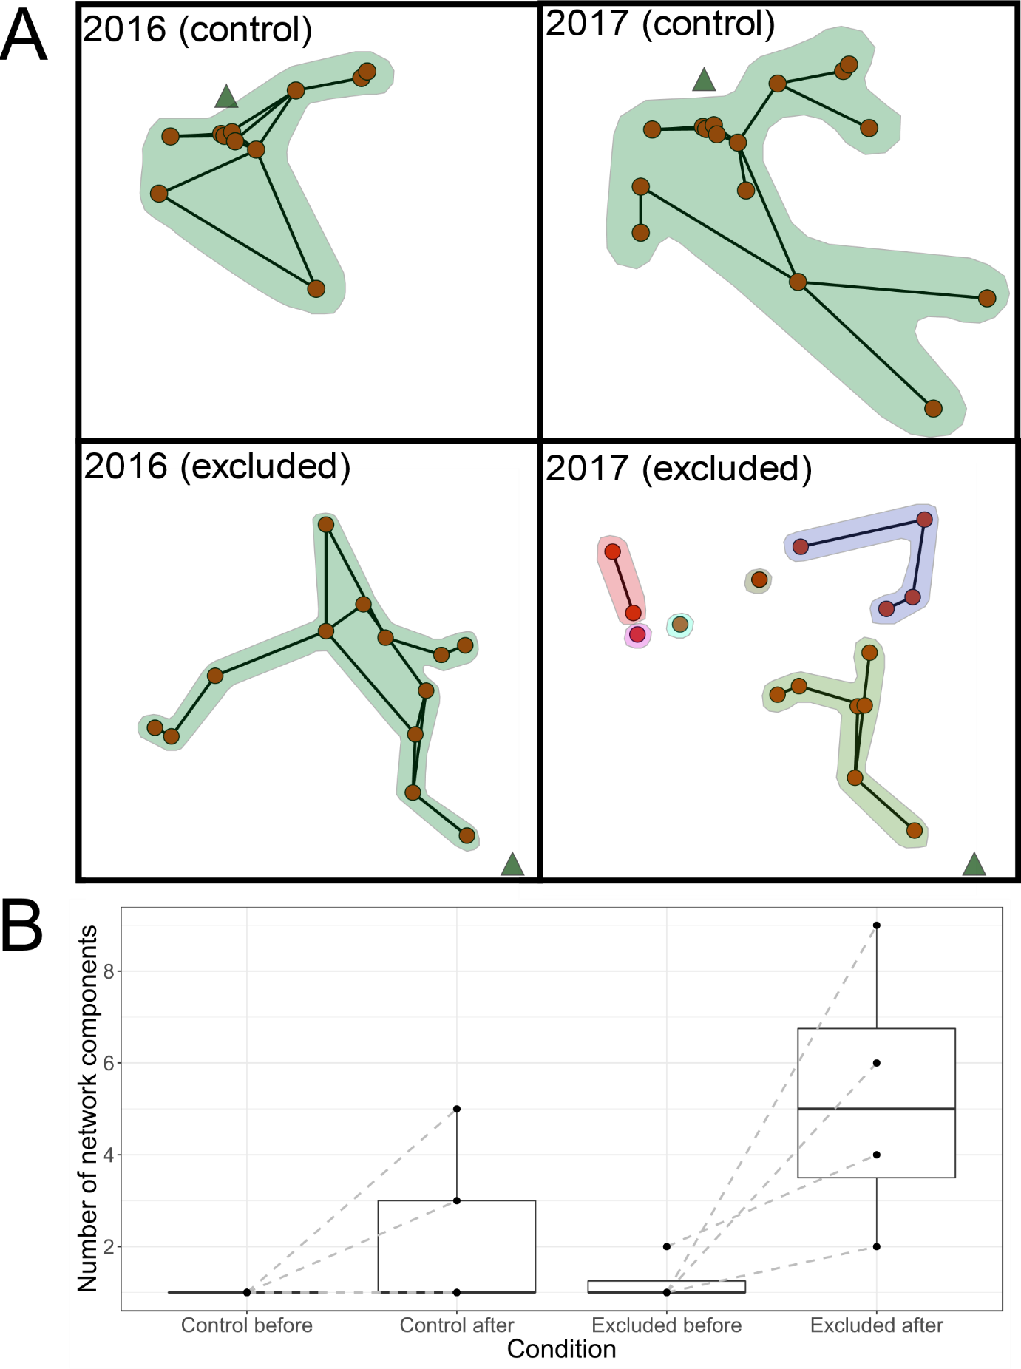
Figure 2. Control networks showed no change, while networks with exclusion showed an increase in network components. A: Examples of inter-nest networks of colonies before (2016) and after (2017) a single key food source was either unchanged (control condition) or excluded (excluded condition). Nodes indicate nests, black connections indicate inter-nest trails and coloured polygons indicate independent network components. Green triangles indicate the location of the focal food source. B: Comparison of number of network components of colonies before (August 2016) and after (August 2017) in the control and “excluded” conditions. Middle lines represent median values, lower and upper hinges represent 25th and 75th percentiles respectively and whiskers reach to the lowest (lower whisker) or highest (higher whisker) value, with a maximum reach of 1.5 x IQR from the hinge. All data are plotted as individual points. Lines between points indicate colony identity.

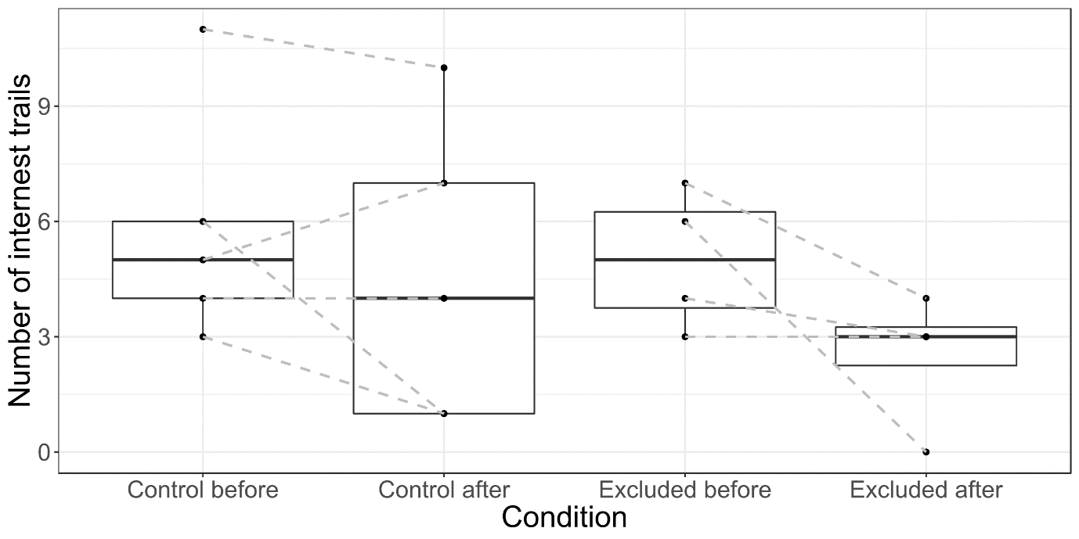
Figure 3. Comparison of number of inter-nest trails to nests that foraged on focal trees in colonies before (August 2016) and after (August 2017) in the control and “excluded” conditions. Middle lines represent median values, lower and upper hinges represent 25th and 75th percentiles respectively and whiskers reach to the lowest (lower whisker) or highest (higher whisker) value, with a maximum reach of 1.5 x IQR from the hinge. All data are plotted as individual points. Lines between points indicate colony identity.

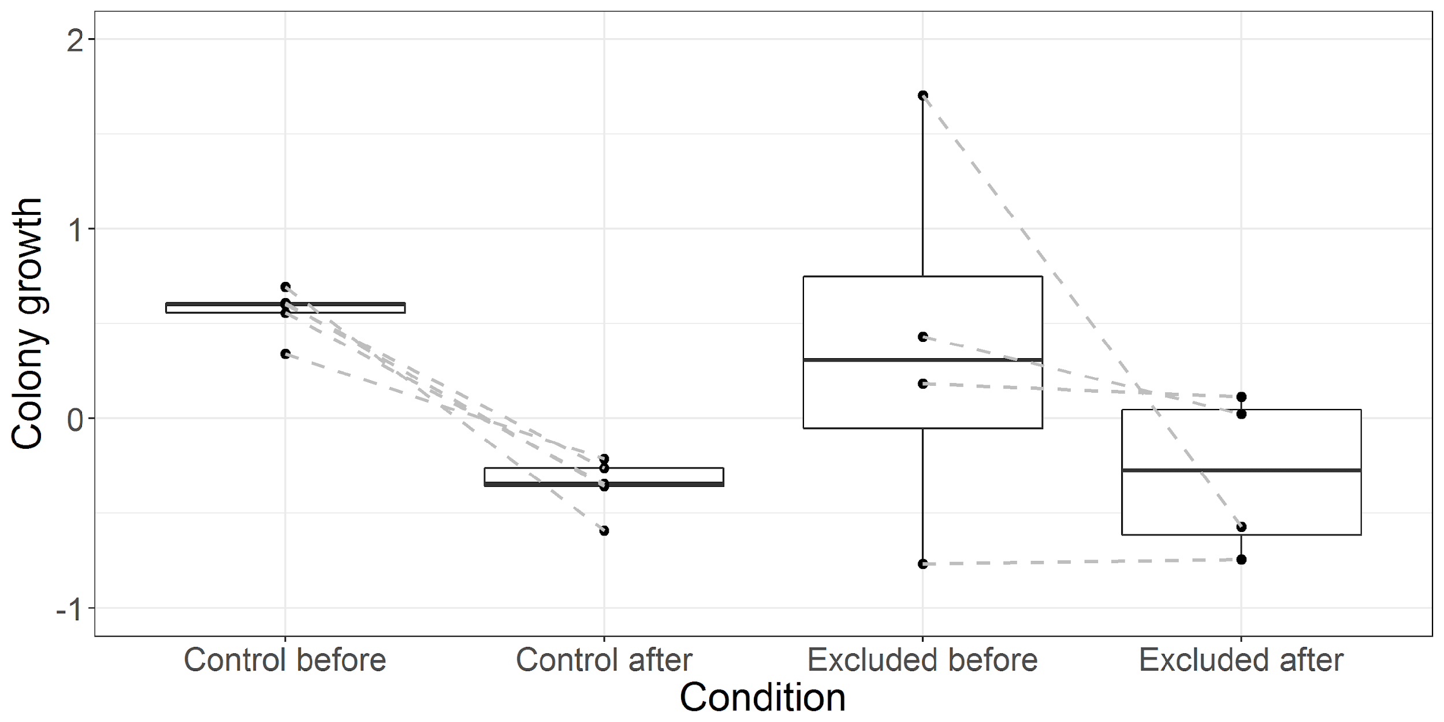
Figure 4. Comparison of growth in colony population between August 2015 and August 2016 (before) and between August 2016 and August 2017 (after) in the control and “excluded” conditions. Middle lines represent median values, lower and upper hinges represent 25th and 75th percentiles respectively and whiskers reach to the lowest (lower whisker) or highest (higher whisker) value, with a maximum reach of 1.5 x IQR from the hinge. All data are plotted as individual points. Lines between points indicate colony identity.

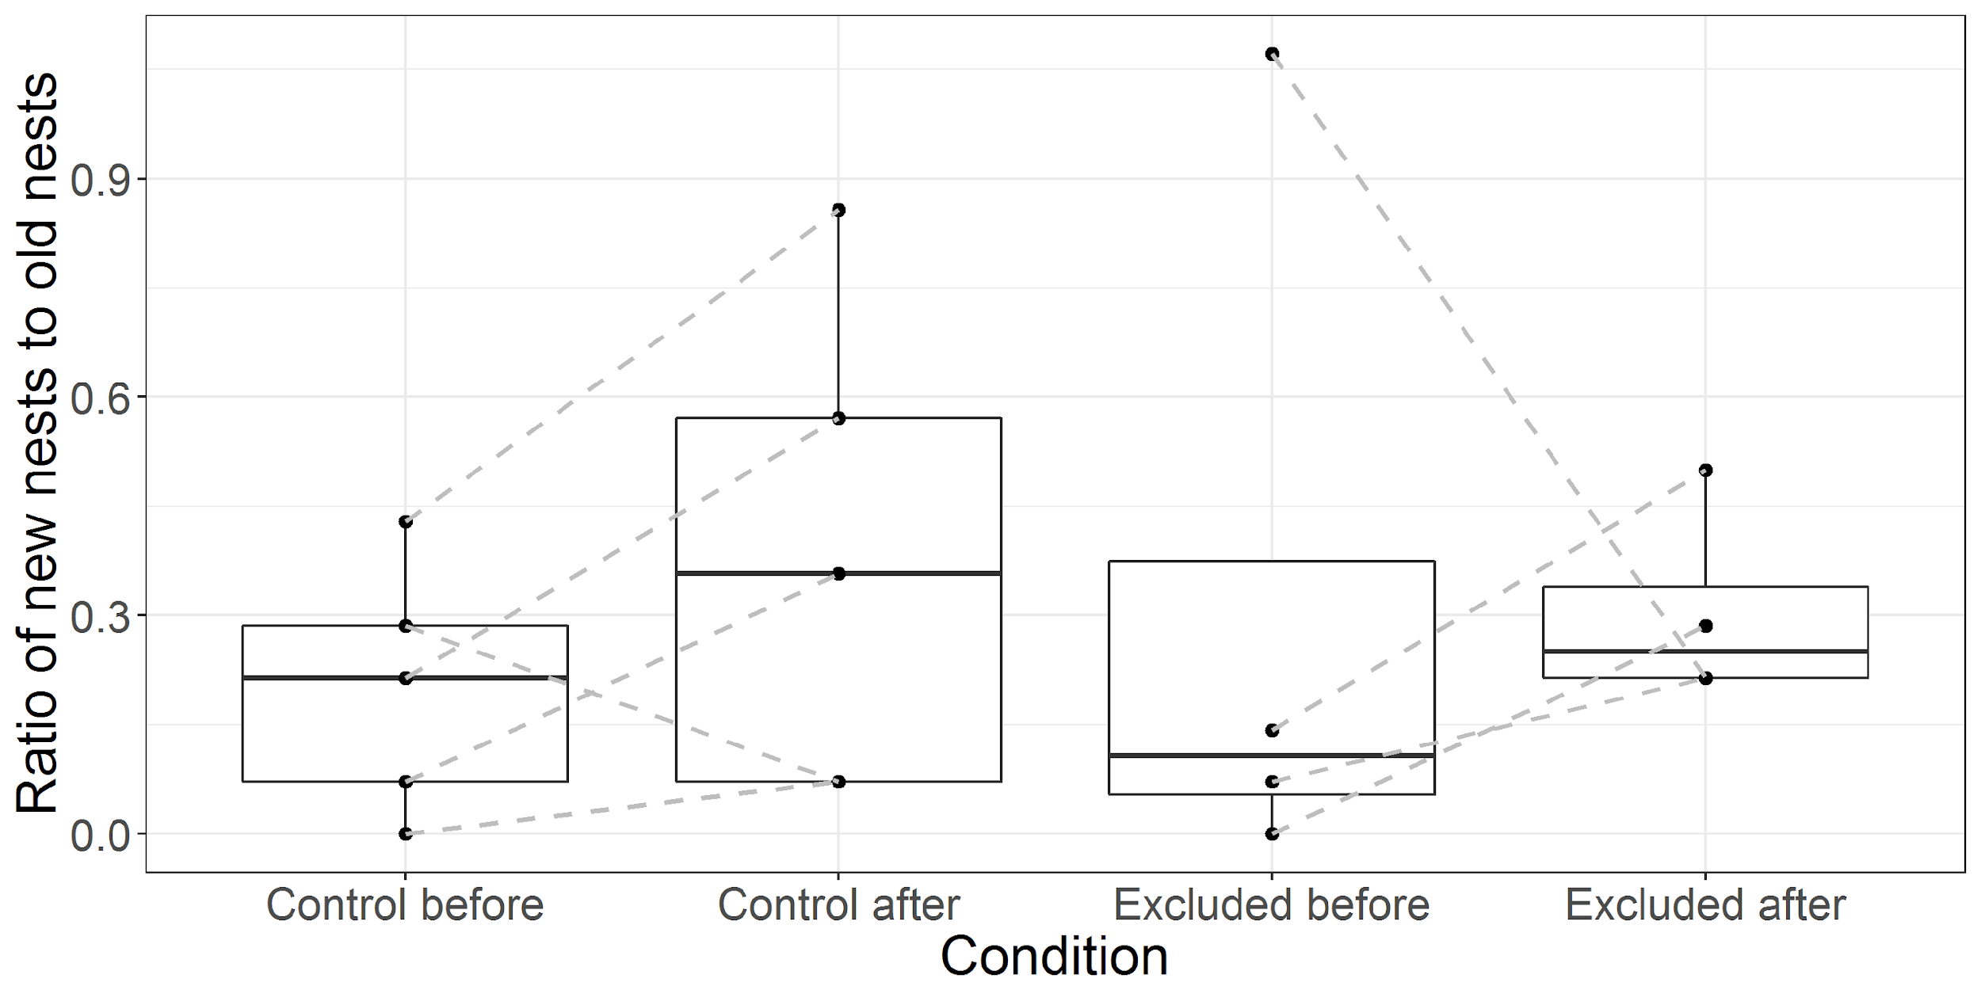
Figure 5. Comparison of number of new nests founded between August 2015 and August 2016 (before) and between August 2016 and August 2017 (after) in the control and “excluded” conditions, standardized by the number of nests in the colony at the previous timepoint. Middle lines represent median values, lower and upper hinges represent 25th and 75th percentiles respectively and whiskers reach to the lowest (lower whisker) or highest (higher whisker) value, with a maximum reach of 1.5 x IQR from the hinge. All data are plotted as individual points. Lines between points indicate colony identity.

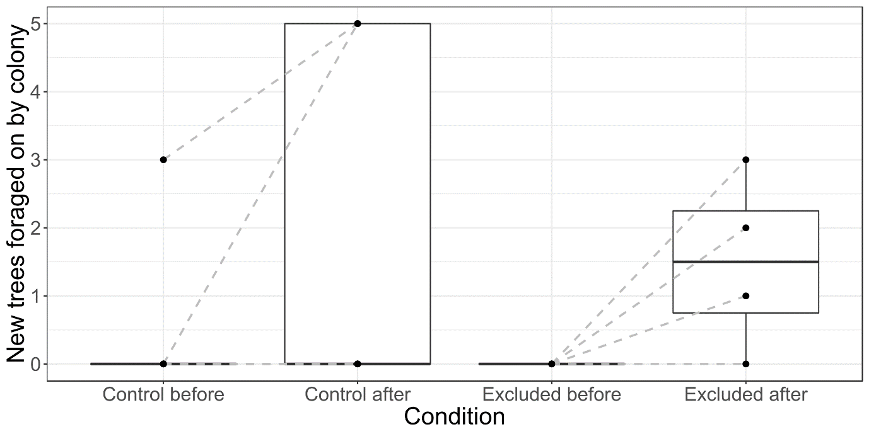
Figure 6. Comparison of number of new trees foraged on by colonies in August 2016 (before) and in August 2017 (after) in the control and “excluded” conditions. Middle lines represent median values, lower and upper hinges represent 25th and 75th percentiles respectively and whiskers reach to the lowest (lower whisker) or highest (higher whisker) value, with a maximum reach of 1.5 x IQR from the hinge. All data are plotted as individual points. Lines between points indicate colony identity.

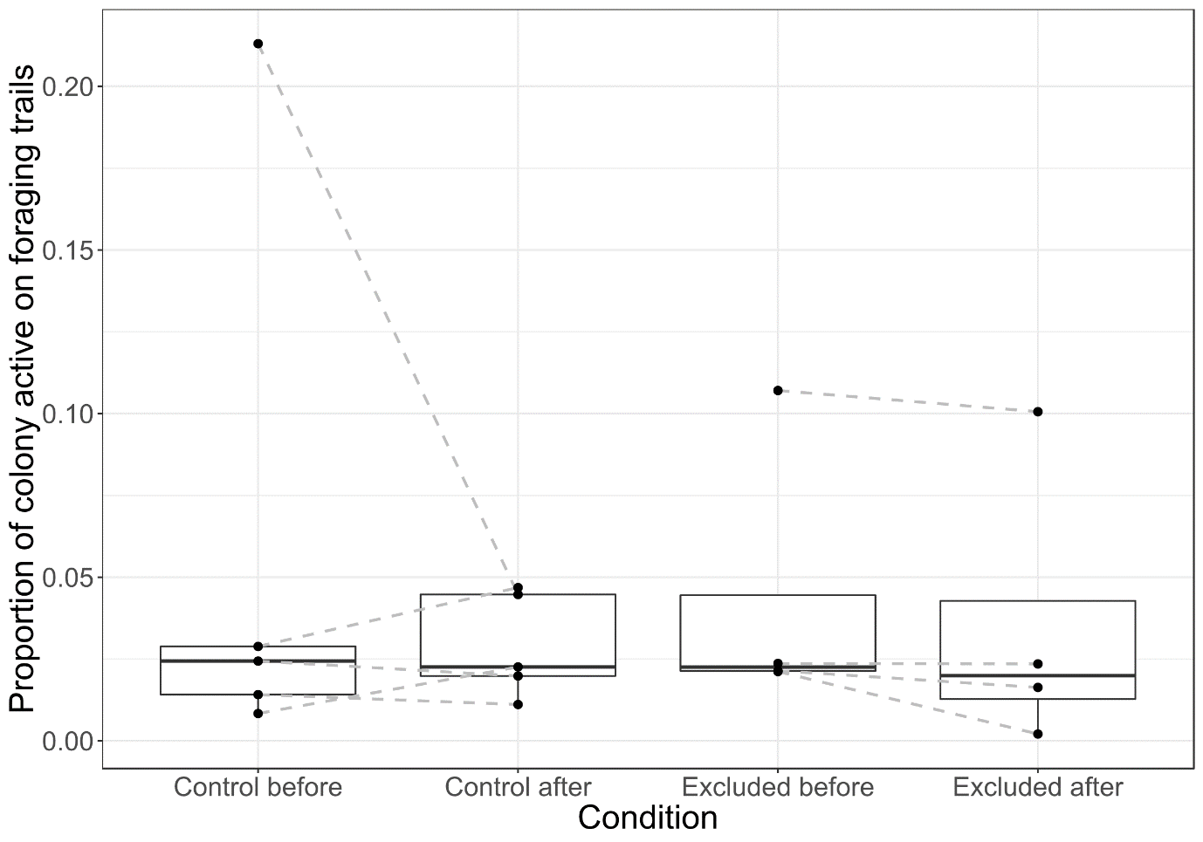
Figure 7. Comparison of proportion of colonies active on foraging trails in August 2016 (before) and in August 2017 (after) in the control and “excluded” conditions. Middle lines represent median values, lower and upper hinges represent 25th and 75th percentiles respectively and whiskers reach to the lowest (lower whisker) or highest (higher whisker) value, with a maximum reach of 1.5 x IQR from the hinge. All data are plotted as individual points. Lines between points indicate colony identity.

