**Resistance of mound-building termites to anthropogenic land-use change**

Andrew B. Davies1,2, Philip G. Brodrick2, Catherine L. Parr3,4,5 and Gregory P. Asner2

1Department of Organismic and Evolutionary Biology, Harvard University, Cambridge, Massachusetts, USA, 2Center for Global Discovery and Conservation Science, Arizona State University, Tempe, Arizona, USA, 3School of Environmental Sciences, University of Liverpool, Liverpool, UK, 4School of Animal, Plant and Environmental Sciences, University of the Witwatersrand, Johannesburg, South Africa, 5Department of Zoology and Entomology, University of Pretoria, Pretoria, South Africa.

**\*Corresponding author:** Andrew Davies – Department of Organismic and Evolutionary Biology, Harvard University, 22 Divinity Avenue, Cambridge, MA, 02138, USA. E-mail: [andrew_davies@fas.harvard.edu](mailto:andrew_davies@fas.harvard.edu)

**Running title:** Termites resist human land-use change

**Abstract**

Humans pose a major threat to many species through land-use change in virtually every habitat. However, the extent of this threat is largely unknown for invertebrates due to challenges with investigating their distributions at large scales. This knowledge gap is particularly troublesome for soil macrofauna because of the critical roles many of these organisms perform as ecosystem engineers. We used a combination of high-resolution airborne Light Detection and Ranging and deep learning models to map the distribution of the ecologically important termite genus *Macrotermes* across a South African savanna land-use gradient, quantifying the effects of land-use change on patterns of mound densities, heights and spatial patterning. Despite significant anthropogenic alteration to landscapes, termite mounds persisted and shared a number of similarities to mounds in untransformed areas. Mean mound height was not substantially reduced in transformed landscapes, and over-dispersion of mounds at localized scales was conserved. However, mound densities were partially reduced, and height distributions in transformed areas differed to those in protected areas. Our findings suggest that mound-building termites persist even in areas of relatively high human disturbance, but also highlight important differences in termite distributions that could lead to reductions in ecosystem services provided by termites in human-modified landscapes. The persistence of at least half of mounds in human-modified landscapes could serve as starting points for savanna restoration.

**Key-words:** convolutional neural networks, deep learning,LiDAR, *Macrotermes*, savanna, South Africa, termite mounds

**Introduction**

Unabated human land-use change continues worldwide, leading to severe biodiversity loss and reductions in ecosystem function (Foley *et al* 2005, Newbold *et al* 2015, Flynn *et al* 2009). These losses increase ecosystem vulnerability and jeopardize ecosystem services and human livelihoods (Chapin III *et al* 2000, Potts *et al* 2010, Cardinale *et al* 2012). However, measuring changes in ecosystem function is challenging at large scales because biodiversity-ecosystem function relationships are complex and often result from intra- and/or inter-species interactions that vary across landscapes. Moreover, alterations to ecosystem function resulting from species loss can take years to manifest, exceeding the lifespan of most studies (Pringle and Tarnita 2017, Staver 2018). However, some organisms have disproportionate influence on ecosystem function, and a loss or significant disruption of these species could serve as a proxy for effects of land-use change on ecosystem function.

Globally widespread soil macrofauna such as termites, ants and earthworms play fundamental roles as ecosystem engineers. Termites are particularly important in savanna environments where their mound-building activities reorganize the physical and chemical distribution of soils throughout the landscape, creating nutrient and moisture hotspots with enhanced vegetation growth (Sileshi *et al* 2010, Seymour *et al* 2014, Davies *et al* 2014b). In turn, these nutrient hotspots have cascading effects on invertebrate and mammalian herbivores, and can influence vegetation and herbivory patterns over as much as 30% of savanna landscapes (Levick *et al* 2010b, Davies *et al* 2016a, 2016b). Moreover, at local scales, termite mounds are often spatially over-dispersed due to intra-specific competition between neighboring colonies, enhancing termite influence on ecosystem characteristics and function due to the even distribution of mound benefits across space (Pringle *et al* 2010). Termites and their mounds, as well as the spatial arrangement of colonies, can also increase agricultural yields (Evans *et al* 2011) and may promote ecosystem robustness to climatic change and stress events (Bonachela *et al* 2015, Ashton *et al* 2019). The persistence of keystone termite colonies and their over-dispersed spatial patterning is therefore essential for maintaining healthy, functioning savanna ecosystems.

Most studies of biodiversity loss resulting from land-use change have focused on plants and vertebrates (e.g. Pimm and Raven 2000, Ceballos and Ehrlich 2002, Flynn et al. 2009). Comparatively few studies have investigated changes in invertebrate diversity, despite its wide-ranging impacts on ecosystems, and invertebrate-focused research has largely investigated local-scale effects in European and North American ecosystems (Sánchez-Bayo and Wyckhuys 2019). An urgent need exists for large-scale studies of invertebrate responses to human land-use change (Thomas *et al* 2019), especially studies that investigate insect population and community changes across environmental gradients. The current lack of large-scale investigations into the impacts of land-use change on invertebrates is at least partially due to difficulties in observing patterns of invertebrate richness and/or abundance over large extents, caused both by the sheer abundance of invertebrates and their small size. Mound-building termites, however, provide a rare case for assessing invertebrate responses to land-use change over large geographic areas due to the capability of remote-sensing technology to effectively map termite mounds (Levick *et al* 2010a, Davies *et al* 2014a). However, the impact of human land-use change on termites has not yet been examined at scales large enough to capture shifts in important mound characteristics such as height, which is indicative of colony size (Meyer *et al* 2000), density, or spatial patterning.

Effects of land-use change on termite mound distributions are also difficult to predict. Although termites have been shown to be adversely affected by human disturbance (e.g. Eggleton *et al* 1996, Jones *et al* 2003, Muvengwi *et al* 2017a, Dosso *et al* 2013), they are largely resistant to natural disturbance such as fire and herbivore activity (Davies *et al* 2012, Lagendijk *et al* 2016), and could similarly be unperturbed by human activities that do not result in whole-scale landscape changes or mound destruction, which is often the case in agricultural systems. Furthermore, human attitudes towards termites, especially in subsistence settings, can be conflicting and potentially lead to differing outcomes for termite persistence. Many people acknowledge that termites can confer some benefits to agriculture and use termite mound soil in subsistence agricultural practices (Sileshi *et al* 2009, Jouquet *et al* 2018). Humans, particularly in Africa, also consume termites as part of their diet or for medicinal purposes (Sileshi *et al* 2009), and could therefore be inclined to conserve termites. Conversely, however, termites are often viewed as pests that damage buildings and agricultural crops, which can drive efforts to exterminate them (Rouland-Lefèvre 2011, Su and Scheffrahn 2000, Jouquet *et al* 2018). Agricultural use of termite mound soil can also be destructive when cultivators disassemble mounds to distribute the enriched soil in crop fields.

Here, we investigate effects of human activity on termite mounds by combining high-resolution airborne Light Detection and Ranging (LiDAR) data with deep learning models to map distributions and heights of mounds from the widespread termite genus *Macrotermes* across a land-use gradient in South African savanna. We ask whether human land-use change has altered patterns in *Macrotermes* mound densities, heights and spatial patterning. The surveyed landscapes consisted of four land-use types, ordered here according to land-use intensity: i) an untransformed government-managed conservation area, Kruger National Park, that has remained protected over much of the past century, ii) a privately-owned conservation area that was converted from low density cattle farming to a protected conservation area in the 1960s, and communal areas comprised of land used either for iii) cattle grazing and/or firewood extraction or iv) small-scale subsistence agriculture by local communities. Termite mound locations were identified in the LiDAR data using a convolutional neural network (CNN), allowing for the rapid and consistent classification across land-use types of 47,242 termite mounds over 76,474 ha. We analyzed differences in mound density, height, and spatial patterning across the land-use types by bootstrapping equal subsamples across land-use types, and by generating and analyzing Ripley’s K curves of termite mounds within each land-use type.

**Methods**

*Study region*

Our study took place in the Lowveld region of northeastern South Africa, a low-lying landscape dominated by savanna vegetation (Fig. 1). Mean annual precipitation is ~630 mm yr−1 and mean annual temperature is ~22° C. The dominant geology is granite, with gabbro intrusions also present (Venter *et al* 2003). These gabbro intrusions were excluded from the study due to the low number of *Macrotermes* mounds present on this geology (Davies *et al* 2014a). Three dominant land tenure systems are present in the region: (i) Kruger National Park (KNP), a large government-owned conservation area, (ii) Sabi-Sand Game Reserve, a privately-owned conservation area and (iii) state-owned communal areas. The area that is now KNP was officially conserved between 1898 and 1926 and today comprises almost 2 million ha. Sabi-Sand Game Reserve is a 63,000 ha privately protected area sharing an unfenced boundary (fences were removed in 1991) with KNP on its southern and eastern limits. The reserve was established in 1965 and consists of an association of freehold owners with a strong tourism-based approach to conservation. Prior to being a conservation area, the land was primarily used for low density commercial cattle farming. State-owned communal areas alongside these conservation areas are all within the Bushbuckridge municipality and are part of the former self-governing territories or ‘homelands’ established under the apartheid regime. Due to forced removals and relocations to the region during apartheid, population density (ranging between 150 and 300 people km-2) is high, as are levels of unemployment (Pollard *et al* 2003). Residents rely mostly on a combination of subsistence farming, livestock husbandry, and the consumption and trade of natural resources at informal markets (Shackleton *et al* 2001). Electricity is increasingly available, but firewood remains a dominant fuel for cooking, resulting in high levels of firewood extraction from communal rangelands and a subsequent reduction of woody biomass and tree cover (Wessels *et al* 2013). Rain-fed crops are grown around homesteads or in arable fields in close proximity to settlements.

*LiDAR surveys*

Discrete-return airborne Light Detection and Ranging (LiDAR) data were collected over the study landscapes in late March/early April 2012 using the Global Airborne Observatory (GAO) Alpha system, formerly known as the Carnegie Airborne Observatory (Asner *et al* 2007). The LiDAR surveys were carried out at the end of the wet season when vegetation was at leaf-on stage. The aircraft was flown at approximately 2,000 m above ground level, achieving an average laser shot point spacing of 2 shots m−2. Further details concerning the LiDAR specifications can be found in Asner et al. (2009). LiDAR data enable high-resolution and accurate measurements of three-dimensional vegetation structure and the underlying terrain over large spatial extents by combining laser ranges from the LiDAR with location data from an embedded Global Positioning System-Inertial Measurement Unit (GPS-IMU) (Asner *et al* 2007). This combination results in a three dimensional ‘point cloud’ of known locations from each laser-surface interaction. LiDAR data points were processed to identify which laser pulses penetrated the vegetation canopy and reached the ground surface using the *lasground* tool packaged in LAStools software (Rapidlasso, Gilching, Germany). These points were used to interpolate a digital terrain model (DTM) of the ground surface at a 1 m resolution.

*Termite mound identification*

The LiDAR-derived DTM’s were used to produce a hillshade map, from which 16,025 termite mounds were manually identified over 23,013 ha. Manual identification of termite mounds from hillshade maps has been shown to be accurate for mounds over 0.5 m in height (Davies *et al* 2014a). Two separate convolutional neural networks (CNNs) were then trained with different landscape subset sizes (256 x 256 and 512 x 512 m), and ensembled to generate a final probability. We used a CNN architecture designed for semantic segmentation, structurally similar to U-Net (Ronneberger *et al* 2015) but adapted for different input sizes (Brodrick *et al* 2019). Each contiguous patch of classified pixels was then deemed an independent mound, and the mound center was selected as the point with the maximum elevation within a 10 m radius of the cluster. Mound height was determined by taking the difference of the mound maximum elevation and the average elevation of points in a surrounding 10 m radius ring that excluded the mound itself, following Davies *et al.* (2014a). Compared with manually identified mounds, we found precision and recall rates of 0.84 and 0.91, respectively (Fig. 2, Appendix S1). In addition to high accuracy, the use of the CNNs facilitated a consistent treatment of mounds over large areas compared with manual identification. In total, 47,242 termite mounds were identified over 76,474 ha of study area.

*Characterization of land-use polygons*

Savanna *Macrotermes* in this ecosystem (southern African granitic savanna) are known to restrict mound construction to hillcrests (Davies *et al* 2014a, Levick *et al* 2010a), and woody cover can influence mound densities (Davies *et al* 2014a). We therefore quantified differences in topography and vegetation cover within each study polygon (see below) and land-use type. The LiDAR DTM was used to calculate the relative elevation above the nearest stream channel across each polygon by dividing the elevation above a given channel by the elevation of the nearest crest above the same channel, producing a relative elevation model (REM). Values in the REM represent proportional distances above streams with streambeds modelled as 0 and hillcrests as 1. The proportion of each polygon that consisted of stream valleys (REM between 0 and 0.05) and hillcrests (REM >0.9) was then calculated. To calculate tree canopy height, a digital surface model (DSM) was first constructed from the LiDAR data based on interpolations of all first-return points (i.e. the top of the canopy and, where only ground returns exist, bare ground). The vertical difference between the DTM and DSM was then measured to generate a model of canopy height above ground (digital canopy model, DCM) at a 1 m resolution. The proportion of vegetation cover within each polygon was then measured as the proportion of 1 m cells that contained vegetation taller than 1 m. This height threshold ensured that only woody vegetation was included in the measurements, with herbaceous cover and bare ground excluded. We further distinguished between the proportion of tree and shrub cover in each polygon by measuring the proportion of 1 m cells that contained vegetation taller than 3 m (tree cover) and the proportion with vegetation between 1 and 3 m in height (shrub cover).

*Analysis*

To divide the study region into the four land-use types (subsistence agriculture, communal grazing, KNP, and private reserve), we used official boundaries for KNP and Sabi-Sand Private Reserve, and delineated Subsistence Agriculture and Communal Grazing using Google Earth images (sourced from DigitalGlobe imagery) corresponding to the 2012 LiDAR survey time period. Subsistence agriculture is clearly distinguishable from other land-uses by the presence of cleared fields, whereas communal grazing areas are undeveloped, open areas in between settlements and agricultural fields. Delineated communal grazing areas were also compared to maps in published studies (Wessels *et al* 2013, Mograbi *et al* 2015) to ensure that they covered similar extents. We excluded areas with uncharacteristic terrain (e.g. the Bushbuck Ridge in L8) or unclear land-use, as well as Andover Nature Reserve in L5 (see Fig. 1). Differences in LiDAR data availability between land-use types (Table 1) resulted in varying numbers of termite mounds surveyed per land-use. To assess mound densities, we bootstrap sampled 2,000, 100 ha subsets (sensitivities presented in Appendix S2) within each land-use type and examined the histogram of mound densities from each set of samples. To compare distributions of mound heights between land-use types, we normalized the generated mound height histograms by the maximum binned number of mounds within the land-use type. To quantify differences in spatial patterning, we generated Ripley’s K curves for each land-use type using the R package *spatstat* (Baddeley and Turner 2005). The Ripley’ s *K* function is a second-order statistic that uses inter-point distances to measure deviation from spatial homogeneity. The expected distribution of features under complete spatial randomness is plotted against spatial distance and the observed distribution. When observed values fall below the expected distribution for spatial randomness, over-dispersion occurs, while values above the expected distribution indicate clustering. Because not all land-use types were contiguous (Fig. 1), we generated a unique Ripley’s K curve for each polygon that exceeded 300 ha in size (smaller polygons were found to be dominated by boundary-condition effects and were therefore unreliable – see Appendix S3). To understand the relationship between termite mound heights and densities, we used the same 2,000 bootstrapped samples and compared the mean mound height to mound density within each 100 ha sample area. Finally, we examined relationships between mound density and height with woody cover for each bootstrapped sample, stratifying woody cover by the proportion within each 100 ha sample area that was under 1m in height, between 1 and 3 m tall, and over 3 m tall.

**Results**

Landscape topography (proportion of each polygon that was either a valley or hillcrest) did not differ substantially between study polygons or land-use types (Table 1). Agricultural areas had significantly lower vegetation cover, including lower tree and shrub cover, compared with the other land-use types, which did not differ significantly from one another (Table 1).

Mound densities were lowest in the communal grazing areas (mean = 0.33 mounds ha-1), followed by agricultural fields (0.45 mounds ha-1), Kruger National Park (0.62 mounds ha-1), and the private reserve (0.82 mounds ha-1) (Table 1, Fig. 3a). Mound densities varied significantly among all land-use types (Kolmogorov–Smirnov (K-S) test p < 0.001 for all comparisons). Mean mound height was similar across land-use types (Table 1, Fig. 3b), but the distribution of mound heights was significantly homogenized in the human-dominated landscapes. There was a substantially higher proportion of taller mounds in the protected areas, with the tallest mounds found within the private conservation areas (K-S test p < 0.001 for all comparisons, Fig. 3b). Whereas Ripley’s K analyses revealed that mounds were over-dispersed at local scales in all land-use types, landscape clustering of mounds was evident in all landscapes other than the agricultural fields where mounds were randomly distributed at broader scales. The human-modified landscapes (agricultural fields and communal grazing areas) also displayed the largest variation in spatial patterning between study polygons, demonstrated by the variability in the degree of clustering and over-dispersion exhibited as well as in the distance over which either pattern persisted. This variability contrasted sharply with the almost identical patterning in each of the six protected landscape polygons. Over-dispersion of mounds also persisted over larger distances in the agricultural landscapes (up to ~150 m) relative to all other land-use types (~60-70 m) (Fig. 3c), i.e. mounds remained evenly spaced in these landscapes, but were further apart.

Agricultural fields also displayed the weakest relationship between mound height and density across the land-use types. While there was a significant (p < 0.001) positive relationship between termite mound height and density in all land-use types, with mound height increasing linearly with density, this relationship was much stronger (evidenced by the steeper slope) within the two protected land-use types and was weakest in the agricultural fields (Fig. 4). Neither mound density nor height was strongly correlated with woody cover in any land-use type, nor for any woody height classification (Fig. S4).

**Discussion**

Airborne mapping and spatial modeling revealed that despite significant anthropogenic alteration to landscapes over multiple decades, termite colonies persisted in transformed landscapes and exhibited a number of the same spatial patterning characteristics as those in protected areas. Mean termite mound height was not substantially reduced in transformed landscapes (Fig. 3b), and over-dispersion of mounds was present at localized scales in all land-use types (Fig. 3c). Moreover, although reduced, mound densities in the transformed areas were still 55% (grazing areas) and 77% (subsistence agriculture) of the densities recorded in Kruger National Park. This degree of termite resistance to land-use transformation is remarkable considering the scale of habitat modification that included clearing for agriculture, large-scale and unsustainable firewood extraction and active attempts by people to destroy and clear mounds (F. Nyathi pers. comm.). That mound densities in the human modified landscapes remained at or above half the densities of the protected areas suggests a continuation of some termite-mediated ecosystem functioning in these systems, and the potential use of termite mounds as starting points for savanna restoration given their ability to stabilize ecosystems (Bonachela et al. 2015).

Our findings were also unexpected given that field-based studies have found termites to be highly sensitive to human disturbance (e.g. Eggleton et al. 1996, Jones et al. 2003, Muvengwi et al. 2017), and suggest that the mound-building termite, *Macrotermes*, is less susceptible to disturbance than other genera. *Macrotermes* are generalist feeders, consuming a wide range of dead organic matter, and are therefore likely able to switch their diet according to available feeding substrate. Other generalist feeders within the subfamily Macrotemitinae have been shown to be less sensitive to habitat perturbation compared with other groups, particularly soil-feeding termites (Davies *et al* 2012, Muvengwi *et al* 2017a). *Macrotermes* is also the largest, and likely dominant (Evans and Kasseney 2019), termite in these systems, and could exclude other termites from food resources, thereby monopolizing reduced resources in transformed landscapes. Whether dominance by *Macrotermes* leads to declines in other termite genera in transformed landscapes, with a concomitant reduction in ecosystem services provided by termites, was beyond the scope of our study and requires further investigation.

Notwithstanding their resistance to land-use change, we found important differences in termite mound characteristics between human-modified and protected areas. Mound densities were lower in transformed landscapes (Fig 3a), consistent with findings of lower abundance for other taxonomic groups in response to human land-use change (Sánchez-Bayo and Wyckhuys 2019, Flynn *et al* 2009). However, in contrast to what might be expected, mound densities were lower in communal grazing areas relative to agricultural fields. Termite abundance has been shown to decline with agricultural clearing elsewhere (Jones *et al* 2003, Muvengwi *et al* 2017a), whereas uncleared grazing areas could be expected to be more similar to natural termite habitat (see also Hagan et al. 2017 where grazing increased *Trinervitermes* mound densities). Subsistence agricultural practices in our study area did not include large-scale land clearing common in industrial farming (Foley *et al* 2005), and farming practices in the region often result in additional organic matter inputs to the soil through mulching, excess crop residue after harvesting, and the use of cattle dung for fertilizer, which likely provide increased food resources for termites. In contrast, grazing areas in the region are subject to large-scale, unsustainable firewood extraction (Wessels *et al* 2013), which likely lowers food availability for termites and could consequently reduce mound density. Future studies quantifying coarse woody debris across land-use types would help determine if firewood extraction is indeed a key mechanism of reduced mound densities. Over-grazing in these regions can also facilitate woody encroachment (Mograbi *et al* 2015), which lowers termite abundance (Leitner *et al* 2018). However, despite higher mound densities in agricultural areas relative to communal grazing areas, there were fewer mounds in both these land-use types relative to the protected areas, suggesting that both forms of land use have some negative effect on termite colony survival.

In contrast to clear differences in termite mound densities, mean mound heights were similar across land-use types (Fig 3b). Mound height is strongly correlated with colony size in *Macrotermes* (Meyer *et al* 2000), and the similarities in mean mound height suggest that despite the presence of fewer colonies in human-modified landscapes, those that do establish are, on average, of similar size to those inside protected areas, suggesting that individual termite colonies are able to withstand high levels of human disturbance. Although it is possible that similar mean mound height across the land-use types is a legacy of previously extant colonies given that termite mounds can persist for exceptionally long periods of time (Erens *et al* 2015), abandoned mounds have been observed to remain for only a few years (e.g. 3-10 years in Australia, Wilson & Agnew, 1992), reducing the likelihood of legacy effects driving the observed pattern. However, determining the proportion of active to inactive mounds in these landscapes is necessary to better understand effects of land-use change on termite colonies.

Despite similar means, the distribution of mound height was significantly truncated in agricultural fields and communal grazing areas, with most of the tallest mounds found in protected areas, particularly in privately conserved areas. Termite mound influence on savanna vegetation increases with mound size (Joseph *et al* 2013, Muvengwi *et al* 2017b), and so a higher proportion of tall (and consequently wide, Davies et al. 2014) mounds in protected areas likely results in stronger mound-induced effects here relative to the human-modified landscapes. Taller termite mounds in protected areas could also contribute to increased mound densities because larger colonies likely produce more alates capable of initiating new colonies. The increased frequency of tall mounds in the private conservation areas relative to KNP is intriguing and could be due to land-use practices aimed at increasing wildlife sightings for tourists in the private reserves. These practices, which include an increased number of artificial water points and vegetation clearing along some roads, could increase food availability for termites through increased woody debris from vegetation clearing and increased dung availability from more mammalian herbivores attracted to the increased water availability. While similar spatial patterns, and therefore inter-mound distances, between the private reserves and KNP suggest consistent termite foraging ranges, increased food supply could enable the persistence of larger colonies in the private reserves.

Termite mound height also increased with mound density in all land-use types, suggesting that where termite colonies persist in large numbers, they also establish the largest colonies (see also Davies et al. 2014), likely facilitated by increased food resources. This pattern of increased mound density with height was, however, weaker in the agricultural fields, possibly because farmers actively clear mounds in a spatially stochastic fashion compared with indirect, semi-natural regulation of mounds in communal grazing areas where decreased food supply (due to woody biomass extraction) across the landscape leads to a mirrored, yet diminished, pattern of the natural areas. Farmers in the region also excavate termite mound soil for use as fertilizer (F. Nyathi, pers. comm.) and sometimes attempt to remove mounds where termites are seen as pests, altering mound structure and likely reducing height. Such clearing by humans could also lead to an increased number of small mounds in these areas, which may not be detected in the LiDAR data (Davies *et al* 2014a), possibly contributing to lower observed mound densities here.

Agricultural fields also displayed the strongest differences in mound spatial patterning across landscapes. Whereas Ripley’s K analyses revealed that mounds were over-dispersed at local scales in all land-use types, suggesting strong inter-colony competition wherever termite mounds persist, clustering of mounds at the landscape scale was replaced by random patterning in agricultural areas. Landscape clustering arises from abiotic controls over mound distributions, with factors such as soil moisture content restricting mounds to drier hillcrests (Levick *et al* 2010a, Davies *et al* 2014a). While this clustering occurred in grazing areas, it was more variable than in the protected areas, again suggesting that mound density reductions in grazing areas occurred in a naturally mediated fashion that did not substantively disrupt their spatial patterning. In contrast, mound density reductions in agricultural areas likely stem from more direct and spatially random processes that are indifferent to abiotic controls (such as active mound clearing by humans), thereby disrupting landscape clustering. However, local-scale over-dispersion still persists in these agricultural landscapes, albeit at greater dispersion distances likely due to lower mound densities, demonstrating the powerful effect inter-colony competition has on mound patterning and the resistance of this natural process to anthropogenic disturbance. Topographic differences between land-use types were limited (Table 1), suggesting that differences in mound spatial patterning in agricultural areas were not a result of selection for specific topographic regions for agriculture by people.

Given the disruptions to termite mound densities and spatial patterning in the human transformed landscapes, what are the likely consequences on ecosystem function? Over-dispersion of termite colonies at fine spatial scales leads to an even distribution of mound-associated benefits, such as nutrient and moisture enrichment (Pringle *et al* 2010). Since this over-dispersed pattern is not severely disrupted in any land-use we studied, the benefits of mounds remain well distributed where they occur, a remarkable finding given the significant alteration of the land surface by people (see Fig. 2). However, lower mound densities in human-transformed landscapes, despite similar mean colony size, will lead to reduced termite activity between mounds, which is also evidenced by the larger inter-mound distances (up to 150 m). Termite activities, such as foraging for dead organic matter and mound construction, influence multiple processes that enhance ecosystem function, e.g. water infiltration, nutrient cycling and decomposition of organic matter (as reviewed in Jouquet et al. 2011). A decrease in termite activity could therefore lower agricultural production (Evans *et al* 2011) and slow natural ecosystem processes, leading to cyclical declines in resources such as woody biomass and tall tree abundance, resources already under pressure in these human-dominated landscapes (Wessels *et al* 2013, Mograbi *et al* 2017). Future studies examining changes in ecosystem function resulting from altered termite populations are essential for uncovering the impacts of termite declines on both natural ecosystem processes and human livelihoods, especially since it is unknown how changes in the assemblage composition of ecologically important taxa, such as termites, directly result in changes to the ecosystem functions they mediate (Kagezi *et al* 2011). Similarly, mound longevity and enhanced moisture and nutrient content after colony death are important avenues for future research. Our remote sensing approach could not quantify mound activity, which could vary across land-use types and thus influence the provisioning of ecosystem services if abandoned mounds disintegrate over short periods of time (Wilson and Agnew 1992).

There is an urgent need to understand global change impacts on under-studied but critically important groups such as insects, and while recent studies suggest widespread insect declines (Sánchez-Bayo and Wyckhuys 2019, Lister and Garcia 2018), more robust and large-scale data are needed before firm conclusions can be made (Thomas *et al* 2019). There is a particularly important need for more studies investigating insect population and community changes over large environmental and temporal gradients to better understand the impact of human land-use change on ecosystems and their function. Our results suggest that anthropogenic activities do have clear impacts on termite mounds, but also demonstrate surprising levels of resistance to land-use change. These findings highlight the need for careful study of changing insect communities, as well as the impacts these changes might have on ecosystem function, before allowing the rampant expansion of human activities in natural environments.

**Author contributions:** GPA led the airborne data collection and research funding, ABD and CLP developed the research questions, ABD and PGB analyzed the data, ABD wrote the first draft of the manuscript, and all authors contributed to revisions.

**Data accessibility:** Data and code supporting the results will be deposited in Github

**Acknowledgements**

Penelope Mograbi is thanked for helpful comments on an earlier version of the manuscript The Andrew Mellon Foundation, the South African Council for Scientific and Industrial Research (CSIR) Strategic Research Panel and the South African Government Department of Science and Technology (DST), funded the LiDAR data collection used in this study. The Global Airborne Observatory is made possible by support provided by private foundations, visionary individuals, and Arizona State University.

**References**

Ashton L A, Griffiths H M, Parr C L, Evans T A, Didham R K, Hasan F, Teh Y A, Tin H S, Vairappan C S and Eggleton P 2019 Termites mitigate the effects of drought in tropical rainforest *Science (80-. ).* **363** 174–7 Online: http://science.sciencemag.org/content/363/6423/174.abstract

Asner G P, Knapp D E, Kennedy-Bowdoin T, Jones M O, Martin R E, Boardman J and Field C B 2007 Carnegie Airborne Observatory: in-flight fusion of hyperspectral imaging and waveform light detection and ranging for three-dimensional studies of ecosystems *J. Appl. Remote Sens.* **1** 13536 Online: http://dx.doi.org/10.1117/1.2794018

Asner G P, Levick S R, Kennedy-Bowdoin T, Knapp D E, Emerson R, Jacobson J, Colgan M S and Martin R E 2009 Large-scale impacts of herbivores on the structural diversity of African savannas *Proc. Natl. Acad. Sci. USA* **106** 4947–52

Baddeley A and Turner R 2005 spatstat: An R Package for Analyzing Spatial Point Patterns. R-package version: 1.42-2 *J. Stat. Softw.* **12** 1–42 Online: https://user2015.math.aau.dk/docs/tutorials/spatstat.pdf

Bonachela J A, Pringle R M, Sheffer E, Coverdale T C, Guyton J A, Caylor K K, Levin S A and Tarnita C E 2015 Termite mounds can increase the robustness of dryland ecosystems to climatic change *Science (80-. ).* **347** 651 LP – 655 Online: http://science.sciencemag.org/content/347/6222/651.abstract

Brodrick P G, Davies A B and Asner G P 2019 Uncovering Ecological Patterns with Convolutional Neural Networks *Trends Ecol. Evol.* **34** 734–45 Online: http://www.ncbi.nlm.nih.gov/pubmed/31078331

Cardinale B J, Duffy J E, Gonzalez A, Hooper D U, Perrings C, Venail P, Narwani A, Mace G M, Tilman D, Wardle D A, Kinzig A P, Daily G C, Loreau M, Grace J B, Larigauderie A, Srivastava D S and Naeem S 2012 Biodiversity loss and its impact on humanity *Nature* **486** 59–67 Online: http://www.nature.com/articles/nature11148

Ceballos G and Ehrlich P R 2002 Mammal Population Losses and the Extinction Crisis *Science (80-. ).* **296** 904 LP – 907 Online: http://science.sciencemag.org/content/296/5569/904.abstract

Chapin III F S, Zavaleta E S, Eviner V T, Naylor R L, Vitousek P M, Reynolds H L, Hooper D U, Lavorel S, Sala O E, Hobbie S E, Mack M C and Díaz S 2000 Consequences of changing biodiversity *Nature* **405** 234 Online: https://doi.org/10.1038/35012241

Davies A B, Baldeck C A and Asner G P 2016a Termite mounds alter the spatial distribution of African savanna tree species *J. Biogeogr.* **43** 301–13 Online: http://dx.doi.org/10.1111/jbi.12633

Davies A B, Eggleton P, van Rensburg B J and Parr C L 2012 The pyrodiversity–biodiversity hypothesis: a test with savanna termite assemblages *J. Appl. Ecol.* **49** 422–30 Online: http://dx.doi.org/10.1111/j.1365-2664.2012.02107.x

Davies A B, Levick S R, Asner G P, Robertson M P, van Rensburg B J and Parr C L 2014a Spatial variability and abiotic determinants of termite mounds throughout a savanna catchment *Ecography (Cop.).* **37** 852–62

Davies A B, Levick S R, Robertson M P, van Rensburg B J, Asner G P and Parr C L 2016b Termite mounds differ in their importance for herbivores across savanna types, seasons and spatial scales *Oikos* **125** 726–34

Davies A B, Robertson M P, Levick S R, Asner G P, van Rensburg B J and Parr C L 2014b Variable effects of termite mounds on African savanna grass communities across a rainfall gradient ed F Gilliam *J. Veg. Sci.* **25** 1405–16 Online: http://doi.wiley.com/10.1111/jvs.12200

Dosso K, Deligne J, Yéo K, Konaté S and Linsenmair K E 2013 Changes in the termite assemblage across a sequence of land-use systems in the rural area around Lamto Reserve in central Côte d’Ivoire *J. Insect Conserv.* **17** 1047–57

Eggleton P, Bignell D E, Sands W A, Mawdsley N A, Lawton J H, Wood T G and Bignell N C 1996 The diversity, abundance and biomass of termites under differeing levels of disturbance in the Mbalmayo Forest Reserve, southern Cameroon *Philos. Trans. R. Soc. London B* **351** 51–68

Erens H, Boudin M, Mees F, Mujinya B B, Baert G, Van Strydonck M, Boeckx P and Van Ranst E 2015 The age of large termite mounds—radiocarbon dating of Macrotermes falciger mounds of the Miombo woodland of Katanga, DR Congo *Palaeogeogr. Palaeoclimatol. Palaeoecol.* **435** 265–71

Evans T A, Dawes T Z, Ward P R and Lo N 2011 Ants and termites increase crop yield in a dry climate *Nat Commun* **2** 262 Online: http://dx.doi.org/10.1038/ncomms1257

Evans T A and Kasseney B D 2019 The dominance hierarchy of wood-eating termites from China *Insects* **10** 210 Online: https://www.mdpi.com/2075-4450/10/7/210

Flynn D F B, Gogol-Prokurat M, Nogeire T, Molinari N, Richers B T, Lin B B, Simpson N, Mayfield M M and DeClerck F 2009 Loss of functional diversity under land use intensification across multiple taxa *Ecol. Lett.* **12** 22–33 Online: https://doi.org/10.1111/j.1461-0248.2008.01255.x

Foley J A, DeFries R, Asner G P, Barford C, Bonan G, Carpenter S R, Chapin F S, Coe M T, Daily G C, Gibbs H K, Helkowski J H, Holloway T, Howard E A, Kucharik C J, Monfreda C, Patz J A, Prentice I C, Ramankutty N and Snyder P K 2005 Global Consequences of Land Use *Science (80-. ).* **309** 570 LP – 574 Online: http://science.sciencemag.org/content/309/5734/570.abstract

Hagan J G, du Toit J C and Cramer M D 2017 Long-term livestock grazing increases the recruitment success of epigeal termites: insights from a >75-year grazing experiment in the Karoo, South Africa *African J. Range Forage Sci.* **34** 123–32 Online: https://www.tandfonline.com/doi/full/10.2989/10220119.2017.1314981

Jones D T, Susilo F X, Bignell D E, Hardiwinoto S, Gillison A N and Eggleton P 2003 Termite assemblage collapse along a land-use intensification gradient in lowland central Sumatra, Indonesia *J. Appl. Ecol.* **40** 380–91 Online: http://doi.wiley.com/10.1046/j.1365-2664.2003.00794.x

Joseph G S, Seymour C L, Cumming G S, Cumming D H M and Mahlangu Z 2013 Termite mounds as islands: woody plant assemblages relative to termitarium size and soil properties *J. Veg. Sci.* **24** 702–11 Online: http://dx.doi.org/10.1111/j.1654-1103.2012.01489.x

Jouquet P, Chaudhary E and Kumar A R V 2018 Sustainable use of termite activity in agro-ecosystems with reference to earthworms. A review *Agron. Sustain. Dev.* **38** 3 Online: http://link.springer.com/10.1007/s13593-017-0483-1

Jouquet P, Traoré S, Choosai C, Hartmann C and Bignell D 2011 Influence of termites on ecosystem functioning. Ecosystem services provided by termites *Eur. J. Soil Biol.* **47** 215–22 Online: http://www.sciencedirect.com/science/article/pii/S1164556311000422

Kagezi G H, Kaib M, Nyeko P, Bakuneeta C, Schädler M and Brandl R 2011 Decomposition of tissue baits and termite density along a gradient of human land-use intensification in Western Kenya *Afr. J. Ecol.* no-no Online: http://dx.doi.org/10.1111/j.1365-2028.2011.01263.x

Lagendijk D D G, Davies A B, Eggleton P and Slotow R 2016 No evidence for an elephant-termite feedback loop in Sand Forest, South Africa *Biol. Conserv.* **203**

Leitner M, Davies A B, Parr C L, Eggleton P and Robertson M P 2018 Woody encroachment slows decomposition and termite activity in an African savanna *Glob. Chang. Biol.* **24** 2597–606 Online: http://doi.wiley.com/10.1111/gcb.14118

Levick S R, Asner G P, Chadwick O A, Khomo L M, Rogers K H, Hartshorn A S, Kennedy-Bowdoin T and Knapp D E 2010a Regional insight into savanna hydrogeomorphology from termite mounds *Nat. Commun.* **1** 65

Levick S R, Asner G P, Kennedy-Bowdoin T and Knapp D E 2010b The spatial extent of termite influences on herbivore browsing in an African savanna *Biol. Conserv.* **143** 2462–7 Online: http://www.sciencedirect.com/science/article/B6V5X-50G0F5S-5/2/0f304adf1b2cee4e168627dc74b6033c

Lister B C and Garcia A 2018 Climate-driven declines in arthropod abundance restructure a rainforest food web. *Proc. Natl. Acad. Sci. U. S. A.* **115** E10397–406 Online: http://www.ncbi.nlm.nih.gov/pubmed/30322922

Meyer V W, Crewe R M, Braack L E O, Groeneveld H T and van der Linde M J 2000 Intracolonial demography of the mound-building termite Macrotermes natalensis (Haviland) (Isoptera, Termitidae) in the northern Kruger National Park, South Africa *Insectes Sociaex* **47** 390–7

Mograbi P J, Asner G P, Witkowski E T F, Erasmus B F N, Wessels K J, Mathieu R and Vaughn N R 2017 Humans and elephants as treefall drivers in African savannas *Ecography (Cop.).* **40** 1274–84 Online: http://doi.wiley.com/10.1111/ecog.02549

Mograbi P J, Erasmus B F N, Witkowski E T F, Asner G P, Wessels K J, Mathieu R, Knapp D E, Martin R E and Main R 2015 Biomass Increases Go under Cover: Woody Vegetation Dynamics in South African Rangelands *PLoS One* **10** e0127093 Online: https://doi.org/10.1371/journal.pone.0127093

Muvengwi J, Mbiba M, Ndagurwa H G T, Nyamadzawo G and Nhokovedzo P 2017a Termite diversity along a land use intensification gradient in a semi-arid savanna *J. Insect Conserv.* **21** 801–12 Online: http://link.springer.com/10.1007/s10841-017-0019-7

Muvengwi J, Witkowski E T F, Davies A B and Parrini F 2017b Termite mounds vary in their importance as sources of vegetation heterogeneity across savanna landscapes *J. Veg. Sci.* **28** 1008–17

Newbold T, Hudson L N, Hill S L L, Contu S, Lysenko I, Senior R A, Börger L, Bennett D J, Choimes A, Collen B, Day J, De Palma A, Díaz S, Echeverria-Londoño S, Edgar M J, Feldman A, Garon M, Harrison M L K, Alhusseini T, Ingram D J, Itescu Y, Kattge J, Kemp V, Kirkpatrick L, Kleyer M, Correia D L P, Martin C D, Meiri S, Novosolov M, Pan Y, Phillips H R P, Purves D W, Robinson A, Simpson J, Tuck S L, Weiher E, White H J, Ewers R M, Mace G M, Scharlemann J P W and Purvis A 2015 Global effects of land use on local terrestrial biodiversity *Nature* **520** 45 Online: https://doi.org/10.1038/nature14324

Pimm S L and Raven P 2000 Biodiversity: Extinction by numbers *Nature* **403** 843–5

Pollard S, Shackleton C M and Carruthers J 2003 Beyond the fence: people and the lowveld landscape *The Kruger Experience: Ecology and Management of Savanna Heterogeneity* ed J T Du Toit, K H Rogers and H C Biggs (Washington, DC: Island Press) pp 422–46

Potts S G, Biesmeijer J C, Kremen C, Neumann P, Schweiger O and Kunin W E 2010 Global pollinator declines: Trends, impacts and drivers *Trends Ecol. Evol.* **25** 345–53 Online: https://www.sciencedirect.com/science/article/pii/S0169534710000364

Pringle R M, Doak D F, Brody A K, Jocqué R and Palmer T M 2010 Spatial pattern enhances ecosystem functioning in an African savanna *PLoS Biol* **8** e1000377 Online: http://dx.doi.org/10.1371%2Fjournal.pbio.1000377

Pringle R M and Tarnita C E 2017 Spatial Self-Organization of Ecosystems: Integrating Multiple Mechanisms of Regular-Pattern Formation *Annu. Rev. Entomol.* **62** 359–77 Online: http://www.annualreviews.org/doi/10.1146/annurev-ento-031616-035413

Ronneberger O, Fischer P and Brox T 2015 U-net: Convolutional networks for biomedical image segmentation *Lecture Notes in Computer Science (including subseries Lecture Notes in Artificial Intelligence and Lecture Notes in Bioinformatics)* vol 9351 (Springer, Cham) pp 234–41 Online: http://link.springer.com/10.1007/978-3-319-24574-4_28

Rouland-Lefèvre C 2011 Termites as Pests of Agriculture BT - Biology of Termites: a Modern Synthesis ed D E Bignell, Y Roisin and N Lo (Dordrecht: Springer Netherlands) pp 499–517 Online: https://doi.org/10.1007/978-90-481-3977-4_18

Sánchez-Bayo F and Wyckhuys K A G 2019 Worldwide decline of the entomofauna: A review of its drivers *Biol. Conserv.* **232** 8–27 Online: https://www.sciencedirect.com/science/article/pii/S0006320718313636

Seymour C L, Milewski A V, Mills A J, Joseph G S, Cumming G S, Cumming D H M and Mahlangu Z 2014 Do the large termite mounds of Macrotermes concentrate micronutrients in addition to macronutrients in nutrient-poor African savannas? *Soil Biol. Biochem.* **68** 95–105 Online: http://www.sciencedirect.com/science/article/pii/S0038071713003234

Shackleton C M, Shackleton S E and Cousins B 2001 The role of land-based strategies in rural livelihoods: The contribution of arable production, animal husbandry and natural resource harvesting in communal areas in South Africa *Dev. South. Afr.* **18** 581–604 Online: https://www.tandfonline.com/doi/full/10.1080/03768350120097441

Sileshi G W, Arshad M A, Konaté S and Nkunika P O Y 2010 Termite-induced heterogeneity in African savanna vegetation: mechanisms and patterns *J. Veg. Sci.* **21** 923–37 Online: http://dx.doi.org/10.1111/j.1654-1103.2010.01197.x

Sileshi G W, Nyeko P, Nkunika P O Y, Sekematte B M, Akinnifesi F K and Ajayi O C 2009 Integrating Ethno-Ecological and Scientific Knowledge of Termites for Sustainable Termite Management and Human Welfare in Africa *Ecol. Soc.* **14** Online: http://www.ecologyandsociety.org/vol14/iss1/art48/

Staver A C 2018 Prediction and scale in savanna ecosystems *New Phytol.* **219** 52–7 Online: http://doi.wiley.com/10.1111/nph.14829

Su N-Y and Scheffrahn R H 2000 Termites as Pests of Buildings BT - Termites: Evolution, Sociality, Symbioses, Ecology ed T Abe, D E Bignell and M Higashi (Dordrecht: Springer Netherlands) pp 437–53 Online: https://doi.org/10.1007/978-94-017-3223-9_20

Thomas C D, Jones T H and Hartley S E 2019 “Insectageddon”: a call for more robust data and rigorous analyses *Glob. Chang. Biol.* Online: http://doi.wiley.com/10.1111/gcb.14608

Venter F J, Scholes R J and Eckhardt H C 2003 The abiotic template and its associated vegetation pattern *The Kruger Experience: Ecology and Management of Savanna Heterogeneity* ed J T Du Toit, H C Biggs and K H Rogers (Washington DC, USA: Island Press)

Wessels K J, Colgan M S, Erasmus B F N, Asner G P, Twine W C, Mathieu R, van Aardt J A N, Fisher J T and Smit I P J 2013 Unsustainable fuelwood extraction from South African savannas *Environ. Res. Lett.* **8** 014007 Online: http://stacks.iop.org/1748-9326/8/i=1/a=014007?key=crossref.056731292c319cf2898a2f3b76e7b6f1

Wilson J B and Agnew A D Q 1992 Positive-feedback Switches in Plant Communities *Adv. Ecol. Res.* **23** 263–336

**Table 1:** Termite mound, topographic and vegetation cover characteristics for each of the four land-use types.

|  |  |  |  |  |  |  |  |  |  |  |  |  |
| --- | --- | --- | --- | --- | --- | --- | --- | --- | --- | --- | --- | --- |
| Land-use type | Area (ha) | No. of mounds | Bootstrapped mound density (mean mounds/ha) | Bootstrapped std. dev. of mound density (mounds/ha) | Mound density (mounds/ha) | Mean mound height (m) | Std. dev. of mound height (m) | Proportion valley (REM < 0.05) | Proportion crest (REM > 0.9) | Proportion vegetation cover > 1 m | Tree cover (proportion of vegetation cover > 3 m) | Shrub cover (proportion of vegetation cover > 1 & < 3 m) |
| Agriculture | 2328.89 | 1039 | 0.48 | 0.10 | 0.45 | 1.19 | 0.41 | 0.09 | 0.12 | 0.11 | 0.05 | 0.06 |
| Grazing | 9341.57 | 3082 | 0.34 | 0.14 | 0.33 | 1.15 | 0.39 | 0.09 | 0.11 | 0.31 | 0.12 | 0.20 |
| Kruger | 51196.92 | 31994 | 0.62 | 0.27 | 0.62 | 1.27 | 0.45 | 0.11 | 0.08 | 0.27 | 0.14 | 0.13 |
| Private | 13606.57 | 11127 | 0.78 | 0.30 | 0.82 | 1.37 | 0.50 | 0.11 | 0.10 | 0.31 | 0.16 | 0.16 |



**Figure 1:** Study area in the Lowveld region of northeastern South Africa (see inset map) spanning (from east to west) Kruger National Park, the privately owned Sabi-Sand Game Reserve, and communal areas within the Bushbuckridge municipality. Landscapes for which airborne LiDAR data were available are delineated 1–8. Gabbro intrusions, which were excluded from analysis, are mapped within the predominantly granitic landscape. Human settlements in proximity to the study polygons are also mapped.

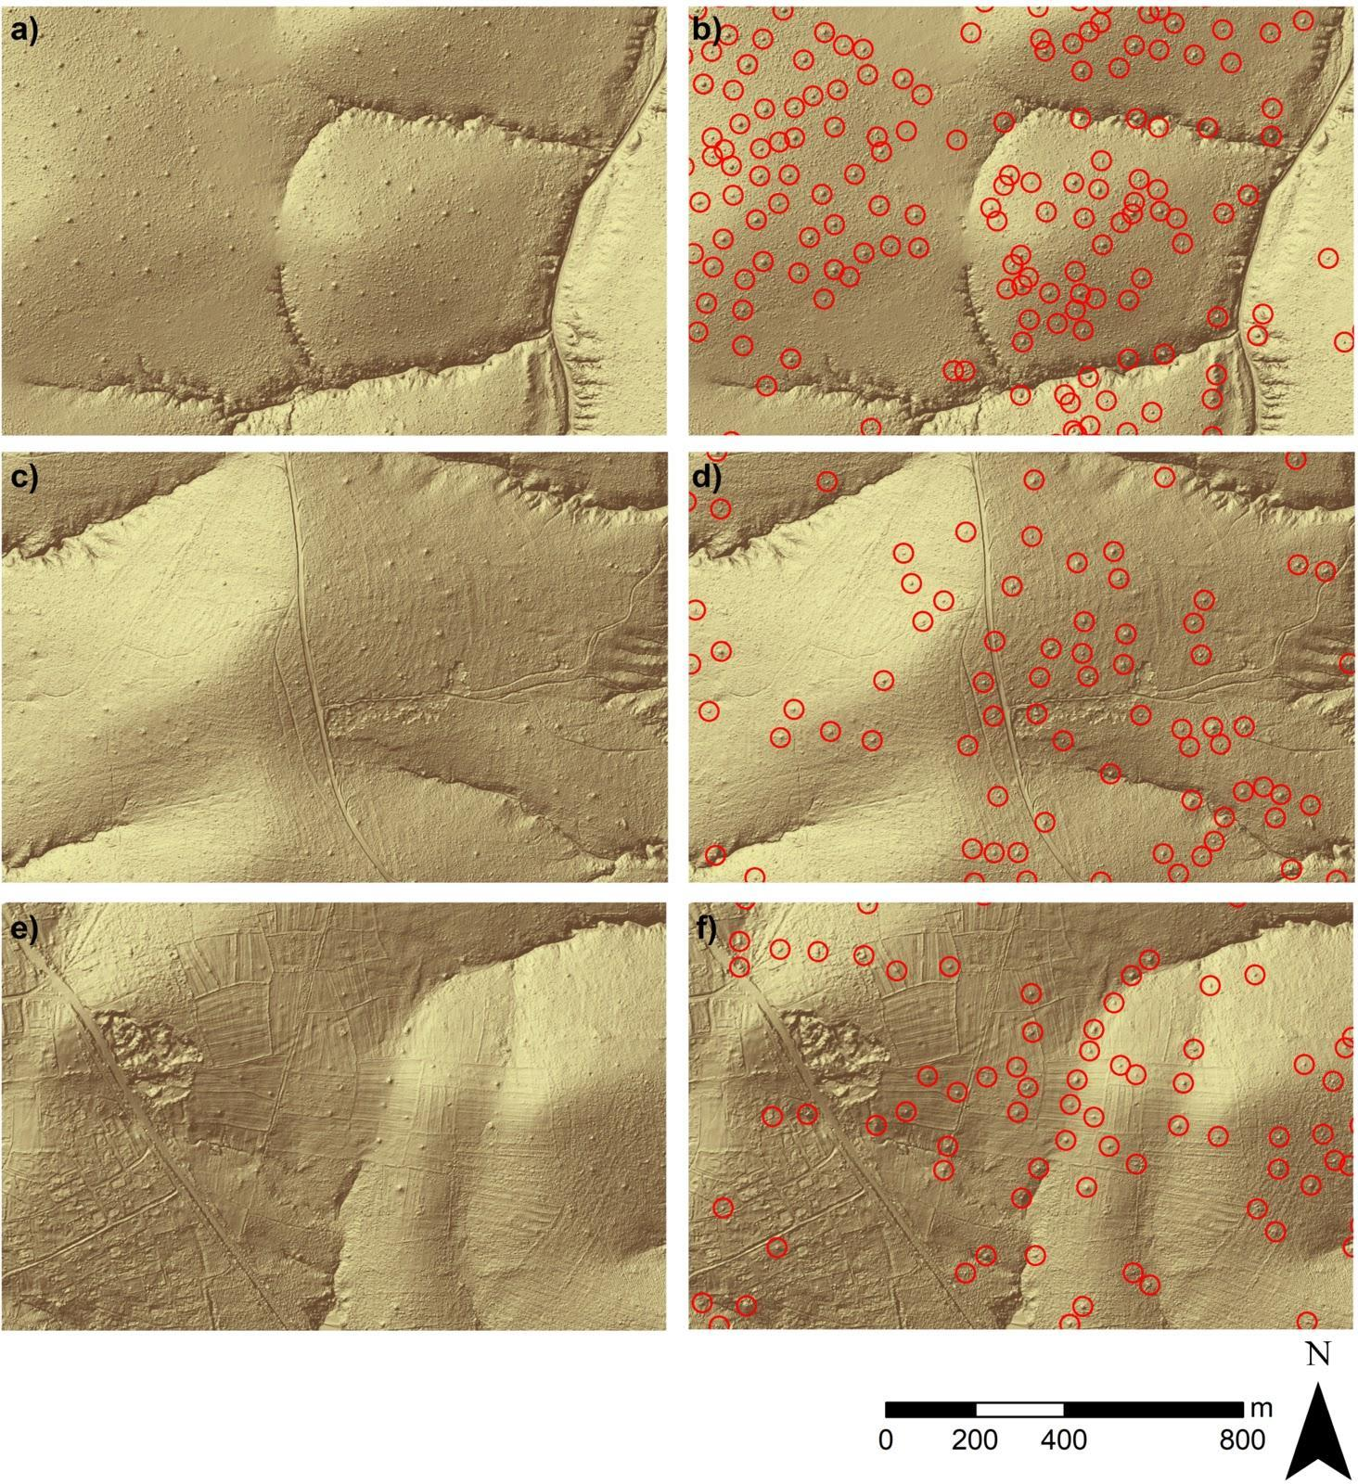

**Figure 2:** Example hillshade images showing termite mound distributions, with and without mounds identified by the convolutional neural network (CNN) model (depicted by red circles in the right-hand panels). Hillshades were produced from airborne LiDAR-derived digital elevation models, and highlight the differences between Kruger National Park (a-b, subset of Landscape 3), communal grazing land (c-d, subset of Landscape 7), and agricultural fields (e-f, subset of Landscape 7).  See Fig. 1 for landscape locations.

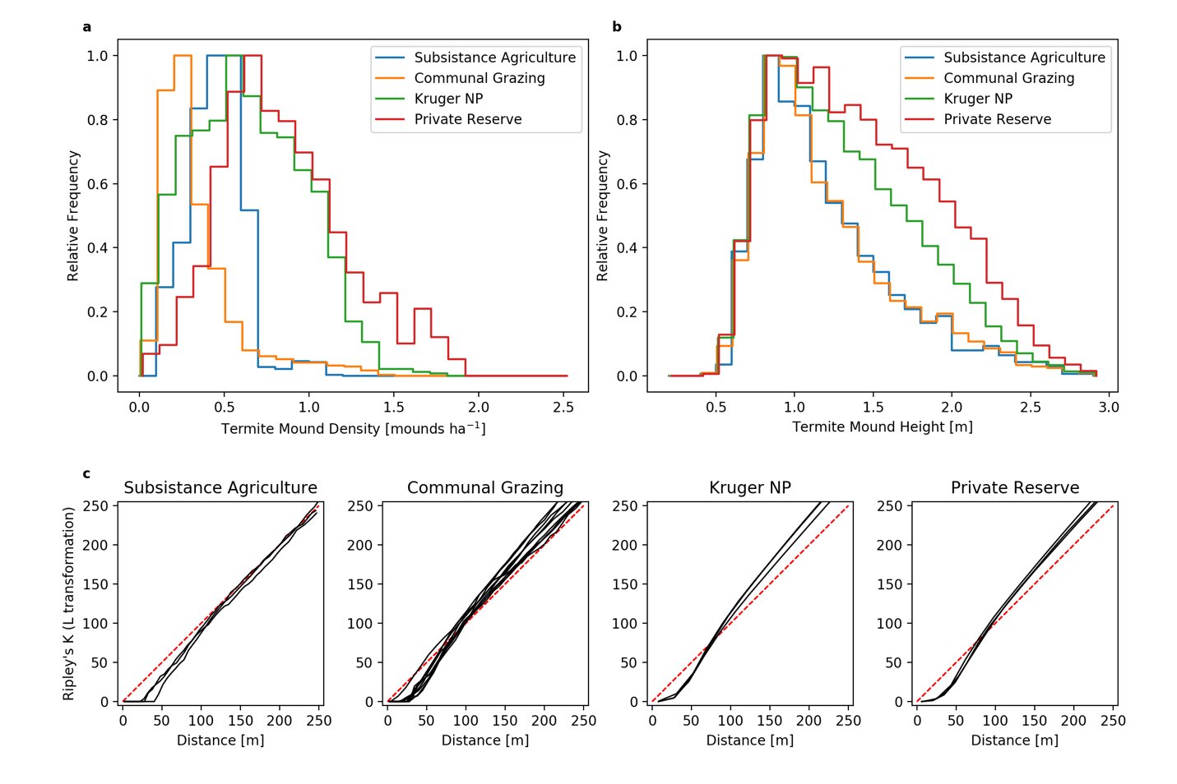

**Figure 3:** Distribution of termite mound heights (a) and densities (b) measured with airborne LiDAR across areas of varying land-use in northeastern South Africa. The height distributions were generated from all measured mounds per land-use, whereas density distributions were generated by sampling 2000 100 ha blocks with replacement from each land-use type. c) Ripley’s *K* (L transformation) function for termite mounds across the land-use types. The red dashed line represents the distribution of mounds under complete spatial randomness, whereas the black solid lines represent the observed mound distribution per land-use polygon (> 300 ha in extent) in each land-use type. Values below the red dashed line indicate over-dispersion (even spacing) while values above the dashed line indicate clustering. Private Reserve represent areas within Sabi-Sand Game Reserve.

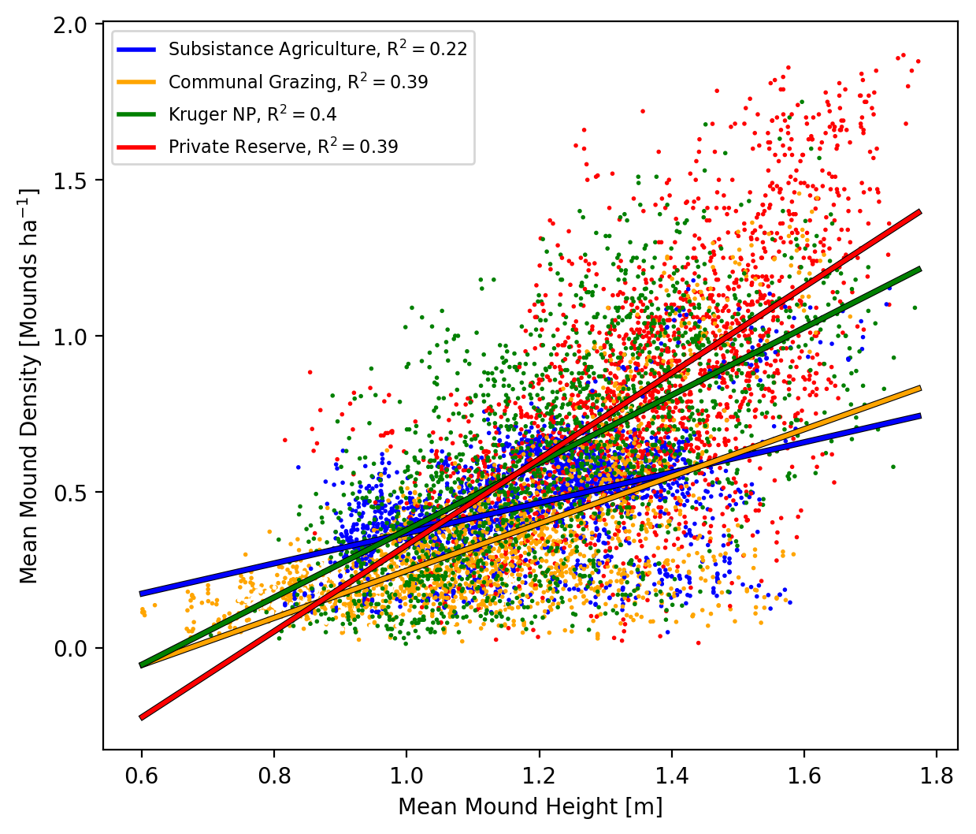

**Figure 4:** Termite mound heights vs densities. Points represent the mean height and density in each of the 2000 100 ha blocks from each land-use type. The lines represent linear regressions (with associated R2 values in the legend) per land-use type.