LIFE in a ZOO: Henri Lefebvre and the (social) production of (abstract) space in Liverpool

Matthew Thompson, University of Liverpool

Abstract
Building on recent critical contributions towards conceptualising neighbourhood change as socially produced and politically ‘performed’, this article takes a closer look at the work of Henri Lefebvre to understand the (social) production of urban space as a deeply political process. A common critical characterisation of neighbourhood change occurring through a grand Lefebvrean struggle between ‘abstract space-makers’ and ‘social space-makers’ is critically examined through an in-depth historical case study of the Granby neighbourhood in Liverpool. Here, these forces are embodied respectively in technocratic state-led comprehensive redevelopment, notably Housing Market Renewal and its LIFE and ZOO zoning models; and in alternative community-led rehabilitation projects such as the Turner Prize-winning Granby Four Streets Community Land Trust. By tracing the surprisingly intimate interactions and multiple contradictions between these apparently opposing spatial projects, the production of neighbourhood is shown to be a complex, often violent political process, whose historical trajectories require disentangling in order to understand how we might construct better urban futures.

Introduction
An unequal struggle, sometimes furious, sometimes more low key, takes place between the Logos and the Anti-Logos [...] The Logos makes inventories, classifies, arranges: it cultivates knowledge and presses it into the service of power. [Anti-Logos] by contrast, seeks to overcome divisions – divisions between work and product, between repetitive and differential, or between needs and desires. On the side of the Logos […] are ranged the forces that aspire to dominate and control space: business and the state… In the opposite camp are the forces that seek to appropriate space: various forms of self-management… (Lefebvre 1991, 391-2)
This article looks at the dialectical struggle Henri Lefebvre sees as defining the historical production of space – between the forces of Logos and Anti-Logos, or abstract space and social space – by grounding it more concretely at the neighbourhood scale, to consider the impact of urban regeneration programmes and planning policy on everyday life. It builds on recent work in critical urban theory towards a socio-spatial approach that conceptualises neighbourhood change as the product of political decisions and collective actions in space – ‘spatial projects’ – as much as the result of more structural socioeconomic, demographic and technological shifts. I follow David Madden (2014) in conceptualising neighbourhood as an unfinished ‘spatial project’ in which various actors and organisations project out into space their own specific agendas in myriad colliding, competing and cooperating ways which together help enact or produce place. I bring this into closer conversation with Manuel Aalbers’ (2006, 2015) distinction between two broad approaches towards producing neighbourhood: ‘abstract space-makers’, who promote the generation of exchange value and bureaucratic rationalisation of space, and ‘social space-makers’, concerned with the production of use value – convivial ends of play, collective encounter, and social reproduction. This socio-spatial approach, however, risks oversimplifying the dialectical relation between abstract and social space. A deeper engagement with Henri Lefebvre’s (1991) The Production of Space may help elucidate the critical perspective this approach brings to the complex process of neighbourhood decline and transformation.
To understand these processes more clearly, I focus my lens on a case study of Granby in Liverpool, drawing on original and secondary data, including semi-structured interviews and participant observation, conducted between 2012 and 2015 for doctoral research which looked into Liverpool’s recent post-war history of experimentation with collective alternatives to public housing. Granby is an interesting case as an especially deprived and long-neglected inner-city neighbourhood in which various technocratic state policies for comprehensive redevelopment – tools of abstract space – have been applied since the 1960s to contend with worsening economic and housing conditions, and which in turn have been contested by residents and civil society organisations in ways which have produced new social spaces through democratic innovations in housing management and neighbourhood governance. These include one of the country’s largest and most successful housing cooperative movements of the 1970s, and some of the UK’s first urban community land trusts (CLT) emerging today. Most notable is the Granby Four Streets CLT, which in 2015 was the first ever housing project to win the prestigious Turner Prize.
But this is not a story of simple contestation producing progressive outcomes. In the following, I argue that the common characterisation of abstract versus social space is a more complex and dialectically-interwoven relation, with ambiguous outcomes stemming from their collision and combination in historical contexts. I show how the production of neighbourhood is shaped through the interaction of abstract and social space-makers, clashing and cooperating with unforeseen and often violent impacts. Lefebvre saw violence as an inherent feature of abstract space, and I show that spatial projects conceived and implemented by social – as well as abstract – space-makers can contribute to the production of (violent) abstract space.
Through Granby’s history, I trace how earlier actions and decisions taken by social space-makers are complicatedly implicated in shaping the future production of space, adversely interacting with other conditions down the decades to produce often contradictory and counterintuitive outcomes. For instance, the admirable activism of Granby residents in contesting demolition-and-rebuild policies inadvertently led to the formulation of a more heavy-handed technocratic model for state intervention in low demand neighbourhoods, intriguingly called the LIFE model, whose rationale I will explain below. LIFE in turn became the precedent for the monolithic zoning logic of Housing Market Renewal (HMR), the latest and most interventionist in a long line of attempts to resolve the city’s ‘wicked’ problems of unemployment, depopulation, housing vacancy, deprivation and dereliction (Cole 2012; Cocks and Couch 2012). HMR as it was rolled out in Liverpool involved the subdivision of target areas for comprehensive redevelopment into ‘Zones of Opportunity’ – commonly referred to by the unfortunately metaphorical ‘ZOO’. This article, then, is also about LIFE in a ZOO: the everyday life of Granby residents trapped in a ZOO and the violence enacted by HMR as a technology of abstract space. In what follows, I explore place-based resistances to, but also the co-production of, such technocratic tools of abstract space and their genesis in contradictory interactions between abstract and social space-makers.

Lefebvre’s theory of abstract space
For Lefebvre ([1961] 2002, 305) the historical production of space is a movement towards the domination of what he calls abstract space: the unified socio-spatial dimension of state-technocracy and market-capitalism, together producing “a naked empty social space stripped bare of symbols”. In classical Marxism, exploitation in the production process – the labour-capital relation – is the original source of alienation and the primary contradiction of capitalism; all others mere derivative reflections. Extending Marx’s theory of alienation in the sphere of production to the sphere of social reproduction, Lefebvre criticised Marx for limiting his analysis to the economic sphere; for not seeing the effects of alienation in the political and cultural spheres of bureaucratic state power and the quantification, calculability and managed spectacle creeping into everyday life (Wilson 2013a). By a dual process of division and homogenisation – ‘difference-through-sameness’ – abstract space works to divorce people from the land, enclosed through legal and spatial boundaries and divided into exchangeable units for state control and capital accumulation (Lefebvre [1974] 1991). It imposes a quantitative homogenous equivalence that violently erases diverse subjective experience, place identities, historicity, and qualitatively rich collective cultures.
In characteristically dialectical fashion, Lefebvre (1991, 165) argues that abstract space “attains its full meaning only when it is contrasted with the opposite and inseparable concept of appropriation.” Posited against the onslaught of abstract space is a dialectical counter-movement for the re-appropriation of social space, reconnecting people and place, the users and producers of space, working towards a radical experimental-utopian possibility – what Lefebvre calls ‘differential space.’ Lefebvre’s ([1968] 1995) earlier concept, The Right to the City, can be seen as an expansive political vision to combat the urban symptoms of abstract space – displacement, division, exclusion, alienation, peripheralisation – through the generalised production of social and differential space. Thus we have two opposing – though radically unequal – forces competing against each other to inscribe space with their own vision, according to fundamentally different conceptions of society. Due to the historical dominance of abstract space, those struggling for social space must actively contest and challenge dominant models. The (socioeconomic) production of housing is thus marked by a struggle between what Aalbers’ (2006) calls ‘social space-makers’, who “produce residential space for use”, and ‘abstract space-makers’, who “follow the instrumental logics of exchange value when producing housing.”
This distinction broadly correlates with the dialectic between conceived and lived space in Lefebvre’s spatial triad. The former is composed of ‘mental’ abstractions – those intellectual, technocratic and scientific discourses, plans and logics that construct analytical and rational representations of social reality to justify abstract space – which projects itself onto lived space, in the “devastating conquest of the lived by the conceived, by abstraction” (Lefebvre, quoted in Wilson 2013a, 3). In contrast, lived space is “directly ‘lived’ through its associated images and symbols, and hence the space of ‘inhabitants’ and ‘users’” (Lefebvre 1991, 38), and also those artists, writers and philosophers who attempt to meaningfully represent lived space and its imaginative transformation (Leary 2013). This is the most physical, ‘pre-rational’ and affective space of everyday experience (Pierce and Martin 2015); the realm of collective memory, desire, art, music, play, festivity, eroticism, intoxication, excess and encounter (Merrifield 1995). For Lefebvre, the latter is the very essence of the ‘urban’: the concentrated interaction of people, ideas and materials through social encounter (Merrifield 2013).
The third unifying dimension in the spatial triad is ‘perceived space’ or spatial practices, which ‘secrete’ society’s space through accumulated multiple ‘daily realities’ and material flows (Lefebvre 1991, 38). Abstract space can be seen as the accumulation and penetration of ‘conceived space’ into the more material spatial practices of society; as the foreclosure of the possibility of encounter through division, homogenisation and alienation (Merrifield 2013). Social space is that which resists and escapes the grip of abstraction, protecting the use values of lived space and the promise of a postcapitalist ‘differential’ space (Leary 2013; Wilson 2013a).
In reinterpreting Lefebvre’s theory of the production of space for the neighbourhood scale , Madden (2014, 480) introduces the concept of ‘spatial project’, a term he uses to signify
Coordinated, continuous, collective campaigns to produce and format space according to identifiable logics and strategic goals, pursued by specific actors utilizing particular techniques.
Reflecting Lefebvre’s (1991, 129) key insight that the social relations of production “project themselves into a space, becoming inscribed there, and in the process producing that space itself”, Madden (2014, 480) explains that spatial projects are, “as the phrase has it, spatial projections of social power; they produce space, in an ongoing, contingent, uneven manner.” This forms the basis of the socio-spatial approach to urban change: the idea that urban space is defined, shaped and reproduced by projections ‘out’ into space; politically-motivated ‘movements’ into space in efforts to shape urban space in the image of the movers. Contrary to orthodox narratives which conceptualise urban decline and recovery as a naturalised process in a city or neighbourhood’s ‘life cycle’, the socio-spatial approach foregrounds agency, collective action and political decision-making as significant powers contending otherwise deterministic and structural processes of demographic, technological and economic change.
Spatial projects can be further explicated with Deborah Martin’s concept of ‘place-frames’: competing representations of space used as political tools to re-imagine and re-produce urban space for different ends (Pierce and Martin 2015). Place-frames may guide the practical ways in which spatial projects attempt to remake urban space – explicable through ‘performativity’. Place-frames can have powerful performative effects on urban reality. We can see this all too clearly in the manner in which maps, statistical research, viability models, zoning policies, property brochures and vision statements inscribe environments with their designs, in more or less conscious ways. Abstract space is thus not simply emergent hegemonic social reality but also those specific tools or technologies of power geared towards the “representational erosion of differentiated symbolic systems by an instrumental rationality” (Wilson, 2013b: 4). Tools of abstraction have a dual ontology, simultaneously describing or representing the world and constitutively intervening in or ‘performing’ the world. Aalbers (2014) and Christophers (2014) adapt Judith Butler’s concept of ‘performativity’ – “the reiterative power of discourse to produce the phenomena that it regulates and constrains” (Butler quoted in Aalbers 2014) – to the study of how maps and viability models, respectively, have a ‘performative’ effect on the urban space they claim to merely map or model. Powerfully remaking space in the image of the very assumptions and axioms used to observe and measure it, these instruments ‘perform’ a certain vision of social reality into existence.
In this article, I illustrate how Liverpool’s post-war ‘slum clearance programme’ and 21st century HMR Pathfinder are technologies of abstract space, with powerfully performative, violent impacts on lived space. This reflects similar arguments made about post-war suburban housing development and transport planning (Butler 2005); and neoliberal public housing restructuring policies, specifically HOPE VI, the pioneering American precursor to HMR (Jones and Popke 2013). However, it is not just abstract space-makers who can remake space in this way: social space-makers too can have a performative impact through grassroots spatial visions, together producing complex ‘entanglements’ of competing spatial projects, which require disentangling if we are to uncover the ways in which power works to produce space. The following historical analysis of the production of Granby in Liverpool explores such entanglements.

Tracing the (social and abstract) production of Granby, Liverpool
Despite being perhaps the most multi-cultural and ethnically diverse area of Liverpool – home to one of the oldest and most established black communities in Britain – Granby’s historical trajectory is an extreme example of Liverpool’s economic fate. Once a very prosperous quarter of merchant and artisan houses fronting tree-lined streets and grand boulevards, the area had by the 1960s accrued a reputation for crime, vandalism, and squalor (Merrifield 2002; Beckett 2015). Liverpool City Council efforts to regenerate the area were hindered by poor communications with residents, made difficult by deprivation, transience, the predominance of private tenants renting off small-time absentee landlords, and the hostility provoked by the threat of demolition imposed by the post-war ‘slum clearance programme’ (Hook 1970). In response, the council set up Granby Planning Action Area and invited Shelter, the recently-established homelessness campaign organisation, to investigate the potential for a rehabilitation alternative. Their solution was the Shelter Neighbourhood Action Project (SNAP), rolled out from 1969-72, as one of the first action-research programmes nationwide to experiment with participatory rehabilitation of inner-city terraced neighbourhoods as an alternative to comprehensive renewal; a pioneering sister project of the Community Development Projects then gaining government policy support (McConaghy 1972). SNAP was to provide the vital link with residents, articulating their needs to the council, whilst delivering much-needed housing improvements, such as reducing densities, installing inside toilets and repairing dilapidation. This was later to become the blueprint for the rehabilitation approach to regeneration, fervently supported by the 1973-83 Liberal council administrations and delivered by the city’s growing housing association sector (Holmes 2005).

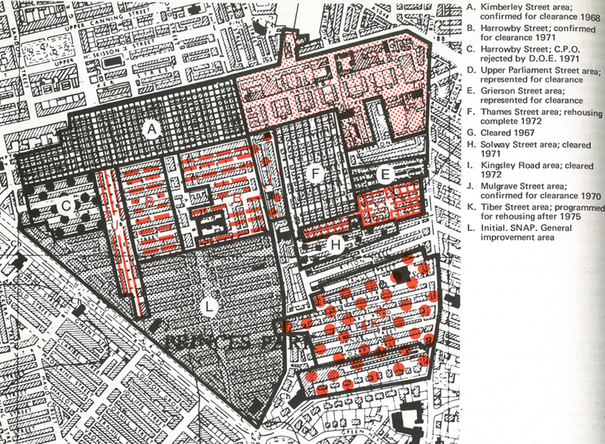
Figure 1: Map of main clearance areas in Granby, 1969-70, with SNAP marked as ‘L’ (source: McConaghy, 1972: 62)

However, SNAP ran against the grain of conventional thinking on urban renewal, operating in only one small corner of the Granby Planning Action Area, with the remainder still earmarked for clearance and redevelopment (see figure 1). The local Labour Party had controlled council policy from 1955 until 1973, during which they pursued a large-scale demolition and council house-building programme known as the ‘Slum Clearance Programme’ – reflecting similar policies across the UK in the post-war period (Cole 2012). As late as 1966, the council decided to clear 78,000 houses it deemed unfit for human habitation, mostly in the inner-city ring of Victorian terraces. SNAP was caught up in a battle with the council to prevent further clearances, yet its funds and project boundaries were delimited. Within the wider Granby Planning Action Area, SNAP covered only its southern corner, known as the Granby Triangle.
The slum clearance programme – as a state technology of abstraction – reveal what Lefebvre saw to be the fundamental violence of abstract space. Where Marx saw the actions of labourers in specific industries abstracted into quantitatively-equivalent units of abstract labour-time to be traded as money, Lefebvre revealed analogously how abstraction divides urban space into rationalised parcels or plots, alienated from lived context. Just as commodity fetishism conceals the violence carried out on producers in the enforced expropriation of their labour, so too is violence performed by abstract space on people and place. Lefebvre (1991, 289) goes so far as to suggest that “there is a violence intrinsic to abstraction”. Violence in abstraction begins with the act of subsumption – subsuming disparate processes and heterogeneous things into homogenous abstractions or signs (Jameson 2015). This involves the necessary exclusion of some aspects of reality. This rather abstract sense of violence takes on real power in the historical-material production of space. In his account of an ‘actually existing abstract space’ in Mexico, Japhy Wilson (2013b) represents abstract space as three forms of violence: first, direct violence, such as state power deployed on citizens in enforced displacement; second, symbolic violence, the subtle homogenisation, flattening or simplifying of lived meanings by the domination of logics of equivalence, accumulation, quantification and bureaucracy; and third, structural violence, the socioeconomic structural dynamics of capitalism, embodied through impositions of grids and systems through which exchange value flows.
We can see this three-fold violence of abstract space enacted in Liverpool from the slum clearances to more contemporary interventions. First, direct violence is evident in the displacement and breaking up of communities necessitated by the slum clearance programme. Some estimates put the number of residents decanted from Liverpool’s inner city to the new towns and outer estates as high as 160,000 (Sykes et al. 2013). Liverpool’s comprehensive urban renewal has been described by Tony Lane (1997, 140) as “a sort of latter-day urban equivalent of the Highland clearances of several hundred years ago”.
Second, symbolic violence – difference-through-sameness – has been incurred by the operation of monolithic urban renewal, as a technology of abstract space, which for Lefebvre (1991, 370)
Destroys the historical conditions that gave rise to it, its own (internal) differences, and any such differences that show signs of developing, in order to impose an abstract homogeneity.
Granby’s council-led redevelopments involved the total erasure of existing 19th century street patterns, replaced by ad hoc suburban designs, with blocks arranged in internally-facing cul-de-sacs. With little coherence or legibility in either building design or road layout, the surrounding area has lost much of its unique urban identity, and appears sharply at odds with the original four streets remaining of the Granby Triangle (see figures 2 and 3). A local architect describes the result as a “history lesson in all the bad architecture of the last 30 years” (Interview, 2014). At the risk of romanticising the terraces, it must be remembered that they too are a concrete expression of abstract space, built by speculative builders to house migrant workers, often in appalling conditions, and arranged in abstract grid-like street patterns, with standardised ‘back-to-back’ housing designs. There was a reason why it was called the slum clearance programme: many of these houses lacked basic modern facilities like hot water and inside toilets. In many respects, then, the council was enlightened in its reformist determination to upgrade insanitary living conditions with modern housing, but whose methods of implementation leant too heavily on abstract rationality, with too often violent implications.

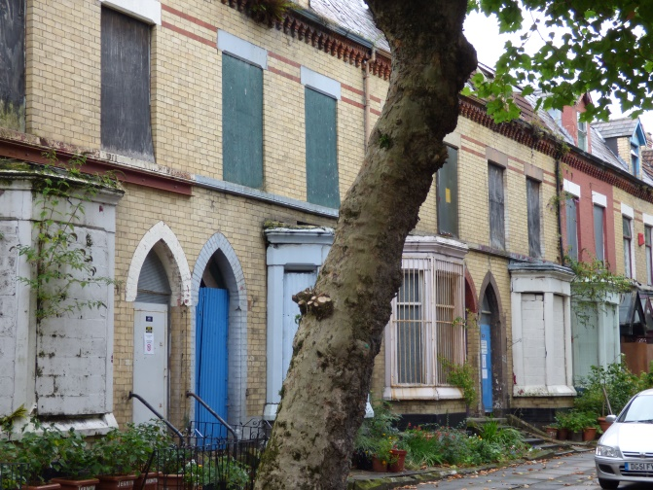
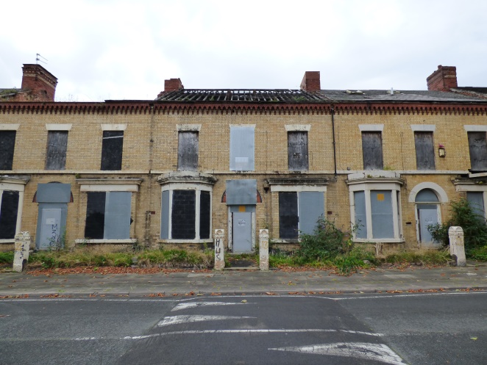
Figure 2: The stark reality of neighbourhood decline in Granby (source: author’s own photographs, 2014)
However, such streets quickly became home to densely woven networks of families, friends and neighbours who forged communal ties and created rich social space out of the deleterious material environment. Destroying such a delicate social fabric through comprehensive redevelopment was a directly, as well as symbolic, violent act – replacing social space with an abstract space of homogenous housing estates. This goes to show that, while abstract space can be colonised by social space, social space can in turn be wiped out by abstract space.
Third, for the most damning critics, the clearances amounted to a kind of structural violence, a tragic repeat of the WWII Blitz:
Liverpool…has suffered two blitzes in the last 30 years. The first left the whole city ruined but defiant. The second has picked off areas with equally devastating results. The new enemy is faceless (Merseyside Socialist Research Group, 1980, 67)
Despite such strong language, these critics are nonetheless adamant that the local state is not, ultimately, to blame for the devastation; rather, the “new enemy is faceless” – the impersonal, structural logic of abstract space. These public policy mistakes were not conscious attacks, intentionally carried out by planners, but rather enactments of the faceless, modernist “analytic spirit” of the post-war period (Lefebvre 1991, 307-8).
According to some critics, Liverpool’s modernist comprehensive renewal programmes amounted to “major self-inflicted public policy mistakes”, which compounded seismic economic shifts to create the “perfect storm” for a vicious cycle of decline (Sykes et al. 2013, 307). In the mid-20th century, Liverpool witnessed the destruction of its maritime base due to global economic restructuring leaving the city “marooned on the wrong side of the country” (Lane 1997, 46). The consequences were devastating, especially for the inner-city dockside neighbourhoods, so dependent on jobs associated with the docks. Liverpool’s population halved from over 800,000 in the post-war period to just over 400,000 in 2000 (Cocks and Couch 2012); around three quarters of the docklands population were lost, leaving up to 60% unemployment rates for those left behind (Lane 1997, 126). Much of this was voluntary migration, as people left in search of work, but an estimated 160,000 people were displaced to the metropolitan periphery by the slum clearance programme (Sykes et al. 2013). The combined effects tipped some neighbourhoods into a vicious spiral of decline: unemployment, depopulation, housing vacancy, dereliction, crime, and social unrest. This structural form of violence indirectly enacted by post-war planning in combination with socioeconomic forces was to hit Granby especially hard (figure 2).

Urban regeneration in a SNAP!
It was into this context of the violent abstraction of the slum clearances and structural economic decline that SNAP was mobilised as an alternative method of regeneration aiming to renew social space. SNAP was intended as a rehab alternative to demolition; yet the idea was to go deeper than mere physical upgrading: to work closely with existing residents to satisfy needs and make lasting improvements in health, welfare and employment. A local office for SNAP workers – composed of architects, housing managers and even a sociologist – was opened ‘onsite’ in Granby, allowing direct contact with residents. This was a forward-thinking move for regeneration policy towards more social space-making, but one which also blurred the boundaries between professional experts and resident-users, complicating the neat distinction between conceived/abstract and lived/social space.
Many of these SNAP professionals became co-op activists in developing the country’s first rehab housing cooperatives in 1972 and the first secondary co-op support agency to service them; in turn inspiring a city-wide movement of some 50 co-ops, as an alternative system of public housing based on collective dweller control (Thompson 2016). More directly, SNAP initiated the organisation of street committees elected by residents. Task forces were organised as discussion groups on each subject reflecting local concerns, such as housing, health and crime, and their findings were incorporated in the SNAP final report to the council (McConaghy 1972).
One of the Task Forces set up by SNAP to encourage resident control over the planning process was tasked with transportation and traffic. Prior to SNAP, the council had committed to a plan for the construction of a major distributor road to connect the southern suburbs with the city centre, running right through the heart of Granby. This would have left the grand boulevard of Princes Avenue ludicrously under-utilised as the “widest pedestrian walkway in Britain” (McConaghy 1972, 97), bull-dozed properties, divided Granby in two, and displaced many residents to new-build estates. This example captures the violent power of abstract space:
In order to dominate space, technology introduces a new form into a pre-existing space – generally a rectilinear or rectangular form such as a meshwork or chequerwork. A motorway brutalizes the countryside and the land, slicing through space like a great knife. Dominated space is usually closed, sterilized, emptied out. (Lefebvre 1991, 165)
One of Lefebvre’s (1991, 381-2) examples of practical “counter-projects” mobilised against abstract space to protect social space is “when a community fights the construction of urban motorways or housing developments.” We can see this in the SNAP Task Force’s opposition to the urban motorway and their successful campaign for a compromise solution avoiding Granby altogether. However, the experience of being threatened by increased traffic through-flow of the highway scheme stimulated resident fears that their neighbourhood would be overrun by traffic. Moreover, Granby was historically a locus of kerb-crawling and crime (Hook 1970). Residents understandably wanted to stem this flow of unwanted activity and so Task Force representatives decided on a traffic management scheme that blocked off the ends of most outwardly-connecting streets (McConaghy 1972). The resulting cul-de-sac layout did indeed resolve these issues in the short-term, but unfortunately had severe repercussions for the vitality of the area in the long run.
Significantly, clearance area ‘A’ (figure 1) was to prove especially damaging to the future of the area, in ways which combined problematically with SNAP Task Force traffic calming measures. In order to build the new housing estate in conventional 1970s layout, the top end of Granby Street was built over, and cut short from connecting to the major arterial road, effectively severing the main shopping street of Granby from its vital connection with the city-centre. With the state acting here to undermine rather than enhance spatial flows – seemingly counter to the logic of abstract space – this demonstrates the limits of a Lefebvrean analysis in interpreting state technocracy simply as its lever. The state is not reducible to abstract space and serves multiple rationalities – some, it seems, more rational than others.
When coupled with SNAP’s choice to block Granby Street’s southern entrance too, this dubious decision created a stagnant dead-end road without the through-flow – pedestrian, car or bus – that had once sustained it as a vibrant district shopping artery. In his political analyses of Granby, Andy Merrifield (1996, 2002) recalls Jane Jacobs’ prescription of an active and busy ‘street ballet’ in which many eyes-on-the-street provide the best form of safety and self-policing. Residents certainly got a much quieter and safer street in pushing for cul-de-sacs, but by the late 1980s the area had once again become a hotspot for crime, paradoxically encouraged by the cul-de-sac bollards, preventing a vibrant street ballet of passers-by. Granby Street was finally opened up at the junction with Princes Avenue in 1993 but “until then, the street had been blocked off, and the social isolation seemed to be perpetuated by its physical isolation and fortress-like quality” (Merrifield 2002, 58).
By the 1980s, Granby had effectively become “Liverpool’s ghetto” (Beckett 2015). According to the 1981 census, 40% of men in Granby ward were jobless (ibid); as high as 90% for black teenagers (Merrifield 2002). The coincidence of unemployment and poverty with certain ethnic and demographic groups, notably young black men, had severe repercussions when in 1981 rioting erupted in response to police brutality and racial discrimination against the local black community, the longest-established in the UK. Ironically, bollarding had another function unforeseen by the SNAP Task Force: not only helping keep crime and kerb-crawling out – albeit displacing it elsewhere – but also helping police contain urban unrest as an anti-riot tool for ‘kettling’, along with the so-called ‘riot hills’, installed on some of the cleared housing sites (Hughes 2015).
Since then, Granby has been marked by territorial stigma, dissuading many prospective tenants from moving in, contributing to the growing problem of depopulation and low demand, with ‘hard-to-let’ properties falling into disrepair. The once bustling Granby Street became almost entirely vacant and derelict, its Post Office closing in 1994 owing to successive hold-ups. The area has also suffered with neglect in basic public services such as street lighting, cleaning and rubbish collection, and inaction over regeneration, which many residents suspect to be intentional ‘managed decline’ dished out by the council as ‘punishment’ for the 1981 Uprising (Interviews, 2014). However, the contributory factors of Granby’s decline are multiple and complex, fundamentally deriving from Liverpool’s economic problems but also rooted in legislative changes at the national level, such as the 1988 Housing Act, removing government funding for rehabilitation, and placing increasing commercial pressures on public housing providers, gradually privatised as market actors (Hodkinson 2012).
Although SNAP may have adversely contributed to this decline, its enduring effects as a spatial project, long after the programme ended in 1972, is encapsulated in the only remaining terraces in Granby today mapping almost perfectly onto the original SNAP boundaries. These four streets at the bottom of the Granby Triangle were to become the centre of a longstanding struggle by residents to save the area from successive waves of demolition, after rehab had passed out of the policy limelight (see Merrifield [1996, 2002] for a detailed account). Not only did SNAP save several streets from demolition but also cultivated a culture of empowerment and hope that would resurface several decades later as resistance to the next wave of demolition plans. Collective action against displacement evolved into one of the country’s first urban community land trusts – christened Granby Four Streets CLT – to rehabilitate empty homes for local use under collective ownership (Thompson 2015). At the same time, however, by continually stalling and preventing council plans, anti-demolition campaigning led to a deadlock in decision-making, leaving the area in a kind of purgatory, with counterintuitive consequences for the development of a new policy approach geared more towards abstraction than ever.

LIFE in a ZOO
It was the Council’s difficult experience of working in neighbourhoods like Granby that led to a game-changing policy for bringing clearer leadership and greater coordination in addressing such complicated regeneration dilemmas. The Liberal Democrats took council control from Labour in 1998 and initiated a new Housing Strategy to bring about more coordinated collaboration between council departments, housing associations, developers and communities; creating more joined-up strategic regeneration in contexts where multiple tenures, owners and interests overlap, collide, and conflict to create the sort of stalemate reached in Granby (Inside Housing Awards 2004). First, stock transfer to housing associations was promoted as the “only realistic option” (Richard Kemp, then Executive Member for Housing, quoted in Holmes 2005, 131). Second, the ‘LIFE model’ rationalised inner-city neighbourhoods into five distinct zones, or “areas of opportunity”, and assigned one lead housing association to each (Inside Housing Awards 2004).
Under the LIFE model, each housing association would assign itself a clearly defined role within each area, following L-I-F-E: Lead in an area; Influence what happens; Follow by collaborating with others; or Exit where presence is minimal (Holmes 2005). In Granby, as for the entire L8 district, Plus Dane became the Lead association, and began developing plans for holistic neighbourhood management, working more closely with the council to plan redevelopment. Winning an Inside Housing award in 2004, the rationale of the LIFE model was that
Without [it], the council, private developers and other partners would have had to consult, negotiate and collaborate with around 40 associations operating across the market renewal pathfinder area. Residents and other stakeholders would be confused by the range of partners and effective delivery of the programme could be hampered (Liverpool Council’s group manager for neighbourhood services quoted in Inside Housing Awards 2004)
The LIFE model was thus a rather rational response to the confusion of too many agencies operating in one area, duplicating processes. Yet the irony of naming a technocratic spatial policy ‘LIFE’ – a tool of abstract space designed to rationalise lived space – seems lost on policy-makers; just as the symbolic significance of Zones of Opportunity (ZOO) would likewise later elude HMR’s architects.
The LIFE model is where the logic behind HMR Pathfinders seems partly to derive. The impetus for strategic demolition-and-rebuild schemes in large-scale zones of empty homes was already beginning to emerge in Liverpool council thinking as far back as the early 1970s, with the creation of monopoly General Improvement Areas (GIA) for housing associations, inspired by SNAP; later given coherence as a joined-up policy initiative in the Liverpool Strategic Housing Partnership and the LIFE model (Holmes 2005). On the flipside, it was the GIA policy of the Liberal Council that proved particularly favourable to the development of rehabilitation housing co-ops, which went on to inspire a politically radical and socially empowering new-build co-op movement, in which working class member-residents had the chance to collectively design, develop, own and manage their homes for the first time in their family history (Thompson 2016). This is abstraction counterintuitively creating the conditions for social space-makers.
Crafted out of GIA precedent, in response to growing neighbourhood regeneration deadlock, the LIFE model in turn constructed the operational muscle tissue ready to be fully flexed once HMR funding was secured. Liverpool led a group of northern city councils to lobby central government for funding intervention in failing housing markets (Interviews, 2014). Early research reports (Nevin et al. 1999) commissioned by Liverpool Council recommended that Liverpool’s inner-city could be a pilot for government funding of housing market restructuring, becoming one of the largest recipients when HMR Pathfinders were launched nationally in 2002 (Cocks and Couch 2012).
The rationale for HMR was radical in its multi-scalar focus on regional market restructuring, bringing together and rationalising the confusing number of previous and ongoing area-based initiatives in a similar vein to LIFE. Once given the green light, Liverpool was in the perfect position to hit the ground running. The five ‘areas of opportunity’ formatted by the LIFE model were translated into the four Zones of Opportunity (ZOOs) distinctive to Liverpool’s HMR Pathfinder, unwittingly creating a problematic metaphor in the acronym ZOO, within which many people still lived. In order to identify specific areas ripe for intervention, researchers constructed indicators of decline, abstracted from international academic data, from which to ‘rate’ different areas based on their relative popularity and projected sustainability (Nevin et al. 1999) – creating an abstract model of ‘neighbourhood viability’ linked to capacity to generate exchange value (Webb 2012). Affected communities were not invited to contribute to this problem definition process, and so the ‘evidence’ for this intervention was drawn primarily from only those abstract ‘representations of space’ conceived by policy-makers and researchers. To get ‘objective’ evidence on what type of houses to build, HMR policy-makers conducted surveys with their target consumer population, those middleclass residents currently living in affluent suburbs (Webb 2012). Their responses were unsurprisingly in favour of the kind of suburban housing they lived in: arranged in cul-de-sacs with gardens and garage space for a car to commute into the city (figure 3).

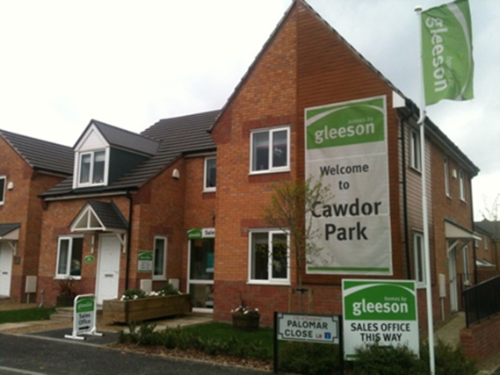
Figure 3: Identikit HMR housing replacing Victorian and Georgian terraces in the Granby Triangle.

Following the LIFE logic, the HMR Pathfinder appointed a single preferred housing association and developer for each ZOO to carry out refurbishment and rebuild plans in smaller-scale renewal areas (Liverpool City Council 2003). These renewal areas – or ‘regeneration zones’ – covered large areas of land, encompassing residential blocks, including housing worth saving, in order to create large enough ‘land banks’ and economies of scale for profitable redevelopment by the grant regime partners. The centralised systematic and large-scale approach of the British housing development industry means that developers will only take on land for redevelopment above a certain spatial scale, which when combined with the ZOO/LIFE model in Liverpool HMR delivery, leads to a questionable approach akin to
Pulling out all teeth and replacing them with dentures even if only a few teeth show signs of caries, rather than keeping and repairing all teeth as long as possible by fillings or root canal treatments (Schulze Bäing 2014)
Indeed, assets of architectural and social value remaining in these cordoned off areas have been described as “collateral damage” by a politically prominent proponent of HMR (Interview, 2013). According to one regeneration consultant (ibid), these zones were treated not as lived spaces but as abstract sites in a “chessboard” of strategic land parcels, to be stripped bare of residents and packaged up for redevelopment, so the Pathfinder partnership may “shift pieces around” to be activated at different stages according to changing dynamics of market profitability and resident opposition. This was the start of the abstract monolithic one-size-fits-all approach that characterised HMR, which has faced sustained academic critique for excluding residents from the decision-making process, with no resident representation on the governing board of stakeholders (Cole 2012); and as a form of state-led gentrification or symbolic violence, erasing working class lived space for an aspirational ‘space of positions’, radically transforming place in the image of a target middle class population, attracted through an improved ‘residential offer’, thereby marginalising alternative ways of valuing housing as shelter or belonging (Allen 2008).
In spending public funds to transfer land to private developers and quasi-privatised housing associations to profit from the sale of new homes, HMR has been framed as ‘accumulation-by-dispossession’, part of the ‘new urban enclosures’ eating into public housing (Hodkinson 2012). HMR Pathfinders have been characterised as ‘grant regimes’ (Cocks and Couch 2012) which lobby for state funding to dispossess residents from their homes – through compulsory purchase orders (CPO) and tenancy evictions with meagre compensation – and then revalorise the land through demolition-and-rebuild so that regime partners may pocket the difference in value from the ‘rent gap’. Indeed, an unconscious recognition of the violence played out in accumulative asset-stripping is expressed in the standardised signs put up on CPO’d properties in HMR zones to dissuade thieves and squatters (figure 4).
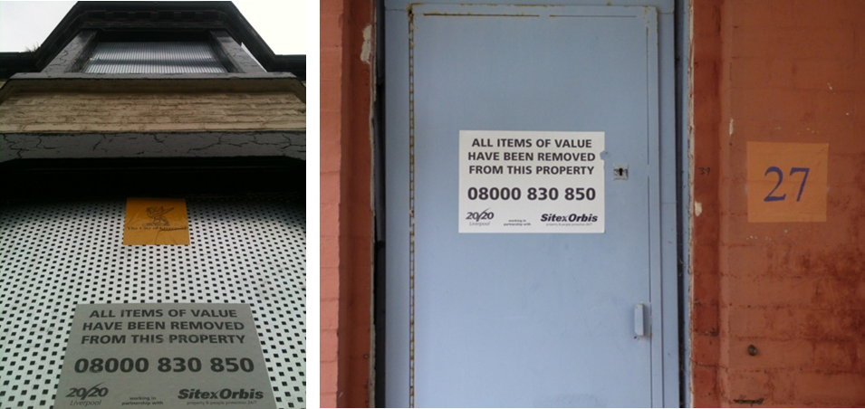
Figure 4: Familiar sign of asset-stripping in HMR areas – left in Anfield, right in Granby (source: author’s own photographs)

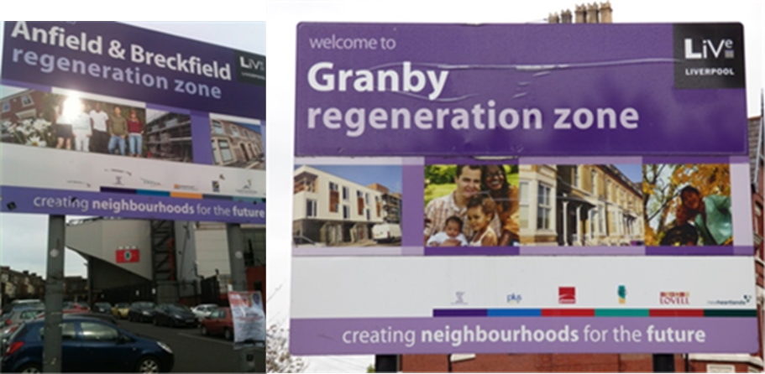
Figure 5: Indicative signs heralding the boundaries of regeneration zones (source: author’s own photographs)

The boundaries of these renewal areas within the five ZOOs were marked by ‘welcoming’ signs repeated across the city in the same generic format (figure 5). This is abstract space at its most transparent, revealed in the tagline ‘creating neighbourhoods for the future’, as if to emphasise these neighbourhoods are not for current users but rather end-users in some distant future. Paradoxically, ‘creating’ suggests an active doing in the present – it assures us action is happening right now – but with an ever-receding time horizon, existing in the abstract, as an indeterminate vision.

Structurally or politically unsound?
Many residents of the Granby Triangle were glad to move out of their crumbling homes and into housing newly-built by HMR; others were not. Popular opinion was often more favourable than critical commentaries suggest. In Anfield for instance – an ex-HMR neighbourhood now home to Liverpool’s other successful urban CLT, Homebaked – demolition was supported by some 90% of the local community (Ellis and Henderson 2013). In Granby, however, the building stock was generally perceived as much higher architectural quality, and many believed the Council was needlessly demolishing good housing as part of the large-scale zoning conditions required by the Pathfinder partners for profitable development; or else was part of a long-term punitive strategy for the 1981 Uprising and subsequent anti-demolition campaigning (Interviews, 2014). Having evicted most remaining public tenants from housing association stock before its transfer into council ownership for consolidation, only those defiant homeowners – those with the security of tenure and increasingly embattled and passionate commitments to place – remained to resist HMR.
The council had for years tried to buy out these homeowners with arguments about the structural condition of properties, deemed unsafe for inhabitation. One common argument was that the bay windows – striking architectural features of larger properties – were coming away from the wall and ‘structurally unsound’ (ibid). Official surveys recommended that these bays be pulled down and bricked in, but residents sought an independent assessment, which advised the bays could indeed be ‘tied-in’, thereby saving the houses and confirming suspicions that the Council was bent on demolition. One of the most dramatic confrontations came in 2011 when residents engaged in picketing and direct action to blockade Cairns Street with cars against approaching bulldozers. They alerted the local press so that the resulting stand-off was reported (Duffy 2011); a successful strategy that further galvanised the spirit of resistance. The Council eventually earmarked the end two houses of Cairns Street, to be demolished and rebuilt. Residents organised a peaceful protest as contractors began scaffolding. Despite modest numbers, around 20 residents, their sustained picketing using megaphones, banners and placards successfully prevented contractors from entering the houses to carry out demolition; attracting good coverage in the Liverpool Echo (Stewart 2011; Duffy 2011). Some activists super-glued locks shut and painted scaffolding with ‘anti-vandal paint’: an ironic signifier of “civic vandalism” (Interviews, 2014). But the builders ultimately beat them to it, arriving before sunrise to begin stripping out interiors, causing structural damage to an adjoining property scheduled for refurbishment. A council spokesperson dismissed it as “unfortunate” collateral damage (Stewart 2011). Residents accused the builders of intentionally damaging the structure to leave no choice but demolition.
Such underhand practices of invoking – and performing – structural damage to make the case for the bulldozer is a familiar story. Activists witnessed contractors throwing bricks through wooden floors to “test their strength”, collapsing into cellars, thereby helping bring about the very degradation they were employed to prevent (Interviews, 2014). Shortly before their dissolution, the Granby Residents’ Association were told by the council that their base in a disused office on one of the corner buildings on Granby Street was likewise structurally unsafe; they were consequently evicted, leaving them without a headquarters from which to plan anti-demolition campaigns. Incidentally, this is the building that SNAP had originally rehabilitated from a ruin into the Granby Centre, with various functions as a community anchor over the years, and later a neighbourhood police station, known locally as the ‘cop shop’ (ibid). Residents believe the Council’s reason to be a patent lie to suppress any possible resistance to demolition plans; a suspicion confirmed when the very same office in the cop shop was later offered as a base, without any extra work to make it safe, to the builders working on the redevelopment of Beaconsfield Street, which Plus Dane completed after HMR funding was withdrawn by the incoming Coalition Government. This, then, is a concrete example of how abstract space “asphyxiates whatever is conceived within it and then strives to emerge” (Lefebvre 1991, 370).

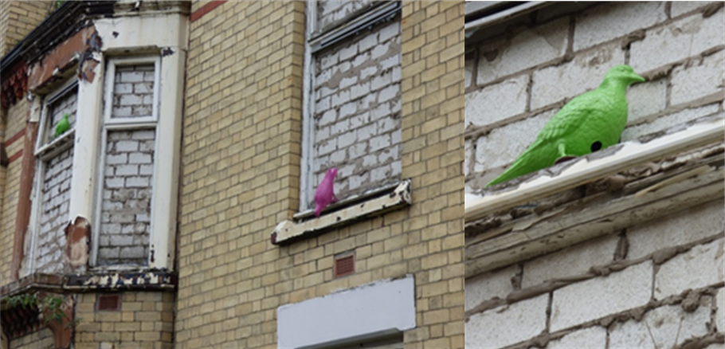
Figure 6: subversive art in Granby Four Streets (source: author’s own, 2014)

Violence is central to HMR, as a technology of abstract space. A longstanding resident-activist describes the actions of a state-hired private contractor:
As soon as people left they bricked them up from the inside, so if you looked from the street they had all this oozing kind of concrete, then they walked outside and smashed all the windows, leaving you with jaggy bits of glass (Interview, 2014).
The violence enacted was most acute in instances where, particularly reported in Anfield, the bricking up of houses was initiated on the same day evicted residents moved out their belongings (Interviews, 2015). By bricking up the windows, the contractors were able to secure against crime, squatting and the elements houses which were already in a dangerous state of disrepair through wilful neglect (figure 6). But to remaining residents it revealed the assumptions made about their neighbourhood, left in a visually vandalised condition as a scar for the community to daily endure:
I think it shows that you actually despise the people who are living there, that you don’t even rate them as fully human; because it’s what you’d do if there was nobody there isn’t it? It’s what you’d do if it was like an old military site say, or somewhere that nobody lived (ibid).
In some sense, this is a ‘concrete abstraction’ (Lefebvre 1991). The concept of abstract space is seen by Łukasz Stanek (2008) as analogous to Marx’s concept of ‘concrete abstraction’: labour as an “abstraction which became true in practice” (Marx quoted in Stanek 2008). Just as money is the concrete abstraction of labour, so too are physical spaces of regulation, quantification and circulation – property plots, suburban sprawl, pre-fab tower blocks, distribution channels, containerised ports, communication networks – the concrete abstractions of abstract space. Thus the meaning of abstract space as a ‘concrete abstraction’ is twofold: the concrete transformation of material space in terms of abstract representations; and the more subtle infusion of social space with the abstract sense of value as an objective equivalent. This latter sense is evoked in the HMR signs exclaiming ‘all items of value have been removed’ (figure 4). In the former sense, the abstract space of HMR logic is made concrete in the hostile homogeneity of Granby’s grey breeze-blocked windows and in the negative impacts on residents (figure 6).
Such a violent approach to securing empty properties nonetheless appears in accordance with Council guidelines in the ‘Living Through Change’ programme for HMR delivery. This aimed “to make clearance areas and their surrounding area, safe, secure, clean and well managed”, through what was called ‘Target Hardening’, “fitting extra security measures (i.e. doors, locks, etc.) to occupied properties and around the clearance areas”; and ‘Enhanced Void Security’, “ensuring that empty properties are appropriately secured to reduce the risk of vandalism and anti-social behaviour” (Liverpool City Council 2007, 28). This impersonal and technocratic language emphasises safety and security and bureaucratic rationalisation, disregarding aesthetic and psycho-social effects on existing residents, who, unsurprisingly, refer to the programme as ‘living through Hell’ (Interviews, 2014).

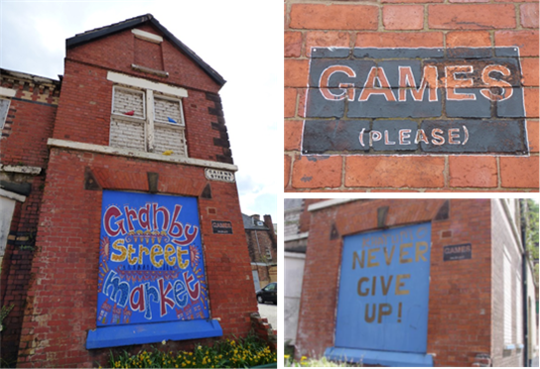
Figure 7: resisting the symbolic violence of abstract space (source: author’s own)

In direct response to the bricking up of ‘voids’, residents subverted these images of violence through artistic expression – colourful pigeons perched on window ledges to brighten up the bleak view; pointing to an alternative vision of new life emerging out of the cracks of abstract space. They also boarded over some of the more prominent window infills, emblazoning them with messages of hope, resilience and play (figure 7). These symbols hint at the creative use of public space and acts of ‘commoning’ going on in Granby (Thompson 2015). Encouraging collective encounter, festivity and the carnivalesque, they are tentative micro-expressions of the jouissance of differential space (Merrifield 1995).

Granby CLT: finishing the work that SNAP started
Since 2011, a loose alliance of social space-makers – resident-activists, social financiers and radical architects – has formed around the shared vision of establishing a Community Land Trust (CLT), as an institutional vehicle to drive forward community-led rehabilitation rather than demolition, for the common ownership of land and democratic management of perpetually affordable homes for local people. This has grown organically from a guerrilla gardening project transforming the dereliction into a public street garden, host to a popular monthly street market. Such creative re-appropriation of neglected land for community use are attempts to reclaim social space from the abstract space of comprehensive redevelopment – forms of ‘commoning’ that work between the legal and spatial boundaries of abstract space to re-imagine and perform social space (Thompson 2015).
The CLT has recently been successful in acquiring 10 properties from the council, with their vision for the entire neighbourhood adopted by development partners, Plus Dane and Liverpool Mutual Homes. The complex and contradictory struggle to develop the CLT – to secure community mandate, find funding, convince the council to transfer public assets, and develop designs – has been documented in detail elsewhere (Thompson 2015). Of interest here are the continuities and parallels between the CLT campaign and SNAP, which maps directly onto and first saved the Granby Four Streets from demolition. Both spearheaded a radically participatory, hands-on, immersive and holistic approach to neighbourhood regeneration. Building on the SNAP idea for an onsite office, the CLT’s architects – a collective of do-it-yourself innovators from London, called Assemble – have been living with the community in a CLT-owned house whilst they work with residents to complete the renovations. With such obvious spatial, ideological and historical connections, it is no wonder that leading CLT activists have begun reading the original SNAP report (McConaghy 1972) as a rich repository of historical evidence and source of inspiration. Positioning the CLT as its contemporary heir, they believe they are “finishing the work that SNAP started” (Interview, 2015).
And just like SNAP, the CLT is riven with contradictions. In 2015, Granby CLT became the first ever community-led housing project, and Assemble the first ever architectural design studio, to win or indeed be nominated for the national art award (Thompson 2016). This has brought a huge amount of unexpected publicity upon which Assemble and CLT activists have capitalised, starting a social enterprise, the Granby Workshop (figure 8). This specialises in the very business of the regeneration process, employing some 14 local people with paid positions to design and make furniture, housing fixtures and architectural features, using reclaimed materials recycled from the CLT houses (Thompson 2016). Whilst pointing in a promising new direction for the neighbourhood –creating much-needed economic activity, whose surpluses will largely be reinvested in further regeneration – this also highlights the dependency of social space on abstract spaces of global exchange: The Granby Workshop is selling products around the world on the back of its Turner Prize fame, thereby commodifying the project, even the neighbourhood itself.

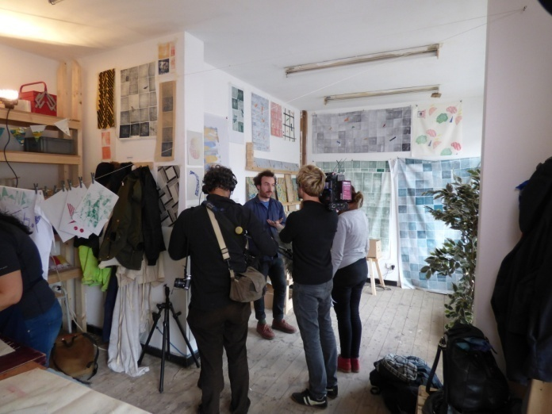
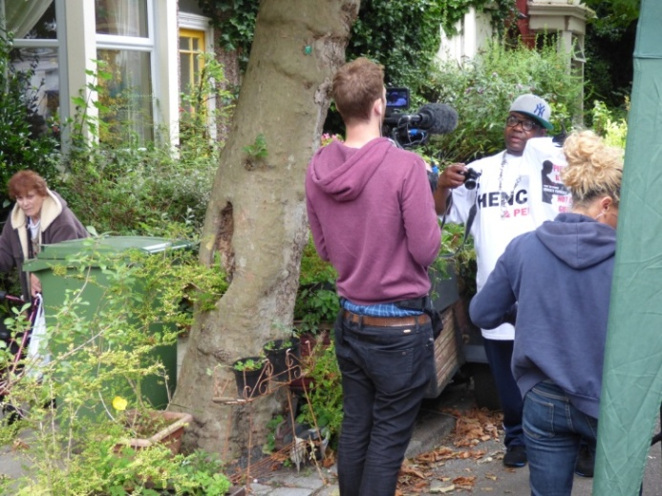
Granby has in many ways become a zoo once more – though a different kind of zoo: a Debordian ‘spectacle’. Indeed, the neighbourhood is at risk of being repackaged for consumption by gentrifiers, tourists, and international researchers; residents have long complained of ‘researcher fatigue’. Most recently, Granby has won more attention as a finalist in the 2016 UN-BHSF World Habitat Awards. This process of being plugged into gobal circuits of (cultural) capital was accelerated by the Turner Prize victory. The question remains whether all those residents left outside of the limelight cast by Assemble feel quite so victorious? When not so long ago it was unthinkable to residents, there is now the very real prospect of gentrification, whereby a colonising group of design professionals recreate the habitus of the neighbourhood in their own image. The true promise, therefore, of the CLT model – as a performative tool of social space – is to mitigate against this risk with institutional covenants to protect affordable housing for local people in perpetuity, made accountable by democratic governance. How well this works in practice remains to be seen.
Figure 8: Assemble member, Lewis, being interviewed by a German film crew in the Granby Workshop (left); and Leroy Cooper, a well-known longstanding Granby resident likewise caught on camera at a Cairns Street Market (right).

Conclusion: disentangling the (social) production of (abstract) space
This article has shown how the LIFE and ZOO models had ‘performative’, and violent, impacts on Granby’s urban environment and inhabitants, just as Christophers (2014) and Aalbers (2014) have demonstrated for planning policies elsewhere. The abstract logic of these programmes materialised in monolithic development zones, the destruction of architecturally-valuable housing, the Target Hardening and breeze-blocking of voids delivered through the ‘Living Through Hell’ programme – yet also spurred some residents on towards alternative spatial projects. These anti-demolition activists are now beginning to ‘perform’ a new kind of social space, by utilising the language and tools of abstraction – masterplans, business plans, costings, building models – to convince gatekeepers, notably the council and national funding bodies, of the viability and legitimacy of community ownership via the CLT. But the ways in which abstract tools are used in each approach differs markedly: whilst HMR bricks up and suffocates social space with concrete abstractions – sometimes quite literally – CLT campaigners are working in, with and against abstract space to build a more convivial space based on use values.
Although Lefebvre (1991), and by extension Aalbers (2006, 2014), provides a neat heuristic of ideal-type actors in the production of space, this historical case illustrates how social reality is far more complex and contradictory than this simple opposition between abstract and social, conceived and lived, space suggests. The struggle between these two visions is always unfinished, open-ended and complex; reproducing space and creating new conditions for different spatial projects, in ways which clash, cooperate or interlock to produce unexpected results – what Melanie Lombard (2014) describes as ‘entanglements’ of power. We might, then, elaborate Madden’s (2014) notion of neighbourhood as an unfinished spatial project by emphasising the messy and contradictory crossovers and combinations between various interest groups, with finely shaded orientations towards abstract and social space, each containing potentials for the other.
In showing how HMR, and the post-war comprehensive redevelopment that preceded it, embodied and violently enacted abstract space, I do not mean to imply that the direct and symbolic violence incurred in Granby was intentionally directed or consciously performed by policy-makers and development actors. I simply suggest that the ‘analytic spirit’ through which these policies were conceived and operated had violent implications: that, pace Lefebvre and by extension Wilson (2013), this violence is an intrinsic facet of abstraction, but which is reproduced by social space-makers too. Seeing the issue as one of the dominance of abstract space, and the insidious logic of abstraction working its way through the models, plans and approaches of abstract and social space-makers alike – albeit more predominant in the former – allows us to move on from a crude ‘blame game’ towards understanding the complex systemic processes and often perverse incentive structures influencing individual actions at work in the production of neighbourhood.
In this light, often counterintuitive outcomes can be seen to result from the decisions of well-intentioned projects aiming for inclusive and participatory social space. We can see this (social) production of (abstract) space in the SNAP Task Force’s bollarding off Granby, cutting vital through-flow sustaining the neighbourhood. The social space-making of SNAP, then, has had both progressive and regressive effects on the production of space: saving Granby from demolition; initiating the co-op movement; inspiring new democratic planning practices among local housing associations; sowing seeds for the CLT vision – but also contributing to the area’s isolation and socioeconomic decline. We can also see this in the genesis of the monolithic logic of ZOOs in the LIFE model, whose roots in turn can be traced back to SNAP and to the Liberal Council’s GIA zones for rehabilitation, which helped bring Liverpool’s housing co-op movement as well as the LIFE model into being. Successful resistance against successive regeneration programmes inspired by SNAP created a deadlock in decision-making and provoked more extreme state-led solutions. This reveals how progressive spatial projects can, through myriad historical connections, inadvertently contribute to the expansion of abstract space.
Lastly, the social space produced by the Granby CLT spatial project – for all its achievements in eschewing the monolithic and technocratic abstraction of comprehensive redevelopment for a more experimental, democratic, holistic and socially-responsive approach – is nonetheless implicated in the production of abstract space. The ZOO of HMR has been replaced by a different kind of zoo – a ‘spectacle’ of media-friendly arts-led regeneration, inserting Granby into global circuits of cultural consumption. Granby’s sister and Liverpool’s only other successful CLT project to date, Homebaked in Anfield, mirrors this trend – driven by artists from the get-go, and funded by the Liverpool Biennial arts festival – raising problematic questions around the role of art, cultural capital and social class in regeneration. In constructing these spaces as art works to be collectively crafted, experienced and then consumed in popular, architectural and academic press, do we not risk aestheticising political issues; demeaning the long hard struggle of social space-making; fetishising as a product the deeply-embedded social process of regeneration? In reifying these projects as outstanding one-of-a-kind artistic creations, do we not place them in a bubble of exception, depoliticising their power to contest abstract space by boxing them off as unthreatening spectacles? Their categorisation as ‘art’ certainly problematises identification as progressive social space – progressive for who exactly?
Invited to write in a special edition of Liverpool Biennial’s online journal, Don Mitchell (2014, 5) situates Homebaked CLT – equally applicable to Granby – alongside May 1968 and Occupy, within the radical tradition of urban occupation and anti-capitalist struggle. He suggests that “Homebaked [CLT] and Co-operative Bakery Anfield are just as thrilling as the example of the neighbourhood park forums that developed across Turkey after Taksim Square was cleared out” because they
Show that urban space can be collectively taken and collectively remade, that use can dominate exchange, that our fate is not necessarily a fate written by the tendency towards abstract space in capitalism.
Mitchell sees projects like Homebaked and Granby CLT as oppositional to abstract space, and believes the trick to undermining its dominance lies not with confrontational power, as classical Marxists hold, but rather through a kind of anti-power, slowly revealing the true source of its energy, the labour of the multitude:
But here’s the secret: [...] the tendency towards abstract space, requires an enormous amount of work, both to push it forward and to maintain the actual space – the exchangeable space – that results. [...] Any system so reliant on the labour of multitudes in order to support an image of naturalness is eminently interruptible.
Mitchell’s insight cuts both ways: social space is incredibly difficult to develop and sustain, and perhaps even more dependent than abstract space on the energies of the multitude for its sustenance. Social space must be actively produced and renewed by participants through intensive engagement, and is always at risk of slippage into, appropriation or co-optation by abstraction. Whilst abstract space has the benefit of systemic momentum on its side, social space-makers must campaign all the more vigorously to create spaces for use rather than accumulation or disciplinary regulation. Such a perspective on power – incremental, immanent change through slowly expanding the use values and social practices rather than confronting abstract space directly – indeed resonates with the ethos of SNAP and Granby CLT. Like other critical commentaries on the subject, however, this paints a particularly bipolar vision of abstract and social space: as if withdrawing our labour from the former will automatically generate the latter, or vice versa; that promoting social space will necessarily destroy abstract space by encroaching directly into its domain, through direct ‘appropriation’. If I have shown anything here it is to emphasise the more complex dialectical relationship between these two aspects in Lefebvre’s (1991, 52) theory of the production of space: that “abstract space carries within itself the seeds of a new kind of space”, but that, likewise, if we are not careful, social space gives birth to abstraction.

References
Aalbers, Manuel. 2006. “‘When the Banks Withdraw, Slum Landlords Take Over’: The Structuration of Neighbourhood Decline through Redlining, Drug Dealing, Speculation and Immigrant Exploitation.” Urban Studies 43 (7): 1061–86.
———. 2014. “Do Maps Make Geography? Part 1: Redlining, Planned Shrinkage, and the Places of Decline.” ACME: An International E-Journal for Critical Geographies 13 (4): 525–56.
Allen, Chris. 2008. Housing Market Renewal and Social Class. Routledge.
Beckett, Andy. 2015. Promised You A Miracle: UK 80-82. Penguin Books.
Butler, Chris. 2005. “Reading the Production of Suburbia in Post-War Australia.” Law Text Cuture 9: 11–33.
Cocks, Matthew, and Chris Couch. 2012. “The Governance of a Shrinking City: Housing Renewal in the Liverpool Conurbation, UK.” International Planning Studies 17 (3): 277–301.
Cole, Ian. 2012. “Housing Market Renewal and Demolition in England in the 2000s: The Governance of ‘Wicked Problems.’” International Journal of Housing Policy 12 (3): 347–66.
Duffy, Tom. 2011. “Peaceful Protest on Toxteth Street Forces Demolition Men to down Tools.” Liverpool Echo, July 12. http://www.liverpoolecho.co.uk/news/liverpool-news/peaceful-protest-toxteth-street-forces-3369896.
Ellis, Hugh, and Kate Henderson. 2013. Planning Out Poverty: The Reinvention of Social Town Planning. Town and Country Planning Association.
Hodkinson, Stuart. 2012. “The New Urban Enclosures.” City: Analysis of Urban Trends, Culture, Theory, Policy, Action 16 (5): 500–518.
Holmes, Christopher. 2005. A New Vision for Housing. Routledge.
Hook, Michael. 1970. “SNAP: Toxteth, Liverpool.” Architects’ Journal 10th June.
Hughes, Ronnie. 2015. “The Bollards of Liverpool 8.” A Sense of Place. https://asenseofplaceblog.wordpress.com/.
Inside Housing Awards. 2004. “Good Practice in Partnership Working: Liverpool Strategic Housing Partnership for the LIFE Model.” Inside Housing, November 12.
Jameson, Fredric. 2015. “The Aesthetics of Singularity.” New Left Review 92 (March/April): 101–32.
Jones, Katherine, and Jeff Popke. 2013. “Re-Envisioning the City: Lefebvre, HOPE VI, and the Neoliberalization of Urban Space.” Urban Geography 31 (1): 114–33.
Lane, Tony. 1997. Liverpool: City of the Sea. 2nd ed. Liverpool University Press.
Leary, Michael Edema. 2013. “A Lefebvrian Analysis of the Production of Glorious, Gruesome Public Space in Manchester.” Progress in Planning 85: 1–52.
Lefebvre, Henri. 1991. The Production of Space. Blackwell.
———. 1995. Writings on Cities. Wiley-Blackwell.
———. 2002. Critique of Everyday Life, Volume II. Verso.
Liverpool City Council. 2003. Strategic Integrated Investment Framework. Merseyside Housing Market Renewal Pathfinder.
———. 2007. Housing Market Renewal in Liverpool Annual Report 2006/07. Liverpool City Council.
Lombard, Melanie. 2014. “Constructing Ordinary Places: Place-Making in Urban Informal Settlements in Mexico.” Progress in Planning 94 (November): 1–53.
Madden, David. 2014. “Neighborhood as Spatial Project: Making the Urban Order on the Downtown Brooklyn Waterfront.” International Journal of Urban and Regional Research 38 (2): 471–97.
McConaghy, Des. 1972. Another Chance for Cities: SNAP 69-72. Liverpool: Shelter Neighbourhood Action Project.
Merrifield, Andy. 1995. “Lefebvre, Anti-Logos and Nietzsche: An Alternative Reading of The Production of Space.” Antipode 27 (3): 294–303.
———. 1996. “Social Justice and Communities of Difference: A Snapshot from Liverpool.” In The Urbanization of Injustice, edited by Andy Merrifield and Erik Swyngedouw, 256–85. New York University Press.
———. 2002. “Them and Us: Rebuilding the Ruins in Liverpool.” In Dialectical Urbanism, 53–73. Monthly Review Press.
———. 2013. The Politics of the Encounter: Urban Theory and Protest Under Planetary Urbanization. University of Georgia Press.
Merseyside Socialist Research Group. 1980. Merseyside in Crisis. Manchester Free Press.
Mitchell, Don. 2014. “Taking Space.” Stages: Liverpool Biennial #2 (Homebaked: the perfect recipe). http://www.biennial.com/journal.
Nevin, Brendan, Peter Lee, Jenny Phillimore, Alex Burfitt, and Lisa Goodson. 1999. Measuring the Sustainability of Neighbourhoods in Liverpool. Centre for Urban and Regional Studies The University of Birmingham.
Pierce, Joseph, and Deborah Martin. 2015. “Placing Lefebvre.” Antipode 47 (5): 1279–1299.
Schulze Bäing, Andreas. 2014. The Welsh Streets: A Written Statement to the Welsh Streets Inquiry. University of Liverpool.
Stanek, Łukasz. 2008. “Space as Concrete Abstraction: Hegel, Marx, and Modern Urbanism in Henri Lefebvre.” In Space, Difference, Everyday Life: Reading Henri Lefebvre, edited by Kanishka Goonewardena, Stefan Kipfer, Richard Milgrom, and Christian Schmid. Routledge.
Stewart, Gary. 2011. “Anger as Toxteth Granby Triangle House ‘damaged’ by Contractors.” Liverpool Echo, September 29. http://www.liverpoolecho.co.uk/news/liverpool-news/anger-toxteth-granby-triangle-house-3366443.
Sykes, Olivier, Jonathan Brown, Matthew Cocks, David Shaw, and Chris Couch. 2013. “A City Profile of Liverpool.” Cities 35: 299–318.
Thompson, Matthew. 2015. “Between Boundaries: From Commoning and Guerrilla Gardening to Community Land Trust Development in Liverpool.” Antipode 47 (4): 1021–1042.
———. 2016. “Why the Turner Prize Isn’t Enough to Resolve a Housing Crisis.” Town and Country Planning 85 (6 (June)): 221–28.
Webb, David. 2012. “Conceptualising the Bounded Agency of Housing Researchers: The Case of Housing Market Renewal in England.” International Journal of Housing Policy 12 (3): 315–30.
Wilson, Japhy. 2013a. “‘The Devastating Conquest of the Lived by the Conceived’: The Concept of Abstract Space in the Work of Henri Lefebvre.” Space and Culture 16 (3): 364–80.
———. 2013b. “The Violence of Abstract Space: Contested Regional Developments in Southern Mexico.” International Journal of Urban and Regional Research 38 (2).

