Running head: Fleas of Cats and Dogs

Fleas infesting cats and dogs in Great Britain: spatial distribution of infestation risk and its relation to treatment

AMBER-ROSE COOPER¹, EMILY NIXON¹, HANNAH ROSE VINEER², SWAID ABDULLAH³, HANNAH NEWBURY⁴ and RICHARD WALL¹

¹School of Biological Sciences, University of Bristol, Bristol, UK, ²Department of Infection and Microbiome, Institute of Infection, Veterinary and Ecological Sciences, University of Liverpool, Liverpool, UK, ³School of Veterinary Science, University of Queensland, Australia, ⁴MSD Animal Health, Walton Manor, Milton Keynes, UK

Abstract. The spatial pattern of flea (Siphonaptera: Pulicidae) infestation risk in cats and dogs across Great Britain is quantified, using data collected from a national survey undertaken in 2018, with particular attention given to the association between insecticidal treatment and infestation risk. Flea infestation risk declined significantly from south to north. None of the factors: pet breed, sex, neutered status, or whether the pet had been abroad, showed any relationship with the underlying geographic distribution, which is most likely to be associated with climatic factors. However, overall, only 23.6% of the cats and 35% of the dogs inspected had been treated with identifiable flea products that were still ‘in date’ at the point of inspection. The percentage of owners treating their pet broadly followed infestation risk. The insecticide fipronil is a common active in a wide range of flea treatments and was the most frequently applied insecticide class, particularly in cats. However, 62% of cats and 45% of dogs that had been treated with a fipronil-based product that was ‘in date’ at the point of inspection still had fleas. Persistent flea infestation is likely to be due to a range of factors, including compliance and application failure, but the data provide strong inferential evidence for a lack of efficacy of fipronil-based products. Given the ubiquity of flea infestation, this finding and the relatively low-level of treatment compliance, highlight a clear need for greater owner education about the importance of flea management and a better understanding of the efficacy of different products.

Keywords. climate, Ctenocephalides, efficacy, fipronil, infestation, insecticide,

Correspondence: Amber-Rose Cooper, School of Biological Sciences, University of Bristol, 24 Tyndall Avenue, Bristol, BS8 1TQ, UK. Tel.: +441179341205; E-mail: ac16246@bristol.ac.uk
Introduction
Fleas, particularly the cat flea, Ctenocephalides felis, are the most abundant ectoparasites of cats and dogs worldwide (Kristensen et al., 1978; Rust and Dryden, 1997; Rust, 2017). In addition to the irritation, blood loss and transmission of infectious disease agents associated with biting, blood-feeding may trigger a severe allergic dermatitis in sensitised hosts. Flea allergic dermatitis is one of the most important dermatological conditions seen in small animal veterinary practice (Hill et al., 2006). In addition to their clinical importance, fleas are of concern because they can be vectors of zoonotic pathogens, such as Bartonella spp. (Abdullah et al., 2019) and Rickettsia felis (Abdullah et al., 2020). The management of flea infestations is particularly intractable because flea species are rarely host specific; some clades of flea are associated with particular types of host although this may be derived as much from specific patterns of habitat-use as host-specificity (Whiting et al., 2008). In general, hosts that are taxonomically related or are similar in their ecology are likely to share flea species (Iannino et al., 2017). The fact that C. felis will feed on cat and dog hosts in the domestic environment (Beresford-Jones, 1981; Chesney, 1995) and may also be maintained in reservoir populations by wildlife, contribute to its ubiquity and persistence (Rust, 2017).
Despite the clinical importance of Ctenocephalides fleas, true prevalence estimates for flea infestation are relatively rare because they necessitate large-scale and randomised sampling, which requires extensive recruitment of pets and owners. Most studies are relatively localised and look at the species diversity or intensity of infection found on animals known to be infested (Baker & Hatch, 1972; Beresford-Jones, 1981; Baker & Mulcahy, 1986; Chesney, 1995). For example, in the UK, Clarke (1999) examined fleas on cats and dogs from central England between September 1995 and February 1996; 257 randomly selected dogs and 126 cats of mixed breed, sex and age were sampled and examined. A total of 138 fleas were recovered, of which 133 (96.4%) were C. felis, infesting 8% of dogs and 20% of cats (Clarke, 1999). In contrast, a larger scale survey recruited 31 veterinary practices to obtain evidence of flea infestations and dermatological lesions potentially associated with them. During a single week in July 2005, 2653 dogs and 1508 cats were examined for evidence of flea infestation. This showed that 21% of the cats and 7% of dogs were infested (Bond et al., 2007). Skin lesions compatible with FAD were present in 8% of the cats and 3% of the dogs. Of the fleas collected, 99% were the cat flea, C. felis. Interestingly, almost half of the owners of the dogs and cats were unaware of their pet's flea infestation. At a national level, in a recent survey in the UK, 326 veterinary practices were asked to follow a standardised flea inspection protocol on a randomised selection of cats and dogs between April and June 2018 (Abdullah et al., 2019). In total, 812 cats and 662 dogs were examined and, overall, 28.1% of the cats and 14.4% of the dogs were flea infested. More than 90% of the fleas on both cats and dogs were the cat flea, C. felis and 11% of samples were positive for Bartonella spp., while 3% were positive for Dipylidium caninum (Abdullah et al., 2019). Consideration of the spatial patterns within flea prevalence data could provide important insights into the factors that drive infestation risk. As a result, here, the spatial pattern of flea infestation across Great Britain are considered, with particular attention given to the role that differential patterns of insecticide treatment may have on infestation prevalence.

Methods
This study used data collected in a national UK survey undertaken in 2018; it has been described in detail by Abdullah et al. (2019). In brief: the nationwide campaign was instigated in March 2018 with the recruitment of veterinary practices. Practices that registered an interest in participating were sent a kit, consisting of an inspection protocol, questionnaires, envelopes, sealable polythene bags and flea combs. The protocol instructed veterinary practitioners to select 5 cats and 5 dogs per week at random for four weeks. The randomisation procedure to be adopted was not specified, however, veterinarians were asked to undertake flea inspections for animals where the infestation status was unknown, for example when giving booster injections, routine operations, or when offering free flea checks or at other routine nurse clinics. Each flea check was done using a dampened flea comb. The pet was combed for a maximum of 5 min, focusing attention on the parts of the body most likely to harbour fleas: the lower back, tail-head, and posterior and inner thighs. The dampened comb increased the probability of fleas sticking to the comb-teeth long enough to allow capture. At the end of the grooming process, the entire comb was placed in plastic sample bag and sealed. The bag was sent to the University of Bristol where the presence of fleas and the species present were identified using recognised morphological identification features (Beacournu & Launay, 1990).
Veterinarians were asked to complete a questionnaire for each animal regardless of whether fleas were found or not, recording the owner address, pet species, breed, sex, neutered status, presence and abundance of fleas, whether the pet had been abroad in the previous two weeks and its insecticidal treatment history. Veterinarians could print and post the questionnaires or submit them online. Questionnaire data were entered into Microsoft Excel spreadsheet.

The distribution of flea infestation
To consider the spatial distribution of flea infestation risk, the deviation of the spatial distribution of the questionnaire respondents from complete spatial randomness (CSR), was estimated using the G-function and significance envelope based on Monte Carlo simulation with 100 repeats, using the Gest and envelope functions from the R package “spatstat” (Baddeley et al., 2015), with R version 3.6.1 (R Core Team, 2019).
The spatial distribution of flea cases in cats and dogs separately across Great Britain
were investigated and areas (“hotspots”) identified where there was a higher density of cases than would be expected in complete spatial randomness (taking into account the underlying distribution of cases and controls). Co-ordinates of pet owners’ homes were used in the spatial analysis as cases (where fleas were reported in the questionnaire) and controls (where fleas were not reported in the questionnaire). For cases and controls separately, cross validation was used to select a smoothing bandwidth for the kernel estimation of point process intensity using the method of Berman and Diggle (1989), with the R package “spatstat” (Baddeley et al., 2015). The risk function from the “sparr” package (Davies et al., 2018) was used to estimate A natural log transformed relative risk function based on the ratio of the 2D kernel density estimates of the cases and controls. The bandwidth factors had a pooled symmetry with respect to cases and controls, with adaptive smoothing and Diggle edge correction (Davies et al., 2018). Asymptotic tolerance contours were plotted using the tol.contour function from the “sparr” package (Davies et al., 2018), with the P values indicating the statistical significance of elevated risk. Spatial results were overlaid on to a shapefile provided by Ordnance Survey Open Data (GB boundary line regional level) which was read into R using the readOGR function from the “rgdal” package and then transformed into “spatstat” format using the as function from the “sf” package (Pebesma, 2018). In addition to the relative risk analysis, SatScanTM version 9.6 was used to identify significant spatial clustering using a Bernoulli model (Kulldorff, 1997). A maximum cluster radius of 100km was set to avoid inappropriately large clusters. Using multiple models for spatial risk assessment allows for areas of uncertainty to be identified, and for reciprocal model validation.

Effects of treatment on flea infestation
Among the questions relating to treatment history, owners were asked whether their animal was being treated for fleas, which product their animal was treated with and when it was last treated. In most cases this allowed animals to be placed into one of three categories: treated ‘in date’, treated ‘out of date’ or untreated. Animals were classified as treated ‘in date’ if, at the point of inspection, they had been treated within the product label claim period of efficacy. Untreated animals were those that did not receive any insecticidal protection. However, in addition, if an owner claimed that the animal was ‘treated’, but the period of active protection of the last treatment given had expired 3 months or more prior to the inspection date, regardless of the product used, the animal was also classified as untreated since it was considered as not being engaged in any regular treatment programme (Dryden et al., 2000). Animals that had been treated previously, but the label claim period of efficacy had expired within the last three months, were classified as treated but ‘out of date’. In a small number of cases, the answer was too vague to allow the active compound used to be identified (e.g. “supermarket product”) and these animals were excluded from this analysis.
To investigate whether any of the factors: pet breed, sex, neutered status, or whether the pet had been abroad, showed any relationship with the underlying geographic distribution of flea infestation risk factors, the data were split into four distinct geographical regions based on the co-ordinates of the pet owners’ homes. Co-ordinates located north of the Scottish border were grouped as Scotland. The remaining cases from England, Wales and the Isle of Man were split by latitude into three groups with approximately even numbers of cases: latitudes up to and including 51.52 were considered as the South, latitudes up to 53.18 were classified into a central group, and the remaining latitudes up to the Scottish border were defined as the North. Chi square analysis was then used to examine differences in the proportion of infested animals between these regions or differences between treatment types used.

Results
Spatial distribution of flea infestation risk
The locations of pet owners responding to the questionnaire were not distributed evenly across Great Britain. Significant clustering and deviation from complete spatial randomness of the locations of cat owners were found at distances less than ~18km and at distances less than ~20km for dog owners, as demonstrated by the G function estimate. For animals where at least a partially competed case history was submitted, 228 of the 812 cats (28%) and 95 of the 662 dogs (14%) were infested with fleas, with the relative infestation risk generally declining from south to north across Great Britain (Fig. 1) and areas of significantly higher risk being present for cats in central Wales and the Welsh borders, as shown by tolerance contours (Fig. 1A). This is supported by the SatScanTM Bernoulli model, which predicted that cats in central Wales and the Welsh borders are twice as likely to have fleas than elsewhere in Great Britain (Table 1). On dogs, the relative risk of fleas being present was significantly higher in North Wales, the North Wales borders, South Wales and South West England (Fig. 1B). This is supported by corresponding significant SatScan™ clusters; one identified across the North Wales border and another in South Wales and South West England, where dogs were 3 and 4.5 times more likely to have fleas than elsewhere in Great Britain, respectively (Table 1). Both spatial modelling methods (relative risk analysis and SatScan™ were in agreement, indicating no areas of elevated uncertainty in the risk assessment.

Treatment patterns
None of the factors: pet breed, sex, neutered status, or whether the pet had been abroad, showed any relationship with the underlying geographic distribution of flea infestation risk, as determined by Chi-square analysis (P>0.1). In total, for cats 808 questionnaires were completed with information relating to treatment (75 from Scotland, 227 from northern England, 255 from Wales and central England, and 251 from southern England) and for dogs 658 contained treatment information (59 from Scotland, 215 from northern England, 190 from Wales and Central England, and 194 from southern England). For cats, 52.6% (n=425) and for dogs 38.6% (n= 253) received no flea treatment (Fig. 2). There was a significant regional pattern in treatment for cats: the percentage of animals treated was lowest in Scotland and highest in southern England (χ²=10.4, d.f. = 3, P=0.02). However, for dogs, while the underlying regional trend was similar, the differences were not significant (χ²=6.37, d. f. = 3, P=0.1).
Only 23.6% (n=191) of the cats and 35% (n=231) of the dogs had been treated with flea products that were still ‘in date’ at the point of inspection. There were significant regional variations in the percentage of animals with ‘in date’ treatments for cats (Fig. 2A) but not dogs (Fig. 2B). For cats, a significantly higher number of animals had ‘in date’ treatments in southern England than other regions (χ²=12.94, d. f. = 3, P=0.02). However, for dogs there was no significant overall regional pattern (χ²=4.26, d. f. = 3, P=0.1).

Effects of treatment on flea infestation
For infested cats 92% carried the cat flea C.f. felis and 1.3% the dog flea C. canis; for infested dogs, 90% were infested by cat fleas, 3% by dog fleas. The remaining animals were infested by rabbit, bird or hedgehog fleas (Abdullah et al., 2019). For the analysis of insecticidal treatment, animals infested by C. felis and C. canis were not distinguished because of the similar aetiology of infection and the fact that most product label claims cover both species. The small number of animals infested by other flea species were excluded. For analysis of the effects of treatment, proprietary commercial products were categorised on the basis of their primary active insecticidal class. There was no consistent regional difference in the patterns of active insecticide class used for treatment, so regions are pooled for analysis here. For cats, 47% (n=154) of owners said that they used a fipronil-based product (Fig. 3A) which was a significantly greater number than for any other treatment-class (χ²=240.5, d. f. = 3, P<0.001). Fluralaner and imidacaloprid-based products were used by 13% and 19% of cat owners, respectively, and indoxocarb and selamectin-based products by 7% and 11%, respectively. Other product types applied to cats in low numbers and therefore pooled here, included lufenuron, nitenpyram, spinosad and unspecified ‘natural’ compounds (3.6%; n=12). There were no significant differences between insecticide classes in the proportion of animals with in-date applications (χ²=6.45, d. f. = 3, P>0.1). However, for cats treated with fipronil-based products that were ‘in date’, 61.9% (n=57) were still infested by fleas (Fig 3A). For cats treated with ‘in date’ fluralaner and imidacloprid-based products, 4.1% and 19.0% of the animals treated with these compounds (n=1 and n=8, respectively) were infested by fleas. Also, 30.7% (n = 13) and 36.8% (n = 19) of animals treated with ‘in date’ indoxocarb and selamectin-based products had fleas, respectively (Fig 3a). Flea infestation for animals with ‘in date’ fipronil-based treatment was significantly greater than for other treatment classes (χ²=24.1, d.o.f. = 3, P=0.01)
For dogs, there was no tendency for any one insecticide class to predominate, and fipronil, fluralaner and imidacloprid-based products were used on 26%, 25% and 34% (n=97, 93 and 126) of the animals, respectively (Fig. 3B). Afoxolaner and selamectin-based products were used by 9% and 4% of owners. Other insecticidal compounds used in small numbers and grouped here, included nitenpyram, pyriprole, sarolaner, Spinosad, and unspecified ‘natural’ compounds (n = 13, 3.5%; Fig. 3B). For the five main insecticide classes, 50.4% (n=49) of dogs treated with fipronil and 74% (n=69) of dogs treated with fluralaner had been treated with products that were ‘in date’ at the point of inspection; there were no significant differences between the insecticide classes in the numbers of animals with ‘in date’ applications (χ²=6.4, d.f. = 3, P>0.05). However, as was seen for cats, 44.9% (n= 49) of the dogs treated with fipronil-based products that were ‘in date’ at the point of inspection still had fleas. This was significantly greater than seen for fluralaner (1.4%), imidacloprid (15.7%), afoxolaner (4.1%) or selamectin (14.3%) treated animals (χ²=35.7, d. f. = 3, P<0.01) with the number of flea infested animals with ‘in date’ treatments being highest for fipronil-treated animals and lowest for fluralaner-treated animals.

Discussion
Flea infestation risk in cats and dogs in Great Britain shows statistically significant geographic variation, which is independent of the underlying uneven distribution of questionnaire responses; the highest infestation risks were observed in southern and central England and Wales, and the lowest infestation risk in Scotland. To attempt to explain this pattern a wide range of potential risk factors were explored. None of the factors: pet breed, sex, neutered status, or whether the pet had been abroad, showed any relationship with the underlying geographic distribution of flea infestation. However, consideration of treatment as a potential explanation for the spatial infestation-risk pattern revealed some important trends. Overall, only 23.6% of the cats and 35% of the dogs inspected had been treated with insecticidal flea products that were still ‘in date’ at the point of inspection. Given the ubiquity of flea infestation, this relatively low-level compliance is surprising and shows a clear need for greater owner education about the need for year-round flea treatment (Halos et al., 2014). The use of insecticidal treatment in cats appears to be related to the spatial risk pattern, with owners in Scotland (lower risk region) less likely to treat and less likely to have in-date treatments than owners in southern England (higher risk region). It is considered that this is likely to be a response to the perceived lower risk in more northerly latitudes rather than having any causative relationship. No similar significant pattern was observed in the dog treatment response, although a similar non-significant trend was evident in the data. There was no consistent regional difference in the patterns of insecticidal class used to prevent flea infestation.
From the results presented here therefore the reason for the observed spatial infestation-risk pattern cannot be determined. The survey considered on-animal treatment only, but there is no reason to suspect that consistent geographic differences in the use of environmental insecticide treatments or other indoor environmental conditions might be influencing the infestation pattern observed. The latitudinal infestation-risk gradient, therefore, strongly suggests that it is likely to be driven by climatic factors. The ability of C. felis to tolerate a wide range of environmental conditions contributes to the abundance and distribution of this species, however its development and mortality rates, like those of most insects, are highly sensitive to temperature and humidity. At 24°C and 75% relative humidity the duration of the three larval instars is about 1 week, but at 13°C and 75% relative humidity larval development takes about 5 weeks, although the larval cycle can take up to 200 days under more unfavourable conditions. Larvae will only survive at temperatures between about 13°C and 35°C and they are extremely susceptible to desiccation; mortality is high below 50% relative humidity and outdoors flea larvae cannot develop in arid areas exposed to the hot sun (Silverman & Rust, 1983). As a result, in the northern hemisphere, changing abundance generally shows a seasonal pattern with numbers increasing around late spring and early autumn when environmental conditions are favourable for larval development (Rinaldi et al., 2007). For example, in a study of 744 dogs from 79 localities in Spain temperature and rainfall were shown to strongly affect the flea abundance (Gracia et al., 2007): mean annual temperature was negatively correlated with the overall abundance of C. canis and Pulex irritans, but positively related to C. felis abundance. Similarly, flea infestations in domestic dogs in different regions of Iran were shown to be highest in areas of temperate climate with higher rainfall and this resulted in clear seasonal patterns with the highest infestation rates observed in August and the lowest in January (Tavassoli et al., 2010).
However, any effects of external climatic conditions on flea prevalence may be buffered because fleas are able to breed within buildings. Areas within a building with the necessary high humidity for egg and larval development are often limited but, where they do exist, along with an appropriate food source for larvae, they may allow fleas to survive and bite all year round independently of local climate (Clark, 1999). If flea populations in the UK were maintained largely indoors, the link between climate and prevalence would be expected to be weak. So, the significant spatial pattern observed here suggests that outdoor populations of fleas and outdoor sources of infection are likely to be significant. This also suggests that wildlife may play an important role in maintaining a reservoir of fleas for persistent reinfection of companion animals. Indeed it has been suggested that domestic cats and dogs may play a crucial role as bridging hosts for fleas of different wild animals, domestic animals and humans that they come into contact with during their host-seeking behaviour (Dobler & Pfeffer, 2011). As such, the spillover of parasites at the domestic animal - wildlife interface is a pervasive threat to animal health and this holds true for cat fleas in particular, being host-generalists infesting over 130 wildlife species (Clark et al., 2018). Hence, wildlife reservoirs for fleas in the UK may be an important reason for the persistence of apparently intractable flea infestations (Halos et al., 2014). Given the existence outdoor breeding populations of fleas in some areas, climate change might also be expected to have an important role in determining future infestation patterns. Future studies which consider the relationships between flea infestation in companion animals and outdoor behaviour, their contacts with wildlife in particular, might be valuable.
One particularly important finding from this study was that 62% of the cats and 45% of the dogs that had been treated with a fipronil-based product that was ‘in date’ at the point of inspection still had fleas. In cats 31% and 37% of animals treated with in-date Indoxocarb and selamectin-based products also had fleas, respectively. Clearly, to some degree, persistent flea infestation on treated animals is likely to be due to compliance and misapplication issues and this will vary with the ease with which owners can apply each product and its persistent efficacy. Fluralaner, for example, has a 12-week duration of efficacy and had the lowest level of flea infestation in treated animals. It is difficult to conceive why fipronil-based products might be associated with significantly higher compliance issues than other similar products although the availability of some products, such as fipronil, in a range of ‘over-the counter’ generic formulations may also be important, because it could be that owners who buy insecticides without veterinary advice are more likely to apply them incorrectly. In addition, it is acknowledged that pyrethroid resistance now appears to be widespread in flea populations, but it has been argued that despite their broad use since 1994, there is no evidence that resistance has developed to on-animal or oral treatments such as fipronil (Rust, 2017) and experimental studies have shown high levels of efficacy (Lebon et al., 2018). However, the data presented here, suggest that fipronil resistance in the fleas infesting companion animals is also possible. These two factors may indeed be causally related, since widely available ‘over the counter’ insecticides, bought and applied without professional advice, may be a contributory factor leading to selection for resistance.

Acknowledgements
We would like to thank Amanda Melvin and Daniel Guerrero of MSD Animal Health for their help and support throughout the flea collection process, and Megan Barstow, Anna Koi and Marina Metaxaki for laboratory assistance. The authors declare that they have no conflict of interest with regard to this manuscript.

Data Availability Statement
The data generated during the current study are not publicly available in accordance with the data protection act, but anonymised data are available from the corresponding author on request.

References
Abdullah S., Helps, C., Tasker, S., Newbury, H. & Wall, R. (2019) Flea-borne pathogens of cats and dogs. Parasites and Vectors, 12, 71.
Abdullah, S., Lait, P., Helps, C., Newbury, H. & Wall, R. (2020) The prevalence of Rickettsia felis DNA in fleas collected from cats and dogs in the UK. Veterinary Parasitology, DOI: 10.1016/j.vetpar.2020.109143
Baddeley, A.; Rubak, E. &Turner, R (2015) Spatial Point Patterns: Methodology and Applications with R. London: Chapman and Hall/CRC Press, London.
Baker, K.P. & Hatch, C. (1972) The species of fleas found on Dublin dogs. Veterinary Record, 91, 151-152.
Baker, K.P. & Mulcahy, R. (1986) Fleas on hedgehogs and dogs in the Dublin area. Veterinary Record, 199, 15-17.
Beacournu, J.C. & Launay, H. (1990) Les Puces de France et du Basin Mediterraneen Occidental. Faune de France, 76, Paris.
Beresford-Jones, W.P. (1981) The prevalence of fleas on dogs and cats in an area of central London. Journal of Small Animal Practice, 22, 27-29.
Berman, M. & Diggle, P. (1989) Estimating weighted integrals of the second-order intensity of a spatial point process. Journal of the Royal Statistical Society, Series B 51, 81–92.
Bond, R., Riddle, A., Mottram, L., Belignet, F. & Stevenson, R. (2007) Survey of flea infestation in dogs and cats in the United Kingdom during 2005. Veterinary Record, 160, 503-506.
Chesney, C.J. (1995) Flea species found on cats and dogs in South West England: further evidence of the polyxenous state, with implications for flea control. Veterinary Record, 136, 356-358
Clark, F.F. (1999) Prevalence of the cat flea Ctenocephalides felis and oocyte development during autumn and winter in Leicester City, U.K. Medical and Veterinary Entomology, 13, 217-218.
Clark, N.J., Seddon, J.M., Slapeta, J. & Wells, K. (2018) Parasite spread at the domestic animal - wildlife interface: anthropogenic habitat use, phylogeny and body mass drive risk of cat and dog flea (Ctenocephalides spp.) infestation in wild mammals. Parasites & Vectors, 11 (1).
Davies, T.M; Marshall, J. C. & Hazelton, M.L. (2018). Tutorial on kernel estimation of continuous spatial and spatiotemporal relative risk. Statistics in Medicine, 37, 1191-1221.
Dobler, G. & Pfeffer, M. (20111) Fleas as parasites of the family Canidae. Parasites & Vectors, 4(139).
Dryden, M.W. (1989) Biology of the cat flea, Ctenocephalides felis felis. Companion Animal Practice - Parasitology/Pathobiology, 19, 23-26.
Dryden, M. W., Denenberg, T. M. & Bunch, S. (2000). Control of fleas on naturally infested dogs and cats and in private residences with topical spot applications of fipronil or imidacloprid. Veterinary Parasitology, 93, 69-75.
Halos, L., Beugnet, F., Cardoso, L., Farkas, R., Franc, M., Guillot, J., Pfister K. & Wall, R. (2014). Flea control failure? Myths and realities. Trends in Parasitology, 30, 228-233.
Hill, P.B., Lo, A., Eden, C.A.N., Huntley, S., Morey, V., Ramsey, S., Richardson, C., Smith, D.J. Sutton, C., Taylor, M.D., Thorpe, E., Tidmarsh, R., & Williams, V. (2006) Survey of the prevalence, diagnosis and treatment of dermatological conditions in small animals in general practice. Veterinary Record, 158, 533-539
Iannino, F., Sulli, N., Maitino, A., Pascucci, I., Pampiglione, G. & Salucci, S. (2017) Fleas of dog and cat: species, biology and flea-borne diseases. Veterinaria Italiana, 53, 277-288
Kristensen, S., Haarlv, N. & Mourier, H. (1978) A study of skin diseases in dogs and cats. IV. Patterns of flea infestation in dogs and cats in Denmark. Nordisk Veterinaer Medicin, 30, 401-413.
Kulldorff, M. (1997) Bernoulli, discrete poisson and continuous poisson models. A spatial scan statistic. Communications in Statistics: Theory and Methods, 26, 1481-1496.
Gracia, M.J., Calvete, C., Estrada, R., Castillo, J.A., Peribáñez, M.A. & Lucientes, J. (2007) Fleas parasitizing domestic dogs in Spain. Veterinary Parasitology, 151, 312-319.
Lebon, W., Franc, M., Bouhsira, E., Lienard, E., Murray, M., Carithers, D. & Beugnet, F. (2018) Prevention of flea egg development in a simulated home environment by Frontline (R) Gold (fipronil, (S)-methoprene, pyriproxyfen) applied topically to cats. International Journal of Applied Research in Veterinary Medicine, 16, 74-80.
Ordnance Survey Open Data (2020) Order OS Open Data. https://www.ordnancesurvey.co.uk/opendatadownload/products.html. Accessed 17th April 2020.
Pebesma, E. (2018) Simple Features for R: Standardized Support for Spatial Vector Data. The R Journal, 10(1), 439–446.
R Core Team (2019) R: A language and environment for statistical computing. R Foundation for Statistical Computing, Vienna, Austria. https://www.R-project.org/.
Rinaldi, L., Spera, G., Musella, V., Carbone, S. Veneziano, V., Iori, A., Cringoli, G. (2007) A survey of fleas on dogs in southern Italy. Veterinary Parasitology, 148, 375-378.
Rust, M.K. & Dryden M.W. (1997) The biology, ecology, and management of the cat flea. Annual Review of Entomology, 42, 451-473.
Rust, M.K., (2017) The biology and ecology of cat fleas and advancements in their pest management: a review. Insects, 8, 118.
Silverman, J. & Rust, M. K. (1983). Some abiotic factors affecting the survival of the cat flea, Ctenocephalides felis (Siphonaptera: Pulicidae). Environmental Entomology, 12, 490-495.
Tavassoli, M. Ahmadi, A. Imani, A., Ahmadiara,E., Javadi, S. & Hadian, M. (2010) Survey of flea infestation in dogs in different geographical regions of Iran. Korean Journal of Parasitology, 48, 145–149.
Whiting, M.F., Whiting, A.S., Hastriter, M.W. & Dittmar, K. (2008) A molecular phylogeny of fleas (Insecta: Siphonaptera): origins and host associations. Cladistics, 24, 677-707.

Table 1. Cluster analysis: locations (Cartesian coordinates where x = Easting and y = Northing, British National Grid reference system) with the radius (m) of significant clusters of flea cases in Great Britain from April to June 2018 according to SatScanTM analysis, along with the number of respondents in the cluster, the number of flea infestation cases, the percentage prevalence and relative risk with P-value, for domestic cats and dogs.

Cluster | Cluster locations and radius (m) | Number of respondents | Number of flea infestation cases | Flea prevalence % | Relative risk | P-value
Cats
Central Wales and Welsh borders | x = 351206  y = 238233  Radius = 50889.78 | 14 | 14 | 100 | 2.16 | P < 0.01
Dogs
South Wales and South West England | x = 367213  y = 180295  Radius = 89505.42 | 52 | 31 | 59.6 | 3.04 | P < 0.001
North Wales border | x = 364573  y = 389038  Radius = 11090.37 | 7 | 7 | 100 | 4.56 | P < 0.05

Figure Legends

Fig 1. Relative infestation risk: natural log-transformed relative risk of 2D kernel density estimates for cases and controls of flea infestation in cats (A) and dogs(B) reported between April to June 2018. Lighter colours (yellow) indicate a greater relative risk. Tolerance contour lines are overlaid, with P values and areas with significantly higher risk (P < 0.05) indicated by the thicker contour lines. . Note the different scale for Figs 1A and 1B.

Fig 2. The percentage of cats (A) and dogs (B) where owners reported giving no flea treatment (black bars) and where owners reported that animals had been treated with an identifiable product that was ‘in date’ at the point of inspection (grey bars). Bars with 95% confidence intervals. Data for 4 regions of Great Britain, 1: Scotland, 2: northern England, 3: central England and Wales: 4 southern England.

Fig 3. The of owners who reported that their animal had been given a flea treatment with a particular insecticidal product class (black bars); the percentage of those treated with a particular insecticidal product class that was ‘in date’ at the point of animal inspection (white bars); the percentage of those with ‘in date’ treatments where fleas were found on the animal (grey bars) for cats (A) and dogs (B). Bars with 95% confidence intervals.

Fig 1

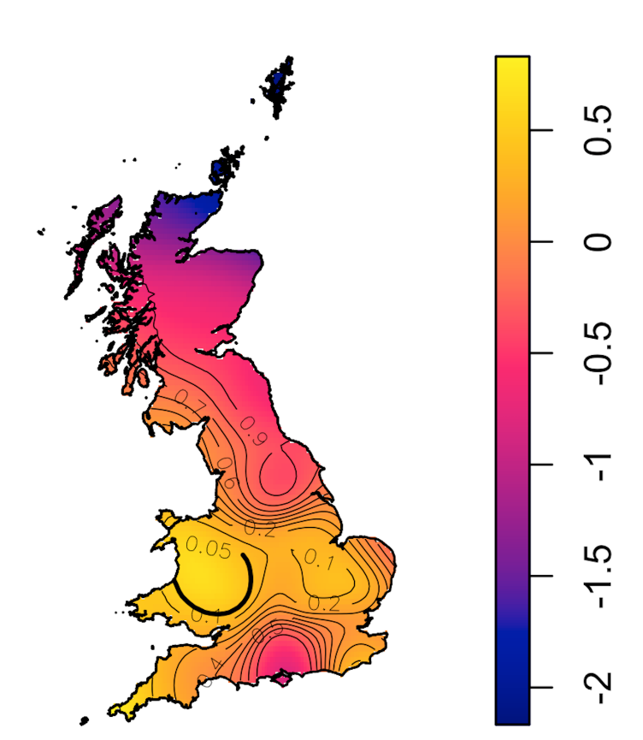
A

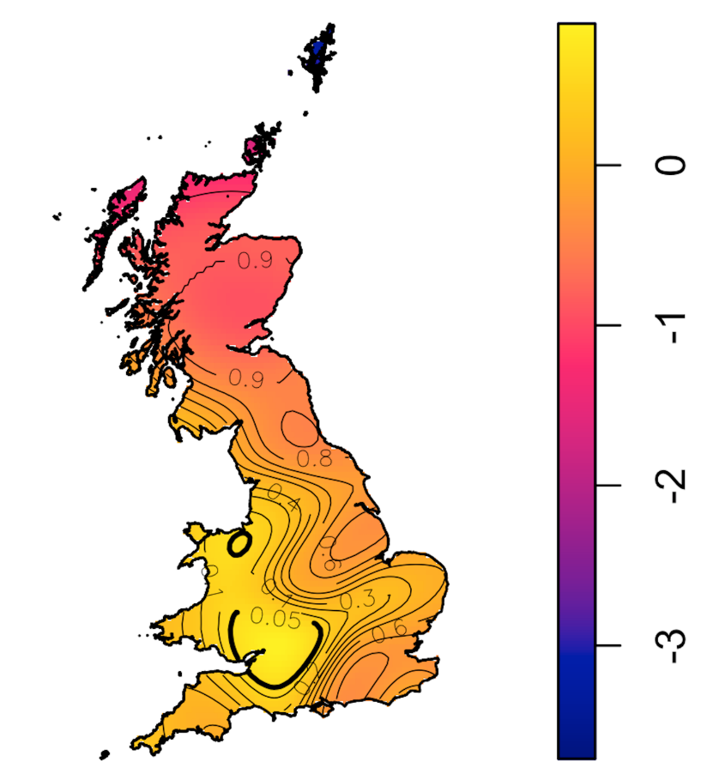
B

Fig 2

A
B

Fig 3

