Submission of Evidence on the Disproportionate Impact of Covid-19 on Grassroots Football:
An agenda to protect our game and communities.

Submitted by The Football Collective.
The Football Collective is the largest global network of football scholars that aims to bring critical debate and informed solutions to our game.

Author Information:
Dr Dan Parnell, University of Liverpool
Dr Daniel Fitzpatrick, Aston University
Dr David Cockayne, University of Liverpool
Dr Eleanor Drywood, University of Liverpool
Dr Paul Widdop, Manchester Metropolitan University

Summary
- The COVID-19 crisis provides the impetus to fundamentally reconsider the structure and priorities of English football. COVID-19 has revealed the fragile nature of the football ecosystem in England and the unsustainable business models that pervade the football pyramid. The key stakeholders in football need to re-think the relationship between professional football clubs, grassroots football and the wider community, given its significant economic and social contribution.

- Grassroots football is in decline. A return to play is not enough. This aspect of football requires significant investment to ensure quality experiences and participation goals are met. In England, grassroots or community football is not only the most popular sport, but it is also a significant contributor to economic, social and public health outcomes. COVID-19 could present a tipping point for an already declining grassroots game.

- Playing sport is a significant driver in the realisation of children’s rights and well-being. Football presents a unique opportunity in the lives of young people to improve their health, to access training and education, and to develop social capital. The removal of informal and more structured opportunities to play football, particularly at the grassroots, can have a significant detrimental effect on children’s mental and physical well-being, as well as impact resources embedded in social networks.

- Robust political leadership is urgently needed to protect grassroots football in the short term, to ensure its future sustainability. This moment of reflection also represents an opportunity to arrest the decline in the number and quality of playing surfaces due to central and local government mismanagement, which has been accelerated during the past decade of austerity.

Introduction
In this submission, we discuss why grassroots football (and particularly the vulnerable communities that rely on it) will be negatively affected by COVID-19. The centrality of football – in terms of the both professional football clubs and grassroots football – to people’s everyday lives has been brought into focus by the pandemic. But, to date, the response by government and the football authorities has privileged the narrow stratum of the elite professional game (i.e. the English Premier League [EPL]) to the detriment of other levels, notably grassroots football. In the short-term, the pandemic is likely to have a disproportionately negative impact on the physical and mental well-being of those adults and children in the most deprived communities in England.

The authors of this report have been researching the consequences of austerity for grassroots sport, with a particular focus on football in England, since 2010. Grassroots football constitutes a complex but delicate ecosystem of volunteers, private businesses, local authorities siting at the heart of communities around the country. We argue grassroots football, an important vehicle for delivering several public health outcomes, faces multiple challenges. The lack of an effective governance regime to protect and develop the infrastructure of grassroots football has left it in a perilous state. We express the need to fundamentally transform the governance and priorities of English football in order to save it.

- Inequalities in English Football

  - ‘Project Restart’ The widening gap between the wealth in the English Premier League and vast majority of the football pyramid has put into stark reality by the COVID-19 pandemic. It has exposed the great inequalities that exist within the professional game and unsustainable management practices that pervade its corporate governance. On 13th March 2020, the EPL was postponed and three days later, English football authorities also postponed all grassroots football. On the 27th March 2020, this decision evolved, and non-league football and grassroots football was confirmed as ‘null and void’ and are yet to have a confirmed full return-to-play date, at the same time many facilities and pitches have been left untouched during this period, degrading them further. The early postponement and accelerated return of the English Premier League demonstrates the preoccupation of the football authorities with the top level of men’s professional football, as well as gulf in resources between the elite and the rest of the English game. The media has also had an almost exclusive focus on the return of the men’s professional game, predominantly the EPL and Championship. The financial resources to provide the testing regime required for Project Restart has been the key factor in this discrepancy. The estimated weekly cost of £30,000 to test an average squad and backroom staff of 50 people three times per week is clearly beyond the means of most professional clubs. In this respect, COVID-19 has shown us that in addition to the clear chasm in financial might between the EPL (and to a lesser extent the Championship as its feeder league), the debate about Project Restart has also revealed the extent to which football in England is viewed by the media and the football authorities as an exercise in mass consumption rather than mass participation.

  - Trickle-Down Economics Despite the widespread rejection of trickle-down economics, there remains a belief within the football authorities that the accumulation of wealth at the top of the professional will naturally permeate down to the grassroots game. This flawed thinking has failed to arrest the decline of the grassroots game in times of plenty. The real prospect of a recession in football does not augur well for the rest of the football ecosystem. Intervention is needed to protect the grassroots game as the lifeblood of football. We propose the introduction of 5% levy of broadcasting rights on the EPL to be distributed to the grassroots.

  - Activity Gap While there have been some positives regarding COVID-19 and physical activity, such as reported increases in walking and cycling, there are major barriers facing the return of contact sports, such as football and rugby. The nature of the social distancing measures has seen the return of some amateur sports (such as golf and tennis) before football. Access to private golf courses and tennis clubs (many of which are insisting on annual membership) is likely to exclude the majority of the adult population and almost all children. There has been considerable debate about the potential of a widening ‘attainment gap’ in educational outcomes between children, due to differential access to technology and appropriate spaces for learning in the home according to family income. Equally concerning and is the possibility of a growing ‘Activity gap’ between children (that is already discernible), as a result of COVID-19 and varying financial means of accessing sport. Despite the reported upturn in ‘home workouts’ and outdoor exercise (primarily walking and cycling), inequalities in activity levels have persisted during lockdown, ‘with women, older people, people on low incomes, people living alone, people without children in the household, people with a long-term health condition, people without access to private outdoor space and people self-isolating because they're at increased risk, all finding it harder to be active’.

- The Impact of Austerity on Grassroots Football

  - Sport in an Age of Austerity EPL clubs were relatively insulated against previous global economic recession – the value of broadcasting rights has continued to rise and most have maintained healthy attendances. However, it is the communities surrounding clubs that have borne the brunt of austerity driven cuts to public spending exacerbating socio-economic inequalities. Austerity policies have disproportionately impacted those who rely on state welfare and public services, including sport facilities. Significant reductions to the central government grants has prompted major cuts to discretionary services, such as sport, by local authorities. The existential threat posed by COVID-19 to many football clubs (especially those lower down the football pyramid), coupled with the expected £10 billion shortfall in local authority budgets presents a ‘perfect storm’ that could decimate these already vulnerable communities.

  - ‘Flexible Use of Capital Receipts’ The sale of playing fields is familiar terrain for those determined to protect and conserve grassroots and access to green space. However, the relaxation of the fiscal rules on local authorities in 2016 – the so-called ‘flexible use of capital receipts’ - by the Conservative government has changed the public landscape in England. Until 2016, local authorities could only use the capital raised from the sale of public assets to fund the purchase of new assets. The change enabled local authorities to ‘to finance the revenue costs of service reform’. However, a data compiled by the Bureau of Investigative Journalism and Huffpost has revealed that this has resulted in the sale of public sport facilities and playing fields (amongst other public assets) by local authorities to fund essential service and redundancies. This new pressure on adequate facilities for grassroots football has compounded the absence of a robust national statutory framework to protect playing fields, set against the shortfall in housing stock.

  - Pitch Maintenance Where playing fields have been retained there is evidence of a systematic abonnement of these facilities, which has had a cumulative effect on the quality and even viability of pitches for playing competitive football. As a result, there have been increased reports of cancelled matches on natural grass pitches. It is worth noting that the 1968 Chester Report represented the first official recognition of the 'makeshift or poor conditions' of the playing facilities on offer to those in the community. Over 50 years later the state of grassroots football in England is in a far more parlous condition. The committee should ask why this has been able to happen in spite of the huge increases in revenue in the professional game. The reliance on local authority provision for facilities is compounded by the majority of pitches being grass based. For example, in 2014, there were 639 publicly available artificial grass pitches in England, as compared to 3,735 in the World Cup winning nation, Germany.

  - Price Inflation The ‘pitch fees’ charged by local authorities have risen significantly in recent years. An example of this trend is evident on the Wirral (North West, England), which has witnessed significant increases in expenditure from grassroots football clubs directed toward the payment of pitch fees. Whilst adult category A pitch fees have increased from £220 in 2004 to £ 549 in 2016, junior category A pitch fees have also grown from £ 115 to £ 292, evidencing increases of 150 per cent and 153 per cent over 12 years. These increases have ultimately increased cost for football players in terms of club membership, pricing many adults and children out of the game. Affordable access to football facilities is therefore crucial for delivering sport participation goals. This is a consideration for local authorities, grassroots clubs and sport facilities who have also had to navigate austerity balancing accessibility for ‘hard-to-reach’ groups, alongside their own sustainability. It is worth noting that sport participation among groups defined as hard-to-reach has not altered significantly by comparing the Active People data in 2008–09 with 2013–14, whilst number of people playing 11-aside competitive football has steadily decline between 2005 and 2015.

  - Privatisation of Sport and the Increased Cost of Access. As the quality of public pitches and facilities continues to be degrade, and satisfaction is systematically reduced, the way in which people access football has undergone a major change. The FA Premier League part fund the FA’s Parklife Project, which represents national governing bodies’ attempts to respond to the changing dynamics of ‘consumer’ behaviour in grassroots football. Established in November 2016, the FA (in partnership with Sport England, the Department of Culture, Media and Sport, the FA Premier League, Football Foundation, and selected local authorities) dedicated a five-year investment of £230 million to develop up to 120 football hubs complete with new 3G pitches, changing facilities, and clubhouses across 30 of the country’s biggest town and cities. In the tendering process explicit consideration was ‘given to the factors which will support a more commercially focussed offer to drive income generation and help make the model sustainable’. The project seeks to emulate the business model adopted by private football facility companies: the vision is for football hubs that could host a mixture of school and community sessions during the day and profit-making “pay as you play” sessions in the evening accompanied by revenue-generating bars and refreshment facilities. Regarding the incremental privatisation of grassroots football, the committee should consider the trade-off between access and affordability on the one hand and financial sustainability on the other. The gradual erosion of grassroots football pitches and facilities as a ‘public space’ needs greater scrutiny, not least because it also involves a loss of human capital (in the form of the volunteer workforce is the glue which holds grassroots football together). The outsourcing of grassroots football to the private sector will ultimately result in a loss of control and a reduction in the skills, goodwill and social capital in the community unless safeguards are put in place.

- Governance Principles

  - Community Value and Stakeholder Governance The position of football clubs as community assets needs to go beyond rhetoric and platitudes and should be institutionalised in the governance regime of the sport. This requires fundamental reforms that surpass voluntary codes of corporate change to ensure the sustainability of clubs. Options for consideration: Greater democratisation of club governance, salary caps and a strengthened Financial Fair Play regime. However, reform needs to go beyond technocratic change to the regulation of the professional game. A fundamental recalibration of governance processes that institutionalises a stakeholder approach, and provide a voice to its various interests particularly those at the grassroots who are currently marginalised, is essential.

  - Devolution and Grassroots Sport Public health has been devolved from the National Health Service (NHS) to local authorities since 2013. The devolution city deals to the English city regions also represent an opportunity to introduce a new approach that engages with football’s various stakeholders from all levels (including key providers of grassroots football, such as schools, universities and local authorities, alongside the FA, Sport England, other National Governing Bodies, professional clubs and grassroots associations) coordinated by the offices of the metro mayor. There is an opportunity for the devolved regions and local authorities to demonstrate political leadership on grassroots sport, given the importance of physical activity into as part of a wider public health policy that shifts from a system that treats ill-health to one that promotes wellbeing. Formation of alternative organizational structures – i.e. mutual and cooperatives – offer a potential platform to connect and activate various combinations of stakeholders that collectively co-produce and deliver value to grassroots football.

  - ‘Football is Medicine’ Utilizing the UK’s most popular sport to drive participation is important to tackle inactivity and promote health (see Figure 1). The significance of driving participation has become a growing need for football authorities. The loss and declining quality of space is significant for sports participation and the potential health outcomes associated with playing. Indeed, the short-term costs savings from allowing sport playing fields, including football pitch quality, to decline, may be the biggest false economy of our time when we realise the long-term financial impact to the NHS of inactivity.

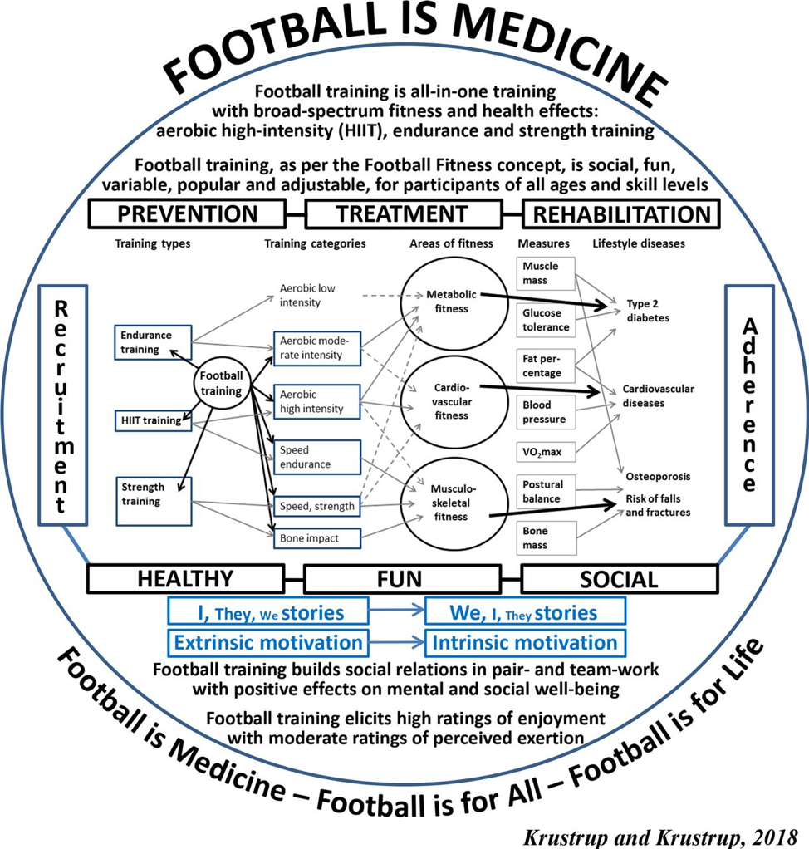

  - Children’s right to play Participation in football has potential benefits for the realisation of children’s rights and welfare . These range from healthier lifestyles, to education and training opportunities, to enabling relationship and social capital. The opportunities offered through football can mitigate the worst effects of poverty. An inability to access opportunities to play football should be of concern from a children’s rights perspective. Participation in sport can expose young people to risky situations and without formal processes and structures in place safeguarding issues can arise. One of the impacts of the COVID-19 outbreak has been a rolling back of child protection measures at local and national level (European Children’s Rights Unit, 2020 - forthcoming), sport is not immune from the potential risks of this. Engaging professional clubs in their responsibilities to support the development of children in their communities (not only those registered to their academies) is an important step to mitigate the disproportionate impact that the combined effects of Covid-19 and a decade of austerity has had on the opportunities for grassroots football.

- Recommendations
We believe that further consideration of the impact of COVID-19 on grassroots football and its potential role in an economic and public health recovery from the pandemic is needed. Sport is not a panacea and cannot solve complex social problems alone. However, the current pandemic has triggered something of a social experiment that emphasizes the negative externalities that emerge when people are denied opportunities to participate in grassroots sport. A fundamental recasting of sport and physical activity as a basic right of citizenship is needed. This requires a stakeholder approach to the governance of the game involving both political and football authorities. We outline a range of short and long-term measures to address the impact of COVID-19.

4.1 Short-term (next 3 months)
- Launch consultation with local authorities, schools and academy trusts, football authorities, professional clubs and third sector organisation on how to delivery physical activity and sport as part of the £1 billion summer catch up plan for school children;
- Ring-fence funding for local authorities to institute social distancing measures and enable the ‘unlocking’ of public sports facilities;
- Freeze the ‘flexible use of capital receipts’ to protect playing fields and sport facilities;
- Introduce proportional levy on broadcasting rights received by EPL to fund grassroots.

  - Long-term (6-12 months)
- Commission pilot of a stakeholder approach to football governance in two city regions;
- Introduce tax-breaks for lower-league community-focused clubs who demonstrate commitment to invest in a broader range of local education and grassroots initiatives;
- Digital infrastructure hosted and managed by an independent group/think-tank to monitor and make visible initiatives and opportunities. This institutionalizes responsibility and makes key stakeholders accountable.

In this submission, the term grassroots is used a catch-all label to encompass three distinct but inter-related levels: youth and junior football (boys and girls under-18), community football (male and female amateur leagues and competitions, including 11-a-side and small-sided games), and recreational football (more informal and casual games that take place outside of a formal competitive structure) .
Parnell, D. and Pringle, A. (2016) Football and health improvement: an emerging field, Soccer & Society, 17:2, 171-174, DOI: 10.1080/14660970.2015.1082753; Parnell, D., and Krustrup, P. (2018). Sport and Health: Exploring the Current State of Play. Abingdon: Routledge; Krustrup, P. and Parnell, D. (2019). Football as Medicine: Prescribing Football for Global Health Promotion. Abingdon: Routledge.
Parnell, D., Bond, A.J., Widdop, P. and Cockayne, D. (2020). ‘Football Worlds: Business and networks during COVID-19’, Soccer & Society. DOI: 10.1080/14660970.2020.1782719
Ibid.
Delaney, M. (2020) Coronavirus testing costs pose problem for sport’s restart plans, The Independent, Thursday 30 April 2020, Available at: https://www.independent.co.uk/sport/football/premier-league/premier-league-news-coronavirus-testing-2019-20-season-restart-table-a9493041.html
Krugman, P. (2020). Arguing with zombies: Economics, politics, and the fight for a better future. New York: WW Norton & Company.
Sport England (2020) Coronavirus: Research into how the coronavirus crisis has affected people's activity levels and attitudes towards exercise, Available at: https://www.sportengland.org/know-your-audience/demographic-knowledge/coronavirus#the_story_so_far
Ibid.
Webber, D. M. (2019). Feasting in a time of famine: The English Premier League, ‘conspicuous consumption’ and the politics of austerity. Journal of Consumer Culture. https://doi.org/10.1177/1469540518820948
Blyth, M (2013) The austerity delusion: Why a bad idea won over the West. Foreign Affairs, 92(3): 41–56.
Parnell, D., Millward, P., & Spracklen, K. (2015). Sport and austerity in the UK: An insight into Liverpool 2014. Journal of policy research in tourism, leisure and events, 7(2), 200-203.
Widdop, P., King, N., Parnell, D., Cutts, D. and Millward, P. (2018). ‘Austerity, policy and sport participation in England’, International Journal of Sport Policy and Politics, 10:1, 7-24, DOI: 10.1080/19406940.2017.1348964
The Bureau of Investigative Journalism (2019) ‘Their community spaces are being sold off but these people are fighting back’, Available at: https://www.thebureauinvestigates.com/stories/2019-03-06/communities-fighting-back-against-council-sell-offs
King, N. (2009) Sport Policy and Governance: Local Perspectives. Oxford: Elsevier.
O’Gorman, J., Fitzpatrick, D., Sibley, J., Hindmarsh, M., Saskova, Z. and Parnell, D. (2018). ‘Contemporary issues in the management of grassroots football’. In: Chadwick, S., Parnell, D., Widdop, P., & Anagnostopoulos, C. (Eds.). Routledge Handbook of Football Business and Management. London: Routledge.
Chester, N. (1968) ‘Report of the committee on football’, London: HMSO, 1.68, para 73
King, N. (2009) Sport Policy and Governance: Local Perspectives. Oxford: Elsevier.
Gibson, O. (2014) FA reveals its 2020 vision: football hubs and 3G pitches for all. [online] 10 October 2014, The Guardian. Available at: https://www.theguardian.com/football/2014/oct/10/fa-football-hubs-3g-pitches-grassroots
Parnell, D., May, A., Widdop, P., Cope, E. and Bailey, R. (2019). Management strategies of non-profit community sport facilities in an era of austerity, European Sport Management Quarterly, 19:3, 312-330, DOI: 10.1080/16184742.2018.1523944
Widdop, P., King, N., Parnell, D., Cutts, D. and Millward, P. (2018). ‘Austerity, policy and sport participation in England’, International Journal of Sport Policy and Politics, 10:1, 7-24, DOI: 10.1080/19406940.2017.1348964
O’Gorman, J., Fitzpatrick, D., Sibley, J., Hindmarsh, M., Saskova, Z. and Parnell, D. (2018). ‘Contemporary issues in the management of grassroots football’. In: Chadwick, S., Parnell, D., Widdop, P., & Anagnostopoulos, C. (Eds.). Routledge Handbook of Football Business and Management. London: Routledge.
Sport England, 2017, p. 2
Gibson, O. (2014) FA reveals its 2020 vision: football hubs and 3G pitches for all. [online] 10 October 2014, The Guardian. Available at: https://www.theguardian.com/football/2014/oct/10/fa-football-hubs-3g-pitches-grassroots
Parnell, D., May, A., Widdop, P., Cope, E. and Bailey, R. (2019). Management strategies of non-profit community sport facilities in an era of austerity, European Sport Management Quarterly, 19:3, 312-330, DOI: 10.1080/16184742.2018.1523944
Cabinet Office (2015) Sporting Future: A New Strategy for an Active Nation. Available at: https://assets.publishing.service.gov.uk/government/uploads/system/uploads/attachment_data/file/486622/Sporting_Future_ACCESSIBLE.pdf
Krustrup, P. and Parnell, D. (2019). Football as Medicine: Prescribing Football for Global Health Promotion. Abingdon: Routledge.
UNICEF (Essson, J., Darby, P., Drywood, E., Mason, C. and Yilmaz, S.) Children Before Players: Current Risks and Future Research Agendas 2020, Available at: https://repository.lboro.ac.uk/articles/Children_before_players_Current_risks_and_future_research_agendas/11590800/1
Mason, C., Darby, P., Drywood, E., Esson, J. and Yilmaz, S. (2019). ‘Rights, Risks and Responsibilities in the Recruitment of Children within the Global Football Industry’, International Journal of Children’s Rights. 27(4): 738-756.

